Kidney Disease Data Cleansing and Visualization Project
Student: Yusra El-Faran
Instructor for the Course: Dr. Hager Saleh
Documented on: 15-11-2025

Summary

It is an initiative that does extensive preprocessing and visualization of Chronic Kidney Disease data. It involves the management of missing data, the management of outliers, and the creation of various visualizations. The actions are strictly guided by the lecture-based approach, which makes them conform to the course requirements.

Data Set Overview

The data consists of 398 records and 25 variables.

1. Handling Absent Data
Before cleaning, a summary of missing entries was as follows:
chronologic age 9 blood pressure 12 specific gravity 46 albumin level 45 blood glucose 48 red blood cells 151 pyocytes 64 platelet count 4 bacterial assessment 4 blood glucose 44 blood urea nitrogen19 serum cholesterol 17 sodium level 87 potassium level 88 hemoglobin conc. 51 packed cell volume 69 white cells 105 renal count 129 high blood pressure2 diabetes 2 coronary disease 2 appetite 1 clinical exam 1 anemia 1 classification 0
Missing data entries were completed with the KNN Imputer (k=2).

2. Handling Outliers (IQR Method)

Interquartile Range (IQR) method was used to identify and treat outliers.

3. Visual Data Display
Correlation heat map:
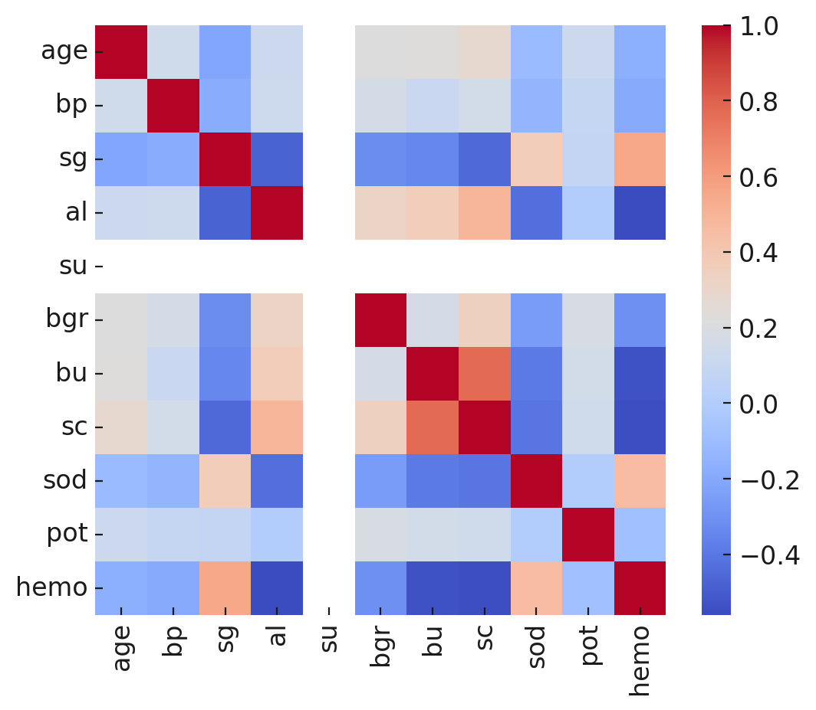
Age Distribution Histogram:
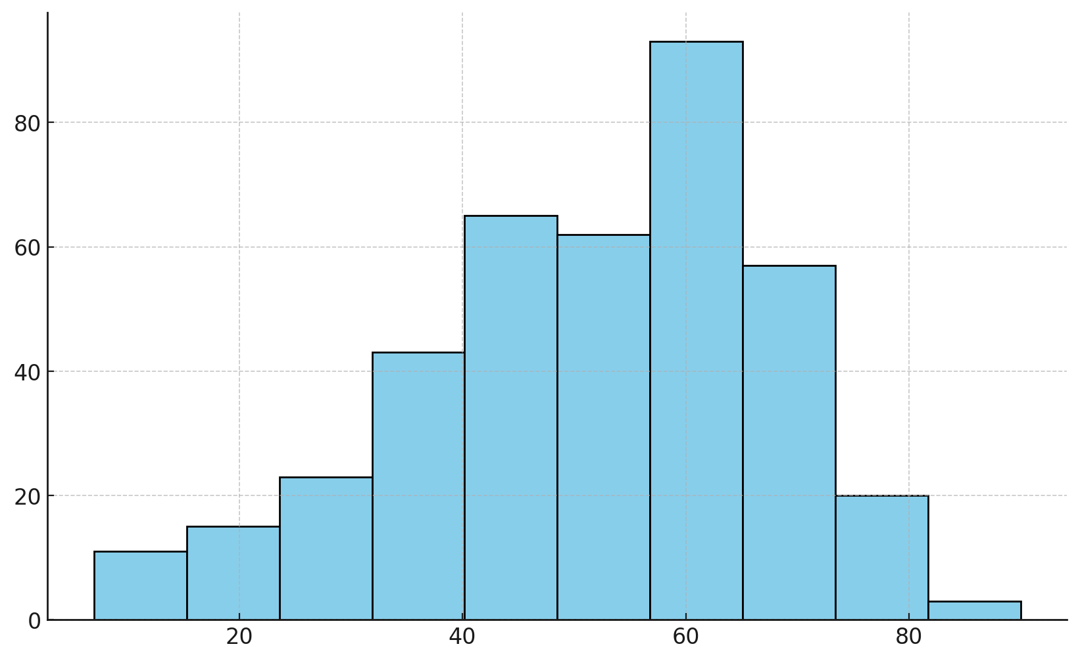
Box Chart for Blood Pressure:
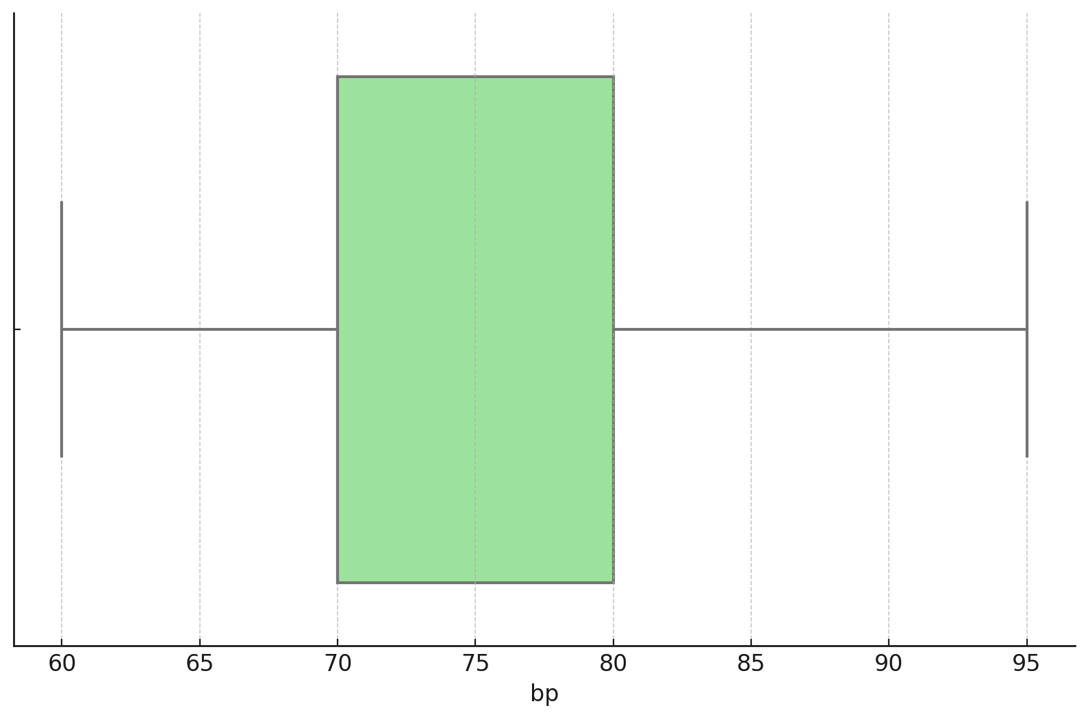

Concluding Remarks
Every preprocessing stage of this project is already finished, and it includes missing values, outliers, and the creation of necessary visualization. The output of the data set is prepared to be analyzed or used in machine-learning.

