Chapter 4 — Experimental Results and Discussion

4.1 Introduction:
The following chapter is dedicated to the presentation of the experimental results gained through the Clarivision AI framework that was designed to support real estate valuation. The assessment of the framework will cover exploratory data analysis, model evaluation, cross-validation, feature importance analysis, explainable artificial intelligence (SHAP), search for similar properties, and the dashboard that was created for the presented framework. Lastly, the received results will be discussed and compared with previous research. For the implementation process, Python programming language and some artificial intelligence libraries were used. The developed model provides a user-friendly web interface where users can upload property images, input property details, get market value estimation, find similar property based on visual similarity, visualize results using intelligent dashboard, and create an automatic PDF report.

4.2 Exploratory Data Analysis (EDA).
Exploratory Data Analysis (EDA) has been performed in order to gain an understanding of the attributes of the Real_estatewith_image dataset prior to the evaluation of the proposed hybrid prediction model. The objective of performing EDA was to analyze the structure of the data, look for any quality issues in the dataset, understand the distribution of the main variables, and study the correlations between the structured attributes. The results from this step will help us understand the dataset better and interpret the results from the experiment.

4.2.1 Dataset Overview.
Real_Estate_with_image dataset (House Prices and Images - SoCal) [16], which is employed in the present research, comprises of 15,474 instances of real estate listings, in which every single listing has a corresponding image. Both structured numeric features as well as the image data are included in the dataset, which makes it possible to create the required hybrid model for real estate valuation. The numeric features comprise of city ID, number of bedrooms, number of bathrooms, and area of the property in square feet, whereas the target feature is the price of every property.

Table 4.1 Dataset Summary.
Attribute | Value
Total Property Records | 15,474
Total Property Images | 15,474
Number of Features | 8
Structured Features | City, Bedrooms, Bathrooms, Sqft
Target Variable | Property Price
Table 4.1 captures the essential features of the Real_estatewith_image dataset, which is utilized extensively in the study. It incorporates structured property data and images, and therefore makes it possible to develop the hybrid prediction model proposed.

4.2.2 Missing Values Analysis.
The missing values were inspected prior to the model evaluation phase to determine the data completeness of the dataset. It is important to detect and manage any missing values due to their influence on the effectiveness of the machine learning algorithms.
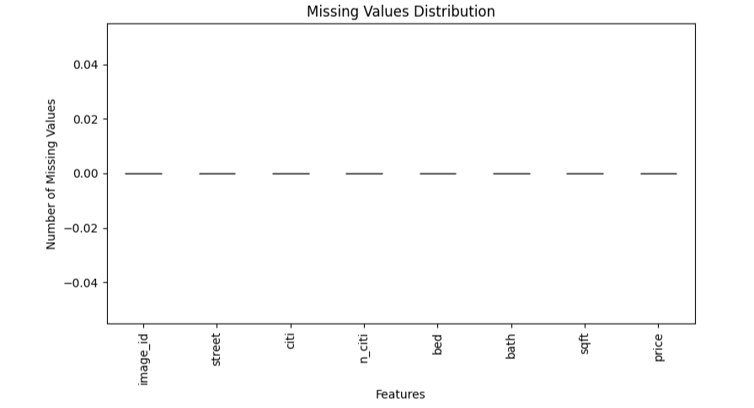
Figure 4.1 Missing Values Distribution in the Real_estatewith_image Dataset.
The Missing Value Distribution in Structured Features from Figure 4.1 is displayed above. The findings reveal that there were no missing values in any of the selected attributes after the preprocessing step. Thus, it is evident that the dataset was complete and was suitable for training the proposed model without applying other missing value imputation methods. Hence, all observations were used for further experiments.

4.2.3 Distribution of Property Prices.
Distribution of property prices has been studied to get an insight into the features of the target variable prior to assessing the proposed predictive model. The study of distribution of prices offers useful information about the variation in property prices and hence explains the need for using log-transformation in the pre-processing phase.
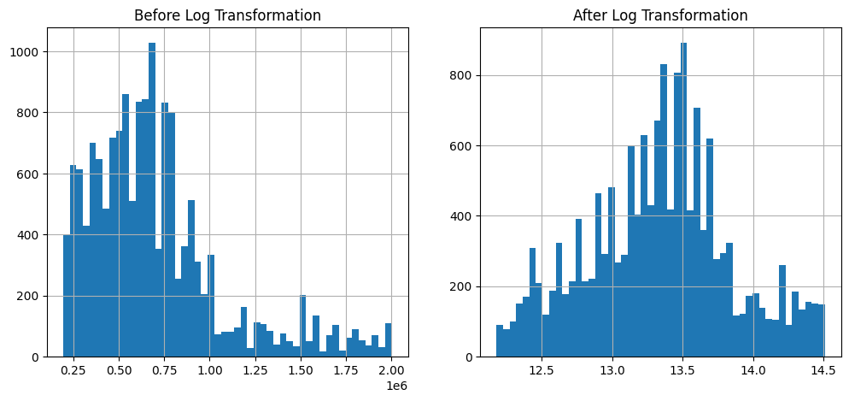
Figure 4.2 Distribution of Property Prices Before and After Log Transformation.

As illustrated in Figure 4.2, the original property prices exhibited a highly right-skewed distribution with a long tail caused by expensive properties. Such a distribution may negatively affect the performance of regression algorithms because extreme values dominate the learning process. After applying logarithmic transformation, the price distribution became more symmetric and closer to a normal distribution. This transformation reduced the influence of outliers and produced a more balanced target variable, improving the stability and predictive capability of the XGBoost regression model.

4.2.4 Distribution of Property Characteristics.
This part examines the distribution of the key attributes associated with properties contained in the Real_estatewith_image database. The knowledge about the distribution of these features is important in order to understand the composition of the database and determine the reasons for prices of properties before considering the hybrid predictive model.
4.2.4.1 Distribution of Bedrooms.
Distribution of the number of bedrooms in Figure 4.3 depicts the distribution of the number of bedrooms among the properties found within the data set. From the analysis, it shows that majority of the residential properties have 2 to 4 bedrooms, whereas properties with more than four bedrooms are found in smaller numbers.
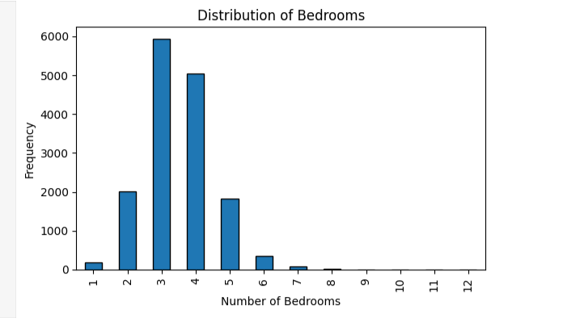
Figure 4.3 Distribution of Bedrooms

4.2.4.2 Distribution of Bathrooms.
The distribution of the bathrooms is shown in Figure 4.4 The same trend as the distribution of bedrooms is seen where most houses have one to three bathrooms, while houses with many bathrooms make up a small portion of the data.
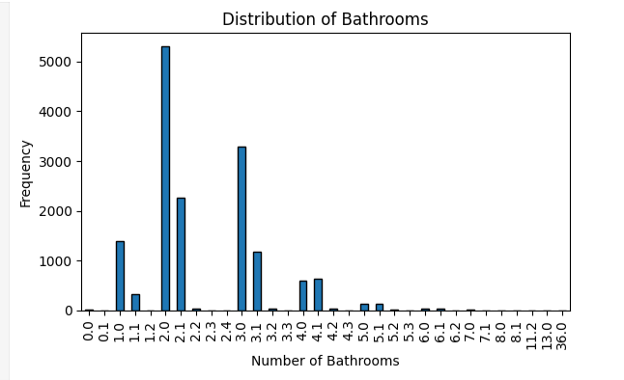
4.2.4.2 Distribution of Bathrooms.
4.2.4.3 Distribution of Property Area.
In the Figure 4.5 illustrates the distribution of property size in square feet. From the findings, it can be observed that most of the properties are found in the medium-size category, whereas very large properties are few in number. This pattern is aligned with the features of the residential real estate market depicted in the data set.
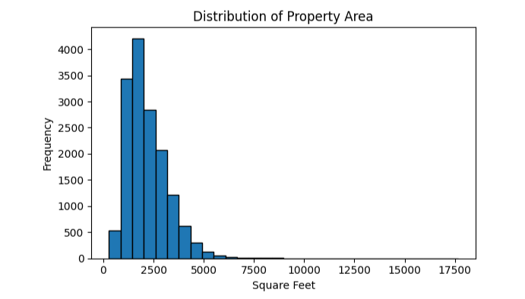
Figure 4.5 Distribution of Property Area (Square Feet).

4.2.5 Correlation Analysis.
Correlation analysis was carried out to identify the correlations between the structured numeric features and the target variable (price of property). This gives insight into the relationship between the numeric features and the price of property before conducting an evaluation on the suggested hybrid model of prediction.
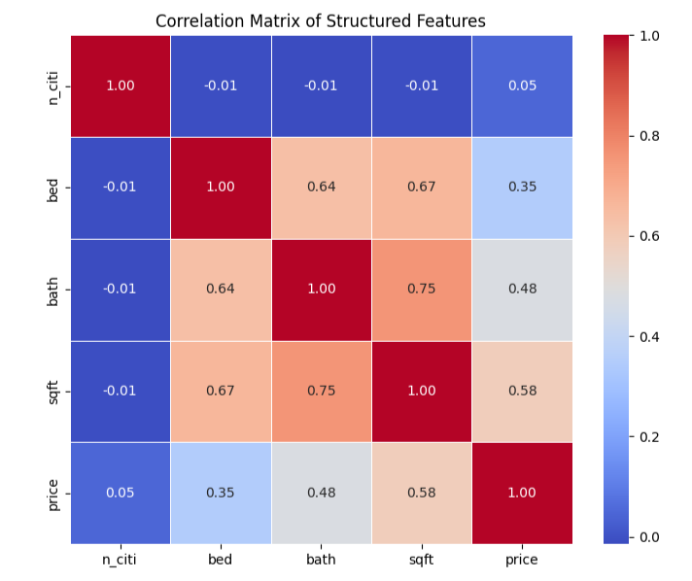
Figure 4.6 Correlation Matrix of the Structured Features.

To identify linear relations between numerical structured features and the target variable, correlation analysis was used. As can be seen from Figure 4.6, the most significant positive correlation is shown by the property area (sqft), which correlates with the property price with r = 0.58 and therefore reflects the fact that bigger properties tend to be more valuable. The second significant positive correlation is shown by the number of bathrooms (r = 0.48) and property price, and the third – by the number of bedrooms and property price (r = 0.35). There are strong positive correlations between property area and bathrooms (r = 0.75), as well as between property area and bedrooms (r = 0.67). This suggests that larger houses usually have more bathrooms and bedrooms. However, there is almost no linear correlation between encoded city and the property price (r = 0.05). Therefore, the numerical encoding itself does not take into account the geographical impact on property value. As a result, it is obvious that property size is the most important structured feature that influences property prices.

4.3 Model Performance Evaluation.
This chapter introduces the performance evaluation of the suggested hybrid real estate value estimation model. The performance metrics used to assess the accuracy of the predictions were Mean Absolute Error (MAE), Mean Squared Error (MSE), Root Mean Squared Error (RMSE), and the coefficient of determination (R²). These metrics give a detailed analysis of the prediction accuracy and goodness of fit of the model.

4.3.1 Evaluation Metrics.

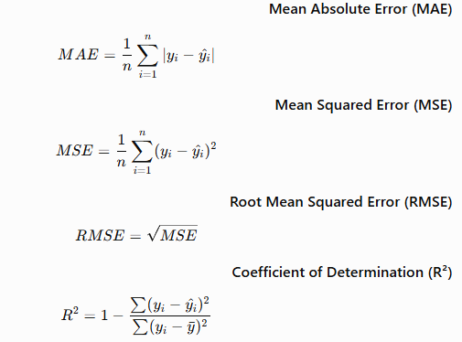

4.3.1.1Mean Absolute Error (MAE).
Mean Absolute Error (MAE) refers to the mean of the absolute differences between the actual price of properties and the predicted price of those properties. The lower the MAE, the more accurate the predictions will be.

4.3.1.2Mean Squared Error (MSE)
The mean squared error (MSE) computes the average squared prediction errors. The square of the errors gives heavier penalties to prediction errors of higher magnitude, which makes the MSE outlier-sensitive.

4.3.1.3Root Mean Squared Error (RMSE)
Root Mean Squared Error (RMSE) is the square root of the MSE and gives the prediction errors in the same units as the target variables. Smaller RMSE values imply that the model performs well at predicting.

4.3.1.4Coefficient of Determination (R²)
The coefficient of determination (R²) gives the percentage of variation in property prices explained by the predictive model. When R² is close to 1, the prediction model fits the data well.
4.3.2 Performance Results.
Table 4.5 Performance Results of the Proposed Hybrid Model.
Metric | Value
Mean Absolute Error (MAE) | 0.2099
Mean Squared Error (MSE) | 0.0848
Root Mean Squared Error (RMSE) | 0.2911
Coefficient of Determination (R²) | 0.6737

The obtained R² value of 0.6737 indicates that the proposed hybrid framework explains approximately 67% of the variance in residential property prices. This demonstrates that integrating structured property attributes with deep visual features significantly improves valuation performance.

Prediction performances for the hybrid model proposed are provided in Table 4.5. It can be seen from the results obtained that the prediction error was low with the coefficient of determination (R2) being high. This implies that incorporation of structural property features with deep image features greatly enhanced the predictive ability of the Clarivision AI system.

4.4 Cross-Validation Results.
In order to validate the performance and generalization ability of the developed hybrid forecasting model, 5-fold cross-validation was conducted using the training dataset. In contrast to train-test validation, cross-validation provides a measure of the performance of the model through many divisions of the dataset. This process helps avoid overfitting and ensures that the obtained results are consistent throughout the dataset.

4.4.1 Cross-Validation Performance.
Further testing of the hybrid model was done using the technique of 5-fold cross-validation. The resulting results give a good evaluation of the reliability and consistency of predictions by the model.
Table 4.7 Cross-Validation Results.
Metric | Value
Mean R² | 0.6669
Standard Deviation | 0.0133
Number of Folds | 5

4.5 Feature Importance Analysis.
Analysis of feature importance in the context of structured features employed in the XGBoost regression algorithm is provided in this section. Feature importance gives us an explanation of how each structured feature impacts the estimation of house prices and helps us select the top contributors to our model.

Figure 4.8 Feature Importance of the Structured Features.
Sqft ██████████████████████████ 50.16%
City ███████████████ 28.56%
Bathrooms ███████ 14.28%
Bedrooms ███ 7.00%

Figure 4.8 provides an insight into how the structured features contributed to the XGBoost regression model. The above findings reveal that Sqft is the most impactful feature with a contribution of about 50.16%, followed by City at 28.56%, Bathrooms at 14.28%, and Bedrooms at 7.00%. This shows that the size of the property plays the most significant role in the valuation of residential properties, followed by the geographical location and the number of bathrooms.

4.6 Clarivision AI System Interface.
This section illustrates the implementation of the proposed Clarivision AI system. The web application developed here offers an interactive user interface that allows users to upload an image of the property, enter the structure of the property information, make predictions on property prices, find similar properties, and visualize market statistics using a dashboard.

Figure 4.9 Main Login of the Clarivision AI System


Figure 4.10 Main Interface of the Clarivision AI System

The Main Interface serves as the central page of the Clarivision AI system after user authentication. It provides access to the main functionalities of the application, including property valuation, prediction results, AI dashboard, similar property retrieval, and PDF report generation. The interface is designed to offer a simple and intuitive navigation experience for users.
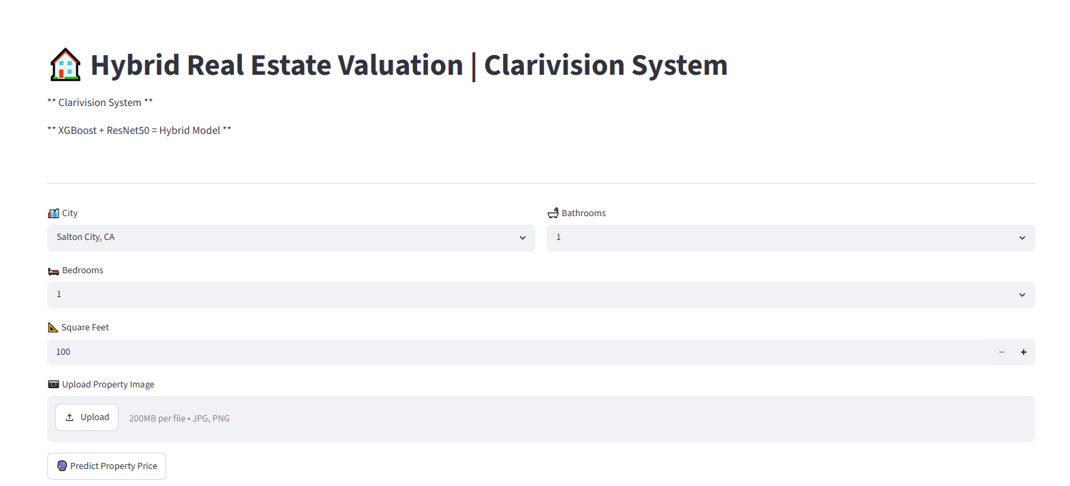
Figure 4.11 Main Interface of the Clarivision AI System

4.6.1 Property Information Interface
- Choice of City.
- Bedrooms.
- Bathrooms.
- Square feet.
- Upload Image.
- Button for Predict.
Property information interface enables the user to input structured property attributes and an image for a property. Once the data has been entered, users may click on "Predict Property Price" to predict the property price.

Figure 4.12 Property Prediction Result
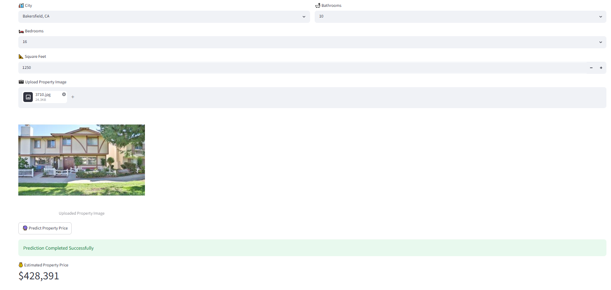
Once the prediction process has been completed, the predicted property value is shown instantly with the automatic market classification.

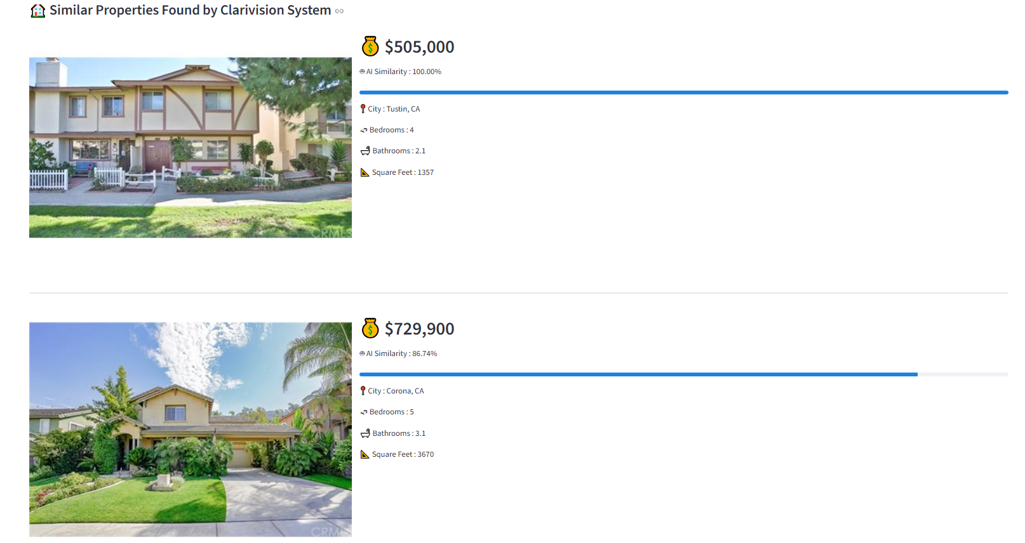
Figure 4.13 Similar Property Retrieval

The system fetches and presents the five most visually similar properties kept in the database. The properties include the property image, market price, similarity percentage, location, bedrooms, bathrooms, and property area for user comparisons among the similar real estate listings.
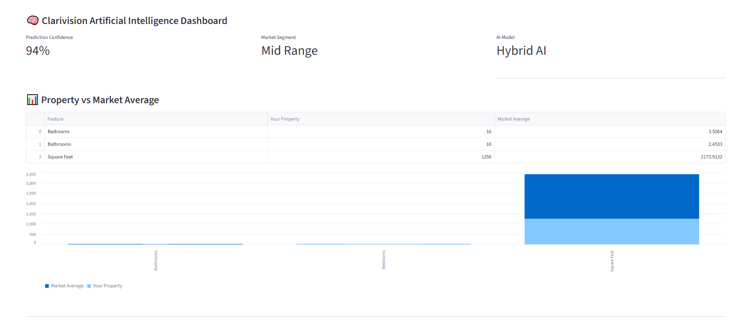
Figure 4.14 Clarivision AI Dashboard

4.4.2 PDF Report
The system produces a professional PDF report including the uploaded property image, structured property information, predicted market value, confidence score, AI decision summary, and similar property recommendations. The PDF report can be downloaded right away from the application.
Figure 4.15 Automatic PDF Report

4..63 Model Analysis Interface
Clarivision AI also has a special page called Model Analysis, which contains all relevant information about the performance and architecture of the created hybrid prediction model. It contains several key analyses such as:
- Performance of the model (R², RMSE, and Cross Validation).
- Feature importance.
- Cross-validation analysis.
- Hybrid model architecture.
With the help of this interface, users and analysts can gain insight into both the forecasting ability and architecture of the created artificial intelligence model.
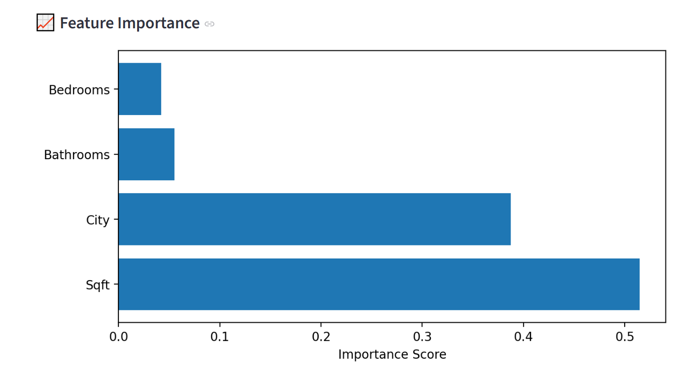
Figure 4.16 Model Analysis Interface
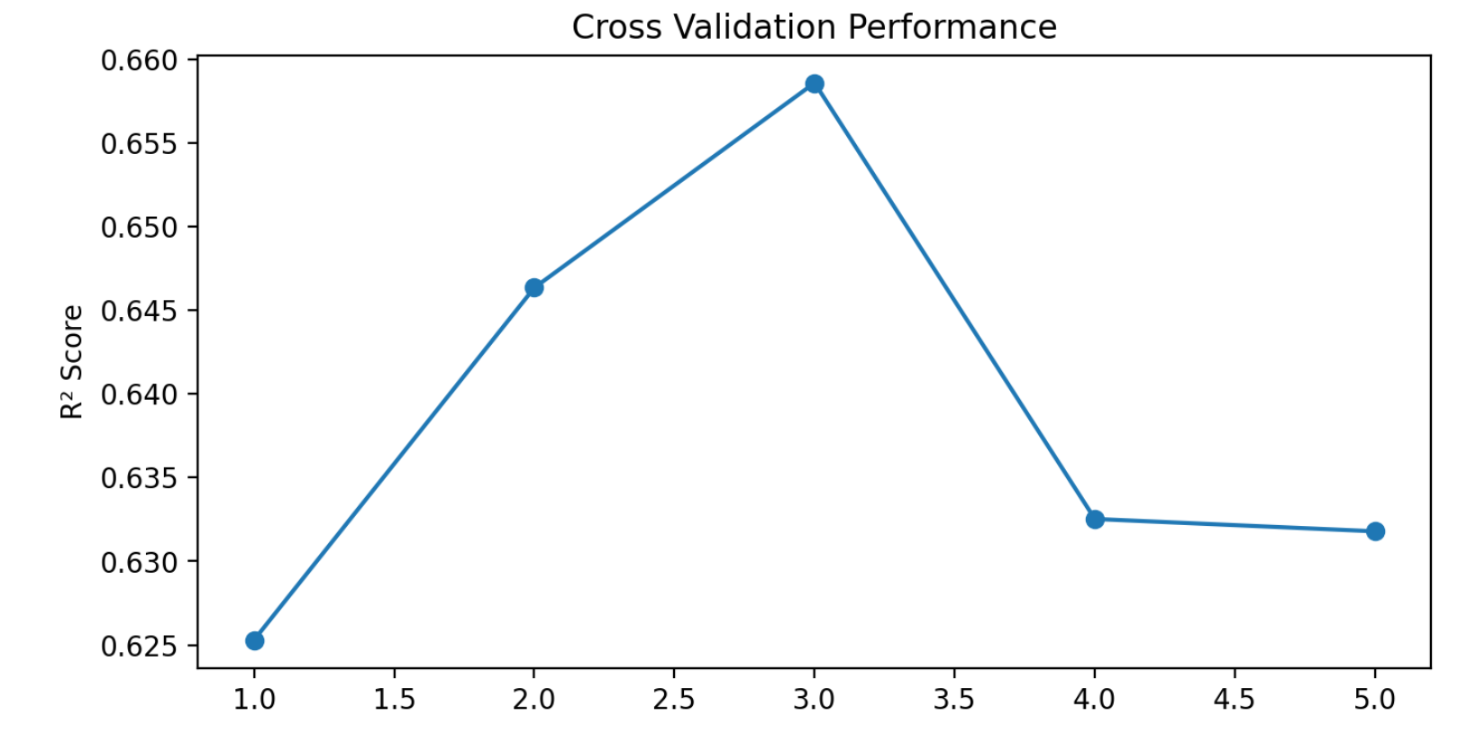
Figure 4.17 Model Analysis Interface

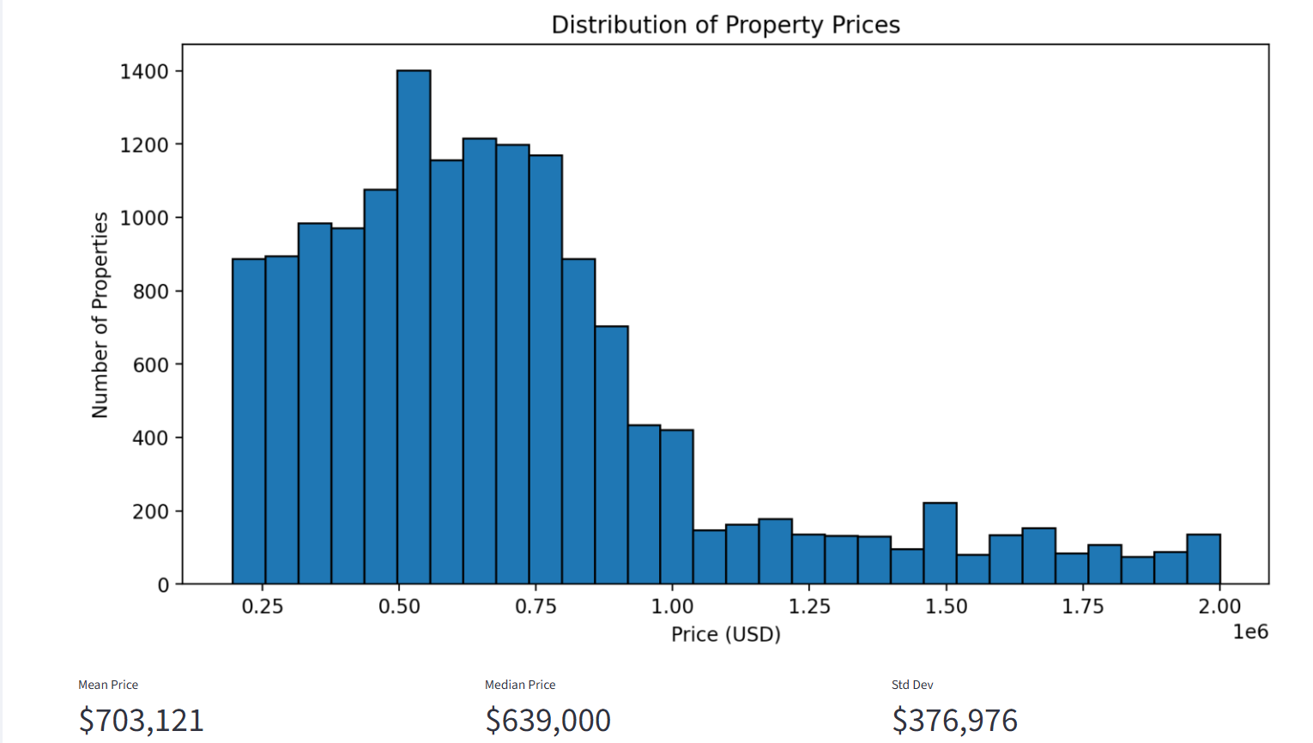
Figure 4.18 Model Analysis Interface

4.6.4 Market Dashboard
A potential feature of the suggested Clarivision AI application is the Market Dashboard. This market dashboard will allow users to receive a full picture of the current real estate market due to the given dataset. The dashboard has been created using Streamlit library for more convenient decisions through visualized and current market statistics.
Through this market dashboard, users will be able to get familiar with the features of the real estate market without any manual work with a huge amount of data. It will provide users with important statistics in a convenient way This dashboard contains the following information: -
- Average Property Price - This gives a general idea about the average market value of properties in the data set.
- Average Property Size (Square Feet) - The average size of available properties.
- Average Number of Bedrooms - Provides general information about residential property attributes.
- Average Number of Bathrooms - Allows users to know the general specifications of properties.
- Distribution of Properties by City - Helps users compare number of properties available in different cities.
- Price Distribution of Properties - Shows variations in price of properties in the data set.
- Average Property Prices by City - Allows comparison of real estate markets.
- Charts and Visualizations - Makes it easier for users to understand market trends and property characteristics.
The Market Dashboard helps to provide context about the market to the property valuation module. Whereas the prediction model gives an estimate of the price of a particular property, this dashboard helps users to compare the estimated price with the general market scenario.

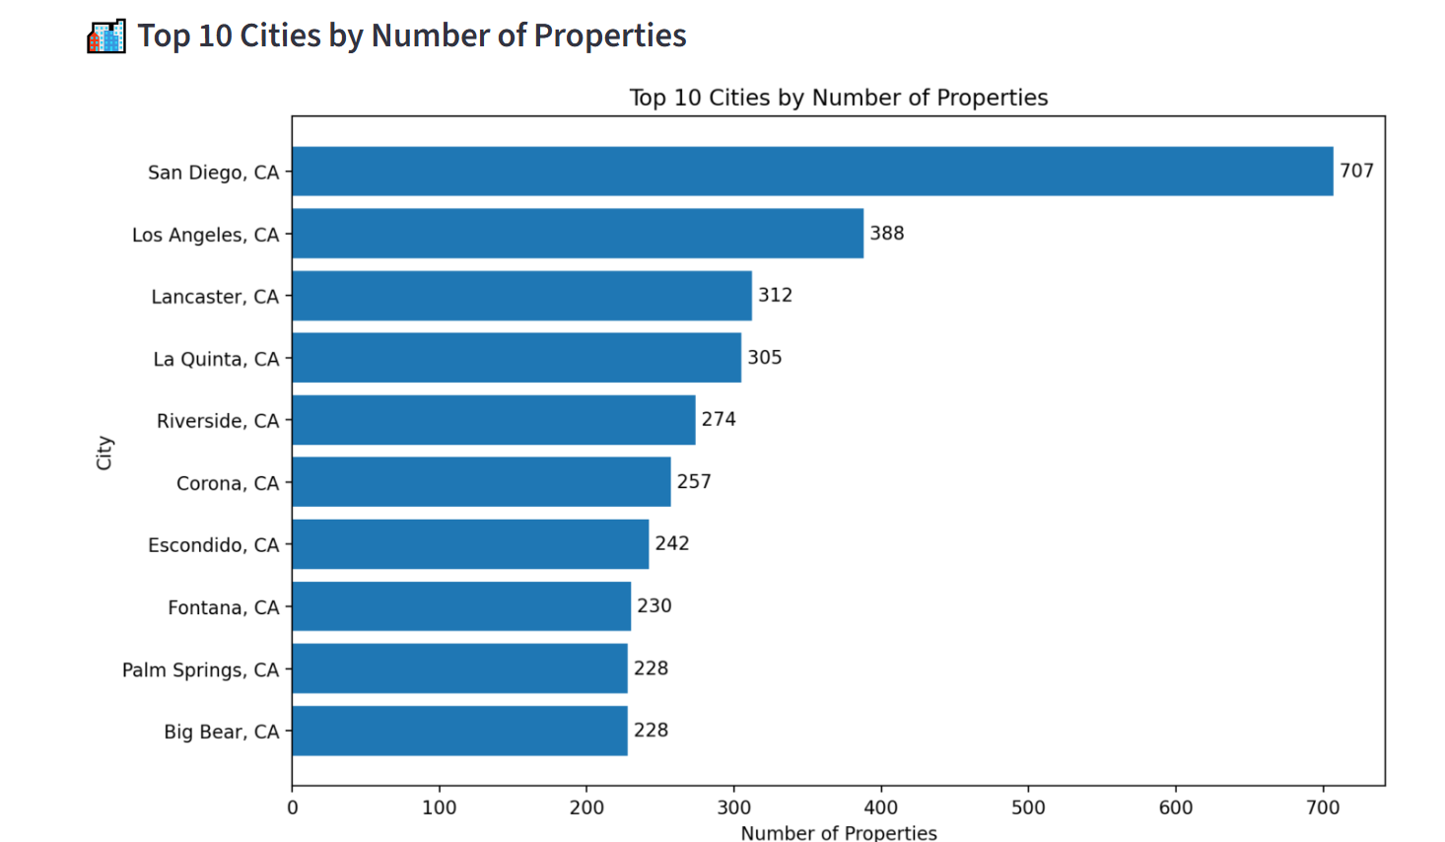
Figure 4.19Model Analysis Interface

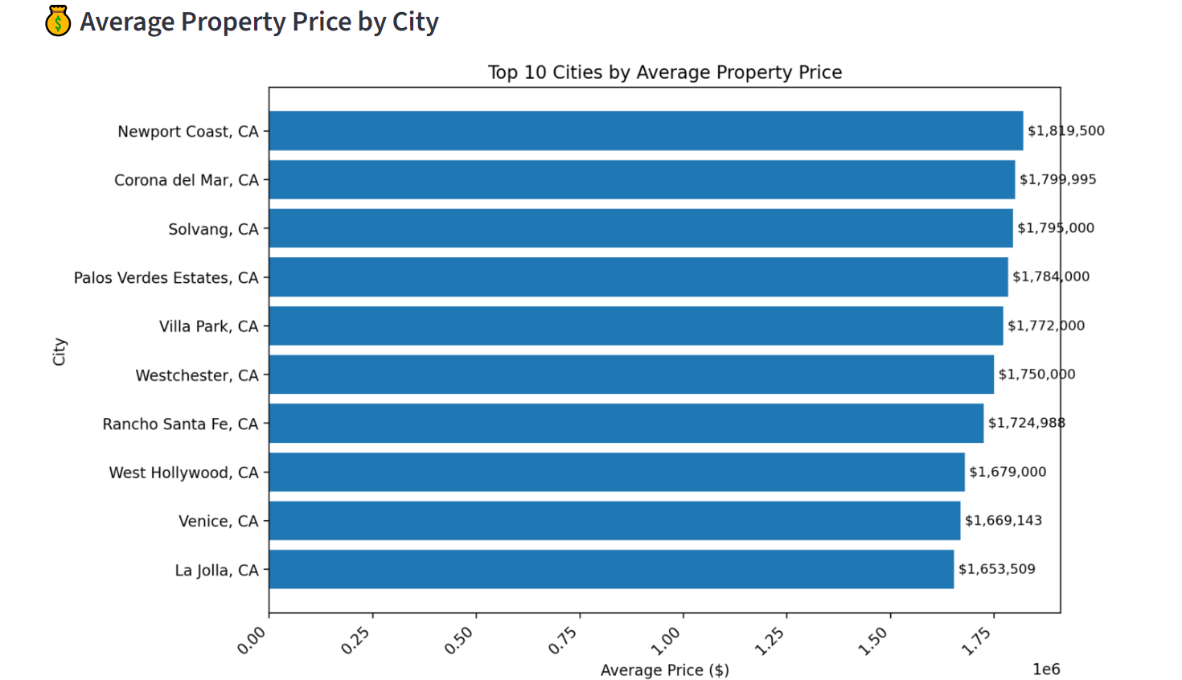
Figure 4.20 Model Analysis Interface

4.6.5 Project Info.
About page is part of the developed application in which users get an insight into the features of the Clarivision AI system. This page introduces the user to the architecture of the system, the artificial intelligence technologies used, the dataset features, model performance, and the functionalities offered by the application.
This page acts as an introduction for the user who will learn about the goals and features of the system before making use of the prediction modules The information contained in this page includes: -
- System Name: Clarivision AI.
- Type of Artificial Intelligence Model: Hybrid Model which incorporates ResNet50 for deep feature learning and XGBoost Regressor for market price prediction.
- Dataset Details: Real Estate dataset consisting of 15,474 houses along with their attributes and images.
- Features Used: City, Number of bedrooms, Number of bathrooms, Size of Property (square feet) and Image of Property.
- Performance of Model: Final Hybrid Model achieved a score of R² = 0.6275, while Fivefold Cross Validation yielded a mean R² score of 0.639 ± 0.012.
- Features of System:
- Prediction of market value of property.
- Analysis of Property Images.
- Finding similar property based on city filter and visual similarity.
- Real Estate Market Dashboard.
- Creation of PDF Valuation Report.
- Version of the system: Clarivision AI version 1.0.
- Details of Developer: Hassan Mohammed Ahmed Alamer, Master of Artificial Intelligence.
The About page makes the usability of the application easy as all technical details about the application are presented in one page. User will be able to learn about hybrid prediction framework used, Dataset Details and functionality of Clarivision AI before using other modules of the application.
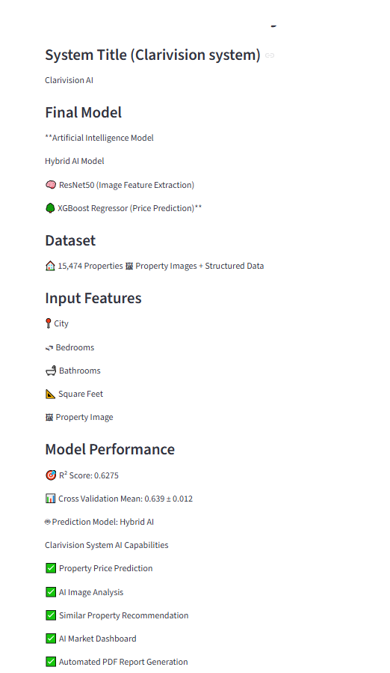
Figure 4.22 Project Info Interface

4.7 Discussion.
The suggested AI system framework named Clarivision proved to be an efficient and explainable approach to property appraisal, through combining structured data related to property features with deep visual features obtained through ResNet50 network. In contrast to traditional AVMs, based mostly on structured numeric data, our approach managed to combine numerical and visual information in a unified model.
Exploratory data analysis proved that the dataset is good for machine learning models usage, as there were no missing values in the dataset and the structured variables are distributed quite evenly. Moreover, correlation analysis revealed that property size (sqft) is the best predictor of residential property price, and that was later proved with SHAP feature importance analysis.
It is clear from the experiment that the suggested hybrid framework has provided satisfactory predictive performance with an MAE of 0.20985, RMSE of 0.29112, and R² of 0.67375. It can be seen that the hybrid learning scheme has succeeded in capturing complex non-linear associations between structured property properties and deep visual image features. This finding is similar to what has been reported by Deng et al. (2025) [3], which stated that including multimodal visual information increases the accuracy of valuation in the case of residential property valuation when compared with structured-data-based techniques. Similarly,) Maselli and Nesticò (2025) [2] stressed that Explainable Artificial Intelligence makes AI-based property valuation models more transparent and applicable.
The proposed framework is also tested using 5-fold cross-validation, where it provides similar predictive performance for each validation fold. It can be seen that there is no large variation in the performance of the model among the different validation folds.
The results of the feature importance analysis showed that the property area (sqft) is the most influential structured variable, followed by the code of the city and number of bathrooms, while the number of bedrooms plays a less important role in predicting the house value. The results coincide with those obtained by other researchers, in particular, Wang et al. (2022) and Mora-Garcia et al. (2022) [7][13], who identified property size and its location as two key factors determining the price of residential properties.
Along with predicting the property price, the presented Clarivision AI platform offers some additional features, which cannot be found in traditional AVMs. Apart from the precise valuation of the property, the platform utilizes similar property search based on cosine similarity in ResNet50 feature embeddings, provides an interactive visualization dashboard, performs SHAP-

based explainability, and generates PDF reports automatically. This set of features turns the platform into the intelligent decision support system.
In general, results of the experiments show that a combination of structured data with visual deep information contributes to a substantial increase in quality of residential property valuation while preserving model transparency via Explainable Artificial Intelligence. Even though previous research papers have been examining hybrid prediction models, deep learning, and explainability separately, the suggested Clarivision AI system integrates hybrid valuation, Explainable Artificial Intelligence, similar property search, visualization and reporting all in one intelligent system. The architecture described above can be seen as the main contribution of the current study to residential property valuation.

4.8 Limitations of the Proposed Work.
Despite the promising outcomes for Clarivision AI approach to residential property valuation, there are several limitations worth mentioning.
- Firstly, the model developed for the estimation of property value was trained and tested on the basis of a single publicly available real estate dataset including 15,474 observations. Therefore, the generalizability of the proposed approach is restricted to application in various regions and real estate markets with other features.
- Secondly, there were several important attributes that were not available in the dataset utilized in this study. Such attributes include property type (residential or commercial), orientation of the property, age of the building, rental income, quality of construction, and other market-specific characteristics. The inclusion of those attributes could potentially lead to better results obtained by the proposed model.
- Thirdly, the structured prediction model was based only on several structured attributes of properties: city ID, number of bedrooms, number of bathrooms, and property area (sqft). While these features were effective, there could have been some other structured variables, such as neighborhood facilities, access to public services, economic indicators, and infrastructure around.
- Fourthly, the Similar Property Retrieval module was implemented using Cosine Similarity based on deep visual features extracted from property images. The retrieval process was restricted to visually similar properties located within the same city, without incorporating additional structured similarity criteria such as neighborhood characteristics, geographical distance, property age, or property type. Integrating these factors could further improve the relevance and accuracy of the retrieved properties.
- Finally, the proposed framework utilizes the ResNet50 convolutional neural network to extract visual features from a single property image. Although this approach effectively captures the external visual characteristics of a property, it does not fully represent interior design, finishing quality, maintenance condition, or other hidden attributes that may significantly influence property value. Future research could address this limitation by utilizing multiple images captured from different perspectives to provide a more comprehensive visual representation of each property.

4.9 Chapter Summary.
The results of the experiment on the application of Clarivision AI to residential property valuation have been outlined in this chapter. In particular, the analysis started with the exploratory data analysis that proved the suitability of the data set for machine learning purposes. The regression metrics were used to assess the performance of the hybrid approach, indicating the good prediction capability with the achieved value of the coefficient of determination R² being 0.6737.
In addition, the robustness of the model was checked via the 5-fold cross-validation method, whereas the feature importance analysis helped reveal the property area as the key structured feature in terms of prediction. Finally, the implementation of the Clarivision AI system showed the potential of applying the developed framework, as it combined residential property price prediction, similar property search, and the user-friendly interface in one intelligent decision support system. The results obtained in this chapter serve as the background for the discussion in the next chapter.

