

Enhancing Aspect Based Sentiment Analysis Of Saudi E-Commerce Reviews Using BERT Models

Prepared By
Areej Haddaj Alqarni
252001729

Submitted in fulfillment of the requirements for the degree Master of Science in Artificial Intelligence
At
College of Informatics
Midocean University
UAE
Supervisor: Dr. Yasser Abdul Hamid
College of Informatics, Midocean University, Comoros
[2026- Third Trimester ]

Acknowledgements

Alhamdalalah, by whose grace good deeds are accomplished; it is through His favor and guidance that I have completed this modest effort. I praise and thank Him for granting me the patience to complete this research. I would like to express my sincere gratitude to my thesis advisor, Dr. Yasser Abdel Hamid, for his guidance and continuous support throughout the writing process, I would also like to thank my dear family for their constant support, patience and encouragement.

Abstract

Sentiment analysis is of critical importance to all companies and has become an effective method for gauging customer satisfaction in the e-commerce sector, given the widespread use of e-commerce platforms for making purchasing decisions. To address this challenge, in this study, we developed a model for sentiment analysis in Arabic customer reviews, primarily covering the Saudi dialect, to help companies effectively assess the quality of products and services. The second part includes a review of the literature on sentiment analysis in Arabic and six academic papers that have significantly enhanced the theoretical frameworks supporting our study. A dataset of customer reviews of clothing in the Saudi dialect was collected and compiled, and the text was preprocessed (data cleaning, standardization, and filtering). We then developed an aspect-based sentiment analysis by fine-tuning pre-trained language models, specifically the SaudiBERT and CAMeLBERT-DA models, and compared their performance. The comparison results showed that the SaudiBERT model, which was trained on the Saudi dialect, outperformed the CAMeLBERT-DA model—trained on a wide range of Arabic dialects—with an accuracy of 92% versus 91%.

Table of Contents
Abstract 2
Chapter 1 Introduction 8
1.1 Problem Definition 8
1.2 Thesis Objectives 9
1.3 Thesis Contribution 9
1.4 Thesis Organization 9
Chapter 2 Background and Related work 11
2.1 The Role of Sentiment Analysis in E-Commerce 11
2.2 Sentiment analysis in the Arabic language 11
2.3 Machine Learning Approaches 11
2.4 Pre-trained Language Models 12
2.5 Datasets in Arabic Sentiment Analysis 12
2.6 Related work 13
2.7 Literature Review Matrix 15
2.8 Research Gaps 17
2.9 Summary 17
Chapter 3 Proposed Approach 17
Proposed Approach 18
3.1 Data Collection and Description 18
3.2 Dataset Refinement 18
3.3 Data preprocessing 20
3.4 Input Representation and Tokenization: 21
3.5 Training setup: 22
3.6 Model Training: 22
3.7 Performance Evaluation Metrics: 22
Chapter 4 Experimental Results and Discussion 23
Experimental Results 23
4.1 Experimental Setup: 23
4.2 Feature Relationship Analysis: 23
4.3 Baseline Model Performance 25
4.4 Overall Model Performance Evaluation: 25
4.5 Performance Evaluation per Aspect: 26
4.6 Comparative Performance Analysis SaudiBERT vs. CAMeLBERT-DA: 28
4.7 illustrative case study: 28
4.8 Discussion: 29
Chapter 5 Conclusion and Future Work 30
5.1 Conclusion 30
5.2 Future work 30
References 32

List of Abbreviations

- NLP: Natural Language Processing.
- SA: Sentiment Analysis.
- SVM: Support Vector Machine.
- NB: Naive Bayes.
- KNN: K-Nearest Neighbors.
- DT: Decision Tree.
- RF: Random Forest.
- ABSA: Aspect-Based Sentiment Analysis.
- TF-IDF: Term Frequency – Inverse Document Frequency.
- BOW: Bag Of Words.
- POS Tagging: Part-of-Speech Tagging.
- BERT: Bidirectional Encoder Representations from Transformers.
- HCABSA: Hybrid Contextual Aspect-Based Sentiment Analyzer.
- AdamW: Adaptive Moment Estimation with Weight.
- LSTM: Long Short-Term Memory.
- Bi LSTM: Bidirectional Long Short-Term Memory.

List of Figures

Figure 1: A simple from clothes DataSet 17
Figure 2:Distribution of sentiment in the original dataset 19
Figure 3: after merging and enhancement 19
Figure 4:A sample from Dataset after preprocessing 20
Figure 5: Correlation between Aspects Before balance 24
Figure 6 :Correlation between Aspects after balance 24
Figure 7: Training and validation loss curve 25
Figure 8: Overall Confusion Matrix of SaudiBert 26
Figure 9: Overall Confusion Matrix of CAMeLBERT-DA 26
Figure 10: case study 29

List of Tables

Table 1 Summary Of Related Studies 14
Table 2 split data set 21
Table 3: Preparing a hyperparameter 21
Table 4 : Evaluation of Each Aspect of SaudiBert 27
Table 5: Evaluation of Each Aspect of CAMeLBERT-DA 28
Table 6:Comparative Results SaudiBERT vs. CAMeLBERT-DA 29

Chapter 1 Introduction

  - Problem Definition
E-commerce has seen remarkable growth in recent years, prompting companies to rely on online platforms as an essential tool for attracting customers and understanding their needs and preferences. It has become essential to measure customer satisfaction with products, and customer reviews on e-commerce sites are a key source for understanding their experiences with products and services. The sheer volume of reviews written by customers on these sites poses a major challenge for companies in handling the massive amount of data, compared to the past when data was analyzed using traditional methods. This makes analysis impractical, highlighting the need to develop smart and fast analysis techniques capable of handling large amounts of data. These technologies rely on artificial intelligence to accurately analyze and identify customer sentiments, enabling companies to adjust and improve product quality, satisfy their customers, and enhance the quality of their services. Many Arabic studies have addressed the topic of sentiment analysis, but the proposed approach still requires further development, There is a clear need to contribute better methods for processing natural language, and companies need a sentiment analysis system based on aspects that enable a more accurate understanding of customer opinions With the rapid growth of e-commerce in the Arab world, sentiment analysis in Arabic still faces many challenges, such as the scarcity of datasets, which has led some models to rely on limited-size datasets; the reliance of most models on machine learning techniques that hinder the understanding of complex linguistic contexts; and the limited use of aspect based sentiment analysis in analyzing customer reviews which is what companies need to grow their businesses. Another issue is that customers write reviews in local dialects rather than Standard Arabic, meaning that specialized models must be trained for each dialect.
  - Thesis Objectives
This thesis presents the following aims:
- To collect and prepare a dataset of customer reviews written in the Saudi dialect from e-commerce platforms.
- To apply Natural Language Processing techniques to preprocess, clean, and analyze informal text written in Saudi dialect.
- To develop a sentiment analysis model, including Aspect-Based Sentiment Analysis (ABSA), capable of classifying customer satisfaction levels (positive, negative, and neutral).
- Evaluating the Performance of BERT Models in aspect-based Sentiment Analysis on Saudi Dialect.
- To identify the most influential linguistic features that contribute to determining sentiment in Saudi dialect customer reviews.
  - Thesis Contribution
This thesis also makes several scientific contributions, including:
- A sentiment analysis model based on dimensions, specifically designed for customer comments in the Saudi dialect.
- Fine-tuning of pre-trained language models on a dataset in the Saudi dialect.
- Advancements in the study of customer satisfaction in the Saudi market and data-driven decision-making for e-commerce platforms.
  - Thesis Organization

This thesis is divided into several chapters as follows:

Chapter 1: This chapter includes an introduction that presents the research problem and objectives, as well as the thesis’s contributions.

Chapter 2: This chapter includes the background that defines the theoretical framework of the study, as well as a review of the literature and previous studies.

Chapter 3: This chapter contains the Proposed Approach, which describes the research design, data collection methods, preprocessing steps, and the machine learning techniques used.

Chapter 4: Experimental Results and Discussion, where we present the experimental results and evaluate the model’s performance.

Chapter 5: Conclusions and Future Work, where we highlight the main results, their contributions, and their limitations, along with recommendations for future research.

Chapter 2 Background and Related Work

2.1. The Role of Sentiment Analysis in E-Commerce
E-commerce has experienced tremendous growth over the past few years and has become an integral part of consumer purchasing behavior; it is now playing a major role in bringing about a comprehensive shift in consumer buying practices. This growth has driven organizations to understand customers through digital channels by analyzing reviews and ratings across all digital platforms, including websites and social media. Today’s market cannot rely solely on traditional feedback methods; rather, markets must possess smart tools to understand customers’ digital impressions in order to improve service quality, make data-driven decisions, and enhance customer satisfaction levels. Therefore, sentiment analysis plays a significant role in e-commerce because it enables companies to understand customer reviews, which are a valuable asset (Hung et al., 2023). Sentiment analysis (SA) has become essential because it allows companies to gain insights into customer satisfaction and ways to improve quality. Given the vast volume of reviews that cannot be processed manually, sentiment analysis provides valuable insights into customer perceptions by analyzing text-based customer reviews using text content processing and identifying whether they are positive, negative, or neutral.
2.2. Sentiment analysis in the Arabic language
In Arabic, sentiment analysis plays a crucial role, especially in analyzing customer reviews and social media. Language analysts struggle with dialectal variation, morphological complexity, and ambiguity in informal or abbreviated texts. In the face of these challenges, numerous studies have emphasized the importance of constructing corpora and lexicons for various dialects such as Jordanian, Egyptian, and Saudi Arabic in order to create more robust and efficient models of sentiment analysis in Arabic. A blend of traditional and modern algorithms is being used to analyses types of text and to classify sentiment, each with a characteristic value and operation approach.

Machine Learning Approaches
Much work has been done on Arabic sentiment analysis using machine learning techniques, and the studies mainly focus on specific stages starting from text preprocessing to ensure the quality of data before the classification. This part consists of noise removal, text normalization, and dealing with the many language features in the Arabic language. Then, feature extraction techniques were used to make a numerical representation of textual data, allowing machine learning algorithms to process this effectively. (Alrefae et al. 2024) used six different feature extraction combinations to discover the most robust way to improve model accuracy. Several machine learning classifiers were evaluated, including SVM, NB, RF, and KNN. The main result of this study is that the SVM model combined with TF-IDF, POS tagging, and bigram features attained the greatest rate of performance among the models evaluated. Additionally, the research conducted by (Dahbi ,et al.,2023) proved that the performance of machine learning algorithms was improved significantly when they convert local dialects texts into Modern Standard Arabic (MSA). Specifically, the SVM classifier achieved the best performance after this conversion, indicating the significance of linguistic normalization in Arabic sentiment analysis. (Louti,et al.,2023) proved that the SVM algorithm shows strong performance very close to the deep learning model CAMeLBERT, which is further proof indicating that the SVM algorithm can perform very fast and effectively in Arabic sentiment analysis tasks.
2.4. Deep Learning Approaches
Deep learning algorithms have demonstrated their ability to handle morphological complexities and their excellence in feature extraction. Studies have shown that deep learning outperforms machine learning in understanding context across Arabic dialects, as evidenced in the study (Alahmary, et al. ,2019), in which the Bi LSTM model outperformed the SVM model with an accuracy of 94% versus 84%.
2.5.Pre-Trained Language Models
These are artificial intelligence models that were first trained with a large set of texts to learn the linguistic structures, context, and relationships of words. They can later be fine-tuned for particular tasks, such as text classification, sentiment analysis, question answering, or information extraction, without need to train them from scratch: freeing up time and resources and increasing accuracy. There are clear gaps in previous investigations since the amounts of training data used to fit models are small, and many were collected by hand from various platforms. This lack of sufficient data directly affected the models' performance, and it might lead to some inaccuracies for the models' evaluation results due to the limited dataset.
2.6.Datasets in Arabic Sentiment Analysis
In previous studies on sentiment analysis, datasets tend to be sourced from websites like social media or review websites such as Twitter or e-commerce platforms. The latter dataset type includes user-generated texts in Modern Standard Arabic or various Arabic dialects. Texts are typically annotated into positive, negative, neutral, and otherwise, using preprocessing such as the removal of noise, normalization, and stemming to give high quality data and to improve the processing performance. However, compiling high-quality Arabic sentiment data is still difficult due to the range of dialects, the rise of informal language practices, and a shortage of publicly annotated resources. In fact, in the study (Alrefae et al. 2024) , researchers developed aspect-based sentiment analysis (ABSA) compared to conventional full-text sentiment analysis. For this, a carefully annotated dataset on aspects can be needed which can include factors such as price, quality, service, and so forth, to correctly identify sentiment of the other aspects. Our results showed that ABSA delivers a much more detailed and in-depth analysis than general sentiment analysis, offering actionable and accurate insights into customer opinions and a richer grasp of user experience
2.7.Related work
In study (Alomari ,et al. ,2017), the researchers built a dataset of Arabic tweets in the Jordanian dialect. The data were collected using keywords related to general Jordanian topics. Data was preprocessed: data cleaning, removal of URLs, unwanted characters, repeated words, and hashtags. The tweets were subsequently annotated manually and categorized as positive, negative, or neutral. The dataset was trained with conventional machine learning algorithms like Support Vector Machine (SVM) and Naïve Bayes. TF-IDF representation along with stemming and bigram features in the SVM model led to the best accuracy, F1-score, and recall scores, according to the findings.
Similarly, in (Dahbi,et al.,2023) in particular, focused on the citizens’ opinions towards the traffic conditions in three Moroccan cities. Responses were gathered from social media posts on Twitter and Facebook in the Moroccan dialect. The authors used standard machine learning algorithms, and it was observed that the SVM model performed better than other algorithms after translating the Moroccan dialect into Modern Standard Arabic (MSA) with an accuracy of 92%. These findings also indicated a predominance of negative sentiments, particularly in the city of Rabat.
In 2024, study (Alrefae et al. 2024) applied Aspect-Based Sentiment Analysis (ABSA) to analyze customer reviews written in the Saudi dialect using Natural Language Processing techniques and machine learning algorithms. Two separate datasets were extracted from e-commerce platforms such as Amazon and Shein, one for the clothing category and the other for electronics. The data were then annotated by recognizing relevant aspects, such as quality and price in the electronics category, as well as size and color in the clothing category, and all values for sentiment levels were set as 1 (positive), −1 (negative), or 0 (neutral). The results of the evaluation showed that the Support Vector Machine (SVM) method outperformed other models with an accuracy of 86.5%, an F1-score of 85.82%, and a recall of 86.50% when using a combination of TF-IDF, POS, and bigram features.
In a study (Sridhar, et al., 2025), researchers developed the Hybrid Contextual Aspect-Based Sentiment Analyzer (HCABSA) to evaluate customer reviews of food products on Amazon. They collected a dataset of Amazon food reviews from Kaggle, processed it to eliminate noise and irrelevant information, and then used POS tagging to identify aspects and words indicating sentiments related to each aspect using a lexicon-based approach. They then used frequency -based candidate extraction to identify the most frequent words to make them key aspects, feature extraction using Bag of Words, and then the Gradient Boosting Decision Tree technique to classify sentiments. It was compared with SVM, NB, and TD models, and the HCABSA model outperformed the other models with an accuracy of 98%.

In study(Musleh, et al. , 2023) , the sentiment of comments on the YouTube platform to enable content creators to assess viewers satisfaction with their content. This study addressed the challenge resulting from the removal of the dislike count feature on YouTube by relying on user comments as an alternative indicator of audience perception. The data were collected using a Python-based script connected to the YouTube Application Programming Interface (API), through which 4,760 comments were gathered from various video categories. The sentiments were manually labeled by five annotators into two classes: positive and negative. After removing irrelevant comments, a balanced dataset consisting of 4,212 comments was obtained, equally divided into 2,106 positive and 2,106 negative comments. Following text preprocessing, several machine learning classifiers were evaluated. The results demonstrated that the Naïve Bayes classifier outperformed the other classifiers, achieving an accuracy of 94.62%, a precision of 94.64%, a recall of 94.64%, and an F1-score of 94.62%.
In study (Louti,et al.,2023) researchers sought to design an opinion-based sentiment system for Arabic language opinions of higher education students in order to enhance and improve the learning process. The paper advanced this SVM-SAA-SCR model which prioritizes text preprocessing prior to classifying opinions under Positive, Negative and Neutral sentiment using SVM (Support Vector Machine). The actual dataset obtained from Prince Sattam bin Abdulaziz University (PSAU) which comprises students perspectives on several educational topics. The performance of the system was assessed by comparing it to the advanced CAMeLBERT model. The difference between the two models was small, which confirmed the robustness and effectiveness of the proposed SVM–SAA–SCR algorithm.
The researchers (Abo,et al. ,2024) analyzed customer sentiment toward services during the 2019 Hajj season, including hotels, transportation, and restaurants. The researchers constructed a dataset consisting of 10,000 tweets about these three services and manually classified the sentiment as positive, negative, or neutral. They compared SVM and NB. The results showed that NB achieved a higher accuracy than SVM at 94%, while the latter was 85%; however, SVM outperformed NB in precision, with 88% compared to NB 78%.
2.8.Literature Review Matrix
This table provides a summary of the most relevant previous studies related to sentiment analysis in the context of e-commerce, highlighting the methodologies used and the key findings of each study.
Table 1 Summary Of Related Studies
Study | Algorithm | Dataset | Key Findings
(Alrefae, et al., 2024) | SVM,  Random Forest (RF), Naïve Bayes (NB), KNN | Amazon, Jarir, Shein, Noon, and X (Twitter( | - For the electronics dataset, the RF algorithm worked well with TF-IDF, POS tagging, and trigrams, achieving an average accuracy of 86.26% per aspect.  - For the clothing dataset, using TF-IDF along with POS tagging and bigrams, an average accuracy of 86.51% per aspect was achieved.
(Alomari, et al.,2017) | SVM  Naïve Bayes | collected from the X (Twitter( | The results showed that SVM outperformed Naïve Bayes in terms of accuracy and F-score.
(Dahbi,et al.,2019) | Naive Bayes, SVM,KNN, Decision Tree | using a Python script from X (Twitter(  and Facebook | SVM algorithm achieved the highest performance after converting the texts from the Moroccan dialect to Modern Standard Arabic (MSA).
(Louati, et al., 2023) | SVM | real student opinions from the Department of Computer Science and Information Systems at Prince Sattam University. | The SVM-SAA-SCR model achieved strong performance with an accuracy of 84.7% ,Precision of 86% and Recall 85%.
(Musleh, et al.,2023) | NB, SVM,KNN, DT,RF. | YouTube comments | Achieved an accuracy of 94.62%, precision of 94.64%, recall of 94.64%, and F1-score of 94.62%, making it the best-performing classifier among the six evaluated classifiers.
(Abo,et al. ,2024) | SVM , NB. | Collect data in  X( Twitter). | SVM achieved 85% accuracy and 88% Precision .  NB achieved 94% accuracy and 78% Precision .
(Sridhar, et al., 2025) | HCABSA | Food Amazon reviews from Kaggle | HCABSA achieved 98% accuracy , 97% Precision and  97% Recall and 97% F1-score
(Alahmary, et al. ,2019) | LSTM,  Bi LSTM | Collect data in X( Twitter). | LSTM achieved 92% accuracy , Bi LSTM 94% accuracy ,SVM 86.4%.

2.9.Research Gaps
Most previous Arabic sentiment analysis studies have scarce resources and datasets on the Arabic language, while limited datasets that do not include all dialects and domains were considered. In addition, the linguistic lexicons and dictionaries are still not well utilized and have not been integrated with modern techniques, such as Transfer Learning, which limits the model's ability to understand nuanced and figurative expressions and accurately analyze sentiments, delaying the construction of proper tools for Arabic text analysis.
2.10.Summary
The studies highlight the importance of sentiment analysis in business development and in leveraging information extracted from social media texts to enhance and improve business practices. They demonstrate that Arabic text analysis is feasible and effective, whether in Modern Standard Arabic or in various dialects, with the necessity of performing text preprocessing, feature extraction, and considering dialectal differences to improve accuracy. The results also showed the effectiveness of machine learning algorithms, particularly the SVM algorithm, which achieved the best performance and was considered the most efficient scenario among the evaluated classifiers.

Chapter 3 Proposed Approach

This chapter outlines the scientific methodology and steps involved in training AI models specializing in aspect-based sentiment analysis identification based on customer reviews in the Saudi dialect on e-commerce platforms. The approach focuses on deep learning models based on transformers, specifically the SaudiBert and CAMeLBERT models.
3.1 Data collection and Description
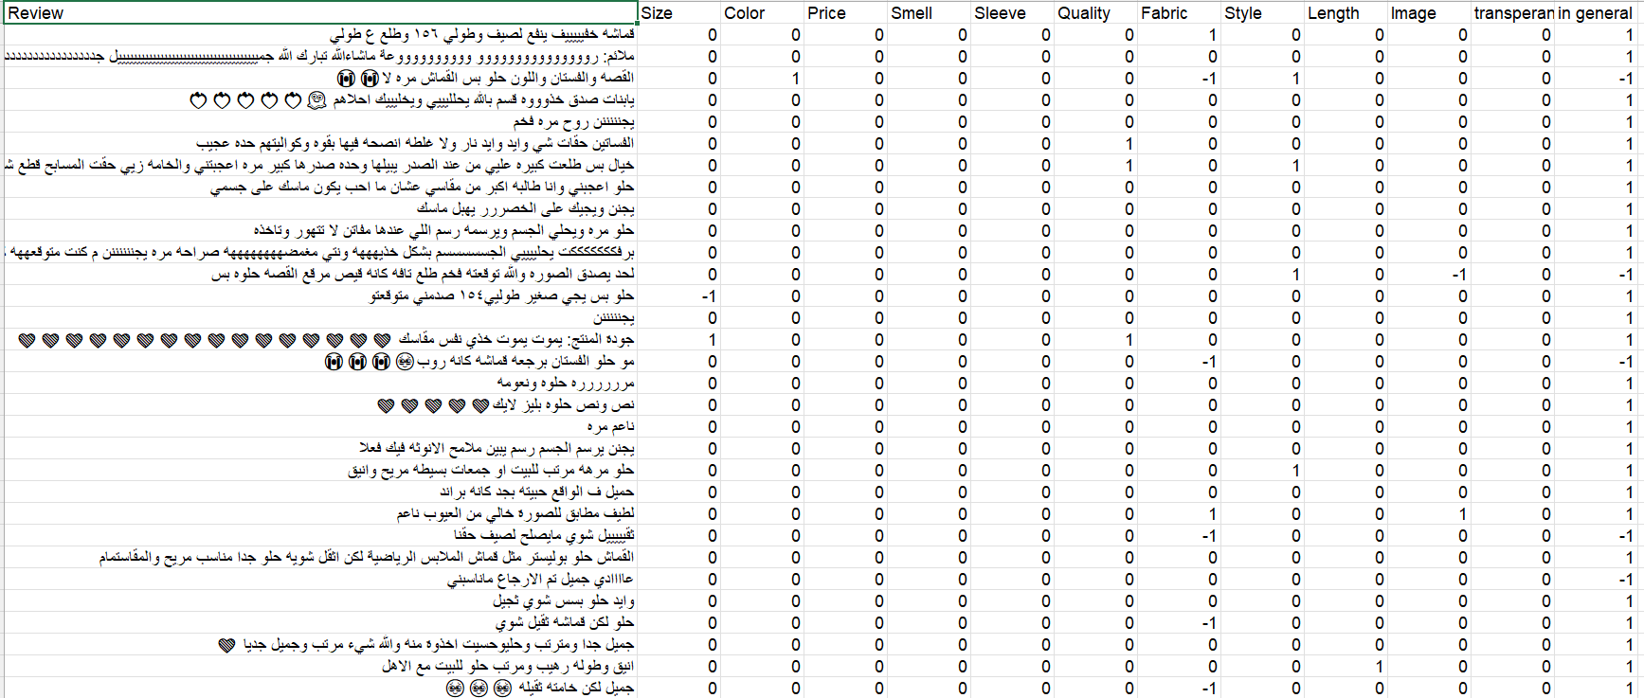
Dataset obtained from the website IEEE Dataport was used to analyze customer reviews of clothing on Saudi Arabian e-commerce sites. The analysis relies on aspect-based sentiment analysis (ABSA) and Saudi Dialect, hence its suitability for the project, the Data set included 2142 reviews written in the Saudi dialect, consists of text feature (Reviews) and 12 target labels size , Color , Price , Smell, Sleeve, Quality , Fabric , Style, Length , image ,transparency and in general Each label is structured as a three class , representing sentiment positive 1, negative -1, Neutral 0).

Figure 1 A simple from clothes DataSet

3.2 Dataset Refinement
After reviewing the original dataset, it was optimized by reducing and merging certain features to improve the model’s training efficiency, including addressing the issue of data sparsity. It was observed that the features in the original dataset were imbalanced, with the “neutral” class dominating most of the data, causing the models to consistently predict the “neutral” class rather than the other classes. To reduce noise, detailed features were combined and converted into summary features. For example, transparency was combined with fabric, and sleeve and length were combined with size. This step ensures data is condensed into a single dimension so the model can be trained on dense samples of categories, and it reduces overlap and ambiguity, as detailed dimensions can confuse the model. For example, during testing, the model predicts the length of a dress classified as -1 on the length dimension, and another review classifies the size as -1. Therefore, reducing the dimensions helps eliminate interference and increase the model’s accuracy. A strong correlation was also observed between the (in general) aspect and the other aspect of (Style) and (Quality). Due to the high frequency of (in general) samples in the dataset, the model began prioritizing this aspect over the other (style) aspect, causing it to become overfit. For example, when classifying a review"الشكل مره عجبني و القماش" روعه ” instead of classifying it as a positive (style), it is classified as (in general). This step prevented the model from favoring the most common aspect and raised the scale score for the less frequently classified aspects. A discrepancy was observed in the distribution of review ratings, with the (Smell) and (Price) categories receiving the lowest ratings. Data for each of these categories was scaled to balance the results and ensure the model remained unbiased. Figure 2 illustrates the distribution of sentiments across aspects after merging and optimization, and clearly shows the concentration of positive and negative data compared to the original dataset in Figure 1.

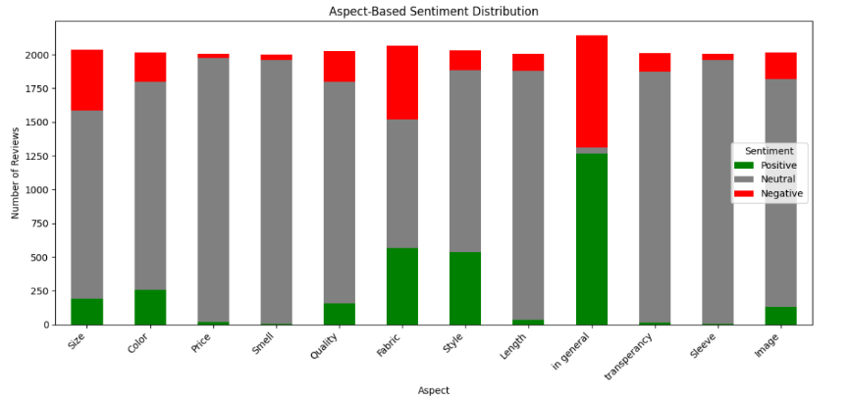

Figure 2:Distribution of sentiment in the original dataset

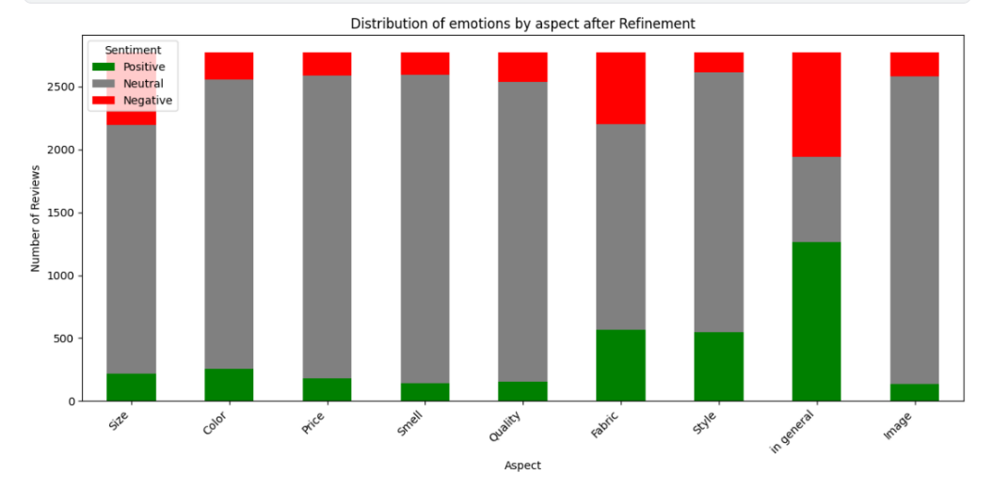

Figure 3:Distributing sentiment across eight aspects after merging and enhancement

3.3 Data preprocessing
The data processing stage is a crucial phase for ensuring the accuracy and quality of the model. Cleaning and formatting processes are applied to reduce noise before passing the data to the model, including:
- Handling missing values: after examining the data and detecting the missing values, they were processed. The cleaning process was also applied to Empty Strings/Whitespace, which do not contain meaningful review but contain spaces. They were dealt with using a regular expression to convert the spaces into missing values ​​and then processed.
- Data cleaning: Delete URLs, emojis, hashtags, special characters, and punctuation that do not convey emotional meaning.
- Arabic text normalization: To simplify the Arabic language and ensure its consistency, several processes must be applied, namely:
- letter normalization : standardizing various forms of specific characters to single uniform shape , this including converting Alif (أإاّ) to (ا) and replacing (ة) to (ه) also (ى) to (ي).
- Removal of diacritics (tashkeel): eliminating Arabic vowels such as ًٌَُِ This step is necessary for matching because the model considers it different due to the diacritics.
- Removal of Tatweel such as (جميــل) to (جميل ) .
- Removal whitespace normalization: all redundant whitespaces including tabs and multiple consecutive spaces and leading and trailing spaces were removed using strip() function.
- Removal of repeated letters in the word such as (مرررررره ) to (مره ).
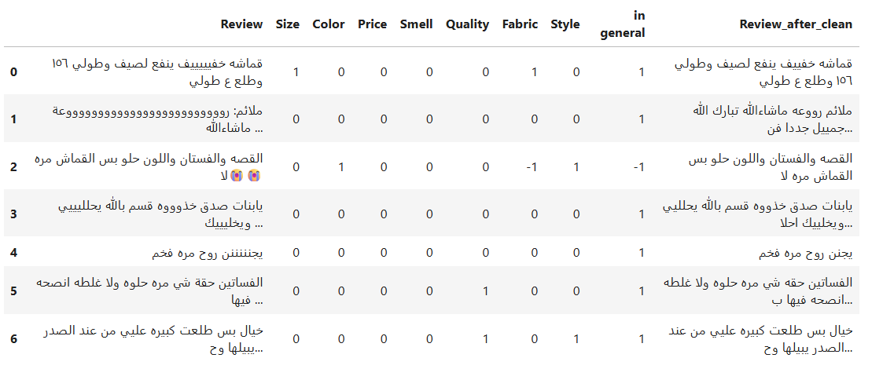
Figure 4:A sample from Dataset after preprocessing

- Label Encoding: This includes the fact that the targets to represent emotions are 1 for positive, -1 for negative, and 0 for neutral. Label encoding was performed to convert the values ​​to 0 for negative, 1 for neutral, and 2 for positive in order to avoid programming errors during training.
- Data Splitting: To address the issue of overfitting, the dataset was divided into three independent sets, with 70% of the data allocated to the training set, while the remaining 30% was distributed equally between the test set 15% and the validation set 15%. This was done to ensure sufficient data for training and accurate evaluation. Subsequently, data augmentation was performed on the training set, while the test and validation sets were kept in their original form to avoid data leakage and overfitting, and to verify the model’s ability to generalize and make predictions on unseen samples.

Table 2 split data set
Set | Ratio | Reviews Count | Status
Training set | 70% | 3877 | Augmented
Validation set | 15% | 416 | Original
Testing set | 15% | 416 | Original

- Input Representation and Tokenization:
At this stage, the model’s tokenizer was used to convert the raw text into a digital format that the model could process. The model relied on Sud-words, which handled compound words. A token length of 128 was set for all inputs. Padding was added to sentences shorter than this length using zeros, and Truncation was applied to sentences exceeding this length. An attention mask is also generated from these operations; the benefit of this is that it directs the model to focus on the actual tokens and ignore the padding.
3.4 Training setup:
To ensure training efficiency, the PyTorch framework was used. A custom data class named ABSADataset was created to map the text to an 8-dimensional classification matrix. The Dataloader tool was also used to organize the data into batches of 16 samples each, which helps simplify its processing on the graphics processing unit GPU, and the hyperparameter settings were carefully tuned to guide and optimize the model training process.
Table 3: Preparing a hyperparameter
Hyperparameter | value | Purpose
Model | SaudiBert | model pre-trained on the Saudi dialect
Learning Rate | 5×10⁻⁶ | Weights should be stabilized before and during the training
Epochs | 8 | To prevent overfitting
Max length | 128 | To ensure that all revisions are covered and that no important words are omitted
Warmup steps | 30% | To protect the model from fluctuations

3.5 Performance Evaluation Metrics:
At this stage, the model SaudiBERT ability to accurately classify emotions for each of the eight aspects is evaluated, using standardized measures that provide a clear indication of the model's performance:
- Accuracy: To measure the overall percentage of correct predictions made by the model.
- Precision: To measure the model's reliability in predicting a specific category and to ensure there aren't too many incorrect classifications.
- Recall: To measure the model's ability to detect all actual cases belonging to a specific category and to ensure that no important review is missed.
- F1-Score: This is the most important metric because it represents the harmonious average between (precision) and (recall). It was used to confirm the strong performance of the model even in the event of an imbalance between the number of positive, negative, and neutral reviews

Chapter 4 Experimental Results and Discussion

This chapter reviews the results obtained after training and evaluating the model, focusing on its ability to classify emotions across several aspects of the Saudi dialect.
4.1 Experimental Setup:
The experiment was carried out on the Kaggle platform, relying on a GPU to accelerate the training of the model SaudiBERT . Python was used as the main development environment, relying on the Pytorch library to build the model structure and the Hugging Face Transformers library to call the pre-trained weights and the model's tokenizer.
4.2 Feature Relationship Analysis:
To understand the relationship between the different dimensions of the dataset, a correlation matrix was created. Figure 4 illustrates the correlation between variables after the improvements were made, showing that most dimensions exhibit weak to moderate correlations, indicating that each dimension contributes relatively independent information, making them suitable for dimension-based sentiment analysis. Figure 5 shows the relationship between dimensions before the improvements were made, revealing a strong correlation between in general and Fiber, with a correlation of 0.24, suggesting a potential bias in the model toward in general.

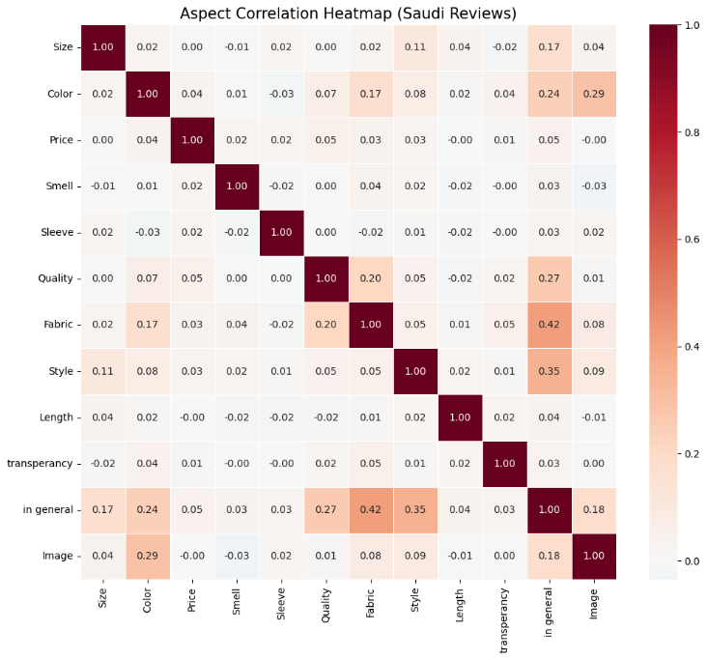

Figure 5Correlation between Aspects Before balance

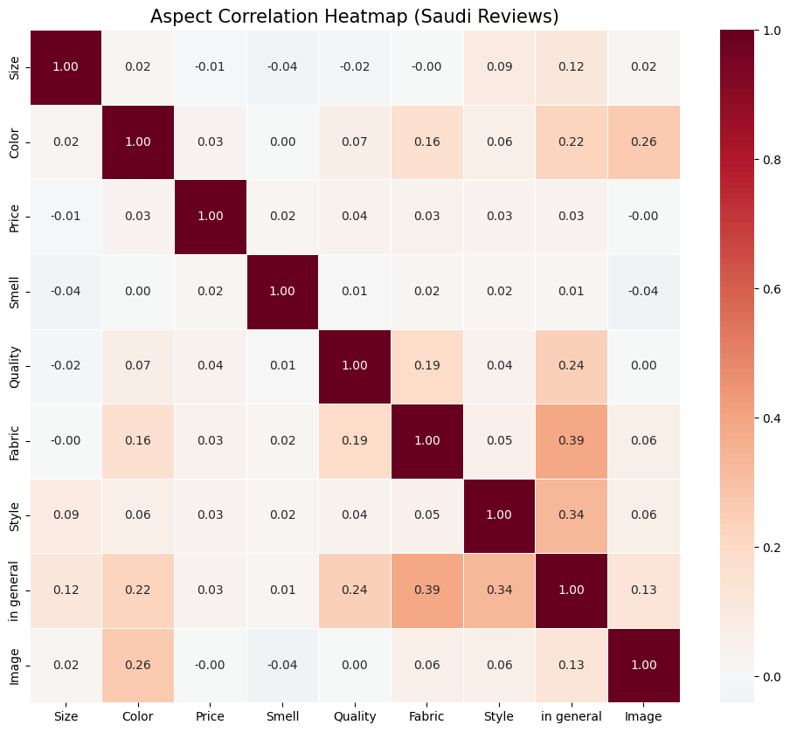

Figure 6 Correlation between Aspects after balance

4.3 Overall Model Performance Evaluation:
To evaluate the performance of the SaudiBERT model at aspect-based sentiment analysis ABSA two visual metrics were used: the curve loss, which illustrates the loss for the model trained over 9 epochs for both training loss and validation loss, as well as a confusion matrix, which provides detailed analysis of the final classification results for positive, negative, and neutral classes and error analysis.

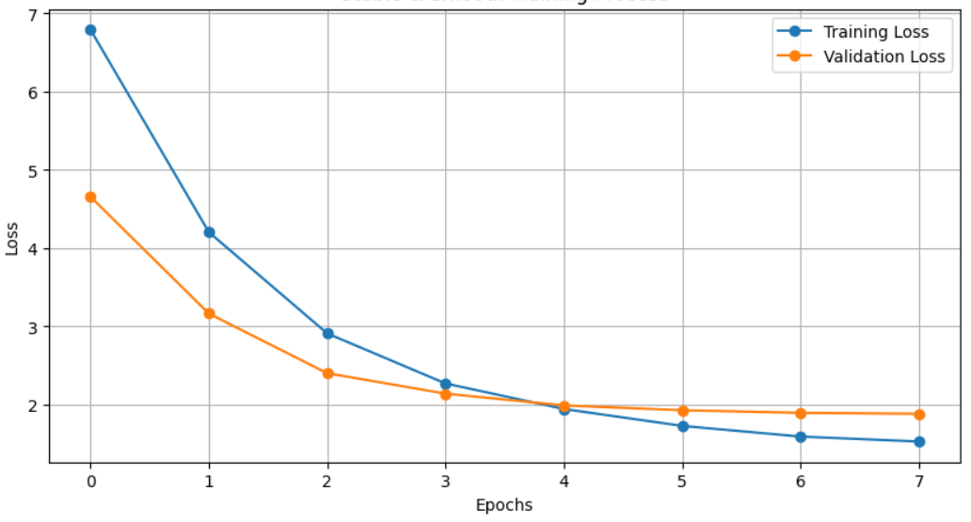

Figure 7 Training and validation loss curve

In figure, it can be observed that the loss curve shows a continuous downward trend, reflecting a gradual decrease in the models loss as it learns from the data and progressively improves its predictions as Training progresses, figure 4 also shows that the validation curve began to converge with the training curve by the 8 epochs, which means that the model has reached a sufficient stage of learning and has avoided overfitting during training.
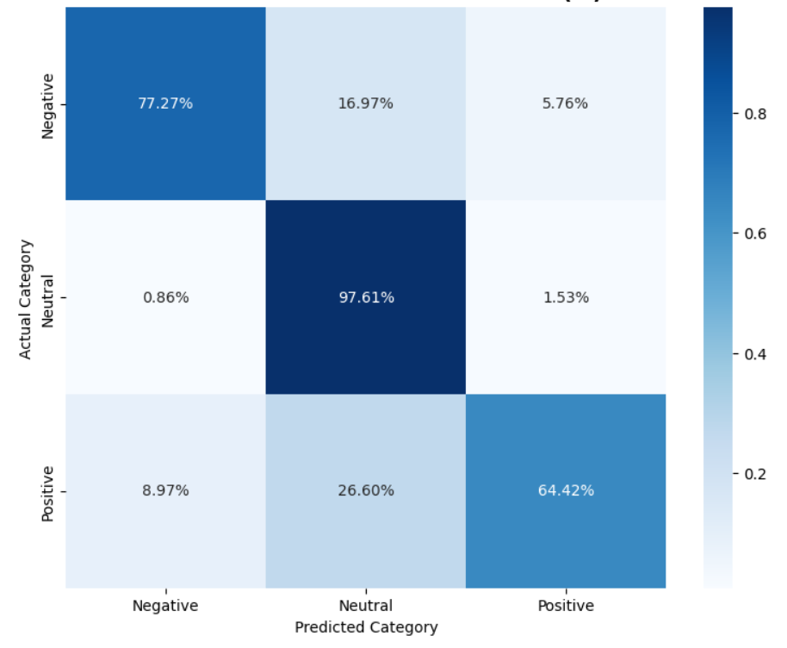

Figure 8: Overall Confusion Matrix of SaudiBert
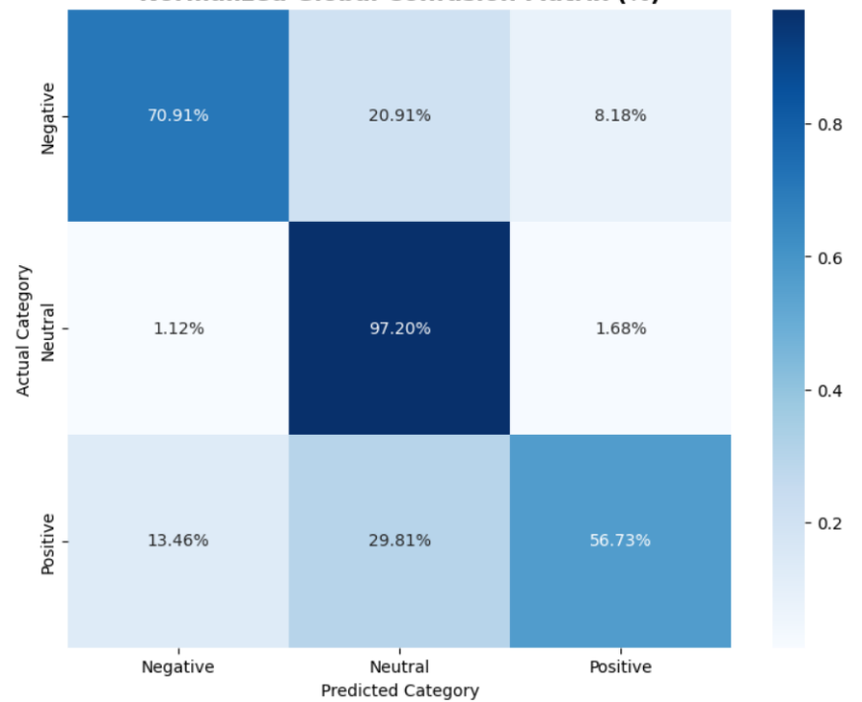

Figure 9 Overall Confusion Matrix of CAMeLBERT-DA

The SaudiBERT confusion matrix shown in Figure 8 illustrates the model’s final performance in classifying sentiments into three categories (positive, negative, and neutral). Data analysis shows that the model achieved the highest classification accuracy for the neutral category, with 2,614 correct predictions, while the positive category was correctly classified in 201 cases, and the negative category was correctly classified in 255 cases. In contrast, the confusion matrix for CAMeLBERT-DA in Figure 9 showed a slight difference, with the neutral category achieving 2,603 correct predictions, the negative category reaching 234 predictions, and the positive category reaching 177.
4.4Comparative Performance Analysis SaudiBERT vs. CAMeLBERT-DA:
A benchmark comparison was conducted between the SaudiBERT model trained on Saudi dialect data and the CAMeLBERT model trained on a wide and diverse range of Arabic dialects, such as Gulf, Egyptian, and Levantine dialects. The purpose of this comparison is to test the hypothesis of whether allocating a model to a specific dialect provides accuracy in analysis or whether comprehensive models for more than one dialect are capable of delivering similar performance.

- Performance Evaluation per Aspect:
- SaudiBERT Performance:
The evaluation metrics for the individual product aspects, as detailed in the table demonstrate the model's robust capability in classifying diverse sentiment categories. The average accuracy reached 92% with a consolidated F1-score of 79%, Recall 77%, and Precision 85% .
Table 4 : Evaluation of Each Aspect of SaudiBert
Aspect | Accuracy | Precision | F1-Score | Recall
Size | 91% | 82% | 81% | 80%
Color | 94% | 88% | 84% | 80%
Price | 98% | 96% | 94% | 93%
Smell | 98% | 96% | 96% | 96%
Quality | 90% | 74% | 50% | 45%
Fabric | 87% | 82% | 82% | 83%
Style | 80% | 76% | 55% | 52%
Image | 95% | 89% | 86% | 83%

A closer look at the results reveals that objective aspects like (Smell) and (Price) achieved exceptional performance, with F1-score of 96% and 94% respectively, this is primarily due to the Saudi dialect, on the other hand, the (Quality) aspect recorded the lowest F1-score 50% , which can be attributed to its high semantic subjectivity and overlap with other descriptors, despite these challenges, the consistently high precision across most categories confirms that the model effectively minimizes false positives classifications, providing a reliable foundation for automated sentiment analysis .
- CAMeLBERT-DA Performance:
Table 5: Evaluation of Each Aspect of CAMeLBERT-DA
Aspect | Accuracy | Precision | F1-Score | Recall
Size | 89% | 78% | 75% | 73%
Color | 92% | 85% | 78% | 73%
Price | 96% | 89% | 87% | 85%
Smell | 98% | 91% | 90% | 90%
Quality | 91% | 75% | 59% | 52%
Fabric | 85% | 79% | 79% | 79%
Style | 79% | 48% | 48% | 48%
Image | 95% | 89% | 82% | 82%

- Comparison of Overall Average Evaluation:
The results show that the SaudiBERT model outperforms the CamelBERT model. This superiority is attributed to the specialized nature of the SaudiBERT model, as it was trained specifically on texts and data derived from the local Saudi dialect, giving it a superior ability to understand the precise terminology and cultural contexts used in clothing reviews. Despite the comprehensiveness of the CamelBERT model and its training on multiple Arabic dialects (including the Saudi dialect).

Table 6:Comparative Results SaudiBERT vs. CAMeLBERT-DA
Model | Accuracy | Precision | F1-Score | Recall
SaudiBERT | 92% | 85% | 79% | 77%
CAMeLBERT | 91% | 79% | 75% | 73%

4.5 illustrative case study:
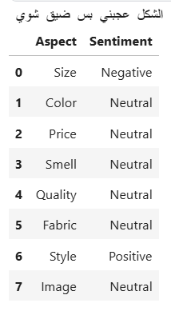
To verify the model’s ability to analyze sentiment by aspect in complex contexts, a qualitative analysis was conducted on a review written in the Saudi dialect, the text contains “الشكل عجبني بس ضيق شوي” , the table shows the model’s outputs for a text containing multifaceted opinions Price, Fabric and Size.

Figure 10 case study

The analysis above demonstrates the model’s effectiveness in distinguishing between sentiments within a single review it has proven its ability to identify praise directed at the Style while simultaneously identifying criticism regarding Size.

4.6 Error Analysis
Although the models achieved high accuracy, the confusion matrix revealed the error rates incurred by the models during prediction. This is due to several reasons, including the overlap between positive and neutral classifications, which stems from the nature of the language; for example "جاء نفس الصورة " might be classified by the model as neutral, or "المقاس جاء تمام" carries a positive meaning here, but the model might classify it as neutral. Another source of error is the ambiguity of terms such as "الخامة واقفة " or "الجودة ماشي حالها " which the model might interpret as praise or criticism, causing confusion.

4.7 Discussion:
At the conclusion of this chapter, the study’s central hypothesis—namely, the ability of specialized language models, specifically the SaudiBERT model, to overcome the linguistic diversity challenges posed by the Saudi dialect—has been confirmed. Achieving an overall accuracy of nearly 90% is not merely a numerical success; rather, it is an indicator of the success of the fine-tuning process in deriving the precise semantic features that distinguish Saudi reviews from other Arabic dialects.
Through analysis of the confusion matrix and qualitative results, it is clear that the model has developed ‘contextual awareness’ that enabled it to distinguish between overlapping sentiments toward different aspects of the product; its ability to identify a negative sentiment toward price and a positive one toward Fabric in a single sentence reflects high proficiency in handling complex ABSA tasks. Although there are some challenges posed by words with double meanings or sarcastic styles, which were observed in some classification errors, the overall results position this model as a reliable and applicable tool in Customer Experience Analytics systems. Thus, this chapter paves the way for the transition to Chapter 5, where the final recommendations and future prospects for developing this technology to include other Arabic dialects or more complex linguistic tasks will be reviewed.

Chapter 5 Conclusion and Future Work

5.1 Conclusion
The study’s results demonstrated the ability of pre-trained language models to analyze customer sentiment based on their comments, with the SaudiBERT model—which was specifically trained on the Saudi dialect—achieving 92% accuracy, outperforming the CamelBERT model, which was trained on multiple dialects and languages and achieved 91% accuracy. The study culminates in the development of a fine-tuned sentiment analysis model, specifically designed to enable e-commerce companies to understand their customers’ needs, allowing them to develop their products and improve the customer experience.
5.2 Future work
Based on the results obtained several future research directions can be identified for the development and improvement of sentiment analysis systems based on aspects of the Saudi dialect, namely:
- Inclusion of local dialects: we propose that future studies expand the scope of data collection to include reviews representing all regional dialects in Saudi Arabic such as Najdi, Hijazi and others in order to train a model capable of capturing region-specific vocabulary thereby ensuring higher classification accuracy.
- Expanding the Dataset: we propose building a larger and more divers dataset to significantly improve the model’s ability to generalize results and reduce errors in rare categories.
- Developing an API: to enable companies to view and utilize the analyses to improve quality.
- Sentiment analysis using Emojis: in future studies we propose incorporating emojis as key semantic variables in ABSA rather than simply removing them from the text.

References
- Alrefae, R., Alqahmi, R., Alduraibi, M., Almatrafi, S., & Alayed, A. (2024). Enhancing Customer Experience Through Arabic Aspect-Based Sentiment Analysis of Saudi Reviews. International Journal of Advanced Computer Science & Applications, 15(7).‏
- Alotaibi, S., Mehmood, R., & Katib, I. (2019, June). Sentiment analysis of Arabic tweets in smart cities: A review of Saudi dialect. In 2019 Fourth International Conference on Fog and Mobile Edge Computing (FMEC) (pp. 330-335). IEEE.‏
- Abo, M. E. M., Qazi, A., Saad, A. A. A., Elsahib, H. A., & Abdelaziz, A. (2024, August). Sentiment Analysis in Saudi Arabic Dialect for HAJJ Season Services Using Twitter Data. In 2024 1st International Conference on Logistics (ICL) (pp. 1-5). IEEE.‏
- Alahmary, R. M., Al-Dossari, H. Z., & Emam, A. Z. (2019, January). Sentiment analysis of Saudi dialect using deep learning techniques. In 2019 International conference on electronics, information, and communication (ICEIC) (pp. 1-6). IEEE.‏
- Kaseb, A., & Farouk, M. (2022, December). SAIDS: A novel approach for sentiment analysis informed of dialect and sarcasm. In Proceedings of the Seventh Arabic Natural Language Processing Workshop (WANLP) (pp. 22-30).‏
- Dahbi, M., Saadane, R., & Mbarki, S. (2019, October). Social media sentiment monitoring in smart cities: an application to Moroccan dialects. In Proceedings of the 4th International Conference on Smart City Applications (pp. 1-6).‏
- AlFutamani, A. A., & Al-Baity, H. H. (2021). Emotional Analysis of Arabic Saudi Dialect Tweets Using a Supervised Learning Approach. Intelligent Automation & Soft Computing, 29(1).‏
- Alomari, K. M., ElSherif, H. M., & Shaalan, K. (2017, June). Arabic tweets sentimental analysis using machine learning. In International conference on industrial, engineering and other applications of applied intelligent systems (pp. 602-610). Cham: Springer International Publishing.‏
- Louati, A., Louati, H., Kariri, E., Alaskar, F., & Alotaibi, A. (2023). Sentiment analysis of Arabic course reviews of a Saudi university using support vector machine. Applied Sciences, 13(23), 12539.‏
- Musleh, D. A., Alkhwaja, I., Alkhwaja, A., Alghamdi, M., Abahussain, H., Alfawaz, F., ... & Abdulqader, M. M. (2023). Arabic sentiment analysis of youtube comments: Nlp-based machine learning approaches for content evaluation. big data and cognitive computing, 7(3), 127.‏
- Sridhar, D., Manikandan, K., Padma Priya, R., Pradeepa, D., Vasumathi, B., & Shankar, R. (2025). Fine- Tuning Pre-trained Models for Aspect-Based Sentiment Analysis of Amazon Food Reviews. 2025 International Conference on Computer, Electrical & Communication Engineering (ICCECE), 1-5.
- Hung, L. P., & Alias, S. (2023). Beyond sentiment analysis: A review of recent trends in text based sentiment analysis and emotion detection. Journal of Advanced Computational Intelligence and Intelligent Informatics, 27(1), 84-95.‏

