3.1 Introduction
This chapter describes the methodology used to design, build, and evaluate an Artificial Intelligence (AI)-based Clinical Decision Support System (CDSS) for multi-class thyroid disorder risk assessment. The framework brings together machine learning and clinical decision support principles so that healthcare professionals can identify thyroid disorders from routinely collected laboratory results. Throughout the design, the aim was to produce an interpretable and reliable screening tool that supports early detection while complementing, rather than replacing, clinical judgement.
Development proceeded through a sequence of stages: dataset acquisition, data preprocessing, feature selection, model development, model evaluation, and prototype implementation. The publicly available UCI ANN Thyroid Disease dataset served as the primary data source because it is a well-established benchmark for thyroid disease classification and contains measurements that clinicians routinely rely on. Although the original dataset records many clinical attributes, only five laboratory parameters were retained for modelling: Thyroid Stimulating Hormone (TSH), Triiodothyronine (T3), Total Thyroxine (TT4), Thyroxine Uptake (T4U), and Free Thyroxine Index (FTI). These five biomarkers were chosen because they are the most clinically informative indicators of thyroid function and are widely available in practice.
A supervised model was then trained using the Extreme Gradient Boosting (XGBoost) algorithm. XGBoost was preferred over the alternatives after preliminary testing because of its strong predictive performance, resistance to overfitting, capacity to capture non-linear relationships, and suitability for structured tabular medical data. The classifier performs multi-class prediction across three thyroid conditions, Hyperthyroidism, Hypothyroidism, and Normal thyroid function, and its performance was assessed using accuracy, precision, recall, F1-score, and confusion matrix analysis.
To make the framework usable in practice, the trained model was embedded in an interactive CDSS built with the Streamlit framework. Through this interface, clinicians and researchers can enter laboratory values, run an automated risk assessment, inspect prediction confidence, review reference ranges, and read clinically interpretable recommendations. A clinical validation layer based on established reference ranges was added alongside the prediction engine to provide supplementary interpretation when real clinical values are entered. This hybrid design improves transparency and helps users relate laboratory findings to the model's output.
Figure 3.1 summarizes the complete methodology. The workflow starts with dataset acquisition and preprocessing, moves through feature selection, model training with XGBoost, and performance evaluation, and ends with integration into the CDSS and the generation of prediction reports and clinical recommendations. Each stage contributes to a decision-support framework that is dependable, interpretable, and clinically relevant.
The remainder of the chapter is organized as follows. Section 3.2 outlines the overall research methodology. Section 3.3 presents the system architecture. Section 3.4 describes the selected dataset, and Section 3.5 explains the preprocessing procedures. Section 3.6 justifies the chosen laboratory features and details the development of the XGBoost classifier, and Section 3.7 covers model evaluation. Section 3.8 describes the CDSS prototype, Section 3.9 walks through the end-to-end system workflow, and Section 3.10 summarizes the chapter.

3.2 Research Methodology
The study followed a quantitative, experimental methodology to build and evaluate an AI-based CDSS for multi-class thyroid disorder risk assessment. Its central aim was a predictive framework able to classify patients into one of three conditions, Hyperthyroidism, Hypothyroidism, or Normal thyroid function, from routinely collected laboratory measurements. Supervised machine learning and clinical validation logic were combined to produce a decision-support tool that is reliable, interpretable, and practical for healthcare use.
The methodology was carried out as a series of connected stages, from dataset acquisition through to the deployment of an interactive prototype, with each stage designed to safeguard data quality, predictive accuracy, model reliability, and clinical relevance. Figure 3.1 presents the overall research methodology.
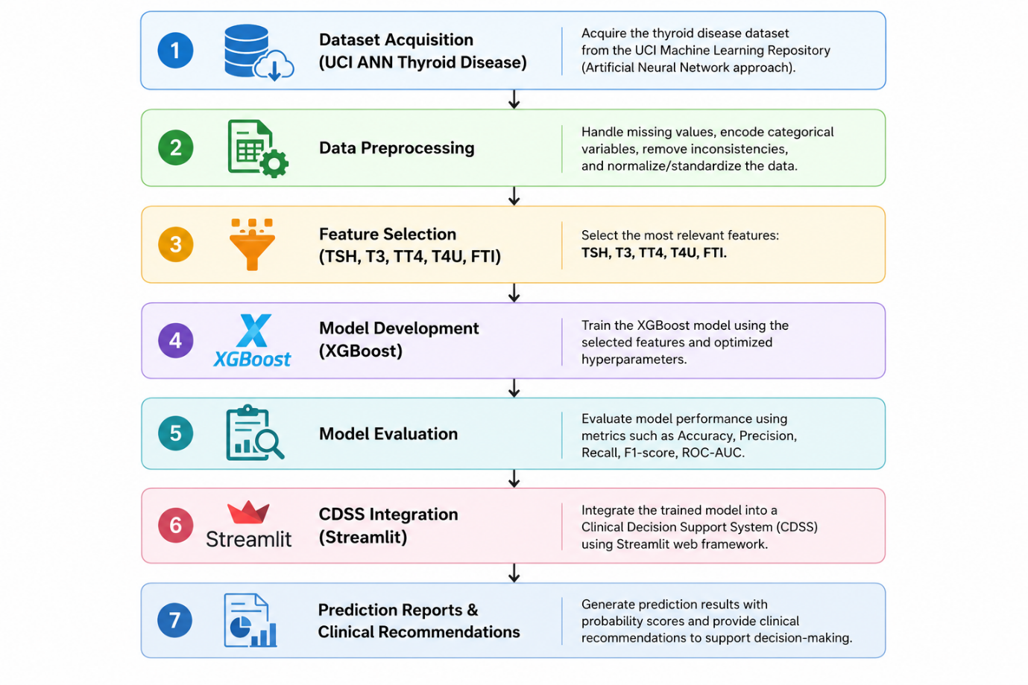
Figure 3.1 Overall Research Methodology

The first stage acquired the UCI ANN Thyroid Disease dataset from the UCI Machine Learning Repository. This dataset is a recognized benchmark for thyroid disease classification and includes measurements used in routine diagnosis. Because the original data contain several demographic and clinical variables, only the laboratory attributes tied directly to thyroid function were retained, which keeps the model simple and eases future clinical implementation.
Preprocessing followed. This stage inspected the dataset structure, identified the laboratory variables of interest, extracted the target class labels, converted the categorical diagnosis labels into numerical classes, and partitioned the data into training and testing subsets. Careful preprocessing gives the algorithm clean, consistent input and limits the influence of irrelevant information.
Feature selection came next. Guided by clinical practice and the endocrinology literature, five laboratory parameters were chosen as predictors: TSH, T3, TT4, T4U, and FTI. These biomarkers are standard in thyroid function assessment and together carry enough physiological information to separate normal function from hypothyroidism and hyperthyroidism. Limiting the model to five clinically meaningful variables also improves interpretability and reduces computational cost.
The predictors were then used to train an XGBoost classifier. XGBoost is an ensemble method built on gradient-boosted decision trees and is known for high accuracy, computational efficiency, and an ability to model complex non-linear relationships in structured data. Using labelled records from the dataset, the algorithm built decision trees in sequence, with each tree correcting the errors of those before it, and combined their outputs to predict the most probable thyroid class.
A separate validation subset guided the learning process and gave an early read on generalization before the final model was assessed on unseen test data. Performance was then measured with accuracy, precision, recall, F1-score, and confusion matrix analysis. Together these metrics capture both overall correctness and the model's ability to distinguish among the three classes.
The trained classifier was integrated into a web-based CDSS developed with Streamlit. The interface lets users enter laboratory values, run an assessment, view prediction confidence, and read interpretable recommendations. It was deliberately styled as a modern healthcare dashboard to improve usability and support future adoption.
The prototype uses a dual prediction architecture that sets it apart from many existing thyroid prediction systems. When normalized values matching the UCI dataset are entered, the prediction comes directly from the trained XGBoost model. When real clinical values are entered, an additional clinical validation layer based on established reference ranges is applied. This arrangement lets both research data and realistic clinical data pass through the same environment while improving the transparency of the results.
Finally, the complete system was tested with both unseen dataset records and clinically representative laboratory values. Each run produced the predicted class, prediction confidence, a probability distribution across all classes, a reference-range comparison, a clinical interpretation, and a recommendation message. These outputs show that machine learning and clinical decision support can be combined to help clinicians assess thyroid disorders.
The result is a framework that is technically sound, clinically interpretable, and suitable for deployment as a decision-support application, linking predictive analytics with practical healthcare decision-making.

3.3 Proposed System Architecture
The proposed CDSS was designed as a modular framework in which machine learning and clinical decision support principles work together to assess thyroid disorders. The architecture is layered: each component performs a defined function and passes its results to the next, producing an accurate and interpretable prediction. This separation of concerns improves maintainability, scalability, and extensibility.
Six components make up the architecture, the Data Input Layer, Input Processing Layer, Prediction Engine, Clinical Validation Layer, Decision Support Layer, and User Interface Layer, which operate in sequence to turn laboratory measurements into clinically meaningful recommendations.
The Data Input Layer is the entry point. Users supply patient demographic details, age and gender, together with the five laboratory measurements: TSH, T3, TT4, T4U, and FTI. These parameters were selected because they are the most clinically relevant biomarkers of thyroid function and are routinely available.
The Input Processing Layer then checks the entered values for completeness and consistency and determines the type of input. Values in the normalised format of the UCI dataset are routed to the machine learning engine, whereas values entered in standard clinical units activate the clinical validation module. This automatic detection lets the prototype handle both research data and realistic clinical scenarios without manual configuration.
The Prediction Engine is the core AI component. It applies the trained XGBoost classifier to the five laboratory variables. During training the algorithm learned the relationships between laboratory measurements and thyroid diagnoses from labelled records; at inference it evaluates the input feature vector, estimates the probability of each class, and returns the class with the highest probability. The class probabilities are also used to derive the confidence score shown to the user.
The Clinical Validation Layer improves interpretability by comparing laboratory values against established thyroid reference ranges. Rather than replacing the model, it adds a second layer of interpretation, flagging abnormal measurements and highlighting clinically significant findings. This lets clinicians weigh the AI prediction against familiar clinical standards.
Outputs from the Prediction Engine and the Clinical Validation Layer pass to the Decision Support Layer, which merges predictions, confidence scores, reference-range comparisons, and validation results into a single assessment. From these it produces an interpretable diagnosis, a confidence estimate, a risk category, and a recommendation message, translating complex model output into information clinicians can act on.
The final component, the User Interface Layer, was built with Streamlit. Through this web dashboard users enter patient information, submit laboratory values, view prediction confidence, review reference ranges, and download an assessment report. The layout keeps the workflow clear while remaining transparent about the model's predictions.
This modular architecture offers several practical benefits. Separating the components makes the software easier to maintain, since modules can be updated independently. It also leaves room for future extensions, such as adding laboratory parameters, swapping in alternative algorithms, or connecting to electronic health record systems. Finally, clearly dividing data processing, prediction, clinical validation, and user interaction makes the whole framework easier to understand, validate, and deploy.
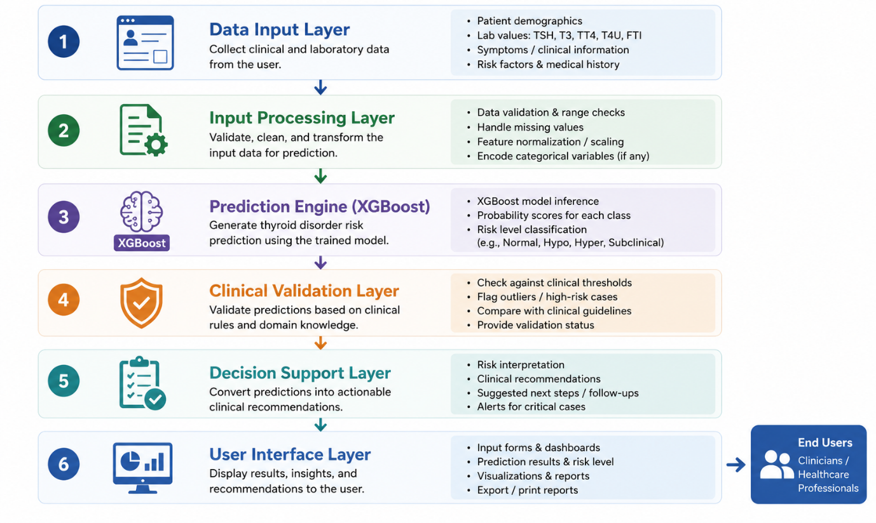
Figure 3.2 Proposed System Architecture

3.4 Dataset Description
A model is only as good as the data it learns from, so choosing a suitable dataset is a decisive step in building an accurate and clinically meaningful classifier. This study used the ANN Thyroid Disease dataset from the UCI Machine Learning Repository as its primary source for development and evaluation. The dataset is well known in the machine learning community and has been used extensively as a benchmark for thyroid disease classification.
The dataset contains patient records drawn from routine thyroid function assessments, each combining demographic information, laboratory measurements, and clinical indicators associated with thyroid disorders. It was originally assembled to support research in artificial intelligence and medical diagnosis, which makes it a natural fit for evaluating machine learning approaches to thyroid classification.
Many of the original attributes are categorical indicators, administrative fields, or variables that add little to thyroid classification. To keep the framework practical and interpretable, this study used only laboratory measurements that are routinely available during thyroid function testing. Restricting the model to clinically significant variables reduces complexity and improves the interpretability and applicability of the system.
Five laboratory parameters were selected as predictive features:
- Thyroid Stimulating Hormone (TSH)
- Triiodothyronine (T3)
- Total Thyroxine (TT4)
- Thyroxine Uptake (T4U)
- Free Thyroxine Index (FTI)
These measurements are the principal biochemical indicators clinicians use to evaluate the thyroid gland, and together they provide enough physiological information to separate normal function from hypothyroidism and hyperthyroidism.
The prediction task was framed as a multi-class classification problem with three mutually exclusive classes:
- Hyperthyroid
- Hypothyroid
- Normal
Each record belongs to exactly one class. For supervised training, these diagnostic labels were encoded as numerical values.
Before training, the data were split into subsets for development and evaluation. The training set was used to learn the relationships between laboratory variables and diagnosis, while an independent test set, held out entirely from training, provided a realistic estimate of how well the model would generalize to new cases.
The dataset was chosen for three reasons. It is publicly available, so the methodology can be reproduced by other researchers. It has been widely used in earlier thyroid prediction studies, which supports comparison with reported results. And it contains measurements that are collected in routine practice, keeping the resulting model relevant to real healthcare settings.
Some limitations should be acknowledged. The records are historical and were collected under specific clinical conditions, so they may not fully reflect current patient populations or laboratory procedures. The laboratory values are also stored in the dataset's own preprocessed representation rather than in standard clinical reporting units, which means the model performs best on data resembling the original dataset. To address this, the prototype includes a clinical validation layer that supports interpretation of real clinical values alongside the model's predictions.
On balance, the UCI ANN Thyroid Disease dataset offers a reliable, well-established foundation for developing and evaluating the proposed CDSS. Its mix of clinically relevant measurements and diagnostic labels supports both a robust multi-class classifier and an objective, standardised performance assessment.
Table 3.1 lists the five selected laboratory features with their clinical purpose, and Table 3.2 defines the three target diagnostic classes.
Table 3.1 Selected Laboratory Features
Feature | Full Name | Clinical Purpose | Unit
TSH | Thyroid Stimulating Hormone | Primary indicator of thyroid function | mIU/L
T3 | Triiodothyronine | Measures active thyroid hormone | ng/mL
TT4 | Total Thyroxine | Measures circulating thyroxine | µg/dL
T4U | Thyroxine Uptake | Estimates thyroid hormone binding | Ratio
FTI | Free Thyroxine Index | Estimates biologically active thyroxine | Index
Table 3.2 Target Classes
Class ID | Diagnosis | Description
1 | Hyperthyroid | Excessive production of thyroid hormones, resulting in increased metabolic activity.
2 | Hypothyroid | Reduced thyroid hormone production, leading to decreased metabolic activity.
3 | Normal | Laboratory measurements indicate normal thyroid gland function.
Note: For training, the class labels were encoded as 0, 1, and 2 to meet the input requirements of the XGBoost classifier. The original labels are restored when predictions are displayed in the CDSS.
Figure 3.3 summarizes how the dataset was prepared, from the raw UCI records through variable selection and label encoding to the final training and testing subsets.
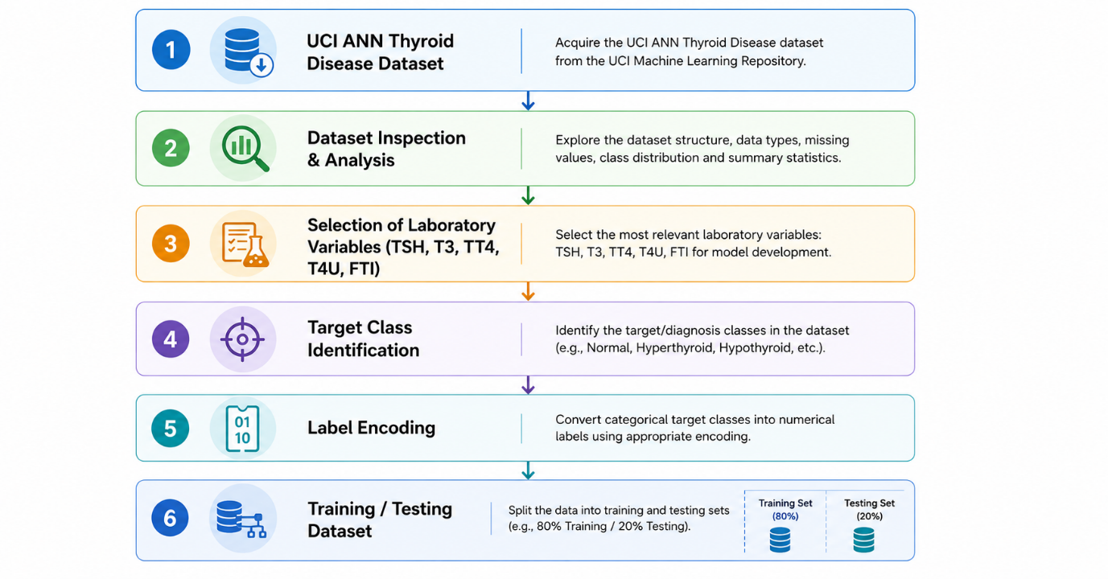
Figure 3.3 Dataset Preparation Overview

3.5 Data Preprocessing
Preprocessing is a foundational stage of any machine learning project, because the quality of the input data directly shapes how well the model performs. Medical datasets often carry redundant attributes, categorical variables, missing values, and inconsistencies that must be resolved before training. A structured preprocessing procedure was therefore applied to prepare the UCI ANN Thyroid Disease dataset for supervised learning.
The goal at this stage was to convert the raw dataset into a clean, consistent format suitable for modelling while preserving the clinical meaning of the selected variables. Figure 3.4 illustrates the preprocessing workflow.

3.5.1 Dataset Inspection
Preprocessing began with a detailed inspection of the dataset. Each attribute was reviewed for its data type, clinical significance, and suitability for the prediction model. The data comprise demographic variables, laboratory measurements, Boolean indicators, referral information, and diagnostic labels.
A preliminary statistical analysis examined the distribution of each variable, checked for inconsistencies, and verified data integrity, confirming that the selected laboratory variables were complete and fit for the analysis that followed.

3.5.2 Feature Extraction
Only laboratory variables tied directly to thyroid function were retained for modelling, with the selection focused on biochemical indicators measured during routine thyroid assessment. The following variables were extracted:
- Thyroid Stimulating Hormone (TSH)
- Triiodothyronine (T3)
- Total Thyroxine (TT4)
- Thyroxine Uptake (T4U)
- Free Thyroxine Index (FTI)
These are the principal biomarkers clinicians use to evaluate thyroid function, and limiting the model to them improves interpretability while lowering computational cost. A compact set of five clinically meaningful variables also brings faster execution, easier clinical interpretation, and greater potential for practical use in healthcare settings.

3.5.3 Target Variable Preparation
Because the task is multi-class classification, the diagnostic labels in the dataset were extracted as the target variable. Three classes were considered:
- Hyperthyroid
- Hypothyroid
- Normal
Machine learning algorithms require numerical rather than textual labels, so each class was encoded before training, as shown below.
Original Class | Encoded Label
Hyperthyroid | 0
Hypothyroid | 1
Normal | 2
This encoding was applied for training only. Within the CDSS, numerical predictions are converted back to their clinical labels before being shown to the user.

3.5.4 Data Partitioning
To assess how well the model generalizes, the data were split into independent training and testing subsets. The training subset let the XGBoost algorithm learn the relationships between laboratory measurements and diagnoses, while the testing subset stayed untouched during training and was used only to evaluate performance on unseen records. Keeping the test data separate limits optimistic performance estimates and gives a realistic picture of the model's behavior on new patients.

3.5.5 Data Representation
The laboratory values in the dataset follow the original formatting of the UCI ANN Thyroid Disease repository, so they differ from the numbers reported by clinical laboratory systems. TSH values, for example, appear as normalized figures rather than conventional clinical units, and the model therefore learns relationships based on this representation.
To improve practical use, a clinical validation layer was added to the CDSS. When users enter values in conventional clinical units, the system performs reference-range validation and offers interpretable guidance alongside the model's prediction. This dual-processing strategy makes the prototype more usable while preserving the integrity of the trained model.

3.5.6 Preprocessed Dataset
After preprocessing, the final dataset consisted of five laboratory predictors and one target variable representing the thyroid diagnosis class. This dataset served as the input to the XGBoost classifier during model development. The workflow ensured that the data supplied to the algorithm were consistent, clinically relevant, and correctly formatted for multi-class classification. Table 3.3 shows the structure of the final dataset.
Table 3.3 Final Dataset Structure
Variable | Type | Purpose
TSH | Numerical | Predictor
T3 | Numerical | Predictor
TT4 | Numerical | Predictor
T4U | Numerical | Predictor
FTI | Numerical | Predictor
Diagnosis | Categorical (Encoded) | Target Variable
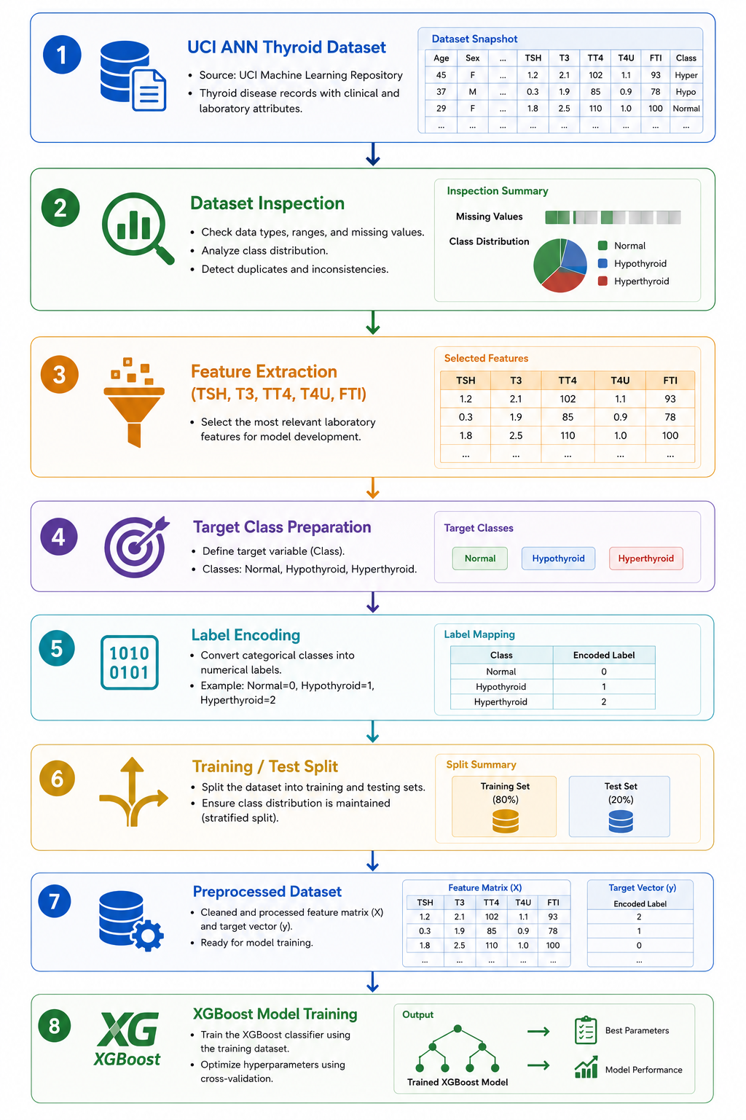
Figure 3.4 Data Preprocessing Workflow

3.6 Machine Learning Model Development
The core intelligence of the CDSS is a supervised model that performs multi-class classification of thyroid disorders. Once preprocessing was complete, the prepared dataset was used to train a model that learns the relationship between laboratory measurements and diagnostic category. The objective was a classifier able to assign patients accurately to one of three conditions: Hyperthyroidism, Hypothyroidism, or Normal thyroid function.
Thyroid classification has previously been tackled with Decision Trees, Support Vector Machines (SVM), Artificial Neural Networks (ANN), Random Forests, and gradient boosting methods. Each has strengths, and the right choice balances predictive performance, robustness, efficiency, and suitability for structured medical data. After comparing several approaches early in the research, XGBoost was chosen as the primary classifier.

3.6.1 Selection of the XGBoost Algorithm
XGBoost is an advanced implementation of gradient boosting that improves accuracy while remaining computationally efficient. Where a single decision tree makes predictions from one hierarchical structure, XGBoost builds an ensemble of trees, each trained to reduce the errors of those before it, so that overall performance improves gradually.
Several technical and practical considerations motivated this choice. First, XGBoost performs strongly on structured tabular data like the UCI ANN Thyroid Disease dataset; since thyroid measurements are numerical rather than images or text, tree-based ensembles tend to suit them better than deep learning architectures. Second, its built-in regularization reduces overfitting, which matters for medical data where complex variable interactions can otherwise harm generalization. Third, its boosting mechanism captures the non-linear interactions among biomarkers that simple linear models miss. Finally, XGBoost returns class probabilities as well as predicted labels, and these probabilities feed the confidence scores presented in the CDSS, letting users see not only the predicted diagnosis but also the certainty behind it.

3.6.2 Model Training Process
Training followed the supervised learning paradigm. Each record supplied the five laboratory measurements as input features together with the corresponding diagnostic label:
- Thyroid Stimulating Hormone (TSH)
- Triiodothyronine (T3)
- Total Thyroxine (TT4)
- Thyroxine Uptake (T4U)
- Free Thyroxine Index (FTI)
Using these labelled examples, the algorithm learned patterns linking measurements to diagnoses. Unlike conventional programming, the model was never told explicitly how to diagnose a disorder; instead it derived decision boundaries directly from historical data by minimizing classification error. At each boosting iteration a new tree was added to correct the residual errors of the existing ensemble, and this continued until the training criteria were met. The final model represents the combined knowledge of many trees, giving more accurate and stable predictions than any single tree could.

3.6.3 Hyperparameter Configuration
The performance of XGBoost depends on several hyperparameters that govern tree complexity, learning speed, and the trade-off between bias and variance. The final configuration was chosen experimentally to balance predictive performance against generalization. Table 3.4 lists the main hyperparameters used during development.
Table 3.4 XGBoost Hyperparameter Configuration
Parameter | Description | Value
Algorithm | Classification model | XGBoost
Objective function | Multi-class classification | multi:softprob
Number of classes | Output classes | 3
Number of trees (n_estimators) | Total boosting iterations | 100 [confirm final value]
Maximum tree depth (max_depth) | Maximum depth of each tree | 6 [confirm final value]
Learning rate (learning rate) | Step size during boosting | 0.1 [confirm final value]
Evaluation metric | Performance measure | Multi-class log loss
Note: Values marked [confirm final value] should be replaced with the exact hyperparameters from the final notebook if they differ.

3.6.4 Prediction Mechanism
After training, the model was integrated into the CDSS for real-time inference. When laboratory values are entered through the interface, the system builds a feature vector from the five variables and passes it to the trained model. Prediction proceeds in four steps:
- Feature vector construction: the entered measurements are converted into a numerical feature vector compatible with the model.
- Model inference: the ensemble evaluates the vector, with each tree assessing the input using the patterns learned during training.
- Probability estimation: the trees' outputs are combined to estimate the probability of each class, and the highest-probability class is chosen as the prediction.
- Clinical interpretation: the predicted class, confidence score, and probability distribution pass to the Decision Support Layer, which turns them into an interpretable assessment report.
This mechanism delivers rapid, consistent assessments while keeping the confidence behind each prediction visible.

3.6.5 Integration into the Clinical Decision Support System
The trained model was serialized and integrated into the Streamlit prototype using the Joblib library. It loads into memory once at startup, so predictions run without retraining. The prediction engine operates independently of the interface: the interface gathers patient information and laboratory values, while the engine performs the classification. This separation improves maintainability and lets the model be retrained or replaced without touching the front end. The engine also works with the clinical validation module, which interprets measurements against established reference ranges, so that prediction and clinical validation together provide a more informative assessment than either alone. Figure 3.5 outlines the model development process.
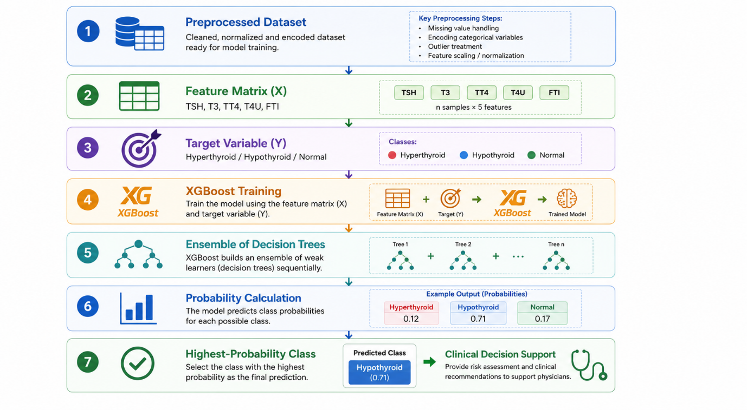
Figure 3.5 XGBoost Model Development Process

3.7 Model Evaluation
Evaluating the model before integrating it into the CDSS is essential for judging its effectiveness and reliability. Because the goal is a classifier that identifies thyroid disorders accurately, a thorough evaluation was carried out on unseen records. Testing on independent data gives an objective measure of generalization and reduces the risk of overstating performance.
After training, the XGBoost classifier was evaluated on the held-out testing set, which had played no part in development. This ensures that the reported figures reflect the model's ability to classify new records rather than to memories training patterns, and it makes the test set an unbiased benchmark for practical applicability.
Because thyroid prediction is a multi-class problem, no single metric is sufficient. Different metrics reveal different strengths and weaknesses, so five complementary measures were used: accuracy, precision, recall, F1-score, and confusion matrix analysis. These metrics and their purpose are summarised in Table 3.5, and the overall evaluation workflow is shown in Figure 3.6.

3.7.1 Classification Accuracy
Classification accuracy is the proportion of records classified correctly out of all records evaluated. It gives an overall sense of performance and is among the most commonly reported metrics in supervised learning. It is defined as:
Accuracy = Number of Correct Predictions / Total Number of Predictions
High accuracy indicates that the classifier assigns the correct category to most records. On its own, however, accuracy can be misleading when classes are imbalanced, so additional metrics were also considered.

3.7.2 Precision
Precision measures the reliability of the classifier's positive predictions, that is, the share of records predicted to belong to a class that truly belong to it. It is defined as:
Precision = TP / (TP + FP)
where TP denotes true positives and FP denotes false positives. High precision means few false positives, which increases confidence in the diagnoses the model produces.

3.7.3 Recall
Recall, also called sensitivity or the true positive rate, measures how well the model identifies records that genuinely belong to a class. It is calculated as:
Recall = TP / (TP + FN)
where TP denotes true positives and FN denotes false negatives. Recall matters greatly in medicine, because missing a real case can have serious consequences; maximizing recall helps reduce missed thyroid disorders.

3.7.4 F1-Score
The F1-score combines precision and recall into a single value and is useful across multiple classes because it reflects both the correctness and the completeness of predictions. It is the harmonic mean of the two:
F1 = 2 x (Precision x Recall) / (Precision + Recall)
Unlike accuracy, the F1-score accounts for both false positives and false negatives, giving a fuller picture of classification performance.

3.7.5 Confusion Matrix
Confusion matrix analysis offers a detailed view of the classifier's behavior by tabulating correct and incorrect predictions for each class against the true labels. For a three-class problem, the matrix shows how often records from each class were classified correctly or assigned to another class, which helps identify classes that are harder to separate. It also supports interpretation of the different error types, a valuable perspective in healthcare, where the clinical implications of misclassification vary from case to case.

3.7.6 Classification Report
A classification report was also generated. It reports precision, recall, F1-score, and support for each class, giving a per-class view that overall accuracy cannot. This makes it possible to compare predictive capability across Hyperthyroidism, Hypothyroidism, and Normal thyroid function and to build a more complete understanding of the classifier's strengths and limitations.

3.7.7 Integration of Evaluation Results
The metrics obtained here confirmed that the XGBoost model reached satisfactory performance before it was integrated into the CDSS. Only after it performed acceptably on the independent test set was the model exported and embedded in the Streamlit prototype. Within the application, the model returns not only the predicted class but also the probability of each category; these probabilities drive the confidence score shown in the interface. Evaluation therefore serves two purposes: validating the model and enhancing the interpretability of the decision-support system.
Table 3.5 Performance Evaluation Metrics
Metric | Purpose | Importance
Accuracy | Measures overall classification performance | Provides an overall indication of prediction correctness
Precision | Measures correctness of positive predictions | Reduces false positive diagnoses
Recall | Measures ability to detect actual disease cases | Reduces missed thyroid disorder cases
F1-score | Balances precision and recall | Provides a comprehensive measure of performance
Confusion Matrix | Visualizes classification outcomes | Identifies patterns of correct and incorrect predictions
Classification Report | Summarizes metrics for each class | Enables detailed evaluation of individual classes
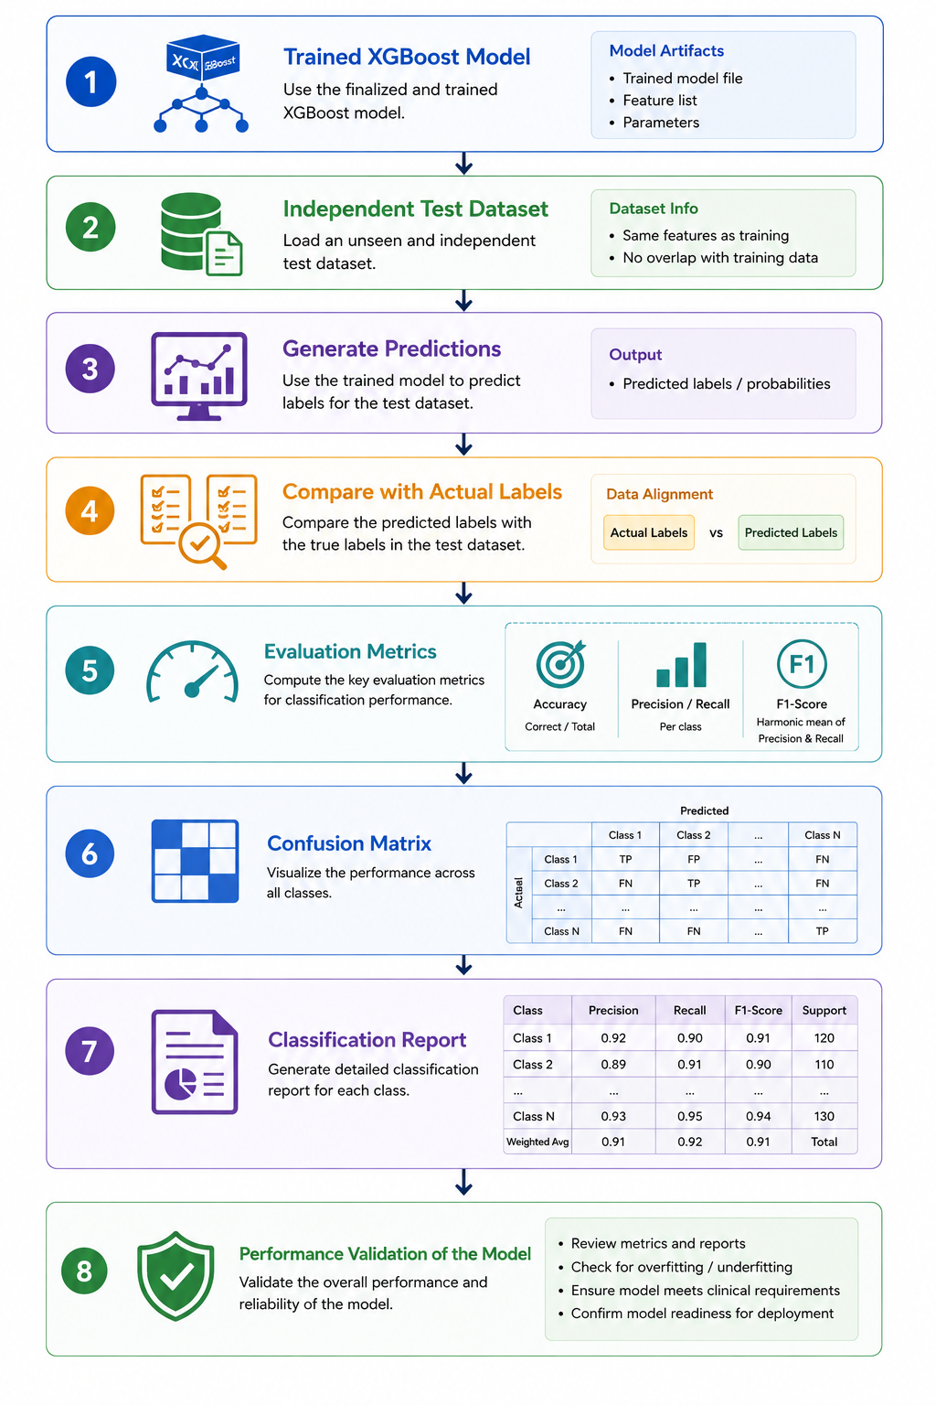
Figure 3.6 Model Evaluation Workflow

3.8 Clinical Decision Support System Development
The final stage integrated the trained model into an interactive CDSS. While the XGBoost classifier generates the predictions, clinicians need an interface that presents them clearly and in clinically meaningful terms. A web-based prototype was therefore built to connect the model's output to clinical decision-making.
The CDSS was implemented with Streamlit, an open-source Python library for building interactive data science and machine learning applications. Streamlit was chosen because it integrates trained models with intuitive interfaces while keeping deployment simple, and because it supports real-time interaction, which suits a proof-of-concept healthcare tool. Rather than requiring users to run Python scripts, the prototype offers a dashboard where laboratory values are entered directly; once submitted, the system runs the assessment and returns a structured clinical report. This makes the tool accessible to non-technical users and demonstrates the framework's practical value. A modular design separates the interface from the prediction engine, so the model can be updated without altering the front end, which improves maintainability and eases future enhancements.

3.8.1 User Interface Design
The interface was designed to resemble a modern clinical dashboard, favoring clarity and ease of use, and is organized into sections that guide the user through the assessment. The first section captures demographic information, patient identifier, age, and gender. These variables are not used as predictive features in the current implementation, but they provide context for the report and add realism to the prototype. The second section collects the five laboratory measurements needed for prediction:
- Thyroid Stimulating Hormone (TSH)
- Triiodothyronine (T3)
- Total Thyroxine (TT4)
- Thyroxine Uptake (T4U)
- Free Thyroxine Index (FTI)
Each value is entered through a numerical field that minimizes data-entry errors. Before prediction, the interface previews the detected input type, automatically distinguishing normalized UCI values from conventional clinical units so that users need not select a mode manually.

3.8.2 Prediction Engine Integration
The prediction engine is the AI component of the CDSS. The trained model was exported with Joblib and loaded at application startup. When an assessment begins, the entered values are converted into a feature vector and passed to the engine, which estimates the probability of each class. The highest-probability class becomes the prediction and is returned with the full probability distribution, and the maximum probability is shown as the confidence score. Keeping prediction logic separate from the interface preserves a modular architecture that supports retraining or replacement of the model without front-end changes.

3.8.3 Clinical Validation Layer
A distinguishing feature of the framework is its clinical validation layer. The model was trained on normalized UCI values, yet clinicians read results against standard reference ranges. To bridge this gap, a rule-based validation module compares each measurement with established thyroid reference ranges and flags whether it falls inside or outside the expected limits. It does not replace the model's prediction but adds clinical context that helps users interpret the result. Combining statistical prediction with familiar laboratory interpretation improves transparency and strengthens user confidence.

3.8.4 Assessment Report Generation
After prediction, the system generates a structured report that draws on both the model and the validation module to give a complete overview of the assessment. The report includes:
- Patient information
- Laboratory measurements
- Detected input type
- Prediction engine used
- Predicted thyroid class
- Prediction confidence score
- Probability distribution for all classes
- Laboratory reference-range comparison
- Clinical interpretation
- Recommendation message
This turns numerical model output into clinically understandable information that supports thyroid assessment.

3.8.5 Explainability and User Interpretation
Interpretability is essential for AI in healthcare, since clinicians are reluctant to trust predictions they cannot examine. The CDSS therefore includes several mechanisms to make the process transparent. Alongside the predicted class, it shows the model's confidence score, the probability of each category, and a comparison of laboratory values against reference ranges, so users can see both the prediction and the certainty behind it. A brief textual explanation describes the findings that shaped the assessment, followed by a recommendation intended to support decision-making. These additions improve usability while keeping the system firmly in a supporting role rather than acting as an autonomous diagnostic tool.

3.8.6 Prototype Workflow
The workflow begins when the user enters patient information and laboratory measurements. The system validates the values and decides whether they represent normalised research data or conventional clinical values. The validated inputs then pass to the prediction engine, which returns a prediction and probability distribution, while the clinical validation module simultaneously checks the measurements against reference ranges. The Decision Support Layer finally combines both sets of outputs into a unified report shown in the interface, allowing users to obtain an interpretable assessment within seconds.
Table 3.6 summarises the main components of the system and their functions, and Figure 3.7 shows how they interact during an assessment.
Table 3.6 Main Components of the Clinical Decision Support System
Component | Function
User Interface | Collects patient information and laboratory measurements
Input Validation Module | Verifies entered values and detects input type
XGBoost Prediction Engine | Performs multi-class thyroid classification
Clinical Validation Layer | Compares laboratory values with reference ranges
Decision Support Layer | Combines AI predictions with clinical interpretation
Report Generation Module | Produces a structured assessment report for the user

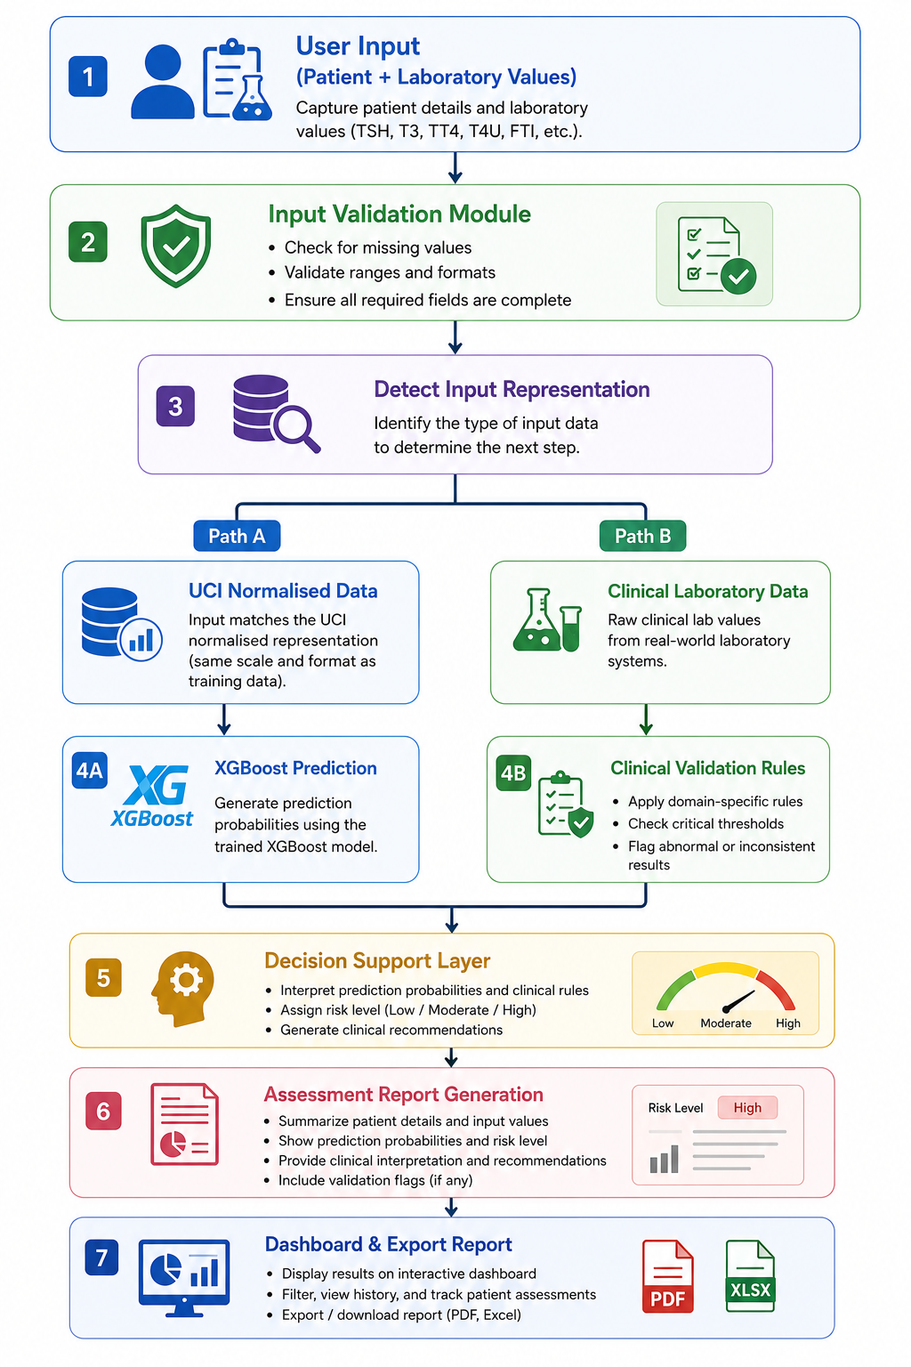
Figure 3.7 Clinical Decision Support System Workflow

3.9 System Workflow
The proposed CDSS follows a structured workflow that brings data acquisition, prediction, clinical validation, and result presentation together in one framework. The design lets users complete an assessment efficiently while keeping the process transparent. Figure 3.8 shows the complete operational workflow.
The workflow starts when the user opens the Streamlit interface and reaches the patient information section, where identifier, age, and gender are entered. These details are not used as predictive inputs, but they are included in the report to aid documentation and usability.
Next comes the laboratory input section, which requires the five predictive measurements:
- Thyroid Stimulating Hormone (TSH)
- Triiodothyronine (T3)
- Total Thyroxine (TT4)
- Thyroxine Uptake (T4U)
- Free Thyroxine Index (FTI)
These values form the feature vector analyzed by the prediction engine. Once all values are entered, the system checks that the inputs are complete and numerically valid and determines whether they follow the normalized UCI representation or conventional clinical units. This automatic detection supports both research testing and realistic data entry without a manual mode selection.
If the values match the normalized UCI format, the feature vector goes straight to the XGBoost classifier, which evaluates the measurements, estimates the probability of each class, selects the highest-probability class as the diagnosis, and reports the maximum probability as the confidence score. If the values represent conventional clinical measurements, the Clinical Validation Layer is activated instead, comparing each parameter with established reference ranges to provide interpretation that complements the model and improves transparency.
Outputs from the Prediction Engine and the Clinical Validation Layer then move to the Decision Support Layer, which integrates the prediction, confidence score, probability distribution, reference comparison, and rule-based interpretation into a single assessment, turning numerical output into clinically understandable information. The Streamlit dashboard finally presents the predicted condition, confidence, probability distribution, reference comparison, interpretation, and recommendation, with an option to export the report for documentation or later review.
This workflow shows how artificial intelligence and clinical decision support can work together. Rather than acting autonomously, the framework serves as an intelligent assistant that analyses measurements, applies patterns learned from historical data, and presents interpretable results to support clinicians in thyroid assessment.
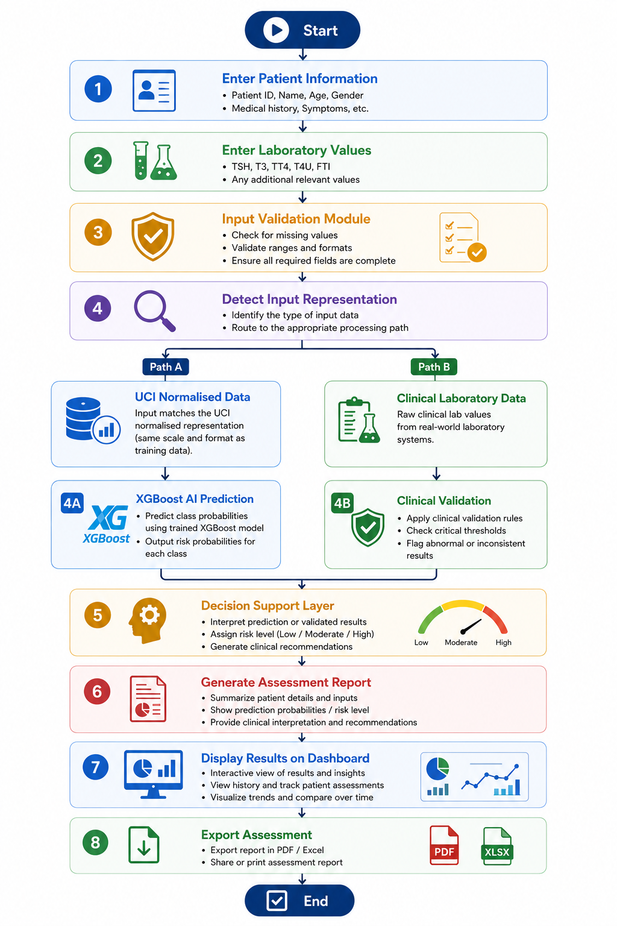
Figure 3.8 Overall System Workflow

3.10 Chapter Summary
This chapter set out the methodology for developing the proposed AI-based CDSS for multi-class thyroid disorder risk assessment. The work covered dataset selection, preprocessing, feature extraction, model development, evaluation, and the implementation of a web-based prototype. The UCI ANN Thyroid Disease dataset provided the basis for training, with five clinically significant laboratory variables serving as predictors. An XGBoost classifier was developed for multi-class classification and evaluated using accuracy, precision, recall, F1-score, and confusion matrix analysis.
To make the framework practical, the trained model was integrated into a Streamlit-based CDSS offering laboratory data entry, automated risk assessment, confidence estimation, reference comparison, and recommendation generation. A clinical validation layer was added to interpret measurements against established reference ranges and complement the model's predictions.
The methodology described here provides the technical foundation of the framework and the basis for evaluating its performance. The next chapter presents the implementation, performance analysis, experimental evaluation, and discussion of the developed system.

