Automatic Detection of Arabic Spam Messages Using Machine Learning Techniques

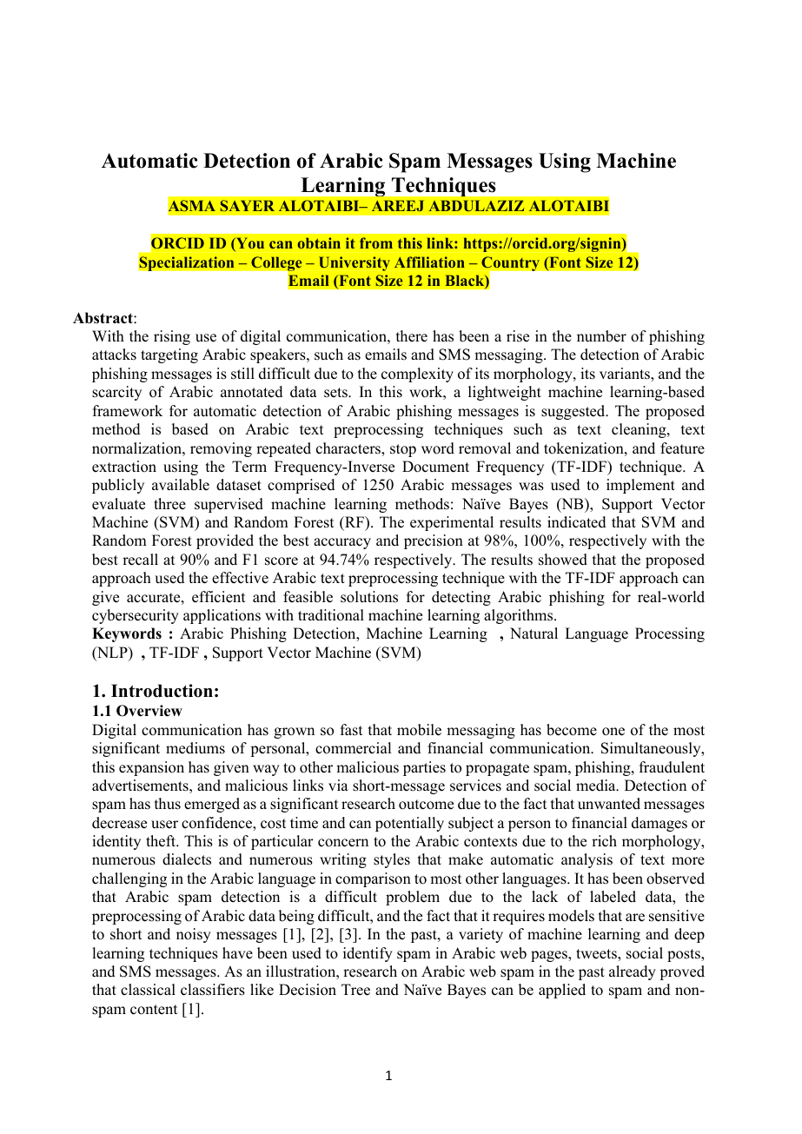 | Reviewer Notes - Page 1  1. Correction: Complete all author metadata required by Midocean Journal, including ORCID IDs, specialization, college, university affiliation, country, and email addresses. Remove all template placeholders before resubmission.  2. Reviewer Comment: The title refers to Arabic spam messages, while the abstract and methodology repeatedly refer to phishing messages, SMS, and emails. Please standardize the scope and terminology throughout the paper.  3. Reviewer Comment: The abstract should clearly state the exact dataset type, source, class distribution, train/test split, and whether the reported 98% accuracy is based on the held-out test set only.  Dr. Khaled Eskaf  khaledeskaf@midocean.edu.km

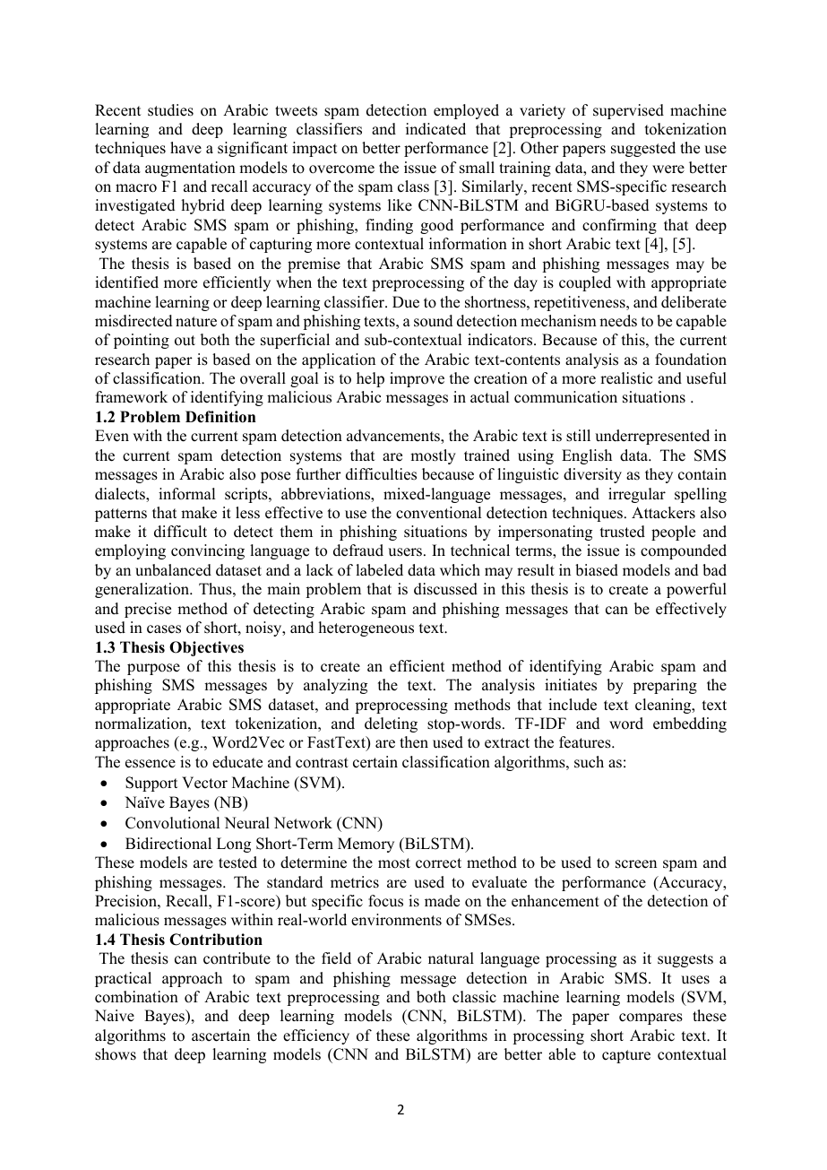 | Reviewer Notes - Page 2  1. Correction: Replace 'Thesis Objectives' and 'Thesis Contribution' with 'Research Objectives' and 'Research Contributions' to match the journal-article format required by Midocean Journal.  2. Reviewer Comment: The objectives mention CNN and BiLSTM, but the implemented methodology later evaluates only Naive Bayes, SVM, and Random Forest. Please remove non-implemented models or report their experiments clearly.  3. Reviewer Comment: The problem definition should be rewritten in a formal journal style and should avoid calling the work a thesis.

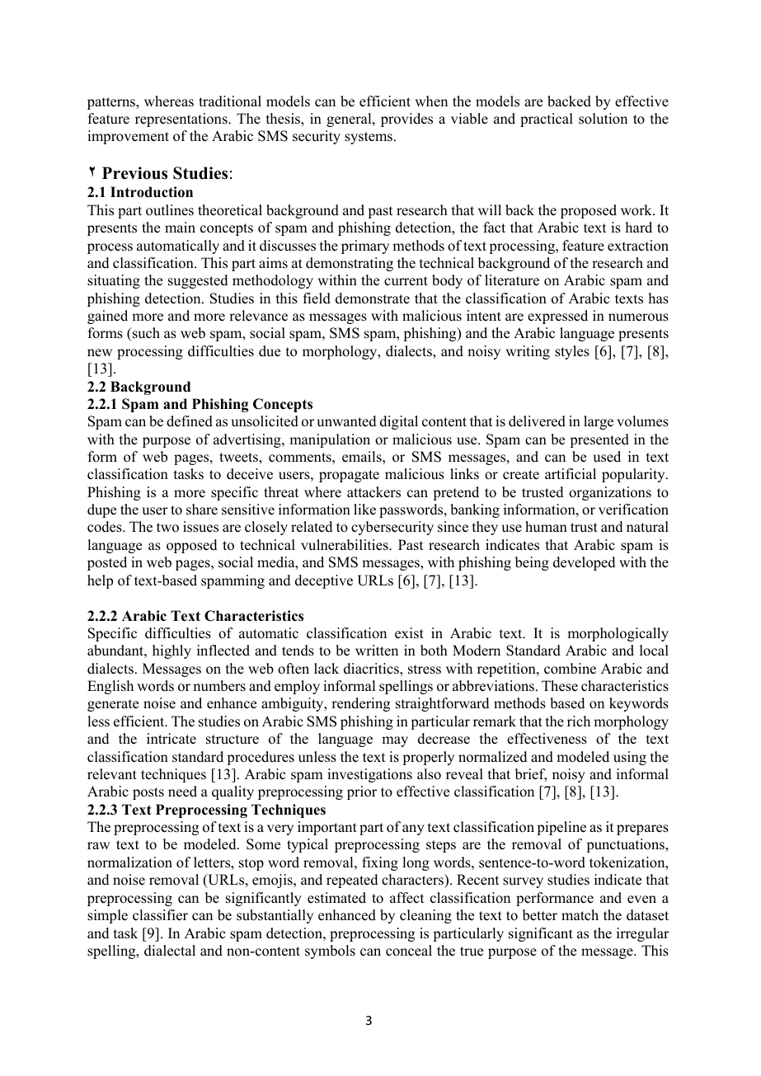 | Reviewer Notes - Page 3  1. Correction: Replace 'This part' with 'This section' and maintain journal-article terminology throughout the manuscript.  2. Reviewer Comment: The theoretical background is relevant, but it should be more focused on Arabic spam/phishing detection rather than general definitions. Add a clearer transition from Arabic linguistic challenges to the selected ML approach.  3. Reviewer Comment: Support claims about Arabic morphology, dialectal variation, and noisy writing styles with strong recent references.

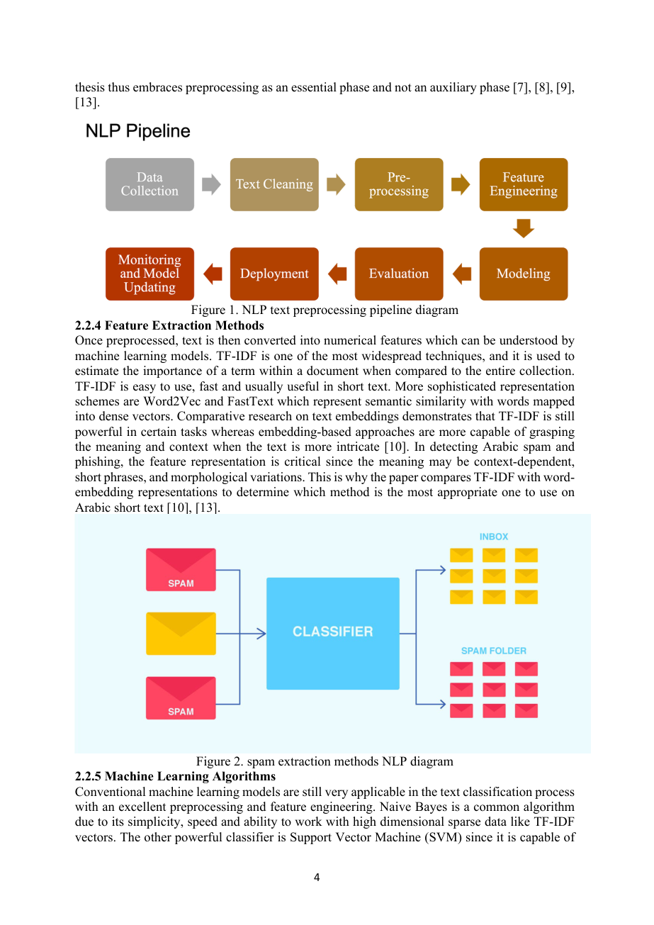 | Reviewer Notes - Page 4  1. Reviewer Comment: Figures 1 and 2 require proper source attribution, permission status, or a statement that they were created by the authors. Generic diagrams should not be used without citation.  2. Correction: The caption 'spam extraction methods NLP diagram' is unclear. Replace it with an academic caption such as 'Feature extraction and classification workflow for spam detection.'  3. Reviewer Comment: The section mentions Word2Vec and FastText, but the actual experiment uses TF-IDF only. Remove unimplemented feature extraction methods from the methodology claims or add their experimental results.

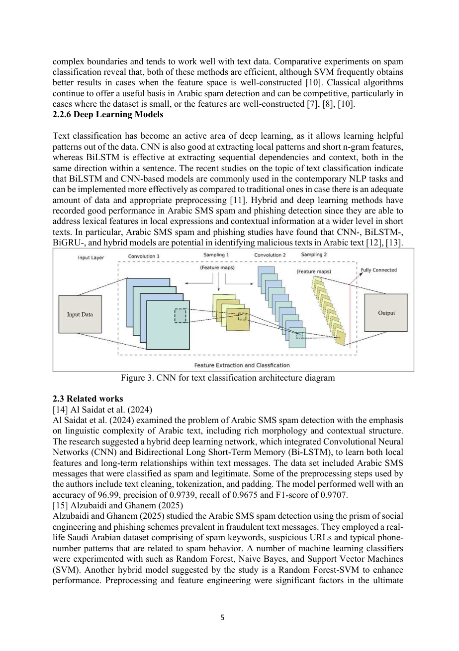 | Reviewer Notes - Page 5  1. Reviewer Comment: The deep learning section is too broad relative to the implemented experiment. Since CNN, BiLSTM, and transformer models were not implemented, this section should be shortened and used only as literature background.  2. Correction: Ensure Figure 3 has a proper source citation and that it is directly relevant to text classification rather than being used as a generic image.  3. Reviewer Comment: The related work should compare methods critically, not only describe each study. Focus on dataset type, Arabic language handling, feature representation, class imbalance, and evaluation design.

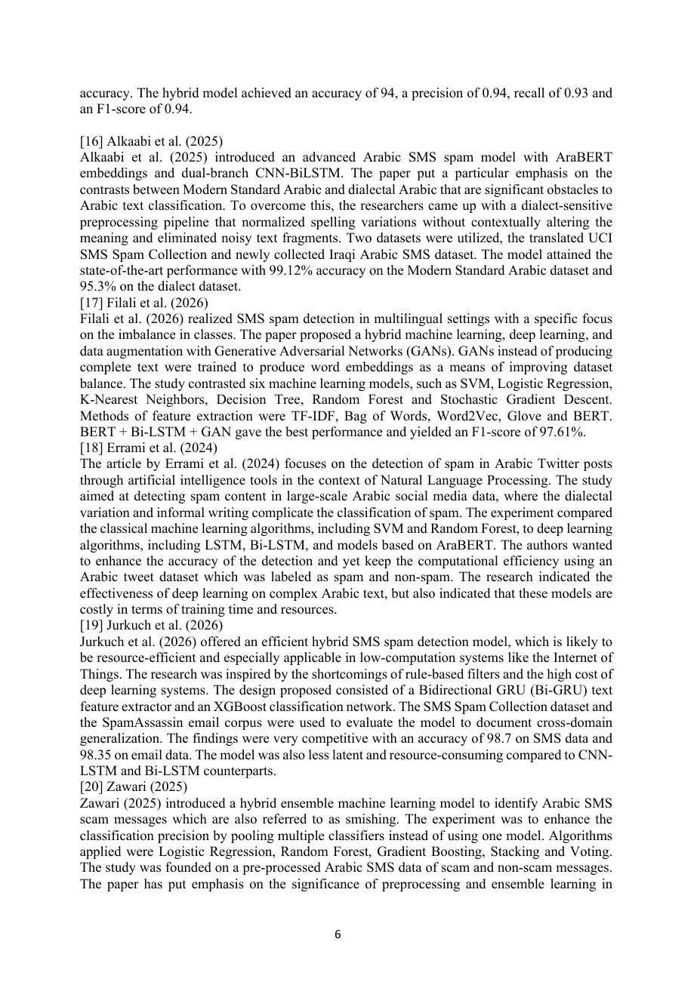 | Reviewer Notes - Page 6  1. Reviewer Comment: Several related studies from 2025 and 2026 must be carefully verified for publication status, DOI, journal details, and relevance before being retained in a journal manuscript.  2. Correction: Use consistent terminology for BiLSTM/Bi-LSTM, SVM, RF, NB, TF-IDF, and Arabic SMS/phishing across the paper.  3. Reviewer Comment: When discussing high accuracies in prior studies, explain whether they are directly comparable to this paper in terms of dataset size, language, task definition, and train/test protocol.

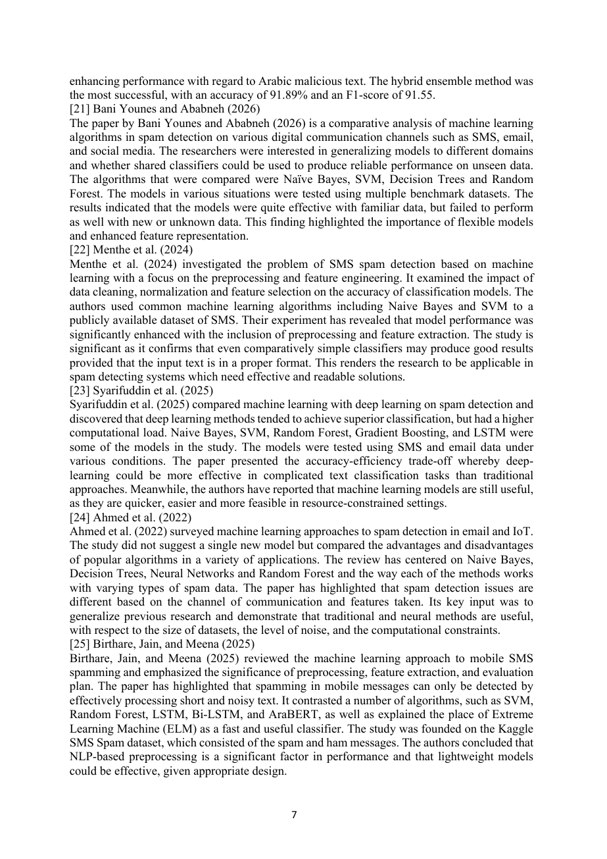 | Reviewer Notes - Page 7  1. Reviewer Comment: Some studies in the related work are not Arabic-specific or not SMS/phishing-specific. Please justify their inclusion or move them to a broader background paragraph.  2. Reviewer Comment: The literature review would be stronger if organized thematically: traditional ML, deep learning, Arabic preprocessing, class imbalance, and lightweight deployment.  3. Correction: Avoid repeating the same conclusions across multiple related-work summaries.

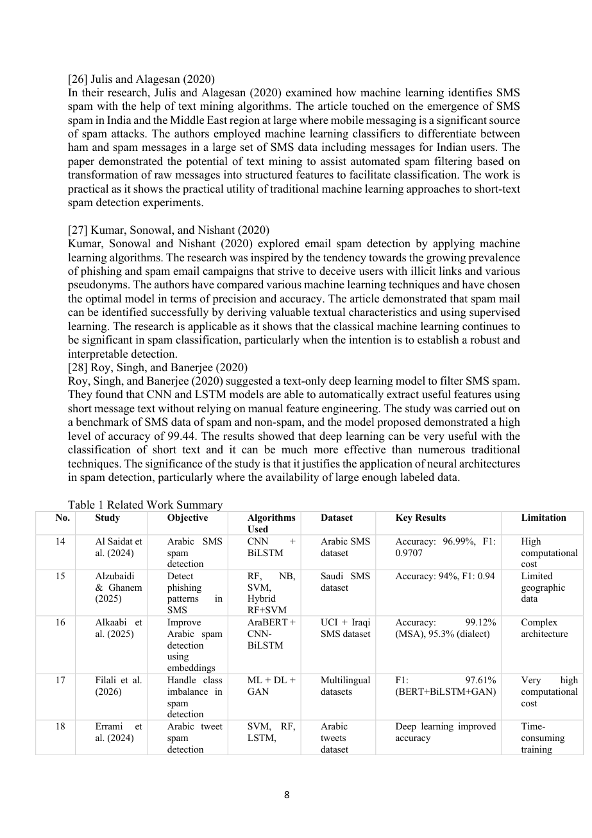 | Reviewer Notes - Page 8  1. Correction: Table 1 is too crowded and should be reformatted using the Midocean Journal table style. The rows should fit clearly within page margins.  2. Reviewer Comment: The table should include full citation identifiers consistently and should not mix author names, years, and study numbers in an unclear format.  3. Reviewer Comment: Add a short synthesis after the table explaining the exact research gap that the present study addresses.

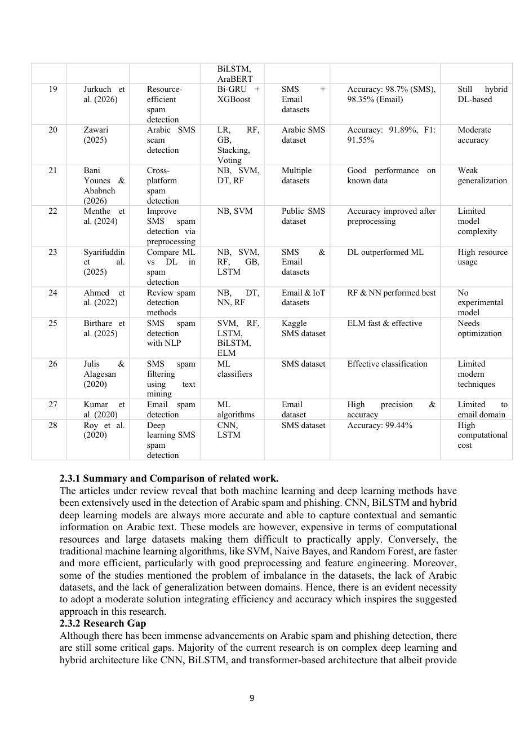 | Reviewer Notes - Page 9  1. Correction: The continuation of Table 1 is visually dense and difficult to read. Consider shortening the table or moving detailed comparisons to an appendix.  2. Reviewer Comment: The research gap is relevant, but it should be aligned with the actual implemented model. The paper claims a lightweight ML solution, so avoid framing the contribution around deep learning models that were not tested.  3. Reviewer Comment: Clarify whether the target application is SMS spam, email phishing, or general Arabic malicious-message detection.

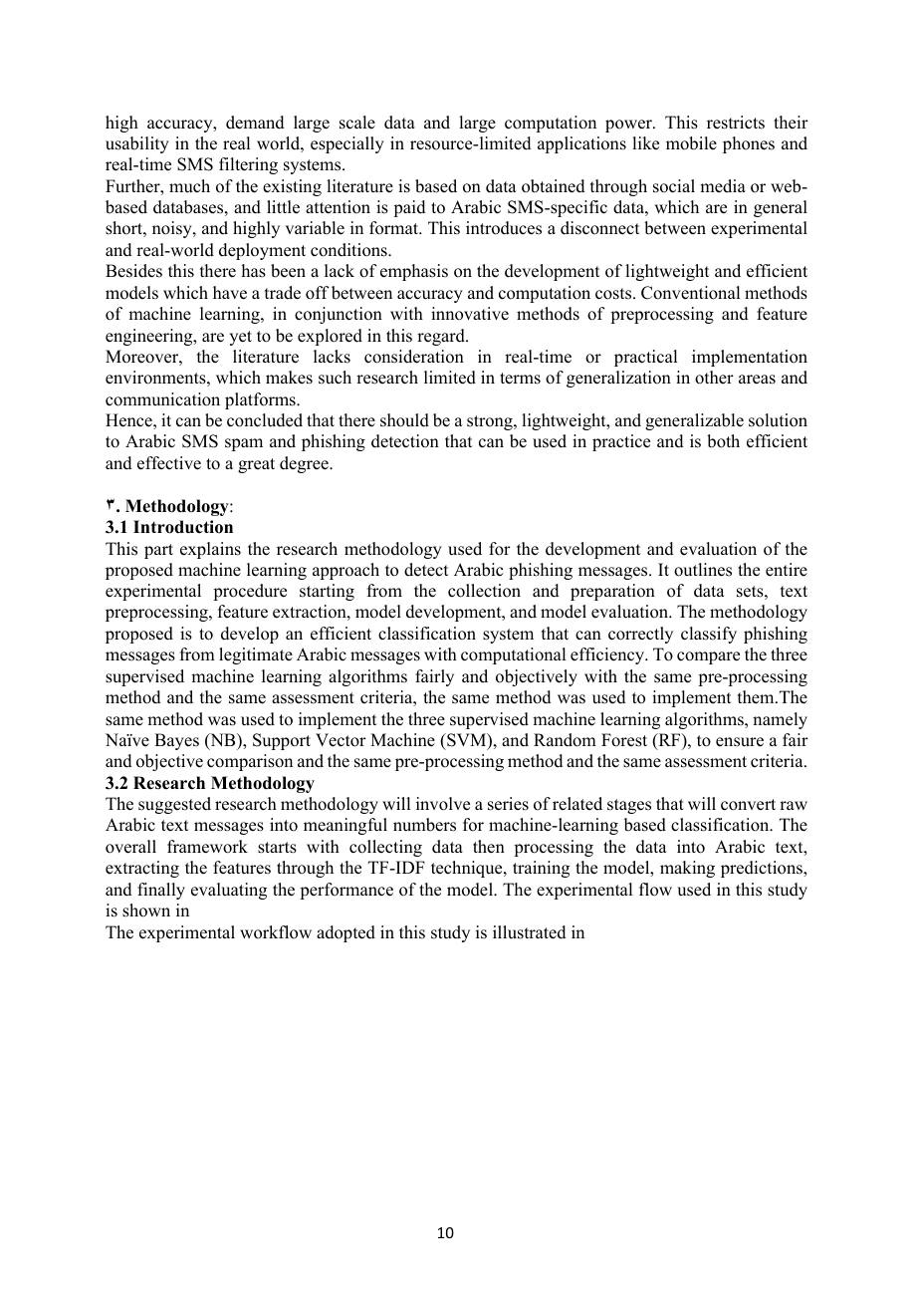 | Reviewer Notes - Page 10  1. Correction: Replace Arabic-style section numbering artifacts such as '٣.' and '٤.' with consistent English journal numbering throughout the manuscript.  2. Correction: Remove duplicated sentences in the methodology introduction. The paragraph repeats the same idea about implementing the three supervised algorithms.  3. Reviewer Comment: The methodology should explicitly state all preprocessing rules, feature extraction parameters, model hyperparameters, and evaluation protocol in a reproducible way.

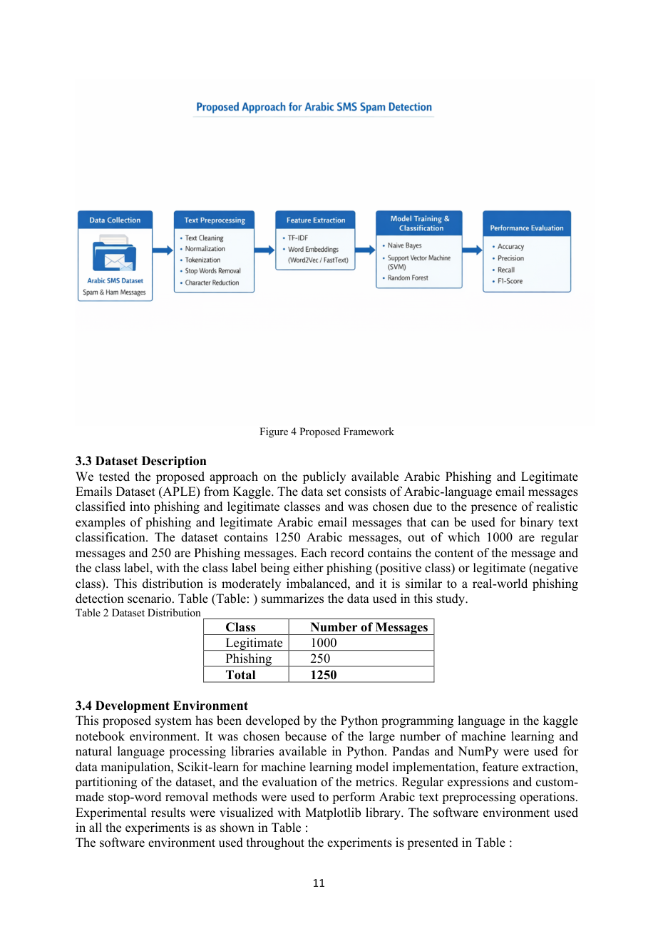 | Reviewer Notes - Page 11  1. Reviewer Comment: There is a major scope inconsistency. The title discusses Arabic spam messages, while the dataset is described as the Arabic Phishing and Legitimate Emails Dataset (APLE). Please revise the title, abstract, objectives, and methodology to match the actual dataset.  2. Correction: Replace incomplete references such as 'Table (Table:)' and 'Table :' with correct table numbers and cross-references.  3. Reviewer Comment: Provide the Kaggle dataset link, access date, license, and any preprocessing or exclusion criteria applied to the 1,250 messages.

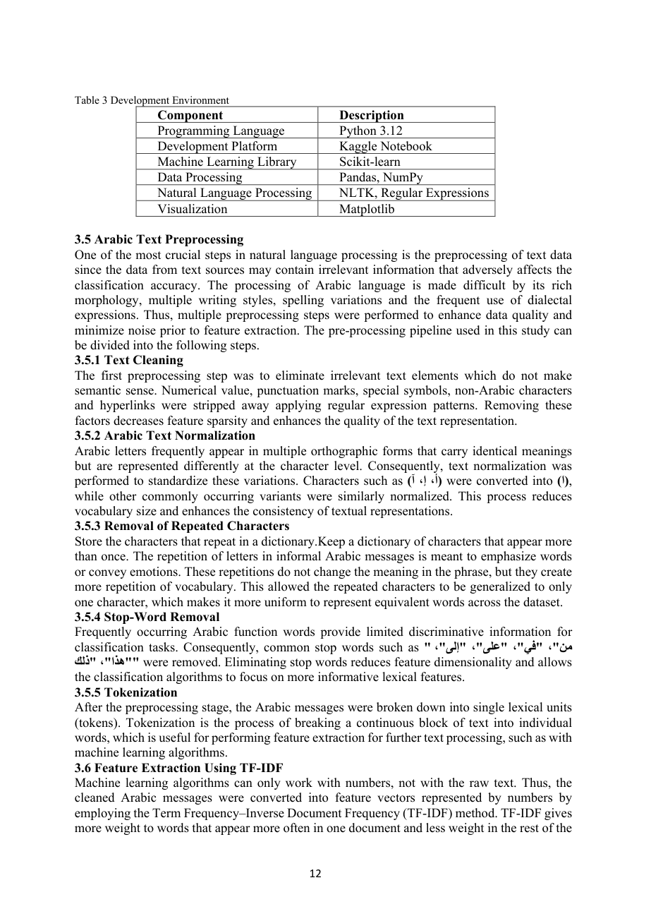 | Reviewer Notes - Page 12  1. Correction: Rewrite 'Store the characters that repeat in a dictionary.Keep a dictionary...' as a clear academic sentence. Also fix the missing space after the period.  2. Reviewer Comment: Provide examples of Arabic normalization rules and cite a source or justify the custom stop-word list. Consider whether stemming or lemmatization was tested or intentionally excluded.  3. Reviewer Comment: State whether removing non-Arabic characters may remove useful phishing cues such as URLs, numbers, brand names, or mixed-language attack indicators.

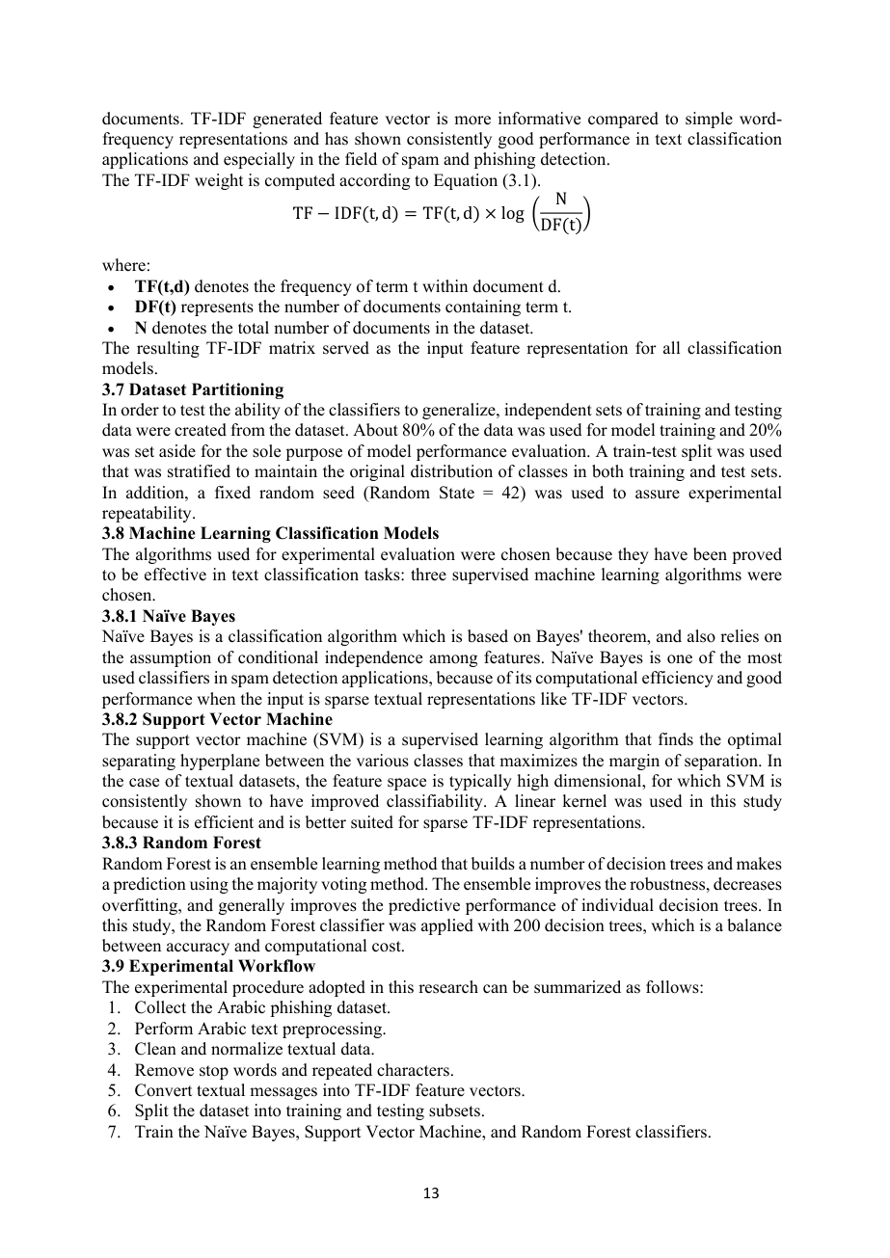 | Reviewer Notes - Page 13  1. Correction: The TF-IDF equation is not formatted correctly. It should be written in a standard mathematical form and numbered consistently according to journal style.  2. Reviewer Comment: Add model configuration details: SVM kernel and C value, Naive Bayes type and smoothing parameter, Random Forest depth, criterion, feature limits, and class-weight settings if used.  3. Reviewer Comment: Since the dataset is imbalanced, explain whether class weights, stratification, threshold tuning, or resampling were considered.

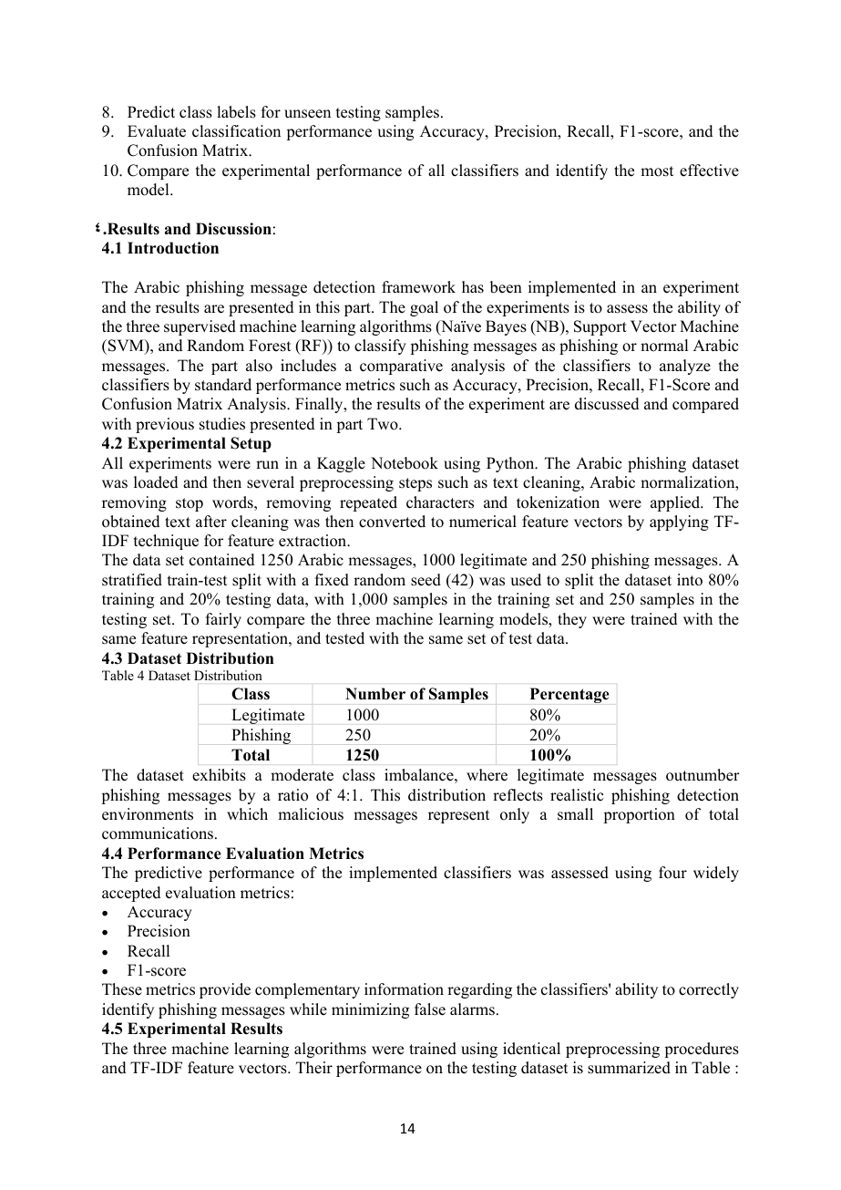 | Reviewer Notes - Page 14  1. Correction: Replace 'part' with 'section' throughout the Results and Discussion section.  2. Reviewer Comment: The experimental setup is clear, but the evaluation metrics should specify which class is treated as the positive class and whether scores are binary, macro, or weighted.  3. Reviewer Comment: Provide the exact number of legitimate and phishing samples in the train and test sets after stratified splitting.

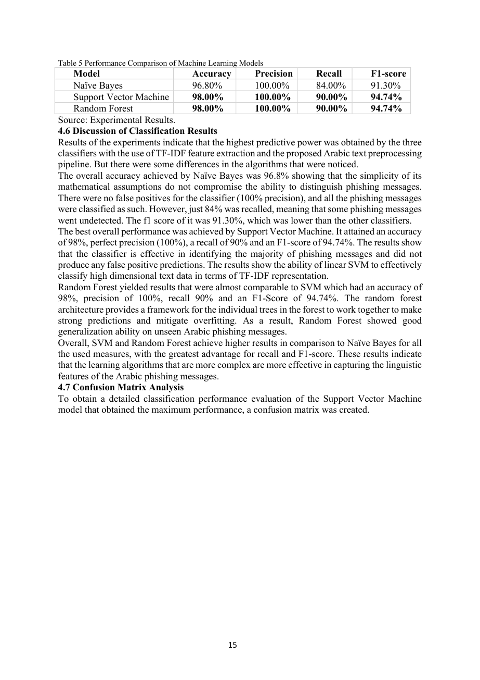 | Reviewer Notes - Page 15  1. Correction: The sentence stating that all phishing messages were classified correctly contradicts the reported recall of 84% for Naive Bayes. Please correct this interpretation.  2. Reviewer Comment: The claim of 100% precision needs careful explanation. In cybersecurity, false negatives are often more critical than false positives; therefore, the discussion should emphasize the remaining missed phishing messages.  3. Reviewer Comment: Add confidence intervals or repeated runs where possible, because a 250-sample test set may not be sufficient to support strong generalization claims.

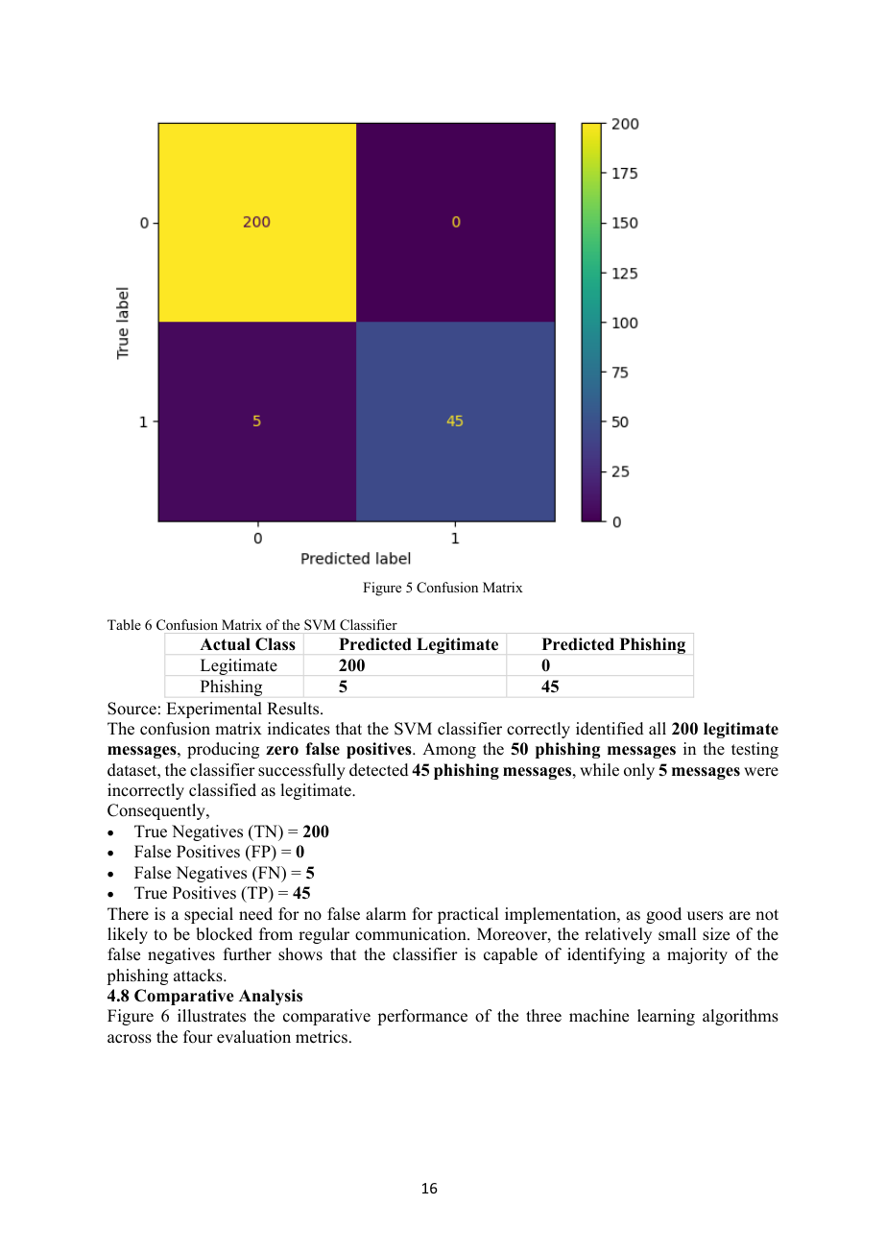 | Reviewer Notes - Page 16  1. Reviewer Comment: The confusion matrix is useful, but it should be clearly labeled with class names rather than numeric labels 0 and 1.  2. Reviewer Comment: The 5 false negatives are important because phishing messages classified as legitimate create real security risk. This point should be discussed more critically.  3. Correction: Improve the wording 'good users are not likely to be blocked' to formal academic language, such as 'legitimate users are unlikely to be incorrectly flagged.'

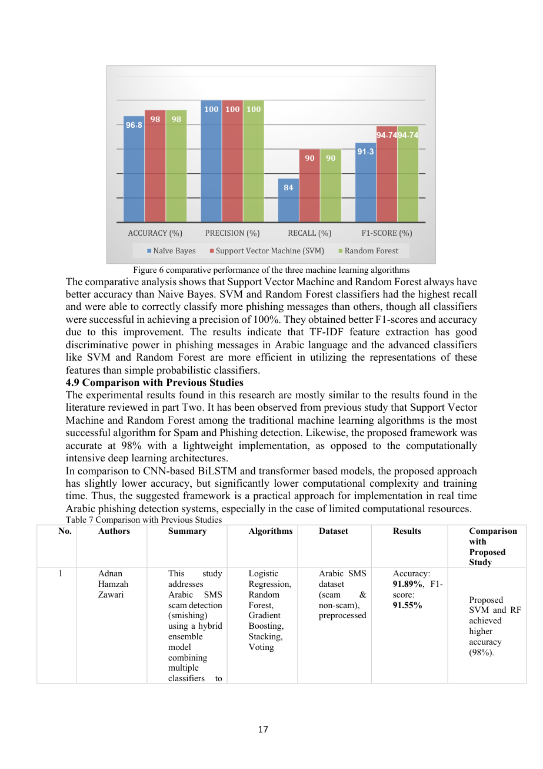 | Reviewer Notes - Page 17  1. Correction: Figure 6 should use consistent decimal formatting and clear axis labels. Avoid mixing Arabic decimal separators and English labels in the same figure.  2. Reviewer Comment: The comparison with previous studies should be cautious. Report whether prior studies used the same dataset, language variety, task type, and test split before claiming higher performance.  3. Reviewer Comment: The table on previous studies is very large and may be unsuitable for the main text. Consider summarizing the strongest comparisons and moving details to an appendix.

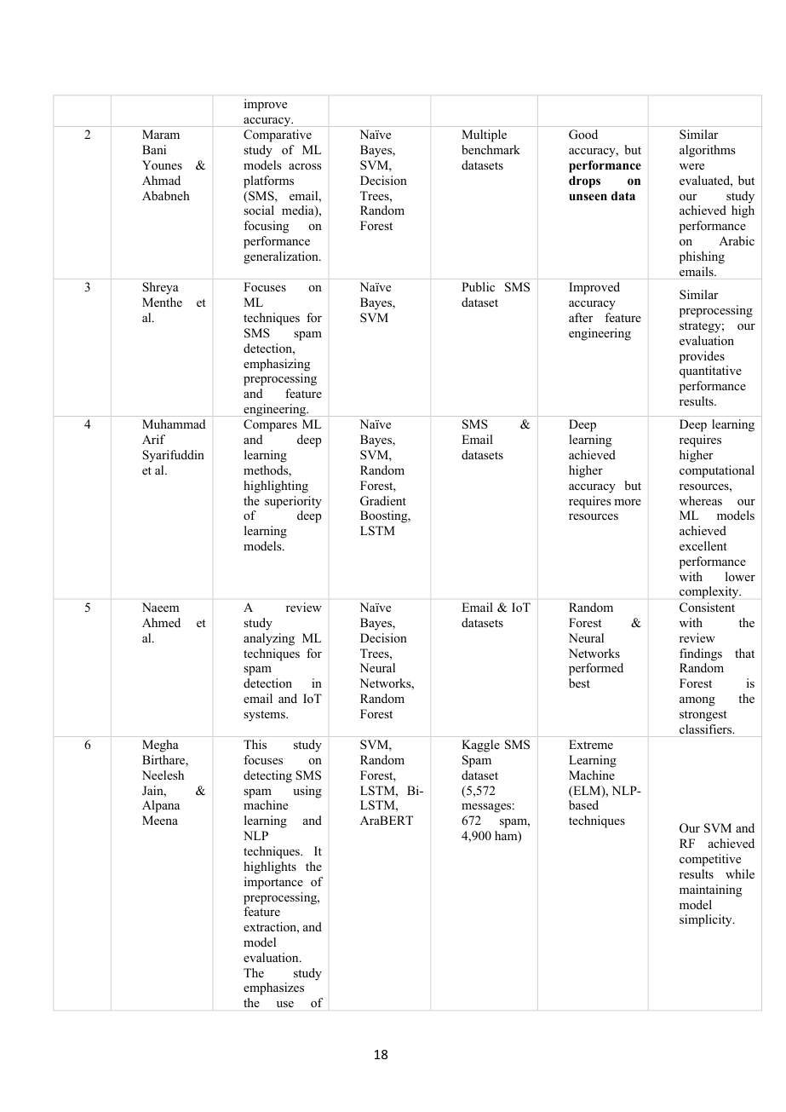 | Reviewer Notes - Page 18  1. Correction: The continuation of Table 7 is visually crowded and difficult to follow. Use landscape orientation, smaller content, or a simplified comparison table.  2. Reviewer Comment: Some comparison entries are too general and do not provide enough methodological detail. Include dataset size, language, model type, and evaluation metrics consistently.  3. Reviewer Comment: Avoid claiming superiority over studies using different datasets unless this limitation is clearly stated.

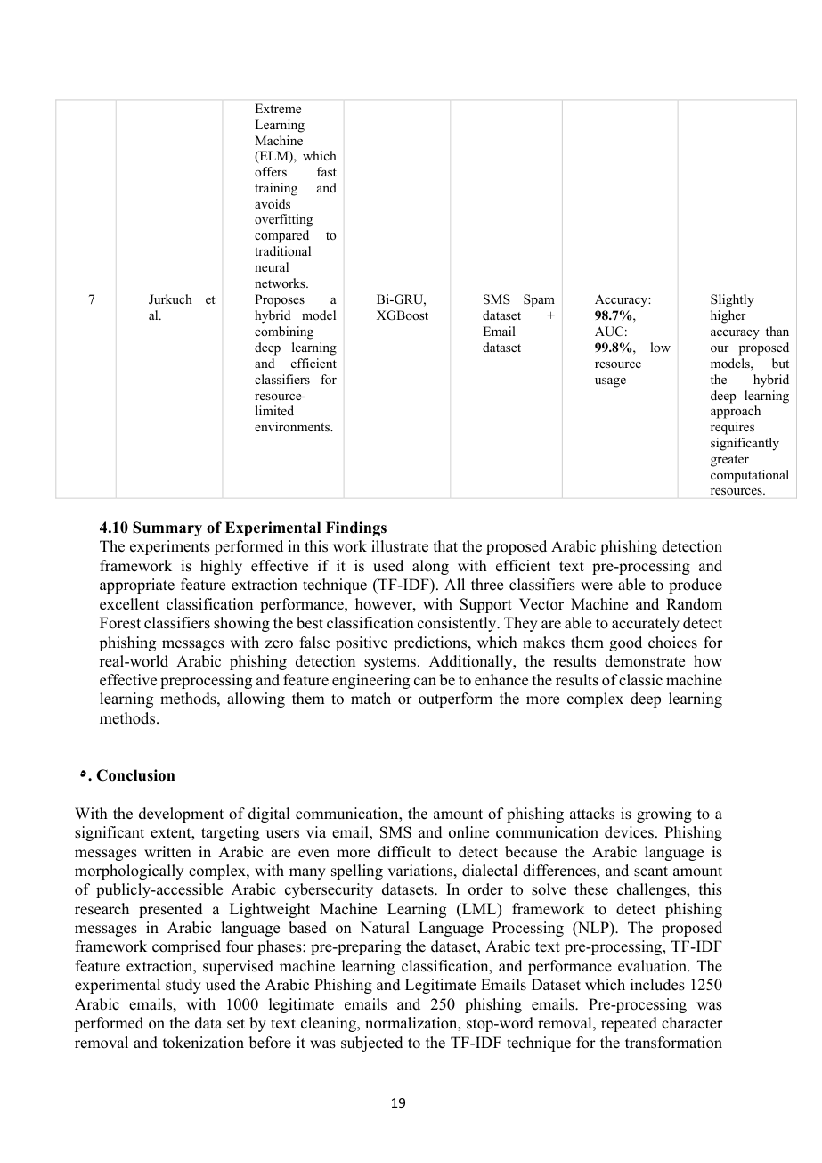 | Reviewer Notes - Page 19  1. Reviewer Comment: The summary claims that classic machine learning methods may match or outperform more complex deep learning methods. This should be moderated because the comparison is not controlled on the same dataset.  2. Correction: The conclusion states that the framework comprised four phases, but it lists five phases. Please correct the number or restructure the sentence.  3. Reviewer Comment: Add a separate limitations paragraph before the conclusion or before recommendations, including small dataset size, class imbalance, dataset-domain mismatch, lack of external validation, and limited deployment testing.

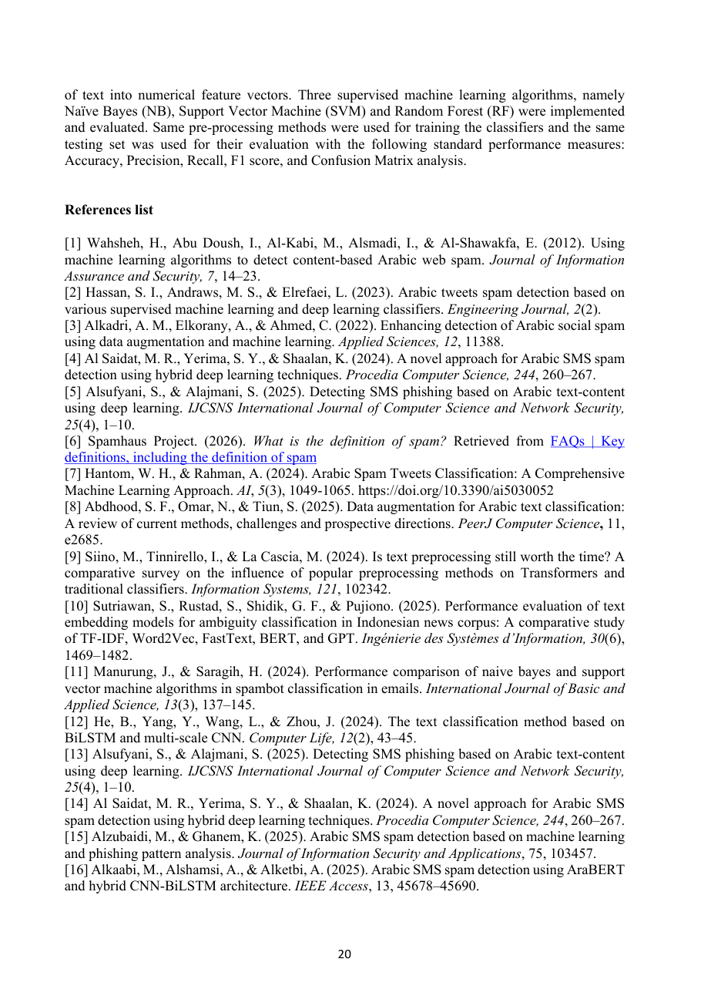 | Reviewer Notes - Page 20  1. Reviewer Comment: The reference list needs a complete audit. Ensure every in-text citation appears in the reference list and every reference is actually cited in the manuscript.  2. Correction: Add DOI links where available and apply one consistent citation style required by Midocean Journal.  3. Reviewer Comment: Some references appear incomplete or potentially weak for a journal article. Replace non-scholarly or unverifiable sources with peer-reviewed sources when possible.

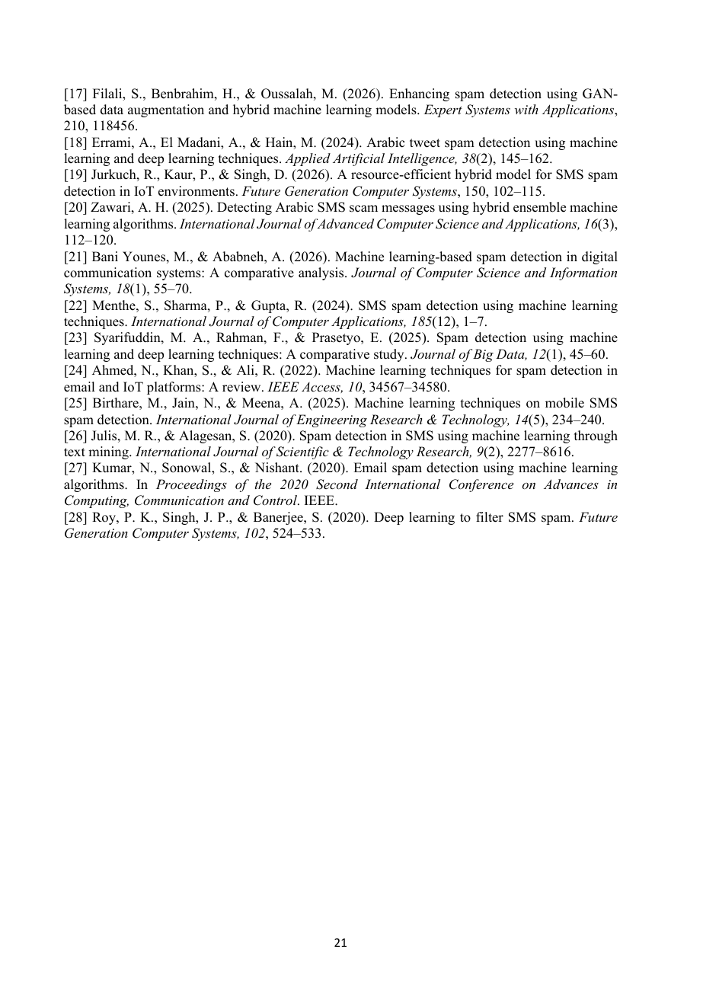 | Reviewer Notes - Page 21  1. Correction: Several reference entries require full bibliographic details, including journal volume, issue, page range, publisher/conference name, and DOI where available.  2. Reviewer Comment: Before publication, verify the authenticity and publication details of recent 2025/2026 references and avoid citing sources that cannot be independently verified.  3. Reviewer Comment: The final version should include a polished English proofread to correct grammar, punctuation, spacing, capitalization, and terminology consistency.

