Background
Arabic is one of the most widely spoken languages, with flexible grammatical structures, and different regional dialects. While Modern Standard Arabic (MSA) is used in formal communication, which differs in vocabulary, pronunciation, grammar and writing style. These variations make Arabic one of the most difficult languages for Natural Language Processing (NLP) applications.
Arabic Dialect Identification (ADI) is the problem of classifying Arabic text or speech into its dialect. ADI has been an important preprocessing step for many NLP applications such as machine translation, sentiment analysis, speech recognition, information retrieval and conversational systems, and the correct dialect identification can significantly boost the overall system's performance.
Despite the significant progress made in Arabic (NLP), (ADI) is still a challenging problem due to the high linguistic similarity among dialects, spelling variations, code-switching, and the lack of standard writing conventions. These challenges have led to the creation of increasingly sophisticated computational approaches, ranging from traditional Machine Learning (ML) methods to Deep Learning (DL) techniques and, more recently, Transformer-based models. Hence, the following sections introduce the main preprocessing techniques, feature representation methods and computational frameworks commonly used for Arabic Dialect Identification.
Natural Language Processing (NLP)
“We will take Natural Language Processing—or NLP for short—in a wide sense to cover any kind of computer manipulation of natural language” [1].
In this context, natural language refers to the languages used by humans in everyday communication, while NLP encompasses computational methods for processing and analyzing such language data.

Data Preprocessing
Data preparation is a significant step to convert unstructured textual data to structured data for computational analysis. The aim is to improve the data quality by lowering the noise and inconsistencies that could impact the performance of classification models . Typically, preprocessing begins with cleaning the data. by removing non-text content like URLs, HTML tags, emojis, special characters, extra white space and other irrelevant items.
Feature representation
is the transformation of text data into numerical vectors that can be processed by computational models. It is very important in NLP because the quality of the features extracted directly affects the performance of the text classification task. Traditional feature representation methods encode text based on statistical information rather than semantic meaning. The most widely used discussed in the following sections.
Word embedding model
"Word embeddings aim to encode the syntactic and semantic information of words into distributed representations, i.e., each word is represented by a vector. Word embeddings are the basis for encoding word-level semantics, and word2vec and GloVe are the most common ways to obtain word embeddings.[1]"
Bag of Words
"The Bag of Words (BoW) model represents a document by considering only the occurrence of words while ignoring their order. As described by Manning et al. (2008), in the Bag of Words model, "the exact ordering of the terms in a document is ignored but the number of occurrences of each term is material." Consequently, documents containing the same words with identical frequencies are considered equivalent regardless of word order (Manning et al., 2008).[2]"
Mathematical Representation
According to Wilbur and Kim [3], the Bag-of-Words approach represents a document $d$ using the frequency of each vocabulary term as follows:
$$\begin{matrix} & d={\left\{tf_{vd}\right\}}_{v∈V} & & \end{matrix}$$Where:
- $d$represents a document.
- $V$is the vocabulary containing all terms.
- $v$represents a term in the vocabulary.
- $tf_{vd}$is the number of times term $v$occurs in document $d$.
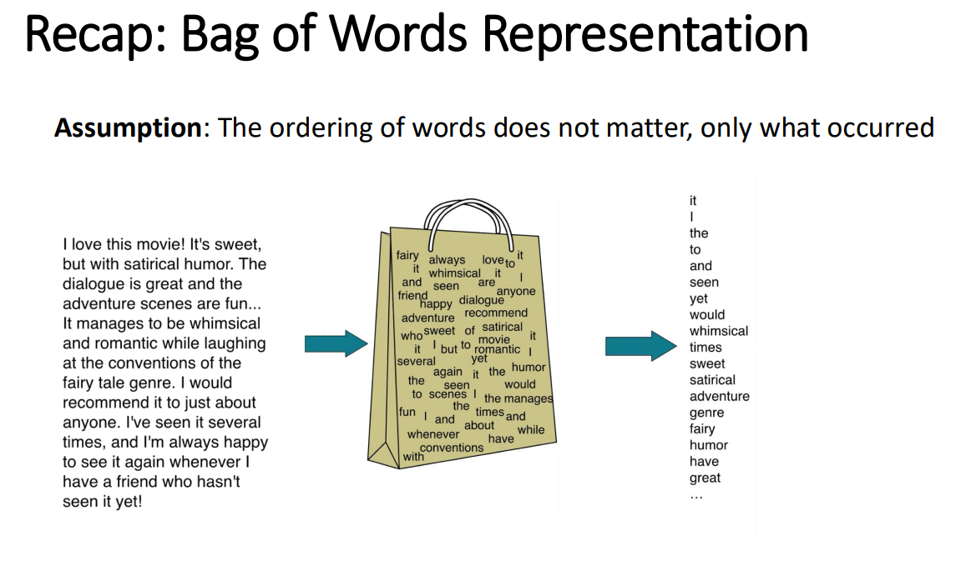
Figure 4 illustrates the Bag of Words representation, where the original document is transformed into an unordered collection of words and then represented as a numerical vector.
Source: Reproduced from [4, slide 3]
Term Frequency–Inverse Document Frequency (TF-IDF)
"A weighting function that depends on the term frequency (TF) in a given document calculated with its relative collection frequency (IDF). The term frequency emphasizes term significance in a given document, and inverse document frequency emphasizes term significance in the collection as a whole (TF*IDF) [5] "
Mathematical Representation
The following TF–IDF equations are reproduced from [6, pp. 117–120]:
The Term Frequency (TF) of a term $t$in document $d$is defined as:
$$TF(t,d)=f_{t,d}$$
where:
- $f_{t,d}$is the number of occurrences of term $t$in document $d$.
The Inverse Document Frequency (IDF) is defined as:
$$IDF(t)=log⁡\left(\frac{N}{df_{t}}\right)$$
where:
- $N$is the total number of documents in the corpus.
- $df_{t}$is the number of documents containing term $t$.
Finally, the TF-IDF weight is computed as:
$$TF \text{⁣}- \text{⁣}IDF(t,d)=TF(t,d)×IDF(t)$$
These equations assign higher weights to terms that occur frequently in a specific document but infrequently across the document collection, making them more discriminative for text representation.
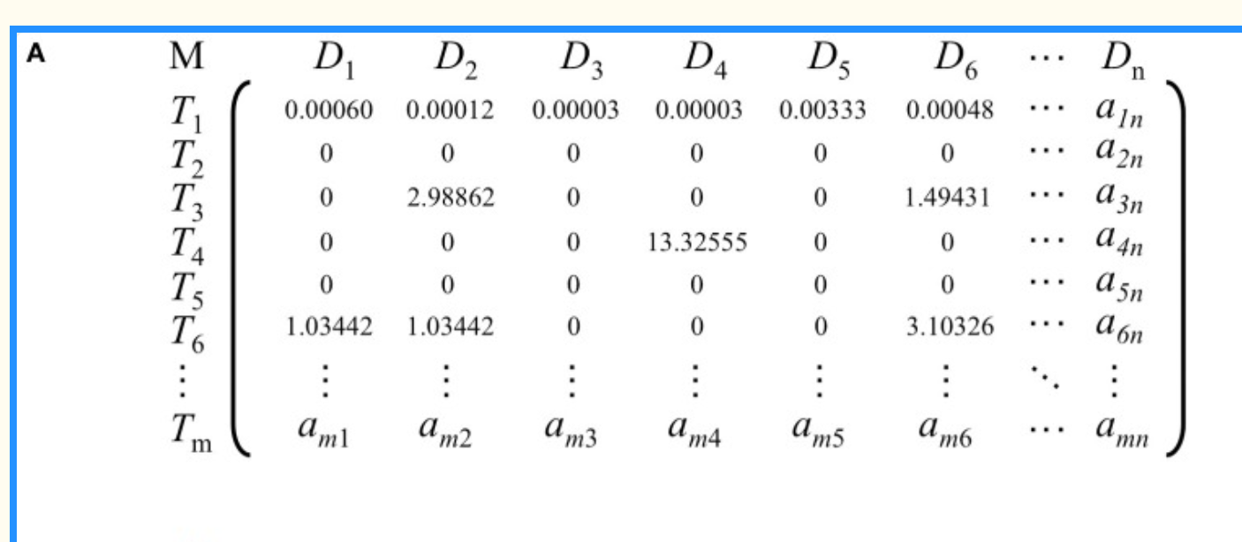
Figure [7]. TF–IDF-weighted term–document matrix.
Source: Adapted from [7, Fig. 1(A)].
N-grams
"An n-gram is a sequence of n words: a 2-gram (bigram) is a two-word sequence, and a 3-gram (trigram) is a three-word sequence.[8]"
The following equations are adapted from [9]:
Equation (1): Chain Rule
$$P(w_{1}^{m})=\prod_{i=1}^{m}{P(}w_{i}∣w_{1}^{i-1})$$
Equation (2): N-gram Approximation
$$P(w_{i}∣w_{1}^{i-1})≈P(w_{i}∣w_{i-n+1}^{i-1})$$

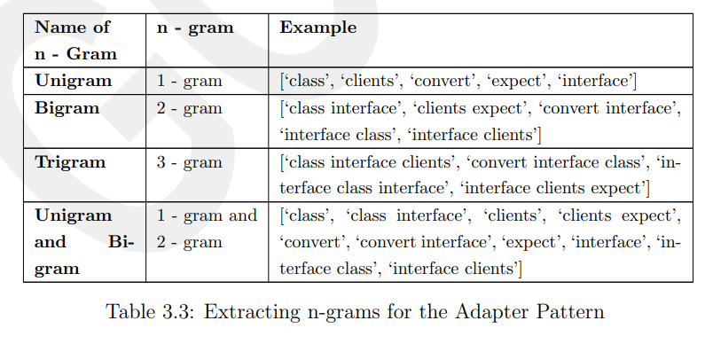
Extracting n-grams examples. Source: Adapted from [10, Table 3.3].
Word2vec
"Google's word2vec toolkit was released in 2013. It can efficiently learn word vectors from a large corpus. The toolkit has two models, including Continuous Bag-of-Words (CBOW) and Skip-gram.[11]"
Mathematical Representation
The following equations are reproduced from [12]:
Word2Vec is implemented using two main architectures: Continuous Bag-of-Words (CBOW) and Skip-Gram. CBOW predicts the target word from its surrounding context, whereas Skip-Gram predicts the surrounding context words from the target word .
Continuous Bag-of-Words
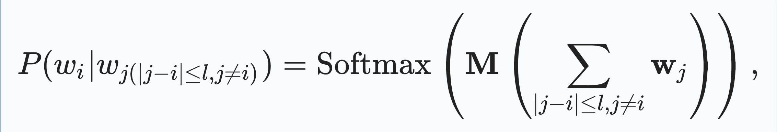
where $P(w_{i}∣w_{j}(∣j-i∣≤l, j≠i))$denotes the probability of predicting the target word $w_{i}$given its surrounding context words. $l$represents the context window size, $M$is the weight matrix in $R^{∣V∣×m}$, $V$denotes the vocabulary size, and $m$is the dimensionality of the word embedding vector.
Skip-Gram
"On the contrary to CBOW, Skip-gram predicts the context given the center word."
where $P(w_{j}∣w_{i})$is the probability of context word $w_{j}$given $w_{i}$, and $M$is the weight matrix. The loss function is defined similar to CBOW as
$$\begin{matrix} & L=-\sum_{i}{\sum_{j(∣j-i∣≤l, j≠i)}{P(}}w_{j}∣w_{i}). & & \end{matrix}$$
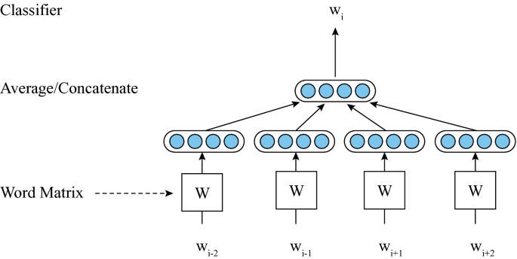
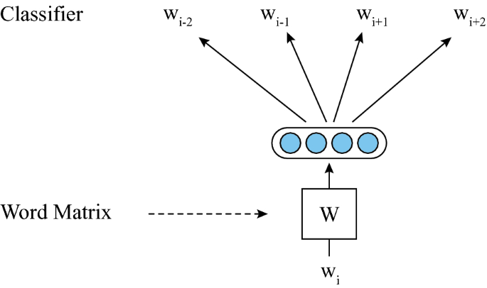

Global Vectors Algorithm
"global vectors (GloVe) developed by Pennington et al. GloVe is an unsupervised learning method that performs word-word clustering (center-context pairs) over all available texts.[13]"

Mathematical Representation
Objective Function [14]
$$J=\sum_{i,j=1}^{V}{f(}X_{ij}){\left(w_{i}^{T}{\tilde{w}}_{j}+b_{i}+{\tilde{b}}_{j}-log⁡X_{ij}\right)}^{2}$$
Weighting Function
$$f(x)=\left\{\begin{matrix}(x/x_{max})^{α}, & \text{if }x<x_{max}, \\ 1, & \text{otherwise.}\end{matrix}\right.$$
where:
- $J$is the overall training objective (cost function).
- $V$is the vocabulary size.
- $X_{ij}$is the number of times word $j$occurs in the context of word $i$(co-occurrence count).
- $w_{i}$is the vector representation of the target word.
- ${\tilde{w}}_{j}$is the vector representation of the context word.
- $b_{i}$and ${\tilde{b}}_{j}$are bias terms associated with the target and context words, respectively.
- $f(X_{ij})$is a weighting function that reduces the influence of extremely frequent or infrequent word co-occurrences.
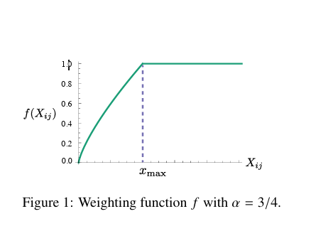
Figure 15. Weighting function $f(x)$with $α=3/4$. Source: Pennington et al. [15].

FastText
" based on the skipgram model, where each word is represented as a bag of character n-grams. A vector representation is associated to each character n-gram; words being represented as the sum of these representations.[16]"
Mathematical Representation
The following equation is reproduced from [16]:
$$s(w,c)=\sum_{g∈G_{w}}{z_{g}^{T}}v_{c}$$
where:
- $s(w,c)$is the scoring function between the target word $w$and the context word $c$.
- $G_{w}$denotes the set of character n-grams contained in the target word $w$.
- $z_{g}$is the vector representation of the character n-gram $g$.
- $v_{c}$is the vector representation of the context word $c$.
- $z_{g}^{T}v_{c}$represents the dot product between the n-gram vector and the context word vector.
- The summation over all $g∈G_{w}$indicates that the word representation is obtained by summing the vector representations of all its character n-grams.
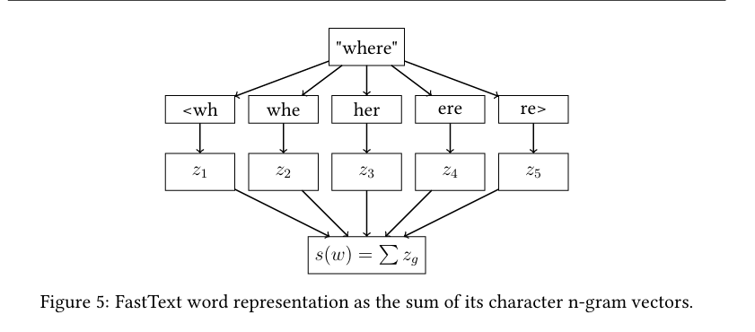
Figure X. FastText word representation as the sum of its character n-gram vectors.
Source: Reproduced from [17, Fig. 5].
Machine Learning Models
Machine learning is defined as “the study of computer algorithms that improve automatically through experience” [18].
Naïve Bayes (NB)
"Naïve Bayes is a simple learning algorithm that utilizes Bayes rule together with a strong assumption that the attributes are conditionally independent, given the class. While this independence assumption is often violated in practice, naïve Bayes nonetheless often delivers competitive classification accuracy. Coupled with its computational efficiency and many other desirable features, this leads to naïve Bayes being widely applied in practice.[19]"
Mathematical Representation
The following equations are reproduced from [20]:

Equation 1 (Bayes' Theorem)
$$P(C∣X)=\frac{P(X∣C) P(C)}{P(X)}$$
where:
- $P(C∣X)$is the posterior probability of class $C$given the observed data $X$.
- $P(X∣C)$is the likelihood of observing data $X$given class $C$.
- $P(C)$is the prior probability of class $C$.
- $P(X)$is the evidence or marginal probability of observing data $X$.

Equation 2 (Naïve Bayes Classifier)
Because Naïve Bayes assumes that all features are conditionally independent given the class, Bayes' theorem can be simplified as follows:
$$P(C∣X)∝P(C)\prod_{i=1}^{n}{P(}x_{i}∣C)$$
where:
- $x_{i}$denotes the $i^{th}$feature.
- $n$is the total number of features.
- $P(x_{i}∣C)$is the conditional probability of feature $x_{i}$given class $C$.
- $P(C)$is the prior probability of class $C$.
- The product term assumes conditional independence among all features.

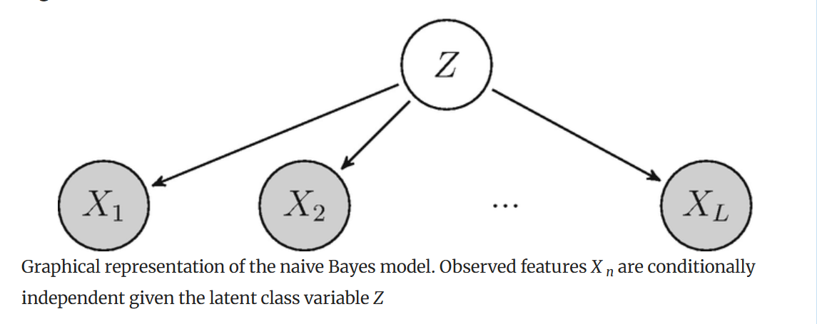
Figure 21. Graphical representation of the Naïve Bayes model. The observed features $X_{1},X_{2},…,X_{L}$are assumed to be conditionally independent given the class variable $Z$.
Source: N. Beerenwinkel and J. Siebourg, Probability, Statistics, and Computational Science, in Evolutionary Genomics, Methods in Molecular Biology, vol. 1910, Humana, 2019 (Figure 7).
Support Vector Machine (SVM)
"Support vector machine (SVM) is a supervised machine learning algorithm applied to data classification and regression. Starting from the 1990s early formalization presented by Cortes and Vapnik (1995), support vector machine (SVM) has been highlighted as a machine learning method widely applied in several research areas.[22]"
Mathematical Representation
The following equations are reproduced from [23]:

Hyperplane Equation
$$w⋅x+b=0$$This equation represents the decision hyperplane that separates different classes. SVM aims to find the optimal hyperplane that maximizes the margin between classes.
Where:
- $w$: Weight vector.
- $x$: Input feature vector.
- $b$: Bias term.

Classification Constraint
$$y_{i}(w⋅x_{i}+b)≥1,i=1,…,n$$This constraint ensures that all training samples are correctly classified while maintaining the separating margin.
Where:
- $y_{i}$: Class label of the $i$-th sample.
- $x_{i}$: Feature vector of the $i$-th sample.
- $w$: Weight vector.
- $b$: Bias term.
- $n$: Number of training samples.
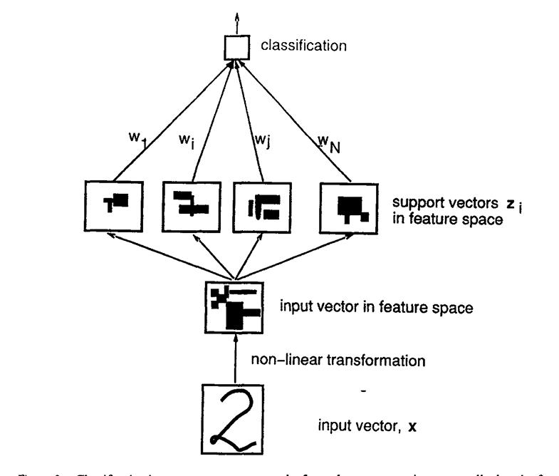
Classification by a support-vector network of an unknown pattern. The input vector is first transformed into a high-dimensional feature space using a nonlinear transformation, where an optimal hyperplane is constructed to perform classification.
Source[24]: C. Cortes and V. Vapnik, Support-Vector Networks, Machine Learning, vol. 20, no. 3, pp. 273–297, 1995, Fig. 3.
Logistic Regression (LR)
"Logistic regression is a probabilistic statistical classification model that predicts the probability of the occurrence of an event."
Logistic (Sigmoid) Function [25]
$$P(y=1∣x)=\frac{1}{1+e^{-(w^{T}x+b)}}$$
This equation represents the logistic (sigmoid) function, which transforms the linear output into a probability value between 0 and 1, indicating the likelihood that a sample belongs to the positive class.
Where
- $P(y=1∣x)$: Probability that the input belongs to the positive class.
- $w$: Weight vector.
- $x$: Input feature vector.
- $b$: Bias term.
- $e$: Euler's constant.
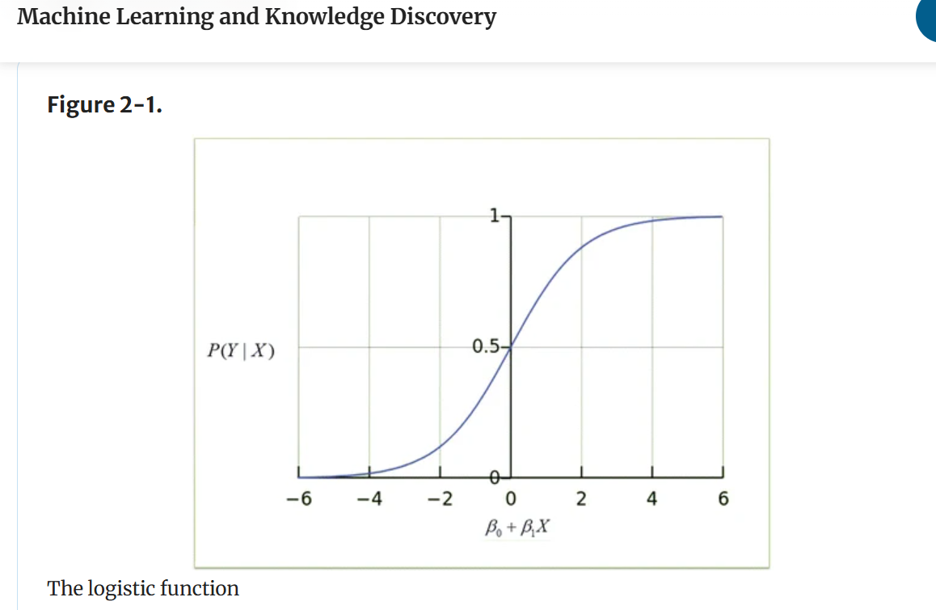
Figure [25] illustrates the logistic (sigmoid) function used in logistic regression. The function maps the linear predictor $\left(β_{0} + β_{1}X\right)$to a probability value ranging from 0 to 1, enabling binary classification.
Random Forest (RF)
"The random forest algorithm formalized by Breiman (2001) is a supervised learning method applied to predict the class for a classification problem or the mean value of a target variable of a regression problem.[26]"
Majority Voting [27]
$$\hat{y}=mode⁡\left\{h_{1}(x),h_{2}(x),…,h_{K}(x)\right\}$$
This equation represents the prediction mechanism of the Random Forest classifier, where the final class is determined by the majority vote of all decision trees.
Where
- $\hat{y}$: Final predicted class.
- $h_{i}(x)$: Prediction of the $i^{th}$decision tree.
- $K$: Total number of trees in the forest.
- $mode⁡$: Majority voting function.
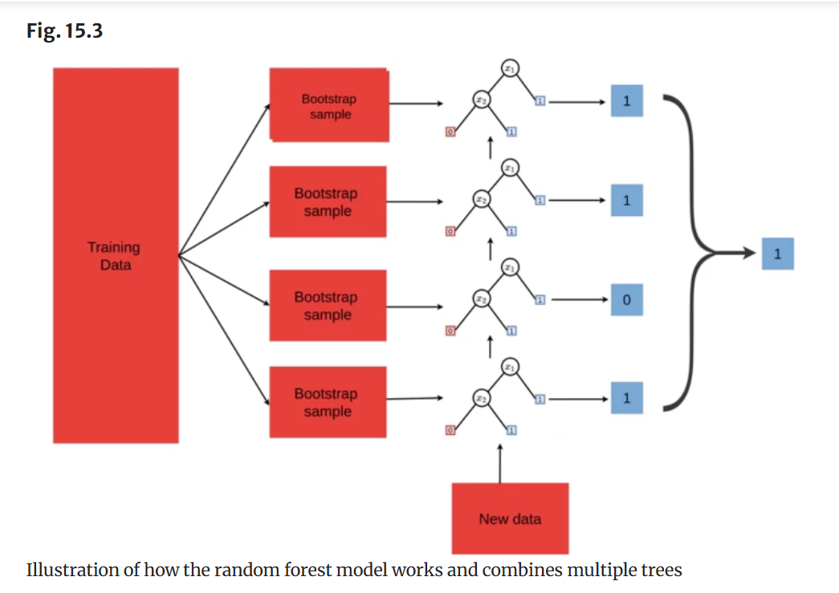

Source: Adapted from Random Forest for Genomic Prediction, Springer, Fig. 15.3.
Decision Tree (DT)
"A decision tree is a prediction model used in various fields ranging from social science to astrophysics. Given a set of data, logic construction diagrams are manufactured that are very similar to rule-based prediction systems, which serve to represent and categorize a series of conditions that occur in succession, to solve a problem. Nodes in a decision tree involve testing a particular independent variable (attribute). Often, an attribute value is compared with a constant."[28]

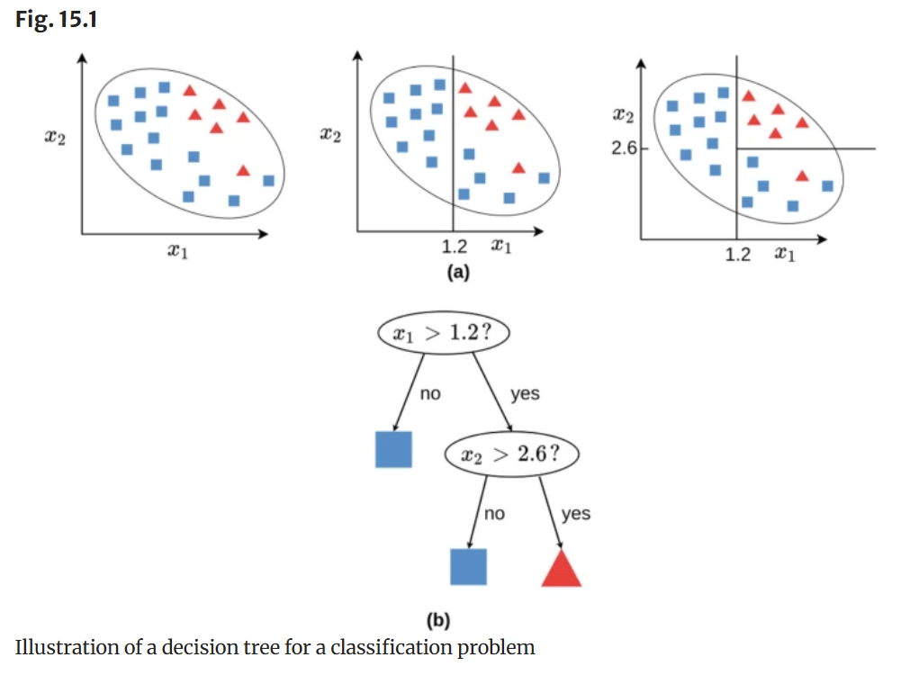
Source [29] : A. C. de Lima, Decision Trees, in Statistical Machine Learning for Genomic Prediction, Springer, 2022, Fig. 15.1.
Equation [30]
$$Gain(S,A)=Entropy(S)-\sum_{v∈Values(A)}{\frac{∣S_{v}∣}{∣S∣}}Entropy(S_{v})$$
Where:
- $Gain(S,A)$: Information Gain obtained by splitting dataset $S$using attribute $A$.
- $Entropy(S)$: Entropy of the original dataset before splitting.
- $Values(A)$: Set of all possible values of attribute $A$.
- $S_{v}$: Subset of dataset $S$corresponding to value $v$of attribute $A$.
- $∣S_{v}∣$: Number of samples in subset $S_{v}$.
- $∣S∣$: Total number of samples in the original dataset.
- $Entropy(S_{v})$: Entropy of subset $S_{v}$.
K-Nearest Neighbors (KNN)
"The K-nearest neighbor (KNN) algorithm is a theoretically mature method and one of the simplest machine learning algorithms. The KNN algorithm is a non-parametric method, which tends to perform better in datasets with irregular decision boundaries. The idea of this method is: if most of the K nearest samples (i.e., nearest neighbors in the feature space) of a sample in the feature space belong to a certain category, then the sample also belongs to this category.[31]"
Euclidean Distance Equation [32]
$$d(x,x^{'})={∥x-x^{'}∥}_{2}=\sqrt{\sum_{j=1}^{p}{{\left(x_{j} − x_{j}^{'}\right)}^{2}}}$$
Where:
- $d(x,x^{'})$: The Euclidean distance between the two samples $x$and $x^{'}$.
- $x$: The feature vector representing the query or test sample.
- $x^{'}$: The feature vector representing a training sample.
- ${∥x-x^{'}∥}_{2}$: The $L_{2}$-norm of the difference between the two feature vectors.
- $x_{j}$: The value of the $j^{th}$feature in sample $x$.
- $x_{j}^{'}$: The value of the $j^{th}$feature in sample $x^{'}$.
- $j$: The index of a feature.
- $p$: The total number of features or dimensions.
- $\sum_{j=1}^{p}{}$: The summation over all features, from the first feature to the $p^{th}$feature.
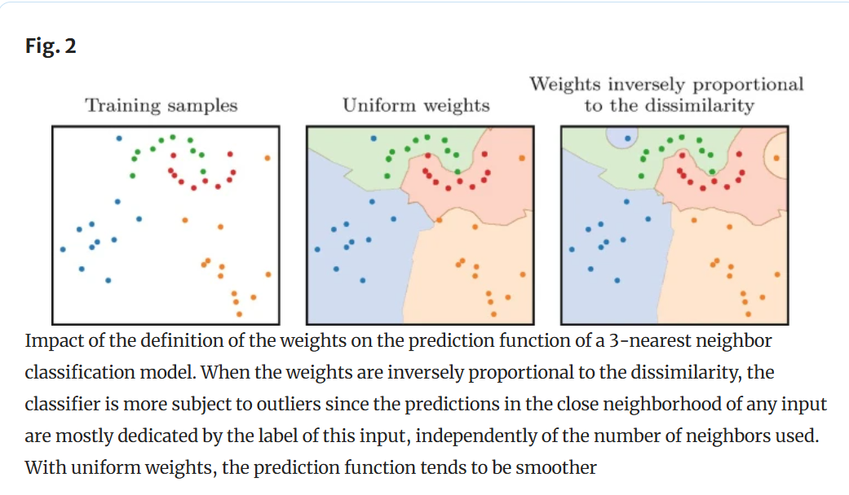
Figure 32. Effect of uniform and distance-based weighting on the decision boundaries of a 3-nearest neighbor classifier.
Source: Reproduced from [32, Fig. 2].
XGBoost
"Tree boosting is a highly effective and widely used machine learning method. In this paper, we describe a scalable end-to-end tree boosting system called XGBoost, which is used widely by data scientists to achieve state-of-the-art results on many machine learning challenges.[33]"
$$L(ϕ)=\sum_{i}{l(}{\hat{y}}_{i},y_{i})+\sum_{k}{Ω(}f_{k})$$where
$$Ω(f)=γT+\frac{1}{2}λ∥w∥^{2}$$
- $L(ϕ)$: Overall objective function.
- $l({\hat{y}}_{i},y_{i})$: Differentiable loss function measuring the discrepancy between the predicted value ${\hat{y}}_{i}$and the true value $y_{i}$.
- ${\hat{y}}_{i}$: Predicted value of the $i$-th sample.
- $y_{i}$: True value of the $i$-th sample.
- $Ω(f)$: Regularization term used to penalize model complexity.
- $f_{k}$: The $k$-th regression tree.
- $K$: Total number of regression trees.
- $γ$: Penalty coefficient for the number of leaves.
- $T$: Number of leaf nodes in a tree.
- $λ$: L2 regularization parameter.
- $w$: Vector of leaf weights.
- $∥w∥^{2}$: Squared L2 norm of the leaf weight vector.
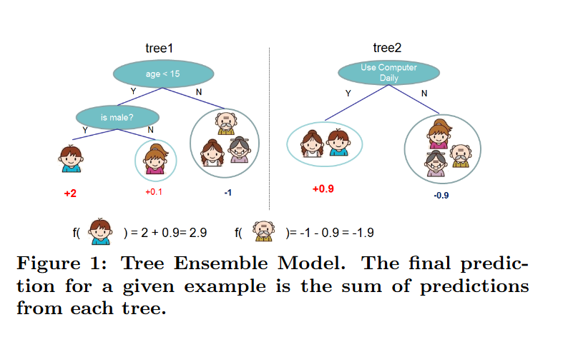
Figure 33. Tree ensemble model used in XGBoost, where the final prediction is obtained by summing the outputs of all individual trees.
Source: Adapted from [33].
Deep Learning Models
Deep learning is defined as “a form of machine learning that enables computers to learn from experience and understand the world in terms of a hierarchy of concepts” [34].
Recurrent Neural Network (RNN)
"Recurrent neural networks ،or RNNs (Rumelhart et al., 1986a), are a family of neural networks for processing sequential data. Much as a convolutional network is a neural network that is specialized for processing a grid of values X such as an image.[35]"
$$h^{\left(t\right)}=f\left(h^{\left(t − 1\right)},x^{\left(t\right)};θ\right)$$
Where:
- $h^{\left(t\right)}$: Hidden state at time step $t$.
- $h^{\left(t − 1\right)}$: Hidden state at the previous time step.
- $x^{\left(t\right)}$: Input at time step $t$.
- $f(⋅)$: Nonlinear activation function.
- $θ$: Model parameters (weights and biases).
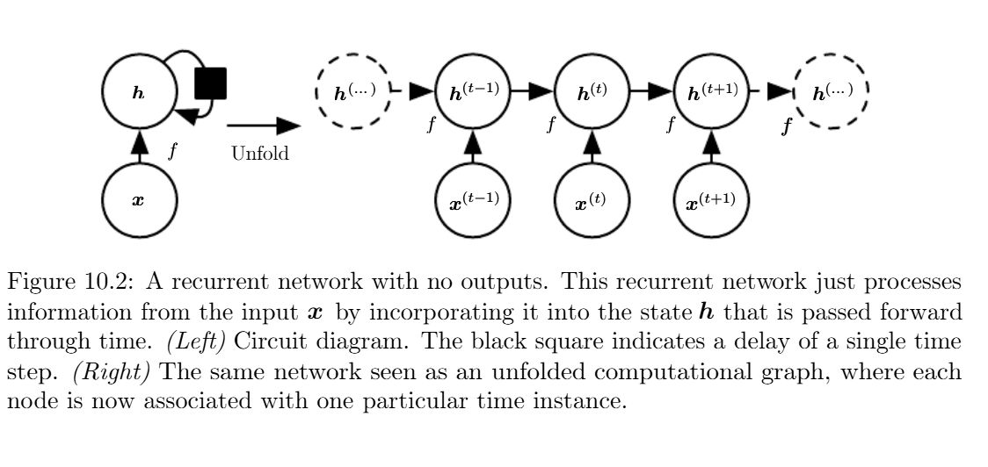
Figure 35. A recurrent neural network with no outputs, shown as a circuit diagram and as an unfolded computational graph through time.
Source: Reproduced from [35, Fig. 10.2].
Long Short-Term Memory (LSTM)
"is a type of gated RNN which was proposed in 1997 . Due to the property of remembering the long-term dependencies, LSTM has been a successful model in many applications like speech recognition, machine translation, image captioning, etc. LSTM has an inner self loop in addition to the outer recurrence of the RNN. The gradients in the inner loop can flow for longer duration and are conditioned on the context rather than being fixed. In each cell, the input and output is the same as that of ordinary RNN but has a system of gating units to control the flow of information.[36] "
The LSTM model uses three gates to control the information stored, updated, and released by the memory cell:
$$f_{t}=σ\left(U_{f}x_{t} + W_{f}h_{t-1} + b_{f}\right) \\ i_{t}=σ\left(U_{i}x_{t} + W_{i}h_{t-1} + b_{i}\right) \\ c_{t}=f_{t}⊙c_{t-1}+i_{t}⊙tanh⁡\left(U_{c}x_{t} + W_{c}h_{t-1} + b_{c}\right) \\ o_{t}=σ\left(U_{o}x_{t} + W_{o}h_{t-1} + b_{o}\right) \\ h_{t}=o_{t}⊙tanh⁡(c_{t})$$
Where:
- $f_{t}$: Forget gate vector at time step $t$.
- $i_{t}$: Input gate vector at time step $t$.
- $o_{t}$: Output gate vector at time step $t$.
- $c_{t}$: Cell state at time step $t$.
- $c_{t-1}$: Cell state at the previous time step.
- $h_{t}$: Hidden state at time step $t$.
- $h_{t-1}$: Hidden state at the previous time step.
- $x_{t}$: Input vector at time step $t$.
- $U$and $W$: Input and recurrent weight matrices.
- $b$: Bias vector.
- $σ$: Sigmoid activation function.
- $tanh⁡$: Hyperbolic tangent activation function.
- $⊙$: Element-wise multiplication.

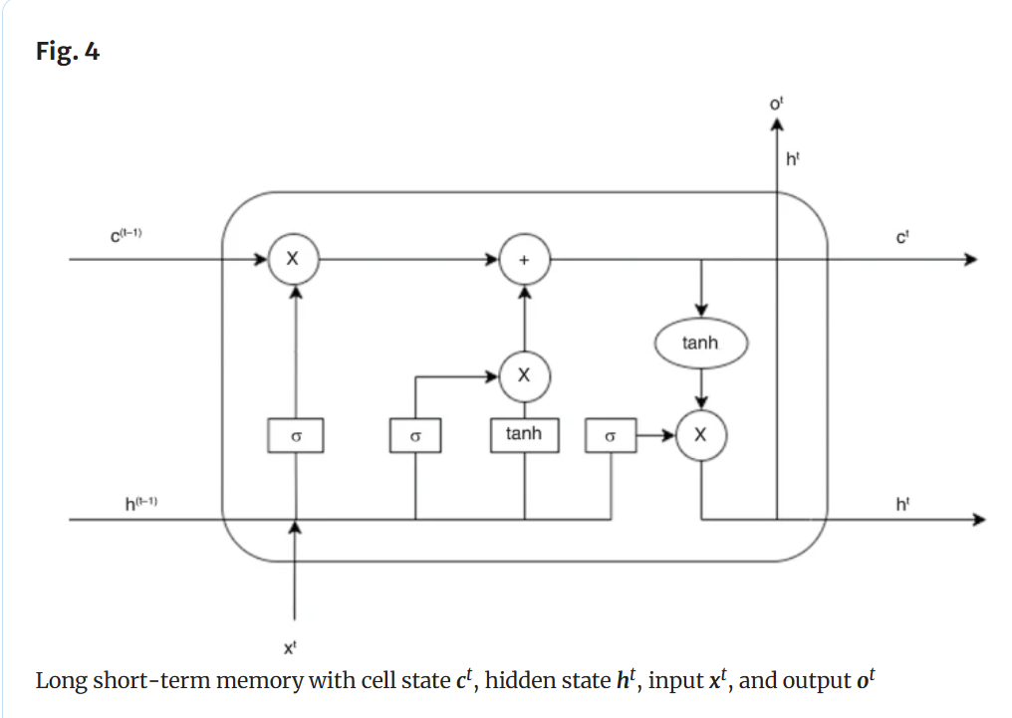
Figure 36 . Long short-term memory architecture showing the cell state $c^{t}$, hidden state $h^{t}$, input $x^{t}$, and output $o^{t}$.
Source: Reproduced from [36, Fig. 4]
BiLSTM
"BiLSTMs “consist of two LSTMs that are run in parallel: one on the input sequence and the other on the reverse of the input sequence”. The hidden state of the BiLSTM is the result of the concatenation of the forward and backward hidden states at each time step, allowing the BiLSTM to capture both past and future information.[37] "
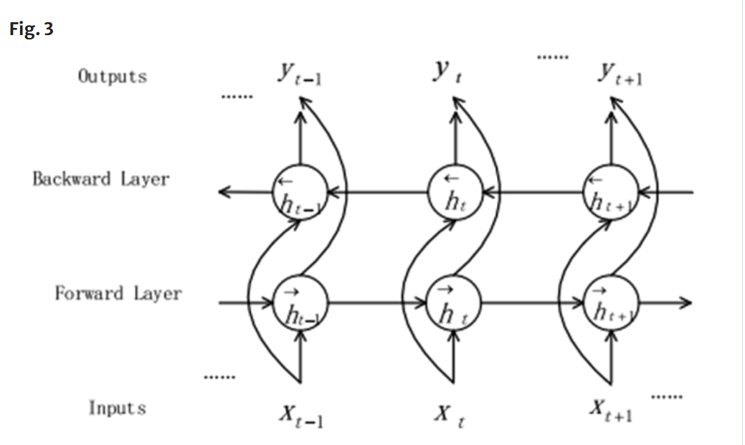
$$\vec{h_{t}}=tanh⁡\left(W_{x\vec{h}}x_{t} + W_{\vec{h}\vec{h}}{\vec{h}}_{t-1} + b_{\vec{h}}\right) \\ \overset{⃖}{h_{t}}=tanh⁡\left(W_{x\overset{⃖}{h}}x_{t} + W_{\overset{⃖}{h}\overset{⃖}{h}}{\overset{⃖}{h}}_{t-1} + b_{\overset{⃖}{h}}\right) \\ y_{t}=W_{\vec{h}y}{\vec{h}}_{t}+W_{\overset{⃖}{h}y}{\overset{⃖}{h}}_{t}+b_{y}$$Figure 37. Architecture of a bidirectional recurrent neural network with forward and backward hidden layers.
Source: Reproduced from [37, Fig. 3].

Convolutional Neural Network (CNN)
“Convolutional networks, also known as convolutional neural networks, or CNNs, are a specialized kind of neural network for processing data that has a known grid-like topology.[38]”
Mathematical Representation
The following equations are reproduced from [39]:
$$s(t)=(x*w)(t)=\sum_{a=-∞}^{∞}{x(a)w(t-a)}$$
Where:
- $s(t)$: The output feature map at position $t$.
- $x(a)$: The input value at position $a$.
- $w(t-a)$: The convolution kernel or filter weight.
- $w$: The convolution kernel used to extract local features.
- $*$: The convolution operation.
- $a$: The index over the input sequence.
- $t$: The position of the resulting feature in the output sequence.
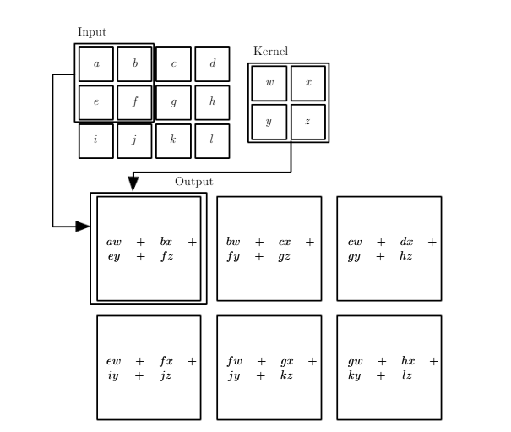
Figure 39. Two-dimensional convolution using a $2×2$kernel applied to a $3×4$input matrix.
Source: Reproduced from [39, Fig. 9.1, p. 328].

Transformer-Based Models
"The Transformer similar to RNN-translation models is based on an encoder and a decoder module. The encoder is very similar to BERT, while the decoder resembles GPT. It is a sequence-to-sequence model (Seq2seq), which translates a source text of the input language to a target text in the target language. Instead of relating distant tokens by a large number of computation steps, it directly computes the self-attention between these tokens in parallel in one step.[40]"
The scaled dot-product attention mechanism is defined as [40]:
$$Attention⁡(Q,K,V)=softmax⁡\left(\frac{QK^{T}}{\sqrt{d_{k}}}\right)V$$
Where:
$Q$: the query matrix.
$K$: the key matrix.
$V$: the value matrix.
$K^{T}$: the transpose of the key matrix.
$QK^{T}$: the matrix of dot-product scores between the query and key vectors.
$d_{k}$: the dimensionality of the key vectors.
$\sqrt{d_{k}}$: the scaling factor used to prevent the dot-product scores from becoming excessively large.
$softmax⁡(⋅)$: the normalization function that converts the scaled scores into attention weights.
$softmax⁡\left(\frac{QK^{T}}{\sqrt{d_{k}}}\right)V$: the weighted sum of the value vectors.
$Attention⁡(Q,K,V)$: the contextualized output produced by the attention mechanism.
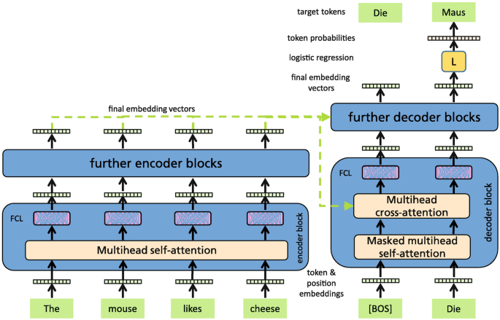
Figure 40. Transformer encoder–decoder architecture showing self-attention, masked self-attention, and cross-attention mechanisms.
Source: Reproduced from [40, Fig. 2.13].
BERT (Bidirectional Encoder Representations from Transformers)
“BERT (Bidirectional Encoder Representations from Transformers) was proposed by Devlin et al. and is an important approach for generating contextual embeddings. BERT is based on the concept of attention and on the Transformer architecture.[41]”
The BERT input representation is formed by summing the token, position, and segment embeddings, as follows [41]:
$$x_{t}=e_{t}^{\text{token}}+e_{t}^{\text{position}}+e_{t}^{\text{segment}}$$
Where:
$x_{t}$: the final input representation of the token at position $t$.
$e_{t}^{token}$: the token embedding representing the lexical identity of the token.
$e_{t}^{position}$: the positional embedding representing the token’s position in the input sequence.
$e_{t}^{segment}$: the segment embedding indicating whether the token belongs to the first or second input segment.
$t$: the position of the token in the input sequence.
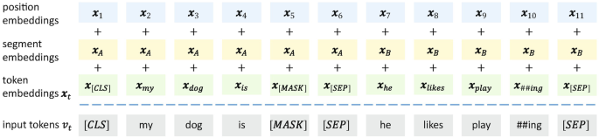
Figure 41 . BERT input representation formed by summing token, segment, and position embeddings.
Source: Reproduced from [41, Fig. 2.1].
AraBERT
" We use the BERT-base configuration that has 12 encoder blocks, 768 hidden dimensions, 12 attention heads, 512 maximum sequence length, and a total of 110M parameters1 . We also introduced additional preprocessing prior to the model’s pre-training, in order to better fit the Arabic language.[42] "
AraBERT follows the BERT-base architecture and therefore relies on the same bidirectional Transformer encoder and self-attention mechanism described previously.

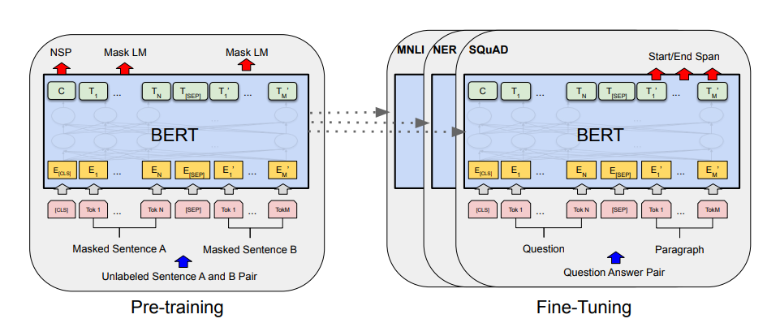
Figure 43. Overall pre-training and fine-tuning procedures for BERT, which provides the underlying architecture for AraBERT.
Source: Reproduced from [43, Fig. 1].
MARBERT
“MARBERT is a new model pre-trained from scratch using a large Twitter dataset. It uses the same network architecture as BERTBase, but without the next sentence prediction objective.”[44]
MARBERT follows the BERTBase architecture and therefore uses the same self-attention mechanism described previously. Unlike the original BERT pre-training procedure, MARBERT is trained without the Next Sentence Prediction objective.
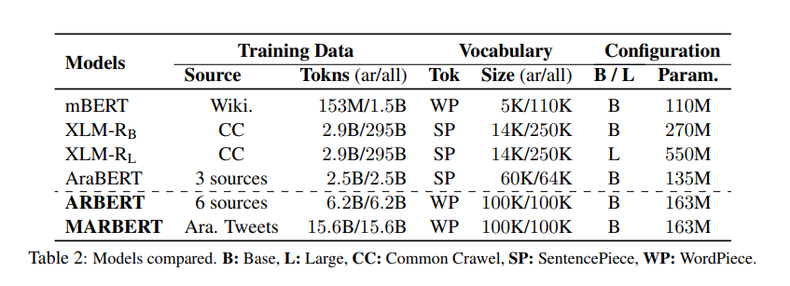
Comparison of MARBERT with other multilingual and Arabic pre-trained language models. [ 44]
CAMeLBERT
CAMeLBERT is a family of Arabic pre-trained language models developed to investigate the influence of Arabic language variants and pre-training data size on downstream NLP tasks[45].
CAMeLBERT-MSA
CAMeLBERT-MSA is a variant-specific language model pre-trained on Modern Standard Arabic (MSA) data The model is intended to capture linguistic characteristics associated primarily with Modern Standard Arabic[45].
CAMeLBERT-DA
CAMeLBERT-DA is a variant-specific language model pre-trained on Dialectal Arabic (DA) data collected. This model is particularly relevant to Arabic dialect identification because its pre-training data represents several Arabic dialect varieties [45].
CAMeLBERT-CA
CAMeLBERT-CA is a variant-specific language model pre-trained on Classical Arabic (CA) data. The model was designed to represent the linguistic features of historical and classical Arabic texts [45].
CAMeLBERT-Mix
CAMeLBERT-Mix is a mixed-variant language model pre-trained on a combination of Modern Standard Arabic, Dialectal Arabic, and Classical Arabic. The model provides broader coverage of Arabic linguistic variation by combining the three major Arabic variants within a single pre-training corpus[45].
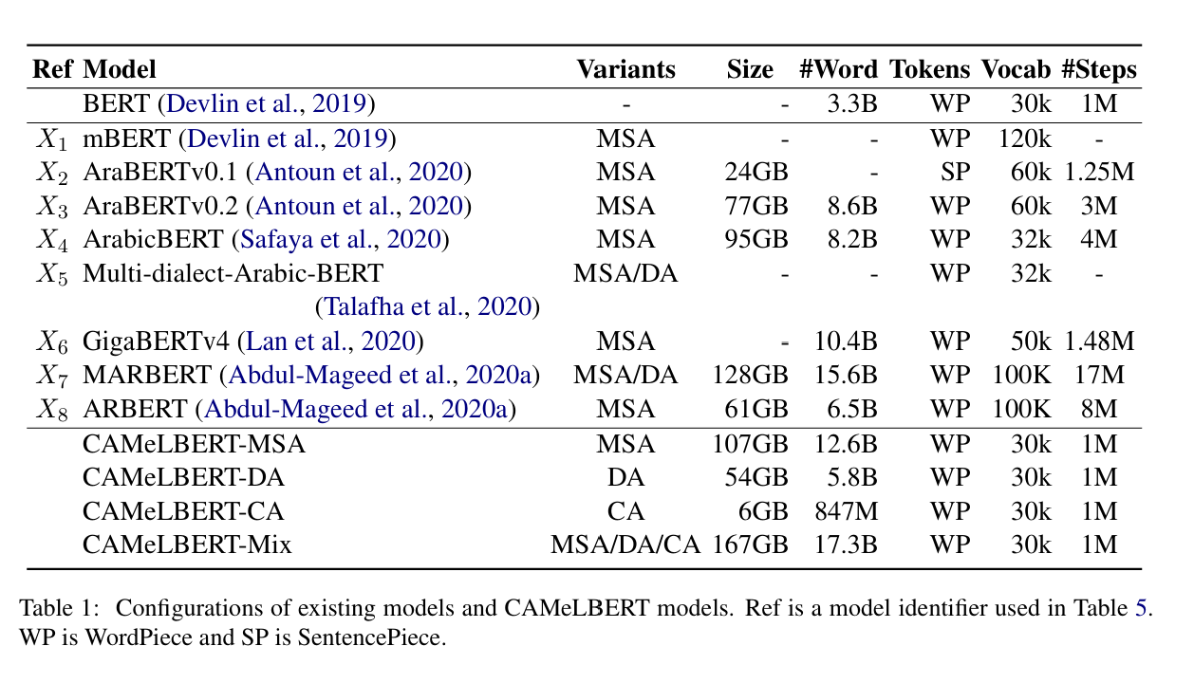
Table 45. Pre-training configurations of the CAMeLBERT model variants.
Source: Reproduced from [45, Table 1].

References:
[1] S. Bird, E. Klein, and E. Loper, Natural Language Processing with Python: Analyzing Text with the Natural Language Toolkit. Sebastopol, CA, USA: O’Reilly Media, 2009.
[1] X. Han, S. Gao, Y. Lin, Z. Liu, M. Sun, and J. Zhou, "Word-Level Semantics Encoding," in Knowledge Representation Learning and Knowledge-Guided NLP, Singapore: Springer, 2023.
[2] C. D. Manning, P. Raghavan, and H. Schütze, Introduction to Information Retrieval. Cambridge, U.K.: Cambridge University Press, 2008.
[3] [X] W. J. Wilbur and W. Kim, “The ineffectiveness of within-document term frequency in text classification,” Information Retrieval, vol. 12, no. 5, pp. 509–525, 2009, doi: 10.1007/s10791-008-9069-5.
[4] University of Pennsylvania, “CIS 4190/5190: Applied Machine Learning—Lecture 16: NLP (Part 2),” Spring 2025. [Online]. Available: https://www.seas.upenn.edu/~cis5190/spring2025/docs/lecture18.pdf
[5] Abu El-Khair, I., "TF*IDF," in Encyclopedia of Database Systems, 2nd ed., L. Liu and M. T. Özsu, Eds. New York, NY, USA: Springer, 2018.
[6] C. D. Manning, P. Raghavan, and H. Schütze, Introduction to Information Retrieval. Cambridge, U.K.: Cambridge University Press, 2008, pp. 117–120.
[7] H. Chen, B. Martin, C. M. Daimon, and S. Maudsley, “Effective use of latent semantic indexing and computational linguistics in biological and biomedical applications,” Frontiers in Physiology, vol. 4, Art. no. 8, Jan. 2013, doi: 10.3389/fphys.2013.00008.
[8] D. Jurafsky and J. H. Martin, Speech and Language Processing: An Introduction to Natural Language Processing, Computational Linguistics, and Speech Recognition, 3rd ed. Stanford, CA, USA: Stanford University, 2025.
[9] C. D. Manning and H. Schütze, Foundations of Statistical Natural Language Processing. Cambridge, MA, USA: MIT Press, 1999.
[10] A. Altun, A Consolidated Approach for Detecting Design Patterns Using NLP, M.S. thesis, Dept. of Computer Engineering, Izmir University of Economics, İzmir, Türkiye, 2025.
[11] Z. Liu, Y. Lin, and M. Sun, Representation Learning for Natural Language Processing. Singapore: Springer, 2020.
[12] Z. Liu, Y. Lin, and M. Sun, Representation Learning for Natural Language Processing. Singapore: Springer Nature Singapore Pte Ltd., 2020.
[13] M. V. Wüthrich and M. Merz, Statistical Foundations of Machine Learning. Springer, 2023.
[14] J. Pennington, R. Socher, and C. D. Manning, “GloVe: Global Vectors for Word Representation,” Proceedings of the 2014 Conference on Empirical Methods in Natural Language Processing (EMNLP), Doha, Qatar, 2014, pp. 1532–1543.
[15] J. Pennington, R. Socher, and C. D. Manning, “GloVe: Global Vectors for Word Representation,” Proceedings of the 2014 Conference on Empirical Methods in Natural Language Processing (EMNLP), Doha, Qatar, 2014, pp. 1532–1543.
[16] P. Bojanowski, E. Grave, A. Joulin, and T. Mikolov, "Enriching Word Vectors with Subword Information," Transactions of the Association for Computational Linguistics, vol. 5, pp. 135–146, 2017, doi: 10.1162/tacl_a_00051.
[17] Y. Labrak, “Language models at the crossroads of text and speech for health applications,” Ph.D. dissertation, Avignon Université, Avignon, France, 2025.
[18] T. M. Mitchell, Machine Learning. New York, NY, USA: McGraw-Hill, 1997.
[19] G. I. Webb, "Naïve Bayes," in Encyclopedia of Machine Learning, C. Sammut and G. I. Webb, Eds. Boston, MA, USA: Springer, 2011.
[20] K. P. Murphy, Machine Learning: A Probabilistic Perspective. Cambridge, MA, USA: MIT Press, 2012.
[21] N. Beerenwinkel and J. Siebourg, "Probability, Statistics, and Computational Science," in Evolutionary Genomics, M. Anisimova, Ed., Methods in Molecular Biology, vol. 1910. New York, NY, USA: Humana, 2019, pp. 33–70, doi: 10.1007/978-1-4939-9074-0_2.
[22] R. G. Negri, “Support Vector Machines,” in Encyclopedia of Mathematical Geosciences, Encyclopedia of Earth Sciences Series, Springer, 2023.
[23] C. Cortes and V. Vapnik, “Support-Vector Networks,” Machine Learning, vol. 20, no. 3, pp. 273–297, Sep. 1995, doi: 10.1007/BF00994018.
[24] C. Cortes and V. Vapnik, “Support-Vector Networks,” Machine Learning, vol. 20, no. 3, pp. 273–297, Sep. 1995, doi: 10.1007/BF00994018.
[25] V. Kotu and B. Deshpande, “Logistic Regression,” in Machine Learning: Classification Algorithms, in Data Science: Concepts and Practice. Berkeley, CA, USA: Apress, 2015, ch. 2.
[26] E. D. Attanasi and T. C. Coburn, “Random Forest,” in Encyclopedia of Mathematical Geosciences, B. S. Daya Sagar, Q. Cheng, J. McKinley, and F. Agterberg, Eds., Encyclopedia of Earth Sciences Series. Cham, Switzerland: Springer, 2023, pp. 1182–1185. doi: 10.1007/978-3-030-85040-1_265.
[27] G. de los Campos and J. M. Hickey, “Random Forest for Genomic Prediction,” in Statistical Machine Learning for Genomic Prediction. Cham, Switzerland: Springer, 2021.
[28] A. C. de Lima, “Decision Trees,” in Statistical Machine Learning for Genomic Prediction. Cham, Switzerland: Springer, 2022, ch. 15. doi: 10.1007/978-3-030-89010-0_15.
[29] A. C. de Lima, “Decision Trees,” in Statistical Machine Learning for Genomic Prediction. Cham, Switzerland: Springer, 2022, ch. 15. doi: 10.1007/978-3-030-89010-0_15.
[30] J. R. Quinlan, “Induction of Decision Trees,” Machine Learning, vol. 1, no. 1, pp. 81–106, 1986, doi: 10.1007/BF00116251.
[31] Y. Zhang, “K-Nearest Neighbor Algorithm,” in Machine Learning, Singapore: Springer, 2022, pp. 70–72. doi: 10.1007/978-981-19-2879-6_2.
[32] L. Brunet, M. Bouhaddou, and E. M. Marcotte, “Classic Machine Learning Methods,” in Machine Learning for Biological and Translational Research, vol. 2709, Methods in Molecular Biology, New York, NY, USA: Humana, Springer, 2023. doi: 10.1007/978-1-0716-3195-9_2.
[33] Chen, T., & Guestrin, C. (2016). XGBoost: A Scalable Tree Boosting System. Proceedings of the 22nd ACM SIGKDD International Conference on Knowledge Discovery and Data Mining (KDD '16).
[34] I. Goodfellow, Y. Bengio, and A. Courville, Deep Learning. Cambridge, MA, USA: MIT Press, 2016.
[35] I. Goodfellow, Y. Bengio, and A. Courville, Deep Learning. Cambridge, MA, USA: MIT Press, 2016.
[36] S. Das, A. Tariq, T. Santos, S. S. Kantareddy, and I. Banerjee, “Recurrent Neural Networks (RNNs): Architectures, Training Tricks, and Introduction to Influential Research,” in Machine Learning for Brain Disorders, O. Colliot, Ed. New York, NY, USA: Humana, 2023, pp. 117–138, doi: 10.1007/978-1-0716-3195-9_4.
[37] M. S. Zaoad, M. M. R. Mannan, A. B. Mandol, M. Rahman, M. A. Islam, and M. M. Rahman, “An attention-based hybrid deep learning approach for Bengali video captioning,” Journal of King Saud University–Computer and Information Sciences, vol. 35, pp. 257–269, Jan. 2023, doi: 10.1016/j.jksuci.2022.11.015.
[38] Y. LeCun, L. Bottou, Y. Bengio, and P. Haffner, “Gradient-Based Learning Applied to Document Recognition,” Proceedings of the IEEE, vol. 86, no. 11, pp. 2278–2324, 1998.
[39]I. Goodfellow, Y. Bengio, and A. Courville, Deep Learning. Cambridge, MA, USA: MIT Press, 2016, ch. 9, p. 328.
[40] G. Paaß and S. Giesselbach, “Pre-trained language models,” in Foundation Models for Natural Language Processing. Cham, Switzerland: Springer, 2023, pp. 19–78, doi: 10.1007/978-3-031-23190-2_2.
[41] G. Paaß and S. Giesselbach, “Pre-trained language models,” in Foundation Models for Natural Language Processing. Cham, Switzerland: Springer, 2023, pp. 19–78, doi: 10.1007/978-3-031-23190-2_2.
[42] W. Antoun, F. Baly, and H. Hajj, “AraBERT: Transformer-based model for Arabic language understanding,” in Proc. 4th Workshop Open-Source Arabic Corpora and Processing Tools, with a Shared Task on Offensive Language Detection, Marseille, France, 2020, pp. 9–15.
[43] J. Devlin, M.-W. Chang, K. Lee, and K. Toutanova, “BERT: Pre-training of deep bidirectional transformers for language understanding,” in Proc. 2019 Conf. North American Chapter Assoc. Comput. Linguistics: Human Language Technologies, Minneapolis, MN, USA, 2019, pp. 4171–4186.
[44] M. Abdul-Mageed, A. Elmadany, and E. M. B. Nagoudi, “ARBERT & MARBERT: Deep bidirectional transformers for Arabic,” in Proceedings of the 59th Annual Meeting of the Association for Computational Linguistics and the 11th International Joint Conference on Natural Language Processing, vol. 1, Online, 2021, pp. 7088–7105.
[45] G. Inoue, B. Alhafni, N. Baimukan, H. Bouamor, and N. Habash, “The interplay of variant, size, and task type in Arabic pre-trained language models,” in Proceedings of the Sixth Arabic Natural Language Processing Workshop, Kyiv, Ukraine, Apr. 2021, pp. 92–104.

