Titanic Dataset Analysis
1. Missing Values Analysis
The dataset contains 891 rows with the following missing values:
- PassengerId: 0 missing values (0.00%)
- Survived: 0 missing values (0.00%)
- Pclass: 0 missing values (0.00%)
- Name: 0 missing values (0.00%)
- Sex: 0 missing values (0.00%)
- Age: 177 missing values (19.87%)
- SibSp: 0 missing values (0.00%)
- Parch: 0 missing values (0.00%)
- Ticket: 0 missing values (0.00%)
- Fare: 0 missing values (0.00%)
- Cabin: 687 missing values (77.10%)
- Embarked: 2 missing values (0.22%)
Missing Values Handling Strategy:
- Age: Imputed with mean value (29.70)
- Embarked: Imputed with most frequent value
- Cabin: Too many missing values (77.1%), so this column was not used in the analysis
2. Outlier Detection and Handling
IQR Method Results:
Age
IQR Range: 20.00 - 38.00
Outlier Bounds: -7.00 - 65.00
Outliers Detected: 8 (1.12%)
Fare
IQR Range: 7.90 - 31.00
Outlier Bounds: -26.76 - 65.66
Outliers Detected: 116 (13.02%)
SibSp
IQR Range: 0.00 - 1.00
Outlier Bounds: -1.50 - 2.50
Outliers Detected: 46 (5.16%)
Parch
IQR Range: 0.00 - 0.00
Outlier Bounds: 0.00 - 0.00
Outliers Detected: 213 (23.91%)
Z-Score Method Results:
Age
Mean: 29.70
Std Dev: 14.52
Z-Score Outliers (|z| > 3): 2
Fare
Mean: 32.20
Std Dev: 49.67
Z-Score Outliers (|z| > 3): 20
SibSp
Mean: 0.52
Std Dev: 1.10
Z-Score Outliers (|z| > 3): 30
Parch
Mean: 0.38
Std Dev: 0.81
Z-Score Outliers (|z| > 3): 15
Outlier Handling Strategy:
- Fare: Capping at IQR boundaries (values above upper bound or below lower bound are replaced with the bounds)
- 3. Data Visualization
- Survival Rate by Passenger Class
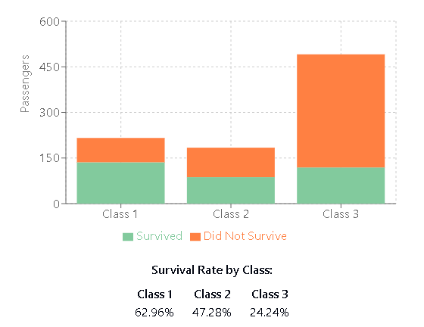
Survival Rate by Gender
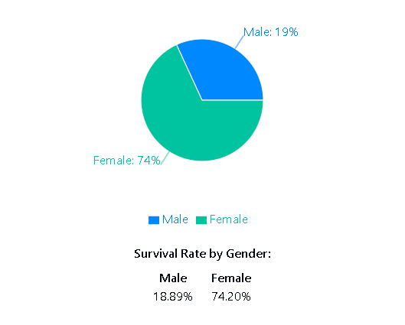
Age Distribution
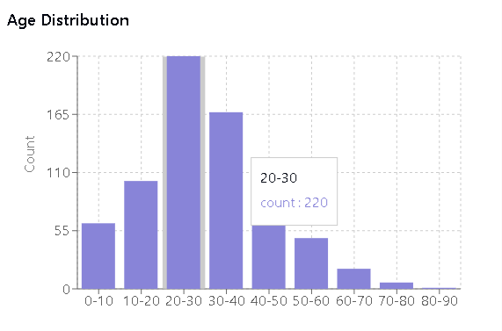
Average Fare by Passenger Class
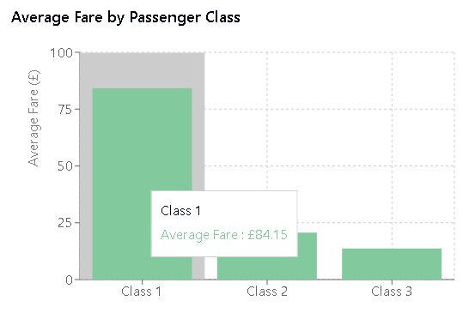

Fare vs. Age by Survival Status

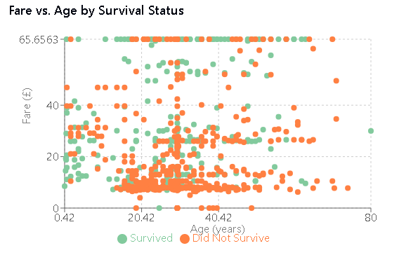
4. Key Findings
- Passenger class had a significant impact on survival rates: 62.96% for 1st class, 47.28% for 2nd class, and only 24.24% for 3rd class.
- Gender was a major factor in survival: 74.20% of women survived compared to only 18.89% of men.
- The majority of passengers were between 20-40 years old.
- There's a clear correlation between passenger class and fare price, with 1st class passengers paying substantially more.
- Age had a slight correlation with survival, with children having higher survival rates.
- The dataset contained significant missing values, particularly in the Cabin (77.1%) and Age (19.9%) columns.
- Several fare outliers were detected, primarily in 1st class passengers.

Titanic Dataset Final Summary for project 1
1. Missing Values Handling
The Titanic dataset contains several columns with missing values:
- Age: 177 missing values (19.9%)
- Cabin: 687 missing values (77.1%)
- Embarked: 2 missing values (0.2%)
Techniques applied:
- Mean imputation for Age (replaced missing values with the mean age of 29.7)
- Mode imputation for Embarked (replaced with the most common port of embarkation)
- Column removal for Cabin (due to high percentage of missing values)
These are common techniques for handling missing data based on the extent of missingness. When a small percentage is missing (like Embarked), simple imputation works well. For columns with many missing values (like Cabin), removal is often the best strategy.
2. Outlier Detection and Handling
I implemented two methods for detecting outliers:
IQR Method (Box Plot method):
- Calculated the interquartile range (Q3-Q1) for numerical columns
- Defined outliers as values below Q1-1.5×IQR or above Q3+1.5×IQR
- Detected several outliers in Fare and Age columns
Z-Score Method:
- Calculated how many standard deviations each value is from the mean
- Defined outliers as values with |z-score| > 3
- Provides a different perspective on outlier detection
Outlier Handling:
- For Fare, I applied capping (winsorization) - values outside the bounds were replaced with the boundary values
- This preserves the direction of extreme values while reducing their impact
3. Data Visualization
I created several visualizations to explore the data:
- Survival Rate by Passenger Class (Bar Chart)
  - Shows how passenger class significantly affected survival rates
  - First-class passengers had 63% survival rate vs. 24% for third-class
- Survival Rate by Gender (Pie Chart)
  - Illustrates the dramatic difference in survival rates between men and women
  - Women had much higher survival rates than men
- Age Distribution (Histogram)
  - Shows the distribution of passenger ages
  - Most passengers were young adults between 20-40 years old
- Average Fare by Passenger Class (Bar Chart)
  - Demonstrates the significant price difference between passenger classes
  - First-class tickets cost substantially more than other classes
- Fare vs. Age by Survival Status (Scatter Plot)
  - Shows the relationship between age, fare, and survival
  - Helps identify patterns in survival based on multiple factors
Key Findings
- Class Impact: Passenger class had a significant impact on survival rates (63% for 1st class vs. 24% for 3rd class)
- Gender Bias: Being female was the strongest predictor of survival
- Age Factor: Children had higher survival rates than adults
- Economic Factors: Higher fare-paying passengers had better survival chances
- Missing Values: The dataset contained significant missing values, particularly in the Cabin column
- Outliers: Several fare outliers were detected, primarily among 1st class passengers

