

AI-Based Construction Site Safety Monitoring System
Prepared By
Name: Mohammed Ali Alhawshabi ID No.: 261002622
Name: Mohammed Omar Baatiyyah ID No.: 261002493
Submitted in fulfillment of the requirements for the degree Master of Science in Artificial Intelligence
At
College of Informatics
Midocean University
UAE
Supervisor Name: Dr. Mohamed Eassa
College of Informatics, Midocean University, Comoros
Email: 261002493@st.midocean.edu.km
Email: 261002622@st.midocean.edu.km

Acknowledgements

We would like to thank our supervisor, Dr. Mohamed Essa, for his continuous guidance and valuable feedback throughout this research. His expertise in both artificial intelligence and galaxy studies has greatly influenced the direction of this work. His comments challenged us to think more critically and approach the research from a scientific perspective rather than a purely technical one.

We are also thankful to the faculty members at the College of Informatics, Midocean University, for providing a supportive academic environment that inspired independent thinking and research development.

Finally, we would like to express our appreciation to our families for their patience, encouragement, and support during this journey.

Abstract

Construction zones stay dangerous. Statistics actually suggest that four out of five accidents happen because of human choices rather than gear failure. Relying on a single foreman to spot every single risk across a massive project is just too slow. But the real issue is that manual checks can't see around every corner at once. This research introduces a live monitoring system that uses existing cameras to track safety metrics-an approach that doesn't stop the actual work or require constant human eyes on every screen. It bridges the gap in supervision.

Gear checks matter. The software confirms that crews have their helmets and high-visibility vests on by using the CHVG data collection. It then switches to skeleton tracking to map out exactly how a person moves through the workspace. By identifying specific body positions, the program can instantly recognize if someone has collapsed or is standing in a way that might lead to a serious back injury (which is a common site problem). This isn't simply a recording tool, nor purely a database. Real-time detection changes the game.

Machines and people often occupy the same tight spaces on a busy project. Collisions happen fast Instead of filling out reports after a fall, the digital eye sends an immediate alert to the site manager so they can act before the situation worsens (which saves time). This study proves that machine learning isn't just for sorting files, it can actively prevent deaths by shifting the industry from a reactive stance to a truly proactive safety culture zero accidents is the goal.

Contents
i
Acknowledgements ii
Abstract iii
List of Abbreviations iv
List of Figures v
List of Tables vi
Chapter 1: Introduction 1
1.1 Overview 1
1.2 Problem Definition 3
1.3 Thesis Objectives 4
1.4 Thesis Contribution 5
1.5 Thesis Organization 5
Chapter 2: Background and Related Work 6
2.1 Introduction 6
2.2 Background 7
2.3 Related work 12
2.4 Related Work Summary 18
Chapter 3: Proposed Approach (Methodology) 21
Chapter 4: Experimental Results and Discussion 22
Chapter 5: Conclusion and Future Work 23
References 24

List of Abbreviations
- AI: Artificial Intelligence.
- CNN: Convolutional Neural Network.
- DL: Deep Learning.
- DECaLS: Dark Energy Camera Legacy Survey.
- GAN: Generative Adversarial Network.
- Grad-CAM: Gradient-weighted Class Activation Mapping.
- MCD: Monte Carlo Dropout.
- ML: Machine Learning.
- RA: Right Ascension.
- SDSS: Sloan Digital Sky Survey.
- XAI: Explainable Artificial Intelligence.
- F1-score: Harmonic mean of precision and recall.
- ViT: Vision Transformer.
- VGG19: Visual Geometry Group 19.
- DCGAN: Deep Convolutional Generative Adversarial Network.
- CvT: Convolutional Vision Transformer.
- S-PLUS: Southern Photometric Local Universe Survey.
- CANDELS: Cosmic Assembly Near-infrared Deep Extragalactic Legacy Survey.
- S0: Lenticular Galaxy.

List of Figures
Figure 1.1: Example of Body PPE need to be worn on construction site 1

List of Tables
Table 2.1:

Chapter 1: Introduction

1.1 Overview
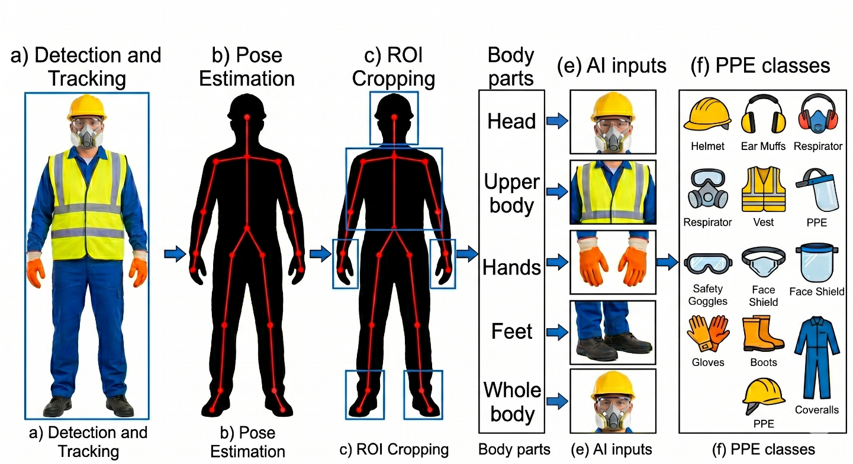
Traditional safety relies on visual monitoring, Supervisors walk across job sites to spot risky habits and offer quick verbal corrections. This method known as Behaviour-Based Safety, certainly helps but hits several hard walls in practice. It demands massive amounts of time and a small army of scouts who often bring their own biases to track every moving piece on a project that never stays the same [1] [2]. Human eyes simply can't see everything. Obviously, this isn't a failure of intent, nor a lack of effort. But the scale of modern builds makes total coverage a pipe dream.
Figure 1.1: Example of Body PPE needs to be worn on construction site

Human eyes often fail, relying on manual oversight creates gaps in safety that physical observers simply cannot fill. This is why engineers now lean on Computer Vision to interpret visual data from site feeds. By granting machines the capacity to decode digital streams, firms gain a tireless watcher that operates through the night (even in low light) far cry from the sporadic checks of a human foreman without getting in the way of the actual building work [1] [2]
Raw camera feeds mean nothing. This research employs specific deep learning architectures to translate visual data into safety metrics. We start with object detection via the YOLO algorithm to scan for gear. It isn't just about finding pixels, the system identifies whether a worker wears a hard hat or vest by rapidly parsing video frames a task requiring high speed computation, safety compliance happens in real-time.
Dynamics matter more than gear, tools such as OpenPose and ST-GCN provide deeper insights into physical behavior. These systems map out a human skeleton to monitor how joints move through space. By analyzing these skeletal graphs over a period (using spatial-temporal networks), the software distinguishes between normal labor and dangerous events like falling or lifting with poor form [1] [3] [4]. It catches what static images miss.
Naturally, gear alone fails it isn't simply a solution, nor purely a distraction, but a baseline that misses the human element. But the project merges YOLO and ST-GCN to map out the messy reality of man-machine contact by analyzing the whole frame what a person wears, their physical gait, and their proximity to equipment the system builds a predictive shield that doesn't just react but anticipates trouble [4].

1.2 Problem Definition
Construction sites are among the most dynamic and hazardous work environments. Workers are exposed every day to serious physical hazards such as falling from a height or being struck by heavy machinery or materials. Statistics demonstrate that the most occupational accidents and fatal injuries on these sites are caused by unsafe behaviour and actions of workers. Therefore, the management of these risks is a very complex task, given that the environment is in constant change [2].
To protect workers from these hazards, construction companies have strict safety regulations requiring the use of Personal Protective Equipment (PPE), such as hard hats, high-visibility vests, and protective glasses. However, ensuring that workers continuously wear this equipment is a major challenge. Workers often fail to comply with safety rules due to discomfort, forgetfulness, or a lack of continuous supervision, which leaves them completely vulnerable to severe and preventable injuries.
Currently, the rules for safety are enforced by human safety officers through manual inspections. This traditional approach has been proven to be highly flawed in that it is subjective, time consuming and prone to human error. It is physically impossible for human supervisors to keep track of every single worker at all times on a large, active construction site. As a result, many unsafe acts and violations of rules for Personal Protective Equipment (PPE) are not observed until an incident occurs.
There is a significant gap in the current technological solutions. While some computer vision systems exist, they usually have a narrow focus. They either only detect static objects (like checking for a helmet) or only track basic body motions in isolation. Very few systems can analyze the complex and dynamic relationships between the worker and their movements. For example, simply tracking a worker's arm movement is not enough; safety systems need to understand if that movement represents a dangerous interaction with a hazardous tool, machine, or material.
Hence the main problem that this thesis is intended to solve is the lack of an integrated, automated and real-time monitoring system. The construction industry urgently needs an intelligent framework that can simultaneously ensure PPE compliance, instantly detect physical injuries or falls, and correctly identify unsafe man-machine interactions before a tragedy occurs [3] [4].

1.3 Thesis Objectives
The main objective of this research is to develop a computer vision based intelligent camera monitoring system for improved safety in construction sites. The particular objectives include:
- To design and train a computer vision model to accurately detect safety helmets and high visibility vests in real-time, based on reliable image data sets.
- To develop a skeleton based action recognition framework for monitoring workers’ postures in real-time and accurately, and for detecting sudden anomalies such as injuries or falls.
- To assess the interaction of construction workers with the environment (man-machine/material) to identify unsafe behaviors before they cause accidents.
- To evaluate the accuracy and speed of the system under different environmental conditions, such as varying lighting.

1.4 Thesis Contribution
Upon previous researches, this research aims to make the following practical contributions to the field of construction safety:
1. Unified dual architecture: Most of the existing work considers object detection and action recognition as two separate problems. This thesis proposes a single, synchronized system for both. The proposed system integrates YOLO (for PPE and object detection) and Spatial Temporal Graph Convolutional Networks (ST-GCN) (for skeleton-based posture and fall detection) to process dual layers of safety information simultaneously. This reduces processing redundancy and provides a more efficient real-time monitoring solution.
2. Aware Hazard Identification: This research advances the concept of man-machine interaction proposed in earlier studies. Rather than simply recording that a worker is near a machine, the proposed system adds "awareness" and it evaluates whether the worker interacting with the machine is wearing the correct PPE and whether their body posture indicates a safe operation or an impending accident.
3. Comprehensive Fall and Injury Detection: Most of the existing systems focus on safety gear violations. However, this thesis deals with continuous monitoring and real time monitoring of sudden physical anomalies. The analysis of movements of joints between frames of a video by the system is a reliable way to quickly detect a fall or sudden injury and to quickly send medical or managerial help.
4. A Scalable Template for the Construction Industry: This thesis closes the gap between theoretical AI models and practical safety management, by providing a highly scalable and cost-effective template. This new system changes the industry from reactive safety management (after the accident) to proactive prevention (before the injury) and provides a realistic alternative to manual safety inspections.

1.5 Thesis Organization
The rest of this thesis is organized as follows.
Chapter 2 discusses the theoretical background and relevant research areas.
Chapter 3 presents the proposed methodology.
Chapter 4 analyzes the experimental results.
Chapter 5 concludes the study and suggests directions for future work.

References
[1] Image-and-skeleton-based parameterized approach to real-time identification of construction workers' unsafe behaviors. Journal of Construction Engineering and Management. Guo, H., Yu, Y., Ding, Q., & Skitmore, M. (2018).

[2] Applications of Computer Vision in Monitoring the Unsafe Behavior of Construction Workers: Current Status and Challenges. Buildings. Liu, W., Meng, Q., Li, Z., & Hu, X. (2021).

[3] PPE-EYE: A Deep Learning Approach to Personal Protective Equipment Compliance Detection. Computers. Rahman, A., Ahmed, M. S., AlBugami, K. N., Alabbad, A. Y., AlFantoukh, A. A., Alshaikhahmed, Y. H., ... & Alshahrani, S. M. (2026).

[4] Study on the Interaction Behaviors Identification of Construction Workers Based on ST-GCN and YOLO. Sensors. Li, P., Wu, F., Xue, S., & Guo, L. (2023).

[5] PPE detector: a YOLO-based architecture to detect personal protective equipment (PPE) for construction sites. Ferdous M, Ahsan SMM. 2022. PPE detector: a YOLO-based architecture to detect personal protective equipment (PPE) for construction sites.

