MIDOCEAN university

College of Management
Department of Business Administration

Analyzing the Connection Between Talent Management Practices, Employee Engagement Levels, and Organizational Performance in Public and Private Sector Organizations in Saudi Arabia

Prepared by student:
Mutaz Abu Sabt

Supervised by:
Dr. Al Faisal Abdulhamid
Dr. Fayiz Jarad

Academic year
2024-2025

List of content

Chapter 1.
1.1 Introduction 7
1.2 Problem Statement 8
1.3 Significance of the Study 11
1.4 Research Objectives 11
1.5 Research Questions 12
1.6 Research Hypothesis 12-14
1.7 Research Approach 14

Chapter 2.
2.1 Introduction 16
2.2 Previous Studies 16-17
2.3 Theoretical Framework 17

Chapter 3
3.1 Introduction 19
3.2 Methodology 19
3.3 Research Approach 19
3.4 Research Design 20
3.5 Survey Design 21
3.6 Theoretical Concept 22
3.7 Model Plan 22
3.8 Research Instrument 24
3.9 Method of Analysis 24
3.10. Data Collection 24
3.11. Data Validity and Reliability 24
3.12 Sample Selection and Inclusion of Participants 25
3.13 Limitations 25

Chapter 4
4.1 Introduction 27
4.2 Data Analysis 27
4.3 Results 27-42
4.4 Conclusion 41
4.5 Recommendations 42
References 44-55
Appendices 47

Acknowledgement

I would like to express my sincere gratitude to all those who have supported me throughout the course of this research.
I am deeply grateful to Midocean for providing the resources and environment that made this research possible. My sincere thanks go to the faculty and staff for their assistance and encouragement throughout my academic journey.
I would like to extend my appreciation to all the participants who took the time to contribute to the study. Without their cooperation and willingness to share their experiences, this research would not have been possible.
A special thanks to my colleagues, friends, and family for their constant support, understanding, and patience during the course of this project. Their encouragement and belief in me have been a constant source of motivation.
Lastly, I am thankful to all those who provided technical assistance, resources, or advice during this research. Your contributions have been greatly appreciated.
Thank you all for your support and for making this research journey a rewarding experience.

Table 4.3.1: Characteristics of participants....................................................... 30
Table 4.3.2: Talent Acquisition ............................................................... 31
Table 4.3.3: Talent Development ............................................................ 31
Table 4.3.4: Talent Retention .............................................................. 32
Table 4.3.5: Employee Engagement ........................................................... 32
Table 4.3.6: Organizational Performance .................................................... 33
Table 4.3.7: Talent Management Predictors of Employee Engagement .............................................................. 35
Table 4.3.8: Talent Management Predictors of Organizational Performance ..................................................... 35
Table 4.3.9: Mediating Effect of Employee Engagement on the Relationship Between Talent Management Practices and Organizational Performance Indicators ............................................................ 35
Table 4.3.10: Factor and Internal Consistency .......................................................... 36
Table 4.3.11: SEM Estimate ............................................................... 37
Table 4.3.12: Sub-Hypotheses Testing Results ...................................................... 39
Table 4.3.13: Hypotheses Testing Results .......................................................... 39

Figure 1.1.1: Conceptual framework: talent management and its influence on organizational
performance (Čizmić & Ahmić, 2021) …………………………………………………………………………………………………….…….8

Figure 1.1.2: Descriptive statistics and the correlation matrix, estimation of the model (Al Aina &
Atan, 2020) …………………………………………………………………………………………………………………………………………….……….9
Figure 3..7.1: Conceptual Model…………………………………………………………………………………………..……………………… 23
Figure 4.3.1: Correlation Matrix between Scale Components ……………………………………………………………….……34

Figure 4.3.2 Structural Equations Model ………………………………………………………………………………………………..……38

Abstract
Background: In today’s business landscape, talent management and employee engagement are widely recognized for their role in improving organizational performance. However, there remains a research gap in understanding their empirical relationship within Saudi Arabian workplaces (Dayel et al., 2020). This study seeks to fill that gap by exploring how these factors contribute to organizational performance in Saudi Arabia.
Purpose: The study aims to examine the link between talent management, employee engagement, and organizational performance by addressing key questions: What is the relationship between talent management and employee engagement? How do these practices influence performance? To what extent does employee engagement mediate this relationship?
Research Design and Methodology: A quantitative approach was used to analyze the interaction between these variables. Data were gathered from employees across various industries in Saudi Arabia through structured surveys employing stratified probability sampling. The survey featured Likert scale items assessing talent management, employee engagement, and organizational performance. Statistical techniques, including correlation and regression analyses, were applied for data analysis.
Findings: The results revealed a strong positive correlation between talent retention and organizational performance, with employee engagement playing a mediating role. While talent acquisition and development had a less direct impact, their effects were still positively influenced by engagement. These findings emphasize the critical role of talent retention in sustaining high levels of engagement and enhancing performance.
Practical Implications: The study highlights that effective talent retention strategies in Saudi Arabia can significantly enhance employee engagement and overall organizational performance. The insights gained can help organizations design targeted talent management practices to boost productivity and competitive advantage.
Originality/Value: This research offers novel empirical evidence on the relationship between talent management, employee engagement, and organizational performance in Saudi Arabia. It addresses an essential research gap and provides practical recommendations for improving talent management strategies.
Limitations and Future Research Directions: A key limitation of this study is its cross-sectional design, which restricts causal inferences. Future research should adopt longitudinal approaches and explore different regions to enable comparative analysis. Overcoming these limitations can further refine talent management practices and contribute to global organizational performance improvements.

CHAPTER 1

1.1 Introduction
Talent management and employee engagement have become increasingly important in driving organizational performance (Kamel, 2019). Studies show that well-executed talent management strategies can lead to higher employee engagement, which positively affects overall performance (Hongal & Kinange, 2020). Engaged employees are often more productive, making engagement a key factor in organizational success (Payambarpour & Hooi, 2015).
With rising competition and a limited pool of skilled professionals, organizations are placing greater emphasis on attracting, developing, and retaining talent while also building work environments that encourage engagement (Oladimeji et al., 2023; Urme, 2023). Retention and employee development are now seen as essential components of long-term success.
There is growing agreement that talent management, engagement, and recognition contribute meaningfully to performance across different organizational contexts (Masri & Suliman, 2019). However, the specific relationship between these elements and how they affect outcomes still requires further clarification. For example, while Figure 1.1.1 proposes certain links, it’s not yet confirmed whether those factors have a direct and measurable influence on performance.
Talent management typically includes practices such as attracting, hiring, developing, and retaining skilled individuals. These practices are especially critical for organizations competing in fast-changing industries where talent is scarce (Ifeoma et al., 2015).

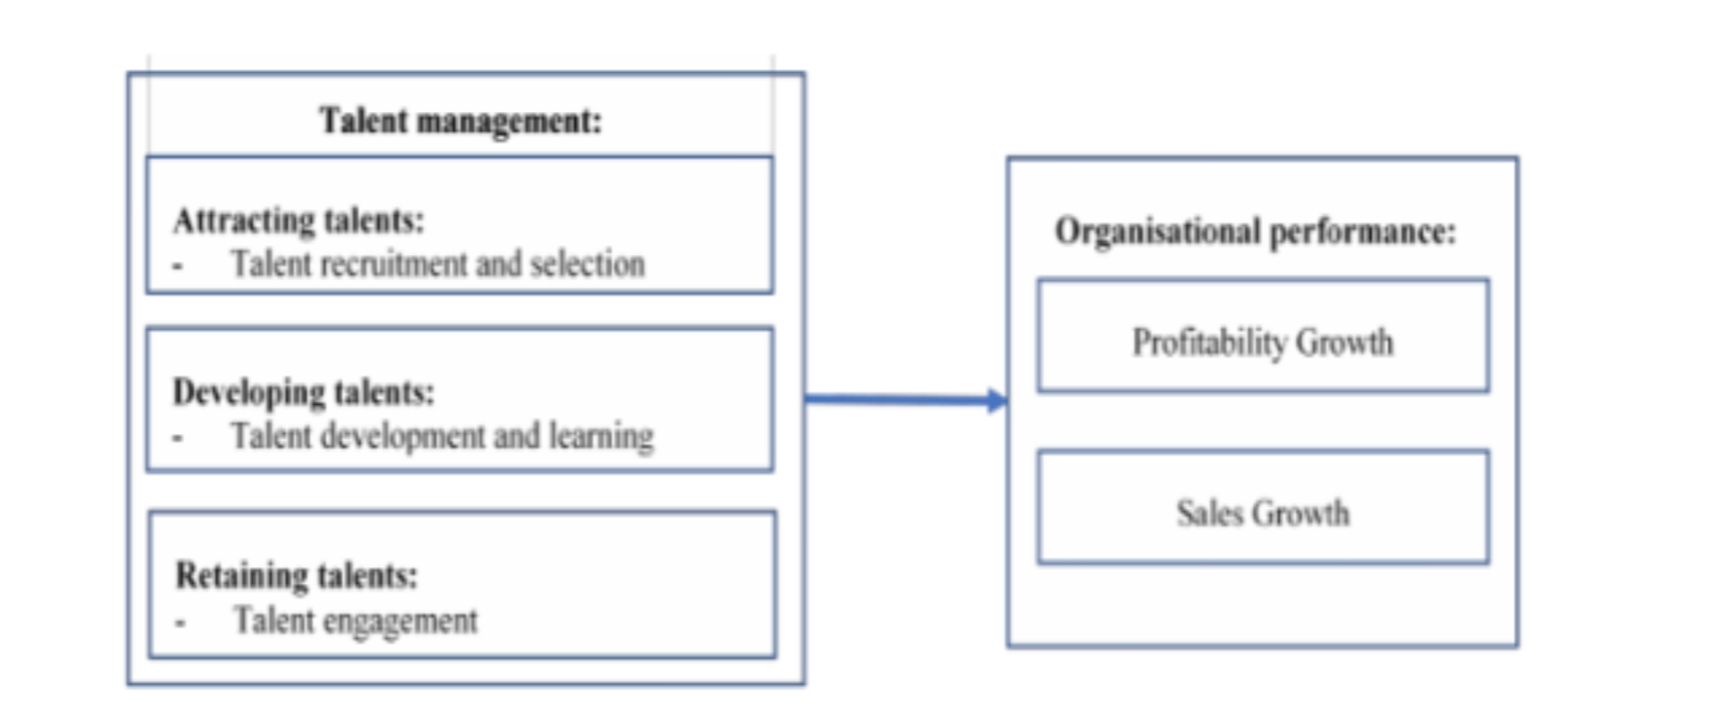
Figure 1.1.1: Conceptual framework: talent management and its influence on organizational
performance (Čizmić & Ahmić, 2021)

Within talent management practices, it is evident that learning and development strategies, along with career management, have more significant and statistically noteworthy impacts on sustainable organizational performance compared to talent attraction and retention. Which indicates that investing in employee learning and development initiatives and adopting effective career management strategies are essential for organizations aiming to improve their long-term performance and sustainability (Al Aina & Atan, 2020).
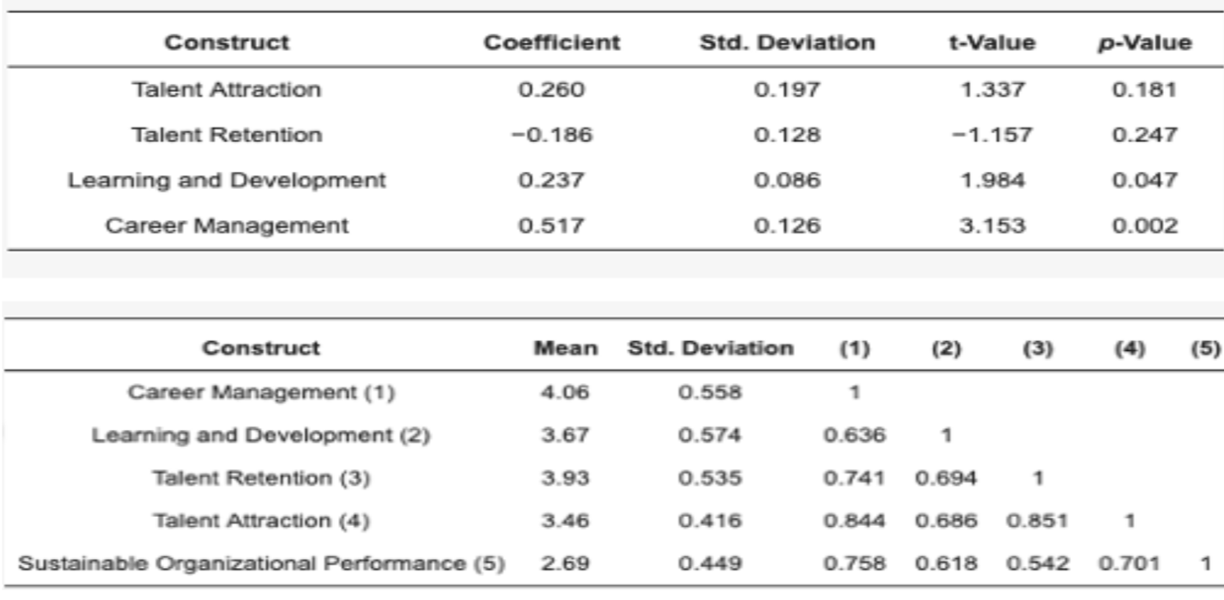
Figure 1.1.2: Descriptive statistics and the correlation matrix, estimation of the model (Al Aina &
Atan, 2020)

However a clearer understanding of how talent management, employee engagement, and organizational performance are connected is still needed, especially in the context of Saudi Arabian workplaces. This study addresses that gap by using a quantitative approach to examine the relationships between specific talent management practices, levels of employee engagement, and key performance outcomes. The goal is to offer practical insights that can help organizations strengthen their talent strategies and improve overall effectiveness.

1.2 Problem Statement
Adeoye and Adong (2023) suggest that a strong research problem should address a gap in existing knowledge, which often stems from limited data or weak methodologies that prevent clear conclusions (Ajemba & Arene, 2022). Recognizing such gaps helps guide future research efforts and contributes to advancing the field (Chand, 2023).
In today’s competitive landscape, the shortage of skilled professionals has intensified the race among organizations to attract and retain talent (Dalayga et al., 2017). While hiring is essential, many companies face a deeper challenge: how to balance talent acquisition with fostering genuine employee engagement. Long-term success depends not just on bringing in qualified individuals, but also on keeping them engaged and committed (Dahshan et al., 2018).
The growing demand for specialized talent, coupled with a shrinking supply, has increased pressure on organizations. Strategic talent placement—putting the right people in the right roles at the right time—has become a key factor in driving performance (Rabbi et al., 2015). At the same time, companies are finding it harder to retain high-performing employees, especially as global competition and mobility increase (Mohamad Mazlan & Jambulingam, 2023; Amankwah-Amoah, 2020). With greater freedom to change jobs or locations, skilled employees are less tied to traditional ideas of job stability. Their departure can bring significant operational and financial costs, making talent retention strategies more critical than ever (Rexhepi & Vladi, 2015).
This study addresses the lack of empirical research that connects talent management, employee engagement, and organizational performance in a unified framework. Although each of these elements has been studied on its own, there is a need for a clear, data-driven understanding of how they interact and influence each other. The key research question guiding this study is:
What is the most effective balance between talent management practices and employee engagement levels in driving organizational performance?

1.3 Significance of the Study
This study adds value by exploring how talent management and employee engagement affect organizational performance, focusing on Saudi workplaces where research is still limited. It helps fill a gap in understanding how these elements work together and offers practical insights for improving HR strategies. The findings can support companies in attracting and retaining talent, boosting engagement, and improving results. HR professionals, managers, and policymakers can use the insights to make better decisions and shape more effective practices suited to the local market. This research also strengthens academic knowledge by offering real data from the Saudi context.

1.4 Research Objectives
This research aims to understand how talent management and employee engagement influence organizational performance. To support this, the study sets out the following objectives:
- Examine the link between talent management practices and employee engagement
- Measure employee engagement levels in Saudi organizations
- Analyze current talent management practices in Saudi Arabia
- Assess how both talent management and engagement impact performance
- Offer practical recommendations to improve HR strategies and outcomes in Saudi workplaces

1.5 Research Questions
The research questions guiding this study are:
- How are talent management, employee engagement, and organizational performance related?
- What’s the link between talent management practices and employee engagement?
- How do talent management and engagement impact organizational performance?
- What’s the connection between engagement and performance?
- Which talent management practices have the strongest effect on performance?
- Does employee engagement mediate the relationship between talent management and performance?

1.6 Research Hypothesis
To achieve the study’s objectives and answer the research questions while attempting to bridge the identified gap, several hypotheses are proposed. These hypotheses stem from a comprehensive review of existing literature, including both historical and recent research on the relationships between talent management practices, employee engagement levels, and organizational performance. Below is a detailed presentation of the formulated hypotheses:

Hypothesis 1:
- 1a: There is a significant positive relationship between talent management practices and
employee engagement levels.
Sub-Hypotheses:
- 1.1a: Talent acquisition practices significantly positively influence employee
engagement levels.
- 1.2a: Talent development practices significantly positively influence employee
engagement levels.
- 1.3a: Talent retention practices significantly positively influence employee
engagement levels.
Hypothesis 2:
- 2a: There is a significant positive relationship between talent management practices and
organizational performance indicators.
Sub-Hypotheses:
- 2.1a: Talent acquisition practices significantly positively influence
organizational performance indicators.
- 2.2a: Talent development practices significantly positively influence
organizational performance indicators.
- 2.3a: Talent retention practices significantly positively influence organizational
performance indicators.
Hypothesis 3:
- 3a: There is a significant mediating effect of employee engagement on the relationship
between talent management practices and organizational performance indicators.
Sub-Hypotheses:
- 3.1a: Employee engagement significantly mediate the relationship between talent
acquisition practices and organizational performance indicators.
- 3.2a: Employee engagement significantly mediate the relationship between talent
development practices and organizational performance indicators.
- 3.3a: Employee engagement significantly mediate the relationship between talent
retention practices and organizational performance indicators

1.7 Research Approach
The study uses a quantitative approach based on survey data from employees across various sectors in Saudi Arabia. It applies statistical tools like correlation and regression to explore how talent management affects employee engagement and how both influence organizational performance. Control variables are included for accuracy.

By targeting diverse industries and using strong sampling techniques, the study ensures generalizability and reliability. The findings aim to support better HR decisions and highlight how strategic talent management boosts engagement, retention, and overall organizational success.

CHAPTER 2

2.1 Introduction
Talent management, employee engagement, and organizational performance are essential components of organizational success, especially in competitive business environments. As the job market continues to face growing challenges, implementing effective talent management strategies and employee engagement initiatives has become critical to sustaining performance and achieving long-term goals.
Previous research has examined the connections between these elements, showing how talent management improves organizational outcomes, how employee engagement enhances productivity, and how the limited supply of skilled professionals poses challenges. Studies also highlight the importance of learning and development for long-term growth, as well as the need for strong talent retention strategies in a globally competitive job market.
This study expands on existing research by exploring the connections between talent management, employee engagement, and organizational performance, specifically within the Saudi Arabian workplace. It aims to offer empirical insights into how employee engagement influences the impact of talent management on performance, addressing a key gap in the literature relevant to the region’s unique economic and cultural setting.

2.2 Previous Studies
Several studies have explored the relationships between talent management, employee engagement, and organizational performance, underlining their collective impact on organizational success in today’s competitive business environment.
- Talent Management and Organizational Performance: Kamel (2019) stressed the importance of talent management in enhancing organizational outcomes. Similarly, Hongal and Kinange (2020) provided empirical support showing that effective talent management improves both engagement and performance.

- Employee Engagement and Productivity: Payambarpour and Hooi (2015) found that engaged employees contribute more to productivity. Their findings indicate a clear link between higher engagement and better individual and organizational outcomes.

- Challenges in Talent Availability: Oladimeji et al. (2023) discussed the ongoing shortage of skilled professionals, urging organizations to focus on retaining and developing internal talent to stay competitive.

- Learning and Development: Al Aina and Atan (2020) demonstrated that investment in employee learning and career growth has a positive, measurable impact on sustainable performance, making it a vital component of long-term success.

- Global Competition and Talent Retention: Amankwah-Amoah (2020) highlighted the increasing pressure from global job markets, noting that companies must prioritize retention strategies to combat high turnover and protect organizational knowledge and performance.

2.3 Theoretical Framework
This study is grounded in the connection between talent management, employee engagement, and organizational performance. These three elements are key to driving growth and sustainability in today’s competitive business environment. With talent shortages and rising demands for high-performing teams, understanding how these factors influence each other is essential.
The framework explores how effective talent management can boost engagement and how engaged employees contribute to better performance. It also investigates whether engagement acts as a bridge between talent strategies and outcomes. By focusing on the Saudi Arabian context, the study offers fresh insights into how these relationships play out in a unique cultural and economic setting, addressing a gap in the current literature.

