A Comprehensive Review of Artificial Intelligence Approaches for Diabetic Retinopathy Classification
Asraa Alwattar – Rahaf Barakat
ORCID ID: 253001066 / 253002370
Master of Science in Artificial Intelligence – College of Informatics – Midocean University – Union of the Comoros
ماجستير ذكاء اصطناعي حديث – كلية المعلوماتية – جامعة ميدأوشن –جزر القمر
Email: esraawattar96@gmail.com – rahafmdbarakat@gmail.com
Supervisor: Dr. (Wesam Ahmed) College of Informatics – Midocean University – Union of the Comoros

Abstract:
Diabetic retinopathy (DR) is among the most frequent causes of preventable blindness; therefore, early detection and accurate automated screening are necessary to provide timely clinical treatment. Recently, with the help of advances in the field of artificial intelligence, specifically deep learning and transfer learning, the evaluation of retinal fundus images using convolutional neural networks, transformers, and hybrid architectures was significantly enhanced. This survey presents a systematic overview of deep learning approaches for diabetic retinopathy classification and critical analysis of previous works concerning the history of development, performance, advantages, and disadvantages of deep learning architectures. Vision transformers (ViTs), hybrid approaches, ensemble learning, and transfer learning methods are reviewed. Nevertheless, a number of problems still exist, such as class imbalance, lack of diversity of the datasets used for training, high computational cost, absence of external validation, and insufficient interpretability for clinical use. Future directions of research on the topic are described; namely, explainable artificial intelligence, lightweight models, multi-dataset validation, self-supervised learning, and clinically robust hybrid approaches.

Keywords: Diabetic Retinopathy, Deep Learning, Hybrid Deep Learning, Transfer Learning, Medical Image Classification

الملخص:
تعتبر اعتلال الشبكية السكري واحدة من أبرز الأمراض التي قد تؤدي إلى فقدان النظر بشكل يمكن الوقاية منه؛ لهذا السبب فإن إجراء فحص آلي دقيق ومتابعة طبية مبكرة يكون ضرورياً لتوفير العلاج اللازم لاعتلال الشبكية السكري في الوقت المناسب. وقد شهدت تقنيات تحليل صورة قاع العين باستخدام الشبكات العصبية الالتفافية والمحولات والبنى الهجينة تقدماً ملحوظاً في السنوات الأخيرة مع ظهور الذكاء الاصطناعي وبالأخص في تعلم العميق والتعلم بالنقل. ويتم في هذه الدراسة استعراض تطبيق أساليب التعلم العميق في تصنيف اعتلال الشبكية السكري بطريقة منهجية، إضافة إلى تقديم تحليل نقدي لأدبيات موضوع الدراسة من خلال استعراض تطور الأساليب، أدائها، مواصفاتها السلبية والإيجابية. كما يتم تقديم نظرة على أساليب المحولات البصرية، الأساليب الهجينة، التعلم التجميعي، والتعلم بالنقل. لكن حتى الآن لا تزال هناك بعض التحديات مثل توازن الفئات، التنوع المحدود لمجموعات التدريب، ارتفاع التكلفة الحاسوبية، عدم وجود تحقق باستخدام مجموعات البيانات الخارجية وقلة قابلية تفسير النتائج للاستخدام السريري.
الكلمات المفتاحية: اعتلال الشبكية السكري، التعلم العميق، التعلم العميق الهجين، التعلم بالنقل، تصنيف الصور الطبية

1. Introduction
Diabetic retinopathy (DR) is one of the most frequent complications associated with diabetes mellitus. DR is also among the major reasons for preventable blindness that people suffer from in their working age all over the world. The disease slowly starts to affect the blood vessels of the retina without any visible symptoms on early stages of the condition. Therefore, early screening and diagnostic are essential not to lose sight forever. Traditionally, the diagnostic process includes the visual examination of retinal fundus images done by experts and is quite time-consuming, expensive, and subjective, which makes large-scale screening impossible. Due to progress in artificial intelligence (AI) and machine learning (ML), in particular, there appeared an opportunity to perform automated medical image analysis. A range of neural networks was created for detection of retinal diseases.. Transfer learning has helped achieve significant success in retinal fundus image classification, as pretrained models are applied to small samples of labeled medical data. In more recent times, there has been an increased focus on transformer-based models due to their ability to learn both local and global contextual information using self-attention mechanisms, while hybrid models combining deep feature extractors and machine learning classifiers have demonstrated further improvements in performance and robustness. While such advancements have been made, there still exist certain issues that need to be addressed: the vast majority of research in this field either utilizes only one dataset, suffers from class imbalance, requires significant computational resources, or is not sufficiently interpretable for clinical use. The problem is exacerbated by the fact that different preprocessing approaches, feature extraction methods, classifiers, and evaluation criteria hinder comparisons between various studies in the literature. This survey provides a thorough literature review of machine learning, deep learning, transfer learning, transformer-based, and hybrid methods for classifying diabetic retinopathy. The selected papers are evaluated based on the datasets used, image preprocessing, feature extraction, classifiers, performance measures, and current limitations.

2. Background and Theoretical Foundations
Diabetic Retinopathy (DR) is one of the leading causes of blindness throughout the world, which necessitates early diagnosis to facilitate effective treatment. Recent advancements in Artificial Intelligence (AI), including deep learning, transfer learning, transformers, and hybrid models, have enabled greater accuracy in the classification of retinal images than was possible previously. Technological advancements in the past few years have helped increase the accuracy of feature extraction and image classification. This chapter explains some of the basic technologies utilized in the classification of diabetic retinopathy.
2.1 Diabetic Retinopathy Classification
Classification of DR is defined as the automatic determination of the stage of diabetic retinopathy using retinal fundus images. With respect to the ICDR Grading System (Wilkinson et al., 2003), diabetic retinopathy can be categorized into five types, which include No Diabetic Retinopathy, Mild, Moderate, Severe, and Proliferative diabetic retinopathy. The classification of the disease is important for early diagnosis, treatment, and prevention of blindness. There has been growing interest in the automated classification of diabetic retinopathy in recent times.
2.2 Machine Learning Approaches for DR
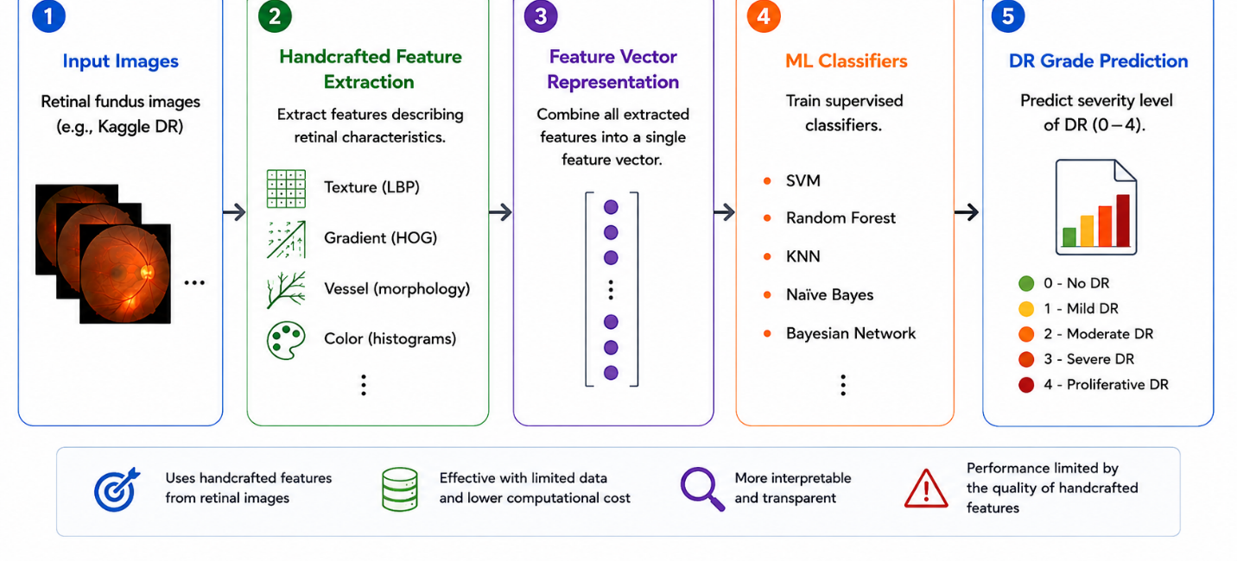
Before the development of deep learning approaches, classical machine learning (ML) methods with handcrafted image descriptors were widely applied in diabetic retinopathy classification problems. In general, classical ML-based frameworks for classification include the process of extracting retinal texture, blood vessels, and lesion shape descriptors such as LBP, HOG, and morphological or color descriptors, which serve as input to train a supervised classifier, such as SVM, Random Forest, K-Nearest Neighbor (KNN), and Naïve Bayes. For example, the research by Al Fahad and Khan (2025) examined the performance of a classical ML framework with classical handcrafted retinal texture and gradient features together with different supervised classifiers on the Kaggle DR dataset; it was shown that SVM, Random Forest, and Bayesian Network classifiers showed the best performance compared to other methods. Classical ML frameworks can be helpful in case when annotations are sparse, computational resources are limited, or interpretability is important because in some cases handcrafted features can be associated with specific retinal anomalies. Nevertheless, their performance depends on the discriminative ability of handcrafted descriptors. as shown at the figure 1 below:

Figure 1. Classical machine learning pipeline for diabetic retinopathy classification. (Al Fahad & Khan, 2025)
2.3 Deep Learning Approaches for DR
It is important to note that deep learning techniques such as Convolutional Neural Networks (CNN) have become one of the popular models for classifying diabetic retinopathy owing to their ability to automatically learn discriminative features from retinal fundus images without hand-crafted feature engineering like mentioned previously. Various CNN models, including ResNet (He et al., 2016), DenseNet, EfficientNet, and ConvNeXt (Liu et al., 2022) have been developed and shown potential for feature extraction through hierarchical design. Numerous CNN models have been employed in classifying diabetic retinopathy. For example, Ali & Dawood (2023) and Patil et al. (2023) fine-tuned the ResNet-50 on retinal fundus images, achieving classification accuracy more than 97%. These CNN models, among others, include the ConvNeXt which leverages the conventional CNN architecture and contemporary design motivated by Vision Transformers (ViTs).
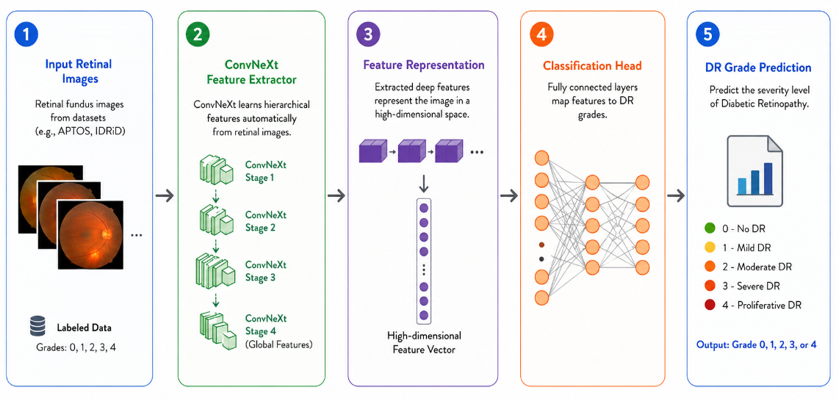

Figure 2. Deep learning pipeline for diabetic retinopathy classification using ConvNeXt. (Liu et al., 2022)
2.4 Transfer Learning in Medical Imaging
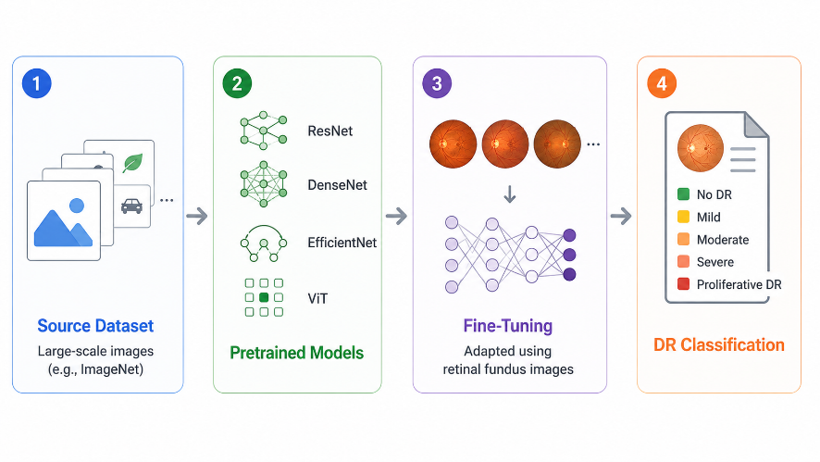
Transfer learning has become one of the most effective methods for medical image analysis, especially when large retinal medical datasets are unavailable (Pan & Yang, 2010). Deep neural networks are not trained from scratch; instead, pretrained models trained on large-scale datasets such as ImageNet are fine-tuned for retinal fundus image analysis. As a result, training becomes faster, convergence is achieved more quickly, feature extraction is improved, and high classification accuracy can be achieved even with limited medical data. Transfer learning has therefore become an essential component of most diabetic retinopathy classification frameworks that use modern CNN- and transformer-based models (Patil et al., 2023; Youldash et al., 2024), as shown in Figure 3 below:

Figure 3. Transfer Learning Workflow in Medical Image Analysis for Diabetic Retinopathy Classification. (Pan & Yang, 2010)
2.5 Transformer-Based Models
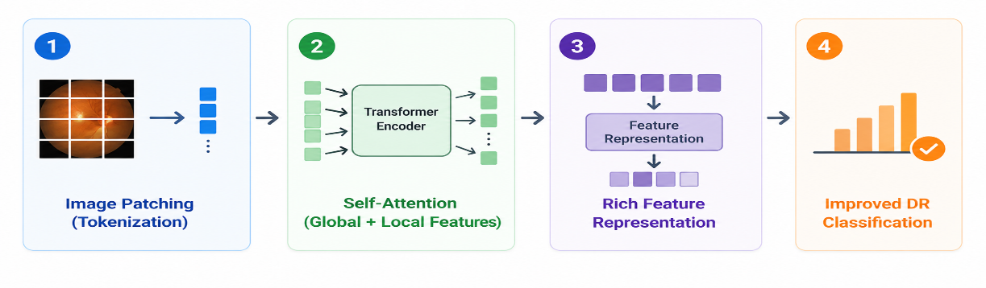
Transformer models have received much consideration in medical image processing thanks to their self-attention architecture (Vaswani et al., 2017), which allows extracting local as well as global features from the images. One of the most famous transformer architectures is Swin Transformer (Liu et al., 2021), whose fame is connected with its hierarchy and shifted-window self-attention mechanism, which makes it possible for the network to capture local retina lesions while retaining the global context. There are other effective transformers in diabetic retinopathy detection like ViT (Dosovitskiy et al., 2021) and DINOv2 (Oquab et al., 2023), as shown in Figure 4 below:
Figure 4. Transformer-Based Architecture for Diabetic Retinopathy Classification. (Liu et al., 2021)
2.6 Hybrid Deep Learning Frameworks
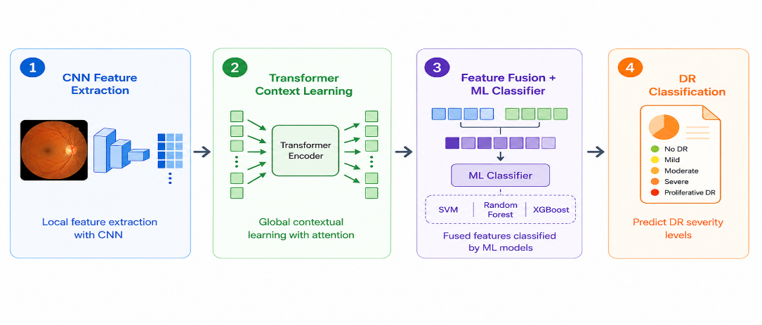
Hybrid deep learning frameworks integrate various AI models for better classification of diabetic retinopathy cases. The integration of hybrid deep learning frameworks includes convolutional neural networks for local features, transformers for global context understanding, and machine learning models like SVM, Random Forest, or XGBoost for classification as illustrated in Jabbar et al. (2024), Fayyaz et al. (2023), and Mohanty et al. (2023). The latest study shows that hybrid CNN-Transformer models can provide complementary feature representation through feature fusion resulting in increased robustness, generalizability, and accurate classification than single model architectures. Thus, hybrid frameworks have become one of the most researched topics in automated diabetic retinopathy classification, as demonstrated in Figure 5 below:
Figure 5. Hybrid Deep Learning Framework for Diabetic Retinopathy Classification. (Jabbar et al., 2024)
2.7 Evaluation Metrics

Model performance for diabetic retinopathy classification is usually assessed by different quantitative performance metrics, as illustrated in the works of Patil et al. (2023) and Akhtar et al. (2025). Accuracy is the ratio of correctly classified instances, whereas other performance metrics such as Precision, Recall (Sensitivity), Specificity, and F1-score offer more thorough insights into the performance of classification models, particularly in situations where the datasets are imbalanced. Also, other techniques such as Confusion Matrix and Area Under the Receiver Operating Characteristic Curve (AUC-ROC) are often used in assessing classification models' performance.

2.7.1 Confusion Matrix
The confusion matrix shows classification performance by comparing the predicted class labels with actual class labels. There are four possible results, namely, TP (True Positive), TN (True Negative), FP (False Positive), and FN (False Negative). They help calculate different types of performance metrics. The confusion matrix plays an important role in medical image classification since it allows understanding the type of error that occurs during model classification.
- TP: Positive samples correctly classified.
- TN: Negative samples correctly classified.
- FP: Negative samples incorrectly classified as positive.
- FN: Positive samples incorrectly classified as negative.

2.7.2 Performance Metrics
The effectiveness of the diabetic retinopathy classifier models is measured by using several metrics, which are computed based on the confusion matrix. Different metrics give different views about classifier efficiency, especially when working with an imbalanced dataset of medical data.
- Accuracy $Accuracy=\frac{TP+TN}{TP+TN+FP+FN}$
- Precision $Precision=\frac{TP}{TP+FP}$
- Recall (Sensitivity) $Recall=\frac{TP}{TP+FN}$
- Specificity $Specificity=\frac{TN}{TN+FP}$
- F1-score $F1=2×\frac{Precision×Recall}{Precision+Recall}$
Apart from that, there is one more widely-used criterion that allows evaluating the efficiency of classifying different categories and measuring how well a certain model performs – it is the Area Under the Receiver Operating Characteristic Curve (AUC-ROC).
3. Previous Studies
This section provides an overview of the latest research on the diagnosis of diabetic retinopathy utilizing artificial intelligence tools such as machine learning, deep learning, transfer learning, transformer networks, and hybrid solutions, which are presented in Table 1. The discussed studies involve various datasets, image pre-processing methods, feature extraction approaches, and classification techniques that can be applied to increase the accuracy of the diagnosis. The review reveals the key advantages and disadvantages of the reviewed approaches along with their potential future directions.
Jiwani et al. (2022) proposed a simple CNN-based model for binary diabetic retinopathy classification using the IDRiD dataset, which, despite lower accuracy than other models, remains a valuable benchmark study with accuracy about 75%.
Fayyaz et al. (2023) introduced a hybrid approach in which AlexNet and ResNet101 were used for feature extraction, ant colony optimization for feature selection, and SVM for classification, attaining an accuracy of about 93% and confirming the effectiveness of combining CNN-based feature extraction with SVM.
Lin and Wu (2023) proposed a revised ResNet-50 architecture aimed at reducing overfitting and improving stability; while robust, its test accuracy of 74.32% was lower than that of several more recent architectures.
Mohanty et al. (2023) compared a hybrid VGG16 and XGBoost model with DenseNet121 for diabetic retinopathy detection and classification, concluding that DenseNet121 outperformed the hybrid model with an accuracy of about 74.3%.
Patil et al. (2023) employed ResNet-50 with transfer learning and Test-Time Augmentation on the APTOS dataset, validated on EyePACS, demonstrating a high accuracy of 97.87% together with a strong Quadratic Weighted Kappa and emphasizing the role of augmentation in improving classifier reliability.
Ali and Dawood (2023) proposed a ResNet-50-based transfer learning system for diabetic retinopathy classification on the APTOS 2019 dataset, obtaining an accuracy of 98.3% and confirming the applicability of transfer learning to retinal images, though without external validation.
Das et al. (2023) developed the DRFEC framework and evaluated twenty-six pretrained deep learning models on EyePACS, with EfficientNetB4 obtaining the highest validation accuracy of around 79.11% while exposing overfitting problems in some architectures.
Youldash et al. (2024) studied six pretrained CNN models, including EfficientNet and RegNet variants, on the APTOS and Saudi clinical datasets, achieving high accuracy of 96% on binary classification but comparatively weaker results on the multi-class task. The main value of this study lies in its external clinical validation.
Shamrat et al. (2024) proposed DRNet13, a deep neural network specifically designed for fundus image analysis, which surpassed fifteen pretrained CNNs with an accuracy of roughly 96-97%, although the results were obtained from a single dataset and at a notable computational cost.
Jabbar et al. (2024) developed a lesion-based hybrid model that combined deep learning for feature extraction with machine learning classifiers such as SVM, Random Forest, Decision Tree, and Linear Regression, reaching an accuracy of around 94%.
Guefrachi et al. (2024) proposed a multistage deep learning training method for diabetic retinopathy screening using transfer learning networks such as ResNet152-V2 and InceptionResNet-V2, with the best result presented through a graphical interface and a reported accuracy of around 97%, though with an associated risk of overfitting.
Akhtar et al. (2025) proposed a deep learning model called RSG-Net for diabetic retinopathy grading, designed for both four-stage multi-class classification and binary classification using the Messidor-1 dataset. By combining image cropping, Gaussian-blur denoising, histogram equalization, resizing, and augmentation, the model achieved strong results, reporting 99.36% testing accuracy for the four-stage task and 94.2% for the binary task, although its generalization beyond the evaluation dataset remained limited.
Wu et al. (2025) introduced mBRSET, a portable retinal fundus image dataset collected in real clinical settings using handheld retinal cameras, and benchmarked ConvNeXt V2, DINOv2, and Swin V2 on the dataset, reporting best F1-scores of 80.33 for the three-class task and 87.4 for the binary task. This study is notable for highlighting the difficulty of achieving strong performance on real-world noisy data.
Grzybowski and Jin (2026) examined artificial intelligence-based medical devices for diabetic retinopathy screening within the European Union, using a framework that enhanced fundus images through resizing, normalization, and augmentation to balance the classes, and reported accuracy levels around 80% across heterogeneous data sources and reporting standards.

Table 1 Summarizes and compares the studies discussed above, highlighting their datasets, methods, key results, and limitations, arranged chronologically from the earliest to the most recent to illustrate how the field has evolved over time:
Authors | Year | Method / Model | Dataset | Results | Limitations
Jiwani et al. (2022) | 2022 | CNN (binary) | EyePACS / IDRiD | ~75% | Moderate accuracy
Fayyaz et al. (2023) | 2023 | AlexNet + ResNet101 + SVM | Fundus images | ~93% | Small feature set
Lin & Wu (2023) | 2023 | Revised ResNet-50 (CNN) | Kaggle DR images | 74.32% | Low test vs. train
Mohanty et al. (2023) | 2023 | ResNet-50 / DenseNet121 | Kaggle DR | ~74.3% | Low test accuracy
Patil et al. (2023) | 2023 | ResNet-50 + TTA | APTOS + EyePACS | 97.87% | Multi-class imbalance
Ali & Dawood (2023) | 2023 | ResNet-50 (transfer learning) | APTOS 2019 | 98.3% | No external validation
Das et al. (2023) | 2023 | 26 pretrained DL nets (DRFEC) | Kaggle EyePACS | ~79.11% | Low validation accuracy
Youldash et al. (2024) | 2024 | EfficientNetV2, RegNetX | Kaggle EyePACS | ~96% | Class imbalance
Shamrat et al. (2024) | 2024 | Deep Learning (DRNet13) | Fundus images | ~96-97% | Computational cost
Jabbar et al. (2024) | 2024 | GoogleNet + ResNet + ML | Fundus dataset | ~94% | Limited validation detail
Guefrachi et al. (2024) | 2024 | Deep Learning (ResNet152-V2) | Kaggle DR dataset | ~97% | Overfitting risk
Akhtar et al. (2025) | 2025 | Deep Learning (RSG-Net) | EyePACS | 94.2% | Limited generalization
Wu et al. (2025) | 2025 | ConvNeXt V2, DINOv2, SwinV2 | mBRSET | 80.33  87.4 | Limited dataset size
Grzybowski & Jin (2026) | 2026 | AI DR devices (CNN) | EU datasets | ~80% | Heterogeneous data and reporting

4. Challenges and Limitations
Despite the considerable advancements made in diabetic retinopathy classification, there are still many open challenges left unresolved. First, the problem of class imbalance exists when severe cases of diabetic retinopathy are rare and occur less often compared to normal or mild cases, making it harder to classify minority classes. Another issue relates to the limited diversity of retinal image data in public studies. Additionally, the variability of imaging parameters and processes still influences the accuracy of automated classifiers. Contemporary deep learning and transformer-based models need a lot of computational resources that limit their applicability in practice. Furthermore, some models are non-interpretable, limiting clinicians' trust in automated diagnostics. While hybrid methods have demonstrated success, the combination of modern transformers with classical machine learning classifiers has not been thoroughly researched yet.
5. Future Directions
In the future, the field of diabetic retinopathy classification needs to work on advancing the development of more intelligent and clinically useful artificial intelligence models. Hybrid models that can be created using CNN, transformer architecture, and machine learning classifiers can be considered one of such methods that can increase the efficiency of feature extraction and classification process. In addition, lightweight deep learning models that generate accurate outcomes but use less computational power can be used in the future. It should be noted that future studies should use larger and more diverse sets of retinal images. The use of multiple datasets in the process of external validation can improve the ability of the models to generalize, and the proper approach to class imbalance problem solution can help to classify minority classes better. Finally, the field of explainable artificial intelligence (XAI) can be expected to be an important part of the future classification systems due to improved interpretability.
6. Conclusion
The current survey examines the latest achievements in artificial intelligence techniques for classification of diabetic retinopathy with an emphasis on deep learning, transfer learning, transformers, and hybrid models. It can be seen from the presented literature that those techniques showed impressive progress in improving classification accuracy and reliability. At the same time, the literature shows the number of persistent problems such as class imbalance, lack of diversity of datasets, high computational cost, and poor model interpretability. In conclusion, the current survey gives a complete insight into the latest trends in diabetic retinopathy classification and potential research directions, including explainable AI (XAI).

References
Akhtar, S., Aftab, S., Ali, O., Ahmad, M., Khan, M. A., Abbas, S., & Ghazal, T. M. (2025). A deep learning based model for diabetic retinopathy grading. Scientific Reports, 15, 3763.
Al Fahad, N., & Khan, R. U. (2025). Classical machine learning based diabetic retinopathy detection using handcrafted features. Ingénierie des Systèmes d'Information, 30(12), 3201–3206.
Ali, A. A., & Dawood, F. A. A. (2023). Deep learning of diabetic retinopathy classification in fundus images. Journal of Engineering, 29(12), 139–152.
Das, D., Biswas, S. K., & Bandyopadhyay, S. (2023). Detection of diabetic retinopathy using convolutional neural networks for feature extraction and classification (DRFEC). Multimedia Tools and Applications, 82(19), 29943–30001.
Dosovitskiy, A., Beyer, L., Kolesnikov, A., Weissenborn, D., Zhai, X., Unterthiner, T., Dehghani, M., Minderer, M., Heigold, G., Gelly, S., Uszkoreit, J., & Houlsby, N. (2021). An image is worth 16x16 words: Transformers for image recognition at scale. In International Conference on Learning Representations (ICLR).
Fayyaz, A. M., Sharif, M. I., Azam, S., Karim, A., & El-Den, J. (2023). Analysis of diabetic retinopathy (DR) based on deep learning. Information, 14(1), 30.
Grzybowski, A., & Jin, K. (2026). Artificial intelligence-based medical devices for diabetic retinopathy screening in the European Union. Ophthalmology and Therapy, 15(2), 569–589.
Guefrachi, S., Echtioui, A., & Hamam, H. (2024). Diabetic retinopathy detection using deep learning multistage training method. Arabian Journal for Science and Engineering, 49(2), 1079–1096.
He, K., Zhang, X., Ren, S., & Sun, J. (2016). Deep residual learning for image recognition. In Proceedings of the IEEE Conference on Computer Vision and Pattern Recognition (CVPR)(pp. 770–778).
Jabbar, A., Liaqat, H. B., Akram, A., Sana, M. U., Azpíroz, I. D., de la Torre Díez, I., & Ashraf, I. (2024). A lesion-based diabetic retinopathy detection through hybrid deep learning model. IEEE Access, 12, 40019–40036.
Jiwani, N., Gupta, K., & Afreen, N. (2022). A convolutional neural network approach for diabetic retinopathy classification. In 2022 IEEE 11th International Conference on Communication Systems and Network Technologies (CSNT) (pp. 357–361). IEEE.
Lin, C.-L., & Wu, K.-C. (2023). Development of revised ResNet-50 for diabetic retinopathy detection. BMC Bioinformatics, 24, 157.
Liu, Z., Lin, Y., Cao, Y., Hu, H., Wei, Y., Zhang, Z., Lin, S., & Guo, B. (2021). Swin transformer: Hierarchical vision transformer using shifted windows. In Proceedings of the IEEE/CVF International Conference on Computer Vision (ICCV)(pp. 9992–10002).
Liu, Z., Mao, H., Wu, C.-Y., Feichtenhofer, C., Darrell, T., & Xie, S. (2022). A ConvNet for the 2020s. In Proceedings of the IEEE/CVF Conference on Computer Vision and Pattern Recognition (CVPR)(pp. 11966–11976).
Mohanty, C., Mahapatra, S., Acharya, B., Kokkoras, F., Gerogiannis, V. C., Karamitsos, I., & Kanavos, A. (2023). Using deep learning architectures for detection and classification of diabetic retinopathy. Sensors, 23(12), 5726.
Oquab, M., Darcet, T., Moutakanni, T., Vo, H., Szafraniec, M., Khalidov, V., Fernandez, P., Haziza, D., Massa, F., & El-Nouby, A. (2023). DINOv2: Learning robust visual features without supervision. arXiv preprint arXiv:2304.07193.
Pan, S. J., & Yang, Q. (2010). A survey on transfer learning. IEEE Transactions on Knowledge and Data Engineering, 22(10), 1345–1359.
Patil, M. S., Chickerur, S., Abhimalya, C., Naik, A., Kumari, N., & Maurya, S. (2023). Effective deep learning data augmentation techniques for diabetic retinopathy classification. Procedia Computer Science, 218, 1156–1165.
Shamrat, F. M. J. M., Shakil, R., Sharmin, S., Ovy, N. H., Akter, B., Ahmed, M. S., Ahmed, M. Z., Ahmed, K., Bui, F. M., & Moni, M. A. (2024). An advanced deep neural network for fundus image analysis and enhancing diabetic retinopathy detection. Healthcare Analytics, 5, 100303.
Vaswani, A., Shazeer, N., Parmar, N., Uszkoreit, J., Jones, L., Gomez, A. N., Kaiser, Ł., & Polosukhin, I. (2017). Attention is all you need. In Advances in Neural Information Processing Systems (NeurIPS)(pp. 5998–6008).
Wilkinson, C. P., Ferris, F. L., Klein, R. E., Lee, P. P., Agardh, C. D., Davis, M., Dills, D., Kampik, A., Pararajasegaram, R., & Verdaguer, J. T. (2003). Proposed international clinical diabetic retinopathy and diabetic macular edema disease severity scales. Ophthalmology, 110(9), 1677–1682.
Wu, C., Restrepo, D., Nakayama, L. F., Zago Ribeiro, L., Shuai, Z., Barboza, N. S., Sousa, M. L. V., Fitterman, R. D., Pereira, A. D. A., Regatieri, C. V. S., Stuchi, J. A., Malerbi, F. K., & Andrade, R. E. (2025). A portable retina fundus photos dataset for clinical, demographic, and diabetic retinopathy prediction. Scientific Data, 12, 323.
Youldash, M., Rahman, A., Alsayed, M., Sebiany, A., Alzayat, J., Aljishi, N., Alshammari, G., & Alqahtani, M. (2024). Early detection and classification of diabetic retinopathy: A deep learning approach. AI, 5(4), 2586–2617.

