

Predicting and Mitigating Urban Traffic Congestion Using Artificial Intelligence

Prepared By
Name: [Musab Abdullah Alsalamah] ID No: [252000152]
Submitted in fulfillment of the requirements for the degree Master of Science in Modern artificial intelligence
At
College of Informatics
Midocean University
UAE
Supervisor Name: Dr. Yasser Abdel Hamid
College of Informatics, Midocean University, Comoros
[3-2025]

Abstract
Traffic congestion remains a major challenge in urban environments, particularly at signalized intersections where vehicle queues can build up rapidly during peak periods. This study proposes a machine learning-based approach for predicting short-term traffic congestion and exploring its potential use in adaptive traffic signal control.
The study utilizes real traffic-volume data collected from multiple junctions. After preprocessing and feature engineering, several machine learning models were evaluated, including Logistic Regression, Random Forest, Support Vector Machine, and Gradient Boosting. Among these, the Gradient Boosting model achieved the best performance, with an accuracy of 0.968, precision of 0.893, recall of 0.977, and F1-score of 0.933.
In addition to prediction, a simplified adaptive traffic signal mechanism was implemented to simulate how predicted congestion can be used to adjust signal timing. The simulation results suggest that increasing green signal duration during predicted congestion periods may help reduce potential vehicle accumulation and improve traffic flow.
The results demonstrate that machine learning models can effectively predict traffic congestion and support decision-making in traffic management. While the adaptive control was evaluated in a simplified simulation environment, the findings highlight the potential of integrating prediction models with traffic signal strategies for improving urban traffic performance.

Table of Contents

Abstract 2
Table of Contents 3
List of Abbreviations 5
List of Figures 6
List of Tables 7
Chapter 1: Introduction 8
1.1 Problem Definition 8
1.2 Thesis Objectives 9
1.3 Thesis Contributions 10
1.4 Thesis Organization 11
Chapter 2 Background and Related Work 12
2.1 Introduction 12
2.2 Classical Machine Learning Methods 13
2.3 Deep Learning Approaches 13
2.4 Hybrid and Optimized Models 14
2.6 Research Gaps and Opportunities 16
2.8 Previous Studies on Traffic Congestion Forecasting 17
2.9 Comparative Summary Table 19
2.10 Summary 20
Chapter 3 Proposed Approach 21
3.1 Overview 21
3.2 Dataset Description 22
3.3 Data Preprocessing 23
3.4 Feature Engineering 23
3.5 Model Selection 24
3.6 Training Process 26
3.7 Model Evaluation 27
3.8 Adaptive Traffic Signal Mechanism 28
3.9 Summary 28
Chapter 4: Experimental Results and Discussion 30
4.1 Overview 30
4.2 Model Performance 30
4.3 Analysis of Predictions 31
4.4 Adaptive Traffic Signal Evaluation 32
4.5 Discussion 34
4.6 Summary 35
Chapter 5: Conclusion and Future Work 36
5.1 Introduction 36
5.2 Future Work 37
References 38

List of Abbreviations
- AI: Artificial Intelligence
- ANN: Artificial Neural Network
- ARIMA: Autoregressive Integrated Moving Average
- BiLSTM: Bidirectional Long Short-Term Memory
- CNN: Convolutional Neural Network
- CPO: Crested Porcupine Optimizer
- DT: Decision Tree
- DeepONet: Deep Operator Network
- F1-score: F1 Measure
- GB: Gradient Boosting
- GAT: Graph Attention Network
- GRU: Gated Recurrent Unit
- IoT: Internet of Things
- ITS: Intelligent Transportation Systems
- KNN: k-Nearest Neighbors
- LightGBM: Light Gradient Boosting Machine
- LSTM: Long Short-Term Memory
- MAE: Mean Absolute Error
- MAPE: Mean Absolute Percentage Error
- ML: Machine Learning
- MLP: Multi-Layer Perceptron
- PeMS: Performance Measurement System
- PI-DeepONet: Physics-Informed Deep Operator Network
- R²: Coefficient of Determination
- RF: Random Forest
- RMSE: Root Mean Square Error
- RNN: Recurrent Neural Network
- SHAP: SHapley Additive exPlanations
- STGCN: Spatio-Temporal Graph Convolutional Network
- SVM: Support Vector Machine
- XAI: Explainable Artificial Intelligence
- XGBoost: Extreme Gradient Boosting

List of Figures
Figures 1 23
Figures 2 25
Figures 3 26
Figures 4 27
Figures 5 28
Figures 6 29
Figures 7 32
Figures 8 34

List of Tables
Comparative Table 1 18

Chapter 1: Introduction

1.1 Problem Definition
Urban traffic congestion at signalized intersections results in measurable impacts such as increased vehicle delay, higher fuel consumption, and elevated emissions, particularly during rush hour periods. Most existing signal control strategies, such as fixed-time or semi-actuated systems, are designed based dependent dependent dependent depending dependent on predefined plans or limited responsiveness to traffic conditions. As a result, they frequently fail to adjust to real-time fluctuations in traffic demand. This leads to the formation of vehicle queues, increased travel delays, higher fuel consumption, and greater environmental impact.
Although congestion trends tend to repeat during peak hours, identifying exactly which traffic approaches will experience excessive demand continues to be a complex task. Traditional traffic analysis methods rely on historical means or rule-based approaches, which are not capable of representing nonlinear relationships and time correlations in traffic flow. Consequently, congestion is typically detected only after it has already formed, limiting the effectiveness of reactive traffic management strategies (Medina-Salgado et al., 2022)
At the same time, the growing availability of traffic data from detectors and intelligent transportation systems provides an opportunity to improve congestion management. By applying artificial intelligence plus machine learning techniques, it becomes possible to analyze traffic behavior more effectively and predict congestion before it occurs. Therefore, the main issue addressed in this study is the lack of accurate and preemptive methods for predicting congestion at signalized intersections. Addressing this limitation is vital for supporting responsive traffic signal control systems that can respond to expected traffic conditions and increase overall intersection performance. Despite the extensive research on traffic congestion prediction, most existing studies focus primarily on improving forecasting performance without directly integrating the prediction results into operational traffic signal control systems. In many cases, congestion is predicted as an analytical outcome rather than being utilized for instant or forward-looking decision-making.
Furthermore, a significant portion of the literature emphasizes complex deep learning models that require high computing resources, making them not as practical for actual deployment in traffic control environments.
In contrast, this study suggests a simplified yet effective framework which does not only predicts short-term congestion using structured traffic data, but also directly translates these predictions into responsive traffic signal control decisions. The novelty of this work consists in linking prediction outputs with implementable signal timing strategies, allowing proactive traffic management rather than reactive responses.

1.2 Thesis Objectives
This study is guided by the following research question:
Could a machine learning model, specifically a Gradient Boosting classifier, outperform a simple historical average baseline in predicting short-term traffic congestion at urban intersections?
Hypothesis: The main hypothesis of this study is that a Gradient Boosting model can achieve higher prediction quality than a baseline model based on historical averages in predicting short-term traffic congestion.
Additionally, it is hypothesized that uniting prediction results with responsive traffic signal timing can improve traffic movement by lowering congestion buildup at intersections. In addition, the study considers the following sub-question:
Can predicted congestion levels be effectively used to support responsive traffic signal timing decisions that reduce potential vehicle accumulation?
To achieve this objective, the study concentrates on several specific goals. First, it aims to analyze real-world traffic detector data in order to identify temporal patterns and traffic movements associated with congestion formation. Apprehending these patterns is essential for building reliable predictive systems.
Second, the study considers a range of machine learning and deep learning techniques suitable for short-term congestion prediction in urban traffic environments. This entails evaluating different modeling methods to determine their efficiency when capturing traffic behavior.
Third, the research applies feature engineering and feature selection techniques to boost model effectiveness while maintaining interpretability. Selecting the most relevant features helps boost forecast exactness and supports better comprehension of the factors influencing congestion.
In addition, the study appraises the performance of the developed models using standard classification metrics including accuracy, precision, recall, and F1-score. This secures a comprehensive assessment of the models’ ability to detect congestion effectively.
Finally, the study intends to provide analytical and visual insights which can support proactive traffic management decisions. These results are intended to assist traffic operators toward refining signal control strategies and advancing overall intersection performance.
Overall, these objectives add to the wider goal of improving urban mobility via data-driven and intelligent transportation systems.

1.3 Thesis Contributions
This thesis adds to the field of AI-based traffic management by proposing a structured and reproducible system for predicting traffic congestion at signalized intersections using real-world detector data. The proposed framework focuses on capturing short-term traffic congestion patterns at the approach level, delivering a practical basis for intelligent traffic evaluation and decision making.
A key contribution of this study lies in integrating congestion prediction with traffic signal control concepts. Rather than treating congestion forecasting as a standalone analytical task, the proposed approach illustrates how predictive outputs can support adaptive signal timing strategies. In particular, the framework enables anticipatory adjustments of green-time allocations for heavily loaded traffic movements, helping to reduce queue buildup and increase overall intersection performance.
From a research perspective, this work also brings together recent progress in machine learning, deep learning, and hybrid modeling techniques within the context of traffic congestion forecasting. By organizing and applying these methods to actual traffic data, the analysis delivers a clear and practical foundation toward upcoming developments in intelligent transportation systems.
Furthermore, the thesis stresses the importance of linking predictive analytics with operational traffic management. This connection improves the practical relevance of the proposed framework and supports its possible extension toward real-time deployment, network-level coordination, and more advanced control strategies such as reinforcement learning–based traffic signal optimization.

1.4 Thesis Organization
This thesis is organized into five main chapters.
Chapter 1 introduces the research background, defines the problem, outlines the objectives, and spotlights the main contributions of the study.
Chapter 2 presents the theoretical background and reviews related work in the field of traffic congestion prediction, including classical machine learning methods, deep learning approaches, and combined models.
Chapter 3 describes the suggested methodology, including dataset description, data preprocessing, feature engineering, model selection, training process, and evaluation, as well as the responsive traffic signal mechanism.
Chapter 4 presents the experimental results and discusses the model effectiveness, prediction analysis, and the effectiveness of the adaptive signal system.
Chapter 5 concludes the study and provides recommendations for future work.

Chapter 2 Background and Related Work

2.1 Introduction
Traffic congestion forecasting has become an essential element of modern intelligent transportation systems (Medina-Salgado et al., 2022; Rahmani et al., 2023). especially since metropolitan regions continue to experience increasing traffic demand. At signalized intersections, traditional traffic management approaches based on fixed signal plans and historical averages commonly struggle to react effectively to short-term variations in traffic flow. These limitations reduce the ability of traffic authorities to manage congestion in an active and efficient manner.
Recent progress in data collection technologies, sensing systems, and computational capabilities have enabled the use of machine learning and deep learning techniques in traffic analysis. In contrast to classic methods, data-driven approaches can detect intricate temporal patterns and nonlinear relationships within traffic data, bringing about more accurate and adaptable congestion prediction models.
In addition to methodological developments, a growing body of research has studied different modeling methods for traffic congestion forecasting, ranging from classical machine learning methods to advanced deep learning and combined models. These studies give important knowledge of the advantages and disadvantages of each approach, as well as their usefulness for actual traffic contexts.
Within this context, AI-based congestion forecasting is progressively acknowledged as a key enabler regarding responsive traffic signal control and smart city applications. By predicting congestion before it occurs, these systems support proactive traffic management strategies that improve intersection performance and overall traffic throughput.
This chapter presents the theoretical background and reviews relevant literature related to traffic congestion forecasting. It examines present methods, highlights key developments in the field, and identifies research gaps that motivate the suggested approach in this study.

2.2 Classical Machine Learning Methods
Early studies in traffic congestion prediction relied heavily on classical machine learning techniques applied to structured traffic datasets. These methods were primarily used to classify congestion levels or estimate short-term traffic conditions based relying on historical data and basic temporal features (Vlahogianni et al., 2014).
Common algorithms in this category include logistic regression, decision trees, support vector machines (SVM), k-nearest neighbor (KNN), and ensemble algorithms such as the Gradient Boosting Classifier. Gradient boosting builds models sequentially, where each new model focuses on correcting the errors of the previous ones, causing better predictive performance and better management of complicated data patterns.
Among these methods, tree-based models, particularly decision trees and random forests, received notable attention because of to their sturdiness and explainability. Random forests, for example, improve prediction performance by combining multiple decision trees, which helps reduce overfitting as well as enhances generalization when dealing with noisy traffic data.
Despite their advantages, classical machine learning models have considerable limitations. In particular, they have difficulty capturing complicated time correlations and nonlinear relations between traffic flows among different intersections. This limitation reduces their effectiveness in highly rapidly changing urban traffic environments, in which traffic patterns can change rapidly over time.

2.3 Deep Learning Approaches
Deep learning techniques have greatly advanced traffic congestion forecasting by permitting models to learn complex, nonlinear, and time-dependent patterns directly from traffic data. As opposed to classical machine learning methods, these approaches are better suited for handling sequential data and representing temporal relationships in traffic flow (Kashyap et al., 2022).
Recurrent neural networks (RNNs), particularly Long Short-Term Memory (LSTM) models, are widely used in traffic prediction due to their capacity for modeling time-series data and retain long-term dependencies. As a result, LSTM-based models have displayed better performance in short-term congestion forecasting compared with standard methods. In addition, attention-based mechanisms have been introduced to further boost model effectiveness by focusing on the most relevant temporal features (Fang et al., 2022).
To further boost forecasting ability, hybrid deep learning structures have been introduced. For example, Convolutional Neural Network–LSTM (CNN–LSTM) models combine convolutional layers for extracting spatial attributes with recurrent layers for learning time-dependent dynamics. This assimilation permits the model to better represent both local traffic variations and overall temporal trends.
More recently, graph-based deep learning models have gained increasing attention in traffic forecasting research. In addition, physics-informed deep learning models have been introduced to incorporate domain knowledge into traffic prediction, boosting model correctness and model scalability (Wang et al., 2021). By representing traffic networks as graphs, these models can represent spatial connections between intersections while simultaneously modeling temporal changes. Such spatiotemporal approaches provide a more thorough understanding of how congestion propagates throughout urban road networks. Despite their strong forecasting abilities, deep learning models regularly require large volumes of data, extensive training time, and considerable computing resources. In actual traffic regulation systems, these requirements may limit their feasible deployment, notably within settings with limited infrastructure or real-time constraints.
Therefore, while deep learning approaches deliver high accuracy, there is still a call for efficient and interpretable models that can be more easily integrated into operational traffic infrastructures.

2.4 Hybrid and Optimized Models
Hybrid and optimization-based models have appeared as effective approaches to advance traffic congestion prediction by tackling the limitations of standalone machine learning and deep learning techniques. These models combine different learning mechanisms or integrate optimization algorithms for boosting model effectiveness and stability.
In many cases, mixed approaches incorporate neural networks with metaheuristic optimization techniques, such as genetic algorithms or swarm-based methods, to improve parameter setting and training efficiency. These optimization-based strategies help achieve better convergence and increase robustness, notably when handling with noisy and highly variable traffic data.
In addition, combined architectures that integrate multiple deep learning components, such as CNN–RNN or CNN–LSTM models, have shown strong performance in traffic forecasting tasks. Such approaches have been successfully applied in traffic signal prediction and control systems (Islam et al., 2022). By combining spatial feature extraction with temporal sequence modeling, these models are able to capture complicated traffic patterns more effectively than single-structure models.
Overall, hybrid and optimized models provide a flexible and strong framework for congestion prediction, making them apt for applications that require high exactness and trustworthiness, for example responsive traffic signal control systems (Cheng et al., 2022; Topilin et al., 2025).

2.5 Use of Traffic Datasets
The performance of traffic congestion forecasting models depends largely on the quality and relevance of the datasets used for training and evaluation (Medina-Salgado et al., 2022). Most existing studies rely on real-world traffic data collected from operational transportation systems, including loop detectors, intelligent traffic signals, and IoT-based sensing technologies. These large-scale datasets are frequently analyzed using big data techniques to improve traffic prediction performance (Zhu et al., 2019).
Well-known data sources include large-scale traffic databases and open-data platforms provided by transportation authorities. In addition, publicly available datasets have become widely used in research, as they provide accessible and standardized data for model development and comparison.
In this study, a real-world traffic dataset obtained from the Kaggle platform is utilized for congestion prediction and analysis. Specifically, the Traffic Prediction Dataset provides structured traffic-related data that can be used to model and forecast traffic conditions. Such datasets offer important temporal information that supports the development of machine learning and deep learning models.
Data preprocessing is a critical step in preparing practical datasets for analysis. This process normally includes processing missing values, correcting inconsistent records, removing outliers, and generating relevant temporal features such as time of day and day of week. These steps guarantee that the dataset accurately reflects traffic behavior and is suitable for machine learning and deep learning applications.

2.6 Research Gaps and Opportunities
Despite the major developments in AI-based traffic congestion forecasting, several limitations remain in the existing literature. Many current models rely primarily on past data and do not fully incorporate real-time traffic information, which limits their usefulness in practical traffic regulation systems (Liu et al., 2025).
In addition, a large number of studies focus on isolated intersections or short road segments. This narrow scope restricts the ability of models to generalize over interconnected urban traffic networks, where bottlenecks often propagates between multiple intersections.
Another important limitation relates to the complexity of advanced models. Although hybrid as well as graph-based deep learning approaches have shown strong predictive performance, their real-life application can be difficult due to high computing requirements and limited interpretability (Kashyap et al., 2022). These factors may reduce their usability in actual traffic operations.
These gaps highlight several opportunities for future research. There is a need to develop models that are not simply accurate, but equally scalable, interpretable, and appropriate for instant deployment. Furthermore, integrating congestion prediction with responsive traffic signal control remains an important research direction, as it enables the transition from reactive to proactive traffic management strategies.

2.7 Historical Development of Traffic Congestion Forecasting
Early research on traffic congestion forecasting was primarily based on statistical and analytical methods. Techniques such as linear regression, autoregressive integrated moving average (ARIMA), as well as probabilistic models were widely used to examine past traffic data and detect recurring patterns, notably during peak periods. While these approaches provided useful baseline insights, they were limited in their ability to represent nonlinear relationships and rapid time variations under traffic conditions.
With the advancement of computational methods, machine learning techniques began to play a more prominent role in traffic forecasting. Models such as decision trees, support vector machines (SVM), k-NN (KNN), and logistic regression offered greater flexibility by learning complex relationships directly from traffic data. These methods boosted predictive performance relative to traditional statistical approaches, although they still experienced difficulties during modeling long-term time-based dependencies.
In recent years, deep learning approaches have greatly transformed traffic congestion forecasting. Recurrent neural networks (RNNs), particularly Long Short-Term Memory (LSTM) and Gated Recurrent Unit (GRU) models, have demonstrated strong capability in learning sequential and temporal patterns in traffic data. Furthermore, the emergence of spatiotemporal as well as graph-based neural networks has enabled the modeling of both of spatial interactions as well as time dynamics inside traffic networks.
Overall, the evolution of traffic congestion forecasting demonstrates a move from traditional statistical methods to more advanced, data-driven approaches capable of handling the intricacy of contemporary urban traffic infrastructures. Early traffic forecasting relied on statistical models such as ARIMA.

2.8 Previous Studies on Traffic Congestion Forecasting
A substantial body of recent research has proved the effectiveness of artificial intelligence techniques for predicting road congestion and traffic flow under multiple conditions. (Katambire et al., 2023) compared ARIMA and LSTM models for short-term traffic-flow prediction at an urban intersection and reported that LSTM consistently outperformed ARIMA in terms of MAE, MAPE, and RMSE. Their findings stressed the importance of temporal learning for congestion-related forecasting tasks.
(Muhammed et al., 2024) proposed a hybrid Graph Attention Network–Bi-directional LSTM–Attention (GAT–Bi-LSTM–Attention) model for multi-horizon traffic-speed prediction using freeway datasets. The study demonstrated that incorporating spatial interactions alongside time attention components markedly increased forecasting precision as compared with simpler deep learning structures.
Tree-based ensemble algorithms have also shown strong performance in congestion-related prediction tasks. Chen et al. (2021) applied an XGBoost model to predict travel time using real-world probe-vehicle data and achieved better accuracy and computational performance effectiveness compared with traditional gradient boosting models. These results illustrated the suitability of ensemble learning approaches for working with heterogeneous and noisy traffic datasets.
More advanced hybrid and physics-informed approaches have recently emerged. Li et al. (2025) introduced a physics-informed Deep Operator Network (DeepONet) that integrates traffic-flow preservation principles into the learning process. Their experimental results showed considerable improvements regarding forecast exactness and an enhanced ability to capture congestion propagation over both space and time.
In addition, Sakib (2025) evaluated multiple tree-based machine learning models, including Decision Trees, Random Forest, Gradient Boosting, XGBoost, and LightGBM, under highly congested urban traffic conditions. The study found that Random Forest achieved the best overall performance, while explainable AI tools such as SHAP provided important knowledge of the factors influencing congestion, thus increasing model explainability.
Overall, these studies indicate a clear trend toward hybrid, spatiotemporal, and interpretable AI-based models for traffic congestion forecasting. However, much of the existing literature focuses primarily on forecasting performance, with limited emphasis on directly linking congestion forecasts to operational traffic-control strategies for example adaptive signal timing. This gap motivates the need for combined systems that combine accurate prediction with practical traffic management applications. While a wide range of models such as ARIMA, LSTM, XGBoost, as well as graph-based neural networks have been successfully applied in traffic congestion prediction, the implementation of all these models is beyond the scope of this study.
Instead, this research focuses on evaluating a representative set of machine learning models and selecting the most suitable approach based on performance, computational effectiveness, and practical usefulness.
The reviewed models are included to offer a complete comprehension of the current state of the art and to position the proposed approach within the wider research context.

2.9 Comparative Summary Table
The following table presents a comparative summary of representative quantitative findings from recent studies on traffic congestion forecasting. It stresses the diversity of modeling methods applied in the literature and summarizes their reported performance and key contributions.
Study | Model
  Key Findings
  Katambire et al.(2023)
  LSTM vs. ARIMA
  Compared ARIMA and LSTM for short-term traffic-flow forecasting at Muhima Junction (Rwanda). Using MAE, MAPE and RMSE as evaluation measures, this LSTM model attained lower errors than ARIMA and was selected as the best-fitting model for monthly traffic-flow prediction, supporting its use foradaptive traffic-signal control.
  Muhammed et al. (2024)
  GAT–Bi-LSTM–Attention
  Proposed a hybrid GAT-Bi-LSTM-Attention model for multi-horizon traffic-speed prediction on PeMSD4/PeMSD7 freeway datasets. The full model (GAT-Bi-LSTMA) achieved MAE ≈ 0.19, RMSE ≈ 0.43 and MAPE ≈ 9.7% on PeMSD4—substantially better than ablated variants without Bi-LSTM, attention or GAT—showing the benefit of combining graph-based spatial representation with bi-directional LSTM and time-based attention.
  Topilin et al. (2025)
  CPO–CNN–LSTM–Attention (Hybrid Deep Model)
  Developed a Crested Porcupine Optimizer (CPO)-CNN-LSTM-Attention model for urban traffic-flow forecasting on Paris road data. The combined architecture achieved RMSE in the range 17.35–19.83 and MAE about 13.98–14.04, outperforming comparison models and demonstrating strong short-term prediction performance for congestion-prone urban corridors.
  Chen & Fan (2021)
  XGBoost (Tree-Based Gradient Boosting)
  Used an XGBoost model to predict freeway travel time from probe-vehicle data. After hyperparameter optimization, XGBoost delivered higher prediction effectiveness as well as efficiency than a standard Gradient Boosting model, indicating that boosted decision-tree ensembles are effective for congestion-related travel-time forecasting on freeways.
  Li et al. (2025)
  Physics-Informed DeepONet (PI-DeepONet)
  Introduced a physics-informed Deep Operator Network for traffic-state estimation, embedding the traffic-flow conservation law and the Greenshields fundamental diagram into the learning process. Experiments on real-world traffic data showed that DeepONet and PI-DeepONet improved MAE and RMSE by up to about 24.17% and 27.84%, respectively, compared with state-of-the-art baselines, while better capturing congestion propagation in space and time.
 |  | Evaluated five tree-based models for travel-time prediction amid heterogeneous, highly congested traffic conditions in Dhaka (Bangladesh) using Google Maps travel-time data. Random Forest achieved the lowest RMSE, MAE and MAPE and the highest R² among the models. SHAP analysis showed that “travel time 15 minutes prior” was the most influential predictor, followed by earlier travel times and section length, highlighting the value of explainable ensemble models for congestion-related travel-time prediction.
  Sakib (2025)
  Tree-Based ML + XAI (DT, RF, GBM, XGBoost, LightGBM + SHAP)
Comparative Table 1

2.10 Summary
This chapter presented a comprehensive review of related work in the field of traffic congestion forecasting, presenting the evolution of methodologies from early statistical and machine learning approaches to advanced deep learning, hybrid, and physics-informed models. The reviewed studies show that artificial intelligence–based techniques significantly outdo standard methods in representing the elaborate temporal and spatial dynamics of urban traffic infrastructures.
The literature analysis shows a clear shift toward spatiotemporal and hybrid modeling architectures, such as CNN–LSTM architectures, graph-based neural networks, and optimization-enhanced models, which offer better predictive correctness and stability. In addition, recent studies stress the growing importance of model explainability through explainable AI techniques, enabling better comprehension of the factors influencing congestion.
In spite of these progressions, the review also identified several limitations within existing research, including limited incorporation of live traffic data, insufficient consideration of network-level congestion propagation, and a weak connection between congestion prediction and practical traffic-signal control strategies. These gaps point out the need for forecasting systems that are not simply accurate, but also extensible, interpretable, and operationally relevant.
Building on the understanding gained from the reviewed literature, this study centers on developing a congestion prediction framework customized to actual traffic signal data and consistent with the requirements of adaptive signal control. The next chapter builds based based based based on this foundation by describing the suggested methodology, dataset attributes, feature engineering process, and model development steps used to address the identified research gaps.

Chapter 3 Proposed Approach

3.1 Overview
This chapter explains the method followed to develop a traffic congestion prediction system and boost traffic signal efficiency. The process starts with understanding the dataset and preparing it for analysis, followed by feature extraction, model training, and evaluation. Finally, an responsive traffic signal mechanism is introduced based on the model projections.

3.2 Dataset Description
The dataset used in this project was obtained from Kaggle (Fedesoriano, 2021) and contains traffic flow data collected from multiple road junctions over time. It includes 48,120 records representing hourly vehicle counts.
Each observation relates to a specific junction at a specific time, permitting the model to learn temporal traffic patterns.
The dataset contains the following main attributes:
DateTime: Represents the timestamp of each observation
Junction: Indicates the junction number (1 to 4)
Vehicles: Number of vehicles recorded at that time
The dataset contains 4 classes corresponding to the four junctions.
The dataset is suitable for time-based prediction tasks, as it reflects real traffic behavior such as peak hours and daily variations.
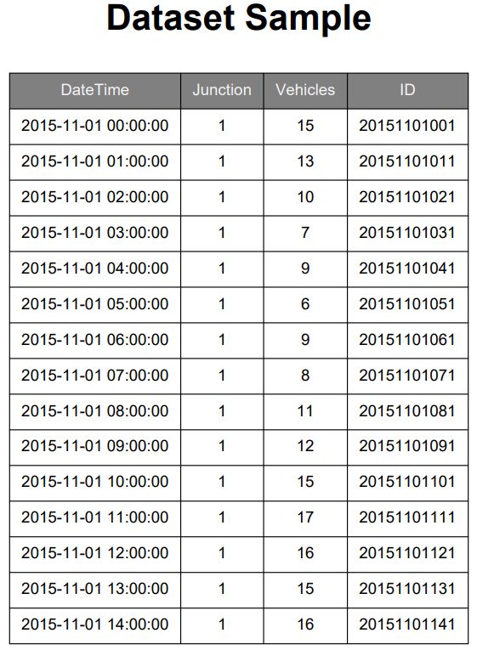
Figures 1

3.3 Data Preprocessing
Before training the model, the dataset was prepared to guarantee consistency and usability.
First, the DateTime column was converted into a proper datetime format. After that, the dataset was sorted chronologically to maintain the time sequence.
New time-related features were then extracted from the DateTime column, including:
Hour of the day
Day of the week
These features help the model understand traffic movements more effectively.
Additionally, the dataset was checked for missing values and inconsistencies. Since the dataset was relatively clean, only minimal preprocessing was required.

3.4 Feature Engineering
To improve the forecasting capability, additional features were created based on the existing data.
Time-based features such as hour and day of week were used as key inputs to capture traffic patterns.
A new target variable called congestion was also created based on the number of vehicles. A threshold was used to classify traffic conditions into:
0 → No congestion
1 → Congestion
This transformation allowed the problem to be treated as a classification task. Although the dataset contains multiple junctions, the Junction variable was included as an input feature to allow the model to learn location-specific traffic patterns.
However, this approach may limit the generalization capability of the model, as it can implicitly associate traffic congestion patterns with specific junction identifiers rather than learning generalized traffic behavior.
An alternative approach would be to develop separate models for each junction, permitting more specialized learning of local traffic behavior. This approach is recommended for future work and may further improve forecast precision.
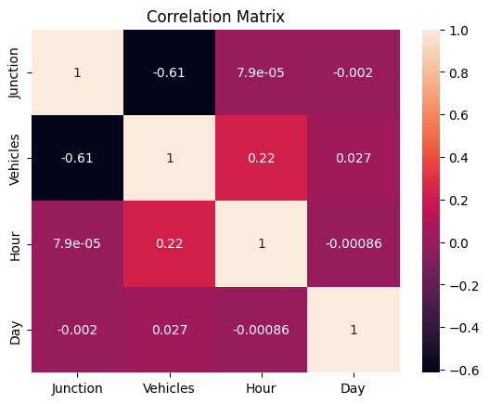
Figures 2

3.5 Model Selection
In this study, four machine learning models were evaluated for short-term traffic congestion prediction: Logistic Regression, Random Forest, Support Vector Machine (SVM), and Gradient Boosting. These models were selected to represent different machine learning families and to allow a comparative assessment of predictive performance and computational effectiveness.
The Logistic Regression model was implemented with max_iter = 2000, class_weight = "balanced", and random_state = 42.
The Random Forest model was implemented with n_estimators = 300, max_depth = 10, class_weight = "balanced", and random_state = 42.
The Gradient Boosting Classifier was implemented with n_estimators = 200, learning_rate = 0.05, max_depth = 3, and random_state = 42.
The SVM model was implemented using the RBF kernel with probability = True, class_weight = "balanced", and random_state = 42.
Standardization was applied for Logistic Regression as well as SVM through a preprocessing pipeline.
Gradient Boosting was selected as the final model based on a combination of predictive performance, computational effectiveness, and suitability for structured traffic data. Compared with the other tested models, Gradient Boosting achieved strong classification performance while continuing to maintain moderate training and prediction times. In addition, tree-based ensemble algorithms are well suited for tabular datasets with temporal and lag-based features, as they can represent nonlinear relationships without demanding extensive feature transformation.
To further examine model durability, a time-series cross-validation procedure was also applied using five splits. This step was used to evaluate whether the tested models maintained stable performance over various temporal segments of the dataset. The comparative results supported the selection of Gradient Boosting as a dependable and effective model for this study.
Regarding model parameter setting, no exhaustive optimization procedure such as Grid Search or Random Search was performed in this study. Instead, the selected hyperparameter values were chosen based on practical experimentation and commonly used configurations for tree-based ensemble models. The main objective of the study was to evaluate the feasibility of machine learning for congestion prediction and responsive traffic signal support rather than to obtain the absolute maximum possible accuracy via comprehensive parameter refinement.
Although full model tuning was not conducted, the adopted Gradient Boosting configuration produced strong results in terms of accuracy, precision, recall, and overall robustness during temporal validation. Subsequent research may extend this study by applying systematic model tuning techniques to further improve predictive performance and compare the optimized results with the current configuration.
Figures 3
Additionally, the execution time of the models was compared to evaluate their processing effectiveness.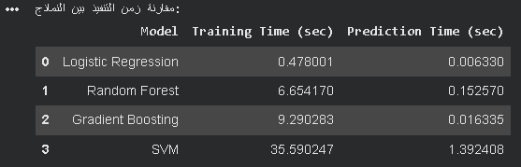
Figures 4

3.6 Training Process
The dataset was divided into training and testing sets. The training set was used to train the model, while the testing set was used to evaluate its performance.
During training, the model learned the relationship between the input variables (such as hour, day, and junction) and the target variable (congestion).
The training process intended to produce a model capable of making dependable predictions on unseen data.

3.7 Model Evaluation
After training, the model was evaluated using the testing dataset.
The evaluation focused on common classification standards such as:
Accuracy: 0.968
Precision: 0.893
Recall: 0.977
F1-score: 0.933
These metrics were used to measure how well the model predicts congestion.
The results showed that the model can reasonably capture traffic patterns as well as predict congestion levels, rendering it suitable for further application. In addition to classification metrics, training time and prediction time were compared across the evaluated models for assessing the models' computational practicality for traffic management applications.
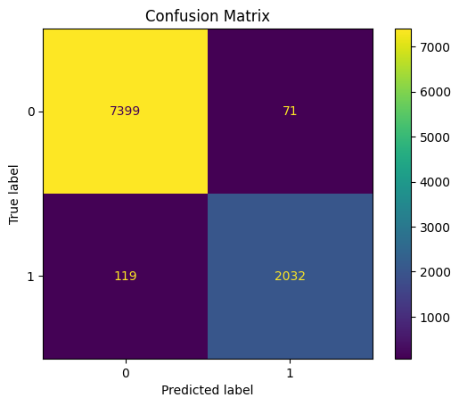
Figures 5
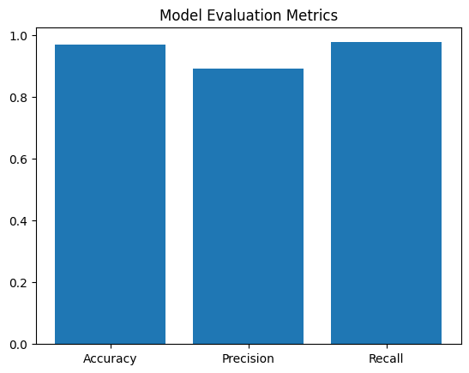
Figures 6

3.8 Adaptive Traffic Signal Mechanism
After obtaining the prediction results, an responsive traffic signal mechanism was implemented to emulate real-life application.
If the model predicts congestion in the next hour, the system adjusts the traffic signal timing by increasing the green light duration. The adjustment depends on the prediction probability, allowing the system to respond more effectively to expected traffic conditions.
If no congestion is predicted, the signal remains in its normal timing mode.
This mechanism demonstrates how anticipatory models can be integrated with traffic regulation systems to reduce congestion and boost traffic flow.

3.9 Summary
This chapter presented the proposed approach used in this project, starting from data preparation and feature engineering to model training and evaluation. It also introduced an responsive traffic signal mechanism based on prediction results. The next chapter will present the experimental results and discussion.

Chapter 4: Experimental Results and Discussion

4.1 Overview
This chapter presents the results obtained from the implemented model and discusses its performance in predicting traffic congestion. It also evaluates the effectiveness of the responsive traffic signal mechanism based on the model projections.

4.2 Model Performance
Gradient Boosting Classifier
The Gradient Boosting Classifier was trained using the prepared dataset and evaluated on the testing data. The model showed good ability in the capturing of traffic patterns and predicting congestion.
The evaluation was based on common classification metrics, including:
Accuracy: Measures the overall correctness of predictions
Precision: Measures how many predicted congestion cases were correct
Recall: Measures how many actual congestion cases were correctly identified
F1-score: Provides a balance among precision plus recall, particularly useful in imbalanced classification problems. The model attained a high F1-score, showing a good balance between detecting congestion cases and avoiding false alarms. This suggests that the model performs reliably in identifying congestion scenarios free of excessive misclassification. The results show that the model can clearly distinguish between congested and non-congested traffic conditions. This suggests that the selected features, particularly time-based features such as hour and day of the week, play an important role in predicting traffic behavior. To further evaluate model effectiveness, a confusion matrix was analyzed. The results showed a high number of true positives and true negatives, indicating that the model is effective in correctly classifying both congested and non-congested traffic conditions.
The number of false negatives (missed congestion cases) was relatively low, which is particularly important in traffic management applications, as failing to detect congestion may cause inefficient signal control decisions.

Similarly, the number of false positives was limited, suggesting that the model does not frequently trigger unnecessary congestion alerts.

Figures 7

4.3 Analysis of Predictions
The prediction results show that congestion is more likely to occur during specific time periods, notably during peak hours.
For example, higher congestion levels were observed during:
Morning hours (7 AM to 9 AM)
Evening hours (4 PM to 7 PM)
This behavior matches real-world traffic patterns, where people commute to and from work.
Additionally, the model showed consistent predictions throughout different junctions, although some variations were observed depending on traffic intensity at each location.

4.4 Adaptive Traffic Signal Evaluation
To evaluate the practical impact of the system, an responsive traffic signal mechanism was applied based on the predicted congestion.
When congestion was predicted, the system increased the green signal duration. This tweak helped simulate augmented traffic movement by allowing more vehicles to pass through the intersection.
The adaptive mechanism showed the following advantages:
- Reduction in predicted congestion impact
- Improved signal responsiveness
- Better utilization of green time

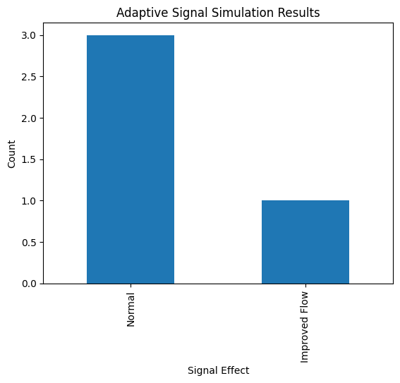
Figures 8
Figure X: Intelligent Traffic Signal Simulation Results
The simulation results show that a significant portion of predicted congestion cases were associated with extended green signal timing, implying a possible improvement in traffic flow under the adaptive signal control strategy.
- Reduced potential vehicle accumulation at intersections
- Smoothed traffic flow flow during peak periods
- More efficient use of signal timing compared to fixed timing systems
Although this evaluation is based on simulation, it demonstrates how predictive systems can be integrated with traffic control systems to support smarter traffic management.

4.5 Discussion
To assess the effectiveness of the proposed model, its performance can be compared to a simple baseline approach based on historical averages. In such a baseline, congestion is predicted based on recurring patterns at specific times (e.g., peak hours), without using machine learning techniques.
Compared to this baseline, the Gradient Boosting model provides more accurate and flexible predictions, as it captures nonlinear relationships and time-based variations in traffic data. This enables the model to identify congestion trends that cannot be detected using simple historical rules.
Therefore, the proposed approach manifests a clear improvement relative relative to baseline methods in predicting short-term traffic congestion.
Although advanced models such as LSTM and ARIMA were discussed in the literature review, they were not implemented in this study due to scope and computing limitations. However, previous studies have shown that LSTM models are especially effective when capturing time correlations in traffic data, while ARIMA models are commonly used as statistical baselines.
Compared to these approaches, the Gradient Boosting model presents a balance between predictive performance, computational effectiveness, and ease of implementation. In addition, tree-based models such as Gradient Boosting are more suitable for structured tabular datasets with engineered features, as used in this study. This makes the proposed approach more practical for real-life deployment in traffic regulation systems.
The results confirm that machine learning can be effectively used for traffic congestion prediction.
One of the key strengths of this procedure is its simplicity. By using a structured dataset and time-based features, the model was able to achieve reasonable performance without demanding complex inputs such as weather or sensor data.
However, there are some limitations:
The dataset contains only a limited number of junctions
Outside factors such as weather conditions and accidents were not considered
In spite of these limitations, the approach delivers a firm springboard for future improvements and applied applications.

4.6 Summary
This chapter presented the experimental results and analysis of the proposed system. The Gradient Boosting model demonstrated good performance in predicting traffic congestion, and the responsive traffic signal mechanism showed encouraging potential in boosting traffic flow.

Chapter 5: Conclusion and Future Work

5.1 Introduction
This study proposed a machine learning-based system for predicting traffic congestion at signalized intersections and supporting responsive traffic signal control.
The main research question investigated whether a Gradient Boosting model could outperform a simple historical average baseline in predicting short-term traffic congestion. The experimental results showed that the Gradient Boosting model attained high performance, with strong accuracy, precision, recall, and F1-score, showing its ability to reliably detect traffic congestion patterns. Compared to a baseline approach based on historical averages, the proposed model delivered improved performance by detecting nonlinear relationships and time-based variations in traffic data. This confirms that machine learning techniques can provide more accurate and flexible congestion prediction than traditional rule-based methods. In addition, an responsive traffic signal mechanism was implemented and evaluated through a simulation-based approach. The results indicated that increasing green signal duration during predicted congestion periods can help reduce vehicle accumulation and boost traffic traffic traffic operation efficiency. Although the adaptive control was evaluated in a simplified simulation environment, the findings show the feasible effectiveness of integrating prediction models with traffic signal control strategies.
Overall, the study shows that Gradient Boosting can effectively forecast road congestion and that prediction-driven signal control can contribute to boosting traffic management performance. The findings of this study directly answer the research question. The results confirm that the Gradient Boosting model outperforms a simple historical average baseline in predicting short-term traffic congestion. This demonstrates the effectiveness of machine learning approaches in detecting complicated traffic patterns and supports their use in intelligent traffic regulation systems.

5.2 Future Work
Although the proposed approach attained promising results, there are several opportunities for improvement and further development.
First, additional data sources can be incorporated to improve forecast precision. For example, including weather conditions, road events, or special events may yield a more complete understanding of traffic behavior.
Second, more advanced models such as deep learning techniques can be explored. Models like Long Short-Term Memory (LSTM) are particularly suitable for time-series data and may improve long-term traffic prediction.
Third, the responsive traffic signal system can be extended to operate in real-time environments. Integrating the model with live traffic data and actual signal controllers would make the system more practical and influential.
Finally, the system can be expanded to cover a larger number of junctions and different cities, which would improve its scalability and wider applicability.

References
- FEDESORIANO , Traffic Prediction Dataset https://www.kaggle.com/datasets/fedesoriano/traffic-prediction-dataset
- Medina-Salgado, et al. (2022). Urban traffic flow prediction techniques: A review. Sustainable Computing: Informatics and Systems, 35, 100739. https://doi.org/10.1016/j.suscom.2022.100739
- Rahmani, et al. (2023). Graph neural networks for intelligent transportation systems: A survey. IEEE Transactions on Intelligent Transportation Systems, 24(8), 8846–8859. https://doi.org/10.1109/TITS.2023.3257759
- Katambire, et al. (2023). Forecasting the traffic flow by using ARIMA and LSTM models: Case of Muhima Junction. Forecasting, 5(4), 616–628. https://doi.org/10.3390/forecast5040034
- Chen, et al. (2021). A freeway travel time prediction method based on an XGBoost model. Sustainability, 13(15), 8577. https://doi.org/10.3390/su13158577
- Cheng, et al. (2022). Combination predicting model of traffic congestion index in weekdays based on LightGBM–GRU. Scientific Reports, 12, 2912. https://doi.org/10.1038/s41598-022-06975-1
- Sakib, N. (2025). Machine learning-based travel time prediction models for complex traffic conditions. In Proceedings of the 7th International Conference on Advances in Civil Engineering (ICACE 2024). SSRN. https://papers.ssrn.com/sol3/papers.cfm?abstract_id=5238355
- Zhu, et al. (2024). Adaptive graph attention and long short-term memory network for traffic flow prediction. Mathematics, 12(2), 255. https://doi.org/10.3390/math12020255
- Topilin, et al. (2025). Traffic flow prediction via a hybrid CPO-CNN-LSTM-Attention architecture. Smart Cities, 8(5), 148. https://doi.org/10.3390/smartcities8050148
- Wang, et al. (2021). Learning the solution operator of parametric partial differential equations with physics-informed DeepONets. Science Advances, 7(40), eabi8605. https://doi.org/10.1126/sciadv.abi8605
- Li, et al. (2025). Physics-informed deep operator network for traffic state estimation. arXiv preprint. https://arxiv.org/abs/2508.12593
- Liu, et al. (2025). A review of traffic flow prediction methods in intelligent transportation system construction. Applied Sciences, 15(7), 3866. https://doi.org/10.3390/app15073866
- Kashyap, et al. (2022). Traffic flow prediction models – A review of deep learning techniques. Cogent Engineering, 9(1), 2010510. https://doi.org/10.1080/23311916.2021.2010510
- Zhu, et al. (2019). Big data analytics in intelligent transportation systems: A survey. IEEE Transactions on Intelligent Transportation Systems, 20(1), 383–398. https://doi.org/10.1109/TITS.2018.2815678
- Fang, et al. (2022). Attention meets long short-term memory: A deep learning network for traffic flow forecasting. Physica A: Statistical Mechanics and Its Applications, 587, 126485. https://doi.org/10.1016/j.physa.2021.126485
- Wang, et al. (2021). A hybrid deep learning model with 1DCNN-LSTM-attention networks for short-term traffic flow prediction. Physica A: Statistical Mechanics and Its Applications, 583, 126293. https://doi.org/10.1016/j.physa.2021.126293
- Islam, et al. (2022). Using CNN-LSTM to predict signal phasing and timing aided by high-resolution detector data. Transportation Research Part C: Emerging Technologies, 141, 103742. https://doi.org/10.1016/j.trc.2022.103742
- Lv, et al. (2015). Traffic flow prediction with big data: A deep learning approach. IEEE Transactions on Intelligent Transportation Systems, 16(2), 865–873.
https://doi.org/10.1109/TITS.2014.2345663
- Vlahogianni, et al. (2014). Short-term traffic forecasting: Where we are and where we’re going. Transportation Research Part C: Emerging Technologies, 43, 3–19.
https://doi.org/10.1016/j.trc.2014.01.005
- Genders, et al. (2019). Using a deep reinforcement learning agent for traffic signal control. arXiv preprint.
https://arxiv.org/abs/1904.08117

