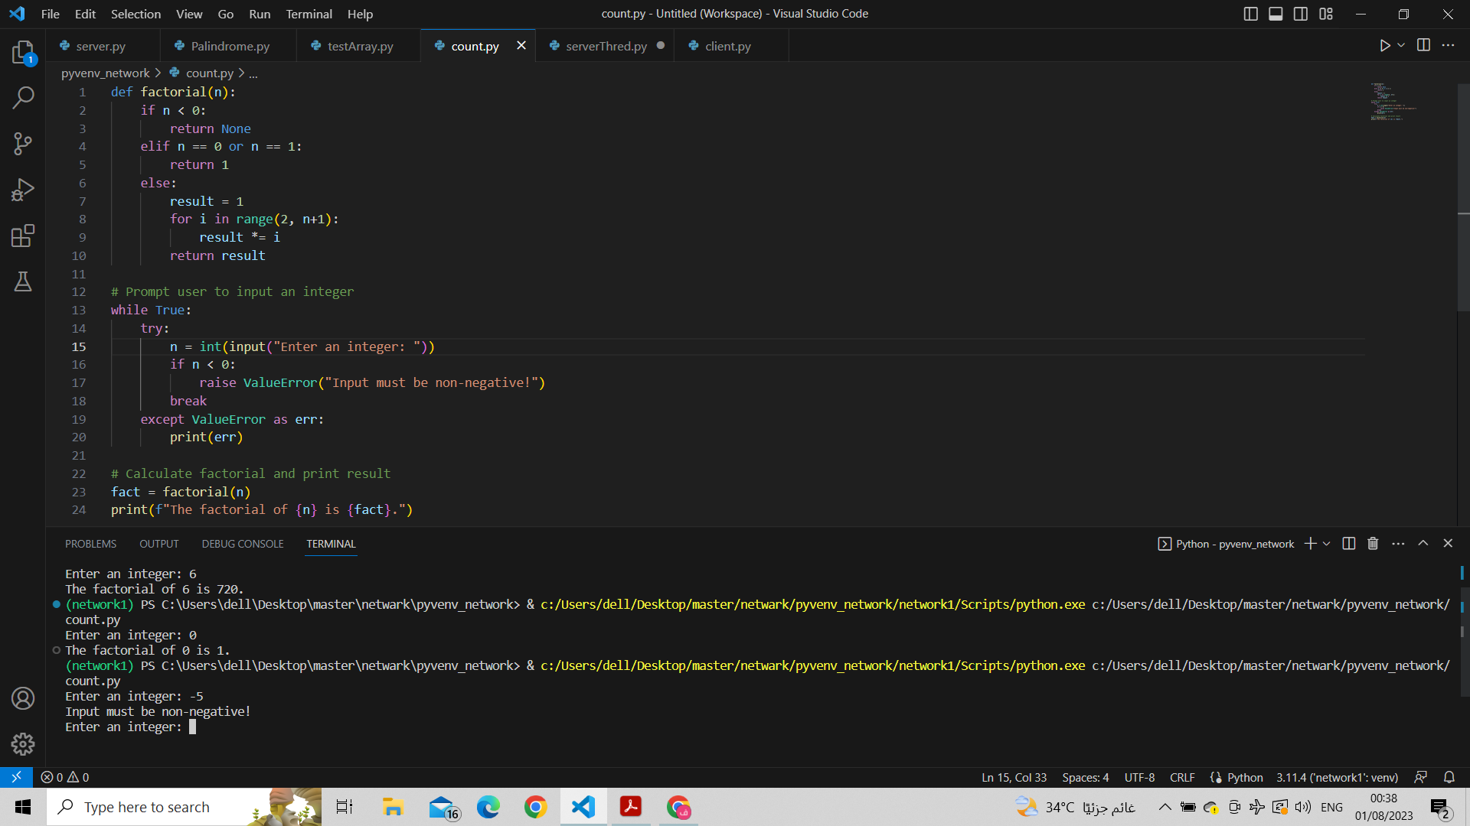

def factorial(n):
if n < 0:
return None
elif n == 0 or n == 1:
return 1
else:
result = 1
for i in range(2, n+1):
result *= i
return result

# Prompt user to input an integer
while True:
try:
n = int(input("Enter an integer: "))
if n < 0:
raise ValueError("Input must be non-negative!")
break
except ValueError as err:
print(err)

# Calculate factorial and print result
fact = factorial(n)
print(f"The factorial of {n} is {fact}.")

رابط المشاركه على تويتر
https://twitter.com/toma__1442/status/1686130976752095233?s=46&t=4BoRmpyxlrJdHGAEiKS1pQ

