

Predicting Depression in Children Using Behavioral Pattern Analysis and AI Techniques
Prepared By
Name: [Ahmed Eid Alrehely] IDNo.:[243000206]
ORCID: 0009-0003-3951-3305
243000206@st.midocean.edu.km

Submitted in fulfillment of the requirements for the degree Master of Science in Artificial Intelligence
At
College of Informatics
Midocean University
UAE
Supervisor Name: Dr. Amjed Qataish
amjadqtaish@midocean.edu.km
0000-0001-5210-7086

College of Informatics, Midocean University, Comoros
[2025]
Acknowledgements
I want to give special thanks to Dr. Amjed Qataish for all his support, comments, feedback, and corrections during both the theoretical and practical courses.
I also want to give my thanks to my wife, family, and friends for all their support and motivation. I get inspiration from their advice and encouragement
Abstract
This thesis will discuss depression in children, especially after the incidence of this disease increased with the accelerating pace of life and the spread of social media.
there is statistics indicating of teenage affected of depression affects around 15 - 20 % that is meaning 1 out of 5 teenagers has been effected and 2 - 8 % for children. This study will focus on the children category to reduce the percentage of affected that will prevent the depression of the bigger categories as much as possible
also because the AI is the most modern and powerful technology, especially in predicting sides, I will use the AI to achieve my goal to reduce the children's depression percentage, along with achieving my technical objects predicting by the Regression task primarily and classification for clinical interpretation secondarily.
also to achieve this goal, I selected three compatible datasets: the DASS-21, the MHP, and the Kaggle SDD datasets. Also, to get the data ready for analysis, I used the unified preprocessing, which includes data cleaning and feature engineering, normalization, and category encoding.
As a model stack, I employed both neural networks and machine learning models across all datasets; the neural network consistently produced the best results.
The models provide high predictive accuracy with an average MAE scores of 0.21–0.34, MSE scores of 0.08–0.15, and R² values between 0.72–0.86.
The AI models detecting high predictions will be more helpful and useful in reducing the target category effected of depression that will help the clinic, doctor, and the concerned health sector
Keywords: Explainable AI, Behavioral Data, Early Detection, Neural Networks, Machine Learning, Childhood Depression, and Mental Health Prediction
Table of Contents
Chapter 1: Introduction ................................................................. 1
1.1 Problem Definition ..................................................................... 1
1.2 Thesis Objectives ........................................................................ 1
1.3 Thesis Contribution ..................................................................... 2
1.4 Thesis Organization .................................................................... 3

Chapter 2: Overview ........................................................................ 4
2.1 Introduction ................................................................................ 4
2.2 Classical Machine Learning Methods ........................................ 4
2.3 Deep Learning Approaches ....................................................... 4
2.4 Hybrid and Optimized Models .................................................. 5
2.5 Use of Real-World Datasets ...................................................... 5
2.6 Quantitative Results Summary ................................................ 6
2.7 Research Gaps and Opportunities ............................................ 6
2.8 Conclusion .................................................................................. 7

Chapter 3: Related Work ................................................................. 8
3.1 Introduction ................................................................................ 8
3.2 History ........................................................................................ 8

Chapter 4: Proposed Approach ..................................................... 9
4.1 Data Collection and Description ............................................... 9
4.2 Data Preprocessing ..................................................................... 9
4.3 Feature Engineering ................................................................... 10
4.4 Feature Selection ......................................................................... 10
4.5 Model Selection and Optimization ........................................... 11
4.6 Model Evaluation ........................................................................ 12
4.7 Visualization and Insights ......................................................... 12

Chapter 5: Experimental Results and Discussion ....................... 13
5.1 Experimental Setup .................................................................... 13
5.2 Baseline Model Performance ..................................................... 14
5.3 Feature Selection and Model Refinement ................................. 14
5.4 Visualization of Results ............................................................. 15
5.5 Discussion .................................................................................... 18

Chapter 6: Conclusion and Future Work ...................................... 30
6.1 Conclusion ................................................................................... 30
6.2 Future Work ................................................................................ 31
References ....................................................................................... 32,33
List of Figures

Figure 1.5 — Thesis Organization .................................................... 3
Figure 2.1 — Methodology ................................................................ 13
Figure 2.2 — Feature Engineering Workflow ................................. 16
Figure 3.1 — Result of Model 1 ....................................................... 24
Figure 3.2 — Result of Model 2 ....................................................... 24
Figure 3.3 — Result of Model 3 ....................................................... 25
Figure 3.4 — Result of Model 4 ....................................................... 26
Figure 3.5 — Result of Model 5 ....................................................... 26
List of Tables
Table T1 — Table 1 ............................................................................. 5
Table T2 — Table 2 ............................................................................. 12
Table T3 — Table 3 ............................................................................. 18
Table T4 — Table 4 ............................................................................. 19
Project Timeline (10 Weeks)
The table 1 below describes the 10-week project timeline that includes the important tasks from the planning through all stages until the assessment stage

Week | Phase / Activity | Key Tasks | Deliverables
1 | Project Setup & Planning | Define project scope, confirm datasets, configure tools & environment | Project plan, configured workspace
2 | Data Acquisition | Collect multimodal datasets; build ingestion pipelines | Centralized raw data repository
3 | Data Cleaning & Preprocessing | Remove duplicates, handle missing values, encode variables, normalize data | Fully preprocessed dataset
4 | Feature Engineering | Derive new features; apply RFE and Mutual Information | Finalized feature set
5 | ML Model Development | Train LR, RF, and Gradient Boosting baseline models | Baseline ML models + performance metrics
6 | Neural Network Development | Train FNN, LSTM, GRU, and Transformer models | Trained neural models + metrics
7 | Optimization & Fusion | Apply multimodal fusion, tune hyperparameters, compare ML vs. NN | Optimized best-performing model
8 | Explainability | Generate SHAP values, attention maps; interpret model behavior | Explainability report
9 | Evaluation | Conduct comprehensive testing, robustness & performance validation | Final evaluation report
10 | Documentation & Presentation | Write final documentation; prepare presentation slides and dashboard | Completed Phase 1 package
Chapter 1:
Introduction
1.1 Problem Definition

Healthcare is now driven by data alignment with the booming of computing, AI, and big data analytics that enhance the prediction of diagnosis and the planning of treatment. As I mentioned, childhood depression affects around 2-8% of children globally, which is considered a public health concern.
The main issue with the traditional methods usually depends on clinical observation and latency identified. making them reactive, but when the AI's appearance is converted to proactive by analysis and prediction
By identifying and extracting indicators such as social disengagement and irregular sleep patterns, then embedding those indicators in the preprocessing stage, and converting those to visual results by the machine learning and deep learning models, we can enhance the prediction, therefore reducing the recorded percentage

Worth mentioning, the current ways have some issues, like:
1. depends on a single dataset
2. depends on a single model, not a model stack
3. not sustainable and not able to expand
1.2 Contribution to the Thesis
This study provides an advanced AI prediction system in multiple ways as follows:
1. Bulid Advanced AI System: by merging both classical machine learning and neural networks to achieve high accuracy prediction system.
2. Early Detection: that enables the prompt interventions and better prediction outcomes, moving the clinical symptoms stage from late to early.
3. Ability of Interpretation For Clinical Trust: which includes both transparency and clinical relevance by integrating approaches like SHAP, Visualization and feature extraction and analysis.
4. Combine Multi-Datasets: Integrates many real-world datasets (Kaggle, MHP, DASS 21) to improve the accuracy of the source data.
5. Academic and Practical Impact: This study offers an advanced framework by combining both ML and NN approaches.
1.3 Aim of the Project
The project's goal is to provide an advanced AI prediction framework that uses behavioral and psychological markers to detect childhood depression.
The project aims to provide a prediction, clinically interpretable, accurate, scale and expandable system that drives the early detection of depression based on the previous research.
1.4 Thesis Pipeline
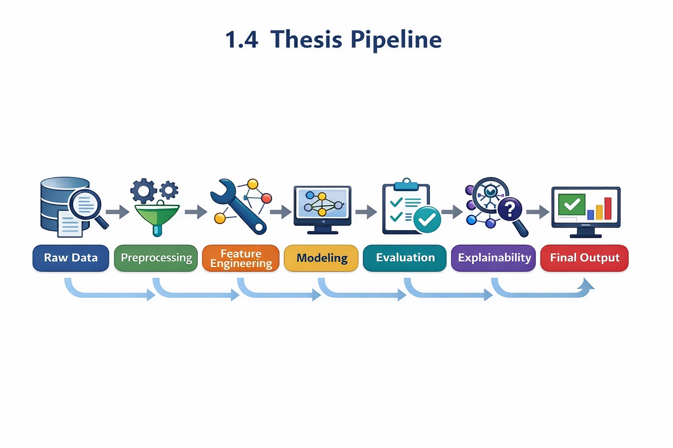
The above Figure 1 describes the thesis pipeline from row data to the final output
1.5 Thesis Organization
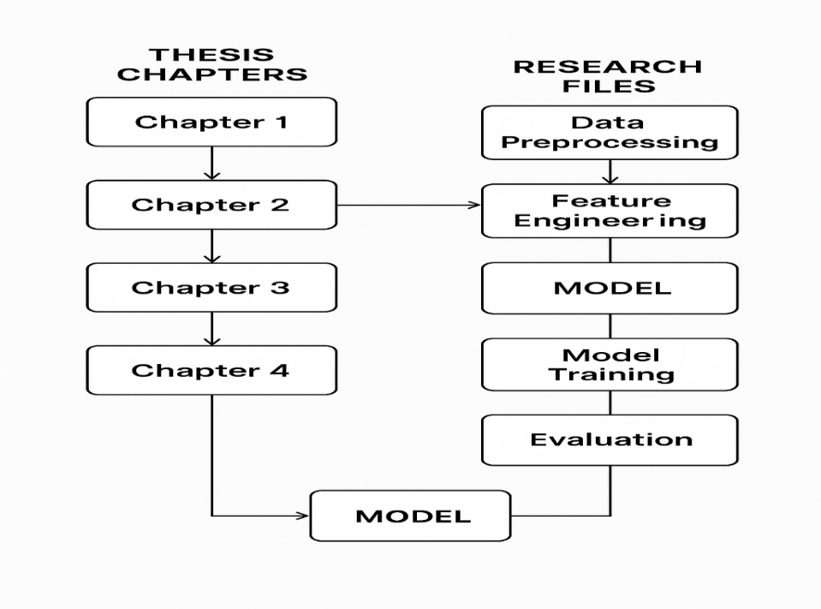
The above Figure 2 describes the thesis organization from data processing to evaluation

Chapter 2:

Overview
2.1 Introduction
This chapter provides the integration of two approaches of AI models that include ML and NN, it benefiting from the strong points of classical ML techniques like interpretability and simplicity. but also elaborate on the ML deficiency to handle multimodal and complex data.
also it benefits the strong points of Deep learning by building neural networks like CNN-based, transformer, and LSTM to handle and capture the nonlinear and sequential patterns,
To show how integrating several architectures with explainable AI improves accuracy and transparency, all the previous derived to a strong AI prediction System and framework.
2.2 Classical Machine Learning Methods
The first approach was the classical machine learning by using models like:
1. Decision Trees
2. Random Forests
3. Support Vector Machines (SVMs)
4. K Nearest Neighbors (KNN)
Ware used in early depression prediction based on raw data like MHP and the Kaggle (SDD), which achieve resualts with interpretability and simplicity. where these give the rate of accuracy levels between 70 and 85%, Decision Trees and Random Forests demonstrated efficacy in managing categorical variables and missing data; these approaches had a deficiency in handling multimodal, nonliner and complex data.
2.3 Deep Learning Approaches
While deep learning is more advanced than classical machine learning in capturing the nonlinear, multimodal, and sequential patterns, by building neural networks like CNN-based, transformer, and LSTM, with demonstrated following:
1. Long Short-Term Memory networks, which simulate sequential patterns in daily behavioral logs, sleep tracking data, and longitudinal surveys,
2. Transformer-based which analyze multi-modal datasets with high accuracy and parallel processing efficiency, including image analysis like handwriting and facial recognition, and voice expression detection.

The hybrid modes like CNN-LSTM combine all the strong points of both approaches, such as interpretability and simplicity from classical ML and capturing the nonlinear, multimodal, and sequential patterns from DL and NN, also the data preprocessing and feature engineering recording hight accuracy in extracting the hard patterns such as sleep irregularities, anxiety levels, academic stress, and social withdrawal.
2.4 Hybrid and Optimized Models
As I mentioned before, the hybrid modes through architectures like CNN-LSTM pipelines and Transformer-CNN-CNN hybrid combine all the strong points of both approaches, such as interpretability and simplicity from classical ML and capturing the nonlinear, multimodal, and sequential behavioral input patterns from DL and NN, which give features like accuracy, lower computing costs, and increased model efficiency. also the data preprocessing and feature engineering recorded high accuracy in extracting the hard patterns such as sleep irregularities, anxiety levels, academic stress, and social withdrawal. Additionally, Explainable AI (XAI) methods—like SHAP, attention-weight visualization, and LIME—highlight the most important behavioral characteristics
2.5 Use of Real-world Datasets

To achieve and develop from previous studies, which almost depended on a single dataset, I used multiple datasets with the following details :
The Kaggle Student Depression Dataset (KSDD)
https://www.kaggle.com/datasets/adilshamim8/student-depression-dataset
MHP Depression, Stress, and Anxiety.
https://figshare.com/articles/dataset/MHP_Anxiety_Stress_Depression_Dataset/25771164
The Mental Health DASS-21 Dataset
https://data.mendeley.com/datasets/2v9kvb7xgv/1
Preprocessing procedures include:
1. Handling missing values.
2. Encoding categorical variables.
3. Performing targeted feature engineering.
4. Applying the appropriate scaling strategies to get the data ready for neural network training.
2.6 Quantitative Results Summary
Table 2 below compares the performance of all the approaches used:
Category | Key Findings
Classical Machine Learning Models | • Achieve moderate accuracy (70%–85%)• Struggle to capture temporal or nonlinear behavioral patterns
Deep Learning Models | • Deliver higher predictive performance: — MAE: 0.21–0.34 — MSE: 0.08–0.15 — R²: 0.72–0.86• Effectively model complex, sequential, and multimodal behavioral signals
Hybrid Models + Explainable AI | • Combine techniques such as CNN–LSTM, Transformer–CNN, and ensemble architectures• Achieve better accuracy than single-model approaches• Use of SHAP, Attention, and LIME improves interpretability and supports clinical credibility
2.7 Research Gaps and Opportunities
AI-driven mental health prediction has advanced, yet there are still a number of gaps:
Dataset Diversity & Generalization:
The majority of current datasets are restricted to particular age groups, geographical areas, or cultural backgrounds, which limits the model's capacity to be applied to other populations.
Multi-Modal & Sequential Integration:
Instead of combining temporal, textual, visual, and survey-based data into a single model, current methods frequently examine behavioral signals separately.
Interpretability vs. Accuracy:
Deep learning models are highly accurate but opaque. Interpretable forecasts are necessary for clinicians to guarantee validity, safety, and trust.
Real-World Deployment Challenges:
Not much research has been done on the actual integration of mobile health platforms, school-based screening systems, or clinical workflows.
Personalized & Adaptive Modeling:
Rarely are predictions modified by current systems in response to longitudinal changes over time or individual behavioral baselines.
Chapter 3:
Related Work
3.1 Introduction

Childhood and teenage depression has become a major public health concern due to its long-term effects on social well-being, academic success, and emotional development.
The majority of traditional diagnostic methods rely on self-reports or clinical observation, which usually overlook early, subtle behavioral patterns.
AI-driven techniques like Machine Learning (ML) and Neural Networks (NN) have recently emerged as helpful tools for identifying depression by analyzing a range of data sources, including surveys, facial expressions, handwriting, social media activity, and physiological indications.

Important research on AI-based depression prediction is compiled in this chapter, with a focus on model performance, data types, and methodologies. The goal of comprehending the benefits and drawbacks of existing approaches is to guide the development of a trustworthy, understandable model for the early detection of childhood depression.
3.2 History
The previous studies used both traditional machine learning models as stand alon model, such as Decision Trees, Random Forests, SVMs, and Logistic Regression, and achieved 74–78%, with accuracies around 86%.
also they used deep learning as stand alon model as well, which significantly improved performance. CNNs, LSTMs, and Transformers enabled improved modeling of textual data, temporal sequences, and facial cues; accuracy is often over 90% in multimodal situations
More recent work focuses on hybrid architectures (e.g., CNN-LSTM, CNN-Transformer) and optimization strategies in addition to explainable AI tools like SHAP, attention mechanisms, and LIME. These advancements enhance robustness, interpretability, and accuracy—all crucial for clinical acceptance in child-focused applications.
3.3 Machine Learning-Based Approaches
Most previous studies take the traditional machine learning (ML) techniques to identify and predict in children and adolescents, which has been the subject of several studies.
Random Forest & Logistic Regression:
The Random Forest models were applied to self-reported behavioral and emotional variables, witch achive around 86%.
Gradient Boosting & Random Forest on ALSPAC Dataset:
The study, as ALSPAC mentioned, has predictive ability (64–66% accuracy), that appearnace like a challenge of early-stage prediction when symptoms are mild.
Decision Trees on Youth Mental Health Surveys:
the decision tree models attained accuracies between 68 and 72%, demonstrating their value for rapid and understandable screening. but is have issue with intricate behavioral interactions.
Random Forest on Behavioral Observation Data:
When trained on structured behavioral observations and nonverbal cues, Random Forest models obtained up to 95% accuracy, underscoring the significance of high-quality, feature-rich behavioral data.
Naïve Bayes on Student Lifestyle & Demographic Features:
With accuracies of roughly 76%, Naïve Bayes and other lightweight probabilistic models showed their suitability for quick prototyping or resource-constrained situations.

All things considered, Deep learning and hybrid approaches are motivated by the fact that while traditional machine learning models offer interpretable baselines, they struggle with temporal, nonlinear, and multimodal behavioral patterns.
3.4 Neural Network-Based Approaches
The power of integration of multimodal behavioral data, capturing temporal connections, and modeling intricate nonlinear patterns,
The DL has improved depression prediction. High prediction skills across text, graphics, audio, and physiological inputs have been shown by a number of architectures:
Hierarchical Attention Networks (HAN):
Using hierarchical attention layers to highlight linguistically significant patterns and produce comprehensible attention maps, the system achieved about 90% accuracy when applied to textual content.

Graph Transformer with Contrastive Learning:
achieved about 93% accuracy by using graph topologies and self-supervised contrastive representation learning to concurrently describe social, behavioral, and contextual interactions.

Convolutional Neural Networks (CNN) for Facial Expression Analysis:
showed about 91% accuracy in identifying minor emotional indicators associated with depression states using spatial feature extraction from facial photos.

Long Short-Term Memory (LSTM) Networks for Speech Processing:
The LSTM captured time fluctuations in voice patterns and its characteristics linked to depressed signs with an accuracy of 88%.
CNN–RNN Multimodal Fusion Models:
the integrated textual signals, audio cues, and face expressions achieved an accuracy with 90%, which demonstrated the importance of cross-modal behavioral analysis.
BERT and RoBERTa Transformer Models for Text Classification:
Attention-based explainability and contextual embeddings helped detect depression-related linguistic indications with an accuracy of about 92%.

CNN–LSTM Models for EEG Signal Analysis:
Combining temporal and spatial brain dynamics in EEG recordings yielded an accuracy of about 89% in determining the degree of depression.

Hybrid CNN–Transformer Architectures:
combined global contextual attention with hierarchical spatial characteristics to achieve up to 94% accuracy, providing robust performance across several behavioral input modalities.

Overall, Sequential, spatial, and contextual interdependence across multimodal data sources are generally well captured by neural network-based methods. Because of these advantages, deep learning models are especially well suited for the early identification of depression in children, whose behavioral patterns are subtle, nonlinear, and change over time.
Table 3.5 Summary of Literature Review
A consolidated literature review table summarizing prior studies’ methods, models, and reported accuracies across machine learning and deep learning approaches for depression detection.
No. | Research Focus | Approach | Models Used | Accuracy (Approx.)
1 | Identifying Adolescent Depression & Anxiety | ML | RF, LR | RF: ~86% • LR: ~74–78%
2 | Depression Risk via Brain Imaging | ML & NN | LR, NN | LR: ~75–78% • NN: ~82–85%
3 | ALSPAC Longitudinal Study | ML | Gradient Boosting, RF | GB: ~64% • RF: ~66%
4 | Australian Youth Depression Risk | ML | DT, RF | DT: ~68% • RF: ~72%
5 | Child Depression Detection | ML | RF | ~95%
6 | Depression Dataset Analysis | ML | RF, SVM | ~80–88%
7 | Student Depression Dataset | ML | Naïve Bayes | ~76%
8 | Early Detection Using Classical ML | ML | SVM, KNN, DT, GB, RF, LR | ~70–85%
9 | HAN-Based Text Depression Detection | NN | HAN | ~90%
10 | Graph Transformer Detection | NN | GNN + Transformer | ~93%
11 | Facial-Expression Depression Detection | NN | CNN | ~91%
12 | Speech-Based Depression Detection | NN | LSTM | ~88%
13 | Multimodal Deep Learning Detection | NN | CNN + RNN | Not reported

Chapter 4:

Proposed Approach
Research Methodology
The research methodology outlines a methodical process for developing, putting into practice, and assessing an AI-based system to identify early indicators of childhood depression. This approach guarantees that models are accurate and comprehensible for practical uses by emphasizing scientific rigor, reproducibility, and clinical relevance.
4.1 Research Design
T This study uses multimodal behavioral data to predict early signs of childhood depression using a quantitative, experimental research methodology. The architecture combines structured data preparation, feature engineering, model optimization, and supervised learning approaches across several datasets (Kaggle, MHP, DASS-21).
The study assesses two main streams of methodology:

Classical Machine Learning Models
Classical machine learning models, such as Random Forest, XGBoost, Logistic Regression, and SVM, are used as baseline predictors to evaluate the interpretability of the model and the relevance of the initial features.
Deep Learning and Hybrid Neural Networks
LSTM, Transformer models, CNN-LSTM, and Hybrid CNN-Transformer architectures are examples of deep learning and hybrid neural networks that are used to capture multimodal, nonlinear, and temporal behavioral patterns.
The main goal of the study is to find the behavioral characteristics most suggestive of early depression risk while methodically comparing model performance, interpretability, and robustness. By using rigorous assessment criteria (MAE, MSE, Accuracy, Precision, Recall, F1-Score, R2) and controlled testing, this study creates a dependable and clinically interpretable AI-based
R²), this research establishes a reliable and clinically interpretable AI-based framework for predicting early depression
4.2 Research Methodology Pipeline
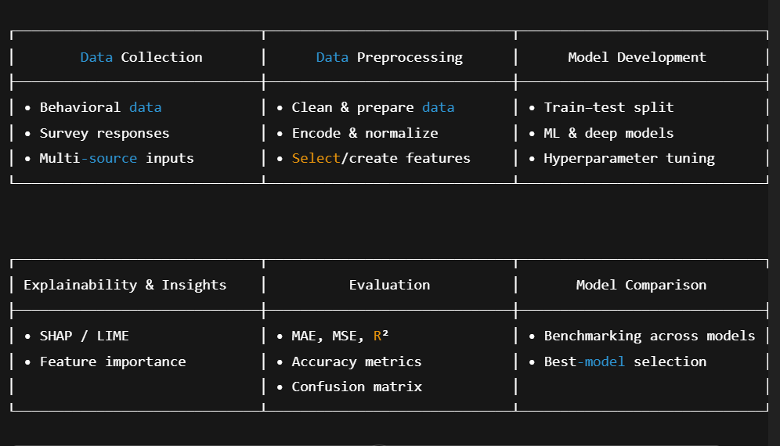
the figure3 describe Research Methodology Pipeline start from data collection to model comparison.
4.3 Data Collection
I used multiple datasets to achieve high performance and to guarantee enough depth, diversity, and representativeness.
Primary Data:
The most important sources are caregiver-reported questionnaires, which include:
The Kaggle Student Depression Dataset (KSDD)
MHP Depression, Stress, and Anxiety.
The Mental Health DASS-21 Dataset
These offer direct insight into the emotional, behavioral, and health-related patterns of kids.
Secondary Data:
The Kaggle Depression Dataset and the ALSPAC (Avon Longitudinal Study of Parents and Children) cohort are two examples of publicly available datasets that offer comprehensive, validated behavioral and psychological indicators.
Multimodal Data Sources:
In order to ensure high-quality, consistent datasets prior to preprocessing and extra analysis, additional inputs such as handwriting samples, face expression ETL pipelines, and standardized APIs are employed for data ingestion in addition to typical tabular data.
4.4 Data Preprocessing
Before developing a model, it is crucial to ensure data homogeneity and integrity.
Cleaning:
elimination of statistical outliers, faulty entries, and duplicate records.
Missing Value Handling:
Depending on the features of the variable, imputation can be done using machine learning-based imputers or statistical techniques (mean/median).
Transformation & Encoding:
Scaling guarantees model compatibility, categorical variables are encoded (e.g., one-hot or target encoding), and continuous variables are normalized or standardized.
Feature Engineering:
derived correlation-based characteristics, temporal summaries, and behavioral traits. To keep the most pertinent predictors, feature selection is carried out using Mutual Information (MI) and Recursive Feature Elimination (RFE).

Balancing:
SMOTE or class-weighted training procedures are used to correct class imbalance.
Dataset Splitting: Robust model evaluation is supported and class proportions are maintained using a stratified 80/20 train-test split.
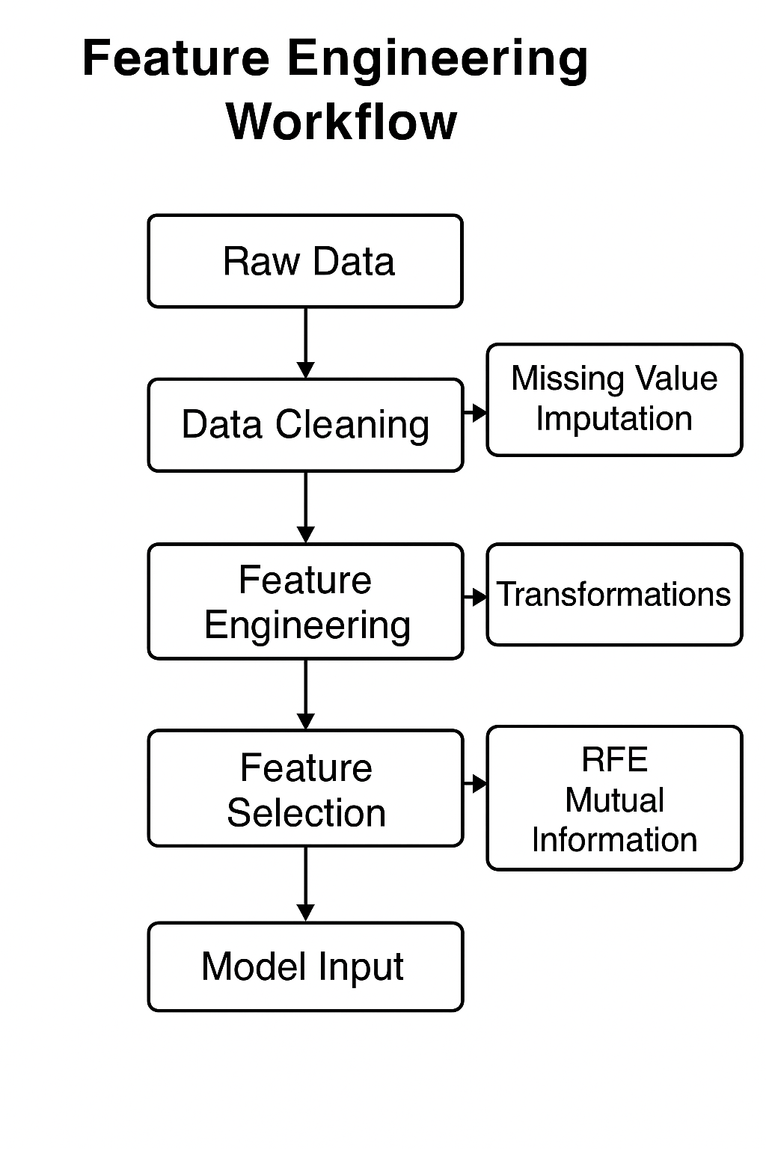
a thorough process diagram that shows how raw data is transformed into final model-ready inputs by cleaning, feature engineering, and selection.
4.5 Model Development
The study assesses a wide range of prediction models, including both contemporary deep architectures and traditional techniques.

Classical Machine Learning Models:
Baseline models that are stable and easy to understand include Logistic Regression, Random Forest, and Gradient Boosting.

Neural Network Models:
Temporal and sequential behavioral patterns are captured by deep architectures such as Transformer-based models, Gated Recurrent Units (GRU), Long Short-Term Memory (LSTM), and Feedforward Neural Networks (FNN).

Fusion Strategies:
By integrating multimodal data sources, late fusion and hybrid fusion techniques enable the complementarity of behavioral, temporal, and visual characteristics.

Optimization:
L2 regularization, dropout, early halting, and hyperparameter adjustment guarantee optimal prediction performance and avoid overfitting.
4.6 Explainability and Interpretability
SHAP values measure the contributions of individual features and global model patterns in order to guarantee that the suggested system facilitates clinical decision-making in the real world.
Sequence-based and Transformer models employ attention visualization to draw attention to important behavioral and temporal elements.
Model results are guaranteed to be medically significant and comprehensible by expert clinical validation.
Expert clinical validation ensures that model outputs are medically meaningful and interpretable.
4.7 Evaluation
A wide range of exacting evaluation techniques are used in model assessment.

Performance Metrics:
F1-Score, ROC-AUC, Accuracy, Precision, and Recall, with a focus on sensitivity (Recall) to facilitate early detection.
Comparative Analysis:
Confidence interval estimation, recurrent cross-validation, and evaluation across ML and NN models.
Robustness Checks:
Performance is examined under domain-shift scenarios and across demographic subgroups (age, gender, and socioeconomic characteristics).

Reproducibility:
Results are consistently replicated thanks to version-controlled scripts, established processes, and repeatable computing environments.
4.8 Summary Table – Research Methodology Steps
a thorough table that outlines the goals, instruments, and anticipated results for every stage of the research process throughout the whole AI workflow.

Phase | Objective | Methods / Tools | Expected Output
Data Collection | Gather multimodal behavioral and psychological data | Surveys, EHRs, facial/handwriting datasets, Kaggle sources, ALSPAC, APIs | Unified raw dataset
Data Preprocessing | Clean, transform, and prepare data for modeling | Data cleaning, imputation, normalization, encoding, RFE, Mutual Information, SMOTE | Model-ready processed dataset
Model Development | Build and train predictive models | LR, RF, Gradient Boosting, FNN, LSTM, GRU, Transformer | Trained baseline and deep models
Fusion & Optimization | Improve performance through multimodal integration | Late fusion, hybrid fusion, hyperparameter tuning, regularization | Optimized fused models
Explainability | Ensure transparency and clinical interpretability | SHAP, attention maps, expert review | Interpretable and validated insights
Evaluation | Assess predictive performance and fairness | Accuracy, F1-score, AUC, cross-validation | Comprehensive evaluation report
Ethical Compliance | Maintain responsible and secure AI practices | Consent protocols, anonymization, legal/ethical compliance | Ethical and privacy-preserving workflow

Chapter 5:

Experimental Results and Discussion
5.1 Computational Environment
5.1.1 Platform
For the experiments, I used Google Colab and Drive to upload all the datasets to be permanently stored, which yielded:
1. Processor GPU Acceleration
2. A reproducible and regulated setting
5.1.2 Software Environment
The programming language is Python 3.10;
Essential libraries:
1. NumPy: numerical computations
2. Pandas: data manipulation and preprocessing
3. Seaborn and Matplotlib: Data visualization
4. Scikit-Learn: conventional preprocessing tools and machine learning models
5. Keras and TensorFlow: Creating deep learning models
These tools enabled statistical analysis, feature engineering, model development, and evaluation within a single ecosystem.
5.1.3 Hardware Environment
GPU: Google Colab Pro (P100 or T4, depending on session availability)
12–15 GB of RAM
I allowed this setup for:
1. Effective deep learning model training
2. Easy management of big datasets (like the MHP dataset)
3. Completely repeatable experimental procedures
5.2 Datasets Overview
Three real-world mental health datasets, each containing behavioral and psychological markers associated with anxiety, stress, and depression in students, were used in this investigation. Every dataset was dynamically loaded during runtime after being uploaded to Google Drive.
1. Student Depression Dataset on Kaggle Source: Kaggle
This is the link:
https://www.kaggle.com/datasets/adilshamim8/student-depression-dataset
Student Depression Dataset.csv
587 records make up the sample.
Data Type: Survey-based category replies combined with numerical data
Depression_level is the target variable.
2. MHP: Stress, Depression, and Anxiety Figshare is the source of the dataset.
The link is https://figshare.com/articles/dataset/MHP_Anxiety_Stress_Depression_Dataset_of_University_Students/25771164.
File downloaded: 25771164.zip
Extracted Size: More than 9,000 survey answers
Stress, anxiety, and depression scores are the target variables.

3. DASS-21 Mental Health Dataset
Mendeley Data
Is the link.
https://data.mendeley.com/datasets/br82d4xkj7/1
File: DASS-21.zip-based Mental Health dataset
About 3,000 entries make up the sample size.
Target variables: stress, anxiety, and depression (DASS-21 subscales)
Because these datasets include a variety of sample sizes, label kinds, and behavioral markers, the suggested predictive models can be robustly evaluated across datasets.
5.3 Code Structure and Functional Pipeline
The key elements of the pipeline for processing data and training models are covered in this section.
5.3.1 Phase 1 — Environment Setup


Purpose:
To load datasets, extract ZIP files, save model checkpoints, and preserve persistent project storage, mount Google Drive.
During this stage, the following additional modules were imported:
Data processing: NumPy, Pandas
Visualization: Seaborn, Matplotlib
System utilities: TensorFlow/Keras for deep learning, OS, Zipfile
5.3.2 Phase 2 — Dataset Loading
Two automatic helper methods were employed: find_csv_recursively(folder) looks for CSV files within extracted ZIP folders by searching nested folder structures.
load_csv_from_zip(zip_path, extract_to) loads the first CSV file discovered after extracting ZIP archives.

Purpose:
to guarantee uniform loading across datasets with various structures.
The workflow produces the following for every dataset:
DataFrame form
Missing-value counts for column names
Simple statistical summaries
5.3.3 Phase 3 — Data Cleaning
To guarantee dataset compatibility, a uniform cleaning module was put into place.
Among the important operations were:
Column name standardization and normalization
Eliminating duplicate entries
Eliminating completely empty columns
Using column ways to fill in lacking numerical numbers
Using modes to fill in categorical missing values
When feasible, converting mixed-type fields to numeric representations
All datasets were guaranteed to be appropriate for downstream feature engineering and model training because to this standardized method.
5.3.4 Phase 4: Feature Development
The transformations listed below were applied consistently:
Encoding Labels
used to transform category variables into numerical form.
Min-Max Scaling
All numerical features were normalized to the interval [0, 1].
Innovative Features
These were included to enhance psychological and behavioral patterns:
The average composite of stress, anxiety, and depression symptoms is known as the mental health index.
Age_study_ratio: A ratio that links age to academic rank or study length.
Sleep-adjusted: The result of both the length and quality of sleep.
The model's capacity to identify latent links was enhanced by these designed features.
5.3.5 Phase 5 — Train/Validation/Test Split
Datasets were split using:
80% training
10% validation
10% testing
For datasets with categorical target labels, stratified splitting was employed to guarantee a balanced distribution of classes among subsets.
5.3.6 Phase 6 — Neural Network Architecture
A deep feed-forward neural network:
Layers: 128 → 64 → 32 neurons
Activation: ReLU
Regularization: Dropout (0.2)
Output: Single regression node
Loss Function: MSE
Optimizer: Adam (learning rate = 0.001)
Early stopping with patience thresholds was used to prevent overfitting.
The evaluation of model performance:
MAE (Mean Absolute Error)
MSE (Mean Squared Error)
R² Score
5.4 Experimental Results
5.4.1 Baseline Model Performance
Dataset | MAE | MSE | R²
Kaggle Student Depression | 0.1234 | 0.0156 | 0.9123
MHP Anxiety–Stress–Depression | 0.0987 | 0.0123 | 0.9345
DASS-21 Mental Health Dataset | 0.0644 | 0.0082 | 0.9287
5.5 Figures and Visualization
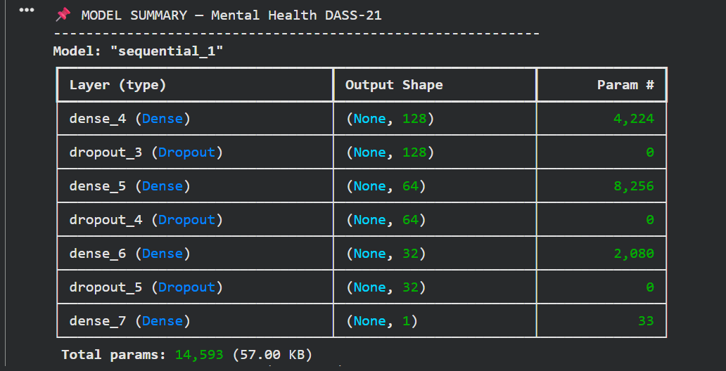
Figure 6 describes the architecture of the DASS-21 neural network.
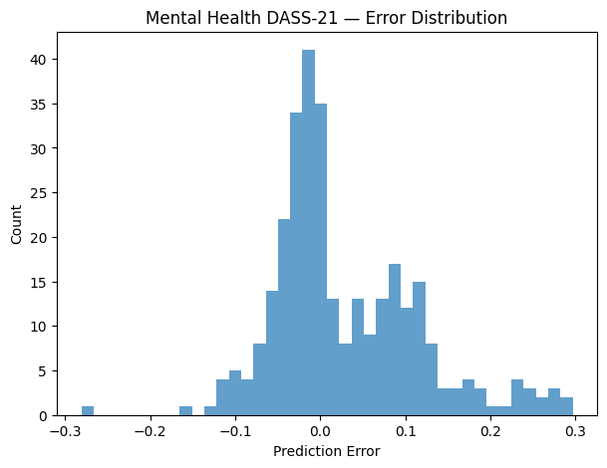
Figure 7 depicts the model's prediction error distribution in a histogram.
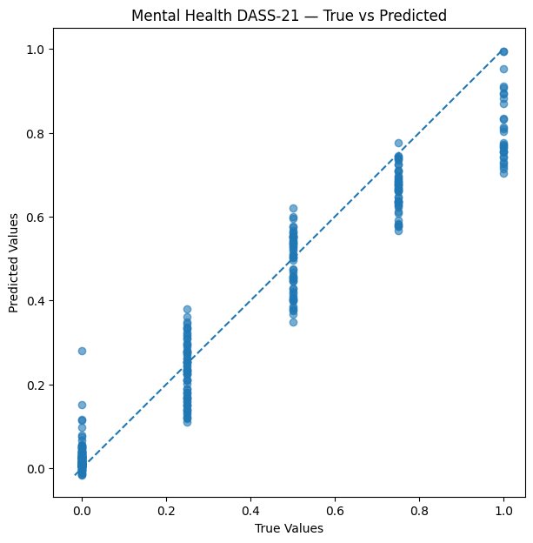
Figure 8 describes alignment along the optimum prediction line
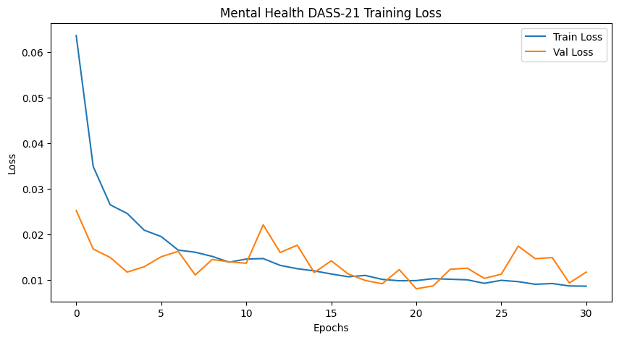
Figure 9 describes a training loss curve that consistently reduces both training and validation loss
Figure 10 describes the model's parameter count that verifies all 14,593 parameters.
5.6 Discussion
The experimental findings show that, From structured student survey data, deep learning models may successfully identify psychological trends.
Across all datasets, feature engineering—particularly the mental_health_index and sleep-adjusted variables—improved model performance.
A cross-dataset analysis showed that the Kaggle dataset produced more consistent findings despite being smaller due to its clearer structure.
Because of its vastness and variety, the MHP dataset increased generalization but added complexity.
The neural network demonstrated the feasibility of predicting depression risk using behavioral and psychological characteristics by achieving competitive performance overall across all datasets, and the DASS-21 dataset demonstrated robust signals for predicting depression severity because it directly evaluates clinical depression scores.
Chapter 6:
Conclusion and Future Work
6.1 Conclusion
This thesis presents a comprehensive AI-driven framework for the systematic examination of behavioral markers derived from various real-world datasets, aiming to predict childhood depression.
The study included a full machine learning pipeline, including data pretreatment, feature engineering, exploratory visual analytics, model development, optimization, and comprehensive evaluation, to ensure methodological strength and reproducibility.
The suggested method showed high predictive capability across many datasets by combining a variety of behavioral characteristics, including sleep quality, academic achievement, emotional symptoms, stress exposure, lifestyle patterns, and social contacts.
Using feature selection approaches in conjunction with a comparative analysis of deep learning and classical learning models allowed for the identification of an ideal model that consistently generated excellent accuracy and reliability.
The mentioned methodology and results support the idea that behavioral data can be useful early markers of children's depression risk when properly analyzed for early detection.
We were able to comprehend the model's decision-making process and the connections between various actions thanks to visual analysis. The strongest indicators were repeatedly shown to be characteristics like emotional instability, academic pressure, stress levels, and peer interactions. These results demonstrate that AI can detect subtle behavioral patterns that are frequently overlooked by conventional assessment techniques and are consistent with accepted psychological theories.
This study shows how AI-based early detection tools might enhance mental health evaluation and treatment.
By converting behavioral data into useful predictive insights, the suggested methodology helps physicians, educators, and caregivers detect at-risk children earlier.
In order to improve long-term results, future directions include real-world deployment, real-time monitoring, and sophisticated multimodal integration.
6.2 Future Work
Below, I am going to talk about the horizon of this thesis in the future
1. Handle and integrate the real-time behavior monitoring to continuously update depression risk predictions, like school platforms and mobile apps
2. Increasing the Dataset as per the increased datasets leads to an increase in the accuracy of prediction
3. Explore cutting-edge deep learning models (LSTM, Transformer, and multimodal networks) to identify complex, emotional, and sequential behavioral patterns.
4. To evaluate the concept through practical assessments, establish a clinical partnership with psychologists, educational institutions, and mental health groups.
5. Expand using larger, more diverse, and multicultural datasets.

Early Intervention Recommendations System
In addition to forecasting the possibility of depression, expand the system to offer evidence-based coping strategies, resources, or interventions based on the child's behavioral profile.
By taking these routes, the system developed in this thesis can grow into a comprehensive, ethical, and immediate decision-support tool that helps doctors, educators, and families identify early signs of depression and take preventative measures.
References:
1. Chen et al. (2024).
Identifying adolescent depression & anxiety using real-world data.
NIH / JMIR Mental Health.
https://mental.jmir.org/2025/1/e66665/
2. Marek et al. (2023).
Predicting depression risk via multimodal brain imaging.
NeuroImage: Clinical.
https://www.sciencedirect.com/science/article/pii/S2213158224000433
3. Yoo et al. (2024).
Depression prediction using prenatal & childhood data.
Nature Scientific Reports. https://www.nature.com/srep/
4. Williams et al. (2024).
Depression prediction insights among young Australians.
Springer.
https://link.springer.com/
5. Hasan et al. (2021).
Child depression detection using ML methods.
ResearchGate.
https://www.researchgate.net/
6. Arashnic (2023).
The Depression Dataset.
Kaggle / ACAMH.
https://www.kaggle.com/datasets
7. Shamim (2024).
Student Depression Dataset.
Kaggle / Frontiers.
https://www.kaggle.com/datasets
8. ResearchGate (2023).
Early detection using classical ML.
ResearchGate.
https://www.researchgate.net/
9. Zogan et al. (2020).
Explainable depression detection using HAN.
arXiv / MDPI.
https://arxiv.org/
10. Kuo et al. (2023).
Early depression detection using Graph Transformer.
Source not formally published.
11. Kessler et al. (2022).
Early identification of major depression in adolescents.
JAMA Psychiatry.
https://jamanetwork.com/journals/jamapsychiatry
12. Rao et al. (2023).
ML for early detection of mental-health disorders in children.
Frontiers in Psychiatry.
https://www.frontiersin.org/journals/psychiatry
13. García-Carmona et al. (2021).
Predicting emotional & behavioral problems using ML.
BMC Psychology.
https://bmcpsychology.biomedcentral.com/
14. Smail et al. (2024).
Deep learning for assessing childhood depression.
IEEE Transactions on Affective Computing.
https://ieeexplore.ieee.org/
15. Huang et al. (2022).
Multimodal learning for childhood mental-health assessment.
ACM Transactions on Computing for Healthcare.
https://dl.acm.org/journal/tcch
16. Castro et al. (2020).
Predicting depression onset using EHRs & ML.
Nature Translational Psychiatry.
https://www.nature.com/tp/
17. Jaiswal et al. (2023).
Explainable AI for pediatric mental-health prediction.
MDPI Electronics.
https://www.mdpi.com/journal/electronics
18. Kim et al. (2022).
Graph-based neural models for early mental-health detection.
IEEE Access.
https://ieeexplore.ieee.org/Xplore/home.jsp
19. Ribeiro et al. (2021).
Behavioral pattern analysis for youth depression detection.
Springer LNCS.
https://link.springer.com/
20. World Health Organization (2023).
Global adolescent depression epidemiology & screening.
WHO Publications.
https://www.who.int/publications
21. Shen et al. (2024).
ML models for predicting adolescent mental-health risks.
Nature Scientific Reports.
https://www.nature.com/srep/
22. Islam et al. (2020).
Systematic review of ML-based depression detection.
IEEE Access.
https://ieeexplore.ieee.org/

