Applying Three Techniques to the Housing Dataset
- Dealing with Missing Values
- Dealing with Outliers
- Visualizing the Data
Screenshot

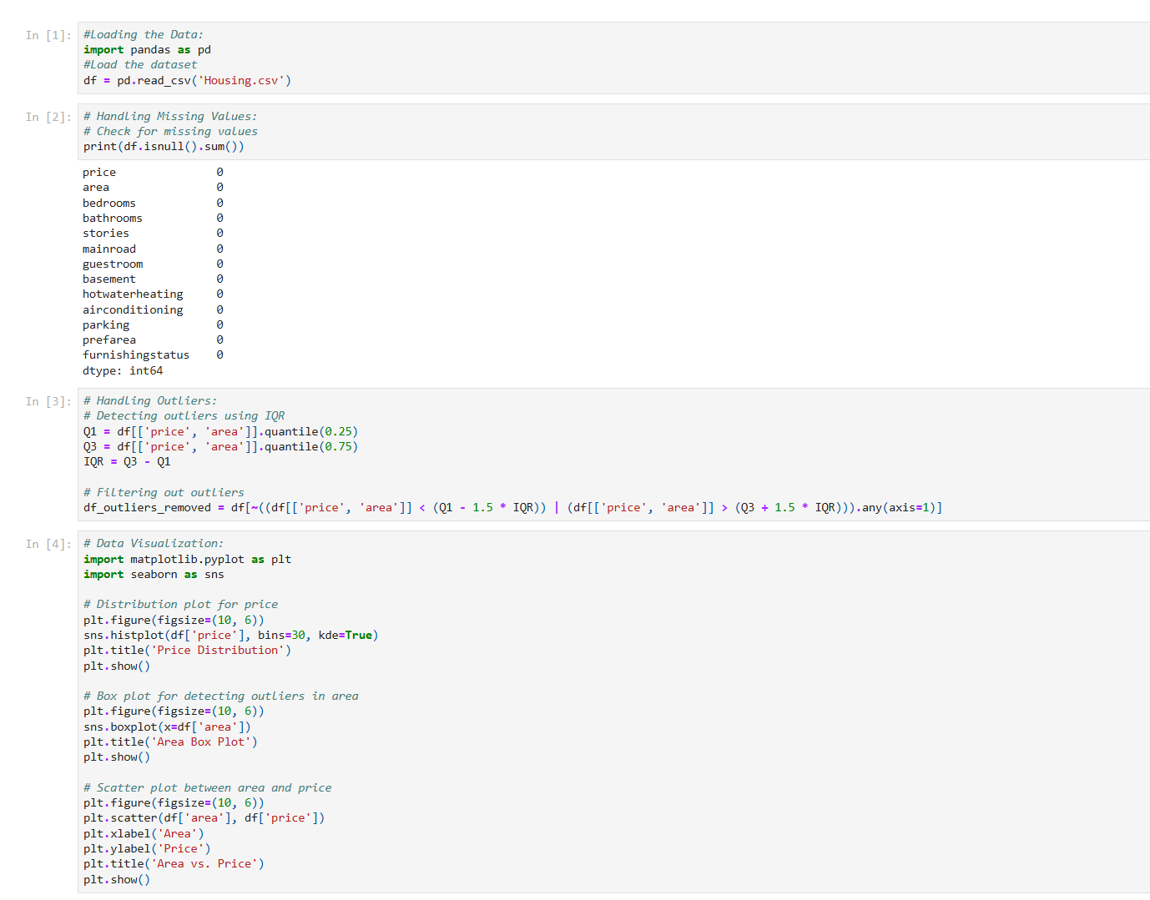
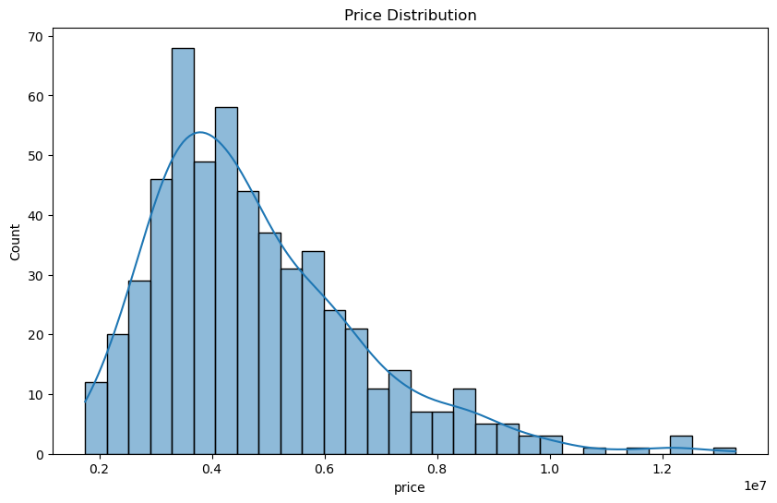
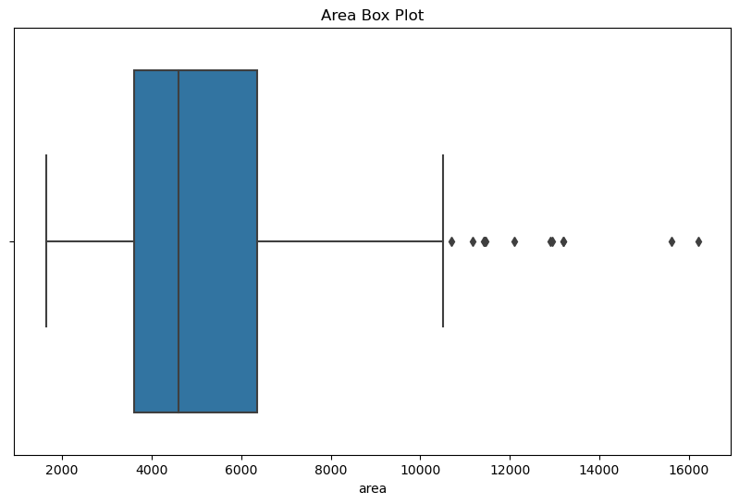
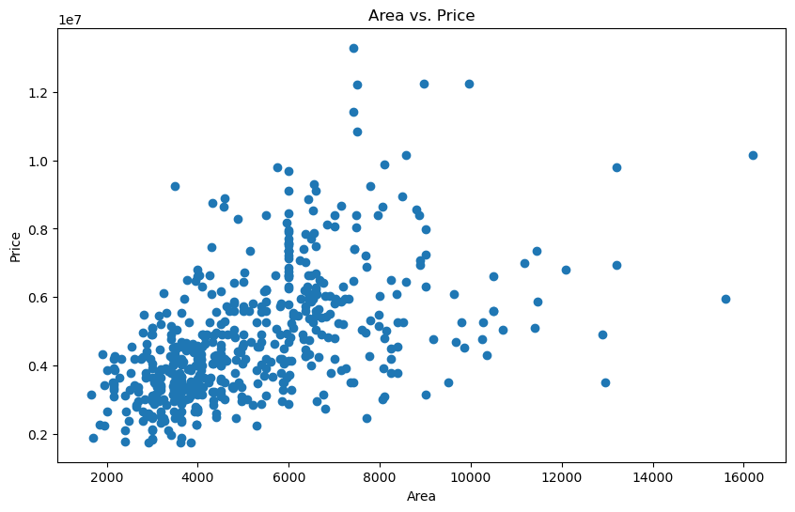

Source Code
#Loading the Data:
import pandas as pd
#Load the dataset
df = pd.read_csv('Housing.csv')

# Handling Missing Values:
# Check for missing values
print(df.isnull().sum())

# Handling Outliers:
# Detecting outliers using IQR
Q1 = df[['price', 'area']].quantile(0.25)
Q3 = df[['price', 'area']].quantile(0.75)
IQR = Q3 - Q1

# Filtering out outliers
df_outliers_removed = df[~((df[['price', 'area']] < (Q1 - 1.5 * IQR)) | (df[['price', 'area']] > (Q3 + 1.5 * IQR))).any(axis=1)]
# Data Visualization:
import matplotlib.pyplot as plt
import seaborn as sns

# Distribution plot for price
plt.figure(figsize=(10, 6))
sns.histplot(df['price'], bins=30, kde=True)
plt.title('Price Distribution')
plt.show()

# Box plot for detecting outliers in area
plt.figure(figsize=(10, 6))
sns.boxplot(x=df['area'])
plt.title('Area Box Plot')
plt.show()

# Scatter plot between area and price
plt.figure(figsize=(10, 6))
plt.scatter(df['area'], df['price'])
plt.xlabel('Area')
plt.ylabel('Price')
plt.title('Area vs. Price')
plt.show()

