The Impact of Innovation on Business Growth in Saudi Organizations

أثر الابتكار في نمو الاعمال في المنظمات السعودية

اسم الطالبة: سمية أنس عبدالحكيم
الرقم الجامعي : 253000613
المقرر : سيمنار - مقترح بحث
التخصص : إدارة الأعمال
السنة : 2026

Name : Sumayya Anas Abdulhakeem
ID : 253000613
Seminar 1 – Research Proposal Master’s Program: Project
Management Academic Year: 2026

Outlines:
1- Introduction
2- Background of the study
3- Innovation and vision 2030
4- Research problems
5- Importance of the study
6- Research objectives
7- Research questions
8- Previous studies
9- Analysis of previous studies
10- Research Gap
11- Theoretical framework
12- Conceptual model
13- Research methodology
14- Research design
15- Population and sample
16- Data collection tool
17- Statistical analysis
18- Study limitations
19- Expected results
20- Discussion
21- Recommendations
22- Conclusion
23- References

Introduction:

Innovation is widely recognized as a primary catalyst for organizational success and a cornerstone of contemporary business strategy. In an era defined by hyper-competitive markets, the systematic adoption of novel concepts is no longer optional but a fundamental requirement for institutional survival.
Corporate expansion is intrinsically linked to an organization's capacity for continuous product and service development. By fostering an innovative culture, enterprises can significantly enhance operational performance and optimize productivity metrics. Ultimately, the integration of innovative practices facilitates the achievement of long-term sustainability, positioning innovation as a critical driver of comprehensive business development.

Cont. introduction:

The Kingdom of Saudi Arabia is currently undergoing a profound economic metamorphosis, characterized by a shift toward more diversified and resilient market structures. To maintain a competitive edge within this evolving landscape, domestic organizations are increasingly compelled to enhance their operational performance. Innovation serves as a pivotal mechanism in this process, facilitating broader economic development and supporting the national objective of reducing oil dependency.
Central to this transformation is Saudi Vision 2030, a strategic framework that mandates the integration of innovative practices across all industrial and social sectors. For enterprises to secure sustainable growth, the implementation of forward-thinking, innovative strategies is essential. Consequently, this study provides a critical examination of the current state of innovation within Saudi organizations, assessing its impact on regional business evolution.
Core Drivers of Innovation in KSA
- Macro-Economic Shift: Transitioning from resource-based to knowledge-based economic models.
- Regulatory Framework: The influence of Vision 2030 as a catalyst for cross-sector modernization.
- Strategic Imperative: The necessity for localized innovation strategies to meet global competitive standards.
- Organizational Efficacy: The direct correlation between creative problem-solving and institutional growth.

Background of the Study:

Innovation has received significant attention in academic research and business practice. Researchers emphasize that organizations that adopt innovative strategies are more likely to achieve higher levels of productivity and organizational performance. Innovation also supports the development of competitive advantages.

Innovation contributes to improving operational processes and developing new business models. Organizations that focus on innovation are better able to adapt to rapid changes in technology and global markets.

Innovation and Vision 2030:

Saudi Vision 2030 positions innovation as a fundamental pillar for achieving economic diversification and long-term sustainability. This strategic framework incentivizes organizations to integrate advanced technologies and pioneering practices to optimize institutional productivity. Furthermore, innovation serves as a critical catalyst in transitioning the Kingdom toward a globally competitive, knowledge-based economy.

Saudi organizations are increasingly prioritizing strategic investments in innovation, driven by comprehensive digital transformation and robust research and development (R&D) initiatives. These advancements are essential for bolstering the competitive edge of national enterprises and fostering resilient economic growth. By aligning with global technological trends, these initiatives directly contribute to the realization of the Kingdom’s overarching national objectives.

Research Problem:

Many organizations face difficulties in achieving continuous growth.
Competition in the market is increasing rapidly.
Some companies do not apply innovation effectively.
Lack of innovation may reduce productivity.
Weak innovation leads to poor performance.
This creates a need to study innovation.

Organizations in Saudi Arabia need modern strategies.
Innovation may help improve business performance.
However, not all companies use innovation.
There is limited research in Saudi context.
Understanding innovation is important.
This study investigates its effect on growth.

Importance of the Study:

Innovation constitutes a fundamental determinant of institutional success, serving as the primary engine for operational optimization. Beyond mere survival, the strategic integration of innovative processes yields several critical outcomes:
* Productivity and Resource Efficiency: Streamlining workflows and enhancing output quality through novel methodologies.

* Strategic Competitiveness: Establishing a distinct market position by leveraging unique value propositions.

* Resilience and Longevity: Ensuring long-term organizational sustainability in the face of disruptive global trends.

* Empirical Justification: This research delineates the multi-dimensional importance of innovation as a non-negotiable prerequisite for modern corporate existence.

Cont. Importance of the Study:

The findings of this research offer substantial utility for both practitioners and the academic community, particularly within the context of the Saudi Arabian market:
* Managerial & Executive Utility: Providing decision-makers with a robust framework for navigating complex strategic shifts.

* Knowledge Advancement: Contributing to the existing body of literature regarding innovation management in emerging economies.

* Economic Alignment: Supporting the growth trajectory of Saudi organizations in alignment with national development goals.

* Actionable Insights: Delivering evidence-based, practical recommendations to facilitate tangible business development and institutional growth.

Research Objectives:

The overarching aim of this research is to critically evaluate the dynamics of innovation and its multi-faceted influence on the Saudi business sector. Specifically, the study seeks to:

* Analyze Innovation Typologies: To categorize and examine the various forms of innovation adopted by organizations.

* Evaluate Organizational Efficacy: To determine the direct correlation between innovative practices and overall institutional performance.

* Quantify Business Growth: To develop metrics for assessing how innovation drives scalability and market expansion.

* Contextualize Regional Impact: To provide an empirical explanation of how innovation functions as a catalyst for development within the specific economic landscape of Saudi Arabia.

Cont. Research Objectives:

To achieve the primary objectives, the study focuses on measuring specific variables across three core innovation domains and their subsequent outcomes:
1. Innovation Metrics
- Technological Innovation: Assessing the adoption of advanced systems, R&D, and digital transformation.

- Administrative Innovation: Evaluating novel shifts in organizational structure, human resource management, and internal processes.

- Marketing Innovation: Investigating the implementation of new market-entry strategies, branding, and consumer engagement models.

2. Performance & Growth Indicators
- Financial Trajectory: Examining the rate of profit growth and capital accumulation.

- Market Positioning: Analyzing shifts in market share and competitive standing.

- Operational Excellence: Measuring longitudinal performance improvements and resource optimization.

Research Questions:

Does innovation affect business growth?
Does technology improve performance?
Does management innovation help growth?
Does marketing innovation increase sales?
Is innovation related to profit?
Can innovation improve competitiveness?
Do innovative companies grow faster?
Does innovation increase productivity?
Do organizations need innovation?
Is innovation important in Saudi Arabia?
Can innovation improve quality?
Previous Study 1:

Schumpeter (1934) emphasized that innovation is a major driver of economic development. According to his theory, innovation enables organizations to introduce new products and processes that stimulate economic growth.

Previous Study 2:

Drucker (1985) argued that innovation is a fundamental tool for achieving business success. Organizations that actively encourage innovation are more likely to achieve sustainable growth.

Previous Study 3:

Tidd and Bessant (2018) found that innovation significantly improves organizational performance and competitiveness. Their research shows that innovative organizations tend to achieve higher productivity.

Analysis of Previous Studies:

Previous studies indicate a strong positive relationship between innovation and business growth. Organizations that adopt innovative strategies are better able to improve performance and achieve competitive advantage.

Research Gap:

Despite the growing economic importance of the region, there remains a conspicuous shortage of empirical literature focusing on business growth within the Saudi Arabian context. Current research lacks a granular analysis of specific innovation types and often relies on theoretical frameworks rather than authentic, real-world data. This study addresses these critical deficiencies by providing applied research grounded in primary evidence.

Theoretical Framework:

- Independent Variable Innovation
- Dependent Variable Business Growth

Conceptual Model:
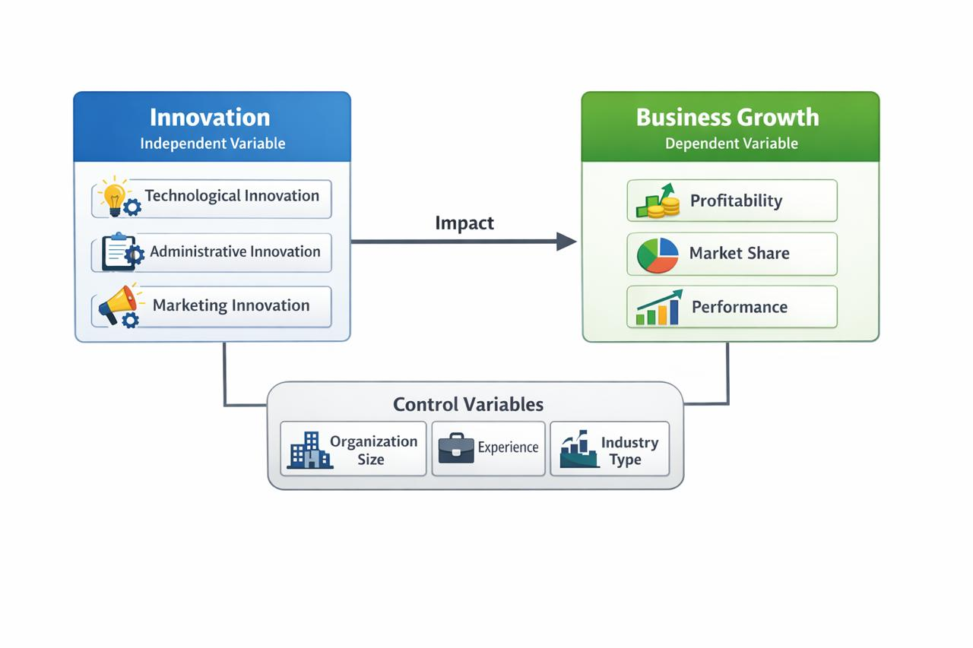
Research Methodology:

- Descriptive method used.
- Questionnaire used.
- Sample from organizations.
- Data collected.
- Statistical analysis used.
- SPSS used.
- Population: Saudi organizations.
- Sample: employees.
- Tool: questionnaire.
- Analysis: statistics.
- Test hypotheses.
- Measure relationship.

Research Design:
For this study, I’ve chosen a descriptive research design. This approach is key because it allows us to clearly map out and explain exactly how day-to-day innovation practices connect with overall organizational performance.
Population and Sample:

The study focuses on the people driving these organizations—the employees and managers working right here in Saudi Arabia. To ensure the insights are meaningful, the sample is drawn from individuals who have firsthand experience and
knowledge of how innovation actually works in their workplace.

Data Collection Tool:

To gather the necessary insights, I’m using a structured questionnaire.
This tool was specifically designed to capture the reality of innovation practices and measure their direct impact on business growth.

Statistical Analysis:

The collected data will be analyzed using statistical techniques to examine the relationship between innovation and business growth.

Study Limitations:

Like many research studies, this research may face several limitations. These limitations may include:
- Limited time available for collecting and analyzing data.
- A relatively small sample size of participants.
- Possible difficulties in obtaining accurate responses from participants.
- The study focuses only on organizations within Saudi Arabia.
Expected Results:

- Innovation improves growth.
- Innovation increases profit.
- Innovation improves performance.
- Innovation increases market share.
- Innovation supports development.
- Innovation leads to success.

Discussion:

The findings of this study underscore that innovation is the cornerstone of contemporary business sustainability. In an era defined by rapid disruption, companies are compelled to develop and scale new ideas systematically. However, technological adoption alone is insufficient; it requires a structural overhaul of management frameworks and a shift in marketing paradigms to truly capture value. Ultimately, the results confirm that sustainable business growth is inextricably linked to an organization’s ability to integrate diverse innovation types into its core operations.

Recommendations:

- Support innovation.
- Train employees.
- Use technology.
- Improve management.
- Encourage creativity.
- Develop strategies.
- Invest in research.
- Use modern tools.
- Improve marketing.
- Support new ideas.
- Follow Vision 2030.
- Develop organizations.

Conclusion:
The Strategic Link Between Innovation and Success
- The Foundation of Growth: Innovation is no longer a luxury but a fundamental requirement for organizational survival and expansion.
- Direct Correlation: There is a verifiable link between an organization's innovation capacity and its overall business performance.
- Organizational Transformation: To remain competitive, companies must undergo a structural shift from traditional operations to innovation-centered models.
- Operational Excellence: Implementing diverse innovation types directly leads to enhanced efficiency and superior service delivery.
- Macroeconomic Impact: On a broader scale, fostering innovation within individual organizations provides the necessary support for the national economy.
- Path to Sustainability: Ultimately, a commitment to continuous improvement and creative problem-solving is the most reliable driver of long-term success.

References:
1. Schumpeter, J. A. (1934). The Theory of Economic Development. Harvard University Press.
2. Drucker, P. F. (1985). Innovation and Entrepreneurship. Harper & Row.
3. Porter, M. E. (1990). The Competitive Advantage of Nations. Free Press.
4. Rogers, E. M. (2003). Diffusion of Innovations (5th ed.). Free Press.
5. Chesbrough, H. W. (2003). Open Innovation: The New Imperative for Creating and Profiting from Technology. Harvard Business School Press.
6. Christensen, C. M. (1997). The Innovator’s Dilemma. Harvard Business School Press.
7. Barney, J. (1991). Firm resources and sustained competitive advantage. Journal of Management, 17(1), 99–120.
8. Damanpour, F. (1991). Organizational innovation: A meta-analysis of effects of determinants and moderators. Academy of Management Journal, 34(3), 555–590.
9. Crossan, M. M., & Apaydin, M. (2010). A multi-dimensional framework of organizational innovation. Journal of Management Studies, 47(6), 1154–1191.
10. Tidd, J., & Bessant, J. (2018). Managing Innovation (6th ed.). Wiley.
11. Davila, T., Epstein, M. J., & Shelton, R. (2012). Making Innovation Work. Wharton School Publishing.
12. Kaplan, R. S., & Norton, D. P. (2004). Strategy Maps: Converting Intangible Assets into Tangible Outcomes. Harvard Business School Press.
13. OECD. (2018). Oslo Manual: Guidelines for Collecting, Reporting and Using Data on Innovation. OECD Publishing. 14. OECD. (2021). SME and Entrepreneurship Outlook. OECD Publishing.
15. World Bank. (2020). Innovation and Economic Growth. World Bank Publications.
16. McKinsey Global Institute. (2021). The Future of Innovation. McKinsey & Company.
17. Harvard Business Review. (2019). The Innovation Imperative. Harvard Business Review Press.
18. Global Innovation Index. (2022). Global Innovation Index Report.
19. Saudi Vision 2030. (2021). Vision 2030 Progress Report. Government of Saudi Arabia.
20. World Economic Forum. (2022). Global Competitiveness and Innovation Report.

THANK YOU
Name : Sumayya Anas Abdulhakeem
ID : 253000613
Seminar 1 – Research Proposal Master’s Program: Project
Management Academic Year: 2026

