

Title
Explainable Multimodal Skin Lesion Classification Using ResNet-18 and TabNet with LIME

Prepared By

Name: Alanoud Alnjrany ID No: 261001412
Name: Fatimah Hasan Alghamdi ID No: 222000322
Name: Halah Qader Agha ID No: 253001696

Submitted in fulfillment of the requirements for the degree Master of Science in Artificial Intelligence

At

College of Informatics Midocean University

Supervisor Name: D\Sherif Mostafa………….
Collage of Informatics, Midocean University, Comoros
Email……………….
Explainable Multimodal Skin Lesion Classification Using ResNet-18 and TabNet with LIME

Acknowledgements

Firstly, we wish to convey our sincere appreciation to our supervisor Sherif Mostafa for his guidance, unwavering assistance and patience throughout this study. His scholarly guidance and constructive critiques have been indispensable to our research progress and enabled us to complete this work. We are thankful to the faculty and personnel of the Department for supplying a secure, encouraging environment and the resources necessary for this project. We also acknowledge with gratitude the International Skin Imaging Collaboration (ISIC) and other public dermatology image repositories whose freely available images made it possible to compile the dataset used here. On a personal level, we remain indebted to our families for their steady support and encouragement during the long hours devoted to this research. Their confidence in us made this endeavour achievable. Finally, we extend thanks to everyone who in any way helped produce this thesis.

Abstract

Skin cancer ranks among the most prevalent cancers globally, and its occurrence continues to climb. Both melanoma and non-melanoma forms can become fatal if undetected, so early detection heavily influences patient prognosis. Interpreting dermatological imagery is challenging: practitioners may disagree when assessing the same lesion, early-stage appearances often overlap across conditions, and diagnosis relies strongly on the observer’s experience. Deep learning reduces that gap. Convolutional neural networks such as ResNet-18 already reach classification performance on skin images that, in some contexts, nears that of trained clinicians. Their main drawback is a lack of interpretability: they deliver a prediction without explaining the rationale, which limits clinical acceptability. This thesis bridges these two needs. A ResNet-18 model, initialised with ImageNet weights, is fine-tuned via transfer learning on a curated, multi-source collection of 878 dermatological images across ten skin-condition labels (nine used in the working splits). The dataset spans malignant, benign, inflammatory and infectious entities. Given its modest size, the approach employs data augmentation and class-weighting to boost generalisation and protect the slightly under-represented classes, while LIME highlights the image regions that actually informed each decision. The objective is straightforward to state but demanding to attain: preserve high accuracy while giving clinicians a transparent, visual account of the model’s reasoning.

Contents
List of Abbreviations 5
List of Figures 6
List of Tables 7
Chapter 1: Introduction 8
Overview 8
Problem Definition 8
Thesis Objectives 9
Thesis Contribution 9
Thesis Organization 9
Chapter 2: Background and Related Work 10
Skin Cancer and Dermoscopy 10
Machine Learning and Deep Learning for Image Classification 10
Residual Networks and ResNet-18 10
Transfer Learning 11
The Class-Imbalance Problem 11
Explainable Artificial Intelligence (XAI) 11
Related Work 14
Summary and Research Gap 16
Chapter 3: Dataset Selection 17
Choice of Dataset 17
Source and Composition 17
Characteristics 17
Class Distribution and the Imbalance Challenge 17
Accessibility 18
Chapter 4: Proposed Framework 19
Overview of the Framework 19
Data pre-processing 19
Data Augmentation and Class Balancing 20
Classification Model: Pre-trained ResNet-18 20
Training Setup 20
Explainability with LIME 21
Evaluation Strategy 21
Tools and Technologies 21
References 22

List of Abbreviations
Abbreviation | Meaning
AD | Atopic Dermatitis
AI | Artificial Intelligence
AK | Actinic Keratosis
ANN | Artificial Neural Network
AUC | Area Under the ROC Curve
BKL | Benign Keratosis
CAD | Computer-Aided Diagnosis
CNN | Convolutional Neural Network
DF | Dermatofibroma
DL | Deep Learning
FN | False Negative
FP | False Positive
Grad-CAM | Gradient-weighted Class Activation Mapping
ISIC | International Skin Imaging Collaboration
LIME | Local Interpretable Model-Agnostic Explanations
MEL | Melanoma
ML | Machine Learning
NV | Melanocytic Nevus
ReLU | Rectified Linear Unit
ResNet | Residual Network
ROC | Receiver Operating Characteristic
SCC | Squamous Cell Carcinoma
SHAP | SHapley Additive exPlanations
SVM | Support Vector Machine
TL | Transfer Learning
TRC | Tinea / Ringworm / Candidiasis
VASC | Vascular Lesion
XAI | Explainable Artificial Intelligence

List of Figures
Figure 1: Class distribution of the curated skin-condition dataset 20
Figure 2: Proposed framework (ResNet-18 + LIME) 22

List of Tables
Table 1: Summary and comparison of related studies 18
Table 2: Class distribution of the curated skin-condition dataset 20
Table 3: Main hyper-parameters of the proposed configuration 24

Chapter 1: Introduction

Overview
Skin cancer is one of the most frequently diagnosed cancers worldwide, with incidence rising over recent decades. It arises when skin cells proliferate uncontrollably, often after long-term exposure to ultraviolet radiation from sunlight or tanning devices. Clinicians typically separate skin cancer into melanoma and non-melanoma groups. Melanoma is less common but accounts for the majority of skin-cancer fatalities because of its propensity to metastasise. The encouraging fact is that lesions caught early are usually highly treatable, so timely detection greatly improves survival. Consequently, accurate early diagnosis is critical. (4, 19, 21)

Clinical assessment commonly begins with a visual inspection of the lesion, frequently aided by a dermoscope — a handheld magnifier that reveals structures invisible to the naked eye. While dermoscopy improves diagnostic detail, interpreting its images remains subjective. Judgement depends on the examiner’s training and experience, and studies repeatedly show that even seasoned specialists may disagree on the same case. Early-stage lesions from different causes can resemble one another, further complicating diagnosis. Meanwhile, the workload of suspect lesions is increasing and dermatology specialists are scarce in many regions outside metropolitan centres. These pressures have driven interest in computer-aided diagnosis (CAD). The intention is not to replace dermatologists, but to supply a rapid, dependable second opinion that can be deployed widely.

Over the past decade, deep learning — particularly convolutional neural networks (CNNs) — has transformed what CAD systems can achieve. Architectures such as ResNet, VGG and EfficientNet have reached performance on benchmark datasets comparable to board-certified dermatologists. ResNet-18, the model adopted here, is a compact residual network that trains quickly, adapts well to mid-sized datasets using transfer learning, and is a pragmatic choice for a project of this scope. (4, 19, 21)

However, predictive performance alone is insufficient. Many deep networks act like opaque mechanisms: they output a confident label without explaining the basis for it. In medical contexts that opacity is problematic. A clinician presented with an unexplained malignancy prediction has little grounds to trust it, and regulators are cautious about approving systems that cannot justify their decisions. Explainable Artificial Intelligence (XAI) aims to fill this gap. Methods like LIME produce visual maps indicating image regions that influenced the prediction, converting a bare label into a human-reviewable argument. This thesis centres on that union: a fine-tuned ResNet-18 for classification, coupled with LIME to make each decision interpretable. (10, 14, 15)

Problem Definition
This thesis confronts two intertwined issues. First, skin-condition classification is intrinsically difficult: malignant and benign lesions can differ only subtly, inflammatory and infectious diseases may mimic one another, and many public dermatology collections are heavily imbalanced with common classes far outnumbering rare ones. A classifier trained on such skewed data tends to bias toward majority classes, leaving rare but clinically important categories underrepresented. To mitigate this, the current study uses a curated, roughly balanced dataset; the trade-off is fewer images per class overall, necessitating transfer learning and augmentation to compensate.

Second, even a highly accurate model has limited clinical value if it cannot explain its predictions. Clinicians need to know the basis for a diagnosis, especially when cancer is a possibility. There is tension between raw performance and interpretability: top-performing CNNs are often inscrutable, while more transparent models frequently sacrifice accuracy. The core challenge is therefore to construct a classifier capable of handling all ten curated categories — including the rarer ones — whilst offering per-prediction explanations that clinicians can assess.

Thesis Objectives
With the above in mind, this thesis pursues the following goals:
- Develop a multi-class classifier for the ten skin-condition categories in the curated dataset using a pre-trained ResNet-18 and transfer learning.
- Address the limited dataset size and mild class imbalance through data augmentation, transfer learning and class weighting so that under-represented classes are not overlooked
- Integrate LIME so every prediction is accompanied by a visual explanation indicating image regions that contributed to the decision.
- Evaluate the model using metrics such as accuracy, precision, recall, F1-score, and AUC, and assess whether the LIME outputs align with clinical reasoning.
- Demonstrate that acceptable accuracy and interpretability can be achieved in a form that dermatologists could realistically rely on.

Thesis Contribution
This work aims to deliver:
- An end-to-end, explainable skin-condition classification pipeline that combines a fine-tuned ResNet-18 with LIME on a curated ten-category dermatological dataset.
- A strategy for data efficiency and balance — combining augmentation with class weighting — that maintains robust per-class results on a small dataset without degrading overall accuracy.
- A qualitative assessment of LIME explanations to verify that the model attends to the lesion rather than irrelevant background skin or imaging artefacts (e.g., hair, rulers, ink)..
- Empirical and literature-backed evidence that a lightweight architecture such as ResNet-18 suffices for the task, making it suitable for resource-constrained hardware.

Thesis Organization
The remainder of this document follows a straightforward structure. Chapter 2 provides the necessary background and surveys recent work most relevant to this study, comparing methods and outcomes. Chapter 3 describes the curated skin-condition dataset — its provenance, composition and the aspects that make it challenging. Chapter 4 details the proposed framework step by step, from image preparation and imbalance handling to fine-tuning ResNet-18, applying LIME and evaluation. Results, discussion and conclusions will appear in the subsequent phase after the model has been implemented and assessed.

Chapter 2: Background and Related Work
Background and Related Work. This chapter delves deeper into the technical and scientific foundations that underpin the project, ranging from the medical aspects of skin lesion diagnosis to deep learning and explainable AI techniques relevant to the proposed framework. The latter half reviews recent studies closely related to the problem, summarising their contributions and contrasting their approaches to identify the gap this thesis intends to fill.

Skin Cancer and Dermoscopy
Clinicians class skin cancer broadly into melanoma and non-melanoma types. Melanoma originates from melanocytes — pigment-producing cells — and, though less common, it accounts for the majority of deaths due to its aggressive metastatic behaviour. Non-melanoma cancers are mainly basal cell carcinoma and squamous cell carcinoma, which are more frequent but generally less aggressive. Alongside malignant entities are benign lesions — common moles, benign keratoses, dermatofibromas and vascular marks — which may visually resemble cancerous lesions.

Dermoscopy is the principal technique for examining pigmented lesions. Using magnification and controlled illumination, often with immersion fluid or polarisation to reduce glare, a dermoscope reveals colours and structural patterns invisible to the unaided eye: pigment networks, dots and globules, streaks, and vascular arrangements. Clinicians often distil these features into heuristics such as the ABCD rules — asymmetry, border, colour, and differential structures — but while features are describable, consistent grading is difficult, making the task well suited to pattern-learning approaches like deep learning.

Machine Learning and Deep Learning for Image Classification
Earlier image-analysis systems depended on hand-crafted features: researchers wrote code to extract measurements of colour, texture and shape and fed these descriptors into classifiers such as support vector machines or random forests. This approach was limited by the quality of the engineered features, and creating effective descriptors for medical images is time-consuming. Deep learning obviated that bottleneck by learning hierarchical features directly from pixels. Convolutional Neural Networks (CNNs) form the backbone of image deep learning: stacked convolutional layers detect local patterns, pooling layers reduce spatial dimensions and summarise activations, and non-linearities like ReLU allow modelling complex relationships. Lower layers learn basic edge and colour detectors, while deeper layers form higher-level textures and lesion structures; fully connected layers map these representations to class probabilities. Architectures from AlexNet and VGG to the residual networks have made CNNs the standard for image classification in medicine and beyond.

Residual Networks and ResNet-18
As networks deepened in search of higher accuracy, researchers encountered the degradation problem: beyond a certain depth, adding layers degraded performance because gradients vanished during backpropagation. Residual Networks (ResNets) introduced identity shortcut connections so each layer learns a residual — a small correction — relative to its input instead of a brand-new transformation. These skip connections preserve gradient flow and allow very deep networks to be trained successfully. ResNet-18 is the compact member of the family with 18 weight layers and about eleven million parameters. It is efficient, modest in memory use, and less prone to overfitting on mid-sized datasets, which explains its popularity in medical imaging and motivates its selection here. (6)

Transfer Learning
Training deep networks from scratch demands large volumes of labelled data, which are rarely available in medical domains. Transfer learning solves this by starting from a model pre-trained on a large, general dataset such as ImageNet; the early layers of such a model already capture generic visual primitives — edges, textures, shapes — useful for many tasks. The final classification layer is replaced and the network is fine-tuned on the new medical data, typically using a low learning rate to adapt general features to the target domain without obliterating them. Transfer learning is central to improving accuracy and reducing training time for skin-lesion tasks and is core to the method proposed here. (3, 8)

The Class-Imbalance Problem
Real-world dermoscopic collections tend to be skewed because common lesion types are photographed far more frequently than rare ones. Presenting a network with thousands of examples from one class and only a few hundred from another biases the model toward the majority class, which is problematic when rare classes are clinically significant. Countermeasures include augmentation to expand minority classes (through rotation, flipping, scaling and colour jitter), re-sampling strategies (oversampling minorities or undersampling majorities), and cost-sensitive losses (weighted cross-entropy makes mistakes on rare classes more costly; focal loss shifts focus to harder-to-classify examples). The dataset used here is curated to be roughly balanced, leaving only a small residual skew; the framework therefore combines augmentation with light class weighting to protect smaller categories. (5, 9, 20)

Explainable Artificial Intelligence (XAI)
Explainable AI comprises techniques that reveal the decision rationale of complex models. For image classifiers, post-hoc methods are common: they interpret a trained model without changing its internals. Grad-CAM traces gradients into the last convolutional layer to produce a coarse heatmap of attended regions. SHAP employs game-theoretic principles to assign contribution values to features. LIME, the chosen method in this project, explains a single prediction by perturbing the input: it segments the image into super-pixels, toggles subsets of them on and off, observes changes in the model’s output, and fits a simple, interpretable model to this local behaviour. The result is a ranked map of super-pixels indicating their influence on the prediction. LIME is model-agnostic, aligns naturally with perceptual image patches, and its outputs are generally easy for clinicians to interpret. Its strong local fidelity in medical imaging further supports its selection. (10, 14, 15)

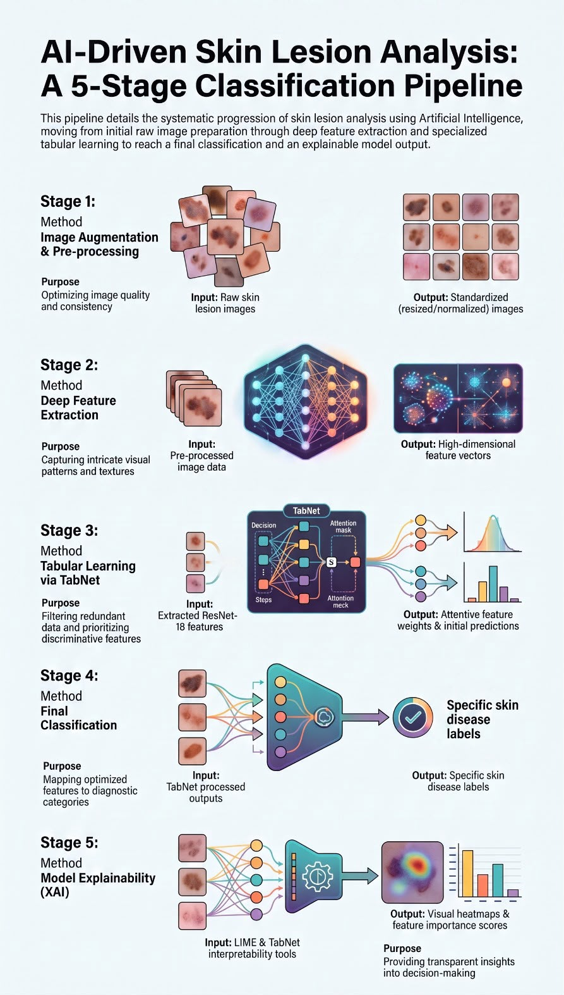
Methodology Overview:
The proposed framework combines a pre-trained ResNet-18 model with TabNet for skin disease classification. First, ResNet-18 is used to extract
deep features from skin images after the pre-processing stage. These extracted features are then provided
to TabNet, which selects the most relevant features through its attentive
feature selection mechanism and performs the classification task. To improve the interpretability of the
model, LIME is applied to explain the prediction results by highlighting the
image regions that contribute most to the final decision. In addition, TabNet
provides feature importance scores that help identify the features influencing the classification process.

Framework Flow:

Skin Disease Image Dataset

Pre-processing (Resize, Normalize, Augmentation)

ResNet-18 Feature Extraction

TabNet Classifier

Skin Disease Prediction

LIME Explanation

Related Work
Over the past decade, deep learning research for skin lesion classification has transitioned from foundational architecture testing to clinical validation. Early milestones in this area centred on enhancing the diagnostic capacity of convolutional neural networks (CNNs). A pivotal step forward came with the introduction of deep residual learning: Yu et al (2017) showed the ResNet architectures, by incorporating residual or skip connection, successfully bypassed the optimisation bottlenecks typical of very deep networks. By mitigating the vanishing gradient problem, these connections facilitated more effective training of deeper models, which in turn yielded higher classification accuracy. Utilising this approach, their work demonstrated superior melanoma classification on the ISBI 2016 dataset, underscoring the viability of deep residual networks in medical imaging.
In parallel, Esteva et al. (2017) published a landmark study illustrating how crucial massive datasets are to the performance of deep learning models. By training an Inception-v3 network on a vast corpus of over 129,000 clinical images covering more than 2,000 distinct skin diseases, they developed a model capable of matching the diagnostic accuracy of board-certified dermatologists in skin cancer identification. This achievement offered compelling proof of deep learning's potential as a clinical decision-support tool. However, because both of these early studies prioritized raw classification accuracy over interpretability, they left the underlying decision-making process of the models obscured—a lack of transparency that hindered clinical trust and underscored the urgent need for explainable artificial intelligence (XAI).
Current research in the field of AI medical models has shifted from its early-stage focus on model development, to conducting deployment validation benchmarked against practicing clinicians and building unified standardized evaluation benchmarks. A core study on skin cancer detection that is widely cited in academia confirms that this AI model outperforms most clinicians, yet this type of AI still has clear clinical application boundaries.
Around the same time, Tschandl et al. (2018) released the HAM10000 dataset, addressing a critical shortage of high-quality training data. This collection compiled over 10,000 dermoscopic images of pigmented lesions across seven categories, sourced from multiple clinics. By providing a diverse, open-access benchmark, HAM10000 gave researchers a standard framework to train stronger models, run fair comparisons, and build systems that generalize well to new data. It remains a foundational dataset for testing deep learning tools in dermatology today.

Table 1: Summary and comparison of the most relevant related studies.
Study (Year) | Model / Technique | Dataset | Explainability | Reported performance / key finding | Limitations
Yu et al. (2017) | Very deep residual networks (>50 layers) | ISBI 2016 | None | Early proof that ResNet depth helps melanoma recognition | Small benchmark dataset; no explainability; limited generalization evaluation.
Esteva et al. (2017) | Inception-v3 CNN | 129,450 clinical images | None | Matched 21 dermatologists | Used mainly clinical images rather than dermoscopy; black-box model; high computational cost.
Haenssle et al. (2018) | Inception-v4 CNN | Dermoscopic melanoma set | None | CNN AUC 0.86 vs dermatologists 0.79 | Focused mainly on melanoma detection; limited interpretability; external validation was limited.
Tschandl et al. (2018) | Dataset contribution | HAM10000 (10,015; 7 cls) | None | Standard dermoscopy benchmark | Dataset imbalance and duplicated visual patterns; not a classification model.
Brinker et al. (2019) | CNN (ResNet-based) | 12,378 melanoma images | None | Beat 136 of 157 dermatologists | Melanoma-focused evaluation; no explainability; possible dataset bias.
Combalia et al. (2019) | Dataset contribution | BCN20000 | None | Realistic in-the-wild lesions for ISIC 2019 | Class imbalance remained; dataset quality varies; not a predictive framework.
Codella et al. (2019) | Challenge protocol | ISIC 2019 (8 cls) | None | Defined the eight-class benchmark | Benchmark only; severe class imbalance; no model architecture proposed.
Gessert et al. (2020) | EfficientNet ensemble + metadata | ISIC 2019 (8 cls) | None | Won ISIC 2019; top accuracy, heavy | Large ensemble requires high computational resources and is unsuitable for real-time deployment.
Kassem et al. (2020) | Modified GoogLeNet + TL | ISIC 2019 (8 cls) | None | ~94.9% accuracy; imbalance addressed | Relied heavily on augmentation; no explainability; limited external validation.
Mahbod et al. (2020) | Multi-scale multi-network ensemble | ISIC 2018 | None | ~86.2% balanced accuracy | Complex architecture; computationally expensive; difficult to deploy on resource-limited devices.
Nigar et al. (2022) | Deep CNN + LIME | ISIC 2019 (8 cls) | LIME | ~94.5% acc.; explanations clinically aligned | LIME explanations may be unstable and computationally intensive; Grad-CAM not evaluated.
Munjal et al. (2024) | Inception-v3 + Grad-CAM + LIME | HAM10000 aug. (7 cls) | Grad-CAM + LIME | ~96% acc.; AUC ~99.8% | Performance depends on heavy augmentation; explainability evaluated qualitatively rather than quantitatively.
Gayatri & Aarthy (2024) | DL + augmentation / regularisation | ISIC 2019 (8 cls) | Saliency-based XAI | Reduced overfitting on imbalance | Saliency maps provide limited explanation quality; no comparison with multiple XAI methods.
Mia et al. (2025) | Lightly tuned DenseNet-169 | ISIC (multi-class) | None | Balanced classification via augmentation | No explainability; dependence on augmentation; limited real-world clinical validation.
Shakya et al. (2025) | VGG19 / ResNet-18 / MobileNet-V2 | Dermoscopic images | LIME | ResNet-18 competitive and efficient | LIME only; relatively small dataset; no external clinical testing.

Summary and Research Gap
Taken together, these studies show a clear pattern. Deep CNNs with transfer learning now classify skin lesions at levels comparable to dermatologists, and ISIC 2019 serves as a common benchmark for multi-class tasks. Two issues emerge repeatedly: class imbalance — tackled by augmentation, re-sampling or cost-sensitive losses — and interpretability. While explainable AI is gaining traction, many top-performing models remain black boxes and only a few works (e.g., Nigar et al., 2022; Munjal et al., 2024) combine competitive accuracy with image-level explanations, often relying on heavy backbones. This thesis aims to start from that point: use a lightweight ResNet-18 on a curated, roughly balanced dataset, employ augmentation and class weighting for the remaining skew, and use LIME to explain every decision so that accuracy and trust are achieved together rather than as opposing goals.

Chapter 3: Dataset Selection

Choice of Dataset
This project uses a curated, multi-source skin-condition dataset assembled from openly accessible dermatological image archives. The selection was intentional. The dataset spans ten clinically relevant categories — not only malignant and benign neoplasms but also common inflammatory and infectious disorders — making the classification problem broader and more reflective of routine dermatology. It is approximately balanced across classes, which reduces majority-class bias common in public collections, and because it is sourced from public repositories the experiments remain reproducible. (1, 2, 18)

Source and Composition
The curated dataset aggregates images from multiple public repositories. Dermoscopic images for classic lesion types — melanoma, melanocytic nevus, benign and actinic keratoses, dermatofibroma, squamous cell carcinoma and vascular lesions — are principally drawn from the ISIC archive, while clinical photographs supply examples for inflammatory and infectious categories (atopic dermatitis and the tinea/ringworm/candidiasis group) and for the healthy (normal-skin) reference class. Merging these sources introduces diversity in imaging equipment, anatomical sites and capture circumstances, producing a dataset that is more realistic and challenging than any single source.

Characteristics
The active dataset comprises 878 images assigned to training and validation splits, organised under a ten-class taxonomy: actinic keratosis, atopic dermatitis, benign keratosis, dermatofibroma, a healthy (normal-skin reference) category, melanocytic nevus, melanoma, squamous cell carcinoma, the tinea/ringworm/candidiasis group, and vascular lesion (Table 2). Images are colour photographs with varying resolutions and aspect ratios, so they are rescaled to a uniform input size prior to training. The taxonomy encompasses malignant (melanoma, squamous cell carcinoma), pre-malignant (actinic keratosis), benign (melanocytic nevus, benign keratosis, dermatofibroma, vascular lesion) and non-neoplastic (atopic dermatitis, tinea/ringworm/candidiasis) conditions. The healthy class serves as a normal-skin reference and is reserved in the current splits, to be filled as more images are gathered. This work relies solely on the visual content of images rather than any patient metadata.

Class Distribution and the Imbalance Challenge
Contrary to heavily skewed public benchmarks, the curated dataset is roughly balanced: most populated classes contain about one hundred images, with the tinea/ringworm/candidiasis group slightly smaller at seventy-six examples. Thus, the largest populated class is only around 1.3 times the size of the smallest — far less extreme than ratios seen in datasets like ISIC 2019. Table 2 and Figure 1 present the distribution. This relative balance reduces majority-class bias, so the main difficulty becomes the modest total sample size rather than severe imbalance. For that reason, the framework described in Chapter 4 emphasises transfer learning and augmentation to improve generalisation and applies light class weighting to address the remaining slight skew.. (5, 20)

Table 2: Class distribution of the curated skin-condition dataset across the training and validation splits.
ID | Category | Train | Val. | Total | Share
0 | Actinic keratosis | 80 | 20 | 100 | 11.4%
1 | Atopic Dermatitis | 81 | 21 | 102 | 11.6%
2 | Benign keratosis | 80 | 20 | 100 | 11.4%
3 | Dermatofibroma | 80 | 20 | 100 | 11.4%
4 | Healthy (normal-skin reference) | — | — | reserved | —
5 | Melanocytic nevus | 80 | 20 | 100 | 11.4%
6 | Melanoma | 80 | 20 | 100 | 11.4%
7 | Squamous cell carcinoma | 80 | 20 | 100 | 11.4%
8 | Tinea / Ringworm / Candidiasis | 56 | 20 | 76 | 8.7%
9 | Vascular lesion | 80 | 20 | 100 | 11.4%
 | Total (populated categories) | 697 | 181 | 878 | 100%

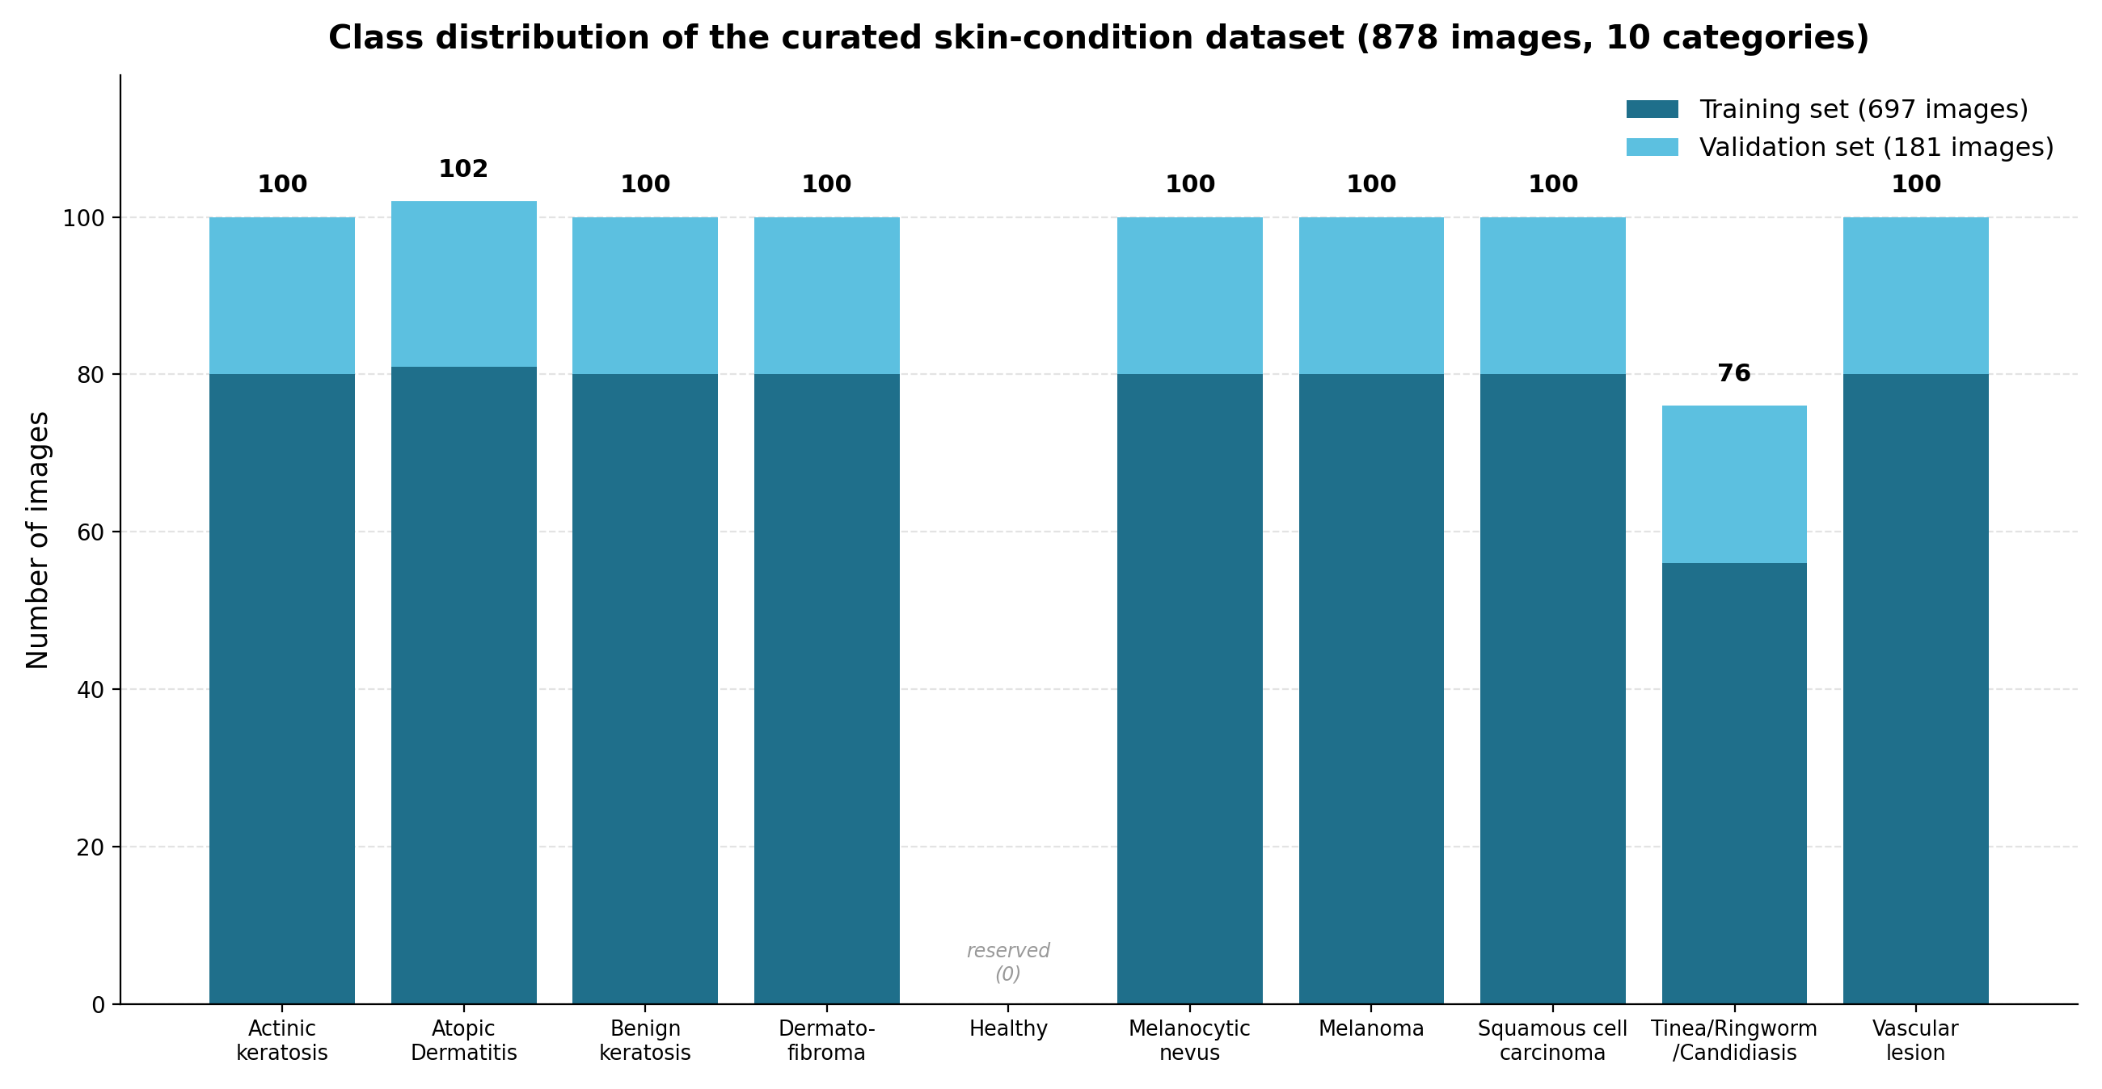
Figure 1: Class distribution of the curated skin-condition dataset, showing the approximately balanced categories and the reserved healthy reference category.

Accessibility
The images are sourced from openly available dermatology repositories — principally the ISIC archive supplemented by public clinical-image collections — and are used here strictly for academic research. Because the original sources are public and the class definitions are explicit, the dataset can be reconstructed and the experiments replicated, facilitating transparent model development and evaluation as described in the next chapter.

Chapter 4: Proposed Framework

Overview of the Framework
The proposed pipeline accepts a raw dermatological image and outputs two products simultaneously: a predicted skin-condition label and a visual justification for that prediction. The system proceeds through sequential stages: data preparation, imbalance handling, classification by a pre-trained ResNet-18, explainability via LIME, and evaluation. The following sections describe each stage and the tools employed.
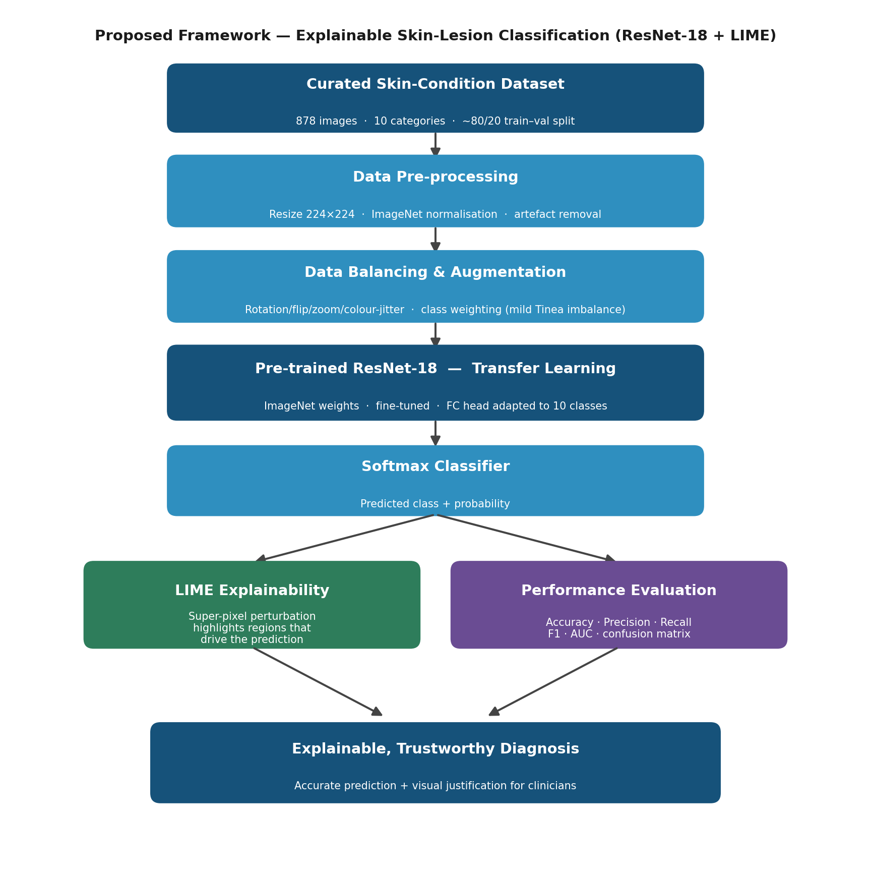
Figure 2: The proposed framework for explainable skin-lesion classification using a pre-trained ResNet-18 and LIME.

Data pre-processing
Given the variability in image size and quality, the initial stage standardises inputs. Each image is resized to 224 × 224 pixels — the input dimension expected by ResNet-18 — and pixel intensities are normalised using ImageNet mean and standard deviation so the fine-tuned model remains consistent with its original pre-training. Obvious dermatological clutter — hairs, ink marks, rulers and dark lens vignetting — is minimised where possible since such artefacts can bias learning. The curated collection is partitioned into stratified training and validation sets (approximately 80% and 20%, i.e., 697 training and 181 validation images) so class proportions are preserved across splits. (3, 6)

Data Augmentation and Class Balancing
Two complementary measures maximise learning from the small, roughly balanced dataset. First, data augmentation creates plausible variants of lesions via random rotations, horizontal and vertical flips, zooms and modest brightness/contrast shifts, effectively enlarging the training set and acting as a regulariser to reduce overfitting. Second, light class weighting compensates for the modest under-representation of the tinea/ringworm/candidiasis group: the loss function is weighted inversely to class frequency so errors on smaller classes incur greater penalty. Focal loss is considered as an alternative to further emphasise difficult examples. Together these techniques reduce the risk that the network will neglect clinically important minority categories. (5, 9)

Classification Model: Pre-trained ResNet-18
The core classifier is a ResNet-18 seeded with ImageNet weights. The convolutional backbone — residual blocks with skip connections — is preserved and fine-tuned on the dermatology images, while the original 1,000-way final layer is replaced by a fully connected layer of ten neurons (one per class), followed by a softmax to produce probabilities. Fine-tuning proceeds with a low learning rate so that general visual features from ImageNet are softly adapted to the dermatology domain. ResNet-18 is intentionally chosen over larger networks: it offers sufficient accuracy, trains faster and uses less compute, which makes it suitable for practical deployment. (3, 6, 8)

Training Setup
Training uses the Adam optimiser with a weighted cross-entropy loss, images supplied in mini-batches and a learning-rate schedule that decays over time. Validation performance is checked every epoch and early stopping halts training when improvement ceases, preventing overfitting and saving resources. Table 3 lists sensible starting hyper-parameters to be explored empirically in the implementation phase.

Table 3: Main hyper-parameters of the proposed configuration.
Setting | Value
Input image size | 224 x 224 x 3
Backbone network | ResNet-18 (pre-trained on ImageNet)
Output layer | Fully connected, 10 neurons + softmax
Loss function | Cross-entropy with class weighting (focal loss considered)
Optimizer | Adam
Initial learning rate | 1e-4 with scheduler
Batch size | 32
Epochs | Up to 50, with early stopping
Train / validation split | ≈ 80 % / 20 % (697 / 181 images, stratified)
Framework | PyTorch + torchvision

Explainability with LIME
After the classifier issues a prediction, LIME is applied to explain it. The method first segments the image into super-pixels (patches of neighbouring pixels with similar properties) and produces many perturbed copies in which random subsets of these patches are masked out. The trained ResNet-18 is evaluated on each perturbed image, and LIME records how the predicted probability for the target class changes as different regions are removed. From these observations, LIME fits a simple, interpretable surrogate model that locally approximates the deep network and ranks super-pixels by their influence. The result is an overlay that highlights regions most responsible for the decision. If these regions correspond to the lesion itself, confidence in the model increases; if they point to background or artefacts (hair, rulers, ink), the explanation reveals potential shortcomings — the transparency clinicians require. (14)

Evaluation Strategy
The framework will be assessed on quantitative and qualitative grounds. Quantitatively, classification performance will be reported using accuracy as well as per-class recall and F1 (with averaged summaries) so that strong results on common classes cannot mask poor performance on rarer ones; ROC AUC and confusion matrices will further clarify which classes are confused. Recall on malignant classes is prioritised because missing a cancerous lesion is costlier than raising a false alarm. Qualitatively, LIME outputs will be examined to determine whether the model concentrates on clinically relevant image regions, an indicator of practical trustworthiness.

Tools and Technologies
The implementation will be in Python. The model and training pipeline will use PyTorch and torchvision, which supply the pre-trained ResNet-18 weights. Image processing and augmentation will use OpenCV, Pillow and Albumentations; NumPy and pandas will manage data; scikit-learn will provide evaluation metrics. LIME and scikit-image will handle explanations and super-pixel segmentation, while Matplotlib will visualise outcomes. Training will be performed on a GPU via Google Colab or a comparable environment to keep experiment turnaround times manageable.

References
[1] Codella, N., Rotemberg, V., Tschandl, P., Celebi, M. E., Dusza, S., Gutman, D., Helba, B., Kalloo, A., Liopyris, K., Marchetti, M., Kittler, H., and Halpern, A. "Skin Lesion Analysis Toward Melanoma Detection 2018: A Challenge Hosted by the International Skin Imaging Collaboration (ISIC)." arXiv preprint arXiv:1902.03368, 2019.
[2] Combalia, M., Codella, N. C. F., Rotemberg, V., Helba, B., Vilaplana, V., Reiter, O., Carrera, C., Barreiro, A., Halpern, A. C., Puig, S., and Malvehy, J. "BCN20000: Dermoscopic Lesions in the Wild." arXiv preprint arXiv:1908.02288, 2019.
[3] Deng, J., Dong, W., Socher, R., Li, L.-J., Li, K., and Fei-Fei, L. "ImageNet: A Large-Scale Hierarchical Image Database." Proceedings of the IEEE Conference on Computer Vision and Pattern Recognition (CVPR), 248-255, 2009.
[4] Esteva, A., Kuprel, B., Novoa, R. A., Ko, J., Swetter, S. M., Blau, H. M., and Thrun, S. "Dermatologist-level classification of skin cancer with deep neural networks." Nature, 542(7639), 115-118, 2017.
[5] Gayatri, E., and Aarthy, S. L. "Reduction of overfitting on the highly imbalanced ISIC-2019 skin dataset using deep learning frameworks." Journal of X-Ray Science and Technology, 32(3), 2024.
[6] He, K., Zhang, X., Ren, S., and Sun, J. "Deep Residual Learning for Image Recognition." Proceedings of the IEEE Conference on Computer Vision and Pattern Recognition (CVPR), 770-778, 2016.
[7] Kassem, M. A., Hosny, K. M., and Fouad, M. M. "Skin Lesions Classification Into Eight Classes for ISIC 2019 Using Deep Convolutional Neural Network and Transfer Learning." IEEE Access, 8, 114822-114832, 2020.
[8] Krizhevsky, A., Sutskever, I., and Hinton, G. E. "ImageNet Classification with Deep Convolutional Neural Networks." Advances in Neural Information Processing Systems (NeurIPS), 25, 1097-1105, 2012.
[9] Lin, T.-Y., Goyal, P., Girshick, R., He, K., and Dollar, P. "Focal Loss for Dense Object Detection." Proceedings of the IEEE International Conference on Computer Vision (ICCV), 2980-2988, 2017.
[10] Lundberg, S. M., and Lee, S.-I. "A Unified Approach to Interpreting Model Predictions." Advances in Neural Information Processing Systems (NeurIPS), 30, 4765-4774, 2017.
[11] Mia, M. M., et al. "Exploring Augmentation Strategies for Balanced Skin Lesion Classification: An Explainable Lightly Tuned DenseNet-169 Architecture." 2025.
[12] Munjal, G., Bhardwaj, P., Bhargava, V., et al. "SkinSage XAI: An explainable deep learning solution for skin lesion diagnosis." Health Care Science, 3(6), 438-455, 2024.
[13] Nigar, N., Umar, M., Shahzad, M. K., Islam, S., and Abalo, D. "A Deep Learning Approach Based on Explainable Artificial Intelligence for Skin Lesion Classification." IEEE Access, 10, 113715-113725, 2022.
[14] Ribeiro, M. T., Singh, S., and Guestrin, C. "'Why Should I Trust You?': Explaining the Predictions of Any Classifier." Proceedings of the 22nd ACM SIGKDD International Conference on Knowledge Discovery and Data Mining, 1135-1144, 2016.
[15] Selvaraju, R. R., Cogswell, M., Das, A., Vedantam, R., Parikh, D., and Batra, D. "Grad-CAM: Visual Explanations from Deep Networks via Gradient-Based Localization." Proceedings of the IEEE International Conference on Computer Vision (ICCV), 618-626, 2017.
[16] Shakya, M., Patel, R., and Joshi, S. "A comprehensive analysis of deep learning and transfer learning techniques for skin cancer classification." Scientific Reports, 15, 4633, 2025.
[17] Simonyan, K., and Zisserman, A. "Very Deep Convolutional Networks for Large-Scale Image Recognition." International Conference on Learning Representations (ICLR), 2015.
[18] Tschandl, P., Rosendahl, C., and Kittler, H. "The HAM10000 dataset, a large collection of multi-source dermatoscopic images of common pigmented skin lesions." Scientific Data, 5, 180161, 2018.
[19] Brinker, T. J., Hekler, A., Enk, A. H., et al. "Deep learning outperformed 136 of 157 dermatologists in a head-to-head dermoscopic melanoma image classification task." European Journal of Cancer, 113, 47-54, 2019.
[20] Gessert, N., Nielsen, M., Shaikh, M., Werner, R., and Schlaefer, A. "Skin lesion classification using ensembles of multi-resolution EfficientNets with meta data." MethodsX, 7, 100864, 2020.
[21] Haenssle, H. A., Fink, C., Schneiderbauer, R., et al. "Man against machine: diagnostic performance of a deep learning convolutional neural network for dermoscopic melanoma recognition in comparison to 58 dermatologists." Annals of Oncology, 29(8), 1836-1842, 2018.
[22] Mahbod, A., Schaefer, G., Wang, C., Dorffner, G., Ecker, R., and Ellinger, I. "Transfer learning using a multi-scale and multi-network ensemble for skin lesion classification." Computer Methods and Programs in Biomedicine, 193, 105475, 2020.
[23] Yu, L., Chen, H., Dou, Q., Qin, J., and Heng, P. A. "Automated Melanoma Recognition in Dermoscopy Images via Very Deep Residual Networks." IEEE Transactions on Medical Imaging, 36(4), 994-1004, 2017.
[24] Databasehttps://www.kaggle.com/datasets/ujjwalsinha01/skin-disease-classification-dataset

