

An AI-Based Early Warning System for Academic Risk Prediction Using Machine Learning and Learning Management System Data
Marya Mohammed Bawazir
ORCID: 253000692
Master of Science in Artificial Intelligence
College of Informatics, Midocean University, UAE
Email: 253000692@st.midocean.edu.km
Hala Haytham Hajjar
ORCID: 253001456
Master of Science in Artificial Intelligence
College of Informatics, Midocean University, UAE
Email: 253001456@st.midocean.edu.km
Supervisor
Dr. Hager Saleh
College of Informatics
Midocean University, Comoros

Abstract
Early identification of students at academic risk has become a critical challenge for institutions to improve learning outcomes, provide timely academic intervention, and increase student retention. This study proposes an Artificial Intelligence (AI)-Based Early Warning System for predicting students' academic performance using the educational data extracted from a Private Learning Management System (LMS). The proposed framework consists of 1,395 student records described by 17 educational attributes, where students were classified into four academic performance categories: Excellent, Good, Pass, and Fail. The proposed methodology integrates data preprocessing, Random Forest (RF)-based feature selection, class balancing using the Synthetic Minority Oversampling Technique (SMOTE), supervised machine learning algorithms, and Grid Search for hyperparameter optimization. Four experimental configurations were designed to investigate the individual and combined effects of feature selection and class balancing on prediction performance. Eight supervised machine learning algorithms, including traditional and ensemble learning models, were comparatively evaluated using Accuracy, Precision, Recall, F1-score, and Confusion Matrix analysis. The experimental results demonstrated that Extreme Gradient Boosting (XGBoost) achieved the highest predictive performance among all evaluated models, reaching an accuracy of 82.80%, with corresponding precision, recall, and F1-score values of 82.63%, 82.80%, and 82.42%. Furthermore, RF based on feature selection effectively reduced data dimensionality while maintaining competitive predictive performance, whereas SMOTE improved minority-class recognition and enhanced the robustness of several classifiers. The proposed AI-Based Early Warning System provides an effective decision-support tool for identifying academically at-risk students at an early stage, enabling timely intervention and evidence-based educational decision-making. Future research should investigate explainable artificial intelligence techniques, deep learning models, and real-time learning analytics to further enhance prediction accuracy and personalized educational support.
Keywords: Academic Risk Prediction, Early Warning System, Machine Learning (ML), Learning Management System, XGBoost.

1. Introduction (add citation marya )
Artificial Intelligence (AI) transformed modern education by enabling data-driven approaches that improve learning outcomes and support educational decision-making. The widespread adoption of Learning Management Systems (LMSs) has generated a large volume of educational data describing students’ academic performance, assessment results, learning behavior, and engagement activities. These data provide valuable opportunities for developing intelligent systems capable of supporting early academic intervention.
Predicting students’ academic performance has become an important research topic in higher education. Traditional evaluation methods often identify academically at-risk students only after poor performance has occurred, limiting the effectiveness of intervention strategies. Consequently, machine learning techniques have been increasingly employed to analyze educational data and provide early predictions that assist instructors and academic advisors in supporting students before academic failure occurs.
Although previous studies have reported promising results, several challenges remain. Many existing approaches evaluate a limited number of machine learning algorithms or investigate only a single preprocessing technique without considering the combined impact of feature selection, class balancing, and hyperparameter optimization. In addition, comprehensive comparisons between traditional and ensemble learning models using real-world LMS data are still limited.
To address these challenges, this study proposes an AI-Based Early Warning System for predicting students’ academic risk using educational data extracted from a Learning Management System. The proposed framework integrates data preprocessing, Random Forest-based feature selection, class balancing using the Synthetic Minority Oversampling Technique (SMOTE), supervised machine learning algorithms, and Grid Search-based hyperparameter optimization. Four experimental configurations were designed to investigate the impact of preprocessing techniques on prediction performance, while eight supervised machine learning algorithms were comparatively evaluated to identify the most reliable model for early academic risk prediction. Narratively evaluated to identify the most reliable model for early academic risk prediction.
2. Research Problem
Despite the widespread adoption of (LMSs), many education sectors still face challenges in identifying academically at-risk students before their performance decreases. Traditional evaluation methods rely on midterm, short quizzes, and final examination results that limit the ability to provide timely academic support and early intervention.
Although LMS platforms continuously collect educational data describing students' learning behavior, assessments, participation, and engagement, these data are not fully utilized to support proactive academic decision-making. The existing machine learning (ML) studies often evaluate a limited number of algorithms or focus on individual preprocessing techniques without investigating the combined effects of feature selection, class balancing, and hyperparameter optimization using real-world educational datasets.
Addressing this problem is essential for improving student retention, enhancing learning outcomes, and supporting evidence-based educational decision-making. Therefore, this study proposes an AI-Based Early Warning System that integrates advanced preprocessing techniques with multiple supervised machine learning models to accurately predict students' academic risk and enable timely educational intervention.

3. Importance of the Study(كامله بدون تفرع hala )
The importance of this study lies in the growing need for intelligent educational systems that can identify academically at-risk students at an early stage using LMS data. By integrating advanced machine learning techniques into an AI-Based Early Warning System, this study contributes to both scientific research and educational practice.

3.1 Scientific Importance
We propose an integrated machine learning framework that combines data preprocessing, Random Forest-based feature selection, SMOTE, and Grid Search optimization to improve academic risk prediction. In addition, it provides a comprehensive comparison of eight supervised machine learning algorithms under four experimental configurations to identify the most effective model for predicting students' academic performance.

3.2 Practical Importance
The proposed framework enables educational institutions to identify academically at-risk students at an early stage, allowing timely intervention and personalized academic support. It also supports evidence-based educational decision-making and can be integrated into Learning Management Systems to improve student retention and overall learning outcomes.

4. Study Objectives
The primary objective of this study is to develop an early warning system that can be applied to classify students' risk levels in terms of their academic performance by using AI and ML methods. The project will rely on LMS data, including students' academic performance indicators, engagement, and demographics, to identify those who have risks of poor performance as early as possible. For this purpose, the target (Final Mark) is transformed into a classification problem ( Excellent, Good, Pass, and Fail). We use the technique of data pre-processing and feature engineering to increase the quality of the data used for predictions.
5. Review of Previous Studies
CR-NODE was proposed by Bettahi et al.(Bettahi et al., 2025), where continuous time was combined with completion-specific features to predict early dropout behavior. The dataset consists of longitudinal interactions recorded in the Canvas Learning Management System at a large public university spanning several terms. In the dataset, there are 100,878 students’ enrollments that have final grades, out of which we filtered 89,734 temporal interactions meeting the minimum observations requirement. To ensure temporal consistency and data quality, data preprocessing involved several steps. There were several steps in data preprocessing to make sure that the data was consistent over time and of good quality. They used six different baseline methods (Logistic Regression, RF, XGBoost, Gradient Boosting, LSTM, and Basic Neural ODE) to compare CR-NODE and set comprehensive performance benchmarks. The results showed that CR-NODE had the best balance between the rates of true positives and true negatives. XAI was used to understand model predictions.

Ujkani et al. (Ujkani et al., 2024)proposed a model based on CNN, LSTM, and XGBOOST. They used a dataset that was collected from the Open University Learning Analytics Dataset. It includes 32,593 students over a 9-month course period from 2014 to 2015. Different pre-processing steps were applied for predicting students’ success: Merge and Consolidate, Missing Value Handling, Feature Engineering, and Data Splitting. Different DL and ML models for forecasting students' success. To comprehend the prediction of models, the RF Classifier, Gradient Boosting Classifier, KNN, Multi-Layer Perceptron (Neural Network), First Custom Neural Network Architecture, Second Custom Neural Network Architecture, and XAI were employed. LSTMs were employed for training and assessment. Their findings show that, when compared to models for predicting students' success, their proposed models performed with the best accuracy, up to 94%. The models' predictions were analyzed using XAI, RF Classifier, and Gradient Boosting Classifier.

The proposed RADAR system by Embarak et al.(Embarak & Hawarna, 2024) used statistical analysis and ML algorithms to identify patterns and trends in the data that indicate a student was at risk of falling behind or dropping out. A dataset of the students from a particular school district was taken to build the system; the information was gathered and processed properly through feature integration, data cleansing, and feature selection.This approach allows for the identification of the following elements of each particular individual student goals, strengths, weaknesses, identification of patterns that imply the student is in danger of dropping out of the educational institution, identification of the signs indicating the student is having difficulties, as well as providing necessary support. In this case, PAP can help in evaluating the ability of the student to continue studying in the future, as well as predicting the level of his/her success. With the help of such a comparison, Embarak et al. can emphasize the limitations of these methods. The machine learning system incorporating XAI can process multiple kinds of data and take into account other factors associated with the risks posed to students. Machine learning algorithms such as DT are applied to analyze the information and find patterns. Prediction of the students was done with the help of the specified criteria, thresholds, and patterns.
Subsequently, personalized interventions and evaluation became possible with the help of the findings of this stage.

Macfadyen (Macfadyen & Dawson, 2010)described how LMS data might be used to forecast the academic performance of students and determine which ones need extra help. The data sample for this research was obtained from the Blackboard Vista Learning Management System (LMS) at the University of British Columbia in Canada. The data sample contained logs of student activities such as participation in discussions, completion of assessments, sending emails, interactions, and frequency of logging into the LMS. These variables were then utilized to analyze student behavior on the internet and, thus, to forecast their performance. In the first place, the collected data were subject to further processing. Major predictors of student performance were established; they included participation in discussions, messaging, performance in tests/ quizzes, and frequency of logging into the LMS. Data cleaning was conducted, which entailed the elimination of observations that had missing values and structuring for predictive modeling (PM). The regression model (RM) technique was adopted for developing the predictive model (PM) for academic success using activity data from the LMS. LR was utilized to discover students at risk of poor performance and to predict their academic failure. Network analysis was also carried out to analyze patterns of interaction and determine which students are disengaged in discussion forums. According to the findings, activity data of students from the Learning Management System can be used to make accurate predictions regarding their performance. The regression model was able to explain more than 30% of the variance in the final grade. Additionally, the logistic regression model accurately predicted 81% of the failures.
Queiroga et al.(Queiroga et al., 2022) Presented a research paper that attempted to predict the at-risk students in high schools (secondary education level) by applying ML and learning analytics. The research presented the preprocessing techniques for the dataset, the modeling approaches, and the bias analysis conducted when constructing the predictive models. Additionally, the need for employing past student performance as predictors of future student performance was emphasized. The database for this study was sourced from the National Administration of Public Education (ANEP) of Uruguay. The database contained information on nine different education systems that covered the educational life journey of students from primary school to secondary school spanning 2015-2020. This included information on 258,440 students, encompassing their grades, attendance, demographics, and other features. Data preprocessing was also undertaken prior to modeling. Data preprocessing entailed the cleansing of data, integration of databases for multiple education systems, conversion of the database into a time series database, and derivation of additional attributes. Methodology: The methodological process undertaken was based on the CRISP-DM data mining methodology. Machine learning algorithms such as RF, DT, AdaBoost, LR, NB, and MLP were investigated. RF and MLP gave almost similar results; however, the latter model was preferred since it had a better performance and was more interpretable. From the analysis, it is clear that the ML models have done remarkably well through achieving a very high accuracy rate when predicting at-risk students. The AUROC and F1 scores produced a result above 0.90 and 0.88, respectively. Out of the eight models, seven were considered acceptable based on the bias score.
Bagunaid (Bagunaid et al., 2024)introduced E-FedCloud, an AI-based e-learning system. The method was intended to predict student performance and identify potential difficulties that students may face. Recommendations were created and continually tracked in order to enhance the performance of the students. Engagement of the students was analyzed through federated learning, as well as Shannon entropy, which allowed secured data access. The application of deep reinforcement learning was achieved by using a method called ID2QN, which was used to predict the performance of students and categorize them according to their level of risk, such as students that might drop out of school, poor performers, and students that may fail the class. Also, ontology graphs, along with attention capsules, were used to create personal recommendations for each student. The
OULAD dataset comprising 32,593 students taking 22 courses was used as a training dataset. The dataset comprised demographic information, performance information, and learning behaviors data, including login behavior, assessment behavior, and interaction behavior. Preprocessing techniques were performed before using the modeling procedure.
These include data cleansing, feature selection, multiple sources' data integration, and preparing behavioral, academic and demographic variables. To improve data quality, additional preprocessing techniques such as contrast enhancement, denoising and image stabilization were carried out. In addition, various machine learning algorithms and deep learning algorithms were used. As a result, ID2QN Deep Reinforcement Learning algorithm was chosen for predicting academic performance. The majority voting multi-objective clustering algorithm was used to classify students based on the level of their involvement, and the Attention-based Capsule network was used for customization recommendation system. In terms of securing the collected data, federated learning and Cycle-GAN were applied. It is worth mentioning that the E-FedCloud framework exhibited a high prediction capability of identifying students who might experience difficulties. The accuracy of the model equaled almost 97%, and the F1-score equaled 95%.
Johora (Johora et al., 2025)developed an XML approach to predict the academic performance of undergraduate students in Bangladesh. In this research, a dataset consisting of 872 samples was created. It included demographic, academic, and behavioral data of the students. Preprocessing steps were followed, including handling of the missing data, elimination of the unimportant columns, and conversion of the categorical variables to numeric values using one-hot encoding. To overcome the class imbalance problem, SMOTE was used, and feature scaling was done. After that, several ML approaches were implemented. They included RF, GB, XGBoost, SVM, KNN, DT, and LR. As it can be seen, it was proved that stacking ensemble model is better in terms of its performance. In order to interpret the model and see what features play a key role in achieving success among students, SHAP and LIME methods were implemented in this research project. It should be noted that the highest accuracy reached 86.38% in terms of stacking ensemble model.
Christou et al. (Christou et al., 2023)have proposed a Machine Learning technique to forecast students’ future grades and study time based on past educational data. In this paper, the authors propose a feature selection and construction method called FSC4RBF which is implemented by Radial Basis Function Neural Networks using grammatical evolution. The data used in this study was collected from different departments of the University of Ioannina, Greece such as Physics, Philosophy, Primary Education, History, Mathematics, and Chemistry, which included students' educational data such as grades, course details, and study time. Preprocessing includes organizing and transforming student’s academic record data into suitable input features for machine learning models. Feature engineering helps in predicting accurate results. Comparison among different ML methods like DT, Bayesian Network, SVM, and various Neural Networks indicates that proposed (FSC4RBF) gives the best results. It obtained the lowest mean square error in most regression tasks and the highest accuracy in all classification tasks.
Realinho et al.(Realinho et al., 2022) introduced a study in which a public higher education dataset containing 4424 student records with demographic, socioeconomic, macroeconomic, and academic features was developed to predict student dropout and academic success. The data were collected from multiple institutional sources, merged, cleaned, and preprocessed to support machine learning classification tasks. Several ML techniques were applied to analyse student performance and identify at-risk students. The study used a public dataset from the Polytechnic Institute of Portalegre, Portugal, containing 4424 student records with 35 attributes. The dataset included demographic, macroeconomic, socioeconomic, and academic performance data from enrollment until the end of the first and second semesters. Data collected from multiple sources, such as academic systems, national databases, The data were then combined into one single dataset. Data cleaning was done by eliminating duplicates, managing missing data, managing outliers, renaming the variable names, and selecting suitable features. The students were classified into groups according to their year of graduation.The analysis included the following ML models: RF, XGBoost, light gradient boosting machine (LightGBM), and CatBoost. Data integration and data preprocessing were performed, together with feature importance analysis conducted based on permutation feature importance. The project did not include the results about specific accuracy since the main goal was presentation and analysis of the dataset, but not the development of a single ML model. Nonetheless, the presented dataset allows predicting student drop-out and student achievement and can be used for benchmarking ML models and building learning analytics systems.
The employment of AI techniques to predict student academic performance within the BL environment of SEU was first done by Hamadneh (Hamadneh et al., 2022). The study sought to identify the major determinants of student academic achievement and develop a PD for student academic performance. Data for this study were extracted from the Blackboard LMS. The data contained the following predictors: type of study, participation in live lectures, exam results, and completion of assignments. Final exam marks were the target variable. Various data preprocessing techniques were employed. These techniques included descriptive statistics, correlation, multicollinearity test, and regression analysis, which used ordinary least squares, fixed-effects, and random-effects models. To determine the quality of the data and the key factors that determine students' academic success, the following procedures were followed. The researchers subsequently built a PD using the artificial neural network technique. The ANN in this case is a multilayer perceptron, whose input nodes are four, hidden nodes are ten, and the output node is one, which represents the final grade. The results indicated that the proposed hybrid neural network model achieved strong predictive performance with low prediction error.
The project of Skittou et al (Skittou et al., 2023)developed an early warning system that took into account a number of socio-cultural, structural, and educational factors that have a direct impact on a student’s decision to drop out of school. They worked on an original database by aggregating data from several operational systems. The number of pupils in the study population is 125354, including 59384 girls. A considerable number of properties are deemed highly important for defining a student who is likely to drop out or not. dedicated to this issue, which reflected their approach of seeking exhaustiveness and precision in the choice of dropout indicators. The model they built performed very well, particularly with the KNN, with an accuracy rate of over 99.5% for the training set and over 99.3% for the test set. The database used is built specifically for this project's preprocessing; they used mainly ML analysis methods specialized in classification. Hence, the use of the best-known and most efficient methods for this aspect of analysis: SVM, RF, SGD, and KNN. The results are visualized using a Django application they developed for this purpose, and we show how this can be useful for educational planning.
David Bañeres et al. (Bañeres et al., 2020) created a new system with multiple contributions. The Gradual At-Risk (GAR) model was the first contribution, a predictive model. Such a model predicted students' chances of failing a course based solely on their grades. Using the dataset in a data mart, a thorough analysis of the model was carried out on the entire collection of university courses. They can see that, starting with the fall semester of 2016, the number of training registries rises every semester (20161). For every course and semester, they suggested a way to find the optimal classifier and training set. KNN, DT, NB, SVM, LR, Hierarchical Mixed models, and Neural Network models. The second is a technique to establish a cutoff point for classifying a course's trained GAR model as high- or low-quality. In an actual classroom, the GAR model gave students feedback according to their risk level. As a result, a teacher cannot afford to give a student incorrect advice or a message. The EWS uses GAR to modify the kind of message that is sent to the student. The third contribution involved using the EWS in two courses in an actual classroom. In terms of dashboards and feedback, the GAR model was utilized to give teachers and students useful information. They examine how well at-risk students are identified in such a real-world learning environment and how this affects the courses' final performance. Two undergraduate courses were used to test the system, and the results demonstrated a high level of accuracy in identifying students who were at risk.
Albreiki, Balqis, et al. [(Bañeres et al., 2020) stress the use of a customized rule-based system with the Risk Flag to identify and visualize at-risk students early in the course delivery. The dataset was gathered from an undergraduate programming course at the United Arab Emirates University's College of Information Technology. The information shows how well students performed in the introductory programming course during the academic years 2016–2017 (fall and spring), 2017–2018 (fall and spring), and 2018–2019 (fall and spring). The data was pre-processed to make it readable for the ML methods. To resolve any discrepancies, all files are first combined into a single structure. A Python script was used to combine the files into a single CSV file, and min-max normalization was used to normalize the marks. The averaged value of the same coursework components was used to replace the missing values, which were handled using imputation techniques. Time-wise, the results are still inefficient, and there are a lot of false predictions. They suggest a tailored rule-based model that provides at-risk students with prompt identification. It reacts in real time to the student's performance in the assessment component. It also helps the teacher identify the at-risk students and provide prompt intervention by visualizing them.
With various ML algorithms, Khan, Ijaz, et al. (Khan et al., 2021) created a set of prediction models. Because DT outperforms other models, they were further developed into a format that is simple to understand. The student academic records for a course taught at Buraimi University College, Sultanate of Oman, are used in the dataset. The college's registration department provides the data, and all ethical standards are strictly adhered to. Three semesters are covered by the training dataset. The training dataset contains 151 instances with one prediction class and ten prediction features. Students are categorized as "Low" or "High" based on the prediction. Data cleaning: The noise is either eliminated or minimized using a variety of methods. The training dataset contains 151 instances after the noisy instances are eliminated. WEKA, an open-source program with a variety of algorithms for data pre-processing, classification, clustering, regression, and association rules, was created at the University of Waikato in New Zealand. Four popular machine learning algorithms were chosen. They selected KNN, which is implemented as IBk in WEKA, from lazy algorithms. In WEKA, RepTree is a DT implementation. In a similar vein, they selected NV as the fourth algorithm and Multilayer Perceptron, a class of Artificial Neural Networks. They divided the training dataset into ten intervals of the same length using tenfold cross-validation. The tenth interval in each cycle is used to evaluate the algorithm's performance, while the first nine are used for learning. It was an iterative process; in each iteration, a new interval was chosen for testing. Both the teacher and the students seemed to find the prediction model beneficial. The prediction model appeared constructive and helpful for both the instructor and the students. By the sixth week of the semester, the students who were most likely to produce subpar results had been identified and warned. The model was praised by students who were on the verge of having a low CGPA, and an early warning inspired them to work hard and overcome their situation. Similarly, the students who achieved satisfactory results also followed the attendance advice, and by the end of the semester, very few students showed up for class. The improvement of the struggling students served as a gauge for the overall effects. Four out of five students were able to produce an end result that was acceptable. From the beginning of the course, students' performance is closely monitored as part of the supportive measures. Additionally, a series of preventive measures is implemented to provide extra support to students who are having difficulty.
Akçapınar et al.(Akçapınar et al., 2019) studied 76 students enrolled in the Computer Hardware course in the Department of Computer Education and Instructional Technology at a state university in Turkey. The students' ages ranged from 21 to 23 years, with 41 women and 35 men. Data collected about the students' learning processes at the end of the term included 3803 sessions, 119,921 page visits, 4566 written texts, 62 discussion forum questions, 297 responses, 8601 evaluations, and 3937 tags used to label written messages. Both final term academic achievement scores and interaction among students data from the virtual classroom were taken into account in the analysis. They used two different preprocessing methods. These included techniques for data transformation and feature selection. The CN2 (86%) and kNN (86%) algorithms achieved the highest classification accuracy, and the Gini index was used to select the best features. According to the results of the study, at the end of the term, the kNN algorithm had an 89% accuracy rate in predicting students who would not succeed.

Table 1 Of The Reviewed Papers
Paper | Year | Models | Limitation | Dataset | Type | The best model | Result
Bettahi et al.(Bettahi et al., 2025) | 2025 | CR-NODE  LR, RF, XGBoost, Gradient Boosting, LSTM, and Basic Neural ODE | It focuses exclusively on predictive accuracy without evaluating whether deployment actually improves student outcomes. | large public university Dataset. | Private -Need request-. | CR-NODE | CR-NODE achieves the best balance
Ujkani et al(Ujkani et al., 2024) | 2024 | RF Classifier, Gradient Boosting Classifier, KNN, Multi-Layer Perceptron (Neural Network), First Custom Neural Network Architecture, Second Custom Neural Network Architecture, XAI, and LSTM. | The dataset used in this study is from a pre-pandemic period; it is important to acknowledge the broader context of how the COVID-19 pandemic may have altered students’ habits, motivations, and learning behaviors. | Open University Learning Analytics Dataset | Public https://analyse.kmi.open.ac.uk/open_dataset | Custom Neural Network Architecture | The proposed models performed with the best accuracy of up to 94% compared to models for predicting students’ success
Embarak & Hawarna (Embarak & Hawarna, 2024) | 2024 | Data analysis, ML, feature selection, XAI, RADAR | The study relied on a specific dataset from a specific computing major, which may limit the generalizability of the findings to other situations. | Students from a school district Dataset. | Private | RADAR system | The RADAR system can help at-risk students receive better support and direction
Macfadyen & Dawson(Macfadyen & Dawson, 2010) | 2010 | Correlation analysis, Regression model, LR, Network analysis | Applied to one course only, a small dataset, not a full AI model, limited generalization | LMS dataset from Blackboard (student activity, messages, logins, assessments) | Private | LR model | Predicted at-risk students with 81% accuracy and explained 30% of the variation in final grades
Queiroga et al (Queiroga et al., 2022) | 2022 | RF, DT, AdaBoost, MLP, NB, LR | Needs annual data preprocessing and retraining; results based on Uruguay data only; one model showed bias and weak performance. | Nationwide K-12 dataset (Uruguay), 258,440 students; demographic data, grades, absences, social welfare, school data (2015–2020) | Private | RF | Achieved high performance (AUROC > 0.90, F1 > 0.88) and successfully predicted at-risk and dropout students early
Bagunaid et al(Bagunaid et al., 2024) | 2024 | ID2QN (Deep Reinforcement Learning), MV-MOC Clustering, Att-CapsNet (DL), Federated Learning (CGAN), TSE (Entropy), LWEA + Blockchain | High computational complexity; requires multi-modal biometric data; privacy concerns; tested mainly on the OULAD dataset | OULAD dataset (32,593 students, 22 courses); demographic, academic, and behavioural LMS data | Public No Access | ID2QN (Improved Duelling Deep Q Network) | Achieved ~97% accuracy and ~95% F1-score; outperformed PCT, MST-FaDe, Fuzzy SVM, and AISAR; effectively predicted at-risk students early
Johora, Fatema Tuz, et (Johora et al., 2025) | 2025 | RF, Gradient Boosting, XGBoost, SVC, KNN, DT, LR, Stacking Ensemble, SHAP, LIME | Small dataset (872 students) from Bangladesh only; limited generalizability; based on survey data | 872 undergraduate students from multiple universities; demographic, academic, and behavioural features (31 features) | Private | Stacking Ensemble (RF + GB + SVC) | Achieved 86.38% accuracy; SHAP and LIME identified key factors such as attendance affecting student performance
Christou, Vasileios, et(Christou et al., 2023) | 2023 | RBF Neural Network, SVM, DT, Bayesian Network, Neural Networks | Data from one university only; limited generalization | Student academic records from several departments, University of Ioannina | Private | Feature selection and construction method for RBF network | Achieved the highest accuracy and the lowest error compared with other models in predicting grades and dropout
Realinho, Valentim, et al.(Realinho et al., 2022) | 2022 | Random Forest, XGBoost, LightGBM, CatBoost | An imbalanced dataset, limited to one institution, and mainly focused on dataset description rather than proposing a strong predictive model. | Student Dropout and Academic Success Dataset – Polytechnic Institute of Portalegre | Public No Access | Not specified | Identified the most important factors for dropout prediction, such as grades, approved courses, tuition status, and course type
Hamadneh, Nawaf N., et al. (Hamadneh et al., 2022) | 2022 | ANN, Multilayer Perceptron Neural Network, Multilayer Perceptron Neural Network with Firefly Algorithm | Limited to one university, a small dataset, and a few features | Dataset from the Blackboard Learning Management System at the Saudi Electronic University | Private | Neural Network trained by Firefly Algorithm | Achieved strong prediction performance with a root mean square error of 0.39 and identified midterm exams, assignments, attendance, and study mode as key factors
Skittou, et al (Skittou et al., 2023) | 2023 | SVM, Random Forest, SGD, and KNN. | Lack interfaces for administration and data manipulation in dynamic and interactive ways, because aggregating data from several operational systems | The database used is built specifically for this project by aggregating data from several operational systems | Private- Need to request access from the author | (KNN) algorithm | Visualized using a Django application we developed for this purpose, and we show how this can be useful for educational planning.
Bañeres, David, et al.(Bañeres et al., 2020) | 2020 | DT, NB, SVM, LR, Hierarchical Mixed models, KNN, Neural Network models | When the assessment process is changed regarding the number of assessment activities or the contents of the activities, the model is invalid for the course. | This model has been tested using data available in an institutional data mart, where curated data from six semesters are available. | Private | Gradual At-Risk (GAR) model | The model showed a high accuracy in correctly detecting at-risk students.
Albreiki, Balqis, et al. (Albreiki et al., 2021) | 2021 | Statistical and ML techniques | The results still lack efficiency in terms of time and have high false predictions. In this study, we propose a customized rule-based model that offers timely identification for at-risk students. | The data was collected from a programming course taught for undergraduate students at the College of Information Technology (CIT), United Arab Emirates University (UAEU). | Private -Need request-. | Customized rule-based system (RBS) | It visualizes the at-risk students to support the educator in recognizing these students and offering timely intervention.
Khan, Ijaz, et al.(Khan et al., 2021) | 2021 | ML algorithms  KNN  RepTree  DT  (MLP)  (ANN) | The training dataset of a course may comprise a low number of total instances due to limitations on classroom size. | The student's academic records for a course taught at Buraimi University College (BUC), | Private -Need request-. | Developed a set of prediction models | The prediction model appeared constructive and helpful for both the instructor and the students.
Akçapınar, et al.(Akçapınar et al., 2019) | 2019 | Prediction model  Classification model | Transferability and generalizability of prediction models into the different courses are still limited. | The study was conducted at a state university in Turkey with 76 students in online learning activities for a period of 14 weeks | Private -Need request- | (KNN) | The kNN algorithm accurately predicted unsuccessful students at the end of the term with a rate of 89%.

6. Methodology(hala)
This section presents the methodology adopted to design, implement, and evaluate the proposed AI-Based Early Warning System for Academic Risk Detection in the Education sector. Figure 3.1 describes the basic framework and identifies students who are at risk of poor academic achievement using educational data collected from (LMS)
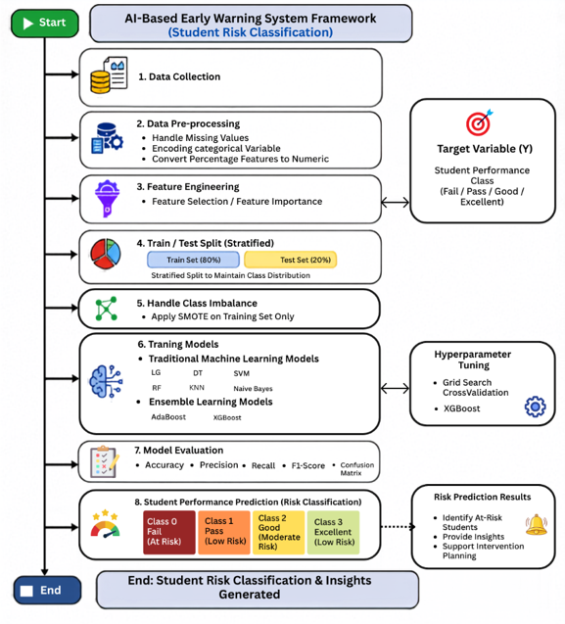
Figure 1. Proposed AI-Based Early Warning Framework

7.1 Dataset Description
We used a private educational dataset collected from a Learning Management System (LMS). The dataset contains 1,395 student records represented by 17 educational attributes describing students' academic performance, participation, assessments, virtual classroom activities, homework completion, discussion participation, attendance, and other engagement indicators. The target variable represents students' academic performance and classifies each student into one of the following four categories: Excellent, Good, Pass and Fail.

3.2 Data Preprocessing
The data preprocessing is an important step in this process. It ensures the preparation of data for further analysis and improves its quality prior to modeling. The preprocessing includes the following steps:
- Handling missing values to ensure data quality.
- Converting percentage features into numerical values using the Pandas library in Python.
- Encoding categorical variables into numerical representations to ensure the compatibility with ML algorithms.
- Splitting dataset into 80% training and 20% testing subsets using the Stratified Train-Test Split technique.
- Applying (SMOTE) only to the training dataset to address class imbalance.
- Preparing the final dataset for feature selection and subsequent machine learning model development.

3.3 Data Splitting
The dataset was divided into 80% training data and 20% testing data using the Stratified Train-Test Split technique. Stratified sampling was adopted to preserve the original distribution of the four academic performance categories in both subsets, ensuring a fair evaluation of the developed models.

3.4 Feature Selection
Feature selection was done to determine which educational features made significant contributions in predicting the students' academic performance. Elimination of the less important variables makes the prediction process easier and less complicated. The steps involved in the feature selection include:
- Feature Importance Analysis: An RF classifier was used to generate the importance of each educational feature based on its ability to contribute to prediction accuracy. Feature Importance was determined by finding the average decrease in impurity of all the decision trees generated through the Random Forest algorithm.
- Feature Selection: From the determined feature importance, all the features were sorted in order of importance. Those features with insignificant importance, which included Teachers' Messages and Student Login Percentage, were discarded, while the others were retained for further machine learning analysis.

3.5 Experimental Configurations
In order to examine the effect of feature selection and class balancing on the performance of the prediction model, four experimental setups were created and tested separately. The four experimental setups allowed a thorough comparison of the impact of both preprocessing steps individually and together.
The following table describes the four experimental setups in brief:
- Experiment 1: Full Feature Set but no SMOTE.
- Experiment 2: Selected Feature Set but no SMOTE.
- Experiment 3: Full Feature Set with SMOTE.
- Experiment 4: Selected Feature Set with SMOTE.
Each experiment was conducted under similar conditions using the same machine learning models and the same evaluation criteria for comparison. After selecting the best models from each experiment, they were further optimized using Grid Search.

3.6 Machine Learning Models
To determine the most suitable predictive model for the proposed AI-Based Early Warning System, several supervised machine learning algorithms were implemented and evaluated under identical experimental conditions. The evaluated algorithms represent different learning strategies commonly used in educational data mining and classification problems. The evaluated models were divided into two categories.
3.6.1 Traditional Machine Learning Models
Six traditional classification algorithms were investigated in this study: DT, RF, LR, SVM, KNN, NB. These models represent different statistical, probabilistic, distance-based, and tree-based learning approaches, providing a comprehensive comparison of classical machine learning techniques for predicting students' academic performance.
3.6.2 Ensemble Learning Models
In addition to the traditional classifiers, two ensemble learning algorithms were evaluated:AB, XGB. These ensemble learning algorithms combine multiple learners to improve prediction accuracy, enhance model robustness, and reduce overfitting. Due to their strong predictive capabilities, they were included in the comparative analysis to evaluate their effectiveness in predicting students' academic performance.

3.7 Model Optimization
After evaluating the baseline machine learning models, hyperparameter optimization was performed to improve prediction performance. In this study, Grid Search with cross-validation was employed to identify the optimal hyperparameter values for the best-performing models from each experimental configuration. Specifically, Decision Tree (DT), Random Forest (RF), and XGBoost (XGB) were optimized whenever they achieved the highest performance. The optimized models were then retrained using the selected hyperparameters and evaluated on the testing dataset using the same evaluation metrics adopted throughout this study, including Accuracy, Precision, Recall, F1-score, and Confusion Matrix. The detailed optimization results are presented in the following chapter.
8. Results and Discussion. (marya add equation of the evaluation matrix)
8.1 Experimental Setup
Experiments were carried out via Google Collab using Python 3 as an implementation environment. The performance was evaluated on a private dataset that consists of 1,395 student instances and includes 17 academic and behavioral features, such as participation, assessments, attendance, and engagement measures. For data preprocessing, Pandas and NumPy libraries were used, while the ML models were built using the Scikit-learn framework and the XGB library. To conduct a fair experiment, we split the dataset into 80% train and 20% test using stratified sampling. A feature selection technique was utilized in two experimental settings to examine the influence of shrinking the number of input features. Because of the imbalanced nature of our dataset, the SMOTE algorithm was applied exclusively to the train set during the corresponding experiments.

8.2 Class Distribution and Feature Importance
From the information provided in Table 2, it is clear that the distribution of data in four academic performance classes was not even. In particular, the percentage of the Good class constituted 51.97% while the Pass class constituted only 7.67%. The rest of the data was related to Excellent and Fail classes (23.08% and 17.28%, correspondingly).
Table 2. Distribution of Student Performance Classes.
Class | Number of Students | Percentage
Good | 725 | 51.97
Excellent | 322 | 23.08
Fail | 241 | 17.28
Pass | 107 | 7.67

As illustrated in Figure 2 below, it is clear that the problem of imbalance was solved using SMOTE. The Good class had more observations compared to other classes prior to oversampling. In the SMOTE-oversampled training dataset, there were equal numbers of observations in each class, meaning that the dataset was balanced. The balance dataset was then utilized for the SMOTE-based experiments.

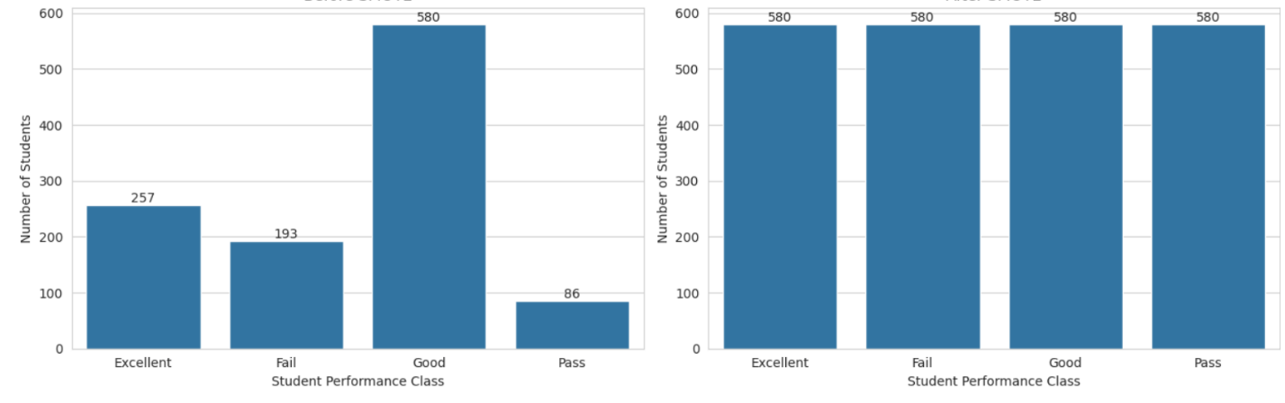
Figure 2. Class Distribution with and without Applying SMOTE.
The analysis of feature importance was done in order to understand which factors are more important in the prediction of student academic performance. An RF classifier was used for the estimation of the relative importance of each input variable. From the feature importance results shown in Figure 3, it is evident that the variables that have the highest importance in the prediction of student academic performance include Homework, Absence, and Interactive Contents. Other participation variables, such as Average Participation Percentage, Contents Participation Percentage, and Homework Participation Percentage, are also relatively highly important, showing the great role played by participation and continuous assessment activities of students in accurate prediction. However, Teacher Messages and Student Login Percentage have extremely low importance, implying that these variables contribute little to the prediction process.
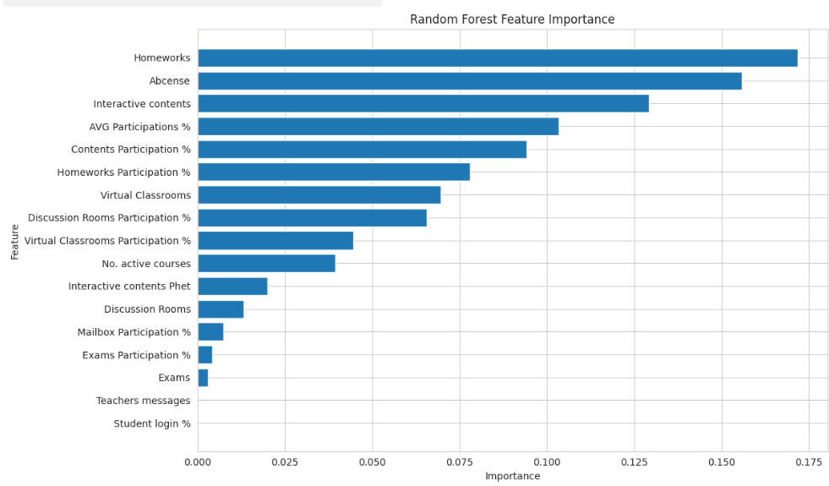
Figure 3. Random Forest Feature Importance Ranking.
8.3 Results of Model Performance
As shown in Table 3, the ensemble learning models have always shown better results compared to the traditional ML algorithms in all experimental conditions. As far as the analyzed models are concerned, XGB provided the highest accuracy of 82.80% in both EXP1 and EXP2, but remained the same (82.08%) in EXP3 and EXP4 due to their stable predictive ability regardless of different preprocessing techniques. However, RF showed the best performance of all the traditional ML algorithms prior to SMOTE implementation, while DT was able to become the best-performing traditional model after balancing the dataset, achieving 79.93% in EXP4. It is also evident from Table 2 that AB showed the lowest performance in all experiments, with accuracy rates ranging from 70.97% to 74.19%. Such superior results of XGB can be explained by their gradient boosting approach, which helps to identify complicated nonlinear relationships between the features of students' behavior. The mentioned results correspond to those obtained by (Johora et al., 2025)who found that XGB-based models outperformed traditional ML methods, as well as (Bettahi et al., 2025)
Table 3. Performance of the Evaluated Models under the Four Experimental Configurations.
NUM | Configuration | Approach | Model | Accuracy | Precision | Recall | F1-Score
1 | Full Features +  Without SMOTE. | Traditional ML | RF | 79.57 | 79.64 | 79.57 | 78.77
1 | Full Features +  Without SMOTE. | Traditional ML | DT | 79.21 | 79.42 | 79.21 | 79.21
1 | Full Features +  Without SMOTE. | EL | XGB | 82.80 | 82.63 | 82.80 | 82.42
1 | Full Features +  Without SMOTE. | EL | AdaBoost | 74.19 | 73.91 | 74.19 | 72.70
2 | Selected Features + without SMOTE. | Traditional ML | RF | 79.57 | 79.69 | 79.57 | 78.77
2 | Selected Features + without SMOTE. | Traditional ML | DT | 78.14 | 78.27 | 78.14 | 78.14
2 | Selected Features + without SMOTE. | EL | XGB | 82.80 | 82.63 | 82.80 | 82.42
2 | Selected Features + without SMOTE. | EL | AdaBoost | 74.19 | 73.91 | 74.19 | 72.70
3 | Full Features + SMOTE. | Traditional ML | DT | 79.57 | 79.82 | 79.57 | 79.51
3 | Full Features + SMOTE. | Traditional ML | RF | 79.21 | 79.28 | 79.21 | 78.25
3 | Full Features + SMOTE. | EL | XGB | 82.08 | 82.24 | 82.08 | 81.89
3 | Full Features + SMOTE. | EL | AdaBoost | 71.33 | 73.89 | 71.33 | 70.92
4 | Selected Features + SMOTE. | Traditional ML | DT | 79.93 | 80.56 | 79.93 | 79.84
4 | Selected Features + SMOTE. | Traditional ML | RF | 79.21 | 79.52 | 79.21 | 78.27
4 | Selected Features + SMOTE. | EL | XGB | 82.08 | 82.31 | 82.08 | 81.82
4 | Selected Features + SMOTE. | EL | AdaBoost | 70.97 | 73.94 | 70.97 | 70.71

The confusion matrices shown in Figure 4 represent a complete description of the classification results of the models used in our study for all four experimental designs. The prevalence of the diagonal elements in the XGB matrix suggests that most of the records have been correctly classified, while the few misclassifications occur among adjacent academic performance classes. It indicates that the XGB model is capable of differentiating among the four performance categories well. The results show that despite applying the selected data preprocessing methods such as feature selection and SMOTE, there is very little variation in the classification patterns, implying that none of the preprocessing methods change the predictive capabilities of XGB. Rather, they preserve the classification performance of the algorithm while enhancing the representation of minority classes. The observations from the confusion matrices are in line with the results quantitatively shown in Table 3, which indicate that XGB has performed best in terms of Accuracy, Precision, Recall, and F1-score among all the models considered. Similar conclusions can be drawn from (Bettahi et al., 2025) and (Johora et al., 2025).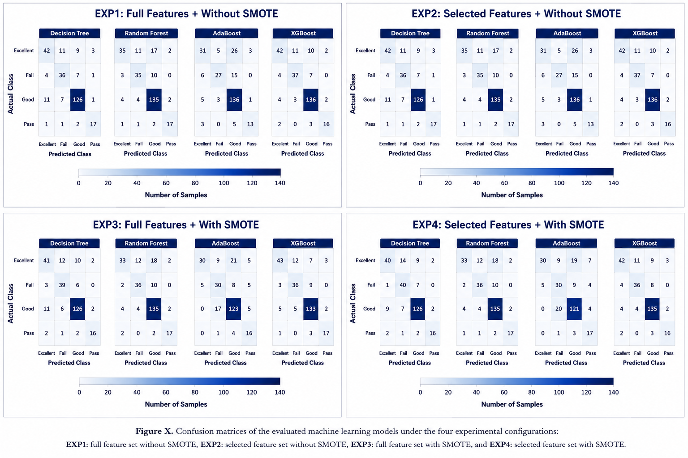
Figure 4. Confusion Matrices of the Evaluated Models.

8.4 Hyperparameter Optimization
Based on Table 4, the effect of the Grid Search optimization was different for the tested models. The model RF consistently improved in the experiments without SMOTE, with its accuracy changing from 79.57% to 80.29%. DT obtained the best result in EXP4, and its accuracy increased from 79.93% to 82.80%. This shows that hyperparameter tuning significantly increased the classification quality of DT in the selected features setting with SMOTE. However, XGB showed minor changes after optimization. As can be seen from Table 3, the classification accuracy of the model XGB stayed above 81.70% for all experiment configurations, which means that the initial settings of the model parameters were close to the optimal ones for the current data set. It can be concluded that Grid Search optimization affected the traditional machine learning models more compared to XGB, which had a high generalization ability.
Table 4. Performance of the Best Selected Models under Default and Optimized Hyperparameter Settings.
EXP NUM | Grid Search | Model | Accuracy | Precision | Recall | F1-Score
1 | Without | XGB | 82.80 | 82.63 | 82.80 | 82.42
1 | Without | RF | 79.57 | 79.64 | 79.57 | 78.77
1 | With | XGB | 81.72 | 81.66 | 81.72 | 81.10
1 | With | RF | 80.29 | 80.21 | 80.29 | 79.35
2 | Without | RF | 79.57 | 79.69 | 79.57 | 78.77
2 | Without | XGB | 82.80 | 82.63 | 82.80 | 82.42
2 | With | RF | 80.29 | 80.62 | 80.29 | 79.18
2 | With | XGB | 81.72 | 81.66 | 81.72 | 81.10
3 | Without | DT | 79.57 | 79.82 | 79.57 | 79.51
3 | Without | XGB | 82.08 | 82.24 | 82.08 | 81.89
3 | With | DT | 77.78 | 78.49 | 77.78 | 78.05
3 | With | XGB | 82.08 | 82.33 | 82.08 | 81.48
4 | Without | DT | 79.93 | 80.56 | 79.93 | 79.84
4 | Without | XGB | 82.08 | 82.31 | 82.08 | 81.82
4 | With | DT | 82.80 | 82.56 | 82.80 | 82.37
4 | With | XGB | 81.72 | 81.66 | 81.72 | 81.10

8.5 Final Model Selection
Performance of the optimized XGB algorithm in all the experiments is presented in Table 4, and Figure 5 displays confusion matrices for all four configurations. As can be seen from Figure 5, the optimized XGB model correctly classified the majority of students' cases with the minimal number of misclassified data cases between neighboring classes of academic performance. High consistency of the classification results in all the experiments shows that the feature selection procedure and application of SMOTE to data have had little impact on the prediction behavior of the XGB algorithm, demonstrating its reliability when used with different data preprocessing techniques. Considering the quantitative results obtained and qualitative analysis performed, the XGB algorithm was chosen as the prediction model. The obtained results are similar to the results obtained by (Johora et al., 2025) and (Bettahi et al., 2025).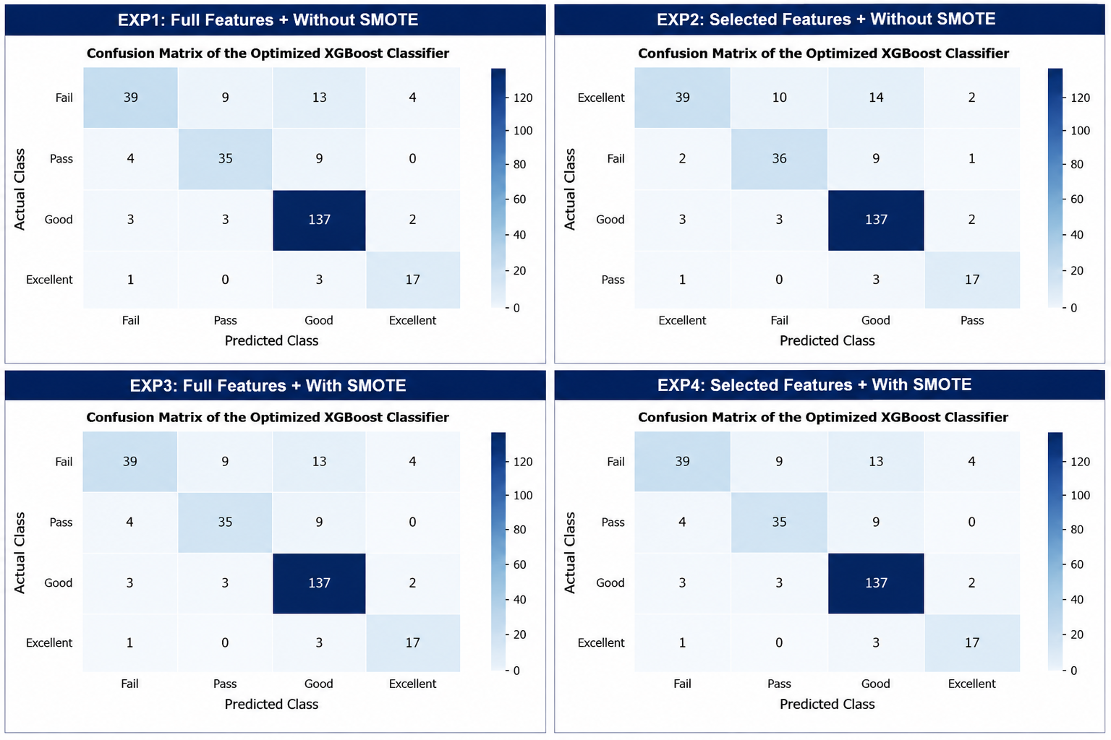
Figure 5. Confusion Matrix of the Final XGB Model.

9. Conclusion.
This study proposed an Artificial Intelligence (AI)-Based Early Warning System for predicting students' academic risk using Learning Management System (LMS) data. The proposed framework integrated data preprocessing, Random Forest-based feature selection, SMOTE, supervised machine learning algorithms, and Grid Search-based hyperparameter optimization.
The experimental results showed that XGBoost achieved the highest predictive performance, obtaining an accuracy of 82.80%, while Random Forest feature selection effectively reduced the number of input features without significantly affecting prediction performance. In addition, SMOTE improved class balance, and Grid Search enhanced the performance of the best-performing models.
These findings are consistent with previous studies, confirming that ensemble learning algorithms provide reliable prediction performance for educational data. The proposed framework can support the early identification of academically at-risk students and assist educational institutions in implementing timely interventions and evidence-based academic decision-making.

References
Akçapınar, G., Altun, A., & Aşkar, P. (2019). Using learning analytics to develop early-warning system for at-risk students. International Journal of Educational Technology in Higher Education, 16(1), 40.
Albreiki, B., Habuza, T., Shuqfa, Z., Serhani, M. A., Zaki, N., & Harous, S. (2021). Customized rule-based model to identify at-risk students and propose rational remedial actions. Big Data and Cognitive Computing, 5(4), 71.
Bagunaid, W., Chilamkurti, N., Shahraki, A. S., & Bamashmos, S. (2024). Visual data and pattern analysis for smart education: a robust DRL-based early warning system for student performance prediction. Future Internet, 16(6), 206.
Bañeres, D., Rodríguez, M. E., Guerrero-Roldán, A. E., & Karadeniz, A. (2020). An early warning system to detect at-risk students in online higher education. Applied Sciences, 10(13), 4427.
Bettahi, A., Harroud, H., & Belouadha, F.-Z. (2025). Early Student Risk Detection Using CR-NODE: A Completion-Focused Temporal Approach with Explainable AI. Algorithms, 18(12), 781.
Christou, V., Tsoulos, I., Loupas, V., Tzallas, A. T., Gogos, C., Karvelis, P. S., Antoniadis, N., Glavas, E., & Giannakeas, N. (2023). Performance and early drop prediction for higher education students using machine learning. Expert Systems with Applications, 225, 120079.
Embarak, O. H., & Hawarna, S. (2024). Automated AI-driven system for early detection of at-risk students. Procedia Computer Science, 231, 151–160.
Hamadneh, N. N., Atawneh, S., Khan, W. A., Almejalli, K. A., & Alhomoud, A. (2022). Using artificial intelligence to predict students’ academic performance in blended learning. Sustainability, 14(18), 11642.
Johora, F. T., Hasan, M. N., Rajbongshi, A., Ashrafuzzaman, M., & Akter, F. (2025). An explainable AI-based approach for predicting undergraduate students academic performance. Array, 26, 100384.
Khan, I., Ahmad, A. R., Jabeur, N., & Mahdi, M. N. (2021). An artificial intelligence approach to monitor student performance and devise preventive measures. Smart Learning Environments, 8(1), 17.
Macfadyen, L. P., & Dawson, S. (2010). Mining LMS data to develop an “early warning system” for educators: A proof of concept. Computers & education, 54(2), 588–599.
Queiroga, E. M., Batista Machado, M. F., Paragarino, V. R., Primo, T. T., & Cechinel, C. (2022). Early prediction of at-risk students in secondary education: A countrywide k-12 learning analytics initiative in uruguay. Information, 13(9), 401.
Realinho, V., Machado, J., Baptista, L., & Martins, M. V. (2022). Predicting student dropout and academic success. Data, 7(11), 146.
Skittou, M., Merrouchi, M., & Gadi, T. (2023). Development of an early warning system to support educational planning process by identifying at-risk students. IEEE access, 12, 2260–2271.
Ujkani, B., Minkovska, D., & Hinov, N. (2024). Course success prediction and early identification of at-risk students using explainable artificial intelligence. Electronics, 13(21), 4157.

