

Early Prediction of Alzheimer’s Disease using Deep Learning and Data Fusion
Prepared By
Name: Ahmed Naji Lutf. ID No.: 253000445
Name: Mohamed Amin Miqdad ID No.: 252001179

Submitted in fulfillment of the requirements for the degree Master of Science in Artificial Intelligence at Collage of Informatics Midocean University, UAE.
At
College of Informatics
Midocean University
UAE
Supervisor Name: Dr. Mohamed Essa
Collage of Informatics, Midocean University, Comoros
Email: 252001179@st.midocean.edu.km / 253000445@st.midocean.edu.km

Acknowledgements
We are truly grateful to our supervisor Dr. Mohamed Essa for his invaluable instructions and support. His insightful feedback helped us a lot to improve ourselves through this research.
We would like to thank the faculty members at the College of Informatics, Midocean University, for providing a consistence guidance and support which helped us.
Our gratitude to the Alzheimer’s Disease Neuroimaging Initiative (ADNI) for providing us with required datasets that helped us with this research.
Finally, we would like to express our appreciation to our families for their patience and support.

Abstract
Detection of Alzheimer’s disease (AD) and it progresses still one of the toughest challenges in medical field. When disease detected early this will often makes a big difference in the treatment plans. The issue is that many current diagnostic models look at the problem from one angle which could lead to wrong conclusion because it relies only to one single source of data, such as brain imaging without look to clinical data or vice versa, Because of this one-sided approach, doctors can miss the detection of early disease symptoms ,especially during the first stages when a person shifts from a normal condition (NC) to mild cognitive impairment (MCI), before it developed to full Alzheimer’s (AD).
To deal with this limitation, this study presents a new approach that combines deep learning with data fusion. The framework is designed to examine 3D MRI scans with clinical of patients from the ADNI dataset. We will build a two-path model for this purpose: one path uses a 3D-ResNet network to automatically pull-out visual features from the images, and the other relies on deep neural networks (DNN) to process the clinical data. This approach will help the model to give a more details and better understand of a patient’s condition.
Keywords: Alzheimer’s Disease, Deep Learning, Data Fusion, CNN, 3D-ResNet, Early Prediction, Medical Imaging, Explainable AI.

Table of Contents
i
Acknowledgements ii
Abstract iii
Table of Contents iv
List of Abbreviations v
List of Figures vi
Chapter 1: Introduction 1
Introduction 1
1.1 Problem Definition 2
1.2 Thesis Objectives 3
1.3 Thesis Contribution 4
1.4 Thesis Organization 4
Chapter 2: Related Work 5
2.1 Introduction 5
2.2: Background 6
2.3 Related Work 10
2.3 Related Work Summary 16
Chapter 3: Proposed Methodology 19
3.1 Introduction 19
3.2 Overall Framework 19
3.3 Dataset Description 20
3.4 Preprocessing 20
3.4.1 Data Preparation 20
3.4.2 Clinical Feature Encoding and Normalization 21
3.4.3 MRI Image Preprocessing 21
3.5 Baseline CNN Architecture 22
3.6 Deep CNN Architecture 23
3.7 Proposed 3D ResNet-18 Model 23
3.8 Multimodal Fusion Framework 24
References 25

List of Abbreviations
- AI: Artificial Intelligence.
- ML: Machine learning
- DL: Deep Learning.
- CNN: Convolutional Neural Network.
- ResNet: Residual Network
- GAN: Generative Adversarial Network.
- XAI: Explainable Artificial Intelligence.
- ViT: Vision Transformer.
- VGG: Visual Geometry Group 19.
- NC: Norma Cognitive
- MIC: Mild Cognitive Impairment
- AD: Alzheimer's Disease
- MRI: Magnetic Resonance Imaging
- ADNI: Alzheimer’s Disease Neuroimaging Initiative

List of Figures
- Figure 1.1: MRI images of Normal Cognitive (Row 1), Mild Cognitive Impairment (row 2) and last is Alzheimer’s Disease
- Figure 2.1: ANN machine learning model to detect brain dementia. Adopted by [14]
- Figure 2.2: CNN model with multiple layers to detect brain dementia.
- Figure 2.3: VGG16 feature extractor dementia detection. Adopted by [17]
- Figure 2.4: Unimodal 3D images into 3D CNN

Chapter 1: Introduction

Introduction
Alzheimer’s disease is one of the most difficult brain conditions. While it is more common in older people, it can affect individuals at different stages of life, including those in their younger years. It slowly destroys memory and thinking skills, and in many cases, it is only discovered after the person shows clear symptoms. However, research has shown that changes in the brain start many years before these symptoms appear. This is why finding the disease early is the main goal of medical research today. For example, [1] showed that we can catch these early signs by identifying brain changes over time.
Within time, AI is getting more and more attention in every field and medical field as well for helping doctors, researchers and patients to give more accurate results about brain scans, especially MRIs, considered very helpful because they give a big and clear picture of the brain. According to that, recent papers by [2] and [3] take advantage of AI progress to scans and to put together some really accurate models to spot the disease. But worth noting that a significant portion of past research has focused on unimodal data, such as analyzing only MRIs. Although it is good to at certain degree, this approach fails to capture the full scope of Alzheimer's evolving condition. Recent research proves that combining different sources such as merging brain scans with a patient’s clinical records and physical symptoms [4] leads to a much more precise and reliable diagnosis.
In this thesis, we propose an AI system for early diagnosis that looks at both brain changes and medical records over time. We use data from the ADNI, which is a famous collection of medical information used by many top researchers, including [5] and [6].
The main goal of this work is to see if combining brain images and clinical memory tests can help us find the disease in earlier stages which aims to give a clear and easy-to-understand tool to help patients as early as possible.

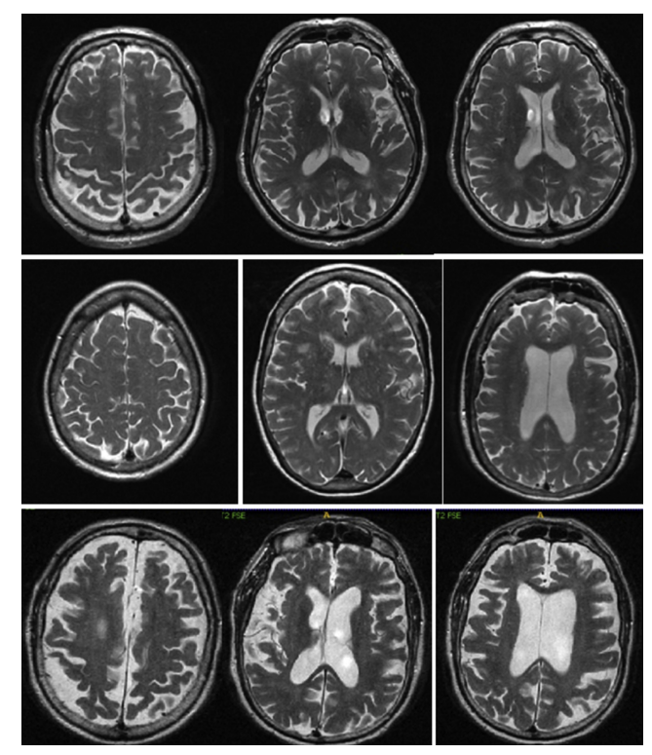
Figure 1.1: MRI images of Normal Cognitive (Row 1), Mild Cognitive Impairment (row 2) and last is Alzheimer’s Disease

1.1 Problem Definition
Despite the large number of studies applying deep learning to Alzheimer’s diagnosis, several important limitations remain.
First, many approaches focus exclusively on imaging data, particularly structural MRI. While MRI can reveal brain atrophy and structural abnormalities, it does not incorporate molecular or genetic information that may indicate susceptibility before structural damage becomes severe.
Second, both neuroimaging and genomic datasets are high-dimensional. Imaging volumes contain millions of voxels, and genomic profiles may include thousands of features. Directly training deep learning models on such data can lead to overfitting if not handled properly. And for that we must have a good method for feature extraction and data size reducing.
The main issue with Alzheimer’s is the changing withing the time, and most models just deal with data as one picture. They ignore the long-term changes of the disease and how it grows over time. Because of that, they will miss some clues that show at the very beginning of disease symptoms.
On top of all that, merging different types of data together which is known as (multimodal fusion) is challenging tasks. And There is no clear approach on how to mix brain scans with genetic data. Which lead us to find a solution for building the network that contain multi data type to do a give an excellent results one tested patients.

1.2 Thesis Objectives
The purpose of this research is to build and test an AI system that can read different data types to catch Alzheimer's in early stages. To do that we will apply the following steps:
- To create a deep learning model to import and MRI scans and extract important details.
- To develop multimodal fusion to mix the genetic data with brain pictures.
- To test and track the changes over time
- To check if our proposed framework give a better result by make a comparison with others that look only at one kind of data.

1.3 Thesis Contribution
The aim of this thesis is to contribute to the field of Alzheimer’s disease by improving the early detection by implementing the following techniques:
- Deep learning model that handles different data type such as MRI images and clinical data for better diagnostic decisions
- A multi computer vision algorithms including baseline CNN and 3D ResNet-18 model for better comparing and classification.
- A framework to achieve better computing power performance with large scale of data sets.
- Using of Explainable AI (XAI) techniques to help to define and explain the exact brain areas as the computer do in order to increase the transpierce for doctors and their patients

1.4 Thesis Organization
The remainder of thesis organized as follows
Chapter 2: a discussion about history of Alzheimer's diagnosis over years
Chapter 3: present the proposed framework and its workflow
Chapter 4: analyze and cover testing phase and results.
Chapter 5: summarizes the study and the future direction of work.

Chapter 2: Related Work

2.1 Introduction
With artificial intelligence (AI) things has changed in general not to mention the methods around how we diagnose brain diseases. In this chapter we will reviews past studies on detecting Alzheimer’s Disease (AD). We will see how things shifted from simple practices to modern deep learning [6,7]. The goal here is to take a look and find out the problems in past researches with knowing why and try overcome with better ways, generally the major studies use only one type of data at a time which is not enough when you dealing with a human brain and with taking this into consideration a need of different data types (data fusion) is a real medical need, not just an extra . study [8] show that mixing 3D MRI scans with basic clinical records gave much better and increase the accuracy result. Combining this will lead to better tracking for a patient as they go from a healthy state (Normal Control, NC) to Mild Cognitive Impairment (MCI), and finally to AD.
Diagnosing AD relied a lot on manual checks and the doctor's personal opinion this was situation before using the computers. Doctors usually checked memory loss using simple tests like the Mini-Mental State Examination (MMSE). Even after using MRI scans, doctors had to look at many 2D image slices by eye to find changes one the brains, like brain shrinking [9,10]. Doing this manually cost a lot of time and resources, not only that but doctors can have a different opinion for same things they have looked for. And, as human cannot see the tiny brain changes with just our own eyes due to our limitations and for sure cannot see the tiny brain changes that happen in the very early stages of the disease. And the damage was already done withing the time and wrong diagnoses. Because of this delay it became more and more important to look for better and automated tools for medical field.
In order to understand what we mean to these tools, we need to look back at traditional Machine Learning (ML) and shifting to Deep Learning (DL). Traditional ML is good in some case like basic clinical data. But it is not good when come to deal with medical images because it required humans interactions to pick the important features first [11]. To overcome with this limitations deep learning fixes this by automatically fetch an important details from the raw 3D data. And can deal with simple shapes and move to large scale complex disease patterns. This automation means no humans interaction required to do the manual work, making DL a best choice for modern MRI scans [12].

2.2: Background
In the last two decades, the diagnosing for Alzheimer’s disease changed a lot. At the beginning finding the small, early signs of the disease is still was a hard task for computers, but things getting easier withing time for doctors, researchers and patients due to evolving of tools that used machine learning and deep learning to help analyze patient data.
Firstly, machine learning methods required many manual work steps. Including collecting and data cleansing of raw data such as MRIs or genomic data after that researchers have to split the data. Then, with help human experts they need pick out important features, like tissue texture, brightness, or brain shape. Once these features extracted, they used standard models like Support Vector Machines or Decision Trees for learning and recognize the patterns.
These approaches have been used in the diagnosis of brain disorders, including Alzheimer’s disease, where performance is often influenced by the quality of the extracted features [13,16].
Study [13] explored the use of machine learning to predict whether patients with mild cognitive impairment (MCI) may progress to Alzheimer’s disease (AD). It employed XGBoost as a classification model and incorporated the Shapley value (SHAP) method to provide insights into feature contributions, including MRI and genetic data.
Studies [14–16] investigated different machine learning pipelines for Alzheimer’s disease classification and prediction. Study [14] followed a supervised learning approach in which multiple classifiers, including Support Vector Machine, Random Forest, and Artificial Neural Network, were trained and compared using structured feature sets derived from non-medical and behavioral data. In the case of the Artificial Neural Network, the input layer received a fixed-length feature vector representing the selected variables, which were then processed through hidden layers to model non-linear relationships before producing the final output. The techniques used pre-processing, feature selection, and model evaluation. Study [15] improve this by using multimodal data and explainable AI to be able to know how the model makes its decisions. While study [16] focused on feature extraction from images. They selected some details from brain scans and used them as inputs for models classification.
generally, these studies follow the same basic steps: pre-processing the data, extracting features, training the model, and checking the results. But things changed when researchers pay attention to mixing different data types (multimodal integration) to ensure that we can have better understand of how model thinking (interpretability).

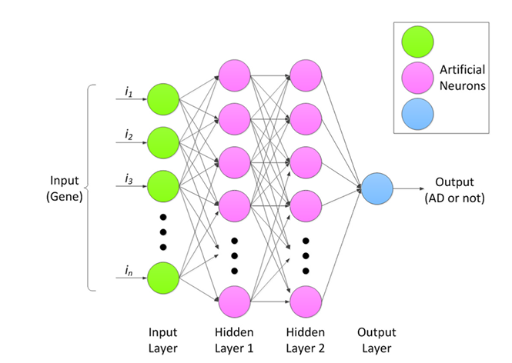
Figure 2.1: ANN machine learning model. Adopted by [14]
Although machine learning provided a big leap in detecting Alzheimer's, working directly with raw 3D brain scans has a limitation problem. Extracting good features required a lot human interactions to deal with brain areas not only this but flatten a complex 3D brain into a simple data table caused an important spatial detail to be lost.
To solve these extraction issues, the researchers used a deep learning computer vison, especially Convolutional Neural Networks (CNNs). Without relying on human input features, CNNs find a way to visualize patterns directly from the MRI data. By passing the adjusted scans through convolutional and pooling layers, these networks handle everything from basic lines to complex brain damage.
And for getting better accuracy research seeks to using deeper networks for better result, like AlexNet which changed how we classify medical images. They proved that having deeper layer such as ReLU activations and dropout makes it much easier for the model to recognize important features.

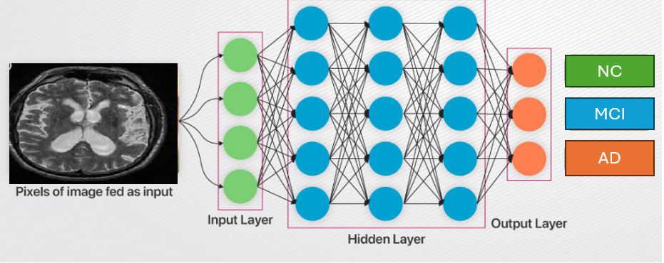
Figure 2.2: CNN model extracting data from MRI scan

Following these early models, VGG-16 became a very popular network due to its effective algorithms. It uses small filters to pull a complex visual detail. It can learn features step by step by moving from simple to complex brain tissues. In Alzheimer's research, VGG-16 is often used with a technique called transfer learning. Researchers take models that are already trained on huge datasets like ImageNet and fine-tune them to help for MRI scans.
Nowadays, VGG-16 is mainly used as a simple feature extractor. It finds a features and passed it to fully connected layers then to classifiers to group patients into different stages. Recent studies show that using this network with data augmentation and normalization will greatly improves the model's accuracy with better data handling [17].

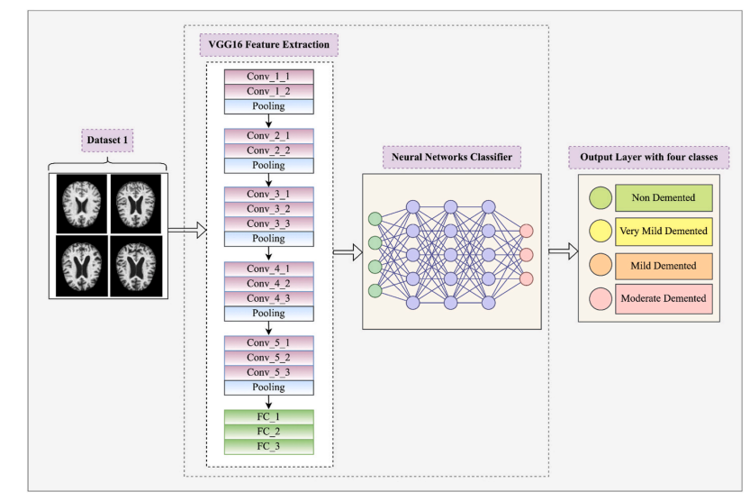
Figure 2.3: VGG16 feature extractor and classifier to help for brain diagnoses. Adopted by [17]
While 2D CNNs was helpful but using them for 3D MRI scans lead use to real challenges. In order to make these models work, the 3D brain scan has to be cut into flat 2D slices. But slicing images will breaks the natural connections between different brain regions. As a result, the model loses a lot of important spatial information, which at the end lead to make it difficult to understand the brain full structure.
To solve this, researchers moved toward 3D-CNNs. Instead of using flat pixels, these networks used and process voxels (3D pixels). This allows the model to take in the entire MRI scan at once, preserving the actual shape and structural details of the brain [18].
However, even with these improved 3D models, a major clinical issue sill exist. Almost all of these systems were unimodal, meaning they only looked at one type of information. For example, a deep learning model might be perfect at analyzing an MRI, but it completely ignores the patient's clinical history or the model might predict the disease using clinical history but never actually look at the physical brain. This is not how doctors work in real life , they did not diagnose a patient based on just one test. Instead, they look at the brain scan alongside the patient's age, education level, and cognitive tests like the MMSE [19,21].

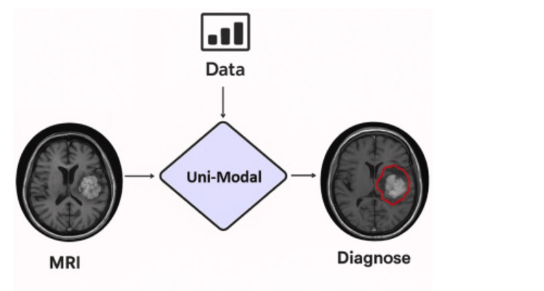
Figure 2.4: Unimodal 3D images into 3D CNN
Put all this history together the hard manual work of early machine learning, the challenges of cutting 3D images into 2D, and how 3D models can only use one type of data , we will clearly see a big missing part in the current studies. There is a need for an AI system that actually supposed to work like doctors in clinics. We want a model that take a look at full 3D brain scans properly, and at the very same time, read the patient's medical records over time. Combining these different kinds of information together into one single system is simply the best way to make early diagnosis much better.

2.3 Related Work
Muksimova et al (2025) proposed a multi-modal deep learning framework called FusionNet for the early detection and classification of Alzheimer’s disease. The model integrates deep learning techniques: a 3D CNN with an LSTM network to track brain changes over time. Using the ADNI dataset, the study combined MRI, PET, and CT scans to train the system effectively. The proposed framework achieved a high diagnostic accuracy of 94%. However, its main limitations are the high computational power required for processing 3D multi-modal scans, and the practical difficulty and high cost of obtaining all three types of brain scans for a single patient in standard clinical settings.
Li et al (2025). presented a multi-modal deep learning framework to improve the early detection of Alzheimer’s disease. The researchers focus on integration on two main deep learning techniques: a Convolutional Neural Network (CNN) to analyze brain images, and a Transformer model to process genetic data, combined via a cross-transformer fusion. The study used the ADNI dataset, including MRI scans and genetic records from 1,541 patients across different stages: healthy (NC), stable memory loss (sMCI), progressive memory loss (pMCI), and Alzheimer’s disease (AD). This system achieved a high accuracy of 93.04%. However, its main limitations are the use of a basic CNN model that restricts performance and the difficulty of mixing different genetic records.
Bricaud and Masala (2026) presented a comprehensive framework to evaluate various deep learning models for detecting early Alzheimer's disease. Instead of relying on a single network, the researchers compared several different methods, including traditional CNNs and modern Vision Transformers. They used the ADNI data set for MRI scans and grouping the patients into normal and Alzheimer’s disease they used individual 2D slices and entire 3D, this hybrid model (ConvNeXtV2-L) achieved 91.07% as accuracy, however the main limitation with the study the is relies fully on MRI images without using of patient’s clinical records.
Bekhet et al. (2026) introduced a deep learning framework named (DeepALZNET) for the early prediction and detection of Alzheimer’s disease. The researchers mainly used two independent techniques: the first one is 1D Convolutional Neural Network (CNN) and the second one is a Random Forest model, they used both models to analyze patient clinical records, and to detect changes in brain MRI scans by using VGG19 network. The study used large public datasets, specifically ADNI and OASIS to categorize the patients into three stages: normal cognitive (NC), mild cognitive impairment (MCI), and Alzheimer's disease (AD). The framework achieved over 90% as accuracy. However, its main limitations are the combine images and clinical data to unified decision, and it relies on 2D images which might miss some 3D details of the brain.
Zhang et al. (2023) Proposed a framework to improve the early detection of Alzheimer’s disease by Neural Network (GNN) as multi model. Instead of analyzing flat images, they used an advanced GNN deep learning techniques to understand the network connections and relationships between different brain regions. The study used the ADNI dataset and combine brain scans (MRI and PET) for a more advanced analysis. Patients categorized into four main developmental stages: healthy (NC), early memory loss (EMCI), late memory loss (LMCI), and Alzheimer's disease (AD). The proposed framework achieved a 92% accuracy in detecting the disease. Nevertheless, the study main limitations related to high clinical cost for patients to go both for MRI and PET scans and the heavy computational power needed for each individual patient.
Helaly et al. (2021) used a deep learning framework called (E2AD2C) to detect and classify of Alzheimer’s disease in early stages. The methods used in the study focused mainly on using simple computer networks (CNN) and a more advanced, pre-trained system called VGG19. The study used ADNI dataset to brain scan images, covering four different stages: healthy (NC), early memory loss (EMCI), late memory loss (LMCI), and Alzheimer’s disease (AD). And for accuracy the study reached to 95.17% for using the simple computer, and accuracy of 97%. for advanced VGG19 model. Yet the study drawbacks are the high computer power needed for the 3D brain scans without considering to use other patient data like memory tests or age.
Warren and Moustafa (2026) in their study they used a multimodal scan system that combines functional brain imaging (fMRI) with clinical tests to identify Alzheimer’s disease. The proposed method uses a 3D Convolutional Neural Network (3D CNN) that analyzes a brain region that could be affected early in the disease. To make the model more trustworthy, the researchers enhanced the fMRI scans with five clinical memory tests to prevent any data errors. A key part of their method is the use of "explainable AI" (XAI) through a technique called perturbation ranking, which helps in the examination. The study selected a small group of 52 participants from the ADNI database. The accuracy was 90%, which is much better than the 58% accuracy reached when using brain scans, even so mixing the brain data with clinical tests give a better accuracy but research dealt with very small sample size and need to be tested on large patients’ data set.
Wang et al. (2024) In this paper, the authors developed a deep learning model to catch Alzheimer's early by mixing data from different data sources. For brain changes, they used a ResNet to pull features from specific brain areas, and with help of an attention convolution module they have a close look to a sick spot. For achieving this the ADNI data set has been using to mix MRI brain scans with genetic data to create special 3D images. The patients have been split into three groups: NC, MCI, and AD. By using this approach, they reached to 93.44% accuracy. Still the main issues are building 3D image fusions required a lot of computing power with noting the difficulty of getting the clinic data and ask every single patient to do both an advanced MRI and a full genetic test.

Alsubaie et al. (2026) built a new deep learning model called BiFPN3DViT to find Alzheimer's using brain pictures. The framework basically mixed a 3D CNN to grab the basic brain shapes, a Bi-directional Feature Pyramid Network (BiFPN) network to link details of different sizes, and Vision Transformers to get the whole brain picture. They tested on large scale of data set from ADNI, nearly 4,706 MRI scans, which grouped by healthy people, patients with mild memory loss, and Alzheimer's cases. By putting these together, their model hit a 92.1% accuracy in sorting the three disease stages. But the main downside of this model is that depend only on MRI scans without taking into consideration the patient's medical files.

Ahmed et al (2023) tried to spot Alzheimer's by looking at brain pictures. They built a Deep CNN model to put people into three groups, completely healthy, having mild memory problems, and actual Alzheimer's patients. They used a regular MRI scan from ADNI data set to train their network. The model worked very well and getting a 93.86% accuracy but it has a limitation because it only takes a look to brain scans and ignores the patient's medical files and without Explainable AI, doctors facing a challenge of figuring out why the computer made its choice.

Lu et al. (2022) used a deep learning system to check for Alzheimer's by depend only on brain pictures. The system collected a huge number of MRI scan, approximately over 85,000 from a lot of different hospitals, including the ADNI dataset. They used a transfer learning, which means they took an Inception-ResNet-V2 network that was already trained on simple stuff, and just did a little modification on it to find Alzheimer's. Because they trained it on so many images, the model got an accuracy between 90.9% and 94.5% across different test groups. Nonetheless the big downsides related to the dependency of scans without looking to the patients' medical files.

Khalid et al (2026) found out that depending on MRI only is not enough to detect Alzheimer’s , so they came up with dual-modal approach. With using data set pulled from OASIS-3. And then using a CNN to work with MRI images and for clinical data they decided to go with Random Forest model. This helped them to combine brain scans with clinical symptoms to give a full profile insight. Because of dual-model approach they achieved 94%. Above all of that they used also Explainable AI to map out the exact damaged areas, like the hippocampus. Yet the study downside is not using a single unified model with fused clinical and MRI data instead they rely totally on two separate models for processing the MRI scan and clinical data.

Sheikh et al. (2025) focused on detecting early Alzheimer's in fast and low-cost using brain pictures. While many deep learning models are heavy and require a lot of computing powers, the researchers decided to focus on lightweight networks, specifically EfficientNetV2B0 and MobileNetV2 which allow clinic data to be processed efficiently. They took flat 2D slices from ADNI MRI scans to sort patients into three stages: totally normal, early mild memory loss, and late mild memory loss. The best their model get is 88.0% accuracy. They also added Explainable AI to highlight the same brain areas the computer was looking at and to increase the result trust for doctors. Although the study shows that small models can be useful but the main issues here are that they only used flat 2D slices instead of the whole 3D brain shape with ignoring of the patients' clinical history.

Ghosh et al. (2023) came up with a safe way for hospitals to work together to find Alzheimer's using brain scans. To overcome the issue of patient’s data distributed in different places and the privacy concerns, they used something called Federated Learning. Using this they allow multiple clinics to train a small network like MobileNet together without sharing any private pictures. They used flat 2D MRI scans from ADNI and OASIS data sets. This helped them reach 95.24% accuracy on the OASIS data, and 84% accuracy when mixed both datasets. Although the approach gives a good accuracy, the main drawback is that study using only flat 2D slices instead of the whole 3D brain and ignored the patients' medical files totally in the study.

Abbasian and Hammond (2024) presented a 3D deep learning model to detect Alzheimer's in early stages. By using brain pictures, they categories patients’ brains between healthy or early mild cognitive impairment (EMCI) only. And with help of 3D-CNN they look at the whole 3D brain all at once instead of slicing it into flat 2D slices. They used ADNI dataset for 3D MRI scans. The research succeeds in reaching 81.80% accuracy in separating the early-stage patients from the healthy ones. This gives an indication that using a full 3D brain gives more details than 2D methods. However the study main limitations are, it only looks at two groups (early sick versus normal) and it only uses MRI scans while ignoring the other clinical data.

2.3 Related Work Summary
Table 2.3: Summary and Comparison of Related Studies on Alzheimer’s Disease

Study (Year) | Proposed Method | Key Accuracy | Main Limitations
Muksimova et al. (2025) | CNN + LTMS | 94.00% | Fuses images only; completely lacks integration of clinical medical records.
Li et al. (2025) | CNN + Transformer | 93.04% | Struggles with MCI-to-AD prediction.
Bricaud & Masala (2026) | Hybrid CNN (ConvNeXtV2-L) | 91.07% | MRI-only; lacks integration of clinical medical records.
Bekhet et al. (2025) | 1D CNN + Random Forest | > 90.0% | No simultaneous fusion; relies on 2D images.
Zhang, Y., et al. (2023) | GNN framework | 92% | Highly computational cost with required of both MRI + PET scans
Helaly et al. (2021) | E2AD2C (CNN & VGG19) | 97.0% | High power for 3D scans; images-only.
Warren & Moustafa (2026) | 3D CNN with XAI | 90.0% | Very small sample size; lacks validation.
Wang, J., et al. (2024) | ResNet + Attentation convolution | 93.44% | Highly computational cost with required of both MRI + PET scans
Alsubaie et al. (2026) | BiFPN3DViT (3D CNN + BiFPN + ViT) | 92.10% | MRI-only; lacks integration of clinical medical records.
Ahmed et al. (2023) | Deep CNN | 93.86% | MRI-only; lacks Explainable AI tools.
Lu et al. (2022) | Transfer Learning (Inception-ResNet-V2) | 94.50% | MRI-only; data mostly from Western populations.
Khalid et al. (2026) | CNN & Random Forest | 94.00% | Processes images and clinical data separately; lacks a fully unified fusion network.
Sheikh et al. (2025) | Lightweight CNN (EfficientNetV2B0) & Explainable AI | 88.00% | 2D images only; lacks integration of clinical medical records.
Ghosh et al. (2023) | Federated Learning & MobileNet | 95.24% | 2D images only; lacks integration of clinical medical records.
Abbasian & Hammond (2024) | 3D CNN | 81.80% | MRI-only; lacks clinical data integration.

Chapter 3: Proposed Methodology

3.1 Introduction
In this chapter, we present the proposed framework used for the early prediction of Alzheimer’s disease. The main objective of the proposed system is to combine information obtained from brain MRI scans with clinical patient records to improve diagnostic accuracy. Unlike traditional approaches that rely on a single data source, the proposed framework follows a multimodal learning strategy where image data and clinical information are processed independently before being combined into a unified decision-making system.
The framework consists of four main stages: data preparation, data preprocessing, feature extraction, and multimodal fusion. MRI scans are analyzed using 3D ResNet-18 architecture, while clinical records preprocessing was performed to improve data quality, ensure consistency, address missing values, and prepare the dataset for efficient and reliable model training. The extracted features are then fused together and passed to the final classification stage for disease prediction.

3.2 Overall Framework
The proposed framework is designed to simulate the clinical decision-making process followed by physicians. Instead of relying on MRI scans alone, the system combines both imaging and clinical information.
The complete workflow consists of the following steps:
- Collect MRI scans and clinical records from the ADNI dataset.
- Preprocess MRI images and clinical variables.
- Extract image features using a 3D ResNet-18 model.
- Extract clinical features.
- Combine both feature sets using feature fusion.
- Perform final classification into Normal Control (NC), Mild Cognitive Impairment (MCI), or Alzheimer’s Disease (AD).

3.3 Dataset Description
This research uses data obtained from the Alzheimer’s Disease Neuroimaging Initiative (ADNI) database. The dataset contains structural MRI scans together with clinical and demographic information collected from patients at different stages of Alzheimer’s disease progression.
The patients are categorized into three classes:
- Normal Control (NC)
- Mild Cognitive Impairment (MCI)
- Alzheimer’s Disease (AD)

3.4 Preprocessing

3.4.1 Data Preparation
To build our final dataset, we combined clinical and demographic data from separate files and then we extracted key patient features, including gender, education level, Mini-Mental State Examination (MMSE) scores, and final diagnoses. Since many patients had multiple follow-up visits over time, we sorted the records chronologically by examination date (EXAMDATE) and kept only the most recent visit for each subject. Finally, we merged these tables using an inner join based on the unique patient ID (PTID), creating a single, comprehensive master clinical file. Next, we matched this master clinical dataset with the structural MRI by extracting the PTID directly from the image filenames using string splitting. A final inner join was performed to combine both modalities; any patient lacking either a valid MRI scan or a complete clinical profile was excluded. This process resulted in a fully synchronized multimodal dataset ensuring that every sample used in subsequent modeling contains paired imaging and phenotypic data.

3.4.2 Clinical Feature Encoding and Normalization
To prepare the synchronized clinical features for deep learning initialization, we applied a standardized preprocessing pipeline involving categorical encoding, missing value imputation, and feature scaling. First, the categorical attribute for gender (PTGENDER) was converted into a binary format (0, 1) using label encoding. Similarly, the diagnostic target labels (DIAGNOSIS), originally indexed from 1 to 3 in the ADNI cohort (representing Cognitively Normal [CN], Mild Cognitive Impairment [MCI], and Alzheimer's Disease [AD]), were re-mapped to a zero-indexed vector (0, 1, 2) to match standard cross-entropy loss requirements:
$$y_{new} = y_{old} - 1$$

To handle potential missingness in cognitive scores without reducing our sample size, missing entries in the Mini-Mental State Examination (MMSCORE) were imputed using the feature's median value. Finally, to eliminate scale disparities and accelerate gradient descent convergence, continuous features specifically education level (PTEDUCAT) and MMSE scores were normalized to a constrained range of [0, 1] via Min-Max scaling. For each continuous feature $x$, the transformation was computed as follows:
$$x_{scaled}=\frac{x-x_{min}}{x_{max}-x_{min}}$$
where $x_{min}$ and $x_{max}$ represent the minimum and maximum values of the respective feature across the cohort. The fully preprocessed dataset was then exported as readymade and processed dataset

3.4.3 MRI Image Preprocessing
To feed the structural neuroimaging data into our deep learning architecture, we constructed a custom data pipeline (AlzheimerMRIDataset). For each subject, the corresponding 3D MRI volume was dynamically loaded and decoded into a numerical array. Given the spatial resolution variations across clinical scans, we applied lower-order spline interpolation via geometric zooming to reduce and standardize each 3D volume into a uniform target isotropic spatial grid of $64 ×64 ×64$ voxels. To calculate the scaling transformation for each dimension$d ∈\{x, y, z\}$, the scale factors $s_{d}$ were defined by:
$$s_{d}=\frac{T_{d}}{C_{d}}$$
where $T_{d}$ represents the target dimension size and $C_{d}$ represents the current raw dimension size. Following grid alignment, voxel intensity normalization was performed using min-max scaling to bound the signal amplitude within $\left[0,1\right]$ across all subjects, compensating for varying scanner signal contrasts. The normalization function for each voxel $v$ is given by:
$$v_{norm}=\frac{v-v_{min}}{v_{max}-v_{min}}$$
where $v_{min}$ and $v_{max}$ represent the minimum and maximum global intensities within that individual 3D scan. The normalized array was subsequently converted into a single-channel PyTorch tensor with an added channel dimension:
$$\text{Shape: }\left[1,64,64,64\right]$$
To ensure a rigorous and unbiased evaluation of the predictive models, the cohort was partitioned using a standardized three-way stratified split: $70\%$ for training, $15\%$ for validation, and $15\%$ for independent testing. Stratification was strictly enforced across the diagnostic labels (DIAGNOSIS) during both splitting phases to preserve the baseline class proportions. Finally, these partitions were encapsulated into PyTorch DataLoaders with a batch size of 4, where shuffling was enabled exclusively for the training set to preserve generalization integrity

3.5 Baseline CNN Architecture
A simple 3D Convolutional Neural Network (CNN) was initially developed to establish a baseline performance level.
The model contains basic convolutional layers followed by pooling operations and fully connected layers. Although the model was capable of learning simple image patterns, its performance remained limited due to the complexity of Alzheimer’s disease and the high dimensionality of MRI data.
The baseline experiment provides a reference point for evaluating more advanced architectures.

3.6 Deep CNN Architecture
To improve feature extraction capability, a deeper CNN architecture was developed.
Additional convolutional layers and filters were introduced to increase model capacity and capture more detailed structural information from MRI scans. Despite achieving better performance than the baseline model, training became more challenging due to gradient degradation in deeper networks. These limitations motivated the use of residual learning architectures.

3.7 Proposed 3D ResNet-18 Model
The primary image analysis component of the proposed framework is based on the 3D ResNet-18 architecture.
The original ResNet model was modified to support MRI scans. Since MRI images are grayscale volumes, the first convolutional layer was adjusted to accept a single input channel instead of the standard three-channel RGB input.
Furthermore, the final fully connected classification layer was modified to produce three output classes corresponding to:
- NC
- MCI
- AD
The model was trained using the Adam optimizer with a learning rate of 0.0005 and Cross-Entropy Loss as the optimization objective.
The use of residual connections allows information to flow directly across layers and helps overcome the vanishing gradient problem commonly observed in deep neural networks.

3.8 Multimodal Fusion Framework
The final stage of the proposed system combines information extracted from both MRI scans and clinical records.
Feature vectors generated by the 3D ResNet-18 model and clinical data are concatenated into a unified feature representation. The resulting fusion vector contains a total of 515 features representing both structural brain information and clinical patient characteristics.
The fused representation is then passed to the final classification network, which predicts the patient category as NC, MCI, or AD.
By integrating complementary information from both modalities, the proposed framework aims to improve diagnostic reliability and support earlier disease detection.

References
[1] Muksimova, S., Umirzakova, S., Baltayev, J., & Cho, Y. I. (2025). Multi-modal fusion and longitudinal analysis for Alzheimer's disease classification using deep learning. Diagnostics, 15(6), 717
[2] Li, Y., et al. (2025). An imaging and genetic-based deep learning network for Alzheimer's disease diagnosis. Frontiers in Aging Neuroscience, 17, 1532470.
[3] Bricaud, I., & Masala, G. L. (2026). Multi-architecture deep learning for early Alzheimer's detection in MRI: Slice- and scan-level analysis. International Journal of Environmental Research and Public Health, 23(3), 322.
[4] Bekhet, S., et al. (2025). Alzheimer disease predicting from clinical and MRI data using DeepALZNET dual pathway framework. Scientific Reports, 15, 43250
[5] Zhang, Y., He, X., Chan, Y. H., Teng, Q., & Rajapakse, J. C. (2023). Multi-modal graph neural network for early diagnosis of Alzheimer’s disease from sMRI and PET scans. Computers in Biology and Medicine, 164, 107328.
[6] Helaly, H. A., et al. (2022). Deep learning approach for early detection of Alzheimer’s disease. Cognitive Computation, 14(5), 1711–1727.
[7] Shen, D. et al., "Deep learning in medical image analysis," Annual Review of Biomedical Engineering, 2017.
[8] Shojaei, S., Abadeh, M. S., & Momeni, Z. (2023). An evolutionary explainable deep learning approach for Alzheimer’s MRI classification. Expert Systems with Applications, 220, 119709.
[9] Alsubaie, A., Alqarni, M., Alshamrani, S., & Alruwaili, M. (2026). A novel Alzheimer’s disease classification framework integrating 3D CNN with bidirectional feature pyramid network and vision transformers. IEEE Access, 11, 11364136.
[10] Ahmed, H. M., Elsharkawy, Z. F., & Elkorany, A. S. (2023). Alzheimer disease diagnosis for magnetic resonance brain images using deep learning neural networks. Multimedia Tools and Applications, 82(12), 17963–17977.
[11] Lu, B., Li, H. X., Chang, Z. K., Li, L., Chen, N. X., Zhu, Z. C., ... & Yan, C. G. (2022). A practical Alzheimer's disease classifier via brain imaging-based deep learning on 85,721 samples. Journal of Big Data, 9(1), 101.
[12] Khalid, M. Z., et al. (2026). Detection and classification of Alzheimer's disease using deep and machine learning. Tomography, 12(1), 4.
[13] Gelir, F., Akan, T., Alp, S., et al. (2024). Machine Learning Approaches for Predicting Progression to Alzheimer's Disease in Patients with Mild Cognitive Impairment. Biomedical Signal Processing and Control.
[14] Hsiao, C. C., et al. (2023). Classifying Alzheimer's disease and normal subjects using machine learning techniques and genetic-environmental features. Journal of the Formosan Medical Association, 123(5), 600-608.
[15] Jahan, S., et al. (2023). Explainable AI-based Alzheimer's prediction and management using multimodal data. PLoS One, 18(11), e0294253.
[16] Jiang, S. F., et al. (2024). Machine learning models for diagnosing Alzheimer's disease using brain cortical complexity. Frontiers in Aging Neuroscience, 16, 1434589.
[17] Sharma, S., Kumar, R., & Singh, M. (2022). A deep learning-based CNN model with VGG16 feature extractor for the detection of Alzheimer’s disease using MRI scans. Materials Today: Proceedings.
[18] Ghosh et al. (2023). A robust distributed deep learning approach to detect Alzheimer's disease from MRI images. Mathematics, 11(12), 2633.
[19] Abbasian, P., & Hammond, T. A. (2024). A comprehensive analysis of early Alzheimer disease detection from 3D sMRI images using deep learning frameworks. Information, 15(12), 746.
[20] Warren and Moustafa. (2026). Functional and clinical: An explainable deep learning model for multimodal Alzheimer’s disease classification. Brain and Behavior, 16, e71240.
[21] Payan, A., Montana, G., "Predicting Alzheimer’s disease using 3D CNN," NeuroImage, 2015.

