جامعة ميدأوشن

كلية الإدارة
إدارة المشاريع ماجستير

عنوان البحث

أثر تطبيق ضبط الرواسب على أداء مشاريع الإنشاء في ولاية كوينزلاند

إعداد الطالب / هزار نبيل خلوف
251001995

إشراف/
د.الفيصل عبد الحميد
د.فايز جراد

العام الدراسي:
2025

Midocean University
Faculty of Management
Master of Project Management

Research Title

The impact of Sediment Control implementation on construction project performance in Queensland

Prepared by:
Hazar Nabeel Khallouf
251001995

Supervised by:
Dr. Alfaisal Abdelhameed Mohamed
Dr. Fayez Ali Jrad

Year:
2025

Introduction:
Construction projects and infrastructure development represent a significant sector in the state of Queensland, Australia, and there are continuous future plans and ongoing expansion in this field. According to the Australian Infrastructure Budget Monitor 2024-25, Queensland ranked fifth among Australian states and territories for its proportion of government spending on infrastructure, with 14.6% of its budget allocated for 2024-25. However, Queensland is known for its tropical climate and experiences a wet season with heavy rainfall through out the year. This can result in water pollution, as the uncontrolled movement of sediments can run off into rivers, waterways, creeks, and drainage systems, causing contamination, harming aquatic life, and generating considerable economic costs.
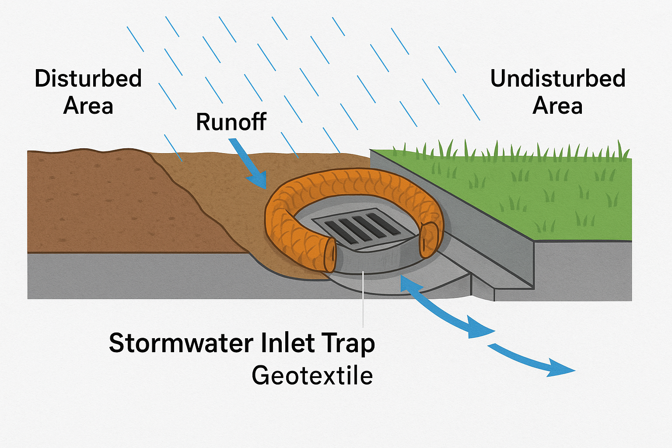
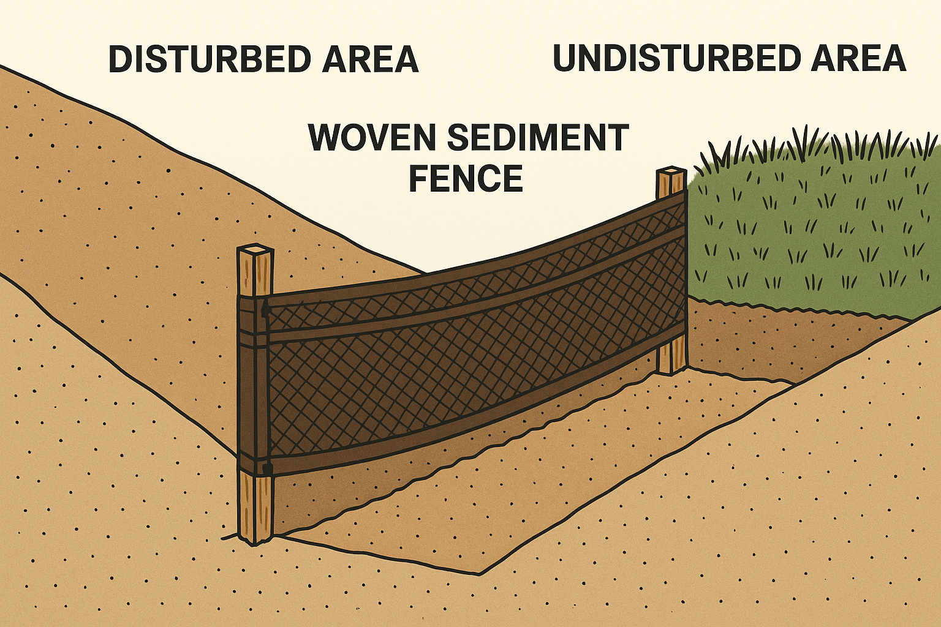
The Queensland Government has adopted a strict regulatory approach to addressing this issue and has enforced specific requirements on construction projects. The IECA Best Practice Erosion and Sediment Control Guidelines (2008) serve as the primary reference for all regulations related to sediment control on construction sites. Sediment control focus on minimizing the entrance of polluted material to the water ways to protect the environment from any possible damage that could happen due to construction activities. This shall be under the Queensland sediment control guidelines and regulations. For example, to do that, it is common in Queensland to use the Woven sediment fence in buildings construction sites to trap the sediment and allow water through, or the stormwater inlet traps which used in large duty and infrastruction construction sites.

Furthermore, construction project performance is often challenged when complying with sediment control plans and Queensland regulations. Cost is one of the most critical concerns for clients, stakeholders, engineers, and contractors, and adherence to the state’s regulations for sediment control can significantly increase the cost of projects. Moreover, potential and unexpected delays may occur throughout the project timeline while attempting to implement and maintain the sediment control plan.
There is no doubt that such environmental control practices aim to promote a more sustainable future and improve environmental outcomes, not only but also, contibutes in long-term durability of infrastructure development. However, in the construction field, these practices may also negatively influence the delivery quality of projects, as some environmental requirements can lead to rushed rework or delays in certain structural activities to comply with environmental regulations.
The management plan of any construction project is crucial and may be considered the most important foundation before commencing work. However, construction activities cannot begin before obtaining an approved sediment control plan from the authorities. Additionally, site opening or project commencement can be paused or require modifications. Typically, pre-rain and post-rain inspections are carried out by the Department of Environment, Tourism, Science and Innovation, and missing such inspections for any reason can create disruptions in the project’s management plan.
This research aims to examine the potential challenges that may arise during construction projects as a result of complying with the state of Queensland’s sediment control regulations, and to highlight the issues associated with their implementation.

Problem Statement:
Construction projects play a major role in the economic growth of Queensland, but they can also cause harm and damage to topsoil and natural vegetation areas, especially during the wet season. The uncontrolled movement of sediments, silt, cement, mud, or other pollutants may be washed away from construction sites and carried through external and stormwater drainage systems, causing pollution to rivers, creeks, wetlands, and waterways. Therefore, the Queensland Government and local councils have implemented strict regulations to control such substances and minimize the risk of environmental pollution, based on the IECA Best Practice Erosion and Sediment Control Guidelines (2008).
While these regulations are essential to ensure a sustainable working environment, they have created significant challenges for the engineering community by impacting the performance factors of construction project delivery. Upholding the standards of sediment control may increase project costs, cause unexpected delays, and affect the quality and sequencing of work. The management and planning of construction projects may become more complex due to the need to coordinate approvals, inspections, and sediment control activities alongside other environmental requirements.
This research seeks to address the lack of understanding of how sediment control regulations affect the performance factors of construction projects, namely cost, time, quality and long-term benefits, and project planning and management. Despite the importance of sediment control in the construction field, there is limited academic research exploring these impacts, and this study aims to highlight and address that gap.

Significance of the research:
This research is important because it bridges a critical gap in both the academic and practical understanding of how applying sediment control plans and regulations affects the performance factors of construction projects in Queensland, Australia. Despite the importance of sediment control in achieving sustainable outcomes and protecting both the environment and structural elements in the long term, there are limited studies addressing its effect on performance factors such as cost, time, quality, long-term benefits, and project planning and management.
By presenting this research, valuable and relevant concepts will be explored. Understanding how sediment control measures influence project performance will enable engineers and stakeholders to improve project planning, enhance quality, produce more accurate cost and time estimations, and strengthen overall project management. Furthermore, this research will support local authorities and councils in reviewing their environmental regulations and guidelines to ensure they are more achievable and practical without compromising the quality of project delivery. Overall, the study aims to support the protection of Queensland’s natural ecosystems while sustaining the growth of infrastructure development.
Academic Significance
- Highlights the impact of sediment control on the performance of construction projects specifically cost, time, quality, and planning and management in Queensland, providing a foundation for future research as very few studies currently address this topic.
- Contributes to both project management and environmental engineering by linking theories of project delivery quality with sustainable construction outcomes.
- Gather and present potential challenges in applying sediment control on construction projects to support future academic studies.
Practical Significance
- Support the infrastructure industry involving engineers, contractors and project managers by presenting the most common problems and challenges during the implementation of sediment control, to help avoid them in future projects and enable better planning.
- Provides a clearer understanding of how complying with sediment regulations can increase project costs or cause unexpected delays, letting stakeholder plan projects more effectively.
- Offer local authorities and councils, ideas that may lead to adjustments in some rules and regulations of sediment control to achieve better quality in construction projects.

Objectives of the study:
The aim of this study is to investigate how implementing sediment control regulations can impact construction projects in Queensland, by studying the cost, time, quality and project management.
- Cost
- Analysing how far will the sediment control increase the cost of construction projects by comparing the cost of the project with and without applying these regulations.
- Presenting the cost overrun in construction projects due to sediment control applications by comparing the planned cost vs the actual cost of construction projects.
- Time
- Evaluating how sediment control affect construction projects schedules by highlighting the unexpected delays causing schedule disruptions.
- Quality and long-term benefits
- Measuring the quality of performing structural activities such as task orders or rushed work during the project while applying sediment control.
- Exploring how sediment control activities such as protecting the subgrade in construction projects contributes to long-term infrastructure development and protecting structural elements.
- Project planning and management
- Presenting how sediment control takes a part in planning and managing the project before starting construction by initiating approvals and regulatory documentation.
- Investigating the increase in complexity in construction projects due sediment control hold points.

Research questions:
The main question of this research is how sediment control regulations affect the performance factors of construction projects in Queensland, Australia, namely cost, time, quality and long-term benefits, and project planning and management. The following are some questions that will be answered and discussed in this research.
- How far does implementing sediment control raise up the cost of construction projects in Queensland?
- How does the cost differ between the planned and actual in construction projects that apply sediment control?
- How will the difference between the planned and actual cost cause cost overrun in construction projects?
- What is the direct cost of implementing sediment control to construction projects in Queensland?
- What is the in direct cost of implementing sediment control to construction projects in Queensland?
- What are the challenges that stakeholders face in Queensland while scheduling construction projects?
- How will applying sediment control cause unexpected delays and schedule disruptions in construction projects in Queensland?
- How many working days should stakeholders allow for sediment control implication?
- How to measure the quality of performing structural activities among with applying sediment control in construction projects in Queensland?
- How sediment control contributes to long-term infrastructure development and protecting structural elements in construction projects in Queensland?
- What are the short-term benefits of sediment control?
- What are the long- term benefits of sediment control?
- How can the sediment control affect the plan and management of construction projects?
- To what extend may the sediment control regulation increase the complexity of construction projects in Queensland?
- Is planning for sediment control to be implemented at construction site considered complicated?

Research Hypotheses:
This research has multiple hypotheses that are listed as follows:
- Cost:
- The total cost of construction projects in Queensland will be higher by 10% to 20$ after applying sediment control compared to projects that do not apply these measures.
- Planned and actual cost will differ in construction projects after implementing sediment control regulations.

- Time:
- The implementation of sediment control regulations will cause unexpected delays and disruptions in the schedule of construction projects in Queensland.

- Quality and Long-Term Benefits:
- The quality of some structural and civil activities in construction projects will be lower by following sediment control rules and regulations which cause interruptions and rushed civil tasks.
- The long-term durability of structural elements will improve by applying proper sediment and control plan in construction projects.

- Project Planning and Management:
- A lot of effort must be done while initiating the management plan of construction projects with sediment control.
- The execution of sediment control requirements raise up the construction projects’ complexity due to the significant number of approvals and inspections needed throughout the project’s life cycle.

Literature Review:
1- The Economic Cost of Erosion and Sediment Loss from Construction Sites in South East Queensland. (Griffith University & IECA Australasia, 2015)
2- Erosion and Sediment Control—WSUD During the Construction Phase of Land Development (Nambour SEQ case study). (Elsevier/ScienceDirect, 2018)
3- Runoff and Sediment Loss from Forest Roads in Southeast Queensland. (ScienceDirect/Forest Ecology & Management, 2005)
4- Review of Erosion and Sediment Control in South East Queensland. (Water by Design, 2023) — research/discussion paper synthesizing recent findings and practice in SEQ.
5- Sediment Basin Water Quality on a Large Highway Construction Project. (IECA Australasia Conference Paper, 2023) — monitored turbidity/TSS under different basin management approaches.
6- Field-Monitoring Sediment Basin Performance during Highway Construction. (MDPI—Water, 2022) — not QLD-specific but robust site monitoring methods you can adapt.

Research Methodology:
- Research Design:
This research uses a descriptive and analytical design to study the impact of sediment control implementation on the performance of construction projects in Queensland. The research will use a mixed-method approach which will combine quantitative data that is collected through surveys and qualitative data that is collected from interviews. The descriptive aspect in this study will be outlining the challenges in the construction field in terms of project performance factors during the implementation of sediment control while the analytical aspect will investigate to what extent these challenges affect the performance of the project. The design of this research will provide a significant understanding for all construction industry-related engineers, stakeholders, project managers and contractors across Queensland.
- Data collection methods:
The data that will be collected in this research is collected using both qualitative and quantitative methods to provide clear and comprehensive understanding of sediment control implementation on construction project performance in Queensland. The qualitative data will be obtained through conducting some semi-structured interviews with experts in the construction industry to learn more about the challenges and obstacles that could affect the project’s outcome during the implementation of sediment control. While the quantitative data will be gathered by a structured survey that is distributed among engineers, contractors, project managers and some local council employees. This mixed methodology will highlight issues and challenges and make it easier to statistically analyse the data related to construction site performance during sediment control.
- Population and Sample:
The research will target professionals who were involved in construction industry especially in infrastructure projects where sediment control was applied in Queensland. These professions will include office/site engineers, project managers, project officers, environmental inspectors and contractors. It will also target employees in the environmental control sector at local councils as they are directly linked to construction project outcome and performance. The sampling size will be approximately 50 to 100 survey participants to ensure various aspects from different sides related to the implementation of sediment control in the construction industry in Queensland. However, the interviews might range between 5 to 10 interviews to collect quantitative data about the obstacles, cost issues, planning and managing challenges in the construction field resulting from the application of sediment control.
- Data Analysis Techniques:
Quantitative: This part of the research will discuss the numerical section of how applying sediment control in construction projects affects cost, time, quality and project planning. It will analyse the survey data, which allows accurate predictions and comparisons among the construction project key performance after the implementation of sediment control in Queensland.
Qualitative: This part of the research will observe and explore the effect of sediment control application on construction projects in Queensland by studying and analysing the conducted interviews. It will focus on investigating the key performance of construction projects and the challenges that might occur during the project through the sediment control implementation. Additionally, a case study related to the quality and complexity of construction projects while applying certain regulations related to sediment control will be discussed and analysed in detail.

Research Tools:
- Structured Survey:
A well-prepared structured survey will gather data from several professionals involved in construction projects in Queensland. This survey will target office/site engineers, project managers, project officers, environmental inspectors, and contractors to explore their thoughts on the impact of sediment control implementation on construction projects.
- Semi-structured interviews:
Semi-structured interviews will play a pivotal role in this research, discussing the impact of sediment control application on construction projects in Queensland with employees from various local councils. The interviews will focus on investigating the key performance indicators of construction projects and the challenges that might occur during the project due to the application of sediment control.
- GIS and site-based observation:
GIS and site-based observation will serve as an analytical supporting tool to assess the relationship between the construction industry, especially infrastructure projects, and the implementation of sediment control across multiple construction sites and projects in Queensland. The GIS tool will help in determining the obstacles that affect project key performance indicators throughout the process of sediment control on construction sites. It is both a scientific and practical tool that will show how sediment control influences the cost, time, quality, and planning of construction projects across Queensland and add more accuracy to the research.
- Focus Group:
This research will gather ideas and insights from a group of professionals, which will allow for the presentation of valuable points about how sediment control regulations affect the performance factors of construction projects, namely cost, time, quality and long-term benefits, and project planning and management. The process will involve collecting the points of view and opinions from a group of professionals in the construction industry (4 to 8 participants) regarding the implementation of sediment control regulations and its relevance to project performance and outcomes.

Research limitations:
Although many valuable points were discussed and highlighted in this research, there are multiple limitations that impact the findings and results. It is crucial to mention these limitations, as it helps in supporting the transparency of this research and increases the validity of the research outcomes.
- Geographic and contextual limitation
This research is conducted, and all data collected are based on construction projects located only in Queensland. As mentioned earlier, it is a wet state with a tropical climate that follows strict rules and regulations in terms of environmental control, which makes it a perfect place to study sediment control-relevant strategies and issues. This is unlike other areas where climate conditions and environmental control vary, for example, Western Australia. Thus, this research is only valid within the context of Queensland's environmental control regulations.
- Data availability and confidentiality
Conducting such research will involve seeking out multiple actual projects to compare several criteria, such as the actual cost and the planned cost after applying sediment control in the project, as well as the need to examine some schedules and plans for time delays, quality observation, and sediment control inspection details. This might be a struggle, as many construction organizations and local governments may prefer to maintain confidentiality over such criteria, which could lead the study to rely on estimations rather than records or actual data. This limitation can affect the data collected from surveys and interviews, for example, which will not guarantee the complete accuracy of the research.
- Sample size and representation
It is very common in Australia to work DIDO (drive-in, drive-out) or FIFO (fly-in, fly-out), so the participants in the survey, interviews, and focus groups might not be located in Queensland. Additionally, since they are from multiple professions, such as engineers, project managers, and contractors, who might work in a hybrid capacity for both construction projects and local governments, this may result in various views regarding the implementation of sediment control in the construction industry affecting project key performance indicators.
- Environmental and project variability
The construction industry has a wide range of projects that varies in size, budget, scope, locations, structures and environmental conditions. This may influence the implication of sediment control regulations for a particular project, for example small projects like homes and commercial buildings may have minor sediment control regulations to follow than the infrastructure projects like external/stormwater drainage and highways. Therefore, it might be hard to connect the relation between the sediment control framework and the key performance of construction projects.

- Limited availability of previous studies
This research is seeking to study the effect of the implication of sediment control on construction project and study that influence on the cost, time, quality and long-term benefits and planning of the project. However, very limited resources and academic previous studies were available related, instead studies mostly focus on environmental outcomes. This makes it challenging to address the effect on construction key performance, thus the research will rely on collecting data from survey, interviews and focus group along with construction projects.

