دور الذكاء الاصطناعي في تصنيف أنواع الشعر وتحليل التلف باستخدام صور المجهر الإلكتروني الماسح

Artificial Intelligence for Hair Type Classification and SEM-Based Damage Analysis: Toward Intelligent Curly Hair Assessment

Sara Ismail
Email: saraismailse@gmail.com

Dr.Khaled Eskaf
Email: khaledeskaf@ midocean.edu.km

Artificial Intelligence, College of Informatics, Midocean University, Comoros

الملخص
الأهداف: تهدف هذه الدراسة إلى تطوير إطار قائم على الذكاء الاصطناعي لتصنيف أنواع الشعر من الصور العادية واستكشاف تحليل تلف الشعر باستخدام صور المجهر الإلكتروني الماسح. مكان الدراسة: تستند الدراسة إلى بيانات صور رقمية عامة وصور مجهرية للشعر، مع توظيف النموذج في سياق دعم التقييم الذكي للشعر المجعد والعناية الشخصية. المنهجية: استخدمت الدراسة مسارين متكاملين؛ اعتمد المسار الأول على نموذج EfficientNet-B0 لتصنيف أنواع الشعر إلى مستقيم ومموج ومجعد وكثيف الالتفاف، بينما اعتمد المسار الثاني على استخلاص عامل الذيل من صور SEM ثم تطبيق التجميع غير الخاضع للإشراف باستخدام K-means لبناء ملف
استكشافي لمستويات التلف. النتائج: أظهرت التجارب أن أفضل إعداد للتصنيف حقق دقة اختبار بلغت %91.42 مع توازن جيد بين الدقة
والاسترجاع ودرجة F1، كما أوضحت نتائج صور SEM أن عامل الذيل يوفر مؤشرًا مفيدًا لتمييز أنماط السطح المختلفة وبناء مجموعات تلف أولية عبر أكثر من مجموعة بيانات. التوصيات: توصي الدراسة بتوسيع العمل مستقبلًا عبر التعاون مع خبراء الشعر والجلدية لإنتاج تسميات مرجعية موثقة، وتحويل المسار المجهري من تحليل استكشافي إلى نظام تقييم مؤكد، وربط ناتجَي المسارين مستقبلًا بنظام توصية شخصي للعناية بالشعر.
الكلمات المفتاحية: الذكاء الاصطناعي، تصنيف أنواع الشعر، الشعر المجعد، صور المجهر الإلكتروني الماسح، EfficientNet-B0، عامل الذيل، .K-means

Abstract
Objectives: This paper examines how artificial intelligence can support two related tasks in hair analysis: identifying visible hair type from ordinary images and exploring surface-damage patterns from scanning electron microscope (SEM) images. Study Location: The work is based on publicly available hair-image and SEM datasets and is positioned toward intelligent assessment of curly and textured hair, with future use in personalized hair-care support.
Methodology: The study followed two parallel paths. In the first, EfficientNet-B0 was trained to classify straight, wavy, curly, and kinky hair. In the second, SEM images were preprocessed through grayscale conversion, label removal, orientation correction, ROI selection, histogram analysis, and tailing-factor extraction, after which K-means clustering was used to group the samples exploratory. Results: The best image-classification setting reached 91.42% test accuracy, with closely matched precision, recall, and F1-score. The SEM workflow also produced interpretable groupings across the Dryad and L'Oréal datasets, although these groups remain exploratory because expert microscopic labels were unavailable. Recommendations: Future work should add expert annotation, strengthen validation of microscopic damage levels, test the classifier on broader real-world images, and integrate both paths into a recommendation system only after stronger verification.
Keywords: artificial intelligence, hair type classification, curly hair, SEM image analysis, EfficientNet-B0, tailing factor, K-means clustering.

Introduction
Curly hair and other textured hair types have received growing attention in cosmetic practice, dermatological assessment, and personalized hair care. Still, analyzing them in a consistent way is not easy. Hair appearance changes with curl pattern, density, strand thickness, styling condition, lighting, and background. At the same time, judging hair damage under the microscope usually depends on specialist experience. This combination of visual complexity and expert dependence makes the problem well suited for artificial intelligence (AI)-based support.
In recent years, AI, especially machine learning, deep learning, and computer vision, has shown strong ability to learn from visual data and improve decision-making in applied tasks. Similar approaches have already been used in image-based inspection, quality control, and prediction problems in other domains, which suggests that they can also help make hair assessment more objective and repeatable (Eskaf, 2024a, 2024b).
Most earlier studies deal with only one side of the problem. Some focus on hair detection or visible hair-type classification from regular images, whereas others use scanning electron microscopy (SEM) to examine microscopic surface damage. In practice, both views matter: visible hair structure affects styling and product choice, while microscopic surface condition reflects shaft health and treatment needs.
For this reason, the present study brings the two views together in a dual-path framework. One path uses EfficientNet-B0 to classify straight, wavy, curly, and kinky hair from ordinary images. The second path analyzes SEM images by extracting the tailing factor and grouping the resulting values with K-means. Because expert microscopic labels were not available, the SEM path is presented as an exploratory stage rather than a final diagnostic system. This keeps the claims of the paper aligned with what the available data can genuinely support.

Research Problem
Both visible hair classification and microscopic damage analysis are difficult because the data vary substantially. In regular images, background clutter, hairstyle changes, lighting conditions, and overlap between neighboring hair types can confuse a model. In SEM images, fine surface structures are visible, but interpreting them consistently still requires experience and careful measurement.
Although AI methods have improved image analysis in many areas, there is still no widely used framework that handles both tasks together: recognizing structural hair type from regular images and organizing SEM-based surface information into a meaningful damage profile.
Accordingly, this study asks two practical questions: Can a lightweight deep learning model classify hair type with strong performance? And can tailing-factor analysis of SEM images provide a useful computational basis for separating different surface-condition patterns when expert labels are not yet available?

Importance of the Study
The study is important scientifically because it links computer vision, deep learning, feature extraction, and unsupervised learning within a single applied framework. It moves the discussion from purely descriptive hair analysis toward measurable and reproducible computational procedures. The work is also important because it distinguishes clearly between a supervised classification problem, where labels are available, and an exploratory grouping problem, where expert microscopic labels are absent. This distinction improves methodological transparency.

The study is important practically because users, stylists, cosmetic researchers, and product developers all need better tools for consistent hair assessment. A robust hair-type classifier can support user profiling and product guidance, while a structured SEM workflow can help organize microscopic observations more objectively. Together, these components provide a foundation for future recommendation systems that could match hair type and damage profile to more appropriate care strategies.

Study Objectives
This study aims to achieve the following objectives:
- To develop an AI-based model for hair type classification from regular images.
- To design an SEM-based analytical workflow for extracting surface-condition features related to hair damage.
- To evaluate EfficientNet-B0 as the main deep learning backbone for classifying straight, wavy, curly, and kinky hair images.
- To apply tailing-factor extraction and K-means clustering to SEM images in order to build an exploratory grouping of damage profiles.
- To provide a more rigorous basis for future personalized recommendation systems by combining visible hair phenotype information with microscopic surface-condition analysis.

Theoretical Literature of the Study
Artificial intelligence is used here as a practical umbrella term for the methods applied in the study. Instead of discussing AI in a very broad or abstract way, the paper focuses on two concrete uses: supervised image classification and exploratory clustering based on extracted microscopic features. Each use serves a different purpose in the proposed framework.
Machine learning methods learn patterns from data and use those patterns for prediction or grouping. Deep learning is especially useful for image tasks because convolutional neural networks can learn visual features directly from pixel data (Goodfellow et al., 2016).
EfficientNet-B0 is particularly relevant here because it offers a good compromise between accuracy and computational cost, which makes it suitable for a four-class hair-type problem (Tan & Le, 2019).
For the present problem, regular images and SEM images provide different kinds of information. Ordinary images capture the visible hair pattern, such as curl level, strand arrangement, and overall morphology. SEM images, by contrast, reveal surface details such as cracks, irregular cuticles, holes, and roughness that are not easily observed in standard photographs. This is why the study does not force both tasks into one identical modeling pipeline.
Within the SEM path, two ideas are especially important. The first is the region of interest (ROI), which helps focus the analysis on the central and most informative part of the hair shaft. The second is the tailing factor, a histogram-based measure that can act as a proxy for surface asymmetry and roughness (Chu et al., 2020). In this study, the tailing factor is treated as a descriptive computational feature, not as a substitute for expert diagnosis.
Because microscopic ground-truth labels were unavailable, K-means clustering was used to organize the extracted tailing-factor values into provisional groups. This is a reasonable first step, but the groups should be interpreted cautiously. They are exploratory profiles rather than confirmed damage categories.

Review of Previous Studies
The previous literature can be viewed through three connected lines of work. The first line focuses on quantitative microscopic damage assessment. Chu et al. (2020) showed that SEM images can be processed automatically and that brightness-histogram analysis can be used to

quantify surface damage more objectively than manual inspection alone. Their work, however, did not address visible hair-type classification.
The second line deals with visible hair analysis. Muhammad et al. (2018) studied hair detection, segmentation, and hairstyle classification in unconstrained images, while Dertli and Koklu (2025) examined deep-learning approaches for structural hair-type classification. These studies confirm that hair-pattern recognition from regular images is feasible, but they leave the microscopic side of the problem open.
A third line of work looks at broader AI use in cosmetic and hair-related evaluation. Daniels et al. (2021) showed that AI can support more objective assessment of hair assembly features and treatment effects. More recent work on quantitative hair phenotyping and fairness-aware hairstyle classification also points to the value of reproducible computational analysis in hair research (Gaines et al., 2023; Meishvili et al., 2024).
The present study builds on these strands by combining a supervised path for visible hair-type classification with an exploratory SEM-based path for microscopic surface analysis. It also differs from more optimistic student-style claims by treating the SEM grouping honestly as exploratory when expert labels are absent. In addition, the study is informed by broader applied AI work showing how data-driven pipelines can support classification, prediction, and quality control in visually complex settings (Eskaf, 2024a, 2024b).

Comparative synthesis of representative studies
To make the research gap more explicit, Table 1 presents a comparative synthesis of representative studies in microscopic damage assessment, hair-pattern classification, broader AI- assisted hair research, and applied AI systems from the author's prior work. The comparison clarifies that the current paper does not merely repeat prior classification or SEM analysis studies; rather, it integrates the visible and microscopic perspectives while keeping the claims of the SEM path appropriately exploratory.

Table 1. Comparative synthesis of representative prior studies and the present contribution

Study | Primary Focus | Method | Key Contribution | Limitation / Gap
Chu et al. (2020) | Hair surface damage | SEM analysis and tailing factor | Quantified  microscopic surface damage objectively | Did not address visible hair-type classification
Muhammad et al. (2018) | Hair detection and hairstyle analysis | Computer vision and deep learning | Showed feasibility of  in-the-wild hair analysis | Did not examine SEM- based damage
Dertli & Koklu (2025) | Structural hair- type classification | Deep features + ML classifiers | Reported promising hair-type recognition | Did not integrate microscopic analysis
Daniels et al. (2021) | AI for cosmetic hair research | AI-based image evaluation | Supported objective evaluation of treatment effects | Not focused on combined type-and-damage analysis
Eskaf (2024a, 2024b) | Applied AI for prediction and quality control | AI model design, evaluation, and intelligent support | Showed how AI pipelines can support complex decision  tasks | Different domain; motivates but does not solve hair analysis directly
Present study | Visible type + exploratory SEM profile | EfficientNet-B0 + tailing factor + K- means | Combines macroscopic classification with exploratory  microscopic grouping | SEM path still requires expert-validated labels

Methodology
The methodology follows a dual-path design. The first path deals with hair-type classification from regular images. The second path deals with exploratory damage analysis from SEM images. The aim is not to force both tasks into one homogeneous modeling approach, but to use the method that best fits each data type and research objective.

Datasets
For the hair classification task, the study used a Kaggle dataset containing images of different hair structures. The original dataset included straight, wavy, curly, kinky, and dreadlocks images. Because dreadlocks represent a hairstyle rather than a structural hair type, they were excluded from the final classification setting. The retained dataset therefore contained four classes and 1,549 images.
For the SEM analysis task, two datasets were used: the Dryad dataset with 47 TIFF images and the L'Oréal dataset with 429 PNG images. Using two datasets was important for checking whether the proposed SEM workflow behaved consistently across different image collections.

Preprocessing for Hair Type Classification
Data augmentation was applied to improve generalization and reduce overfitting. The augmentation pipeline included random resized cropping, horizontal flipping, rotation, color jitter, and random erasing. These steps were designed to reduce the chance that the model would memorize irrelevant visual regularities such as pose, fixed framing, or overrepresented local regions.

Deep Learning Model
EfficientNet-B0 was selected for the hair-type classification path because it offers a strong balance between accuracy and efficiency. The classification target consisted of four classes: straight, wavy, curly, and kinky. The dataset was split into training, validation, and testing subsets, and four experiments were conducted by varying the learning rate and number of epochs while keeping the batch size fixed at 16.

SEM Image Processing and Feature Extraction
The SEM workflow was based on the general logic proposed by Chu et al. (2020). Each image was converted to grayscale, screened for SEM label removal, aligned according to estimated hair orientation, cropped to a central ROI, normalized in brightness, and analyzed through histogram- based processing. The tailing factor was then calculated as the main handcrafted feature used to describe the surface profile.

Exploratory Damage Grouping
Because expert microscopic labels were not available, the study did not train a supervised damage classifier. Instead, K-means clustering was applied to the extracted tailing-factor values to build provisional groupings of surface condition. These clusters were interpreted cautiously as low-, moderate-, and high-damage profiles based on the observed numerical ranges, not as fully validated diagnostic classes.

Evaluation
Hair-type classification was evaluated using accuracy, precision, recall, F1-score, classification reports, and confusion matrices. The SEM path was evaluated descriptively through repeated experiments on the Dryad dataset, cross-dataset application to the L'Oréal dataset, histogram behavior, and cluster summaries. This dual evaluation strategy reflects the different levels of label availability and validation support in the two paths.

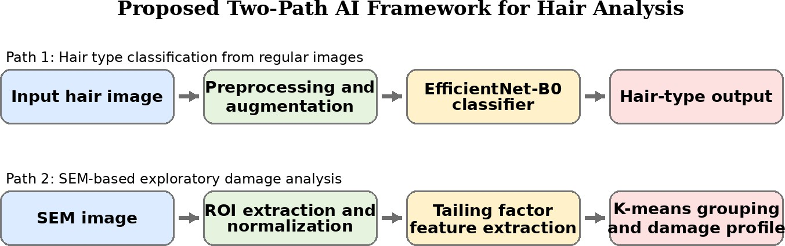

Figure 1. Proposed two-path AI framework for visible hair-type classification and SEM-based exploratory damage analysis.

Table 2. Hair type dataset used for classification after excluding dreadlocks

Hair Type | Number of Images | Note
Straight | 488 | Retained in final classification task
Wavy | 330 | Retained in final classification task
Curly | 514 | Retained in final classification task
Kinky | 217 | Retained in final classification task
Dreadlocks | 443 | Excluded because it represents a hairstyle rather than a structural hair type
Total original dataset | 1,992 | Original downloaded dataset
Total final classification set | 1,549 | Dataset used for the four-class model
Table 3. SEM datasets used in the exploratory damage-analysis path

Dataset | Number of Images | Image Type
Dryad | 47 | TIFF
L'Oréal | 429 | PNG
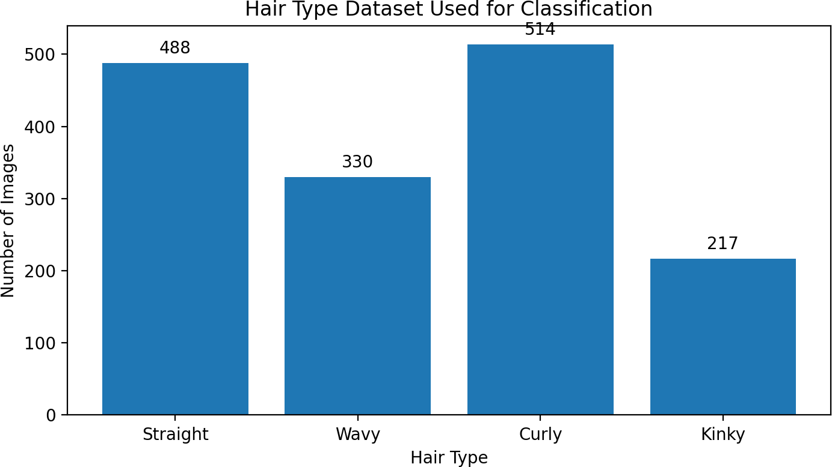

Figure 2. Distribution of the four retained hair-type classes used for model training and testing.

Results

Hair Type Classification Results
Four experiments were carried out in the classification path by changing the learning rate and the number of epochs while keeping the batch size fixed at 16. The results show that performance depended clearly on the learning-rate choice. Experiment 2, which used a learning rate of 0.0001 for 8 epochs, produced the strongest test results: 91.42% accuracy, 91.86% precision, 91.42% recall, and 91.41% F1-score.
Experiment 4 needs careful interpretation. Its training output showed the highest validation peak, around 93.13%, but its final reported test accuracy was 88.41%. For that reason, it should not be treated as the best overall model. In this paper, Experiment 2 is considered the most reliable configuration because it gave the best balanced performance on the test set.
The class-level results for Experiment 2 show particularly strong performance for straight and curly hair, while kinky and wavy hair remain somewhat more difficult because of their smaller sample size and visual overlap with neighboring categories. Even so, the confusion matrix indicates that the model learned a useful feature representation across all four classes.
The SEM results indicate that the preprocessing and tailing-factor extraction pipeline can be applied in a consistent way to both the Dryad and L'Oréal datasets. Running the procedure with different ROI settings on the Dryad images produced readable histogram behavior and plausible tailing-factor values. Applying the same general workflow to the L'Oréal images suggests that the method is not tied to one dataset only.
Since expert annotation was unavailable, the SEM path was treated as an exploratory grouping problem rather than a supervised classification problem. K-means clustering produced three provisional groups. The largest group contained relatively low tailing-factor values, while the highest group contained only one extreme sample above 4.20. This is informative, but it also shows that stronger validation and better-labeled data are still needed.
Taken together, the results point in two directions. The visible hair-type classifier is the main validated contribution of the study because it is supported by standard supervised metrics. The SEM path is useful as a structured exploratory workflow, but it should be described as preparation for future expert-grounded work rather than as a finished damage-prediction model.
This interpretation keeps the paper consistent with what the available evidence can genuinely support.

Table 4. Hair type classification experiments and reported performance metrics

Experiment | Learning Rate | Batch Size | Epochs | Accuracy | Precision | Recall | F1-score
Exp 1 | 0.001 | 16 | 8 | 86.70% | 87.48% | 86.70% | 86.80%
Exp 2 | 0.0001 | 16 | 8 | 91.42% | 91.86% | 91.42% | 91.41%
Exp 3 | 0.00001 | 16 | 8 | 84.12% | 84.53% | 84.12% | 83.64%
Exp 4 | 0.0001 | 16 | 15 | 88.41% | 88.76% | 88.41% | 88.33%
Note. Experiment 4 reached the highest reported validation peak (~93.13%) but not the highest final test accuracy. For publication purposes, Experiment 2 is interpreted as the strongest generalizable configuration.

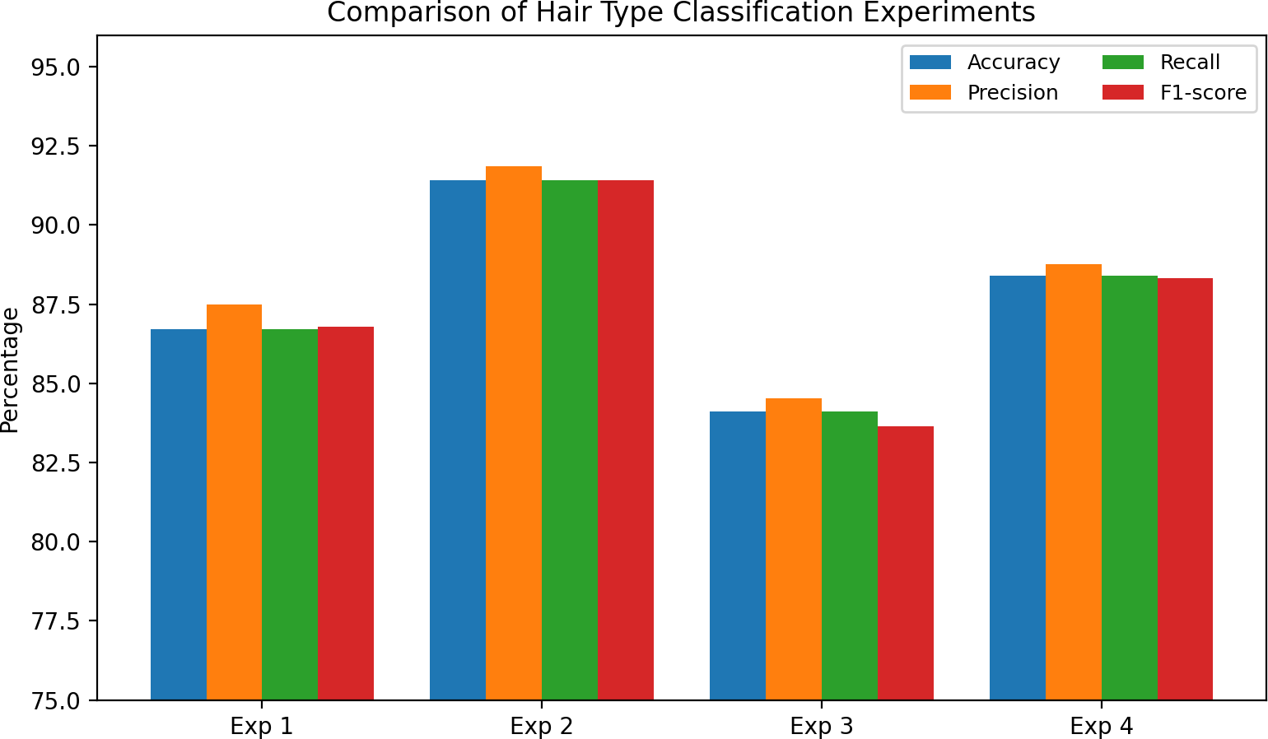

Figure 3. Comparison of the four hair classification experiments across accuracy, precision, recall, and F1-score.

The learning rate was set to 0.001, number of epochs 8 and the batch size was 16. The model achieved an accuracy of 87%.

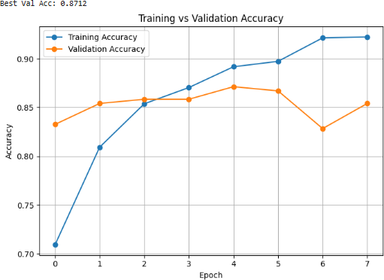
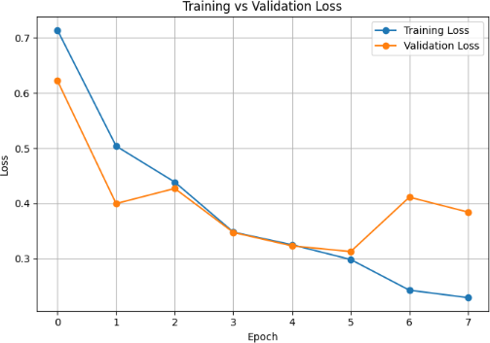

Figure. 3. Hair Type Classification - Experiment 1

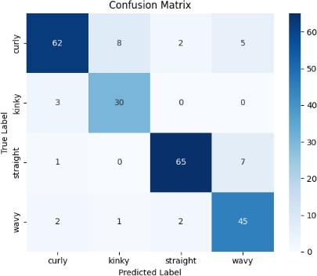

Figure. 4. Hair Type Classification - Experiment 1 – confusion matrix

Table 5. Class-level report for the best-performing test configuration (Experiment 2)

Class | Precision | Recall | F1-score | Support
Curly | 0.97 | 0.87 | 0.92 | 77
Kinky | 0.82 | 0.97 | 0.89 | 33
Straight | 0.91 | 0.97 | 0.94 | 73
Wavy | 0.91 | 0.86 | 0.89 | 50
Macro average | 0.90 | 0.92 | 0.91 | 233
Weighted average | 0.92 | 0.91 | 0.91 | 233
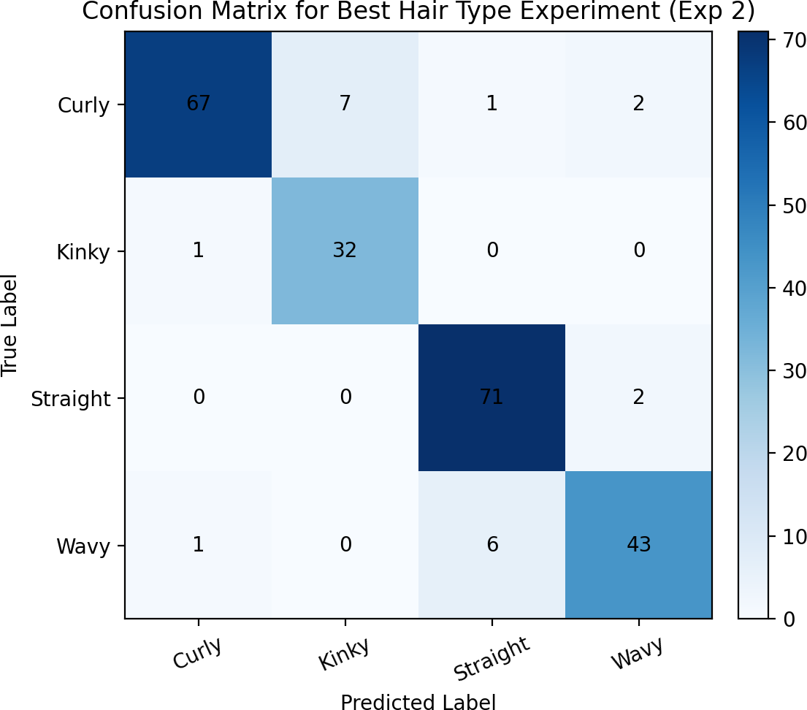

Figure 5. Confusion matrix for Experiment 2, the best overall test configuration in the revised interpretation of results.

  - SEM Analysis
SEM images provide a detailed view of the hair surface, which helps in studying hair condition and identifying characteristics that may be related to damage. It provides details that are not visible in regular images, so it helps in examining the hair's structure more deeply. The tailing factor is used as the main feature to represent the level of hair surface damage, the higher its value, the greater the damage. To validate the effectiveness of the proposed methodology, a number of experiments were implemented on two different SEM datasets. The first Dryad dataset, which also used in Fanny Chu research to ensure consistency.
    - Dryad Dataset Experiments:
Experiment 1 - RIO 75% - FILTER_MAX_4000X FALSE:
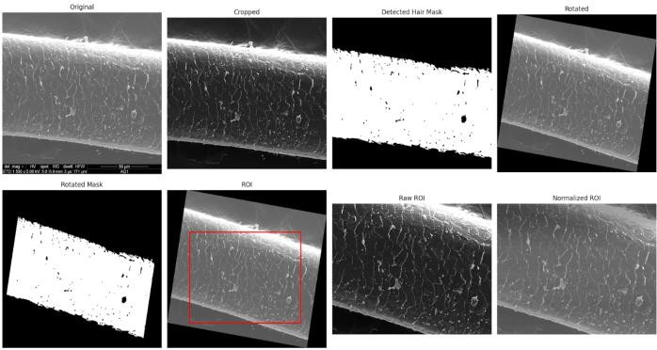
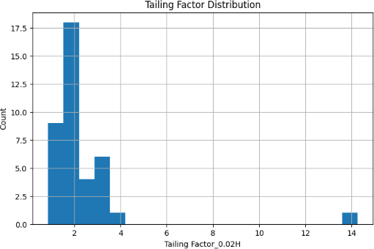
Figure 11. SEM Analysis - Experiment 1- RIO Figure 12. SEM Analysis - Experiment 1 – Tailing factor distribution

Experiment 2 - RIO 70% - FILTER_MAX_4000X FALSE:
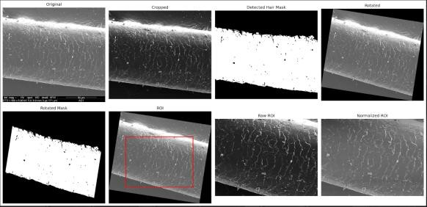

Figure 13, SEM Analysis - Experiment 2- RIO

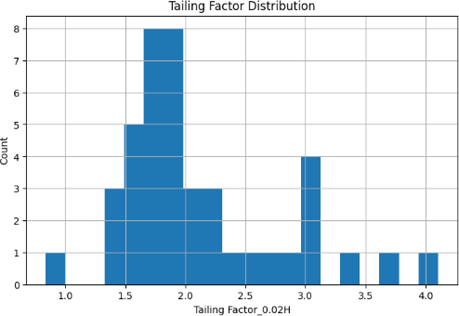
Figure 14. SEM Analysis - Experiment 2 – Tailing factor distribution

Table 6. Exploratory K-means cluster summary for tailing-factor-based SEM grouping

Ordered Cluster | Interpretation | Count | Minimum | Maximum | Mean
0 | Provisional low- damage profile | 19 | 1.291667 | 2.034483 | 1.667799
1 | Provisional moderate- damage profile | 7 | 2.227273 | 2.888889 | 2.475220
2 | Provisional high-damage profile | 1 | 4.205882 | 4.205882 | 4.205882
Note. The semantic labels low, moderate, and high damage are editorial interpretations for discussion only. Because expert microscopic labels were unavailable, these groups should be read as exploratory profiles rather than definitive damage classes.

Since expert annotation was not available, an unsupervised learning approach (K-means clustering) to group the data into relevant clusters.
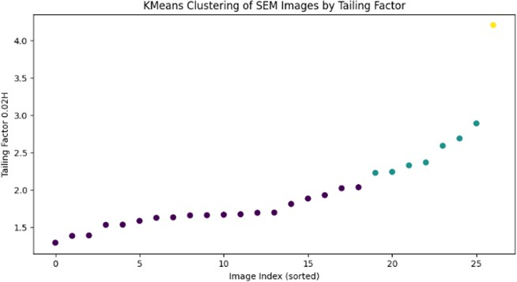

Figure15. SEM Analysis – Kmeans clustering by Tailing factor

Conclusion and Discussion of Results
In this work, a dual-path AI framework was developed for hair analysis. The first path dealt with hair-type classification from regular images, and the second path explored SEM-based surface analysis. The classification results show that EfficientNet-B0 can distinguish structural hair types effectively, with the best configuration reaching 91.42% test accuracy and showing strong precision, recall, and F1-score. These findings suggest that deep learning can provide reliable support for visible hair-pattern classification when the data are prepared carefully and the training settings are tuned properly.
The SEM path also produced useful findings. By combining ROI selection, histogram analysis, and tailing-factor extraction, the study turned a difficult visual interpretation task into a repeatable computational workflow. The clustering output cannot yet be treated as expert- confirmed damage diagnosis, but it does show that meaningful groupings can emerge from the extracted feature.
The main point of the paper is that the two paths contribute at different levels of evidence. The visible classification path is quantitatively validated, while the SEM path remains exploratory

because microscopic labels were not available. Presenting the study in this balanced way avoids overclaiming and provides a more credible basis for future work on integrated hair-care recommendation systems.

Methodological limitations
The main limitation of the study is that the SEM path lacks expert-validated microscopic labels, so it cannot be presented as a definitive damage-classification system. In addition, the clustering result is imbalanced, with one very small high-value cluster, which suggests that broader and better-labeled data are needed. Finally, although the visible hair-type classifier performed well, it should still be tested on more diverse real-world images before being considered ready for wider deployment.

Recommendations
The following recommendations arise from the present work: | 1. Future work should include expert annotation of SEM images so that damage analysis can be validated through supervised learning or formal ground-truth comparison. | 2. Additional clustering validation metrics such as silhouette score and Davies-Bouldin index should be reported in future versions of the SEM analysis. | 3. The hair-type classification dataset should be expanded with more diverse backgrounds, ethnicities, lighting conditions, and image-capture settings to improve real-world robustness. | 4. Fairness and generalizability should be assessed explicitly because hair research can be sensitive to underrepresentation of certain texture groups. | 5. The outputs of the visible classification path and the future validated damage-analysis path should be integrated into a recommendation system only after stronger expert verification. | 6. Collaboration with cosmetic scientists, dermatologists, and trichology experts is strongly recommended so that computational outputs can be translated into reliable practical advice.

References
Chu, F., Anex, D. S., Jones, A. D., & Hart, B. R. (2020). Automated analysis of scanning electron microscopic images for assessment of hair surface damage. Royal Society Open Science, 7, 191438. https://doi.org/10.1098/rsos.191438
Daniels, G., Tamburic, S., Benini, S., Randall, J., Sanderson, T., & Savardi, M. (2021). Artificial intelligence in hair research: A proof-of-concept study on evaluating hair assembly features. International Journal of Cosmetic Science, 43(4), 405-418. https://doi.org/10.1111/ics.12706
Dertli, B., & Koklu, M. (2025). Classification of hair types with deep learning methods. In Proceedings of the 5th International Conference on Trends in Advanced Research (ICTAR).
Eskaf, K. (2024a). Advanced AI techniques for real-time blood glucose prediction in diabetics: A study using deep learning and genetic algorithms. Midocean Journal for Research and Studies, 1(1). https://doi.org/10.71335/5y36na30
Eskaf, K. (2024b). SmartDate: AI-driven precision sorting and quality control in date fruits. In 2024 IEEE 21st International Conference on Smart Communities: Improving Quality of Life Using AI, Robotics and IoT (HONET). IEEE. https://doi.org/10.1109/HONET63146.2024.10822938
Gaines, M. K., Page, I. Y., Miller, N. A., Greenvall, B. R., Medina, J. J., Irschick, D. J., Crosby, A. J., et al. (2023). Reimagining hair science: A new approach to classify curly hair phenotypes via new quantitative geometric and structural mechanical parameters. Accounts of Chemical Research, 56(11), 1330-1339.
Goodfellow, I., Bengio, Y., & Courville, A. (2016). Deep learning. MIT Press.
Kim, Y., Kim, S., Moon, H., Yu, Y., & Noh, J. (2024). Scalp diagnostic system with label-free segmentation and training-free image translation. arXiv. https://arxiv.org/abs/2406.17254
Lasisi, T., Zaidi, A. A., Webster, T. H., Stephens, N. B., Routch, K., Jablonski, N. G., & Shriver, M. D. (2021). High-throughput phenotyping methods for quantifying hair fiber morphology. Scientific Reports, 11, 11535.

Massey, L. (2011). Curly girl: The handbook (2nd ed.). Workman Publishing.
Meishvili, G., Clemoes, J., Hewitt, C., Hosenie, Z., Xiao, X., de La Gorce, M., Wilczkowiak, M., et al. (2024). Hairmony: Fairness-aware hairstyle classification. In SIGGRAPH Asia 2024 Conference Papers (pp. 1-11).
Muhammad, U. R., Svanera, M., Leonardi, R., & Benini, S. (2018). Hair detection, segmentation and hairstyle classification in the wild. Image and Vision Computing, 71, 25-37.
Robbins, C. R. (2012). Chemical and physical behavior of human hair (5th ed.). Springer. https://doi.org/10.1007/978-3-642-25611-0
Tan, M., & Le, Q. (2019). EfficientNet: Rethinking model scaling for convolutional neural networks. In Proceedings of the 36th International Conference on Machine Learning (pp. 6105-6114). PMLR.

