

AI-Based Construction Site Safety Monitoring System
Prepared By
Name: Mohammed Ali Alhawshabi ID No.: 261002622
Name: Mohammed Omar Baatiyyah ID No.: 261002493
Submitted in fulfillment of the requirements for the degree Master of Science in Artificial Intelligence
At
College of Informatics
Midocean University
UAE
Supervisor Name: Dr. Mohamed Eassa
College of Informatics, Midocean University, Comoros
Email: 261002493@st.midocean.edu.km
Email: 261002622@st.midocean.edu.km

Acknowledgements

We would like to thank our supervisor, Dr. Mohamed Essa, for his continuous guidance and valuable feedback throughout this research. His expertise in both artificial intelligence and galaxy studies has greatly influenced the direction of this work. His comments challenged us to think more critically and approach the research from a scientific perspective rather than a purely technical one.

We are also thankful to the faculty members at the College of Informatics, Midocean University, for providing a supportive academic environment that inspired independent thinking and research development.

Finally, we would like to express our appreciation to our families for their patience, encouragement, and support during this journey.

Abstract

As it is known that construction sites are inherently dangerous, containing numerous sharp tools that can lead to injuries of varying severity. Preventing such injuries is often difficult due to a multitude of factors, including the failure to wear protective equipment on construction sites. One of the most important methods for monitoring and ensuring workers on construction sites is a visual inspection by the site supervisor to verify that all workers are wearing appropriate protective gear. Checking the use of protective gear at construction sites is extremely important and requires significant human intervention, not only when workers enter the site but also during their daily work hours.

To ensure worker protection, the system uses artificial intelligence to check whether workers are wearing adequate protective gear. Additionally, it monitors worker movements, and in the event of an injury, it immediately alerts paramedics to expedite the rescue operation.

In large and crowded construction sites, it is difficult to monitor everyone at the same time, which may require more personnel for monitoring, thus increasing the cost. In addition, artificial intelligence helps in detecting cases of infection immediately and quickly, which contributes to saving lives more and faster. This study proves that the machine is not just a means of sorting files, but can also effectively prevent fatalities by shifting monitoring from a reactive to a proactive approach as much as possible, where achieving zero dangerous incidents is the primary goal.

Contents
i
Acknowledgements ii
Abstract iii
List of Abbreviations iv
List of Figures v
List of Tables vi
Chapter 1: Introduction 1
1.1 Overview 1
1.2 Problem Definition 3
1.3 Thesis Objectives 4
1.4 Thesis Contribution 5
1.5 Thesis Organization 5
Chapter 2: Background and Related Work 6
2.1 Introduction 6
2.2 Background 7
2.3 Related work 12
2.4 Related Work Summary 18
Chapter 3: Proposed Approach (Methodology) 21
Chapter 4: Experimental Results and Discussion 22
Chapter 5: Conclusion and Future Work 23
References 24

List of Abbreviations
- AI: Artificial Intelligence.
- CNN: Convolutional Neural Network.
- DL: Deep Learning.
- DECaLS: Dark Energy Camera Legacy Survey.
- GAN: Generative Adversarial Network.
- Grad-CAM: Gradient-weighted Class Activation Mapping.
- MCD: Monte Carlo Dropout.
- ML: Machine Learning.
- RA: Right Ascension.
- SDSS: Sloan Digital Sky Survey.
- XAI: Explainable Artificial Intelligence.
- F1-score: Harmonic mean of precision and recall.
- ViT: Vision Transformer.
- VGG19: Visual Geometry Group 19.
- DCGAN: Deep Convolutional Generative Adversarial Network.
- CvT: Convolutional Vision Transformer.
- S-PLUS: Southern Photometric Local Universe Survey.
- CANDELS: Cosmic Assembly Near-infrared Deep Extragalactic Legacy Survey.
- S0: Lenticular Galaxy.

List of Figures
Figure 1.1: Example of Body PPE need to be worn on construction site 1

List of Tables
Table 2.1:

Chapter 1: Introduction

1.1 Overview
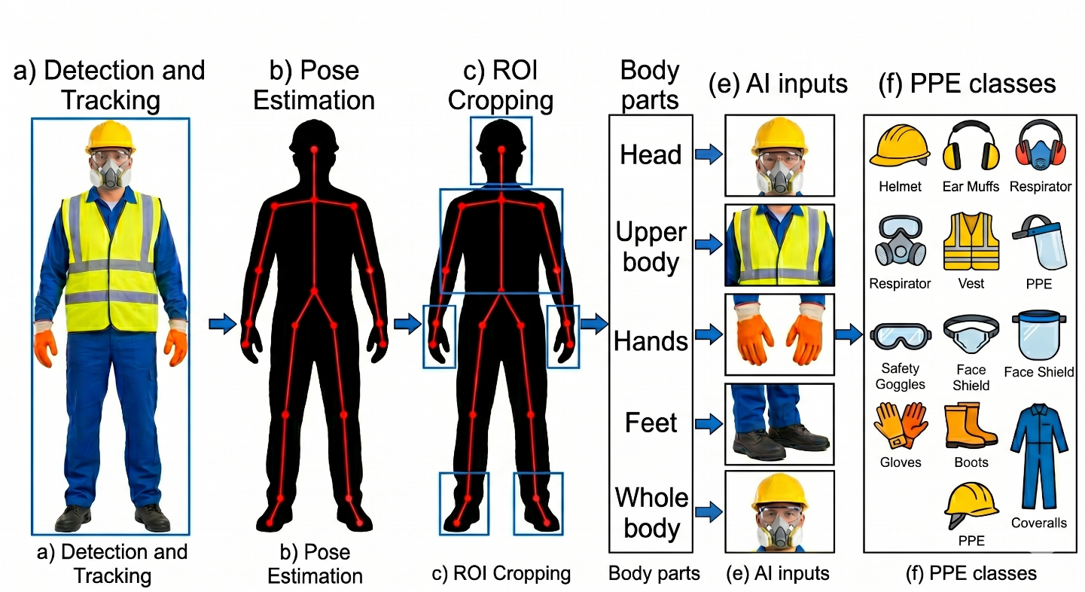
Safety generally relies on visual observation, with supervisors moving around construction sites to monitor workers' behaviour, including any hazardous actions. This method, known as behavioural screening, is useful but faces several challenges in practice. It requires a large team of observers who often rely solely on their understanding of behaviour on construction sites [1][2]. Simply, the human eye cannot see everything around it. This is not a shortcoming of the work or effort, but the sheer size of the construction site must be considered.
Figure 1.1: Example of Body PPE needs to be worn on construction site

The human eye often misidentifies problems, and relying on manual supervision can create safety gaps that human observers may not be able to detect. This is why engineers rely on computer vision technologies to interpret and process CCTV footage from construction sites.

By enabling machines to analyse and sort CCTV footage, companies can have a monitor on construction sites 24/7 without fatigue or boredom (even in low light). This eliminates the need for intermittent searches by human supervisors and does not impede workflow or speed.

Artificial intelligence can detect, analyse, and identify individuals who do not wear protective gear such as body Armor, gloves, and impact resistant footwear, as well as determine the appropriate equipment for each work environment.
in additions, AI can predict whether a worker on-site has been injured, potentially to faster rescue times compared to human intervention. [1] [3] [4].

However, PPE alone is not enough to protect employees but proactively checking whether a worker is wearing appropriate PPE helps significantly reduce workplace injuries on construction sites and save a life [4].

1.2 Problem Definition
Construction sites are among the most dangerous places where workers are exposed to serious injuries and even fatalities, such as falls from heights or collisions with heavy or dangerous equipment. Most studies indicate that injuries on construction sites result from unsafe actions and behaviors by workers. Therefore, risk management at these sites is extremely important and complex due to the constantly changing behaviors of workers during their shift [2].
To protect construction workers, construction companies require strict guidelines for the use of personal protective equipment (PPE) such as safety vests, goggles, and high-visibility vests. However, ensuring workers consistently wear PPE is a significant challenge, as many disregard safety rules due to discomfort, forgetfulness, or a lack of constant supervision, potentially fast to serious injuries.
Currently, safety rules are applied at construction sites by field safety supervisors. Studies have shown that such an approach is ineffective and has many human flaws because it relies on the human element, which may make mistakes and may not be available at all times when workers are present. Therefore, it is difficult for them to monitor everyone, especially in large and active construction sites. As a result, incorrect practices and violations of safety rules at construction sites may not be discovered.
There is currently a gap in technological solutions that could be better developed through computer vision systems. Some existing systems may be able to determine if a worker is wearing a helmet (stationary objects), others only track the movement of objects, and a few can analyse the worker's dynamic movements. Simply tracking the worker's hand movements is insufficient; it's necessary to know if they are handling a sharp tool and require specific safety systems for such tasks.

Based on what has been mentioned previously, this study will solve the problem of the lack of integration, automation and immediate monitoring, helping the construction sector to provide an automated and intelligent framework that ensures compliance with safety procedures using PPE by immediate detection of physical work injuries or falls, and accurate identification of workers’ interaction with sharp tools to identify and reduce risks before they occur. [3] [4].

1.3 Thesis Objectives
The main objective of this research is to develop a computer vision based intelligent camera monitoring system for improved safety in construction sites. The objectives include:
- To design and train a computer vision model to accurately detect safety helmets and high visibility vests in real-time, based on reliable image data sets.
- To develop a skeleton based action recognition framework for monitoring workers’ postures in real-time and accurately, and for detecting sudden anomalies such as injuries or falls.
- To assess the interaction of construction workers with the environment (man-machine/material) to identify unsafe behaviors before they cause accidents.
- To evaluate the accuracy and speed of the system under different environmental conditions, such as varying lighting.

1.4 Thesis Contribution
Based on previous studies and research, this research offers a practical contribution to the field of safety at construction sites:
1. Unified dual architecture: Most current studies present two separate models for detecting safety devices and detecting object movements, but in our study we propose a single system for both models to process two layers of data simultaneously, which helps reduce processing redundancy and provides a more efficient monitoring solution.
2. Aware Hazard Identification: In this study, we will develop the concept of integrating machine with human movement. The study will not only determine whether the worker is wearing appropriate protective clothing, but will also identify if they are near a sharp machine without wearing the appropriate protective clothing, as well as their body position relative to the machine. This will help reduce risks or prevent accidents altogether.
3. Comprehensive Fall and Injury Detection: While most current studies focus on safety system violations, we will examine continuous and sudden body movements, utilizing surveillance video footage to help determine if there is a possibility of a worker falling for any reason and to send medical assistance immediately.
4. A Scalable Template for the Construction Industry: This thesis closes the gap between theoretical AI models and practical safety management, by providing a highly scalable and cost-effective template. This new system changes the industry from reactive safety management (after the accident) to proactive prevention (before the injury) and provides a realistic alternative to manual safety inspections.

1.5 Thesis Organization
The rest of this thesis is organized as follows.
Chapter 2 discusses the theoretical background and relevant research areas.
Chapter 3 presents the proposed methodology.
Chapter 4 analyzes the experimental results.
Chapter 5 concludes the study and suggests directions for future work.

Chapter 2: Background and Related Work
2.1 Introduction
Safety procedures at construction sites began in the early 20th century as the construction industry experienced rapid growth and development. Early safety and protection measures were established at that time, and based on this development, safety was divided into physical safety, operational guidelines, and basic protective equipment. All these standards focus on the safety and health of workers at construction sites, protecting their bodies and lives from injuries, thus emphasizing that human safety is the fundamental requirement.

The typical safety hierarchy at construction sites can be further illustrated in Figure 2.1, which shows the relationship between hazard removal, safety controls, and the last line of defines. Later, Later, safety authorities developed such (OSHA) further developed these frameworks by updating rigorous compliance checklists and implementing penalties for safety violations.
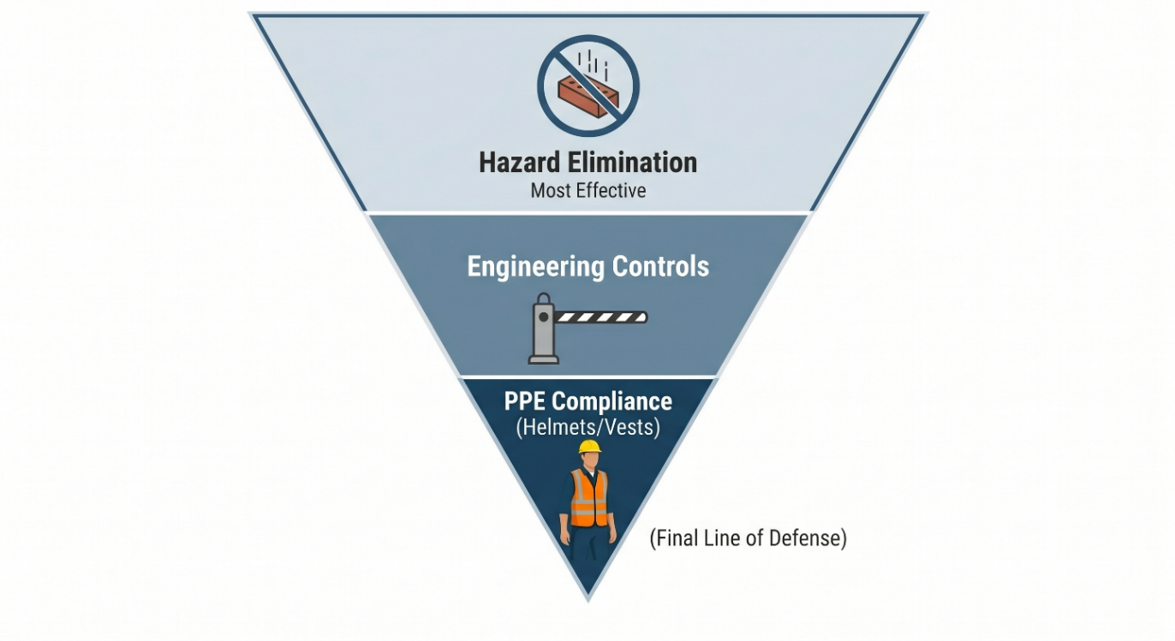
Figure 2.1: PPE needs to be worn on construction site
With the safety systems recommended by international safety organizations for construction sites, safety checks were previously conducted by on-site supervisors who would tour construction facilities and visually inspect the availability of safety systems. While these systems have been in use for years, this method remains somewhat effective, it has become impractical due to the sheer volume of work and the scale of construction projects in our time.

2.2 Background
Currently, with the increasing growth of construction projects and the growing number of workers and their movement within these projects, safety problems have begun to emerge. These massive sites and industrial cities have begun to generate enormous volumes of work that are difficult to monitor manually effectively. As an alternative solution, the collective safety system was launched, enabling construction contractors to report hazards immediately upon their occurrence. This demonstrates how collective human cooperation contributes to reducing risks.

Because of that, the monitoring of construction sites has continued to expand with the addition of closed-circuit television cameras (CCTV) and drones for wide area surveillance. For this reason, the demand for automated safety monitoring has become a matter of interest to researchers in the field of artificial intelligence.

From this perspective, the roles of artificial intelligence, machine learning, and deep learning in image and video analysis have become prominent. AI algorithms can analyze, detect, and improve hazard detection at construction sites. Conversely, deep learning can use neural networks to automatically extract complex visual movements and actions. Both methods can be very useful in addressing the problem of adhering to safety standards at construction sites, given that construction site images contain complex visual information that the human eye cannot manually infer, process, and encode. This is evident in the visual contrast between field supervisors when making decisions regarding the implementation of safety systems, as illustrated in the figure 2.2.
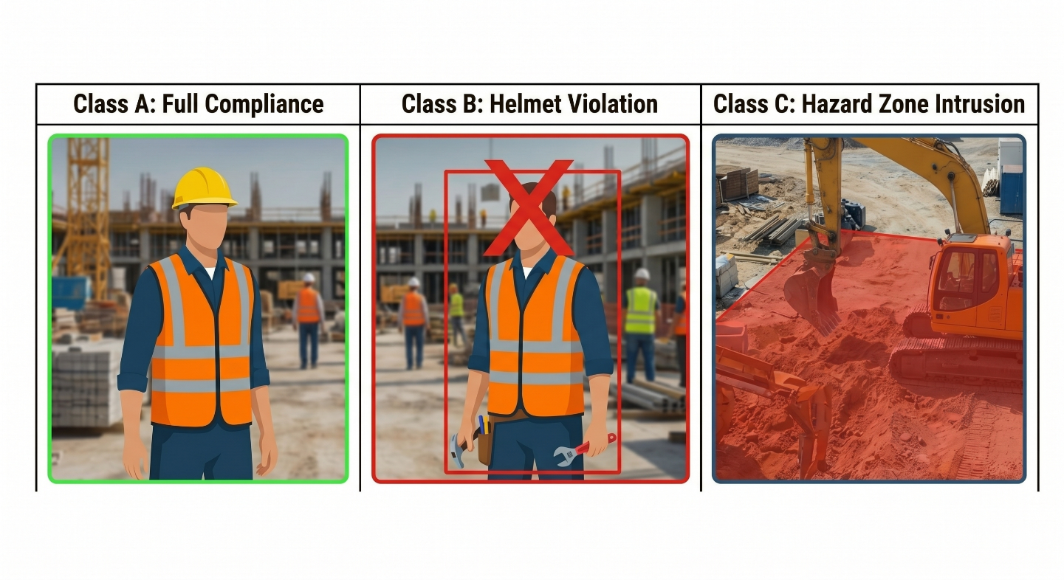
Figure 2.2: showing how AI can detect and analyze the CCTV data

The figure 2.2 illustrates examples of construction site images from the safety category, which visual characteristics such as dust, lighting, and other factors. Detecting safety violations under these conditions presents a big challenge for automated detection through image and video analysis. The different positions and interactions of objects or humans make deep learning techniques highly effective for directly identifying safety violation from detailed image Pixels.

From a computer vision perspective, site safety detection is a real-world problem for identifying and classifying objects. Therefore, this study aims to detect different types of safety equipment from classified images used at construction sites. Deep learning systems, such as neural networks, can achieve this goal in this case, as they can accurately and automatically locate safety equipment.

Before the deep learning in artificial intelligence, machine learning was used for basic functions such as detecting the color of protective vests, identifying the shapes of protective equipment, and so on. and with these advanced techniques, they faced challenges in determining all outputs from (CCTV) due to environmental conditions and certain limitations in construction sites.

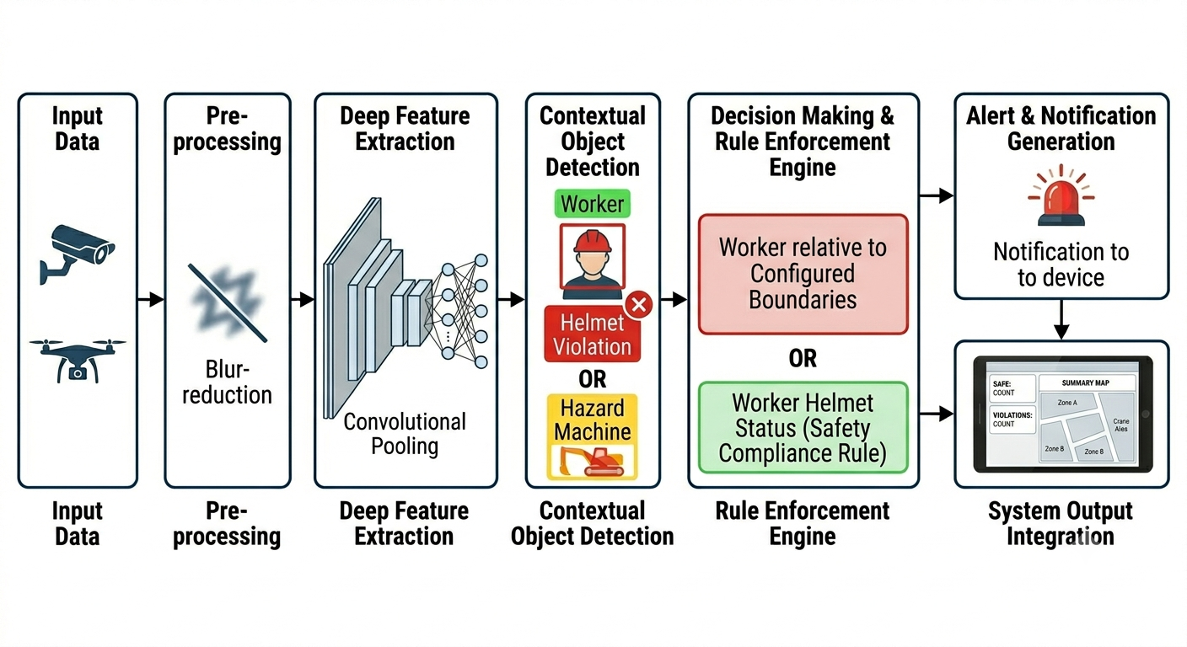
With the growing interest in neural networks (CNN) in industrial automation, safety results have shown remarkable success. Studies have demonstrated that relying on neural networks (CNN) in security and safety has achieved impressive results, rivalling the current practices of supervisors in busy construction sites. These networks have success in verifying compliance with safety regulations at construction sites.
Figure 2.3: Schematic overview of a deep learning flow for construction safety monitoring

The figure 2.3 illustrates the process of image processing, content detection, and classification at construction sites through specific steps, starting with camera input and culminating in the identification of expected safety conditions and their corresponding alerts. This example demonstrates how deep learning can be leveraged to extract and utilize data.
In addition to neural network techniques (CNN), other technologies have been discovered in the field of construction safety. One of the most prominent of these is transfer learning, which utilizes previously used models (such as dataset containing large scale safety images) and recent construction site images related to safety. Another technique called (Vision Transformers) which can help the model better and more detect and recognize construction sites, such as identifying the relationship between a worker and a heavy crane operating nearby.

References
[1] Image-and-skeleton-based parameterized approach to real-time identification of construction workers' unsafe behaviors. Journal of Construction Engineering and Management. Guo, H., Yu, Y., Ding, Q., & Skitmore, M. (2018).

[2] Applications of Computer Vision in Monitoring the Unsafe Behavior of Construction Workers: Current Status and Challenges. Buildings. Liu, W., Meng, Q., Li, Z., & Hu, X. (2021).

[3] PPE-EYE: A Deep Learning Approach to Personal Protective Equipment Compliance Detection. Computers. Rahman, A., Ahmed, M. S., AlBugami, K. N., Alabbad, A. Y., AlFantoukh, A. A., Alshaikhahmed, Y. H., ... & Alshahrani, S. M. (2026).

[4] Study on the Interaction Behaviors Identification of Construction Workers Based on ST-GCN and YOLO. Sensors. Li, P., Wu, F., Xue, S., & Guo, L. (2023).

[5] PPE detector: a YOLO-based architecture to detect personal protective equipment (PPE) for construction sites. Ferdous M, Ahsan SMM. 2022. PPE detector: a YOLO-based architecture to detect personal protective equipment (PPE) for construction sites.

