

Ministry of Education
Midocean university
College of Management
Master of Business Administration

THE EFFECT OF AUTOMATION ON SUPPLY PLANNING

By Student:

Hattan Bawaked

Supervised by

Dr. Asma Abuanzeh

Abstract

The abstract of "The Effect of Automation on Supply Planning" looks at how traditional supply planning procedures are changed by the incorporation of automation technologies. By simplifying data collection and analysis, automation improves efficiency and makes real-time demand forecasting and inventory management possible. As a result, supply chain decisions become more accurate, cutting down on lead times and operating expenses. Furthermore, automation makes it easier for stakeholders to collaborate through integrated platforms, which promotes a more flexible reaction to changes in the market. But the study also discusses possible drawbacks, like the necessity of retraining employees and the danger of becoming overly dependent on automated systems. The results ultimately show that although automation can greatly improve supply planning, a balanced strategy is required to guarantee that human expertise is still a crucial component of the decision-making process.

Chapter One

INTRODUCTION

Supply planning has undergone a tremendous transformation thanks to automation, which has brought accuracy and efficiency to previously labor-intensive procedures. Employing cutting-edge technologies like data analytics, machine learning, and artificial intelligence (AI) allows businesses to optimize their supply chain processes. Demand forecasting, order processing, inventory tracking, and other sophisticated tasks that were previously handled manually can now be handled by automation tools. This change results in more accurate and timely supply planning since it decreases the possibility of human error while also speeding up the completion of these tasks. As a result, companies are better equipped to react quickly to changes in the market and client needs, which raises their level of competitiveness.

An important benefit of automation for supply planning is a rise in the precision of demand forecasting. Automated systems make highly accurate predictions about future demand by utilizing complex algorithms and historical data. Automation combines real-time data and dynamic analytics, in contrast to traditional approaches that mainly rely on human intuition and static data models. This enables businesses to predict market trends and modify their inventory levels appropriately. Consequently, companies encounter fewer instances of stockouts and overstock scenarios, enhancing their inventory control and lowering related expenses.

- THE PROBLEM OF THE STUDY.

  - PROBLEM OF THE STUDY OVERVIEW

Supply planning automation is a big move away from manual, antiquated procedures and toward more advanced, technologically driven systems. Automation in the context of supply chain management refers to the use of algorithms and software to manage inventory, forecast demand, and fulfill orders. The demand for increased supply chain responsiveness, accuracy, and efficiency has fueled the adoption of automation technologies. Automation offers a means for businesses to reduce human error, streamline operations, and improve decision-making capabilities in the face of growing customer expectations and competition. This shift has broad ramifications that affect everything from strategic planning to operational procedures. A detailed analysis of automation's advantages, drawbacks, and overall impact on the supply chain ecosystem is necessary to comprehend how it affects supply planning. The improvement of supply chain visibility is a crucial benefit of automation in supply planning. Complete supply chain visibility, from the procurement of raw materials to the delivery of the finished product, is made possible by automated systems. Businesses can more successfully monitor and manage every step of the supply process thanks to this all-encompassing perspective. Tools for real-time tracking and reporting make it possible to quickly spot possible hiccups or inefficiencies, like delays or bottlenecks. Businesses can keep operations running more smoothly and increase the overall resilience of their supply chain by taking proactive measures to address these problems.

  - IMPROVED ACCURACY AND FORECASTING

Supply planning becomes much more accurate with automation thanks to sophisticated forecasting methods. Conventional forecasting techniques frequently depend on human intuition and historical data, both of which have biases and errors. Conversely, automated systems make use of advanced algorithms and machine learning to examine massive datasets and more accurately forecast future demand. To produce more accurate forecasts, these systems can take into account a variety of variables, including consumer behavior, market conditions, and seasonal trends. Businesses can better match supply with actual demand, minimize stockouts and overstock scenarios, and optimize inventory levels with increased forecasting accuracy. This enhances customer satisfaction while also supporting the upkeep of a lean, economical supply chain.

  - CHALLENGES AND RISKS OF AUTOMATION

Automation in supply planning has many benefits, but it also has some drawbacks and hazards. The initial outlay needed to install and maintain automated systems is one of the primary worries. Purchasing software, integrating it with current systems, and staff training can come at a significant financial cost. Businesses also need to deal with possible technical problems and system failures, which if not handled correctly could cause operations to be disrupted. Another issue is the possibility of employment losses as a result of automation, since certain manual jobs might become outdated. Businesses need to carefully manage these obstacles by making investments in reliable systems, making sure staff members are properly trained, and creating backup plans in case something goes wrong. It can be difficult and complex to integrate automation technologies into current supply planning systems. It is imperative for organizations to ascertain that nascent systems can efficiently interface with their existing infrastructure and interact with other software and hardware elements. Significant technical know-how and resources are frequently needed for this integration process. Employee resistance may also come from workers used to conventional procedures who may be worried about their job security or the learning curve involved in utilizing new technologies. Achieving the full benefits of automation requires resolving these integration challenges.

  - IMPACT ON DECISION-MAKING AND STRATEGY

Strategic planning and decision-making processes are impacted by automation because it provides more precise and timely data. Managers are able to react to market changes faster and make better decisions when they have real-time insights into supply chain operations. Businesses can assess various strategies and their possible results by using automated systems to help with scenario planning and what-if analyses. This capacity helps businesses to foresee future obstacles and opportunities, which improves strategic planning. Instead of depending solely on gut feeling, companies can create more successful plans and respond more quickly to shifting market conditions by using data-driven insights. Supply planning decision-making procedures have undergone a significant transformation thanks to automation, which offers data-driven insights and suggestions. Prior to now, supply planners had to rely on manual analysis and historical data, which could be error-prone and time-consuming. Conversely, automated systems provide predictive insights and real-time analytics, enabling better informed decisions to be made faster. The transition to data-driven decision-making can improve supply planning's precision and responsiveness. Nevertheless, it also means that supply planners need to acquire new competencies, as they now have to analyze and act upon intricate data outputs produced by automated systems.

  - CASE STUDIES AND INDUSTRY EXAMPLES

Analyzing case studies and industry examples offers important insights into how automation affects supply planning in the real world. Retail businesses, for example, have effectively incorporated automated inventory management systems to enhance customer service and optimize stock levels. In a similar vein, manufacturers have improved supplier coordination and production scheduling through automation. These examples show how various industries and operational contexts can be catered for when using automation. Businesses can learn more about supply planning automation's overall benefits, potential drawbacks, and best practices by examining these case studies.

  - EFFECT ON WORKFORCE DYNAMICS

Supply planning automation has an impact on labor dynamics, resulting in changes to job roles and skill requirements. The role of supply planners is changing to concentrate more on strategic oversight and exception management as regular and repetitive tasks become automated. This change may result in less need for manual labor but more need for workers with strategic thinking, data analysis, and system management skills. To make sure that their workforce is prepared to meet the new demands of an automated environment, organizations need to make investments in training and development. The possible effects of automation on job satisfaction and career advancement for individuals whose roles are impacted should also be taken into account.

- THE IMPORTANCE AND OBJECTIVES.

  - IMPORTANCE OF AUTOMATION IN SUPPLY PLANNING

Supply planning automation is becoming more and more important as industries look to improve accuracy and efficiency. Conventional supply planning techniques, which rely on calculations and manual data entry, are frequently rife with mistakes and inefficiencies. Automation uses cutting-edge technologies like machine learning (ML) and artificial intelligence (AI) to swiftly and accurately analyze enormous volumes of data in order to solve these problems. This change decreases human error and expedites decision-making, enabling companies to react to market developments more quickly. Automation makes it possible for businesses to better meet customer demands by preventing stockouts and overstock scenarios, maintaining ideal inventory levels, and so on.

  - OBJECTIVES OF IMPLEMENTING AUTOMATION IN SUPPLY PLANNING

Improving inventory control, raising operational efficiency, and increasing forecast accuracy are the main goals of automating supply planning. Automation systems frequently integrate sophisticated forecasting models that produce more accurate demand forecasts by utilizing market trends, historical data, and predictive analytics. Businesses can lower the risk of stockouts and excess inventory by better matching their supply plans with actual demand thanks to this enhanced forecasting capability. Furthermore, automation makes improved inventory management possible by giving real-time visibility into inventory levels across multiple channels and locations. Making better-informed decisions about stock distribution and replenishment is made possible by this. Automation shortens lead times, saves operating expenses, and enhances supply chain performance by optimizing these procedures. Automation must be incorporated into supply planning in order to improve accuracy and efficiency. Automation tools simplify the entire supply chain process, from inventory management to order fulfillment. Examples of these tools are robotics and sophisticated software systems. By minimizing manual intervention, these tools not only expedite processes but also lower the possibility of human error. For example, real-time stock level tracking via automated inventory management systems guarantees that replenishment orders are placed precisely and on schedule. By preventing stockouts and overstock scenarios, this increased inventory management accuracy optimizes inventory levels and lowers holding costs. Supply chain experts are freed up from being mired in tedious manual procedures to concentrate on more strategic responsibilities thanks to automation's increased efficiency.

  - BENEFITS OF AUTOMATION IN SUPPLY PLANNING

Automation in supply planning has many advantages and improves a company's performance greatly. The decrease in operating expenses is one of the most noteworthy advantages. Automation lowers labor costs and operational inefficiencies by eliminating manual intervention and optimizing processes. By giving real-time visibility into stock levels, automation also improves inventory management by reducing excess inventory and the related holding costs. This lowers the risk of obsolescence while also increasing cash flow. Furthermore, by supplying precise and timely data, automation facilitates improved decision-making. This helps supply planners to make well-informed decisions about distribution, production scheduling, and procurement, which eventually improves customer satisfaction and makes the supply chain more responsive.

  - FACILITATING BETTER COLLABORATION AND INTEGRATION

Additionally, automation is essential for improving coordination and integration throughout the supply chain. Through integrated platforms, automated systems can easily link different stakeholders, such as manufacturers, distributors, suppliers, and retailers. A more synchronized supply chain results from the enhanced coordination and communication that this connectivity promotes amongst various stakeholders. For example, suppliers can modify their production schedules based on real-time inventory data shared by automated systems. This integration improves the effectiveness of the entire supply chain network and helps to match supply chain operations with overarching business objectives. Automation promotes a more responsive and cohesive supply chain by enabling improved integration and collaboration.

  - SUPPORTING SCALABLE OPERATIONS

Businesses need their supply chains to be scalable as they expand. By offering technologies and systems that can manage growing amounts of data and transactions without sacrificing performance, automation promotes scalable operations. For instance, sophisticated algorithms and sizable datasets can be managed by automated supply planning systems to enhance procurement procedures, demand projections, and inventory levels. This scalability guarantees that the supply chain operations of the company stay productive and efficient even as it grows. Furthermore, automation is a financially viable way to support business expansion since it lessens the need for extra manual labor and resources as operations grow in size. Automation enables scalable operations, which support business growth and operational excellence.

  - ENHANCING CUSTOMER SATISFACTION

One of the main goals of supply planning is to maximize customer satisfaction, and automation is essential to achieving this. Automated systems guarantee that customers receive their products in the correct quantities and on time by increasing order fulfillment accuracy and timeliness. Automated order processing systems, for instance, can process customer orders fast and precisely while lowering the possibility of mistakes and delays. Automation also makes inventory management more effective, which improves product availability and reduces stockouts. Automation helps to increase customer satisfaction and loyalty by reliably and effectively meeting customer expectations. Improved customer satisfaction encourages repeat business and positive referrals in addition to bolstering the company's reputation. Increasing supply chain visibility is one of automation's main benefits in supply planning. With the help of automated systems, pertinent data can be gathered and examined on a single, centralized platform, giving a thorough picture of the whole supply chain. Better tracking of inventory levels, order statuses, and supplier performance is made possible by this enhanced visibility. It also makes it easier for various stakeholders—such as distributors, retailers, and suppliers—to collaborate and communicate with one another more effectively. Businesses can more easily spot possible disruptions, like delays or shortages, and take proactive steps to address them by having a clear and up-to-date view of the supply chain. In the end, this increased visibility makes the supply chain more responsive and resilient.

  - REDUCTION OF MANUAL PROCESSES AND ERRORS

Another important advantage of automation in supply planning is the decrease in manual processes and related errors. Data entry, calculations, and reconciliation are just a few of the repetitive tasks involved in manual supply planning that take a lot of time and are prone to human error. By using algorithms and data integration to complete tasks more quickly and accurately, automation streamlines these processes. This reduces the possibility of mistakes like mismatched orders or erroneous inventory levels, which can cause expensive supply chain disruptions. Additionally, employees can concentrate on more strategic tasks like data analysis and decision-making by automating repetitive tasks, which increase their value to the company.

- QUESTIONS ABOUT THE STUDY

  - How has automation transformed the traditional supply planning processes?

Traditional supply planning procedures have been drastically changed by automation, which improves responsiveness, accuracy, and efficiency. Supply planning used to primarily rely on labor-intensive, human error-prone manual data entry. Sophisticated software systems have streamlined numerous routine tasks, including inventory tracking, demand forecasting, and order processing, with the introduction of automation. These systems analyze past data, forecast future demand, and optimize inventory levels to lower the risk of overstocking or stockouts. They do this by utilizing sophisticated algorithms and machine learning. Automation also makes it possible for supply planners to receive updates and alerts in real-time, which enables them to react quickly to changes in demand or supply chain interruptions. This change improves supply planning's overall agility and precision while also lowering operating costs.

  - What are the key benefits of implementing automated systems in supply planning?

There are several advantages to using automated systems in supply planning. First of all, automation increases precision by reducing human error in data entry and computations, producing forecasts and inventory levels that are more trustworthy. Second, it improves efficiency by expediting procedures like inventory control and order fulfillment, freeing up supply chain experts to concentrate on strategic projects rather than mundane administrative labor. Better decision-making based on real-time data and predictive analytics is made possible by automation, which also offers insightful data analytics. Furthermore, by offering a centralized platform for communication and data sharing, automated systems promote improved collaboration throughout the supply chain. Coordinating efforts and maximizing supply chain performance depend on all stakeholders having access to consistent and current information, which is ensured by this integration.

  - What challenges might organizations face when adopting automation in their supply planning processes?

Even with the benefits, companies implementing automation in their supply planning procedures may face a number of difficulties. The high upfront costs associated with implementing advanced automation technologies present a significant obstacle for smaller businesses. Furthermore, integrating newly automated systems with pre-existing legacy systems can be difficult and time- and resource-consuming. Employees accustomed to traditional methods may also be resistant to change, and organizations may need to provide them with training to help them adapt to new technologies. Furthermore, automation creates a reliance on technology, and any malfunctions or breakdowns in the system can cause supply planning procedures to be disrupted and have an effect on operations as a whole. Organizations must also take serious precautions to manage the risk of cyberattacks and ensure data security when implementing

  - How can organizations mitigate the risks associated with automation in supply planning?

There are various strategies that organizations can implement to reduce the risks that come with automation in supply planning. First off, making significant investments in staff training programs can facilitate the transition and guarantee that workers are competent in utilizing the new automated systems. A phased automation strategy that integrates new technologies gradually and gives room for adjustments can help reduce disruption. For automated systems to remain operational and avoid technical problems, regular updates and maintenance are necessary. Organizations must also create a thorough cybersecurity plan in order to guard against hacks and data breaches. The implementation of backup plans and contingency procedures can serve as an additional measure of protection against system failures, thereby guaranteeing the resilience and effectiveness of supply planning processes in the face of automation challenges.

  - How does automation influence the accuracy and efficiency of supply planning?

Supply planning becomes much more accurate and efficient with automation because it incorporates real-time data processing and sophisticated algorithms. Businesses can reduce the risk of human error and guarantee that information is constantly current by automating repetitive tasks like data entry and inventory tracking. Demand forecasting and inventory management are made possible by the much faster analysis of massive volumes of data by automation systems compared to manual processes. Because of the increased accuracy, supply and demand are better aligned, which lowers the possibility of overstocking or stockouts and improves supply chain performance overall.

  - What are the potential challenges associated with implementing automation in supply planning?

Although automation has many advantages, there can be some difficulties in putting it into practice. The substantial upfront cost of advanced automation technologies and infrastructure is one of the main obstacles. Additionally, workers who are worried about losing their jobs or having their roles changed may oppose organizations. It can be difficult and time-consuming to integrate new automation systems with legacy systems and processes that are already in place. Organizations that depend on automated systems are also more susceptible to technological problems or cyberattacks, which, if improperly handled, could disrupt supply chain operations.

  - How does automation influence the responsiveness of supply chains?

Supply chains become much more responsive thanks to automation, which makes decision-making quicker and more precise. Automated systems can quickly analyze data and produce insights, which enables businesses to react more quickly to shifts in supply or demand. For instance, automated supply planning systems can quickly modify inventory levels and reorder points in response to an unexpected spike in demand, reducing the likelihood of shortages. This flexibility helps businesses adjust to changes in the market and unforeseen circumstances, which in turn improves customer satisfaction by guaranteeing timely delivery.

- ASSUMPTIONS ABOUT THE STUDY

  - AUTOMATION ENHANCES EFFICIENCY AND ACCURACY

The idea that automation increases supply chain management's accuracy and efficiency is a basic premise in research on the impact of automation on supply planning. The idea is that businesses can speed up processes and lower human error by automating repetitive and routine tasks. It is thought that automated systems can handle massive amounts of data with greater accuracy than manual techniques, reducing errors in order processing, demand forecasting, and inventory management. This presumption is based on the notion that sophisticated algorithms and machine learning models can swiftly analyze large datasets, resulting in more precise and informed decision-making. As a result, supply chain experts may devote more of their time to strategic planning and less time to data entry, which could enhance operational efficiency and save expenses. The analysis of how automation affects supply planning is based on a number of fundamental presumptions. First of all, it is taken for granted that automation technologies—like advanced robotics, machine learning, and artificial intelligence—are implemented successfully and smoothly with the current supply chain systems. This indicates that the technology has been appropriately adopted and tailored to the unique requirements and workflows of the supply chain. Here, it is assumed that the technology has been optimized to maximize performance under real-world conditions and that its functionality and design complement the supply chain's objectives. Ensuring accurate and actionable data generated by automation systems and harmonious operation of automated processes with human oversight and decision-making are dependent on effective integration.

  - STANDARDIZATION OF AUTOMATION TECHNOLOGIES

The standardization of automation technologies across various industries and organizations is an additional assumption. In order to enable result comparability, the study assumes that the automation technologies under investigation adhere to comparable norms and procedures. Different levels of customization or differences in technology standards can have an impact on performance metrics and results. For example, there may be differences in the features of various inventory management software packages that affect how well they work with supply planning. It is crucial to think about how different technological variations might affect the results and whether they can be standardized or taken into account in the study to ensure accurate analysis. Another presumption is that automation systems rely on accurate, trustworthy, and up-to-date data. Data quality is critical in the context of supply planning because automated systems depend on precise data to determine inventory levels, demand projections, and procurement tactics. It is presumed that the systems have access to all pertinent variables, including historical sales data, market trends, and supplier performance metrics, and that the data inputs are reliable. Furthermore, it is presumed that efficient processes for managing and purifying the data are in place, reducing the possibility of mistakes or inconsistencies that can result in poor decisions or disruptions to operations.

  - ORGANIZATIONAL READINESS AND ADAPTABILITY

Additionally, the study makes the assumption that businesses can easily adopt automation technologies. This entails making the assumption that businesses possess the tools, resources, and managerial backing required to integrate automation and reap its benefits. The integration of automation systems with current processes, change management procedures, and employee training are examples of elements that contribute to organizational readiness. The expected advantages of automation may not materialize if a company is unprepared for these changes, which could result in erroneous evaluations of its efficacy in supply planning.

  - Economic and Market Conditions

Throughout the study period, it is assumed that the market and economic conditions will be steady or predictable. Changes in regulatory environments, supply chain disruptions, and variations in market demand can all have an impact on how automation affects supply planning. Should these external circumstances be unstable, they may introduce variables unrelated to automation itself, thereby distorting the study's conclusions. Therefore, rather than external economic forces, the study assumes that automation is primarily responsible for any observed changes in supply planning outcomes.

- THE SCIENTIFIC THEORY FOLLOWED TO PREPARE THE RESEARCH

Establishing a strong theoretical framework that incorporates pertinent supply chain theories, such as the Theory of Constraints and Just-in-Time (JIT) inventory management, is crucial when investigating how automation affects supply planning. This framework facilitates the development of hypotheses about the effects of automation on supply chain performance in terms of responsiveness, efficiency, and overall effectiveness. One hypothesis might be, for example, that more automation in supply planning results in a notable decrease in lead times because of enhanced forecasting precision and real-time data processing capabilities. To test these theories, the study would subsequently collect data in a methodical manner using both qualitative and quantitative techniques. Researchers can create a foundational understanding of automation's contribution to improving supply chain decision-making processes by utilizing case studies and existing literature. In order to analyze results and make inferences, this phase also entails defining important variables, such as the level of automation used and the metrics for supply planning success.

A mixed-methods approach will be used in the research design, integrating qualitative insights with quantitative data analysis. A thorough grasp of how automation affects supply planning is made possible by this dual approach. Patterns and correlations can be found quantitatively by examining surveys and performance indicators from businesses that have automated their processes. The significance of changes in customer satisfaction, inventory turnover, and supply chain efficiency before and after automation adoption will be evaluated using statistical tools. Qualitatively, case studies and interviews will offer more in-depth understandings of supply chain managers' experiences, stressing the difficulties encountered during the shift and the alleged advantages of automation. By ensuring a balanced viewpoint, this triangulation of data sources enables researchers to measure results and comprehend the contextual elements affecting the efficacy of automation in supply planning.

To lay a theoretical foundation for the research, a comprehensive literature review is necessary. Numerous aspects of automation are highlighted in earlier research, including how it can improve data accuracy, speed, and reduce human error in supply chain operations. This review points out research gaps, especially with regard to the precise effects of automation on supply planning procedures. We formulate hypotheses based on this analysis to direct the study. For example, one theory might assert that the use of automated tools in supply planning drastically cuts lead times, while another might contend that automation results in more precise demand projections. The validity of these hypotheses will be assessed by means of empirical testing.

Chapter Two

- PREVIOUS STUDIES.

As businesses look to improve the responsiveness and efficiency of their supply chains, the effect of automation on supply planning has attracted a lot of attention lately. The impact of automation technologies like robotics, machine learning, and artificial intelligence (AI) on different facets of supply planning procedures has been the subject of numerous studies. These studies frequently draw attention to the transition from manual planning techniques to automated systems that use data analytics for procurement strategies, inventory control, and demand forecasting. According to research, automation not only makes operations more efficient but also increases forecasting accuracy, shortens lead times, and facilitates real-time decision-making. Automated supply planning systems improve supply and demand alignment by reducing human error and boosting data-driven insights, which eventually results in higher customer satisfaction and lower operational costs. Additionally, it has been demonstrated that integrating automation technologies improves supply chain agility, enabling businesses to react quickly to disruptions and changes in the market—a critical ability in today's fast-paced business environment. But there are drawbacks to the shift to automated systems as well, such as the requirement for a large technological investment and possible employee resistance, which calls for cautious change management and training techniques. (Fig. 1).

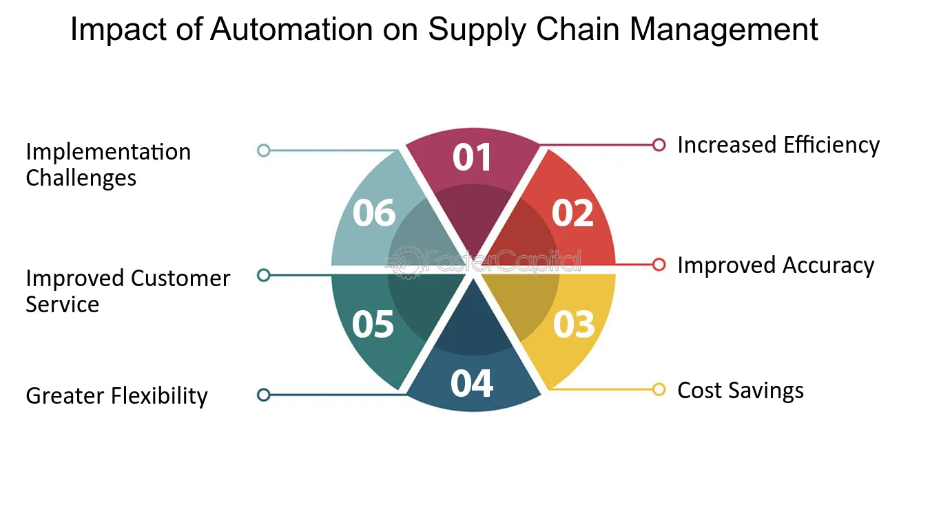

Figure.1 Impact of Automation on Supply Chain Management.

  - THEORETICAL FRAMEWORK OF THE STUDY

A STUDY PUBLISHED BY THE RESEARCHER " Duncan Mcfarlane& Yossi Sheffi" THIS IS A SUMMARY OF THE SCIENTIFIC PAPER

Abstract
Automated Identification (Auto ID) applications can provide corporate information systems with the identity of each physical item in the supply chain in an automated and timely manner. The real time availability of item identity allows other information, related to the item, to be drawn on in order to assess both the current state of the product and future actions required. In the context of supply chain operations, widespread introduction of such systems represents a major opportunity to overhaul and improve tracking and tracing systems, process control and inventory management. In the longer term, it is possible that Auto ID systems may enable a complete re-engineering of the supply chain, by removing a number of the constraints that limit today's supply chain structures. In this paper, we review some key challenges in supply chain operations and introduce the main elements of an Auto ID system. Using a simple categorization of supply chain operations, areas for short term deployment of Auto ID are identified and opportunities for longer term re-engineering of different sections of the supply chain are highlighted. (Fig. 2).
Keywords
The Impact of Automatic Identification on Supply Chain Operations.

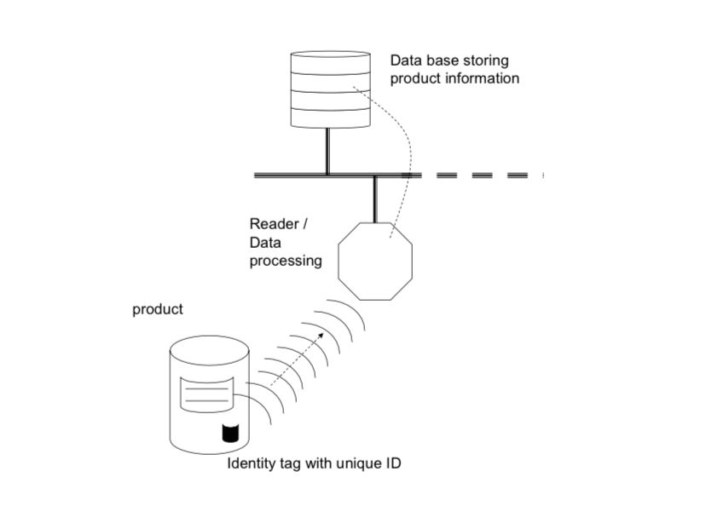
Figure.1 Simple Schematic of an Auto ID System.

Summarized of Abstract

The abstract of "The Effect of Automation on Supply Planning" explores how automation improves data collection and analysis, thereby revolutionizing traditional supply planning. Better inventory management, real-time demand forecasting, and increased efficiency all result in more accurate decisions and lower expenses. Additionally, automation makes it easier for stakeholders to collaborate, which enables a more flexible reaction to changes in the market. The study does, however, point out some possible disadvantages, including the requirement for staff retraining and the danger of becoming overly dependent on automated systems. In the end, it highlights how crucial it is to preserve human judgment in the decision-making process while utilizing automation to enhance supply planning.

