Chapter 5: Conclusions, Recommendations, and Future Work
5.1 Introduction
This chapter summarizes the major findings of the study and highlights its scientific and practical contributions. It also presents recommendations for improving intelligent email management systems and suggests several directions for future research.
5.2 Conclusions
The experimental results demonstrated that the proposed DistilBERT-based multi-task learning model successfully achieved the objectives of this study. The model was capable of performing both multi-label email category classification and priority classification within a single architecture while outperforming the traditional baseline models.
Compared with Logistic Regression and Linear SVM, the proposed model consistently achieved higher classification performance on the independent holdout test set. For category classification, the model achieved a Macro F1-score of 0.9672 with a Hamming Loss of 0.0175, indicating highly accurate multi-label predictions. For priority classification, it achieved an overall Accuracy of 0.9529, a Macro F1-score of 0.9327, and a High Priority Recall of 0.8627, demonstrating its ability to identify critical emails more effectively than the baseline models.
The study also demonstrated the effectiveness of the multi-task learning framework, where a shared DistilBERT encoder successfully learned contextual representations that supported both classification tasks simultaneously. This design simplified the overall system architecture by eliminating the need to develop separate models for category classification and priority prediction.
Furthermore, threshold tuning proved to be an effective post-processing technique. By increasing the category decision threshold from 0.50 to 0.60, the model achieved a slight improvement in Macro F1-score together with a reduction in Hamming Loss without requiring any additional training or architectural modifications.
Finally, integrating Explainable Artificial Intelligence (XAI) through the LIME algorithm enhanced the interpretability of the proposed system by identifying the textual features that contributed most to each prediction. This increased the transparency of the model and strengthened confidence in its predictions.
Figure (5.1): Overall Framework of the Proposed Study
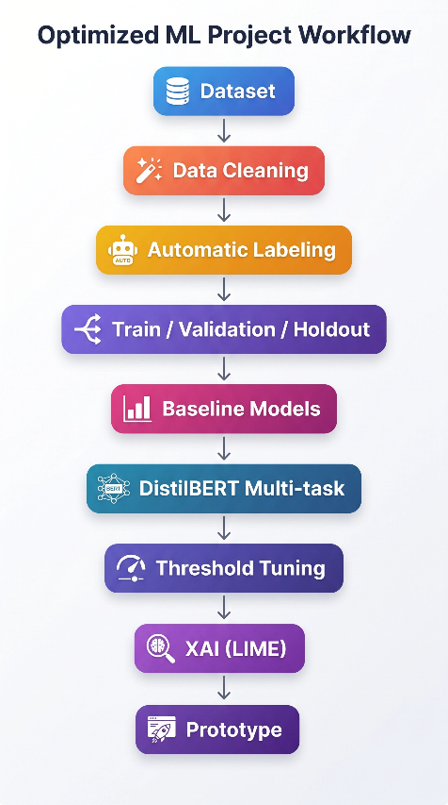
Figure 5.1 summarizes the complete workflow of the proposed study, beginning with dataset preparation and preprocessing, followed by model development, performance optimization through threshold tuning, model interpretation using LIME, and finally prototype implementation
5.3 Study Contributions
The study provides several important contributions that extend beyond improving classification performance.
First, it proposes an integrated multi-task learning framework capable of simultaneously performing email category classification and priority prediction using a single DistilBERT model.
Second, it demonstrates that contextual language models substantially outperform traditional TF-IDF-based machine learning approaches for intelligent email management.
Third, it shows that simple inference-time optimization through threshold tuning can improve multi-label classification performance without increasing computational cost.
Fourth, it integrates Explainable Artificial Intelligence (LIME) into the proposed framework, enabling individual predictions to be interpreted and increasing model transparency.
Finally, the study presents a functional prototype that demonstrates the practical applicability of the proposed approach in real email management environments.
Figure (5.2): Main Contributions of the Study
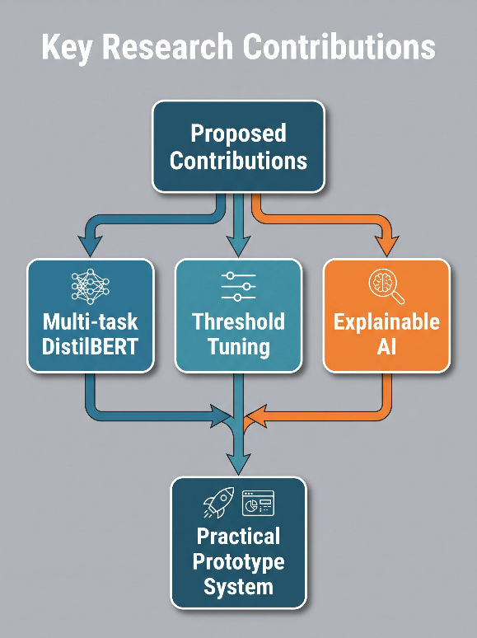
Figure 5.2 summarizes the main scientific and practical contributions achieved by the proposed framework, including the DistilBERT multi-task architecture, threshold optimization, explainable artificial intelligence, and the implementation of a practical prototype.

5.4 Recommendations
Based on the findings of this study, the following recommendations are proposed:
- Deploy transformer-based multi-task learning models in intelligent email management systems.
- Apply threshold tuning as a standard post-processing step for multi-label classification tasks.
- Incorporate Explainable AI techniques to improve user trust and system transparency.
- Continuously retrain models using newly collected organizational emails to maintain performance over time.
- Integrate the proposed framework with enterprise document management and administrative communication systems
5.5 Future Work
Several directions can be explored to extend the current study.
Future research may investigate larger transformer architectures such as BERT, RoBERTa, or DeBERTa to determine whether further performance improvements can be achieved.
The proposed framework may also be extended to multilingual email classification, particularly Arabic-English bilingual environments frequently encountered in governmental organizations.
Additional email attributes such as attachments, sender information, timestamps, and conversation history could be incorporated to improve classification accuracy.
Future work may also explore adaptive threshold optimization techniques that dynamically adjust decision thresholds according to class distributions.
Finally, the proposed model could be deployed and evaluated within a real organizational email management system to measure its effectiveness under operational conditions.
Figure (5.3): Future Research Directions
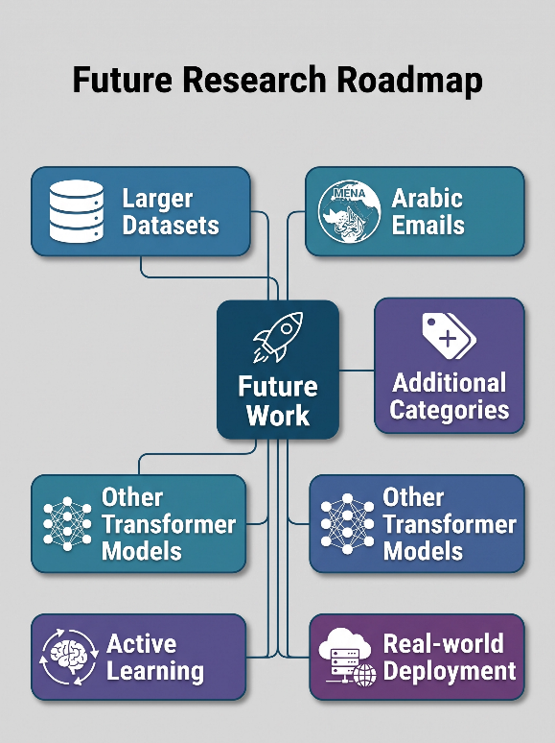
Figure 5.3 illustrates several potential directions for extending the proposed framework, including the use of larger datasets, multilingual email collections, additional classification categories, alternative transformer architectures, active learning techniques, and deployment within real-world email management systems.
5.6 Chapter Summary
This chapter summarized the major findings of the study and confirmed that the proposed DistilBERT multi-task model successfully achieved the research objectives.
The experimental results demonstrated substantial improvements over traditional machine learning models in both category classification and priority prediction. In addition, threshold tuning further enhanced multi-label classification performance, while the integration of LIME increased the transparency and interpretability of the model.
Overall, the study provides an effective framework for intelligent email management that combines contextual language understanding, multi-task learning, inference-time optimization, and explainable artificial intelligence within a unified architecture.

