

A Deep Learning Framework for Early Classification of Chronic Kidney Disease Using Structured Clinical Data
Prepared By
Name: Nasser Naim Qanabta ID No.: 251003169

Submitted in fulfillment of the requirements for the degree Master of Science in Artificial Intelligence
At
Collage of Informatics
Midocean University
UAE
Supervisor Name: Wesam Ahmed
Collage of Informatics, Midocean University, Comoros
Email: wesamahmed@midocean.edu.km

Acknowledgements

Special thanks to Dr. Wesam Ahmed for her guidance and support during this research.

Abstract

List of Publications

Table of Contents
Acknowledgements iii
Abstract iv
List of Publications iv
List of Abbreviations vi
List of Figures vii
List of Tables viii
Chapter 1 Introduction 1
1.1 Problem Definition 1
1.2 Thesis Objectives 2
1.3 Thesis Contribution 2
1.4 Thesis Organization 3
Chapter 2 Overview 4
2.1 Introduction 4
2.2 Literature Review and Related Work 5
2.3 Research Gap 6
2.4 Dataset Overview 7
2.5 Key Features and Clinical Relevance 9
2.6 Data Preprocessing 9
2.7 Exploratory Data Analysis (EDA) 10
2.8 Proposed System Architecture 11
2.9 Deep Neural Network (DNN) Architecture 11
2.10 Explainability Using SHAP 12
2.11 Evaluation Metrics 13
2.12 Summary 13
References 14

List of Abbreviations
- AI: Artificial Intelligence
- ANN: Artificial Neural Networks
- AUC: Area Under the Curve
- BLSTM: Bidirectional Long Short-Term Memory
- CKD: Chronic Kidney Disease
- CNN: Convolutional Neural Network
- DL: Deep Learning
- DNN: Deep Neural Network
- EDA: Exploratory Data Analysis
- LSTM: Long Short-Term Memory
- ML: Machine Learning
- NLP: Natural Language Processing
- PCA: Principal Component Analysis
- ReLU: Rectified Linear Unit
- RF: Random Forest
- ROC: Receiver Operating Characteristic
- SHAP: SHapley Additive exPlanations
- XAI: Explainable Artificial Intelligence

Note: The following abbreviations (CNN, LSTM, BLSTM, RF, NLP, ANN, PCA) are used only in the Literature Review (Section 2.2) to describe previous studies and are not part of the implemented methodology in this thesis

List of Figures
2.1 Global Prevalence of Chronic Kidney Disease…………………………… | 3
2.2 Hierarchy of Artificial Intelligence technologies and their relationships.… | 4
2.8 Proposed System Architecture for CKD Classification…………………… | 9

List of Tables
2.1 Description of CKD Dataset Features ………………………… 6

Chapter 1 Introduction
Chronic Kidney Disease (CKD) is a progressive, often silent condition that affects approximately 10% of the global population and is considered a major contributor to morbidity and mortality worldwide. The early stages of CKD are typically asymptomatic, making timely detection challenging. Traditional diagnostic methods rely on manual interpretation of clinical and laboratory results, which can be time-consuming and prone to human error.
The emergence of artificial intelligence (AI), particularly deep learning (DL), offers new possibilities in automating disease detection and enhancing diagnostic accuracy. Deep learning models have shown strong potential in processing structured clinical data and uncovering non-linear relationships between features and health outcomes. However, many AI models lack explainability, which limits their adoption in clinical settings.
This research aims to develop a deep learning-based classification model for early detection of CKD using real-world clinical data. The model will also integrate explainable AI (XAI) techniques, specifically SHAP (SHapley Additive exPlanations), to ensure transparency and support medical decision-making.

Problem Definition
Despite the high prevalence and clinical significance of CKD, many cases remain undiagnosed until the disease reaches advanced stages. The delayed diagnosis is often due to reliance on traditional diagnostic processes that do not scale efficiently and may overlook complex interactions among patient variables. Moreover, the increasing volume of electronic medical records calls for automated solutions that can support early, accurate, and scalable detection of chronic conditions like CKD.
There is a growing need for AI-based models that can analyze clinical features and classify patients as CKD or not CKD accurately and explainably. Such models must be capable of generalizing across patient populations and providing insights that clinicians can trust.

Thesis Objectives
The primary objectives of this thesis are as follows:
- To design and implement a deep learning (DNN) model for binary classification of CKD presence using structured clinical data.
- To apply SHAP as an explainability tool to interpret model predictions and identify the most influential features.
- To evaluate the performance of the proposed model using accuracy, precision, recall, F1-score, and AUC.
- To benchmark the DNN model against traditional machine learning classifiers using the same dataset.

1.3 Thesis Contribution
This research makes the following contributions:
- Development of a deep learning pipeline for CKD classification using real-world, large-scale clinical data.
- Integration of SHAP to enhance model transparency and support clinical interpretation.
- Empirical comparison between deep learning and traditional machine learning approaches in CKD detection.
- Demonstration of the feasibility of explainable AI models in supporting clinical decision-making.
Importance and Value Added:
This project fills a critical gap in the literature by providing an accurate, explainable, and scalable solution for early CKD classification using a large, real-world dataset. By integrating SHAP, it bridges the gap between predictive performance and clinical trust, supporting real-world adoption in healthcare settings. The project also demonstrates how explainable AI can uncover new clinical patterns and support evidence-based decision-making.

1.4 Thesis Organization
The remainder of the thesis is structured as follows:
- Chapter 1 Introduces the research topic, defines the problem, and presents the study objectives and contributions.
- Chapter 2 Reviews the literature, describes the dataset, and discusses the deep learning and explainability techniques used.

Chapter 2 Overview

2.1 Introduction
Chronic Kidney Disease (CKD) is a long-term, progressive condition characterized by the irreversible loss of kidney function. Globally, CKD affects over 800 million people, with many cases going undetected until advanced stages due to its asymptomatic nature. Early diagnosis is essential to prevent complications such as cardiovascular events, kidney failure, and increased healthcare burden.
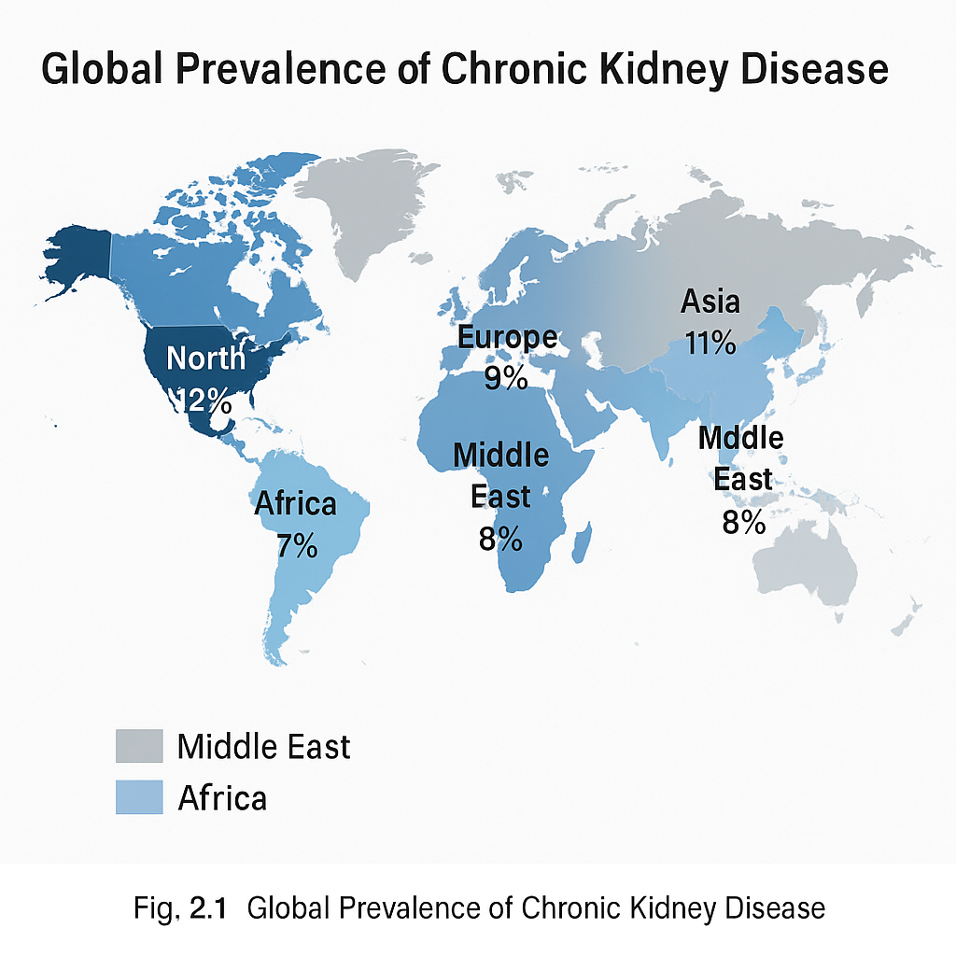
Fig. 2.1: Global Prevalence of Chronic Kidney Disease illustrating regional variations in CKD prevalence.
In recent years, the application of artificial intelligence (AI) in medicine has opened new possibilities for disease detection and classification. Among AI approaches, deep learning (DL) has shown superior performance in processing structured clinical data, allowing the automatic discovery of complex relationships between patient features and disease outcomes.
This chapter provides an overview of related work in AI-based CKD detection, introduces the dataset used in this research, describes the technologies employed, and outlines the research gap that this thesis aims to address.

2.2 Literature Review and Related Work
In recent years, the application of artificial intelligence (AI) in medicine has opened new possibilities for disease detection and classification.
Fig. 2.2: Hierarchy of Artificial Intelligence technologies and their relationships, illustrating the roles of Machine Learning (ML), Deep Learning (DL), Natural Language Processing (NLP), and Large Language Models (LLMs).

Numerous studies have explored the use of machine learning (ML) and deep learning models for the detection of CKD. Traditional ML models such as logistic regression, support vector machines (SVM), decision trees (DT), and random forests (RF) have been widely used for binary classification tasks. For example, early studies applied these models on the UCI CKD dataset, achieving moderate accuracy, often in the range of 85–95%.
However, traditional ML models rely heavily on feature engineering and are limited in capturing non-linear relationships. Deep learning models, on the other hand, can learn hierarchical representations of input data, which is particularly valuable when working with complex clinical variables.
A recent study by Saif et al. (2024) proposed a deep learning framework called Deep-kidney, which combines CNN, LSTM, and BLSTM models in an ensemble architecture to predict CKD up to 12 months in advance. Their approach demonstrated exceptional accuracy (over 99.3%) using a large dataset of over 90,000 insurance records. However, their work focused on prediction rather than real-time classification and did not utilize structured laboratory features such as serum creatinine or hemoglobin. Moreover, the complexity and computational cost of their ensemble model make it less feasible for clinical settings with limited resources.
In contrast, this thesis focuses on real-time classification of CKD presence using structured clinical data. It adopts a simpler deep neural network (DNN) model and integrates SHAP (SHapley Additive exPlanations) to ensure transparency and interpretability.
Clinical Impact:
By focusing on real-time classification and explainability, this work directly supports clinicians in making timely, data-driven decisions and helps bridge the gap between AI research and practical healthcare application.

2.3 Research Gap
While the literature shows strong progress in AI-driven CKD detection, several gaps remain:
- Prediction vs. Classification: Many studies aim to predict CKD occurrence in the future, which is different from real-time classification used in clinical diagnosis.
- Lack of Explainability: Few deep learning models provide interpretable outputs, which limits clinical trust and applicability.
- Dataset Limitations: Some studies rely on small or synthetic datasets, or use administrative billing codes instead of real laboratory data.
This research addresses these issues by:
- Focusing on binary classification (CKD / Not CKD) for real-time clinical use.
- Using a real-world dataset with structured lab and clinical features.
- Incorporating SHAP to provide explanation for each prediction, enhancing transparency and trust.
Clinical Reasoning:
Using SHAP not only explains model predictions, but also allows for the discovery of new clinical patterns that may not be obvious to practitioners, thereby supporting evidence-based medicine and personalized care.

2.4 Dataset Overview
The dataset used in this study is the Chronic Kidney Failure Dataset – Reboot, available on Kaggle. It consists of 15,051 patient records, each representing a single patient and including 25 features. These features cover demographic information (e.g., age), laboratory test results (e.g., serum creatinine, blood urea, hemoglobin), and medical history (e.g., hypertension, diabetes, anemia).
The target variable is binary: ckd or notckd. This setup supports a supervised learning approach for binary classification using clinical data.

Table 2.1: Description of CKD Dataset Features
Feature Name | Description | Type | Clinical Relevance
Age | Patient age (years) | Numeric | Risk factor
Blood Pressure (bp) | Systolic/diastolic (mm/Hg) | Numeric | Hypertension, CKD risk
Specific Gravity (sg) | Urine concentration | Categorical | Kidney concentrating ability
Albumin (al) | Urine albumin levels | Categorical | Marker of kidney damage
Sugar (su) | Urine sugar levels | Categorical | Diabetes, kidney function
Red Blood Cells (rbc) | Normal/abnormal | Categorical | Anemia, kidney function
Pus Cell (pc) | Normal/abnormal | Categorical | Infection, inflammation
Pus Cell Clumps (pcc) | Present/absent | Categorical | Infection
Bacteria (ba) | Present/absent | Categorical | Infection
Blood Glucose Random (bgr) | mg/dl | Numeric | Diabetes, kidney risk
Blood Urea (bu) | mg/dl | Numeric | Kidney filtration
Serum Creatinine (sc) | mg/dl | Numeric | Key marker for CKD
Sodium (sod) | mEq/L | Numeric | Electrolyte balance
Potassium (pot) | mEq/L | Numeric | Electrolyte balance
Hemoglobin (hemo) | gms | Numeric | Anemia, CKD
Packed Cell Volume (pcv) | % | Numeric | Anemia, kidney function
White Blood Cell Count (wc) | cells/cmm | Numeric | Infection, inflammation
Red Blood Cell Count (rc) | millions/cmm | Numeric | Anemia, kidney function
Hypertension (htn) | Yes/No | Categorical | Major CKD risk factor
Diabetes Mellitus (dm) | Yes/No | Categorical | Major CKD risk factor
Coronary Artery Disease (cad) | Yes/No | Categorical | Comorbidity
Appetite (appet) | Good/Poor | Categorical | Nutritional status

2.5 Key Features and Clinical Relevance
The features included in the dataset are clinically significant indicators used by nephrologists to evaluate kidney function. The most important variables identified in both literature and exploratory analysis include:
- Serum Creatinine (sc): A key indicator of kidney filtration function; elevated levels suggest impaired kidney performance.
- Blood Urea (bu): Reflects nitrogen waste in the blood; higher levels are associated with reduced kidney clearance.
- Hemoglobin (hemo): Often low in CKD patients due to reduced erythropoietin production by the kidneys.
- Packed Cell Volume (pcv) and Red Blood Cell Count (rc): Related to anemia, which is a common complication in CKD.
- Specific Gravity (sg) and Albumin (al): Reflect urine concentration and presence of proteinuria, both are important in assessing kidney damage.
- Hypertension (htn) and Diabetes Mellitus (dm): Recognized as primary risk factors and frequent comorbidities in CKD patients.
These features form the core of the input space used for training the classification model.

2.6 Data Preprocessing
Prior to model training, several preprocessing steps were applied to ensure data quality and consistency:
- Missing Values Handling: For numeric features, missing values were imputed using the median; for categorical features, the mode was used.
- Encoding: Binary categorical variables (e.g., yes/no) were encoded using label encoding, while multi-class categorical variables were one-hot encoded.
- Normalization: Continuous variables such as creatinine, urea, and hemoglobin were normalized using min-max scaling to ensure uniformity across input features.
- Feature Selection: Correlation analysis was conducted to remove redundant variables, and domain knowledge guided the retention of clinically relevant attributes.
This preprocessing pipeline ensures that the dataset is suitable for training a deep learning model.

2.7 Exploratory Data Analysis (EDA)
Exploratory Data Analysis was performed to identify key patterns in the data. Key findings include:
- Serum Creatinine was significantly higher in CKD patients than non-CKD.
- Hemoglobin and Packed Cell Volume were lower in CKD cases, consistent with anemia.
- Albumin presence in urine was more frequent in CKD cases.
- Heatmaps of feature correlation revealed strong positive association between creatinine and urea, and negative association between hemoglobin and CKD label.
These insights validated the clinical importance of the selected features and provided guidance for model input selection.

2.8 Proposed System Architecture
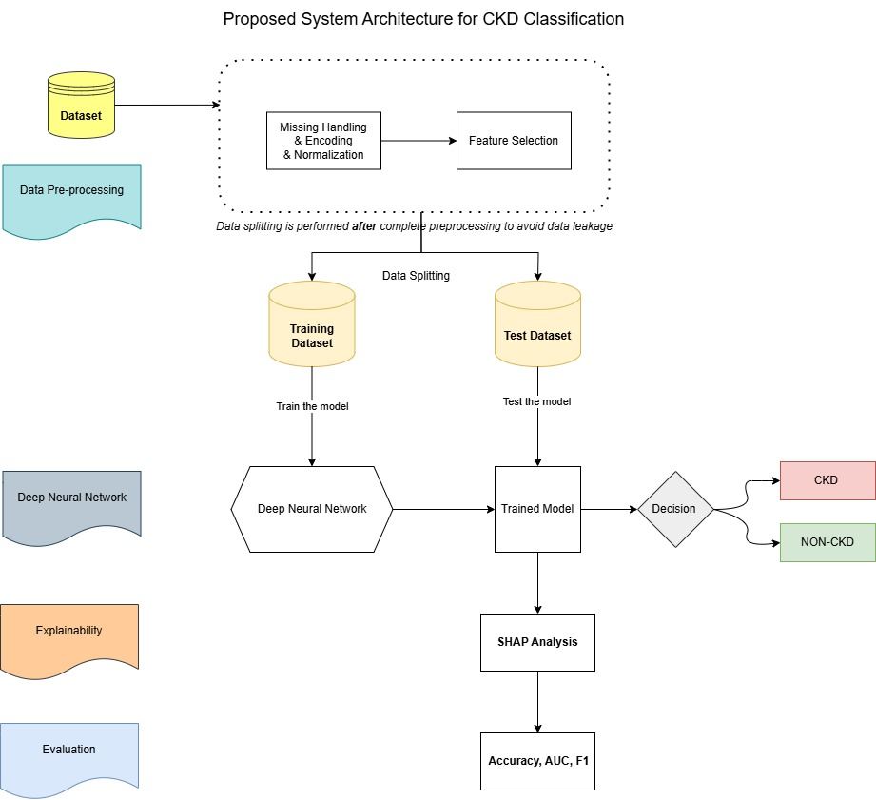
Fig. 2.8: Proposed System Architecture for CKD Classification.
The workflow includes data preprocessing (missing value handling, encoding, and normalization), feature selection, data splitting, DNN model training, SHAP-based explainability, and final classification output. Data splitting is performed after complete preprocessing to avoid data leakage.

2.9 Deep Neural Network (DNN) Architecture
To perform binary classification of CKD, a Deep Neural Network (DNN) model was designed with the following characteristics:
- Input Layer: Number of neurons equal to the number of selected features (e.g., 20–25).
- Hidden Layers: Two fully connected layers with 64 and 32 neurons respectively, activated by ReLU.
- Output Layer: A single neuron with sigmoid activation to output a probability between 0 and 1.
- Loss Function: Binary Cross-Entropy, suitable for binary classification.
- Optimizer: Adam optimizer with learning rate tuning based on validation loss.
- Training: Conducted for 100 epochs using mini-batch gradient descent (batch size 32).
Practical Justification:
This architecture balances model complexity and interpretability, and has demonstrated strong performance in similar clinical classification tasks. DNNs are particularly effective for structured clinical data, as they can capture complex, non-linear relationships between features, supporting more accurate early detection of CKD.

2.10 Explainability Using SHAP
While deep learning models often act as "black boxes," this thesis integrates SHAP (SHapley Additive exPlanations) to interpret the DNN model’s predictions.
- Global Interpretability: SHAP summary plots show the most influential features across the entire dataset.
- Local Interpretability: SHAP provides case-by-case explanations for individual predictions, helping clinicians understand why a specific patient was classified as CKD or not.
For example, a patient with high creatinine and low hemoglobin would have a high SHAP value pushing toward the CKD class. Such insights are valuable for building clinician trust and enhancing model transparency.
Clinical Value:
SHAP not only increases trust in the AI system, but can also reveal new clinical associations and support personalized patient care.

2.11 Evaluation Metrics
To assess the performance of the classification model, several standard metrics are employed:
- Accuracy: Proportion of correct predictions.
- Precision: Proportion of positive predictions that were correct (CKD predicted and truly CKD).
- Recall (Sensitivity): Proportion of actual CKD cases correctly identified.
- F1-Score: Harmonic mean of precision and recall.
- ROC Curve and AUC: Measures the model’s ability to distinguish between classes at different thresholds.
These metrics ensure a comprehensive evaluation, especially important in datasets with class imbalance, and provide a robust assessment of the model’s clinical utility.

2.12 Summary
This chapter presented the clinical background of CKD, reviewed previous work in AI-based detection, and identified current research gaps. It detailed the dataset, preprocessing, model design, explainability strategy, and evaluation metrics. The next chapter will present the detailed methodology and implementation.
pipeline, deep learning architecture, and model evaluation methods. Importantly, it introduced SHAP explainability to bridge the gap between predictive performance and clinical trust.
The next chapter will present the proposed methodology and implementation strategy for training and evaluating the classification model.

References
- KDIGO. (2023). KDIGO 2023 Clinical Practice Guideline for the Evaluation and Management of Chronic Kidney Disease. Kidney International, 104(1S), S1–S125. https://kdigo.org/guidelines/ckd-evaluation-and-management/
- Sabanayagam, C., Banu, R., Lim, C., et al. (2025). Artificial intelligence in chronic kidney disease management: a scoping review. Theranostics, 15(10), 4566–4578. https://www.thno.org/v15p4566.htm
- Saif, D., Sarhan, A. M., & Elshennawy, N. M. (2024). Deep-kidney: an effective deep learning framework for chronic kidney disease prediction. Health Information Science and Systems, 12(3). https://doi.org/10.1007/s13755-023-00261-8

