Midocean Journal Reviewer Notes
Explainable Deep Learning for Bean Leaf Disease Classification Using Attention and Grad-CAM
Prepared for academic review only - please revise the manuscript accordingly before resubmission/publication.

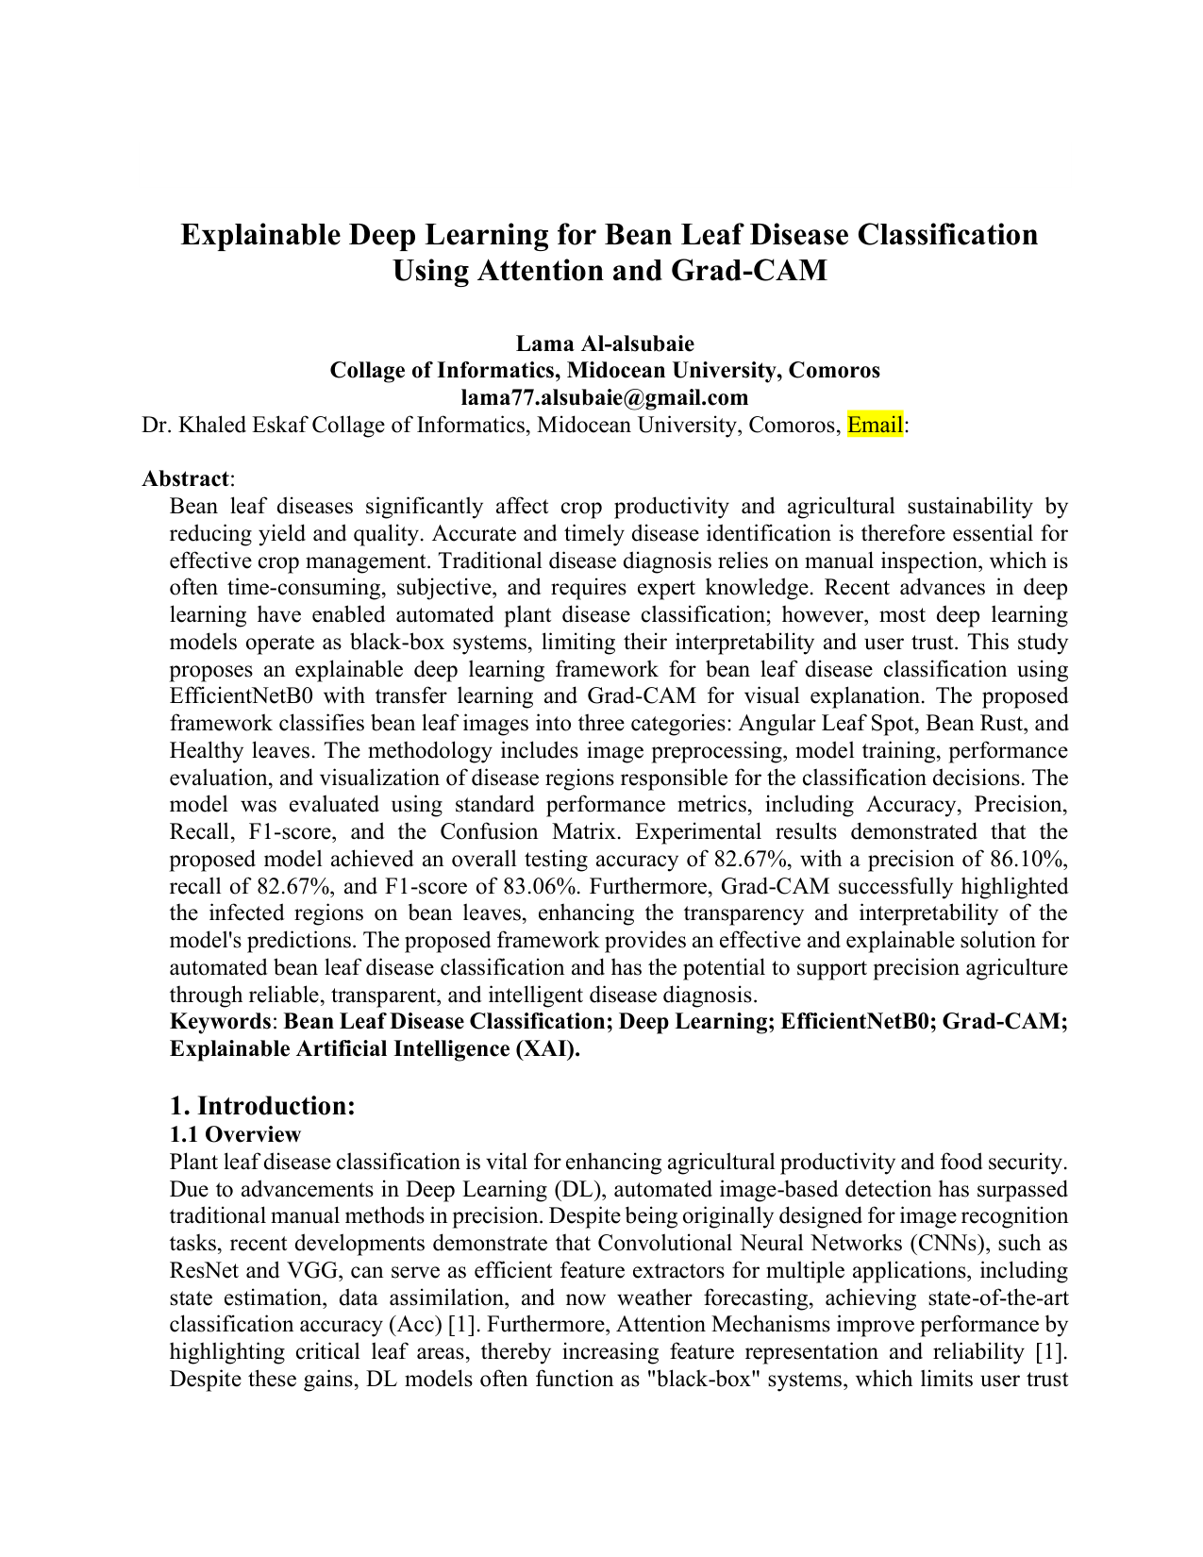 | Reviewer Notes - Page 1  1. Correction: Replace 'Collage of Informatics' with 'College of Informatics' in the author affiliation. Also complete the supervisor's email address or remove the incomplete email field.  2. Reviewer Comment: The title mentions both Attention and Grad-CAM. The paper must clearly state whether an attention mechanism was actually implemented in the model. If the implemented model is EfficientNetB0 + Grad-CAM only, the title should be revised to avoid overclaiming.  3. Reviewer Comment: The abstract is generally informative, but it should include the dataset source, number of images, split strategy, and whether results are reported on an independent test set. This will strengthen reproducibility.  Dr. Khaled Eskaf  khaledeskaf@midocean.edu.km

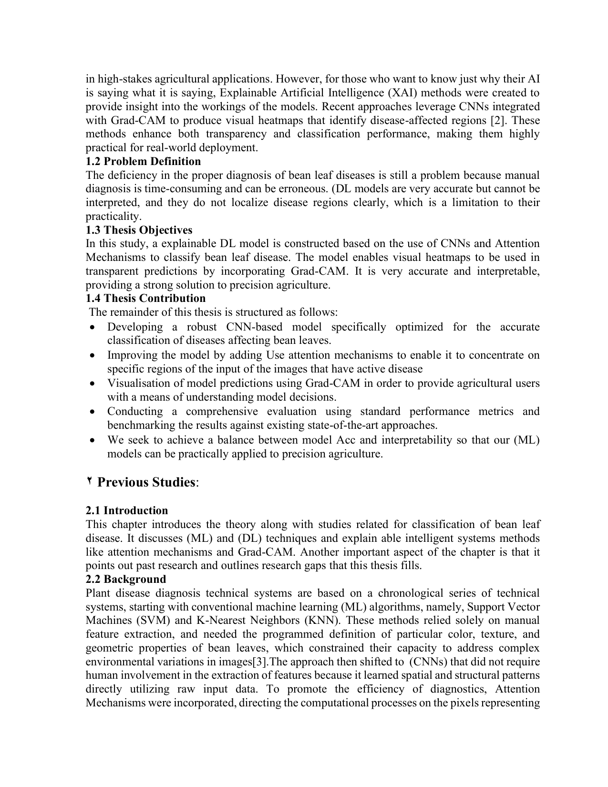 | Reviewer Notes - Page 2  1. Correction: Replace 'Thesis Objectives' and 'Thesis Contribution' with 'Research Objectives' and 'Research Contributions' to match the journal-article format required by Midocean Journal.  2. Reviewer Comment: The problem definition contains language and punctuation issues, including an opening parenthesis before 'DL models' without proper closure. Please rewrite this section in formal academic style.  3. Reviewer Comment: The sentence 'The remainder of this thesis is structured as follows' is not suitable for a journal paper. It should be rewritten as a contribution statement or removed.

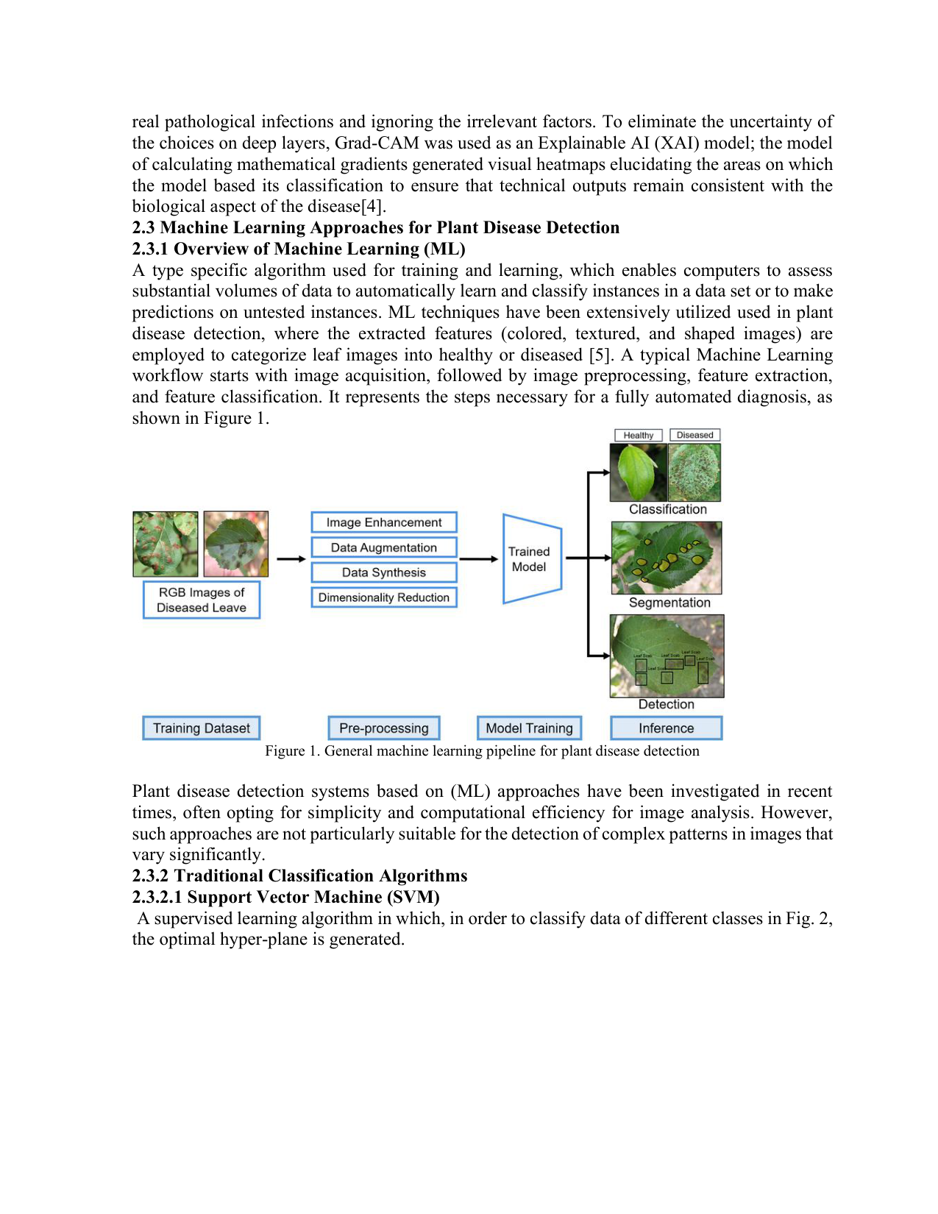 | Reviewer Notes - Page 3  1. Reviewer Comment: This section is largely textbook-style. Please reduce the general explanation of ML and focus more directly on bean leaf disease classification and the research gap.  2. Correction: Ensure that Figure 1 has a clear source citation or state that it was created by the author. The figure caption should follow one consistent journal format.

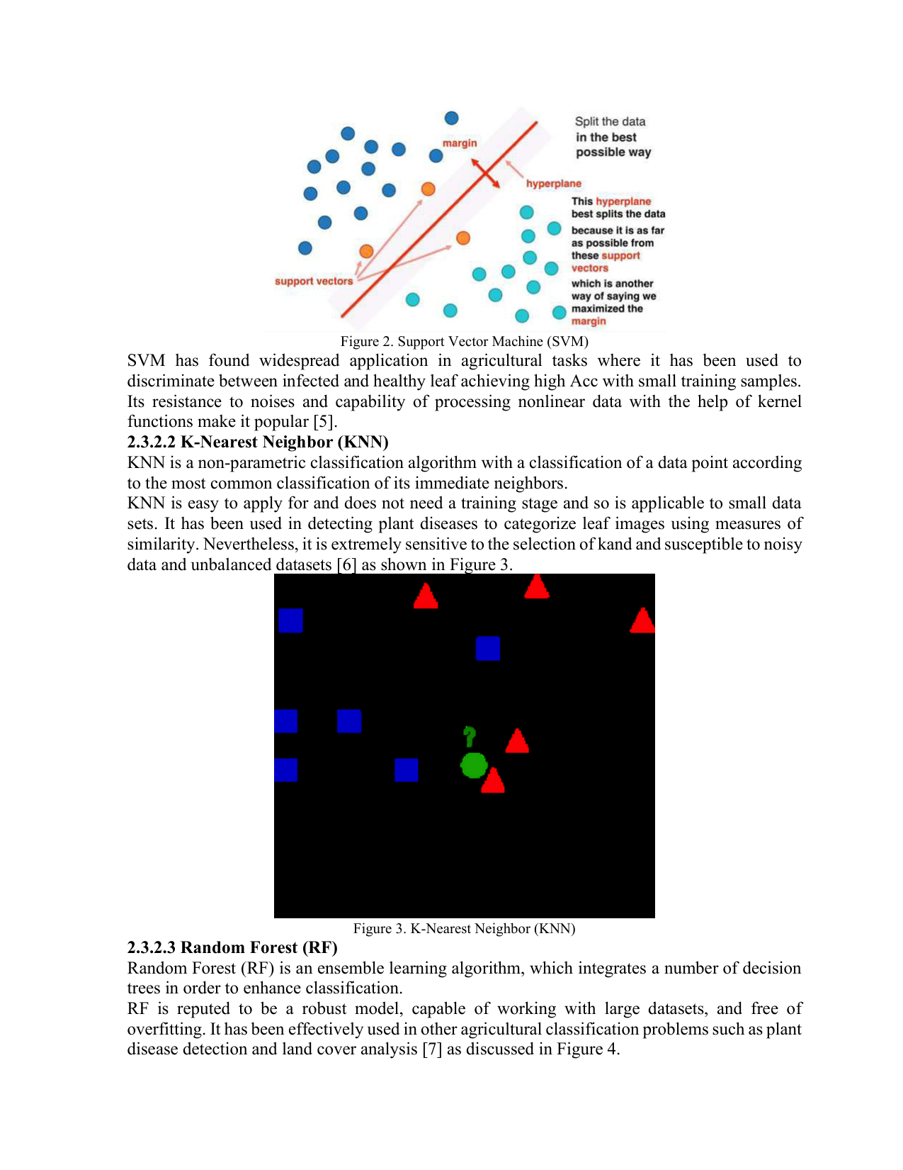 | Reviewer Notes - Page 4  1. Correction: Fix the typo 'selection of kand' to 'selection of k'.  2. Reviewer Comment: Figures 2 and 3 require proper source attribution and permission status. Avoid using generic internet figures without citation.  3. Reviewer Comment: The paragraph on KNN should be connected more clearly to why KNN is limited for bean leaf disease classification.

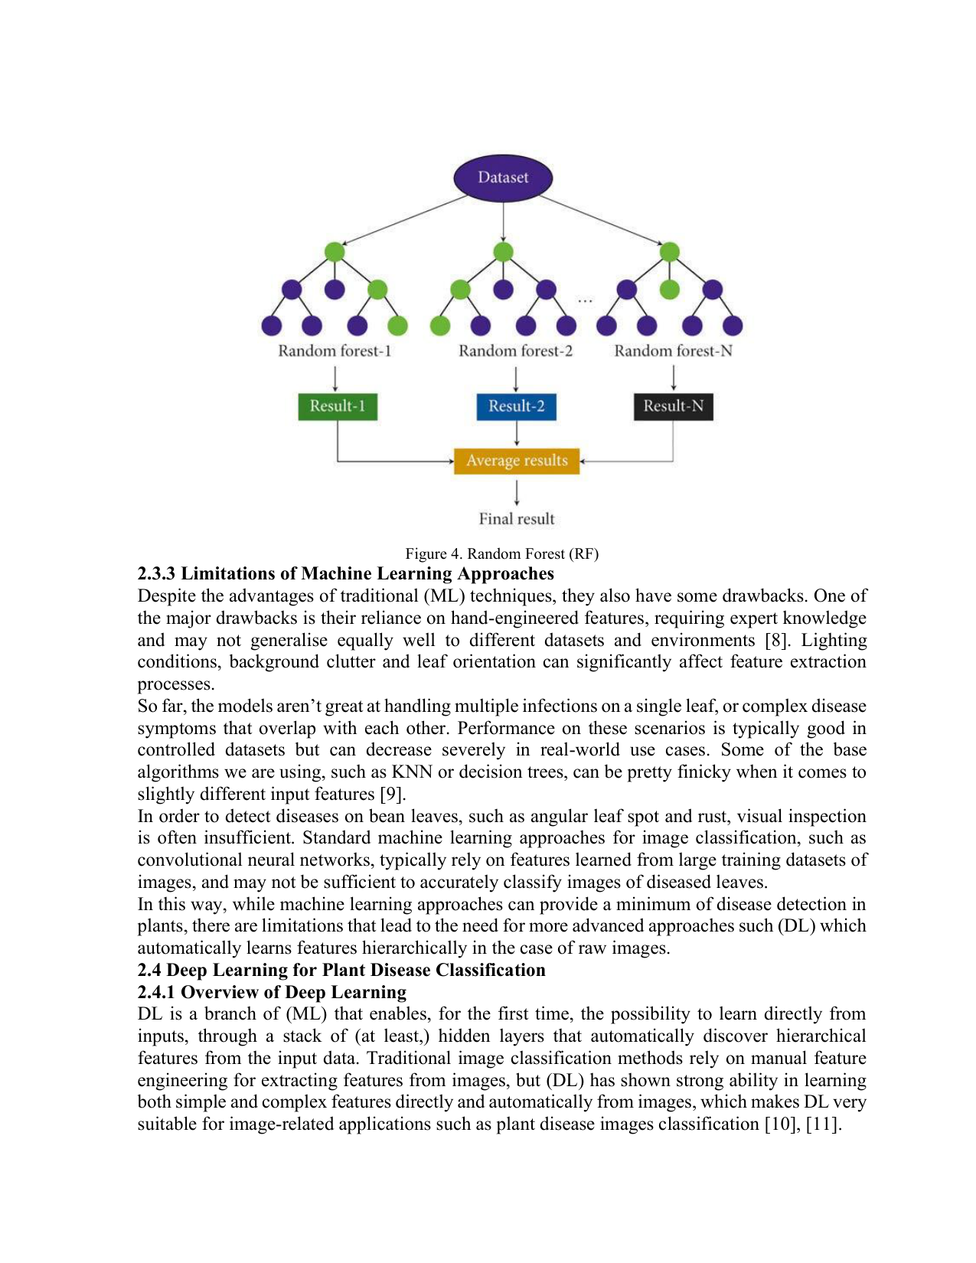 | Reviewer Notes - Page 5  1. Correction: The phrase 'the models aren’t great' and 'pretty finicky' are informal. Rewrite in professional academic language.  2. Reviewer Comment: The sentence describing CNNs as standard machine learning approaches is conceptually inaccurate. CNNs belong to deep learning, not traditional machine learning. Please correct the technical classification.  3. Reviewer Comment: The limitations section should be supported by stronger references and should transition logically to the need for deep learning and explainability.

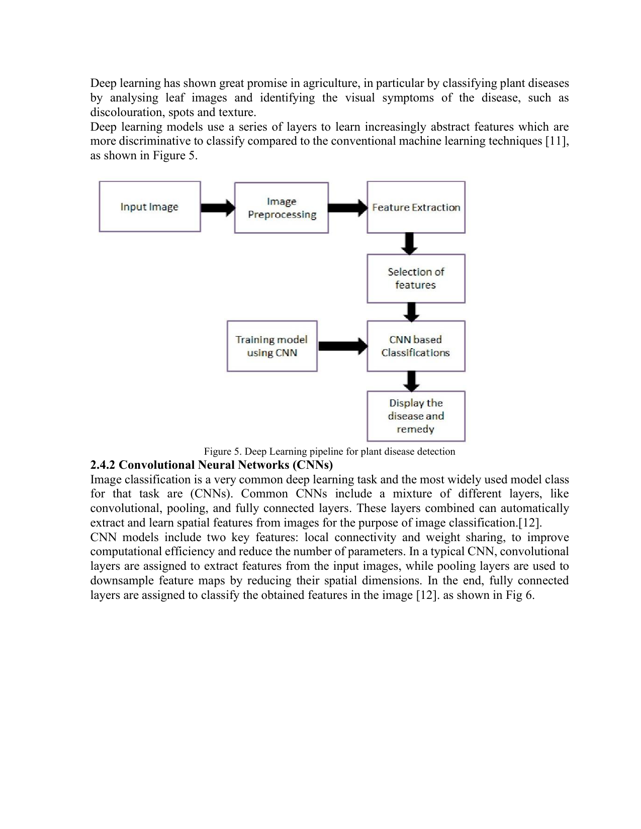 | Reviewer Notes - Page 6  1. Reviewer Comment: Figure 5 should be cited properly or identified as author-created. The figure also includes 'Display the disease and remedy', which is not part of the proposed methodology; please ensure figure content matches the paper scope.  2. Correction: Improve the sentence 'Image classification is a very common deep learning task...' for grammar and academic clarity.

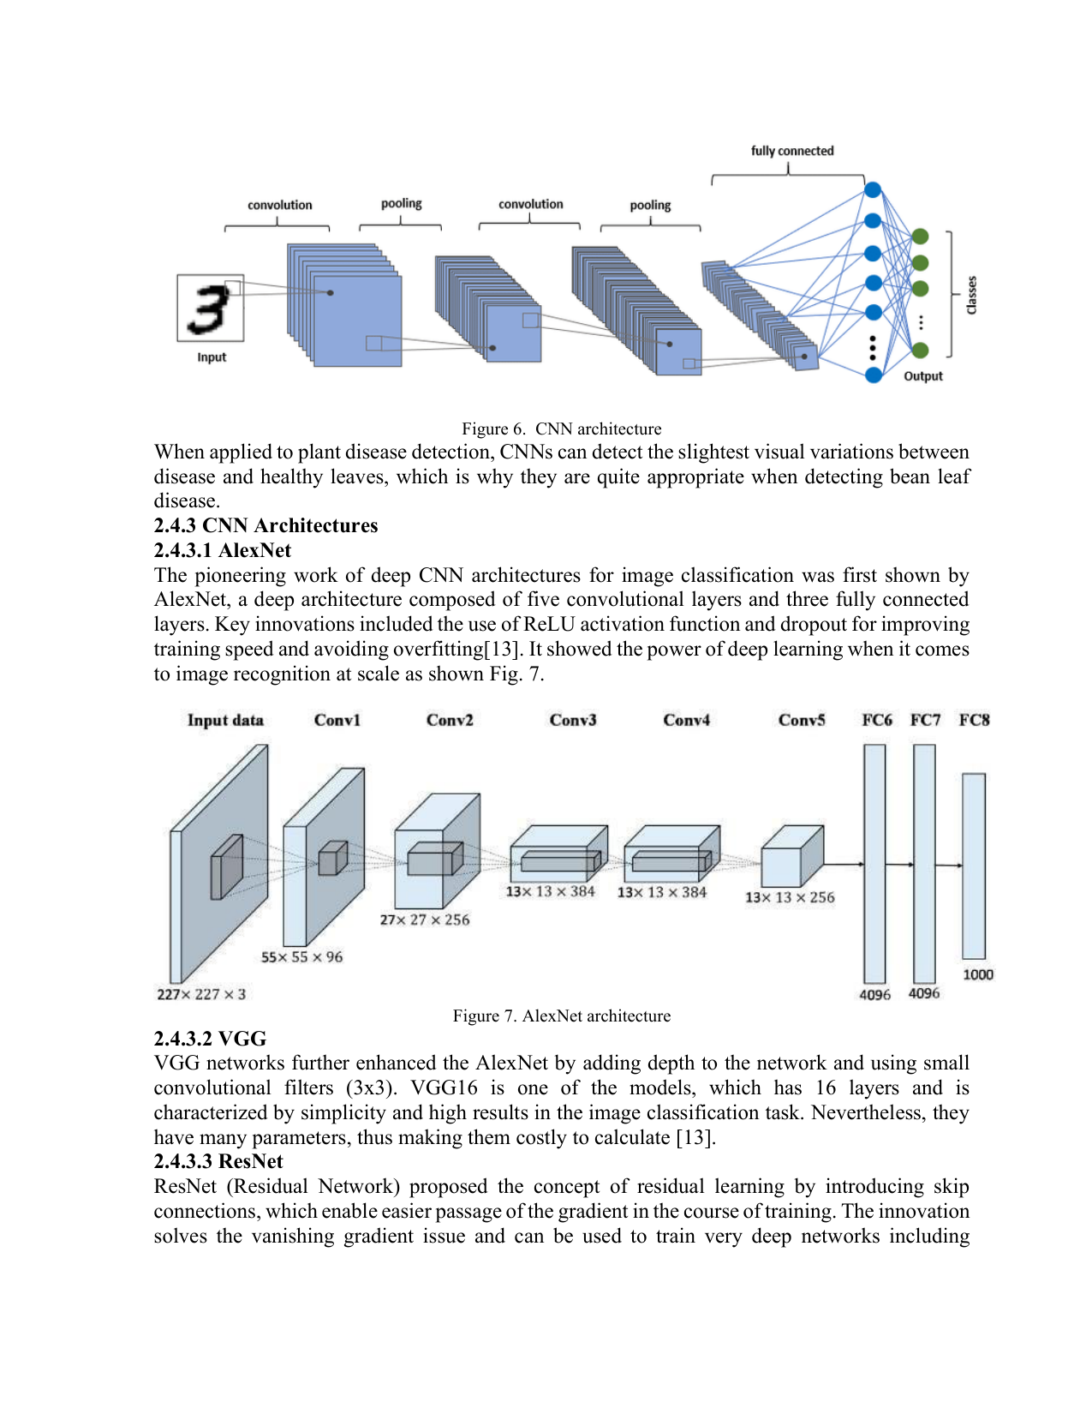 | Reviewer Notes - Page 7  1. Reviewer Comment: The discussion of AlexNet, VGG, and ResNet is useful, but it should be shortened. The paper should give more space to the actual proposed EfficientNetB0 framework and the experimental design.  2. Correction: Ensure all architecture figures have proper references and consistent figure numbering.

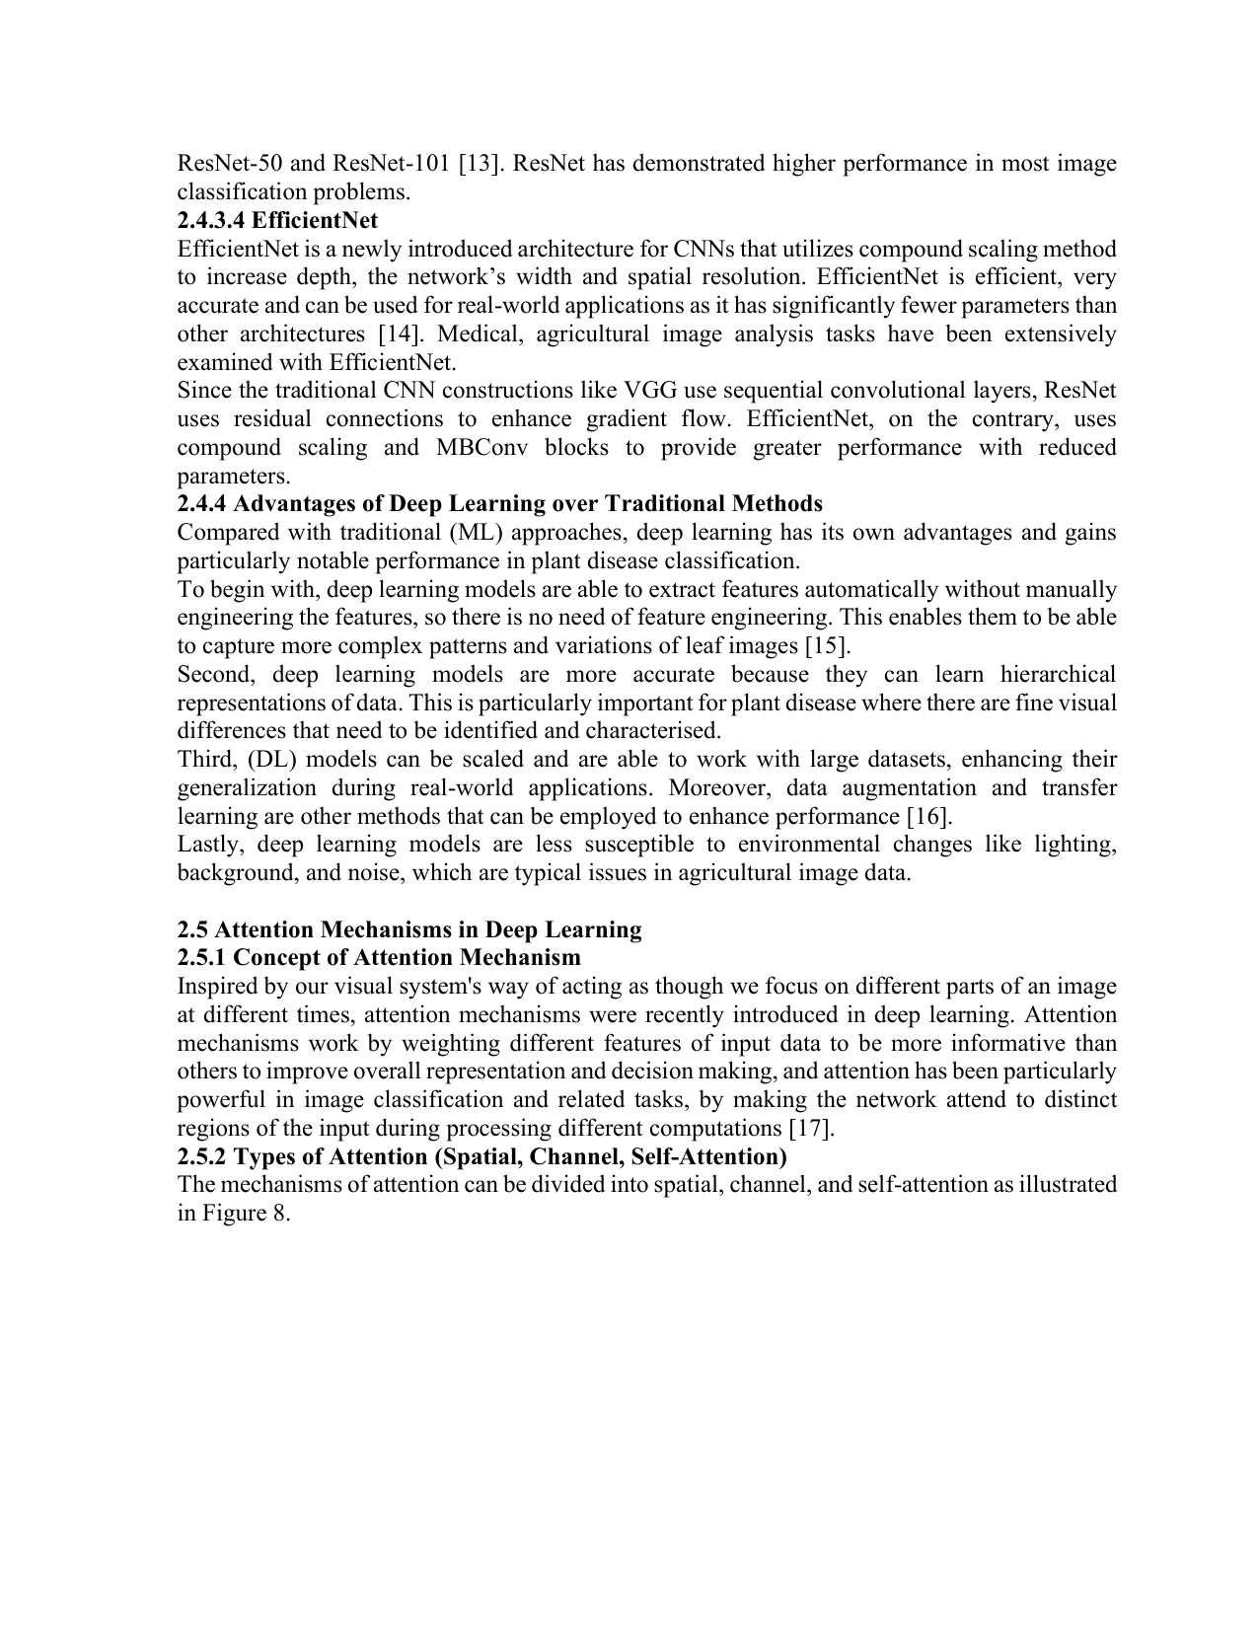 | Reviewer Notes - Page 8  1. Reviewer Comment: The paper repeatedly claims the use of attention mechanisms, but the methodology later describes EfficientNetB0 and Grad-CAM only. Please clarify whether an attention block such as CBAM, SE, or self-attention was implemented and evaluated.  2. Correction: Avoid vague phrases such as 'recently introduced' unless the statement is historically accurate and supported by citation.

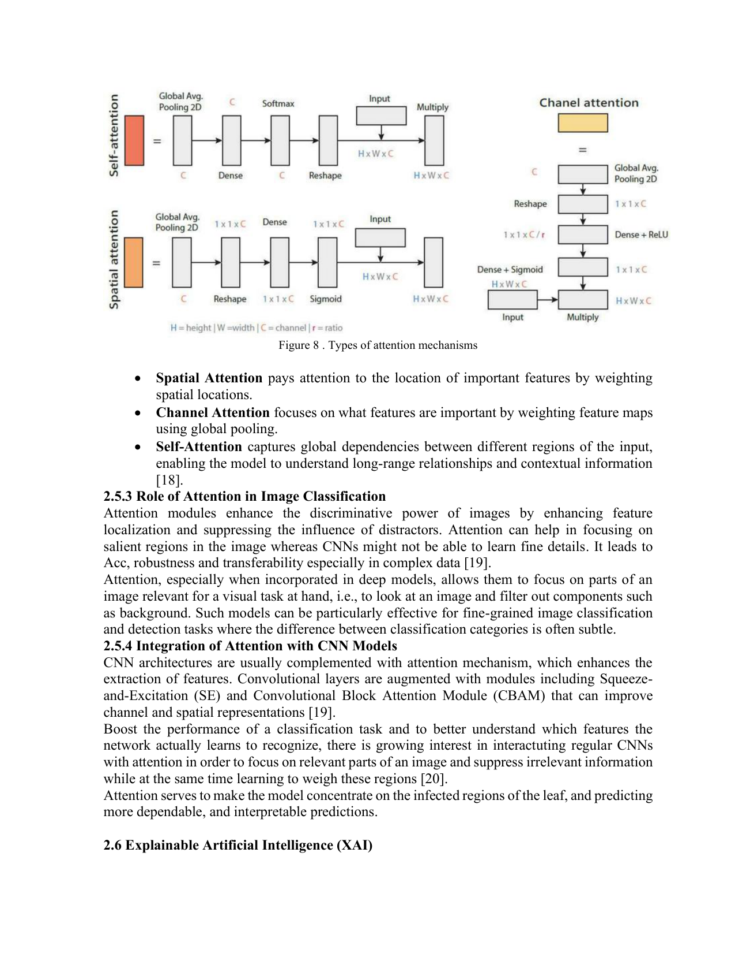 | Reviewer Notes - Page 9  1. Correction: Fix the typo 'interactuting regular CNNs' and rewrite the sentence for clarity.  2. Reviewer Comment: If attention is part of the model, include the attention layer/module architecture, placement in the network, and its contribution to performance. If not, remove attention from the title, abstract, objectives, and framework figure.

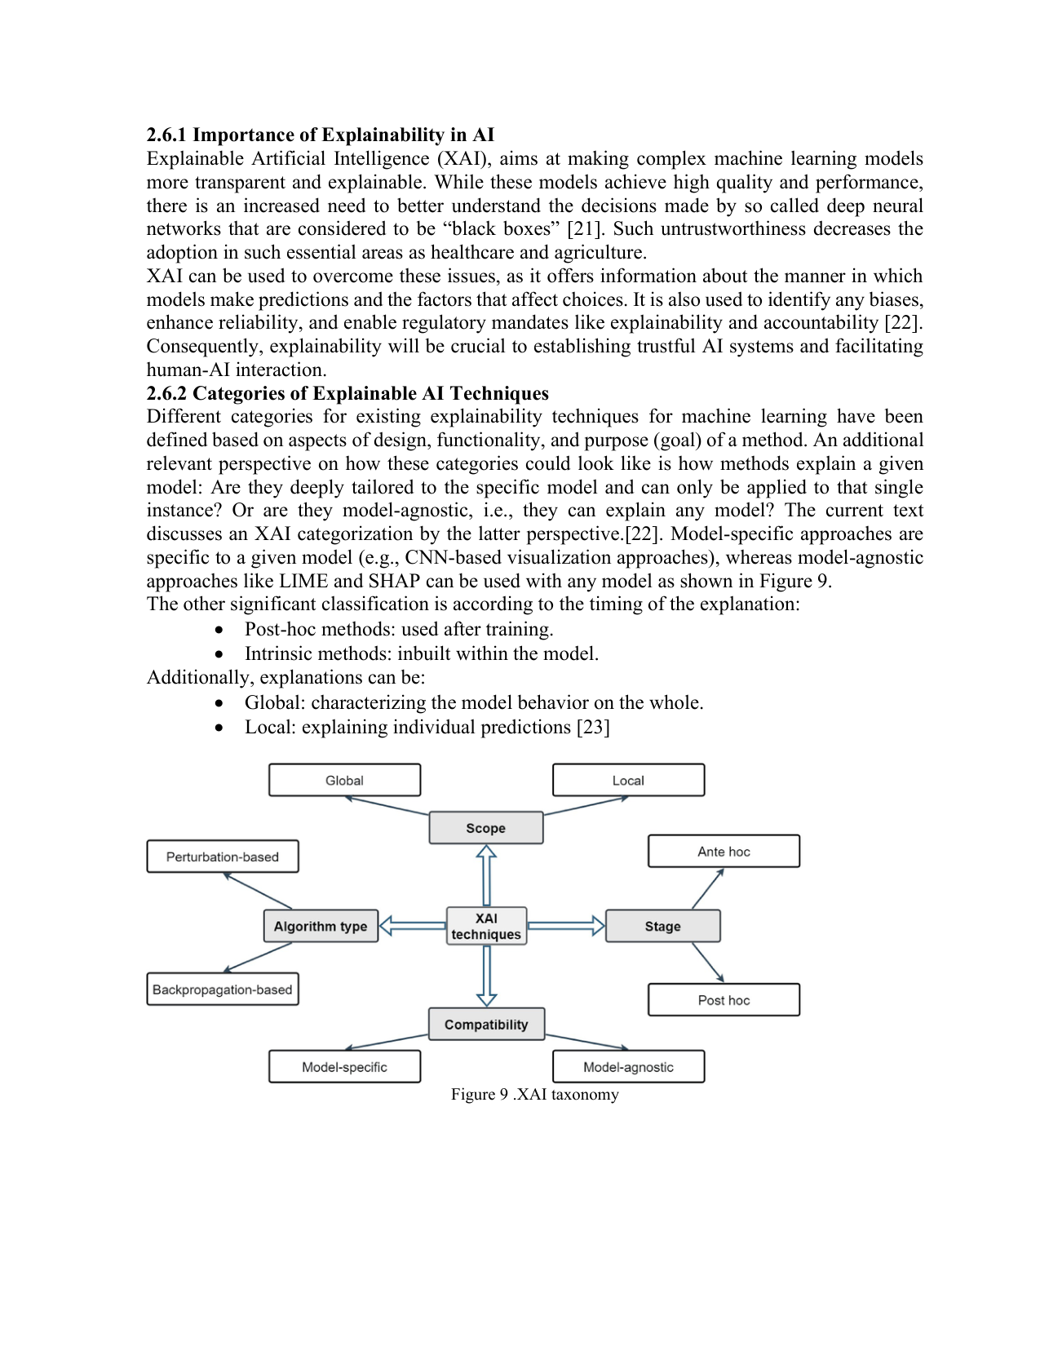 | Reviewer Notes - Page 10  1. Reviewer Comment: The XAI section is relevant, but it is too general. Please connect the explanation more specifically to agricultural users, plant pathology, and trust in disease diagnosis.  2. Correction: Use one consistent terminology: either 'Explainable AI' or 'XAI'. Avoid repeated or informal phrasing.

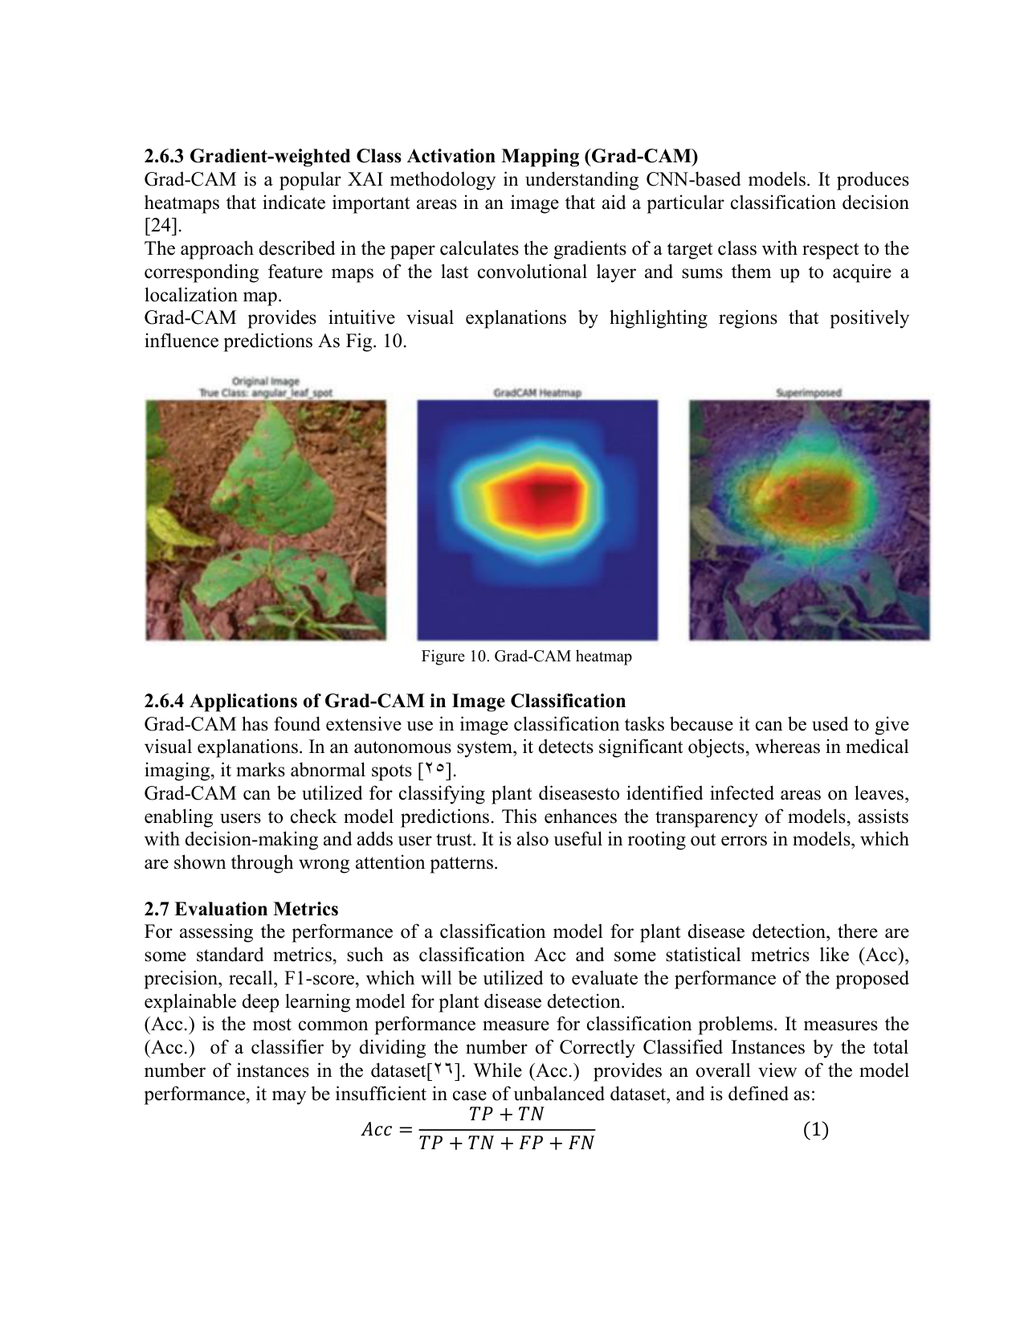 | Reviewer Notes - Page 11  1. Correction: Rewrite 'Grad-CAM provides intuitive visual explanations... As Fig. 10' as a complete academic sentence.  2. Reviewer Comment: For evaluation metrics, specify whether the reported precision, recall, and F1-score are macro, micro, or weighted averages. This is essential when classes are imbalanced.  3. Reviewer Comment: Equations should be formatted consistently and numbered according to the journal style.

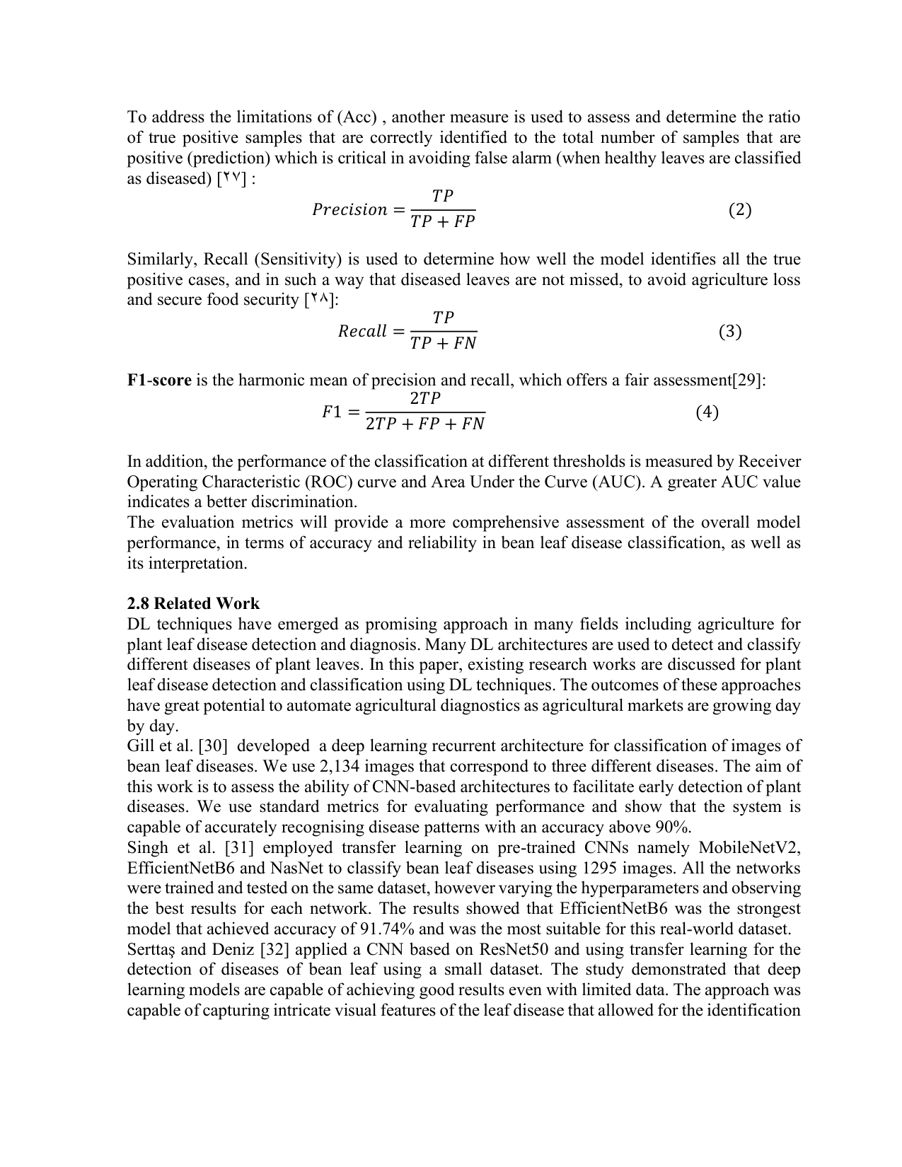  Add in Section 2.8: Khaled Eskaf [45] proposed SmartDate, an AI-driven date-fruit quality-control system using deep learning and intelligent optimization, supporting AI-based precision agriculture. | Reviewer Notes - Page 12  1. Reviewer Comment: The related-work section should provide deeper comparative analysis rather than listing studies one by one. Add a paragraph that explicitly identifies the research gap addressed by this work.  2. Correction: Replace first-person wording such as 'We use' with objective academic wording, unless the journal allows first-person style.

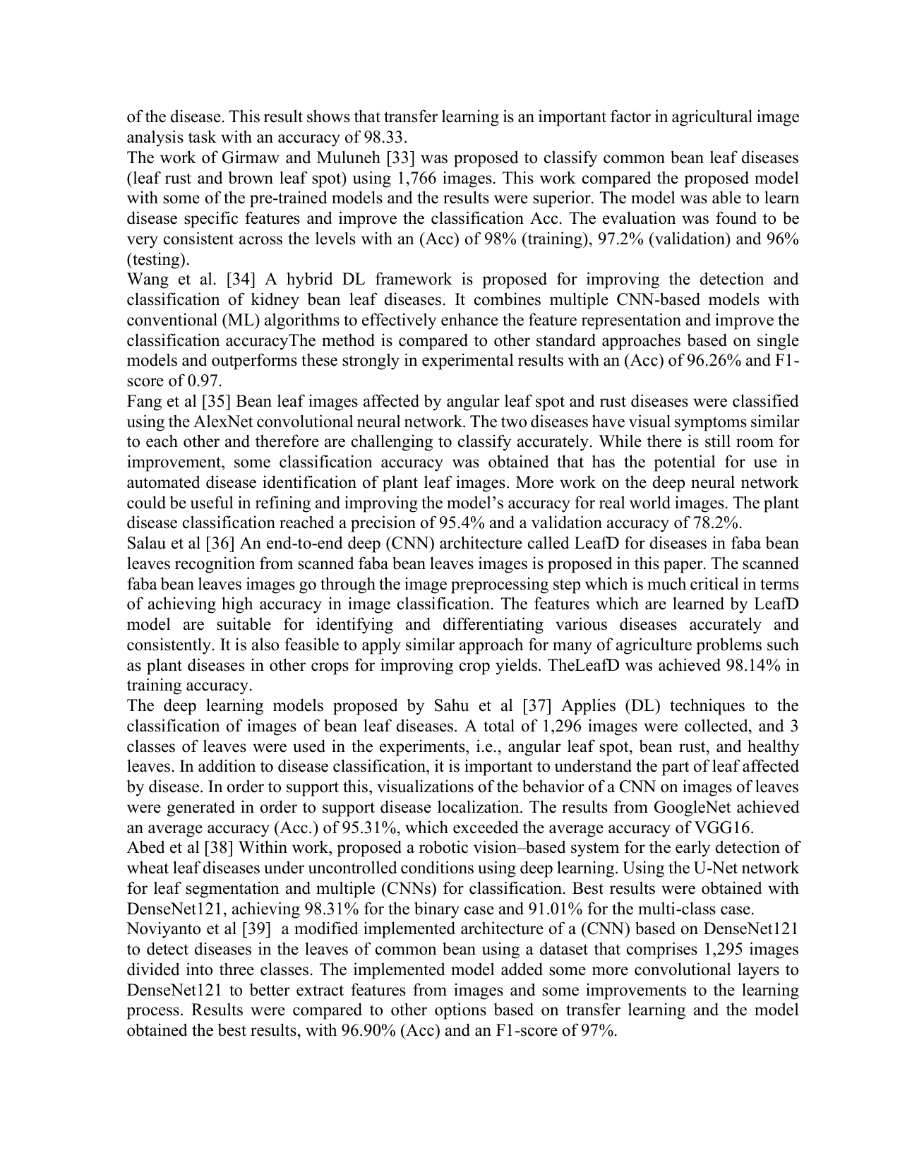 | Reviewer Notes - Page 13  1. Correction: Add missing spaces and punctuation, for example 'classification accuracyThe method' should be 'classification accuracy. The method'.  2. Reviewer Comment: Several cited studies report very high accuracy. The paper should explain why the proposed model has lower accuracy and what value explainability adds despite this difference.

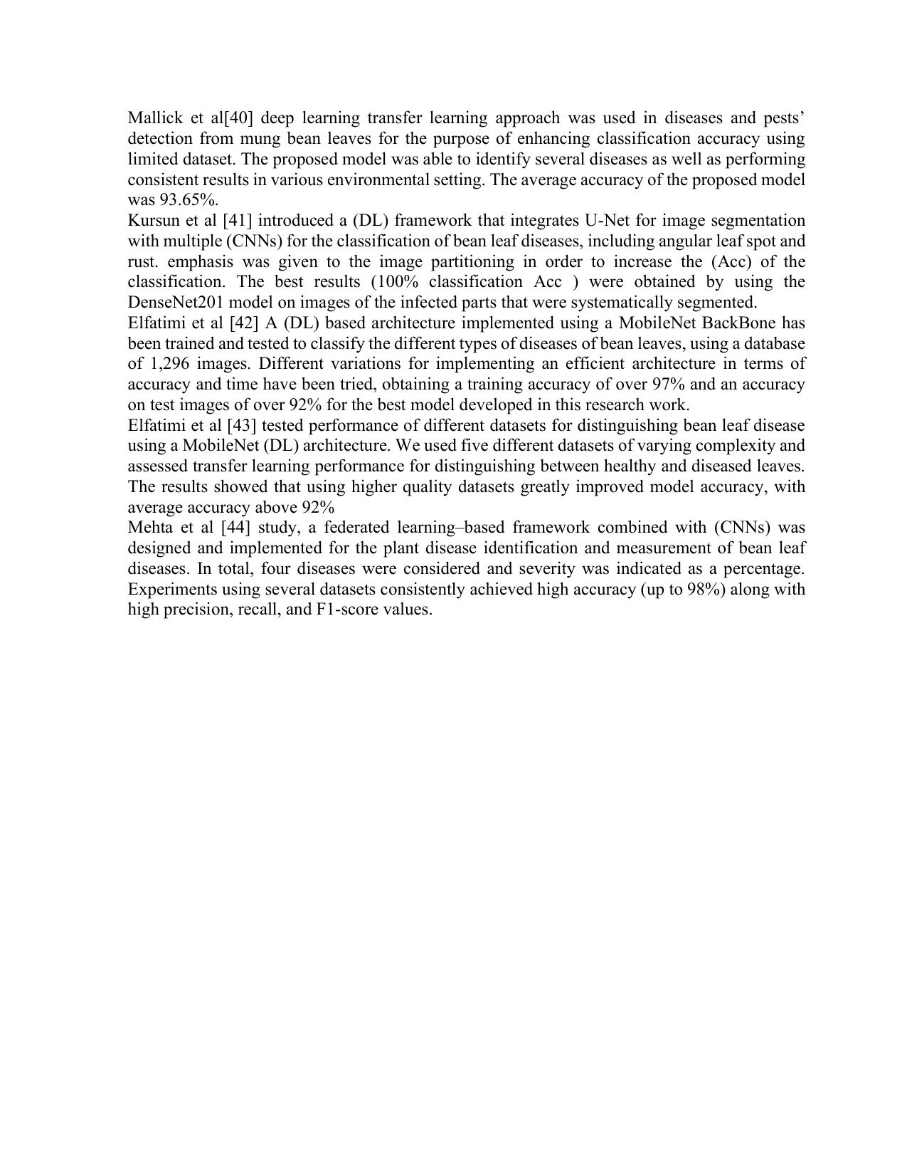 | Reviewer Notes - Page 14  1. Reviewer Comment: Please make sure that all studies in the related-work section are directly relevant to bean leaf disease classification or explain clearly why studies on wheat, mung bean, or faba bean are included.  2. Correction: Check capitalization and abbreviation consistency, e.g., DL, ML, Acc., EfficientNetB0, Grad-CAM, and XAI.

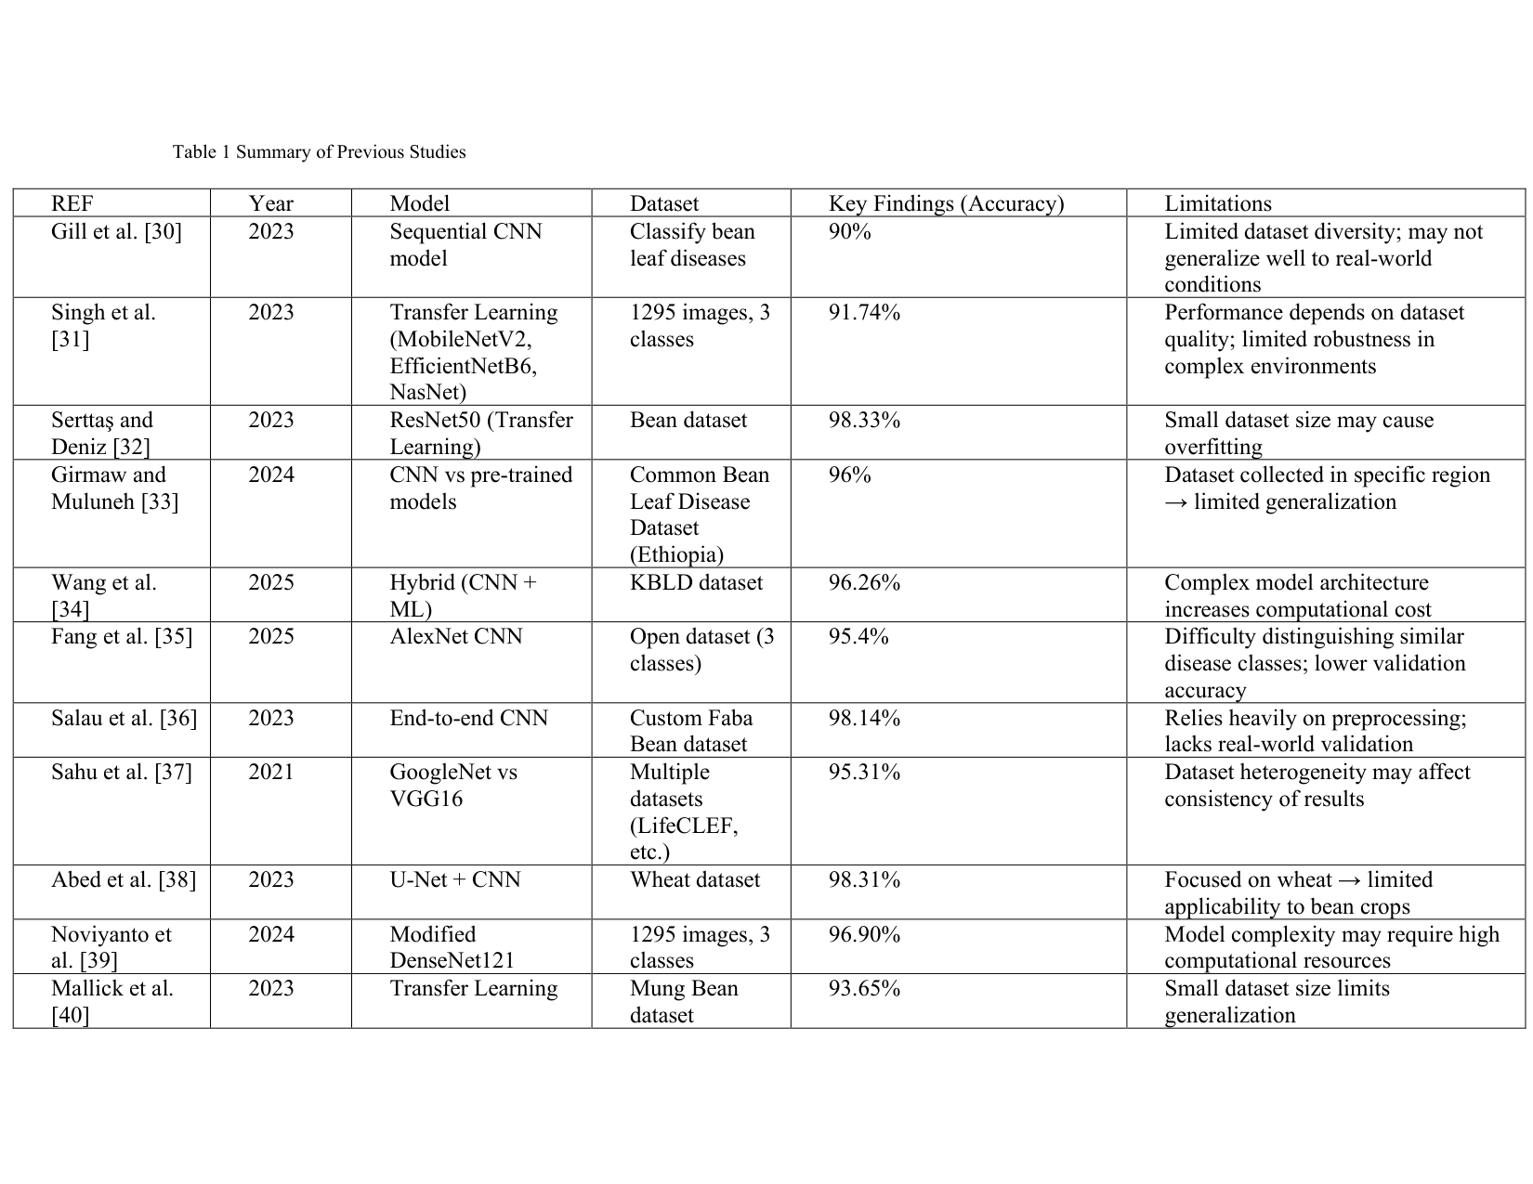 | Reviewer Notes - Page 15  1. Reviewer Comment: Table 1 is useful, but it needs formatting improvement. Use consistent column widths, align text clearly, and ensure the table does not look crowded.  2. Reviewer Comment: Add a short synthesis after the table explaining what is still missing in the literature and how the current paper contributes.

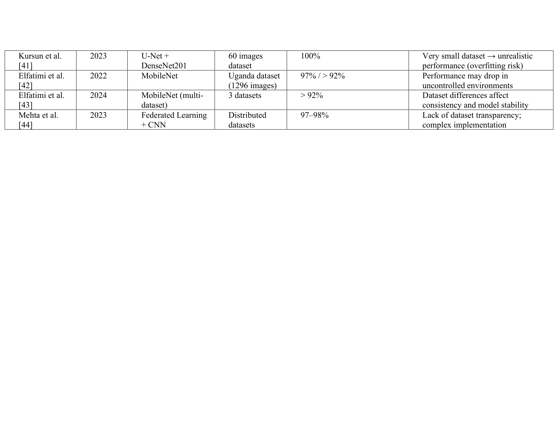 | Reviewer Notes - Page 16  1. Correction: The continuation of Table 1 is oversized and visually inconsistent. It should be reformatted to fit the page properly using the journal table style.  2. Reviewer Comment: The table numbering will conflict with the later 'Table 1 Experimental Environment'. Please renumber all tables sequentially throughout the paper.

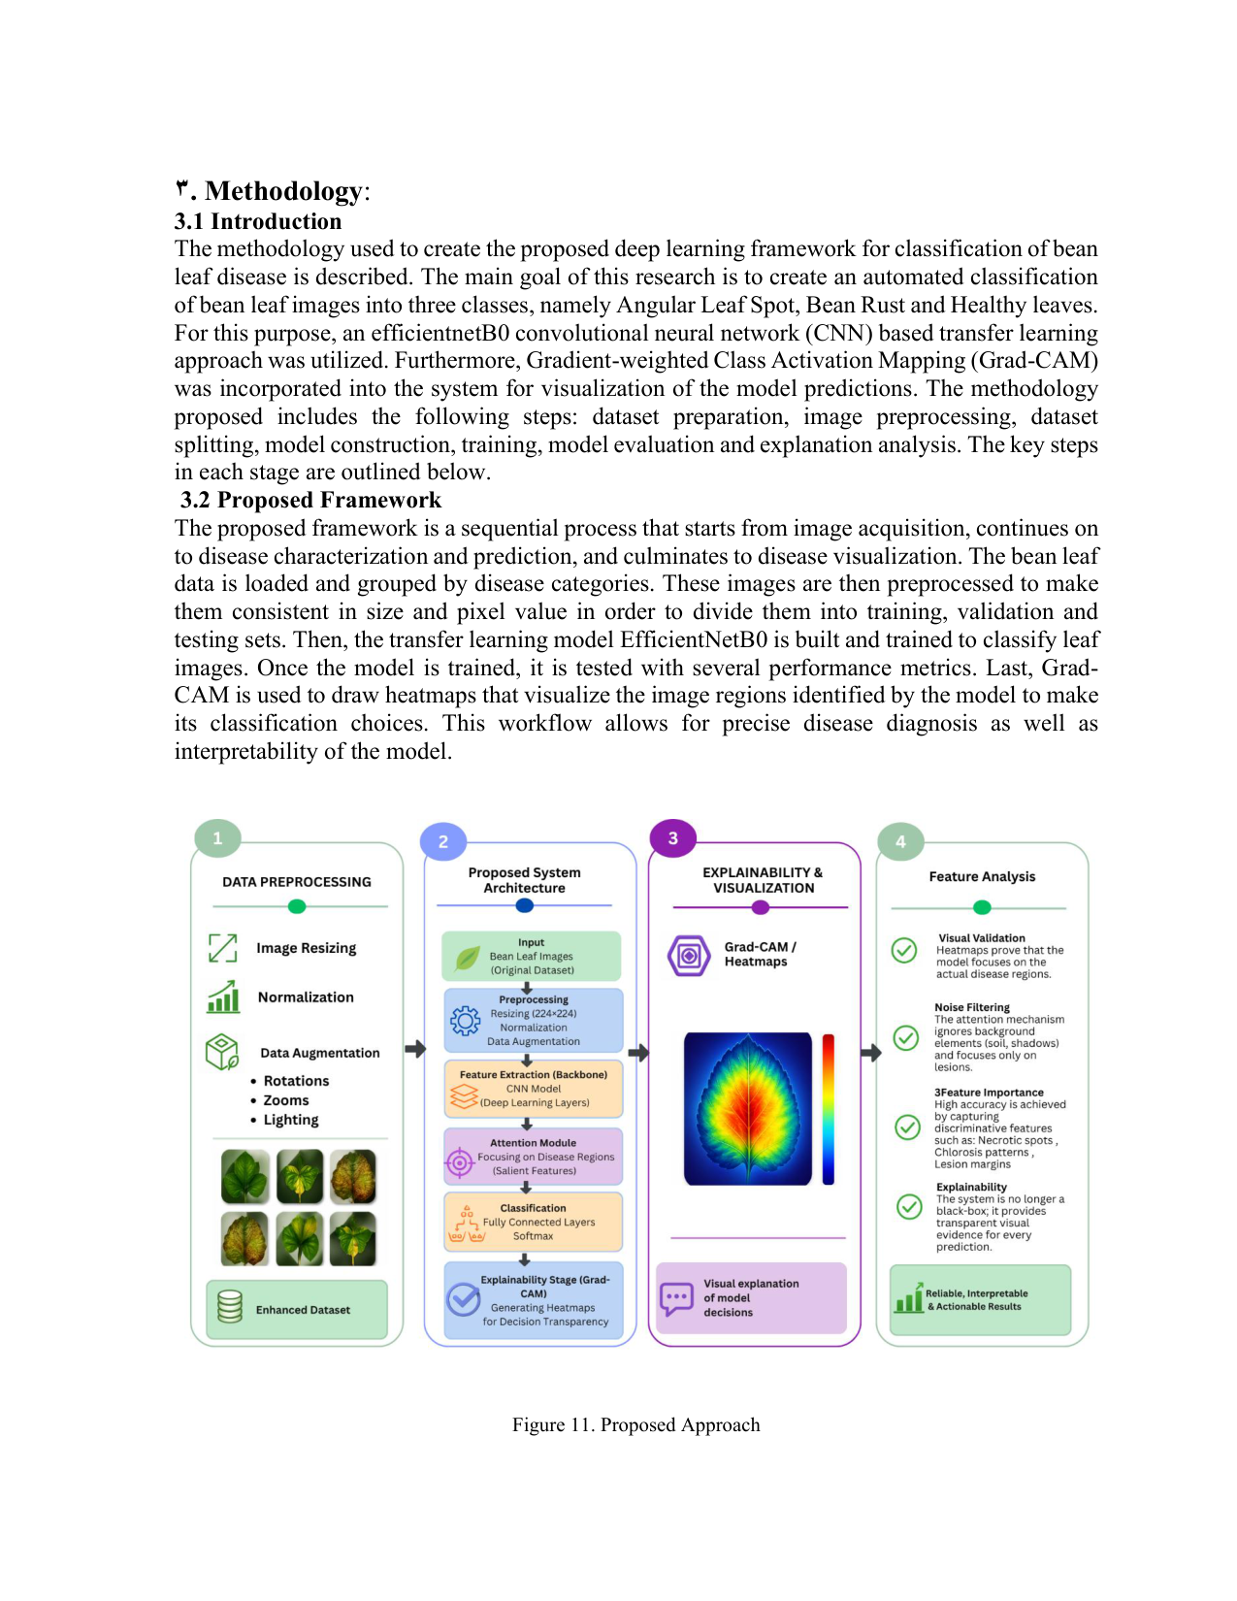 | Reviewer Notes - Page 17  1. Reviewer Comment: The proposed framework figure includes an attention module, while the described model architecture does not clearly implement one. This inconsistency must be corrected before publication.  2. Correction: Replace 'efficientnetB0' with the correct capitalization 'EfficientNetB0'.

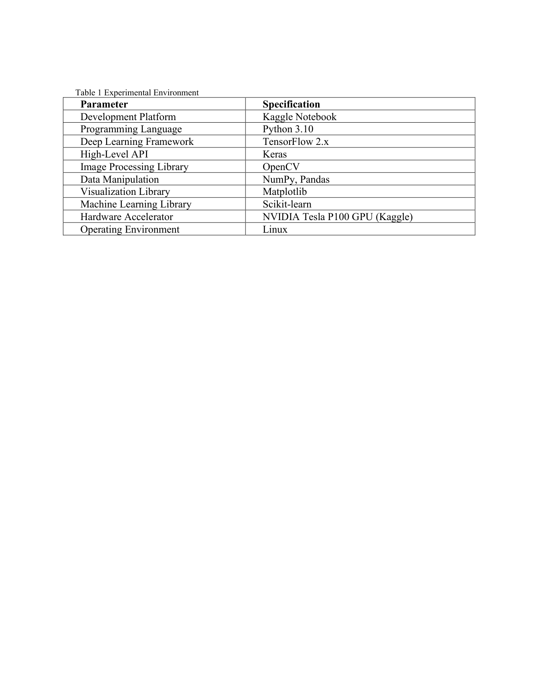 | Reviewer Notes - Page 18  1. Correction: This table should not be numbered 'Table 1' because an earlier Table 1 already appears in the paper. Renumber it as Table 2 and update all later table numbers accordingly.  2. Reviewer Comment: The experimental environment is clear, but the methodology still needs exact training hyperparameters such as batch size, number of epochs, learning rate, optimizer settings, callbacks, and random seed.

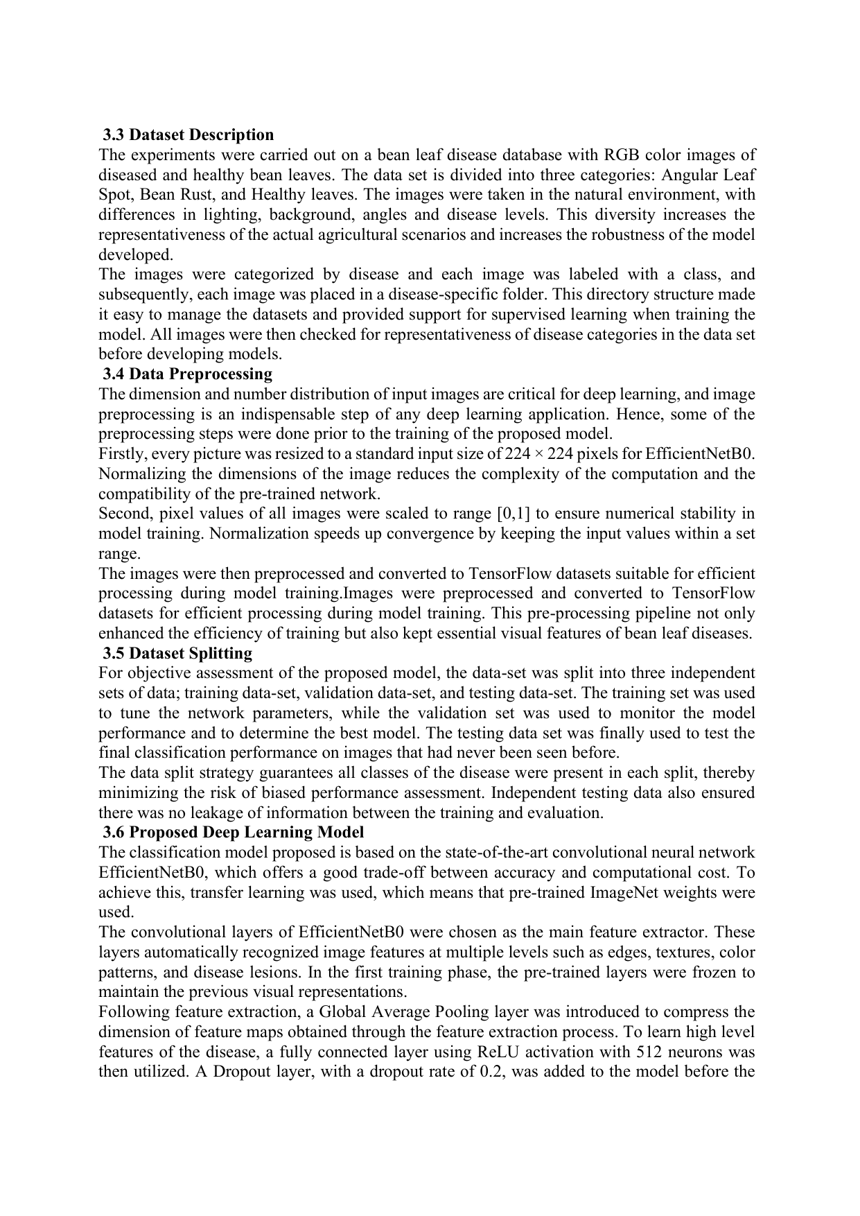 | Reviewer Notes - Page 19  1. Reviewer Comment: The dataset description is incomplete. Please add the dataset source/link, total number of images, number of images per class, license or access information, and whether any duplicate images were removed.  2. Reviewer Comment: The dataset split ratios are not provided. Include exact training/validation/testing percentages and sample counts for each class in each split.  3. Correction: Remove the duplicated sentence about converting images to TensorFlow datasets.

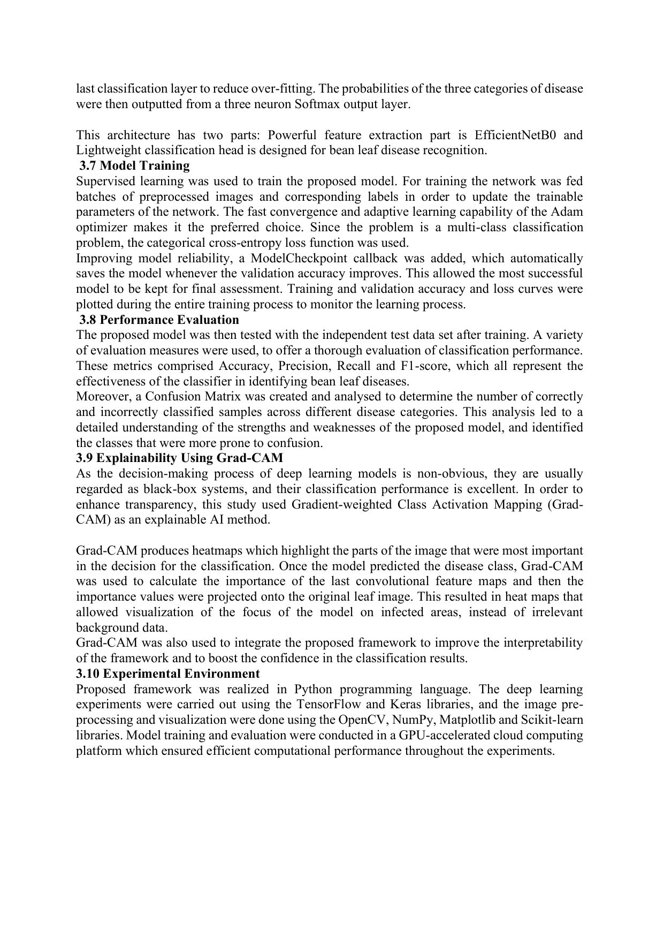 | Reviewer Notes - Page 20  1. Reviewer Comment: Clarify the transfer-learning strategy: which EfficientNetB0 layers were frozen, whether fine-tuning was later performed, and how many trainable parameters were used.  2. Reviewer Comment: The figure suggests data augmentation, but the text does not specify augmentation settings. Add rotation, zoom, brightness, flip, and other augmentation ranges used.  3. Correction: Add exact model-training details: epochs, batch size, learning rate, early stopping or checkpoint criteria, and hardware runtime if available.

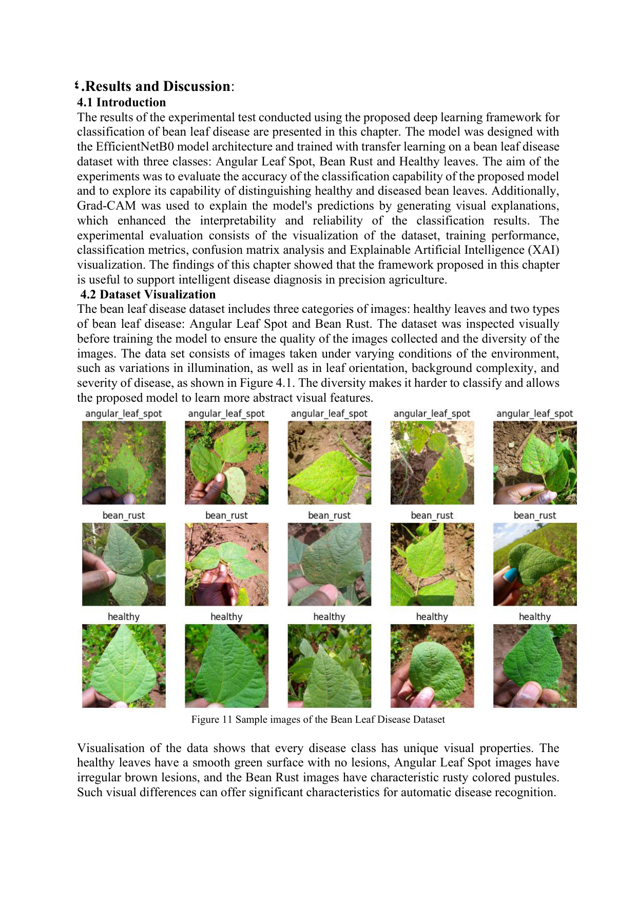 | Reviewer Notes - Page 21  1. Correction: Replace 'chapter' with 'section' throughout the results and discussion to match journal style.  2. Correction: The text refers to Figure 4.1 but the caption is Figure 11. Please standardize figure numbering throughout the paper.  3. Reviewer Comment: Dataset visualization is useful, but it should include the number of samples per class and a note on class balance.

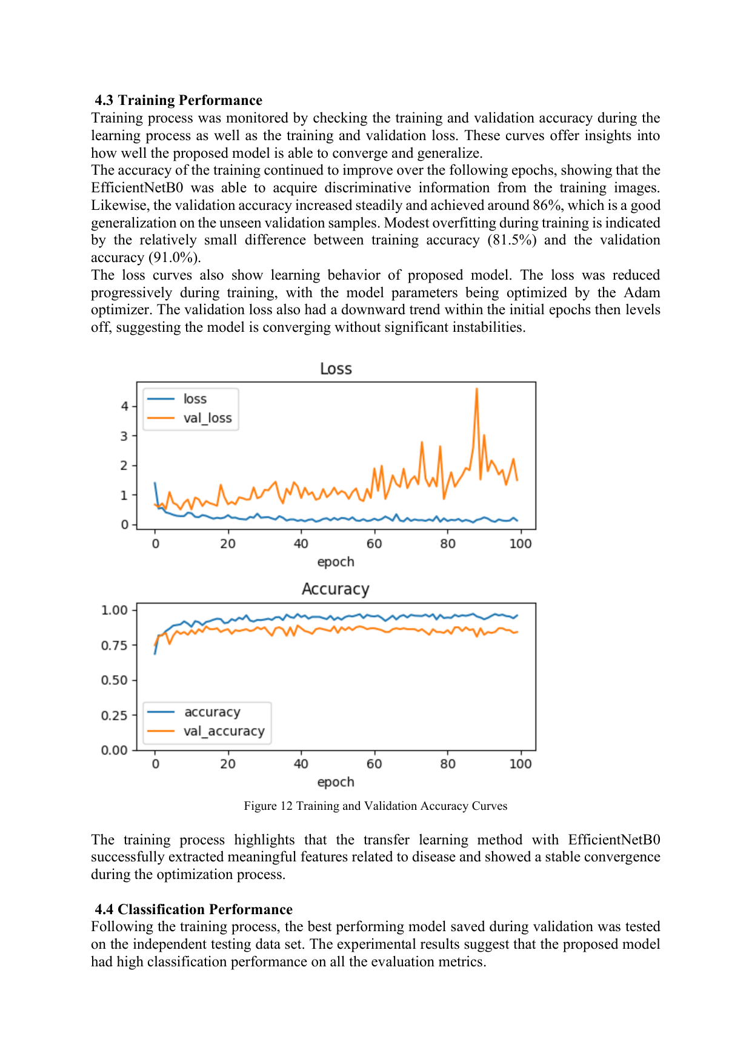 | Reviewer Notes - Page 22  1. Reviewer Comment: The interpretation of the training curves needs revision. The plot shows validation loss increasing and becoming unstable after early epochs, which suggests overfitting or training instability. The claim of stable convergence should be corrected.  2. Correction: The sentence says a small difference between training accuracy (81.5%) and validation accuracy (91.0%), but the plotted training accuracy appears higher than validation accuracy. Please verify and report the correct values.  3. Reviewer Comment: Add measures used to reduce overfitting, such as dropout, augmentation, early stopping, or fine-tuning control.

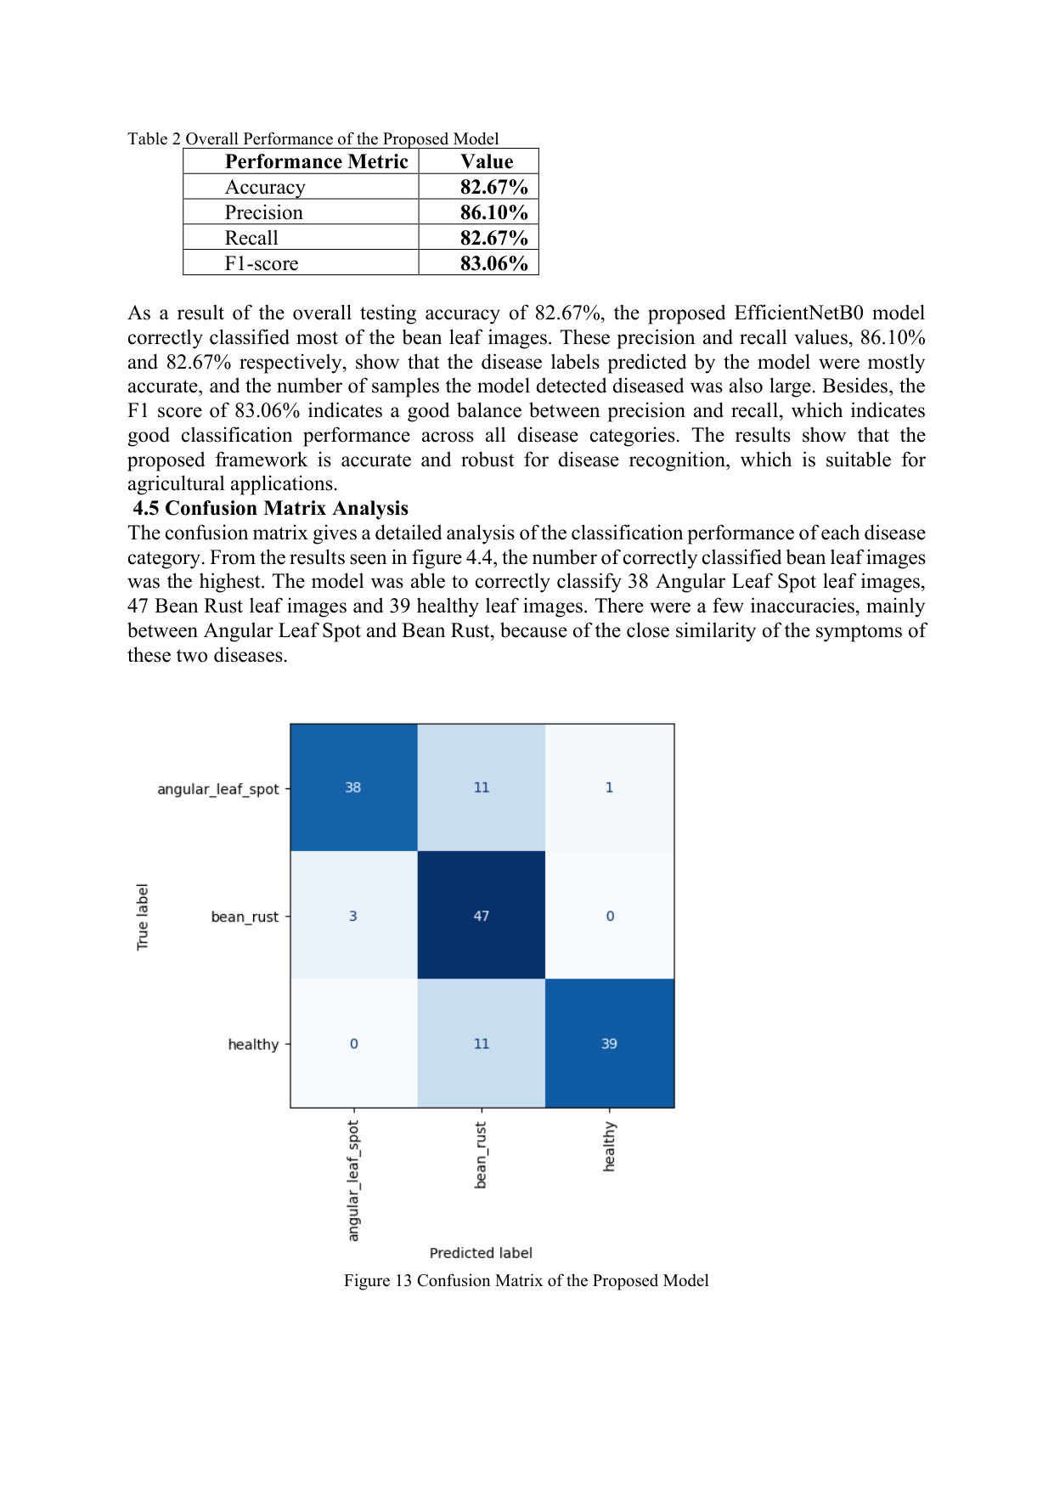 | Reviewer Notes - Page 23  1. Reviewer Comment: Add a per-class precision, recall, and F1-score table. Overall weighted metrics are not enough because the confusion matrix shows meaningful class-level differences.  2. Reviewer Comment: The confusion matrix shows 11 Angular Leaf Spot images misclassified as Bean Rust and 11 Healthy images misclassified as Bean Rust. This error pattern should be discussed more deeply.  3. Correction: Check table numbering again. This should not conflict with previous tables.

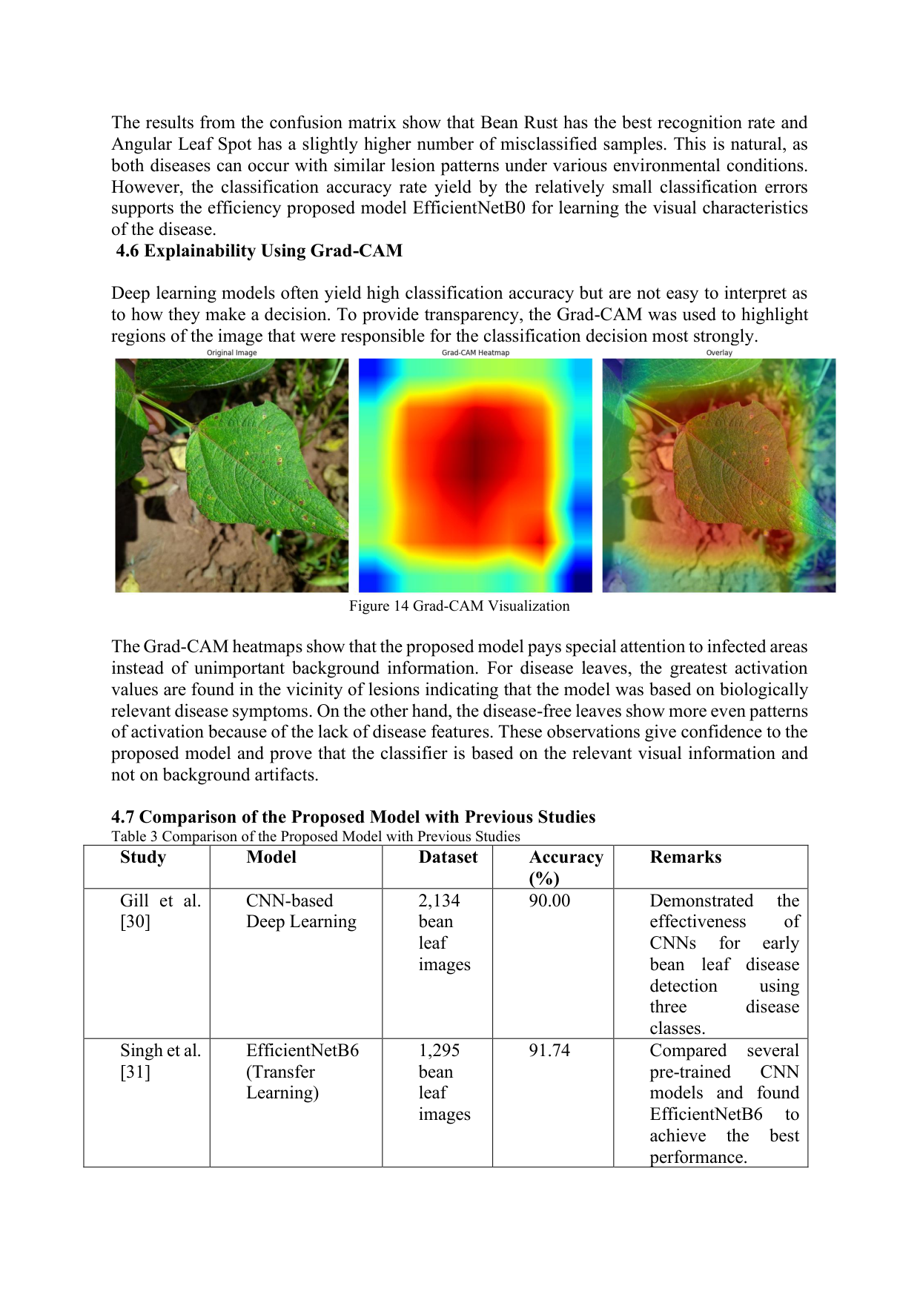 | Reviewer Notes - Page 24  1. Reviewer Comment: The Grad-CAM visualization is important, but one example is not sufficient. Add Grad-CAM examples for all three classes and include at least one incorrect prediction to demonstrate model limitations.  2. Reviewer Comment: The heatmap appears broad and centered; please explain how it confirms focus on biologically relevant disease regions rather than general leaf area.

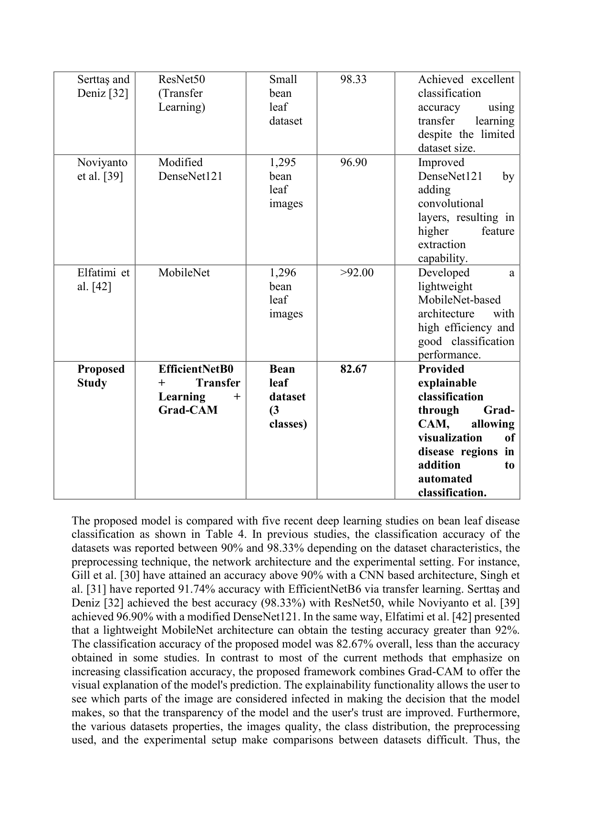 | Reviewer Notes - Page 25  1. Reviewer Comment: The proposed model accuracy (82.67%) is lower than several prior works. This is acceptable only if the paper clearly justifies the contribution through explainability, dataset difficulty, or real-world robustness. Please strengthen this argument.  2. Correction: The text refers to Table 4 while the caption says Table 3. Please correct all cross-references.  3. Reviewer Comment: The comparison table should include whether each previous study used explainability methods, not only accuracy.

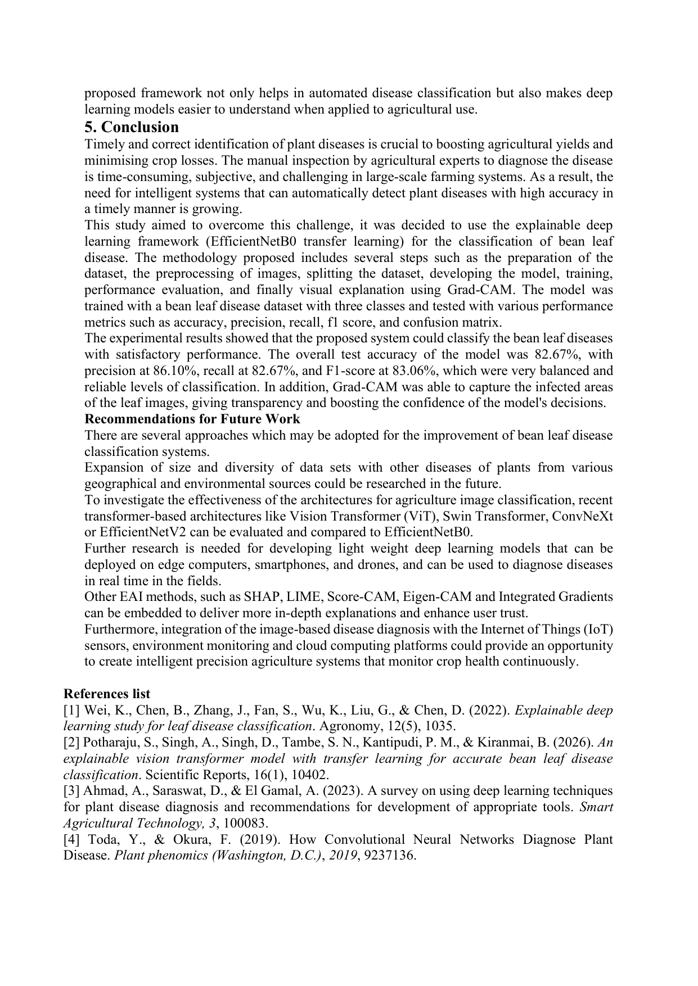 | Reviewer Notes - Page 26  1. Reviewer Comment: The conclusion should be more balanced. Avoid describing the performance as highly reliable without also acknowledging the relatively modest accuracy compared with previous works.  2. Correction: Replace 'EAI methods' with 'XAI methods'.  3. Reviewer Comment: Add a formal limitations paragraph before the future-work recommendations, including limited dataset information, possible overfitting, lack of external validation, and limited Grad-CAM examples.

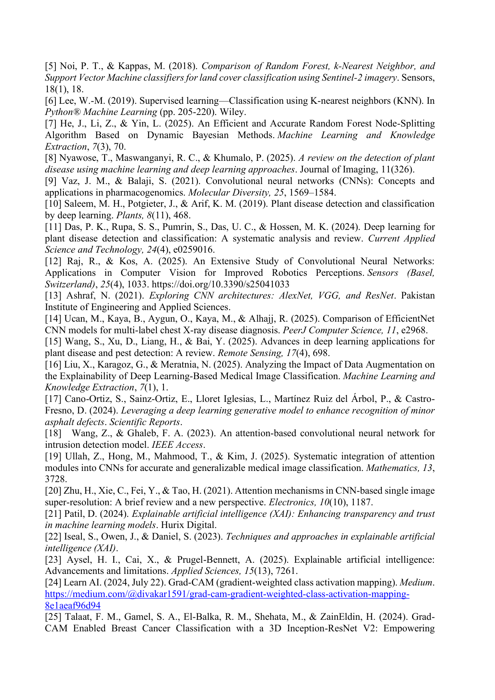 | Reviewer Notes - Page 27  1. Reviewer Comment: The reference list should be revised according to the journal style. Add DOI links where available and ensure all references cited in the text appear in the list and vice versa.  2. Reviewer Comment: Some references are weak or non-scholarly for a journal article, such as a Medium article for Grad-CAM. Replace with the original Grad-CAM paper or stronger peer-reviewed sources.

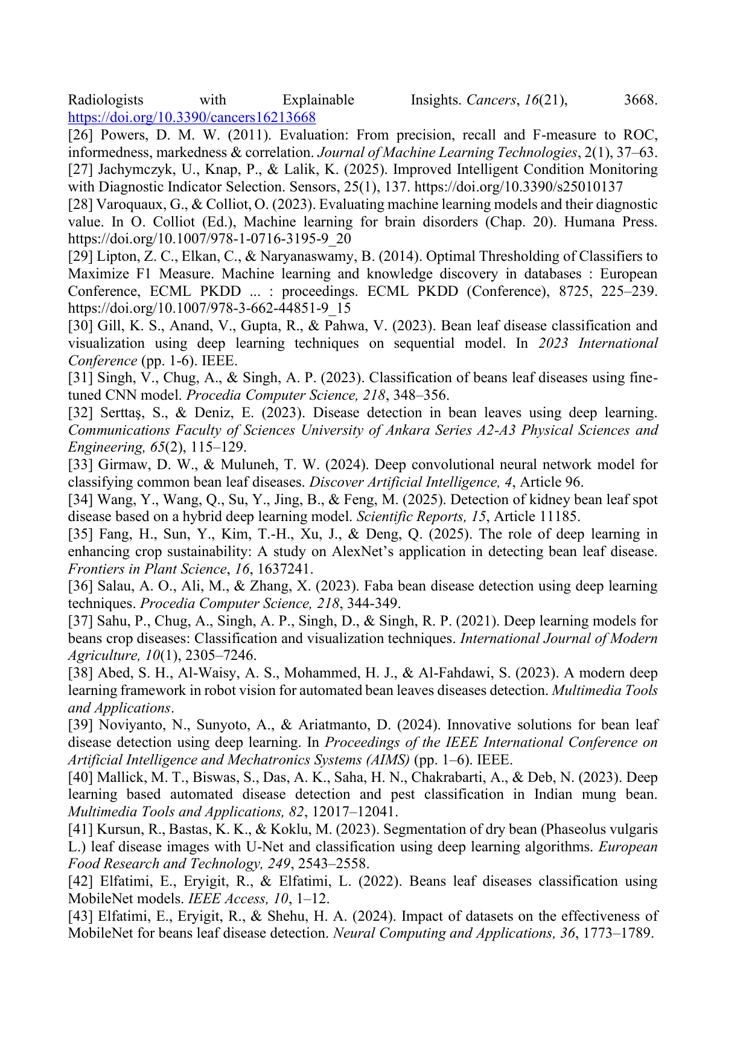 | Reviewer Notes - Page 28  1. Reviewer Comment: Verify the quality and completeness of references. Some conference references appear incomplete and need full venue name, proceedings details, page numbers, and DOI when available.  2. Correction: Ensure consistent punctuation, capitalization, italics, and journal names in all references.

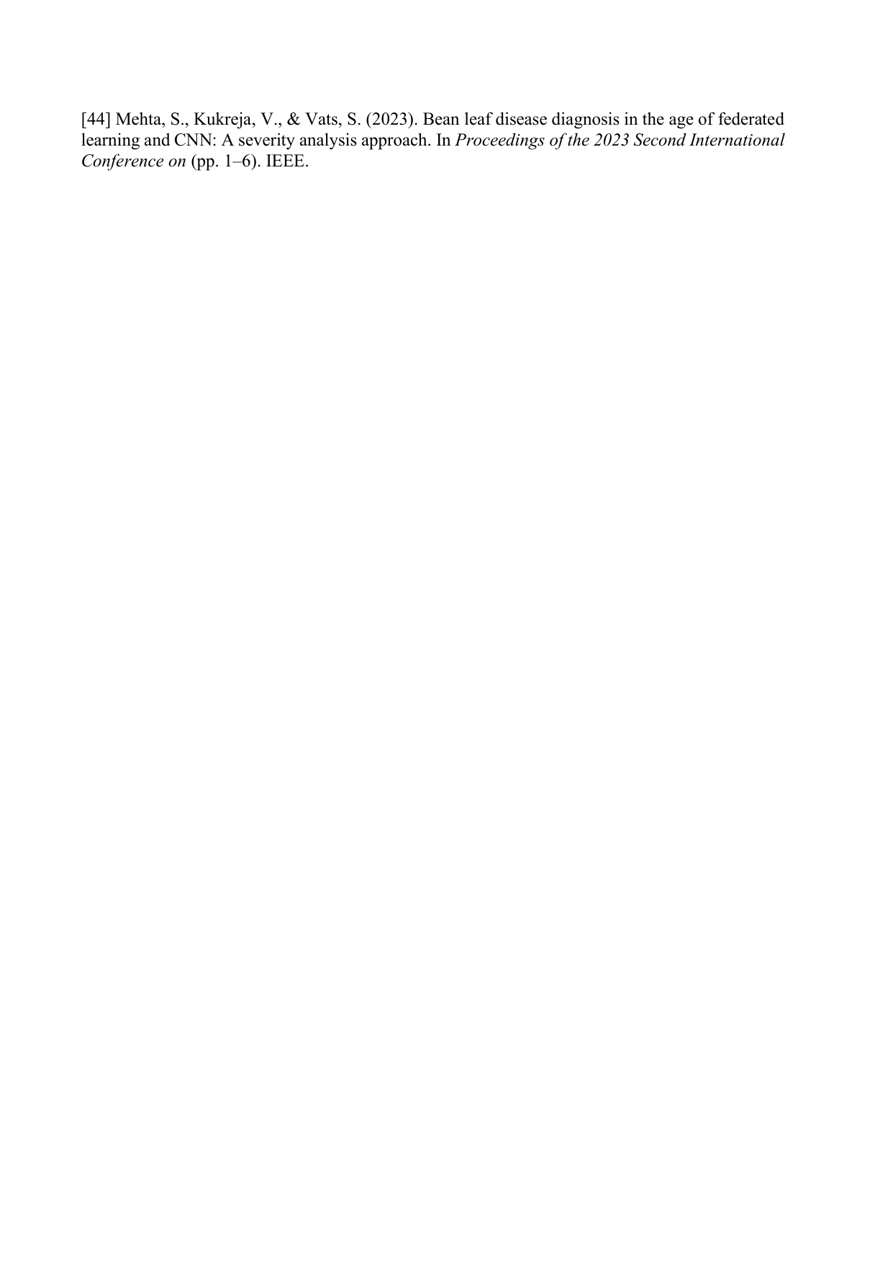  Add to References: [45] K. Eskaf, "SmartDate: AI-Driven Precision Sorting and Quality Control in Date Fruits," IEEE HONET, 2024, pp. 124-129, doi: 10.1109/HONET63146.2024.10822938. | Reviewer Notes - Page 29  1. Reviewer Comment: The final reference entry is incomplete. It must include the full conference name, publisher, page range, and DOI if available.  2. Reviewer Comment: Before publication, conduct a final reference audit to ensure every in-text citation number corresponds correctly to the reference list.

