

Deep Learning Framework for Galaxy Morphology Classification and Analysis
Prepared By
Name: Ahmad Yousef Alkahlout ID No.: 253000753
Name: Mohmmed Taleb Mohammed ID No.: 252000097

Submitted in fulfillment of the requirements for the degree Master of Science in Artificial Intelligence
At
College of Informatics
Midocean University
UAE
Supervisor Name: Dr. Mohamed Essa
College of Informatics, Midocean University, Comoros
Email: 253000753@st.midocean.edu.km / 252000097@st.midocean.edu.km

Acknowledgements

We would like to thank our supervisor, Dr. Mohamed Essa, for his continuous guidance and valuable feedback throughout this research. His expertise in both artificial intelligence and galaxy studies has greatly influenced the direction of this work. His comments challenged us to think more critically and approach the research from a scientific perspective rather than a purely technical one.

We are also thankful to the faculty members at the College of Informatics, Midocean University, for providing a supportive academic environment that inspired independent thinking and research development.

Finally, we would like to express our appreciation to our families for their patience, encouragement, and support during this journey.

Abstract
Galaxy morphology classification is an important topic in astrophysics because the shape of a galaxy can provide useful clues about how it formed and how it has changed over time. In recent years, astronomical surveys such as the Sloan Digital Sky Survey (SDSS) and the Dark Energy Camera Legacy Survey (DECaLS) have produced very large collections of galaxy images. Because of this rapid increase in data, manual visual classification is becoming less practical, especially for large-scale studies. This has made automated deep learning methods more relevant in this area.

Recent research has shown that convolutional neural networks (CNNs) can achieve good performance in galaxy image classification. Even so, most earlier studies have focused mainly on improving classification accuracy. Other important issues, such as how stable the model is under image variations, how confident it is in its predictions, and whether its decisions can be interpreted clearly, are often discussed separately.

In this research, a deep learning framework for galaxy morphology classification is explored using CNNs together with transfer learning models such as ResNet and EfficientNet. The Galaxy10 DECaLS dataset is used as the main dataset because it contains labeled galaxy images and has been used in several studies in this field.

The framework evaluates classification performance using common measures such as accuracy and F1-score. It also examines robustness by applying controlled perturbations to the input images and observing how the predictions change under different conditions. In addition, Monte Carlo Dropout is used to estimate prediction uncertainty, while Grad-CAM is used to identify the image regions that have the greatest influence on the model’s decision.

The aim of this research is not only to obtain good classification performance, but also to better understand how reliable and interpretable these models are in astronomical image analysis. More importantly, the study brings together classification performance, robustness analysis, uncertainty estimation, and explainable AI in one framework to support more reliable automated galaxy morphology classification.
Contents
Acknowledgements ii
Abstract iii
List of Abbreviations v
List of Figures vi
List of Tables vii
Chapter 1: Introduction 1
1.1 Overview 1
1.2 Problem Definition 3
1.3 Thesis Objectives 4
1.4 Thesis Contribution 4
1.5 Thesis Organization 5
Chapter 2: Background and Related Work 6
2.1 Introduction 6
2.2 Background 7
2.3 Related work 11
2.4 Related Work Summary 17
Chapter 3: Proposed Approach (Methodology) 20
Chapter 4: Experimental Results and Discussion 21
Chapter 5: Conclusion and Future Work 22
References 23

List of Abbreviations
- AI: Artificial Intelligence.
- CNN: Convolutional Neural Network.
- DL: Deep Learning.
- DECaLS: Dark Energy Camera Legacy Survey.
- GAN: Generative Adversarial Network.
- Grad-CAM: Gradient-weighted Class Activation Mapping.
- MCD: Monte Carlo Dropout.
- ML: Machine Learning.
- RA: Right Ascension.
- SDSS: Sloan Digital Sky Survey.
- XAI: Explainable Artificial Intelligence.
- F1-score: Harmonic mean of precision and recall.
- ViT: Vision Transformer.
- VGG19: Visual Geometry Group 19.
- DCGAN: Deep Convolutional Generative Adversarial Network.
- CvT: Convolutional Vision Transformer.
- S-PLUS: Southern Photometric Local Universe Survey.
- CANDELS: Cosmic Assembly Near-infrared Deep Extragalactic Legacy Survey.
- S0: Lenticular Galaxy.

List of Figures
Figure 1.1: Example of galaxy morphology complexity relevant to automated galaxy classification. 1
Figure 2.1: Hubble morphological classification scheme. 7
Figure 2.2: Relationship between Artificial Intelligence, Machine Learning, Deep Learning, and Computer Vision. 9
Figure 2.3: Simplified architecture of a convolutional neural network (CNN) for image classification. 10
Figure 2.4: Example of a saliency map highlighting discriminative regions in galaxy morphology classification. 12

List of Tables
Table 2.1: Comparison of related studies in galaxy morphology classification 18

Chapter 1: Introduction

1.1 Overview
Galaxy morphology classification is an important topic in astronomy because the visible structure of a galaxy can tell us a great deal about how that galaxy formed and how it changed over time. As astronomical research developed, scientists found that features such as shape, brightness distribution, spiral arms, and central bulges could provide useful clues about the physical nature and evolutionary history of galaxies. For this reason, morphology classification has remained a central task in astrophysical research [1].
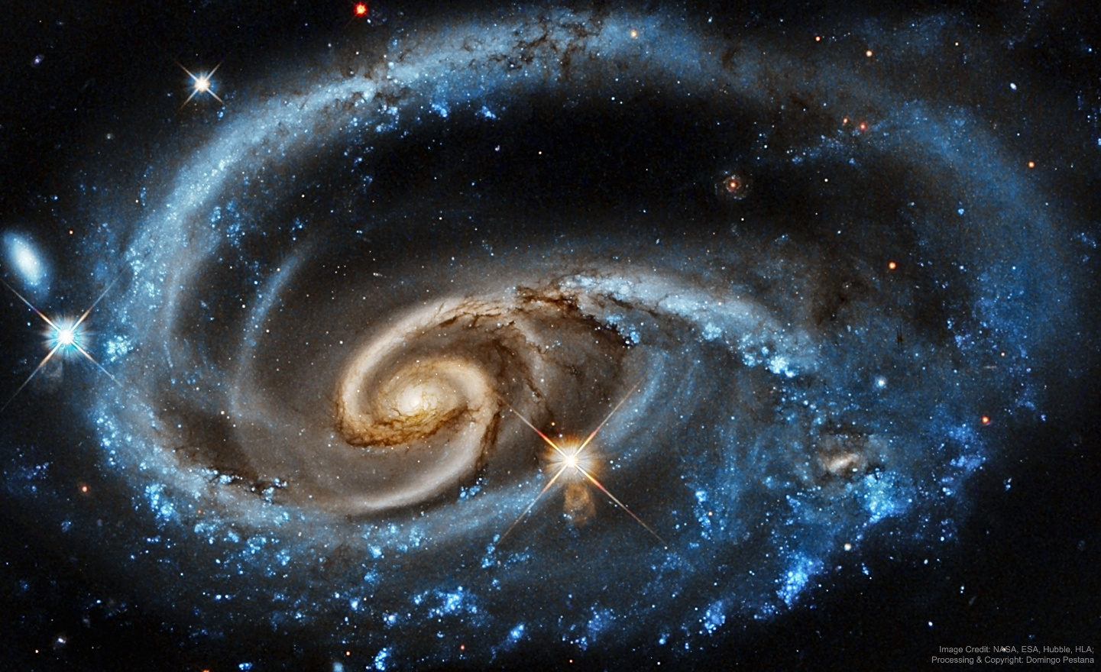
Figure 1.1: Example of galaxy morphology complexity relevant to automated galaxy classification studies. Source: NASA/Hubble.
As shown in Figure 1.1, galaxy images can look quite different from one another. Some galaxies have clear and easily recognized structures, while others appear more complex or less distinct. Differences in shape, orientation, brightness, and internal details can make the classification process more difficult, especially when the boundaries between galaxy types are not clear.
In earlier years, galaxy classification was conducted through manual visual inspection by astronomers. This traditional approach was useful and helped build the foundations of morphological studies, but it also required a great deal of time and effort. With the arrival of large astronomical surveys such as the Sloan Digital Sky Survey (SDSS) and the Dark Energy Camera Legacy Survey (DECaLS), the number of available galaxy images increased dramatically. As a result, manual classification became much harder to manage on a large scale [1].
Because of this, automated methods have received much more attention in recent years. Deep learning, especially convolutional neural networks (CNNs), has shown strong potential in galaxy image classification because these models can learn visual patterns directly from raw images. Several previous studies have reported encouraging results and have shown that CNN-based methods can perform at a level that is comparable to human classification in some tasks [2].
At the same time, there is growing interest in looking beyond classification accuracy alone. In scientific applications, it is not enough for a model to produce a correct label most of the time. Researchers also need to know whether the model is focusing on meaningful galaxy structures, whether its predictions remain stable when image conditions change, and whether it can reflect uncertainty when the galaxy image is difficult to interpret. For this reason, explainability and reliability have become important concerns in recent work on galaxy morphology classification [3].
Based on these points, this research explores galaxy morphology classification through a deep learning framework that considers not only classification performance, but also robustness, uncertainty estimation, and interpretability. The study uses the Galaxy10 DECaLS dataset as the main benchmark because it provides labeled galaxy images that are suitable for supervised deep learning experiments. The purpose is to examine how these different aspects can work together to support a more reliable and meaningful approach to automated galaxy morphology classification.

1.2 Problem Definition
Although many studies have used deep learning for galaxy morphology classification, most of them mainly focus on performance measures such as accuracy and F1-score. These measures are important, but they do not fully answer all the questions that matter in scientific work.

One important issue is that deep learning models are often treated as black boxes. In astronomy, this can be a problem because researchers usually want to know why the model gave a certain result. For example, if a model classifies a galaxy as spiral, it should be possible to check whether the decision was based on meaningful features such as spiral arms or the central bulge, rather than on background details or unrelated patterns.

Another issue is that galaxy images are not always captured under the same conditions. Differences in brightness, noise, contrast, and other visual changes can affect the appearance of a galaxy image. Because of this, a model may perform well in normal conditions but become less stable when the input image is slightly changed. For practical scientific use, it is important for the model to remain reliable under such variations.

There is also the problem of uncertainty. Some galaxies do not have clear morphological features, and some may show structures that make them difficult to classify into one class only. In such cases, giving only a final label may not be enough. It is also useful to know how confident the model is in its prediction, especially when the galaxy image is unclear or lies between more than one class.

Based on these issues, the main problem addressed in this thesis is that current deep learning approaches for galaxy morphology classification often achieve good performance, but they do not always provide enough information about interpretability, robustness, and prediction uncertainty within one unified framework.

This leads to the main research question of this study:
How can a deep learning framework for galaxy morphology classification achieve strong classification performance while also being interpretable, robust to image variations, and able to express prediction uncertainty in a meaningful way?
To investigate this problem, the Galaxy10 DECaLS dataset is used as the main benchmark. This dataset provides labeled galaxy images that are suitable for supervised deep learning experiments and allows the proposed framework to be evaluated in a structured and consistent way.

1.3 Thesis Objectives
The main objectives of this research can be summarized as follows:
- Develop baseline CNN models for galaxy morphology classification and evaluate their ability to learn structural features directly from astronomical images.
- Apply transfer learning techniques using pretrained architecture such as ResNet and EfficientNet to enhance model performance and generalization, especially when working with limited training data.
- Assess classification performance through standard quantitative metrics, including accuracy and F1-score, to determine how well the models distinguish between different galaxy types.
- Analyze model robustness by introducing controlled perturbations to the images and observing how prediction performance changes under varying observational conditions.
- Incorporate uncertainty estimation into the classification pipeline using Monte Carlo Dropout, to better understand how confident the model is when predicting ambiguous or transitional galaxy morphologies.
- Use explainable AI techniques, particularly Grad-CAM, to interpret the model’s decisions and verify whether the network focuses on scientifically meaningful structures when classifying galaxy images.

1.4 Thesis Contribution
This research offers several key contributions to the study of automated galaxy morphology classification:

- A structured evaluation of deep learning architectures:
The work provides a systematic assessment of different deep learning models applied to galaxy morphology classification, including both baseline CNNs and transfer‑learning models. This helps clarify how various architectures perform on astronomical image data.
- A robustness evaluation procedure:
The study introduces a method for examining how model performance changes under controlled variations in the input images. This robustness analysis highlights the sensitivity of the models to observational differences and helps determine how stable their predictions are.
- Integration of uncertainty estimation into the classification pipeline:
By applying Monte Carlo Dropout, the research explores how uncertainty can be quantified during prediction, especially when dealing with galaxies that exhibit ambiguous or transitional morphologies. This adds an important reliability dimension to the overall framework.
- Use of explainable AI techniques for scientific interpretation:
The study applies Grad‑CAM not merely for visualization, but to verify whether the models focus on morphologically meaningful structures when making decisions. This enhances trust in the automated classification process by aligning model attention with known astronomical features.

1.5 Thesis Organization
The rest of this thesis is organized as follows.
Chapter 2 discusses the theoretical background and relevant research areas.
Chapter 3 presents the proposed methodology.
Chapter 4 analyzes the experimental results.
Chapter 5 concludes the study and suggests directions for future work.

Chapter 2: Background and Related Work

2.1 Introduction
This chapter presents the background and the previous studies related to galaxy morphology classification using deep learning. It begins by introducing the basic ideas behind galaxy classification and how this area has developed over time, starting from manual visual inspection and moving toward automated methods. It then reviews a number of recent studies that applied deep learning techniques to galaxy image analysis.

In recent years, research in this area has grown quickly because large astronomical surveys have produced huge numbers of galaxy images. This has made automated classification more important than before. Deep learning models, especially convolutional neural networks, have shown strong ability in learning useful patterns from image data, which makes them suitable for galaxy morphology classification.

At the same time, many existing studies focus on classification accuracy. Although accuracy is important, it is not the only issue that matters in scientific applications. Other aspects, such as robustness to image changes, prediction uncertainty, and model interpretability, are also important when deep learning models are used in astronomy.

For this reason, this chapter does not only review previous work in terms of model performance. It also looks at the methods, datasets, and evaluation approaches used in earlier studies, with the aim of identifying the main strengths, limitations, and research gaps. This helps place the proposed framework of this thesis within the wider context of current research in galaxy morphology classification.

2.2 Background
Galaxy morphology studies date back to the early 20th century when Hubble proposed one of the first galaxy classification schemes [4]. According to this classification, galaxies were divided into several basic morphological types like elliptical, spiral, and irregular galaxies. Hubble's contribution laid the groundwork for further exploration and research of galaxy morphology and development.

An illustrative representation of the Hubble galaxy classification scheme can be found in Figure 2.1. It illustrates the connection between elliptical galaxies and the two basic branches of spiral galaxies – normal spirals and barred spirals. Later, de Vaucouleurs elaborated Hubble's classification by introducing more categories, including S0 lenticular galaxies and other morphological distinctions [5].

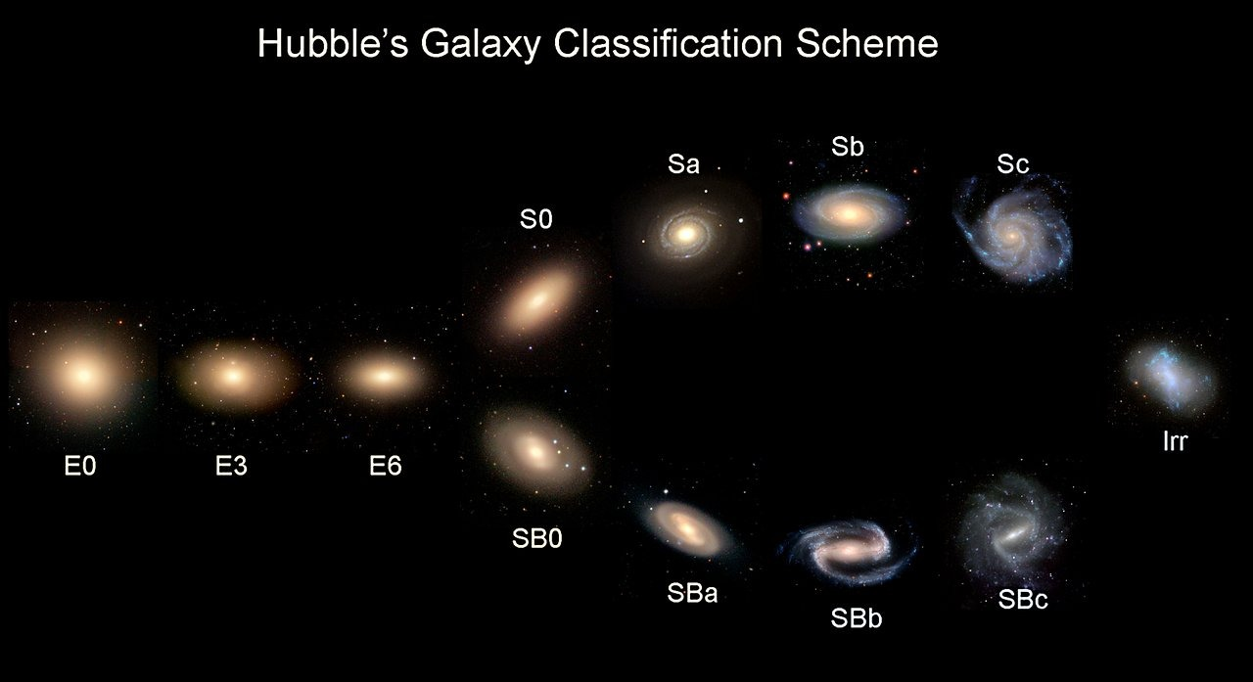
Figure 2.1: Hubble morphological classification scheme illustrating elliptical, spiral, and barred spiral galaxies.
Source: Adapted from Hubble (1936) [4].

For many years, The process of galaxy classification was based on the manual visual analysis of galaxy images until relatively recently. It relied on the judgement of astronomers who identified the basic structural features of galaxies and assigned them particular classification labels. Even though this traditional method of galaxy classification remains valid to some extent, it became rather impractical due to the increasing number of galaxy observations.

The issue of manually classifying large amounts of galaxy images became evident with the rise of modern surveys. The Sloan Digital Sky Survey (SDSS) produced a large quantity of images that could not be classified manually easily and efficiently [6]. As an alternative solution, the Galaxy Zoo project was initiated. It provided an opportunity for the public to participate in galaxy classification. It demonstrated that citizen science could be used to classify large volumes of galaxy images.

However, the volume of astronomical data kept increasing due to surveys like the Dark Energy Camera Legacy Survey (DECaLS). Therefore, the problem of automated galaxy classification became even more urgent and encouraged researchers to adopt deep learning methods to address it.

In this regard, artificial intelligence, machine learning, and deep learning became important approaches in the domain of astronomical image analysis. Machine learning algorithms allow improving the model from the training data, whereas deep learning implies using multilayer neural networks to extract complex patterns. Both concepts can be beneficial in tackling the issue of galaxy morphology classification since galaxy images contain complicated visual information that cannot be encoded manually.

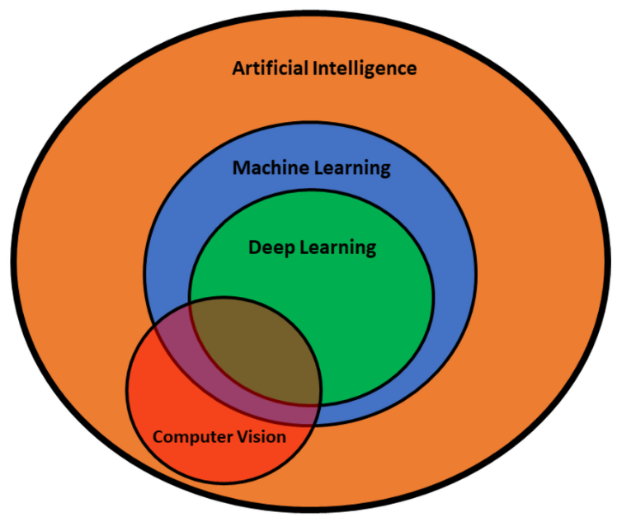
Figure 2.2: Relationship between Artificial Intelligence, Machine Learning, Deep Learning, and Computer Vision. Source: Adapted from Mohimont et al. (2022) [19].

From the perspective of computer vision, the classification of galaxy morphology is a typical image classification problem. The objective of the task is to detect particular morphological patterns from labelled galaxy images. Deep learning models like CNNs can be particularly helpful in this case, as they enable identifying and learning the visual structure of galaxy images automatically.

Prior to deep learning, most of the automated galaxy classification methods relied on handcrafted features like colour, brightness or shape information. However, despite the usefulness of these approaches, they had certain limitations, as they could not capture all the morphological peculiarities of galaxy images properly.

With CNNs becoming increasingly popular in astronomy, galaxy classification models showed promising results in this regard. Specifically, it was proved previously that CNN-based approaches could achieve classification accuracy comparable to that of humans. For instance, Dieleman et al. [2] achieved impressive results in predicting galaxy morphologies from images.
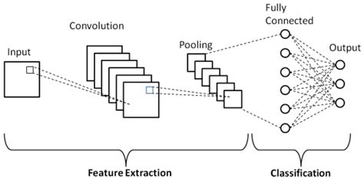
Figure 2.3: Simplified architecture of a convolutional neural network (CNN) for image classification. Source: Prepared by the authors.
Typically, the CNN architecture includes convolutional and pooling layers for learning image features followed by fully-connected layers for classification. As seen in Figure 2.3, each layer performs a certain type of operation and contributes to the model's performance by learning image features at different abstraction levels.

Over recent years, researchers have started to pay greater attention to the interpretability of deep learning models. Therefore, explainable artificial intelligence (XAI) gained popularity in various scientific domains. One of the key advantages of XAI methods is that they allow showing the areas in the image that have the greatest impact on the model decision [3]. In the scientific community, it is essential for the explanation of model predictions.

2.3 Related work
Walmsley et al. [1] Walman investigated the morphological classification of galaxies on a larger scale using machine learning techniques on current astronomical datasets. The use of the Galaxy Zoo DECaLS dataset allowed the researchers to utilize morphological classifications provided by many citizen scientists. The authors developed a deep learning model called Zoobot, which integrates convolutional neural network and probability approaches to estimate the entire distribution of answers provided by volunteers for about 300,000 galaxies. The model provided good agreement with human classification efforts and demonstrated good prediction accuracy, even with regard to complicated morphological patterns. The main advantage of the investigation under analysis is the creation of one of the biggest morphological catalogs created using deep learning techniques. However, the use of volunteer-generated answers can be considered the main disadvantage of the methodology employed in this research.

Dieleman et al. [2] In their paper, Deliman et al. proposed a deep learning framework for galaxy morphological classification using rotation-invariant CNNs. The study applied images from the Galaxy Zoo data set and was aimed at developing new CNN architecture which would allow classifying galaxies irrespective of their rotational orientation. With the introduction of rotation symmetry to the architecture of the network, it was able to better learn the morphological patterns, including spiral arms and bulge characteristics of galaxies, directly from the pixel-level data. According to the authors, the proposed method reached human-like accuracy levels in morphological classification, achieving about 91% of prediction accuracy. An obvious advantage of this approach is in its ability to handle rotational variability, characteristic of many astronomical images. However, as compared to standard CNN models, additional complexity arises due to the introduction of the new property.

Bhambra et al. [3] conducted a research on the explainability of deep learning models which were used in the classification of galaxies based on their morphology. In this research, different explainable artificial intelligence approaches such as Grad-CAM and saliency maps were used to illustrate image areas that contributed towards the prediction made by deep learning models. Through galaxy images obtained from large sky surveys such as Galaxy Zoo and DECaLS, it was shown that deep neural networks were able to recognize different morphological structures within galaxies such as spiral arms, galactic core structures, and even asymmetry. This research illustrates that using explainability techniques, it is possible to learn more about the internal functioning of deep learning models.
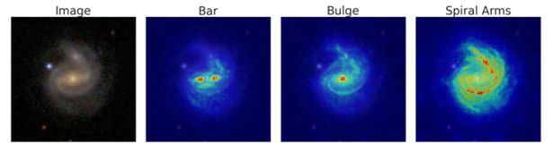
Figure 2.4: Example of a saliency map highlighting discriminative regions in galaxy morphology classification.
Source: Adapted from Bhambra et al. (2022) [3].

As shown in Figure 2.4, saliency maps highlight the regions of the galaxy image that contribute most strongly to the model's prediction. In many cases, the visualization confirms that the neural network focuses on key morphological structures such as spiral arms, bars, or the central bulge. This provides an additional layer of reliability by allowing astronomers to verify whether the classification decision is based on meaningful physical features. In this thesis, a similar explainability approach will be used to evaluate whether the proposed deep learning framework focuses on relevant morphological structures when classifying galaxy images.

Domínguez Sánchez et al. [7] researched the application of deep convolutional neural networks in improving the accuracy of galaxy morphology classification using images captured by the Sloan Digital Sky Survey (SDSS). The model they created aimed at being able to recognize the important attributes used to differentiate between certain types of galaxies like elliptical and spiral galaxies. With the aid of the large number of images provided by the SDSS survey, the CNN model managed to classify the images with a success rate of about 95%. One of the strengths of the work done by Dominizes Sanches is that their CNN does not have to rely on any pre-defined feature set to be able to learn important morphological characteristics since these can be learned from pixels alone.
Luo et al. [8] examined problems related to galaxy morphological classification in situations when there are not many labeled samples available – a frequent situation in the field of astrophysics. They developed an innovative semi-supervised deep learning algorithm that uses convolutional neural network and GAN models. In this case, the experiments were conducted using the Galaxy10 DECaLS dataset, and the classification accuracy obtained was around 84%. One positive point about this study is the reduced need for big fully labeled samples due to the simultaneous application of both labeled and unlabeled data. Such an innovation will be particularly beneficial in astronomy due to the time consumption involved in the process of labeling. On the other hand, one drawback of such an algorithm is its instability.

Yao et al. [9] focused on improving galaxy morphology classification through data augmentation when there is limited data for training. In this study, the Galaxy10 DECaLS dataset was used, in which a few-shot-learning-inspired augmentation technique was applied to enhance image diversity within the training set. This research indicated that with their augmentation technique, the robustness of their models could be increased to achieve up to 95% accuracy rate. One major advantage of this research is that they managed to show that augmentation can be effective without requiring changes to the core classification problem. On the other hand, one major limitation of this study is that overuse of augmentation or unrealistic augmentation might lead to spurious patterns.

Le et al. [10] carried out a comparative study of several deep learning models for galaxy morphology classification. The researchers employed the Galaxy10 DECaLS dataset to test customized CNN algorithms against the transfer learning algorithm models like ResNet and EfficientNet. It is demonstrated that the EfficientNet model produced an accuracy score of about 87%, which is considered among the best-performing models tested in the paper. The main advantage of this study lies in the fact that it presents a comparative analysis between several architectures under identical experimental conditions. On the other hand, the experimental research was limited to the utilization of just one dataset, implying its potential applicability to other astronomical survey data.

Xie et al. [11] investigated the problem of galaxy morphology classification using a deep convolutional neural network built upon the VGG19 model. The experiment was carried out on the Galaxy10 DECaLS dataset, which offers annotated images of galaxies collected from extensive astrophysical observations. With the use of transfer learning, the researchers managed to implement the VGG19 model to learn hierarchical visual features that allow discrimination between various types of galaxies. As a result, the proposed model attained an accuracy level of around 84.5%, confirming that conventional deep CNN models are capable of providing adequate performance in this task. At the same time, the researchers found that models such as VGG19 have numerous parameters that lead to overfitting problems.

Cheng [12] explored the use of ViT in classifying galaxies according to morphology. In his study, the researcher used the Galaxy10 DECaLS dataset to find out if transformer architecture is capable of capturing global patterns better than other types of traditional CNNs. The suggested model used self-attention for highlighting significant parts of the galaxy, achieving an accuracy of about 86%. An advantage in this research was a finding showing that transformer models could indeed learn dependencies from the whole image rather than focusing only on local areas. However, one drawback was the need for a lot of training data.

Cao et al. [13] came up with a combination approach to deep learning where the researcher merged CNNs with elements from transformers in order to classify the morphology of galaxies. For this research, Cao used galaxy images from the Galaxy Zoo database. Specifically, CvT architecture was used because the model integrates local feature detection in CNNs and global feature detection in transformer architectures. The achieved accuracy was around 98%, thus making it one of the most effective models among those that have been reviewed in this analysis. One strength of this research paper is that it uses both the aforementioned architectural designs, hence can detect patterns in galaxies using a wide range of approaches. However, the improvement made in the model makes it complex, thus requiring more computational resources.

Urechiatu et al. [14] focused on the potential usefulness of convolutional neural networks (CNNs) in improving automated classifications of galaxy morphology. For the experiment, the authors used a dataset consisting of 10,000 images of galaxies taken from the Galaxy Zoo 2 database, which is known to contain labeled images provided by many volunteers. Specifically, in order to build the algorithm, the authors came up with a CNN architecture which they expected to be able to distinguish morphological traits better, and also applied a number of methods to preprocess and augment data. As a result, the accuracy in classification reached 92%. However, despite high effectiveness in recognizing simple structures of galaxies, the models failed to work properly when dealing with complicated morphologies.

Bom et al. [15] explores the ability of deep learning to assist with morphological classification of galactic objects on the basis of images obtained via the S-PLUS sky survey. In addition to this information source, the research also makes use of morphological catalogs created within the scope of other large astronomical studies. For this purpose, the authors propose developing a CNN thatLearns morphology-related features based on the input image. Namely, it learns features related to the core morphology of the galaxy, its brightness profile, and whether there is any sign of spiral structure formation. As a result, this allows the neural network to recognize different types of galaxies correctly. According to the experimental findings, the accuracy of this network ranges from 92% to 95%. Thus, CNNs prove efficient at solving such problems under appropriate training conditions. On the other hand, one should take into account that observation conditions might affect the prediction made. The presence of noise and variable intensity, as well as imaging artifacts, might influence CNN operation in this case.

Wei et al. [16] investigated galaxy morphology classification using transformer architecture. The experiments were based on the Galaxy10 DECaLS dataset which includes annotated galaxy pictures obtained through comprehensive astronomical surveys. The used architecture included Vision Transformer (ViT) which was responsible for discovering global structural patterns in galaxy images using self-attention. According to the findings of the research, the classification accuracy amounted to around 94%, thus implying the feasibility of implementing transformer-based algorithms in this regard. One of the key advantages of using this technique in galaxy morphology classification includes the ability of the algorithm to detect long-term dependencies in the data which can help analyze complicated structures. On the other hand, transformer architectures need massive training sets to work properly.

Almeida et al. [17] explored the use of transfer learning to improve galaxy morphology classification using deep convolutional neural networks. This research utilized data from the Galaxy Zoo project, which contains images labeled using massive citizen scientist inputs for galaxy morphology. Using the transfer learning method, fine-tuning the pre-trained ResNet model allowed the neural network to learn to recognize the differences between galaxy morphologies, such as spirals and ellipticals. Based on the study findings, the transfer learning method used yielded an average of about 92% accuracy, showing the usefulness of transfer learning with large datasets of natural images to improve results in astrophysics. However, one challenge in performing such transfer learning is the class imbalance in the dataset since morphological differences will be harder to learn by the neural network.

Zhang et al. [18] explored the utilization of a new machine learning approach to classify galaxy morphology. This novel technique was a combination of the convolutional neural network and attention mechanisms. The Galaxy10 DECaLS dataset was used, containing labeled galaxy images obtained from various astronomical researches. The use of the attention mechanism made it possible for the model to focus more on the key features in the images. The precision score achieved in the study was around 96%, which shows that the technique might improve classification effectiveness.

2.4 Related Work Summary
The studies reviewed in this chapter show that deep learning has become a valuable tool in galaxy morphology classification. Different approaches have been used, including traditional CNN models, transfer learning, semi-supervised learning, attention-based methods, and transformer-based architectures. In general, these studies show that deep learning can achieve strong performance when it is applied to large astronomical image datasets.

At the same time, the reviewed studies also show that each approach has its own strengths and limitations. Some studies focused on improving classification accuracy, while others gave more attention to issues such as interpretability, uncertainty estimation, or the effect of limited training data. In many cases, these aspects were studied separately rather than as part of one complete framework.

Table 2.1 provides a comparison of the main studies discussed in this chapter, including the methods used, the datasets, the reported performance, and their relation to the current research.

Ref | Author | Year | Technique Used | Accuracy | Dataset | Comparison with This Research
[1] | Walmsley et al. | 2022 | Bayesian Deep Learning (Zoobot) | Not explicitly reported | Galaxy Zoo / DECaLS | Reference for uncertainty-aware galaxy classification
[2] | Dieleman et al. | 2015 | Rotation-Invariant CNN | ~91% | Galaxy Zoo | Baseline CNN architecture for morphology prediction
[3] | Bhambra et al. | 2022 | Grad-CAM & Saliency Mapping | Not focus of study | Galaxy Zoo / DECaLS | Reference study for explainable AI evaluation
[7] | Domínguez Sánchez et al. | 2018 | Deep Convolutional Neural Network (CNN) | ~95% | SDSS Galaxy Dataset | Deep learning benchmark for galaxy morphology classification
[8] | Luo et al. | 2025 | Semi-supervised Learning (GAN-based) | ~84% | Galaxy10 DECaLS | Semi-supervised learning reference under limited labels
[9] | Yao et al. | 2024 | DCGAN Data Augmentation | Up to ~95% | Galaxy10 DECaLS | Data augmentation reference for improving model generalization
[10] | Le et al. | 2025 | EfficientNetB5 Transfer Learning | ~87% | Galaxy10 DECaLS | Transfer learning architecture benchmark
[11] | Xie et al. | 2024 | VGG19 Transfer Learning | ~84.5% | Galaxy10 DECaLS | CNN transfer learning baseline comparison
[12] | Cheng | 2022 | Vision Transformer | ~86% | Galaxy10 DECaLS | Transformer-based architecture comparison
[13] | Cao et al. | 2024 | Convolutional Vision Transformer (CvT) | ~98% | Galaxy Zoo CANDELS | Hybrid CNN–Transformer performance benchmark
[14] | Urechiatu et al. | 2024 | Convolutional Neural Network (CNN) | ~92% | Galaxy Zoo 2 | CNN-based classification improvement reference
[15] | Bom et al. | 2024 | Deep Neural Network (CNN-based) | ~92–95% | S-PLUS astronomical survey | Baseline CNN architecture for morphology prediction
[16] | Wei et al. | 2024 | Vision Transformer (ViT) | ~94% | Galaxy10 DECaLS | Transformer-based architecture comparison
[17] | Almeida et al. | 2024 | Transfer Learning (ResNet CNN) | ~92% | Galaxy Zoo | Deep learning benchmark for galaxy morphology classification
[18] | Zhang et al. | 2024 | CNN with Attention Mechanism | ~96% | Galaxy10 DECaLS | CNN with attention mechanism benchmark
Table 2.1: Comparison of related studies in galaxy morphology classification
Although recent studies have reported promising results in galaxy morphology classification, several important challenges remain. Many existing models achieve good accuracy, but they do not always provide enough information about how stable their predictions are when image conditions change. In addition, interpretability and uncertainty estimation are still not fully included in many classification frameworks.

Another issue is that some studies depend heavily on large, labelled datasets, while future astronomical surveys may continue to produce data at a scale that makes full labelling difficult. Differences in image quality, brightness, noise, and observational conditions can also affect model performance and reliability.

For these reasons, there is still a need for a framework that does more than classify galaxy images accurately. A more useful approach should also consider robustness, uncertainty, and interpretability together. This is the main gap that motivates the current research, which aims to study galaxy morphology classification through a framework that combines these important aspects in one setting.

Chapter 3: Proposed Approach (Methodology)

Chapter 4: Experimental Results and Discussion

Chapter 5: Conclusion and Future Work

References
[1] [Walmsley, M., et al., 2022] Walmsley, M., Lintott, C., Galloway, M., et al.
“Galaxy Zoo DECaLS: Detailed visual morphology measurements from volunteers and deep learning for 314,000 galaxies”
Monthly Notices of the Royal Astronomical Society 509(3), pp. 3966–3988, 2022.
DOI:10.1093/mnras/stab2093

[2] [Dieleman, S., et al., 2015] Dieleman, S., Willett, K. W., and Dambre, J.
“Rotation-invariant convolutional neural networks for galaxy morphology prediction”
Monthly Notices of the Royal Astronomical Society 450(2), pp. 1441–1459, 2015. DOI:10.1093/mnras/stv632

[3] [Bhambra, P., et al., 2022] Bhambra, P., Joachimi, B., and Lahav, O.
“Explaining deep learning of galaxy morphology with saliency mapping”
Monthly Notices of the Royal Astronomical Society 511(4), pp. 5032–5041, 2022.
DOI:10.1093/mnras/stac368

[4] [Hubble, E., 1936] Hubble, E.
“The Realm of the Nebulae”
Yale University Press, 1936.

[5] [de Vaucouleurs, G., 1959] de Vaucouleurs, G.
“Classification and Morphology of External Galaxies”
Handbuch der Physik 53, pp. 275–310, 1959.
DOI:10.1007/978-3-642-45952-8_12

[6] [Lintott, C. J., et al., 2008] Lintott, C. J., Schawinski, K., Slosar, A., et al.
“Galaxy Zoo: morphologies derived from visual inspection of galaxies from the Sloan Digital Sky Survey”
Monthly Notices of the Royal Astronomical Society 389(3), pp. 1179–1189, 2008. DOI:10.1111/j.1365-2966.2008.13689.x

[7] [Domínguez Sánchez, H., et al., 2018] Domínguez Sánchez, H., Huertas-Company, M., Bernardi, M., Tuccillo, D., and Fischer, J. L.
“Improving galaxy morphologies for SDSS with Deep Learning”
Monthly Notices of the Royal Astronomical Society 476(3), pp. 3661–3676, 2018.
DOI:10.1093/mnras/sty338

[8] [Luo, Z., et al., 2025] Luo, Z., Chen, J., Chen, Z., et al.
“Galaxy Morphology Classification via Deep Semi-supervised Learning with Limited Labeled Data”
The Astrophysical Journal Supplement Series 267(2), Article 45, 2025.
DOI:10.3847/1538-4365/ad1f0c

[9] [Yao, H., et al., 2024] Yao, H., Liu, Y., and Zhao, D.
“A Galaxy Image Augmentation Method Based on Few-shot Learning”
Research in Astronomy and Astrophysics 24(3), Article 035005, 2024.
DOI:10.1088/1674-4527/acf92c

[10] [Le, T., et al., 2025] Le, T., Ibrahim, N., Nguyen, T., et al.
“Enhanced Comparative Analysis of Pretrained and Custom Deep Convolutional Neural Networks for Galaxy Morphology Classification”
Engineering Proceedings 89(1), Article 36, 2025.
DOI:10.3390/engproc2025089036

[11] [Xie, Y., et al., 2024] Xie, Y., Zhang, H., and Wang, L. “Galaxy Morphology Classification Based on VGG19 Deep Convolutional Neural Network”
Astrophysics and Space Science, Article 369, 2024.
DOI:10.1007/s10509-024-04124-8

[12] [Cheng, T., 2022] Cheng, T.
“Vision Transformer Applications for Galaxy Morphology Classification”
The Astrophysical Journal 935, Article 34, 2022.
DOI:10.3847/1538-4357/ac6a52

[13] [Cao, J., et al., 2024] Cao, J., Wu, H., Zhang, Y., et al.
“Galaxy morphology classification based on Convolutional Vision Transformer”
Astronomy & Astrophysics 683, A44, 2024.
DOI:10.1051/0004-6361/202348544

[14] [Urechiatu, R., et al., 2024] Urechiatu, R., and Frincu, M.
“Improved Galaxy Morphology Classification with Convolutional Neural Networks”
Universe 10(6), Article 230, 2024.
DOI:10.3390/universe10060230

[15] [Bom, C. R., et al., 2024] Bom, C. R., Mendes de Oliveira, C., Rembold, S. B., et al.
“An extended catalogue of galaxy morphology using deep learning in the S-PLUS survey”
Monthly Notices of the Royal Astronomical Society 528(3), pp. 4188–4203, 2024.
DOI:10.1093/mnras/stae277

[16] [Wei, Y., et al., 2024] Wei, Y., Zhang, H., and Liu, Q.
“Galaxy morphology classification using Vision Transformer architectures”
Astronomy and Computing 48, Article 100827, 2024.
DOI: 10.1016/j.ascom.2024.100827

[17] [Almeida, J., et al., 2024] Almeida, J., Rodrigues, F., and Silva, P.
“Transfer Learning for Galaxy Morphology Classification using Deep Convolutional Networks”
Astrophysics and Space Science 369, pp. 101–110, 2024.
DOI:10.1007/s10509-024-04175-x

[18] [Zhang, Y., et al., 2024] Zhang, Y., Li, H., Chen, X., and Wang, J.
“Attention-based Deep Learning Framework for Galaxy Morphology Classification”
Astronomy and Computing 47, Article 100810, 2024.
DOI: 10.1016/j.ascom.2024.100810

[19] [Mohimont, L., et al., 2022] Mohimont, L., Alin, F., Rondeau, M., Gaveau, N., and Steffenel, L. A.
“Computer Vision and Deep Learning for Precision Viticulture”
Agronomy 12(10), Article 2463, 2022.
DOI:10.3390/agronomy12102463

