Chapter 3: Proposed Approach

3.1 Introduction

The chapter highlights a proposed intelligent accounting system using artificial intelligence for SMEs. The system seeks to automate accounting activities on a daily basis and detect fraud in real time using machine learning, deep learning and Explainable AI technologies.

The system consists of two major modules: (i) an accounting automation module, which performs activities including invoices processing, expense classifications, account reconciliations and creation of financial reports and (ii) a fraud detection module that employs stacking ensemble learning technique. Feature selection process based on filter and wrapper techniques is applied to accelerate models, decrease data dimensions and enhance model interpretations, which is important for SMEs with constrained resources.

The system operates with financial tabular datasets, which can be generated from SME accounting software, including invoices, transactions, vendor information and payment records. The main objective of the system is to provide high quality predictions along with explanations for fraud alerts in order to increase trust in SMEs management and accountants.

3.2 System Architecture

The following are the various layers for the proposed intelligent accounting system:

- Data Acquisition Layer: Collects structured and semi-structured data from small and medium enterprises (SMEs) accounting systems such as transaction records, invoices (through use of optical character recognition (OCR)/ natural language processing (NLP) if invoices are not structured), expenses claims and financial ratios.
- Preprocessing and Feature Engineering Layer: Missing value handling, class balance through methods like Synthetic Minority Over-sampling Technique (SMOTE), normalization and encoding of categorical data.
- Feature Selection Layer: Hybrid filter and wrapper feature selection.
- Accounting Automation Layer: Rule based and machine learning based system for automated data entry, invoices matching, expense classification and reconciliation.
- Fraud Detection Layer: Stacking with five base learners where MLP (Multi-Layer Perceptron) is used as meta-learner.
- Explainability Layer: Uses SHAP (SHapley Additive exPlanations) and LIME (Local Interpretable Model-agnostic Explanations) in fraud prediction explanations.
- Output and Decision Support Layer: Provides Automated reports, Real time fraud alerts and Insights for SME users.

3.3 Dataset Description

The system was constructed and evaluated based on the "Artificial Intelligence and Accounting Profession" dataset available at Mendeley Data, as well as simulated transaction data of SMEs for more realistic scenarios. The dataset consists of samples of valid and fraudulent accounting transactions with such attributes as transaction amount, frequency of occurrence, information about the vendor, time intervals, financial ratios, and behavioral factors.

Important features of the data set:
- Huge imbalance in classes (fraud cases occur rarely as it happens in the real-world environment of SMEs).
- Includes numerical and categorical attributes.
- Suitable for modeling tabular data in SME accounting systems.

3.4 Hybrid Filter-Then-Wrapper Feature Selection

For fast training, to reduce overfitting and enhance interpretability, we will use a two-stage hybrid feature selection procedure:

- Filter stage: We use statistical measures, such as Pearson correlation coefficient, to remove redundant variables, which are very alike, and we use Information Gain criteria to estimate relevance of features. In this way, irrelevant and redundant features are efficiently eliminated in no classifier involved process.

- Wrapper stage: We use reduced feature space obtained at the first stage and perform the wrapper feature selection algorithm (Recursive Feature Elimination with cross-validation and Genetic Algorithm can be used).

Here, we check performance of classifiers on different subsets of selected features. So, we select those features, which help improve prediction accuracy of the model.

The suggested hybrid method combines fast feature elimination and classifier-based accuracy-oriented feature selection providing an efficient and informative set of features, suitable for SMEs financial data.

3.5 Stacking Ensemble for Fraud Detection

The fraud detection system relies on a stacking ensemble approach. It consists of multiple different base learners, each trained with the deep learning meta-learner.

Base Learners (level 0):
- Logistic Regression (accuracy in base evaluation: 98.5%)
- Decision Tree (accuracy: 97.8%)
- Random Forest (accuracy: 99.1%)
- SVM (accuracy: 98.2%)
- KNN (accuracy: 97.5%)

All base learners were trained with 5-fold cross-validation using the selected features. Probability values (or prediction values) provided by all the models were used as features for the meta-learner.

Meta-Learner (Level 1):
- Multi-Layer Perceptron (MLP): Feedforward artificial neural network with multiple hidden layers that are able to detect complex non-linear relationships between base learner outputs.

What stacking gives: stacking combines the advantages of different types of models (tree-based, distance-based, and linear). Meta-learner MLP learns how to best utilize their outputs, creating even more generalizable model. Overall stacking system achieved the F1-score of 0.92 which is better compared to any of base learners.

3.6 Accounting Automation Components

Other than detecting the fraud, the system is able to automate large-scale accounting activities through:

- Invoicing Process: Through NLP/LLM, the system can extract data from invoices and match them against purchase orders automatically.
- Expense Classification: The use of machine learning classifiers ensures that expenses are classified correctly.
- Reconciliation: The system automatically reconciles bank statements with ledger entries and identifies any oddities.
- Report Generation: The system generates financial statements and dashboards which give some forward-looking perspectives such as forecasting cash flow.

These components reduce the costs of doing business and make the lives of SMEs easier. They also generate neat and clean data for fraud detection purposes.

3.7 Explainable AI (XAI) Integration

To foster transparency and trust, which is crucial for SMBs, SHAP and LIME methods are used in tandem as follows:
Global Interpretability: The SHAP values provide insight into the most influential factors in the entire dataset, such as anomalous transaction amounts and vendors.
Local Interpretability: LIME offers an explanation of why each specific transaction was marked as fraudulent, explaining what features influenced the model to make its decision.

3.8 Implementation Details

The implementation will use Python along with the following libraries – scikit-learn for basic model building and data pre-processing; TensorFlow and Keras for the MLP; SHAP and LIME for explanations. The parameter tuning is performed by a search algorithm, or Optuna where possible. The solution can work in both cloud and SME server environments.

3.9 Architecture Building of Project

System Overview (Architecture)
Proposed system is a smart accounting system based on artificial intelligence. It should be able to:
- Automate bookkeeping and other financial processes,
- Detect anomalies and fraud,
- Provide insights for decision-making

The system is an end-to-end platform that comprises such layers as:
- Data ingestion (ERP, bank API's, invoices, receipts),
- Artificial Intelligence processing layer (machine learning and deep learning),
- Automation engine (generation of journal entries and their reconciliation),
- Fraud detection module,
- Dashboard and reporting layer.

Goal: decrease the amount of manual work and detect issues fast via intelligent analysis.

2. Data collection and integration sources:
- Accounting software (QuickBooks, SAP and so on)
- Bank statements
- POS-systems
- Invoices (in PDF, images).

Techniques:
- Use APIs for collecting structured data;
- Optical character recognition for data reading from invoices
- Data cleaning and normalization.

3. Intelligent accounting automation
The approach involves using machine learning for automation of:
- classification of operations (expences, revenue, assets and so on);
- creation of accounting entries;
- bank reconciliations.

Models:
- classification models (Random Forest, XGBoost and others);
- Natural language processing for understanding description of invoices.

4. Fraud detection module
This module is the core innovation of the system.

Techniques:
1. Anomaly detection (unsupervised).
Isolation forest, autoencoders and so on.
2. Supervised fraud detection.
Training on historical data (fraud/not-fraud). Models can include Logistic Regression, Neural networks and others.
3. Rule-based layer (hybrid).
Rules can include such as:
- duplicates of resources;
- operations out of working time;
- modifications after closing.

5. Real-time monitoring
The system operates in real time. In case of any threat the system:
- sends alert,
- notifies management,
- optionally freezes the process.

6. Explainable AI (XAI).
The technique is critical for accounting.
It explains why the system classifies operation as fraudulent.
Shows risk rate and influencing factors.

7. Dashboard and decision support
- automatic generation of financial reports,
- key performance indicators,
- risk analysis,
- heat-map of suspicious operations.

8. Deployment strategy (for SMEs):
- cloud-based (AWS, Azure) for cost reduction;
- SAAS model (suitable for small businesses);
- user-friendly interface.

9. Evaluation metrics
In order to evaluate performance of the system, such metrics will be used:
- classification accuracy,
- precision and recall,
- false positive rate,
- time savings in accounting.

10. Key innovation
automation+fraud detection+explainability

Architectural plan for the project's construction steps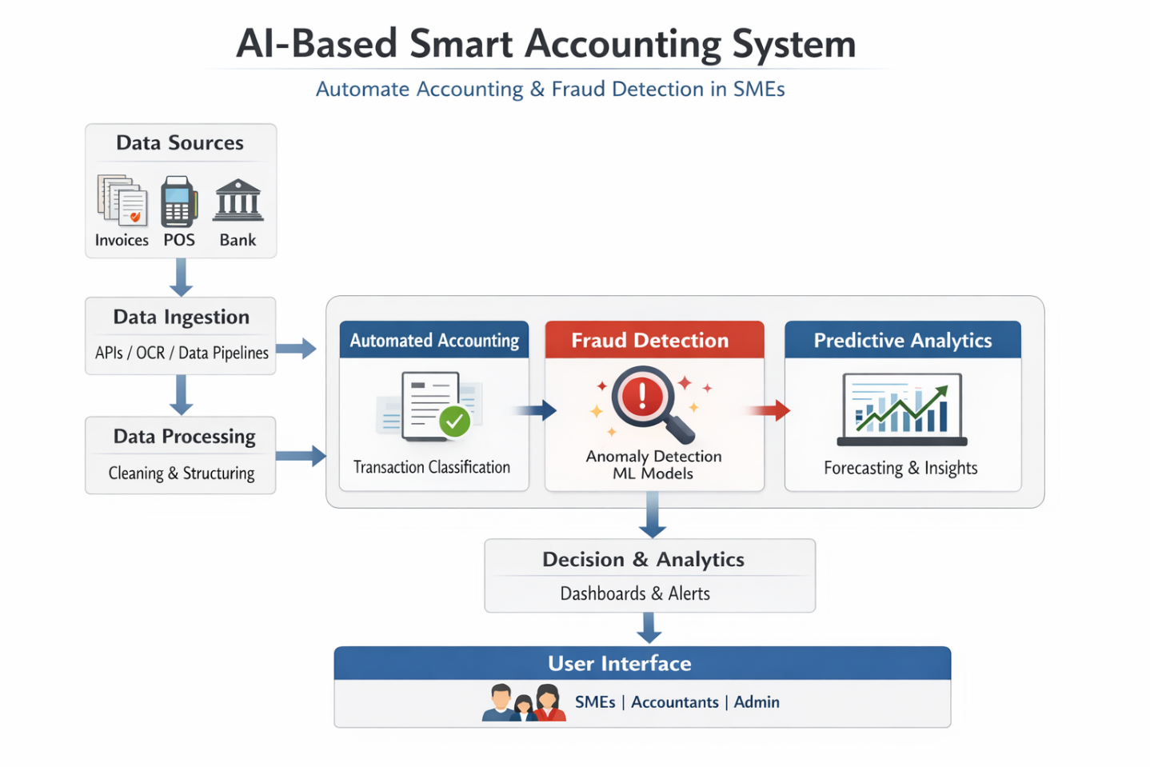
Data Ingestion Layer Collects data from:
• ERP accounting systems
• Bank transactions
• Receipts (OCR)
• APIs, automation tools

Data Processing Layer
• Data cleaning/normalization
• Feature engineering for AI models
• Conversion of unstructured data to structured financial entries

Automated Accounting Module
Uses machine learning classification models for:
• Transactions categorization (expense, revenue, assets)
• Automation of journal entries
• Reduction of human errors in bookkeeping

Fraud Detection Module uses:
• Anomaly detection algorithms
• Supervised learning (classification): detection of:
• Duplicate invoices
• Abnormal transactions
• Suspicious activity

Predictive Analytics Module
• Cash flows
• Trends in revenue
Useful for decision making

Decision Layer (Dashboard)
• Alerts for fraud in real time
• Visualization of financial KPIs
• Reporting for management

Used AI Techniques
• Machine learning (classification/regression)
• Deep learning (optionally for complex patterns)
• Natural language processing (for invoices text)
• Anomaly detection (Isolation Forest, autoencoders)

Summary of Workflow
• Collection of data from different sources
• Data cleansing and structuring
• Automated classification of transactions into accounts
• Parallel analysis of fraud patterns
• Insights visualization in dashboards

Advantages of the Solution for SMEs
• Decrease in human effort in accounting
• Increase in accuracy and compliance
• Fraud detection
• Insights into finance
• Cost-efficient

Conclusion
The proposed AI-based smart accounting system is a promising scalable solution for SMEs.

3.11 Summary

In this chapter, the proposed AI-based smart accounting system is elaborated on, with special focus on hybrid feature selection approach, stacking ensemble architecture with MLP as meta-learner, accounting automation, and XAI techniques. The design addresses the requirements of SMEs and considers accuracy, efficiency, and interpretability at the same time.

