Midocean university,
College of Management
Department of Business Administration



The Impact of Globalization on Supply Chain Networks: Challenges and Opportunities for Multinational Companies

By Student

Mohammed Alafif

05 Nov, 2024

Supervised by

Dr. Alfaisal Abdulhamid
Dr. Fayez Jarad

Abstract

Multinational corporations face both tremendous opportunities and challenges as a result of the effects of globalization on supply chain networks. Businesses that grow internationally face a variety of challenging circumstances, such as shifting consumer preferences, varied regulatory frameworks, and geopolitical unpredictabilities. Strong risk management techniques are required because these factors may result in more logistical difficulties and possible disruptions. On the other hand, businesses can use global markets to source materials, optimize production, and improve distribution efficiency thanks to globalization. Further facilitating real-time data sharing and better decision-making across supply chains is the integration of cutting-edge technologies like blockchain and artificial intelligence. Multinational corporations can also enter emerging markets, which could broaden their clientele and generate more income. Yet, as businesses must deal with pressures to be sustainable, ethical, and resilient, the need for these qualities becomes critical. transparency of the supply chain. In the end, even though globalization presents obstacles, it also offers opportunities for development and expansion, forcing multinational corporations to reconsider and improve their supply chain tactics in order to stay competitive in a market that is changing quickly. Furthermore, as consumers call for more ethical sourcing and production methods, sustainable practices are becoming increasingly important. Multinational corporations must invest in technology, embrace agile strategies, and encourage cooperation with regional partners in order to navigate these dynamics. In the end, even though globalization presents many difficulties, it also provides a way for supply chain management to develop and innovate, allowing businesses to prosper in a world market that is changing quickly.

Chapter One

  - Introduction

The supply chain network landscape has undergone a significant transformation as a result of globalization, presenting multinational corporations with both novel challenges and exciting opportunities. Businesses that grow internationally face a dynamic environment with intricate global interdependencies between suppliers, manufacturers, and customers. Because of their interconnectedness, businesses can access new markets, streamline processes, and use cutting-edge technologies to become more competitive. Globalization has many advantages, but it also has drawbacks, such as supply chain vulnerabilities, geopolitical risks, and regulatory compliance.

The growing complexity of supply chains is one of the main effects of globalization. Diverse regulatory frameworks, cultural disparities, and logistical challenges must be managed by multinational corporations, which can result in inefficiencies and disruptions. These networks become even more complex due to geopolitical tensions and trade policies, which may have an effect on sourcing tactics and operating expenses. Because of this, companies are forced to implement resilient and agile supply chain strategies that can react swiftly to shifting circumstances.
Notwithstanding these difficulties, globalization presents significant opportunities as well. Businesses can take advantage of emerging markets with rising consumer demand by leveraging a global supplier base to lower costs and boost innovation. Furthermore, technological developments like digital platforms and data analytics give businesses the means to enhance forecasting, streamline inventory control, and boost supply chain transparency.

  - Study Problem

Introduction to Globalization and Supply Chains.

The world economy has undergone a significant transformation as a result of globalization, leading to a rise in national interdependence and connectivity. Supply chain networks are significantly impacted by this shift, especially multinational corporations (MNCs) that conduct business across several continents and nations. Once quite straightforward and localized, supply chains have developed into intricate, worldwide networks that have to deal with a variety of regulatory frameworks, cultural variances, and logistical difficulties. Supply chains are becoming more globalized, which presents both opportunities and difficulties. On the one hand, it gives businesses access to fresh markets, diverse material sources, and cost-effective production. However, it also brings with it the risk of supply chain disruptions, trade barriers, and political instability. It is essential for multinational corporations (MNCs) to comprehend how globalization affects supply chains in order to create efficient management.

Historical Evolution of Global Supply Chains.

Global supply chains have historically developed since the emergence of trade routes and the Industrial Revolution, which initiated widespread international trade. The globalization of supply chains has accelerated during the last few decades due to developments in information technology, communication, and transportation. The World Trade Organization (WTO) and other free trade agreements have made it easier for goods and services to move across national borders. Multinational corporations (MNCs) have utilized these advancements to broaden their global operations, aiming to improve their competitiveness by decreasing expenses, innovating, and entering new markets. Easier-to-respond to consumer demands and the quest of economies of scale have propelled the transition from localized production to global manufacturing networks.

Opportunities Presented by Globalized Supply Chains.

Multinational corporations (MNCs) can benefit greatly from globalized supply chains as they open up new markets, provide access to a wider range of resources, and improve operational efficiency. Businesses can diversify their supplier base, lessen reliance on a single source, and reduce the risk of local disruptions by growing their supply chains abroad. Global supply chains also enable multinational corporations (MNCs) to benefit from reduced production costs in various locations, streamlining their cost structures and raising profitability.
Challenges of Managing Global Supply Chains.

Globalization brings about many opportunities, but it also creates a lot of difficulties for supply chain management. The growing complexity of transportation and logistics is one of the main obstacles. Managing longer lead times, navigating various regulatory environments, and dealing with varying infrastructure quality are all part of coordinating the movement of goods across multiple countries. MNCs also have to deal with the possibility of trade wars, unstable political environments, and shifting regulatory environments, all of which can cause supply chain disruptions and raise expenses. Keeping an eye on and maintaining control over the whole supply chain is another significant challenge. As manufacturers, distributors, and suppliers are dispersed throughout various areas, it becomes increasingly challenging to maintain efficient communication and real-time monitoring.
The Role of Technology in Global Supply Chains.

In order to manage the complexity of global supply chains and reduce the risks involved, technology is essential. Information technology advancements like supply chain management software, blockchain technology, and enterprise resource planning (ERP) systems have completely changed how multinational corporations run their supply chains. With the help of these technologies, supply chain operations can be seen and controlled more clearly, allowing businesses to track the flow of goods in real time, keep an eye on inventory levels, and improve logistics. RFID and GPS tracking systems, for instance, let businesses track shipments and guarantee on-time delivery, and predictive analytics can help forecast changes in demand and modify production schedules appropriately.
The Impact of Trade Policies and Regulations

The global supply chains are significantly impacted by trade policies and regulations, which also affect the cross-border movement of goods and services. Alterations in trade agreements, tariffs, and customs processes have a substantial impact on the expenses and effectiveness of global trade. Tariffs on imports, for instance, can raise production costs and cause supply chain disruptions by driving up the cost of specific materials or components. Trade conflicts between major economies, like the one between the US and China, have caused a change in supply chain strategies as businesses try to lessen the effects of tariffs and prevent possible disruptions. Moreover, regulatory disparities among nations may pose difficulties for MNCs in terms of compliance and standardization, necessitating their navigation of a convoluted web of laws and regulations.
Supply Chain Risk Management Strategies.

Sustaining the resilience and stability of global supply chains requires effective risk management. MNCs have to recognize possible risks and create plans to lessen their effects. Diversification is a crucial tactic that minimizes reliance on a single source by procuring materials and components from various suppliers and geographical locations. This strategy lessens the possibility of supply chain interruptions brought on by calamities, unstable political environments, or changes in the local economy. Companies can also develop strategic inventories of essential components and materials to guarantee business continuity in the event of supply disruptions. Using cutting-edge technologies can improve the capacity to recognize and address possible threats, such as real-time monitoring systems and predictive analytics.

The Role of Sustainability in Global Supply Chain.

The importance of sustainability in global supply chains has grown due to pressure from regulations and rising consumer awareness. MNCs must now face greater scrutiny to guarantee that their supply chain operations respect the environment and society. This include cutting back on carbon emissions, assuring ethical labor standards across the supply chain, and minimizing the environmental effect of their operations. Using energy-efficient production techniques, adopting circular economy ideas to cut waste, and sourcing materials from suppliers who respect the environment are a few examples of sustainable supply chain management strategies. To lessen their carbon footprint, businesses can also develop sustainable transportation strategies and invest in renewable energy sources. Establishing trust with stakeholders and customers requires accountability and transparency.
  - The importance of studying

Globalization has created complex global networks that have drastically changed the face of international business. It is critical for multinational corporations to comprehend how globalization affects supply chain networks. The present analysis takes into account the obstacles and prospects that result from the interdependence of international markets. The integration of production processes and distribution networks across national boundaries brought about by globalization has made operations more effective and economical. But it also brings with it complications that need to be carefully managed, like cultural differences, regulatory variations, and geopolitical risks. Globalization has been further accelerated by the emergence of advanced technologies and digitalization, which have made it possible for supply chain partners to collaborate and share data in real time. Because of this interconnectedness, supply chain management needs to take a comprehensive approach that can quickly adjust to disruptions and changes. The COVID-19 pandemic brought attention to the weaknesses in international supply chains and emphasized the importance of adaptability and resilience. Businesses that grow globally must deal with shifting labor markets, consumer preferences, and economic conditions. In an increasingly globalized world, supply chain management success requires striking a balance between cost effectiveness and adaptability and responsiveness. The global supply chains are further complicated by the pursuit of sustainability and ethical practices. When streamlining their supply chains, multinational corporations need to take social responsibility and the environment into account. Because local and global factors interact to create a dynamic environment, strategic decisions need to be well-informed by both. For this reason, researching how globalization has affected supply chain networks is crucial to determining best practices and reducing risks. It offers perceptions into how businesses can take advantage of worldwide opportunities while avoiding possible hazards. By providing insightful viewpoints on the effects of globalization on corporate operations, this study also adds to the larger conversation on the topic. In this context, it becomes imperative for scholars, practitioners, and policymakers to examine how globalization affects supply chain networks.
Strategic Approaches to Managing Global Supply Chains.

It takes a strategic approach that combines risk management, technology, and cooperation to manage global supply chains effectively. The creation of strong risk management frameworks that recognize possible disruptions and create backup plans is one essential tactic. To predict and lessen the impact of geopolitical, economic, and environmental risks on supply chains, businesses must constantly monitor these areas. Advanced technology investments, like those in blockchain, IoT, and AI, can improve supply chain visibility and traceability. These technologies allow for better demand forecasting, more effective inventory management, and real-time tracking of goods. Establishing robust and adaptable networks also requires cooperation with supply chain partners. Coordinating and solving problems can be enhanced by having solid working relationships and lines of communication with distributors, suppliers, and logistics companies. Sustainability and ethics should be given top priority by multinational corporations. Machine learning and data analytics can be used to find areas for optimization and offer insightful information about the performance of the supply chain.

  - The objectives of studying

The Impact of Globalization on Supply Chain Networks: Challenges for Multinational Companies.

Supply chain networks have undergone a significant transformation due to globalization, which presents numerous challenges for multinational corporations. The growing complexity of supply chains is one major obstacle. Businesses that grow internationally have to manage a wider network of manufacturers, distributors, and suppliers that frequently span several continents and nations. The logistical challenges posed by this expansion include coordinating transportation across various geographic regions and guaranteeing timely delivery of goods. Multinational corporations also have different regulatory environments to deal with. Complying with trade, labor, and environmental standards can be challenging since every nation has its own set of laws. The complexity of supply chain operations can be further compounded by regional economic fluctuations and political instability.
The Impact of Globalization on Supply Chain Networks: Opportunities for Multinational Companies.

Multinational corporations can improve their supply chain networks through a number of opportunities presented by globalization, notwithstanding its drawbacks. Having access to a larger pool of suppliers is one significant advantage. Companies can experience cost efficiencies and lower production costs by sourcing materials and components from different regions. Companies can take advantage of competitive advantages in various regions, like lower labor costs or specialized knowledge, by implementing this global sourcing strategy. Additionally, businesses can broaden their clientele and penetrate new markets thanks to globalization. Companies can seize market share and revenue growth by establishing a presence in a variety of regions and tapping into emerging markets with increasing consumer demand. Adopting cutting-edge technologies to improve supply chain operations presents an opportunity. Artificial intelligence (AI), blockchain, and the Internet of Things (IoT) are a few examples of innovations that can improve transparency and visibility throughout the supply chain, allowing for real-time tracking of goods and better decision-making. IoT devices, for instance, can keep an eye on the state of the cargo while it is being transported, guaranteeing quality control and minimizing spoilage. Large-scale data analysis is a capability of AI algorithms, which they can use to forecast demand, optimize inventory levels, and optimize production schedules. A safe and unchangeable transaction record made possible by blockchain technology can boost confidence and lower supply chain fraud. Globalization also promotes cooperation and alliances with other businesses and institutions.
  - Questions to study

Introduction to Questions of Globalization and Supply Chains.

The term "globalization" describes the growing interdependence and connectivity of populations, economies, and cultures around the world. A lot of business operations have been affected by this phenomenon, especially supply chain networks. Leading this change have been multinational corporations (MNCs), who use globalization to streamline their supply chains. It is imperative that these companies comprehend the opportunities and challenges brought about by globalization in order to maintain their competitiveness. What effects has globalization had on supply chain management? Which major forces behind globalization have an impact on supply chain strategies? In what ways do innovations in technology support the integration of global supply chains? What effects do economic and political policies have on international supply chains? What effects do linguistic and cultural barriers have on international supply chain operations? How do trade agreements influence the structure of international supply chains? What impact does globalization have on MNCs' sourcing and procurement strategies? What effects do international supply chain networks have on the environment? How do MNCs handle sustainability issues in the context of an international supply chain? How does an MNC's worldwide distribution network function? What hazards are connected to international supply chains, and what steps can be taken to reduce them? How do multinational corporations handle the intricate global supply chains?

Challenges Questions of Globalization on Supply Chains.

Globalization brings with it many benefits, but it also poses serious problems for supply chain networks. Multinational corporations frequently deal with challenging problems in risk management, regulatory compliance, and logistics. What are MNCs' main logistical obstacles in an international marketplace? What effects do border and customs laws have on international supply chains? What are the obstacles to preserving uniformity in product quality among various geographical areas? How do multinational corporations (MNCs) handle the problem of disparate labor laws and practices across nations? What cybersecurity risks exist for international supply chains, and what steps can be taken to counter them? What is the impact of political instability on supply chain operations in specific regions? What methods do multinational corporations use to handle supply chain interruptions brought on by natural disasters? How do changes in exchange rates for currencies work? What effects do changes in exchange rates have on international supply chains? What difficulties does it present to manage a varied supplier base? In a global supply chain, how do multinational corporations (MNCs) manage the protection of intellectual property? What effects does the disparity in logistics and transportation infrastructure between nations have? What effects do tariffs and trade restrictions have on the cost structure of international supply chains? What part does technology play in resolving issues with the global supply chain? How do multinational corporations make sure that environmental laws are followed in various places? What moral issues are raised by sourcing procedures in an international supply chain? What effects do cultural differences have on coordination and communication within international supply chains?
Opportunities Questions of Globalization on Supply Chains.

Globalization offers many opportunities to improve supply chain networks, despite its drawbacks. These are opportunities that multinational corporations can seize to obtain a competitive advantage. What are the main benefits that supply chain networks can expect from globalization? How can multinational corporations use global sourcing to cut expenses and boost productivity? What are the advantages of having access to a larger talent pool in an international supply chain? How does MNCs get access to new markets and clientele as a result of globalization? What part does innovation play in taking advantage of global supply chains' opportunities? How can MNCs optimize their global supply chain operations with data analytics? What advantages do strategic alliances and partnerships offer in the context of global supply chains?
Case Studies Questions and Real-World Examples.

Analyzing case studies and actual instances can yield insightful information about how supply chain networks are affected by globalization. How are the world's top multinational corporations managing their global supply chains? What are the most important takeaways from prosperous MNCs' supply chain strategies? How did a particular MNC handle the supply chain difficulties brought on by globalization? What tactics did an MNC employ in order to take advantage of the opportunities that came with globalization? In a global setting, how did a multinational corporation handle the sustainability of its supply chain? What part did technology play in the transformation of an MNC's global supply chain? In what ways has globalization helped an MNC strengthen the resilience of its supply chain?

  - Assumptions to study

Overview and Context Assumptions of Globalization in Supply Chains.

Supply chain networks are now very different from what they were before globalization, which makes them an important subject to research in order to comprehend contemporary business dynamics. An unprecedented degree of interconnectedness among nations has resulted from the integration of global markets, which has facilitated the flow of information, goods, and services. Multinational corporations (MNCs) have a plethora of opportunities to grow their businesses and enter new markets as a result of this interconnection. One fundamental presumption is that globalization broadens the scope and improves the effectiveness of supply chains, enabling businesses to more efficiently procure raw materials and distribute goods. But this presumption also suggests that supply chains grow increasingly intricate and possibly more susceptible to interruptions.

Challenges Assumptions in Global Supply Chain Networks.

The complexity and global reach of global supply chain networks present a multitude of challenges. One of the main presumptions is that the risk of supply chain interruptions rises as operations become more widely distributed geographically. Natural catastrophes like hurricanes, floods, and earthquakes are thought to have the capacity to seriously affect supply chain continuity. Global supply chains are thought to be seriously threatened by geopolitical risks such as trade wars, political unrest, and sanctions. The regulatory diversity among nations presents another difficulty for multinational corporations (MNCs), as adhering to various legal and environmental standards can be onerous. It is assumed that there could be inefficiencies and bottlenecks due to the wide regional variations in logistics and transportation infrastructure. Additionally, given that supply chains are becoming more digitally connected and thus vulnerable to cyberattacks and data breaches, it is expected that cybersecurity threats will only become more prevalent. It is believed that managing cultural differences and communication barriers in multinational teams is a difficult task that can have an impact on productivity and teamwork. Another difficulty is the volatility of commodity prices, since shifts in the price of raw materials can have an effect on the total cost of the supply chain. It is believed that the financial stability of international supply chain operations is impacted by fluctuations in currency exchange rates. It is anticipated that sustainability standards and environmental laws will complicate supply chain management and force multinational corporations to invest in environmentally friendly practices and technologies. Given that customers are presumably expecting deliveries to happen faster and with greater reliability, multinational corporations need to continuously improve their logistical capabilities. It is widely believed that supply chain visibility and transparency are essential for efficient management, but it can be difficult to achieve this across a global network. Another presumption is that labor disputes and strikes in various areas may cause supply chain operations to be disrupted. Decisions and strategies related to supply chains are expected to be impacted by political and economic shifts in important markets. Since standards can differ, it is assumed that maintaining quality control across various production sites presents a significant challenge.
  - The Scientific Theory Followed to Prepare the Research

Supply chain networks have undergone significant change as a result of globalization, which offers multinational corporations both opportunities and challenges. Systems theory, which stresses how parts of a complex system are interconnected, is the scientific theory that underpins this study. This entails knowing how economic changes, technological breakthroughs, and global interdependencies affect the cross-border movement of information, goods, and services in the context of supply chains. To examine data from various markets, researchers frequently use quantitative techniques like simulation modeling and regression analysis. This method makes it possible to spot patterns and trends, which aids in calculating how much globalization has affected cost control, operational effectiveness, and market responsiveness. Because of their complexity, these systems necessitate a multidisciplinary approach that integrates knowledge from sociology, logistics, and economics to fully understand the dynamics at work.
Furthermore, the advantages of globalization—like the ability to take advantage of economies of scale and access new markets—are just as important. Strategic frameworks like the Resource-Based View (RBV), which holds that businesses can gain a competitive edge by efficiently employing their resources and capabilities in a global setting, are frequently the subject of research. Successful multinational corporations' case studies demonstrate how flexible tactics, such as local sourcing, cooperative alliances, and cutting-edge technology integration, can lessen difficulties like supply chain interruptions, legal compliance, and cultural differences. Researchers can learn more about the experiences of businesses navigating these complexities by using qualitative techniques like focus groups and interviews. In order to optimize supply chain networks in a world that is becoming more interconnected, the research ultimately seeks to offer practical suggestions for multinational corporations on how to maximize the benefits of globalization while resolving its inherent drawbacks. A mixed-methods approach, combining qualitative and quantitative techniques, is used to conduct the research. Interviews with supply chain managers from different multinational corporations are used to collect qualitative data, examining their personal experiences and perspectives on the opportunities and problems presented by globalization. In order to measure the effect of particular global factors—such as trade policies, technological advancements, and socioeconomic shifts—on supply chain performance, quantitative data is gathered through surveys that are disseminated to a larger audience. In addition to capturing the complexities of the effects of globalization, this all-encompassing approach enables a thorough examination of the trends and patterns that appear in various industries.

Chapter Two

  - Previous studies conducted on

Introduction to previous studies of Globalization in Supply Chains.

Supply chain networks have seen tremendous transformation as a result of globalization, opening up new markets, resources, and technological opportunities for multinational corporations (MNCs). Because of this interconnection, sourcing materials and distributing goods are now more efficient and less expensive. Research has indicated that corporations can reduce the risks associated with sole supplier reliance by diversifying their supply sources as a result of globalization. But this complexity also brings with it drawbacks, like harder logistical tasks and regionally varying regulatory compliance. For example, a McKinsey Global Institute report notes that businesses have extended their supply chains to more than 20 nations, increasing opportunities as well as risks. Globalization also encourages competition, which pushes businesses to continuously innovate. Real-time information sharing across geographical boundaries is made possible in large part by improved communication technologies. However, this quick growth may also present risks, like supply chain interruptions brought on by natural disasters or geopolitical unrest. The difficulty in supply chains is striking a balance between resilience and efficiency. If multinational corporations (MNCs) want to succeed in the global marketplace, they must comprehend these dynamics. Businesses can manage inherent risks and optimize their operations by strategically utilizing globalization. (Fig. 1).

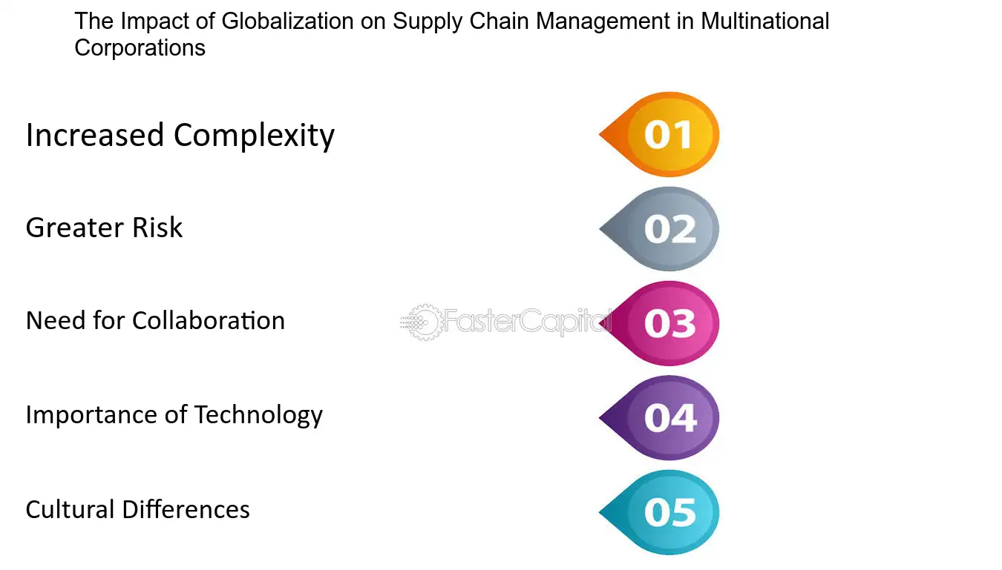

Figure.1 Summarized of The Impact of Globalization on Supply Chain Management in Multinational.

  - Theoretical Framework of the Study

Reshaping the policy debate on the implications of COVID-19 for global supply chains A STUDY PUBLISHED BY THE RESEARCHER " Sébastien Miroudot" THIS IS A SUMMARY OF THE SCIENTIFIC PAPER

Abstract
Disruptions in global supply chains in the context of the COVID-19 pandemic have re-opened the debate on the vulnerabilities associated with production in complex international production networks. To build resilience in supply chains, several authors suggest making them shorter, more domestic, and more diversified. This paper argues that before redesigning global supply chains, one needs to identify the concrete issues faced by firms during the crisis and the policies that can solve them. It highlights that the solutions that have been proposed tend to be disconnected from the conclusions of the supply chain literature, where reshoring does not lead to resilience, and could further benefit from the insights of international business and global value chain scholars. Lastly, the paper discusses the policies that can build resilience at the firm and global levels and the narrative that could replace the current one to reshape the debate on the policy implications of COVID-19 for global supply chains. (Fig. 2).

Keywords
COVID-19, international business, global value chains, risk management, resilience.

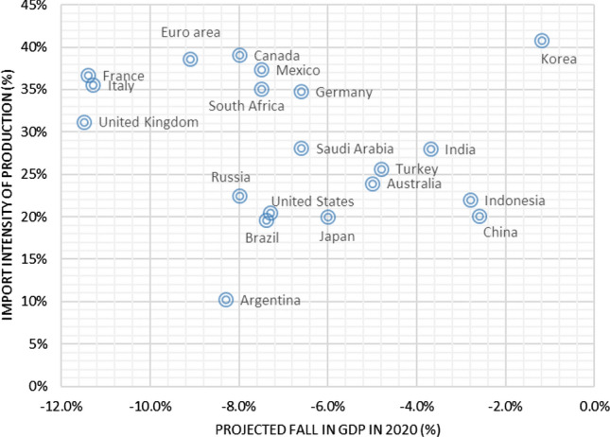
Figure.2 Import intensity of production (2015) and projected fall in GDP in 2020 for G20 economies.
.

Previous studies of Globalization in Supply Chains in Technological Advancements and Their Role.

Global supply chains have been shaped in large part by technological advancements. The movement of goods across borders is now possible more quickly and effectively thanks to innovations in logistics and transportation. Blockchain and other technologies improve traceability and transparency, enabling businesses to keep an eye on their supply chains in real time. Having this visibility is essential for seeing possible problems and acting quickly. Additionally, data analytics gives multinational corporations (MNCs) the ability to understand market trends and consumer behavior, facilitating better decision-making. Automation enhances operational efficiency, lowers costs, and improves accuracy in warehouses and production facilities. Digital platforms also help supply chain partners collaborate more effectively, which promotes creativity and agility. Supply chain strategies have been transformed by the growth of e-commerce, allowing multinational corporations to communicate directly with customers and lessen their reliance on conventional retail channels. Adoption of these technologies does, however, present a unique set of difficulties, such as the requirement for substantial funding and skilled labor. MNCs must thus weigh the advantages of technology integration against the risks and expenses involved. Maintaining a competitive edge in a world that is changing quickly requires embracing digital transformation.

Summarized of Abstract

The effects of globalization on supply chains present both tremendous opportunities and difficulties for multinational firms. Strong risk management is necessary because of the challenges they face, which include shifting consumer preferences, a variety of regulations, and geopolitical uncertainties. With the help of technologies like blockchain and artificial intelligence, globalization enables companies to reach new markets, maximize production, and improve distribution efficiency. They must, however, also respond to calls for ethics, transparency, and sustainability. Companies must make technology investments, implement agile strategies, and work with regional partners in order to stay competitive. In the end, globalization encourages innovation and expansion in supply chain management even though it also poses difficulties.

المستخلص بالعربي

تُقدّم آثار العولمة على سلاسل الإمداد فرصًا هائلة وصعوبات في الوقت ذاته بالنسبة للشركات متعددة الجنسيات. ويتطلب الأمر إدارة قوية للمخاطر بسبب التحديات التي تواجهها هذه الشركات، مثل التغيرات في تفضيلات المستهلكين، وتنوع الأنظمة والقوانين، وعدم اليقين الجيوسياسي. بفضل التقنيات الحديثة مثل البلوك تشين والذكاء الاصطناعي، تمكّن العولمة الشركات من الوصول إلى أسواق جديدة، وتعظيم الإنتاج، وتحسين كفاءة التوزيع. ومع ذلك، يجب على الشركات أن تستجيب أيضًا للمطالب المتعلقة بالأخلاقيات، والشفافية، والاستدامة. وللحفاظ على تنافسيتها، يتعين على الشركات الاستثمار في التكنولوجيا، وتطبيق استراتيجيات مرنة، والتعاون مع الشركاء الإقليميين. في النهاية، تشجع العولمة على الابتكار والنمو في إدارة سلاسل الإمداد، رغم ما تحمله من تحديات.

