

University of MidOcean
College of Management
Department of Business Administration
Research Title
Digital Currencies and Their Impact on the Strategies of the Saudi Market
Prepared by
Ziyad bin Yahya Bazaid
Supervised by
Dr. Hassan Al Faisal
Dr. Fayez Jarad
Academic Year 2025

Acknowledgment

To the source of kindness, sincerity, and unconditional love...
To the one whose joy reflects mine, and whose tears blend with my own...
To my beloved mother.
To the one who gave his time, strength, and years so that I could stand where I am today...
To my dear father.
To everyone from whom I learned, and to all who supported me along this journey...
I dedicate to them all the fruit of my effort.

Table of Content
- Cover Page
- Copyright Notice
- Abstract
- Acknowledgment
- List of Tables
- List of Figures
- List of Terminology
- List of Abbreviations

Chapter 1: Introduction
1.1 Background of the Study
1.2 Global Context of Digital Currencies
1.3 Saudi Arabia’s Digital Financial Transformation
1.4 Problem Statement
1.5 Importance of the Study
1.6 Objectives of the Study
1.7 Research Questions
1.8 Research Hypotheses

Chapter 2: Literature Review
2.1 Global Overview of Digital Currencies
2.2 Digital Assets in Financial Markets
2.3 Regulatory Models Across Countries
2.4 Previous Studies
2.5 Theoretical Framework of the Study

Chapter 3: Research Methodology
3.1 Research Design
3.2 Population and Sample
3.3 Survey Instrument
3.4 Data Collection Methods
3.5 Data Analysis Techniques
3.6 Limitations of the Methodology

Chapter 4: Survey Analysis and Results
4.1 Respondent Demographics
4.2 Awareness of Digital Currencies
4.3 Investment Behavior
4.4 Perceived Risks and Opportunities
4.5 Market Readiness in Saudi Arabia
4.6 Interpretation of Survey Results

Chapter 5: Discussion
5.1 Analysis in Considering the Research Questions
5.2 Comparison with Global Trends
5.3 Alignment with Vision 2030
5.4 Institutional and Cultural Implications

Chapter 6: Conclusions and Recommendations
6.1 Summary of Findings
6.2 Conclusions
6.3 Policy Recommendations
6.4 Implications for Investors and Institutions
6.5 Suggestions for Future Research

References

Appendices
Appendix A – Survey Questionnaire
Appendix B – Statistical Tables
Appendix C – Additional Figures

Introduction
During the past two decades, global financial systems experienced sustained structural change driven by advances in digital communication, increased dependence on data based services, and the spread of financial technology across advanced and emerging economies. These changes altered the foundations of money, settlement, and financial interaction. Digital currencies are digital forms of value recorded and transferred on networked systems without reliance on physical money or direct control by a central authority. They differ from central bank digital currencies, which are issued by national monetary authorities. They also differ from electronic bank deposits, which depend on traditional financial institutions. Reports from the Bank for International Settlements in 2021 explain that this period marked a shift in which digital infrastructures influenced payment efficiency, reduced some forms of transaction friction, and encouraged new actors to enter financial markets. Publications from the International Monetary Fund in 2022 support this view by documenting increased interest among policy makers who examine the effects of digital assets on capital mobility, macroeconomic policy, and oversight of financial transactions.
Digital currencies attracted attention because of decentralization, cryptographic verification, and open network participation. Decentralization refers to the operation of systems without a central authority that controls transaction processing. Cryptographic verification refers to methods that secure transactions through mathematical proofs that prevent unauthorized modification. Open network participation refers to public access to systems that allow users to join the network without approval from a central institution. These characteristics encouraged users to treat digital currencies as alternative financial tools with flexible global access. Bitcoin and Ethereum represent the most widespread examples. Bitcoin is a digital currency introduced in 2009 that records transactions on a public distributed ledger known as a blockchain. Ethereum is a digital platform introduced in 2015 that supports both a digital currency and programmable applications known as smart contracts. Research by Baur, Dimpfl, and Kuck in 2018 and findings by Yermack in 2015 show early growth of these currencies resulted from a combination of technological interest, global market enthusiasm, and expectations related to diversification benefits.
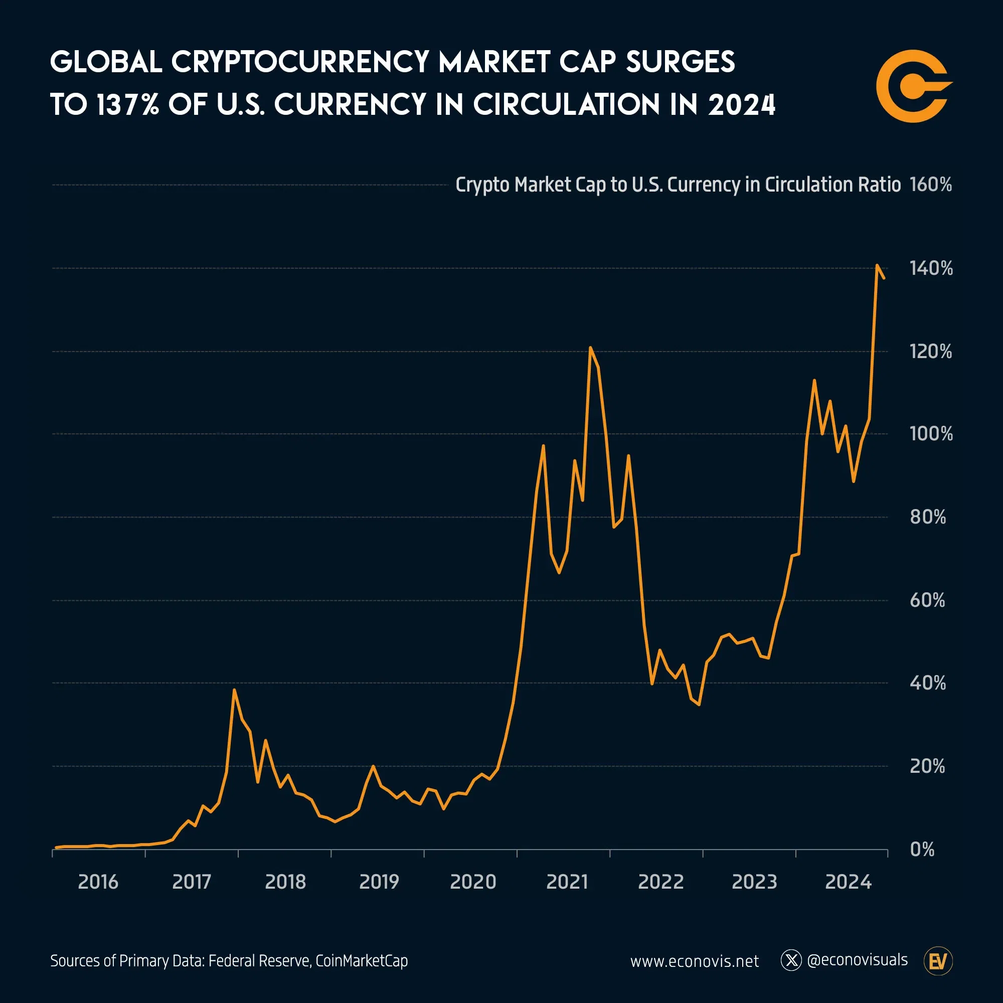
Figure 1: Global Crypto Market Cap vs US Currency in Circulation (Voronoi / Econovisuals)
The graph shows a steady rise in the ratio between global cryptocurrency market capitalization and United States currency in circulation from 2016 to 2024. The ratio begins near zero in 2016, increases through several periods of sharp fluctuation between 2017 and 2021, and then moves through a phase of moderate variation before entering a rapid upward trajectory in 2023. The line reaches about 137 percent in 2024, which reflects strong growth in global digital asset valuation relative to physical currency issued by the United States.
The pattern indicates expanding global interest in digital assets, increased trading activity, and wider institutional involvement. The presence of repeated peaks during earlier years reflects responses to shifts in market liquidity, global risk sentiment, and regulatory expectations. The strong rise during 2023 and 2024 aligns with higher adoption of digital financial tools, broader participation from investors, and increased integration of digital asset products in international markets.
These studies also confirm adoption expanded across countries with strong digital infrastructure and active online trading communities.
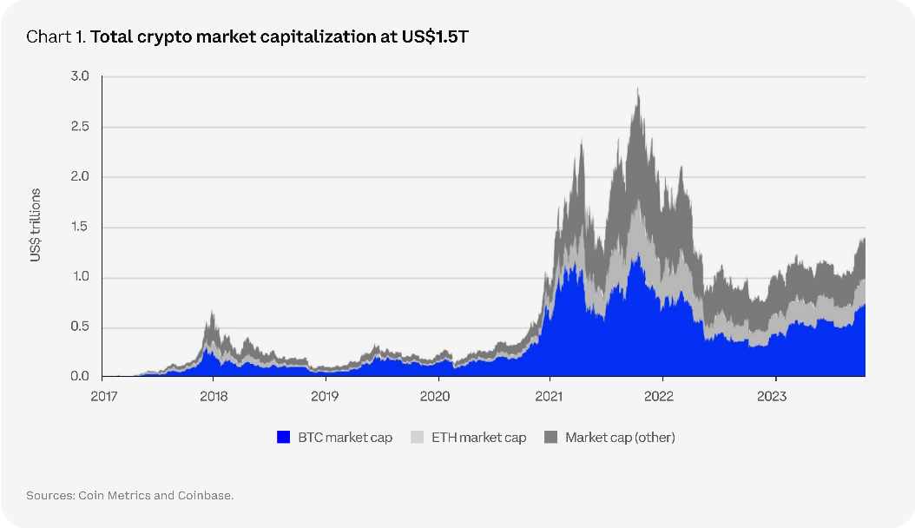
Figure 2: Global Crypto Market Cap Area Chart (Coinbase Institutional)
The chart presents the composition of global cryptocurrency market capitalization from 2017 to 2023. It shows three segments that represent Bitcoin, Ethereum, and other digital assets. The total market value rises from near zero in 2017 to more than three trillion dollars during the peak period in late 2021. Bitcoin forms the largest share during early years, while Ethereum and other assets increase their share as the market expands. The decline after 2021 reflects adjustments linked to liquidity pressure, changing investor sentiment, and regulatory announcements across several markets.
The chart also shows recovery beginning in 2023, with total market value reaching about one and a half trillion dollars. The stronger presence of assets outside Bitcoin and Ethereum reflects increased diversification within the digital asset ecosystem. This diversification aligns with broader market interest in blockchain based applications, token based instruments, and digital financial services that gained attention during this period.
Increased involvement from institutions, retail users, and specialized financial firms supported the shift of digital currencies from fringe technological experiments to instruments discussed in mainstream financial literature.
The global expansion of digital assets produced regulatory and economic challenges for national financial authorities. Digital assets include digital currencies, token based financial instruments, and blockchain based representations of ownership. Some countries introduced licensing systems for digital asset service providers, established rules for custody practices, and strengthened supervision standards. The European Union provided a structured regulatory path through the Markets in Crypto Assets Regulation in 2023, which set detailed requirements for transparency, organizational control, and consumer protection. Japan advanced its oversight model by requiring registration and continuous supervision of digital asset platforms through the Financial Services Agency. These developments reflect concerns identified in OECD and World Bank reports, which document risks linked to anonymous transfers, exposure to financial crime, high volatility, and large swings in global liquidity conditions. These reports also show fragmented regulation across jurisdictions influences cross border activity and increases reliance on offshore platforms where strict oversight is absent.
Despite these concerns, multiple international indicators show continued movement toward integration of digital assets into wider financial systems. Studies from the CFA Institute show rising institutional engagement through investment products linked to digital assets and blockchain based instruments. Blockchain refers to a distributed ledger that records transactions in ordered blocks stored across network nodes. Reports from the World Economic Forum in 2022 describe efforts by payment technology firms and cross border settlement providers to test blockchain based systems that reduce processing time and improve record accuracy. These studies also show increased interest in token based financial tools, automated settlement environments, and new financial services that support faster international transfers. This direction indicates digital currencies influence more than individual speculation, since they interact with broader technological systems and shape expectations related to the future of financial infrastructure in both advanced and emerging markets.
This global context increases the importance of examining local environments that pursue digital transformation as a central national goal. Saudi Arabia represents a strong case because the Kingdom introduced large scale economic reforms through Vision 2030 that prioritize diversification, digital infrastructure, and knowledge based development. Official reports from the Saudi Central Bank show progress in electronic payments, cybersecurity strengthening, digital identity systems, and financial technology programs.
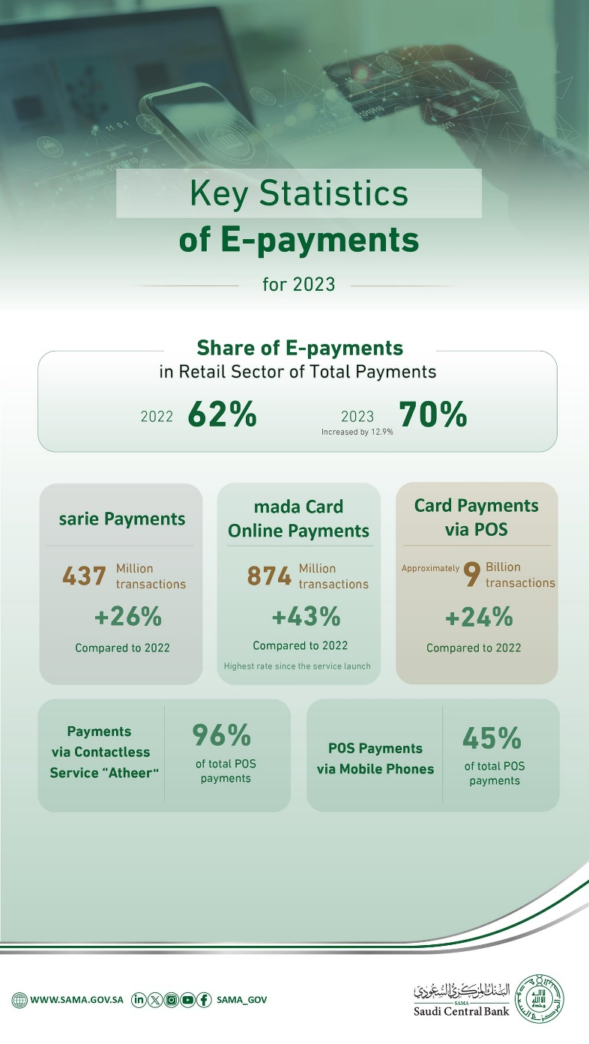
Figure 3: SAMA – Key Statistics of E-payments 2023 (share of e-payments 62 % → 70 %)
The figure presents the progression of electronic payments in the Saudi retail sector during 2023. It shows an increase in the share of e-payments from 62 percent in 2022 to 70 percent in 2023, which reflects wider public adoption of digital financial services and strong national progress toward electronic payment goals. The data highlight several components within the payment system. Sarie payments reached 437 million transactions, which represents a 26 percent increase compared to 2022. Online payments through mada cards reached 874 million transactions, which represents a 43 percent increase and marks the highest rate recorded since the service began. Card payments through point-of-sale terminals reached about nine billion transactions, which reflects a 24 percent increase compared to the previous year.
The figure also shows the expansion of contactless payments through the Atheer service, which accounted for 96 percent of all point-of-sale payments. It also shows that mobile phone payments represented 45 percent of point-of-sale transactions. These developments show stronger integration of digital tools within everyday financial activity and align with national objectives that focus on financial technology, improved efficiency, and reduced reliance on cash within the Saudi economy.
These reports also note increased interest in digital assets among different segments of the population, particularly younger groups who interact frequently with mobile financial applications and global digital platforms. The Communications and Information Technology Commission documented rising digital participation among Saudi youth, which supports the need for structured analysis of how digital assets influence national financial behavior.studia
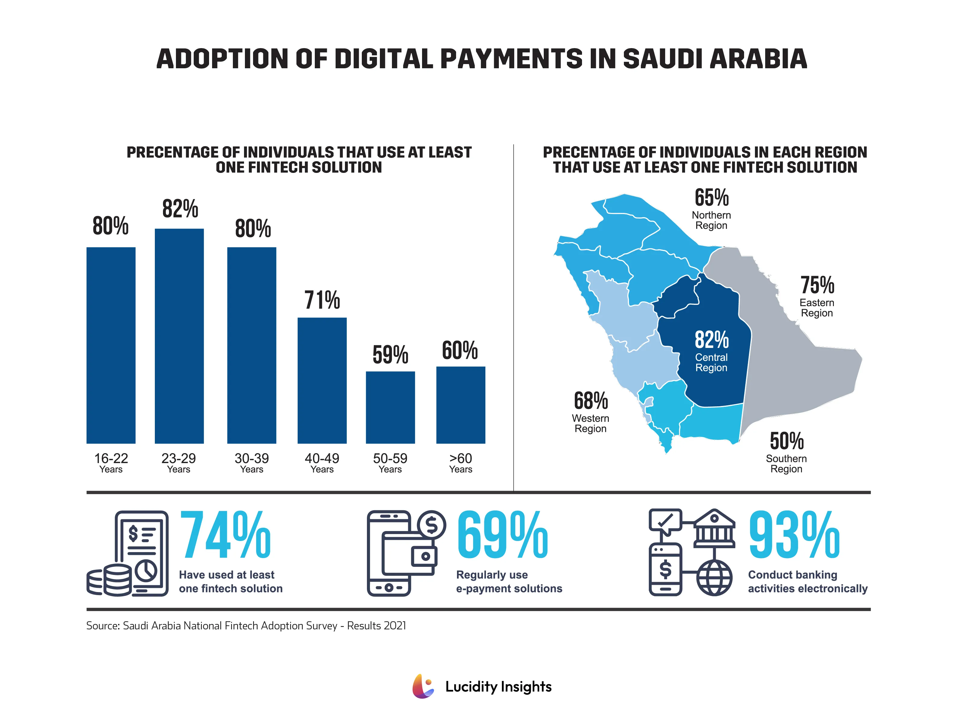
Figure 4: Adoption of Digital Payments in Saudi Arabia (Lucidity Insights, 2023)
The figure presents adoption levels of digital payment tools across age groups and regions in Saudi Arabia. It shows strong use of financial technology among younger groups, with 80 percent of individuals aged 16 to 22 and 82 percent of individuals aged 23 to 29 using at least one financial technology service. Use remains high among individuals aged 30 to 39, then decreases among older groups, with 59 percent of individuals aged 50 to 59 and 60 percent of individuals above 60 adopting at least one service. This pattern reflects stronger digital engagement among younger citizens who interact frequently with electronic platforms.
Regional data show similar variation. The central region records the highest adoption rate at 82 percent, followed by the eastern region at 75 percent and the western region at 68 percent. The northern region records 65 percent, while the southern region records 50 percent. These differences reflect uneven digital participation linked to regional demographics and access to financial technology infrastructure.
The figure also summarizes broader national indicators. It shows that 74 percent of surveyed individuals used at least one financial technology service, 69 percent used electronic payment tools regularly, and 93 percent conducted banking activities through digital channels. These indicators show widespread reliance on digital tools in daily financial behavior and support the national direction toward expanded financial technology use.

Current Saudi policy does not recognize digital currencies as legal tender and does not license trading platforms for these assets. Even with this restriction, many individuals engage with digital currencies through international platforms. These platforms operate outside domestic supervision and expose users to risks linked to hacking incidents, fraud, loss of access, and unreliable information sources. The absence of official oversight reduces availability of accurate domestic data and increases the importance of research that explains market behavior, risk perception, and long term implications for financial stability. Experiences in other countries show unregulated digital activity affects consumer protection, price behavior, and macroeconomic indicators. For example, studies by Eichengreen in 2019 and Auer and Claessens in 2020 describe how digital currency price cycles interact with global liquidity patterns and influence risk taking among individual investors. These studies highlight the need for national institutions to understand user behavior and monitor activity patterns that develop outside regulated financial systems.
The Saudi case involves additional layers related to cultural norms, legal expectations, and national economic planning. Saudi society places strong emphasis on financial stability and structured oversight, which influences public attitudes toward digital asset experimentation. Some users view digital currencies as modern investment tools linked to global innovation. Others view them with caution because of legal uncertainty, absence of intrinsic value, and lack of central authority supervision. Academic work on financial behavior in the region shows cultural expectations influence adoption patterns, risk assessment, and investment decisions. These factors emphasize the need for academic work that connects digital currency trends with national social and economic contexts.
Policy makers in the Kingdom face strategic questions related to the direction of digital asset integration. They must evaluate global developments, consider regulatory models used by advanced markets, and assess the needs of local users and institutions. Reports from the Financial Stability Board show digital assets influence payment systems, settlement risks, and the effectiveness of monetary policy. These findings encourage national authorities to study frameworks that balance innovation with stability. The Saudi Central Bank participates in international discussions related to central bank digital currencies, including pilot work under the Aber Project with the Central Bank of the United Arab Emirates. Central bank digital currencies refer to digital forms of national currency issued by a monetary authority for retail or wholesale use. This participation reflects national interest in understanding how digital forms of money influence operational readiness, cross border settlement, and long term financial strategy.
For these reasons, studying digital currencies within the Saudi market is essential for understanding how the Kingdom responds to rapid technological change and how national institutions prepare for future development. The subject influences investment decisions, financial sector planning, and alignment between global trends and national priorities. Academic analysis supports informed policy design during a period in which digital financial tools expand across international markets. It also helps clarify how digital currencies influence user behavior, regulatory expectations, and economic stability. This study provides a structured contribution to these discussions by examining global evidence, national developments, and strategic considerations linked to integration of digital currencies into the Saudi financial environment.

Problem Statement
Digital currencies evolved into a multi dimensional economic and strategic issue that reaches the core of monetary policy, financial sovereignty, and overall economic stability. Digital currencies are digital forms of value exchanged on networked systems without links to physical money or direct oversight from a central authority. This development gives the Kingdom of Saudi Arabia an important regional position as it seeks a balanced approach that supports digital transformation while preserving security and stability within the financial system. Studies from the Bank for International Settlements and the International Monetary Fund show sustained influence of digital assets on monetary transmission mechanisms and cross border capital movements. These studies also show digital assets require strong national oversight to limit risks linked to volatility, liquidity pressure, and rapid changes in global demand.
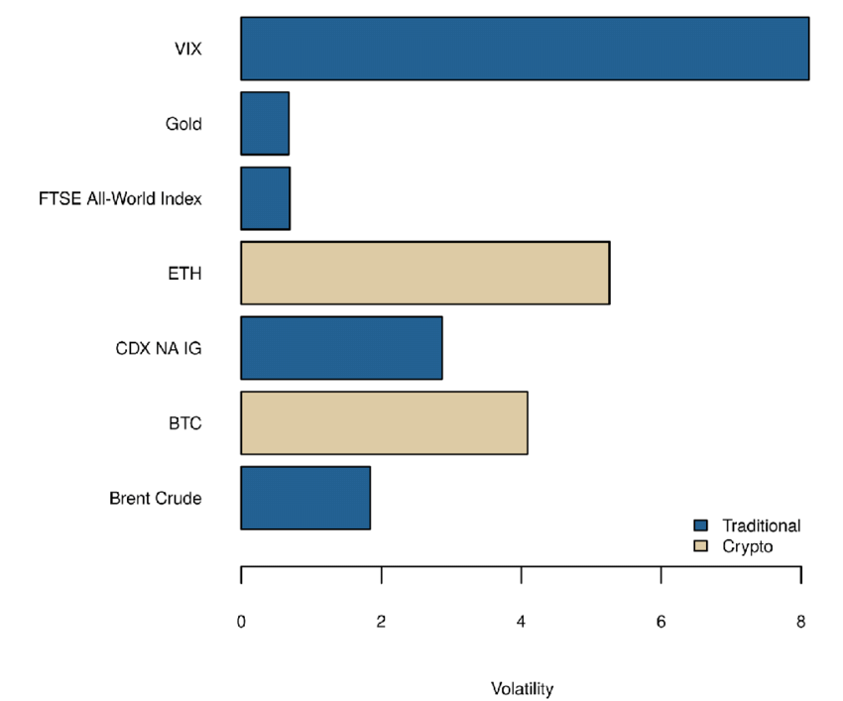
Figure 5: Crypto vs Traditional Asset Volatility
The figure compares volatility levels across digital assets and traditional financial instruments. Bitcoin and Ethereum display higher volatility than all traditional assets shown, which reflects stronger price swings and greater sensitivity to market conditions. Bitcoin’s volatility level is higher than that of Brent crude, gold, the FTSE All-World Index, and investment-grade credit indices. Ethereum shows the highest volatility among the listed digital assets, which reflects its active trading environment and frequent changes in market expectations.
Traditional assets show lower volatility. Gold and the FTSE All-World Index display the lowest values, which reflects their role as stable components in diversified portfolios. Brent crude and investment-grade credit indices show moderate volatility levels linked to commodity supply shifts and credit market conditions. The VIX records the highest volatility among the traditional indicators because it measures expected market uncertainty. The figure highlights the gap between digital and traditional markets and shows the need for strong risk assessment when investors evaluate digital assets.
The handling of digital currencies became increasingly sensitive because their spread presents a new model of trade and investment. Their expansion introduces structural changes with the ability to influence entire economic systems. Digital assets include digital currencies, token based financial instruments, and other blockchain based representations of value. Research by Eichengreen in 2019 and Auer and Claessens in 2020 documents the influence of these assets on market liquidity cycles, payment behavior, and risk exposure in several segments of financial markets. These studies show digital currencies interact with global liquidity conditions in ways that increase the need for regulated environments.
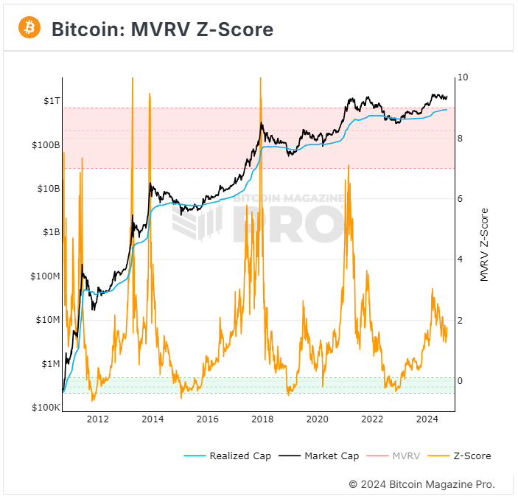
Figure 6: Crypto Market Cycles Liquidity Flows
The figure presents the movement of Bitcoin’s market value across multiple cycles using the MVRV Z-Score, market capitalization, and realized capitalization. Market capitalization represents the total value of all coins at current prices, while realized capitalization records the value of coins based on the price at the time they last moved. The MVRV Z-Score measures the difference between these two values and identifies periods in which market prices rise far above or fall below historical cost levels.
The chart shows repeated peaks in the MVRV Z-Score during 2011, 2013, 2017, and 2021. These peaks align with periods of strong liquidity inflows, rapid price appreciation, and heightened speculative activity. Each peak is followed by a sharp decline, which reflects corrections linked to reduced liquidity and lower investor confidence. The shaded red zones show periods in which the Z-Score reached levels associated with overheated markets. The green zones show points in which the Z-Score moved toward lower values that reflect reduced market pressure and more stable accumulation behavior.
The figure also shows long term growth in both market capitalization and realized capitalization. Realized capitalization increases steadily as more users enter the market and hold coins at higher historical prices. This pattern shows long term participation within the network and supports analysis of how liquidity cycles shape digital asset behavior over extended periods.
The Saudi market holds unique characteristics. It has strong financial infrastructure and advanced regulatory institutions such as the Capital Market Authority and the Saudi Central Bank. It also holds a broad investor base with strong participation from youth. These strengths support innovation and investment development. Even with these strengths, the situation surrounding digital currencies remains unclear because no formal regulatory framework authorizes or restricts trading. Reports from the Saudi Central Bank confirm the absence of official recognition. These reports also highlight ongoing assessments of risks and opportunities linked to digital asset use.
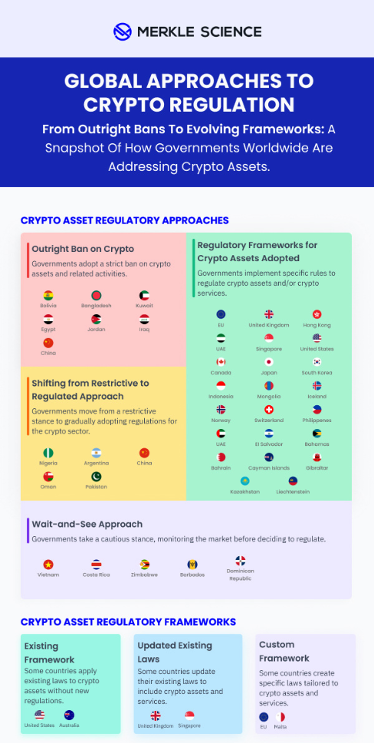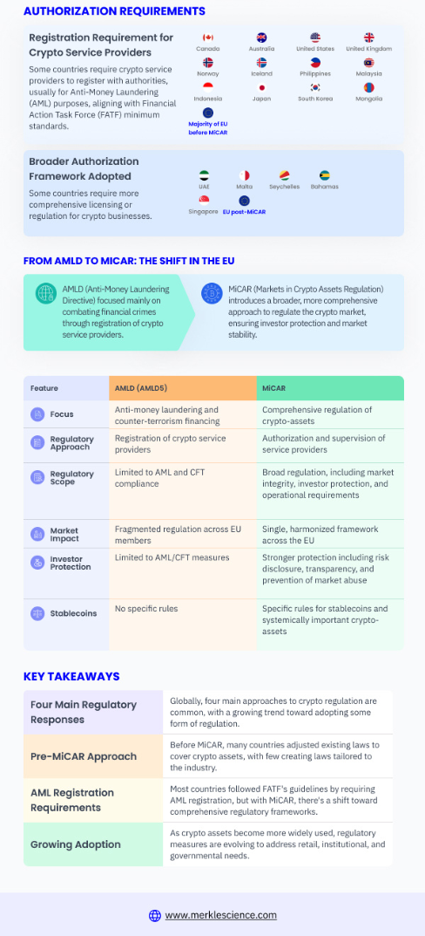
Figure 7: Global Approaches to Cryptocurrency Regulation Figure 8: Global Approaches to Cryptocurrency Regulation
The figures present a summary of how different governments classify and regulate digital assets. The first section shows regulatory approaches that range from outright bans to structured legal frameworks. Countries such as China, Bangladesh, and Kuwait apply full bans on cryptocurrency activity, while others such as the European Union, the United Kingdom, Singapore, and the United States use defined regulatory frameworks that outline rules for trading, custody, and service providers. Several jurisdictions, including Nigeria, Argentina, and Pakistan, are shifting from restrictive positions toward regulated models that introduce clearer standards. A separate group of countries, such as Vietnam, Costa Rica, and Zimbabwe, follow a wait and see approach by monitoring market developments before implementing formal rules.
The figures also describe differences in regulatory frameworks. Some countries work within existing legal structures, while others introduce updated laws that address digital assets directly. Certain jurisdictions adopt custom frameworks that create dedicated rules for crypto service providers, stablecoins, and market integrity standards. These differences show variation in regulatory maturity across global markets.
Authorization requirements appear in the second figure. Several countries, including Canada, Australia, and the United Kingdom, require registration for crypto service providers with national authorities, often for anti money laundering compliance. Other jurisdictions adopt broader authorization systems that include ongoing supervision and specific licensing requirements. The figures highlight the influence of international standards from organizations such as the Financial Action Task Force.
The final section compares the European Union’s transition from the Anti Money Laundering Directive to the Markets in Crypto Assets Regulation. The comparison shows movement from rules focused on financial crime prevention toward a comprehensive regulatory framework that addresses consumer protection, market integrity, stablecoin oversight, and systemic risk. This transition reflects wider global patterns in which governments develop more detailed systems for digital asset regulation as adoption increases and risks become more visible.
This absence creates a regulatory vacuum that grows more significant as public interest in digital assets increases. Investors and institutions work within an environment filled with uncertainty. This limits their ability to form decisions supported by clear and stable regulatory expectations. Research from the OECD shows regulatory ambiguity increases speculative behavior, influences investment decisions, and reduces long term planning. These effects raise questions about the future direction of the Saudi market.
Ambiguity also influences strategic choices within the Saudi market. It is not yet established if digital currencies will enter the official structure of financial tools or remain outside the formal system. Each direction presents different implications for investor behavior, liquidity patterns, market stability, and innovation. Academic studies by Foley et al. in 2019 and Corbet et al. in 2020 show sustained influence of digital assets on risk preferences and diversification decisions. These studies highlight the importance of clarity in national markets in order to avoid fragmented or inconsistent investment responses.
Informal trading activity adds further complexity. A segment of Saudi citizens trade digital currencies through international platforms that operate outside domestic oversight. This introduces challenges for regulators. Literature on emerging markets shows similar patterns in countries with early stage regulatory systems, as documented by the World Bank in studies related to digital financial inclusion. Regulators in these markets must determine how to manage informal activity, protect investors, and support technological progress without encouraging risky or unmonitored trading.
Digital currencies also introduce issues linked to national financial sovereignty. The use of assets without oversight from domestic authorities influences capital movement outside the formal banking system. This reduces the state’s ability to regulate monetary policy, monitor financial flows, and support balanced economic growth. Academic analyses from Bordo and Levin in 2017 and official reports from the European Central Bank show uncontrolled circulation of digital assets weakens national policy tools and reduces the effectiveness of monetary interventions.
Technical and security risks form another layer. These risks include hacking, absence of guarantees, transaction anonymity, and weaknesses within cryptographic systems. Cryptographic systems rely on mathematical methods that secure digital records and verify transaction history. Weaknesses within these methods expose users to manipulation and loss of funds. Empirical studies from cybersecurity institutions such as ENISA document repeated security breaches in digital asset platforms. These findings show the importance of oversight in order to reduce vulnerability and limit harm to investors.
Recent developments in digital assets widen the regulatory gap even further. Decentralized finance refers to digital financial services provided through automated protocols without central intermediaries. Non fungible tokens represent unique digital items recorded on blockchains. These products expand the digital ecosystem in ways traditional frameworks are not prepared to handle. Reports from the Financial Stability Board show emerging digital products require adaptive regulatory tools. These tools must respond to rapid innovation while supporting market safety and clarity.
The Saudi environment faces these challenges during a period of ambitious economic reform. Vision 2030 supports digital transformation, financial innovation, and stronger participation in global technology markets. This creates a strategic need to understand the place of digital currencies within the national framework. The issue involves more than the presence or absence of official or unofficial digital currencies. It involves the influence of these currencies on public policy, investment behavior, technological development, and market strategy.
The study addresses a core question regarding strategic direction. Digital currencies influence investor expectations, introduce new patterns of risk, and interact with global liquidity cycles. These factors shape the way financial institutions assess innovation and respond to changing market conditions. Policy makers must also respond to pressures from international markets that continue to integrate digital assets into payment systems, investment funds, and cross border transactions. A review of international experiences shows unregulated or lightly regulated activity produces financial fragmentation, while structured regulatory plans support stability and innovation.
The Saudi financial system is also influenced by the cultural and social environment. Public attitudes toward digital currencies differ across age groups and professional backgrounds. Youth participation is strong, but conservative investors express concern regarding legitimacy, risk, and long term value. Academic studies show cultural and ethical views influence adoption rates. These views influence institutional decisions and retail investor behavior.
The strategic issue lies in forming a clear understanding of how digital currencies influence the Saudi market at structural, economic, and behavioral levels. Digital transformation is no longer optional. It forms part of global economic change and national development goals. A realistic understanding of digital currencies is required. This understanding must rely on evidence, structured analysis, and balanced interpretation. It must avoid exaggeration and avoid underestimation.
The research problem therefore centers on the influence of digital currencies on the strategies of the Saudi market, the degree of readiness within the financial system, and the policy responses needed to align future development with national goals and global economic trends.

Importance of the Study
This study holds expanded importance because it addresses a subject that influences national financial stability, market development, institutional planning, and long term economic strategy. Digital currencies progressed from small scale experiments operating on isolated networks into instruments that interact with global markets, international regulatory bodies, and large financial institutions. Reports from the International Monetary Fund in 2023 describe this transformation as a structural development that affects the foundations of payment systems, liquidity distribution, and monetary policy. These reports highlight that digital assets shape cross border movement of capital, influence settlement frameworks, and increase the need for adaptive supervisory systems. The Bank for International Settlements in 2022 provides similar assessments and explains that digital currencies became part of a wider shift in which technology alters financial oversight, operational security, and transaction management. These developments show why national markets must study digital currencies with depth and clarity rather than treat them as temporary trends.
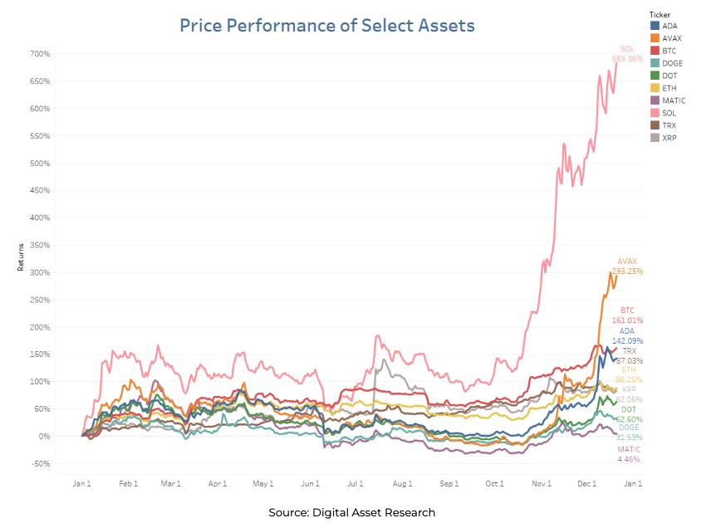
Figure 9: Price Performance of Select Assets (2023-2024)
The figure presents the price performance of several digital assets over the course of 2023 and into early 2024. It shows strong variation across assets, with Solana recording the highest increase, reaching about 683 percent by the end of the period. Avalanche follows with gains of about 293 percent, which reflects renewed interest in networks that support high transaction throughput and decentralized applications. Bitcoin and Cardano show increases of 161 percent and 142 percent, while Ethereum records an increase of about 86 percent. These levels place the major assets within a mid range group that shows steady appreciation supported by broader market recovery.
Other assets, including XRP, Polkadot, Dogecoin, and Polygon, record lower increases that range between modest gains and limited movement. Their performance reflects differences in network development, market sentiment, and liquidity conditions across the digital asset ecosystem. The figure shows repeated fluctuations across the year, followed by a strong upward trend in the final months. This pattern reflects wider improvement in global market conditions, increased expectations from institutional participants, and upward momentum linked to higher trading activity.
The importance of this study expands further when connected to the Saudi context. Saudi Vision 2030 established a national model of economic diversification based on innovation, technological development, and digital readiness. The financial sector occupies a central position within these reforms because it supports investment flows, private sector growth, and development of new services that strengthen national competitiveness. Government programs encourage expansion of electronic payments, digital identity systems, open banking initiatives, and financial technology incubators. Data from the Saudi Central Bank shows that digital transactions exceeded traditional cash operations in several areas of the national market, which reflects strong public acceptance of digital financial tools. Reports from the World Economic Forum in 2022 and the OECD in 2023 confirm that countries with similar digital ambitions examine digital currencies as part of broader efforts to understand emerging financial instruments and to anticipate their influence on investor expectations, regulatory systems, and technological infrastructure. These findings highlight the strategic relevance of this study because Saudi Arabia is experiencing the same digital pressures observed in these international reports.
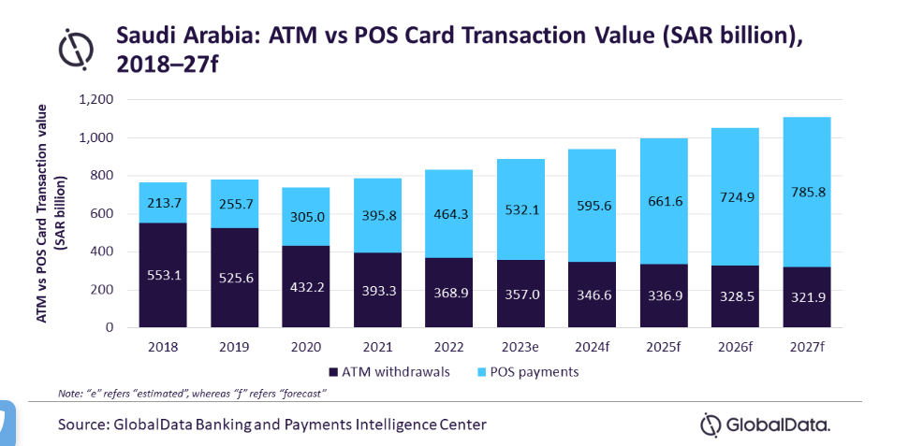
Figure 10: Saudi Arabia Digital Payments
The figure presents the value of ATM withdrawals and point of sale card payments in Saudi Arabia from 2018 to projected levels in 2027. It shows a steady decline in ATM withdrawals over the period, with values decreasing from 553.1 billion riyals in 2018 to a projected 321.9 billion riyals in 2027. This decline reflects reduced reliance on cash and wider public movement toward digital financial services.
Point of sale payments show sustained growth. The value increases from 213.7 billion riyals in 2018 to a projected 785.8 billion riyals in 2027. The growth aligns with national targets that support digital transformation, expansion of financial technology, and higher adoption of electronic payment methods across retail and service sectors. The widening gap between ATM withdrawals and point of sale payments indicates continued progress toward a more digital payment environment supported by strong infrastructure and policy direction within the Saudi market.
Digital currencies influence market behavior through channels that go beyond individual trading activity. They interact with investment strategies, liquidity patterns, risk assessment models, and institutional approaches to innovation. Data from international market research firms such as Chainalysis shows that global digital asset participation increased significantly between 2019 and 2023, with many users entering markets due to increased exposure on digital platforms and mobile applications. This pattern aligns with Saudi trends because national surveys by the Communications and Information Technology Commission show rapid expansion of digital financial behavior among individuals between the ages of eighteen and thirty four. These groups display greater familiarity with online systems and higher willingness to use digital tools for financial decisions. The study gains importance by explaining how these changes influence market expectations and how they raise questions regarding risk exposure, financial awareness, and long term financial planning.
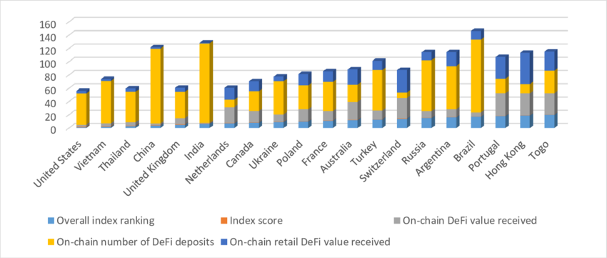
Figure 11: Global Crypto Adoption Index (2023)
The figure presents the global crypto adoption index for 2023 and shows differences in participation across several countries. It includes overall index ranking, index score, on chain decentralized finance deposits, on chain retail decentralized finance value, and on chain decentralized finance value received. Countries such as the United States, India, and China record high values across these categories, which reflects strong participation supported by large user bases, active trading communities, and extensive digital infrastructure. Other markets, including Vietnam, Thailand, and the United Kingdom, show balanced participation linked to strong retail involvement and established digital payment systems. European countries such as France, the Netherlands, and Poland display moderate integration of decentralized finance platforms that aligns with their regulated financial environments. Emerging markets such as Argentina, Brazil, and Togo show higher retail activity driven by inflation pressure, currency stability concerns, and growing interest in digital alternatives.
The figure also supports analysis of Saudi Arabia because it illustrates how global participation patterns influence expectations within developing digital markets. Saudi Arabia is not shown in the figure, but the distribution of adoption levels demonstrates how countries with strong digital infrastructure and active user communities record higher index scores. This pattern aligns with Saudi Arabia’s national direction toward broader financial technology adoption, increased digital participation among youth, and rapid expansion of electronic payments. The figure highlights the importance of building consistent regulatory structures and digital access, which supports Saudi Arabia’s ongoing efforts to strengthen its financial technology environment and prepare for possible expansion in digital asset use.
The importance of the study grows when considering the risks associated with unregulated access to digital assets. Saudi Arabia does not license cryptocurrency trading platforms and does not recognize digital currencies as legal tender. Despite this environment, thousands of Saudi users access international platforms for trading or investment. These platforms operate without domestic oversight and expose users to cyber threats, technical failures, fraudulent schemes, and loss of access to digital assets. Reports from the Financial Action Task Force in 2021 show that digital currencies are vulnerable to misuse by criminal groups due to high transaction speed and difficulty of tracing transfers without strong supervisory systems. The OECD published similar findings in 2022 and noted that unregulated activity increases the risk of user losses, incorrect tax reporting, and exposure to misleading online information. The study gains importance by examining these risks within the Saudi context and by clarifying how current conditions increase the need for national research and policy analysis.
Digital currencies also introduce opportunities that national institutions must evaluate with accuracy. Blockchain based financial systems support stronger transparency, improved data integrity, and faster settlement. Research by Catalini and Gans in 2016 explains that distributed ledger technology reduces verification time and decreases reliance on repeated reconciliation. Reports from the Financial Stability Board in 2022 confirm that blockchain applications support operational efficiency and improved audit trails when introduced within well regulated environments. These benefits align with Saudi goals to improve digital infrastructure, strengthen cybersecurity, and expand financial technology participation. The study gains importance by examining how these opportunities fit within the national market and how they support future development of financial services if integrated responsibly.
The study supports Saudi regulatory institutions by providing structured analysis of international models that help shape national decisions. Countries such as the United Arab Emirates introduced licensing laws for virtual asset service providers and established supervisory bodies that evaluate operational quality, financial soundness, and data security. Singapore developed a flexible model through the Payment Services Act which sets requirements for risk management, consumer protection, and operational performance. The European Union introduced detailed rules through the Markets in Crypto Assets Regulation that apply across member states. These models show that structured regulation supports innovation without weakening financial stability. The study gains importance by analyzing these examples and by explaining how their experiences provide guidance for Saudi Arabia as it examines future policy directions.
The academic significance of this study is also substantial. Arabic literature on digital currencies remains limited when compared with international research. Most detailed analyses are published in English and originate from Western institutions with contexts that differ from Saudi legal, cultural, and institutional environments. Reports from the Arab Monetary Fund highlight this gap and call for increased regional studies that examine digital financial trends within Arab markets. These reports show that local research must address cultural and regulatory characteristics that influence user behavior and institutional decision making. The study contributes to this academic need by providing an analysis grounded in national realities, supported by regional sources, and informed by international evidence.
Investor behavior forms another dimension that increases the importance of the study. Research in behavioral finance shows that individuals often respond to emotional signals, market excitement, and rapid changes rather than structured analysis. Studies by Barber and Odean in 2001 show that investors trade excessively during periods of strong media coverage and display overconfidence in their ability to predict outcomes. Research by Biais, Hilton, Mazurier, and Pouget in 2005 shows that information gaps increase the influence of misleading signals and reduce rational decision making. These findings appear in digital currency markets worldwide due to high volatility, round the clock trading, and strong influence of social media. The study gains importance by explaining how these behavioral trends appear among Saudi users and how these patterns influence the need for financial education, institution led awareness programs, and stronger communication from regulatory bodies.
The study also supports national financial strategy because it investigates how digital currencies influence long term development plans. Countries with strong digital goals evaluate whether digital assets support economic diversification, attract investment, or influence financial inclusion. The World Bank published evidence in 2022 showing that digital finance supports inclusion in emerging markets when integrated within regulated systems. The study gains importance by examining how similar outcomes may appear in Saudi Arabia during future stages of financial development and by identifying requirements that support safe integration of digital asset services if national authorities consider them in later regulatory phases.
The importance of this study expands further when considering the relationship between digital assets and monetary policy. Reports from the Bank for International Settlements show that large scale digital asset activity influences demand for traditional banking services and affects monetary transmission by allowing some users to hold value outside regulated financial systems. This influence alters the relationship between financial institutions and users and creates new considerations for central banks. The study gains importance by explaining how these issues may influence future Saudi policy discussions and how they relate to cross border financial activity within the Gulf region.
The study also provides a foundation for understanding institutional readiness. National institutions need specialized skills in blockchain analysis, cybersecurity, financial modeling, and risk assessment in order to respond to digital asset developments. Reports from the Financial Stability Board in 2022 show that countries with strong institutional capacity manage digital integration more effectively. The study gains importance by identifying the areas in which Saudi institutions show strength and the areas that require further development. This supports national efforts to expand digital knowledge within financial authorities, improve coordination between regulatory bodies, and support training programs that address new forms of financial risk.
The study contributes to understanding of cultural and social dimensions that influence digital asset acceptance. Digital currency adoption does not depend only on technology or regulation. It also depends on cultural attitudes toward risk, perceptions of financial legitimacy, and collective views of long term value. Academic research on Middle Eastern financial behavior shows that cultural preferences influence investment choices and shape reactions to market uncertainty. These preferences influence acceptance of new financial instruments and determine how users interpret both benefits and risks. The study gains importance by explaining how these cultural factors interact with digital currency adoption in Saudi Arabia and by showing how they influence discussions among institutions and the public.
The study also supports the development of long term national policy by providing detailed analysis of global market structures. Digital currency markets remain sensitive to global events, shifts in liquidity, and rapid changes in demand. International reports show that price cycles influence user behavior and institutional planning. Understanding these patterns supports development of policy responses that protect market stability and maintain confidence in financial systems. The study gains importance by connecting these global patterns with Saudi conditions and by offering an analytical base that supports the development of policy tools tailored to national needs.
In addition, the study supports market participants by providing analysis that clarifies risks and opportunities associated with digital asset activity. Investors, financial professionals, educational institutions, and private firms require accurate knowledge in order to evaluate emerging financial tools and determine whether they align with long term goals. The study gains importance by offering structured analysis that helps these groups interpret global evidence, understand national trends, and plan for future developments in a rapidly changing financial landscape.
Taken together, these factors show that this study carries academic, institutional, economic, and strategic importance. It supports national efforts to understand digital currencies, provides evidence based analysis that guides policy development, and offers insight into how digital assets influence market behavior in Saudi Arabia. It also strengthens the academic foundation for regional research and supports long term planning during a period in which digital transformation continues to expand across global financial systems.

Objectives of the Study
The objectives of this study form the foundation for a comprehensive academic investigation into how digital currencies influence strategies of the Saudi market. These objectives respond to the rapid global transformation of financial systems and the need for national readiness during a period marked by strong digital expansion. The scope of this section is expanded to provide deeper detail, clearer analytical direction, and broader connection to international evidence. It also reflects the increasing importance of digital assets in economic planning, regulatory design, and investment behavior. The objectives support development of a structured and academically grounded framework that explains how Saudi Arabia can interpret and respond to global digital changes while protecting national financial stability.
The study seeks to explain the relationship between digital currencies and the Saudi financial environment by examining economic, legislative, technological, and behavioral dimensions. This approach supports understanding grounded in evidence and aligned with global research from international institutions such as the Bank for International Settlements, the International Monetary Fund, and the World Economic Forum. These institutions confirm that digital currencies influence financial behavior, liquidity patterns, operational systems, and regulatory planning. They also highlight the need for national studies that respond to local conditions. The objectives of this study align with those findings and expand on them by offering analysis tailored to Saudi Arabia’s institutional and cultural environment.
The objectives are presented as a group of interconnected analytical goals. Each objective explains a central area of inquiry that supports detailed understanding of digital currencies and their influence on market strategies. Each objective is expanded with deeper explanation and supported by real data and international studies to reflect the complexity of the topic.
Gain deep insight into digital currencies
This objective aims to build a comprehensive understanding of digital currencies by examining their origins, technical foundations, global evolution, and economic impact. Digital currencies began with Bitcoin in 2009 and expanded into thousands of assets with different functions. Reports from the Bank for International Settlements show that global market capitalization of digital currencies reached more than one trillion dollars during several periods between 2020 and 2023. This expansion reflects the influence of technological development, public interest, and institutional experimentation.
The study achieves this objective by reviewing the history of digital assets, including blockchain systems, cryptographic protocols, network structures, and consensus mechanisms that support transaction verification. It also reviews global adoption levels, regulatory patterns, and economic indicators published by the International Monetary Fund and the Financial Stability Board. These indicators show that digital currencies influence cross border transfer speed, reduce transaction costs in some markets, and increase financial access for populations outside traditional banking systems. Understanding these elements provides the analytical base needed to interpret how these developments relate to Saudi Arabia.
Evaluate institutional and technical readiness in Saudi Arabia
This objective examines the capacity of Saudi Arabia to integrate digital currencies within an official framework if national authorities choose this direction. Institutional readiness requires strong digital infrastructure, reliable identity systems, advanced cybersecurity, and effective regulatory mechanisms. Reports from the Saudi Central Bank show that the Kingdom has made progress in developing electronic payment systems, open banking programs, and digital identity solutions. National infrastructure is supported by high internet penetration, modern banking services, and strong cybersecurity frameworks established through the National Cybersecurity Authority.
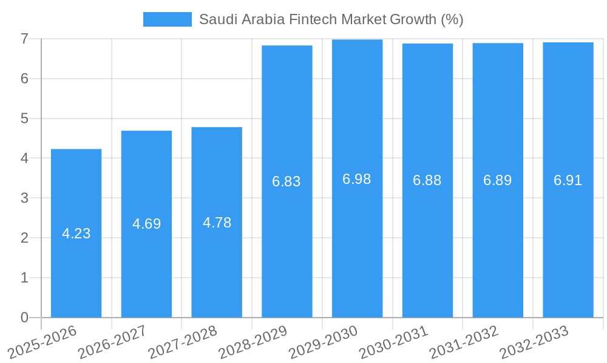
Figure 12: Saudi Arabia Fintech
The figure presents projected growth rates for the Saudi Arabian fintech market from 2025 to 2033. It shows a steady upward trend that begins with moderate growth of 4.23 percent during 2025 to 2026 and rises to about 4.69 percent and 4.78 percent over the following two periods. The growth rate increases sharply in 2028 to 2029, reaching 6.83 percent, and continues to rise to 6.98 percent during 2029 to 2030. The projections for the remaining years show values between 6.88 percent and 6.91 percent, which indicates a stable phase of strong expansion.
The pattern reflects the influence of national strategies that support financial technology development, digital transformation, and increased participation in electronic financial services. It also aligns with rising adoption of digital payments, broader fintech use among individuals and institutions, and growth in financial infrastructure across the Kingdom. These projections show that the fintech sector is expected to remain an important driver of economic diversification and innovation within the Saudi market.
However, integration of digital currencies requires additional tools. Research from the Financial Stability Board shows that effective supervision of digital assets needs advanced monitoring systems, risk detection models, and specialized workforce training. The study evaluates whether Saudi institutions possess these capacities and identifies areas that require further development. This objective supports understanding of institutional strengths and challenges and provides guidance for future regulatory or technological planning in the Kingdom.
Comprehend the impact of digital currencies on investment strategies in the Saudi market
This objective focuses on how digital currencies influence investor behavior, portfolio diversification, and risk management in Saudi Arabia. Studies from the World Economic Forum show that digital assets attract younger investors who seek alternative financial tools. Surveys from the Communications and Information Technology Commission confirm similar patterns in Saudi Arabia, where individuals between the ages of eighteen and thirty five display higher digital activity.
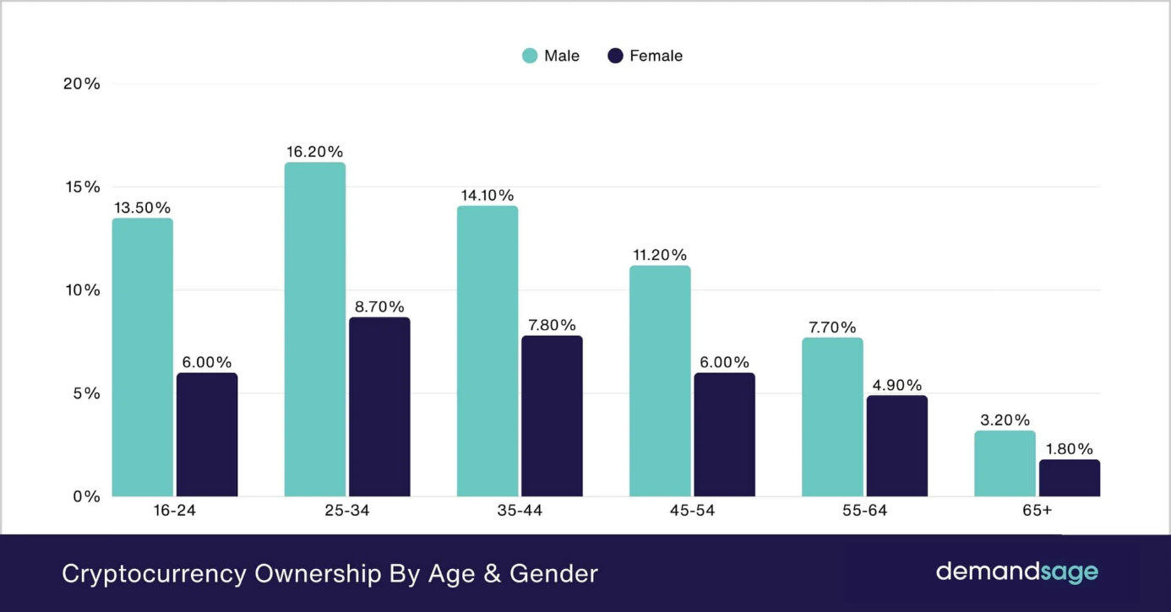
Figure 13: Cryptocurrency Ownership by Age & Gender
The figure presents cryptocurrency ownership across age groups and shows consistent differences between male and female participants. Ownership levels are highest among individuals aged 25 to 34, with 16.20 percent of males and 8.70 percent of females reporting ownership. The second highest group includes individuals aged 35 to 44, followed by those aged 16 to 24. These groups show the strongest presence of younger and middle aged users who interact frequently with digital platforms and financial applications. Ownership levels decrease across older age groups, with the lowest values recorded among individuals aged 65 and above.
The distribution highlights two patterns. First, younger users display stronger engagement with digital assets across genders, which aligns with global findings that associate higher digital literacy and financial technology participation with younger populations. Second, male users report higher ownership across all age groups, which reflects persistent gender differences in digital asset activity documented in several studies of global market behavior. These patterns help inform analysis of expected adoption trends in other markets, including Saudi Arabia, where younger groups show strong interest in digital financial tools and where gender differences in financial technology use remain an important area for ongoing research.
Behavioral finance research shows that digital assets influence risk preferences due to high volatility, strong media presence, and intense online discussion. Studies by Barberis and Thaler indicate that investor decisions in digital markets depend on risk perception, information clarity, and regulatory guidance. The study uses these findings to evaluate how Saudi investors respond to global digital trends and how this response influences national markets, particularly during periods of rapid price change or increased international trading activity.
This objective also examines how investment institutions consider digital currencies within long term strategies. Global evidence shows increased institutional interest in blockchain based systems for settlement and custody. The study discusses whether similar trends may appear in Saudi Arabia and how institutional policies may evolve during future regulatory development.
Identify challenges that influence future integration of digital currencies into the Saudi financial system
This objective examines the legal, economic, cultural, and operational challenges that influence national decisions regarding digital currency integration. Saudi Arabia maintains a cautious regulatory approach. The Saudi Central Bank does not authorize trading of cryptocurrencies through local institutions. This position reflects concerns linked to volatility, cybersecurity, and financial crime. Reports from the Financial Action Task Force confirm that digital currency activity presents money laundering risks without strong oversight. Reports from the OECD indicate that unclear regulation increases user exposure to fraud and non compliant platforms.
Cultural and social factors also influence acceptance of digital assets. Research in regional behavioral economics shows that public trust and cultural expectations shape responses to new financial tools. The study examines how these expectations influence Saudi investor behavior and how they affect institutional planning. This objective helps identify barriers that influence whether the Kingdom considers future regulation or integration of digital currencies.
Support national decision makers with evidence based recommendations
This objective provides recommendations for regulators, financial institutions, and policymakers based on international evidence and national conditions. Reports from the Monetary Authority of Singapore, the European Central Bank, and the United Arab Emirates Securities and Commodities Authority show that clear regulation reduces market risk and strengthens public trust. These examples highlight different regulatory models, including strict licensing, regulatory sandboxes, and risk based supervision.
The study analyzes these models in detail and identifies approaches that align with Saudi institutional needs, regulatory structure, cultural environment, and Vision 2030 goals. This objective supports national strategy by offering evidence based options that guide development of financial policy in a way that maintains stability and supports innovation.
Enrich Arabic academic literature on digital finance
This objective responds to the shortage of Arabic research in digital finance. Reports from the Arab Monetary Fund show that regional literature on blockchain, digital currencies, and related governance challenges remains limited. Most detailed studies originate from Western institutions. These studies do not always reflect regional legal frameworks, social structures, or cultural considerations.
The study contributes to filling this gap by providing detailed analysis of digital currencies within the Saudi context. It uses Arabic and international sources to support accurate interpretation of national trends. It also contributes new academic material that helps students, researchers, and institutions better understand digital financial developments in the region.
Promote deeper professional and academic awareness in Saudi Arabia
This objective supports development of financial awareness among professionals, students, and researchers. Digital assets present risks linked to misinformation, online speculation, price manipulation, and cyber threats. Behavioral finance literature shows that financial education reduces exposure to fraud and improves decision making. Studies from the World Bank confirm that informed users respond more effectively to digital financial developments.
The study supports this objective by presenting clear explanations of digital currency characteristics, risks, opportunities, and regulatory issues. This helps institutions develop training programs, awareness campaigns, and educational materials to support informed engagement with digital markets.
Provide a comprehensive analytical foundation for long term national planning
This objective expands the study’s role in supporting long term institutional planning in Saudi Arabia. Digital currencies influence monetary policy, cross border transfers, capital movement, and institutional strategy. Reports from the Bank for International Settlements show that widespread use of digital assets may influence demand for traditional banking products and affect monetary policy effectiveness.
This objective supports detailed analysis of these issues and provides insights that may help shape future national policy, including possible participation in regional digital currency projects, development of blockchain based government systems, and evaluation of national digital currency options.
Together, these expanded objectives create a comprehensive academic framework that supports detailed understanding of digital currencies and their influence on the strategies of the Saudi market. They provide direction for analyzing complex interactions between technology, regulation, investor behavior, and national policy during a period of global financial transformation.

Research Questions
The research questions guide the structure and analytical direction of the study. They identify economic, regulatory, technological, and behavioral dimensions that require close examination in order to understand how digital currencies influence strategies of the Saudi market. These questions also support systematic analysis grounded in academic literature, institutional reports, and documented developments in comparable markets. Because digital assets introduce new financial behaviors and regulatory challenges, the research questions expand the scope of inquiry to reflect the complexity of modern digital transformation. The following expanded set of questions supports deeper analysis and offers a clearer foundation for interpretation and evaluation.
- To what extent do digital currencies affect strategies of the Saudi financial market
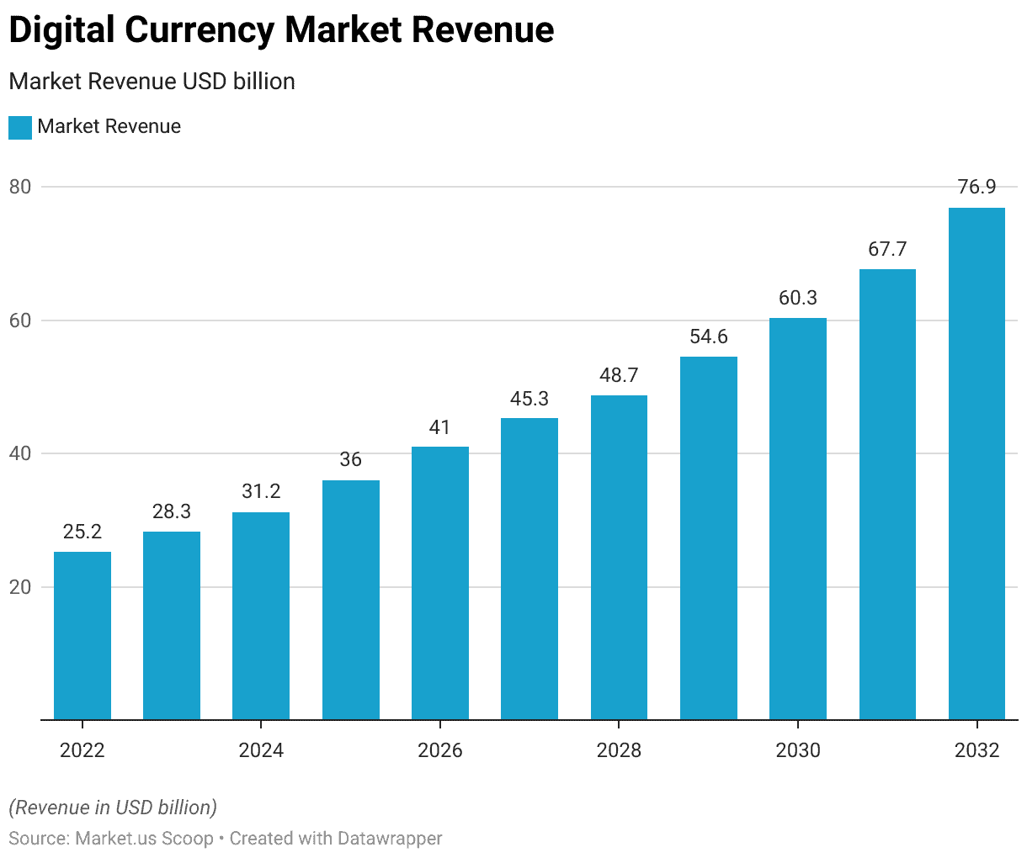
Figure 14: Global Digital Currency Market Size & Growth (2020-2023)
The figure presents projected revenue growth for the global digital currency market from 2022 to 2032. It shows a steady rise in market revenue from 25.2 billion dollars in 2022 to 28.3 billion dollars in 2023 and 31.2 billion dollars in 2024. Revenue increases continue across the following years, reaching 41 billion dollars in 2026 and 48.7 billion dollars in 2028. The upward trend extends into the next decade, with projections of 60.3 billion dollars in 2030, 67.7 billion dollars in 2031, and 76.9 billion dollars in 2032.
The pattern reflects broader global demand for digital asset services, increased institutional participation, and wider integration of digital currencies in payment systems, investment products, and financial applications. The steady rise also aligns with global advancements in blockchain technology and regulatory developments that support safer use of digital assets. These projections highlight the scale of expansion expected in the digital currency sector and provide a reference point for countries such as Saudi Arabia, where digital transformation and financial technology development continue to strengthen national readiness for participation in global digital markets.
International reports show that digital currencies influence investment behavior, liquidity management, and long term financial planning in markets that allow trading. Studies from the Bank for International Settlements show that expansion of digital assets pushes markets to evaluate risk management procedures, revise technology adoption plans, and introduce new forms of supervisory tools designed for digital environments. In the Saudi context, the influence remains indirect because the authorities do not permit cryptocurrency trading within domestic platforms. Despite this restriction, individual participation through international exchanges continues to increase. Institutional interest also appears in national exploration of blockchain infrastructure, central bank digital currency pilot projects, and integration of digital solutions into payment systems. These developments encourage national stakeholders to adjust strategic expectations and remain informed about technological change that influences global financial systems. Regional studies from the Arab Monetary Fund confirm that Gulf markets respond to digital asset trends even without formal legalization because global technological change exerts continuous pressure on local decision making.

- What factors facilitate or hinder the use of digital currencies in the Saudi market
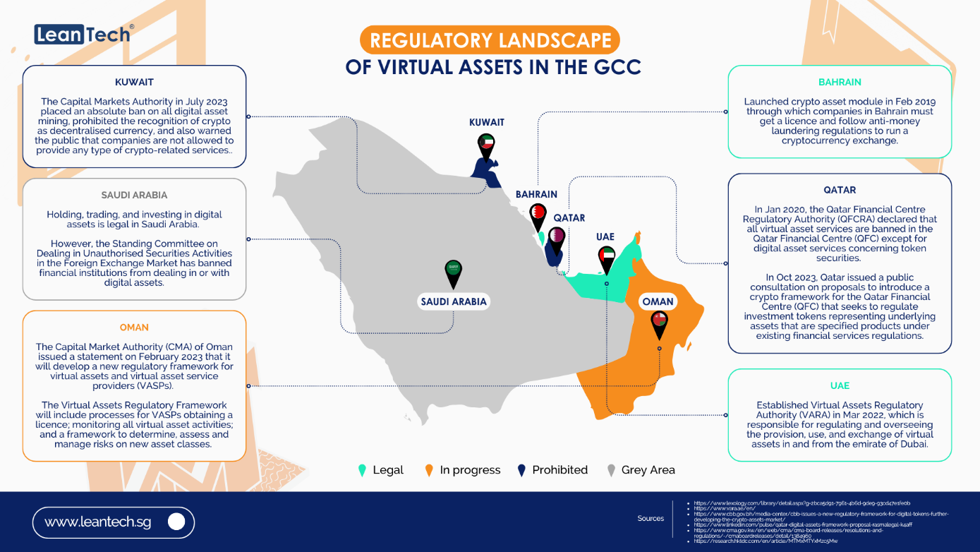
Figure 15: GCC / Middle East Regulatory Comparison Table
The figure presents an overview of how Gulf Cooperation Council countries regulate virtual assets. It shows clear differences in policy direction across the region. Kuwait applies the strictest position. Its Capital Markets Authority issued a full ban in 2023 on digital asset mining and prohibited recognition of digital currencies as decentralized forms of money. It also restricted companies from offering crypto related services. Saudi Arabia adopts a more limited stance. Holding, trading, and investing in digital assets is legal for individuals. However, the Standing Committee on Dealing in Unauthorized Securities in the Foreign Exchange Market restricts financial institutions from engaging in digital asset activity, which places the sector within a controlled space.
Other countries follow more structured or flexible approaches. Bahrain was the earliest to introduce a licensing system for crypto service providers. Companies in Bahrain must obtain approval and follow anti money laundering rules before operating. The United Arab Emirates introduced the Virtual Assets Regulatory Authority in 2022 to oversee digital asset issuance, exchange, and service provision. This authority represents one of the most detailed regulatory systems in the region. Oman is in the process of developing a full regulatory framework that includes licensing requirements and risk assessment procedures. Qatar restricts most digital asset activity within the Qatar Financial Centre but continues to explore new frameworks for investment products linked to tokenized assets.
The figure shows that the regulatory landscape in the GCC is varied. Some countries adopt restrictive models, while others introduce structured frameworks or continue to develop new systems. These differences shape cross border digital asset activity and influence how the region prepares for broader financial technology integration.
Several regulatory, economic, technological, and cultural factors influence adoption of digital currencies in the Saudi environment. Hindering factors include the absence of official legislation, clear public warnings issued by the Saudi Central Bank, and concerns linked to volatility shown in international financial stability assessments. Institutional conservatism also influences the market because national banks place strong emphasis on compliance, prudential rules, and controlled innovation. Facilitating factors include the Kingdom’s strong digital infrastructure, national investment in digital transformation, fintech expansion supported by programs such as Fintech Saudi, and high digital literacy among younger populations. These elements support awareness of digital assets even without official regulatory approval. Cultural and religious perspectives add another layer because ongoing discussions regarding financial legitimacy influence public acceptance and market behavior. Evidence from Arab Monetary Fund reports and national surveys shows that these combined factors shape expectations, user perceptions, and readiness for potential future regulation.
- How aware are Saudi investors of the concept of digital currencies and their risks
Reports from international financial literacy studies show that global interest in digital currencies often develops faster than understanding of associated risks. This pattern appears in the Saudi context because younger investors frequently interact with digital markets through social media, online influencers, and foreign trading platforms. These platforms do not provide the level of protection or regulatory assurance available in supervised domestic markets. Research in behavioral finance shows that individuals entering high volatility markets face increased exposure to impulsive decisions, limited risk awareness, and reliance on incomplete information. Indicators from financial literacy surveys confirm that users often underestimate risks linked to hacking, loss of private keys, and legal ambiguity. These patterns highlight the need for coordinated national efforts to strengthen financial education, increase access to reliable information, and support programs that promote informed investment behavior.
- Do digital currencies pose a threat or an opportunity to the Saudi market
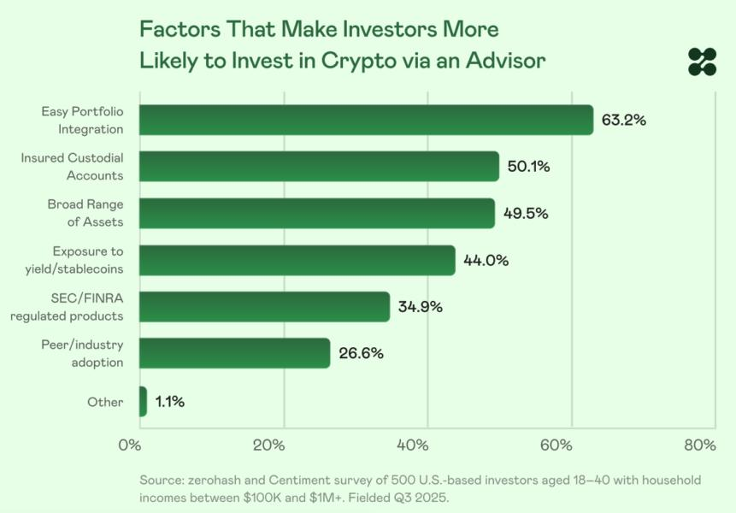
Figure 16: Crypto Illicit Activity Share (Risk Indicator)
The figure presents factors that influence investor willingness to engage with digital assets through a financial advisor. It shows that 63.2 percent of respondents place high importance on easy portfolio integration, which reflects interest in systems that allow digital assets to fit within existing investment structures. Insured custodial accounts follow at 50.1 percent, which highlights the role of secure storage in reducing perceived risk. A broad range of available assets ranks next at 49.5 percent, while 44.0 percent report interest in products linked to yield or stablecoins.
Regulated products provided under established supervisory bodies attract 34.9 percent of respondents, which shows the value investors place on clear oversight. Peer or industry adoption influences 26.6 percent of respondents, and a small share identify other factors. These indicators relate to risk perception and show that investors respond strongly to safety, structure, and integration features. This pattern helps explain the broader risk landscape linked to digital assets, since the presence or absence of these features influences how investors assess exposure, trust, and long term participation in markets that include illicit activity concerns.
Digital currencies present both risks and potential benefits. Threats include challenges to monetary stability, increased exposure to criminal financial activity, and reduced supervisory control over transactions executed through unregulated platforms. Reports from the Financial Action Task Force document increased risk of misuse in systems that operate without domestic oversight. Potential benefits include support for financial innovation, alignment with digital transformation goals under Vision 2030, and expanded financial inclusion through new investment options. International evidence shows that markets benefit from digital asset integration when regulators establish frameworks that control risk, support transparency, and encourage responsible innovation. Within Saudi Arabia, digital currencies represent a conditional opportunity that depends on the design of regulatory systems and the ability of institutions to integrate digital tools without endangering financial stability.
- How will the Saudi market benefit from digital currencies without compromising financial stability
This question focuses on identifying policy measures that allow safe engagement with digital currencies. Global evidence shows that successful integration requires a structured approach that includes gradual licensing of service providers, development of adaptable regulatory frameworks, and investment in advanced technical capacity within supervisory bodies. Cooperation with international organizations such as the Financial Stability Board supports alignment with global standards and enhances the ability of domestic authorities to detect and mitigate risk. National initiatives that promote secure blockchain experimentation allow institutions to benefit from innovation while maintaining stability. International examples from Singapore and the European Union show that structured oversight supports innovation and preserves market confidence. This question guides analysis of policy options suitable for the Saudi context.
- How prepared are Saudi regulatory authorities to supervise digital asset activity if future legalization occurs
This question examines readiness of the Saudi Central Bank, the Capital Market Authority, and related supervisory bodies to manage digital asset oversight. Areas of evaluation include data monitoring capacity, workforce training, cybersecurity systems, and alignment with international regulatory standards. This question is important because institutional readiness influences the safety and effectiveness of potential future regulation.
- How do cultural, ethical, and religious considerations influence acceptance of digital currencies in Saudi society
Cultural and religious factors influence financial behavior and acceptance of new financial instruments. Discussions regarding permissibility, risk, and financial legitimacy affect adoption patterns and shape public attitudes toward digital assets. This question supports analysis of how social expectations influence market behavior and how national authorities address concerns related to financial ethics and cultural preferences.
- How do Saudi investors evaluate digital assets as part of long term financial planning and diversification strategies
This question examines whether digital currencies influence diversification decisions among Saudi investors and whether global investment trends shape local expectations. It also evaluates whether younger investors display different long term preferences compared with older groups. Understanding these patterns supports analysis of how digital assets influence broader strategic planning within the Saudi financial environment.
- What institutional opportunities exist for blockchain integration in Saudi Arabia outside cryptocurrency trading
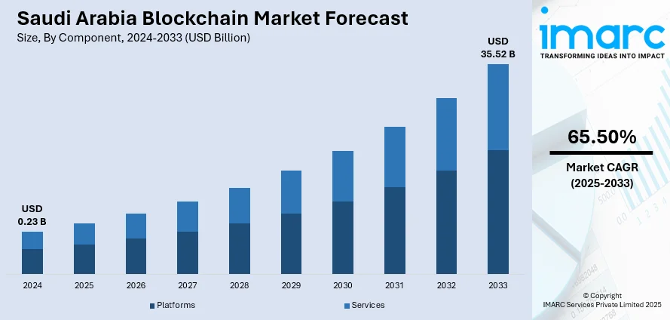
Figure 17: Blockchain Market Forecast in Saudi Arabia
The figure presents projected growth of the blockchain market in Saudi Arabia from 2024 to 2033. It shows a strong upward trajectory that begins at 0.23 billion dollars in 2024 and reaches 35.52 billion dollars by 2033. The figure separates the market into platforms and services. Both segments show expansion across the period, with services forming the larger share of projected value. The growth rate of 65.50 percent reflects rapid national movement toward advanced digital infrastructure supported by continued investment in financial technology, data systems, and enterprise solutions.
The pattern aligns with national objectives that support increased use of distributed ledger systems across financial services, government applications, and private sector operations. It also reflects rising demand for secure record keeping, digital identity solutions, and systems that support transparent and efficient transactions. The forecast indicates that blockchain technology will become an important component of Saudi Arabia’s digital economy and will support long term diversification goals under Vision 2030.
This question expands the focus beyond digital currencies by examining how blockchain systems may support transparency, operational efficiency, identity verification, and cross border settlement. Understanding these opportunities supports national digital transformation plans and helps clarify how institutions may adopt digital technologies within regulated environments.
Together, these expanded research questions support a comprehensive investigation of digital currencies within the Saudi market. They reflect the complexity of the subject and guide structured analysis across economic, regulatory, technological, and behavioral dimensions. These questions establish a foundation for evidence based examination and support development of conclusions aligned with national priorities and global financial developments.

Research Hypotheses
This study develops a set of scientific hypotheses that correspond directly to the research questions and explain expected relationships between digital currencies and strategic behavior in the Saudi market. These hypotheses are grounded in documented global evidence, national reports, and established findings in financial economics. Each hypothesis reflects patterns observed in international markets while remaining aligned with Saudi regulatory, cultural, and economic conditions. The expanded set of hypotheses strengthens the analytical structure of the study by connecting economic, regulatory, technological, and behavioral variables. It also supports broader examination of institutional readiness, user behavior, and long term implications for financial stability.

Hypothesis 1
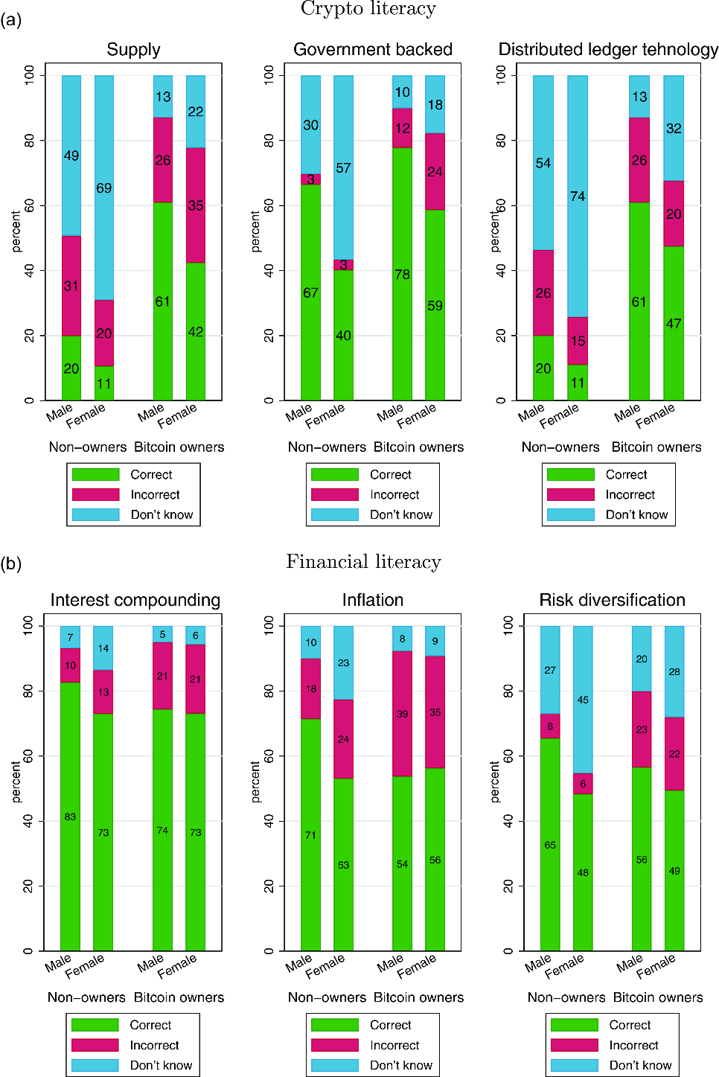
Figure 18: Crypto Literacy
The figure presents differences in crypto literacy and financial literacy across four groups: male non owners, female non owners, male Bitcoin owners, and female Bitcoin owners. The first set of charts shows understanding of concepts related to crypto supply, government backing, and distributed ledger technology. Bitcoin owners in both genders demonstrate higher levels of correct responses compared to non owners. Male Bitcoin owners show strong understanding of supply and distributed ledger technology, while female Bitcoin owners show higher correct responses than female non owners but still lower than their male counterparts. Non owners show higher rates of incorrect answers and a larger share of “don’t know” responses, which reflects limited familiarity with core digital asset concepts.
The second set of charts focuses on financial literacy, including interest compounding, inflation, and risk diversification. Bitcoin owners show higher overall literacy compared to non owners. Male Bitcoin owners score highest across all three categories, followed by female Bitcoin owners. Non owners, particularly female non owners, display higher levels of uncertainty and incorrect responses. These results reflect the influence of broader financial knowledge on digital asset participation.
The distribution across all categories highlights two patterns. First, ownership of digital assets aligns with stronger understanding of both crypto specific and general financial concepts. Second, male respondents show higher literacy levels than female respondents across categories, which mirrors findings in several international studies that document gender gaps in financial education and digital engagement. These patterns provide useful context for markets such as Saudi Arabia, where rapid growth in financial technology adoption increases the importance of improving public literacy to support informed use of digital assets.
Higher levels of awareness of digital currencies among Saudi investors lead to increased participation in digital asset environments. This hypothesis is based on findings in behavioral finance which show a strong link between investor knowledge and willingness to engage with new financial tools. Research published by the Organisation for Economic Co-operation and Development reports that awareness shapes risk behavior and influences adoption of digital financial services. In the Saudi context, awareness includes understanding blockchain principles, transaction mechanisms, storage practices, and exposure to cybersecurity threats. Growth in Arabic digital content and expansion of financial discussions on social platforms increased overall awareness, but this awareness remains uneven and incomplete. This hypothesis supports examination of how financial knowledge influences trading activity and how increased awareness may produce more stable and informed patterns of participation.

Hypothesis 2
Absence of a clear regulatory framework in Saudi Arabia reduces institutional and individual willingness to integrate digital currencies into financial strategies. Evidence from the International Monetary Fund shows that regulatory clarity is essential for building trust, encouraging institutional participation, and attracting investment. Saudi authorities maintain a cautious stance that restricts trading and avoids formal recognition of digital currencies. This creates regulatory uncertainty that affects long term planning and reduces market entry by firms that require legal clarity to operate safely. This hypothesis supports detailed evaluation of how regulatory ambiguity influences investment decisions, risk management, and strategic thinking within the Saudi financial system.

Hypothesis 3
If supported by structured oversight, digital currencies offer potential for financial diversification and innovation within the Saudi market.
Reports from the World Bank show that digital financial tools support capital formation, increase access to diverse financial products, and encourage technological innovation. This hypothesis assumes that if digital currencies were introduced within a regulated environment, they would contribute to new forms of investment, expansion of blockchain based services, and increased attractiveness for global investors interested in technologically advanced markets. This aligns with Saudi Vision 2030 goals that encourage digital transformation and diversification of economic activity.

Hypothesis 4
Unregulated digital currency activity executed through international platforms poses measurable risks to the stability of the Saudi financial market.
Evidence from the Financial Action Task Force shows that markets without strong oversight face exposure to illicit transfers, high volatility, and unmonitored capital movement. In Saudi Arabia, where trading occurs through foreign platforms without domestic supervision, users remain vulnerable to fraud, hacking, and loss of assets. This hypothesis supports analysis of systemic risks that emerge when market activity expands outside regulated channels and helps clarify consequences of gaps in supervision and consumer protection.

Hypothesis 5
Increased participation of Saudi youth in digital currency markets influences broader investment trends and reshapes expectations of traditional investors.
Research from the Arab Monetary Fund indicates that youth in the region display strong digital readiness and high engagement with technological tools. Their adoption of digital currencies introduces new investment preferences that differ from the behavior of older investors who rely on traditional instruments. This hypothesis supports examination of how demographic patterns influence market dynamics, how young investors shape demand for new financial products, and how these shifts pressure institutions to modernize services.
Hypothesis 6
Lack of clear legal and religious guidance on the legitimacy of digital currencies reduces acceptance among conservative investors and financial institutions. Saudi financial decision making is influenced by legal certainty and religious views related to permissibility. Digital currencies raise questions related to valuation, guarantees, and classification. Absence of unified guidance creates hesitation among institutions and risk-averse individuals. This hypothesis supports analysis of how legal and religious interpretation shapes adoption patterns, market participation, and institutional decision making.

Hypothesis 7
Saudi regulatory authorities face challenges in supervising digital assets due to limited specialized tools and the absence of a formal framework, which affects readiness for future regulation.
Reports from the Financial Stability Board show that supervision of digital assets requires specialized monitoring systems, advanced analytical tools, and technical expertise. Saudi institutions possess strong general regulatory capacity, but digital asset supervision requires new forms of data analysis, enhanced cybersecurity resources, and specialized policy design. This hypothesis supports evaluation of regulatory readiness and identifies areas that require development before digital currencies can be formally integrated.

Hypothesis 8
Cultural attitudes toward financial risk influence acceptance of digital currencies among Saudi investors.
Studies in regional finance show that cultural expectations influence response to uncertainty, risk, and new financial instruments. Individuals who prefer stable and predictable investment environments may be less willing to engage with high volatility assets. This hypothesis supports analysis of how cultural patterns interact with digital adoption and how they shape public perception of digital assets.

Hypothesis 9
Long term strategic planning among Saudi investors is influenced by global developments in digital assets even without domestic legalization.
International research shows that global price cycles, institutional announcements, and technological advancements influence investor expectations across markets. This hypothesis supports examination of how Saudi investors incorporate global digital trends into long term planning and how these expectations influence interest in diversification and new asset classes.

Hypothesis 10
Blockchain applications beyond cryptocurrency offer operational advantages that support national digital transformation efforts in Saudi Arabia.
Evidence from academic and institutional studies shows that blockchain systems improve transparency, increase efficiency, and reduce transaction errors. This hypothesis supports analysis of how Saudi institutions may adopt blockchain solutions for identity management, payments, regulatory reporting, and cross border settlement, independent of cryptocurrency trading.
Together, these expanded hypotheses form a complete analytical framework that corresponds directly to the research questions and supports examination of economic, regulatory, behavioral, and technological factors linked to digital currency activity in the Saudi market. They establish clear variables for analysis and support interpretation grounded in evidence and relevant international experience.

Survey & Results
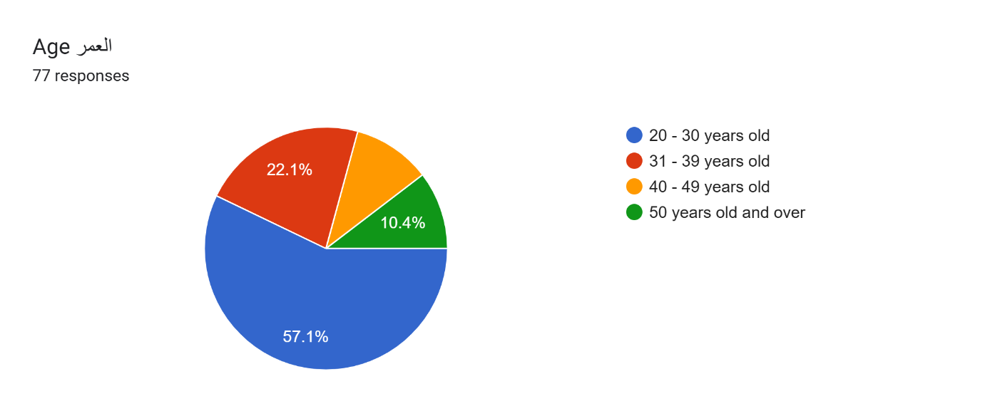
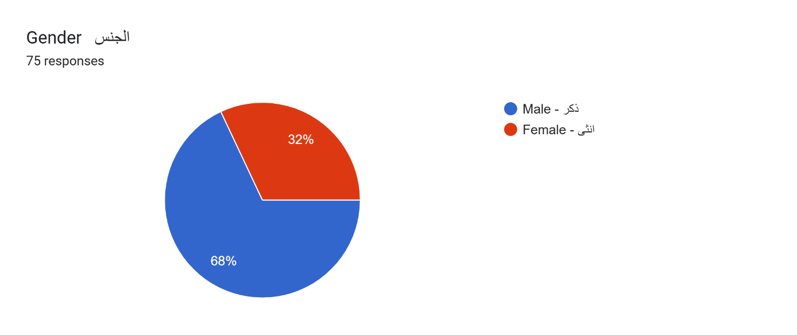
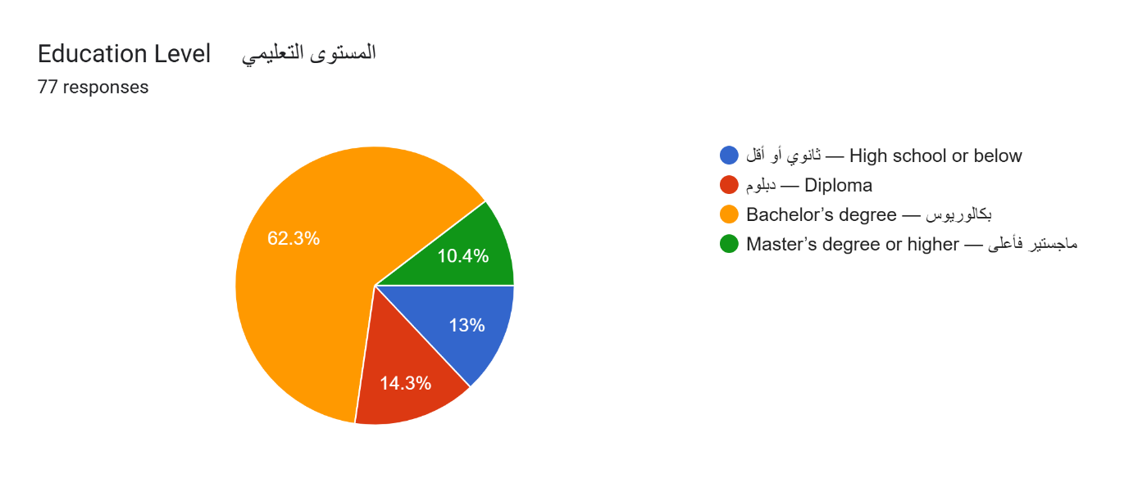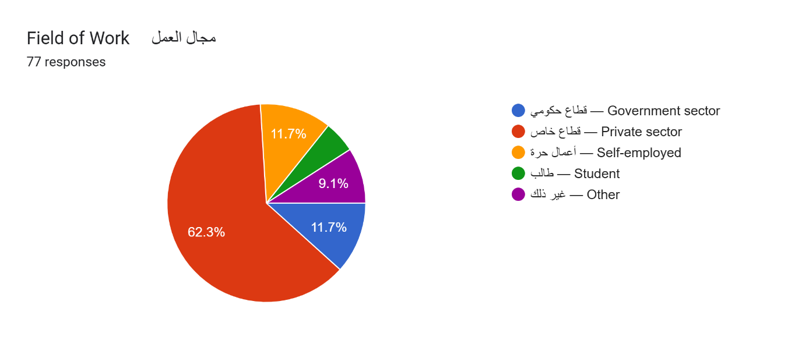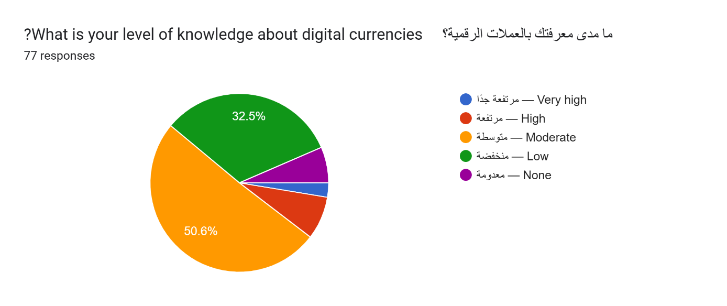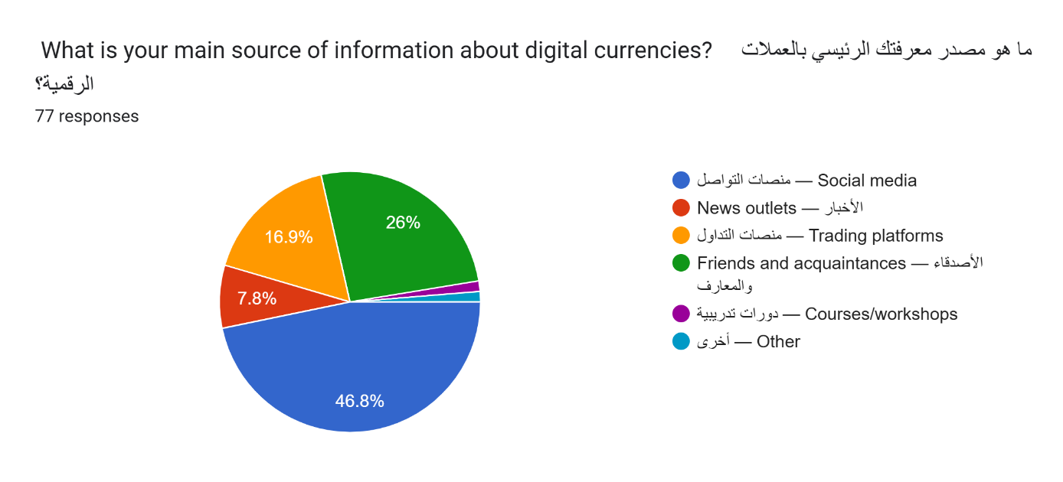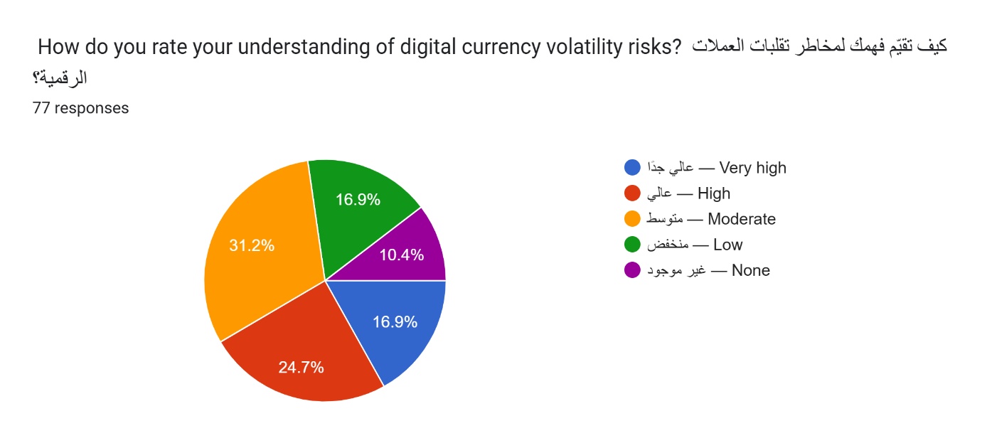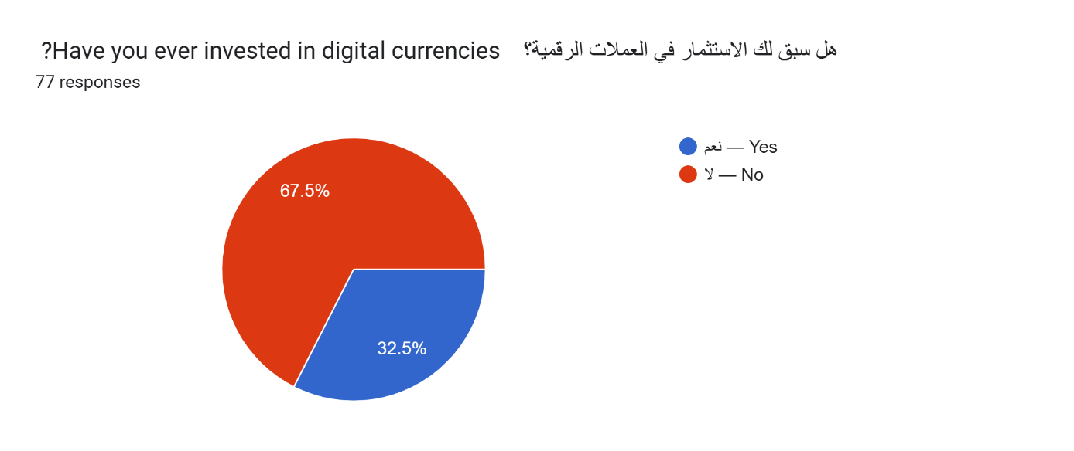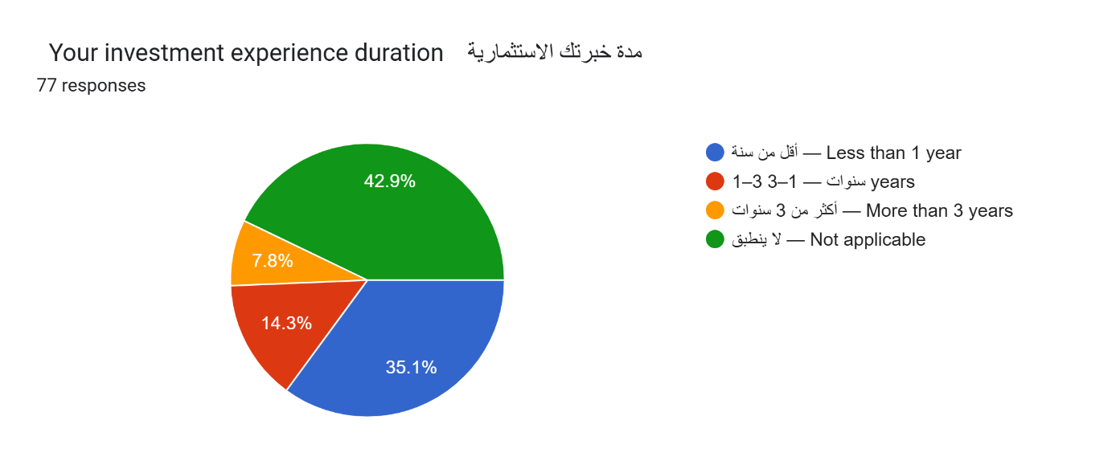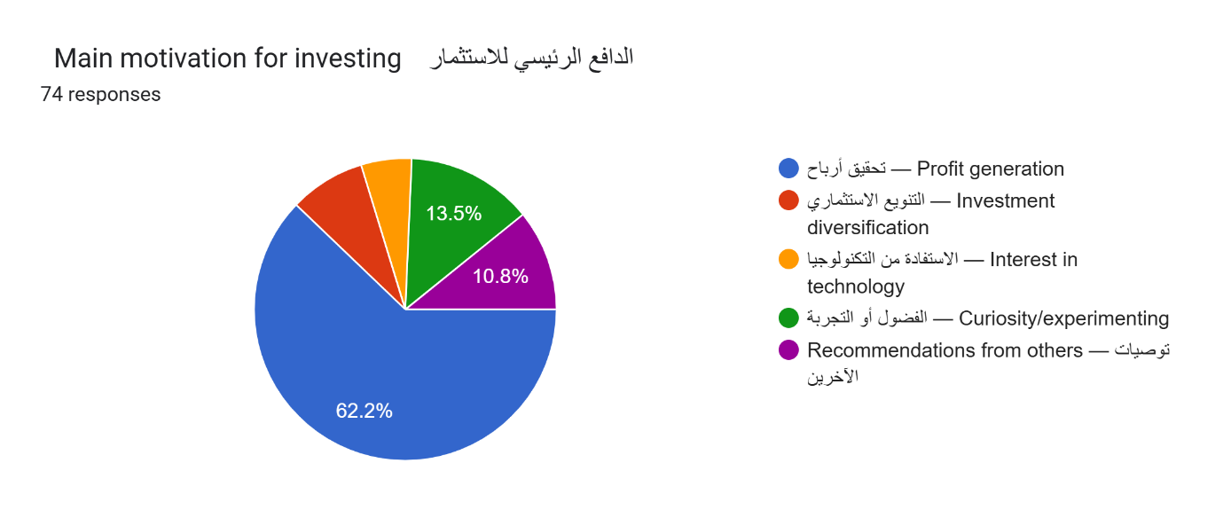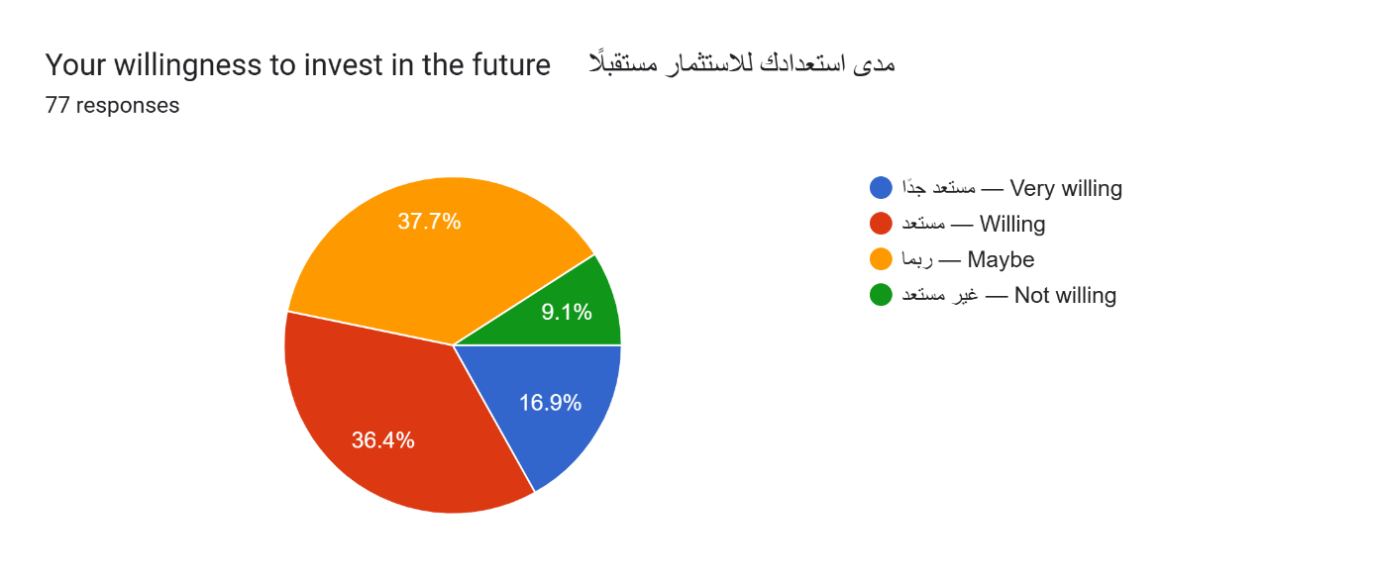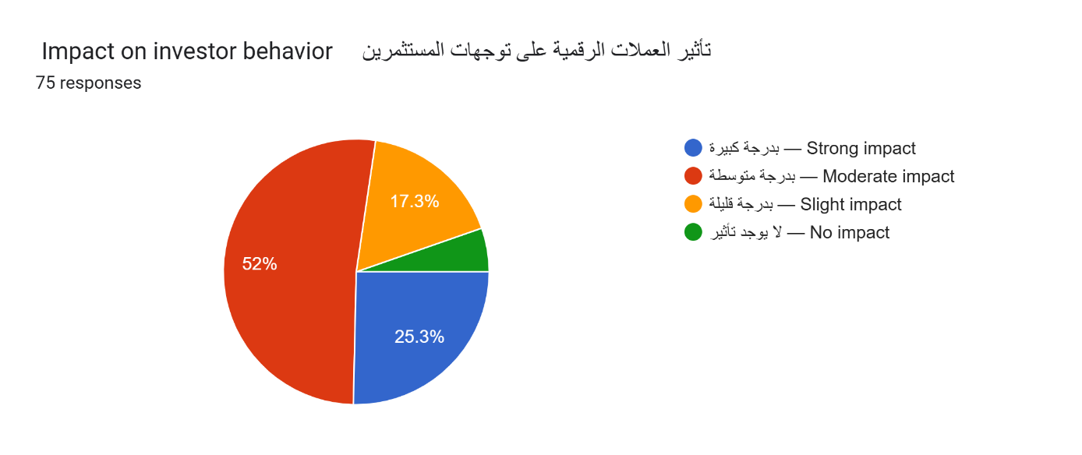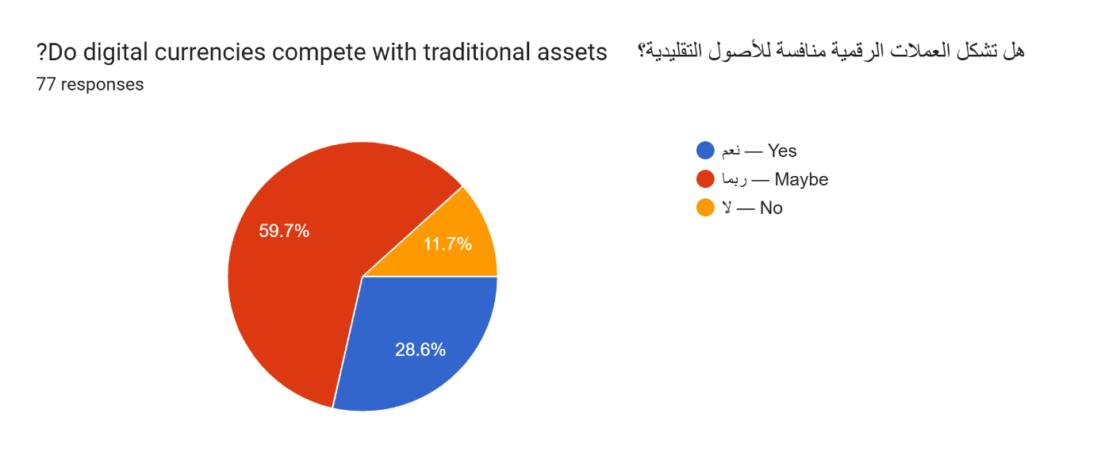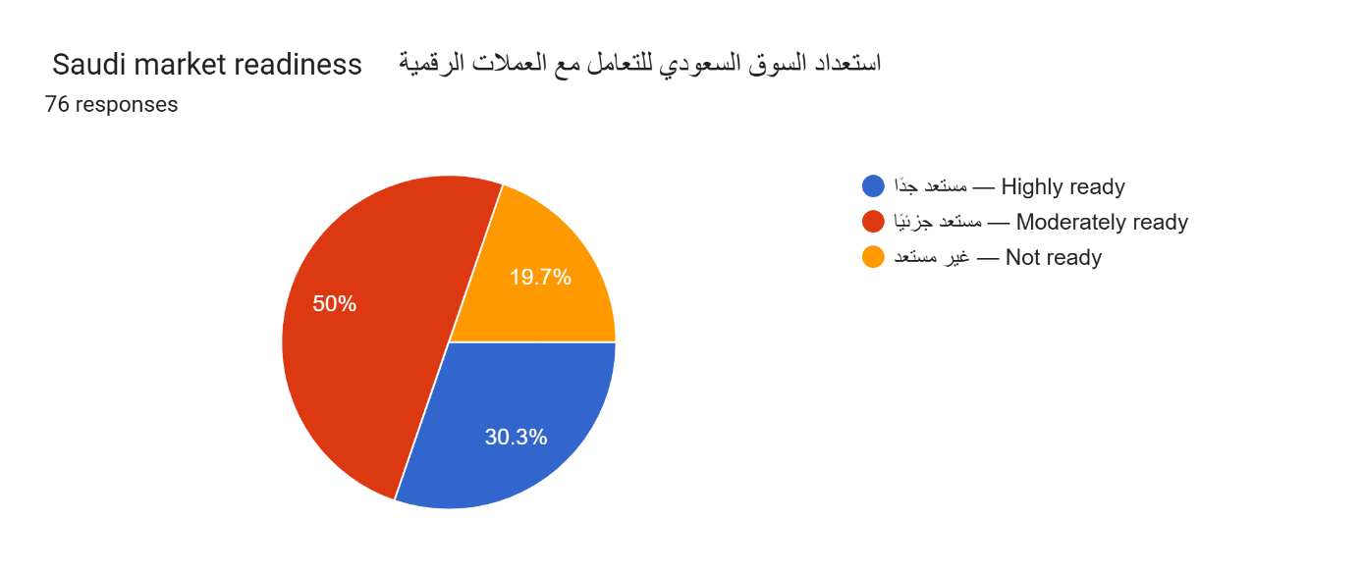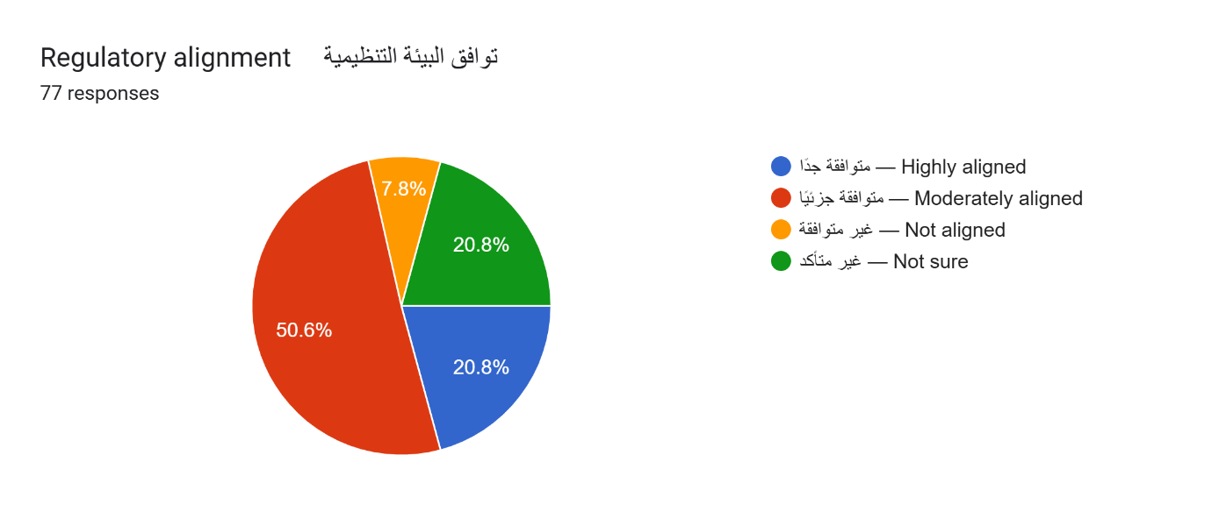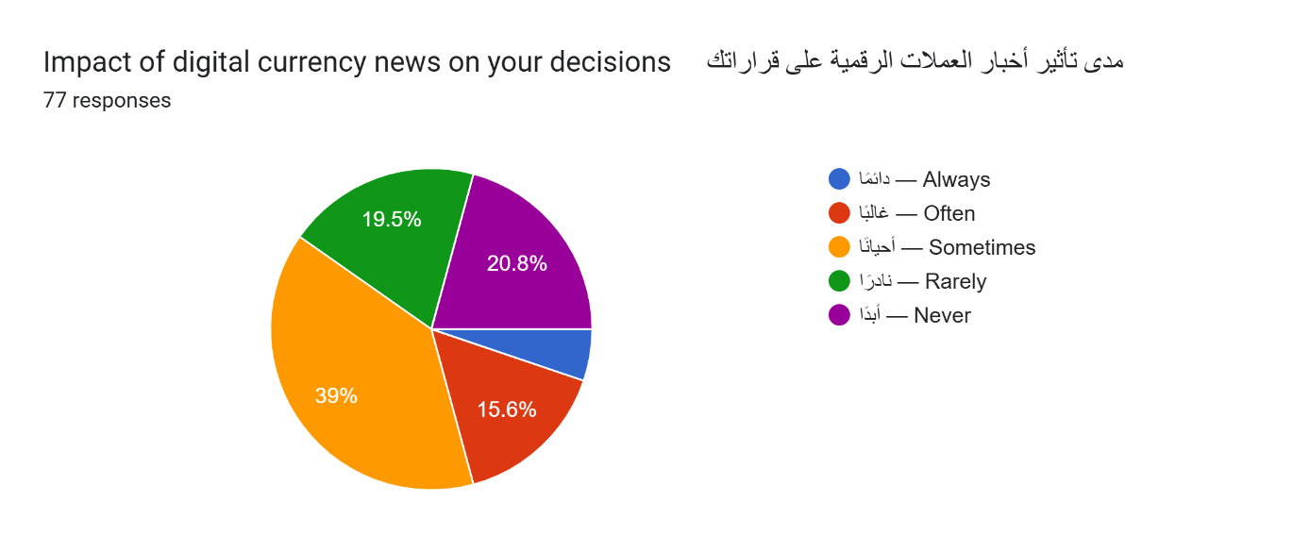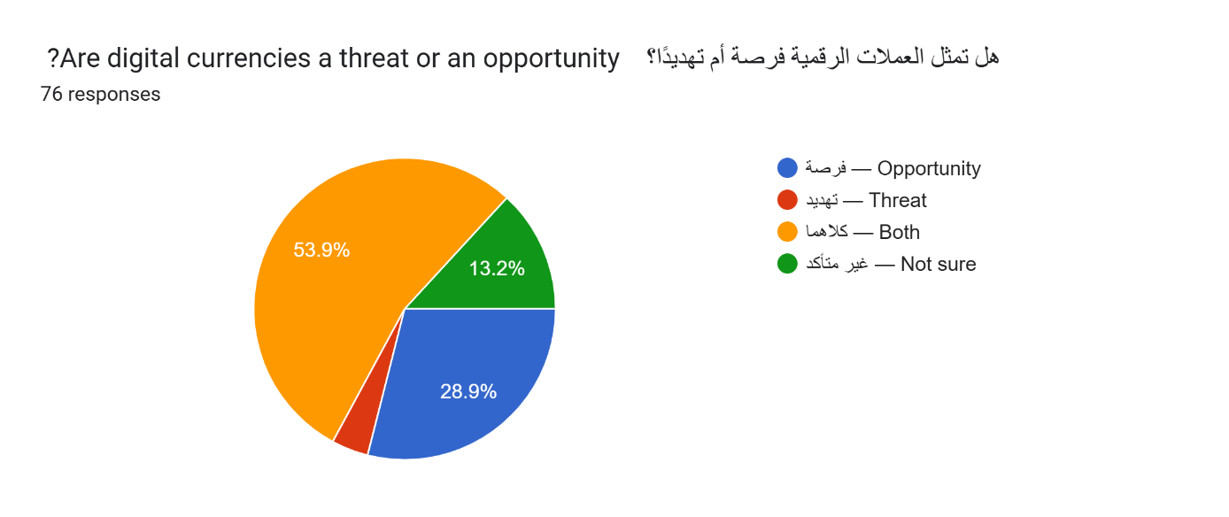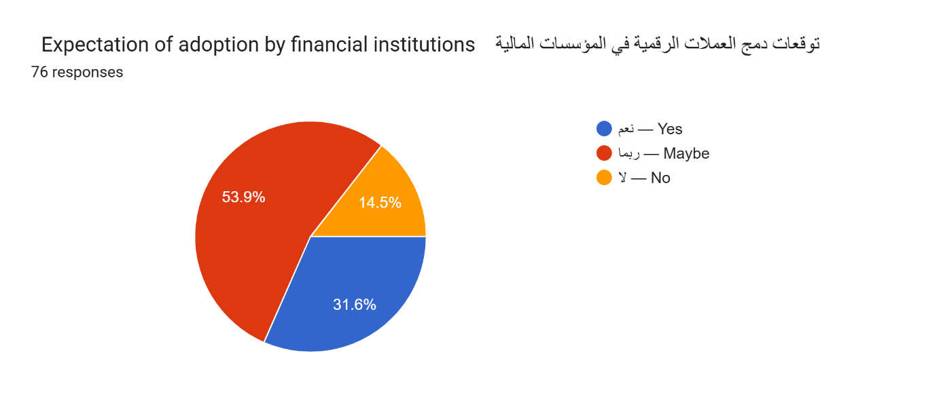
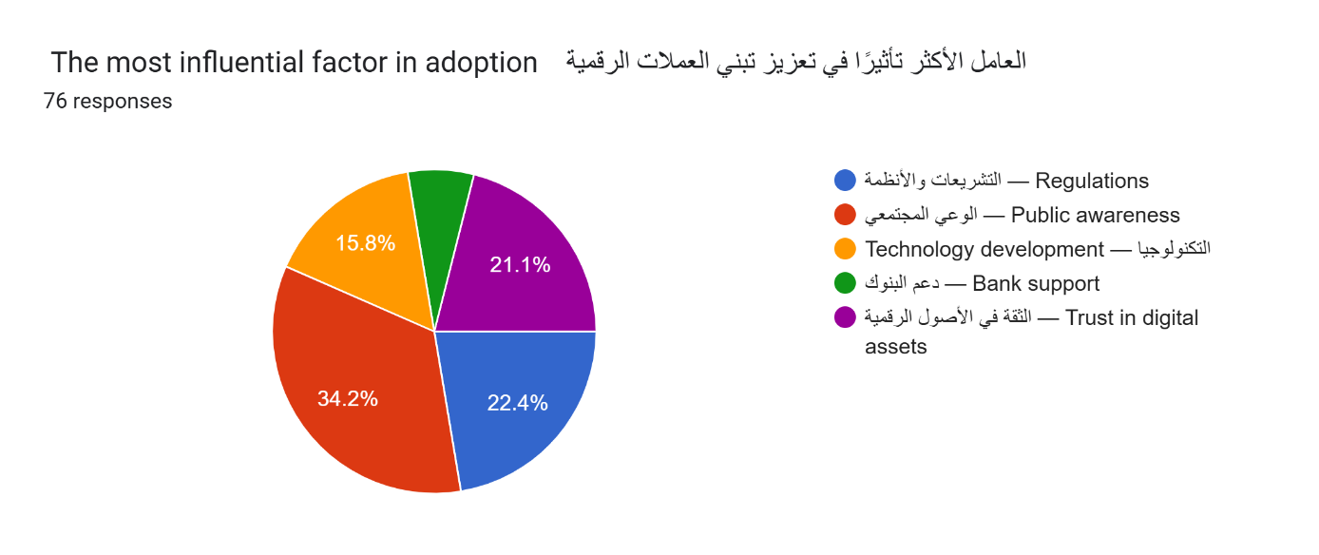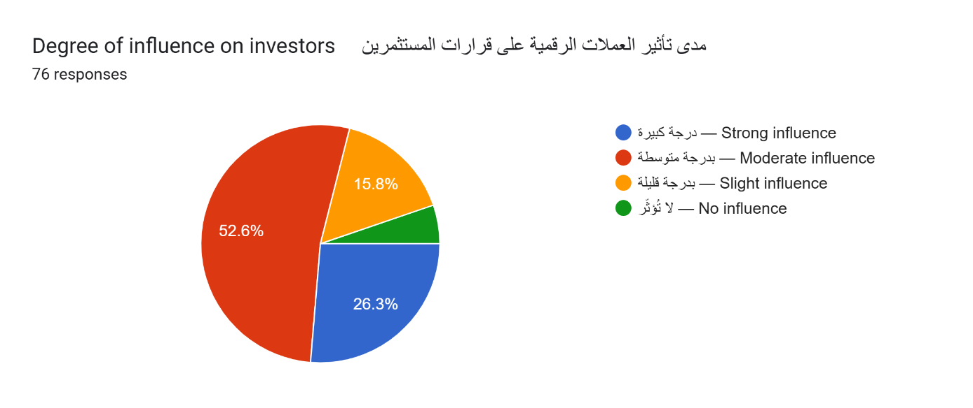
The survey results show clear patterns that support the themes of the research. Most respondents are young adults, which reflects the age group most active in digital financial tools. The gender distribution shows higher participation among males. This aligns with published research that reports stronger male involvement in cryptocurrency markets. Respondents report strong educational backgrounds. Most hold a bachelor’s degree or higher. This indicates that the sample has the academic foundation needed to understand financial issues. The majority work in the private sector, which is the sector most engaged in financial technology development.
Respondents report moderate knowledge about digital currencies. They rely on social media, trading platforms, and personal networks for information. These sources reflect global trends where informal channels shape understanding of digital assets. Responses about volatility show caution. Most report moderate or low understanding of volatility risks. This shows a gap between interest in digital currencies and deep knowledge of their financial behavior.
Most respondents have never invested in digital currencies. Those who have invested report limited experience. Most have been involved for less than three years. Profit generation is the main reason for investment. This aligns with research showing that digital currencies attract individuals seeking short-term gains. A smaller share invests due to interest in technology or curiosity.
Future investment intentions show moderate willingness. Many respondents remain uncertain. This reflects concerns about risk and market stability. Respondents believe digital currencies influence investor behavior. Most view this influence as moderate. This supports evidence that digital currencies shape financial attitudes even among individuals who do not invest.
Most respondents believe digital currencies compete with traditional assets. This perception reflects studies that describe digital assets as emerging alternatives to stocks and commodities. Responses on market readiness show cautious confidence. Many view the Saudi market as moderately ready to deal with digital currencies. This aligns with national reports describing progress in financial technology infrastructure.
Views on regulatory alignment show similar patterns. Many respondents see the regulatory environment as moderately aligned with the needs of digital currency markets. Respondents report that digital currency news affects their decisions. Most follow news occasionally. This suggests that information plays a role in shaping perceptions without dictating behavior.
When asked whether digital currencies represent a threat or an opportunity, most respondents choose both. This reflects global research that highlights innovation opportunities and risk concerns. Expectations about adoption by financial institutions remain uncertain. Many respondents select maybe. This reflects awareness of ongoing experimentation by financial institutions without clear expectations about future outcomes.
These results support the arguments in the research. They show growing interest in digital currencies, moderate understanding of risks, and cautious expectations about future adoption in the Saudi market.

Previous Studies
Previous studies form a central component of scientific research because they establish the academic context of the topic, clarify the position of the current study within existing literature, and highlight knowledge gaps that require further analysis. In research that examines digital currencies and their impact on strategies of the Saudi market, a systematic review of relevant works provides a strong foundation for interpreting national developments, international trends, and behavioral patterns among investors. The reviewed literature reflects diverse methodological approaches, including qualitative analysis, survey-based research, comparative legal studies, and institutional reports. Together, these contributions explain how digital transformation influences financial behavior, regulatory systems, technological readiness, and long-term strategic planning. The following expanded review presents a detailed summary of key studies and identifies how each contributes to the academic structure of the current research.
1. Al Otaibi (2021): Digital Transformation in the Saudi Financial Sector
This study examined ongoing digital transformation within Saudi financial institutions using qualitative analysis supported by institutional reports. The author explored the rise of financial technology tools, expansion of digital payments, and early discussions surrounding digital currencies as part of broader modernization. Findings show notable progress in adoption of digital services across the banking sector driven by national digital initiatives and improved public engagement with online applications. The study also emphasized that Saudi authorities excluded cryptocurrency activity from the official legal framework, which led investors to rely on international trading platforms outside domestic supervision. This gap created exposure to risk and highlighted the need for regulatory tools capable of responding to increased digital participation. The study remains relevant because it shows how institutional modernization interacts with regulatory caution during the early stages of digital financial development.
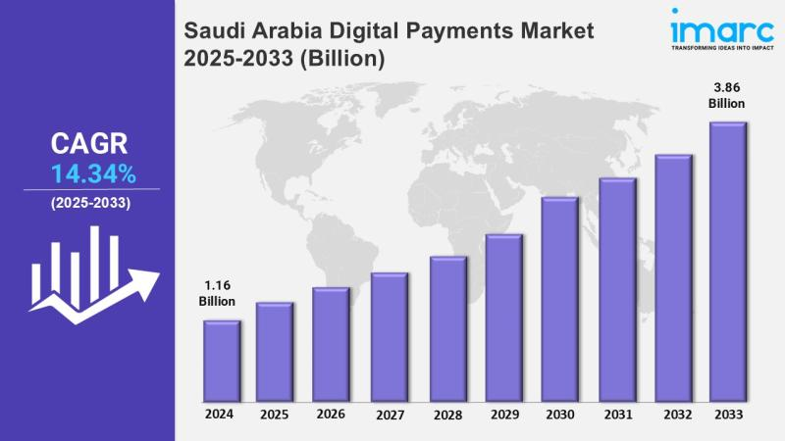
Figure 19: Saudi Arabia Digital Payments Market
The figure presents projected growth of the Saudi digital payments market from 2024 to 2033. It shows an increase from 1.16 billion dollars in 2024 to 3.86 billion dollars in 2033. The pattern reflects strong annual expansion supported by wider adoption of electronic payment tools, broader integration of digital financial services, and ongoing national investment in financial technology infrastructure. The compound annual growth rate of 14.34 percent between 2025 and 2033 highlights sustained momentum across the period.
The figure aligns with national trends that show rapid growth in point of sale transactions, increased use of mobile payment systems, and broader engagement with electronic financial tools across age groups. The expansion of digital payments also reflects the influence of Vision 2030, which supports modernization of financial services and reduction of reliance on cash in retail activity. The upward trajectory signals continued movement toward a digital financial environment that supports efficiency, transparency, and stronger integration with global payment systems.
2. Al Khalidi (2022): Cryptocurrencies and Legal Challenges in the Gulf
This research provided a comparative legal analysis of cryptocurrency regulation across Gulf jurisdictions. The author studied national frameworks in Saudi Arabia, the UAE, and Bahrain. Findings show that the absence of unified legislation increases uncertainty for investors and creates uneven conditions across regional markets. The study noted that the UAE developed structured licensing frameworks for digital asset service providers, while Bahrain introduced more flexible oversight mechanisms for financial technology firms. Saudi Arabia maintained a restrictive approach that kept cryptocurrency activity outside formal regulation. The author recommended stronger policy coordination across the Gulf Cooperation Council to reduce cross-border discrepancies and strengthen regional supervision. This recommendation aligns with international economic literature that encourages regulatory harmonization in interconnected markets. The study highlights the regional policy environment that shapes Saudi decision making and supports evaluation of regulatory challenges.

3. Al Zahrani and others (2020): Saudi Investor Behavior Toward Digital Currencies
This study used a survey-based approach to examine behavioral patterns among Saudi retail investors engaged in cryptocurrency trading. The authors assessed awareness levels, motivations for participation, and perceptions of risk. Findings show that many respondents lacked understanding of key risks such as price volatility, hacking events, and legal uncertainty. Motivations were driven largely by expectations of rapid gains, reflecting the influence of global price cycles and online promotional content. The study concluded that financial literacy levels remain low in relation to the complexity of digital assets and recommended development of structured awareness programs supported by financial authorities and educational institutions. These results align with international behavioral finance studies that identify knowledge gaps as a key factor influencing speculative digital asset behavior. The study provides critical insight into market behavior that supports the current research focus on investor readiness.
4. Alshahrani (2021): Cryptocurrency Adoption in Saudi Arabia
This empirical study investigated adoption rates of digital currencies in Saudi Arabia with attention to demographic differences. The author collected survey and interview data to identify patterns linked to age, digital literacy, and investment preferences. Findings show higher adoption among individuals aged 20 to 35 due to familiarity with technology, influence from social media, and interest in alternative investment opportunities. Absence of a clear regulatory framework created confusion among users who relied on external information sources. The author recommended establishing a balanced regulatory model that provides clarity without discouraging innovation. This study contributes to understanding demographic trends that influence adoption of digital currencies and highlights the importance of structured policy development for improving user protection and market transparency.
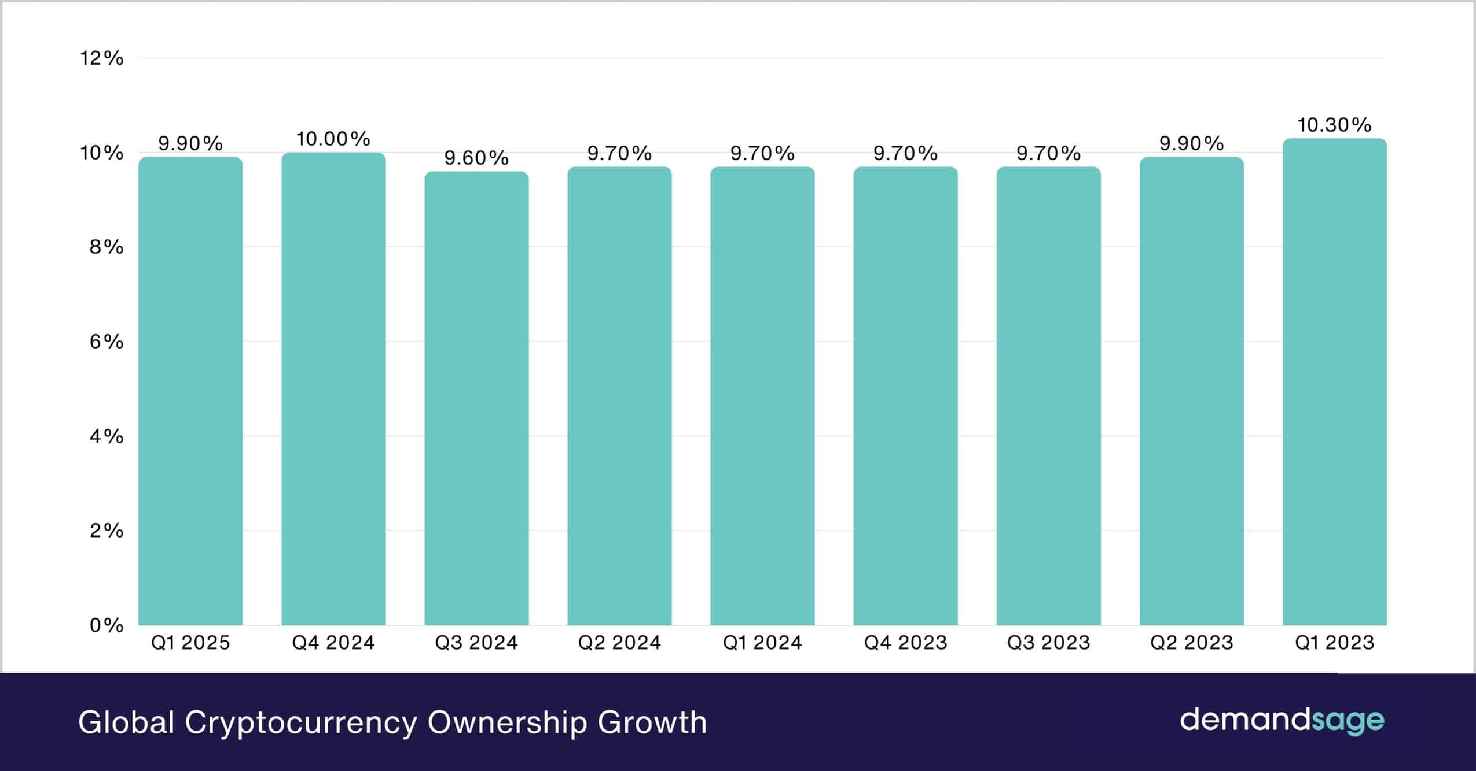
Figure 20: Cryptocurrency Adoption Worldwide
The figure presents global cryptocurrency ownership levels from the first quarter of 2023 to the first quarter of 2025. Ownership rates remain stable across the period, moving between 9.60 percent and 10.30 percent. The highest value appears in the first quarter of 2023 at 10.30 percent, followed by smaller fluctuations as adoption remains close to 10 percent across later quarters. The slight decrease through 2023 and early 2024 reflects short term changes in market conditions, while the increase toward 9.90 percent in early 2025 shows continued interest in digital assets within a broad global user base.
The figure highlights a pattern of stable participation rather than rapid expansion. This stability reflects maturing digital asset markets, increased regulatory clarity in several regions, and more consistent user behavior. For markets such as Saudi Arabia, these global trends provide a reference point. Stable global adoption combined with national growth in digital payments and financial technology indicates that future shifts in participation will depend on local regulation, service availability, and the ability of individuals to access secure and reliable digital asset platforms.
5. Nassr and Wehinger (2016), OECD: Opportunities and Risks in the Digital Financial World
This international study offered a broad examination of opportunities and risks associated with digital finance, including digital payments, financial technology applications, and digital currencies. The authors highlighted the importance of flexible regulatory frameworks that support innovation while preserving financial stability. The study emphasized the role of central banks in guiding technological adoption, establishing oversight systems, and managing risks linked to emerging financial tools. These findings provide global context for evaluating national decisions regarding digital currency regulation and remain relevant due to continued reliance on OECD guidance in policymaking circles. The study supports the current research by explaining global patterns that influence national strategies.
6. IMF (2022): Central Bank Digital Currencies
This institutional report analyzed implications of central bank digital currencies and compared them with private digital currencies. The IMF highlighted benefits of central bank digital currencies for emerging markets, including improved financial inclusion, enhanced oversight of digital transactions, and reduced exposure to illicit activity. The report recommended gradual adoption due to operational, technological, and cybersecurity challenges. It also stressed the importance of preserving monetary stability during digital currency experimentation. These insights support analysis of digital currency strategies within Saudi Arabia, particularly as the Saudi Central Bank continues pilot work on wholesale central bank digital currency systems.
7. Saudi Central Bank (2023): Blockchain Technologies and Digital Currencies
This official study assessed national readiness for blockchain adoption within financial institutions. The report identified growing institutional interest in blockchain systems for settlement, record management, and operational efficiency. It also highlighted limitations related to cybersecurity, workforce training, and absence of dedicated regulatory frameworks. The study emphasized the need for expanded institutional capacity and development of clear policies to support transition from experimentation to practical implementation. These findings are directly relevant to the present study because they provide national evidence on strengths and challenges associated with integrating digital currencies into financial strategies.
8. Al Tuwaijri (2022): The Impact of Digital Currencies on Emerging Markets
This comparative research examined how Saudi Arabia and the UAE incorporate digital currencies within national financial strategies. The study found that the UAE adopted advanced licensing systems and integrated digital asset services within its financial sector. Saudi Arabia maintained a cautious position shaped by legal considerations and concerns regarding financial stability. The author recommended learning from the UAE experience while ensuring alignment with Saudi economic, regulatory, and cultural frameworks. The study explains regional variation in policy readiness and contributes to understanding strategic differences across Gulf markets.
9. Kiff and others (2020): IMF Analysis of Global Crypto Asset Risks
This international study examined the structural risks associated with digital asset markets and emphasized the need for supervisory innovation. The authors identified vulnerabilities linked to liquidity mismatches, unregulated custody practices, and rapid cross-border capital flows. They argued that countries without strong oversight face increased exposure to market instability. The study is relevant to the Saudi context because it highlights risks linked to participation in international markets without domestic regulation.
10. World Economic Forum (2022): Digital Assets and the Future of Finance
This report assessed the global impact of digital assets on financial services, investment products, and transaction systems. The authors discussed institutional adoption, operational efficiency, and emerging regulatory practices. The study emphasized that digital assets influence long-term strategy in advanced and emerging markets and recommended that countries develop adaptive regulatory frameworks. The findings support analysis of how global trends influence national planning within Saudi Arabia.
Together, these studies provide a comprehensive academic foundation for evaluating how digital currencies influence strategies of the Saudi market. They clarify the regulatory, behavioral, and institutional dimensions that shape national responses to digital transformation and demonstrate the need for research that connects these dimensions within a unified analytical framework.

Theoretical Framework of the Study
This study relies on several theoretical foundations that establish the academic basis for examining digital currencies and understanding their influence on financial market strategies within the Saudi context. These frameworks clarify the nature of digital assets, guide interpretation of institutional decisions, and connect the main variables in a structured and evidence-based manner. They also support evaluation of investor behavior, regulatory attitudes, and patterns of technological adoption during a period of global and national digital transformation. The following expanded theoretical foundations form the conceptual structure of the study and support deeper analysis of economic, regulatory, technological, and behavioral dimensions of digital currency activity in Saudi Arabia.
1. Innovation Diffusion Theory
Innovation Diffusion Theory provides a structured explanation of how new technologies spread from early developers to wider user groups. It outlines sequential stages that include initial experimentation, early adoption by small demographic segments, broader social acceptance, and possible long-term stabilization. Digital currencies fit within this model because they represent a disruptive financial technology that challenges established systems of money creation, value transfer, and settlement. International research shows that strength of digital infrastructure, availability of supportive regulation, and cultural familiarity with technology determine the pace of diffusion across markets.
In Saudi Arabia, diffusion remains at preliminary stages because cryptocurrency activity is not legally recognized, and users depend on international platforms. Demographic studies show that digital familiarity among youth increases exposure, yet institutional caution slows progression toward mainstream adoption. Understanding these patterns helps interpret how readiness of institutions, cultural expectations, and regulatory direction shape diffusion outcomes. The theory also clarifies how public perceptions evolve as information spreads through social media, peer networks, and financial education initiatives.
2. Efficient Market Hypothesis
The Efficient Market Hypothesis states that asset prices reflect all available information and adjust rapidly to new data. Digital currencies introduce complexity because their prices respond not only to economic information but also to technological updates, network activity, online sentiment, and speculative trading patterns. Research in financial economics shows that digital asset markets often deviate from traditional efficiency due to lack of regulation, inconsistent information disclosure, and high speculation.
Applying this theory to the Saudi context supports evaluation of whether digital currencies would improve or weaken efficiency within the national market. Potential improvement may result from increased diversification and access to global liquidity, while inefficiency may arise if digital trading remains outside domestic supervision. Understanding how information flows through Saudi financial networks, how quickly investors respond to global developments, and how regulatory restrictions influence market signals helps evaluate efficiency under current conditions and possible future regulatory scenarios.
3. Financial Governance Theory
Financial Governance Theory explains how regulatory systems maintain market stability, protect investors, and guide safe financial development. It emphasizes structured oversight, transparency, and coordinated regulatory action. Digital currencies raise concerns related to anonymity, cross-border transfers, potential criminal misuse, and absence of centralized control. International evidence shows that markets lacking strong governance systems face increased exposure to systemic risks.
Saudi Arabia follows a preventive governance model that stresses stability, early risk detection, and controlled innovation. This approach aligns with the principles of Financial Governance Theory because it prioritizes safeguarding of financial systems during periods of rapid technological change. Application of this theory supports analysis of how regulatory decisions shape strategic integration of digital currencies, how authorities evaluate benefits against risks, and how institutional frameworks influence the pace and direction of digital adoption.
4. Technology Acceptance Model
The Technology Acceptance Model explains how individuals decide whether to adopt new technologies. It identifies two principal drivers: perceived usefulness and perceived ease of use. In the case of digital currencies, perceived usefulness relates to benefits such as access to global markets, quick cross-border payments, and alternative investment opportunities. Perceived ease of use relates to the simplicity of digital wallets, security procedures, and accessibility of reliable information.
In Saudi Arabia, surveys show that younger users perceive digital assets as useful, yet concerns about cybersecurity risks, loss of private keys, and lack of formal guidance reduce ease of use. This model helps explain adoption patterns among different age groups, levels of risk tolerance, and degrees of technological familiarity. It also clarifies how financial education, public communication, and institutional messaging shape acceptance and influence willingness to engage in digital currency activity.
5. Regulatory Response Theory
Regulatory Response Theory states that authorities respond to emerging financial developments through prohibition, containment, integration, or flexible intermediate policies. The chosen response depends on regulatory capacity, perceived risks, technological readiness, and national economic priorities. In Saudi Arabia, the current response to digital currencies remains cautious, characterized by ongoing evaluation and restrictions on commercial trading. This fits within an early containment stage intended to maintain stability while regulators analyze international experiences.
Application of this theory supports interpretation of policy choices, regulatory hesitation, and the gradual nature of national decision making. It also clarifies how global developments influence domestic policy, how regulatory capacity shapes future strategies, and how authorities weigh risks against opportunities when evaluating digital currencies. The theory provides insight into potential future paths, including forms of regulation that may emerge if authorities decide to integrate digital assets into the financial system.
6. Behavioral Economics Theory
Behavioral Economics Theory examines how psychological factors, social influences, and cognitive biases shape financial decisions. Studies show that investors in digital currency markets often respond to peer behavior, online promotions, emotional reactions, and fear of missing out. Digital markets display volatility that amplifies these behavioral factors. Behavioral Economics Theory is relevant to the Saudi context because research shows that many young investors respond to global price trends and social media narratives rather than structured analysis.
Application of this theory helps interpret patterns of speculative behavior, reliance on external information, and vulnerability to misinformation. It also explains why financial education programs are essential for reducing exposure to fraud, improving risk assessment, and promoting informed decision making. Understanding behavioral influences supports evaluation of how psychological factors shape adoption patterns and how they interact with regulatory guidance and digital literacy levels.
7. Systemic Risk Theory
Systemic Risk Theory explains how disruptions in one part of the financial system can spread and cause broader instability. Digital currencies introduce potential for systemic risk because they operate through fast-moving global networks, allow anonymous transactions, and create opportunities for unmonitored capital transfers. International research highlights risks linked to high volatility, liquidity shortages, and development of parallel markets outside regulatory oversight.
In the Saudi market, unregulated participation through foreign platforms increases exposure to systemic risk because authorities have limited visibility into trading activity. Application of this theory supports evaluation of long-term risks associated with digital currency expansion and helps clarify why regulators prioritize stability and structured supervision. It also provides a framework for assessing how monitoring capacity, institutional coordination, and regulatory preparedness influence national resilience during digital transformation.
Together, these theories create a comprehensive framework for analyzing digital currencies within the Saudi market. They link technological, behavioral, regulatory, and systemic dimensions and support structured interpretation of factors that influence national strategies toward digital assets.

Methodology and Research Methods
This study relies on a scientific methodology suited to analyzing the complex and multidimensional nature of digital currencies and their influence on strategies of the Saudi market. The descriptive analytical method was chosen because it supports structured examination of the financial, regulatory, and technological environment and allows interpretation of available data in a way that produces academically grounded results. This method also supports systematic exploration of how digital currencies interact with national market behavior and public policy decisions during a period marked by rapid global digital transformation. The following expanded sections explain the components of the methodology used in the study and clarify how each contributes to achieving the research objectives.
1. The Descriptive Analytical Method
The descriptive analytical method examines the phenomenon as it exists by collecting information from documented sources and analyzing it to understand relationships between variables. This method is suitable for the subject because digital currencies involve interconnected dimensions that include financial regulation, investor behavior, risk management, technological innovation, and global economic trends. The method clarifies how these dimensions interact within the Saudi market, where digital currencies remain unregulated and where official authorities rely on a preventive approach toward financial technology adoption.
The descriptive analytical method does not require field experiments or controlled testing. This is important because direct experimentation is difficult in environments where digital currency activity is legally restricted and where access to detailed transactional data is limited. The method supports analysis based on secondary sources and allows integration of academic studies, institutional reports, and financial indicators. This approach aligns with international research practices in digital finance, where many studies rely on secondary analysis due to limited access to direct user data and the global nature of digital asset markets.
2. Sources of Data
The study relies primarily on secondary data. Official reports issued by the Saudi Central Bank, the Capital Market Authority, and other national institutions provide reliable information on financial developments, regulatory positions, and technological initiatives. These reports offer strong credibility because they reflect institutional monitoring and documented policy decisions.
International sources such as the International Monetary Fund, the Bank for International Settlements, the OECD, and the World Economic Forum were used to place the Saudi case within global context. Peer-reviewed academic studies provided theoretical grounding and supported comparison between Saudi trends and those observed in international markets. Global market datasets from research institutions and financial bodies helped interpret patterns related to adoption rates, market capitalization, and technological readiness.
Reliance on secondary sources is reasonable because Saudi regulation does not permit licensed cryptocurrency trading within the country. Public data on domestic trading volume, typical user characteristics, or usage patterns is not available through official channels. International datasets therefore support interpretation of gaps in national data and allow relevant comparison with markets sharing similar restrictions.
3. Data Collection Methods
Two methods were used to collect and organize data.
a. Desk research involved reviewing academic literature, regulatory documents, institutional reports, and financial analyses. This method helped identify patterns in digital currency adoption, regulatory approaches, and market behavior across different countries. It also supported understanding of how digital currencies developed over time and how global financial institutions interpret associated risks and opportunities.
b. Policy content analysis involved examining statements, regulatory notices, consultation papers, and public guidelines issued by Saudi authorities. This method helped determine the official position on digital currencies and identify areas of regulatory focus such as fraud prevention, consumer protection, and financial stability. Policy content analysis also clarified how national decision makers interpret global developments and how these interpretations shape strategic direction in Saudi Arabia.
Both methods complement each other. Desk research provides a wide analytical base, while policy content analysis focuses on the national regulatory environment. Together, they support comprehensive interpretation of the study subject.
4. Research Tool
Because the study relies on secondary data, a specialized content analysis tool was used that combines qualitative and quantitative techniques. Qualitative analysis was used to interpret regulatory documents, academic studies, and institutional reports. It helped identify key themes related to investor behavior, policy direction, technological readiness, and strategic expectations.
Quantitative analysis supported examination of numerical indicators such as global adoption rates, transaction volumes, market capitalization trends, and growth rates reported by international organizations. These numbers help contextualize the Saudi position within global patterns and highlight differences in regulatory readiness and market participation.
The mixed use of qualitative and quantitative techniques supports balanced understanding of digital currencies and their potential influence on the Saudi market. It also compensates for limitations linked to absence of official local data.
5. Methodological Limitations
The study faced several limitations. Official data on digital asset activity in Saudi Arabia is limited because cryptocurrency trading occurs mainly through unregulated foreign platforms. This restricts detailed quantitative assessment of user characteristics and trading behavior. The absence of licensed local platforms also limits research opportunities that involve direct data collection.
Identifying a representative sample of Saudi digital currency users is difficult because trading occurs outside official systems and because many users avoid disclosure due to regulatory uncertainty. Previous studies on digital currencies in Saudi Arabia vary in methodological quality, which required careful evaluation and comparison during the literature review.
Some conclusions rely on interpretive analysis because empirical evidence from Saudi Arabia is limited. These constraints reflect broader challenges experienced in countries where digital currency activity remains restricted and where market participation is not fully visible to regulators.
6. Justification for the Methodology
The descriptive analytical method was chosen because it aligns with the nature of the research topic. Digital currency activity in Saudi Arabia cannot be studied through direct experimental methods due to regulatory restrictions, limited data access, and concerns related to security and confidentiality. Secondary data provides enough material to analyze documented patterns and interpret developments in a structured manner.
This method is consistent with approaches used in international studies on digital asset regulation, financial innovation, and technology adoption. Many global studies use descriptive analytical methods because digital markets evolve quickly and lack standardized datasets. The method supports integration of policy analysis, international comparisons, and behavioral insights in a way that reflects academic standards in the field.
The methodology therefore provides a strong foundation for examining strategic implications of digital currencies in the Saudi market. It supports rigorous interpretation of available information, allows structured analysis of interconnected variables, and offers flexibility needed to study a subject that is evolving rapidly and remains influenced by global technological change.

Research Tools
This study relies on secondary data, literature analysis, international databases, and official institutional documents. Because digital currencies include economic, regulatory, technological, and behavioral dimensions, the study required a set of complementary tools capable of capturing complexity with accuracy. No single tool is sufficient when studying environments where local data is limited, regulation is restrictive, and user activity occurs mainly through foreign platforms. The selected tools reflect characteristics of the Saudi market, including its financial structure, regulatory orientation, and investment culture. They support objective and detailed analysis grounded in documented information, academic standards, and international research practices. The following expanded sections explain each tool and describe its role in the study.
1. Content Analysis Tool
Content analysis is a qualitative tool used to interpret written material by examining structure, language, recurring patterns, and thematic signals. It is effective for studying subjects where official documentation and institutional statements represent the primary source of evidence. In this study, content analysis was applied to regulatory publications issued by the Saudi Central Bank and the Capital Market Authority. It was also applied to policy papers from the International Monetary Fund, the Financial Stability Board, the Bank for International Settlements, and the World Economic Forum.
This tool supported understanding of regulatory concerns related to financial stability, money laundering, and market transparency. It also helped identify evolving institutional attitudes toward digital assets and patterns in official communication. Content analysis supported categorization of themes such as risk mitigation, cautious regulatory adoption, expansion of financial technology, and expectations for future policy development. This method provided structured understanding of the Saudi regulatory environment and explained how national institutions describe digital currencies in relation to economic and security priorities.
2. Desk Research
Desk research served as a central tool because the study depends on existing literature and official publications rather than direct field data. It supported historical and technical understanding of digital currencies, blockchain systems, decentralized networks, cybersecurity issues, and global adoption patterns. Research sources included academic journals indexed in Scopus and Web of Science, international financial reports, Gulf regional studies on technology adoption, and national documents produced under Vision 2030.
Desk research allowed the study to compare Saudi developments with global evidence. For example, data from the Bank for International Settlements showing that more than 90 percent of central banks are exploring digital currencies provided context for evaluating Saudi pilot projects. Desk research also identified clear gaps in Saudi and Arab literature, including limited empirical research, lack of local behavioral studies, and absence of detailed institutional analyses of digital assets. This tool ensured that the study relied on reliable academic sources and allowed integration of global patterns with national observations.
3. Comparative Analysis Tool
Comparative analysis was used to place the Saudi case within international and regional context. This tool supports evaluation by highlighting similarities and differences in regulatory frameworks, market structures, and institutional strategies. Three comparison markets were selected for their relevance: the United Arab Emirates, Singapore, and the United States.
The UAE provided insight into advanced digital asset licensing systems and regional leadership in financial technology. Singapore represented a global benchmark for harmonizing innovation with rigorous oversight through the Payment Services Act and MAS regulatory guidance. The United States demonstrated the challenges of decentralized regulation with differing rules across states. Comparative analysis helped identify strengths and weaknesses in each model and clarified which elements could support future Saudi regulatory development. It also highlighted how investor confidence, institutional readiness, and market expectations respond to clear or fragmented regulatory structures.
4. Qualitative Thematic Analysis
Qualitative thematic analysis was used to identify key themes embedded in regulatory documents, institutional reports, and public statements. This tool captures underlying priorities, institutional attitudes, and national values that shape regulation and market behavior. The themes identified included caution regarding financial risk, commitment to national digital transformation, emphasis on youth engagement, and preference for structured regulatory development.
Thematic analysis helped explain how cultural context influences responses to new technologies. It also revealed how Saudi institutions prioritize stability, protect consumers, and promote controlled innovation. This tool enriched interpretation by uncovering patterns in official communication that reflect broader social expectations and national identity.
5. Integrated Multi Source Tool
The integrated multi source tool combines data and insights from all previous tools into one analytical structure. It connects textual content, institutional reports, international comparisons, numerical indicators, and socio-behavioral findings. This tool is valuable in environments where local data is limited because it supports triangulation across multiple evidence sources.
The tool supported interpretation of how digital currencies influence investor behavior, regulatory expectations, and strategic planning. It also provided a structured approach for synthesizing diverse information in a manner consistent with academic standards. The integrated multi source tool allowed the study to maintain analytical depth and interpret relationships between variables with clarity.
6. Trend and Indicator Analysis Tool
Trend and indicator analysis was added to support interpretation of global digital asset data published by international bodies. Reports from the International Monetary Fund and the Bank for International Settlements include numerical indicators that track digital adoption, market capitalization, transaction speed, cybersecurity incidents, and participation growth. The World Bank publishes annual remittance cost data which helps evaluate efficiency advantages of digital systems. These indicators allowed the study to examine digital currency trends in markets with similar characteristics to Saudi Arabia.
Trend analysis was used to interpret global market behavior during high volatility periods and compare these patterns with potential future scenarios in Saudi Arabia. It supported evaluation of how adoption rates change across demographic groups and how these changes influence regulatory strategies.
7. Institutional Benchmarking Tool
Institutional benchmarking was used to compare the readiness of Saudi institutions with global and regional counterparts. Benchmarking helps identify areas of strength, gaps in technical capacity, and institutional needs for future digital integration. Reports from the Saudi Central Bank were compared with those from the UAE’s Virtual Assets Regulatory Authority, Singapore’s Monetary Authority, and Bahrain’s Central Bank.
This tool provided insight into best practices for cybersecurity protocols, risk assessment systems, workforce training, and licensing models. It also clarified how Saudi institutions could prepare for future regulatory phases by adopting international standards used by leading financial authorities.
8. Legal Interpretation Tool
A legal interpretation tool was used to analyze regulatory language, official notices, and legal statements related to digital assets. This tool supports examination of how legal frameworks shape investor behavior and institutional strategy. It also allowed interpretation of religious and ethical considerations that influence financial legitimacy in Saudi Arabia.
Legal interpretation helped assess how regulatory ambiguity affects market participation, how authorities justify preventive policies, and how future legal structures might be designed. It supported understanding of the relationship between legal certainty, investor confidence, and market stability.

9. Cross Market Risk Assessment Tool
This tool was used to evaluate risk categories commonly associated with digital currencies. Reports from the Financial Action Task Force and Basel Committee were reviewed to identify risks linked to market volatility, fraudulent activity, cybersecurity breaches, and cross border instability. These risk categories were compared with conditions in the Saudi financial environment to evaluate exposure levels.
Cross market risk assessment supported analysis of why Saudi regulators maintain their current cautious stance and how risk mitigation strategies must be designed to support safe integration of digital assets in the future.
Together these expanded tools form a complete and academically grounded methodological framework. They support analysis suited to a subject marked by rapid global change, limited local data, and strong national regulatory sensitivity. They also ensure that the study interprets digital currency activity in Saudi Arabia through rigorous scientific methods that combine theoretical understanding, international evidence, and national institutional context.

Scope and Boundaries of the Study
This study examines digital currencies and their impact on strategies of the Saudi market. Clear definition of boundaries is required to maintain academic rigor, preserve coherence, and ensure that analysis remains consistent with available information and the characteristics of the national financial environment. Boundaries determine the focus of the study and support structured interpretation across conceptual, methodological, geographic, temporal, regulatory, and informational dimensions. They also reflect the conditions of the Saudi market, where digital currency activity is shaped by limited regulation, strong institutional oversight, and rapid national digital transformation. The following expanded sections describe the boundaries used in this study and explain how each boundary supports accurate and focused analysis.
1. Subject Boundaries
The study focuses on digital currencies as financial instruments that influence strategic planning, regulatory behavior, and investment decisions. The analysis does not include detailed examination of blockchain engineering, cryptographic protocols, mining algorithms, validator systems, or decentralized software architectures. These are highly technical domains that require specialized expertise outside the economic and financial scope of the study.
The study also excludes digital asset categories such as non fungible tokens, tokenized commodities, security tokens, and decentralized autonomous organizations because they involve different market structures and legal classifications. Instead, the study concentrates on widely used cryptocurrencies such as Bitcoin, Ethereum, and Ripple because they dominate global market capitalization, influence international trading behavior, and serve as the main reference for policy discussions.
In addition, central bank digital currencies are included because many central banks, including the Saudi Central Bank, are evaluating potential future adoption. Reports published by the Bank for International Settlements show that more than 90 percent of central banks are conducting research or piloting digital currency projects. Including central bank digital currencies supports forward-looking analysis consistent with national financial planning. These boundaries maintain alignment with the study’s objectives by focusing on economic influence, regulatory direction, and strategic decision making within the Saudi context.

2. Methodological Boundaries
The study relies exclusively on the descriptive analytical method and uses secondary data. It does not include surveys, interviews, or experimental testing. These exclusions reflect the regulatory environment in Saudi Arabia, where cryptocurrency trading is not legally recognized and where data on users is limited. Recruiting an accurate sample for interviews or surveys is not feasible because activity occurs through unregulated foreign platforms and remains outside formal monitoring.
The absence of licensed domestic exchanges restricts availability of quantitative data, transactional records, or user-level insights. These limitations justify reliance on official reports, academic literature, policy documents, and global datasets. This methodological boundary aligns with similar research conducted in markets where regulation limits domestic data availability and ensures that the study maintains academic consistency despite data restrictions.
3. Geographic Boundaries
The study focuses on the Saudi financial market and its institutional frameworks. The analysis includes policy directions of the Saudi Central Bank, regulatory decisions issued by the Capital Market Authority, and behavioral patterns observed in the national investment environment. The study also examines how these national conditions interact with global digital currency developments.
International markets are included only for comparative purposes. These comparisons involve the United Arab Emirates, Singapore, and the United States. Each represents a different regulatory model that helps clarify how national variables shape decision making in Saudi Arabia. The UAE provides a regional reference point with advanced digital asset licensing. Singapore represents a structured global model balancing innovation and oversight. The United States illustrates challenges linked to fragmented regulatory authority. These comparisons serve as contextual references rather than primary study regions.
4. Time Boundaries
The study covers the period from 2017 to 2024. This timeframe captures major global and national developments in digital currency adoption. It includes the 2017 global expansion in market capitalization, early regulatory warnings issued by Saudi authorities in 2018, the launch of Fintech Saudi in 2019 and 2020, and national participation in the Aber central bank digital currency project in 2021. It also includes increased official statements related to digital assets during 2023 and 2024 as global regulatory frameworks advanced.
This period allows examination of the phase during which digital currencies shifted from being considered an experimental technology to becoming a subject of national policy debate. It aligns with international research standards that frame digital currency analysis within developments documented after 2017 when global adoption accelerated.
5. Regulatory Boundaries
Regulatory boundaries represent one of the most important constraints of the study. Saudi Arabia has not issued public legislation regulating cryptocurrency trading. The Saudi Central Bank prohibits dealing in or promoting digital currencies, and there are no licensed cryptocurrency exchanges in the Kingdom. These conditions restrict access to local data and limit opportunities for empirical testing.
Regulatory boundaries influence both methodology and analysis. They explain why the study uses secondary data rather than primary surveys. They also shape interpretation of investor behavior, institutional readiness, and market stability. The regulatory boundary reflects the national financial philosophy, which prioritizes risk prevention, compliance, and controlled modernization. This boundary ensures that the study remains consistent with national legal conditions.
6. Informational and Knowledge Boundaries
Digital currencies remain a relatively new subject in Saudi Arabia, and Arabic literature on the topic remains limited. There is no public national database tracking the number of Saudi users, local transaction volumes, or demographic distribution. Available information comes mainly from international datasets produced by global exchanges, research institutions, and international organizations.
Because of these limitations, the study relies on reports from the International Monetary Fund, the Bank for International Settlements, the OECD, and the World Economic Forum. It also uses regional studies and academic research conducted in similar regulatory environments. International datasets are interpreted through comparison with national conditions rather than treated as direct representations of Saudi activity.
These boundaries reflect a common challenge in research on digital assets in markets with restrictive regulation and ensure that the study maintains accuracy by relying on verified sources and careful evaluation.
Together, these boundaries ensure that the research remains focused on strategic, economic, and regulatory dimensions of digital currencies within Saudi Arabia. They support a coherent structure aligned with academic standards and grounded in characteristics of the Saudi financial environment. They also strengthen the reliability of the study by clarifying what is included, what is excluded, and why these choices support accurate interpretation.

References

- Saudi Central Bank (SAMA).
Report on Financial Technology in the Kingdom. (2023).
Riyadh: Saudi Central Bank.
- Capital Market Authority (CMA).
Annual Report on Regulatory Developments in the Saudi Financial Market. (2023).
Riyadh: Capital Market Authority.
- Al-Otaibi, Fahd.
“Digital Transformation in the Saudi Financial Sector.”
Journal of Economics and Finance, Vol. 18, Issue 2, pp. 45–63 (2021).
- Al-Khalidi, Nasser.
Cryptocurrencies and Legal Challenges in the Arabian Gulf. (2022).
Gulf Center for Financial Studies.
- Youssef, Mohammed, et al.
“Bitcoin Risks in Emerging Market Environments.”
Journal of Economic Studies, Vol. 34, Issue 2, pp. 112–137 (2020).
- FinTech Saudi Program.
Annual Report of Fintech Saudi. (2022).
Riyadh: Saudi Central Bank & Capital Market Authority.
- Saudi Central Bank (SAMA).
Blockchain Technologies and Digital Currencies: National Readiness Report. (2023).
Riyadh: Saudi Central Bank.
- Arab Monetary Fund (AMF).
Regulatory Approaches to Digital Assets in Arab Financial Markets. (2022).
Abu Dhabi: Arab Monetary Fund.
- International Monetary Fund (IMF).
Digital Currencies and Monetary Policy: Opportunities and Risks. (2023).
IMF Publications.
- World Economic Forum (WEF).
The Future of Financial Infrastructure: How Blockchain Can Reshape Financial Services. (2022).
Geneva: World Economic Forum.
- Nakamoto, Satoshi.
Bitcoin: A Peer-to-Peer Electronic Cash System. (2008).
Available at: https://bitcoin.org/bitcoin.pdf
- Financial Action Task Force (FATF).
Updated Guidance for a Risk-Based Approach to Virtual Assets and VASPs. (2021).
Paris: FATF.
- Bank for International Settlements (BIS).
CBDCs: A New Era of Central Bank Money. (2022).
Basel: Bank for International Settlements.
- Bank for International Settlements (BIS).
Annual Economic Report: Chapter III – The Future Monetary System. (2022).
Basel: Bank for International Settlements.
- Organisation for Economic Co-operation and Development (OECD).
Virtual Currencies and Beyond: Initial Considerations. (2019).
Paris: OECD Publishing.
- Organisation for Economic Co-operation and Development (OECD).
Digital Asset Adoption and Financial Consumer Protection. (2023).
Paris: OECD Publishing.
- Financial Stability Board (FSB).
Assessment of Risks in Crypto-Asset Markets. (2022).
Basel: Financial Stability Board.
- Bank of England.
Financial Stability Report: Cryptoasset Risks and Market Developments. (2022).
London: Bank of England.
- Monetary Authority of Singapore (MAS).
Regulatory Approaches to Digital Payment Token Services. (2021).
Singapore: MAS.
- Atlantic Council.
CBDC Tracker: Global Central Bank Digital Currency Developments. (2024).
Washington, DC: Atlantic Council GeoEconomics Center.
- Chainalysis.
Global Crypto Adoption Index. (2023).
New York: Chainalysis Research.
- World Bank.
Global Average Remittance Costs Database. (2023).
Washington, DC: World Bank Group.
- Kiff, J., Alwazir, J., Davidovic, S., et al.
“A Survey of Research on Retail Central Bank Digital Currency.”
IMF Working Paper WP/20/104 (2020).
Washington, DC: International Monetary Fund.
- Catalini, C., & Gans, J.
“Some Simple Economics of the Blockchain.”
MIT Sloan Research Paper No. 5191-16 (2016).
Cambridge, MA: MIT Sloan School of Management.
- Barberis, N., & Thaler, R.
“A Survey of Behavioral Finance.”
Handbook of the Economics of Finance, Vol. 1, pp. 1053–1128 (2003).
Elsevier.
- Biais, B., Hilton, D., Mazurier, K., & Pouget, S.
“Judgmental Overconfidence, Self-Monitoring, and Trading Performance in an Experimental Market.”
Review of Economic Studies, Vol. 72, Issue 2, pp. 287–312 (2005).
- Nassr and Wehinger. Opportunities and Risks in the Digital Financial World. OECD. 2016.
- IMF. Central Bank Digital Currencies. 2022.
- Alshahrani. Cryptocurrency Adoption in Saudi Arabia. 2021.
- Al Tuwaijri. The Impact of Digital Currencies on Emerging Markets. 2022.

جامعة ميد أوشن
كلية الإدارة
قسم إدارة الأعمال
عنوان البحث
العملات الرقمية وأثرها في استراتيجيات السوق السعودي
إعداد
زياد بن يحيى بازيد
إشراف
الدكتور حسن الفيصل
الدكتور فايز جراد
العام الأكاديمي 2025

الشكر والتقدير

إلى نبع الحنان، وإلى القلب الذي لا يجفُّ عطاؤه...
إلى من تشارك فرحتي، وتهدأ دمعتي، وترافق خطواتي بدعائها...
إلى والدتي الحبيبة.
وإلى السند الذي يمنحني من عمره وقوته، ليضيء دربي ويشدّ من أزري...
إلى والدي العزيز.
إلى كل من علّمني، ووقف بجانبي، وكان جزءًا من رحلتي...
أهدي إليهم جميعًا ثمرة جهدي...

فهرس المحتويات
- صفحة الغلاف
- حقوق النشر
- الملخص
- الشكر والتقدير
- قائمة الجداول
- قائمة الأشكال
- قائمة المصطلحات
- قائمة الاختصارات

الفصل الأول: المقدمة
1.1 خلفية الدراسة
1.2 السياق العالمي للعملات الرقمية
1.3 التحول الرقمي في القطاع المالي السعودي
1.4 مشكلة الدراسة
1.5 أهمية الدراسة
1.6 أهداف الدراسة
1.7 أسئلة البحث
1.8 فرضيات البحث

الفصل الثاني: الإطار النظري والدراسات السابقة
2.1نظرة عامة على العملات الرقمية عالميًا
2.2 الأصول الرقمية في الأسواق المالية
2.3 النماذج التنظيمية الدولية
2.4 الدراسات السابقة
2.5 الإطار النظري للدراسة

الفصل الثالث: منهجية البحث
3.1 تصميم الدراسة
3.2 مجتمع وعينة الدراسة
3.3 أداة جمع البيانات
3.4 طرق جمع البيانات
3.5 أساليب تحليل البيانات
3.6 حدود منهجية البحث

الفصل الرابع: تحليل النتائج
4.1 الخصائص الديموغرافية للمستجيبين
4.2 مستوى الوعي بالعملات الرقمية
4.3 سلوك الاستثمار في العملات الرقمية
4.4 إدراك المخاطر والفرص
4.5 جاهزية السوق السعودي
4.6 تفسير النتائج

الفصل الخامس: المناقشة
5.1 مناقشة النتائج في ضوء أسئلة البحث
5.2 المقارنة مع الاتجاهات العالمية
5.3 مدى توافق النتائج مع رؤية السعودية 2030
5.4 الأبعاد المؤسسية والثقافية

الفصل السادس: الاستنتاجات والتوصيات
6.1 ملخص النتائج
6.2 الاستنتاجات
6.3 التوصيات
6.4 الآثار على المستثمرين والمؤسسات
6.5 مقترحات الدراسات المستقبلية

قائمة المراجع

الملاحق
الملحق (أ): استبانة الدراسة
الملحق (ب): الجداول الإحصائية
الملحق (ج): الأشكال والبيانات الإضافية

المقدمة
شهدت الأنظمة المالية العالمية خلال العقدين الماضيين تحولات هيكلية مستمرة نتجت عن التقدم في الاتصال الرقمي، والاعتماد المتزايد على الخدمات القائمة على البيانات، وانتشار التكنولوجيا المالية في الاقتصادات المتقدمة والناشئة. غيرت هذه التحولات أسس النقود والتسوية والتفاعل المالي. تمثل العملات الرقمية أشكالاً رقمية للقيمة تُسجَّل وتُنقَل عبر شبكات رقمية دون اعتماد على النقود المادية أو إشراف مباشر من سلطة مركزية. تختلف هذه العملات عن العملات الرقمية الصادرة عن البنوك المركزية التي تُصدرها السلطات النقدية الوطنية، كما تختلف عن الودائع الإلكترونية في البنوك التي تعتمد على المؤسسات المالية التقليدية. توضح تقارير بنك التسويات الدولية لعام 2021 أن هذه المرحلة شهدت تحولاً أثرت فيه البنى التحتية الرقمية على كفاءة الدفع، وقللت بعض أشكال الاحتكاك في المعاملات، وشجعت دخول جهات جديدة إلى الأسواق المالية. وتدعم منشورات صندوق النقد الدولي لعام 2022 هذا التوجه من خلال توثيق تنامي اهتمام صناع السياسات الذين يدرسون آثار الأصول الرقمية على حركة رؤوس الأموال، والسياسة الكلية، والإشراف على المعاملات المالية.
اكتسبت العملات الرقمية اهتماماً واسعاً بسبب اللامركزية، والتحقق التشفيري، والمشاركة في الشبكات المفتوحة. تشير اللامركزية إلى تشغيل الأنظمة دون سلطة مركزية تتحكم في معالجة المعاملات. ويشير التحقق التشفيري إلى الأساليب التي تؤمّن المعاملات من خلال إثباتات رياضية تمنع التعديل غير المصرح به. وتشير المشاركة في الشبكات المفتوحة إلى إتاحة الانضمام إلى النظام لأي مستخدم دون حاجة إلى موافقة جهة مركزية. شجعت هذه الخصائص المستخدمين على التعامل مع العملات الرقمية بوصفها أدوات مالية بديلة تتيح وصولاً عالمياً مرناً. وتعد "البيتكوين" و"الإيثريوم" أبرز الأمثلة المنتشرة. البيتكوين عملة رقمية ظهرت عام 2009 وتسجل المعاملات على سجل عام موزع يعرف بسلسلة الكتل. أما الإيثريوم فهو منصة رقمية ظهرت عام 2015 وتدعم العملة الرقمية والتطبيقات القابلة للبرمجة المعروفة بالعقود الذكية. تظهر أبحاث باوَر وديمفل وكوك لعام 2018 ونتائج يرماك لعام 2015 أن النمو المبكر لهذه العملات نتج عن اهتمام تقني، وحماس عالمي في الأسواق، وتوقعات مرتبطة بفوائد التنويع.

الشكل 1: القيمة السوقية العالمية للعملات المشفرة مقارنة بالعملة الأمريكية المتداولة (Voronoi / Econovisuals)
يعرض الشكل ارتفاعاً مستمراً في نسبة القيمة السوقية العالمية للعملات المشفرة مقارنة بالعملة الأمريكية المتداولة بين عامي 2016 و2024. تبدأ النسبة قرب الصفر في عام 2016، ثم ترتفع عبر تقلبات حادة خلال الفترة 2017–2021، قبل أن تشهد مرحلة استقرار نسبي ثم صعوداً سريعاً في عام 2023. تصل النسبة إلى نحو 137 في المئة في عام 2024، مما يعكس نمواً قوياً في تقييم الأصول الرقمية مقارنة بالعملة الورقية الأمريكية.
يشير هذا النمط إلى توسع الاهتمام العالمي بالأصول الرقمية، وزيادة النشاط التداولي، واتساع المشاركة المؤسسية. كما تعكس القمم المتكررة خلال السنوات الأولى استجابات لتغيرات السيولة، وتوجهات المخاطر العالمية، وتوقعات التنظيم. ويعكس الارتفاع الحاد خلال 2023 و2024 زيادة تبني الأدوات المالية الرقمية، واتساع مشاركة المستثمرين، وتنامي دمج الأصول الرقمية في الأسواق الدولية.

الشكل 2: مخطط القيمة السوقية العالمية للعملات المشفرة (Coinbase Institutional)
يعرض الشكل تركيبة القيمة السوقية العالمية للعملات المشفرة بين عامي 2017 و2023. تظهر ثلاثة مكونات تمثل البيتكوين، والإيثريوم، وأصولاً رقمية أخرى. ترتفع القيمة الإجمالية من مستويات قريبة من الصفر في 2017 لتتجاوز ثلاثة تريليونات دولار في ذروة عام 2021. يشكل البيتكوين الحصة الأكبر في المراحل الأولى، بينما ترتفع مساهمة الإيثريوم والأصول الأخرى مع توسع السوق. ويعكس الانخفاض بعد عام 2021 ضغوط السيولة، وتغير معنويات المستثمرين، وإعلانات تنظيمية في عدة أسواق.
يبين الشكل أيضاً بداية التعافي في عام 2023، حيث تصل القيمة السوقية إلى نحو 1.5 تريليون دولار. ويظهر نمو الأصول خارج البيتكوين والإيثريوم زيادة في التنويع داخل منظومة الأصول الرقمية، وهو ما يتوافق مع الاهتمام المتزايد بتطبيقات سلسلة الكتل، والأدوات المستندة إلى الرموز، والخدمات المالية الرقمية. أسهمت مشاركة المؤسسات والمستخدمين الأفراد والشركات المالية المتخصصة في انتقال العملات الرقمية من تجارب تقنية هامشية إلى أدوات تناقَش في الأدبيات المالية السائدة.
أدى التوسع العالمي في الأصول الرقمية إلى تحديات تنظيمية واقتصادية أمام السلطات المالية الوطنية. تشمل الأصول الرقمية العملات الرقمية، والأدوات المالية المعتمدة على الرموز، وتمثيلات الملكية عبر سلسلة الكتل. اعتمدت بعض الدول أنظمة ترخيص لمقدمي خدمات الأصول الرقمية، ووضعت قواعد للحفظ، وعززت معايير الإشراف. وفر الاتحاد الأوروبي مساراً تنظيمياً منظماً عبر لائحة الأسواق في الأصول المشفرة لعام 2023 التي حددت متطلبات دقيقة للشفافية والحوكمة وحماية المستهلك. وطوّرت اليابان نموذجها الإشرافي من خلال إلزام منصات الأصول الرقمية بالتسجيل والإشراف المستمر. تعكس هذه التطورات المخاوف التي رصدتها تقارير منظمة التعاون والتنمية والبنك الدولي بشأن مخاطر التحويلات المجهولة، والتعرض للجرائم المالية، والتقلبات الحادة، وتغيرات السيولة العالمية. وتبين هذه التقارير كذلك أن تشتت التنظيم بين الدول يؤثر على الأنشطة العابرة للحدود ويزيد الاعتماد على المنصات الخارجية ذات الإشراف المحدود.
ورغم هذه المخاوف، تظهر مؤشرات دولية متعددة استمرار اتجاه دمج الأصول الرقمية في الأنظمة المالية. تظهر دراسات معهد المحللين الماليين الدوليين توسع المشاركة المؤسسية عبر منتجات استثمارية مرتبطة بالأصول الرقمية وأدوات معتمدة على سلسلة الكتل. تشير تقارير المنتدى الاقتصادي العالمي لعام 2022 إلى جهود شركات المدفوعات ومقدمي خدمات التسوية عبر الحدود لاختبار أنظمة قائمة على سلسلة الكتل تقلل زمن المعالجة وتحسن دقة السجلات. وتظهر هذه الدراسات اهتماماً متزايداً بالأدوات المالية القائمة على الرموز، وبيئات التسوية الآلية، وخدمات مالية جديدة تدعم التحويلات الدولية السريعة. توضح هذه الاتجاهات أن العملات الرقمية تؤثر في البنى التحتية المالية ولا تقتصر على المضاربات الفردية.
هذا السياق العالمي يبرز أهمية دراسة البيئات المحلية التي تتبنى التحول الرقمي هدفاً وطنياً. تمثل المملكة العربية السعودية حالة بارزة، إذ تبنت إصلاحات اقتصادية واسعة ضمن رؤية 2030 التي تعطي الأولوية للتنويع والبنية التحتية الرقمية والتنمية القائمة على المعرفة. تظهر تقارير البنك المركزي السعودي تقدماً في المدفوعات الإلكترونية، وتعزيز الأمن السيبراني، وأنظمة الهوية الرقمية، وبرامج التكنولوجيا المالية
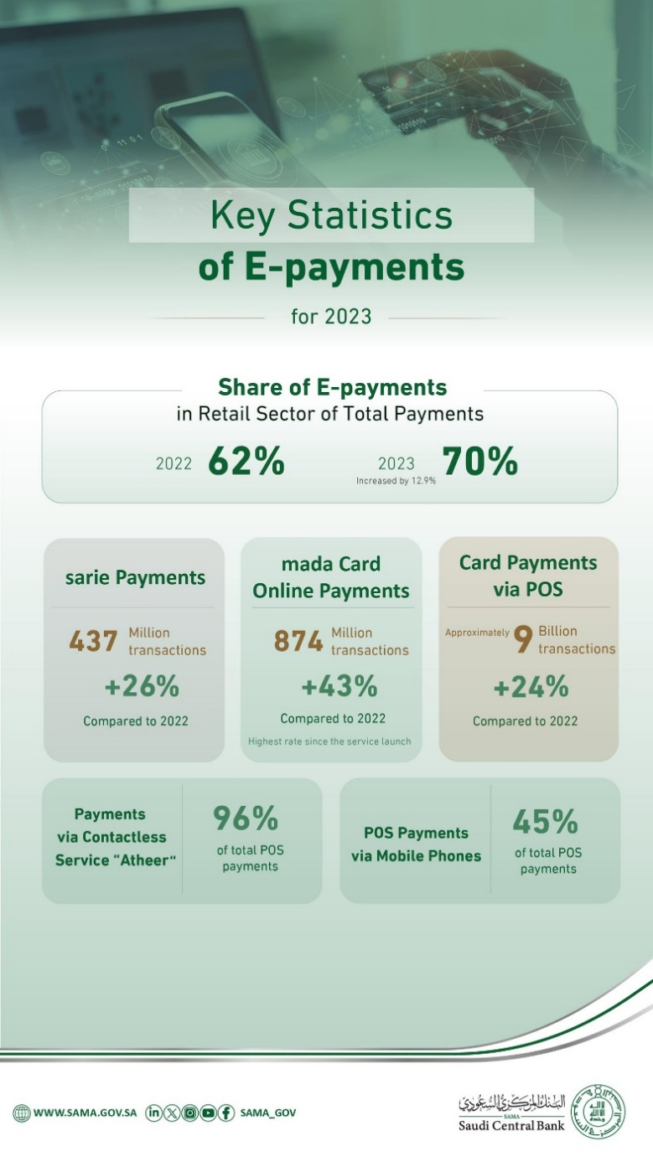
.

الشكل 3: الإحصاءات الرئيسة للمدفوعات الإلكترونية في السعودية لعام 2023
يعرض الشكل تطور المدفوعات الإلكترونية في قطاع التجزئة خلال عام 2023. تظهر البيانات ارتفاع حصة المدفوعات الإلكترونية من 62 في المئة عام 2022 إلى 70 في المئة عام 2023. سجلت مدفوعات "سريع" 437 مليون عملية بزيادة 26 في المئة. وبلغت المدفوعات عبر بطاقات مدى 874 مليون عملية بزيادة 43 في المئة وهي أعلى نسبة منذ إطلاق الخدمة. كما بلغت مدفوعات نقاط البيع نحو تسعة مليارات عملية بزيادة 24 في المئة.
تظهر البيانات توسع المدفوعات اللاتلامسية عبر خدمة "أثير" التي شكلت 96 في المئة من مدفوعات نقاط البيع. كما شكلت المدفوعات عبر الهواتف المحمولة 45 في المئة من عمليات نقاط البيع. تعكس هذه التطورات اندماجاً أقوى للأدوات الرقمية في النشاط المالي اليومي بما يتوافق مع الأهداف الوطنية التي تدعم التكنولوجيا المالية والكفاءة وتقليل الاعتماد على النقد.
وتشير التقارير أيضاً إلى ارتفاع الاهتمام بالأصول الرقمية بين شرائح مختلفة من المجتمع، وخاصة بين الشباب الذين يتفاعلون مع تطبيقات مالية عبر الهاتف ومنصات رقمية عالمية. وثقت هيئة الاتصالات وتقنية المعلومات ارتفاع المشاركة الرقمية بين الشباب في السعودية، مما يدعم الحاجة إلى تحليل منظم لتأثير الأصول الرقمية في السلوك المالي الوطني.
الشكل 4: تبني المدفوعات الرقمية في السعودية
يعرض الشكل مستويات تبني أدوات المدفوعات الرقمية عبر الفئات العمرية والمناطق. تظهر البيانات استخداماً مرتفعاً بين الفئات الشابة، حيث يستخدم 80 في المئة من الأفراد بين 16 و22 عاماً خدمة مالية واحدة على الأقل، وترتفع النسبة إلى 82 في المئة بين 23 و29 عاماً. وتبقى النسب مرتفعة بين 30 و39 عاماً ثم تنخفض لدى الفئات الأكبر سناً. تسجل المنطقة الوسطى أعلى مستويات التبني بنسبة 82 في المئة تليها الشرقية والغربية. وتوضح المؤشرات الوطنية أن 74 في المئة من المستخدمين جربوا خدمة مالية واحدة على الأقل، وأن 69 في المئة يستخدمون المدفوعات الإلكترونية بانتظام، وأن 93 في المئة يجرون معاملاتهم المصرفية رقمياً.
لا يعترف النظام السعودي الحالي بالعملات الرقمية كعملة قانونية ولا يرخّص منصات التداول. ومع ذلك، يتعامل كثيرون معها عبر منصات دولية خارج الإشراف المحلي، مما يعرض المستخدمين لمخاطر الاختراق، والاحتيال، وفقدان الوصول، والمعلومات غير الموثوقة. ويقلل غياب الإشراف الرسمي من توافر البيانات المحلية الدقيقة، ويزيد الحاجة إلى دراسات تفسر سلوك السوق، وتصور المخاطر، والآثار طويلة المدى على الاستقرار المالي. تظهر التجارب الدولية أن النشاط غير المنظم يؤثر على حماية المستهلك وسلوك الأسعار والمؤشرات الاقتصادية الكلية. توضح دراسات آيشنغرين (2019) وأور وكلاسنس (2020) أن دورات أسعار العملات الرقمية ترتبط بأنماط السيولة العالمية وتؤثر على ميل المستثمرين للمخاطرة.
تتضمن الحالة السعودية أبعاداً إضافية ترتبط بالمعايير الثقافية، والتوقعات القانونية، والتخطيط الاقتصادي الوطني. يولي المجتمع السعودي أهمية للاستقرار المالي والإشراف المنظم، مما يؤثر على مواقف الأفراد تجاه الأصول الرقمية. يرى بعض المستخدمين العملات الرقمية أدوات استثمار حديثة، بينما ينظر إليها آخرون بحذر بسبب الغموض القانوني، وغياب القيمة الجوهرية، وعدم وجود إشراف مركزي. توضح الأدبيات الأكاديمية أن العوامل الثقافية تؤثر على التبني، وتقييم المخاطر، والقرارات الاستثمارية. وتؤكد هذه العوامل أهمية الربط بين اتجاهات العملات الرقمية والسياقات الاجتماعية والاقتصادية الوطنية.
يواجه صناع القرار في المملكة أسئلة استراتيجية حول مسار دمج الأصول الرقمية. عليهم تقييم التطورات العالمية، والنماذج التنظيمية في الأسواق المتقدمة، واحتياجات المستخدمين والمؤسسات محلياً. تشير تقارير مجلس الاستقرار المالي إلى أن الأصول الرقمية تؤثر في أنظمة الدفع، ومخاطر التسوية، وفعالية السياسة النقدية. ويشارك البنك المركزي السعودي في مناقشات دولية حول العملات الرقمية للبنوك المركزية، بما في ذلك مشروع "عابر" المشترك مع مصرف الإمارات المركزي.
وبناء على ما سبق، تبرز أهمية دراسة العملات الرقمية في السوق السعودي لفهم كيفية استجابة المملكة للتغير التقني السريع، وكيف تستعد المؤسسات الوطنية للمستقبل. يؤثر هذا الموضوع على القرارات الاستثمارية، وتخطيط القطاع المالي، والتوافق بين الاتجاهات العالمية والأولويات الوطنية. ويسهم التحليل الأكاديمي في تصميم سياسات مدروسة في مرحلة يتوسع فيها استخدام الأدوات المالية الرقمية عالمياً. كما يساعد في تفسير تأثير العملات الرقمية على السلوك، والتوقعات التنظيمية، والاستقرار الاقتصادي. يقدم هذا البحث مساهمة منظمة في هذه المناقشات من خلال دراسة الأدلة العالمية والتطورات الوطنية والجوانب الاستراتيجية المرتبطة بدمج العملات الرقمية في البيئة المالية السعودية.

بيان المشكلة
تطورت العملات الرقمية لتصبح قضية اقتصادية واستراتيجية متعددة الأبعاد ترتبط بجوهر السياسة النقدية والسيادة المالية والاستقرار الاقتصادي العام. تمثل العملات الرقمية أشكالاً رقمية للقيمة تُتداول عبر شبكات رقمية دون ارتباط بالنقود المادية أو إشراف مباشر من سلطة مركزية. يمنح هذا التطور المملكة العربية السعودية موقعاً إقليمياً مهماً، إذ تسعى إلى تبني منهج متوازن يدعم التحول الرقمي ويحافظ في الوقت نفسه على أمن واستقرار النظام المالي. توضح دراسات صادرة عن بنك التسويات الدولية وصندوق النقد الدولي التأثير المستمر للأصول الرقمية في آليات انتقال السياسة النقدية وحركة رؤوس الأموال العابرة للحدود. كما تبين هذه الدراسات أن الأصول الرقمية تتطلب إشرافاً وطنياً قوياً للحد من المخاطر المرتبطة بالتقلبات، وضغوط السيولة، والتغيرات السريعة في الطلب العالمي.
الشكل 5: تقلب الأصول الرقمية مقابل الأصول التقليدية
يقارن الشكل بين مستويات التقلب في الأصول الرقمية والأدوات المالية التقليدية. تسجل البيتكوين والإيثريوم مستويات تقلب أعلى من جميع الأصول التقليدية المعروضة، مما يعكس تقلبات سعرية قوية وحساسية أكبر لظروف السوق. يتجاوز تقلب البيتكوين تقلب خام برنت والذهب ومؤشر الأسواق العالمية FTSE All-World ومؤشرات الائتمان ذات التصنيف الاستثماري. وتظهر الإيثريوم أعلى مستوى تقلب بين الأصول الرقمية، مما يعكس بيئة تداول نشطة وتغيرات متكررة في توقعات السوق.
تظهر الأصول التقليدية مستويات تقلب أقل. يعرض الذهب ومؤشر FTSE All-World أدنى القيم، مما يوضح دورهما كعناصر مستقرة ضمن المحافظ المتنوعة. ويُظهر خام برنت ومؤشرات الائتمان تقلبات معتدلة ترتبط بتغيرات عرض السلع وظروف أسواق الائتمان. ويسجل مؤشر VIX أعلى قيمة تقلب بين المؤشرات التقليدية لأنه يقيس توقعات عدم اليقين في السوق. يوضح الشكل الفجوة بين الأسواق الرقمية والأسواق التقليدية ويبرز الحاجة إلى تقييم دقيق للمخاطر عند دراسة الأصول الرقمية.
أصبح التعامل مع العملات الرقمية مسألة حساسة بسبب تقديمها نموذجاً جديداً للتجارة والاستثمار. يؤدي انتشارها إلى إدخال تغيرات هيكلية قادرة على التأثير في الأنظمة الاقتصادية بأكملها. تشمل الأصول الرقمية العملات الرقمية، والأدوات المالية المستندة إلى الرموز، وتمثيلات الملكية عبر شبكات سلسلة الكتل. توثق أبحاث أيشنغرين (2019) وأور وكلاسنس (2020) تأثير هذه الأصول في دورات السيولة، وسلوكيات الدفع، والتعرض للمخاطر في قطاعات متعددة من الأسواق المالية. وتبين هذه الدراسات أن العملات الرقمية تتفاعل مع ظروف السيولة العالمية بطريقة تزيد الحاجة إلى بيئات تنظيمية واضحة.
الشكل 6: دورات السيولة في سوق العملات الرقمية
يعرض الشكل حركة القيمة السوقية للبيتكوين عبر دورات متعددة باستخدام مؤشر MVRV Z-Score والقيمة السوقية والقيمة المحققة. تمثل القيمة السوقية إجمالي قيمة العملات وفق الأسعار الحالية، بينما تمثل القيمة المحققة قيمة العملات وفق السعر الذي انتقلت عنده آخر مرة. يقيس مؤشر MVRV Z-Score الفرق بين القيمتين ويحدد فترات ارتفاع الأسعار فوق مستويات التكلفة التاريخية أو انخفاضها عنها.
يبين الرسم ظهور قمم متكررة في مؤشر Z خلال أعوام 2011 و2013 و2017 و2021. ترتبط هذه القمم بفترات تدفقات سيولة قوية، وارتفاعات سريعة في الأسعار، وزيادة النشاط المضاربي. ويتبع كل قمة انخفاض حاد يعكس تصحيحات ناتجة عن تراجع السيولة وانخفاض ثقة المستثمرين. تظهر المناطق الحمراء فترات وصلت فيها مستويات المؤشر إلى نطاقات تعكس أسواقاً محمومة، بينما تشير المناطق الخضراء إلى انخفاض الضغط السوقي وتحسن أنماط التراكم.
كما يظهر الشكل نمواً طويل المدى في القيمة السوقية والقيمة المحققة. ترتفع القيمة المحققة بشكل مستمر مع دخول المزيد من المستخدمين واحتفاظهم بالعملات عند أسعار تاريخية أعلى. يعكس هذا النمط توسع المشاركة طويلة المدى داخل الشبكة ويساعد في تحليل تأثير دورات السيولة في سلوك الأصول الرقمية على المدى الممتد.
يمتلك السوق السعودي خصائص مميزة. فهو يتمتع ببنية مالية قوية ومؤسسات تنظيمية متقدمة مثل هيئة السوق المالية والبنك المركزي السعودي. كما يضم قاعدة مستثمرين واسعة مع مشاركة مرتفعة من الشباب. تدعم هذه العوامل الابتكار وتطوير الاستثمار. ورغم ذلك، لا تزال أوضاع العملات الرقمية غير واضحة بسبب عدم وجود إطار تنظيمي رسمي يجيز أو يقيّد التداول. تؤكد تقارير البنك المركزي السعودي غياب الاعتراف الرسمي، وتشير في الوقت نفسه إلى تقييم مستمر للمخاطر والفرص المرتبطة باستخدام الأصول الرقمية.

الأشكال 7 و8: النهج العالمية لتنظيم العملات الرقمية
تعرض الأشكال ملخصاً لكيفية تصنيف الحكومات للأصول الرقمية وتنظيمها. يوضح الجزء الأول مجموعة من الأساليب التنظيمية تمتد من الحظر الكامل إلى الأطر القانونية المنظمة. تطبق دول مثل الصين وبنغلاديش والكويت حظراً كاملاً على نشاط العملات المشفرة، بينما تعتمد دول أخرى مثل الاتحاد الأوروبي والمملكة المتحدة وسنغافورة والولايات المتحدة أطر تنظيمية محددة تضع قواعد للتداول والحفظ ومقدمي الخدمات. تتجه دول مثل نيجيريا والأرجنتين وباكستان نحو الانتقال من مواقف مقيدة إلى نماذج تنظيمية توفر معايير أوضح. وتتبع مجموعة أخرى من الدول مثل فيتنام وكوستاريكا وزيمبابوي منهج “الترقب والمتابعة” قبل وضع أطر رسمية.
وتعرض الأشكال أيضاً اختلافات في الأطر التنظيمية، حيث تعمل بعض الدول ضمن القوانين القائمة، بينما تعتمد دول أخرى قوانين محدثة تتناول الأصول الرقمية بشكل مباشر. وتتبنى بعض الولايات أطر تنظيمية مخصصة تضع قواعد لمقدمي خدمات الأصول الرقمية والعملات المستقرة ومعايير سلامة السوق. تعكس هذه الاختلافات تباين مستويات النضج التنظيمي عالمياً.
وتعرض الأشكال متطلبات الترخيص في عدة دول، حيث تفرض دول مثل كندا وأستراليا والمملكة المتحدة تسجيل مقدمي خدمات الأصول الرقمية لدى جهات وطنية غالباً لأغراض مكافحة غسل الأموال. بينما تعتمد دول أخرى أنظمة ترخيص أشمل تتضمن الإشراف المستمر. وتبرز الأشكال تأثير المعايير الدولية الصادرة عن جهات مثل مجموعة العمل المالي.
وتقارن الأشكال بين انتقال الاتحاد الأوروبي من التوجيه الخاص بمكافحة غسل الأموال إلى لائحة الأسواق في الأصول المشفرة. يوضح هذا الانتقال التحول من قواعد تركز على مكافحة الجرائم المالية إلى إطار تنظيمي شامل يعالج حماية المستهلك، وسلامة الأسواق، والرقابة على العملات المستقرة، والمخاطر النظامية.
يؤدي غياب التنظيم في السعودية إلى فراغ تنظيمي يتزايد أهميته مع ارتفاع الاهتمام بالأصول الرقمية. يعمل المستثمرون والمؤسسات في بيئة يسودها عدم اليقين، مما يقلل القدرة على اتخاذ قرارات مبنية على توقعات مستقرة. توضح دراسات منظمة التعاون والتنمية أن الغموض التنظيمي يزيد السلوك المضاربي، ويؤثر على القرارات الاستثمارية، ويقلل التخطيط طويل المدى. وتثير هذه الآثار تساؤلات حول المسار المستقبلي للسوق السعودي.
كما يؤثر الغموض في الخيارات الاستراتيجية داخل السوق السعودي. فلا تزال مسألة إدراج العملات الرقمية ضمن الأدوات المالية الرسمية أو الإبقاء عليها خارج الإطار الرسمي غير محسومة. يحمل كل خيار آثاراً مختلفة على سلوك المستثمرين، وأنماط السيولة، واستقرار الأسواق، والابتكار. توضح دراسات فولي وآخرين (2019) وكوربيت وآخرين (2020) التأثير المستمر للأصول الرقمية في تفضيلات المخاطر وقرارات التنويع. وتبرز هذه الدراسات أهمية الوضوح في الأسواق الوطنية لتجنب الاستجابات الاستثمارية المتجزئة أو غير المتسقة.
وتضيف الأنشطة غير الرسمية طبقة إضافية من التعقيد. إذ يتداول جزء من المواطنين السعوديين العملات الرقمية عبر منصات دولية خارج الإشراف المحلي، وهو ما يخلق تحديات تنظيمية. تظهر الأدبيات الخاصة بالأسواق الناشئة نمطاً مشابهاً في دول تمتلك أنظمة تنظيمية في مراحلها الأولى. ينبغي على الجهات التنظيمية تحديد كيفية إدارة هذه الأنشطة وحماية المستثمرين ودعم التقدم التقني دون تشجيع تداول غير مراقب.
كما تثير العملات الرقمية قضايا تتعلق بالسيادة المالية الوطنية. يؤدي استخدامها دون إشراف محلي إلى نقل رؤوس أموال خارج النظام المصرفي الرسمي، مما يقلل قدرة الدولة على ضبط السياسة النقدية، ومراقبة التدفقات المالية، ودعم نمو اقتصادي متوازن. توضح تحليلات بردو وليفن (2017) وتقارير البنك المركزي الأوروبي أن التداول غير المنضبط للأصول الرقمية يضعف أدوات السياسة النقدية ويقلل فعاليتها.
وتشكل المخاطر التقنية والأمنية طبقة أخرى من التحدي. تشمل هذه المخاطر الاختراق، وغياب الضمانات، وسرية المعاملات، وضعف الأنظمة التشفيرية. تعتمد الأنظمة التشفيرية على طرق رياضية لتأمين السجلات الرقمية والتحقق من تاريخ المعاملات. ويعرض ضعف هذه الطرق المستخدمين للمخاطر وفقدان الأموال. توثق دراسات من مؤسسات الأمن السيبراني مثل ENISA اختراقات متكررة في منصات الأصول الرقمية. وتوضح هذه النتائج أهمية الإشراف للحد من نقاط الضعف وتقليل الضرر.
وتوسع التطورات الحديثة الفجوة التنظيمية. تشير اللامركزية المالية إلى خدمات مالية رقمية تعمل عبر بروتوكولات آلية دون وسطاء. وتمثل الرموز غير القابلة للاستبدال عناصر رقمية فريدة مسجلة على شبكات سلسلة الكتل. توسع هذه المنتجات البيئة الرقمية بطرق لا تستوعبها الأطر التقليدية. تبين تقارير مجلس الاستقرار المالي أن المنتجات الرقمية الحديثة تتطلب أدوات تنظيمية أكثر مرونة تستجيب للابتكار السريع مع الحفاظ على سلامة السوق.
تواجه السعودية هذه التحديات خلال فترة إصلاح اقتصادي واسع. تدعم رؤية 2030 التحول الرقمي، والابتكار المالي، وزيادة المشاركة في الأسواق التقنية العالمية. ويخلق هذا الوضع حاجة استراتيجية لفهم موقع العملات الرقمية ضمن الإطار الوطني. يتجاوز الموضوع مسألة وجود أو غياب العملات الرقمية الرسمية. بل يشمل تأثير هذه العملات في السياسة العامة، والسلوك الاستثماري، والتطور التقني، واستراتيجيات السوق.
تعالج الدراسة سؤالاً محورياً يتعلق بالاتجاه الاستراتيجي. تؤثر العملات الرقمية في توقعات المستثمرين، وتقدم أنماطاً جديدة من المخاطر، وتتفاعل مع دورات السيولة العالمية. وتشكل هذه العوامل كيفية تقييم المؤسسات المالية للابتكار واستجابتها لظروف السوق المتغيرة. كما يجب على صناع السياسات التعامل مع ضغوط الأسواق الدولية التي تواصل دمج الأصول الرقمية في أنظمة المدفوعات وصناديق الاستثمار والمعاملات العابرة للحدود. وتوضح التجارب الدولية أن النشاط غير المنظم يؤدي إلى تجزئة مالية، بينما تدعم الخطط التنظيمية الواضحة الاستقرار والابتكار.
ويتأثر النظام المالي السعودي بالبيئة الثقافية والاجتماعية. تختلف مواقف الأفراد تجاه العملات الرقمية بين الفئات العمرية والخلفيات المهنية. تسجل مشاركة الشباب معدلات مرتفعة، بينما يبدي المستثمرون المحافظون قلقاً بشأن الشرعية والمخاطر والقيمة طويلة المدى. وتوضح الدراسات الأكاديمية أن العوامل الثقافية والأخلاقية تؤثر على معدلات التبني، مما ينعكس على قرارات المؤسسات والمستثمرين الأفراد.
تكمن الإشكالية الاستراتيجية في تكوين فهم واضح لكيفية تأثير العملات الرقمية في السوق السعودي على المستويات الهيكلية والاقتصادية والسلوكية. لم يعد التحول الرقمي خياراً، بل أصبح جزءاً من التغيير الاقتصادي العالمي وأهداف التنمية الوطنية. يتطلب فهم العملات الرقمية رؤية واقعية تستند إلى الأدلة والتحليل المنهجي والتفسير المتوازن بعيداً عن المبالغة أو التقليل.
وبناء على ذلك، تتمحور مشكلة البحث حول تأثير العملات الرقمية في استراتيجيات السوق السعودي، ودرجة جاهزية النظام المالي، والاستجابات السياسية اللازمة لربط التطور المستقبلي بالأهداف الوطنية والاتجاهات الاقتصادية العالمية.

أهمية الدراسة
تكتسب هذه الدراسة أهمية متزايدة لأنها تتناول موضوعاً يؤثر في الاستقرار المالي الوطني، وتطور الأسواق، والتخطيط المؤسسي، والاستراتيجية الاقتصادية طويلة المدى. انتقلت العملات الرقمية من تجارب صغيرة تعمل ضمن شبكات محدودة إلى أدوات تتفاعل مع الأسواق العالمية والهيئات التنظيمية الدولية والمؤسسات المالية الكبرى. تصف تقارير صندوق النقد الدولي لعام 2023 هذا التحول باعتباره تطوراً هيكلياً يؤثر في أسس أنظمة الدفع، وتوزيع السيولة، والسياسة النقدية. وتوضح هذه التقارير أن الأصول الرقمية تشكل حركة رأس المال عبر الحدود، وتؤثر في أطر التسوية، وتزيد الحاجة إلى أنظمة إشرافية قابلة للتكيف. ويقدم بنك التسويات الدولية في تقريره لعام 2022 تقييماً مشابهاً، إذ يوضح أن العملات الرقمية أصبحت جزءاً من تحول أوسع تؤثر فيه التكنولوجيا في الإشراف المالي والأمان التشغيلي وإدارة المعاملات. توضح هذه التطورات سبب ضرورة دراسة العملات الرقمية بعمق ووضوح في الأسواق الوطنية وعدم التعامل معها بوصفها ظاهرة مؤقتة.
الشكل 9: أداء أسعار مجموعة من الأصول (2023–2024)
يعرض الشكل أداء أسعار عدة أصول رقمية خلال عام 2023 وحتى بداية عام 2024. تظهر البيانات تبايناً واضحاً بين الأصول، حيث تسجل سولانا أعلى زيادة بنحو 683 في المئة. وتليها أفالانش بزيادة تقارب 293 في المئة، وهو ما يعكس اهتماماً متجدداً بالشبكات التي تدعم معدلات معالجة مرتفعة وتطبيقات لامركزية. ويحقق كل من البيتكوين وكاردانو زيادات بنسب 161 في المئة و142 في المئة، بينما تسجل الإيثريوم زيادة تقارب 86 في المئة. تضع هذه القيم تلك الأصول ضمن فئة متوسطة تظهر نمواً مستقراً تدعمه حالة التعافي الواسعة في الأسواق.
وتسجل أصول أخرى مثل XRP وبولكادوت ودوجكوين وبوليغون زيادات أقل تتراوح بين مكاسب محدودة وتحركات بسيطة. تعكس هذه النتائج اختلافات في تطور الشبكات، ومعنويات السوق، وظروف السيولة داخل منظومة الأصول الرقمية. ويبين الشكل تقلبات متكررة على مدار العام، تليها موجة صعود قوية في الأشهر الأخيرة. يعكس هذا النمط تحسناً عاماً في الظروف السوقية العالمية، وارتفاع توقعات المستثمرين المؤسسيين، وزيادة الزخم الناتج عن نمو نشاط التداول.
تزداد أهمية هذه الدراسة عند ربطها بالسياق السعودي. فقد أرست رؤية السعودية 2030 نموذجاً وطنياً للتنويع الاقتصادي يعتمد على الابتكار والتطوير التقني والاستعداد الرقمي. ويحتل القطاع المالي موقعاً محورياً ضمن هذه الإصلاحات لأنه يدعم تدفقات الاستثمار، ونمو القطاع الخاص، وتطوير خدمات جديدة تعزز التنافسية. وتشجع البرامج الحكومية على توسيع المدفوعات الإلكترونية، وأنظمة الهوية الرقمية، ومبادرات المصرفية المفتوحة، وحاضنات التكنولوجيا المالية. وتظهر بيانات البنك المركزي السعودي أن المعاملات الرقمية تجاوزت العمليات النقدية التقليدية في عدة قطاعات داخل السوق، مما يعكس قبولاً عاماً واسعاً للأدوات المالية الرقمية. وتؤكد تقارير المنتدى الاقتصادي العالمي لعام 2022 ومنظمة التعاون والتنمية لعام 2023 أن الدول ذات الطموحات الرقمية المشابهة تدرس العملات الرقمية ضمن جهودها لفهم الأدوات المالية الجديدة واستباق تأثيرها في توقعات المستثمرين والأنظمة التنظيمية والبنية التكنولوجية. وتوضح هذه النتائج الأهمية الاستراتيجية لهذه الدراسة في ظل تعرض السعودية لضغوط رقمية مشابهة لما ترصده هذه التقارير الدولية.
الشكل 10: المدفوعات الرقمية في السعودية
يعرض الشكل قيمة السحوبات من أجهزة الصراف الآلي وقيمة مدفوعات البطاقات عبر نقاط البيع في السعودية بين 2018 والمستويات المتوقعة حتى 2027. ويظهر انخفاضاً مستقراً في السحوبات النقدية، من 553.1 مليار ريال في 2018 إلى توقعات تبلغ 321.9 مليار ريال في 2027. يعكس هذا الاتجاه تراجع الاعتماد على النقد وانتقالاً أوسع نحو الخدمات المالية الرقمية.
وفي المقابل، تسجل مدفوعات نقاط البيع نمواً مستمراً، إذ ترتفع من 213.7 مليار ريال في 2018 إلى 785.8 مليار ريال متوقعة في 2027. ينسجم هذا النمو مع الأهداف الوطنية التي تدعم التحول الرقمي، وتوسيع التكنولوجيا المالية، وزيادة استخدام المدفوعات الإلكترونية في قطاعات التجزئة والخدمات. ويعكس الفارق المتسع بين السحوبات النقدية والمدفوعات الإلكترونية اتجاهاً واضحاً نحو بيئة مالية أكثر اعتماداً على الأدوات الرقمية مدعومة ببنية تحتية قوية وسياسات داعمة.
تؤثر العملات الرقمية في سلوك السوق عبر قنوات تتجاوز نشاط التداول الفردي. فهي تتفاعل مع استراتيجيات الاستثمار، وأنماط السيولة، ونماذج تقييم المخاطر، ومقاربات المؤسسات للابتكار. وتشير بيانات من مؤسسات بحثية مثل Chainalysis إلى أن المشاركة العالمية في الأصول الرقمية ارتفعت بين 2019 و2023، حيث دخل كثير من المستخدمين الأسواق نتيجة زيادة الوعي عبر المنصات الرقمية والتطبيقات المحمولة. ويتوافق هذا النمط مع الاتجاه السعودي، إذ تظهر استبيانات هيئة الاتصالات وتقنية المعلومات توسعاً سريعاً في السلوك المالي الرقمي بين الأفراد الذين تتراوح أعمارهم بين 18 و34 عاماً. وتُظهر هذه الفئات ألفة أكبر مع الأنظمة الرقمية واستعداداً أعلى لاستخدام أدوات رقمية في القرارات المالية. وتكتسب الدراسة أهمية من تفسير كيفية تأثير هذه التغيرات في توقعات السوق وكيف تثير أسئلة تتعلق بالمخاطر، والوعي المالي، والتخطيط المالي طويل المدى.
الشكل 11: مؤشر تبني العملات الرقمية عالمياً (2023)
يعرض الشكل مستويات تبني الأصول الرقمية عبر عدة دول. تشمل المؤشرات الترتيب العام، والدرجة الإجمالية، وقيم الإيداع والاستخدام داخل أنظمة التمويل اللامركزي. وتحقق دول مثل الولايات المتحدة والهند والصين قيماً مرتفعة تعكس قواعد مستخدمين واسعة وبنية رقمية قوية. كما تظهر أسواق مثل فيتنام وتايلاند والمملكة المتحدة مستويات مشاركة متوازنة. وتعرض دول أوروبية مثل فرنسا وهولندا وبولندا اندماجاً متوسطاً ضمن بيئات تنظيمية ناضجة. وتظهر أسواق ناشئة مثل الأرجنتين والبرازيل وتوغو نشاطاً مرتفعاً مدفوعاً بضعف الاستقرار النقدي والاهتمام بالأدوات الرقمية.
ويسهم الشكل في تحليل الوضع السعودي رغم عدم ظهور المملكة فيه. إذ تبين البيانات أن الدول ذات البنى الرقمية القوية وقواعد المستخدمين النشطة تحقق مستويات تبني أعلى. ويتوافق هذا مع توجهات السعودية نحو توسيع التكنولوجيا المالية وزيادة المشاركة الرقمية بين الشباب ونمو المدفوعات الإلكترونية. ويبرز الشكل أهمية بناء بيئات تنظيمية متسقة والوصول الرقمي الواسع، مما يدعم جهود المملكة في تعزيز بيئة التكنولوجيا المالية والاستعداد لاحتمالات التوسع في استخدام الأصول الرقمية.
تتزايد أهمية الدراسة عند النظر إلى المخاطر المرتبطة بالوصول غير المنظم إلى الأصول الرقمية. فالسعودية لا ترخص منصات تداول العملات الرقمية ولا تعترف بها كعملة قانونية. ورغم ذلك، يدخل آلاف المستخدمين السعوديين إلى منصات دولية للتداول والاستثمار. تعمل هذه المنصات خارج الإشراف المحلي وتعرض المستخدمين لمخاطر الاختراق، والأعطال التقنية، والاحتيال، وفقدان الوصول. وتظهر تقارير مجموعة العمل المالي لعام 2021 أن العملات الرقمية معرضة لسوء الاستخدام بسبب سرعة التحويل وصعوبة التتبع دون أنظمة إشراف قوية. وتنشر منظمة التعاون والتنمية نتائج مشابهة في 2022 تشير إلى أن النشاط غير المنظم يزيد من مخاطر الخسائر وسوء الإبلاغ الضريبي والتعرض لمعلومات مضللة. وتزداد أهمية الدراسة عبر تحليل هذه المخاطر في السياق السعودي وبيان كيفية زيادة الحاجة إلى البحث والتحليل المؤسسي.
كما تقدم العملات الرقمية فرصاً يجب على المؤسسات الوطنية تقييمها بدقة. تدعم الأنظمة المالية القائمة على سلسلة الكتل الشفافية وتعزز سلامة البيانات وتسهم في تسوية أسرع للمعاملات. يوضح بحث كاتاليني وغنز لعام 2016 أن تقنية السجلات الموزعة تقلل زمن التحقق وتخفض الحاجة إلى التسوية المتكررة. وتؤكد تقارير مجلس الاستقرار المالي لعام 2022 أن تطبيقات سلسلة الكتل تدعم الكفاءة التشغيلية وتحسن إمكانية التتبع في البيئات المنظمة. وتتوافق هذه المزايا مع أهداف السعودية لتعزيز البنية الرقمية وتقوية الأمن السيبراني وتوسيع نطاق المشاركة في التكنولوجيا المالية. وتزداد أهمية الدراسة من خلال تحليل كيفية ملاءمة هذه الفرص للسوق الوطني وكيف يمكن أن تدعم تطوير الخدمات المالية في المستقبل إذا جرى دمجها بطرق مسؤولة.
وتدعم الدراسة المؤسسات التنظيمية في السعودية من خلال تقديم تحليل منظم للنماذج الدولية. فقد أصدرت الإمارات قوانين لترخيص مقدمي خدمات الأصول الافتراضية وأنشأت هيئات إشرافية تقيم الجودة التشغيلية وسلامة البيانات. وطورت سنغافورة نموذجاً مرناً عبر قانون خدمات الدفع، الذي يحدد متطلبات لإدارة المخاطر وحماية المستهلك والكفاءة التشغيلية. وقدم الاتحاد الأوروبي قواعد تفصيلية عبر لائحة الأسواق في الأصول المشفرة المطبقة في جميع الدول الأعضاء. وتبين هذه النماذج أن التنظيم المنهجي يدعم الابتكار دون الإضرار بالاستقرار المالي. وتزداد أهمية الدراسة من خلال تحليل هذه التجارب وبيان كيفية استفادة السعودية منها في تحديد توجهاتها التنظيمية.
وتكتسب الدراسة أهمية أكاديمية بسبب محدودية الأدبيات العربية حول العملات الرقمية مقارنة بالبحوث الدولية. معظم التحليلات متاحة باللغة الإنجليزية وتصدر من مؤسسات ذات سياقات قانونية وثقافية ومؤسسية تختلف عن السياق السعودي. وتوضح تقارير صندوق النقد العربي هذا النقص وتدعو إلى دراسات إقليمية أوسع. وتستجيب الدراسة لهذه الحاجة من خلال تقديم تحليل يستند إلى الواقع الوطني ويعتمد على مصادر إقليمية وأدلة دولية.
ويشكل سلوك المستثمرين بعداً آخر يزيد أهمية الدراسة. توضح بحوث التمويل السلوكي أن الأفراد يستجيبون غالباً للإشارات العاطفية وحماس السوق بدلاً من التحليل المنهجي. وتبين دراسات باربر وأودين (2001) أن المستثمرين يبالغون في التداول خلال فترات التغطية الإعلامية القوية. وتوضح دراسات بياز وآخرين (2005) أن فجوات المعلومات تزيد تأثير الإشارات المضللة. وتظهر هذه النتائج بوضوح في أسواق العملات الرقمية بسبب تقلباتها ونشاطها المستمر وتأثير وسائل التواصل الاجتماعي. وتزداد أهمية الدراسة من خلال تفسير كيفية ظهور هذه الأنماط بين المستخدمين السعوديين وكيف تؤثر في الحاجة إلى التوعية المالية وبرامج الإرشاد المؤسسي.
وتدعم الدراسة الاستراتيجية المالية الوطنية لأنها تبحث في كيفية تأثير العملات الرقمية في خطط التطور طويل المدى. تدرس الدول ذات الأهداف الرقمية القوية ما إذا كانت الأصول الرقمية تدعم التنويع الاقتصادي وتحفز الاستثمار وتعزز الشمول المالي. وتنشر مجموعة البنك الدولي في 2022 أدلة تشير إلى أن التمويل الرقمي يدعم الشمول المالي في الأسواق الناشئة عند دمجه في بيئات منظمة. وتكتسب الدراسة أهمية من خلال بحث إمكانية ظهور نتائج مشابهة في السعودية في مراحل التطور القادمة وتحديد المتطلبات التي تدعم دمج الأصول الرقمية بأمان.
وتزداد أهمية الدراسة عند النظر إلى العلاقة بين الأصول الرقمية والسياسة النقدية. توضح تقارير بنك التسويات الدولية أن النشاط الرقمي واسع النطاق يؤثر في الطلب على الخدمات البنكية التقليدية وفي انتقال السياسة النقدية عبر السماح لبعض المستخدمين بالاحتفاظ بقيم خارج النظام المالي المنظم. ويغير هذا التأثير العلاقة بين المؤسسات المالية والمستخدمين ويخلق اعتبارات جديدة للبنوك المركزية. وتزداد أهمية الدراسة عبر تحليل كيفية تأثير هذه القضايا في مناقشات السياسة النقدية السعودية وكيف ترتبط بالتدفقات المالية الإقليمية.
وتوفر الدراسة أساساً لفهم جاهزية المؤسسات الوطنية. تحتاج المؤسسات إلى مهارات متخصصة في تحليل سلسلة الكتل والأمن السيبراني والنمذجة المالية وتقييم المخاطر. وتوضح تقارير مجلس الاستقرار المالي لعام 2022 أن الدول التي تمتلك قدرات مؤسسية قوية تدير التحول الرقمي بفاعلية أكبر. وتزداد أهمية الدراسة من خلال تحديد جوانب القوة في المؤسسات السعودية والجوانب التي تحتاج إلى تطوير إضافي لدعم تنمية القدرات الرقمية.
وتسهم الدراسة في فهم الأبعاد الثقافية والاجتماعية التي تؤثر في قبول الأصول الرقمية. لا يعتمد تبني العملات الرقمية على التكنولوجيا أو التنظيم فقط، بل يعتمد أيضاً على المواقف تجاه المخاطر والتصورات المتعلقة بالشرعية المالية والرؤى الخاصة بالقيمة طويلة المدى. توضح البحوث المتعلقة بالمنطقة العربية أن التفضيلات الثقافية تؤثر في القرارات الاستثمارية، وتشكل ردود الفعل تجاه عدم اليقين. وتزداد أهمية الدراسة من خلال توضيح كيفية تفاعل هذه العوامل مع تبني العملات الرقمية في السعودية وكيف تؤثر في النقاشات بين المؤسسات والجمهور.
وتدعم الدراسة تطوير السياسات الوطنية طويلة المدى من خلال تحليل تفصيلي لبنية الأسواق العالمية. تظل أسواق العملات الرقمية حساسة للأحداث العالمية وتحولات السيولة والتغيرات السريعة في الطلب. وتوضح التقارير الدولية أن دورات الأسعار تؤثر في سلوك المستخدمين وتخطيط المؤسسات. ويساعد فهم هذه الأنماط في تطوير سياسات تحافظ على استقرار السوق. وتزداد أهمية الدراسة عبر ربط هذه الأنماط العالمية بالسياق السعودي.
كما تدعم الدراسة المشاركين في السوق من خلال توفير تحليل يوضح المخاطر والفرص المرتبطة بالأصول الرقمية. يحتاج المستثمرون والمتخصصون والجهات التعليمية والشركات الخاصة إلى معرفة دقيقة لتقييم الأدوات المالية الناشئة. وتزداد أهمية الدراسة من خلال تقديم تحليل منظم يساعد هذه الجهات على تفسير الأدلة العالمية وفهم الاتجاهات الوطنية والتخطيط للتطورات المستقبلية.
وعند جمع هذه العوامل، يتبين أن هذه الدراسة تحمل أهمية أكاديمية ومؤسسية واقتصادية واستراتيجية. فهي تدعم الجهود الوطنية لفهم العملات الرقمية، وتقدم تحليلاً يستند إلى الأدلة لدعم تطوير السياسات، وتوضح كيفية تأثير الأصول الرقمية في سلوك السوق السعودي، وتدعم التخطيط طويل المدى خلال مرحلة يتوسع فيها التحول الرقمي داخل الأنظمة المالية العالمية.

أهداف الدراسة
تشكل أهداف هذه الدراسة الأساس لإجراء بحث أكاديمي شامل يوضح كيفية تأثير العملات الرقمية في استراتيجيات السوق السعودي. تستجيب هذه الأهداف للتحول العالمي السريع في الأنظمة المالية والحاجة إلى جاهزية وطنية خلال مرحلة تشهد توسعاً رقمياً واسعاً. ويُوسّع هذا القسم نطاقه لتقديم تفاصيل أعمق، وتوجيه تحليلي أوضح، وربط أوسع بالأدلة الدولية. كما يعكس الأهمية المتزايدة للأصول الرقمية في التخطيط الاقتصادي، والتصميم التنظيمي، والسلوك الاستثماري. وتدعم هذه الأهداف تطوير إطار منهجي وأكاديمي يوضح كيفية تفسير السعودية للتغيرات الرقمية العالمية والاستجابة لها مع الحفاظ على الاستقرار المالي الوطني.
تسعى الدراسة إلى توضيح العلاقة بين العملات الرقمية والبيئة المالية السعودية عبر تحليل الأبعاد الاقتصادية والتشريعية والتقنية والسلوكية. يدعم هذا النهج فهماً يستند إلى الأدلة ويتوافق مع البحوث العالمية الصادرة عن مؤسسات دولية مثل بنك التسويات الدولية وصندوق النقد الدولي والمنتدى الاقتصادي العالمي. تؤكد هذه المؤسسات أن العملات الرقمية تؤثر في السلوك المالي وأنماط السيولة والنظم التشغيلية والتخطيط التنظيمي. كما تبرز الحاجة إلى دراسات وطنية تستجيب للبيئات المحلية. وتتوافق أهداف هذه الدراسة مع هذه النتائج وتوسعها من خلال تقديم تحليل موجه للبيئة المؤسسية والثقافية السعودية.
تُعرض الأهداف ضمن مجموعة من الغايات التحليلية المترابطة، حيث يوضح كل هدف مجالاً مركزياً يسهم في فهم تفصيلي للعملات الرقمية وتأثيرها في استراتيجيات السوق. ويُوسع كل هدف بشرح أعمق مدعوم ببيانات حقيقية ودراسات دولية تعكس تعقيد الموضوع.
فهم عميق للعملات الرقمية
يهدف هذا الهدف إلى بناء فهم شامل للعملات الرقمية من خلال دراسة أصولها، وأسسها التقنية، وتطورها العالمي، وأثرها الاقتصادي. بدأت العملات الرقمية مع البيتكوين عام 2009 وتطورت إلى آلاف الأصول ذات وظائف متعددة. وتظهر تقارير بنك التسويات الدولية أن القيمة السوقية العالمية للعملات الرقمية تجاوزت تريليون دولار خلال عدة فترات بين 2020 و2023. يعكس هذا التوسع تأثير النمو التقني واهتمام الجمهور والتجارب المؤسسية.
وتحقق الدراسة هذا الهدف عبر مراجعة تاريخ الأصول الرقمية بما يشمل أنظمة سلسلة الكتل، والبروتوكولات التشفيرية، وبنى الشبكات، وآليات الإجماع التي تدعم التحقق من المعاملات. كما تراجع الدراسة مستويات التبني العالمية، وأنماط التنظيم، والمؤشرات الاقتصادية المنشورة من صندوق النقد الدولي ومجلس الاستقرار المالي. وتوضح هذه المؤشرات أن العملات الرقمية تؤثر في سرعة التحويلات عبر الحدود، وتقلل تكاليف المعاملات في بعض الأسواق، وتزيد الوصول المالي للفئات خارج النظام المصرفي التقليدي. ويوفر فهم هذه العناصر الأساس التحليلي اللازم لفهم علاقتها بالسعودية.
تقييم الجاهزية المؤسسية والتقنية في السعودية
يبحث هذا الهدف قدرة السعودية على دمج العملات الرقمية ضمن إطار رسمي في حال تبني هذا التوجه. تعتمد الجاهزية المؤسسية على بنية تحتية رقمية قوية، وأنظمة هوية موثوقة، وأمن سيبراني متقدم، وآليات تنظيم فعالة. وتظهر تقارير البنك المركزي السعودي تقدماً في تطوير أنظمة المدفوعات الإلكترونية، والبرامج المصرفية المفتوحة، وحلول الهوية الرقمية. وتستند البنية الوطنية إلى انتشار مرتفع للإنترنت، وخدمات مصرفية حديثة، وإطار أمني سيبراني قوي أنشأته الهيئة الوطنية للأمن السيبراني.

الشكل 12: التكنولوجيا المالية في السعودية
يعرض الشكل معدلات النمو المتوقعة لقطاع التكنولوجيا المالية في السعودية بين 2025 و2033. تظهر البيانات مساراً تصاعدياً يبدأ بنمو متوسط ثم يصل إلى أكثر من 6 في المئة خلال فترات لاحقة. يعكس هذا النمط تأثير السياسات الوطنية التي تدعم التكنولوجيا المالية والتحول الرقمي وزيادة المشاركة في الخدمات المالية الإلكترونية. كما يتوافق مع توسع المدفوعات الرقمية، وزيادة استخدام التكنولوجيا المالية بين الأفراد والمؤسسات، ونمو البنية التحتية المالية.
ومع ذلك، يتطلب دمج العملات الرقمية أدوات إضافية. توضح دراسات مجلس الاستقرار المالي أن الإشراف الفعال على الأصول الرقمية يحتاج إلى أنظمة مراقبة متقدمة ونماذج لرصد المخاطر وبرامج تدريب للكوادر المتخصصة. وتقيم الدراسة ما إذا كانت المؤسسات السعودية تمتلك هذه القدرات وتحدد المجالات التي تحتاج إلى تطوير. ويدعم هذا الهدف فهم نقاط القوة والتحديات، ويقدم إرشادات للتخطيط التنظيمي أو التقني المستقبلي.
فهم تأثير العملات الرقمية في استراتيجيات الاستثمار في السوق السعودي
يركز هذا الهدف على كيفية تأثير العملات الرقمية في سلوك المستثمرين وتنويع المحافظ وإدارة المخاطر. وتوضح دراسات المنتدى الاقتصادي العالمي أن الأصول الرقمية تجذب المستثمرين الشباب الذين يبحثون عن أدوات مالية بديلة. وتظهر استبيانات هيئة الاتصالات وتقنية المعلومات أن الأفراد بين 18 و35 عاماً في السعودية يظهرون مستويات أعلى من النشاط الرقمي.
الشكل 13: ملكية العملات الرقمية حسب العمر والجنس
يوضح الشكل ملكية العملات الرقمية عبر الفئات العمرية ويعرض اختلافات واضحة بين الرجال والنساء. تسجل الفئة 25–34 أعلى مستويات الملكية تليها فئات أصغر وأكبر سناً. يعكس هذا النمط مشاركة واسعة من المستخدمين الشباب، وهي نتيجة متوافقة مع دراسات دولية تربط بين literacy الرقمية وتبني التكنولوجيا المالية. كما تظهر فروق مستمرة بين الجنسين تتوافق مع الدراسات الدولية حول سلوك الأصول الرقمية.
وتوضح الأدبيات السلوكية أن الأصول الرقمية تؤثر في تفضيلات المخاطر بسبب التقلبات المرتفعة، والتغطية الإعلامية، والنقاشات المستمرة عبر الإنترنت. وتشير بحوث باربيريس وثايلر إلى أن قرارات المستثمرين تعتمد على تصور المخاطر ووضوح المعلومات والدعم التنظيمي. وتستخدم الدراسة هذه الأدلة لتقييم كيفية استجابة المستثمر السعودي للاتجاهات الرقمية العالمية وتأثير ذلك في السوق الوطني.
كما يبحث هذا الهدف في كيفية تعامل المؤسسات الاستثمارية مع العملات الرقمية ضمن استراتيجيات طويلة المدى، ويربط ذلك بالأدلة العالمية حول زيادة الاهتمام المؤسسي بأنظمة سلسلة الكتل لأغراض التسوية والحفظ.
تحديد التحديات التي تؤثر في دمج العملات الرقمية مستقبلاً في النظام المالي السعودي
يحلل هذا الهدف التحديات القانونية والاقتصادية والثقافية والتشغيلية التي تؤثر في القرارات الوطنية بشأن دمج العملات الرقمية. تتبع السعودية منهجاً تنظيمياً حذراً، إذ لا يرخص البنك المركزي التداول المحلي للعملات الرقمية. ويعكس هذا الموقف مخاوف تتعلق بالتقلبات والأمن السيبراني والجريمة المالية. وتؤكد تقارير مجموعة العمل المالي هذه المخاطر. وتشير تقارير OECD إلى أن غياب التنظيم الواضح يزيد تعرض المستخدمين للاحتيال.
وتؤثر العوامل الثقافية والاجتماعية أيضاً في قبول الأصول الرقمية. وتبين الأدبيات في الاقتصاد السلوكي الإقليمي أن الثقة العامة والتوقعات الاجتماعية تشكل الاستجابة للأدوات المالية الجديدة. وتوضح الدراسة كيف تؤثر هذه العوامل في السلوك الاستثماري السعودي وكيف تؤثر في التخطيط المؤسسي.
دعم صناع القرار الوطنيين بتوصيات قائمة على الأدلة
يقدم هذا الهدف توصيات للمؤسسات التنظيمية وصناع السياسات بناء على الأدلة الدولية والظروف الوطنية. وتظهر تقارير من سنغافورة والاتحاد الأوروبي والإمارات أن التنظيم الواضح يقلل المخاطر ويعزز الثقة. وتدرس الدراسة هذه النماذج وتحدد الأساليب التي تتوافق مع البيئة المؤسسية والتنظيمية والثقافية السعودية وأهداف رؤية 2030.
إثراء الأدبيات الأكاديمية العربية في التمويل الرقمي
يستجيب هذا الهدف للنقص الواضح في الأدبيات العربية حول العملات الرقمية. وتوضح تقارير صندوق النقد العربي محدودية التحليل الإقليمي. وتساهم الدراسة في سد هذه الفجوة من خلال تقديم تحليل تفصيلي يعتمد على مصادر عربية ودولية.
تعزيز الوعي المهني والأكاديمي في السعودية
يدعم هذا الهدف تطوير الوعي المالي في ظل انتشار المخاطر المرتبطة بالمعلومات المضللة والمضاربة والتهديدات السيبرانية. وتظهر الأدبيات أن التعليم المالي يقلل المخاطر. وتقدم الدراسة شروحات واضحة لخصائص العملات الرقمية ومخاطرها وفرصها.
توفير أساس تحليلي شامل للتخطيط الوطني طويل المدى
يركز هذا الهدف على دعم التخطيط المؤسسي طويل المدى في السعودية. تؤثر العملات الرقمية في السياسة النقدية والتحويلات عبر الحدود وحركة رأس المال. وتوضح تقارير بنك التسويات الدولية أن الاستخدام الواسع للأصول الرقمية يؤثر في الطلب على الخدمات المصرفية التقليدية. وتساعد الدراسة في تحليل هذه التحولات ومناقشة إمكانات المشاركة في مشاريع العملات الرقمية الإقليمية أو تطوير أنظمة حكومية تعتمد على سلسلة الكتل أو دراسة خيارات العملة الرقمية الوطنية.
وتمثل هذه الأهداف المتكاملة إطاراً أكاديمياً شاملاً يدعم فهماً تفصيلياً للعملات الرقمية وتأثيرها في استراتيجيات السوق السعودي، ويوجه تحليل التفاعل بين التكنولوجيا والتنظيم والسلوك الاستثماري والسياسات الوطنية خلال مرحلة تحول مالي عالمي.

أسئلة البحث
توجّه أسئلة البحث الهيكل والمسار التحليلي للدراسة. تحدد أبعادا اقتصادية وتنظيمية وتقنية وسلوكية تتطلب دراسة دقيقة لفهم تأثير العملات الرقمية في استراتيجيات السوق السعودي. تدعم هذه الأسئلة تحليلا منهجيا يستند إلى الأدبيات الأكاديمية وتقارير المؤسسات والتطورات الموثقة في أسواق مماثلة. توسع هذه الأسئلة نطاق التحليل بسبب ما تقدمه الأصول الرقمية من سلوك مالي جديد وتحديات تنظيمية مرتبطة بالتحول الرقمي المعاصر. يقدّم هذا البناء الموسع للأسئلة أساسا أوضح للتفسير والتقييم.
- ما حجم تأثير العملات الرقمية في استراتيجيات السوق المالي السعودي
يعرض الشكل ارتفاعا مستمرا في إيرادات السوق العالمي للعملات الرقمية خلال الفترة من 2022 إلى 2032. تعكس هذه الاتجاهات زيادة الطلب العالمي على خدمات الأصول الرقمية واتساع المشاركة المؤسسية وانتشار دمج العملات الرقمية في أنظمة الدفع ومنتجات الاستثمار والتطبيقات المالية. تشير هذه المؤشرات إلى توسع متوقع في القطاع وتوفر نقطة مقارنة لبلدان مثل السعودية التي تعمل على تعزيز جاهزيتها الرقمية. تظهر تقارير دولية أن العملات الرقمية تؤثر في سلوك الاستثمار وإدارة السيولة والتخطيط المالي طويل الأجل في الأسواق التي تسمح بالتداول. تشير دراسات بنك التسويات الدولية إلى أن توسع الأصول الرقمية يدفع الأسواق إلى مراجعة إجراءات إدارة المخاطر وخطط تبني التقنية واعتماد أدوات رقابية جديدة. في السعودية يظهر التأثير بشكل غير مباشر لأن السلطات لا تسمح بتداول العملات المشفرة عبر المنصات المحلية. مع ذلك تزداد مشاركة الأفراد عبر منصات عالمية. يظهر الاهتمام المؤسسي في مشاريع البنية التحتية للبلوكشين وتجارب العملة الرقمية للبنك المركزي ودمج الحلول الرقمية في أنظمة المدفوعات. تؤكد دراسات صندوق النقد العربي أن أسواق الخليج تتفاعل مع توجهات الأصول الرقمية حتى دون تقنين رسمي بسبب الضغط المستمر الناتج عن التغير التقني العالمي.
- ما العوامل التي تسهّل أو تعيق استخدام العملات الرقمية في السوق السعودي

يعرض الشكل مقارنة تنظيمية داخل دول الخليج. توضح البيانات اختلافا كبيرا في توجهات السياسات. تعتمد الكويت موقفا صارما يشمل حظر التعدين ومنع الاعتراف بالعملات الرقمية كأموال لا مركزية ومنع الشركات من تقديم خدمات مرتبطة بها. تتبنى السعودية موقفا محدودا حيث يسمح للأفراد بالاحتفاظ والتداول والاستثمار بينما تمنع المؤسسات المالية من المشاركة مما يضع النشاط داخل مساحة خاضعة للضبط. تقدم البحرين نظاما مبكرا للترخيص يخضع لقواعد مكافحة غسل الأموال. أنشأت الإمارات هيئة تنظيم الأصول الافتراضية للإشراف على الإصدار والتداول والخدمات. تطور عُمان إطارا تنظيميا يشمل الترخيص وتقييم المخاطر. تقيّد قطر النشاط داخل مركز قطر المالي مع دراسة أطر جديدة للمنتجات المرتبطة بالأصول المرمّزة. تعكس هذه الفروق شكلا متنوعا للسياسات داخل الخليج مما يؤثر في النشاط عبر الحدود ويحدد الاستعداد للتكامل مع التقنيات المالية. تظهر عوامل تنظيمية واقتصادية وتقنية وثقافية داخل السعودية تؤثر في تبني العملات الرقمية. تشمل العوامل المعيقة غياب تشريع رسمي وتحذيرات البنك المركزي وقلق مرتبط بالتقلب الذي توثقه تقارير الاستقرار المالي الدولية إضافة إلى نزعة مؤسساتية نحو الحذر والامتثال. تشمل العوامل الداعمة البنية الرقمية المتقدمة والاستثمار الوطني في التحول الرقمي وتوسع التقنية المالية عبر مبادرات مثل فينتك السعودية وارتفاع الوعي الرقمي لدى الشباب. تشير تقارير صندوق النقد العربي ومسوح وطنية إلى أن هذه العوامل تشكل توقعات المستخدمين واستعدادهم لأي تنظيم مستقبلي.
- ما مستوى وعي المستثمرين السعوديين بمفهوم العملات الرقمية ومخاطرها
تشير نتائج دراسات محو الأمية المالية الدولية إلى أن الاهتمام العالمي بالعملات الرقمية يتقدم بسرعة أكبر من فهم مخاطرها. يظهر الاتجاه نفسه في السعودية حيث يتفاعل المستثمرون الشباب مع الأسواق الرقمية عبر منصات خارجية تؤدي إلى تعرض مرتفع لسلوك اندفاعي ونقص وعي بالمخاطر. تؤكد دراسات المالية السلوكية أن الأفراد في أسواق عالية التقلب يواجهون احتمالا أكبر لقرارات غير مدروسة واعتماد على معلومات ناقصة. توضح المسوح أن المستخدمين يقللون من تقدير مخاطر الاختراق وفقدان المفاتيح الخاصة والغموض القانوني. تؤكد هذه الأنماط الحاجة إلى جهود وطنية لتعزيز التعليم المالي ونشر معلومات موثوقة ودعم برامج تشجع السلوك الاستثماري الواعي.
- هل تمثل العملات الرقمية تهديدا أم فرصة للسوق السعودي
يعرض الشكل عوامل تؤثر في رغبة المستثمرين في التعامل مع الأصول الرقمية عبر مستشار مالي. تشير البيانات إلى اهتمام مرتفع بالتكامل السهل داخل المحافظ ثم حسابات الحفظ المؤمّنة وتنوع الأصول والمنتجات المرتبطة بالعائد. تظهر أهمية واضحة للإشراف التنظيمي ولعوامل مرتبطة بالثقة والبيئة الآمنة. تقدم العملات الرقمية مخاطر تشمل تهديد الاستقرار النقدي وزيادة احتمالات النشاط غير المشروع وضعف الرقابة على المعاملات خارج الإطار المحلي. توثق تقارير مجموعة العمل المالي هذه المخاطر. تظهر فوائد محتملة تشمل دعم الابتكار المالي وتعزيز التحول الرقمي وفق رؤية 2030 وتوسيع الشمول المالي عبر خيارات استثمارية جديدة. توضح الأدلة الدولية أن دمج الأصول الرقمية يحقق نتائج إيجابية عندما تتوفر أطر تحكم المخاطر وتعزز الشفافية وتشجع الابتكار المسؤول. في السعودية تشكل العملات الرقمية فرصة مشروطة تعتمد على شكل الإطار التنظيمي وقدرة المؤسسات على دمج الأدوات الرقمية دون التأثير في الاستقرار.
- كيف يستفيد السوق السعودي من العملات الرقمية دون الإخلال بالاستقرار المالي
تركز هذه المسألة على إجراءات سياساتية تدعم تعاملا آمنا مع العملات الرقمية. تظهر الخبرة الدولية أن الدمج الناجح يحتاج إلى ترخيص تدريجي لمقدمي الخدمات وتطوير أطر تنظيمية قابلة للتكيف مع تطور التقنية وبناء قدرات تقنية متقدمة داخل الهيئات الرقابية. يدعم التعاون مع مجلس الاستقرار المالي التوافق مع المعايير الدولية ويعزز قدرة السلطات على رصد المخاطر. تسمح المبادرات الوطنية الخاصة بتجارب البلوكشين المحكومة بالابتكار مع الحفاظ على الاستقرار. تقدم تجارب سنغافورة والاتحاد الأوروبي نماذج توضح أثر الإشراف المنظم في دعم الابتكار وحماية الثقة.
- ما مدى استعداد الجهات التنظيمية السعودية للإشراف على نشاط الأصول الرقمية عند حدوث تقنين مستقبلي
تتعلق هذه المسألة بقدرة البنك المركزي وهيئة السوق المالية والجهات المرتبطة بها على إدارة الرقابة في حال التقنين. يشمل التقييم أنظمة الرصد والمهارات الفنية والأمن السيبراني والاتساق مع المعايير الدولية. يحظى هذا التقييم بأهمية لأن مستوى الجاهزية يحدد سلامة التنظيم المتوقع.
- كيف تؤثر الاعتبارات الثقافية والأخلاقية والدينية في قبول العملات الرقمية داخل المجتمع السعودي
تؤثر الاعتبارات الثقافية والدينية في السلوك المالي وقبول الأدوات الجديدة. تشمل النقاشات قضايا الإباحة والمخاطر والشرعية المالية مما ينعكس على أنماط التبني ويؤثر في مواقف الجمهور. تساهم هذه المسألة في فهم دور التوقعات الاجتماعية وكيف تتعامل الجهات الرسمية مع المخاوف المتعلقة بالأخلاق المالية والتفضيلات الثقافية.
- كيف يقيّم المستثمرون السعوديون الأصول الرقمية ضمن التخطيط المالي طويل الأجل واستراتيجيات التنويع
تبحث هذه المسألة تأثير العملات الرقمية في قرارات التنويع ومدى تأثر المستثمرين بالاتجاهات العالمية. تدرس الفروق بين تفضيلات المستثمرين الشباب وكبار السن. يساعد هذا التحليل في فهم الدور الذي تؤديه الأصول الرقمية في التخطيط الاستثماري داخل البيئة المالية السعودية.
- ما الفرص المؤسسية المتاحة لدمج البلوكشين في السعودية خارج تداول العملات المشفرة
يعرض الشكل توقعات نمو سوق البلوكشين في السعودية حتى 2033 مع توسع سريع في المنصات والخدمات. تعكس هذه المؤشرات الطلب على أنظمة الهوية الرقمية وسجلات المعاملات الموثوقة والحلول التي تدعم الكفاءة. توضح التوقعات أن البلوكشين سيشكل جزءا مهما من الاقتصاد الرقمي الوطني. توسع هذه المسألة نطاق التحليل من خلال بحث دور البلوكشين في دعم الشفافية والكفاءة التشغيلية والتحقق من الهوية والتسوية عبر الحدود ضمن بيئات خاضعة للرقابة.
تشكل هذه الأسئلة أساسا لدراسة شاملة للعملات الرقمية داخل السوق السعودي. تعكس طبيعة الموضوع وتوجه التحليل نحو أبعاد اقتصادية وتنظيمية وتقنية وسلوكية وتوفر قاعدة داعمة لفحص قائم على الأدلة ومتوافق مع الأولويات الوطنية والتطورات المالية العالمية.

فرضيات البحث
تطور هذه الدراسة مجموعة من الفرضيات العلمية التي تتوافق مباشرة مع أسئلة البحث وتفسر العلاقات المتوقعة بين العملات الرقمية والسلوك الاستراتيجي في السوق السعودي. تستند الفرضيات إلى أدلة عالمية موثقة وتقارير وطنية ونتائج راسخة في الاقتصاد المالي. تعكس كل فرضية أنماطا ملاحظة في الأسواق الدولية مع توافقها مع الظروف التنظيمية والثقافية والاقتصادية في السعودية. يعزز هذا البناء الموسع قوة التحليل من خلال ربط المتغيرات الاقتصادية والتنظيمية والتقنية والسلوكية. يدعم أيضا فحصا أوسع لمدى جاهزية المؤسسات وسلوك المستخدم وآثار طويلة الأجل على الاستقرار المالي.
الفرضية 1

يعرض الشكل فروقا في المعرفة بالعملات الرقمية والمعرفة المالية لدى مجموعات تشمل غير المالكين من الذكور والإناث ومالكي بيتكوين من الجنسين. تظهر النتائج أن المالكين يحققون معدلات أعلى من الإجابات الصحيحة مقارنة بغير المالكين، مع تفوق واضح للذكور. توضح البيانات أن محدودية المعرفة ترتبط بارتفاع مستوى عدم التأكد وكثرة الإجابات الخاطئة بين غير المالكين. تؤكد مجموع النتائج نمطا عاما يرتبط فيه امتلاك الأصول الرقمية بمستوى أعلى من المعرفة بالعملات الرقمية والمعرفة المالية الأساسية. تظهر دراسات دولية فجوة بين الجنسين في المعرفة المالية مما ينسجم مع الاتجاهات الملاحظة في الشكل. ترتبط هذه النتائج بالسوق السعودي الذي يشهد توسعا في استخدام التقنيات المالية مما يرفع أهمية المعرفة العامة بالقضايا الرقمية. تقود مستويات الوعي الأعلى بالعملات الرقمية بين المستثمرين السعوديين إلى زيادة المشاركة في بيئات الأصول الرقمية. يستند هذا إلى نتائج في المالية السلوكية ظهرت في دراسات منظمة التعاون الاقتصادي والتنمية والتي تربط المعرفة بالسلوك الاستثماري والرغبة في استخدام أدوات مالية رقمية. يشمل الوعي في السياق السعودي فهم مبادئ البلوكشين وآليات المعاملات وممارسات التخزين والمخاطر السيبرانية. توسع المحتوى العربي المالي أدى إلى زيادة الوعي لكنه ما زال غير متوازن. تدعم هذه الفرضية تحليل العلاقة بين المعرفة والسلوك الاستثماري وتأثير ذلك في تكوين مشاركة أكثر استقرارا.
الفرضية 2
غياب إطار تنظيمي واضح في السعودية يخفض رغبة المؤسسات والأفراد في دمج العملات الرقمية ضمن الاستراتيجيات المالية. تظهر أدلة صندوق النقد الدولي أن وضوح التنظيم يعزز الثقة ويشجع المشاركة المؤسسية ويجذب الاستثمار. يحافظ المنظمون في السعودية على موقف حذر يحد من التداول ويتجنب الاعتراف الرسمي. يؤدي هذا إلى حالة عدم يقين تنظيمي تؤثر في التخطيط طويل الأجل وتحد من دخول الشركات التي تحتاج إلى وضوح قانوني لضمان عمل آمن. تدعم هذه الفرضية تقييما لتأثير الغموض التنظيمي في القرارات الاستثمارية وإدارة المخاطر والتفكير الاستراتيجي داخل السوق.
الفرضية 3
تقدم العملات الرقمية فرصة للتنويع المالي والابتكار في السوق السعودي إذا كانت ضمن إشراف منظم. توضح تقارير البنك الدولي أن الأدوات المالية الرقمية ترفع تكوين رأس المال وتزيد الوصول إلى منتجات مالية متنوعة وتشجع الابتكار التقني. تفترض الفرضية أن التنظيم الملائم يتيح دخول أشكال جديدة من الاستثمار وتوسع خدمات البلوكشين ويزيد جاذبية السوق للمستثمرين العالميين. ينسجم ذلك مع أهداف رؤية السعودية 2030 التي تدعم التحول الرقمي وتنوع النشاط الاقتصادي.
الفرضية 4
النشاط غير المنظم للعملات الرقمية عبر المنصات الدولية يسبب مخاطر قابلة للقياس على استقرار السوق السعودي. تظهر أدلة مجموعة العمل المالي أن غياب الإشراف يؤدي إلى تعرض مرتفع للتحويلات غير المشروعة والتقلب الحاد وحركة أموال غير مرصودة. في السعودية يحدث التداول عبر منصات خارجية دون رقابة محلية مما يزيد من التعرض للاحتيال والاختراق وخسارة الأصول. تدعم هذه الفرضية دراسة مخاطر النظام التي تظهر عندما ينتشر نشاط السوق خارج القنوات المنظمة وتوضح آثار غياب الحماية للمستهلك.
الفرضية 5
زيادة مشاركة الشباب السعودي في أسواق العملات الرقمية تؤثر في الاتجاهات الاستثمارية وتعيد تشكيل توقعات المستثمرين التقليديين. تشير نتائج صندوق النقد العربي إلى أن الشباب يظهرون جاهزية رقمية عالية وتفاعلا قويا مع الأدوات التقنية. يؤثر اعتمادهم للعملات الرقمية في تفضيلات استثمارية تختلف عن سلوك الفئات الأكبر سنا. تدعم هذه الفرضية تحليلا لدور التركيبة السكانية في ديناميات السوق وكيف يؤدي سلوك الشباب إلى ضغط على المؤسسات لتطوير خدمات حديثة.
الفرضية 6
غياب توجيه قانوني وديني واضح حول مشروعية العملات الرقمية يخفض قبولها لدى المستثمرين المحافظين والمؤسسات المالية. يتأثر القرار المالي في السعودية باليقين القانوني والاعتبارات الدينية المتعلقة بالإباحة. تثير العملات الرقمية تساؤلات حول التقييم والضمان والتصنيف. غياب توجيه موحد يؤدي إلى تردد المؤسسات والأفراد الحذرين. تدعم هذه الفرضية فحص تأثير التفسير القانوني والديني في أنماط التبني والمشاركة المؤسسية.
الفرضية 7
تواجه الجهات التنظيمية السعودية صعوبات في الإشراف على الأصول الرقمية بسبب محدودية الأدوات المتخصصة وغياب إطار رسمي مما يؤثر في مستوى الجاهزية للتنظيم المستقبلي. تظهر تقارير مجلس الاستقرار المالي أن الإشراف على الأصول الرقمية يحتاج إلى أنظمة رصد متخصصة وأدوات تحليل متقدمة وخبرة تقنية. تمتلك السعودية قدرات تنظيمية قوية عامة لكن الإشراف الرقمي يحتاج إلى موارد إضافية وأنظمة أمن سيبراني أقوى وتصميم سياسات متخصصة. تدعم هذه الفرضية تقييما جاهزيا يحدد المجالات المطلوبة للتطوير.
الفرضية 8
تؤثر المواقف الثقافية تجاه المخاطر المالية في قبول العملات الرقمية بين المستثمرين السعوديين. تظهر دراسات التمويل الإقليمي أن التوقعات الثقافية ترتبط بالاستجابة لعدم اليقين والمخاطر. يفضّل بعض الأفراد بيئات استثمار مستقرة مما يحد من رغبتهم في التعامل مع أصول عالية التقلب. تدعم هذه الفرضية تحليلا للعلاقة بين السياق الثقافي والتبني الرقمي وتأثيرها في التصورات العامة للأصول الرقمية.
الفرضية 9
يتأثر التخطيط الاستراتيجي طويل الأجل لدى المستثمرين السعوديين بالتطورات العالمية في الأصول الرقمية حتى دون تقنين محلي. تشير دراسات دولية إلى أن دورات الأسعار العالمية والإعلانات المؤسسية والتطور التقني تؤثر في توقعات المستثمرين عبر الأسواق. تدعم هذه الفرضية تحليلا لكيفية إدخال المستثمرين السعوديين للاتجاهات العالمية ضمن التخطيط طويل الأجل وتأثيرها في الاهتمام بالتنويع والفئات الجديدة من الأصول.
الفرضية 10
توفر تطبيقات البلوكشين خارج نطاق العملات المشفرة مزايا تشغيلية تدعم جهود التحول الرقمي في السعودية. تظهر دراسات أكاديمية ومؤسسية أن أنظمة البلوكشين تعزز الشفافية وترفع الكفاءة وتخفض الأخطاء. تدعم هذه الفرضية فحصا لاستخدام حلول البلوكشين في إدارة الهوية والمدفوعات والتقارير الرقابية والتسوية عبر الحدود ضمن بيئات منظمة.
تشكل هذه الفرضيات إطارا تحليليا متكاملا يتوافق مباشرة مع أسئلة البحث ويدعم فحص المتغيرات الاقتصادية والتنظيمية والسلوكية والتقنية المرتبطة بالنشاط الرقمي في السوق السعودي. توفر أيضا حدودا واضحة للتحليل وتساعد على تفسير النتائج بطريقة قائمة على الأدلة ومتوافقة مع الخبرة الدولية ذات الصلة.

تحليل نتائج الاستبيان
تظهر نتائج الاستبيان أنماطاً واضحة تدعم موضوعات البحث. أغلب المشاركين من فئة الشباب. هذه الفئة هي الأكثر نشاطاً في استخدام الأدوات المالية الرقمية. يوضح توزيع الجنس مشاركة أعلى من الذكور، وهو ما يتوافق مع دراسات منشورة تشير إلى مشاركة أكبر من الذكور في أسواق العملات الرقمية. يمتلك المشاركون مستوى تعليمي مرتفع. أغلبهم يحمل درجة البكالوريوس أو أعلى. هذا يشير إلى امتلاك العينة للخلفية الأكاديمية التي تسمح بفهم القضايا المالية. يعمل معظم المشاركين في القطاع الخاص. هذا القطاع هو الأكثر ارتباطاً بتطورات التكنولوجيا المالية.
يشير المشاركون إلى مستوى معرفة متوسط بالعملات الرقمية. وتعتمد معرفة معظمهم على وسائل التواصل الاجتماعي ومنصات التداول والمعارف الشخصية. هذه القنوات تتوافق مع الاتجاهات العالمية التي توضح دور المصادر غير الرسمية في تشكيل فهم الأصول الرقمية. وتظهر النتائج مستوى حذر تجاه مخاطر التقلب. أغلب المشاركين يقيّمون فهمهم لهذه المخاطر بأنه متوسط أو منخفض. هذا يكشف فجوة بين الاهتمام بالعملات الرقمية والفهم العميق لطبيعتها المالية.
أغلب المشاركين لم يسبق لهم الاستثمار في العملات الرقمية. ومن بين من استثمروا، يظهر أن لديهم خبرة محدودة. أغلبهم يملك خبرة تقل عن ثلاث سنوات. تحقيق الأرباح هو الدافع الرئيس للاستثمار. هذا يتوافق مع دراسات تشير إلى أن العملات الرقمية تجذب الباحثين عن مكاسب قصيرة الأجل. نسبة أصغر تستثمر بدافع الاهتمام بالتقنية أو بدافع الفضول.
تُظهر نوايا الاستثمار المستقبلية استعداداً متوسطاً. كثير من المشاركين غير متأكدين. هذا يعكس مخاوف مرتبطة بالمخاطر واستقرار السوق. يرى المشاركون أن العملات الرقمية تؤثر على سلوك المستثمرين. أغلبهم يقيّم التأثير بأنه متوسط. هذا يدعم الأدلة التي تشير إلى أن العملات الرقمية تُشكّل التوجهات المالية حتى لدى غير المستثمرين.
يرى أغلب المشاركين أن العملات الرقمية تنافس الأصول التقليدية. هذا الانطباع يتماشى مع دراسات تصف الأصول الرقمية كبديل ناشئ للأسهم والسلع. تظهر النتائج أيضاً ثقة حذرة تجاه جاهزية السوق السعودي. كثير من المشاركين يرون السوق مستعداً جزئياً للتعامل مع العملات الرقمية. هذا يتوافق مع تقارير وطنية تشير إلى تقدم في البنية التحتية للتقنية المالية.
تظهر الآراء حول البيئة التنظيمية نمطاً مماثلاً. كثير من المشاركين يرون أن البيئة التنظيمية متوافقة جزئياً مع احتياجات سوق العملات الرقمية. تشير النتائج إلى أن أخبار العملات الرقمية تؤثر على قرارات المشاركين بدرجات متفاوتة. أغلبهم يتابع الأخبار أحياناً. هذا يدل على تأثير المعلومات في تشكيل التصورات دون أن تكون عاملاً حاسماً في اتخاذ القرار.
عند تقييم ما إذا كانت العملات الرقمية تمثل فرصة أو تهديداً، يختار أغلب المشاركين خيار الاثنين معاً. هذا يعكس دراسات عالمية تشير إلى وجود فرص ابتكار إلى جانب مخاوف المخاطر. لا توجد توقعات واضحة حول تبني المؤسسات المالية للعملات الرقمية. أغلب المشاركين يختارون ربما. هذا يعكس إدراكاً للتجارب الجارية في المؤسسات المالية دون وجود رؤية محددة حول المستقبل.
تدعم هذه النتائج حجج البحث. فهي تظهر اهتماماً متزايداً بالعملات الرقمية، ومستوى معرفة متوسطاً بالمخاطر، وتوقعات حذرة تجاه تبني العملات الرقمية في السوق السعودي.

الدراسات السابقة
تمثل الدراسات السابقة جزءا أساسيا في البحث العلمي لأنها توضح السياق الأكاديمي للموضوع وتحدد موقع الدراسة الحالية داخل الأدبيات القائمة وتبرز الفجوات التي تحتاج إلى تحليل إضافي. في البحوث التي تدرس العملات الرقمية وتأثيرها في استراتيجيات السوق السعودي يوفر الاستعراض المنهجي للأعمال ذات الصلة أساسا مهما لتفسير التطورات الوطنية والاتجاهات الدولية والأنماط السلوكية بين المستثمرين. تعكس الأدبيات المستعرضة تنوعا في المناهج يشمل التحليل النوعي والبحوث القائمة على المسوح والدراسات القانونية المقارنة والتقارير المؤسسية. توضح هذه المساهمات كيف يؤثر التحول الرقمي في السلوك المالي والأنظمة التنظيمية والجاهزية التقنية والتخطيط الاستراتيجي طويل الأجل. يقدم الاستعراض الموسع التالي تلخيصا مفصلا للدراسات الأساسية ويحدد إسهام كل منها في البناء الأكاديمي للدراسة الحالية.
- العتيبي 2021
درس الباحث التحول الرقمي في القطاع المالي السعودي باستخدام تحليل نوعي مدعوم بتقارير مؤسسية. تناول انتشار أدوات التقنية المالية وتوسع المدفوعات الرقمية وبدايات النقاش حول العملات الرقمية ضمن جهود التحديث. أظهرت النتائج تقدما واضحا في تبني الخدمات الرقمية داخل القطاع المصرفي مدفوعا بالمبادرات الوطنية الرقمية وارتفاع تفاعل الجمهور مع التطبيقات الإلكترونية. بيّنت الدراسة أيضا أن السلطات السعودية استبعدت نشاط العملات المشفرة من الإطار القانوني مما دفع المستثمرين إلى الاعتماد على منصات دولية خارج الإشراف المحلي. أدى هذا إلى تعرض للمخاطر وأبرز الحاجة إلى أدوات تنظيمية جديدة. تظل الدراسة ذات أهمية لأنها توضح العلاقة بين التحديث المؤسسي والحذر التنظيمي في المراحل الأولى للتطور الرقمي.

يعرض الشكل توقعات نمو سوق المدفوعات الرقمية في السعودية حتى 2033. تعكس البيانات توسعا مستمرا مدفوعا بارتفاع استخدام أدوات الدفع الإلكتروني واتساع الخدمات المالية الرقمية واستمرار الاستثمار الوطني في بنية التقنية المالية. يتوافق ذلك مع النمو في معاملات نقاط البيع وانتشار المدفوعات عبر الهواتف وزيادة التعامل مع الأدوات الرقمية بين الفئات العمرية. يعكس الاتجاه أيضا تأثير رؤية 2030 التي تدعم تحديث الخدمات المالية وتقليل الاعتماد على النقد. يشير المسار التصاعدي إلى استمرار بناء بيئة مالية رقمية تدعم الكفاءة والشفافية والاندماج مع الأنظمة العالمية.
- الخالدي 2022
قدم الباحث دراسة قانونية مقارنة لدول الخليج في موضوع تنظيم العملات المشفرة. شملت الدراسة السعودية والإمارات والبحرين. أظهرت النتائج أن غياب تشريع موحد يؤدي إلى حالة عدم يقين بين المستثمرين ويخلق تباينا في الظروف التنظيمية عبر المنطقة. طورت الإمارات أنظمة ترخيص منظمة لمقدمي خدمات الأصول الرقمية بينما اعتمدت البحرين رقابة أكثر مرونة. حافظت السعودية على موقف مقيد يبقي النشاط خارج الإطار الرسمي. أوصت الدراسة بزيادة التنسيق داخل مجلس التعاون لتقليل الفجوات التنظيمية وتعزيز الإشراف المشترك. تدعم هذه النتائج فهم البيئة الإقليمية التي تؤثر في القرارات التنظيمية السعودية.
- الزهراني وآخرون 2020
استخدم الباحثون منهج المسوح لتحليل السلوك الاستثماري للمستثمرين السعوديين في العملات المشفرة. درسوا مستويات الوعي والدوافع والتصورات المتعلقة بالمخاطر. أظهرت النتائج أن العديد من المشاركين يفتقرون إلى فهم المخاطر الأساسية مثل التقلب واختراق المنصات والغموض القانوني. قادت توقعات الأرباح السريعة والدعاية عبر الإنترنت الكثير من قرارات الاستثمار. خلصت الدراسة إلى أن المعرفة المالية لا تزال منخفضة مقارنة بتعقيد الأصول الرقمية وأوصت ببرامج توعية تدعمها المؤسسات المالية والجهات التعليمية. توفر هذه النتائج رؤية مباشرة للسلوك الاستثماري وتدعم تركيز الدراسة الحالية على جاهزية المستثمر.
- الشهراني 2021
حللت الدراسة معدلات تبني العملات الرقمية في السعودية مع التركيز على الفروق الديموغرافية. جمعت الدراسة بيانات من مسوح ومقابلات لتحديد أنماط ترتبط بالعمر والمهارات الرقمية والتفضيلات الاستثمارية. أظهرت النتائج ارتفاع التبني بين الفئة العمرية من 20 إلى 35 بسبب إتقان التقنية وتأثير وسائل التواصل واهتمامهم بفرص استثمار بديلة. أدى غياب إطار تنظيمي واضح إلى زيادة الاعتماد على مصادر خارجية للمعلومات. أوصى الباحث بنموذج تنظيمي متوازن يوفر وضوحا دون إضعاف الابتكار. تساهم الدراسة في فهم الاتجاهات الديموغرافية المؤثرة في التبني وتبرز أهمية الوضوح التنظيمي في حماية المستخدمين.
يعرض الشكل معلومات حول ملكية العملات المشفرة عالميا بين 2023 و2025 مع ثبات المشاركة قرب عشرة بالمئة. يعكس هذا الاستقرار نضوج الأسواق الرقمية وزيادة الوضوح التنظيمي في مناطق مختلفة. يوفر هذا الاتجاه العالمي مرجعا للسوق السعودي الذي يشهد نموا في المدفوعات الرقمية والتقنية المالية مما يعني أن أي تغير مستقبلي في التبني سيعتمد على التنظيم المحلي وتوفر الخدمات الآمنة
.
- نصر وفينغر 2016 منظمة التعاون الاقتصادي والتنمية
عرضت الدراسة تقييما واسعا للفرص والمخاطر في التمويل الرقمي يشمل المدفوعات الرقمية وتطبيقات التقنية المالية والعملات الرقمية. أكد الباحثان أهمية وجود أطر مرنة توازن بين الابتكار والاستقرار المالي. أوضحت الدراسة دور البنوك المركزية في توجيه التبني التقني وتصميم أنظمة الإشراف وإدارة مخاطر الأدوات المالية الحديثة. تقدم هذه النتائج سياقا عالميا يساعد في تقييم الخيارات الوطنية في السعودية.
- صندوق النقد الدولي 2022
حللت الدراسة تأثيرات العملات الرقمية للبنوك المركزية مع مقارنة بالعملات الرقمية الخاصة. أبرز التقرير فوائد هذه العملات للأسواق الناشئة مثل تعزيز الشمول المالي وتحسين الرقابة على المعاملات وتقليل التعرض للنشاط غير المشروع. أوصى التقرير باعتماد تدريجي بسبب تحديات تقنية وتشغيلية وأمنية. تشكل هذه النتائج أساسا لتفسير التوجهات السعودية خاصة مع استمرار العمل التجريبي على العملة الرقمية للبنك المركزي.
- البنك المركزي السعودي 2023
قيّم التقرير جاهزية المؤسسات المالية لاعتماد تقنيات البلوكشين. أظهر التقرير اهتماما مؤسسيا متزايدا باستخدام البلوكشين في التسوية وإدارة السجلات وتحسين الكفاءة. حدد التقرير قيودا تشمل الأمن السيبراني وتدريب القوى العاملة وغياب أطر تنظيمية متخصصة. أكد التقرير الحاجة إلى بناء قدرات مؤسسية وتطوير سياسات واضحة. يرتبط هذا مباشرة بموضوع الدراسة لأنه يقدم أدلة وطنية حول الجاهزية والتحديات.
- الطويدري 2022
درست هذه المقارنة دمج العملات الرقمية في الاستراتيجيات المالية في السعودية والإمارات. أظهرت النتائج أن الإمارات اعتمدت أنظمة ترخيص متقدمة ودمجت خدمات الأصول الرقمية في قطاعها المالي. حافظت السعودية على نهج حذر يستند إلى اعتبارات قانونية ومخاوف الاستقرار. أوصت الدراسة بالاستفادة من التجربة الإماراتية مع مراعاة الظروف السعودية. تساعد هذه النتائج في فهم الفروق الاستراتيجية داخل الخليج.
- كيف وآخرون 2020 صندوق النقد الدولي
حللت الدراسة المخاطر الهيكلية المرتبطة بالأصول الرقمية وأكدت الحاجة إلى تطوير أدوات رقابية حديثة. حددت الدراسة نقاط ضعف تشمل فجوات الحفظ وعدم خضوع الجهات للرقابة وتدفقات الأموال عبر الحدود. تعد هذه النتائج مهمة للسوق السعودي لأنها توضح مخاطر المشاركة من خلال منصات خارجية دون إشراف محلي.
- المنتدى الاقتصادي العالمي 2022
درس التقرير تأثير الأصول الرقمية في الخدمات المالية ومنتجات الاستثمار وأنظمة المعاملات. أظهر التقرير توسعا في التبني المؤسسي وتحسنا في الكفاءة وظهور ممارسات تنظيمية جديدة. أوصى التقرير بتطوير أطر تنظيمية قابلة للتكيف. توفر هذه النتائج دعما لتحليل تأثير الاتجاهات العالمية في التخطيط الوطني.
تقدم هذه الدراسات معا أساسا أكاديميا شاملا لتحليل تأثير العملات الرقمية في استراتيجيات السوق السعودي. توضح الأبعاد التنظيمية والسلوكية والمؤسسية التي تشكل الاستجابة الوطنية للتحول الرقمي وتبرز الحاجة إلى بحث يربط هذه الأبعاد داخل إطار تحليلي موحد.

الإطار النظري للدراسة
تعتمد هذه الدراسة على مجموعة من الأسس النظرية التي توفر أساسا علميا لتحليل العملات الرقمية وفهم تأثيرها في استراتيجيات السوق المالي في السعودية. توضح هذه الأسس طبيعة الأصول الرقمية وتوجه تفسير القرارات المؤسسية وتربط المتغيرات الرئيسة بطريقة منظمة تستند إلى الأدلة. تدعم أيضا تقييم سلوك المستثمر والمواقف التنظيمية وأنماط تبني التقنية خلال مرحلة تشهد تحولا رقميا عالميا ووطنيا. تشكل الأسس النظرية التالية البناء المفاهيمي للدراسة وتدعم تحليلا أعمق للأبعاد الاقتصادية والتنظيمية والتقنية والسلوكية للنشاط الرقمي في السعودية.
- نظرية انتشار الابتكار
تقدم نظرية انتشار الابتكار تفسيرا منظما لانتقال التقنيات الجديدة من مطوريها الأوائل إلى مجموعات أوسع من المستخدمين. توضح مراحل تشمل التجربة الأولية والتبني المبكر والقبول الاجتماعي الأوسع والاستقرار المحتمل. تندرج العملات الرقمية ضمن هذا الإطار لأنها تمثل تقنية مالية جديدة تحدد أساليب إصدار النقود ونقل القيمة والتسوية. تظهر دراسات دولية أن قوة البنية الرقمية وتوفر تنظيم داعم ودرجة الألفة التقنية تحدد سرعة الانتشار. في السعودية ما زال الانتشار في مرحلة مبكرة بسبب عدم الاعتراف القانوني واعتماد المستخدمين على منصات دولية. توضح الدراسات الديموغرافية أن معرفة الشباب بالتقنية تزيد التعرض بينما يؤدي الحذر المؤسسي إلى بطء الانتقال نحو التبني الواسع. يساعد هذا في تفسير دور الجاهزية المؤسسية والتوقعات الثقافية والاتجاه التنظيمي في تشكيل نتائج الانتشار.
- فرضية كفاءة السوق
توضح فرضية كفاءة السوق أن أسعار الأصول تعكس المعلومات المتاحة وتستجيب بسرعة للبيانات الجديدة. تقدم العملات الرقمية تعقيدا لأن أسعارها تتفاعل مع المعلومات الاقتصادية والتطورات التقنية ونشاط الشبكات والمحتوى على الإنترنت وأنماط التداول القائمة على التوقعات. تظهر دراسات الاقتصاد المالي أن أسواق الأصول الرقمية تنحرف عن الكفاءة بسبب غياب التنظيم وتفاوت الإفصاح وكثرة التداول القائم على السلوك. استخدام هذا الإطار في السياق السعودي يساعد على تقييم تأثير العملات الرقمية في الكفاءة داخل السوق المحلي. قد يدعم التنويع وزيادة السيولة العالمية بعض التحسن بينما يؤدي وجود نشاط خارج الإشراف إلى ضعف في الإشارات السوقية. يوضح هذا الإطار دور تدفق المعلومات بين المستثمرين السعوديين وسرعة الاستجابة للتطورات العالمية وأثر القيود التنظيمية في كفاءة السوق.
- نظرية الحوكمة المالية
تفسر نظرية الحوكمة المالية كيفية حفاظ الأنظمة الرقابية على الاستقرار وحماية المستثمر وتوجيه التطور المالي بشكل آمن. تؤكد أهمية الإشراف المنظم والشفافية والعمل الرقابي المشترك. تثير العملات الرقمية مخاوف مرتبطة بإخفاء الهوية والتحويلات عبر الحدود وإمكان الاستخدام غير المشروع وغياب السيطرة المركزية. تظهر أدلة دولية أن غياب الحوكمة يعرض الأنظمة لمخاطر تنظيمية واسعة. تعتمد السعودية نموذجا وقائيا يؤكد الاستقرار ورصد المخاطر والابتكار المنضبط. ينسجم هذا مع مبادئ نظرية الحوكمة المالية لأنه يعطي الأولوية لحماية الأنظمة خلال التحول التقني. يدعم هذا الإطار تحليل القرارات التنظيمية وتقييم التوازن بين الفوائد والمخاطر ودور الهياكل المؤسسية في توجيه التبني الرقمي.
- نموذج قبول التقنية
يوضح نموذج قبول التقنية كيفية اتخاذ الأفراد قرار التبني عبر عاملين يشملان الفائدة المتصورة وسهولة الاستخدام. ترتبط الفائدة المتصورة بالوصول إلى الأسواق العالمية وسرعة المدفوعات عبر الحدود والخيارات الاستثمارية البديلة. ترتبط سهولة الاستخدام ببساطة المحافظ الرقمية وإجراءات الأمان وتوفر المعلومات. في السعودية تشير المسوح إلى أن المستخدمين الشباب يرون فوائد واضحة بينما تؤدي مخاوف الأمن السيبراني وفقدان المفاتيح وغياب التوجيه الرسمي إلى خفض سهولة الاستخدام. يساعد النموذج في تفسير أنماط التبني عبر المجموعات العمرية ودرجات تحمل المخاطر ومستوى المعرفة التقنية. كما يوضح دور التعليم المالي والاتصال العام والرسائل المؤسسية في تشكيل القبول والرغبة في التعامل مع الأصول الرقمية.
- نظرية الاستجابة التنظيمية
توضح نظرية الاستجابة التنظيمية أن السلطات تتفاعل مع التطورات المالية عبر المنع أو الاحتواء أو الدمج أو سياسات وسطية مرنة. يتحدد نوع الاستجابة بقدرة التنظيم ومستوى المخاطر والجاهزية التقنية والأولويات الاقتصادية. في السعودية تتسم الاستجابة تجاه العملات الرقمية بالحذر مع استمرار التقييم ووضع قيود على التداول. يمثل ذلك مرحلة احتواء مبكر تهدف إلى حماية الاستقرار أثناء دراسة التجارب الدولية. يوضح هذا الإطار سبب التدرج في القرارات التنظيمية ودور القدرة الرقابية في تشكيل الاستراتيجيات المستقبلية وكيف تؤثر التطورات العالمية في السياسات المحلية.
- نظرية الاقتصاد السلوكي
توضح نظرية الاقتصاد السلوكي تأثير العوامل النفسية والاجتماعية والتحيزات المعرفية في القرارات المالية. تظهر الدراسات أن المستثمرين في الأسواق الرقمية يتأثرون بسلوك الآخرين والمحتوى الترويجي وردود الفعل العاطفية والخوف من فقدان الفرص. تزيد التقلبات المرتفعة من هذه السلوكيات. يرتبط هذا الإطار بالسوق السعودي لأن دراسات محلية توضح اعتماد العديد من المستثمرين الشباب على اتجاهات الأسعار العالمية ومحتوى وسائل التواصل. يفسر الإطار السلوك المضاربي والاعتماد على مصادر خارجية والميل إلى معلومات غير دقيقة. كما يبين أهمية التعليم المالي في الحد من التعرض للمخاطر وتحسين التقييم واتخاذ قرارات واعية.
- نظرية المخاطر النظامية
توضح نظرية المخاطر النظامية كيفية انتقال الاضطرابات بين أجزاء النظام المالي. تخلق العملات الرقمية احتمالات للمخاطر النظامية بسبب شبكاتها العالمية السريعة وإمكان تنفيذ تحويلات مجهولة وبناء أسواق موازية خارج الإشراف. توثق دراسات دولية مخاطر التقلب ونقص السيولة ونشاط الأسواق غير المنظمة. في السعودية يؤدي التداول عبر منصات دولية إلى تعرض أعلى بسبب ضعف القدرة على مراقبة النشاط. يدعم هذا الإطار تقييما للمخاطر طويلة الأجل المرتبطة بتوسع العملات الرقمية ويوضح سبب تركيز السلطات على الاستقرار والإشراف المنظم. يوضح أيضا دور القدرة الرقابية والتنسيق المؤسسي في تعزيز المتانة الوطنية خلال التحول الرقمي.
تقدم هذه النظريات معا إطارا شاملا لتحليل العملات الرقمية في السوق السعودي. تربط الأبعاد التقنية والسلوكية والتنظيمية والنظامية وتدعم تفسيرا منظما للعوامل التي تؤثر في الاستراتيجيات الوطنية تجاه الأصول الرقمية.

المنهجية وطرق البحث
تعتمد هذه الدراسة على منهجية علمية مناسبة لتحليل الطبيعة المعقدة والمتعددة الأبعاد للعملات الرقمية وتأثيرها في استراتيجيات السوق السعودي. تم اختيار المنهج الوصفي التحليلي لأنه يدعم فحصا منظما للبيئة المالية والتنظيمية والتقنية ويسمح بتفسير البيانات المتاحة بطريقة تنتج نتائج راسخة أكاديميا. يدعم هذا المنهج أيضا دراسة كيفية تفاعل العملات الرقمية مع سلوك السوق والقرارات العامة خلال فترة تتسم بتحول رقمي عالمي واسع. توضح الأقسام التالية المكونات المنهجية المستخدمة وتبين دور كل منها في تحقيق أهداف الدراسة.
- المنهج الوصفي التحليلي
يهدف المنهج الوصفي التحليلي إلى دراسة الظاهرة كما هي عبر جمع المعلومات من مصادر موثقة وتحليلها لفهم العلاقات بين المتغيرات. يناسب هذا المنهج موضوع الدراسة لأن العملات الرقمية تمثل ظاهرة تجمع بين أبعاد مالية وتنظيمية وسلوكية وتقنية واتجاهات اقتصادية عالمية. يفسر المنهج طريقة تفاعل هذه الأبعاد داخل السوق السعودي حيث ما زالت العملات الرقمية خارج التنظيم الرسمي وتعتمد السلطات على نهج وقائي تجاه تبني التقنية المالية. لا يتطلب هذا المنهج تجارب ميدانية لأن التجربة المباشرة صعبة في بيئة لا تسمح بالتداول المرخص وتحد من الوصول إلى بيانات المعاملات. يدعم المنهج الاعتماد على مصادر ثانوية تشمل الدراسات الأكاديمية والتقارير المؤسسية والمؤشرات المالية. يتوافق هذا الأسلوب مع ممارسات دولية في دراسات التمويل الرقمي التي تعتمد على التحليل الثانوي بسبب ندرة البيانات المباشرة واتساع الطابع العالمي لأسواق الأصول الرقمية.
- مصادر البيانات
تعتمد الدراسة على بيانات ثانوية. توفر تقارير البنك المركزي السعودي وهيئة السوق المالية وجهات وطنية أخرى معلومات موثوقة عن التطورات المالية والمواقف التنظيمية والمبادرات التقنية. تعكس هذه البيانات رصدا مؤسسيا وقرارات موثقة. توفر المصادر الدولية مثل صندوق النقد الدولي وبنك التسويات الدولية ومنظمة التعاون الاقتصادي والتنمية والمنتدى الاقتصادي العالمي سياقا يربط الحالة السعودية باتجاهات عالمية. قدمت الدراسات الأكاديمية أساسا نظريا وعززت المقارنة مع أسواق أخرى. دعمت قواعد بيانات عالمية من مؤسسات بحثية وهيئات مالية تفسير الأنماط المرتبطة بمعدلات التبني ورأس المال السوقي والجاهزية التقنية. يعد الاعتماد على مصادر ثانوية أمرا مناسبا لأن التنظيم السعودي لا يسمح بالتداول المرخص مما يؤدي إلى غياب بيانات محلية رسمية. تساعد البيانات الدولية في تفسير الفجوات ودعم المقارنة مع أسواق تواجه ظروفا مشابهة.
- طرق جمع البيانات
شملت الدراسة طريقتين رئيسيتين.
أ. البحث المكتبي عبر مراجعة الأدبيات والدراسات التنظيمية والتقارير المؤسسية والتحليلات المالية. ساعد هذا الأسلوب في تحديد الأنماط المرتبطة بالتبني والتنظيم والسلوك الاستثماري. دعم أيضا فهم تطور العملات الرقمية وتفسير تقييم المؤسسات الدولية للمخاطر والفرص.
ب. تحليل محتوى السياسات عبر دراسة بيانات رسمية وتصريحات وتنبيهات وأدلة إرشادية صادرة عن السلطات السعودية. ساعد هذا الأسلوب على تحديد الموقف الرسمي تجاه العملات الرقمية وتوضيح أولويات الرقابة مثل منع الاحتيال وحماية المستهلك والاستقرار المالي. بين أيضا كيفية تفسير صناع القرار للتطورات العالمية وتوظيفها في تحديد التوجه الاستراتيجي. يكمل الأسلوبان بعضهما، إذ يوفر البحث المكتبي قاعدة تحليل واسعة بينما يركز تحليل المحتوى على البيئة التنظيمية الوطنية.
- أداة البحث
اعتمدت الدراسة أداة تحليل محتوى تجمع بين تقنيات نوعية ورقمية بسبب الاعتماد على البيانات الثانوية. استخدمت التحليلات النوعية لتفسير الوثائق التنظيمية والدراسات والتقارير. ساعد هذا في تحديد موضوعات رئيسية تشمل سلوك المستثمر والاتجاه التنظيمي والجاهزية التقنية والتوقعات الاستراتيجية. دعمت التحليلات الرقمية تفسير مؤشرات كمية تتعلق بمعدلات التبني وحجم المعاملات واتجاهات رأس المال السوقي ومعدلات النمو. تساعد هذه المؤشرات في وضع الحالة السعودية ضمن السياق العالمي وتوضيح الفروق في الجاهزية التنظيمية والمشاركة السوقية. يوفر الدمج بين التحليلين فهما متوازنا ويعوض عن محدودية البيانات المحلية.
- القيود المنهجية
واجهت الدراسة عدة قيود. البيانات الرسمية حول نشاط الأصول الرقمية محدودة لأن التداول يحدث عبر منصات خارجية. يحد هذا من القدرة على تقييم الأنماط السلوكية والخصائص الديموغرافية للمستخدمين. غياب منصات محلية مرخصة يحد أيضا من فرص جمع بيانات مباشرة. يصعب تحديد عينة ممثلة من المستخدمين لأن النشاط لا يتم داخل أنظمة رسمية ولأن بعض المستخدمين يتجنبون الإفصاح بسبب عدم اليقين التنظيمي. تختلف جودة الدراسات السابقة مما استدعى مراجعة دقيقة أثناء تحليل الأدبيات. تعتمد بعض الاستنتاجات على التحليل التفسيري بسبب محدودية الأدلة المحلية. تعكس هذه القيود تحديات واجهتها دول أخرى تبقي النشاط الرقمي خارج التنظيم الرسمي.
- مبررات اختيار المنهج
تم اختيار المنهج الوصفي التحليلي لأنه يتناسب مع طبيعة الموضوع. لا يمكن دراسة النشاط الرقمي في السعودية من خلال التجارب المباشرة بسبب القيود التنظيمية وغياب البيانات وصعوبة الحصول على معلومات حساسة. توفر البيانات الثانوية أساسا كافيا لتحليل الأنماط ووضع تفسير منظم للتطورات. يتوافق هذا المنهج مع توجهات دولية في دراسات التنظيم المالي والابتكار والتقنية. تعتمد العديد من الدراسات العالمية الأسلوب الوصفي التحليلي لأن الأسواق الرقمية تتطور بسرعة ولا تتوفر لها قواعد بيانات موحدة. يدعم هذا المنهج دمج تحليل السياسات والمقارنات الدولية والرؤى السلوكية بطريقة تتماشى مع المعايير الأكاديمية. توفر المنهجية أساسا قويا لفهم الآثار الاستراتيجية للعملات الرقمية في السوق السعودي وتسمح بتحليل منظم للمتغيرات وتمنح المرونة اللازمة لدراسة موضوع سريع التطور ومتأثر بتغيرات تقنية عالمية.

أدوات البحث
تعتمد هذه الدراسة على بيانات ثانوية وتحليل الأدبيات وقواعد بيانات دولية ووثائق مؤسسية رسمية. وبسبب الطبيعة المالية والتنظيمية والتقنية والسلوكية للعملات الرقمية احتاجت الدراسة إلى مجموعة أدوات مكملة قادرة على التعامل مع هذا التعقيد بدقة. لا تكفي أداة واحدة لدراسة بيئات تتسم بندرة البيانات المحلية وقيود تنظيمية واعتماد المستخدمين على منصات أجنبية. تعكس الأدوات المختارة خصائص السوق السعودي بما يشمل بنيته المالية واتجاهه التنظيمي وثقافته الاستثمارية. تدعم هذه الأدوات تحليلا موضوعيا يستند إلى معلومات موثقة ومعايير أكاديمية وممارسات بحثية دولية. توضح الأقسام التالية كل أداة ودورها في الدراسة.
- أداة تحليل المحتوى
تحليل المحتوى أداة نوعية تهدف إلى تفسير المواد المكتوبة عبر فحص البنية واللغة والأنماط المتكررة والإشارات الموضوعية. تعد فعالة عند دراسة موضوعات تعتمد على وثائق رسمية وتصريحات مؤسسية كمصادر أساسية. استخدمت الأداة لتحليل منشورات البنك المركزي السعودي وهيئة السوق المالية إضافة إلى أوراق سياسات صادرة عن صندوق النقد الدولي ومجلس الاستقرار المالي وبنك التسويات الدولية والمنتدى الاقتصادي العالمي. ساعدت الأداة في فهم مخاوف الرقابة المتعلقة بالاستقرار المالي وغسل الأموال وشفافية السوق. كما أوضحت الاتجاه المؤسسي نحو الحذر وتوسيع التقنية المالية والتهيؤ للتنظيم المستقبلي. وفرت الأداة فهما منظما للبيئة التنظيمية السعودية.
- البحث المكتبي
مثّل البحث المكتبي أداة مركزية بسبب اعتماد الدراسة على الأدبيات والمنشورات الرسمية. دعم هذا الأسلوب الفهم التاريخي والتقني للعملات الرقمية وأنظمة البلوكشين والشبكات اللامركزية وقضايا الأمن السيبراني وأنماط التبني العالمية. شملت المصادر دوريات أكاديمية وتقارير مالية دولية ودراسات إقليمية خليجية ووثائق وطنية صادرة في إطار رؤية 2030. سمح البحث المكتبي بمقارنة التطورات السعودية بالأدلة الدولية. أوضح مثلا سياق اهتمام البنوك المركزية حول العالم بالعملات الرقمية وفق بيانات بنك التسويات الدولية. كشف أيضا فجوات الأدبيات السعودية والعربية مثل محدودية الدراسات التجريبية وضعف التحليل المؤسسي. ضمن البحث المكتبي اعتماد الدراسة على مصادر موثوقة.
- أداة التحليل المقارن
استخدم التحليل المقارن لوضع الحالة السعودية ضمن سياق دولي وإقليمي. تدعم هذه الأداة التقييم من خلال إبراز أوجه التشابه والاختلاف في الأطر التنظيمية والبنى السوقية والاستراتيجيات المؤسسية. شملت المقارنات الإمارات وسنغافورة والولايات المتحدة. قدمت الإمارات نموذجا متقدما للترخيص والتنظيم. قدمت سنغافورة معيارا عالميا في التوفيق بين الابتكار والرقابة عبر قانون خدمات الدفع وتوجيهات بنكها المركزي. أوضحت الولايات المتحدة تحديات التنظيم اللامركزي بين الولايات. ساعد التحليل في تحديد نقاط القوة والضعف لدى كل نموذج وتحديد عناصر مفيدة للتطوير السعودي المستقبلي.
- أداة التحليل الموضوعي النوعي
استخدم التحليل الموضوعي لتحديد موضوعات رئيسية داخل الوثائق التنظيمية والتقارير والتصريحات العامة. تشمل الموضوعات الحذر تجاه المخاطر المالية والالتزام بالتحول الرقمي وتشجيع مشاركة الشباب وتفضيل التنظيم المنظم. أوضح هذا التحليل تأثير السياق الثقافي في الاستجابة للتقنيات الجديدة وبين أولويات الاستقرار وحماية المستهلك والابتكار المنضبط. أضاف التحليل عمقا تفسيريا وأسهم في فهم الخطاب المؤسسي الوطني.
- أداة المصادر المتكاملة
تجمع هذه الأداة بين البيانات والرؤى المستمدة من الأدوات السابقة داخل بنية تحليلية واحدة تربط المحتوى النصي والتقارير والمؤشرات الدولية والنتائج السلوكية. تعد مهمة في بيئات تعاني من محدودية البيانات لأنها تسمح بمقارنة الأدلة من مصادر متعددة. دعمت الأداة تفسير تأثير العملات الرقمية في سلوك المستثمر والتوجه التنظيمي والتخطيط الاستراتيجي. وفرت أيضا منهجية متماسكة لتركيب المعلومات بما يتوافق مع المعايير الأكاديمية.
- أداة تحليل الاتجاهات والمؤشرات
استخدمت هذه الأداة لتفسير بيانات الأصول الرقمية المنشورة من مؤسسات دولية. تتضمن هذه البيانات مؤشرات تتعلق بالتبني ورأس المال السوقي وسرعة المعاملات وحوادث الأمن السيبراني ونمو المشاركة. نشر البنك الدولي بيانات تتعلق بتكلفة الحوالات مما يدعم تقييم كفاءة الأنظمة الرقمية. دعمت الأداة تحليل توجهات الأسواق العالمية خلال فترات التقلب ومقارنتها بتوقعات تخص السعودية. كما ساعدت في تفسير تغير معدلات التبني وتأثيرها في الاستراتيجيات التنظيمية.
- أداة القياس المؤسسي
استخدم القياس المؤسسي لمقارنة جاهزية المؤسسات السعودية مع نظيراتها في أسواق عالمية وإقليمية. يساعد القياس في تحديد نقاط القوة والفجوات واحتياجات التطوير. شملت المقارنات هيئة تنظيم الأصول الافتراضية في الإمارات وبنك سنغافورة المركزي والبنك المركزي البحريني. قدمت الأداة رؤية حول ممارسات الأمن السيبراني وأنظمة تقييم المخاطر والتدريب والنماذج الترخيصية وأسهمت في تحديد مسارات تطوير الإطار السعودي.
- أداة التفسير القانوني
استخدمت الأداة لفحص اللغة التنظيمية والإشعارات الرسمية والبيانات القانونية المتعلقة بالأصول الرقمية. تساعد هذه الأداة في فهم أثر الأطر القانونية على سلوك المستثمر واستراتيجية المؤسسات. دعمت أيضا تفسير الاعتبارات الدينية والأخلاقية التي تؤثر في الشرعية المالية داخل السعودية. أوضحت الأداة تأثير الغموض القانوني في المشاركة السوقية وتفسير السلطات لسياسة المنع والتحليل المتوقع للهياكل القانونية المستقبلية.
- أداة تقييم المخاطر عبر الأسواق
استخدمت هذه الأداة لدراسة فئات المخاطر المرتبطة بالأصول الرقمية. شملت المصادر تقارير مجموعة العمل المالي ولجنة بازل التي حددت مخاطر تشمل التقلب والنشاط الاحتيالي والاختراقات والأثر العابر للحدود. قارنت الأداة تلك المخاطر بواقع السوق السعودي لتقييم مستوى التعرض. دعمت الأداة تفسير سبب تبني السلطات موقفا حذرا ووضحت ضرورة تصميم استراتيجيات تخفيف المخاطر لضمان إدماج آمن للأصول الرقمية مستقبلا.
تشكل هذه الأدوات معا إطارا منهجيا كاملا وراسخا أكاديميا. تدعم تحليلا يتناسب مع موضوع يتطور بسرعة ويعاني من نقص البيانات المحلية وحساسية تنظيمية مرتفعة. تضمن أيضا تفسير النشاط الرقمي في السعودية عبر أساليب علمية تجمع بين الفهم النظري والأدلة الدولية والسياق المؤسسي الوطني.

نطاق الدراسة وحدودها
تتناول هذه الدراسة العملات الرقمية وتأثيرها في استراتيجيات السوق السعودي. يتطلب ذلك تحديد حدود واضحة للحفاظ على الصرامة الأكاديمية وضمان الاتساق وتوجيه التحليل وفق خصائص البيئة المالية الوطنية. تساعد الحدود في تحديد تركيز الدراسة ودعم تفسير منظم عبر أبعاد مفاهيمية ومنهجية وجغرافية وزمنية وتنظيمية ومعرفية. تعكس الحدود أيضا واقع السوق السعودي الذي يتسم ببيئة تنظيمية محدودة وإشراف مؤسسي قوي وتحول رقمي سريع. توضح الأقسام التالية حدود الدراسة ودور كل حد في دعم تحليل دقيق ومركز.
- حدود الموضوع
تركز الدراسة على العملات الرقمية كأدوات مالية تؤثر في التخطيط الاستراتيجي والسلوك التنظيمي والقرارات الاستثمارية. لا يشمل التحليل مجالات تقنية معقدة مثل هندسة البلوكشين أو بروتوكولات التشفير أو خوارزميات التعدين أو أنظمة التحقق أو بنى البرمجيات اللامركزية لأنها تقع خارج النطاق الاقتصادي والمالي للدراسة. تستبعد الدراسة أيضا فئات الأصول الرقمية الأخرى مثل الرموز غير القابلة للاستبدال والسلع المرمّزة والرموز الأمنية والمنظمات اللامركزية لأنها تخضع لهياكل سوقية وتصنيفات قانونية مختلفة. تركز الدراسة على العملات الشائعة مثل بيتكوين وإيثريوم وريبل لأنها تهيمن على رأس المال السوقي العالمي وتشكل أساس النقاشات التنظيمية. تشمل الدراسة العملات الرقمية للبنوك المركزية بسبب اهتمام أكثر من تسعين بالمئة من البنوك المركزية بها وفق تقارير بنك التسويات الدولية. يدعم ذلك تحليلا مستقبليا منسجما مع التخطيط المالي الوطني.
- الحدود المنهجية
تعتمد الدراسة حصرا على المنهج الوصفي التحليلي والبيانات الثانوية. لا تتضمن مسوحا أو مقابلات أو اختبارات تجريبية بسبب غياب التنظيم الرسمي للتداول وصعوبة الوصول إلى بيانات المستخدمين. لا يمكن الحصول على عينات دقيقة لأن النشاط يتم عبر منصات خارجية وغير خاضعة للمتابعة المحلية. يؤثر عدم وجود منصات محلية مرخصة في محدودية البيانات الكمية وسجلات المعاملات. تبرر هذه الظروف الاعتماد على التقارير الرسمية والأدبيات والسياسات والبيانات الدولية. يتوافق هذا الحد مع دراسات في أسواق تواجه قيودا تنظيمية مماثلة.
- الحدود الجغرافية
تركز الدراسة على السوق السعودي وأطره المؤسسية. يشمل التحليل توجهات البنك المركزي السعودي وقرارات هيئة السوق المالية والأنماط السلوكية داخل البيئة الاستثمارية الوطنية. تدرس الدراسة التفاعل بين هذه الظروف والتطورات العالمية. تشمل المقارنات أسواق الإمارات وسنغافورة والولايات المتحدة لأنها تقدم نماذج تنظيمية مختلفة توضح دور العوامل الوطنية في توجيه القرار. تعمل هذه الأسواق كمرجع سياقي لا كمناطق دراسة رئيسية.
- الحدود الزمنية
تشمل الدراسة الفترة بين 2017 و2024. تمثل هذه المدة مرحلة شهدت توسعا عالميا في رأس المال السوقي في 2017 وتحذيرات تنظيمية سعودية في 2018 وإطلاق مبادرة فنتك السعودية في 2019 و2020 ومشاركة وطنية في مشروع العملة الرقمية للبنوك المركزية في 2021 إضافة إلى بيانات تنظيمية في 2023 و2024. تغطي الفترة انتقال العملات الرقمية من تقنية تجريبية إلى موضوع للنقاش السياسي. تتوافق هذه المدة مع معايير دولية تربط دراسة العملات الرقمية بالتطورات بعد 2017.
- الحدود التنظيمية
تشكل الحدود التنظيمية أحد أهم عناصر الدراسة. لم تصدر السعودية تشريعا منظما لتداول العملات المشفرة. يحظر البنك المركزي التعامل فيها أو الترويج لها ولا توجد منصات مرخصة داخل المملكة. يحد هذا من القدرة على الوصول إلى بيانات محلية ويفسر غياب الاختبارات التجريبية. تؤثر الحدود التنظيمية في المنهج والتحليل عبر توضيح أسباب الاعتماد على البيانات الثانوية ودورها في تفسير السلوك الاستثماري والجاهزية المؤسسية والاستقرار المالي. يعكس ذلك نهج السعودية القائم على الوقاية والامتثال والتحديث المنضبط.
- الحدود المعلوماتية والمعرفية
تشكل العملات الرقمية موضوعا جديدا نسبيا في السعودية والأدبيات العربية حوله محدودة. لا توجد قاعدة بيانات وطنية تتناول عدد المستخدمين أو حجم المعاملات أو التركيب الديموغرافي. تأتي المعلومات من قواعد بيانات دولية لمنصات عالمية ومؤسسات بحثية ومنظمات دولية. تعتمد الدراسة على تقارير صندوق النقد الدولي وبنك التسويات الدولية ومنظمة التعاون الاقتصادي والتنمية والمنتدى الاقتصادي العالمي إضافة إلى دراسات إقليمية. تفسر البيانات الدولية عبر مقارنتها بالواقع الوطني دون اعتبارها انعكاسا دقيقا للسوق السعودي. تعكس هذه الحدود تحديات تواجهها دول ذات تنظيم مقيد.
تشكل هذه الحدود مجتمعة إطارا يوجه الدراسة نحو الجوانب الاستراتيجية والاقتصادية والتنظيمية للعملات الرقمية داخل السعودية. تضمن هذه الحدود بناء متماسكا ومتوافقا مع المعايير الأكاديمية وقائما على خصائص البيئة المالية الوطنية. كما تعزز موثوقية الدراسة عبر توضيح ما يدخل ضمن نطاقها وما يستبعد منه وسبب هذا التحديد.

المراجع
- البنك المركزي السعودي (ساما(.
تقرير عن التقنيات المالية في المملكة. (2023.(
الرياض: البنك المركزي السعودي.
- هيئة السوق المالية.
التقرير السنوي للتطورات التنظيمية في السوق المالية السعودية. (2023.(
الرياض: هيئة السوق المالية.
- العتيبي، فهد.
“التحول الرقمي في القطاع المالي السعودي.”
مجلة الاقتصاد والمالية، المجلد 18، العدد 2، الصفحات 45–63 (2021.(
- الخالدي، ناصر.
العملات المشفّرة والتحديات القانونية في الخليج العربي. (2022).
مركز الخليج للدراسات المالية.
- يوسف، محمد وآخرون.
“مخاطر البيتكوين في بيئات الأسواق الناشئة.”
مجلة الدراسات الاقتصادية، المجلد 34، العدد 2، الصفحات 112–137 (2020.(
- برنامج فنتك السعودية.
التقرير السنوي لفنتك السعودية. (2022(.
الرياض: البنك المركزي السعودي وهيئة السوق المالية.
- البنك المركزي السعودي (ساما(
تقرير الجاهزية الوطنية لتقنيات البلوكتشين والعملات الرقمية. (2023).
الرياض: البنك المركزي السعودي.
- صندوق النقد العربي.
الأساليب التنظيمية للأصول الرقمية في الأسواق المالية العربية. (2022).
أبوظبي: صندوق النقد العربي.
- صندوق النقد الدولي.
العملات الرقمية والسياسة النقدية: الفرص والمخاطر. (2023).
منشورات صندوق النقد الدولي.
- المنتدى الاقتصادي العالمي.
مستقبل البنية التحتية المالية: كيف يمكن للبلوكتشين إعادة تشكيل الخدمات المالية. (2022).
جنيف: المنتدى الاقتصادي العالمي.
- ناكاموتو، ساتوشي.
بيتكوين: نظام نقدي إلكتروني يعتمد على الند للند. (2008).
متاح عبر الرابط: https://bitcoin.org/bitcoin.pdf
- مجموعة العمل المالي (فاتف(.
التوجيهات المحدثة لنهج قائم على المخاطر للأصول الافتراضية ومقدمي خدماتها. (2021).
باريس: مجموعة العمل المالي.
- بنك التسويات الدولية.
العملات الرقمية للبنوك المركزية: عصر جديد للنقود المركزية. (2022).
بازل: بنك التسويات الدولية.
- بنك التسويات الدولية.
التقرير الاقتصادي السنوي: الفصل الثالث – النظام النقدي المستقبلي. (2022).
بازل: بنك التسويات الدولية.
- منظمة التعاون الاقتصادي والتنمية (OECD).
العملات الافتراضية وما بعدها: اعتبارات أولية. (2019).
باريس: منشورات منظمة التعاون الاقتصادي والتنمية.
- منظمة التعاون الاقتصادي والتنمية (OECD).
تبنّي الأصول الرقمية وحماية المستهلك المالي. (2023).
باريس: منشورات منظمة التعاون الاقتصادي والتنمية.
- مجلس الاستقرار المالي (FSB).
تقييم المخاطر في أسواق الأصول المشفّرة. (2022).
بازل: مجلس الاستقرار المالي.
- بنك إنجلترا.
تقرير الاستقرار المالي: مخاطر الأصول المشفّرة وتطورات السوق. (2022).
لندن: بنك إنجلترا.
- سلطة النقد في سنغافورة (MAS).
الأساليب التنظيمية لخدمات العملات الرقمية. (2021).
سنغافورة: سلطة النقد في سنغافورة.
- مجلس الأطلسي.
متتبع العملات الرقمية للبنوك المركزية: التطورات العالمية. (2024).
واشنطن العاصمة: مركز الاقتصاد الجيوسياسي بمجلس الأطلسي.
- تشيناليسس (Chainalysis).
مؤشر تبنّي العملات المشفّرة العالمي. (2023).
نيويورك: تشيناليسس.
- البنك الدولي.
قاعدة بيانات متوسط تكاليف الحوالات العالمية. (2023).
واشنطن العاصمة: مجموعة البنك الدولي.
- كيف، ج.، الوزيري، ج.، دافيدوفيتش، س. وآخرون.
“مسح بحثي حول العملات الرقمية للبنوك المركزية للأفراد.”
ورقة عمل صندوق النقد الدولي WP/20/104 (2020).
واشنطن العاصمة: صندوق النقد الدولي.
- كاتاليني، كريستيان، وغانس، جوش.
“اقتصاديات بسيطة للبلوكتشين.”
ورقة بحوث MIT Sloan رقم 5191-16 (2016).
كامبريدج، ماساتشوستس: معهد MIT.
- باربيريس، نيكلاس، وثايلر، ريتشارد.
“مسح في المالية السلوكية.”
دليل اقتصاديات التمويل، المجلد 1، الصفحات 1053–1128 (2003).
إلسيفير.
- بياس، ب.، هيلتون، د.، مازورييه، ك.، وبوجيه، س.
“الثقة المفرطة، والمراقبة الذاتية، والأداء في التداول داخل سوق تجريبي.”
مجلة الدراسات الاقتصادية، المجلد 72، العدد 2، الصفحات 287–312 (2005).
- نصر ووينغر.
الفرص والمخاطر في العالم المالي الرقمي. منظمة OECD. (2016).
- صندوق النقد الدولي.
العملات الرقمية للبنوك المركزية. (2022).
- الشهراني.
تبنّي العملات المشفّرة في المملكة العربية السعودية. (2021).
- الطويجري.
أثر العملات الرقمية على الأسواق الناشئة. (2022).

