
Numbering Systems

Points to cover:

1. Decimal Numbering System
• Base 10: explain why it is a base 10 system; there are numbers from 0 -9
• Explain what are weights and give an example

Weight | Value
100 | 1
101 | 10
102 | 100
103 | 1000
104 | 10000

102
101 100

567

5 x 100 + 6 x 10 + 7 x 1 è 500 + 60 + 7 è 567
Section Questions
Please answer these questions with them so they can answer the sheet

1. What is the weight of digit 6 in 1386?
Answer: 100 = 1
2. Express 100 as a power of ten
Answer: 100 = 102

2. Binary Numbering System
• Base 2: Explain why it is a base 2 system; there are number s from 0 and 1
• Explain the weights in a binary system and give an example

2-Binary Weights

Weight | Value
20 | 1
21 | 2
22 | 4
23 | 8
24 | 16
25 | 32
26 | 64
27 | 128

22 21 20
101

1 x 4 + 0 x 2 + 1 x 1 è 4 + 0 + 1 è 5
Section Questions
Please answer these questions with them so they can answer the sheet

3. What is the highest decimal numbe r that can be represented by 5 numbers of binary digits (bits)?
Answer: 5 bits è maximum number all 1s è 11111 in binary è convert to decimal è
31 in decimal(1+2+4+8+16)

3. Binary to Decimal Conversion
• Explain how to conve rt from binary to decimal using the sum-of-weights method

• Give an example
23 22 21 20

1010
1 x 8 + 0 x 4 + 1 x 2 + 0 x 1 è 8+ 0 + 2 + 0 è 10

4. Decimal to Binary Conversion
• Explain how to conve rt from decimal to binary using the sum-of-weights method
• Give an example
48
i. What’s the largest binary numbe r that can be used to represent 48?
25è32

25=32 | 24=16 | 23=8 | 22=4 | 21=2 | 20=1
1

ii. 48 – 32 = 16
iii. What’s the largest number that can represent 16? 24è 16

25=32 | 24=16 | 23=8 | 22=4 | 21=2 | 20=1
1 | 1

iv. 16 - 16=0

25=32 | 24=16 | 23=8 | 22=4 | 21=2 | 20=1
1 | 1 | 0 | 0 | 0 | 0

• Explain how to conve rt from decimal to binary using the divide-by-2 method
• Give an example
Number | Divide by 2 | Carry (0 = no carry/1=carry)
48 | 24 | 0
24 | 12 | 0
12 | 6 | 0
6 | 3 | 0
3 | 1.5 | 1
1 | 0.5 | 1

48

Write this way
up

110000

Section Questions

Please answer these questions with them so they can answer the sheet

5. How many bits are required to represent 17?
Answer: Convert 17 to binary è 10001 ècount the bits è 5 bits

5. Hexadecimal Numbers:
- Hexa means 16. In the hexadecimal number system, it uses 16 digits. It consists of numbers and alphabets. It includes numbers 0, 1, 2, 3, 4, 5, 6, 7, 8, 9 and A, B, C, D, E, F; total 16 digits.
- It is denoted by s16, where s is a hexadecimal number.
- Examples: 1) A1₁₆ 2) EE9₁₆ 3) FD654₁₆
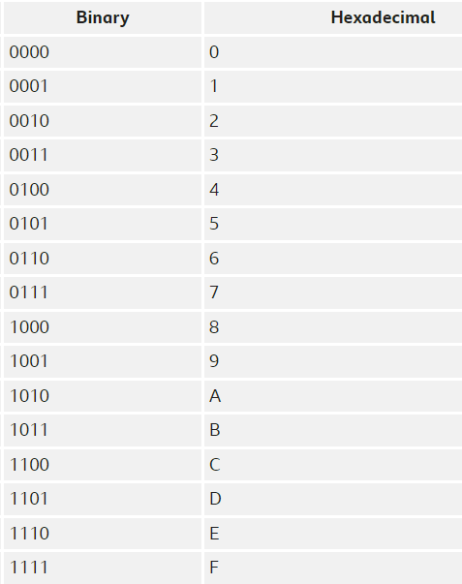
Question 1: Convert A2B₁₆ to an equivalent binary number.
Solution: Given hexadecimal number = A2B₁₆
First, convert the given hexadecimal to the equivalent decimal number.
A2B₁₆ = (A × 16²) + (2 × 16¹) + (B × 16⁰)
= (A × 256) + (2 × 16) + (B × 1)
= (10 ×256) + 32 + 11
= 2560 + 43
= 2603(Decimal number)
Now we have to convert 2603₁₀ to binary
The binary number obtained is 101000101011₂
Hence, A2B₁₆ = 101000101011₂

Question 2: Convert E₁₆ to an equivalent binary number.
Solution: Given, a hexadecimal number is E.
First, convert the given hexadecimal to the equivalent decimal number.
E₁₆ = E × 16⁰
= E × 1
= E
=14 (Decimal number)
Now we have to convert 14₁₀ to binary number.
The binary number obtained is 1110₂
Hence, E₁₆ = 1110₂

