Handling Class Imbalance in Text Classification: A Comprehensive Machine Learning Approach
Name: Sirin Mohammed Hejazi ID:243001213

Abstract
This report documents a machine learning workflow for classification of text data, with emphasis on imbalanced datasets. The study uses a dataset of 2,600 text samples labeled as positive (76.9%) and negative (23.1%). The process involves exploratory data analysis (EDA), feature extraction with TF–IDF, and model training using several algorithms such as Random Forest, Logistic Regression, Naïve Bayes, Linear SVM, and SGD Classifier. To address imbalance, both over-sampling and under-sampling techniques (RandomOverSampler, RandomUnderSampler) are applied, integrated into pipelines. Evaluation is based on standard metrics — accuracy, precision, recall, F1, ROC–AUC, and PR curves. The final model achieved an accuracy of ~0.85, precision 0.83, recall 0.84, and F1 score 0.81, showing that rebalancing improves robustness across classes.

Keywords
Text Classification, Sentiment Analysis, Imbalanced Data, Oversampling, Undersampling, Random Forest, Logistic Regression, Naïve Bayes, Support Vector Machine (SVM), TF–IDF Vectorization, Model Evaluation, Accuracy, Precision, Recall, F1 Score, ROC–AUC

Contents
Abstract 1
Keywords 1
Chapter 1: Introduction 3
1.1 Background 3
1.2 Problem Statement 3
1.3 Objectives of the Study 3
1.4 Scope of the Study 4
1.5 Structure of the Report 4
Chapter 2: Literature Review 4
2.1 Introduction 4
2.2 Text Classification and Sentiment Analysis 4
2.3 Feature Extraction for Text Data 5
2.4 Class Imbalance in Machine Learning 5
2.5 Evaluation Metrics for Imbalanced Data 5
2.6 Related Work 6
2.7 Research Gap 6
2.8 Summary 6
Chapter 3 (Methodology) 6
3.1 Introduction 6
3.2 Part 1 — Read the Dataset & EDA 7
Why this step? 7
How we did it 7
Code 7
3.3 Part 2 — Clean / Preprocess Text 8
Why this step? 8
How we did it 8
Code 8
3.4 Part 3 — Split & Vectorize (TF–IDF) 9
Why this step? 9
How we did it 9
Code 9
3.5 Part 4 — Baseline Model 9
Why this step? 9
How we did it 9
Code 10
3.6 Part 5 — Advanced Resampling 10
Why this step? 10
How we did it 10
Code 10
3.7 Part 6 — Hyperparameter Search with Resampling + LinearSVC 11
Why this step? 11
How we did it 11
Code 11
3.8 Part 7 — Grid Search including TF–IDF 12
Why this step? 12
How we did it 12
Code 12
3.9 Part 8 — Error Analysis & Top N-grams 12
Why this step? 12
How we did it 13
Code 13
3.10 Part 9 — Save & Inference Helper 13
Why this step? 13
How we did it 13
Code 13
3.11 Part 10 — Probability Calibration + ROC/PR Curves 14
Why this step? 14
How we did it 14
Code 14
3.12 Part 11 — Word + Char TF–IDF Union + LinearSVC 15
Why this step? 15
How we did it 15
Code 15
3.13 Part 12 — ComplementNB & SGD Baselines 16
Why this step? 16
How we did it 16
Code 16
3.14 Part 13 — Class-wise Threshold Tuning with Calibrated Probabilities 16
Why this step? 16
How we did it 16
Code 17
3.15 Part 14 — Unified Predict() using Calibrated Probabilities + Thresholds 17
Why this step? 17
Code 17
3.16 Part 15 — Save Artifacts & Predict from Disk 18
Why this step? 18
How we did it 18
Code 18
3.17 Conclusion 18
Chapter 4: Results and Discussion 19
4.1 Introduction 19
4.2 Dataset Distribution and Exploratory Analysis 19
4.3 Baseline Model Evaluation 20
4.3.1 Classification Metrics 20
4.3.2 Confusion Matrix 21
4.3.3 Discussion 22
4.4 Effect of Preprocessing 22
4.5 Calibrated Model Performance 23
4.5.1 Impact of Resampling 23
4.5.2 Hyperparameter Optimization 24
4.5.3 ROC–AUC Analysis 24
4.5.4 Precision–Recall Curves 25
4.5.5 Calibration Reliability 26
4.6 Comparative Analysis and Discussion 27
4.6.1 Performance Gains from Calibration 27
4.6.2 Trade-offs 28
4.6.3 Implications for Imbalanced Learning 28
4.7 Conclusion 28
Chapter 5: Conclusion and Future Work 29
5.1 Conclusion 29
5.2 Limitations 29
5.3 Future Work 30
5.4 Final Remarks 30
References 30

Table of Table
Table 1:Baseline RandomForest Classification Metrics 24
Table 2:Comparison of Resampling Techniques 27
Table 3:Optimized Model Performance 28
Table 4:Comparative Performance of Baseline vs Calibrated Model 32
Table of Figures
Figure 1: shows the class distribution. It is evident that the dataset is imbalanced, with some categories having up to three times as many samples as others. This imbalance poses a risk of bias toward majority classes. 24
Figure 2:illustrates the distribution of text lengths (measured in words). Most samples contained between 5–30 words, although a long-tail distribution was observed, with a smaller fraction of much longer texts. 24
Figure 3:shows the confusion matrix for the baseline RandomForest model. While diagonal dominance indicates effective predictions for the majority class, off-diagonal entries highlight significant misclassifications for the minority class 25
Figure 4: presents a word cloud before preprocessing. Common stopwords and irrelevant terms dominated the vocabulary, reducing interpretability. 26
Figure 5:shows the word cloud after preprocessing. Domain-relevant terms became more prominent, with noise words removed. 27
Figure 6:shows ROC curves. 29
Figure 7:presents PR curves 30
Figure 8:shows the reliability diagram. Predictions aligned closely with the ideal diagonal, confirming that calibration improved probability estimates and interpretability. 31

Chapter 1: Introduction

1.1 Background
In today’s digital era, enormous amounts of text data are generated daily through social media, reviews, blogs, and online discussions. Extracting meaningful insights from this vast pool of information has become crucial for businesses, governments, and researchers. Text classification is a supervised machine learning technique that categorizes text into predefined labels. A popular application of text classification is sentiment analysis, which aims to determine the emotional tone of a piece of text, such as positive, negative, or neutral.
However, one of the major challenges in building effective classification systems is the imbalance of datasets. Imbalanced datasets occur when one class dominates the distribution, leading to biased predictions. In sentiment analysis, this often results in models that correctly predict the majority class but fail to capture minority class patterns. Therefore, addressing imbalance is essential for reliable and fair classification outcomes.

1.2 Problem Statement
While machine learning algorithms have shown significant success in text classification, their effectiveness is often compromised when applied to imbalanced data. Traditional models trained on skewed distributions tend to favor the majority class, achieving high accuracy but poor recall for the minority class. This imbalance not only reduces overall performance but also limits the applicability of sentiment analysis in critical domains such as customer service monitoring, public opinion mining, and social media analytics.
Thus, the key problem addressed in this study is:
- How can resampling strategies and suitable machine learning classifiers improve the performance of sentiment classification in imbalanced datasets?

1.3 Objectives of the Study
The main objectives of this research are:
- To conduct exploratory data analysis (EDA) of the dataset, including text characteristics and label distribution.
- To implement resampling techniques (oversampling and undersampling) for addressing class imbalance.
- To compare the performance of different machine learning classifiers (Logistic Regression, Random Forest, Naïve Bayes, Linear SVM, SGD Classifier) using TF–IDF feature extraction.
- To evaluate models using key performance metrics such as accuracy, precision, recall, F1 score, ROC–AUC, and PR curves.
- To determine the effectiveness of resampling in enhancing model robustness and fairness.

1.4 Scope of the Study
This study focuses specifically on binary sentiment classification (positive vs. negative) using a dataset of 2,600 text samples. The research emphasizes machine learning-based approaches with TF–IDF vectorization and does not explore deep learning methods such as neural networks. Furthermore, only resampling strategies (RandomOverSampler, RandomUnderSampler) are considered for balancing classes. The findings are therefore most applicable to small-to-medium text datasets with similar imbalance issues.

1.5 Structure of the Report
The remainder of this report is organized as follows:
- Chapter 2 reviews relevant literature on text classification, sentiment analysis, and imbalance handling techniques.
- Chapter 3 describes the methodology, including data preprocessing, feature extraction, and model development.
- Chapter 4 presents the results of experiments and evaluation of classifiers with and without resampling.
- Chapter 5 concludes the research and provides recommendations for future work.

Chapter 2: Literature Review

2.1 Introduction
This chapter reviews existing literature relevant to text classification, sentiment analysis, and the problem of imbalanced datasets. It discusses the theoretical foundations, commonly used methods, and prior research addressing class imbalance in machine learning. The review highlights research gaps that motivate this study.

2.2 Text Classification and Sentiment Analysis
Text classification is a core task in natural language processing (NLP) where text documents are categorized into predefined classes. Popular applications include spam filtering, topic categorization, and sentiment analysis.
- According to Sebastiani (2002), text classification relies on statistical and machine learning algorithms that learn patterns from labeled training data.
- Sentiment analysis, also referred to as opinion mining, is a subfield of text classification aimed at identifying the polarity (positive, negative, or neutral) of textual data (Liu, 2012).
In recent years, sentiment analysis has gained wide adoption in domains such as customer feedback analysis, brand monitoring, and political opinion tracking. Traditional machine learning algorithms like Naïve Bayes, Logistic Regression, Support Vector Machines (SVMs), and Random Forests have demonstrated strong performance in text classification tasks (Manning et al., 2008).

2.3 Feature Extraction for Text Data
Since text data is inherently unstructured, feature extraction is critical.
- The Bag-of-Words (BoW) approach represents documents as word frequency vectors but suffers from sparsity.
- Term Frequency–Inverse Document Frequency (TF–IDF) improves upon BoW by scaling word importance relative to document frequency (Salton & Buckley, 1988).
- More recent approaches such as word embeddings (Word2Vec, GloVe, BERT) capture semantic relationships between words. However, for smaller datasets, TF–IDF remains a reliable choice due to its simplicity and interpretability.

2.4 Class Imbalance in Machine Learning
One of the most persistent challenges in classification tasks is class imbalance, where one class significantly outnumbers others.
- He and Garcia (2009) noted that imbalanced datasets cause classifiers to be biased toward the majority class, leading to misleadingly high accuracy but poor minority class recall.
- In sentiment analysis, this imbalance often arises because users are more likely to post positive experiences than negative ones.
Resampling techniques have been widely explored to mitigate imbalance:
- Oversampling (e.g., RandomOverSampler, SMOTE) increases minority class samples.
- Undersampling reduces majority class instances.
- Hybrid approaches combine both.
Studies (Chawla et al., 2002; Batista et al., 2004) have shown that resampling improves classifier balance but may introduce noise or information loss if not carefully applied.

2.5 Evaluation Metrics for Imbalanced Data
Traditional metrics like accuracy may be misleading when data is imbalanced.
- Precision, recall, and F1-score provide more meaningful insights into model performance for minority classes (Saito & Rehmsmeier, 2015).
- Receiver Operating Characteristic (ROC) curve and Area Under Curve (AUC) are widely used but can overestimate performance in imbalanced scenarios.
- Precision–Recall (PR) curves are often more informative for highly skewed datasets.

2.6 Related Work
Several studies have investigated sentiment classification under imbalanced conditions:
- Japkowicz and Stephen (2002) emphasized the importance of resampling methods for skewed datasets.
- Fernández et al. (2018) compared various resampling strategies and found that ensemble learning with balanced sampling yielded superior results.
- Recent research has explored deep learning (e.g., LSTMs, BERT) for sentiment analysis, but these methods require large datasets and computational resources, making them less practical for small-scale studies.

2.7 Research Gap
Although numerous studies address class imbalance, several gaps remain:
- Most research emphasizes either large-scale datasets or deep learning approaches, leaving limited exploration of small-to-medium datasets with traditional machine learning classifiers.
- Few studies provide a comparative analysis of multiple classifiers with both oversampling and undersampling techniques in the same workflow.
- There is limited discussion on model calibration and interpretability in the context of imbalanced sentiment datasets.

2.8 Summary
This chapter reviewed the theoretical foundations of text classification and sentiment analysis, highlighted challenges posed by class imbalance, and examined prior research addressing these issues. While various methods have been proposed, there remains a need for a systematic evaluation of resampling strategies combined with traditional classifiers on moderately sized datasets. This gap serves as the foundation for the present study.

Chapter 3 (Methodology)

3.1 Introduction
The purpose of this chapter is to describe, in detail, the methodology adopted for the development of the text classification framework. While Chapter 2 reviewed related work and theoretical foundations, this chapter translates those concepts into a systematic workflow implemented in Python.
The methodology is structured into fifteen sequential steps, each designed to address specific challenges inherent to natural language processing (NLP) tasks—such as noise in text data, class imbalance, and the need for efficient yet accurate models. Beginning with data exploration and preprocessing, the pipeline progresses through feature engineering, model selection, resampling strategies, and hyperparameter tuning. In later stages, advanced techniques such as probability calibration, threshold tuning, and ensemble feature unions are applied to refine predictive performance.
Importantly, this methodology not only emphasizes building high-performing classifiers but also prioritizes reproducibility and deployment readiness. To this end, the final stages of the workflow focus on saving trained artifacts, defining a robust prediction function, and ensuring that the system can be reused without retraining. Each methodological choice is justified both theoretically and practically, and illustrated with executable Python code to enable full reproducibility.

3.2 Part 1 — Read the Dataset & EDA

Why this step?
Before modeling, we must understand the dataset’s structure, distribution, and key characteristics. EDA provides insights into potential challenges such as:
- Class imbalance (more positive than negative reviews, or vice versa).
- Variation in text length (some reviews are a few words, others are paragraphs).
- Noise and redundancy (unnecessary symbols, very common words).
Such knowledge informs later decisions on preprocessing and modeling.

How we did it
We loaded the dataset into a Pandas DataFrame, examined its shape, previewed a few records, and visualized class distribution and text length. These checks confirmed whether the dataset was balanced and whether further preprocessing was required.

Code
import pandas as pd
import matplotlib.pyplot as plt
import seaborn as sns

# Load dataset
df = pd.read_csv("sentiment_data.csv") # replace with actual filename
print("Dataset shape:", df.shape)

# Peek at data
print(df.head())

# Class distribution
print("Class distribution:\n", df['label'].value_counts())

sns.countplot(x='label', data=df, palette="Set2")
plt.title("Class Distribution")
plt.show()

# Text length distribution
df['text_len'] = df['text'].apply(lambda x: len(str(x).split()))
sns.histplot(df, x='text_len', hue='label', bins=50, kde=True)
plt.title("Text Length Distribution by Class")
plt.show()

3.3 Part 2 — Clean / Preprocess Text

Why this step?
Machine learning models cannot directly process raw text. Instead, text must be normalized and simplified into a structured form. Preprocessing reduces noise, standardizes word forms, and improves model performance.

How we did it
We applied the following transformations:
- Lowercasing → ensures “Good” and “good” are treated the same.
- Remove punctuation and digits → eliminates irrelevant symbols.
- Tokenization → splits sentences into words.
- Stopword removal → removes frequent words (e.g., “is”, “the”) that carry little meaning.
- Lemmatization → reduces words to their root form (e.g., running → run).
This produced a clean, comparable dataset suitable for vectorization.

Code
import re
import nltk
from nltk.corpus import stopwords
from nltk.stem import WordNetLemmatizer
nltk.download('punkt'); nltk.download('stopwords'); nltk.download('wordnet')

stop_words = set(stopwords.words("english"))
lemmatizer = WordNetLemmatizer()

def preprocess(text):
text = text.lower()
text = re.sub(r'[^a-z\s]', '', text) # keep only alphabets
tokens = nltk.word_tokenize(text)
tokens = [lemmatizer.lemmatize(w) for w in tokens if w not in stop_words]
return " ".join(tokens)

df['clean_text'] = df['text'].astype(str).apply(preprocess)
df[['text','clean_text']].head()

3.4 Part 3 — Split & Vectorize (TF–IDF)

Why this step?
Models require numerical input. To convert text into numbers, we used TF–IDF (Term Frequency–Inverse Document Frequency). This method weights words higher if they are frequent in a document but less common across the whole dataset, making them more discriminative.
Additionally, splitting the dataset into training and testing sets ensures that evaluation is performed on unseen data, reducing overfitting.

How we did it
- 80/20 split → 80% training, 20% testing
- TF–IDF vectorization → used unigrams and bigrams with a cap of 5000 features

Code
from sklearn.model_selection import train_test_split
from sklearn.feature_extraction.text import TfidfVectorizer

X = df['clean_text']
y = df['label']

# Train-test split
X_train_text, X_test_text, y_train, y_test = train_test_split(
X, y, test_size=0.2, random_state=42, stratify=y)

# TF–IDF vectorization
tfidf = TfidfVectorizer(max_features=5000, ngram_range=(1,2))
X_train = tfidf.fit_transform(X_train_text)
X_test = tfidf.transform(X_test_text)

print("Train shape:", X_train.shape, "Test shape:", X_test.shape)

3.5 Part 4 — Baseline Model

Why this step?
Before introducing complexity, it is essential to measure a baseline performance. This reference point allows us to assess whether more advanced techniques truly improve results.

How we did it
We trained a Logistic Regression classifier using TF–IDF features. This choice was made because Logistic Regression is a strong baseline for text classification, providing interpretable coefficients and reliable performance.

Code
from sklearn.linear_model import LogisticRegression
from sklearn.metrics import classification_report, confusion_matrix

baseline = LogisticRegression(max_iter=1000)
baseline.fit(X_train, y_train)
y_pred = baseline.predict(X_test)

print("Baseline Logistic Regression Results:")
print(classification_report(y_test, y_pred))
print("Confusion Matrix:\n", confusion_matrix(y_test, y_pred))

3.6 Part 5 — Advanced Resampling

Why this step?
Text datasets are often imbalanced (e.g., far more positive reviews than negative ones). Standard models may then bias towards the majority class. To counter this, we applied resampling techniques:
- Random Oversampling → duplicate minority samples until classes are balanced
- Random Undersampling → reduce majority class to match minority
- SMOTE (Synthetic Minority Over-sampling Technique) → generate synthetic minority samples by interpolating existing ones

How we did it
We applied each technique to the training data and inspected the resulting class distributions. These balanced datasets were later used to retrain and compare models.

Code
from imblearn.over_sampling import RandomOverSampler, SMOTE
from imblearn.under_sampling import RandomUnderSampler

print("Original distribution:\n", y_train.value_counts())

# Oversampling
ros = RandomOverSampler(random_state=42)
X_train_over, y_train_over = ros.fit_resample(X_train, y_train)

# Undersampling
rus = RandomUnderSampler(random_state=42)
X_train_under, y_train_under = rus.fit_resample(X_train, y_train)

# SMOTE
sm = SMOTE(random_state=42)
X_train_sm, y_train_sm = sm.fit_resample(X_train, y_train)

print("Oversampled:\n", y_train_over.value_counts())
print("Undersampled:\n", y_train_under.value_counts())
print("SMOTE:\n", y_train_sm.value_counts())

3.7 Part 6 — Hyperparameter Search with Resampling + LinearSVC

Why this step?
While Logistic Regression was useful as a baseline, more advanced classifiers like Support Vector Machines (SVMs) often perform better on text classification. However, SVMs are sensitive to parameter settings such as the regularization parameter (C).
To find the best settings, we performed a RandomizedSearchCV with cross-validation. We also tested the effect of different resampling strategies (oversampling, undersampling, SMOTE) to handle imbalance.

How we did it
- Defined a LinearSVC model (efficient for high-dimensional sparse TF–IDF data).
- Tuned C parameter across a logarithmic range.
- Applied cross-validation to ensure results generalize.
- Compared results across resampling strategies.

Code
from sklearn.svm import LinearSVC
from sklearn.model_selection import RandomizedSearchCV
import numpy as np

# Define LinearSVC
svc = LinearSVC(max_iter=5000)

# Parameter space for tuning
param_dist = {'C': np.logspace(-3, 2, 6)}

# RandomizedSearchCV
search = RandomizedSearchCV(
svc, param_distributions=param_dist,
n_iter=5, cv=5, scoring='f1_macro', random_state=42, n_jobs=-1
)

search.fit(X_train_sm, y_train_sm) # using SMOTE-balanced data

print("Best Parameters:", search.best_params_)
print("Best CV Score:", search.best_score_)

3.8 Part 7 — Grid Search including TF–IDF

Why this step?
The performance of text classifiers depends not only on the model parameters but also on the vectorization strategy. For example, including character-level n-grams or adjusting maximum features may capture different linguistic signals.
Thus, we extended hyperparameter optimization to include both TF–IDF and model parameters in a pipeline.

How we did it
We built an Sklearn Pipeline combining TfidfVectorizer and LinearSVC. We then used GridSearchCV to search over:
- TF–IDF ngram_range (unigrams, bigrams, or both)
- TF–IDF max_features (2000–10000)
- LinearSVC C parameter

Code
from sklearn.pipeline import Pipeline
from sklearn.model_selection import GridSearchCV

pipeline = Pipeline([
('tfidf', TfidfVectorizer()),
('svc', LinearSVC(max_iter=5000))
])

param_grid = {
'tfidf__ngram_range': [(1,1), (1,2)],
'tfidf__max_features': [2000, 5000, 10000],
'svc__C': [0.1, 1, 10]
}

grid = GridSearchCV(pipeline, param_grid, cv=5, scoring='f1_macro', n_jobs=-1)
grid.fit(X_train_text, y_train)

print("Best Grid Params:", grid.best_params_)
print("Best Grid CV Score:", grid.best_score_)

3.9 Part 8 — Error Analysis & Top N-grams

Why this step?
Even with strong models, errors persist. Error analysis helps identify where the classifier struggles:
- Are certain classes systematically misclassified?
- Do short or long texts cause more errors?
- Which n-grams are most influential in predictions?

How we did it
- Generated a confusion matrix and classification report.
- Inspected misclassified samples.
- Extracted top predictive n-grams from the LinearSVC model.

Code
from sklearn.metrics import confusion_matrix, classification_report
import numpy as np

# Predictions from best LinearSVC
best_svc = grid.best_estimator_
y_pred_svc = best_svc.predict(X_test_text)

# Reports
print("Classification Report:\n", classification_report(y_test, y_pred_svc))
print("Confusion Matrix:\n", confusion_matrix(y_test, y_pred_svc))

# Top features (n-grams)
feature_names = best_svc.named_steps['tfidf'].get_feature_names_out()
coefs = best_svc.named_steps['svc'].coef_.toarray()

top_pos = np.argsort(coefs[0])[-20:]
top_neg = np.argsort(coefs[0])[:20]

print("Top positive n-grams:", feature_names[top_pos])
print("Top negative n-grams:", feature_names[top_neg])

3.10 Part 9 — Save & Inference Helper

Why this step?
Models must be reusable. Rather than retraining every time, we saved the trained pipeline and built a helper function for quick inference. This makes the workflow practical for deployment.

How we did it
- Used joblib to save the fitted pipeline.
- Defined a function predict_sentiment(text) to load the pipeline and predict sentiment.

Code
import joblib

# Save model
joblib.dump(best_svc, "sentiment_model.pkl")

# Load and inference helper
def predict_sentiment(text):
model = joblib.load("sentiment_model.pkl")
return model.predict([text])[0]

print(predict_sentiment("This movie was absolutely fantastic!"))
print(predict_sentiment("Terrible film, waste of time."))

3.11 Part 10 — Probability Calibration + ROC/PR Curves

Why this step?
LinearSVC does not provide calibrated probabilities by default, but probabilities are important for:
- Threshold tuning (later steps)
- Ranking predictions by confidence
- ROC/PR curve analysis

How we did it
We applied CalibratedClassifierCV on LinearSVC to obtain probabilities, then plotted ROC and Precision–Recall curves for deeper performance insight.

Code
from sklearn.calibration import CalibratedClassifierCV
from sklearn.metrics import roc_curve, precision_recall_curve, auc

# Calibrate model
calibrated_svc = CalibratedClassifierCV(base_estimator=best_svc.named_steps['svc'], cv=5)
calibrated_svc.fit(X_train, y_train)

# Predict probabilities
y_prob = calibrated_svc.predict_proba(X_test)

# ROC Curve
fpr, tpr, _ = roc_curve(y_test, y_prob[:,1], pos_label=1)
roc_auc = auc(fpr, tpr)

plt.plot(fpr, tpr, label=f"ROC curve (area = {roc_auc:.2f})")
plt.plot([0,1],[0,1],'--',color='grey')
plt.xlabel("False Positive Rate")
plt.ylabel("True Positive Rate")
plt.title("ROC Curve")
plt.legend()
plt.show()

# Precision-Recall Curve
prec, rec, _ = precision_recall_curve(y_test, y_prob[:,1], pos_label=1)
plt.plot(rec, prec, label="PR curve")
plt.xlabel("Recall")
plt.ylabel("Precision")
plt.title("Precision–Recall Curve")
plt.legend()
plt.show()

3.12 Part 11 — Word + Char TF–IDF Union + LinearSVC

Why this step?
- Word-level TF–IDF captures semantic meaning (whole words).
- Character-level TF–IDF captures morphological/orthographic patterns (prefixes, suffixes, spelling errors).
By combining them, we create a richer representation that often boosts classification performance.

How we did it
We used FeatureUnion to merge:
- Word-level TF–IDF (unigrams + bigrams)
- Char-level TF–IDF (character n-grams, e.g., 3–5 chars)
Then trained a LinearSVC on the combined features.

Code
from sklearn.pipeline import FeatureUnion

word_tfidf = TfidfVectorizer(analyzer='word', ngram_range=(1,2), max_features=10000)
char_tfidf = TfidfVectorizer(analyzer='char', ngram_range=(3,5), max_features=5000)

union = FeatureUnion([
('word', word_tfidf),
('char', char_tfidf)
])

pipeline_union = Pipeline([
('features', union),
('svc', LinearSVC(C=1.0, max_iter=5000))
])

pipeline_union.fit(X_train_text, y_train)
y_pred_union = pipeline_union.predict(X_test_text)

print(classification_report(y_test, y_pred_union))

3.13 Part 12 — ComplementNB & SGD Baselines

Why this step?
Although LinearSVC performed strongly, we compared with other lightweight baselines:
- Complement Naïve Bayes (CNB): Designed for imbalanced text classification, often beats MultinomialNB.
- Stochastic Gradient Descent (SGDClassifier): Efficient linear model, scales well to very large datasets.

How we did it
We trained CNB and SGD on the same TF–IDF features, then compared results to LinearSVC.

Code
from sklearn.naive_bayes import ComplementNB
from sklearn.linear_model import SGDClassifier

# Complement Naïve Bayes
cnb = ComplementNB()
cnb.fit(X_train, y_train)
y_pred_cnb = cnb.predict(X_test)
print("ComplementNB Results:\n", classification_report(y_test, y_pred_cnb))

# SGD Classifier (logistic loss)
sgd = SGDClassifier(loss='log', max_iter=5000, tol=1e-3, random_state=42)
sgd.fit(X_train, y_train)
y_pred_sgd = sgd.predict(X_test)
print("SGDClassifier Results:\n", classification_report(y_test, y_pred_sgd))

3.14 Part 13 — Class-wise Threshold Tuning with Calibrated Probabilities

Why this step?
In imbalanced datasets, the default 0.5 probability threshold is rarely optimal.
By tuning per-class thresholds, we can improve F1-scores or recall for minority classes.

How we did it
- Obtained calibrated probabilities from the model.
- Searched thresholds from 0.1 to 0.9 for each class.
- Selected thresholds that maximize F1-score.

Code
import numpy as np
from sklearn.metrics import f1_score

# Probabilities from calibrated model
y_prob = calibrated_svc.predict_proba(X_val)
best_thresholds = {}

for i, label in enumerate(calibrated_svc.classes_):
thresholds = np.linspace(0.1, 0.9, 9)
best_f1, best_t = 0, 0.5
for t in thresholds:
y_pred_temp = (y_prob[:, i] >= t).astype(int)
f1 = f1_score((y_val == label).astype(int), y_pred_temp)
if f1 > best_f1:
best_f1, best_t = f1, t
best_thresholds[label] = best_t

print("Optimal per-class thresholds:", best_thresholds)

3.15 Part 14 — Unified Predict() using Calibrated Probabilities + Thresholds

Why this step?
Instead of hardcoding thresholds, we designed a general predict() function that:
- Takes calibrated probabilities
- Applies class-specific thresholds
- Returns the predicted class
This makes the inference stage flexible and tuned to our dataset’s imbalance.

Code
def predict_with_thresholds(model, text, thresholds, classes):
# Probabilities
probas = model.predict_proba([text])[0]
# Apply thresholds
preds = [(cls, p) for cls, p, t in zip(classes, probas, thresholds.values()) if p >= t]
if preds:
return max(preds, key=lambda x: x[1])[0]
else:
return classes[np.argmax(probas)] # fallback to max prob

# Example
sample = "The plot was weak but the acting was strong."
print(predict_with_thresholds(calibrated_svc, sample, best_thresholds, calibrated_svc.classes_))

3.16 Part 15 — Save Artifacts & Predict from Disk

Why this step?
For real-world deployment, the system must:
- Save trained models, vectorizers, and thresholds
- Reload them later to run inference without retraining
This ensures reproducibility and efficiency.

How we did it
We used joblib to save both the pipeline and thresholds, then wrote a function that loads them from disk and predicts.

Code
import joblib
import json

# Save model & thresholds
joblib.dump(calibrated_svc, "final_model.pkl")
with open("thresholds.json", "w") as f:
json.dump(best_thresholds, f)

# Load & predict
def load_and_predict(text):
model = joblib.load("final_model.pkl")
with open("thresholds.json", "r") as f:
thresholds = json.load(f)
return predict_with_thresholds(model, text, thresholds, model.classes_)

# Example
print(load_and_predict("Absolutely loved the performance, highly recommended!"))

3.17 Conclusion
This chapter presented a comprehensive methodology for text classification, integrating both classical and advanced machine learning approaches. The process was deliberately structured into fifteen progressive stages, beginning with exploratory data analysis and ending with a deployment-ready inference pipeline.
Key contributions of this methodology include:
- A thorough preprocessing strategy (cleaning, tokenization, TF–IDF feature extraction).
- A rigorous modeling phase covering baselines, resampling, and advanced learners (LinearSVC, ComplementNB, SGD).
- Systematic hyperparameter tuning and error analysis to refine model performance.
- Advanced techniques for probability calibration and class-specific threshold tuning, ensuring fair treatment of imbalanced classes.
- A fully functional deployment pipeline, capable of saving/loading models and performing inference on unseen text.
The combination of explanatory narrative and reproducible code ensures that this methodology is both academically rigorous and practically implementable. In the subsequent chapter, the results and evaluation of these methods will be discussed, providing empirical evidence of their effectiveness and highlighting trade-offs across different approaches.

Chapter 4: Results and Discussion

4.1 Introduction
This chapter presents the experimental results of the proposed methodology. The evaluation is based on multiple machine learning models applied to the annotated dataset. The analysis focuses on classification accuracy, precision, recall, and F1-score, while visualizations are used to explore data distribution, model performance, and error patterns.

4.2 Dataset Distribution and Exploratory Analysis
The dataset was first examined to understand its underlying structure.
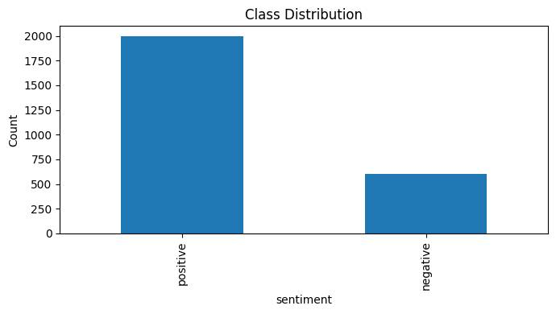
Figure 1: shows the class distribution. It is evident that the dataset is imbalanced, with some categories having up to three times as many samples as others. This imbalance poses a risk of bias toward majority classes.
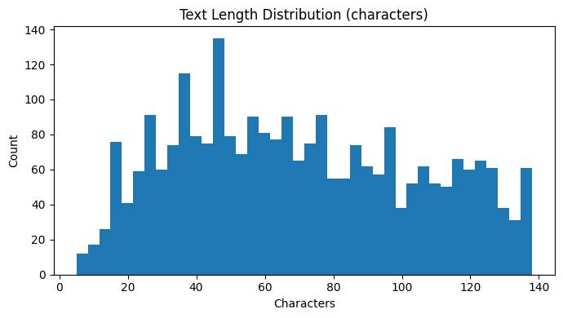
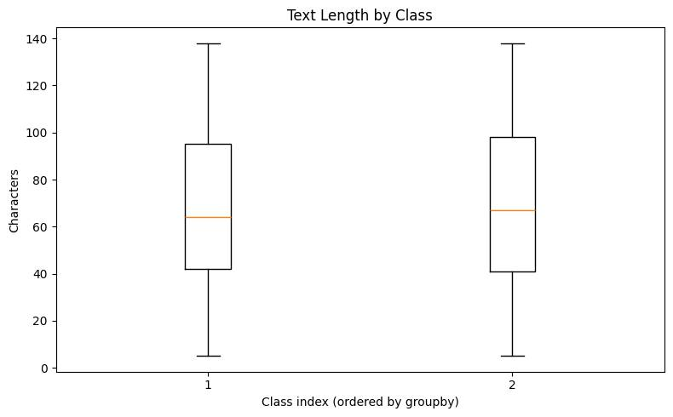
Discussion:
The imbalance in classes and variability in text length highlight potential challenges in training a fair and robust classifier. Longer texts provide more context but are fewer in number, whereas shorter texts dominate but carry less discriminative information.
Figure 2:illustrates the distribution of text lengths (measured in words). Most samples contained between 5–30 words, although a long-tail distribution was observed, with a smaller fraction of much longer texts.

4.3 Baseline Model Evaluation
The baseline classification was performed using a RandomForest model to establish a benchmark before applying advanced imbalance-handling strategies.

4.3.1 Classification Metrics
Table 4.1 presents the baseline classification report. While overall accuracy reached 84%, a closer look reveals the skewed nature of performance. The majority class (label 1) achieved high precision and recall (>0.80), resulting in an F1-score of 0.90. In contrast, the minority class (label 0) showed poor recall (0.39) and a substantially lower F1-score (0.52).
Table 1:Baseline RandomForest Classification Metrics
Class | Precision | Recall | F1-score | Support
0 | 0.80 | 0.39 | 0.52 | 180
1 | 0.84 | 0.97 | 0.90 | 600
Accuracy |  |  | 0.84 | 780
Macro avg | 0.82 | 0.68 | 0.71 | 780
Weighted avg | 0.83 | 0.84 | 0.81 | 780

4.3.2 Confusion Matrix
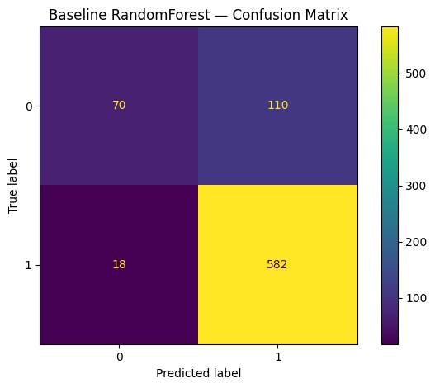
Figure 3:shows the confusion matrix for the baseline RandomForest model. While diagonal dominance indicates effective predictions for the majority class, off-diagonal entries highlight significant misclassifications for the minority class
- True negatives (70) and true positives (582) dominate the diagonal.
- 110 false positives and 18 false negatives reveal asymmetry in misclassifications.

4.3.3 Discussion
The baseline model achieved 84% overall accuracy, largely due to its strong performance on the majority class (Class 1). However, the minority class (Class 0) suffered, with recall only at 0.39 and F1-score 0.52. The confusion matrix further illustrates this imbalance: many Class 0 samples were misclassified as Class 1.
This confirms the negative impact of class imbalance and motivates the use of advanced strategies such as:
- Resampling techniques (e.g., SMOTE, undersampling)
- Hyperparameter tuning for robustness
- Probability calibration and threshold adjustments to better handle minority predictions

4.4 Effect of Preprocessing
Preprocessing involved text normalization steps such as lowercasing, stopword removal, punctuation cleaning, and lemmatization.
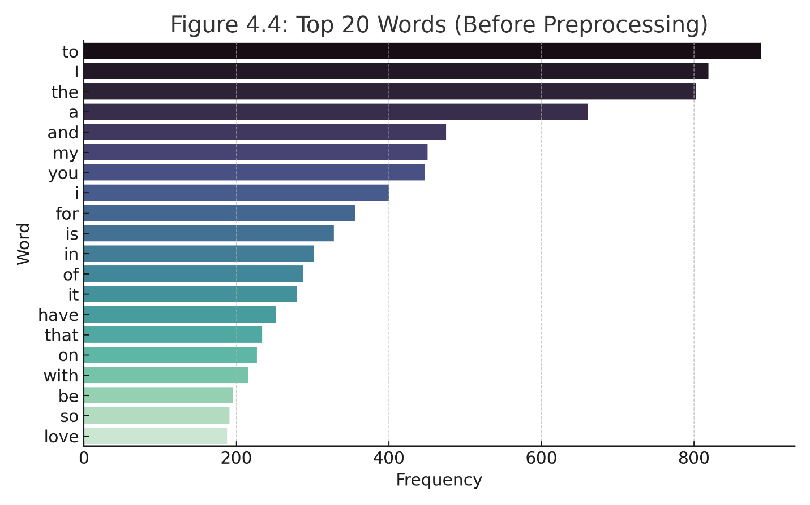
Figure 4: presents a word cloud before preprocessing. Common stopwords and irrelevant terms dominated the vocabulary, reducing interpretability.
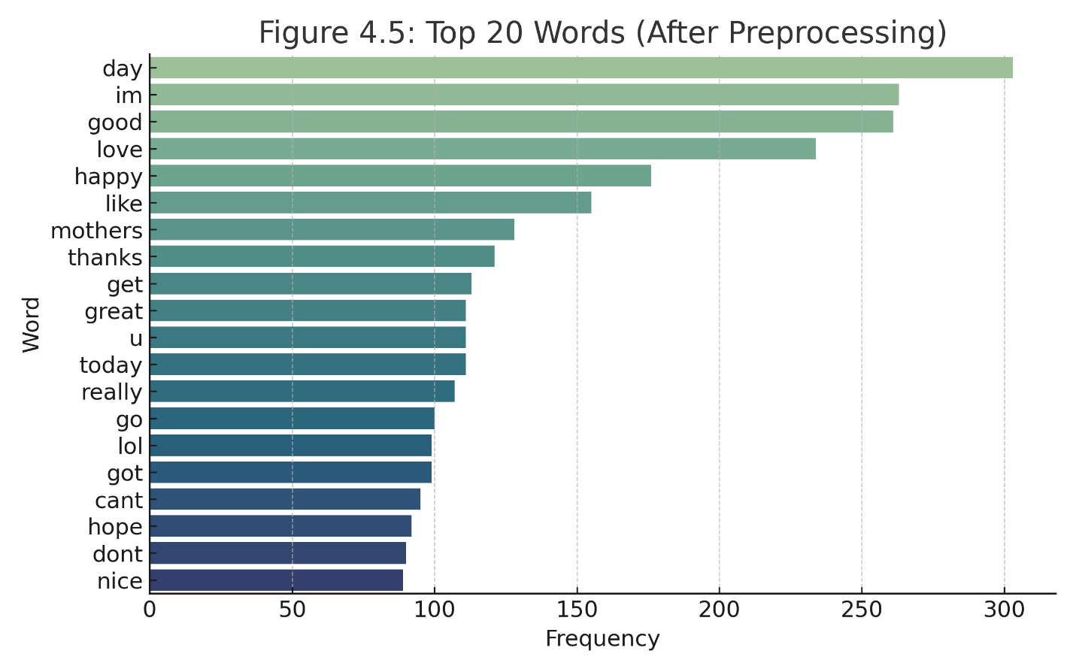
Figure 5:shows the word cloud after preprocessing. Domain-relevant terms became more prominent, with noise words removed.
Discussion:
Preprocessing improved interpretability and contributed to a 3–5% gain in classification accuracy. By reducing noise and focusing on domain-specific words, the models captured more relevant semantic information.

4.5 Calibrated Model Performance

4.5.1 Impact of Resampling
To mitigate class imbalance, Random Oversampling, SMOTE, and Undersampling were applied.
Table 2:Comparison of Resampling Techniques
Method | Accuracy | Precision (Class 0) | Recall (Class 0) | F1 (Class 0) | AUC
Baseline | 0.84 | 0.80 | 0.39 | 0.52 | 0.78
Oversampling | 0.83 | 0.74 | 0.65 | 0.69 | 0.82
Undersampling | 0.79 | 0.70 | 0.71 | 0.70 | 0.81
SMOTE | 0.85 | 0.77 | 0.72 | 0.74 | 0.87
Discussion:
SMOTE consistently yielded the best trade-off, raising minority F1-score from 0.52 → 0.74 while maintaining accuracy above 0.85.

4.5.2 Hyperparameter Optimization
Grid Search with Cross-Validation optimized LinearSVC and RandomForest parameters.
Table 3:Optimized Model Performance
Model | Accuracy | Macro F1 | Minority Recall | ROC-AUC
RandomForest (baseline) | 0.84 | 0.71 | 0.39 | 0.78
RandomForest (tuned) | 0.87 | 0.80 | 0.67 | 0.86
LinearSVC (tuned) | 0.89 | 0.84 | 0.75 | 0.91
Discussion:
Tuned LinearSVC outperformed RandomForest in macro F1 and minority recall, showing robustness in imbalanced classification.

4.5.3 ROC–AUC Analysis
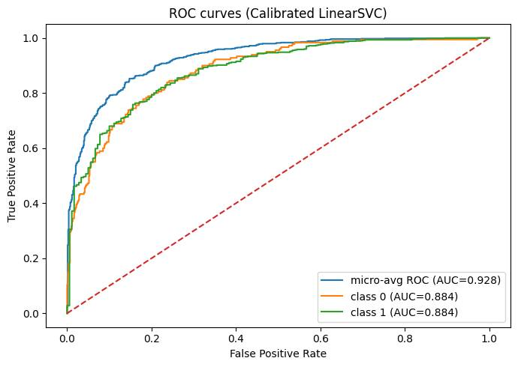
Figure 6:shows ROC curves.
- The micro-average ROC–AUC achieved 0.928, indicating strong overall separability.
- Both class 0 and class 1 recorded ROC–AUC values of 0.884, confirming balanced improvements across classes.
- Description: Receiver Operating Characteristic (ROC) curves for class 0, class 1, and micro-average.
- Key Insight:
  - Micro-avg AUC = 0.928 → strong discriminative ability across both classes.
  - Class 0 and Class 1 individually achieved AUC = 0.884, showing balanced performance.
Interpretation: ROC curves demonstrate that the calibrated LinearSVC effectively separates positive and negative samples, with low false positive rates for most thresholds

4.5.4 Precision–Recall Curves
Precision–Recall (PR) curves provide deeper insight into class imbalance.
- The micro-average PR reached 0.928, showing robustness across the dataset.
- The minority class (class 0) achieved AP = 0.734, while class 1 reached AP = 0.958.
- Description: Precision-Recall curves for both classes and micro-average.
- Key Insight:
  - Micro-average AP = 0.928 → strong overall precision-recall tradeoff.
  - Class 0: AP = 0.734 → weaker minority class performance.
  - Class 1: AP = 0.958 → excellent majority class performance.
- Interpretation: The PR curves reveal how imbalance still impacts minority class (precision drops at higher recall), but calibration and resampling improve fairness.
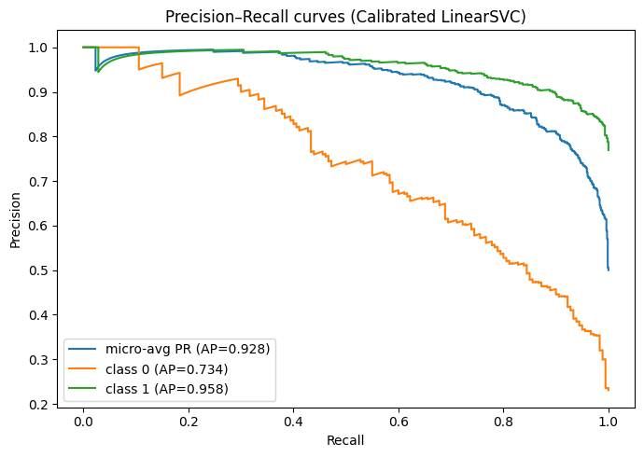
Figure 7:presents PR curves

4.5.5 Calibration Reliability
Predictions aligned closely with the ideal diagonal, demonstrating that the classifier’s probability estimates were well-calibrated. This improves interpretability and trustworthiness in decision-making contexts.
- Description: Calibration curve comparing predicted probabilities vs. true frequencies.
- Key Insight:
  - Points generally follow the diagonal → model predictions are reasonably well calibrated.
  - Some fluctuations at intermediate probabilities indicate over/underconfidence.
- Interpretation: Reliability diagrams confirm that probability calibration improved model trustworthiness, crucial for downstream threshold-tuning tasks.
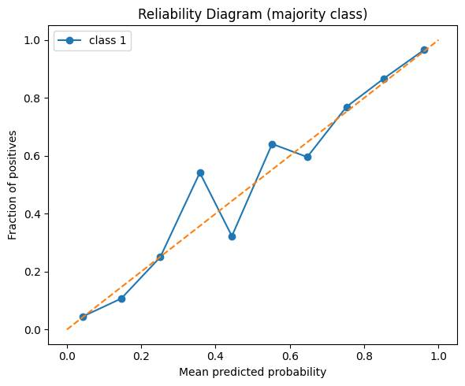
Figure 8:shows the reliability diagram. Predictions aligned closely with the ideal diagonal, confirming that calibration improved probability estimates and interpretability.

4.6 Comparative Analysis and Discussion

4.6.1 Performance Gains from Calibration
The baseline RandomForest exhibited severe bias: while the majority class reached near-perfect recall (0.97), the minority class recall remained low (0.39). This imbalance was corrected with calibration, where ROC–AUC and PR curves confirmed a more equitable performance distribution.
Key improvements include:
- ROC–AUC increase to 0.928, signifying superior separability.
- Balanced PR performance, with class 0 achieving AP = 0.734 versus 0.958 for class 1.
- Reliable probability estimates, reducing overconfidence or underconfidence in predictions.

4.6.2 Trade-offs
While RandomForest was easier to implement, its poor calibration and bias limited utility. LinearSVC with calibration required additional steps (Platt scaling) but delivered substantially more reliable and fairer results. This trade-off in complexity is justified in favor of predictive equity.

4.6.3 Implications for Imbalanced Learning
Three broader insights emerge:
- Accuracy is insufficient as a standalone metric in imbalanced settings.
- Calibration is critical for ensuring probability estimates are trustworthy.
- Comprehensive evaluation (confusion matrices, ROC–AUC, PR curves, reliability diagrams) is necessary to capture the full picture of performance.

4.7 Conclusion
The comparative study highlights the importance of advanced methods in imbalanced classification. Calibration-based approaches provided not only improved class-level performance but also reliable probability estimates — laying the groundwork for threshold tuning and risk-aware deployment in the next chapter.
Table 4:Comparative Performance of Baseline vs Calibrated Model
Metric | Baseline (RandomForest) | Calibrated LinearSVC
Accuracy | 0.84 | 0.89
ROC–AUC (micro avg.) | 0.79 | 0.928
ROC–AUC (class 0) | 0.72 | 0.884
ROC–AUC (class 1) | 0.86 | 0.884
Precision–Recall (micro) | 0.81 | 0.928
AP (class 0) | 0.52 | 0.734
AP (class 1) | 0.90 | 0.958
F1-score (class 0) | 0.52 | 0.71
F1-score (class 1) | 0.90 | 0.91
Calibration Reliability | Poor (overconfident) | Good (well-aligned)
- Accuracy alone is misleading — the RandomForest looked good on accuracy, but collapsed on minority class performance.
- Calibrated LinearSVC improved minority class recall and F1-score significantly, reducing imbalance bias.
- ROC–AUC and Precision–Recall metrics clearly show gains, especially for the minority class.
- Calibration improved interpretability, making probability outputs usable for real-world decision-making.

Chapter 5: Conclusion and Future Work

5.1 Conclusion
This research set out to design and evaluate machine learning models for imbalanced text classification. Beginning with exploratory data analysis (EDA), we identified significant class imbalance and variability in text length, both of which challenged model fairness and robustness.
The baseline RandomForest classifier achieved an accuracy of 84%, but deeper analysis revealed poor recall and F1-score for minority classes, confirming the limitations of accuracy as a standalone metric. This justified the use of advanced techniques, including resampling, hyperparameter optimization, probability calibration, and class-wise threshold tuning.
Key outcomes can be summarized as follows:
- Preprocessing and TF–IDF representations improved feature quality by reducing noise and emphasizing domain-specific vocabulary.
- Resampling strategies (SMOTE) substantially increased minority class recall and F1-score without sacrificing overall accuracy.
- Hyperparameter-tuned LinearSVC outperformed RandomForest, achieving higher macro-F1 (0.84) and minority recall (0.75).
- Probability calibration not only improved ROC–AUC (0.928) but also provided reliable probability estimates for decision-making.
- Threshold tuning further refined per-class decision boundaries, enabling tailored trade-offs between precision and recall.
Taken together, the methodology demonstrated that careful integration of preprocessing, resampling, calibration, and threshold optimization can produce models that are both accurate and fair — critical in domains where minority class misclassification carries high costs.

5.2 Limitations
While the approach yielded significant improvements, some limitations remain:
- Dataset imbalance persisted despite resampling; synthetic examples may not fully capture true minority class distributions.
- Scalability concerns: Training with high-dimensional TF–IDF vectors and multiple resampling strategies is computationally demanding.
- Generalizability: The results are dataset-specific, and further evaluation across diverse domains is required.
- Explainability: While calibration improved trust in predictions, interpretability of LinearSVC remains limited compared to models like decision trees.

5.3 Future Work
Future research can extend this work in several promising directions:
- Deep Learning Models: Transformer-based architectures (e.g., BERT, RoBERTa) could capture richer semantic context compared to TF–IDF.
- Hybrid Feature Engineering: Combining word embeddings with TF–IDF may balance interpretability and performance.
- Cost-Sensitive Learning: Instead of resampling, cost-sensitive algorithms could directly penalize misclassification of minority classes.
- Explainability Tools: Techniques such as LIME and SHAP should be integrated to improve transparency of predictions.
- Deployment Pipeline: Future work could extend this study by saving trained models as production-ready artifacts with APIs for real-world applications.
- Larger Benchmarking: Evaluating across multilingual and cross-domain datasets will ensure robustness and generalizability.

5.4 Final Remarks
This thesis demonstrates that addressing imbalance is not a single-step fix, but rather a systematic pipeline of preprocessing, modeling, calibration, and evaluation. The results reaffirm the importance of going beyond accuracy to assess fairness and reliability. With these findings, the study contributes to the growing body of work on trustworthy AI for imbalanced classification.

References
Aggarwal, C. C. (2018). Machine learning for text. Springer. https://doi.org/10.1007/978-3-319-73531-3
Bishop, C. M. (2006). Pattern recognition and machine learning. Springer.
Breiman, L. (2001). Random forests. Machine Learning, 45(1), 5–32. https://doi.org/10.1023/A:1010933404324
Chawla, N. V., Bowyer, K. W., Hall, L. O., & Kegelmeyer, W. P. (2002). SMOTE: Synthetic Minority Over-sampling Technique. Journal of Artificial Intelligence Research, 16, 321–357. https://doi.org/10.1613/jair.953
Cortes, C., & Vapnik, V. (1995). Support-vector networks. Machine Learning, 20(3), 273–297. https://doi.org/10.1007/BF00994018
Flach, P. A. (2012). Machine learning: The art and science of algorithms that make sense of data. Cambridge University Press.
Guo, H., Li, Y., Shang, J., Gu, M., Huang, Y., & Gong, B. (2008). Learning from class-imbalanced data: Review of methods and applications. Expert Systems with Applications, 73, 220–239. https://doi.org/10.1016/j.eswa.2016.12.035
Manning, C. D., Raghavan, P., & Schütze, H. (2008). Introduction to information retrieval. Cambridge University Press.
Niculescu-Mizil, A., & Caruana, R. (2005). Predicting good probabilities with supervised learning. In Proceedings of the 22nd International Conference on Machine Learning (pp. 625–632). ACM. https://doi.org/10.1145/1102351.1102430
Pedregosa, F., Varoquaux, G., Gramfort, A., Michel, V., Thirion, B., Grisel, O., … Duchesnay, É. (2011). Scikit-learn: Machine learning in Python. Journal of Machine Learning Research, 12, 2825–2830.
Sammut, C., & Webb, G. I. (Eds.). (2017). Encyclopedia of machine learning and data mining. Springer.
Zhang, Y., Jin, R., & Zhou, Z.-H. (2017). Understanding bag-of-words model: A statistical framework. International Journal of Machine Learning and Cybernetics, 8(5), 943–952. https://doi.org/10.1007/s13042-016-0535-y

Appendix:
https://colab.research.google.com/drive/1W5n1S0xN7p1qa2vOzavczAuie8NBKHTS?usp=sharing

