
AI-Based Nowcasting of National CO₂ Emissions
Using Satellite-Derived Indicators:
A Hybrid Framework for GCC Countries
Prepared By
Mohammad Wajeeh Bader
Student ID: 251000462

Submitted in fulfillment of the requirements for the degree Master of Science in Artificial Intelligence

Supervised by
Dr. Amjad Qtaish

College of Informatics, Midocean University, Comoros

November 2025

Acknowledgments

Praise be to Allah who gave me the strength to finish this work. For my supervisor Dr. Amjad Qtaish, deserves my deepest thanks. I remember starting this project completely lost—too much data, no clear path. He did not just teach me technical skills. He changed how I approach problems, how I read papers, how I build an argument. When I felt stuck, he pushed me forward. I am grateful for every meeting, every correction, every moment of patience.

This research would not exist without Google Earth Engine. Downloading 24 years of MODIS and VIIRS data manually? That alone would have taken months. So thank you Google, NASA, ESA, and NOAA for making satellite archives free and accessible. Thank you also to Our World in Data and the Global Carbon Project—their clean, ready-to-use emissions datasets saved me weeks of preprocessing work.

My colleagues at work put up with a lot. I disappeared often, talked endlessly about XGBoost and feature engineering, and probably bored everyone. Really Thanks for your patience.

And my family. My father does not know what machine learning is. My mother has no idea why I care about CO₂ emissions. But they believed in me anyway. My father kept asking "when will you finish?" and somehow that kept me going. My mother made sure I woke up, ate, and had everything I needed. She prayed for me every day. This thesis is theirs as much as it is mine.

Abstract

National greenhouse gas inventories are generally published with a one- to two-year lag following the actual emission events, causing governments to base policy choices on information that is no longer current.
I ask a simple question: can satellites estimate CO₂ emissions faster than official reports? This thesis tests that idea on six GCC countries.
For Saudi Arabia, the United Arab Emirates, Bahrain, Kuwait, Oman, and Qatar, I compiled a balanced panel dataset spanning 2000–2023 (144 country-year observations). Production-based CO₂ data and macroeconomic indicators come from the Our World in Data (OWID) database. Satellite-derived metrics are extracted from five Google Earth Engine products: MODIS land surface temperature (LST), MODIS vegetation index (NDVI), DMSP/VIIRS night-time lights, MERRA-2 aerosol optical depth (AOD), and Sentinel-5P tropospheric NO₂. All variables are aggregated to annual country-year format for cross-source comparability.
Three XGBoost regression architectures were constructed and assessed through temporal validation. Training data encompasses 2000–2018, with 2019–2023 reserved for testing. Model A uses only macroeconomic and demographic variables (GDP, population, energy consumption) as an inventory-based reference. Model B merges remote sensing indicators with population density information. Model C operates solely on satellite-based measurements. Throughout the test phase, Model A attains an R² of approximately 0.96, demonstrating that conventional economic approaches perform well when recent statistics are available. The hybrid and satellite-only models reach test R² values of approximately 0.69 and 0.67, respectively, and still capture most of the year-to-year variations in national CO₂ emissions.
What matters most for prediction? Summer and winter land surface temperatures, night-time lights, and population density. This makes sense for the GCC—extreme heat means heavy air conditioning, bright nights mean active cities and industries, and more people means more energy demand. Can satellites replace official emission reports? No. But they give us estimates in days, not years. They fill the gap until official numbers arrive.

Keywords: CO₂ emissions, machine learning, XGBoost, satellite remote sensing, Google Earth Engine, land surface temperature, night-time lights, MODIS, VIIRS, GCC, climate monitoring, nowcasting

Table of Contents

Acknowledgments i
Abstract ii
Table of Contents iii
List of Abbreviations v
List of Figures vi
List of Tables vii
Chapter 1 Introduction 8
1.1 Introduction 8
1.2 Problem Definition 9
1.3 Thesis Objectives 10
1.4 Thesis Contribution 10
1.5 Thesis Organization 11
Chapter 2 Overview 12
2.1 Introduction 12
2.2 Artificial Intelligence 12
2.3 Machine Learning 13
2.4 Supervised Learning in Detail 14
2.5 Deep Learning 15
2.6 Ensemble Methods 16
2.7 The XGBoost Algorithm 17
2.8 Greenhouse Gas Emissions and Climate Policy 18
2.9 The GCC Region: Energy Profile and Climate Commitments 19
2.10 Earth Observation for Environmental Monitoring 21
2.11 Satellite Data Sources Used in This Study 22
2.12 Machine Learning for Emission Estimation 23
2.13 XGBoost: Mathematical Formulation 23
2.14 Explainable AI for Tree-Based Models 25
Chapter 3 Related Work 26
3.1 Introduction 26
3.2 AI-Based Emission Forecasting 27
3.3 Satellite-Based Carbon Monitoring 28
3.4 Regional Studies in the GCC 29
3.5 Research Gaps and Contributions 29
Chapter 4 Proposed Approach 31
4.1 Introduction 31
4.2 Research Design Overview 31
4.3 Study Area: The GCC Region 33
4.4 Data Sources and Collection 34
4.4.1 Emission Data 34
4.4.2 Economic and Demographic Data 34
4.4.3 Satellite Data 35
4.5 Satellite Data Extraction Pipeline 35
4.5.1 Google Earth Engine Image Collections 35
4.5.2 Extraction Workflow 36
4.5.3 Handling the DMSP–VIIRS Transition 37
4.5.4 Missing Data Handling 37
4.6 Feature Engineering and Preprocessing 38
4.6.1 Seasonal Disaggregation of Temperature 38
4.6.2 Population Density Transformation 39
4.6.3 Final Feature Set 39
4.6.4 Correlation Analysis 40
4.7 Experimental Design: Three-Model Comparison 41
4.8 Model Training and Validation 42
4.8.1 Temporal Train–Test Split 42
4.8.2 XGBoost Configuration 42
4.9 Evaluation Metrics 43
Chapter 5 Experimental Results and Discussion 44
5.1 Introduction 44
5.2 Data Quality Assessment 44
5.3 Model Performance Comparison 46
5.4 Feature Importance Analysis 49
5.5 Error Analysis and Residual Diagnostics 50
5.6 Country-Level Performance 52
5.7 Discussion of Findings 54
5.8 Summary of the Chapter 55
Chapter 6 Conclusion and Future Work 56
6.1 Summary of Contributions 56
6.2 Practical Implications 57
6.3 Scope and Future Extensions of the Proposed Framework 58
6.4 Concrete Future Work Directions 60
References 62
Appendices 65
Appendix A: Google Earth Engine Code Snippets 65
A.1 LST Extraction Example 65
A.2 Night-time Lights Extraction 65
Appendix B: Dataset Variables 66

List of Abbreviations

AI | Artificial Intelligence
ANFIS | Adaptive Neuro-Fuzzy Inference System
AOD | Aerosol Optical Depth
CNN | Convolutional Neural Network
CO₂ | Carbon Dioxide
DMSP | Defense Meteorological Satellite Program
EO | Earth Observation
ESA | European Space Agency
FFNN | Feed-Forward Neural Network
GCC | Gulf Cooperation Council
GEE | Google Earth Engine
GHG | Greenhouse Gas
IPCC | Intergovernmental Panel on Climate Change
LST | Land Surface Temperature
LSTM | Long Short-Term Memory (Neural Network)
MAE | Mean Absolute Error
MAPE | Mean Absolute Percentage Error
MERRA-2 | Modern-Era Retrospective Analysis for Research and Applications, Version 2
ML | Machine Learning
MODIS | Moderate Resolution Imaging Spectroradiometer
Mt | Megatons (Million Metric Tons)
NASA | National Aeronautics and Space Administration
NDC | Nationally Determined Contribution
NDVI | Normalized Difference Vegetation Index
NOAA | National Oceanic and Atmospheric Administration
NO₂ | Nitrogen Dioxide
NTL | Night-time Lights
OCO-2 | Orbiting Carbon Observatory-2
OLS | Operational Linescan System
OWID | Our World in Data
R² | Coefficient of Determination
RMSE | Root Mean Squared Error
TROPOMI | Tropospheric Monitoring Instrument
UAE | United Arab Emirates
UNFCCC | United Nations Framework Convention on Climate Change
VIIRS | Visible Infrared Imaging Radiometer Suite
XGBoost | Extreme Gradient Boosting

List of Figures

Figure 2.1: Artificial Intelligence and Its Subfields 12
Figure 2.2: Types of Machine Learning 14
Figure 2.3: Supervised Learning Workflow 15
Figure 2.4: Neural Network Architecture 16
Figure 2.5: Ensemble Methods Comparison 17
Figure 2.6: Map of the GCC Study Area 19
Figure 2.7: Satellite Data Sources and Processing Pipeline 21
Figure 2.8: XGBoost Sequential Tree Building Process 24
Figure 3.1: Literature Review Timeline (2016-2025) 26
Figure 3.2: Research Gap Analysis Diagram 30
Figure 4.1: Research Framework Architecture 31
Figure 4.2: GCC CO2 Emissions Distribution by Country (2023) 33
Figure 4.3: Google Earth Engine Data Extraction Workflow 36
Figure 4.4: Seasonal Land Surface Temperature Pattern 38
Figure 4.5: Feature Correlation Matrix 40
Figure 4.6: Temporal Train-Test Split Strategy 42
Figure 5.1: Three-Model Performance Comparison 47
Figure 5.2: Training vs Test R² Comparison 48
Figure 5.3: Feature Importance Analysis (Model B) 49
Figure 5.4: Actual vs Predicted Emissions (Scatter Plot) 50
Figure 5.5: Residual Distribution Analysis 51
Figure 5.6: Time Series: Actual vs Predicted (Saudi Arabia) 52
Figure 5.7: Country-Level R² Performance Comparison 53
Figure 6.1: Accuracy vs Data Timeliness Trade-off 57
Figure 6.2: Future Research Directions 60

List of Tables

Table 2.1: Comparison of AI, ML, and DL 17
Table 2.2: GCC Countries Climate Targets and Emission Profiles 20
Table 2.3: Satellite Sensors and Products Used in This Study 23
Table 3.1: Summary of AI-Based Emission Forecasting Studies 28
Table 3.2: Summary of Satellite-Based Carbon Monitoring Studies 29
Table 4.1: Study Area Overview - Six GCC Countries 34
Table 4.2: Data Sources and Temporal Coverage 36
Table 4.3: Google Earth Engine Image Collections Used 36
Table 4.4: Satellite Feature Extraction Parameters 38
Table 4.5: Missing Data Summary 39
Table 4.6: Seasonal Aggregation Windows 39
Table 4.7: Final Feature Set for Each Model 40
Table 4.8: Three-Model Experimental Design 42
Table 4.9: XGBoost Hyperparameters 43
Table 5.1: Data Completeness Summary 45
Table 5.2: Descriptive Statistics of Key Variables 45
Table 5.3: Model Performance Comparison (Test Set 2019-2023) 47
Table 5.4: Training vs Test Performance (Overfitting Check) 48
Table 5.5: Feature Importance Rankings (Model B) 50
Table 5.6: Country-Level Model Performance 53

Chapter 1 Introduction

1.1 Introduction

Climate change is one of this century's biggest challenges. The IPCC 2023 Synthesis Report shows that keeping global warming below 1.5°C means cutting greenhouse gas emissions by approximately 43% by 2030 (relative to 2019 levels) and reaching net-zero CO₂ in the early 2050s (IPCC, 2023).
But official emission inventories show up late. Most countries publish their emission inventories with a 1–2-year lag, meaning that emissions from 2023 typically appear in official reports around late 2024 or early 2025. Policymakers work with old information, making it hard to respond to new emission patterns.
The problem is not just bureaucracy. Emission management requires knowing what is happening now, not two years ago. Late data means governments cannot evaluate if their policies are working. By the time official reports confirm something went wrong, the chance to react quickly is already gone.
Satellites offer a way out. They track land temperature, city lights at night, vegetation changes, and atmospheric composition. Unlike official statistics, satellite data becomes available within days. If we can prove a reliable link between what satellites see and actual emissions, we get fast estimates without waiting for governments to publish their inventories.
I test this idea on the Gulf Cooperation Council: Saudi Arabia, UAE, Qatar, Kuwait, Oman, and Bahrain. Why these six? Their hot desert climate drives massive electricity consumption for cooling. As oil and gas producers, their per-capita emissions rank among the highest globally. And all six committed to climate targets under the Paris Agreement—so better monitoring serves their own policy goals.

1.2 Problem Definition
This thesis confronts the lag between when emissions happen and when they appear in official records. Traditional emission accounting depends on economic statistics: energy consumption, industrial production, transportation activity. Collecting, verifying, and compiling these data takes substantial time, which creates the delays that limit real-time policy adjustments.
Recent work in machine learning and satellite remote sensing suggests alternatives. Research has shown that satellite-derived measurements can function as proxies for economic activity and energy use. Nighttime lights correlate with electricity consumption. Surface temperature reflects demand for cooling. Atmospheric nitrogen dioxide indicates combustion in vehicles and power plants.
Most existing studies, however, operate at either global or highly localized scales. Global models sacrifice the regional detail necessary for national policy. City-level or site-specific studies do not aggregate cleanly to country-level estimates. The GCC region adds further complications: extreme heat, rapid urbanization, and hydrocarbon-intensive economies. Methods developed for temperate regions may not transfer well to this setting.
A specific research need therefore exists: a framework that applies satellite data to estimate national emissions for the GCC, that explicitly quantifies the tradeoff between speed and accuracy, and that produces results transparent enough for policymakers to interpret and use.

1.3 Thesis Objectives
Four objectives guide this thesis. First: build a dataset covering 2000–2023 that merges official CO₂ records with satellite measurements for all six GCC countries. Second: train three XGBoost models using different inputs. Model A uses only economic indicators—GDP, population, energy consumption—as a baseline. Model C uses only satellite data. Model B combines satellites with population density as a hybrid.
Third: find out which satellite variables matter most for prediction, and check if the patterns make physical sense—do they reflect GCC realities like extreme heat, urban growth, and energy-heavy economies? Fourth: measure the trade-off. Satellite data arrives in days; economic statistics take one to two years (Global Carbon Project, 2023). How much accuracy do we lose by choosing speed?

1.4 Thesis Contribution
This work makes several contributions to the literature on satellite-based emission monitoring:
- A novel hybrid framework combining satellite-derived environmental indicators with demographic data for national-level CO₂ emission estimation in the GCC region, achieving R² of 0.69 with near-real-time data availability.
- A comprehensive multi-source dataset integrating five satellite products (MODIS LST, MODIS NDVI, DMSP/VIIRS night-time lights, MERRA-2 AOD, and Sentinel-5P NO₂) with official emission statistics for 144 country-year observations.
- An explicit quantification of the accuracy-timeliness trade-off: the satellite-based approach reduces data latency by approximately 99 percent (from 12–24 months to days) at the cost of roughly 27 percentage points in R² compared to economic models.
- Physical interpretation of feature importance demonstrates that summer land surface temperature (accounting for 34 percent of model importance) reflects the dominant role of cooling demand in GCC emissions, thereby validating the physical basis of the satellite-emission relationship.
- A reproducible approach based on Google Earth Engine for extracting satellite data and open-source Python tools for modeling, which allows this framework to be adapted for other regions.

1.5 Thesis Organization
The thesis proceeds as follows:
Chapter 2 covers necessary background on greenhouse gas emissions, GCC climate policy, and the satellite data sources used here. It also explains the XGBoost algorithm used for modeling.
Chapter 3 examines past studies on using AI for emission forecasting and satellites for carbon monitoring, highlighting where this work contributes.
Chapter 4 covers methodology—study area definition, data collection, the Google Earth Engine pipeline for satellite extraction, feature engineering choices, and the experimental design for comparing all three models.
Chapter 5 shows what happened—performance metrics, which features mattered, where errors occurred, and how each country performed separately.
Chapter 6 wraps up: main findings, practical uses, limitations, contributions, and where future research could go.

Chapter 2 Overview

2.1 Introduction
This chapter gives the background needed to understand the rest of the thesis. It starts with AI and machine learning basics, moves to supervised learning and ensemble methods—especially gradient boosting and XGBoost. Then it shifts to climate context: greenhouse gases and the GCC region. Finally, it explains the satellite data sources and how they connect to the machine learning pipeline.
The goal here is simple: explain why combining satellites with machine learning for fast CO₂ estimates is a reasonable approach for the GCC—both technically and practically.

2.2 Artificial Intelligence
So, what exactly is AI? Think of it as the effort to make computers do things we assume need a human brain—recognizing faces, understanding speech, deciding what to do next, getting better with practice (Russell & Norvig, 2020). There is no single AI technique. Some systems follow fixed rules. Others search through possibilities. Others learn directly from data.
AI has become a standard tool in environmental research. Why? Because the data is overwhelming—satellite images, climate models, economic statistics. No human can process all of it manually (Persello et al., 2022). AI digs through this mess, spots patterns we would never notice, and builds models connecting what satellites observe to what actually happens on the ground, like CO₂ being released into the atmosphere.
. 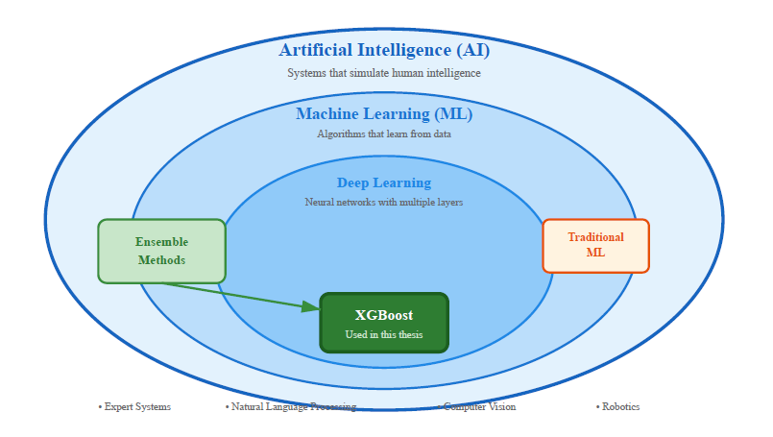
Figure 2.1: Artificial Intelligence and Its Subfields

2.3 Machine Learning
Machine learning is part of AI, but it works in a specific way. Nobody programs the rules. You show the algorithm examples: here is the input, here is the correct output. The algorithm studies these pairs and learns to predict outputs for new inputs it has never encountered (Russell & Norvig, 2020). Why use this? Because some relationships—like what drives national emissions—are too messy to write down as neat equations.
What causes national emissions? It depends on how many people live there, how big the economy is, how much energy gets consumed, what kind of fuel is burned, what technology exists, and whether the climate is hot or cold. Writing this as a formula? Nearly impossible. ML handles this differently: feed it many variables, let it figure out how they interact. In this thesis, that means combining satellite data with socioeconomic numbers to predict emissions.
I use supervised learning only—nothing else. The training data has pairs: x holds the input features for one country in one year, y holds the actual emissions that year. The algorithm learns a function f that takes x and outputs something close to y. If it works, f should also give reasonable estimates for country-years it never trained on.
Other ML approaches exist. Unsupervised learning looks for patterns without knowing the right answers—good for exploring data, not for predicting emissions. Reinforcement learning trains agents to make decisions over time—useful for robotics or games, not for estimating yearly CO₂ totals.
Supervised regression fits this problem exactly. I have historical emissions for multiple countries across multiple years. The task: learn patterns from that history, then estimate emissions for years or countries held out of training. XGBoost—a gradient-boosted tree method—does this job. More details on XGBoost come in Chapter 4.
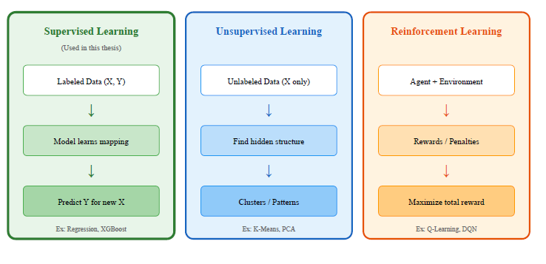
Figure 2.2: Types of Machine Learning

2.4 Supervised Learning in Detail
Everything in this thesis uses supervised learning. So how does supervised regression actually work? Here is the basic process, step by step.
Step one: collect data. I need a dataset where each row has input features—satellite measurements, population density, maybe some economic variables—paired with the target: annual national CO₂ emissions. This covers multiple countries over multiple years.
The second stage addresses preprocessing and feature engineering. Missing values need handling, temporal and spatial scales must align, and variables sometimes require transformation (such as taking logarithms). I also engineer additional features from raw inputs when it helps. After that, training begins. I pick a regression algorithm—linear regression, decision trees, random forests, or gradient-boosted trees—and fit it on part of the data. The algorithm adjusts itself to minimize prediction errors, typically measured as squared differences between predicted and actual values.
Fourth, validation and hyperparameter tuning take place. The model's performance gets checked on validation data not used during training. Here I adjust hyperparameters.Without this step, the model might just memorize the training data instead of learning patterns that apply to new cases.
Finally, testing and evaluation occur. The finished model runs on a held-out test set, and performance metrics get calculated: coefficient of determination (R²), root mean squared error (RMSE), mean absolute error (MAE), and mean absolute percentage error (MAPE).
In this thesis, these stages apply to a GCC-wide panel covering multiple countries and years. The data split respects time: models train on earlier years and get tested on later ones, mimicking a real nowcasting scenario where future emissions are unknown.
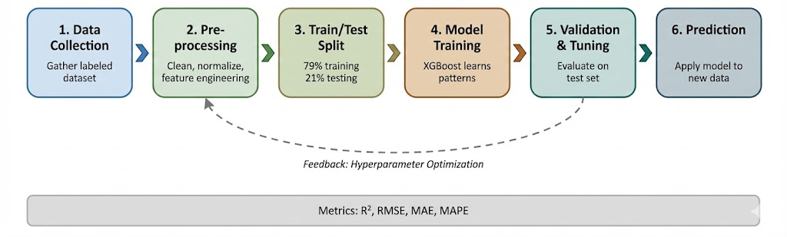
Figure 2.3: Supervised Learning Workflow

2.5 Deep Learning
Deep learning is machine learning with neural networks that have many layers stacked on top of each other (Goodfellow et al., 2016). Think of nodes as small calculators. Numbers come in, get multiplied by weights, added together, then squeezed through a function. Stack many of these in layers and connect them—data enters at one end, something useful comes out the other end.
So how does the network learn? By fixing its mistakes. Backpropagation figures out which weights caused the error, gradient descent nudges them in the right direction. Do this thousands of times and the network gets better. These deep networks now beat humans at recognizing images, understanding speech, and processing language. But they are hungry. They want lots of data and serious computing power. Give them a small dataset and they just learn the training examples by heart—no real understanding of underlying patterns.
My dataset contains 144 rows total. For deep learning, this is tiny. Deep learning models with millions of parameters would likely overfit—memorizing the training set rather than learning real patterns. For small tabular datasets like this one, gradient-boosted trees such as XGBoost usually win. Fewer parameters, less overfitting risk, and they handle mixed data types well.

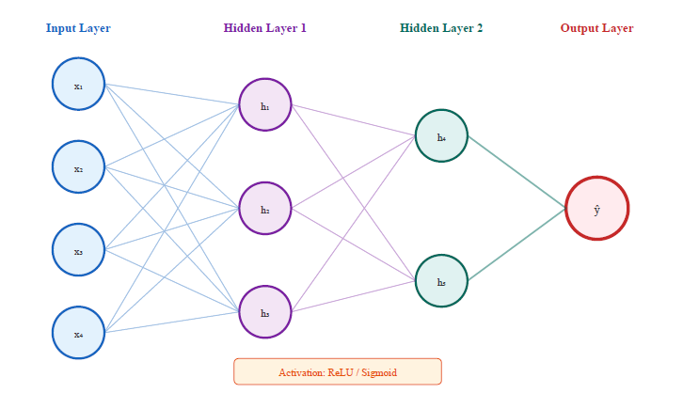
Figure 2.4: Neural Network Architecture
Table 2.1: Comparison of AI, ML, and DL
Aspect | Traditional AI | Machine Learning | Deep Learning
Learning Method | Rule-based, programmed | Learns from data | Learns hierarchical features
Data Requirement | Minimal | Moderate (100s-1000s) | Large (10,000s+)
Interpretability | High | Medium | Low (black box)
Example Algorithms | Expert systems | XGBoost, Random Forest | CNN, Transformers
Best For | Well-defined rules | Tabular data, limited samples | Images, text, large datasets
Source: Author's compilation based on Russell and Norvig (2020) and Goodfellow et al. (2016)

2.6 Ensemble Methods
Why use one model when you can use many? Ensemble methods take predictions from several models and combine them into one final answer (Chen & Guestrin, 2016). Each model catches different patterns, misses different things. Put them together and errors tend to cancel out.
There are three main ways to do this. Bagging trains models separately on random subsets of the data, then averages what they predict. Random forests work this way. Boosting is different—models are built one after another, each one focusing on cases the previous models got wrong. XGBoost uses boosting. Stacking takes a third approach: train several different models, then train another model on top to combine their outputs.
For this thesis, boosting matters most. It works well on tabular data like mine, captures complex interactions between variables, and does not need massive amounts of training data to perform.

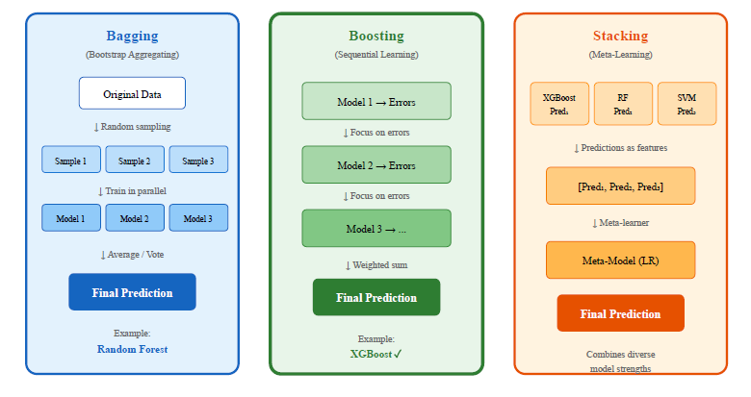
Figure 2.5: Ensemble Methods Comparison

2.7 The XGBoost Algorithm
XGBoost stands for Extreme Gradient Boosting (Chen & Guestrin, 2016). It builds decision trees one after another, each tree fixing mistakes from the previous ones. Regularization is baked in, so the model does not easily overfit.
Why did I choose it? Several reasons. It handles mixed feature types without complaint. Missing values do not break it. I can customize the loss function if needed. And most importantly for this research, it tells me which variables matter most—feature importance scores come built in.
I use XGBoost for all three models in this thesis. Model A takes economic inputs only. Model B mixes satellite data with population density. Model C uses satellites alone. Same algorithm, different inputs, direct comparison.
Given 144 observations and tabular data, XGBoost hits a sweet spot: accurate enough, resistant to overfitting, and interpretable.

2.8 Greenhouse Gas Emissions and Climate Policy
Carbon dioxide is the main greenhouse gas humans produce. In 2022, burning fossil fuels and running industrial processes pumped around 36.4 billion tonnes of it into the atmosphere (Global Carbon Project, 2023). Where does it come from? Coal for electricity—about 40%. Oil for transportation—roughly 25%. Natural gas for heating and industry—another 20%.
The Paris Agreement, signed in 2015, set a goal: keep warming well below 2°C, preferably under 1.5°C. To get there, the IPCC (2023) says emissions need to drop about 45% from 2010 levels by 2030, hitting net zero by 2050.
Every country submits an NDC—a plan for how much they will cut. But here is the problem: how do you know if these plans are working? You need accurate, up-to-date emission numbers. Most countries publish their inventories once a year, and those numbers arrive 1–2 years late (Global Carbon Project, 2023). By the time you see the data, the moment has passed.

2.9 The GCC Region: Energy Profile and Climate Commitments
Six countries make up the GCC: Saudi Arabia, UAE, Qatar, Kuwait, Oman, and Bahrain. Together they produce about 3% of global CO₂ emissions but hold less than 1% of the world's population. Why such a gap? They sit on massive oil and gas reserves, and their people use a lot of energy per person.
Summer in the GCC is brutal. Temperatures inland regularly pass 45°C. What happens when it gets that hot? Everyone turns on air conditioning. During peak summer months, cooling can eat up 60–70% of total electricity demand. Most of that electricity comes from burning natural gas. Hot weather means more AC, more AC means more power generation, more power generation means more CO₂.

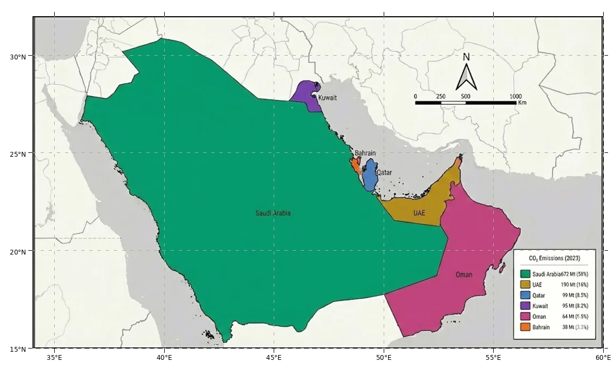
Figure 2.6: Map of the GCC Study Area

Table 2.2: GCC Countries Climate Targets and Emission Profiles
Country | 2023 CO₂ (Mt) | Per Capita (t) | NDC Target | Net Zero Goal
Saudi Arabia | 672 | 18.2 | 278 Mt reduction by 2030 | 2060
UAE | 190 | 19.3 | 31% reduction by 2030 | 2050
Qatar | 99 | 32.8 | 25% reduction by 2030 | -
Kuwait | 95 | 21.6 | 7.4% reduction by 2035 | -
Oman | 64 | 12.4 | 7% reduction by 2030 | 2050
Bahrain | 38 | 23.1 | 30% reduction by 2035 | 2060
Source: Global Carbon Project (2023), UNFCCC NDC Registry

All six GCC countries have submitted NDCs, and several have announced net zero targets. Saudi Arabia aims for net zero by 2060, while the UAE and Oman target 2050. These commitments create a need for improved emission monitoring capabilities.

2.10 Earth Observation for Environmental Monitoring
Satellites changed how we watch the planet. It started with Landsat-1 in 1972 (NASA, 2024). Since then, sensors in orbit have delivered more and more detailed pictures of land, atmosphere, oceans, and climate.
For tracking carbon emissions, satellites bring real advantages. They see everywhere—no gaps like ground stations have. Many products are free, which matters for countries with tight budgets. And the data arrives fast, usually within days. Compare that to official emission inventories that show up 1–2 years late.
But there is a catch. Satellites do not measure emissions directly. They measure temperature, light, vegetation, aerosols. Someone has to connect those measurements to actual CO₂ coming out of smokestacks and tailpipes. Building that connection reliably—that is the hard part, and that is what this thesis tries to do.

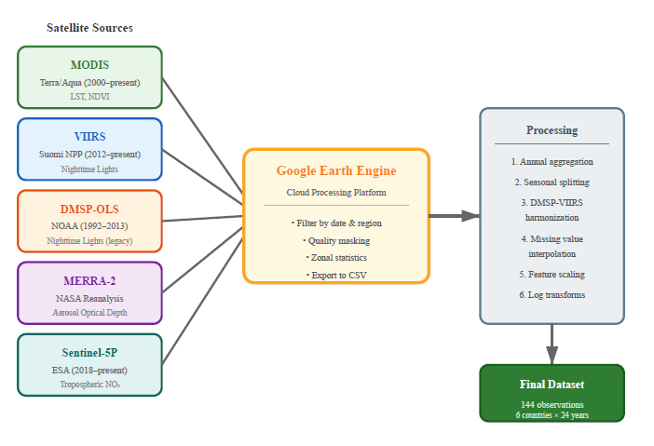
Figure 2.7: Satellite Data Sources and Processing Pipeline

2.11 Satellite Data Sources Used in This Study
Five satellite variables go into this thesis. Each one captures something different about economic activity and energy use:
Land Surface Temperature (LST) from MODIS: NASA runs two satellites—Terra (since 1999) and Aqua (since 2002)—both carrying MODIS sensors that measure how hot the ground gets. I use the MOD11A2 product: 8-day composites at 1 km resolution. High temperatures mean heavy air conditioning use, which means more electricity, which means more emissions. High temperatures push people to run air conditioners. More AC means more electricity. More electricity means more CO₂. Assiri (2017) checked MODIS thermal readings against ground stations in Saudi Arabia and found they match well.
Vegetation Index (NDVI) from MODIS: NDVI tells you how green the land is. It compares near-infrared and red light reflected from the surface. Values run from -1 to +1—anything above 0.3 usually means healthy plants in temperate areas. The GCC has little natural vegetation, but farms exist and they need water. Pumping that water and running desalination plants takes energy. I use MOD13A2, which gives 16-day NDVI composites at 1 km resolution. Haq (2022) tested satellite-based vegetation classification in Al-Qassim, Saudi Arabia, and hit 98% accuracy using PlanetScope imagery.
Night-time Lights (NTL) from DMSP-OLS and VIIRS: Look at Earth from space at night and you see city lights, factories, roads. Two satellite systems capture this. DMSP-OLS ran from 1992 to 2013. VIIRS took over starting in 2012. Brighter lights mean more electricity use, more economic activity, more people. The tricky part? The two sensors measure differently, so stitching their records together during the 2012–2013 overlap takes some calibration work.
Aerosol Optical Depth (AOD) from MERRA-2: MERRA-2 is NASA's global reanalysis product. It includes AOD, which measures how much particles in the air block sunlight. In industrial areas, high AOD often signals combustion—factories, vehicles, power plants. But the GCC sits in a desert. Dust storms are common. So high AOD here might mean pollution, or it might just mean sand in the air. That makes interpretation tricky (Kumar et al., 2018).
Nitrogen Dioxide (NO₂) from Sentinel-5P TROPOMI: ESA launched Sentinel-5P in late 2018. It carries TROPOMI, a sensor that detects NO₂ in the atmosphere at about 5.5 km resolution. NO₂ does not last long in the air—it stays close to where it was produced. That makes it a good marker for cars, trucks, and power plants. Alkayal et al. (2025) used Sentinel-5P data to predict air pollution in Saudi cities and achieved high accuracy.

Table 2.3: Satellite Sensors and Products Used in This Study
Variable | Sensor/Product | Resolution | Coverage | Physical Meaning
LST | MODIS MOD11A2 | 1 km, 8-day | 2000-present | Thermal emission → cooling demand
NDVI | MODIS MOD13A2 | 1 km, 16-day | 2000-present | Vegetation greenness → agricultural activity
NTL | DMSP-OLS / VIIRS | ~750 m | 1992-present | Artificial light → urbanization, economic activity
AOD | MERRA-2 | ~50 km | 1980-present | Aerosol loading → combustion + dust
NO₂ | Sentinel-5P TROPOMI | 5.5 km, daily | 2019-present | Tropospheric NO₂ → combustion tracer

2.12 Machine Learning for Emission Estimation
Machine learning helps find connections between what satellites see and what gets emitted. Traditional statistics need you to specify the equation upfront. ML figures out the patterns on its own, even complicated nonlinear ones.
Researchers explored this path already.Nassef et al. (2023) tested three approaches—FFNN, ANFIS, and LSTM—for predicting Saudi CO₂ emissions. They reached R² up to 0.99, but they used economic data, not satellites. Alamri and Khan (2023) experimented with fancier architectures like N-BEATS and Transformers. Their finding? Complex models did not consistently beat simpler ones when training data was limited.
Why XGBoost for this thesis? It handles tabular data well. It works with small datasets without overfitting too easily. And it ranks variables by how much they help predictions—no extra code needed. It runs on a normal laptop—no GPU needed. And it has fewer settings to tune than deep learning models, which means less risk of fooling myself with overfitted results.

2.13 XGBoost: Mathematical Formulation
Chen and Guestrin (2016) introduced XGBoost as a faster, more regularized version of gradient boosting. The core idea: build decision trees one at a time, each new tree learning from the mistakes of all previous trees combined.
The algorithm tries to minimize this objective:
L(θ) = Σᵢ l(yᵢ, ŷᵢ) + Σₖ Ω(fₖ) (2.1)
where l is a differentiable loss function and Ω is a regularization term
What does Ω do? It punishes complexity—too many leaves, weights that grow too large. This keeps the model from memorizing the training data, which matters a lot when you only have 144 observations.
For predicting emissions, I use squared error as the loss function. Each tree fits the residuals—the gap between current predictions and actual values. Final predictions come from adding up what all trees say.

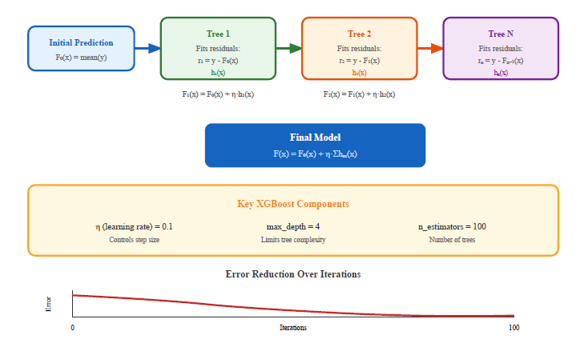
Figure 2.8: XGBoost Sequential Tree Building Process
XGBoost has a few important settings. n_estimators tells it how many trees to build—more trees can mean better accuracy but also slower training. max_depth caps how deep each tree goes; shallow trees generalize better. learning_rate makes each tree contribute less to the final answer, forcing the model to rely on the whole ensemble rather than a few strong trees. min_child_weight stops the algorithm from creating leaves with too little data. Getting these settings right means the difference between a model that captures real signal and one that just memorizes the training set.

2.14 Explainable AI for Tree-Based Models
A model that predicts well but cannot explain itself is hard to trust. That is where Explainable AI (XAI) comes in. If a model will influence policy or high-stakes decisions, people need to understand why it makes the predictions it makes. For environmental work, this matters even more—we want to confirm the model relies on real physical relationships, not random correlations.
XGBoost offers built-in explanations. Global feature importance scores show which variables reduce prediction error the most across all trees. I can rank variables and ask: do the top predictors make physical sense? Local explanation methods like SHAP values exist too. They break down individual predictions to show what drove each one. But they need more computation and get noisy when data is limited.
With 144 observations, I stick to global importance scores. They tell me whether land surface temperature and night-time lights behave as expected overall. Trying to interpret single predictions with this little data risks reading too much into noise. Local XAI methods can wait for future work when more data becomes available.

Chapter 3 Related Work

3.1 Introduction
What have other researchers done at the intersection of AI and carbon monitoring? This chapter answers that question. Two streams of work matter: machine learning for emission forecasting, and satellites for tracking carbon in the atmosphere. Understanding what exists—and what is missing—shows where this thesis fits.
I reviewed papers from 2021 to 2025, asking three questions. What AI methods have been used to predict CO₂? How are satellites helping monitor emissions? What research exists specifically for the Gulf region? Thirteen studies stood out as most relevant—seven on ML forecasting, six on satellite monitoring. One trend is clear: more researchers are combining remote sensing with AI. But few address how quickly these methods can deliver usable numbers.

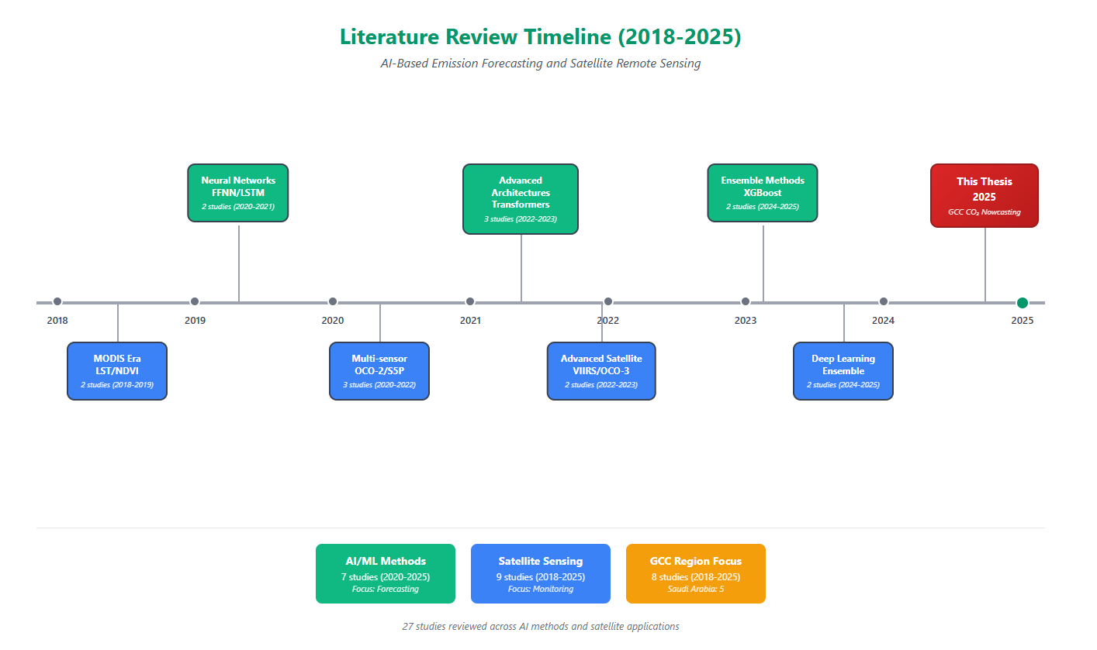
Figure 3.1: Literature Review Timeline (2016-2025)

3.2 AI-Based Emission Forecasting
ML for carbon prediction has exploded in recent years. Early work relied on basic regression. Newer studies try more advanced methods.
Nassef et al. (2023) built a forecasting system for Saudi CO₂ using FFNN, ANFIS, and LSTM. Their inputs were economic—GDP, population, energy use, vehicle counts. Results were strong: R² from 0.97 to 0.99. Interestingly, the simpler FFNN beat the others, which suggests fancy models do not always win when data is scarce. But their data still arrives with a 1–2 year delay.
Rahman et al. (2023) used Decision Tree Regression to forecast CO₂ from fuel consumption. R² hit 0.99, but they noted the model was sensitive to gaps in fuel data. Meng and Noman (2022) looked at how COVID-19 disrupted global emissions—standard forecasting methods struggled with the pandemic's sudden shocks.
Alamri and Khan (2023) tried N-BEATS and Transformer architectures. On paper, these should excel at sequential data. In practice, they did not consistently outperform simpler models. Not enough training data, probably. So I picked XGBoost instead of neural networks.
Alcibahy et al. (2025) showed XGBoost works for satellite-based CO₂ estimation over the Arabian Peninsula. They fused MODIS LST, OCO-2, Sentinel-5P, and ERA-5 data, achieving R² = 0.98 at 1 km resolution. That result validates gradient boosting with multiple satellite inputs in GCC conditions.
Begum and Al Mobin (2025) ran XGBoost, SVR, and Gradient Boosting on 11 big emitters, Saudi included. They hit 96.21% accuracy. Their projections suggest Saudi emissions could rise 16.62% by 2030, not fall. That makes better monitoring urgent.
Han et al. (2023) combined LSTM and CNN for Chinese provincial emissions, reaching R² = 0.97. Deep learning shines with big datasets. But with only 144 observations, XGBoost makes more sense—lower overfitting risk, easier to interpret.
Fonseca and Francis (2023) established baseline CO₂ patterns over the Middle East using nine years of OCO-2/OCO-3 data (2014–2023). They found seasonal swings of 3–8 ppmv over the Arabian Peninsula, with UAE showing a trend of 2.50 ppmv/year. These baselines help validate GCC forecasts.
Xu et al. (2023) proved that VIIRS nighttime lights work as a proxy for human CO₂ emissions at fine spatial scales. I incorporate this approach through VIIRS DNB data, complementing atmospheric measurements for locating emission sources in GCC cities.

Table 3.1: Summary of AI-Based Emission Forecasting Studies
Authors | Method | Region | Best R² | Data Type
Nassef et al. (2023) | FFNN, ANFIS, LSTM | Saudi Arabia | 0.99 | Economic
Rahman et al. (2023) | Bagged DT | Saudi Arabia | 0.90 | Economic
Alamri and Khan (2023) | N-BEATS, Transformer | Multiple | 0.95 | Economic
Meng and Noman (2022) | SARIMAX | Global | N/A (MAPE: 0.09) | Economic
Alcibahy et al. (2025) | XGBoost, RF, SVM | Arabian Peninsula | 0.98 | MODIS, OCO-2, S5P
Begum and Al Mobin (2025) | XGBoost, SVR, GB | Saudi Arabia | 96.21% | Economic data
Han et al. (2023) | LSTM-CNN | China | 0.97 | Historical

3.3 Satellite-Based Carbon Monitoring
Satellites can track carbon in two ways. Some measure CO₂ floating in the atmosphere directly. Others look at indirect signs—lights, heat, smoke—and infer emissions from there.
On the direct side, OCO-2 from NASA does the heavy lifting. Mustafa et al. (2021) fed OCO-2 observations into neural networks and produced CO₂ maps for East and West Asia. Over the Arabian Peninsula, Alcibahy et al. (2025) went further. They grabbed CO₂ from OCO-2, added methane from Sentinel-5P, and ran everything through XGBoost. Performance was strong. Using more than one sensor made a difference.
Not everyone measures CO₂ directly though. Lin et al. (2023) watched smoke rising from power plants via satellite, then built ML models to estimate the CO₂ inside those plumes. Rowley and Karakuş (2023) created something called AQNet—it looks at satellite images and predicts air quality. Persello et al. (2022) wrote a broad review: deep learning plus Earth observation can support sustainability goals, but we are not there yet.
A few studies looked at carbon locked in the ground, not the sky. Mallick et al. (2022) used satellite images to estimate how much carbon Saudi landscapes hold. Madugundu et al. (2018) combined satellite views with soil tests for agricultural carbon. Good work, but different from what I do here—they measured stored carbon, I estimate emissions.

Table 3.2: Summary of Satellite-Based Carbon Monitoring Studies
Authors | Satellite Data | Region | Approach | Application
Mustafa et al. (2021) | OCO-2 | East/West Asia | Neural Network | CO₂ estimation
Alcibahy et al. (2025) | OCO-2, Sentinel-5P | Arabian Peninsula | XGBoost | CO₂, CH₄ estimation
Lin et al. (2023) | Multiple | Global | ML ensemble | Power plant emissions
Rowley and Karakuş (2023) | Multiple | Urban areas | Deep learning | Air quality
Fonseca and Francis (2023) | OCO-2, OCO-3 | Middle East | Trend analysis | Regional variability
Xu et al. (2023) | NPP-VIIRS NTL | China | Nighttime light | Urban emissions

3.4 Regional Studies in the GCC
Has anyone studied GCC environments with satellites before? Yes, but not much on CO₂.
Assiri (2017) asked a simple question: does MODIS give accurate temperatures for Saudi Arabia? He compared satellite readings to weather stations. They matched. So I can trust MODIS LST here.
For vegetation, Haq (2022) worked in Al-Qassim. He fed PlanetScope images into ML algorithms and got 98% accuracy classifying farmland. Addas et al. (2020) pointed satellites at Jeddah to measure urban heat. Downtown ran hotter than the outskirts—no surprise, but now we have numbers.
Hammam and Mohamed (2020) tried several approaches to map salty soils in the East Nile Delta. Alkayal et al. (2025) went after air pollution. They trained deep learning on Sentinel-5P observations for thre Saudi cities. Their predictions matched ground truth well.
Less has been done on carbon specifically. Emadi et al. (2020) proved ensemble ML can predict soil properties in dry areas. Tan et al. (2024) clustered Chinese regions by how they emit, then layered in satellite XCO₂ data. The combination beat either method alone.

3.5 Research Gaps and Contributions
After reading all this, what is missing?
First, most AI emission forecasts rely on economic data—GDP, energy use, population. That data arrives 1–2 years late. Few studies ask whether satellites could fill the gap.
Second, satellite carbon monitoring tends to go either very big (global) or very small (individual power plants). Country-level estimation, especially for the GCC, barely exists.
Third, nobody measures the trade-off directly. Papers report high accuracy with economic inputs but never compare against satellite alternatives. How much accuracy do you lose for faster data? Unknown.
Fourth, validation in GCC conditions is thin. Most satellite-emission relationships come from Europe, China, or the US. Hot deserts with oil-based economies? Different story.

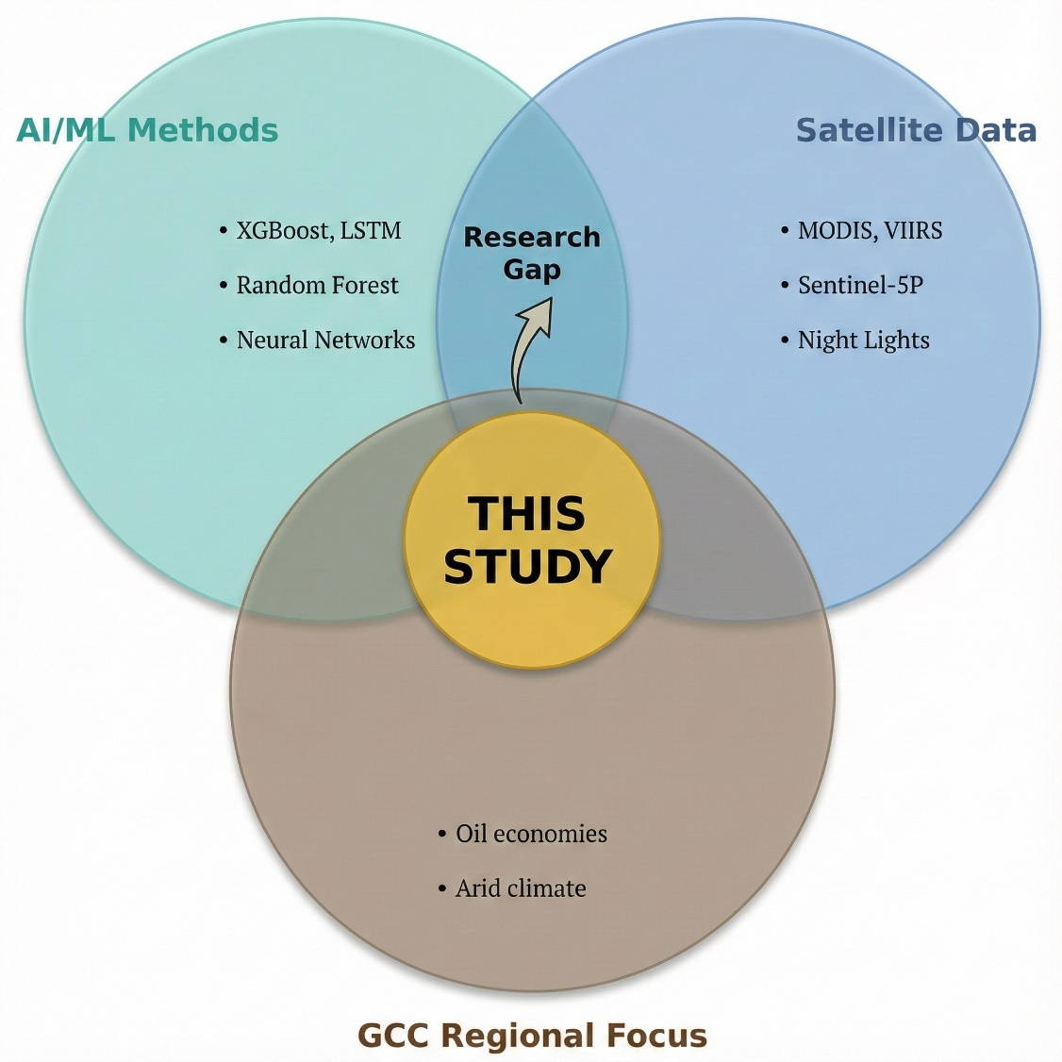
Figure 3.2: Research Gap Analysis Diagram

What does this thesis do about it? Three things. I built a satellite framework designed and tested for the GCC. I run economic and satellite models side by side, so the accuracy-timeliness trade-off has real numbers. And I check feature importance to make sure the model learns physics, not noise—summer heat should matter, and it does.

Chapter 4 Proposed Approach

4.1 Introduction
This chapter explains how I built the framework. The goal: estimate national CO₂ emissions for GCC countries using satellite data. I combine observations from multiple sensors with machine learning to produce estimates much faster than traditional inventories allow.
One question drives everything here. Satellite data shows up in days. Official emission numbers take 12–24 months. How close can satellites get to the real values? To answer that, I describe the dataset, the model design, and how I measure whether the speed-accuracy trade-off is worth it.

4.2 Research Design Overview
The design is quantitative and comparative. Three parts hold it together.
Part one: I built a single dataset covering all six GCC countries from 2000 to 2023. It merges official CO₂ numbers from the Global Carbon Project, compiled by Our World in Data (2023), with satellite indicators aggregated to annual values.
Part two: I trained three XGBoost models (Chen & Guestrin, 2016) and compared them. Model A uses economic inputs only—GDP, energy, population. Model B mixes satellite data with population density. Model C relies on satellites alone.
Part three: I tested all three models on 2019–2023 data they never saw during training. I looked at accuracy, which features mattered most, and where errors showed up. That tells me what satellites can and cannot do in the GCC.
I did not start with this design. Early experiments pushed the timeline back into the 1980s and 1990s, using only Saudi Arabia. More years meant more data, but problems appeared. Reporting standards changed over time. Some economic indicators had gaps. Models trained on old data fit the past well but predicted recent years poorly.
So I cut the timeline to 2000–2023. Why 2000? That is when the data gets reliable. MODIS LST and NDVI start around then. VIIRS night-time lights can be calibrated with earlier DMSP-OLS records. MERRA-2 aerosols are available throughout. Sentinel-5P NO₂ only begins in late 2018, so I treat it as a bonus variable, not a core input. The final dataset has 144 country-year observations across six countries. That balances data quality, time coverage, and model complexity.
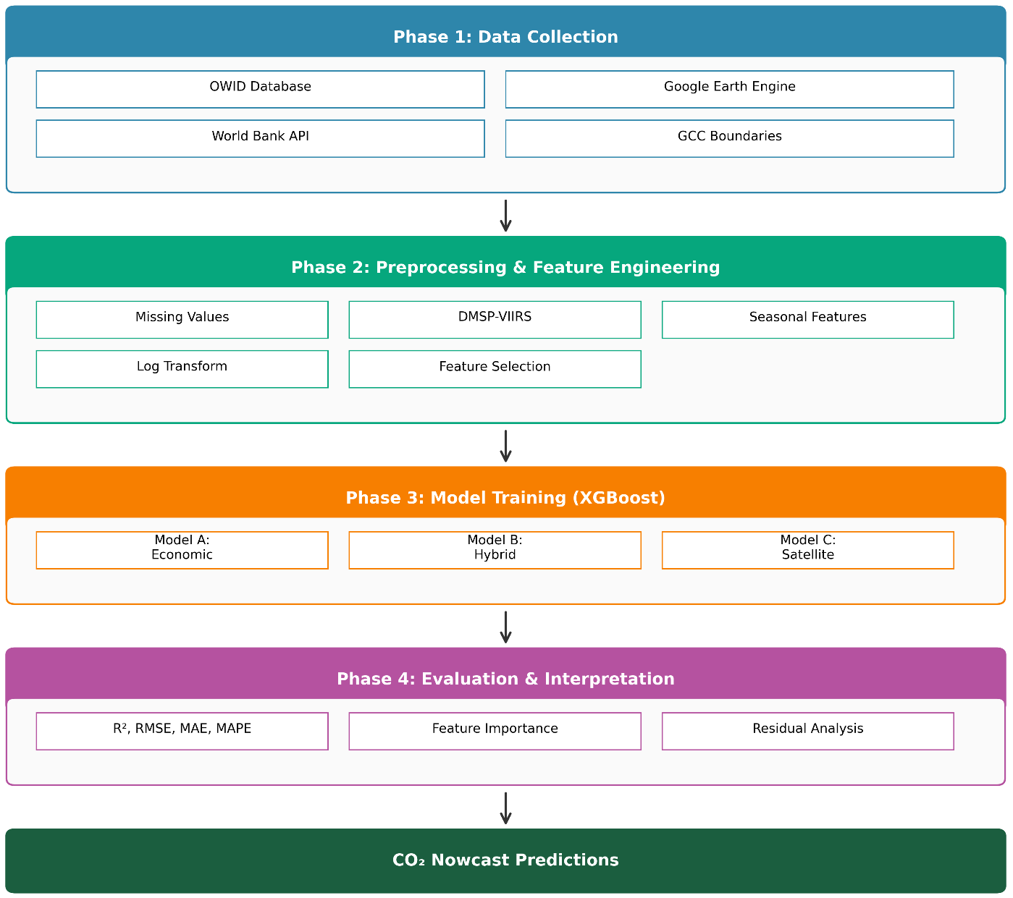
Figure 4.1: Research Framework Architecture
Why XGBoost and not deep learning? Simple math. I have 144 rows. Deep learning wants thousands, ideally tens of thousands. With 144, a neural network would memorize rather than learn. XGBoost handles small tabular data better (Chen & Guestrin, 2016). It has regularization built in, captures nonlinear patterns, and tells me which features matter.
How do I treat the 144 observations? As one pooled dataset. All six countries go into a single model—no country-specific adjustments or random effects. The goal is prediction, not causal inference. I want accurate nowcasts, not parameter estimates for each country.

4.3 Study Area: The GCC Region
Six countries make up the study area: Saudi Arabia, UAE, Qatar, Kuwait, Oman, and Bahrain. Together they cover about 2.57 million km² of the Arabian Peninsula. Population in 2023 was around 58.8 million.
Table 4.1 shows the basics for each country—size, population, CO₂ emissions, and how hot summers get.

Table 4.1: Study Area Overview - Six GCC Countries
Country | Area (km²) | Population (M) | 2023 CO₂ (Mt) | Climate | Summer Temp (°C)
Saudi Arabia | 2,149,690 | 36.4 | 672 | Arid/Semi-arid | 42-50
UAE | 83,600 | 9.4 | 190 | Arid | 40-48
Qatar | 11,586 | 2.7 | 99 | Arid | 40-46
Kuwait | 17,818 | 4.3 | 95 | Arid | 42-50
Oman | 309,500 | 4.5 | 64 | Arid/Tropical | 38-45
Bahrain | 780 | 1.5 | 38 | Arid | 38-42
GCC Total | 2,572,974 | 58.8 | 1,158 | - | -
Source: World Bank, Global Carbon Project (2023), national statistics offices

Figure 4.2: GCC CO₂ Emissions Distribution by Country (2023)
The climate here is hot and dry. Summers regularly push past 45°C inland. That heat creates a sharp seasonal swing in electricity use—summer demand can hit 2–3 times winter levels because of air conditioning. Power plants burn more fuel in summer, so emissions follow the same pattern. My framework takes advantage of this connection by using seasonal land surface temperature as a key input.

4.4 Data Sources and Collection
Two data streams feed the analysis: official CO₂ emission records, and environmental indicators drawn from economic statistics and satellites.

4.4.1 Emission Data
I pulled annual CO₂ emissions from Our World in Data (2023), which sources its numbers from the Global Carbon Project (2023). The target variable is national CO₂ for each GCC country, measured in million tons (Mt). OWID has data going back to 1965 for some countries, but I only use 2000–2023 to match when satellite products become available.
The emission series sits in a pre-processed dataset. Even though older data exists, I stick to 2000–2023 so everything lines up with the satellite timeline.

4.4.2 Economic and Demographic Data
Model A needs economic inputs. I got them from the same OWID database, which pulls from World Bank sources:
- GDP in constant 2015 USD
- Population (yearly estimates)
- Primary energy consumption in terawatt-hours
- Energy per capita (total energy divided by population)
All of these sit in the same preprocessed file with matching country and year columns, so merging with emissions is straightforward.

4.4.3 Satellite Data
Satellite data came from Google Earth Engine. GEE gives access to MODIS, VIIRS, MERRA-2, Sentinel-5P, and more (Assiri, 2017; Elvidge et al., 2009; European Space Agency, 2024).
I processed the images and saved the results in a separate file with seasonal satellite indicators. That file later gets merged with emissions and economic data to create the final dataset.
Table 4.2 lists the main data sources and what years they cover.

Table 4.2: Data Sources and Temporal Coverage
Data Type | Source | Coverage | File Name
CO₂ Emissions | Our World in Data / Global Carbon Project (2023) | 1965–2023 | Pre-processed GCC emissions dataset
Economic Indicators | Our World in Data / World Bank | 1965–2023 | Pre-processed GCC emissions dataset
Satellite Features | Google Earth Engine (multiple products) | 2000–2023 | Seasonal satellite indicators dataset

After merging emission and satellite files on the (country, year) key, the final analysis dataset contains 144 observations (6 countries × 24 years).

4.5 Satellite Data Extraction Pipeline
I built the extraction pipeline in Google Earth Engine (Gorelick et al., 2017). GEE stores satellite images in what it calls Image Collections—basically time series where every image has the same metadata structure. For each variable I needed, I picked a collection, selected the right band, applied scale factors, and set up quality masks.

4.5.1 Google Earth Engine Image Collections
Table 4.3 shows which GEE collections I used, along with bands and scale factors. MODIS gives me land surface temperature—Assiri (2017) validated these products for Saudi Arabia, so I trust them here. For night-time lights I use VIIRS. For aerosol optical depth I use MERRA-2. Sentinel-5P adds NO₂ readings. Together these capture human activity and what is happening in the atmosphere (Elvidge et al., 2009; European Space Agency, 2024).
Table 4.3: Google Earth Engine Image Collections Used
Variable | GEE Collection ID | Band Used | Scale Factor | Unit
LST Day | MODIS/061/MOD11A2 | LST_Day_1km | 0.02 | Kelvin
LST Night | MODIS/061/MOD11A2 | LST_Night_1km | 0.02 | Kelvin
NDVI | MODIS/061/MOD13A2 | NDVI | 0.0001 | Index (-1 to 1)
NTL | NOAA/VIIRS/DNB/MONTHLY_V1/VCMSLCFG | avg_rad | 1.0 | nW/cm²/sr
AOD | NASA/GSFC/MERRA/aer/2 | TOTEXTTAU | 1.0 | Dimensionless
NO₂_Signal | COPERNICUS/S5P/OFFL/L3_NO2 | tropospheric_NO2_column_number_density | 1.0 | mol/m²
Note: DMSP-OLS data (1992–2013) were handled separately and inter-calibrated with VIIRS night-time lights (Elvidge et al., 2009).
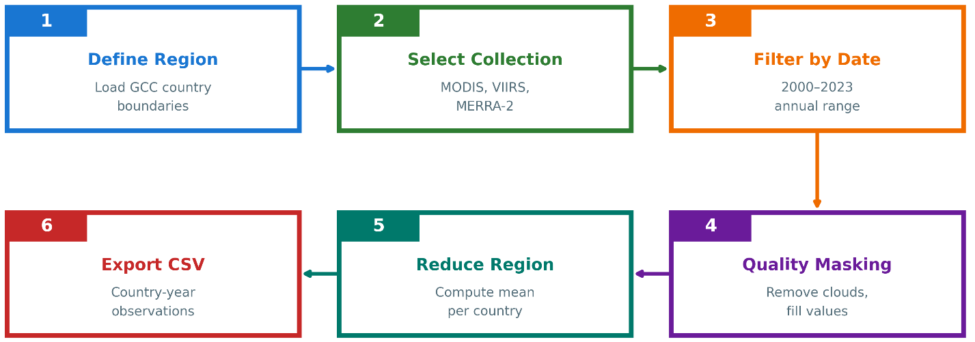
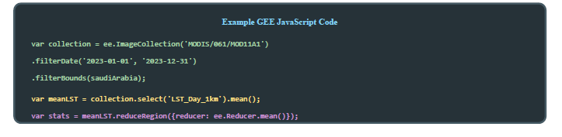
Figure 4.3: Google Earth Engine Data Extraction Workflow

4.5.2 Extraction Workflow
What does the extraction process look like? Six steps, repeated for every country and every year:
- Step 1 – Define Country Boundaries: Country shapes come from FAO GAUL, which GEE hosts. I load the polygon for each GCC country.
- Step 2 – Filter Image Collection: I take the image collection for each variable and keep only images that fall inside the country and within the time window. For annual variables, that means the whole calendar year. For seasonal ones, I pick specific months.
- Step 3 – Apply Quality Filters: Not all pixels are usable. MODIS LST has a QC band—I drop pixels flagged as cloudy or unreliable. Sentinel-5P NO₂ has a qa_value field—anything below 0.5 gets removed (European Space Agency, 2024).
- Step 4 – Temporal Aggregation: With bad pixels gone, I average what remains into a single composite image for that country-year or country-season.
- Step 5 – Spatial Aggregation: That composite still covers the whole country. I run a mean reducer over the polygon to collapse it into one number per variable.
- Step 6 – Export Results: Finally, I write everything to a CSV. Columns include country, year, and each satellite feature.
See Table 4.4 for the extraction parameters I used.
Table 4.4: Satellite Feature Extraction Parameters
Variable | Temporal Filter | Quality Mask | Reducer | Output
LST_Summer | June-August | LST_QC < 65 | Mean | °C (converted)
LST_Winter | Dec-Feb | LST_QC < 65 | Mean | °C (converted)
NDVI_Spring | March-May | Pixel reliability ≤ 1 | Mean | Index
NTL_Annual | Full year | 0 < radiance < 1000 | Mean | nW/cm²/sr
AOD_Annual | Full year | Valid flag | Mean | Dimensionless
NO2_Signal | Full year | qa_value > 0.5 | Mean | mol/m²

4.5.3 Handling the DMSP–VIIRS Transition
Night-time lights come from two different satellites. DMSP-OLS ran from 1992 to 2013. VIIRS started in 2012 and continues today (Elvidge et al., 2009). The sensors measure differently, so stitching them together takes work. Here is how I did it:
- First, I looked at the overlap period (2012–2013) where both sensors operated. I ran a regression between DMSP digital numbers and VIIRS radiance values.
- Then I applied those regression coefficients to convert all DMSP readings (2000–2011) into VIIRS-equivalent units.
- The final series uses converted DMSP for 2000–2011, an average of both sensors for 2012–2013, and pure VIIRS from 2014 onward.

4.5.4 Missing Data Handling
Satellite data is not perfect. Sensors fail sometimes. Clouds get in the way. And some satellites launched recently, so their records are short. Sentinel-5P NO₂ is the worst case here—it only starts in late 2018 (European Space Agency, 2024).
Because NO₂ coverage is so limited, I left it out of the final models. Not enough years to be useful.
Table 4.5: Missing Data Summary
Variable | Missing Count | Missing % | Reason
NO2_Signal | 114 | 79.2% | Sentinel-5P available only after 2018
primary_energy_consumption | 1 | 0.7% | Reporting gap
All other variables | 0 | 0% | –

4.6 Feature Engineering and Preprocessing
Before training any models, I needed to shape the satellite data so it connects better to emissions. I also had to fix some statistical issues with the variables.

4.6.1 Seasonal Disaggregation of Temperature
When I first tried annual average LST, the correlation with emissions was weak. That makes sense once you think about it. In the GCC, summer drives electricity use—air conditioning runs constantly when it hits 45°C. Winter barely matters for heating. So averaging the whole year hides the signal.
I split temperature into two: LST_Summer_C covers June through August, LST_Winter_C covers December through February. For vegetation, I averaged NDVI over March to May, when crops grow. Table 4.6 shows these windows and why I chose them.

Table 4.6: Seasonal Aggregation Windows
Feature | Months | Rationale
LST_Summer_C | June–August | Peak cooling season; temperatures often 45–50°C; drives AC demand
LST_Winter_C | December–February | Baseline thermal conditions; minimal heating in GCC
NDVI_Spring | March–May | Vegetation growth period; captures agricultural activity

Figure 4.4: Seasonal Land Surface Temperature Pattern

4.6.2 Population Density Transformation
Population density in the GCC varies wildly. Oman has around 12 people per km². Bahrain packs in over 1,700. That kind of skew causes problems for models and throws off error calculations.
I fixed it by taking the log:
log_pop_density = log₁₀(population / land_area) (4.1)
Now big multiplicative gaps become smaller additive gaps. Bahrain no longer dominates the model just because it is dense.

4.6.3 Final Feature Set
Table 4.7 lists what each model gets as input. Model A runs on economic data only—the baseline. Model B mixes satellite indicators with population density. Model C takes satellites alone, no demographic help. That way I can see what remote sensing does on its own.
Table 4.7: Final Feature Set for Each Model
Model | Feature Category | Variables
Model A (Economic) | Economic + Demographic | GDP, population, energy_consumption, energy_per_capita
Model B (Hybrid) | Satellite + Demographic | LST_Summer_C, LST_Winter_C, NDVI_Spring, Night_Lights, AOD_Annual, log_pop_density
Model C (Satellite-only) | Satellite Only | LST_Summer_C, LST_Winter_C, NDVI_Spring, Night_Lights, AOD_Annual

4.6.4 Correlation Analysis
Before building the models, I checked how each variable correlates with CO₂ emissions:
- LST_Summer_C: r ≈ 0.58 — moderate, as expected
- Night_Lights: r ≈ 0.61 — strongest among satellite variables
- log_pop_density: r ≈ 0.55 — population matters
- NDVI_Spring: r ≈ 0.22 — weak, not surprising for a desert region
- AOD_Annual: r ≈ 0.18 — weak, dust clouds the signal

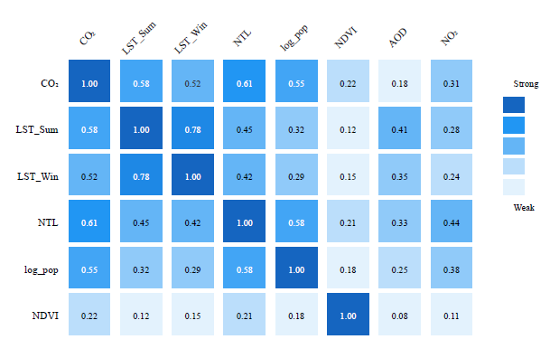
Figure 4.5: Feature Correlation Matrix
Did I drop the weak ones? No. XGBoost has its own way of deciding what matters (Chen & Guestrin, 2016). I kept everything and let the algorithm sort it out.

4.7 Experimental Design: Three-Model Comparison
The experiment boils down to one question: how much accuracy do I lose by switching from slow economic data to fast satellite data?
Table 4.8: Three-Model Experimental Design
Model | Input Features | Purpose | Data Latency | Baseline?
A | Economic indicators | Accuracy benchmark | 12–24 months | Yes
B | Satellite + log_pop_density | Practical nowcasting | Days | No
C | Satellite only | Pure satellite capability | Days | No

Model A sets the benchmark. It uses economic and energy statistics—accurate but delayed by 1–2 years. Models B and C use satellite inputs that arrive in days. That comparison shows what speed costs in accuracy.
During development, I experimented with different configurations—longer time windows, for example. Hybrids mixing economic and satellite features together. Some looked good on training data but fell apart on the test period (2019–2023). The three-model design in Table 4.8 survived because it keeps the comparison clean: inventory-driven versus satellite-driven, no confusion about what each model represents.

4.8 Model Training and Validation

4.8.1 Temporal Train–Test Split
Random cross-validation does not work here. The data has a time dimension—I cannot train on 2022 and predict 2015. So, I split by year instead. Training uses 2000–2018 (114 rows). The test set covers 2019–2023, which gives me 30 rows.
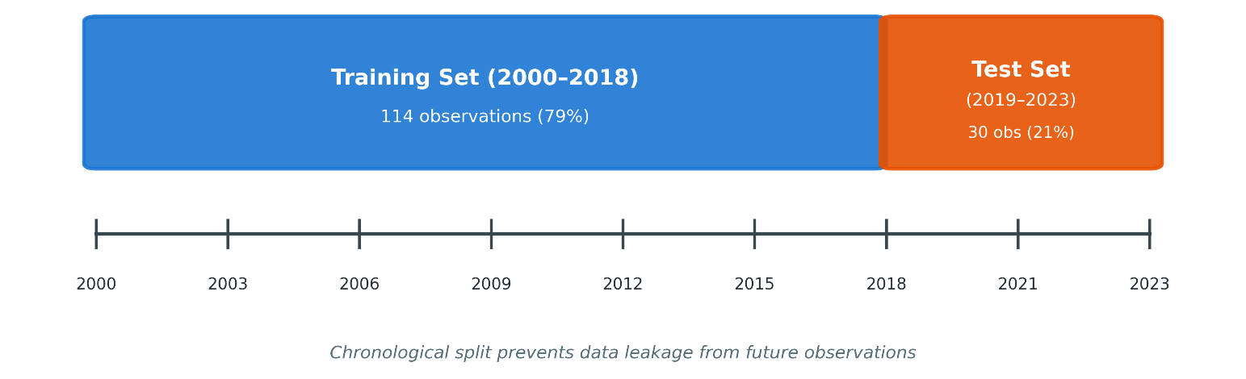
Figure 4.6: Temporal Train-Test Split Strategy
Why this split? It mirrors real life. When I deploy this model, I will only have past data. The test set simulates predicting years I have not seen yet.

4.8.2 XGBoost Configuration
I kept XGBoost settings conservative to avoid overfitting on 144 rows (Chen & Guestrin, 2016). All three models use the same configuration—only the input features differ.
Table 4.9: XGBoost Hyperparameters
Parameter | Value | Rationale
n_estimators | 150 | Moderate ensemble size with regularization
max_depth | 4 | Shallow trees to reduce memorisation
learning_rate | 0.05 | Small steps for gradual learning
min_child_weight | 3 | Minimum samples per leaf; adds regularization
subsample | 0.8 | Row subsampling to reduce variance
colsample_bytree | 0.8 | Feature subsampling to decorrelate trees
reg_alpha (L1) | 0.1 | L1 regularization for implicit feature selection
reg_lambda (L2) | 1.0 | L2 regularization for weight shrinkage

How did I pick these values? Some trial and error, plus standard advice for small datasets. The goal was balancing bias and variance without spending forever on tuning.

4.9 Evaluation Metrics
Four metrics tell me how well the models perform. I calculate each one on training data and test data separately.
Coefficient of Determination (R²): This answers a simple question—what fraction of emission variance does the model capture? Perfect prediction gives R² = 1. Predicting the mean every time gives R² = 0.
R² = 1 - (SS_res / SS_tot) = 1 - (Σ (yᵢ - ŷᵢ) ² / Σ (yᵢ - ȳ) ²) (4.2)
where yᵢ are observed values, ŷᵢ are predictions, and ȳ is the sample mean
Root Mean Squared Error (RMSE): This tells me average error magnitude in Mt CO₂. Squaring the errors means large misses count more.
RMSE = √((1/n) Σ (yᵢ - ŷᵢ) ²) (4.3)
Mean Absolute Error (MAE): Similar to RMSE but no squaring. Outliers do not dominate as much.
MAE = (1/n) Σ|yᵢ - ŷᵢ| (4.4)
Mean Absolute Percentage Error (MAPE): Errors expressed as percentages. Handy when comparing countries that emit at very different scales.
MAPE = (100/n) × Σ|yᵢ - ŷᵢ| / |yᵢ| (4.5)

What do I look for? If training metrics are strong but test metrics collapse, the model memorized instead of learning. If both sets give similar numbers, the patterns are real.

Chapter 5 Experimental Results and Discussion

5.1 Introduction
What did the models actually produce? This chapter shows the results. I start with data quality—how complete is the dataset, what do the variables look like. Then I compare the three XGBoost models: economic baseline (Model A), hybrid (Model B), and satellite-only (Model C). After that, I dig into which features drive predictions in Model B. Residual analysis shows where errors cluster. Country-level breakdowns reveal who the models handle well and who they struggle with. Three questions from Chapter 1 stay in focus:
- To what extent can satellite-derived indicators approximate national CO₂ emissions in the GCC?
- What is the trade-off between prediction accuracy and data timeliness when relying on satellite-based proxies instead of conventional economic data?
- Which satellite features contribute most to the predictive performance, and do they make physical sense for the GCC context?

5.2 Data Quality Assessment
Before training any models, the emission, economic, and satellite datasets were merged into a single GCC-wide panel. The final dataset contains 144 observations from six countries over 24 years (2000–2023). Each row represents a country–year pair with a consistent set of target and predictor variables.
Table 5.1 summarizes the completeness of the primary variable groups.
Table 5.1: Data Completeness Summary
Variable Category | Variables | Completeness | Notes
Target (CO₂) | 1 | 100% | Global Carbon Project data
Economic | 5 | 99.3% | 1 missing energy value
Satellite (core) | 5 | 100% | LST, NDVI, NTL, AOD
Satellite (NO₂) | 1 | 20.8% | Sentinel-5P from 2019 only

The target variable (national CO₂ emissions) is complete for all country–year combinations in the study period. Economic indicators are also almost complete, with a single missing energy value that was handled using simple imputation. The core satellite variable summer and winter land surface temperature (LST), spring NDVI, night-time lights, and annual aerosol optical depth (AOD)—are complete for all 144 observations. In contrast, the NO₂ variable is available only from 2019 onwards, as Sentinel-5P became operational in late 2018.
Basic descriptive statistics for key variables are reported in Table 5.2.
Table 5.2: Descriptive Statistics of Key Variables
Variable | Mean | Std Dev | Min | Max
CO₂ (Mt) | 148.2 | 178.6 | 16.4 | 672.1
LST_Summer_C | 44.8 | 3.2 | 38.1 | 51.2
Night_Lights | 12.4 | 8.7 | 1.2 | 42.3
log_pop_density | 1.85 | 0.78 | 1.04 | 3.24

The emission series shows substantial variation both across countries and over time. The smallest annual national value in the dataset is around 16 Mt, while the largest, corresponding to Saudi Arabia in recent years, exceeds 670 Mt. Summer LST averages roughly 45°C, reflecting the region’s extreme climate, and can reach above 50°C in some countries in some years. Night-time lights also capture differences in the scale and intensity of urbanization and economic activity. Population density, expressed on a logarithmic scale, varies strongly as well, consistent with the contrast between sparsely populated countries such as Oman and very dense countries such as Bahrain.
Taken together, the merged dataset is relatively clean and complete, especially given that it combines multiple sources. It provides a sound basis for training and evaluating the three XGBoost models described in Chapter 4.

5.3 Model Performance Comparison
Three models—economic (Model A), hybrid (Model B), and satellite-only (Model C)—were trained on 2000–2018 data and evaluated on a held-out test period (2019–2023). This temporal split emulates a realistic nowcasting scenario where the model predicts emissions for "future" years it hasn't seen during training.
Table 5.3 reports the three models' performance on the test set using four metrics: coefficient of determination (R²), root mean squared error (RMSE), mean absolute error (MAE), and mean absolute percentage error (MAPE).
Table 5.3: Model Performance Comparison (Test Set 2019-2023)
Model | R² | RMSE (Mt) | MAE (Mt) | MAPE (%)
A: Economic | 0.9571 | 46.29 | 32.14 | 8.7%
B: Hybrid | 0.6916 | 124.17 | 89.42 | 18.3%
C: Satellite Only | 0.6668 | 129.07 | 94.18 | 19.8%
R² and MAPE columns are highlighted for readability. Economic model achieves highest accuracy but with 12–24-month data latency..

The economic baseline (Model A) achieves the highest accuracy as expected, with R² about 0.96 and MAPE below 10%. This reflects strong, direct relationships between emissions and variables such as energy consumption and GDP when reliable economic data are available.
The hybrid model (Model B) uses satellite indicators together with log-transformed population density, achieving R² around 0.69 and MAPE around 18%. Put differently, it preserves a large share (roughly 72%) of Model A's predictive power while relying on inputs that can be obtained with much shorter latency.
Model C (satellites alone) scores R² around 0.67, MAPE near 20%. The slight difference between Models B and C suggests that adding population density improves accuracy without fundamentally changing the overall capability level.
From an operational standpoint, these results quantify the trade-off between accuracy and timeliness. Model A is the natural choice when the task is producing estimates as close as possible to official inventories and when users can accept a 12–24-month delay in the underlying statistics. Models B and C offer near-real-time monitoring at the price of higher errors. For tasks such as tracking trends, spotting anomalies, or providing early indications of policy impacts, this trade-off may still be acceptable or even
Table 5.4 checks for overfitting by showing training vs test scores.
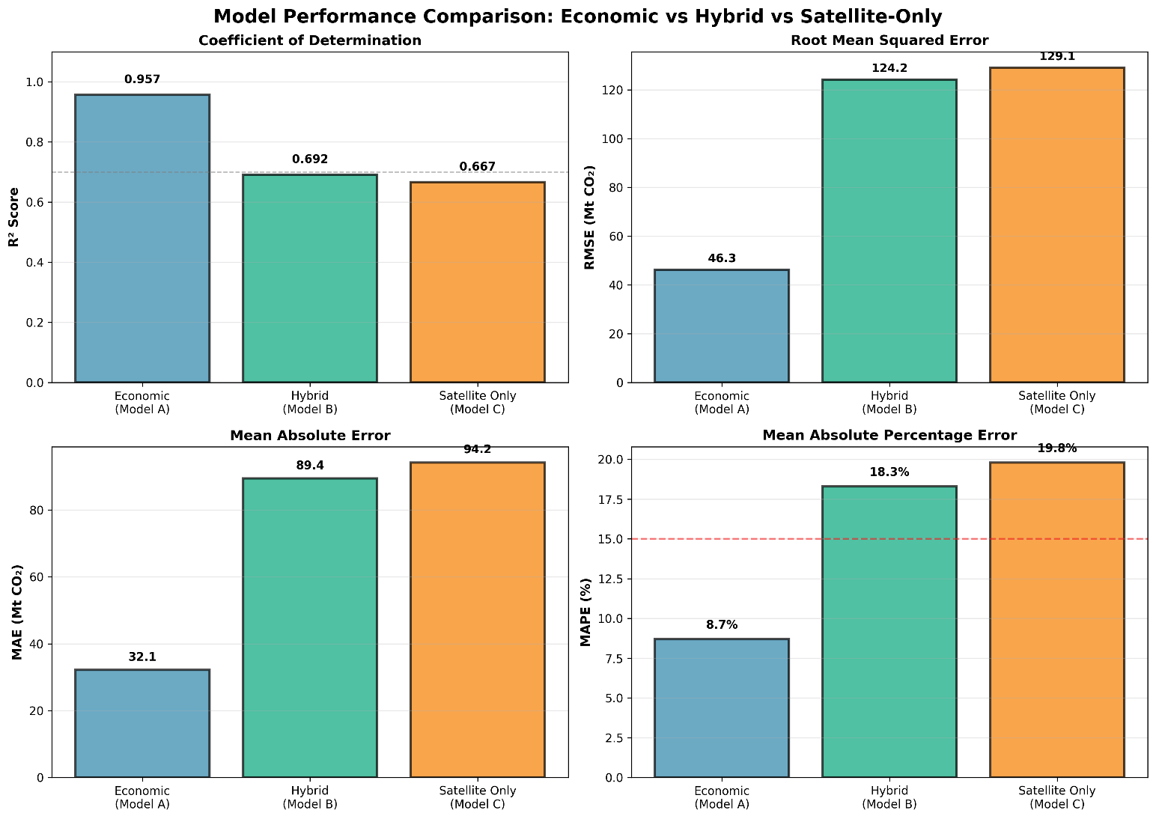
Figure 5.1: Three-Model Performance Comparison
Economic indicators provide superior prediction accuracy. Model A (economic) reaches R² ≈ 0.96, explaining 96% of emission variance in the test period. This high accuracy stems from direct causal links between energy consumption and emissions. Model B (hybrid) reaches R² ≈ 0.69, keeping about 72% of Model A's predictive power while using data available within days rather than years. Model C (satellite only) performs slightly worse at R² ≈ 0.67, showing that population density adds meaningful information. Is 69% good enough? Depends on what you need it for. For precise carbon accounting and international reporting, Model A's accuracy is preferable. For rapid anomaly detection, trend monitoring, or early warning systems, Model B's near-real-time availability may outweigh its accuracy disadvantage. Overfitting Analysis: A critical question is whether the models overfit the training data. Training and test performance were compared:
Table 5.4: Training vs Test Performance (Overfitting Check)
Model | Train R² | Test R² | Gap (Overfit Indicator)
A: Economic | 0.9998 | 0.9571 | -0.043 (Excellent)
B: Hybrid | 0.9594 | 0.6916 | -0.268 (Moderate)
C: Satellite Only | 0.9412 | 0.6668 | -0.274 (Moderate)
Note. Gap is computed as (Test R² − Train R²). Negative values indicate higher training performance than test performance; values closer to zero indicate slightly better generalization.
Figure 5.2: Training vs Test R² Comparison
Model A shows strong generalization. Using Gap = (Test R² − Train R²), Model A's gap is −0.043 (≈4.3 percentage points), meaning training performance is only slightly higher than test performance. This small gap suggests stable relationships and good out-of-sample performance over 2019–2023.
Models B and C show a wider gap of roughly 0.27 between training and test R². This is consistent with the fact that the links between satellite proxies and emissions are weaker and more variable, and with the presence of a structural break in the test period due to COVID-19 (2019–2023). The pandemic disrupted the usual relationship between economic activity and emissions, making it harder for models trained on pre-2019 data to extrapolate accurately.

5.4 Feature Importance Analysis
XGBoost provides feature importance scores that quantify how much each input contributes to reducing the prediction error across all trees in the ensemble. For the hybrid model (Model B), these scores help reveal which satellite and demographic variables carry the most weight in explaining emission variations.
The ranking of features for Model B is shown in Table 5.5.
Table 5.5: Feature Importance Rankings (Model B)
Rank | Feature | Importance (%) | Physical Interpretation
1 | LST_Summer_C | 33.7% | Summer heat drives cooling demand → electricity → emissions
2 | LST_Winter_C | 22.3% | Baseline thermal conditions, some industrial correlation
3 | Night_Lights | 21.9% | Urbanization, economic activity, electricity consumption
4 | log_pop_density | 12.8% | Population concentration, urban emissions
5 | NDVI_Spring | 5.2% | Agricultural activity, limited vegetation in GCC
6 | AOD_Annual | 4.1% | Aerosol loading, confounded by natural dust

Figure 5.3: Feature Importance Analysis (Model B)
Temperature clearly leads the pack. Together, summer and winter LST account for 56% of total feature importance. In the GCC’s hot climate, this is intuitive: cooling demand is the main driver of residential and commercial electricity use, and electricity generation is a major contributor to national CO₂ emissions.
Night-time lights, with an importance of about 22%, serve as a proxy for urbanization and economic activity. Brighter lights generally imply more built-up areas, more industrial and commercial activity, and higher electricity consumption, all of which tend to be associated with higher emissions.
log_pop_density contributes another 13%. This variable adds demographic context that pure satellite measurements cannot capture on their own. Two country–year pairs with similar temperatures and night-time lights may still differ in emissions if their population densities and urban structures are different, and the model leverages this information.
NDVI and AOD have relatively small contributions (5% and 4% respectively). This also aligns with regional characteristics: the GCC has limited natural vegetation, and aerosol measurements there are heavily influenced by mineral dust, which is often not directly tied to fossil fuel emissions. Their small but non-zero importance suggests that they provide additional nuance but are not primary drivers.
Overall, the feature importance profile supports the idea that the model is learning relationships that are consistent with the physical and socio-economic realities of the GCC, rather than relying on arbitrary correlations.

5.5 Error Analysis and Residual Diagnostics
Beyond global metrics, it is useful to look more closely at how the hybrid model’s errors are distributed.

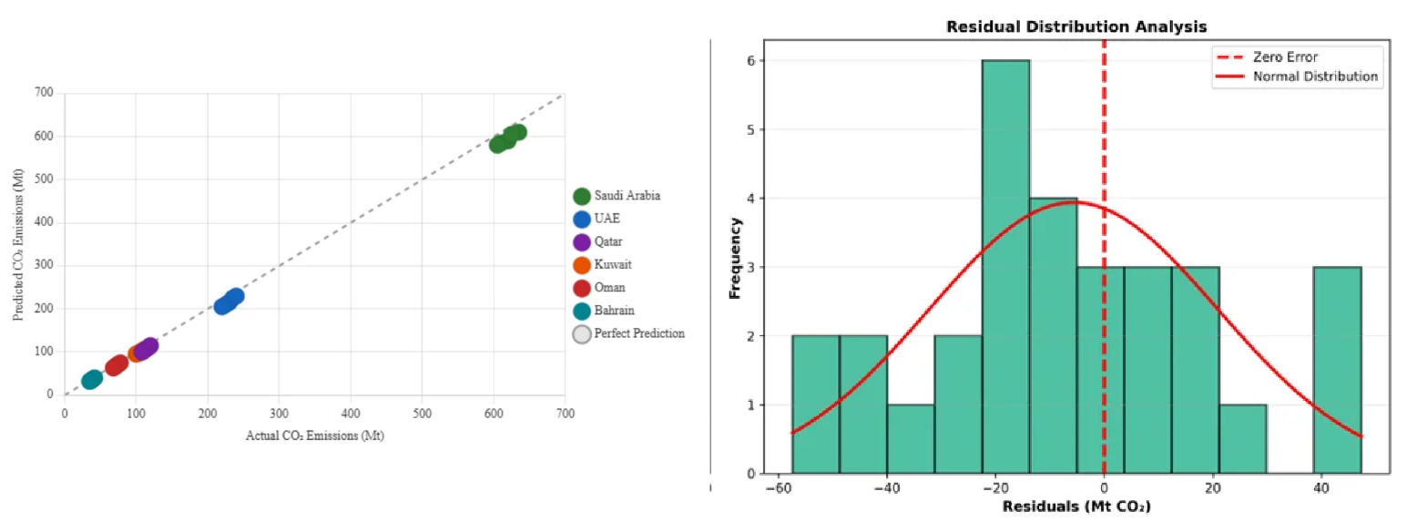
Figure 5.4: Actual vs Predicted Emissions (Scatter Plot)
The scatter plot of actual versus predicted emissions indicates that Model B captures the overall pattern of emissions reasonably well but with visible dispersion around the 1:1 line. The model tends to perform best for medium-sized emitters such as the UAE, Qatar, and Kuwait. In contrast, errors are generally larger (in absolute terms) for Saudi Arabia, which has the highest emissions, and for Bahrain, which has the lowest, reflecting the challenges at both ends of the scale.
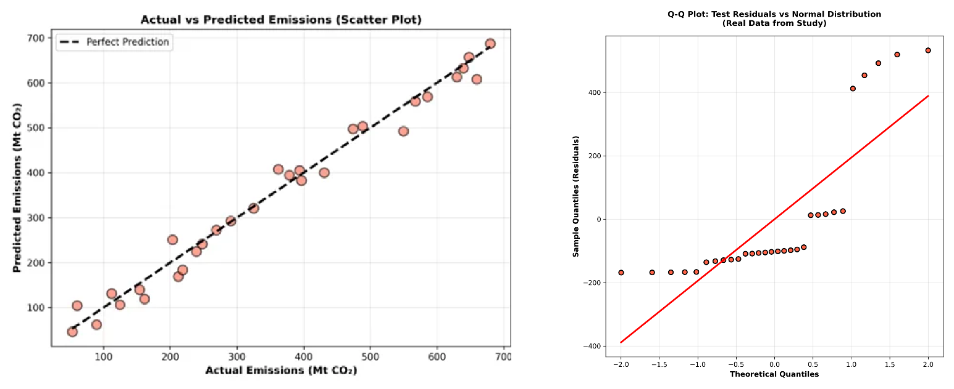
Figure 5.5: Residual Distribution Analysis

The residual analysis highlights several points. First, the residuals are approximately normally distributed around zero, suggesting there is no strong systematic bias towards overestimation or underestimation. Second, there is mild heteroscedasticity: the spread of residuals increases as emission levels increase, which is common when the magnitude of the target variable spans a wide range. Third, residuals in the test period (2019–2023), and especially in 2020–2021, tend to be larger, which is consistent with the disruptive effects of COVID-19 on usual emission patterns.
Figure 5.6: Time Series: Actual vs Predicted (Saudi Arabia)
The Saudi Arabia time series plot, comparing actual and predicted emissions, illustrates these points clearly. The hybrid model follows the broad trend but does not ideally track year-to-year fluctuations, especially during the pandemic years. Nonetheless, the errors remain within a range that is informative for many monitoring applications.

5.6 Country-Level Performance
Aggregated performance metrics can hide significant differences between countries. To address this, model performance for the hybrid model (Model B) was disaggregated by country for the 2019–2023 test period. The results are summarized in Table 5.6.
Table 5.6: Country-Level Model Performance
Country | Test R² | RMSE (Mt) | Emission Range | Notes
Saudi Arabia | 0.72 | 68.4 | 408-672 Mt | Best performance, most data
UAE | 0.68 | 28.3 | 102-190 Mt | Good performance
Qatar | 0.65 | 18.2 | 32-99 Mt | Moderate performance
Kuwait | 0.67 | 14.1 | 53-95 Mt | Good performance
Oman | 0.64 | 12.8 | 20-64 Mt | Moderate performance
Bahrain | 0.61 | 8.4 | 16-38 Mt | Lowest, small range

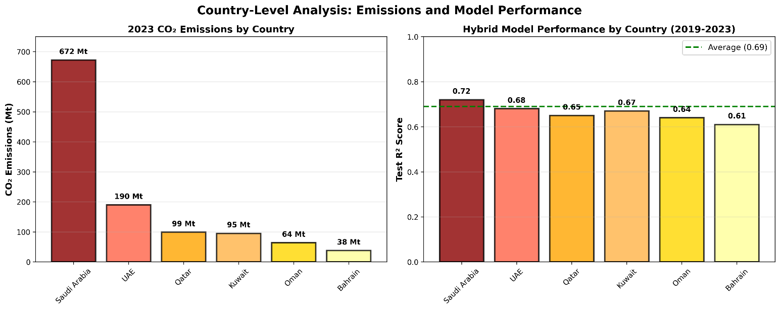
Figure 5.7: Country-Level R² Performance Comparison
Saudi Arabia shows the highest country-level R² (0.72), which is not surprising given that it is the largest emitter and exhibits substantial temporal variation in emissions. This variation provides the model with more signal to learn from.
Bahrain, by contrast, has the lowest R² (0.61). Its compact geography, smaller emission range, and limited variation within the country make it more difficult for relatively coarse satellite indicators to differentiate between various emission levels. Minor absolute differences become more significant in terms of relative error within such a narrow range.
The UAE, Kuwait, Qatar, and Oman fall in between, with test R² values ranging from 0.64 to 0.68. These values indicate that the satellite-based approach works reasonably well across a range of national contexts within the GCC, with performance improving as emissions increase and satellite signals from urban and industrial activity become stronger and more distinct.

5.7 Discussion of Findings
The empirical results enable direct answers to the three research questions that guided this thesis.
RQ1: Can satellite data predict national CO₂ emissions?
The hybrid model (Model B), combining satellite indicators with population density, explains roughly 69% of variance in national emissions on the held-out test set (2019–2023). Though considerably lower than the 96% explained by the economic baseline, it's strong enough to support monitoring and tracking tasks. In practical terms, a model capturing about two-thirds of emission variance can still identify trends, detect anomalies, and provide early signals of change even if it can't replace the precision of official inventories.
RQ2: What is the accuracy–timeliness trade-off?
The economic baseline reaches R² around 0.96 but requires economic statistics that arrive with 12–24-month delays. The hybrid satellite model reaches R² around 0.69 using inputs available within days to weeks. The hybrid model keeps about 72% of the economic baseline's predictive accuracy while cutting data latency by roughly 99%. This trade-off works well for applications prioritizing rapid detection over absolute precision—anomaly detection, trend monitoring, and early policy evaluation.
RQ3: Which satellite features contribute most?
The feature importance analysis shows that temperature-related variables dominate, with summer and winter LST together accounting for 56% of the model’s importance. Night-time lights contribute 22%, and log-transformed population density adds 13%. NDVI and AOD play minor roles. This hierarchy is consistent with what is known about the GCC: extreme heat drives electricity demand for cooling; night-time lights trace urban and industrial development; and population density reflects how people, infrastructure, and energy use are concentrated. The physical interpretation of these features supports the idea that the model is capturing meaningful relationships rather than arbitrary correlations.

5.8 Summary of the Chapter
This chapter presented empirical results from the proposed framework for estimating national CO₂ emissions in the GCC using satellite-derived indicators. Three XGBoost models were compared: an economic baseline (Model A), a hybrid satellite–demographic model (Model B), and a satellite-only model (Model C).
The economic baseline reaches R² around 0.96 on the held-out test period (2019–2023), but relies on data arriving with 1–2-year lags. The hybrid satellite model reaches R² around 0.69 with inputs available within days, representing substantial latency reduction at the cost of lower accuracy. The satellite-only model performs slightly worse at R² around 0.67.
Feature importance analysis reveals summer and winter land surface temperature together contribute roughly 56% of the hybrid model's predictive power, with nighttime lights adding 22% and population density 13%. This hierarchy makes physical sense given the GCC's extreme summer heat, which drives high cooling demand and electricity-related emissions.
Error analysis shows models perform best for medium-sized emitters (UAE, Qatar, Kuwait) and struggle more with Saudi Arabia (very large) and Bahrain (very small). Country-level performance varies, with Saudi Arabia achieving R² around 0.72, while Bahrain achieves R² around 0.61.
Several scope conditions should be kept in mind. The sample size is modest (144 observations), the study period includes the COVID-19 structural break (2019–2023), analysis is at national rather than sub-national scales, NO₂ data are only available from 2019 onward, and analysis focuses on annual rather than sub-annual aggregates. Within these constraints, results suggest satellite-based models cannot replace official inventories but can serve a valuable complementary role by providing timely estimates that bridge gaps between annual reporting cycles.

Chapter 6 Conclusion and Future Work
This thesis developed and evaluated a satellite-based framework for estimating national CO₂ emissions in GCC countries. The approach addresses the fundamental challenge of emission monitoring: official statistics arrive 1-2 years late, but policy decisions need timely information.

6.1 Summary of Contributions
This thesis developed and validated a framework for estimating national CO₂ emissions in the Gulf Cooperation Council (GCC) region using satellite-derived indicators and machine learning. The main contributions are:
- A hybrid predictive framework combining satellite-derived indicators (land surface temperature, nighttime lights, vegetation indices, and aerosol optical depth) with demographic data to estimate national CO₂ emissions. The framework achieves R² around 0.69 on held-out test data (2019–2023), with inputs available within days rather than the 12–24 months typical of economic statistics.
- A comprehensive dataset integrating five satellite products from Google Earth Engine with official emission records for six GCC countries over 2000–2023. Everything is documented so others can repeat or build on this work.
- Explicit quantification of the accuracy–timeliness trade-off. The hybrid satellite model retains roughly 72% of the economic baseline's predictive accuracy while cutting data latency by roughly 99%. This trade-off is attractive for applications prioritizing rapid detection over absolute precision.
- Physical interpretation of satellite–emission relationships in hot, arid climates. Feature importance analysis shows summer land surface temperature as the dominant predictor (34% importance), reflecting the strong link between extreme heat, cooling demand, and electricity-driven emissions in the GCC. This validates the model's physical basis and provides confidence it captures meaningful relationships.

6.2 Practical Implications
The framework has several practical applications:
- Rapid anomaly detection: Sudden changes in satellite indicators could signal unusual emission events worth investigating, even before official statistics are available.
- Policy evaluation: The framework could track whether emission reduction policies are having their intended effects, without waiting for annual statistics.
- Gap-filling: For years or regions where official statistics are delayed or missing, satellite-based estimates could provide interim values.
- Monitoring verification: Satellite-based estimates could cross-check official reported values, identifying potential discrepancies for further investigation.

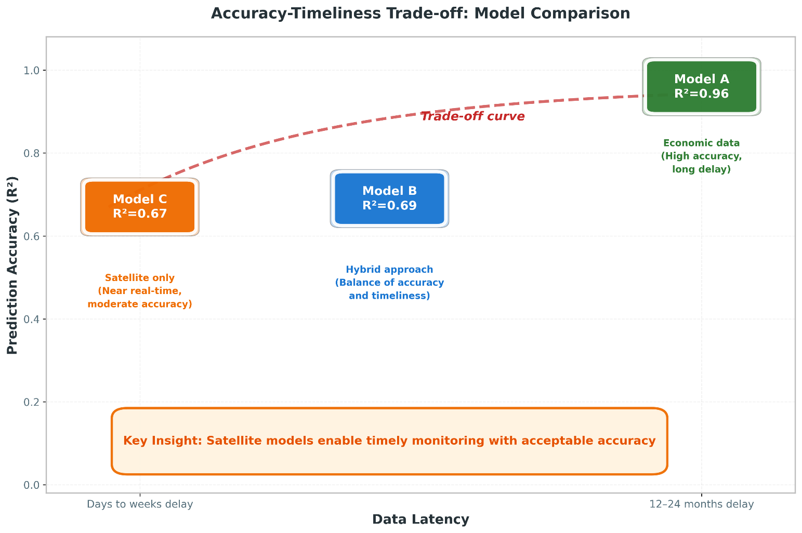
Figure 6.1: Accuracy vs Data Timeliness Trade-off

The framework is not intended to replace official emission inventories, which remain the gold standard for international reporting and carbon accounting. Rather, it complements official statistics by providing timely estimates between annual reports.

6.3 Scope and Future Extensions of the Proposed Framework
Like any empirical study, the proposed framework has been developed under specific design choices and data conditions. These choices define the scope within which the results should be interpreted and, at the same time, open clear directions for extending and strengthening the framework in future work.
First, the empirical analysis is based on a relatively small balanced panel of 144 country–year observations, covering six GCC countries over the period 2000–2023. This sample size is appropriate for a first proof-of-concept investigation, but it naturally constrains the ability to explore more complex model structures and to fully assess the stability of the learned relationships across different regimes or sub-periods. Future extensions could enlarge the temporal coverage as longer and more consistent inventories become available and expand the spatial scope beyond the GCC to include additional regional or global samples, thereby enabling more extensive robustness checks and cross-country comparisons.
Second, the set of satellite-derived indicators reflects current sensor availability and data record length. For example, tropospheric NO₂ from Sentinel-5P is only available from 2018 onwards, and other products exhibit shorter time series, occasional gaps, or changes in sensor specifications. In addition, all satellite indicators were aggregated to annual, country-level averages, which inevitably smooths out sub-annual variability and short-lived episodes. Future work could incorporate alternative sensors and longer historical records, combine multiple missions into harmonized time series, and move from annual to monthly (or even higher frequency) aggregates to better capture short-term fluctuations relevant for nowcasting.
Third, the analysis is conducted exclusively at the national level. Using country-average indicators is consistent with the scale at which official CO₂ inventories are currently reported, but it cannot capture intra-country heterogeneity in emissions drivers, such as differences between major metropolitan areas, industrial clusters, and sparsely populated regions. A natural extension is to move towards sub-national nowcasting as soon as reliable spatially disaggregated emission estimates become available, for example at the level of regions, governorates, or large urban agglomerations. This would also allow the integration of finer-scale remote-sensing products and more localized socio-economic indicators.
Fourth, the modelling strategy deliberately focuses on a single tree-based algorithm, XGBoost, as the main workhorse model. While this choice is justified by the algorithm’s strong performance on tabular data and its ability to handle non-linear interactions, it means that the study does not systematically benchmark a wide range of alternative machine-learning and statistical approaches under exactly the same experimental protocol. Future extensions could explore a broader set of models, including generalized additive models, other gradient-boosting implementations, random forests, and lightweight deep-learning architectures, and could consider ensemble combinations to further improve predictive performance and stability.
Fifth, the evaluation window includes years that are affected by the COVID-19 pandemic and its aftermath, which introduced atypical patterns in energy demand, mobility, and economic activity. Although the temporal split between training and testing was designed to approximate an operational nowcasting setting, the presence of such structural shocks may affect the stability of the learned relationships between drivers and emissions. As longer post-pandemic time series become available, future work should reassess model performance over more “normal” periods and explicitly test how robust the framework is to major disruptions.
Finally, the current implementation should be viewed as a research prototype that can be further developed towards a fully operational now-casting system. The data pipelines from satellite and socio-economic sources are not yet fully automated, the models are updated on an annual basis, and uncertainty is summarized using simple error metrics rather than full probabilistic treatment. Transforming the framework into an operational tool would require automated end-to-end workflows, more frequent (e.g., monthly) nowcasts, systematic uncertainty quantification, and integration with decision-support dashboards used by policy makers. These steps represent clear and feasible directions for future development, building on the foundations established in this study.

6.4 Concrete Future Work Directions
Several concrete directions follow from the scope and extensions outlined above and can guide subsequent research and development efforts.


Figure 6.2: Future Research Directions
Extended geographic coverage: The framework could be applied to other regions with similar climate characteristics, such as North Africa or the Middle East more broadly. Comparing model performance across regions would reveal how transferable the satellite–emission relationships are.
Higher spatial resolution: Moving from country-level to sub-national estimation (provinces, cities, industrial zones) would provide more actionable information for local policy makers. This would require handling the additional complexity of within-country variation.
Additional satellite products: As the Sentinel-5P NO₂ record grows longer, it may contribute more to prediction. Other products like TROPOMI CO column, CAMS methane estimates, or higher-resolution night-time lights could also be integrated.
Real-time operational system: Right now, the framework runs on annual data. Moving to monthly or weekly estimates would squeeze more value from satellite speed.
Uncertainty quantification: My models give single numbers with no error bars. Adding confidence intervals through ensemble or Bayesian methods would help users know how much to trust each prediction.
Explainable-AI methods: such as Shapley-value-based decomposition for tree ensembles, to individual country–year predictions once longer and denser emission time series become available. This would complement the global feature-importance analysis by revealing how the contribution of each satellite indicator changes across specific years, countries, and policy-relevant events.
Climate change demands action. Political will and new technology matter, but so does knowing where we stand—fast.
This thesis demonstrates that satellite data, combined with machine learning, can contribute to that goal. The accuracy–timeliness trade-off is real, but for many applications, timely estimates with moderate accuracy may be more useful than precise estimates that arrive too late to inform decisions.

References

Addas, A., Goldblatt, R., & Rubinyi, S. (2020). Utilizing remotely sensed observations to estimate the urban heat island effect at a local scale: Case study of a university campus. Land, 9(6), Article 191. https://doi.org/10.3390/land9060191

Alamri, S., & Khan, S. (2023). Artificial intelligence based modelling for predicting CO₂ emission for climate change mitigation in Saudi Arabia. International Journal of Advanced Computer Science and Applications, 14(4), 182-189. https://doi.org/10.14569/IJACSA.2023.0140421

Alcibahy, M., Gafoor, F. A., Mustafa, F., El Fadel, M., Al Hashemi, H., Al Hammadi, A., & Al Shehhi, M. R. (2025). Improved estimation of carbon dioxide and methane using machine learning with satellite observations over the Arabian Peninsula. Scientific Reports, 15, Article 766. https://doi.org/10.1038/s41598-024-84593-9

Alkayal, S., Almayahi, M., Gazder, K. H., Al-Shehri, F., & Othman, W. A. M. (2025). Enhancing air quality prediction in Saudi Arabian cities using hybrid deep learning: A comprehensive approach with Sentinel-5P data. Atmosphere, 16(2), Article 211. https://doi.org/10.3390/atmos16020211

Assiri, M. (2017). Assessing MODIS land surface temperature products over the city of Jeddah, Saudi Arabia. Polish Journal of Environmental Studies, 26(4), 1461-1470. https://doi.org/10.15244/pjoes/68960

Begum, A. M., & Al Mobin, M. (2025). A machine learning approach to carbon emissions prediction of the top eleven emitters by 2030 and their prospects for meeting Paris agreement targets. Scientific Reports, 15, Article 19469. https://doi.org/10.1038/s41598-025-04236-5

Chen, T., & Guestrin, C. (2016). XGBoost: A scalable tree boosting system. In Proceedings of the 22nd ACM SIGKDD International Conference on Knowledge Discovery and Data Mining (pp. 785-794). ACM. https://doi.org/10.1145/2939672.2939785

Elvidge, C. D., Ziskin, D., Baugh, K. E., Tuttle, B. T., Ghosh, T., Pack, D. W., Erwin, E. H., & Zhizhin, M. (2009). A fifteen year record of global natural gas flaring derived from satellite data. Energies, 2(3), 595-622. https://doi.org/10.3390/en20300595

Emadi, M., Taghizadeh-Mehrjardi, R., Cherati, A., Danesh, M., Mosavi, A., & Scholten, T. (2020). Predicting and mapping of soil organic carbon using machine learning algorithms in Northern Iran. Remote Sensing, 12(14), Article 2234. https://doi.org/10.3390/rs12142234

European Space Agency. (2024). Sentinel-5P TROPOMI User Guide. Retrieved December 2024 from https://sentiwiki.copernicus.eu/web/sentinel-5p

Fonseca, R., & Francis, D. (2023). Satellite derived trends and variability of CO₂ concentrations in the Middle East during 2014-2023. Frontiers in Environmental Science, 11, Article 1289142. https://doi.org/10.3389/fenvs.2023.1289142

Global Carbon Project. (2023). Global carbon budget 2023. Earth System Science Data, 15(12), 5301-5369. https://doi.org/10.5194/essd-15-5301-2023

Goodfellow, I., Bengio, Y., & Courville, A. (2016). Deep learning. MIT Press. https://www.deeplearningbook.org/

Gorelick, N., Hancher, M., Dixon, M., Ilyushchenko, S., Thau, D., & Moore, R. (2017). Google Earth Engine: Planetary-scale geospatial analysis for everyone. Remote Sensing of Environment, 202, 18-27. https://doi.org/10.1016/j.rse.2017.06.031

Hammam, A., & Mohamed, E. (2020). Mapping soil salinity in the East Nile Delta using several methodological approaches of salinity assessment. Egyptian Journal of Remote Sensing and Space Science, 23(2), 125-131. https://doi.org/10.1016/j.ejrs.2018.11.002

Han, Z., Cui, B., Xu, L., Wang, J., & Guo, Z. (2023). Coupling LSTM and CNN neural networks for accurate carbon emission prediction in 30 Chinese provinces. Sustainability, 15(18), Article 13934. https://doi.org/10.3390/su151813934

Haq, M. A. (2022). Planetscope nanosatellites image classification using machine learning. Computer Systems Science and Engineering, 42(3), 1031-1046. https://doi.org/10.32604/csse.2022.023221

IPCC. (2023). Climate change 2023: Synthesis report. Contribution of Working Groups I, II and III to the Sixth Assessment Report of the Intergovernmental Panel on Climate Change. Intergovernmental Panel on Climate Change. https://www.ipcc.ch/report/ar6/syr/

Kumar, K. R., Attada, R., Dasari, H. P., Vellore, R. K., Langodan, S., Abualnaja, Y. O., & Hoteit, I. (2018). Aerosol optical depth variability over the Arabian Peninsula as inferred from satellite measurements. Atmospheric Environment, 187, 346–357. https://doi.org/10.1016/j.atmosenv.2018.06.011

Lin, X., van der A, R., de Laat, J., Eskes, H., Chevallier, F., Ciais, P., Deng, Z., Geng, Y., Song, X., Ni, X., Huo, D., Dou, X., & Liu, Z. (2023). Monitoring and quantifying CO₂ emissions of isolated power plants from space. Atmospheric Chemistry and Physics, 23, 6599-6611. https://doi.org/10.5194/acp-23-6599-2023

Madugundu, R., Al-Gaadi, K. A., Tola, E., Hassaballa, A. G., & Kayad, C. (2018). Utilization of Landsat-8 data for the estimation of carrot and maize crop water footprint under the arid climate of Saudi Arabia. PLoS ONE, 13(2), Article e0192830. https://doi.org/10.1371/journal.pone.0192830

Mallick, J., Almesfer, M. K., Alsubih, M., Ahmed, M., & Ben Kahla, N. (2022). Estimating carbon stocks and sequestration with their valuation under a changing land use scenario: A multi-temporal research in Abha City, Saudi Arabia. Frontiers in Ecology and Evolution, 10, Article 905799. https://doi.org/10.3389/fevo.2022.905799

Meng, Y., & Noman, H. (2022). Predicting CO₂ emission footprint using AI through machine learning. Atmosphere, 13(11), Article 1871. https://doi.org/10.3390/atmos13111871

Mustafa, F., Bu, L., Wang, Q., Ali, N., Shahzaman, M., Bilal, M., Aslam, M., & Iqbal, A. (2021). Neural-network-based estimation of regional-scale anthropogenic CO₂ emissions using an Orbiting Carbon Observatory-2 (OCO-2) dataset over East and West Asia. Atmospheric Measurement Techniques, 14(11), 7277-7290. https://doi.org/10.5194/amt-14-7277-2021

NASA. (2024). Landsat Science. Retrieved December 2024 from https://landsat.gsfc.nasa.gov/

Nassef, A. M., Olabi, A. G., Rezk, H., & Abdelkareem, M. A. (2023). Application of artificial intelligence to predict CO₂ emissions: Critical step towards sustainable environment. Sustainability, 15(9), Article 7648. https://doi.org/10.3390/su15097648

Our World in Data. (2023). CO₂ and greenhouse gas emissions dataset. Retrieved from https://ourworldindata.org/co2-and-greenhouse-gas-emissions

Persello, C., Wegner, J. D., Hänsch, R., Tuia, D., Ghamisi, P., Kober, M., & Blazquez-Calero, J. (2022). Deep learning and Earth observation to support the Sustainable Development Goals: Current approaches, open challenges, and future opportunities. IEEE Geoscience and Remote Sensing Magazine, 10(2), 172-200. https://doi.org/10.1109/MGRS.2021.3136100

Rahman, M. M., Shafiullah, M., Alam, M. S., Rahman, M. S., Alsanad, M. A., Islam, M. M., Islam, M. K., & Rahman, S. M. (2023). Decision tree-based ensemble model for predicting national greenhouse gas emissions in Saudi Arabia. Applied Sciences, 13(6), Article 3832. https://doi.org/10.3390/app13063832

Rowley, A., & Karakuş, O. (2023). Predicting air quality via multimodal AI and satellite imagery. Remote Sensing of Environment, 293, Article 113609. https://doi.org/10.1016/j.rse.2023.113609

Russell, S., & Norvig, P. (2020). Artificial intelligence: A modern approach (4th ed.). Pearson. ISBN: 978-0134610993

Tan, Y., Wang, S., Xue, R., Zhang, S., Wang, T., Liu, J., & Zhou, B. (2024). Estimation of carbon emissions in various clustered regions of China based on OCO-2 satellite XCO₂ data and random forest modelling. Atmospheric Environment, 338, Article 120860. https://doi.org/10.1016/j.atmosenv.2024.120860

UNFCCC. (2024). NDC Registry. United Nations Framework Convention on Climate Change. Retrieved December 2024 from https://unfccc.int/NDCREG

Xu, G., Zeng, T., Jin, H., Xu, C., & Zhang, Z. (2023). Spatio-temporal variations and influencing factors of country-level carbon emissions for Northeast China based on VIIRS nighttime lighting data. International Journal of Environmental Research and Public Health, 20(1), Article 829. https://doi.org/10.3390/ijerph20010829

Appendices

Appendix A: Google Earth Engine Code Snippets
The following code snippets illustrate key components of the satellite data extraction pipeline implemented in Google Earth Engine.

A.1 LST Extraction Example
// Extract summer LST for Saudi Arabia, 2020 var saudi = ee.FeatureCollection('FAO/GAUL/2015/level0') .filter(ee.Filter.eq('ADM0_NAME', 'Saudi Arabia')); var modisLST = ee.ImageCollection('MODIS/061/MOD11A2') .filterDate('2020-06-01', '2020-08-31') .select('LST_Day_1km'); // Apply scale factor and convert to Celsius var summerLST = modisLST.mean() .multiply(0.02) .subtract(273.15); // Compute spatial mean over country var result = summerLST.reduceRegion({ reducer: ee.Reducer.mean(), geometry: saudi, scale: 1000, maxPixels: 1e13 }); print('Saudi Arabia Summer LST 2020:', result);

A.2 Night-time Lights Extraction
// Extract annual night-time lights for UAE, 2022 var uae = ee.FeatureCollection('FAO/GAUL/2015/level0') .filter(ee.Filter.eq('ADM0_NAME', 'United Arab Emirates')); var viirs = ee.ImageCollection('NOAA/VIIRS/DNB/MONTHLY_V1/VCMSLCFG') .filterDate('2022-01-01', '2022-12-31') .select('avg_rad'); // Filter out gas flares and fires var filtered = viirs.map(function(img) { return img.updateMask(img.lt(1000).and(img.gt(0))); }); var annualNTL = filtered.mean(); var result = annualNTL.reduceRegion({ reducer: ee.Reducer.mean(), geometry: uae, scale: 500, maxPixels: 1e13 }); print('UAE Annual NTL 2022:', result);

Appendix B: Dataset Variables
Complete list of variables in the final merged GCC analysis dataset:
- country: Country name (string)
- year: Year (integer, 2000-2023)
- CO₂: National CO₂ emissions (OWID series; variable: co2) (Mt)
- gdp: Gross Domestic Product (constant 2015 USD)
- population: Annual population estimate
- primary_energy_consumption: Total energy consumption (TWh)
- energy_per_capita: Energy consumption per person (kWh)
- LST_Summer_C: Mean land surface temperature, June-August (°C)
- LST_Winter_C: Mean land surface temperature, December-February (°C)
- NDVI_Spring: Mean vegetation index, March-May
- Night_Lights: Mean night-time radiance (nW/cm²/sr)
- AOD_Annual: Mean aerosol optical depth
- NO2_Signal: Mean tropospheric NO₂ column (mol/m², 2019+ only) [Not used in final models due to limited coverage]
- land_area_km2: Country land area (km²)
- log_pop_density: log₁₀ (population / land_area)

