جامعة ميدأوشن

كلية الإدارة
قسم / تخصص................

العنوان باللغة العربية

إدارة ا لمخاط في تنفيذ الخطة الوطنية للطوارئ للاتصالات
القمر جزر في

إعداد الطالب/

ابراهيم جوهرية

إشراف/
د.الفيصل عبد الحميد
د.فايز جراد

العام الدراسي:
2024

Content index:
A
Adaptation of ITU Guidelines .................................................. 32, 56, 57
Awareness Campaigns (Community) ..................................... 39, 63, 64
Action Plan for NETP Implementation .................................... 56, 57
B
Backup Systems (Telecommunications) .................................. 52, 57
Best Practices, International ................................................... 23, 56
C
Capacity Building .................................................................... 39, 41, 57, 63
Civil Protection Agency .......................................................... 38, 61
Communication Breakdown .................................................... 2, 52
Community Engagement .......................................................... 39, 63
Comoros, Union of .................................................................. 1, 2, 16, 38
Coordination Challenges .......................................................... 39, 54, 61
D
Data Analysis ............................................................................ 44, 51
Data Collection Methods ......................................................... 40, 41
Disaster Management ............................................................... 17, 19, 54
Disaster Preparedness ............................................................... 21, 23, 57
Disaster Resilience .................................................................... 28, 56
Diffusion of Innovation Theory ................................................ 31
E
Emergency Services ................................................................. 38, 52
Emergency Telecommunications ............................................. 1, 19, 52Ethical Considerations .............................................................. 47

F
Financial Constraints ................................................................. 4, 54, 57
Findings, Study ......................................................................... 49, 51Future Research Directions ...................................................... 70

G
Government Institutions ............................................................ 38, 61
Guidelines, ITU ......................................................................... 23, 32, 56
H
Hazards, Natural ........................................................................ 1, 19, 52
Humanitarian Coordination ...................................................... 56, 63
I
Infrastructure Weaknesses ......................................................... 52, 54, 57
Institutional Fragmentation ...................................................... 39, 54, 61
International Partners ............................................................... 56, 64
Interoperability of Systems ....................................................... 52, 62
K
Key Stakeholders ....................................................................... 38, 39
L
Limitations of the Study ........................................................... 46
Local Communities, Role of ..................................................... 38, 39, 63
M
Methodology ............................................................................... 34, 35
Mixed-Methods Design ............................................................. 35, 40
Monitoring and Evaluation ....................................................... 63, 64
N
National Disaster Risk Reduction Strategy (Comoros) ............ 23, 56, 83
National Emergency Telecommunications Plan (NETP) ......1, 2, 16, 52, 54, 57
NGOs (Non-Governmental Organizations) ................................ 38, 63
P
Preparedness, Disaster .............................................................. 21, 23, 57
Public-Private Partnerships ....................................................... 57, 61
Policy Reform ............................................................................ 54, 62
Population Sampling .................................................................. 39
Q
Questionnaire ............................................................................ 40, 41, 78
R
Recommendations ..................................................................... 60, 61
Redundancy in Telecommunications ......................................... 52, 57
Regulatory Frameworks ............................................................. 54, 62
Resilience Theory ...................................................................... 29
Risk Avoidance Strategies ......................................................... 16, 57
Risk Management Theory ......................................................... 28
Roles and Responsibilities .......................................................... 39, 61
S
Sampling Strategy ..................................................................... 39
Satellite Communication ............................................................ 52
SIDS (Small Island Developing States) .................................... 2, 19, 21
Stakeholder Coordination .......................................................... 39, 52, 61
Systems Theory ......................................................................... 30
T
Technical Capacity .................................................................... 38, 39, 41
Telecommunication Operators .................................................. 38, 52, 62
Training Programs ..................................................................... 39, 41, 63
Triangulation (Data Collection) ................................................ 40, 4
U
UNDRR (United Nations Office for Disaster Risk Reduction) .. 23, 56
Urban vs. Rural Coverage .......................................................... 52, 54

List of tables:

Table No. Title Page

Table 1.1 Natural Hazards Affecting the Union of the Comoros (Cyclones, Volcanic Eruptions, Floods, Tsunamis) 3
Table 1.2 Summary of Key Issues in Current Telecommunications System 5
Table 1.3 Study Objectives and Related Research Questions 9
Table 1.4 Scope of the Study Assignments 12
Table 1.5 Scientific Theories Used in the Research 14
Table 2.1 Comparative Analysis of Disaster Telecommunications in SIDS 20
Table 2.2 Summary of Previous Studies and Their Findings 22
Table 2.3 Gaps Identified in the Literature 25
Table 2.4 Key Elements of ITU Guidelines for NETPs 32
Table 3.1 Research Population by Stakeholder Group 38
Table 3.2 Sampling Framework and Size of Respondents 39
Table 3.3 Data Collection Tools and Purposes 41
Table 3.4 Questionnaire Structure and Variables 42
Table 3.5 Timeline for Data Collection and Analysis 44
Table 3.6 Ethical Considerations in the Research 47
Table 4.1 Overview of Current Emergency Telecommunications Infrastructure in the Comoros 52
Table 4.2 Frequency of Natural Disasters and Their Impact on Communication Systems 53
Table 4.3 Identified Risks and Challenges in NETP Implementation 54
Table 4.4 Stakeholder Perceptions of ITU Guidelines Applicability 56
Table 4.5 Proposed Risk Avoidance Strategies and Their Objectives 57
Table 4.6 Recommendations for Government, Telecom Operators, Communities, and International Partners 60
Table 4.7 Summary of Findings and Strategic Priorities 65
Table A.1 Questionnaire Response Rates by Stakeholder Group (Appendix) 78
Table A.2 Interview Participants by Institution 80
Table A.3 Policy Documents Reviewed and Their Sources 83

Index of shapes:

Figure No. Title / Description Page

Figure 1Map of the affected areas (Anjouan and Mohéli) 5
Figure 2 Human Impact – Number of affected people, injured, and displaced 7
Figure 3 Housing Damage – Completely and Partially Destroyed Houses 8
Figure 4 Agricultural and Livestock Damage Overview 9
Figure 5 Education Sector Damage – Classrooms and Schools Affected 10

Extract:Abstract

Chapter One
Introduction:
The Union of the Comoros, a small island developing state (SIDS) located in the Indian Ocean, is highly vulnerable to natural hazards such as cyclones, volcanic eruptions, floods, and tsunamis. These disasters pose significant threats to human lives, critical infrastructure, and socio-economic development. In such situations, reliable and resilient telecommunications are essential for coordinating emergency response, disseminating early warnings, and supporting recovery operations. Without an effective system of communication, the capacity of the state to manage crises and protect its population is severely limited.
Recognizing this need, the International Telecommunication Union (ITU) developed Guidelines for National Emergency Telecommunications Plans (NETPs) to support member states in establishing robust communication frameworks for disaster management. These guidelines emphasize preparedness, resilience, coordination, and the integration of modern technologies to ensure uninterrupted communication during emergencies. For the Comoros, aligning its national plan with ITU recommendations is not only a matter of compliance with international standards but also a strategic necessity for reducing disaster risks.
However, the successful implementation of such a plan is challenged by various risks. These include financial constraints, infrastructural vulnerabilities, limited technical expertise, weak institutional coordination, and low levels of community awareness. If not properly addressed, these challenges can undermine the effectiveness of the National Emergency Telecommunications Plan and compromise the country’s ability to respond to crises.
This study therefore focuses on risk avoidance strategies that can enhance the implementation of the National Emergency Telecommunications Plan in the Comoros. By identifying potential risks and proposing preventive measures, the study aims to contribute both scientifically and practically: scientifically, by enriching academic discussions on disaster risk reduction and telecommunications resilience in SIDS; and practically, by providing actionable insights for policymakers, institutions, and communities in the Comoros.

Study problem.

Comoros is one of the small islands developing state, faces recurring natural hazards such as cyclones, volcanic eruptions, floods, and tsunamis, which frequently disrupt communication networks and hinder disaster response operations. Although the International Telecommunication Union (ITU) provides clear guidelines for the establishment of National Emergency Telecommunications Plans (NETPs), the country continues to face serious difficulties in aligning its national strategies with these international standards. The major problem lies in the vulnerability of existing telecommunication infrastructure, which is often damaged during emergencies due to a lack of redundancy, poor maintenance, and limited investment in resilient technologies. Moreover, financial constraints and dependence on external aid reduce the government’s ability to modernize the sector and ensure continuity of services during crises. Institutional weaknesses, such as limited coordination between state agencies, emergency services, and private operators, also create gaps in preparedness and response. In addition, regulatory and policy frameworks are not fully developed to integrate emergency telecommunications into broader disaster management strategies. Finally, low levels of community awareness and limited technical expertise among local actors further exacerbate these challenges. Unless concrete risk avoidance strategies are developed and implemented, the effectiveness of the National Emergency Telecommunications Plan in the Comoros will remain compromised, leaving the population highly vulnerable to communication breakdowns in times of disaster.

The importance of the study

The importance of this study lies in its contribution to both the scientific field and the practical realities of disaster risk management in the Comoros. On the scientific level, the study enriches academic knowledge on the intersection between telecommunications resilience, disaster preparedness, and risk avoidance strategies. While much research has been carried out in larger and more developed contexts, limited attention has been given to small island developing states (SIDS), such as the Comoros, where vulnerabilities are multiplied due to geographic isolation, small market size, and limited resources. By examining the specific risks that hinder the implementation of a National Emergency Telecommunications Plan in the Comorian context, this study provides a valuable case study that can be used for comparative analysis with other SIDS facing similar challenges. It also contributes to the body of literature that links international frameworks, such as the ITU guidelines, with localized strategies of adaptation and implementation, thereby offering an academic perspective that bridges global standards and local realities. This scientific contribution is not only important for researchers in the field of disaster risk reduction and information and communication technologies, but also for policymakers and international organizations seeking to understand how best to support vulnerable nations.
On the practical level, the study is of great importance for the Comoros itself. It provides concrete recommendations that can guide policymakers, institutions, and telecom operators in strengthening the resilience of communication systems during emergencies. By identifying the main risks—such as infrastructural weaknesses, financial limitations, and institutional fragmentation—and by proposing strategies to avoid or mitigate them, the research offers actionable insights that can directly influence policy and planning. Furthermore, it highlights the role of community engagement and capacity-building, ensuring that the population is not only a beneficiary but also an active participant in the implementation of the National Emergency Telecommunications Plan. For government institutions, this study underscores the need for stronger inter-agency coordination and regulatory frameworks, while for telecom operators it points to the necessity of investing in redundancy, backup systems, and maintenance. International partners and donors can also use the findings to better tailor their support to the country’s specific needs.
Ultimately, the importance of this study is twofold: scientifically, it contributes to a deeper understanding of how international guidelines can be adapted to fragile and resource-constrained environments; and practically, it serves as a roadmap for enhancing the resilience and effectiveness of emergency telecommunications in the Comoros. By doing so, it not only strengthens national disaster preparedness but also safeguards lives and livelihoods, ensuring that communication systems truly serve as lifelines in times of crisis.
The overall objective of this study is to analyze and propose risk avoidance strategies that can support the effective implementation of the National Emergency Telecommunications Plan (NETP) in the Comoros, in line with the guidelines provided by the International Telecommunication Union (ITU). By focusing on the specific vulnerabilities and institutional realities of the country, the study aims to bridge the gap between international recommendations and local applicability, ensuring that emergency telecommunications systems can operate reliably before, during, and after disasters.
More specifically, the study seeks to achieve the following objectives:
- To examine the current state of emergency telecommunications in the Comoros.
This involves analyzing the strengths, weaknesses, and vulnerabilities of the existing infrastructure, policies, and institutional arrangements, in order to establish a clear baseline for the development of an effective NETP.
- To identify the key risks that hinder the implementation of the NETP.
These risks may include infrastructural fragility, financial limitations, regulatory and policy gaps, institutional coordination challenges, and low community awareness. Mapping these risks is essential to understanding the obstacles that must be addressed.
- To assess the relevance and applicability of ITU guidelines in the Comorian context.
While the ITU provides comprehensive recommendations for member states, their practical application requires adaptation to local realities. The study therefore aims to evaluate which aspects of the ITU framework can be directly applied, and which require modification to suit the country’s needs.
- To propose risk avoidance strategies for strengthening the implementation of the NETP.
Based on the analysis of risks and international best practices, the study will suggest concrete strategies to prevent or mitigate challenges. These may include infrastructural redundancy, improved financing mechanisms, stronger regulatory frameworks, inter-agency coordination, capacity-building, and public awareness campaigns.
- To contribute to both academic knowledge and practical policy-making.
The study aims not only to enrich the scientific literature on disaster telecommunications and risk management in small island developing states, but also to provide practical guidance that policymakers, telecom operators, and disaster management institutions in the Comoros can apply directly.
In summary, the objectives of this study are both diagnostic and prescriptive. On one hand, the research seeks to diagnose the challenges and risks associated with emergency telecommunications in the Comoros; on the other hand, it aims to prescribe feasible solutions aligned with international standards yet adapted to national realities. By achieving these objectives, the study will contribute to building a more resilient and effective emergency communication system that can safeguard lives, support coordination, and enhance disaster preparedness in the Comoros.

Study questions

To achieve the objectives of this research, it is essential to formulate guiding study questions that will orient the investigation and provide a clear structure for the analysis. The first question that arises is: What is the current state of emergency telecommunications in the Comoros? This question is fundamental because it helps establish a baseline by examining the existing infrastructure, technologies, and institutional arrangements that are already in place. Without understanding the current level of preparedness, it would be difficult to identify gaps or propose relevant solutions.
The second question is: What are the major risks and challenges that hinder the effective implementation of the National Emergency Telecommunications Plan (NETP) in the Comoros? In the context of a small island developing state, risks may be linked to limited financial resources, fragile infrastructures that are vulnerable to cyclones or volcanic activity, insufficient technical expertise, weak coordination among agencies, and low levels of public awareness. Identifying these risks in detail will help reveal the factors that prevent the country from fully benefiting from modern telecommunications during emergencies.
A third guiding question is: To what extent are the International Telecommunication Union (ITU) guidelines relevant and applicable to the Comorian context? The ITU has developed comprehensive recommendations for member states, but their implementation is often challenging in fragile economies with limited resources. It is therefore important to evaluate how much of the ITU framework can be directly applied in the Comoros, and which elements must be adapted to local conditions to ensure feasibility and sustainability.
The fourth question is more solution-oriented: What risk avoidance strategies can be developed to overcome these challenges and ensure the successful implementation of the NETP? Here, the study will move beyond problem identification and seek practical measures, such as strengthening redundancy in networks, promoting inter-agency collaboration, improving funding mechanisms, updating regulatory frameworks, and enhancing community engagement.
Finally, the fifth question expands the perspective: How can the implementation of such strategies contribute to both national resilience and international best practices in disaster risk management? By addressing this, the study situates the Comoros within a global framework, showing how lessons learned locally can contribute to broader knowledge sharing among small island developing states and disaster-prone countries.
Together, these study questions not only define the scope of the research but also ensure that the analysis remains both diagnostic and prescriptive. They guide the investigation from assessing the current situation, to identifying risks, to aligning with international guidelines, and finally to proposing sustainable strategies that will enhance resilience. In this way, the study questions form the backbone of the research and guarantee that its findings will have both scientific relevance and practical applicability.

Study assignments
In order to achieve its objectives and respond to the research questions, this study is structured around a set of specific assignments that define its scope, focus, and methodological orientation. These assignments represent the concrete tasks that will be undertaken throughout the research process and reflect both the analytical and prescriptive nature of the study.
The first assignment of the study is to analyze the current situation of emergency telecommunications in the Comoros. This task requires a detailed examination of the existing infrastructure, communication technologies, institutional frameworks, and operational mechanisms that are used during emergencies. By carrying out this assignment, the study will establish a baseline that makes it possible to understand what capacities are already available and where significant gaps remain.
The second assignment is to identify and categorize the risks that threaten the effective implementation of the National Emergency Telecommunications Plan (NETP). This involves a systematic review of the vulnerabilities that exist at different levels: infrastructural weaknesses, financial and budgetary constraints, institutional and regulatory gaps, coordination difficulties among stakeholders, and the limited level of awareness within the population. The study must also classify these risks according to their potential impact and likelihood, in order to propose effective strategies for risk avoidance.
A third assignment is to examine the relevance of ITU guidelines within the Comorian context. Since the International Telecommunication Union has developed a comprehensive framework for National Emergency Telecommunications Plans, it is essential to analyze to what extent these guidelines can be realistically applied in the Comoros, and where adaptations are required due to the country’s specific conditions as a small island developing state.
The fourth assignment is to design and propose risk avoidance strategies that can ensure the successful implementation of the NETP. This part of the study moves from diagnosis to prescription, by suggesting measures such as reinforcing network redundancy, developing backup communication systems, strengthening inter-agency coordination, improving financing models, modernizing regulatory frameworks, and building technical capacities at the national and community levels.
Finally, the fifth assignment is to evaluate the expected scientific and practical contributions of these strategies. This includes showing how the study enriches academic research on telecommunications and disaster management in vulnerable contexts, while also offering actionable recommendations for policymakers, institutions, and international partners.
Through these assignments, the study ensures that it not only identifies and analyzes the challenges facing emergency telecommunications in the Comoros, but also provides feasible and sustainable solutions. In doing so, it fulfills its dual mission: contributing to global academic discussions on risk management and offering concrete guidance to strengthen resilience in the Comorian context.
The scientific theory used to prepare the research
Every scientific study is guided by theoretical foundations that orient the research process, define its analytical framework, and ensure the credibility of its findings. This research on risk avoidance strategies for the implementation of the National Emergency Telecommunications Plan in the Comoros is grounded in several interrelated scientific theories that explain how societies manage risks, adopt technologies, and build resilience in the face of disasters.
First, the study is guided by the Risk Management Theory, which emphasizes the identification, assessment, and treatment of risks that may hinder the achievement of objectives. In the context of emergency telecommunications, this theory provides a framework for understanding how vulnerabilities in infrastructure, finance, and governance can threaten the effectiveness of a National Emergency Telecommunications Plan (NETP). By applying this theory, the study not only diagnoses risks but also proposes preventive measures to avoid or reduce their impact.
Second, the research draws upon the Resilience Theory, which explains the capacity of systems and societies to absorb shocks, adapt, and continue functioning under stress. For the Comoros, as a small island developing state highly exposed to natural hazards, resilience theory is essential for designing communication systems that remain operational before, during, and after disasters. The application of this theory ensures that proposed strategies go beyond short-term fixes and instead focus on long-term sustainability.
Third, the study incorporates the Systems Theory, which views telecommunications not as isolated technologies but as part of an interconnected system involving institutions, regulations, infrastructure, and communities. According to this theory, the failure of one element can compromise the entire system, while effective coordination among actors strengthens overall performance. Using this perspective, the research evaluates how government agencies, telecom operators, and international organizations must work together to ensure the success of the NETP.
In addition, the research is informed by the Diffusion of Innovation Theory developed by Everett Rogers, which explains how new technologies and practices are adopted within societies. This is relevant because implementing an NETP involves not only technical solutions but also changes in institutional behavior and community practices. Understanding the social dynamics of technology adoption helps explain potential resistance or delays and provides strategies to accelerate acceptance.
Finally, the study is also aligned with the ITU Guidelines for National Emergency Telecommunications Plans, which, although not a scientific theory in the strict sense, serve as an internationally recognized normative framework. These guidelines integrate elements of risk management, resilience, and systems thinking, making them a practical application of the theoretical approaches guiding this research. To sum up, this research is based on a multidisciplinary theoretical foundation that combines risk management, resilience theory, systems theory, and diffusion of innovation. Together, these theories provide a comprehensive scientific basis for analyzing challenges, identifying risks, and proposing realistic strategies for the Comoros. They ensure that the study is both scientifically rigorous and practically relevant, producing results that can contribute to academic knowledge while guiding policymakers and practitioners in the field of disaster telecommunications.
Chapter Two
Previous Studies and Theoretical Framework
-Introduction

The resilience of emergency telecommunications has been the subject of growing academic and policy-oriented research, especially in the context of disaster risk management. Reliable communication systems are widely recognized as lifelines during crises, enabling the coordination of emergency services, the dissemination of early warnings, and the mobilization of relief efforts. While extensive literature exists on disaster communications in developed contexts, limited attention has been paid to the vulnerabilities and adaptive strategies of Small Island Developing States (SIDS), such as the Comoros. This chapter reviews relevant previous studies, highlights the gaps in knowledge, and presents the theoretical framework guiding this research.

Previous studies
Studies on Disaster Risk Management and Telecommunications
Research in disaster risk management consistently emphasizes the critical role of telecommunications infrastructure in reducing vulnerability and enhancing resilience. According to Haddow and Bullock (2017), robust communication networks are indispensable for ensuring effective coordination among institutions during emergencies. Similarly, Alexander (2018) highlights that the failure of communication systems during disasters often exacerbates human and economic losses. Studies from countries prone to natural hazards, such as Japan and the Philippines, have demonstrated that investment in redundant and diversified communication systems significantly improves disaster preparedness and response.

Telecommunications in Small Island Developing States (SIDS)
SIDS face unique challenges due to geographic isolation, limited financial resources, and fragile infrastructure. Kelman (2019) argues that the vulnerability of SIDS is compounded by their small market size and dependence on external aid, which often restricts investment in resilient technologies. In a comparative study of Pacific islands, Connell (2020) found that weak institutional coordination and underdeveloped regulatory frameworks often undermine national disaster telecommunications strategies. These findings are highly relevant to the Comoros, where similar structural limitations persist.

International Guidelines and Best Practices

The International Telecommunication Union (ITU) has provided comprehensive guidelines for the development of National Emergency Telecommunications Plans (NETPs) which is already set in study by ANRTIC National Authority of Regulation of ITC according to ITU (2019), effective NETPs require an integrated approach that includes risk assessment, redundancy in infrastructure, stakeholder coordination, and community engagement. However, ITU prosposed to the regulator authority to take training of CAP (Common Alerting Protocol)and want also to help us to implement it .
What is CAP ?
Common Alerting Protocol (CAP) …
▪ … is a simple but general format for exchanging all-hazard emergency alerts and public warnings over all kinds of networks.
▪ … is an open, non-proprietary digital message format for all types of alerts and notifications.
▪ … allows a consistent warning message to be disseminated simultaneously over many different warning systems, thus increasing warning effectiveness while simplifying the warning task.
▪ … provides a template for effective warning messages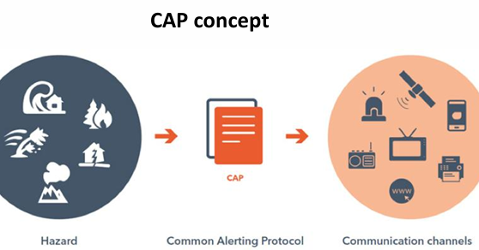

Gaps in the Literature

While existing research provides valuable insights into telecommunications and disaster risk management, there is limited literature focusing specifically on the Comoros. Most studies address broader SIDS contexts without considering the country’s unique vulnerabilities, such as frequent cyclones, volcanic risks, and weak institutional capacities. Moreover, few studies explore risk avoidance strategies in depth, particularly how they can be designed and implemented in alignment with ITU guidelines. This research therefore contributes to filling this gap by offering a focused analysis of the Comorian case.

Theoretical framework
The study is grounded in multiple interrelated theoretical perspectives that provide a comprehensive understanding of risk avoidance in emergency telecommunications:

1. Risk Management Theory
This theory emphasizes the systematic identification, analysis, and treatment of risks that threaten organizational objectives. In the context of this research, it provides a framework for understanding vulnerabilities in Comoros’ telecommunications systems and for designing preventive strategies to reduce their impact.
2. Resilience Theory
Resilience theory explains how systems can absorb shocks, adapt to changes, and maintain functionality during crises. Applying this perspective ensures that proposed strategies for the National Emergency Telecommunications Plan (NETP) are sustainable, enabling communication networks to operate before, during, and after disasters.

3. Systems Theory
Telecommunications systems are not isolated technologies but part of a larger network of institutions, policies, and infrastructures. Systems theory helps analyze the interdependencies among government agencies, telecom operators, and communities. It highlights the risks of systemic failure while also pointing to the benefits of strong inter-agency coordination.

4. Diffusion of Innovation Theory (Rogers, 2003)
Implementing a NETP involves not only technological solutions but also institutional and social change. Diffusion of Innovation theory explains how new practices and technologies are adopted within societies, offering insights into potential resistance and strategies for accelerating acceptance in the Comorian context.

5. ITU Guidelines as a Normative Framework
Although not a scientific theory, the ITU Guidelines for NETPs serve as a practical normative framework that integrates elements of risk management, resilience, and systems thinking. They provide international benchmarks against which the Comoros can design and adapt its national plan.

Conclusion

The literature demonstrates that while disaster telecommunications have been extensively studied in global contexts, there remains a significant gap regarding their implementation in SIDS such as the Comoros. By integrating insights from risk management, resilience, systems theory, and innovation diffusion, this study positions itself at the intersection of theory and practice. It builds upon international guidelines while addressing local realities, thereby contributing to both academic knowledge and practical policy-making.

Chapter Three
Study methodology

-Introduction.

The purpose of this chapter is to present the methodological approach adopted in this research. Since the study seeks to analyze risk avoidance strategies for the implementation of the National Emergency Telecommunications Plan (NETP) in Comoros, the chosen methodology integrates both qualitative and quantitative methods. This mixed-methods design allows for a comprehensive understanding of the challenges and opportunities by combining numerical data with contextual insights from key stakeholders.

-Methodology and research methods.
3.2 Research Design
The study adopts a descriptive and analytical research design. The descriptive component enables the researcher to document the current state of emergency telecommunications in the Comoros, while the analytical dimension focuses on identifying risks, assessing their impact, and evaluating possible strategies for risk avoidance. The mixed-methods approach provides a more holistic perspective by triangulating findings from different sources.

Research community

The target community of this research consists of stakeholders directly involved in emergency telecommunications and disaster risk management in the Comoros. These include:
Government institutions (e.g., Ministry of Telecommunications, Civil Protection Agency).
Telecommunication operators (both public and private).
Emergency services (POLICE, DGSC, and ANACM).
International organizations (notably the International Telecommunication Union Community representatives (local leaders, NGOs, and civil society organizations).

3.4 Sampling Strategy
Given the diversity of stakeholders, the study applies a purposive illustration technique. This non-probability sampling method is appropriate because it allows the researcher to select participants who possess relevant knowledge and expertise on emergency telecommunications. The sample size is expected to include approximately:
10 officials from government agencies
8 representatives from telecom operators, like Comores Telecom ,Yas comores
6 members of emergency services like (DGSC), ANACM…
5 representative from international or regional organizations (UNDRR),OVK, 10 community leaders of Comoros regulator ANRTIC
This distribution ensures that perspectives from policy, technical, operational, and community levels are adequately represented.

3.5 Data Collection Methods
To obtain rich and reliable data, the research employs multiple data collection instruments:
1. Questionnaire
A structured questionnaire is designed to collect quantitative data on perceptions of risks, institutional capacities, and preparedness levels
2. Semi-Structured Interviews
In-depth interviews with key informants (government officials, telecom managers, authority regulation and community leaders) provide qualitative insights into institutional coordination, financial constraints, and practical challenges.

3. Document Analysis
Secondary data, including ITU guidelines, national policy documents, and reports on disaster risk management in the Comoros, are already reviewed to contextualize findings according to ANRTIC.

3.6 Data Analysis
The analysis process combines both quantitative and qualitative techniques:
Quantitative data (from questionnaires) will be analyzed using descriptive statistics (frequency distributions, percentages, and averages). This will highlight the most frequently cited risks and levels of preparedness.
Qualitative data (from interviews) will be analyzed through thematic coding, identifying patterns and categories such as infrastructural weaknesses, financial constraints, institutional gaps, and community awareness.
The integration of these methods ensures a balanced interpretation that reflects both measurable trends and contextual realities.

Search limits
Like all studies, this research faces certain limitations:
Time constraints may limit the depth of interviews and the number of stakeholders reached.
Financial constraints could restrict travel to certain regions of the country. Access to information may be limited due to confidentiality of telecommunication data.
Respondent bias may occur if participants provide socially desirable answers rather than objective assessments.
Despite these limitations, the use of triangulated methods (questionnaires, interviews, and document analysis) enhances the credibility and reliability of the findings.

Chapter Four
Results and recommendations
Introduction
This chapter presents the results of the study and formulates recommendations for strengthening the implementation of the National Emergency Telecommunications Plan (NETP) in the Comoros. The findings are derived from the data collected through questionnaires, interviews, and document analysis. The results are structured around the main research questions: (1) the current state of emergency telecommunications, (2) the risks and challenges hindering implementation, (3) the relevance of ITU guidelines in the Comorian context, and (4) feasible risk avoidance strategies. The chapter concludes with recommendations aimed at policymakers, telecommunication operators, and community stakeholders.

Data analysis

Current State of Emergency Telecommunications in the Comoros

The analysis indicates that while basic telecommunication services are available, the overall system remains fragile. Existing infrastructure is limited in redundancy and vulnerable to natural hazards such as inondation cyclones Tsunami and volcanic eruptions. Network outages are common during crises, highlighting the urgent need for stronger backup systems and disaster-resilient infrastructure.

Risks and Challenges in Implementing the NETP

The study identifies several critical risks that hinder effective implementation:

Infrastructural weaknesses: Telecommunications facilities are concentrated in urban areas, with rural communities often underserved.

Financial constraints: Limited national budget and dependency on external aid restrict investments in modern and redundant technologies.
The national authority of regulation of ITC is now in charge to get a system of early warming for all but not yet established they are still searching to see how to get a way with the help of IUT according to them .
Institutional fragmentation: Coordination among government agencies, emergency services, and telecom operators is weak, leading to overlapping responsibilities and inefficiencies.

Regulatory gaps: Current policies do not fully integrate emergency telecommunications into the broader disaster management framework.

Low community awareness: Many citizens are unaware of the importance of emergency communication protocols, reducing the effectiveness of preparedness measures and this is due to the archaic methode of warming emergency in the country which is deserves to be tried .

Relevance of ITU Guidelines in the Comorian Context

The findings suggest that ITU guidelines provide a valuable framework, particularly regarding preparedness, redundancy, and multi-stakeholder coordination. However, their direct application faces challenges in Comoros due to resource constraints. Adaptation to local realities—such as prioritizing low-cost, community-based communication tools—is necessary for successful implementation.

National Disaster Management
In terms of legislation related to the institutional framework and coordination for disaster risk management, there does not appear to be a specific law in the Union of the Comoros that provides a comprehensive action framework. There are only laws that establish the institutional framework for disaster risk management (DRM).
However, the Union of the Comoros is currently in the process of developing a legislative and regulatory framework for disaster risk management in the country.

Proposed Risk Avoidance Strategies
Based on the results, several risk avoidance strategies emerge:
Infrastructure reinforcement: Develop redundant networks, satellite-based backup systems, and disaster-resistant facilities.Sustainable financing: Establish public-private partnerships and explore regional cooperation mechanisms to mobilize resources.
Institutional strengthening: Improve inter-agency coordination through the creation of a national task force dedicated to emergency telecommunications.
National Regulatory Authority of ITC (ANRTIC): Update telecommunications policies to explicitly integrate emergency response protocols and standards.
Community engagement:such as Launch awareness campaigns and capacity-building programs to ensure local populations actively participate in preparedness measures.

Results
The study confirms that while the Comoros recognizes the importance of emergency telecommunications, multiple vulnerabilities undermine the effective implementation of the NETP. Addressing infrastructural, financial, institutional, and community-related risks is essential for building a resilient national system like the CAP or CBS.

Recommendations
Based on the findings, the following recommendations are proposed:

1. For Government Institutions
Establish a centralized body for emergency telecommunications coordination.
Integrate the NETP into the broader national disaster risk management strategy. Strengthen partnerships with international organizations such as the ITU for technical and financial support.

2. For Telecommunication Operators
Invest in redundant and disaster-resilient infrastructure.
Conduct regular maintenance and simulation exercises to test system reliability. Collaborate with government agencies to share data and ensure interoperability during crises.

3. For Communities and Civil Society
Promote public awareness campaigns on emergency communication protocols.Train local volunteers in the use of community-based communication tools.Encourage citizen participation in preparedness and monitoring activities.

4. For International Partners
Provide targeted technical assistance and funding for infrastructure modernization. Support knowledge transfer and capacity-building programs tailored to the Comorian context .Facilitate regional cooperation among SIDS to share best practices and resources.

References
Local refrences
Government of the Union of the Comoros. (2022). National disaster risk reduction strategy. Moroni: Ministry of Interior.

Government of the Union of the Comoros. (2023). Telecommunications sector policy report. Moroni: Ministry of Posts, Telecommunications, and ICT.
Emergency Response Coordination Manual 2021 Civil Protection Agency, Comoros
Article of the General Direction of Civil Secuirity DGSC based on the disaster of kennet and Chido 2024

Arabic references
No arabic refrences

Foreign references
Alexander, D. (2018). Natural disasters. CRC Press.
Connell, J. (2020). Islands at risk? Environments, economies and contemporary change. The Geographical Journal, 186(3), 223–236. https://doi.org/10.1111/geoj.12312
Haddow, G., & Bullock, J. (2017). Introduction to emergency management (6th ed.). Butterworth-Heinemann.
Kelman, I. (2019). Islandness within climate change narratives of Small Island Developing States (SIDS). Island Studies Journal, 14(1), 25–44. https://doi.org/10.24043/isj.56
Moghadasi, M., Zare, M., & Ardestani, V. (2021). Risk communication and resilience in disaster management: Lessons for telecommunications. Journal of Disaster Risk Studies, 13(1), 1–12. https://doi.org/10.4102/jamba.v13i1.1043
Rogers, E. M. (2003). Diffusion of innovations (5th ed.). Free Press.
International Telecommunication Union. (2019). Guidelines for national emergency telecommunications plans. Geneva: ITU.
International Telecommunication Union. (2020). Strengthening emergency telecommunications for disaster resilience. Geneva: ITU.
United Nations Office for Disaster Risk Reduction (UNDRR). (2015). Sendai framework for disaster risk reduction 2015–2030. Geneva: UNDRR.

Appendices
The questionnaire
Questionnaire on Risk Avoidance Strategies for the Implementation of the National Emergency Telecommunications Plan (NETP) in the Comoros

Section 1: General Information
1. Name of institution/organization:
2. Your position/role: _________
> Please tick (✓) or fill in the appropriate box.

1. Location

[ ] Anjouan

[ ] Mohéli

2. Number of people affected in your area:
☐ ____
3. Number of injured people:
☐ ____
4. Number of homeless people:
☐ ____
5. Number of displaced people:
☐ ____
6. Houses completely destroyed:
☐ ____
7. Houses partially destroyed:
☐ ____

8. Agricultural damage (in %):
☐ ____ %

9. Livestock damage (in %):
☐ ____ %

10. Education sector damage:

Number of classrooms affected: ☐ ____

Number of schools affected: ☐ ____

1. Introduction

Following a natural disaster, an assessment was carried out to evaluate the extent of the damages across the 2 islands of Comoros : Anjouan and Mohéli.
The diagnostic aims to highlight the impact on human lives, housing, agriculture, livestock, and education, providing a clear overview for decision-making and recovery planning.

2. Human Impact
Moheli and Anjouan Total indicator
64,16747,05816,109 | People affected
235 | Injured
17110962 | Homeless
1408753 | Displaced

Analysis:
Anjouan was the most affected, representing 73% of the total affected population.
Homelessness and displacement are also higher in Anjouan, which indicates urgent needs for shelters.

3. Housing Damage
Total category and Anjouan Mohéli

433211 | Completely destroyed houses
966531 | Partially destroyed houses

Analysis:
Anjouan recorded three times more total destruction than Mohéli.Reconstruction efforts should prioritize 32 families in Anjouan who lost their homes completely

4. Agricultural and Livestock Damage
Sector Average Impact Anjouan Mohéli
45% 48% 42% | Agriculture
4% 5%<3% | Livestock

Analysis:
Agriculture was severely impacted, with almost half of the crops destroyed.
Livestock damage remains relatively low but still threatens food security, especially in Anjouan.

5. Education Sector Damage
Indicator Total
39 | Classrooms affected
18 | Schools affected

Analysis:
The education sector suffered moderate damage, with 39 classrooms damaged, affecting 18 schools.
This will disrupt education for hundreds of students unless rapid repairs are initiated.

6. Overall Situation

The crisis disproportionately impacted Anjouan, where damages to housing, agriculture, and population displacement are significantly higher.
Mohéli was less severely affected but still requires support in housing repairs and agriculture recovery.
Education recovery should be prioritized to prevent long-term disruption in children's schooling.

7. Recommendations

1. Immediate Humanitarian Aid
Provide emergency shelters for 171 homeless individuals.
Deliver food and medical support, especially in Anjouan.
2. Housing Reconstruction

Urgent rebuilding of 43 completely destroyed houses.
Repair of 96 partially damaged houses.
3. Agricultural Rehabilitation
Provide seeds and farming tools to restore agricultural production.
Support farmers with subsidies to reduce economic losses
4. Education Recovery
Rapid rehabilitation of the 39 affected classrooms.
Temporary learning spaces to continue education

Abstract

The Union of the Comoros, as a Small Island Developing State (SIDS) located in the Indian Ocean, is highly vulnerable to natural hazards such as cyclones, volcanic eruptions, floods, and tsunamis. These disasters frequently disrupt communication networks, thereby hindering emergency response, coordination, and recovery operations. Recognizing this challenge, the International Telecommunication Union (ITU) developed guidelines for National Emergency Telecommunications Plans (NETPs) to strengthen resilience and preparedness. However, the implementation of such frameworks in the Comoros faces multiple risks, including infrastructural weaknesses, financial constraints, institutional fragmentation, and limited community awareness.

The purpose of this study is to analyze risk avoidance strategies that can enhance the implementation of the NETP in the Comoros, in line with ITU recommendations. Specifically, the research examines the current state of emergency telecommunications, identifies major risks and challenges, evaluates the applicability of ITU guidelines in the Comorian context, and proposes preventive strategies to strengthen resilience.

Methodologically, the study employs a mixed-methods design, combining quantitative data collected through structured questionnaires with qualitative insights obtained from semi-structured interviews and document analysis. The research population includes government agencies, telecommunication operators, emergency services, international partners, and community representatives. Data analysis integrates descriptive statistics and thematic coding to ensure both scientific rigor and contextual depth.

The findings reveal that while the Comoros has taken important steps toward developing an NETP, significant vulnerabilities persist. Weak infrastructure, dependence on external funding, and gaps in institutional coordination remain major obstacles. Nevertheless, strategies such as strengthening redundancy in networks, promoting public-private partnerships, reforming regulatory frameworks, and enhancing community engagement can substantially reduce risks and improve the effectiveness of emergency telecommunications.

This study contributes scientifically by enriching academic discussions on disaster telecommunications and risk management in SIDS, and practically by offering actionable recommendations for policymakers, institutions, and international partners. Ultimately, it seeks to support the development of a more resilient and reliable emergency communication system that safeguards lives and strengthens disaster preparedness in the Comoros.

Keywords: Comoros, Small Island Developing States (SIDS), emergency telecommunications, risk avoidance strategies, disaster resilience, International Telecommunication Union (ITU)

PICTURES OF DISASTER IN COMOROS
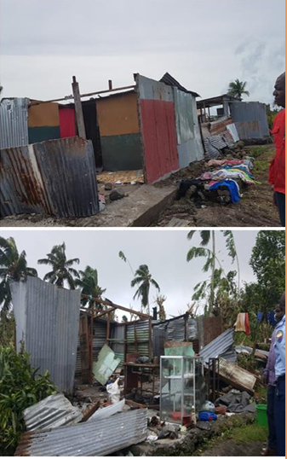

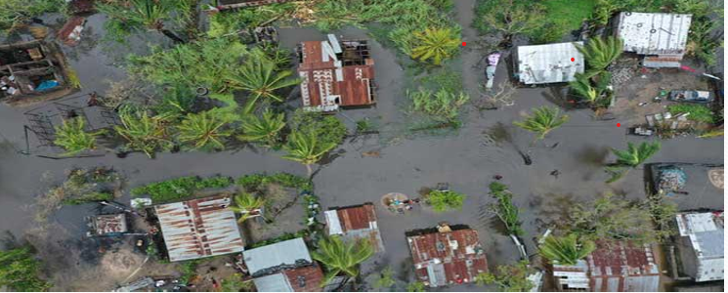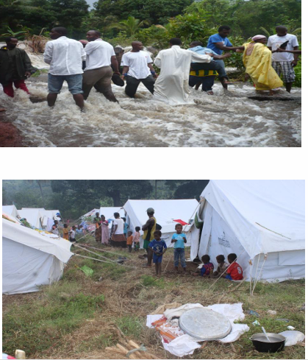

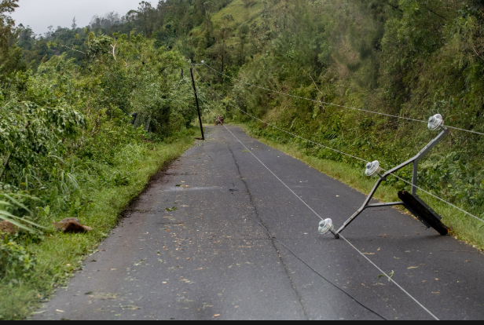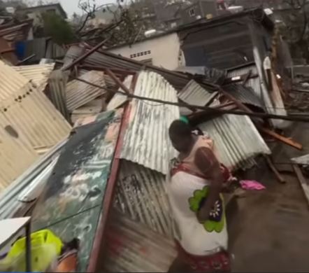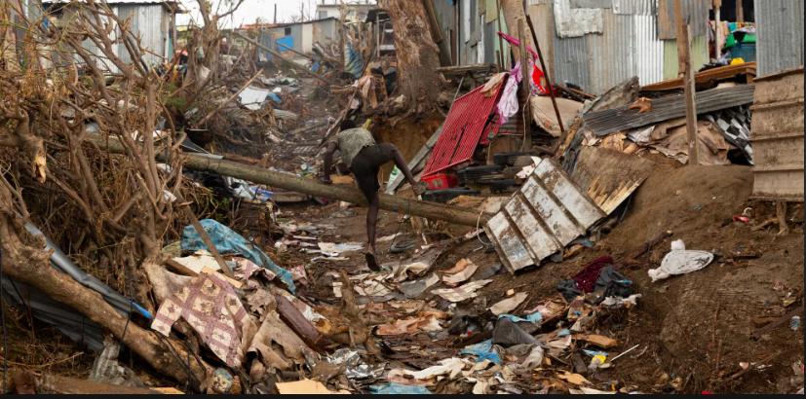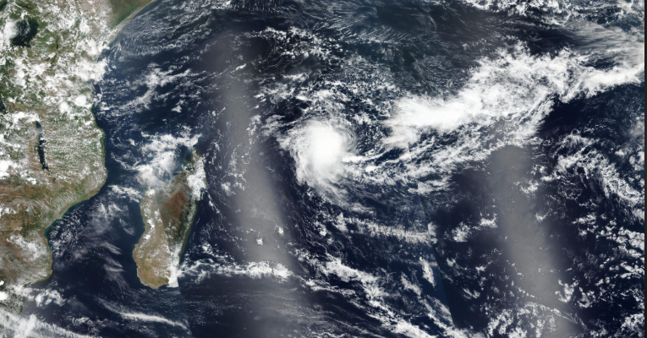


Midocean University
College of Management
Department of Project Management ……….

Title in English
Risk Management in the Implementation of the National Emergency Telecommunications Plan in the Comoros

Prepared by:
DJAOUHARIAT IBRAHIM MHOMA

Supervised by:

Year:2024

