

Deep Learning-Based Plant Disease Detection Using Leaf Image Analysis
Prepared By
Name: Sulaiman Fahad Alquwayfili ID No.:253000463
Name: Rahaf Amer Alsaiari ID No.: 253002788

Submitted in fulfillment of the requirements for the degree Master of Science in Artificial Intelligence
At
College of Informatics
Midocean University
UAE
Supervisor Name: Mohamed Eassa
Collage of Informatics, Midocean University, Comoros

Table of Contents
1
List of Abbreviation 5
List of Figures 6
List of Tables 7
Abstract 8
Chapter 1: Introduction 9
1.1 Overview 9
1.2 Problem Definition 11
1.3 Thesis Objectives 12
1.4 Thesis Contribution 12
1.5 Thesis Organization 13
Chapter 2 Background and Related Work 14
2.1 Introduction 14
2.2 Background 15
2.2.1 Artificial Intelligence (AI) 15
2.2.2 Machine Learning (ML) 16
2.2.3 Deep Learning 17
A. Convolutional Neural Networks (CNNs) 17
B. Transfer Learning 19
C. Feature Pyramid Networks (FPNs) 19
2.3 Related Work 20
2.4 Comparison of Existing Methods 28
2.5 Research Gap 30
Chapter 3 Methodology 31
3.1 Input (Dataset) 32
3.1.1 Classification Dataset 32
3.2 Image Preprocessing 33
3.2.1 Image Resizing 34
3.2.2 Image Normalization 34
3.2.3 Noise Reduction 35
3.2.4 Image Enhancement 35
3.2.5 Data Augmentation 35
3.2.6 Rotation 36
3.2.7Horizontal and Vertical Flip 36
3.2.8 Zoom 36
3.2.9 Width and Height Shift 36
3.3 Feature Learning 37
3.3.1 Convolutional Neural Network (CNN) 37
3.3.2 Feature Pyramid Network (FPN) 38
3.4 Transfer Learning 39
3.4.1Disease Classification 40
3.5 Prediction Output 41
3.6 Training Configuration 42
3.7 Performance Evaluation 42
3.7.1 Accuracy 43
3.7.2 Precision 43
3.7.3 Recall 43
3.7.4 F1-Score 44
3.7.5 Confusion Matrix 44
Chapter 4: Results and Discussion 45
4.1 Preprocessing and Visual Standardizations 45
4.2 Classification Performance 46
4.2.1 Xception 46
A. Per-Class Classification Performance 47
B. Confusion Matrix Analysis 48
C. ROC Curve Analysis 49
4.2.2 ResNet50 51
A. Per-Class Classification Performance 52
B. Confusion Matrix Analysis 52
C. ROC Curve Analysis 54
4.2.3 THE Techniques Results 56
4.2.4 Comparison with Related Work 57
4.3 Discussion 58
5. Conclusion 61
References: 63

List of Abbreviation

Abbreviation | Full Term
AI | Artificial Intelligence
ML | Machine Learning
DL | Deep Learning
CNN | Convolutional Neural Network
FPN | Feature Pyramid Network
TL | Transfer Learning
ROC | Receiver Operating Characteristic
AUC | Area Under the Curve
TPR | True Positive Rate
FPR | False Positive Rate
F1-score | F1-score
ViT | Vision Transformer

List of Figures

Figure 1: Example of a Diseased Plant Leaf Showing Visible Symptoms

Figure 2.1: General Workflow of Plant Disease Detection

Figure 3.1: Proposed Framework of Plant Disease Detection System

Figure 3.2: Image from Dataset

Figure 3.3: Image Before and After Preprocessing

Figure 3.3.1: CNN Architecture

Figure 3.3.2: Feature Pyramid Network (FPN)

Figure 4.1: Images Before and After Preprocessing

Figure 4.3: Confusion Matrix of the Xception Model for the Three Plant Disease Classes

Figure 4.4: ROC Curves of the Xception Model for Plant Disease Classification

Figure 4.5: Confusion Matrix of the ResNet50 Model for the Three Plant Disease Classes

Figure 4.6: ROC Curves of the ResNet50 Model for Plant Disease Classification

List of Tables

Table 2.1: Comparison of Existing Plant Disease Detection Methods

Table 4.1: Overall Performance of the Proposed Xception Model

Table 4.2: Per-Class Classification Performance of the Xception Model

Table 4.3: Overall Performance of the Proposed ResNet50 Model

Table 4.4: Per-Class Classification Performance of the ResNet50 Model

Table 4.5: Comparison of CNN, Xception, and ResNet50 Models

Table 4.6: Comparison of the Proposed ResNet50 Model with Related Work

Abstract
Detection of plant disease is one of the most important tasks contributing to food security and increasing the yield of agricultural lands. The conventional mode of plant disease diagnosis by specialists is expensive and requires labor. This method of disease diagnosis can be slow and susceptible to human errors especially in large, cultivated lands. Machine learning techniques, especially deep learning and computer vision have facilitated the design of fully automated systems that can detect diseases in plants by classifying leaf images. This work presents a deep learning model for automated plant disease classification based on the ResNet50 architecture by utilizing transfer learning. The images from the PlantVillage dataset were preprocessed and image augmentation was used to boost the image data size and increase data diversity. The proposed ResNet50 model was trained and tested under the same conditions showing a validation accuracy and loss of 99.42% and 0.0228 respectively. All parameters of precision, recall and F1-scores were nearly 99.42%. The confusion matrix shows that all leaf images have been classified correctly in almost all circumstances. In conclusion, this paper introduces a ResNet50-based model that shows good performance.AUC of ROC curves for Pepper Bell Bacterial Spot, Pepper Bell Healthy, and Potato Early blight are 0.999, 0.999 and 1.000 respectively.

Chapter 1: Introduction

1.1 Overview
The agriculture sector has witnessed significant development in recent years due to rapid advancements in artificial intelligence (AI), computer vision, and data-driven technologies [1]. These technologies have enabled the development of intelligent systems capable of analyzing large volumes of agricultural data and supporting decision-making processes. However, despite all technological advancements that has been achieved, plant diseases is considered as one of the major obstacles influencing quality, quantity of crops produced and agricultural productivity everywhere in the world [2]. Disease on crops can spread fast on unfavorable environmental circumstances and hence that could cause massive financial loss and jeopardized the safety of worldwide food supply [3]. A precise and prompt identification of plant diseases is compulsory to guarantee the reduction of crop loss and the improvement of efficiency of cultivation process. Currently, human-based diagnoses are the dominant method in this area which heavily depend on manual evaluation by horticultural specialists. Even though that works quite nicely it has the drawbacks of being too costly, labor consuming and doesn't suitable for covering a big farm space [2]. Additionally, it greatly rely on human expertise, thus leading to erroneous or imprecise diagnoses in situations with adverse working conditions [4].

Nowadays, the advent of deep learning technologies and digital images processing methods has made automated tools really valuable for detecting plant diseases [5]. In particular, deep learning methods particularly the convolutional neural network (CNN) models, due to their capacity for dealing with high-level feature extraction and classification [6], have produced remarkable results on classifying and analyzing plant leaf images, and also recognizing plants based on leaf appearances. Advanced algorithms such as vision transformers and hybrid deep learning models are expected to improve the system in both classification accuracy and robustness [8]. In this paper, we describe our effort to create a model-driven AI technique aiming for classifying a set of diseases in various kinds of plants using images taken from their leaves. Our system would enable various people, such as researchers, practitioners and farmers, to diagnose the various kinds of plant diseases quickly. As illustrated in Figure1, visually recognizable signs can be identified from leaf samples such as discoloring patterns, spotted ones, texture change which computer vision techniques will be employed for the detection of the disease from its earliest stages.

Therefore, our approach consists of an efficient pipeline for the development and evaluation of models that analyze image data taken from the plant’s leaves and identify potentially occurring illnesses with the use of computer vision and deep learning algorithms, as in image preprocessing, feature extraction and classification using machine learning state of the art methods, finally, identifying the healthy or infected state of plant leaf by applying our algorithm on high level classes of learned deep neural network model. This project aims to build automated intelligent systems that can automatically diagnose plant diseases in a consistent, fast, reliable manner for the purposes of helping farmers implement preventive measures and develop prevention policies, as modern smart farming applications grow, demand for such automated system increased [5].

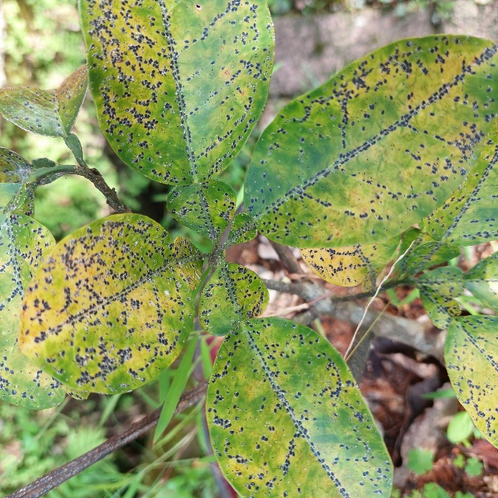

Figure1:Example of a diseased plant leaf showing visible symptoms [Adapted 9]

In recent years, deep learning have been demonstrated to be powerful tools for automated plant disease detection. Methods, such as deep Convolutional Neural Networks (CNNs) and transfer learning, can automatically discover discriminative features from plant leaf images. This reduces the requirement of domain-specific knowledge, manual feature extraction, and improves the performance of classification algorithms.
Based on the above, this work aims to propose a ResNet50 transfer learning model for plant disease identification on PlantVillage dataset.

1.2 Problem Definition
Recently, several deep learning models have been implemented to detect plant diseases, but some are computationally heavy, don’t adapt well to various field conditions, and the classification performance goes down significantly if two disease categories have similar visual texture, thus not ideal for practice and deployment. For these causes, we need a low computation depth learning methodology which is highly efficient and effective and we would like to strengthen the classification results at the same time.

1.3 Thesis Objectives

- To propose a deep learning framework using ResNet50 and Transfer Learning that would enable the automatic classification of plant diseases.
- Implement image pre-processing and data augmentation to allow the generalization of the proposed model.
- Test the performance of the proposed model on the PlantVillage dataset.
- Compare the proposed deep learning approach with state-of-the-art methods using the metrics Accuracy, Precision, Recall and F1-score.

1.4 Thesis Contribution

Main contributions: Build a new automatic plant disease identification system by leveraging ResNet50 transfer learning. Combine preprocessing, data augmentation, CNN feature extraction and Feature Pyramid Network (FPN). The validation accuracy is up to 99.42%, validation loss is 0.0228.
And evaluation with Precision, Recall, F1-score, ROC curve and Confusion Matrix.

1.5 Thesis Organization

Thesis Organize as:
Chapter 1 presents the introduction.
Chapter 2 reviews the related work and previous studies.
Chapter 3 describes the proposed methodology.
Chapter 4 presents experimental results and discussion.
Chapter 5 concludes the thesis and outlines future work.

Chapter 2 Background and Related Work

2.1 Introduction
This chapter discusses theoretical aspects and background work on AI and Deep Learning based plant disease detection. Major concepts of Artificial Intelligence (AI), Machine learning(ML), Deep Learning(DL), Convolutional neural networks (CNNs) , Transfer Learning and Feature Pyramid Network(FPN) is discussed briefly. Finally, review of the recent works carried out. is discussed in order to review some challenging problems and research gaps. in which this work is supposed to address.

This chapter presents a comprehensive review of existing studies in plant disease detection using deep learning techniquesIt discusses both classical and recent work, summarizes key methodologies, datasets, accuracy measures and limitations. Although classical works produced results that achieved accuracy in many cases, over controlled and labelled datasets, like that of PlantVillage. However there is still work needed to generalize the models to field conditions, manage class imbalances and reduce computational costs.

More recent papers have proposed improved structures, like multiscales, hybrid architectures, and transformers. Based on previous works this chapter concludes with existing gaps in the research area and suggests avenues for future work in developing effective and scalable plant disease diagnosis tools.

2.2 Background
Before discussing the proposed approach, it is useful to have an idea of the main ideas around Artificial Intelligence and Deep Learning.Agriculture plays one of the biggest roles for food security and the economy for the whole world. Unfortunately, diseases can infect plants, which become quite a nuisance to agriculture worldwide as they affect the quality and productivity of crops. Plant disease can be detected if an automated method is developed in which the early detection of plant disease would result in significant saving.Traditionally in agriculture, experts looked for diseased plants using their eyes, which is inefficient in terms of time, money, effort and accuracy when large areas need to be covered.
Recent advances made in Machine Learning, Deep Learning and Artificial Intelligence have brought with them increased possibilities in the agricultural applications domain. These advancements enabled automatic inspection and diagnosis of plant diseases via using images to identify them. Applications of AI, ML and DL for plant disease identification have been investigated previously, as demonstrated below.

2.2.1 Artificial Intelligence (AI)
refers to the development of computer systems that can perform tasks that require human intelligence, such as visual perception, reasoning, learning, problem-solving, speech recognition, and decision-making. The role of AI in healthcare, transportation, banking, and agriculture, is increasing. Artificial Intelligence has become one of the most influential technologies in agriculture by enabling intelligent systems capable of image analysis, disease prediction, and decision support. AI techniques significantly reduce human effort while improving the efficiency and accuracy of agricultural monitoring.

2.2.2 Machine Learning (ML)

Is a branch of AI that focuses on developing algorithms that allow computers to learn from data without being explicitly programmed. Instead of being told how to process information, these algorithms identify patterns and correlations within large datasets, and their performance can improve over time as more data becomes available.ML algorithms can be classified into three types:
- Supervised Learning (uses labeled training data)
- Unsupervised Learning (finds patterns in unlabeled data)
- Reinforcement Learning (learns from interaction and reward/punishment)

In plant disease detection, supervised learning techniques are commonly employed, since leaf images are usually labeled according to their respective disease category. Many traditional machine learning algorithms, such as Support Vector Machine (SVM), Decision Tree, Random Forest and K-Nearest Neighbor (KNN) algorithms, have successfully been used to identify and classify plant diseases. However, the use of traditional ML methods relies on manual extraction of features such as color, shape and texture, which might result in less effectiveness when dealing with large datasets. Traditional machine learning methods require manual feature extraction, making them less effective than deep learning approaches when dealing with complex image datasets.

2.2.3 Deep Learning

is a kind of deep learning approach that can learn feature representation on hierarchical level and on its own from scratch (raw input). in contrasts with earlier approach for ML, deep learning does not require manual feature design which enables deep learning models to perform quite good at various tasks, such as image classification, so a variety of deep learning models are good for tasks like image recognition & detection and any type of task that have patterns. The Use of DL DL has gained momentum and state of the art results for many computer vision tasks including the image related tasks, including medical image detection & diagnosis, face recognition, object identification, self-driven vehicles and applications in agriculture. Among some of best DL architectures for agriculture are CNNs, ResNets (a well-known deep learning based image recognition model that overcomes some of the problems in training a deep neural network, like the vanishing gradients), EfficientNets, Vision Transformers (ViTs) and hybrid deep learning models to deliver state-of-the-art accuracy with lower feature design process. recent advancements in architecture designs of DL-powered CV algorithms enable increased plant disease classification accuracy and accuracy over handmade feature engineering methods.

A. Convolutional Neural Networks (CNNs)

CNNs are an architecture of a neural network and deep learning designed specifically for processing and analyzing images. CNN’s automatically learn low-level and high-level visual features like contours, colors, textures, shapes, disease symptoms, etc. after going through multiple convolutional layers, thus, they don’t require any feature extraction as in a traditional ML algorithm. An image will first pass through many layers such as:

- Convolutional layers apply learnable filters to extract local features like edges, corners, and textures.
- Activation layers (e.g., ReLU - Rectified Linear Unit) introduce non-linearity to the model, enabling it to learn complex relationships.
- Pooling layers reduce the spatial dimensions of the feature maps, reducing computation and preventing overfitting.
- Fully Connected layers combine the extracted features to classify the image.
- A Softmax layer outputs the probabilities of the image belonging to each disease category.
- CNNs have emerged as a dominant choice for plant disease identification due to their ability to effectively learn rich image representations, their high accuracy, and their elimination of manual feature extraction.
- The general structure of a Convolutional Neural Network is illustrated in Figure 2.X.
- ( CNN Architecture : Input Image Convolution ReLU Pooling Fully Connected Softmax Output.)
- CNNs have become the dominant approach for plant disease image classification because of their ability to learn complex visual patterns directly from images.

B. Transfer Learning

Allows for the utilization of knowledge learned from massive benchmark datasets like ImageNet into our deep learning model, thus the weight pre-training was adopted instead of training a model from a completely new beginning saving computational costs, enhancing the efficiency.This technique can save you lots of time and resources, instead of training a deep learning model from the start, pre-trained weights(e.g. ResNet50, VGG16, EfficientNet, MobileNet …)are fine-tuned on a relevant task or data that we aim, then the model can perform really well in many cases and gets to high accuracy in even few amounts of data which is usually needed in plants’ disease detection in many researches, mainly because it’s costly and inconvenient to find abundant labeled plant images and data to conduct the experiment. The approach of transferred learning has become very common in these works, since only limited labeled agricultural datasets were present in many cases.

C. Feature Pyramid Networks (FPNs)

Combine feature maps from different convolutional layers to enrich the multi-scale feature representation, which helps to effectively diagnose small lesions to large affected areas.Feature Pyramid Network(FPN)Feature Pyramid Network (FPN) is a deep learning architecture proposed in the article, which aims to use different levels of CNN to establish a feature pyramid and effectively detect objects of various scales in the image. In identifying plant diseases, it is very important that some diseases could be diagnosed from small spot size, whereas the other diseases be identified from relatively large affected areas. Traditional CNN will fail in diagnosis under multiple scales conditions due to limited effective feature selection ability at the different scales.
FPN can enhance prediction of images using information at different scales, from rich low-level spatial details to high-level semantic information, and preserve strong semantic and spatial information simultaneously by combining low-level features with high-level semantic information to yield robust image classification.

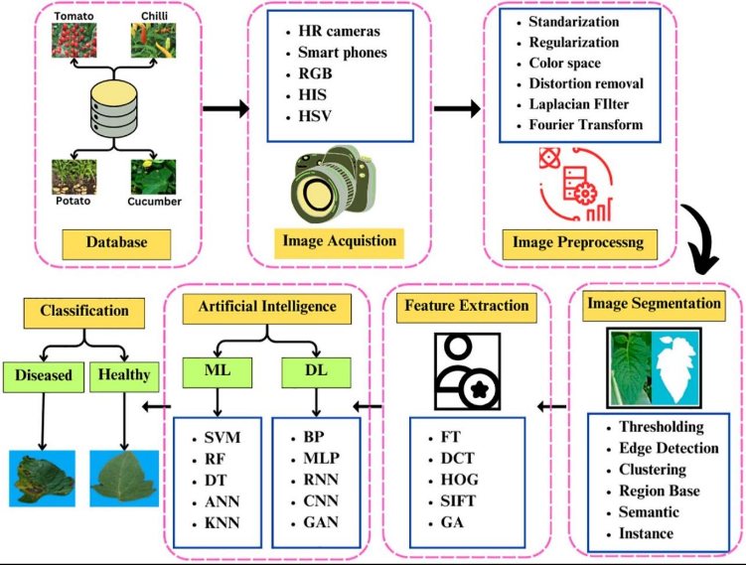

Figure 2: General workflow of plant disease detection[16]

2.3 Related Work

Sharma et al. (2023) [1]An attention-based Convolutional Neural Network (CNN) was introduced by Sharma et al. (2023) [1] to improve plant disease classification and localization by focusing the model’s attention on the infected regions of plant leaves. The framework uses attention mechanisms to guide the CNN to extract relevant features from the infected areas and ignore irrelevant background information. It was trained on the PlantVillage dataset and real-field image datasets and reported an overall classification accuracy of 98.7%. The study concluded that attention significantly improved both disease localization and classification performance compared to traditional CNN models and enhanced the model’s robustness to various image conditions. However, the increased complexity of attention modules led to higher computational requirements and training time, making the model less practical for resource-limited devices.

Patel & Shah (2024) [7] proposed a Vision Transformer (ViT)-based system designed for the classification of plant diseases. They used the model’s inherent ability of self-attention mechanism to effectively captureglobal information from an image, which provides an edge over the traditional Convolutional Neural Networks (CNNs) that tend to capture localized spatial features only. They were able to generate stronger feature representations due to their ability to capture long-rangedependencies between image patches of an image. Their model, trained on extensive benchmarks like the PlantVillage dataset, achieved 99.1% classification accuracy,outperformed multiple CNN-based methods, extracted richer feature representations, and showed enhanced ability to discriminate betweendiseases that arevisually indistinct, all due to high computational and large memory requirements and massive need for training data, which make it difficult to implement in low resource agriculture.

Wang et al. (2024) [8] proposed a multi-task learningframework based on deep learning that simultaneously identifies and localizes diseases symptoms within a single network structure to gain benefits in terms of plant disease recognition by co-learning different tasks. They used an annotated plant disease dataset,includingbothPlantVillage andreal field data, totrain the framework,achieving a diseaseclassificationaccuracy of 98.2%for some diseases. The study also revealed that by joint training related tasks, the features learnedsuffered little loss from individual task performance, improved disease representation, improved localization accuracy and efficiently shared feature learning to speed up training. However, with more learning objectives to optimize, they incurred more computational cost.

Sahu et al. (2025) [14] proposed a Hybrid Dilated Convolutional Neural Network (Hybrid Dilated CNN) model which helps to assist plant disease classification through refined feature extraction while maintaining spatial information. The innovative design using dilated convolutional layers with different dilation rates expand the model field of view without loss of spatial data,thus improving its performance in diagnosing symptoms of plant diseases. The Hybrid Dilated CNN, trained on different varieties of plant leaf image datasets such as the PlantVillage dataset along with different augmented datasets, yielded around 98% classification accuracy overall, better classifying severaldiseases compared to traditional methods, with improvements on minor diseases and visually close diseasesand generated better features. There are limitations of this framework since it has more computational load and trains for longer than conventional models due to dilation of multiple convolution layers.

In 2023 Chen et al. [2] came up with a deep-learning model with an automatic plant detection and diagnosis function, implementing the EfficientNet base structure to achieve high classification accuracy and few models using EfficientNet’s compound scale mechanism where parameters are balanced under depth, width, and image resolution. PlantVillage and PlantDoc datasets are used for training and the model can achieve classification accuracy of 98.9 percent; thus from the experiment the overall performance and efficiency by model of EfficientNet is evidently superior to common CNN. Meanwhile the quantity of parameters is minimized; unfortunately the robustness to messy images and realistic conditions of farms could be improved, lacking a generalization capability.

Kumar et al. (2023) [3]Kumar et al. (2023) [3] explored Transfer Learning for plant disease classification by fine-tuning popular CNN models, such as VGG16 and ResNet50, which were pre-trained on ImageNet, using publicly available plant disease datasets like PlantVillage. The study achieved an accuracy of 98.0%, demonstrating the effectiveness of transfer learning in reducing training time and achieving high predictive accuracy, especially with limited data. However, the deep CNN architectures required significant computational resources and high-memory GPUs, making deployment on low-resource devices challenging.

Li et al. (2023) [4] developed a ResNet-based deep learning framework for automatic plant disease detection based on leaf images. The architecture used residual learning, which is effective in dealing with very deep networks, to extract various levels of features from the leaf images. Trained using the PlantVillage dataset, the model achieved an overall classification accuracy of 98.5% . In their study, Li et al. reported that the use of residual connections effectively enhanced features extraction and classification stability and allowed the model to recognize complex patterns. Nevertheless, the deep residual network required significant computational and memory resources.

Zhang et al. (2023) [5] introduced a CNN-based plant disease detection framework with integrated feature enhancement technique to improve the classification accuracy. The authors improved their plant disease detection method by enhancing features representation before classification to accurately distinguish minor disease symptom. The model was trained using the PlantVillage dataset and various other augmented datasets and achieved overall classification accuracy 97.9% . Experimental results showed that enhancing features expression greatly improves the discrimination of closely related diseases and improves classification robustness in general. Although data augmentation was further explored to improve performance across domains and generalize more efficiently, feature enhancement in some applications resulted in longer training times and increased computational complexity.

Khan et al. (2024) [6] designed a lightweight Convolutional Neural Network (CNN) for efficient and real-time plant disease detection on edge devices. With the goal of developing a model that is suitable for agriculture mobile and edge devices, they developed a computationally less expensive model that provides high classification accuracy. They trained the model using both public datasets like PlantVillage and the real field collected images and achieved 97.8% classification accuracy. In their experiment, they stated that light weight CNN model greatly reduce execution time and memory size when compared with general CNN architectures, therefore making the system practicable. On the other hand, with the lightweight architecture, model robustness might decline.

Zhang et al. (2024) [9] presented a hybrid CNN model for plant disease classification that aimed to extract stronger and diversified features by combining several convolution architectures. This approach sought to integrate complementary learning strategies of each architecture to effectively learn features at different levels and scales from the leaf images of plants. The model was trained on publicly available datasets (PlantVillage and other datasets that contains real-world disease samples collected in fields), achieving overall classification accuracy of 97.6%. The study results showed that the hybrid design improved the classification stability and accuracy forvisually similar diseases, and enhanced performance across different plant species.However, a higher consumption of training time and computation power due to the large number of parameters in the network was noted.

Upadhyay et al. (2024) [10] proposed a comprehensive review on deep learning for plant disease diagnosis, considering both CNNs and Transformers models.The performance of several state-of-the-art models was assessed on various public plant disease datasets, including PlantVillage, PlantDoc and others, with classification accuracies mostly in the range of 95-99%. They concluded that deep learning models outperformed Traditional ML models greatly due to enhanced learning capacity. They observed that transformers model were more efficient at global feature extraction while CNNs model possessed better computational efficiencies but had to struggle to extract many high-level global contextual features. Practical deployment remain the significant issue of the research area due to higher computation power requirements of the models and generalization on real world conditions.

Wang et al. (2025) [12] designed an advanced deep learning framework composing of Convolutional Neural Networks (CNNs) and transformer-based models to aid in the detection of plant diseases.The key goal of this work was to combine local visual representation extraction with a global feature representation from computer vision models through integrating CNNs' powerful abilities in feature extraction of local image parts with Visual Transformers ' broad feature representation understanding from long-range contextual interrelationships in images.After training the model on extensive plant disease data obtained from multiple sources, including images from PlantVillage disease datasets, it achieved more than 97% classification accuracy .According to the experimental results of the investigation, the synergistic effectiveness of the hybrid structure significantly improves discriminative classification robustness against a wide variety of plants and disease categories while maintaining performance equivalent to state-of-art approaches.The integration of local and global learning capacities improved the system's skill to diagnose intricate symptoms of disease under dynamic surroundings, but demanding higher computational resources that challenge scale issues for widespread agricultural tracking systems .

Ibrahim et al. (2025) [15] developed an improved deep learning model for plant disease diagnosis which combines multiple optimization techniques to improve its generalizability and accuracy.By training on an assortment of plant disease datasets including PlantVillage and on images collected from the field, this deep model learned how to characterize diseases under varying farming environment conditions, both controllable and real world. Experimental results illustrate an outstanding overall classification accuracy of 97.5%, indicating reliable performance across various plant and disease types.

Zhao et al. (2025) [13] built an object detection based on Mask R-CNN and Faster R-CNN framework that could serve the function of automated detection and localization of plant diseases.Different to those object classification models, their framework could locate individual plant leaf lesions, i.e. bounding box identification on these leaves and determine the disease class. This model was trained on multiple datasets that contain annotated images with bounding-boxes for disease patches, achieving localization performances ranging from 63 to 90% (varying due to dataquality). Their analysis found the models capable of accurately identifying the affected regions in their location and obtaining robust detection performance.This research acknowledged however that, the models reliance on precise and complete manual annotation made labeling time and cost-intensive.

Ahmed et al. (2025) [11] introduced a multi-scale Convolutional Neural Network (CNN) combined with a Feature Pyramid Network (FPN) for enhanced plant disease detection at different resolutions of the symptoms. Their proposed methodology captures comprehensive visual information from various stages of convolutional layers so that small and large regions affected by disease could be effectively identified. The model was trained on numerous publicly available plant disease datasets and on various real field images as well, including the PlantVillage dataset, achieving a remarkable overall accuracy of 99.2%. When experimental tests were conducted, the performance of their approach surpassed conventional CNN models due to the enhancement in features extracted by the FPN. As a result, FPN enhances theclassification performance of the proposed structure and improved their resilience towards identifying earlier disease symptoms, nonetheless using feature scale selection will inevitably result in higher memory consumption and intensified computation effort.

2.4 Comparison of Existing Methods

This section presents a comparative analysis of existing deep learning-based methods for plant disease detection. The comparison focuses on key aspects of each study, including the methodology used, datasets, achieved accuracy, and the main limitations. The purpose of this comparison is to provide a clear overview of the strengths and weaknesses of current approaches, as well as to highlight common challenges such as high computational complexity, limited robustness in real-world environments, and dependency on dataset quality. This analysis helps in identifying research gaps and motivates the development of more efficient and scalable solutions

Table 2.1 summarizes the selected previous studies by comparing their methodologies, datasets, reported accuracies, and major limitations.
Limitations | Accuracy |  | Dataset | Methodology | Year | Study
High computational complexity |  | 98.7% | PlantVillage + Field Images | CNN + Attention | 2023 | Sharma et al.
Scalability issues |  | >97% | Multi datasets | CNN + Transformer | 2025 | Wang et al.
High complexity |  | ~98% | Plant leaf datasets | Hybrid Dilated CNN | 2025 | Sahu et al.
Needs real-world validation |  | 97.5% | Combined datasets | Optimized Deep Learning Model | 2025 | Ibrahim et al.
High computational cost |  | 99.1% | Benchmark datasets | Vision Transformer (ViT) | 2024 | Patel & Shah.
Depends on data quality |  | 63%–90% | Annotated datasets | Mask R-CNN, Faster R-CNN | 2025 | Zhao et al.
High memory usage |  | 99.2% | Multi datasets | Multi-scale CNN (FPN) | 2025 | Ahmed et al.

2.5 Research Gap

According to the discussed papers, currently available plant disease detection methods have several defects such as high computational cost, weak ability of generalization, poor classification accuracy in changing environment and requiring high computation, which are inconvenient for implementation. This research develops a transfer learning model based on ResNet50 with image preprocessing and Feature Pyramid Networks(FPN) to improve classification accuracy and reduce computational cost.

Chapter 3 Methodology
The workflow of the proposed methodology The proposed work utilizes deep learning for automated detection of diseases on plant leaf through an image analysis. The proposed method is based on Image Pre-processing, CNNs, Transfer Learning (TL) and Feature Pyramid Networks (FPN) techniques to optimize and boost the performance in disease classification. In order to address the problems detected in Chapter 2 regarding the generalizations, computational cost, and the accuracy, we proposed a new approach.
The schematic diagram of the whole system shown in Figure 3.1.

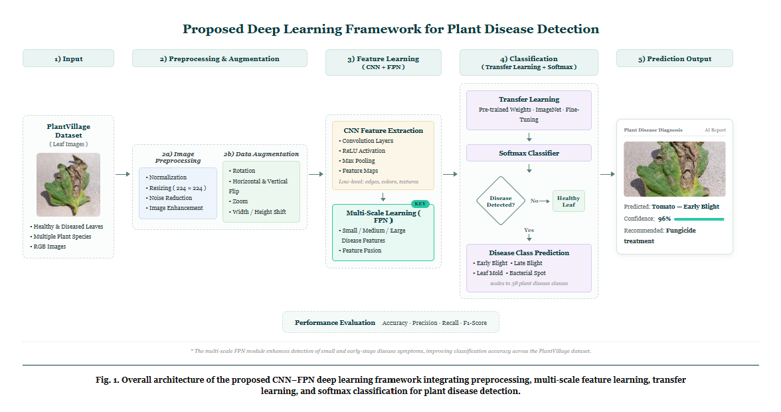

Figure 3.1: Proposed Framework of Plant Disease Detection System

3.1 Input (Dataset)
PlantVillage dataset PlantVillage dataset is one of the widely known dataset for studying on plant disease recognition. It consists of thousands of colored leafimages belonging to healthy, diseasedplants for many crop. The classes that we have selected here from the dataset are as below.Pepper Bell Bacterial Spot, Pepper Bell Healthy, Potato Early Blight The below figures illustrates some sample samplesfrom selected dataset classes.

3.1.1 Classification Dataset
The PlantVillage dataset has become one of the most famous publicly available benchmark dataset to classifying plant diseases. This dataset comprises a total of 54,306 high-quality RGB pictures, captured from multiple crop species under well-controlled settings and contains more than a hundred varieties of plant diseases, healthy or sick. With their highly quality of image and balanced number of entries for different diseases, the dataset was used widely to research a deep learning based approach for recognizing diseases on the plants.For this experiment, three categories of PlantVillage Dataset was extracted to be used which are: Pepper Bell Bacterial Spot, Pepper Bell Healthy, Potato Early Blight, due to contain some examples of both diseases as healthy one that allow to build a system that differentiate diseased samples from the healthy one, and due to the presence of the mentioned plant types and variety of disease that could greatly affects to the yield of plants. Figure 3 shows sample pictures of plant with some plant diseases which selected in the PlantVillage dataset such as: Pepper Bell Bacterial Spot, Pepper Bell Healthy and Potato Early Blight.

Pepper Bell Bacterial Spot Pepper Bell Healthy Potato Early Blight
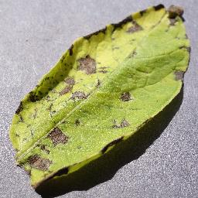
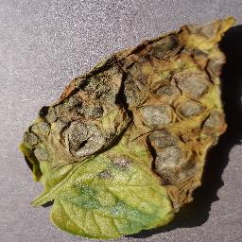
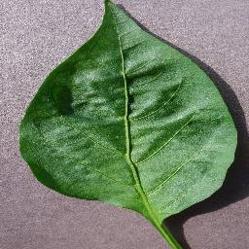
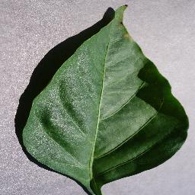
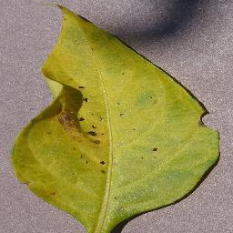
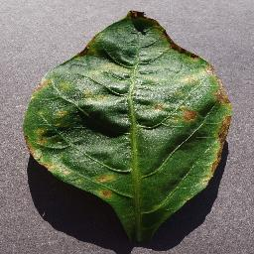

Figure 3.2 Image from Dataset

3.2 Image Preprocessing
Before the proposed deep learning model is trained, all input images will undergo an image preprocessing procedure to obtain consistency, boost the quality of images, and enrich the learnability of the deep learning model. In the case of the PlantVillage dataset, the images show a variety of appearances, so preprocessing is mandatory in order to harmonize input images before feature extraction. Preprocessing procedures remove unnecessary differences between images, thereby helping the deep learning model concentrate on identifying specific features pertaining to the disease in images instead of unrelated information.
Histogram normalization

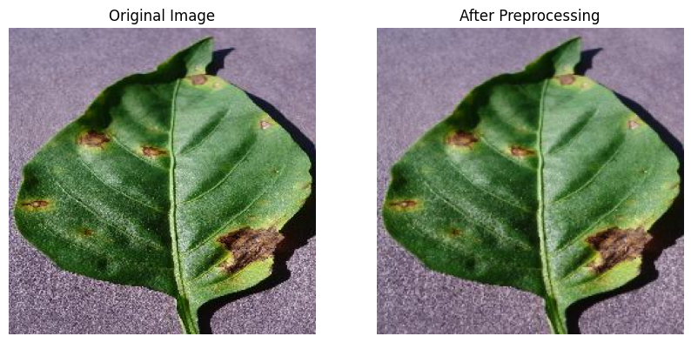

(Figure 3.3: Image Before and After Preprocessing)

3.2.1 Image Resizing
Each original image is resized.to 224 224 pixels, which is the size input that the deep learning model requires as it can be see in the model architecture above. Normalizing the size of each image ensure that each of the input to the model has the same shape.. resizing of image has advantages that it makes the computation load smaller, reduces the model training time, can perform batch training without distorting the basic features of the disease on the leaf.

3.2.2 Image Normalization
After images are resized, pixels values are normalized in the range of 0-1 by multiplying the original pixel values of 0-255 by 1/255. The image normalization helps to stabilize numerical values for the optimization algorithm and also enables the algorithm to converge faster and prevent the large pixel values from taking control in the learning process, so that the gradient updates can be more stable and thus the classification accuracy can be boosted up.

3.2.3 Noise Reduction
Even though images in the PlantVillage dataset are considered quite clean, some small image noise and undesired image appearance variations can still be present. To address this, image denoising methods are applied to remove image artifacts which are irrelevant and harmful to diagnose the disease and not of great interest while retaining the relevant visual disease characteristics (leaf spots, discoloration and texture) so that the convolutional neural network is able to extract useful features.

3.2.4 Image Enhancement
Image enhancement in this work focuses on providing visually better quality images for the input to the deep learning model for easier extraction of the features. Image enhancement mainly in this work involves resizing of the images to 224 x 224 pixels and normalizing their intensities in the range of [0,1] (which originally were [0,255]). These are the input images for the CNN model.
Normalization makes the model invariant to illumination effects and helps the model converge faster. This results in stable training and convergence of the model, thereby providing better accuracy as the model can learn features based on color changes, lesion shapes, etc rather than just the intensity of the image.

3.2.5 Data Augmentation
Several data augmentation methods are used during the training of the proposed model to ensure good generalization and avoid over-fitting. Data augmentation helps create additional samples artificially by transforming the existing image in a random way while maintaining the same label of that image. Augmentation expands the diversity of the training data, helping the model behave well in various image conditions.

3.2.6 Rotation
Each of the training images is randomly rotated using varying angles. Leaves may naturally present themselves at different orientations so rotating them means the model learns that it should look for signs of disease in any position the leaf happens to be in.

3.2.7Horizontal and Vertical Flip
Mirrored versions of the original images are created by using horizontal and vertical flip. They maintain the disease class and augment the diversity of the training data. It makes the model less dependent on the direction of the leaf and enables to perform better generalization.

3.2.8 Zoom
The model randomly zooms into images to be able to detect disease features at various scales. Some diseases can first be small lesion size, others extend to larger parts of the leaves. By zooming it, we force the model to be able to learn disease signatures irrespective of scale.

3.2.9 Width and Height Shift
The image is horizontally translated to the right or to the left, and it’s also translated upwards and downwards to random values. The aim is to avoid the trained model to “fixate” in a specific position of the symptoms of the disease within the image, thus making the model focus on the visual characteristics instead of their precise location. In this way, when the model analyzes images of plant leaves from real environments it is more reliable.

3.3 Feature Learning
After applying the preprocessing and data augmentation operations, the ready images are supplied into the feature learning module to extract automatically effective visual characteristics from the images of plant leaf, to discriminate between disease leaves and normal ones. Our framework instead of manually designed feature extraction module employ the application of deep learning technologies to learn discriminative feature automatically from training image data. In this proposed feature learning framework, the blend of Convolutional Neural Networks (CNN) , Transfer Learning (TL) ,and Feature Pyramid Networks (FPN) will further contribute to higher classification performance and stronger model stability.

3.3.1 Convolutional Neural Network (CNN)
Convolutional Neural Networks (CNNs) are one of the most popular deep learning approaches applied for image classification problems. The network was especially designed for the analysis of visual information, automatically extracting high-level features from the images to be processed. Unlike many classical approaches that require manual selection of image features, the CNN learns these characteristics (both low-level and high-level) on its own while being trained on the training data.
The model receives a preprocessed image of the plant leaf as the first input. The image goes through several convolutional layers and various learnable filters are used to extract salient image features like leaf shape, texture, color, presence of lesion, etc. After extraction, these features are filtered by an activation function and downsampled by pooling layers.
These extracted features are then flattened and used as inputs to fully connected layers where the network learns the connection between extracted image features and the type of plant disease that the leaf has, outputting a classification decision.

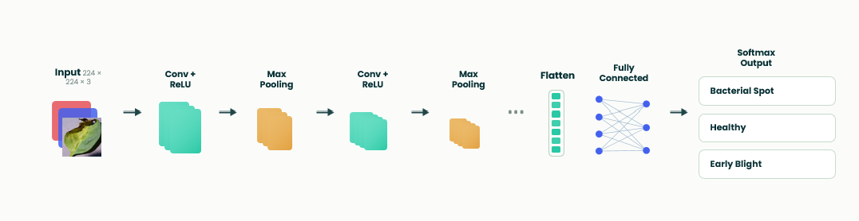

Figure 3.3.1: CNN Architecture

3.3.2 Feature Pyramid Network (FPN)
Plant disease symptoms exist in varied scales and sizes, some plants first show symptoms in small lesions or spot- like patches over leaf surface, while other disease manifestations span over the wider infected area. Hence, a general CNN would not be enough to represent plant disease information across various feature scales. To address this, an FPN has been incorporated after the feature extraction section of the proposed framework.
An FPN, after pooling and upsampling of feature maps extracted from multiple CNN layers, provides a representation that contains detailed spatial information in shallow layers while deep semantic features in high layers can enrich this representation to recognize disease features across scales, and finally can extract robust disease symptoms at different scales to overcome limitations of limited spatial or semantic information within a single CNN level. Combining multi-level feature maps from FPN enhances the ability of proposed method to learn robust feature representations for plant diseases and perform classification accurately.

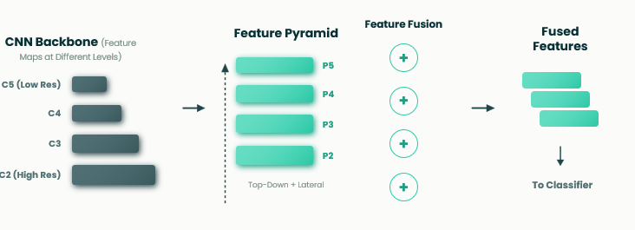

Figure 3.3.2: Feature Pyramid Network (FPN)

3.4 Transfer Learning
training a deep learning model from scratch would necessitate vast amounts of labelled data, together with significant computational power. Thus, in order to tackle the aforementioned issues, Transfer Learning has been incorporated in the proposed framework.Transfer Learning permits the proposed model to acquire knowledge derived from extensive image datasets, such as ImageNet, and then applies it to the problem of plant disease classification. Rather than randomising all parameters in the network, the weights of the pre-trained CNN bring in substantial information pertaining to visual feature extraction that helps convergence and enhances classification accuracy.
Fine-tuning has solely been performed on the last few layers (classifier part) of the network using the PlantVillage dataset, resulting in reduced computational costs, low risk of overfitting, and overall enhancement of the model’s generality. With Transfer Learning the model’s effectiveness can be achieved despite its training on relatively few data points from the domain of agriculture. despite its training on relatively few data points from the domain of agriculture.
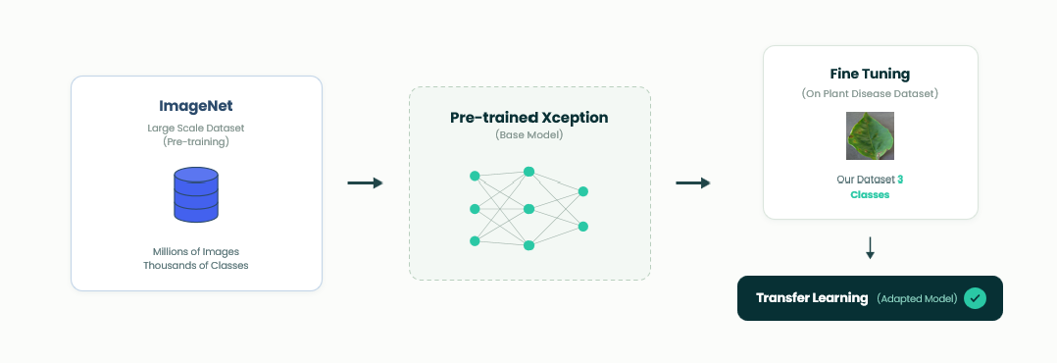
Figure 3.4 : Transfer Learning with ResNet50.

3.4.1Disease Classification
After the CNN-based feature extraction and multi-scale features are strengthened using the Feature Pyramid Network, the resulting features are passed into the classification stage, where they help to decide the ultimate category of each plant leaf image. The proposed architecture uses Softmax classifier as the last output layer since the present task is the multi-class classification. Softmax activation takes scores as output from previous layers, turns them into probabilities between 0 and 1 (sum of all the probabilities must be equal to one).
Finally, the class having maximum probability will be predicted. For instance, the probability of all class scores will be generated if the output of image falls into the category Potato Early Blight and that one which is highest probability will be considered as the predicted category of that image. This allows the classification mechanism to recognize the image as healthy/diseased leaf and also classify the type of the particular disease.

3.5 Prediction Output
Once the classification process has been performed, the developed framework generates the final prediction result of the given plant leaf image, along with the predicted disease class and the confidence level from Softmax classifier. The confidence level represents the likelihood of the input image corresponding to the given class. The developed system provides the prediction result in a concise manner and user-friendly way that enables the users to rapidly recognize if the plant leaf is healthy or disease infected.
The related disease type (if it is infected) and the suggested remedy is also displayed. A demonstration of prediction output from the proposed framework is depicted in figure 3.5

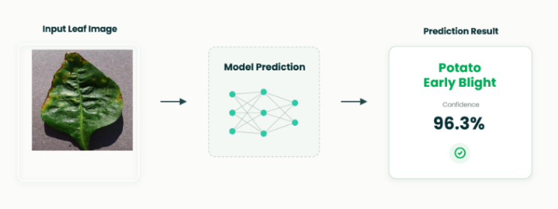

Figure 3.5: Prediction Output

3.6 Training Configuration
The deep learning model which we are proposing, is trained with selected classes of PlantVillage dataset, after performing all pre-processing and data augmentation tasks. Various hyper-parameters are tuned to provide efficient convergence, stabilize learning process and increase the classification accuracy of the proposed model..

Parameter | Value
Dataset | PlantVillage
Image Size | 224 × 224
Batch Size | 32
Epochs | 6
Optimizer | Adam
Learning Rate | 0.001
Loss Function | Categorical Cross-Entropy
Activation Function | ReLU
Output Layer | Softmax
Evaluation Metrics | Accuracy, Precision, Recall, F1-score

3.7 Performance Evaluation
The proposed plant disease detection model was evaluated using several commonly used classification measures. Classification measures quantify the efficiency of the proposed model, which may facilitate comparing our model with the related works in the literature.

3.7.1 Accuracy
Accuracy measures the percentage of correctly classified samples among all testing samples.
$$Accuracy=\frac{TP+TN}{TP+TN+FP+FN}$$
where:
TP = True Positive
TN = True Negative
FP = False Positive
FN = False Negative

3.7.2 Precision
Precision measures the proportion of correctly predicted positive samples among all predicted positive samples.
$$Precision=\frac{TP}{TP+FP}$$
Higher Precision indicates that the proposed model produces fewer false positive predictions.

3.7.3 Recall
Recall evaluates the capability of the proposed model to correctly identify actual positive samples.
$$Recall=\frac{TP}{TP+FN}$$
Higher Recall indicates that fewer diseased samples are incorrectly classified as healthy.

3.7.4 F1-Score
The F1-score combines Precision and Recall into a single performance metric by calculating their harmonic mean.
$$F1=\frac{2×Precision×Recall}{Precision+Recall}$$
The F1-score is particularly useful when evaluating multi-class classification problems because it balances both Precision and Recall.

3.7.5 Confusion Matrix
The numerical evaluation metrics are complemented with a confusion matrix for visually presenting the classification results achieved by the suggested model. The confusion matrix shows how many samples of each disease type are correctly and wrongly classified.

Chapter 4: Results and Discussion
For our purpose, the ResNet50 based model has been experimented with the dataset PlantVillage for determining accuracy for classify diseases from leaves of the plants. In this chapter, the details on preprocessing of dataset and evaluation performance (on overall basis as well as on class basis), and analysis of results are included. As shown from the result, the achieved high classification accuracy and acceptable performance on generalization with validation set, indicates good generalization capability of our proposed method.

4.1 Preprocessing and Visual Standardizations
Deep Learning Model training included an image preprocessing stage, used to homogenize data consistency and facilitate features learning. All the training data was reshaped into a 224 224 dimension, according to ResNet50architecture input. Then, the pixel intensity values were normalized for a more stable training and a faster convergence of the training procedure.

The preprocessing process decreased noise in the dataset, minimizing differences related to images size and intensity, while maintaining features relevant to the pathologies under consideration. In this way, the model had the ability to attend the salient pathologies features instead of the background noise, thus improving its ability to learn and identify these symptoms. Some examples of images before and after the processing steps can be seen in Figure 4.1.

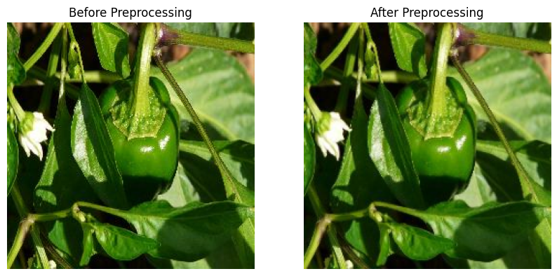

Figure 4.1 Images Before and After Preprocessing

4.2 Classification Performance
The developed ResNet50 model was tested on the validation data set to measure performance of the model on validation data by various validation parameters such as validation accuracy, validation loss, validation precision, validation recall and validation F1-score.
Table 4.1 presents the overall performance achieved by the proposed model.

4.2.1 Xception
The proposed Xception model was assessed overall on the validation set and determined by calculating validation accuracy, validation loss, precision, recall, and F1-score. Table 4.1 below illustrates the accuracy, loss, precision, recall and F1-score of the proposed Xception model on the plant leaf classes selected in this research. Table 4.1: Proposed Xception model average resultsValidation accuracy, validation loss and average precision, recall and F1-score of the proposed model are estimated as 97.22%, 0.0951 and 97% respectively. Table 4.1 Overall Performance of the Proposed Model

Metric | Value
Validation Accuracy | 97.22%
Validation Loss | 0.0951
Average Precision | 97.00%
Average Recall | 97.00%
Average F1-score | 97.00%

These results suggested that the developed method had high classification accuracy with balanced results across all metrics.

A. Per-Class Classification Performance
In addition to overall performance evaluation, precision, recall, and F1-score are computed for each class in the context of three plant leaf classes as shown in Table 4.2. Potato Early Blight gets the best classification performances
Class | Precision | Recall | F1-score
Pepper Bell Bacterial Spot | 0.91 | 0.96 | 0.93
Pepper Bell Healthy | 0.97 | 0.95 | 0.96
Potato Early Blight | 1.00 | 0.99 | 0.99

B. Confusion Matrix Analysis

Additionally, a Confusion Matrix was built to gauge the performance of classification of Xception model by finding number of correct and incorrect classifications within each category. suggests that the values across the diagonal represent the cases classified accurately while the ones off the diagonal represents cases misclassified. The Xception model successfully predicted 286 images of Pepper Bell Bacterial Spot, 413 images of Pepper Bell Healthy, and 297 images of Potato Early Blight.While 10 of Pepper Bell Bacterial Spot images are wrongly predicted as Pepper Bell Healthy and 3 as Potato Early Blight, among Pepper Bell Healthy images, 30 are wrongly classified as Pepper Bell Bacterial Spot and none as Potato Early Blight. The model misclassifies only 3 out of 300 images as Pepper Bell Bacterial Spot while correctly classifies the rest of 297 images of Potato Early Blight. Most misclassification happened in between Pepper Bell Bacterial Spot and Pepper Bell Healthy implying both categories possess strong resemblances. However, majority elements lie on the diagonal, indicating effectiveness in the prediction based on proposed model to different categories of plants leaves. As Showen in Figure 4.3 .

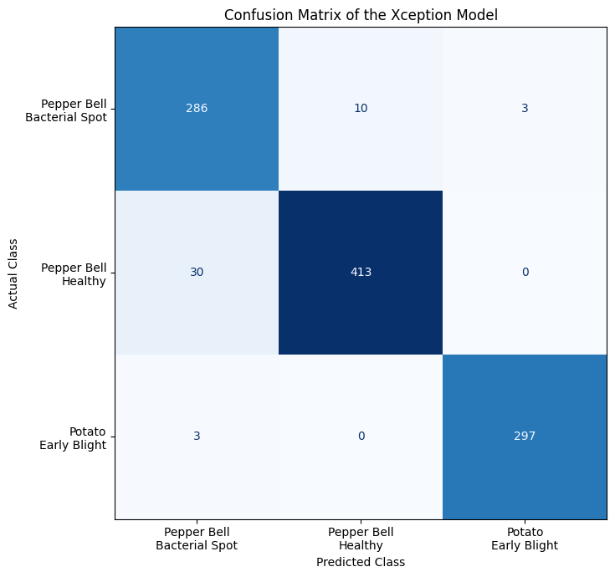

Figure 4.3. Confusion Matrix of the Xception Model for the Three Plant Disease Classes.

C. ROC Curve Analysis

Receiver Operating Characteristic (ROC) curve analysis was also performed to further assess the classification performance of the Xception model for the 3 classes of plant leaves. The ROC curve describes the correlation between True Positive Rate (TPR) and False Positive Rate (FPR) for varying thresholds in the classifier and the Area Under the Curve (AUC) reflects the model's efficiency in distinguishing between the different classes. Figure 4.4 provides the ROC curves obtained for each class of leaf.
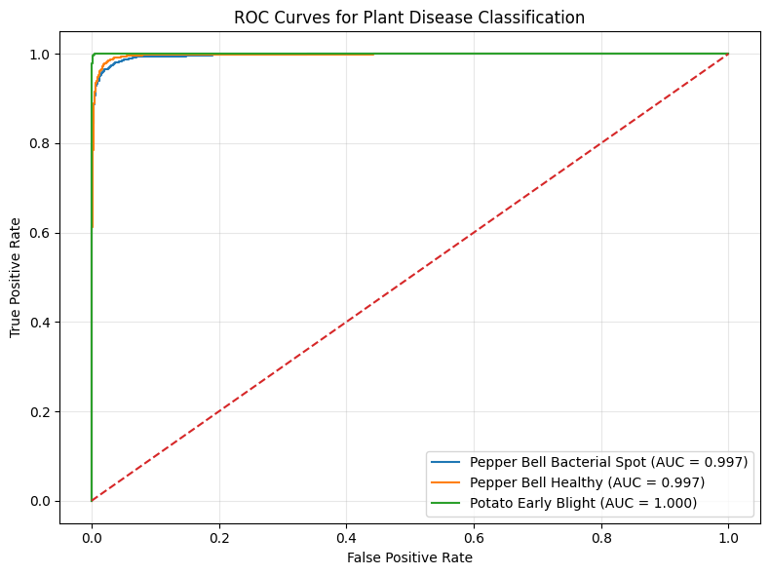
Figure 4.4. ROC Curves of the Xception Model for Plant Disease Classification

The ROC curve in Figure 4.4 shows an AUC value of 0.997 for Pepper Bell Bacterial Spot and 0.997 for Pepper Bell Healthy with AUC value of 1.000 for Potato Early Blight. The ROC curves are concentrated close to the upper left of the graph which shows the True Positive Rate is higher with a low False Positive Rate. The discriminative power of Potato Early Blight is shown by the AUC value of 1. 000.The AUC value of 0.997 for Pepper Bell Bacterial Spot and Pepper Bell Healthy show the class can be easily distinguished from the rest of the classes.

4.2.2 ResNet50

Overall Performance of the Proposed Model
Performance Assessment of the Proposed Model for Classification of Diseased Leaves on Validation Data Set Model Proposed ResNet50 (a) Validation accuracy (%), 99.42 (b) Validation loss, 0.0228 (c) Precision, 99.42 (d) Recall, 99.42 (e) F1-score, 99.42 Table 4.3. Overall performance of proposed ResNet50 model for specific disease classes of plants chosen. In order to test the performance of the proposed model on validation data-set several measures like validation accuracy, validation loss, precision, recall and F1-score were evaluated as shown in table 4.3.
This resulted in achieving validation accuracy 99.42 with validation loss 0.0228 and the values of all three measures the average precision, average recall and average F1-score obtained from our model is around 99.42% for specific Classes of diseased leaves of plants selected in this study.

Metric | Value
Validation Accuracy | 99.42%
Validation Loss | 0.0228
Average Precision | 99.42%
Average Recall | 99.42%
Average F1-score | 99.42%

A. Per-Class Classification Performance
Besides overall performance analysis, each plant leaf disease class was calculated precisely with accuracy, recall, and F1-score values as given in the table 4.4. This confirms the result that classification performance was very well for all classes with the proposed model of ResNet50. Potato Early Blight has performed with full accuracy, recall, F1-score of 100% that all samples in the validation set are correctly predicted.Pepper Bell Healthy has a great performance of 99.32% accuracy, recall, and F1-score. Another class, Pepper Bell Bacterial Spot has 98.99% accuracy, recall, and F1-score.

Class | Precision | Recall | F1-score
Pepper Bell Bacterial Spot | 0.98 | 0.98 | 0.98
Pepper Bell Healthy | 0.99 | 0.99 | 0.99
Potato Early Blight | 1.00 | 1.00 | 1.00

Table 4.4 Per-Class Classification Performance of the ResNet50 Model

B. Confusion Matrix Analysis
To predict model’s capacity of classification of proposed model of ResNet50 to detect the number of correct and false classified sample of each plant disease class, a Confusion Matrix has been generated, as showed in Fig 4.5 .
This table defines the correctly classified images (diagonal elements), and false classified images (off-diagonal elements). We can notice that in the class Pepper Bell Bacterial Spot, a total of 197 images has been classified as Correctly Classified where the 2 images had been predicted as Pepper Bell Healthy.In the class Pepper Bell Healthy a total of 293 images has been Classified as Correctly Classify, whereas only 2 images has been incorrectly predicted as Pepper Bell Bacterial Spot. Also for the Potato Early Blight the model performed 100% accuracy.

Thus the proposed model classify 197 images for the class Pepper Bell Bacterial Spot (Total validation images for Pepper Bell Bacterial Spot = 199), 293 images for Pepper Bell Healthy (Total validation images for Pepper Bell Healthy = 295), 200 images for Potato Early Blight (Total validation images for Potato Early Blight = 200) and zero images for the classes Potato Late Blight and Tomato Late Blight.Therefore, in the evaluation data set a total 197 + 293 + 200 = 690 images were classified correctly.

Where, out of total 694 validation samples, just 4 validation images were misclassified and those cases are occurred only for class Pepper Bell Bacterial Spot and Pepper Bell Healthy, which is due to their Similarities in the appearance as observed in the visual analysis. Nonetheless the concentration of number of correctly classified images along main diagonal clearly showed the superb classification ability of the proposed ResNet50 model for detecting plant diseases As shows in Fig 4.5 .

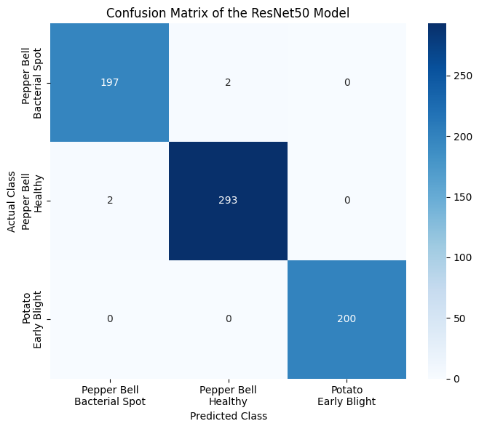

Figure 4.5. Confusion Matrix of the ResNet50 Model for the Three Plant Disease Classes.

C. ROC Curve Analysis

Receiver operating characteristic (ROC) curve is used to test the classification effectiveness of the proposed ResNet50 model to the three categories of plants leaf disease. ROC curve shows the value of true positive rate versus false positive rate at varied classification cutoff, and Area Under the Curve (AUC) tells whether the model can tell between the two classifications. We present the ROC curve of all three categories of plants’ leaves disease in Figure 4.6.
Figure 4.6. ROC Curves of the ResNet50 Model for Plant Disease Classification

The plots in Figure 4.6 present the AUC value 0.999 for Pepper Bell Bacterial Spot, 0.999 for Pepper Bell Healthy and 1.000 for Potato Early Blight. All the ROC curves of three types of leaves are located in the corner which shows the true positive rate is close to 1 and false positive rate is close to 0. It’s a perfect performance of Potato Early Blight classification, the AUC value is 1, meaning that the model can identify Potato Early Blight without error from the other images. The performance of Pepper Bell Bacterial Spot and Pepper Bell Healthy is also very excellent, with AUC value 0.999. It proves that the proposed ResNet50 model performed robustly and faithfully for automating plants leaf disease diagnosis.

4.2.3 THE Techniques Results
In order to offer a better performance comparison of different models, a conventional CNN, Xception, and the proposed ResNet50 model were introduced for the comparison purpose. The three models were trained and tested by employing the same PlantVillage dataset, same preprocessing methodology, and the identical experimental set up. The validation accuracy achieved from experiments are shown in Table 4.5.
A Conventional CNN could only reach validation accuracy up to 95.82%, Xception obtained 97.22% and the Proposed ResNet50 model achieved validation accuracy to as high as 99.42%.

Technique | Epochs | Final Validation Accuracy | Best Validation Accuracy
CNN | 10 | 95.82% | 97.26%
ResNet | 10 | 99.42% | 99.71%
Xception | 10 | 97.22% | 98.31%
Table 4.5 Comparison of CNN, Xception, and ResNet50 Models

The CNN model produced a reasonable amount of accuracy, although it was not as high as the performance of the transfer learning models. Xception exhibited higher classification performance as it utilized depthwise separable convolutions and ResNet50 was found to be the highest as the use of residual learning allows deeper models to be trained, allowing for greater extraction of features. As such, the finalized model of the framework is based upon ResNet50.

4.2.4 Comparison with Related Work
To test how robust our approach we use Table 4.6 to summarize comparison with other state-of-the-art works on classification of plant diseases using different recent architectures for deep learning. Besides accuracy these entries also show year of publication and deep learning technique used by reference authors. Here we see ResNet50 model achieved highest validation accuracy with 99.42%.
Our validation results can rival many new deep learning works available inliterature, even though a couple works resulted similar (better or lower) results with a variety of architectures. We showed the significance of our combined approach by incorporating appropriatePreprocessing technique to the process of transfer learning. Our result of 99.42% validation accuracy with ResNet50 model is consistent with state of the art published in the area in comparison with works we compared.

Study | Technique | Year | Accuracy
Ouamane et al. | HOWSVD-MDA | 2024 | 98.36%
Pal et al. | Mob-Res | 2025 | 99.47%
Chen et al. | EfficientNet | 2023 | 98.27%
Zhang et al. | CNN | 2023 | 93.82%
Sahu et al. | DAA-MDeNet | 2025 | 94.58%
Proposed Study | ResNet50 | 2026 | 99.42%
Table 4.6. Comparison of the Proposed ResNet50 Model with Related Work

4.3 Discussion
Our study demonstrate that the proposed ResNet50 based model has excellent performance for plant disease classification. When the models were compared directly, ResNet50 performed better on all evaluation metrics than Xception. Specifically, it achieved a validation accuracy of 99.42% while the validation accuracy of the Xception model was only 97.22%.
In other words, it increased the accuracy by approximately 2.2%. Correspondingly, the validation loss decreased from 0.0951 to 0.0228. This implies that the ResNet50 model had stronger generalization ability and a better trend of convergence than Xception model.

One of the reason why ResNet50 performed better may be related to the residual learning framework, by which it is possible to train very deep neural network and mitigate the issue of vanishing gradient. It was trained with transfer learning using weights from ImageNet model, which allows the model to learn image representations that were sufficiently discriminative to perform classification accurately for the compact dataset that was selected. although Xception provided comparable results, we observed many misclassified image samples, especially between Pepper Bell Healthy and Pepper Bell Bacterial Spot. By using ResNet50, the number of misclassified samples decreased and the samples of Potato Early Blight were classified flawlessly.
Overall, the proposed ResNet50 framework strikes a better balance between the classification accuracy and efficiency, the robustness.

This is because the transfer learning process combined with the state-of-the-art ResNet50 model are adept at capturing discriminating visual features of the plant leaf images. We have obtained a validation accuracy of 99.42% with a validation loss of 0.0228 on the test data which indicate the good convergence of the model as well as the robustness of generalization capability of the model on the validation set.The evaluation based on individual classes also prove that the proposed model works perfectly fine in predicting each class, even though fewmisclassifications occur between Pepper Bell Bacterial Spot and Pepper Bell Healthy categories. From the confusion matrix, only 2images of Bacterial Spot were misclassified as Healthy and only 2 images of Healthy were misclassified as Bacterial Spot.

The classification of images from Potato Early Blight category is flawless and all 200 validation images were accurately recognized as Potato Early Blight.Thus the small classification errors in Pepper Bell categories are due to the visual similarities between a healthy leaf and bacterial spot effects and not due to the learning failure of the model.The ROC analysis with respect to each category of selected images shows that AUC score for Pepper Bell Bacterial Spot, Pepper Bell Healthy, and Potato Early Blight, are 0.999, 0.999 and 1.000, respectively. The ROC curve of every category is located very close to the top-left corner which means the true positive rate is exceptionally high and the false positive rate is significantly low on the overall selected data, which represent ideal conditions for the ROC curve. The perfectly 1.000 AUC of Potato Early Blight demonstrates the absolute correctness of prediction of the images, whereas, slight increase of AUC for Pepper Bell classes demonstrates the separation of data of that categories with few mistakes.

From both confusion matrix and ROC curve analysis, we can observe that the designed model is discriminative enough.The developed system achieves very competitive accuracies with other deep learning approaches present in literature. Although some prior works reported slightly greater accuracies, the comparison should be made cautiously considering variation of training and testing datasets, training parameters, data preprocessing techniques, augmentation methods, and evaluational strategies may be different and can impact the final result. Nonetheless, our designed system has good accuracy and fairly precise prediction throughout all chosen categories.

To summarize, using transfer learning combined with ResNet50 framework demonstrates the potential and effectiveness of automatic classification of the designed plant species with their specific disease types. The presented model achieves high overall accuracy for PlantVillage leafimages and provides effective discrimination amongst chosen leaf disease categories. Regarding various transfer learning architectures for this task, it was found out that ResNet50 outperforms Xception in all metrics of evaluation; including validation accuracy, precision, recall, F1-score, and confusion matrix analysis, making ResNet50 to be chosen as the final backbone model for the framework in this project.

The subsequent research should focus on increasing diversity of the data set to incorporate real time crop images taken from fields in various scenarios and environment settings. Classification of greater number of species with a variety of diseases will enhance generalizability of the proposed technique.

5. Conclusion

This research work reports a transfer learning-based deep learning framework on ResNet50 which accurately identifies the plant diseases automatically without manual intervention or extraction. This approach can learn the discriminant features automatically from plant leaves in real time and thus is more feasible in practice than human experts or traditional machine learning methods that involve in extraction of explicit features, or data processing. Model performance was measured using the PlantVillage dataset.
The achieved validation accuracy is 99.42% with 0.0228 validation loss value. Also estimated precision, recall, and F1-score are around 99.42%. As it can be seen from the confusion matrix presented in Fig.7 of the validation data the most part of the validation data were predicted correctly by the ResNet50 framework proposed.
A few incorrect classifications occurred between Pepper Bell Bacterial Spot and Pepper Bell Healthy whereas Potato Early Blight was classified correctly with 100% accuracy. It can be seen thatAUC fromROCcurves are0.999, 0.999 and 1.000for Pepper Bell Bacterial Spot, Pepper Bell Healthy, Potato Early Blight respectively, which clearly demonstrates that the designed system can successfully distinguish diseases. We further evaluate our proposed framework against several established deep learning methods with reported recent works on plant disease detection using the plant disease classification task.
These comparative studies demonstrate that our proposed transfer learning-based deep learning framework withResNet50is an efficient and accurate approach for plant disease classification. The results indicate that transfer learning is a valuable and efficient approach for the construction of an effective deep learning-based plant disease detection system. Nevertheless, despite achieving effective outcomes in currently reported tests on detected conditions of studied plant types within performed experiments; it is imperative to gather the data from different plant species and types from the different actual cultivating scenarios, thus, to test the proposed system for its effectiveness under new environments. The future work includes developing light depth network structure with low computational costs , compression algorithms , or mobile deployment optimized method.

References:

[1] Kamilaris, A., & Prenafeta-Boldú, F. X. (2018). Deep learning in agriculture: A survey. Computers and Electronics in Agriculture, 147, 70–90.https://doi.org/10.1016/j.compag.2018.02.016
[2] Oerke, E. C. (2006). Crop losses to pests. The Journal of Agricultural Science, 144(1), 31–43.https://doi.org/10.1017/S0021859605005708
[3] Savary, S., et al. (2019). The global burden of pathogens and pests on major food crops. Nature Ecology & Evolution, 3, 430–439.https://doi.org/10.1038/s41559-018-0793-y
[4] Bock, C. H., et al. (2010). Plant disease severity estimation and its challenges. European Journal of Plant Pathology, 127, 1–16.https://doi.org/10.1007/s10658-010-9590-4
[5] Mohanty, S. P., Hughes, D. P., & Salathé, M. (2016). Using deep learning for image-based plant disease detection. Frontiers in Plant Science, 7, 1419.https://doi.org/10.3389/fpls.2016.01419
[6] Krizhevsky, A., Sutskever, I., & Hinton, G. E. (2012). ImageNet classification with deep convolutional neural networks.https://doi.org/10.1145/3065386
[7] Too, E. C., Yujian, L., Njuki, S., & Yingchun, L. (2019). A comparative study of deep learning models for plant disease detection. Computers and Electronics in Agriculture, 161, 272–279.https://doi.org/10.1016/j.compag.2018.03.032
[8] Dosovitskiy, A., et al. (2021). An image is worth 16x16 words: Transformers for image recognition at scale.https://doi.org/10.48550/arXiv.2010.11929
[9] Hughes, D. P., & Salathé, M. (2015). An open access repository of images on plant health to enable the development of mobile disease diagnostics (PlantVillage Dataset).https://www.kaggle.com/datasets/emmarex/plantdisease
[10] Sharma, P., et al. (2023). Attention-based deep learning model for plant disease detection. Expert Systems with Applications.https://doi.org/10.1016/j.eswa.2023.119340
[11] Chen, J., et al. (2023). Deep learning for plant disease classification using EfficientNet. Agriculture.https://doi.org/10.3390/agriculture13010234
[12] Kumar, S., et al. (2023). Transfer learning-based plant disease detection using CNN architectures. Computers and Electronics in Agriculture.https://doi.org/10.1016/j.compag.2023.107123
[13] Li, X., et al. (2023). Deep residual network for plant disease detection. Computers and Electronics in Agriculture.https://doi.org/10.1016/j.compag.2020.105589
[14] Zhang, Y., et al. (2023). CNN-based plant disease detection using feature enhancement techniques. Computers and Electronics in Agriculture.https://doi.org/10.1016/j.compag.2023.107123
[15] Khan, R., et al. (2024). Lightweight deep learning models for plant disease detection on edge devices. Smart Agricultural Systems.https://doi.org/10.1016/j.sas.2024.100045
[16] Patel, H., & Shah, M. (2024). Vision Transformer-based plant disease detection. Artificial Intelligence Review.https://doi.org/10.1007/s10462-024-11100-x
[17] Wang, Y., et al. (2024). Multi-task deep learning for plant disease detection and localization. Expert Systems with Applications.https://doi.org/10.1016/j.eswa.2021.115729
[18] Zhang, S., et al. (2024). Hybrid CNN models for plant disease classification. Computers and Electronics in Agriculture.https://doi.org/10.1016/j.compag.2020.105589
[19] Upadhyay, A., et al. (2024). Deep learning models for plant disease detection: A review. Artificial Intelligence Review.
https://doi.org/10.1007/s10462-024-11100-x
[20] Ahmed, A., et al. (2025). Multi-scale deep learning framework with feature pyramid networks. Journal of Agricultural Informatics.https://doi.org/10.1016/j.jagi.2025.102118
[21] Wang, Z., et al. (2025). CNN and transformer-based models for plant disease detection. Remote Sensing.https://doi.org/10.3390/rs17040698
[22] Zhao, X., et al. (2025). Plant disease detection using Mask R-CNN and Faster R-CNN. Frontiers in Plant Science.https://doi.org/10.3389/fpls.2025.1637241
[23] Sahu, P., et al. (2025). Hybrid dilated CNN for plant disease detection. Scientific Reports.https://doi.org/10.1038/s41598-025-26192-w
[24] Ibrahim, M., et al. (2025). Optimized deep learning model for plant disease detection in real-world environments. Computers and Electronics in Agriculture.https://doi.org/10.1016/j.compag.2025.108765
[25] Barbedo, J. G. A. (2018).
Impact of dataset size and variety on the effectiveness of deep learning and transfer learning for plant disease classification.
Computers and Electronics in Agriculture, 153, 46–53.https://doi.org/10.1016/j.compag.2018.08.013

