

Explainable Deep Learning for Bean Leaf Disease Classification Using Attention and Grad-CAM
Prepared By
Name: Lama Al-alsubaie ID No: 252001246

Submitted in fulfillment of the requirements for the degree Master of Science in Artificial Intelligence
At
Collage of Informatics
Midocean University
UAE
Supervisor Name: Wesam Ahmed
Collage of Informatics, Midocean University, Comoros

Acknowledgements

I just want to say thank you to everyone who's helped me with my thesis. My family has been amazing, always being patient and encouraging, even when things got really tough. I'm so grateful to my brother Abdullah, who has been with me every step of the way, always there to lend a hand when I needed it. I really appreciate everything he's done for me. Thanks to all of them, I was able to get through this journey. They've made a big difference, and I'm thankful for their support. My brother Abdullah, in particular, has been a huge help, and I'm so lucky to have him in my life. Anyway, I just wanted to take a moment I would like to extend my sincere appreciation to all those who have supported and assisted me. It means a lot to me. I also want to thank Dr. Wessam for her guidance, support and feedback, as they helped immensely to finish this thesis. May they all be blessed by God.

Contents
ii
Acknowledgements iii
List of Abbreviations v
List of Figures vi
List of Tables vii
List of Equations viii
Chapter 1 Introduction 1
1.1 Overview 1
1.2 Problem Definition 1
1.3 Thesis Objectives 1
1.4 Thesis Contribution 2
1.5 Thesis Organization 2
Chapter 2 Background and Related Work 3
2.1 Introduction 3
2.2 Background 3
2.3 Machine Learning Approaches for Plant Disease Detection 4
2.4 Deep Learning for Plant Disease Classification 8
2.5 Attention Mechanisms in Deep Learning 12
2.6 Explainable Artificial Intelligence (XAI) 14
2.7 Evaluation Metrics 16
2.8 Related Work 21
2.9 Chapter Summary 22
References 23

List of Abbreviations
Acc.: Accuracy
CNN: Convolutional Neural Network
DL: Deep Learning
ML: Machine Learning
XAI: Explainable Artificial Intelligence
Grad-CAM: Gradient-weighted Class Activation Mapping
ViT: Vision Transformer
RF: Random Forest
SVM: Support Vector Machine
KNN: K-Nearest Neighbor
CBAM: Convolutional Block Attention Module
ROC: Receiver Operating Characteristic
AUC: Area Under Curve

List of Figures
Figure 1. General machine learning pipeline for plant disease detection 4
Figure 2. Support Vector Machine (SVM) 5
Figure 3. K-Nearest Neighbor (KNN) 6
Figure 4. Random Forest (RF) 7
Figure 5. Deep Learning pipeline for plant disease detection 9
Figure 6. CNN architecture 10
Figure 7. AlexNet architecture 10
Figure 8 . Types of attention mechanisms 12
Figure 9 .XAI taxonomy 15
Figure 10. Grad-CAM heatmap 15
Figure 11. Proposed Approach 22

List of Tables
Table 1. Summary of Previous Studies……………………………………………21

List of Equations
Equation 1 Accuracy 16
Equation 2 Precision 16
Equation 3 Recall 16
Equation 4 F1- score 17

Chapter 1 Introduction

1.1 Overview
Plant leaf disease classification is vital for enhancing agricultural productivity and food security. Due to advancements in Deep Learning (DL), automated image-based detection has surpassed traditional manual methods in precision. Despite being originally designed for image recognition tasks, recent developments demonstrate that Convolutional Neural Networks (CNNs), such as ResNet and VGG, can serve as efficient feature extractors for multiple applications, including state estimation, data assimilation, and now weather forecasting, achieving state-of-the-art classification accuracy (Acc) [1]. Furthermore, Attention Mechanisms improve performance by highlighting critical leaf areas, thereby increasing feature representation and reliability [1]. Despite these gains, DL models often function as "black-box" systems, which limits user trust in high-stakes agricultural applications. However, for those who want to know just why their AI is saying what it is saying, Explainable Artificial Intelligence (XAI) methods were created to provide insight into the workings of the models. Recent approaches leverage CNNs integrated with Grad-CAM to produce visual heatmaps that identify disease-affected regions [2]. These methods enhance both transparency and classification performance, making them highly practical for real-world deployment.

1.2 Problem Definition
The deficiency in the proper diagnosis of bean leaf diseases is still a problem because manual diagnosis is time-consuming and can be erroneous. (DL models are very accurate but cannot be interpreted, and they do not localize disease regions clearly, which is a limitation to their practicality.

1.3 Thesis Objectives
In this study, a explainable DL model is constructed based on the use of CNNs and Attention Mechanisms to classify bean leaf disease. The model enables visual heatmaps to be used in transparent predictions by incorporating Grad-CAM. It is very accurate and interpretable, providing a strong solution to precision agriculture.

1.4 Thesis Contribution
The remainder of this thesis is structured as follows:
- Developing a robust CNN-based model specifically optimized for the accurate classification of diseases affecting bean leaves.
- Improving the model by adding Use attention mechanisms to enable it to concentrate on specific regions of the input of the images that have active disease
- Visualisation of model predictions using Grad-CAM in order to provide agricultural users with a means of understanding model decisions.
- Conducting a comprehensive evaluation using standard performance metrics and benchmarking the results against existing state-of-the-art approaches.
- We seek to achieve a balance between model Acc and interpretability so that our (ML) models can be practically applied to precision agriculture.

1.5 Thesis Organization
The following chapters of this thesis are arranged as follows:
In Chapter 2, the theoretical background and relevant literature are presented. This chapter covers (ML) and (DL) approaches for plant disease detection, introduces the fundamentals of explainable artificial intelligence (XAI), outlines attention mechanisms, and reviews prior studies in this area.
Chapter 3 presents the proposed methodology. It provides details on the dataset, data preprocessing procedures, the architecture of the (DL) model, the incorporation of attention mechanisms, and the application of Grad-CAM for model interpretability.
The chapter 4 presents the results along with their discussion of the experiment. It evaluates tIt assesses the efficiency of the proposed model using established evaluation metrics, compares it with the other existing methods and discusses the results of the visualizations done by explanation methods.
Chapter 5 is the last chapter of the thesis which concludes the thesis by highlighting the main results, discussing the limitations of the study and outlines possible avenues for future research.

Chapter 2 Background and Related Work

2.1 Introduction
This chapter introduces the theory along with studies related for classification of bean leaf disease. It discusses (ML) and (DL) techniques and explain able intelligent systems methods like attention mechanisms and Grad-CAM. Another important aspect of the chapter is that it points out past research and outlines research gaps that this thesis fills.

2.2 Background
Plant disease diagnosis technical systems are based on a chronological series of technical systems, starting with conventional machine learning (ML) algorithms, namely, Support Vector Machines (SVM) and K-Nearest Neighbors (KNN). These methods relied solely on manual feature extraction, and needed the programmed definition of particular color, texture, and geometric properties of bean leaves, which constrained their capacity to address complex environmental variations in images[3].The approach then shifted to (CNNs) that did not require human involvement in the extraction of features because it learned spatial and structural patterns directly utilizing raw input data. To promote the efficiency of diagnostics, Attention Mechanisms were incorporated, directing the computational processes on the pixels representing real pathological infections and ignoring the irrelevant factors. To eliminate the uncertainty of the choices on deep layers, Grad-CAM was used as an Explainable AI (XAI) model; the model of calculating mathematical gradients generated visual heatmaps elucidating the areas on which the model based its classification to ensure that technical outputs remain consistent with the biological aspect of the disease[4].

2.3 Machine Learning Approaches for Plant Disease Detection
2.3.1 Overview of Machine Learning (ML)
A type specific algorithm used for training and learning, which enables computers to assess substantial volumes of data to automatically learn and classify instances in a data set or to make predictions on untested instances. ML techniques have been extensively utilized used in plant disease detection, where the extracted features (colored, textured, and shaped images) are employed to categorize leaf images into healthy or diseased [5]. A typical Machine Learning workflow starts with image acquisition, followed by image preprocessing, feature extraction, and feature classification. It represents the steps necessary for a fully automated diagnosis, as shown in Figure 1.
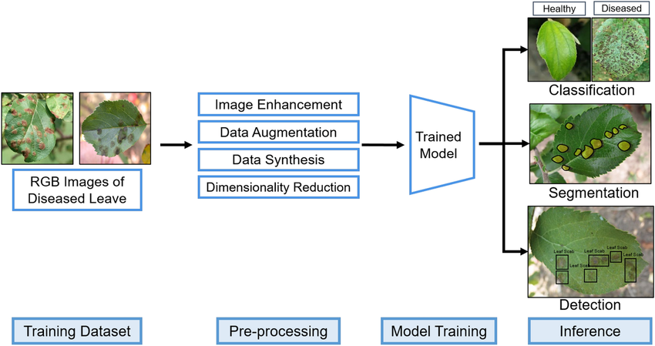
Figure 1. General machine learning pipeline for plant disease detection

Plant disease detection systems based on (ML) approaches have been investigated in recent times, often opting for simplicity and computational efficiency for image analysis. However, such approaches are not particularly suitable for the detection of complex patterns in images that vary significantly.

2.3.2 Traditional Classification Algorithms
2.3.2.1 Support Vector Machine (SVM)
A supervised learning algorithm in which, in order to classify data of different classes in Fig. 2, the optimal hyper-plane is generated.

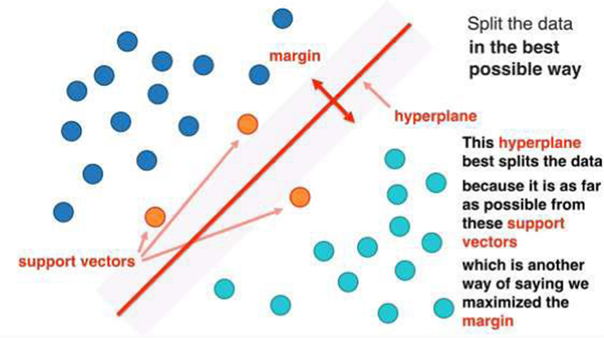
Figure 2. Support Vector Machine (SVM)
SVM has found widespread application in agricultural tasks where it has been used to discriminate between infected and healthy leaf achieving high Acc with small training samples. Its resistance to noises and capability of processing nonlinear data with the help of kernel functions make it popular [5].
2.3.2.2 K-Nearest Neighbor (KNN)
KNN is a non-parametric classification algorithm with a classification of a data point according to the most common classification of its immediate neighbors.
KNN is easy to apply for and does not need a training stage and so is applicable to small data sets. It has been used in detecting plant diseases to categorize leaf images using measures of similarity. Nevertheless, it is extremely sensitive to the selection of kand and susceptible to noisy data and unbalanced datasets [6] as shown in Figure 3.
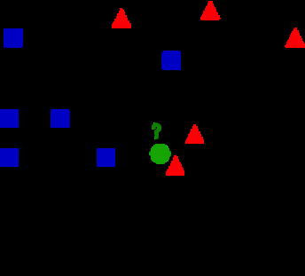
Figure 3. K-Nearest Neighbor (KNN)
2.3.2.3 Random Forest (RF)
Random Forest (RF) is an ensemble learning algorithm, which integrates a number of decision trees in order to enhance classification.
RF is reputed to be a robust model, capable of working with large datasets, and free of overfitting. It has been effectively used in other agricultural classification problems such as plant disease detection and land cover analysis [7] as discussed in Figure 4.

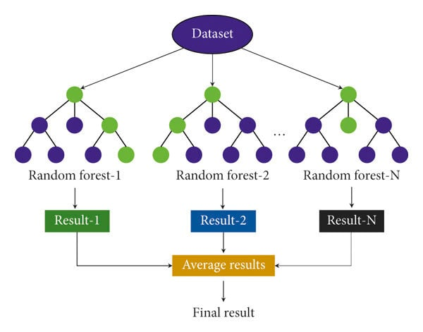
Figure 4. Random Forest (RF)
2.3.3 Limitations of Machine Learning Approaches
Despite the advantages of traditional (ML) techniques, they also have some drawbacks. One of the major drawbacks is their reliance on hand-engineered features, requiring expert knowledge and may not generalise equally well to different datasets and environments [8]. Lighting conditions, background clutter and leaf orientation can significantly affect feature extraction processes.
So far, the models aren’t great at handling multiple infections on a single leaf, or complex disease symptoms that overlap with each other. Performance on these scenarios is typically good in controlled datasets but can decrease severely in real-world use cases. Some of the base algorithms we are using, such as KNN or decision trees, can be pretty finicky when it comes to slightly different input features [9].
In order to detect diseases on bean leaves, such as angular leaf spot and rust, visual inspection is often insufficient. Standard machine learning approaches for image classification, such as convolutional neural networks, typically rely on features learned from large training datasets of images, and may not be sufficient to accurately classify images of diseased leaves.
In this way, while machine learning approaches can provide a minimum of disease detection in plants, there are limitations that lead to the need for more advanced approaches such (DL) which automatically learns features hierarchically in the case of raw images.

2.4 Deep Learning for Plant Disease Classification
2.4.1 Overview of Deep Learning
DL is a branch of (ML) that enables, for the first time, the possibility to learn directly from inputs, through a stack of (at least,) hidden layers that automatically discover hierarchical features from the input data. Traditional image classification methods rely on manual feature engineering for extracting features from images, but (DL) has shown strong ability in learning both simple and complex features directly and automatically from images, which makes DL very suitable for image-related applications such as plant disease images classification [10], [11].
Deep learning has shown great promise in agriculture, in particular by classifying plant diseases by analysing leaf images and identifying the visual symptoms of the disease, such as discolouration, spots and texture.
Deep learning models use a series of layers to learn increasingly abstract features which are more discriminative to classify compared to the conventional machine learning techniques [11], as shown in Figure 5.

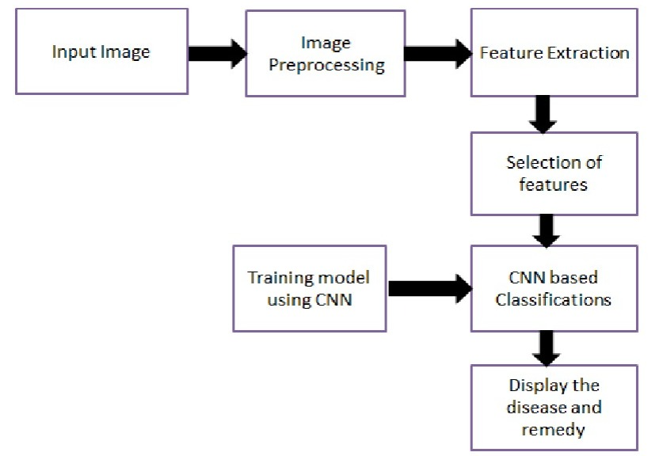
Figure 5. Deep Learning pipeline for plant disease detection

2.4.2 Convolutional Neural Networks (CNNs)
Image classification is a very common deep learning task and the most widely used model class for that task are (CNNs). Common CNNs include a mixture of different layers, like convolutional, pooling, and fully connected layers. These layers combined can automatically extract and learn spatial features from images for the purpose of image classification.[12].
CNN models include two key features: local connectivity and weight sharing, to improve computational efficiency and reduce the number of parameters. In a typical CNN, convolutional layers are assigned to extract features from the input images, while pooling layers are used to downsample feature maps by reducing their spatial dimensions. In the end, fully connected layers are assigned to classify the obtained features in the image [12]. as shown in Fig 6.

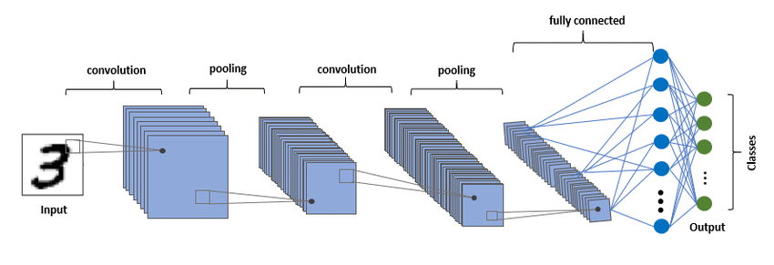
Figure 6. CNN architecture
When applied to plant disease detection, CNNs can detect the slightest visual variations between disease and healthy leaves, which is why they are quite appropriate when detecting bean leaf disease.
2.4.3 CNN Architectures
2.4.3.1 AlexNet
The pioneering work of deep CNN architectures for image classification was first shown by AlexNet, a deep architecture composed of five convolutional layers and three fully connected layers. Key innovations included the use of ReLU activation function and dropout for improving training speed and avoiding overfitting[13]. It showed the power of deep learning when it comes to image recognition at scale as shown Fig. 7.

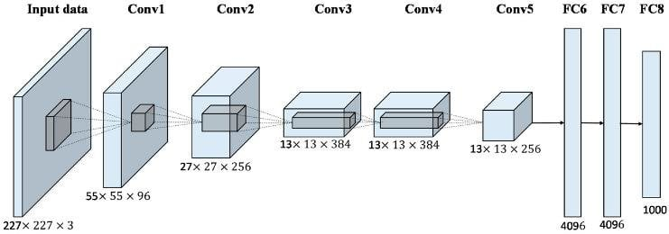
Figure 7. AlexNet architecture
2.4.3.2 VGG
VGG networks further enhanced the AlexNet by adding depth to the network and using small convolutional filters (3x3). VGG16 is one of the models, which has 16 layers and is characterized by simplicity and high results in the image classification task. Nevertheless, they have many parameters, thus making them costly to calculate [13].
2.4.3.3 ResNet
ResNet (Residual Network) proposed the concept of residual learning by introducing skip connections, which enable easier passage of the gradient in the course of training. The innovation solves the vanishing gradient issue and can be used to train very deep networks including ResNet-50 and ResNet-101 [13]. ResNet has demonstrated higher performance in most image classification problems.
2.4.3.4 EfficientNet
EfficientNet is a newly introduced architecture for CNNs that utilizes compound scaling method to increase depth, the network’s width and spatial resolution. EfficientNet is efficient, very accurate and can be used for real-world applications as it has significantly fewer parameters than other architectures [14]. Medical, agricultural image analysis tasks have been extensively examined with EfficientNet.
Since the traditional CNN constructions like VGG use sequential convolutional layers, ResNet uses residual connections to enhance gradient flow. EfficientNet, on the contrary, uses compound scaling and MBConv blocks to provide greater performance with reduced parameters.
2.4.4 Advantages of Deep Learning over Traditional Methods
Compared with traditional (ML) approaches, deep learning has its own advantages and gains particularly notable performance in plant disease classification.
To begin with, deep learning models are able to extract features automatically without manually engineering the features, so there is no need of feature engineering. This enables them to be able to capture more complex patterns and variations of leaf images [15].
Second, deep learning models are more accurate because they can learn hierarchical representations of data. This is particularly important for plant disease where there are fine visual differences that need to be identified and characterised.
Third, (DL) models can be scaled and are able to work with large datasets, enhancing their generalization during real-world applications. Moreover, data augmentation and transfer learning are other methods that can be employed to enhance performance [16].
Lastly, deep learning models are less susceptible to environmental changes like lighting, background, and noise, which are typical issues in agricultural image data.

2.5 Attention Mechanisms in Deep Learning
2.5.1 Concept of Attention Mechanism
Inspired by our visual system's way of acting as though we focus on different parts of an image at different times, attention mechanisms were recently introduced in deep learning. Attention mechanisms work by weighting different features of input data to be more informative than others to improve overall representation and decision making, and attention has been particularly powerful in image classification and related tasks, by making the network attend to distinct regions of the input during processing different computations [17].
2.5.2 Types of Attention (Spatial, Channel, Self-Attention)
The mechanisms of attention can be divided into spatial, channel, and self-attention as illustrated in Figure 8.
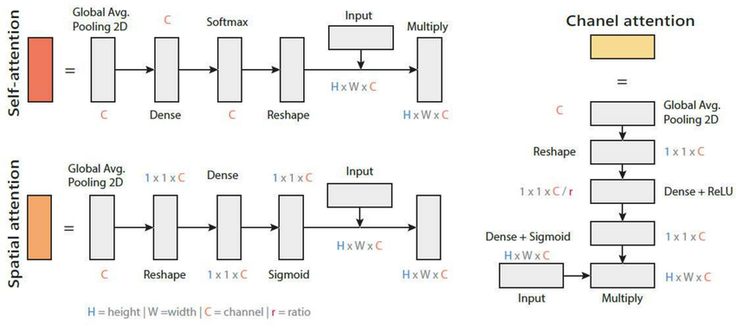
Figure 8 . Types of attention mechanisms

- Spatial Attention pays attention to the location of important features by weighting spatial locations.
- Channel Attention focuses on what features are important by weighting feature maps using global pooling.
- Self-Attention captures global dependencies between different regions of the input, enabling the model to understand long-range relationships and contextual information [18].

2.5.3 Role of Attention in Image Classification
Attention modules enhance the discriminative power of images by enhancing feature localization and suppressing the influence of distractors. Attention can help in focusing on salient regions in the image whereas CNNs might not be able to learn fine details. It leads to Acc, robustness and transferability especially in complex data [19].
Attention, especially when incorporated in deep models, allows them to focus on parts of an image relevant for a visual task at hand, i.e., to look at an image and filter out components such as background. Such models can be particularly effective for fine-grained image classification and detection tasks where the difference between classification categories is often subtle.
2.5.4 Integration of Attention with CNN Models
CNN architectures are usually complemented with attention mechanism, which enhances the extraction of features. Convolutional layers are augmented with modules including Squeeze-and-Excitation (SE) and Convolutional Block Attention Module (CBAM) that can improve channel and spatial representations [19].
Boost the performance of a classification task and to better understand which features the network actually learns to recognize, there is growing interest in interactuting regular CNNs with attention in order to focus on relevant parts of an image and suppress irrelevant information while at the same time learning to weigh these regions [20].
Attention serves to make the model concentrate on the infected regions of the leaf, and predicting more dependable, and interpretable predictions.

2.6 Explainable Artificial Intelligence (XAI)
2.6.1 Importance of Explainability in AI
Explainable Artificial Intelligence (XAI), aims at making complex machine learning models more transparent and explainable. While these models achieve high quality and performance, there is an increased need to better understand the decisions made by so called deep neural networks that are considered to be “black boxes” [21]. Such untrustworthiness decreases the adoption in such essential areas as healthcare and agriculture.
XAI can be used to overcome these issues, as it offers information about the manner in which models make predictions and the factors that affect choices. It is also used to identify any biases, enhance reliability, and enable regulatory mandates like explainability and accountability [22]. Consequently, explainability will be crucial to establishing trustful AI systems and facilitating human-AI interaction.
2.6.2 Categories of Explainable AI Techniques
Different categories for existing explainability techniques for machine learning have been defined based on aspects of design, functionality, and purpose (goal) of a method. An additional relevant perspective on how these categories could look like is how methods explain a given model: Are they deeply tailored to the specific model and can only be applied to that single instance? Or are they model-agnostic, i.e., they can explain any model? The current text discusses an XAI categorization by the latter perspective.[22]. Model-specific approaches are specific to a given model (e.g., CNN-based visualization approaches), whereas model-agnostic approaches like LIME and SHAP can be used with any model as shown in Figure 9.
The other significant classification is according to the timing of the explanation:
- Post-hoc methods: used after training.
- Intrinsic methods: inbuilt within the model.
Additionally, explanations can be:
- Global: characterizing the model behavior on the whole.
- Local: explaining individual predictions [23]

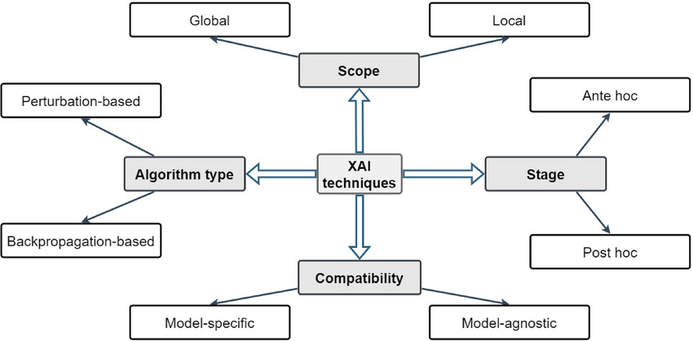
Figure 9 .XAI taxonomy

2.6.3 Gradient-weighted Class Activation Mapping (Grad-CAM)
Grad-CAM is a popular XAI methodology in understanding CNN-based models. It produces heatmaps that indicate important areas in an image that aid a particular classification decision [24].
The approach described in the paper calculates the gradients of a target class with respect to the corresponding feature maps of the last convolutional layer and sums them up to acquire a localization map.
Grad-CAM provides intuitive visual explanations by highlighting regions that positively influence predictions As Fig. 10.

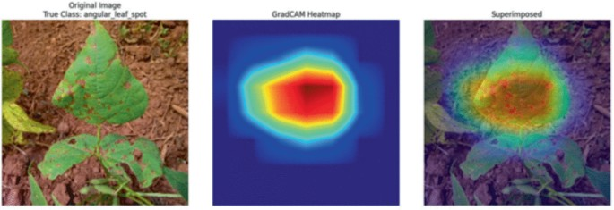
Figure 10. Grad-CAM heatmap

2.6.4 Applications of Grad-CAM in Image Classification
Grad-CAM has found extensive use in image classification tasks because it can be used to give visual explanations. In an autonomous system, it detects significant objects, whereas in medical imaging, it marks abnormal spots [25].
Grad-CAM can be utilized for classifying plant diseasesto identified infected areas on leaves, enabling users to check model predictions. This enhances the transparency of models, assists with decision-making and adds user trust. It is also useful in rooting out errors in models, which are shown through wrong attention patterns.

2.7 Evaluation Metrics
For assessing the performance of a classification model for plant disease detection, there are some standard metrics, such as classification Acc and some statistical metrics like (Acc), precision, recall, F1-score, which will be utilized to evaluate the performance of the proposed explainable deep learning model for plant disease detection.
(Acc.) is the most common performance measure for classification problems. It measures the (Acc.) of a classifier by dividing the number of Correctly Classified Instances by the total number of instances in the dataset[26]. While (Acc.) provides an overall view of the model performance, it may be insufficient in case of unbalanced dataset, and is defined as:
$$Acc=\frac{TP+TN}{TP+TN+FP+FN} (1)$$

To address the limitations of (Acc) , another measure is used to assess and determine the ratio of true positive samples that are correctly identified to the total number of samples that are positive (prediction) which is critical in avoiding false alarm (when healthy leaves are classified as diseased) [27] :
$$Precision=\frac{TP}{TP+FP} (2)$$

Similarly, Recall (Sensitivity) is used to determine how well the model identifies all the true positive cases, and in such a way that diseased leaves are not missed, to avoid agriculture loss and secure food security [28]:
$$Recall=\frac{TP}{TP+FN} (3)$$

F1-score is the harmonic mean of precision and recall, which offers a fair assessment[29]:
$$F1=\frac{2TP}{2TP+FP+FN} (4)$$
In addition, the performance of the classification at different thresholds is measured by Receiver Operating Characteristic (ROC) curve and Area Under the Curve (AUC). A greater AUC value indicates a better discrimination.
The evaluation metrics will provide a more comprehensive assessment of the overall model performance, in terms of accuracy and reliability in bean leaf disease classification, as well as its interpretation.

2.8 Related Work
DL techniques have emerged as promising approach in many fields including agriculture for plant leaf disease detection and diagnosis. Many DL architectures are used to detect and classify different diseases of plant leaves. In this paper, existing research works are discussed for plant leaf disease detection and classification using DL techniques. The outcomes of these approaches have great potential to automate agricultural diagnostics as agricultural markets are growing day by day.
Gill et al. [30] developed a deep learning recurrent architecture for classification of images of bean leaf diseases. We use 2,134 images that correspond to three different diseases. The aim of this work is to assess the ability of CNN-based architectures to facilitate early detection of plant diseases. We use standard metrics for evaluating performance and show that the system is capable of accurately recognising disease patterns with an accuracy above 90%.
Singh et al. [31] employed transfer learning on pre-trained CNNs namely MobileNetV2, EfficientNetB6 and NasNet to classify bean leaf diseases using 1295 images. All the networks were trained and tested on the same dataset, however varying the hyperparameters and observing the best results for each network. The results showed that EfficientNetB6 was the strongest model that achieved accuracy of 91.74% and was the most suitable for this real-world dataset.
Serttaş and Deniz [32] applied a CNN based on ResNet50 and using transfer learning for the detection of diseases of bean leaf using a small dataset. The study demonstrated that deep learning models are capable of achieving good results even with limited data. The approach was capable of capturing intricate visual features of the leaf disease that allowed for the identification of the disease. This result shows that transfer learning is an important factor in agricultural image analysis task with an accuracy of 98.33.
The work of Girmaw and Muluneh [33] was proposed to classify common bean leaf diseases (leaf rust and brown leaf spot) using 1,766 images. This work compared the proposed model with some of the pre-trained models and the results were superior. The model was able to learn disease specific features and improve the classification Acc. The evaluation was found to be very consistent across the levels with an (Acc) of 98% (training), 97.2% (validation) and 96% (testing).
Wang et al. [34] A hybrid DL framework is proposed for improving the detection and classification of kidney bean leaf diseases. It combines multiple CNN-based models with conventional (ML) algorithms to effectively enhance the feature representation and improve the classification accuracyThe method is compared to other standard approaches based on single models and outperforms these strongly in experimental results with an (Acc) of 96.26% and F1-score of 0.97.
Fang et al [35] Bean leaf images affected by angular leaf spot and rust diseases were classified using the AlexNet convolutional neural network. The two diseases have visual symptoms similar to each other and therefore are challenging to classify accurately. While there is still room for improvement, some classification accuracy was obtained that has the potential for use in automated disease identification of plant leaf images. More work on the deep neural network could be useful in refining and improving the model’s accuracy for real world images. The plant disease classification reached a precision of 95.4% and a validation accuracy of 78.2%.
Salau et al [36] An end-to-end deep (CNN) architecture called LeafD for diseases in faba bean leaves recognition from scanned faba bean leaves images is proposed in this paper. The scanned faba bean leaves images go through the image preprocessing step which is much critical in terms of achieving high accuracy in image classification. The features which are learned by LeafD model are suitable for identifying and differentiating various diseases accurately and consistently. It is also feasible to apply similar approach for many of agriculture problems such as plant diseases in other crops for improving crop yields. TheLeafD was achieved 98.14% in training accuracy.
The deep learning models proposed by Sahu et al [37] Applies (DL) techniques to the classification of images of bean leaf diseases. A total of 1,296 images were collected, and 3 classes of leaves were used in the experiments, i.e., angular leaf spot, bean rust, and healthy leaves. In addition to disease classification, it is important to understand the part of leaf affected by disease. In order to support this, visualizations of the behavior of a CNN on images of leaves were generated in order to support disease localization. The results from GoogleNet achieved an average accuracy (Acc.) of 95.31%, which exceeded the average accuracy of VGG16.
Abed et al [38] Within work, proposed a robotic vision–based system for the early detection of wheat leaf diseases under uncontrolled conditions using deep learning. Using the U-Net network for leaf segmentation and multiple (CNNs) for classification. Best results were obtained with DenseNet121, achieving 98.31% for the binary case and 91.01% for the multi-class case.
Noviyanto et al [39] a modified implemented architecture of a (CNN) based on DenseNet121 to detect diseases in the leaves of common bean using a dataset that comprises 1,295 images divided into three classes. The implemented model added some more convolutional layers to DenseNet121 to better extract features from images and some improvements to the learning process. Results were compared to other options based on transfer learning and the model obtained the best results, with 96.90% (Acc) and an F1-score of 97%.
Mallick et al[40] deep learning transfer learning approach was used in diseases and pests’ detection from mung bean leaves for the purpose of enhancing classification accuracy using limited dataset. The proposed model was able to identify several diseases as well as performing consistent results in various environmental setting. The average accuracy of the proposed model was 93.65%.
Kursun et al [41] introduced a (DL) framework that integrates U-Net for image segmentation with multiple (CNNs) for the classification of bean leaf diseases, including angular leaf spot and rust. emphasis was given to the image partitioning in order to increase the (Acc) of the classification. The best results (100% classification Acc ) were obtained by using the DenseNet201 model on images of the infected parts that were systematically segmented.
Elfatimi et al [42] A (DL) based architecture implemented using a MobileNet BackBone has been trained and tested to classify the different types of diseases of bean leaves, using a database of 1,296 images. Different variations for implementing an efficient architecture in terms of accuracy and time have been tried, obtaining a training accuracy of over 97% and an accuracy on test images of over 92% for the best model developed in this research work.
Elfatimi et al [43] tested performance of different datasets for distinguishing bean leaf disease using a MobileNet (DL) architecture. We used five different datasets of varying complexity and assessed transfer learning performance for distinguishing between healthy and diseased leaves. The results showed that using higher quality datasets greatly improved model accuracy, with average accuracy above 92%
Mehta et al [44] study, a federated learning–based framework combined with (CNNs) was designed and implemented for the plant disease identification and measurement of bean leaf diseases. In total, four diseases were considered and severity was indicated as a percentage. Experiments using several datasets consistently achieved high accuracy (up to 98%) along with high precision, recall, and F1-score values.

Table 1 Summary of Previous Studies

REF | Year | Model | Dataset | Key Findings (Accuracy) | Limitations
Gill et al. [30] | 2023 | Sequential CNN model | Classify bean leaf diseases | 90% | Limited dataset diversity; may not generalize well to real-world conditions
Singh et al. [31] | 2023 | Transfer Learning (MobileNetV2, EfficientNetB6, NasNet) | 1295 images, 3 classes | 91.74% | Performance depends on dataset quality; limited robustness in complex environments
Serttaş and Deniz [32] | 2023 | ResNet50 (Transfer Learning) | Bean dataset | 98.33% | Small dataset size may cause overfitting
Girmaw and Muluneh [33] | 2024 | CNN vs pre-trained models | Common Bean Leaf Disease Dataset (Ethiopia) | 96% | Dataset collected in specific region → limited generalization
Wang et al. [34] | 2025 | Hybrid (CNN + ML) | KBLD dataset | 96.26% | Complex model architecture increases computational cost
Fang et al. [35] | 2025 | AlexNet CNN | Open dataset (3 classes) | 95.4% | Difficulty distinguishing similar disease classes; lower validation accuracy
Salau et al. [36] | 2023 | End-to-end CNN | Custom Faba Bean dataset | 98.14% | Relies heavily on preprocessing; lacks real-world validation
Sahu et al. [37] | 2021 | GoogleNet vs VGG16 | Multiple datasets (LifeCLEF, etc.) | 95.31% | Dataset heterogeneity may affect consistency of results
Abed et al. [38] | 2023 | U-Net + CNN | Wheat dataset | 98.31% | Focused on wheat → limited applicability to bean crops
Noviyanto et al. [39] | 2024 | Modified DenseNet121 | 1295 images, 3 classes | 96.90% | Model complexity may require high computational resources
Mallick et al. [40] | 2023 | Transfer Learning | Mung Bean dataset | 93.65% | Small dataset size limits generalization
Kursun et al. [41] | 2023 | U-Net + DenseNet201 | 60 images dataset | 100% | Very small dataset → unrealistic performance (overfitting risk)
Elfatimi et al. [42] | 2022 | MobileNet | Uganda dataset (1296 images) | 97% / > 92% | Performance may drop in uncontrolled environments
Elfatimi et al. [43] | 2024 | MobileNet (multi-dataset) | 3 datasets | > 92% | Dataset differences affect consistency and model stability
Mehta et al. [44] | 2023 | Federated Learning + CNN | Distributed datasets | 97–98% | Lack of dataset transparency; complex implementation

2.9 Chapter Summary
With recent successes in plant disease classification tasks by means of deep learning, it is intriguing to examine how much interpretation capacity these models provide. So far, (CNNs) have been the focus of the majority of works dealing with this problem class. However, also for such promising deep learning approaches the problem of insufficient interpretation ability is still relevant. Particularly, the integration of attention and explanation techniques has so far not been sufficiently addressed.
Transparency is lacking when deep learning is applied to detect diseases of crops. Here we present an easily interpretable deep learning network for bean leaf disease detection that combines a (CNNs) , an attention mechanism and the Grad-CAM method to achieve high accuracy and to provide insight into the results of predictions. In the subsequent chapter this method is described in detail.
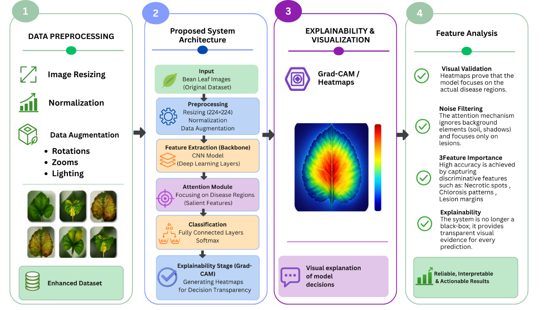

Figure 11. Proposed Approach

References
[1] Wei, K., Chen, B., Zhang, J., Fan, S., Wu, K., Liu, G., & Chen, D. (2022). Explainable deep learning study for leaf disease classification. Agronomy, 12(5), 1035.
[2] Potharaju, S., Singh, A., Singh, D., Tambe, S. N., Kantipudi, P. M., & Kiranmai, B. (2026). An explainable vision transformer model with transfer learning for accurate bean leaf disease classification. Scientific Reports, 16(1), 10402.
[3] Ahmad, A., Saraswat, D., & El Gamal, A. (2023). A survey on using deep learning techniques for plant disease diagnosis and recommendations for development of appropriate tools. Smart Agricultural Technology, 3, 100083.
[4] Toda, Y., & Okura, F. (2019). How Convolutional Neural Networks Diagnose Plant Disease. Plant phenomics (Washington, D.C.), 2019, 9237136.
[5] Noi, P. T., & Kappas, M. (2018). Comparison of Random Forest, k-Nearest Neighbor, and Support Vector Machine classifiers for land cover classification using Sentinel-2 imagery. Sensors, 18(1), 18.
[6] Lee, W.‐M. (2019). Supervised learning—Classification using K‐nearest neighbors (KNN). In Python® Machine Learning (pp. 205-220). Wiley.
[7] He, J., Li, Z., & Yin, L. (2025). An Efficient and Accurate Random Forest Node-Splitting Algorithm Based on Dynamic Bayesian Methods. Machine Learning and Knowledge Extraction, 7(3), 70.
[8] Nyawose, T., Maswanganyi, R. C., & Khumalo, P. (2025). A review on the detection of plant disease using machine learning and deep learning approaches. Journal of Imaging, 11(326).
[9] Vaz, J. M., & Balaji, S. (2021). Convolutional neural networks (CNNs): Concepts and applications in pharmacogenomics. Molecular Diversity, 25, 1569–1584.
[10] Saleem, M. H., Potgieter, J., & Arif, K. M. (2019). Plant disease detection and classification by deep learning. Plants, 8(11), 468.
[11] Das, P. K., Rupa, S. S., Pumrin, S., Das, U. C., & Hossen, M. K. (2024). Deep learning for plant disease detection and classification: A systematic analysis and review. Current Applied Science and Technology, 24(4), e0259016.
[12] Raj, R., & Kos, A. (2025). An Extensive Study of Convolutional Neural Networks: Applications in Computer Vision for Improved Robotics Perceptions. Sensors (Basel, Switzerland), 25(4), 1033. https://doi.org/10.3390/s25041033
[13] Ashraf, N. (2021). Exploring CNN architectures: AlexNet, VGG, and ResNet. Pakistan Institute of Engineering and Applied Sciences.
[14] Ucan, M., Kaya, B., Aygun, O., Kaya, M., & Alhajj, R. (2025). Comparison of EfficientNet CNN models for multi-label chest X-ray disease diagnosis. PeerJ Computer Science, 11, e2968.
[15] Wang, S., Xu, D., Liang, H., & Bai, Y. (2025). Advances in deep learning applications for plant disease and pest detection: A review. Remote Sensing, 17(4), 698.
[16] Liu, X., Karagoz, G., & Meratnia, N. (2025). Analyzing the Impact of Data Augmentation on the Explainability of Deep Learning-Based Medical Image Classification. Machine Learning and Knowledge Extraction, 7(1), 1.
[17] Cano-Ortiz, S., Sainz-Ortiz, E., Lloret Iglesias, L., Martínez Ruiz del Árbol, P., & Castro-Fresno, D. (2024). Leveraging a deep learning generative model to enhance recognition of minor asphalt defects. Scientific Reports.
[18] Wang, Z., & Ghaleb, F. A. (2023). An attention-based convolutional neural network for intrusion detection model. IEEE Access.
[19] Ullah, Z., Hong, M., Mahmood, T., & Kim, J. (2025). Systematic integration of attention modules into CNNs for accurate and generalizable medical image classification. Mathematics, 13, 3728.
[20] Zhu, H., Xie, C., Fei, Y., & Tao, H. (2021). Attention mechanisms in CNN-based single image super-resolution: A brief review and a new perspective. Electronics, 10(10), 1187.
[21] Patil, D. (2024). Explainable artificial intelligence (XAI): Enhancing transparency and trust in machine learning models. Hurix Digital.
[22] Iseal, S., Owen, J., & Daniel, S. (2023). Techniques and approaches in explainable artificial intelligence (XAI).
[23] Aysel, H. I., Cai, X., & Prugel-Bennett, A. (2025). Explainable artificial intelligence: Advancements and limitations. Applied Sciences, 15(13), 7261.
[24] Learn AI. (2024, July 22). Grad-CAM (gradient-weighted class activation mapping). Medium. https://medium.com/@divakar1591/grad-cam-gradient-weighted-class-activation-mapping-8e1aeaf96d94
[25] Talaat, F. M., Gamel, S. A., El-Balka, R. M., Shehata, M., & ZainEldin, H. (2024). Grad-CAM Enabled Breast Cancer Classification with a 3D Inception-ResNet V2: Empowering Radiologists with Explainable Insights. Cancers, 16(21), 3668. https://doi.org/10.3390/cancers16213668
[26] Powers, D. M. W. (2011). Evaluation: From precision, recall and F-measure to ROC, informedness, markedness & correlation. Journal of Machine Learning Technologies, 2(1), 37–63.
[27] Jachymczyk, U., Knap, P., & Lalik, K. (2025). Improved Intelligent Condition Monitoring with Diagnostic Indicator Selection. Sensors, 25(1), 137. https://doi.org/10.3390/s25010137
[28] Varoquaux, G., & Colliot, O. (2023). Evaluating machine learning models and their diagnostic value. In O. Colliot (Ed.), Machine learning for brain disorders (Chap. 20). Humana Press. https://doi.org/10.1007/978-1-0716-3195-9_20
[29] Lipton, Z. C., Elkan, C., & Naryanaswamy, B. (2014). Optimal Thresholding of Classifiers to Maximize F1 Measure. Machine learning and knowledge discovery in databases : European Conference, ECML PKDD ... : proceedings. ECML PKDD (Conference), 8725, 225–239. https://doi.org/10.1007/978-3-662-44851-9_15
[30] Gill, K. S., Anand, V., Gupta, R., & Pahwa, V. (2023). Bean leaf disease classification and visualization using deep learning techniques on sequential model. In 2023 International Conference (pp. 1-6). IEEE.
[31] Singh, V., Chug, A., & Singh, A. P. (2023). Classification of beans leaf diseases using fine-tuned CNN model. Procedia Computer Science, 218, 348–356.
[32] Serttaş, S., & Deniz, E. (2023). Disease detection in bean leaves using deep learning. Communications Faculty of Sciences University of Ankara Series A2-A3 Physical Sciences and Engineering, 65(2), 115–129.
[33] Girmaw, D. W., & Muluneh, T. W. (2024). Deep convolutional neural network model for classifying common bean leaf diseases. Discover Artificial Intelligence, 4, Article 96.
[34] Wang, Y., Wang, Q., Su, Y., Jing, B., & Feng, M. (2025). Detection of kidney bean leaf spot disease based on a hybrid deep learning model. Scientific Reports, 15, Article 11185.
[35] Fang, H., Sun, Y., Kim, T.-H., Xu, J., & Deng, Q. (2025). The role of deep learning in enhancing crop sustainability: A study on AlexNet’s application in detecting bean leaf disease. Frontiers in Plant Science, 16, 1637241.
[36] Salau, A. O., Ali, M., & Zhang, X. (2023). Faba bean disease detection using deep learning techniques. Procedia Computer Science, 218, 344-349.
[37] Sahu, P., Chug, A., Singh, A. P., Singh, D., & Singh, R. P. (2021). Deep learning models for beans crop diseases: Classification and visualization techniques. International Journal of Modern Agriculture, 10(1), 2305–7246.
[38] Abed, S. H., Al-Waisy, A. S., Mohammed, H. J., & Al-Fahdawi, S. (2023). A modern deep learning framework in robot vision for automated bean leaves diseases detection. Multimedia Tools and Applications.
[39] Noviyanto, N., Sunyoto, A., & Ariatmanto, D. (2024). Innovative solutions for bean leaf disease detection using deep learning. In Proceedings of the IEEE International Conference on Artificial Intelligence and Mechatronics Systems (AIMS) (pp. 1–6). IEEE.
[40] Mallick, M. T., Biswas, S., Das, A. K., Saha, H. N., Chakrabarti, A., & Deb, N. (2023). Deep learning based automated disease detection and pest classification in Indian mung bean. Multimedia Tools and Applications, 82, 12017–12041.
[41] Kursun, R., Bastas, K. K., & Koklu, M. (2023). Segmentation of dry bean (Phaseolus vulgaris L.) leaf disease images with U-Net and classification using deep learning algorithms. European Food Research and Technology, 249, 2543–2558.
[42] Elfatimi, E., Eryigit, R., & Elfatimi, L. (2022). Beans leaf diseases classification using MobileNet models. IEEE Access, 10, 1–12.
[43] Elfatimi, E., Eryigit, R., & Shehu, H. A. (2024). Impact of datasets on the effectiveness of MobileNet for beans leaf disease detection. Neural Computing and Applications, 36, 1773–1789.
[44] Mehta, S., Kukreja, V., & Vats, S. (2023). Bean leaf disease diagnosis in the age of federated learning and CNN: A severity analysis approach. In Proceedings of the 2023 Second International Conference on (pp. 1–6). IEEE.

