
Midocean University
College of Management
Master of Project Management

The impact of change management in airports on employee performance in light of digital transformation: an applied study at King Khalid International Airport in Riyadh.

Student Preparation:
Hanadi Mohamed Al-Degaither

Research Supervisors:
Dr. Alfaisal Abdelhameed Mohamed
Dr. Fayez Ali Jrad

Academic Year:
2025

(Copyright notice)
Copyright is owned by Mid-Ocean University. All materials and contents contained in this research are the property of the university and the researcher, and may not be used, reproduced, or distributed without prior permission from Mid-Ocean University.

( Abstract ):
While technology has significantly benefited humanity since the beginning of industrialization, it is crucial for it to keep innovating and adapting to stay relevant amid changing conditions. The rise of digitalization, driven by these technological advances, has led to heightened competition across various industries. In such a fiercely competitive landscape, it is vital for professionals to have a deep understanding of the latest technologies, apply them effectively, and help employees integrate these innovations. This is necessary for executing tasks well in the King Khalid International Airport sector, as well as in other fields. The process of digitalization is especially important for the air transportation industry and beyond. Consequently, this research examines how King Khalid Airport employees approach digitalization. Additionally, the study explores how digitalization affects employee productivity and satisfaction
within airport. To evaluate this impact, the research used the Digital Transformation Readiness Survey scale from the Center for Creative Leadership-Corporate Leaders and other scales that assess employee productivity and satisfaction. It sought to determine the effect of demographic factors on productivity, satisfaction, and levels of digitalization among employees. The study's findings showed a partially significant effect. Regression analysis results indicated that the extent of digitalization significantly affects employee productivity. Moreover, it was found that employee satisfaction plays a crucial role in linking employee productivity with the digitalization process.

Keywords:
Digitalization , Airport Employees , Employee Productivity ,
Employee Satisfaction.

Acknowledgement :
I want to take a moment to express my heartfelt gratitude to all those who played a part in this research. To begin with, I owe thanks to God. Next, I appreciate my family and friends, whose support and understanding helped me through the challenging times in my academic journey; your faith in my potential has been a vital source of inspiration.I also want to acknowledge Mid-Ocean University for creating an academic setting that made this research possible. The university’s resources and facilities were crucial for achieving this goal. Additionally, I am thankful for the help and collaboration from the professors and referees involved in the questionnaire and research sample. Their willingness to share insights and experiences greatly enhanced the project's depth. I extend my thanks to the academic community and the authors whose previous work provided the groundwork for this research. Their contributions were key in developing both the theoretical framework and methodology. Lastly, I am grateful to all who supported me, whether directly or indirectly, in completing this research. This achievement reflects the hard work of many individuals, and I sincerely appreciate every contribution made.

Table of contents:
Copyright notice……………………………………………………………………….II
Abstract…………………………………………………………………….II
Keywords………………………………………………………………….III
Acknowledgement……………………………………………………..III
Table of contents ………………………………………………………IV
List of tables …………………………………………………………VII
List of figure……………………………………………………………..VIII
List of terminology…………………………………………………….VIIII
Chapter 1……………………………………………………………………1
Introduction………………………………………………………………..1
Research problem………………………………………………………..2
Research questions………………………………………………………3
Research significance……………………………………………………4
Research aims……………………………………………………………..5
Research hypotheses………………………………………………………6
Change management theory……………………………………………..7
Chapter 2 (previous studies)……………………………………………..8
Introduction……………………………………………………………………8
Previous studies………………………………………………………………9
Comparison between studies…………………………………………..10
Theoretical framework…………………………………………………….11
Chapter 3 (Research Methodology)……………………………………12
Introduction…………………………………………………………………..12
Research methodology……………………………………………………13
Research population………………………………………………………14
Research sample……………………………………………………………15
Research limitations……………………………………………………….16
Chapter 4 (Results and Recommendations).………………………17
Introduction…………………………………………………………………..17
Data analysis, results………………………………………………………18
Recommendations………………………………………………………….19
References……………………………………………………………………..20
Appendices…………………………………………………………………….21

List of tables:
Table | Page
Matrix of the impact of change  Management on Employees performance (table 1-1) | 1
Demographic findings | 2

List of figures:
Figure | Pages
Figure (1-1) change management theory | 14
Figure (1-2) theoretical framework | 9
Figure (1-3) research methodology

List of terminology :

1- Digital Transformation: The integration of digital technology into all areas of a business, fundamentally changing how it operates and delivers value to customers.
2- Employee Performance: The effectiveness with which an employee fulfills their job responsibilities and contributes to organizational goals.
3- Resistance to Change: The behavioral response of individuals or groups that oppose or struggle against new changes.
4- Technology Adoption: The process by which individuals or organizations begin to use new technologies.
5- Performance Metrics: Standards used to measure employee performance and effectiveness, often including KPIs (Key Performance Indicatore.
( Chapter 1)

-1Introduction :
The term digitalization originates from the Latin word 'digitus,' meaning 'finger,' and is linked to concepts like 'number' and 'digit' in various European languages (Baloğlu, 2023). Digitalization represents a contemporary approach that has rapidly spread in our globalizing world, influenced by the industrial revolution, and affects nearly every aspect of life. This process is continuously evolving, moving through various stages, each introducing new ideas during a time marked by increased production and consumption (Baloğlu, 2023). In existing literature, digitalization is defined as transferring an organization's information and hardware into a virtual space by converting them into digital formats using electronic devices (Baloğlu, 2023). In today's business environment, digital transformation is viewed as an essential phenomenon that permeates all areas of an organization’s operations and integrates digitalization into new management strategies. The benefits of digitalization are numerous, including improved access to information, faster production and workflow, secure information management and storage, and cost savings through digital storage solutions. However, like any new method, it comes with certain challenges, such as security issues, the risk of cybercrime, and new online threats. Nonetheless, it is expected that technology advancements will address these issues promptly (Üzmez & Büyükbeşe, 2021). The study of employee satisfaction began to take shape in the 1920s alongside the emergence of job satisfaction as an academic field. The Neoclassical management perspective of the 1930s and 1940s played a significant role in this evolution, earning acknowledgment in both organizational practices and the academic literature. As a result, research in this area started to proliferate (Çabukel, 2008). These studies produced various definitions, which can generally be summarized as ‘a sense of happiness that enhances an employee’s commitment to their job and workplace’ or ‘the degree to which employees feel aligned with their work and environment’ (Korkmaz & Erdoğan, 2014). Findings from these studies suggest that employee satisfaction brings numerous advantages to employers, such as fostering organizational stability, boosting commitment, increasing motivation, and improving employee performance. Furthermore, it is crucial to recognize the mutual benefit between businesses and employees; a company’s operational effectiveness is directly linked to its capacity to offer rewarding and satisfying benefits to its workforce. Thus, employee satisfaction is a critical factor for both the business and its employees (Korkmaz & Erdoğan, 2014). Employee productivity is measured as a performance ratio, calculated based on the relationship between inputs and outputs. It can be conceptually defined as maximizing an employee’s performance to ensure sustainability at a level that benefits the organization the most (Özçelik & Kandemir, 2017). Key metrics for assessing employee productivity include performance, productivity itself, and the time taken to complete tasks. In the current business environment, there is a clear trend towards enhancing productivity to maintain a competitive advantage. Consequently, the focus on achieving low-cost, high-quality outcomes has become crucial for sustaining that competitive edge (Kıraç, 2024). Furthermore, these definitions influence one another within organizations. Increases in employee satisfaction typically lead to higher productivity, while declines in satisfaction can result in decreased productivity. When employees feel satisfied, they often develop a sense of ownership toward the organization, which can positively influence productivity by encouraging them to find fulfillment in their work (Ulusoy & Tınar, 2017). Conversely, employee dissatisfaction can lead to a lack of enthusiasm for their work, diminished feelings of belonging to the organization, and a potential drop in performance. It is important to note that employee satisfaction can vary based on factors such as individual perspectives, motivation methods, and personality traits (Eceoğlu, 2020).

2- Study problem:
This research focuses on how practices in change management affect employee performance amid the digital transformation happening at King Khalid International Airport in Riyadh.

Key Issues Defining the Research Focus
1. Readiness for Change in the Organization
For successful digital transformation, airports must have strong organizational readiness, which includes clear communication, teamwork, necessary skills, and a supportive culture. When readiness is lacking, progress can be delayed, and the implementation of new technologies may not go smoothly, which can hurt employee performance.
2. Employee Resistance and Adaptation
The shift to digital processes requires quick adjustments from employees. Common obstacles such as reluctance to embrace change, inadequate training, and a shortage of incentives can adversely affect motivation, engagement, and overall performance.
3. Specific Challenges at King Khalid International Airport
This study aims to uncover the unique challenges and possible improvements for employees at King Khalid International Airport, focusing on how customized change management approaches can lessen negative effects and boost positive results during the digital transformation.

The Fundamental Research Question:
How do change management practices influence employee performance during digital transformation at King Khalid International Airport in Riyadh?
-3Sub-Questions:
1- How advanced is the digital technology used by airport staff?

2- Does the use of digital tools influence how productive and satisfied employees are?

3- Are there differences in the digital transformation based on different categories?

-4Study Significance :
The study of change management at airports in the light of digital transformation and its impact on employee performance is very important especially in the context of King Khalid international airport. This study is critical in understanding how to effectively digitize airport operations without compromising employee performance and organizational performance.

Promoting the digital transformation and competition of airports
Airport operations are being impacted by digital transformation, which would not only require enabling technology, but also organizational preparedness, including clarity, collaboration, capabilities, and culture.

Academic research that leads to better understanding the effectiveness of change management in driving innovation, operational performance effectiveness and competitive position of the airlines as airports in an ever changing industry.

5- Study primary objective:
The main goal of this research is to highlight how important digitalization is for the growth of King Khalid International Airport, just like in other industries. The study also seeks to explore how digitalization affects employee satisfaction and productivity. The key aims of this research center around the uncertainties related to these main goals.
1-How much airport staff resist the move to digital processes.
2-The level of trust employees have in digital solutions.
3-Employees’ feelings about digital tools.
4-Whether the company is digitally advanced enough.
5- How digitalization affects the workers.
6- How well employees embrace digital changes.
7-The effect of digital technology on employee productivity.
6- Hypotheses:
To assess this impact, three hypotheses were created. They are summarized below:

H1: Increased digitalization at airports leads to higher employee productivity.
H2: There is a relationship where employee satisfaction affects the connection between digitalization and productivity.
H3: The research suggests that demographics influence the levels of employee satisfaction, productivity, and views on the digitalization process.

7- Change management theory:
Theories of change management offer a systematic way to guide people, teams, and organizations as they move from their current situation to a preferred future. One well-known model in this area is Kurt Lewin’s Change Management Model, which includes three main phases: unfreezing, changing, and refreezing. This framework underlines the importance of preparing staff for transformation, executing the change effectively, and integrating new practices into the organizational culture. Additionally, John Kotter’s Eight Steps for Leading Change highlights creating urgency, forming a guiding coalition, and embedding new methods within the organization’s culture, showcasing the role of leadership in successful change efforts. Another vital theory is the ADKAR Model, which identifies five outcomes necessary for individuals to navigate change successfully: Awareness, Desire, Knowledge, Ability, and Reinforcement. This model emphasizes the individual’s point of view in change management, making sure employees are not just informed but also encouraged to accept changes. For airports like King Khalid Airport in Riyadh, these theories can greatly affect how workers adapt to digital advancements, leading to smoother transitions and better overall performance. By utilizing these theoretical concepts, airport management can create customized plans that resonate with their staff, ensuring that technological upgrades not only change procedures but also motivate and empower employees to build resilience and adaptability in a continually evolving environment.

Figure (1- 1) Change management theory
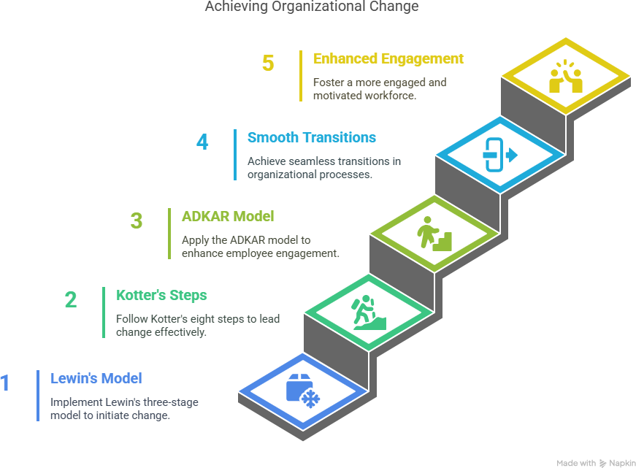
-8Chapter 2 ( Previous Studies ) :

-9Introduction :

The landscape of airport operations worldwide is changing as digital transformation, powered by automation, artificial intelligence, and biometrics, improves efficiency, security, and the overall experience for travelers. King Khalid International Airport (KKIA) is embracing these technologies as part of Saudi Vision 2030, making it a significant player in aviation. However, to truly succeed in digital transformation, it is essential to implement more than just technological improvements. Effective management of change is necessary to help employees adapt, reduce disruptions, and maintain productivity. Research consistently shows that a well-structured approach to change management—incorporating training, communication, leadership support, and employee participation—is crucial for minimizing resistance and enhancing workforce output during periods of digital change. This section synthesizes key literature, pinpoints existing gaps, and sets the stage for exploring how change management influences employee performance at KKIA. The results will prove useful for academic inquiries and practical applications related to digital transformation in airports.

10- Previous Studies:

1- Halpern, N., Mwesiumo, D., Suau-Sanchez, P., Budd, T., & Bråthen, S. (2020). Ready for digital transformation? The effect of organisational readiness, innovation, airport size and ownership on digital change at airports. Journal of Air Transport Management, 90, 101949 - 101949. https://doi.org/10.1016/j.jairtraman.2020.101949

2- Basahel, A., & Alqarni, A. (2019). An empirical study for evaluating performance of King Abdulaziz International Airport with six sigma. APTIKOM Journal on Computer Science and Information Technologies. https://doi.org/10.11591/aptikom.j.csit.157.

3- Fernández-Vidal, J., Perotti, F., González, R., & Gascó, J. (2022). Managing digital transformation: The view from the top. Journal of Business Research. https://doi.org/10.1016/j.jbusres.2022.07.020.

4- Shang, M., Tang, D., Shi, L., & Wang, J. (2025). A study on the relationship between digital transformation elements, innovation capability and digital transformation performance of civil airports. Journal of Computational Methods in Sciences and Engineering, 25, 3763 - 3779. https://doi.org/10.1177/14727978251326504.

5- Klein, S., Spieth, P., & Söllner, M. (2024). Employee acceptance of digital transformation strategies: A paradox perspective. Journal of Product Innovation Management. https://doi.org/10.1111/jpim.12722.

6- Shao, Z., Li, X., Luo, Y., & Benitez, J. (2022). The differential impacts of top management support and transformational supervisory leadership on employees’ digital performance. European Journal of Information Systems, 33, 334 - 360. https://doi.org/10.1080/0960085X.2022.2147456.

7- Guerra, J., Danvila-Del-Valle, I., & Suárez, M. (2023). The impact of digital transformation on talent management. Technological Forecasting and Social Change. https://doi.org/10.1016/j.techfore.2022.122291.

8- Selimović, J., Pilav-Velić, A., & Krndžija, L. (2021). Digital workplace transformation in the financial service sector: Investigating the relationship between employees' expectations and intentions. Technology in Society. https://doi.org/10.1016/j.techsoc.2021.101640.

9- Shin, J., Mollah, M., & Choi, J. (2023). Sustainability and Organizational Performance in South Korea: The Effect of Digital Leadership on Digital Culture and Employees’ Digital Capabilities. Sustainability. https://doi.org/10.3390/su15032027.

10- Suwannapirom, C., & Pranee, S. (2023). A structural equation model of organizational performance of airports of Thailand public company limited. SSRN Electronic Journal. https://doi.org/10.2139/ssrn.4606755.

11- Comparison between studies:

While methodologies and contexts differ, these studies consistently find that organizational readiness, innovation, and effective change management are essential for leveraging digital transformation to improve employee performance in airports. Digital transformation also enhances the impact of HR strategies, underscoring the need for integrated approaches.

Matrix of the Impact of change Management on employee performance
(table 1):

Change Management Aspect | Effect on Employee Performance
Organizational Structure | Strong positive impact; improves service quality and performance.
Leadership Change | Significant positive effect; boosts engagement and performance.
Technological Change | Moderate positive effect; enhances efficiency if well-managed.
Work Culture & Involvement | Positive effect; increases morale and retention.
Communication & Support | Reduces resistance, increases satisfaction.

12- theoretical framework:

This research is based on three main theoretical views that shed light on how digital transformation, change management, and employee performance are connected:

-1 Lewin’s Change Management Model (1951):
- Involves the Unfreeze-Change-Refreeze steps.
- Details phases of how organizations adapt.
-2 Kotter’s 8-Step Change Model (1996):
- Offers a practical approach for implementing change.
- Highlights urgency, building support, and creating a vision.
-3Technology Acceptance Model (TAM) - Davis (1989):
- Looks at how useful and easy technology seems.
- Forecasts how people will adopt new technology.
These models assist in understanding:
The way KKIA handles digital transformation
The factors that affect how employees adopt technology
The importance of leadership in carrying out changes
The methods for maintaining improvements in performance.

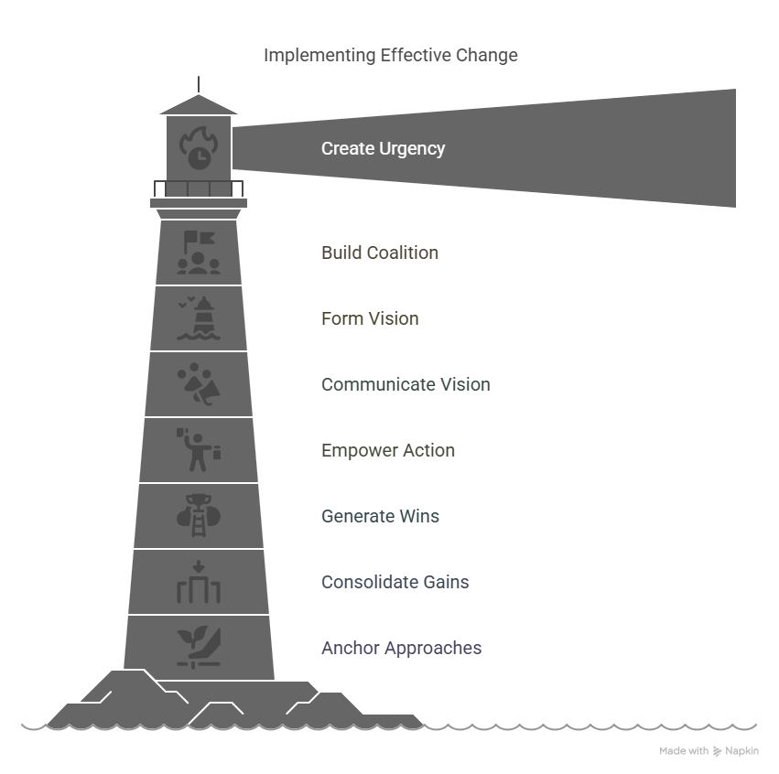
Figer (1-2) theoretical framework

13- Chapter 3 ( Research Methodology ) :

13- Introduction:
This research, a quantitative method is applied within a practical, cross-sectional framework to achieve a structured and measurable analysis of data. The approach details important aspects such as the target group, sampling methods, tools for data gathering, and analysis techniques, which support both reliability and validity. Through the use of organized methods, this study seeks to deliver objective and broadly applicable results regarding the topic being explored.

14- Study Methodology:
This research is a practical, cross-sectional project. The study used a quantitative approach, which is detailed in the methodology section, including information on the population, sample, tools for data collection, and the analysis of the data.



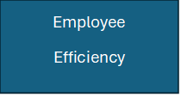
Airport
Digitalization level

Figure ( 1-3 ) Research Model:

15- Study Population :
The group being studied will include workers at King Khalid International Airport (KKIA) in Riyadh, Saudi Arabia, who are impacted by digital transformation efforts, either directly or indirectly. This group may encompass:
1- Operational Workers (such as those in ground handling, security, and customer service)
2- Technical and IT Personnel (like individuals overseeing digital systems, automation, AI, and data analysis)
3- Administrative and Management Teams (including HR, finance, and operations managers)
4- Support Personnel (such as maintenance and logistics staff)
To gain thorough insights, the sample might be divided according to departments, job functions, and degrees of digital adoption.

Data Collection Sources:
To achieve the study objectives the researcher relied on two types of sources in collecting data and information, as follows:
A-Secondary sources: These are data previously collected by another researchr, and relying on them is often less costly and time-consuming, such as books and related publications, scientific journals, and published research
B-Primary sources: These are data collected for the first time from a specific community for the research project. Relying on rhem often requires sufficient effort, time, and more detail than secondary sources because they lead to more accurate and realistic information, such as questionnaites.
These sources are collected for study purposes from university theses and available websites.
The method of collecting primary-data relies on a questionnaire designed by the researcher to collect quantitative data related to subject of the study.

16- Study sample :
Location of the Study: King Khalid International Airport (KKIA) in RiyadhParticipants: Between 300 and 400 employeesSampling Technique: Stratified random samplingMain Categories:Departments: Operations, Security, Information Technology, Customer Service, Administration, and ManagementExperience Levels: Less than 2 years, 2 to 5 years, 5 to 10 years, More than 10 yearsDigital Adoption Types: Early adopters, regular users, and resistant usersMethods of Data Collection:Surveys (quantitative)Interviews (involving 15-20 employees, 10-15 managers, and 5-8 executives)Focus Groups (4-6 groups, each with 8-10 participants) .

Study Tool:
We will use the questionnair as a tool for collecting data for the study, as it is the most appropriate scientific research tool that is consistent with the study data and achieves its objectives of obtaining information. The questionnaire is also considered one of common methods for obtaining facts and collecting data from existing conditions and methods. This study depends on the methodology followed, the study objectives and question, the time allowed, and available financial capabilities. It was concluded that the most appropriate tool and achieving the objectives of this study is the “questionnaire.”

17- Study Limitations:
Investigating how change management affects employee performance during the digital transformation at King Khalid International Airport (KKIA) in Riyadh faces several limitations:
1. Narrow Focus: This research concentrates solely on KKIA, which may hinder the applicability of its results to other airports that operate under different cultural, technological, or operational conditions.
2. Limited Data Availability: Obtaining complete employee performance information or sensitive operational statistics can be challenging, which could restrict the depth of the analysis performed.
3. Bias in Feedback: Using surveys or interviews for gathering employee opinions can lead to bias, as individuals may interpret the effectiveness of change management subjectively.
4. Time Limitations: The research might only reflect a specific period, therefore it might overlook the long-term effects or ongoing consequences of digital transformation efforts.
5. Cultural Influences: The distinct cultural and organizational landscape of Saudi Arabia may shape how employees react to change, making it tough to compare with findings from other countries.
6. Inconsistent Technology Adoption: Variations in how quickly or which digital technologies are embraced at KKIA could impact the reliability of the research outcomes.

Dear Respondent,

I am a Master's candidate (Management) at the University of Midocean Currently, I
to examine the This study aimsam conducting a study titled " The impact of change management in airports on employee performance in light of digital transformation: an applied study at King Khalid International Airport in Riyadh.

I would like to request your cooperation to answer this questionnaire. Any information obtained
will be kept confidential and only used for academic purposes. Your cooperation is highly
appreciated.
Thank you in advance for agreeing to participate in this study. If you have any questions, please
do not hesitate to contact my honorable supervisor, Associate Professor Dr. Alfaisal Abdelhameed Mohamed, or myself
Hanadi Mohamed (Master Candidate).

Table 2: Demographic Finding:
Part One: Please put a check mark (✓ ) in the box that applies to your case:

1-Age:

25 years or less ( ) 26 - 35 years ( )
46 years or more ( ) 36-45 years ( )

2- Educational level:

Below Secondary ( ) Secondary ( )
Diploma ( ) University ( )
Postgraduate Studies ( )

3- Marital Status:

Single ( ) Married ( )
Widowed ( ) Divorced ( )

4- Gender:

Male ( ) Female ( )

5- Current Department / Work Unit at King Khalid International Airport:

Passenger Services ( ) Security Screening ( )
Security Screening ( ) Baggage Handling ( )
Passenger check-in Officer ( ) Operations / Airside Coordination ( )
Information Technology (IT) ( ) Administration / HR / Finance ( )
Management / Supervision ( ) Other: ________________

Chapter 4 ( Results and Recommendations):

Introduction :

Summary and Recommendations This section summarizes overview of the key findings from the adopted research (which examines change management upon employee performance at KKIA in Riyadh while digital transformation continues to take place) and presents recommendations. The Role of the Human Interface Factor in Airport Investment Since airports globally are adopting technology to drive operational efficiencies or improve customer service, the human factor -- notably staff acceptance and performance--has become a critical success determinant.
The research investigated the effects of institutionalized change programs on motivation, productivity, and engagement during a digital transition. Through investigating data from KKIA employees spread throughout different sectors, the study revealed barriers and opportunities of IT transformation in face-to-face services at stake.

Results demonstrate the more subtle relationship between technological change and work force dynamics where how change is managed not only reduces resistance, but it becomes a generative source to create environments in which workers and organizations can engage in ongoing improvement. Using these findings, the guidelines are designed to assist airport leaders in tailoring their change approach for optimal employee performance and help maintain morale while being more efficient.

