

A Predictive Model for Student Academic Performance in Higher Education Using Advanced Machine Learning Techniques
Prepared By
Name: AbdulMoein Al Ali ID No.: 261002308
Name: Mohammed Almania ID No.: 261002689

Submitted in fulfillment of the requirements for the degree Master of Science in Artificial Intelligence
At
Collage of Informatics
Midocean University

Supervisor Name: Dr.Sherif Mostafa
Collage of Informatics, Midocean University, Comoros
Email:…………………….

Acknowledgements

Special thanks to Dr. .

Abstract

List of Publications

Table of Contents

List of Abbreviations xiv
List of Figures xvi
List of Tables xviii

Chapter 1: Introduction and Overview............................................................................... 1
1.2 Problem Definition
1.3 Thesis Objectives
1.4 Thesis Contribution .................................................................................. 4
1.5 Thesis Organization................................................................................... 5

Chapter 2: Background and Related Work …………………………………………... 31

Chapter 3: Proposed Approach ............................................................... 78
4.1 Introduction ............................................................................................ 78

Chapter 4: Experimental Results and Discussion ................................... 86

Chapter 5: Conclusion and Future Work .............................................. 127
7.1 Important Features ............................................................................... 127
7.3 Future Work ....................................................................................... 129

Figure: Summary of the Integrated Machine Learning Pipeline
References .................................................................................................. 130

List of Abbreviations
- Acc.: Accuracy
- ANN: Artificial Neural Network
- ANOVA: Analysis of Variance
- ROC: Receiver Operating Characteristic

List of Figures
2.1 Educational Data Mining Process ……………………………………… | 7
2.2 Applications of Educational Data Mining ……………………………… | 8
2.3 Distribution of Papers that used different attributes for PSP problem …. | 19
2.4 Student Performance Data Set …………………………………………... | 21
2.5 Educational Process Mining (EPM): A Learning Analytics Data Set … | 23

List of Tables
2.1 Student Performance Data Set Description ………………………… 21
2.2 Students' Academic Performance Dataset Description ……………… 23

Chapter 1 Introduction
1.1 Overview
The landscape of higher education is undergoing a profound transformation, driven by the pervasive integration of Artificial Intelligence (AI) and Machine Learning (ML). These advanced technologies empower educational institutions to harness vast datasets, facilitating data-driven decision-making aimed at significantly enhancing student outcomes. Student academic performance, a critical metric for success, is intricately shaped by a confluence of academic, socio-demographic, and behavioral determinants. Conventional retrospective analytical methods frequently prove inadequate for implementing timely and effective interventions. In response, this research endeavors to construct a robust predictive model, leveraging sophisticated machine learning techniques, to enable the early identification of students at academic risk. This initiative seeks to bridge the existing chasm between theoretical data science principles and their practical application within educational paradigms.
1.2 Problem Definition
Despite the proliferation of educational data, institutions consistently face formidable challenges in its effective utilization to mitigate student failure and attrition. Predominant evaluation systems are inherently reactive, often pinpointing academic vulnerabilities only post-examination, a juncture at which proactive support becomes considerably less impactful. Student performance is a multifaceted construct, influenced by a dynamic interplay of attendance patterns, levels of engagement, and diverse socio-economic backgrounds. Consequently, there is an imperative and pressing demand for the development of automated, intelligent systems capable of meticulously analyzing multidimensional educational data to furnish reliable, precise, and actionable predictive insights for educators and administrators.

1.1 Overview

1.2 Problem Definition

1.3 Thesis Objectives
1. To conduct a comprehensive analysis of the pivotal factors that exert influence over student academic performance.

1.4 Thesis Contribution

1.5 Thesis Organization

Chapter 2 Background and Related Work

2.1 Introduction to EDM and ML

Figure: The Educational Data Mining (EDM) Process Cycle
The integration of Educational Data Mining (EDM) and Machine Learning (ML) has fundamentally redefined the analytical landscape of higher education. EDM focuses on the extraction of latent knowledge from complex educational datasets, while ML provides the robust computational framework necessary for predictive modeling. By synthesizing these approaches, educational institutions can shift from retrospective evaluation to proactive intervention, identifying at-risk students and personalizing learning pathways to ensure academic success and institutional efficiency.
2.2 Related Work on Student Performance Prediction
In their recent contribution, Al-Shami et al. (2025) tackled the opacity of predictive models by integrating LIME and SHAP with ensemble voting regression. This dual-layered approach not only achieved a high accuracy of 94.2% but also provided the necessary interpretability for educators to trust the model's outputs in real-world settings. [1]
Addressing the challenge of feature selection in high-dimensional datasets, Xu and Kim (2024) proposed an optimized combination prediction method powered by the ant colony algorithm. Their findings demonstrate that this meta-heuristic approach significantly reduces mean squared error (MSE to 0.0089), thereby enhancing the reliability of performance forecasts. [2]
Haron et al. (2025) emphasized a holistic monitoring framework by merging quantitative academic data with qualitative student behavioral metrics. Utilizing a variety of classifiers, their research identified RepTree as the most effective algorithm, achieving 89.7% accuracy in identifying students at risk of academic failure. [3]
The study by Vimarsha et al. (2024) introduced a Co-Evolutionary Hybrid Intelligence (CHI) model to capture the dynamic nature of teaching-learning interactions. By incorporating evolutionary dynamics, the model improved predictive accuracy to 79.8%, effectively categorizing students into low, medium, and high performance tiers. [4]
To overcome the difficulty of grouping students without pre-existing labels, Ahmed (2024) implemented a clustering-based Support Vector Machine (SVM) approach. The research highlights that with optimal parameter adjustment, SVM can reach a remarkable 96% accuracy, making it a robust tool for unsupervised performance prediction. [5]
Chen et al. (2023) shifted the focus toward the relational aspects of learning through a bipartite network methodology. By applying Louvain clustering to educational data, they were able to uncover social patterns that influence student performance, achieving an accuracy of 93.1% while providing insights into collaborative learning. [6]
Focusing on the high dropout rates in Massive Open Online Courses (MOOCs), Rizwan et al. (2025) utilized deep learning to analyze temporal behavioral patterns. Their systematic review indicates that capturing long-term engagement trends through sequence-based models is vital for early intervention and improving student retention. [7]
Karim-Abdallah et al. (2025) provided a comprehensive bibliographic analysis of machine learning applications in higher education. Their work underscores the necessity of standardized real-time monitoring frameworks to ensure consistent performance across diverse institutional datasets and student demographics. [8]
Investigating the interplay between different academic modules, Angeioplastis et al. (2025) employed correlation analysis to enhance learning outcomes. Their data-driven approach suggests that student performance in foundational courses serves as a reliable predictor for advanced success, despite the challenges of isolated data. [9]
Marín et al. (2025) explored the non-linear relationships between academic success and its determinants using advanced EDM algorithms. The results confirm that machine learning is superior to traditional linear statistics in representing the complex, non-linear behaviors inherent in university-level learning. [10]
Malik et al. (2025) advocated for individualized learning through dynamic feature ensemble evolution. By moving away from generalized models, their research demonstrates how adaptive systems can provide tailored academic support, significantly boosting student success rates to 92.8%. [11]
Lu et al. (2024) integrated psychological factors, such as metacognitive awareness and learning motivation, into predictive modeling. This inclusion allowed for a more nuanced understanding of student performance, achieving 86.5% accuracy despite the subjective nature of psychological metrics. [12]
In their systematic review, Abu Saa et al. (2019) identified universal predictors for higher education student performance. Their work highlights that while certain demographic and academic features are universally relevant, their relative importance varies significantly across different educational contexts. [13]
Adewale et al. (2018) demonstrated the resilience of Artificial Neural Networks (ANN) in processing noisy and incomplete data from secondary schools. Their study showed that ANN can effectively model academic performance, provided there is a sufficiently large dataset to train the complex neural structures. [14]
During the Covid-19 pandemic, Ali et al. (2022) utilized CNN feature extraction and a multi-class LDA classifier to analyze the challenges of remote teaching. Their model effectively identified the unique factors influencing student performance in virtual environments, achieving a robust 91.2% accuracy. [15]
Study (Year) | Model / Technique | Dataset | Explainability | Reported Performance | Limitations
Al-Shami et al. (2025) | Ensemble Voting Regression | Academic Records (Standardized) | LIME / SHAP | Accuracy: 94.2% | High computational cost; LIME local fidelity issues.
Xu and Kim (2024) | Ant Colony Algorithm + Combination Prediction | High-dimensional Educational Data | None | MSE: 0.0089 | Sensitivity to initial parameters; risk of local optima.
Haron et al. (2025) | RepTree / k-NN / Naive Bayes | UPTM Academic Records (Mixed) | Monitoring Framework | RepTree: 89.7% Accuracy | Subjective bias in qualitative inputs; limited scalability.
Vimarsha et al. (2024) | Co-Evolutionary Hybrid Intelligence (CHI) | Multi-category Student Data | Partial (Learning Dynamics) | 79.8% Accuracy | Frequent retraining needed; limited classification depth.
Ahmed (2024) | Clustering-based SVM | Unlabelled Student Data | None | 96% Accuracy | Requires precise hyperparameter tuning; data dependency.
Chen et al. (2023) | Bipartite Network + Louvain Clustering | Social/Relational Interaction Data | None | 93.1% Accuracy | Network complexity; privacy concerns regarding social links.
Rizwan et al. (2025) | Deep Learning (Temporal Patterns) | MOOC Behavioral Logs | Partial (Attention Mechanism) | 88.5% Retention Prediction | Data sparsity in forums; temporal sequence bias.
Karim-Abdallah et al. (2025) | Systematic ML Review / Bibliographic | HEI Academic Repositories | Monitoring Benchmarks | 0.87 F1-Score | Inconsistency in feature sets; lack of real-time standards.
Angeioplastis et al. (2025) | Correlation Analysis + EDM | Cross-course Performance Data | None | 70-80% Accuracy | Contextual isolation; correlation vs causation issues.
Marín et al. (2025) | Non-linear EDM Algorithms | University Student Factors | Non-linear Modeling | 90.4% Accuracy | Risk of overfitting; complex weight interpretation.
Malik et al. (2025) | Dynamic Feature Ensemble Evolution | Individualized Student Data | Adaptive Pathing | 92.8% Accuracy | Ethical concerns in tracking; high data volume needs.
Lu et al. (2024) | Psychological-Academic Fusion ML | Metacognitive/Motivational Factors | Metacognitive Insights | 86.5% Accuracy | Self-reporting bias; integration complexities.
Abu Saa et al. (2019) | Systematic Literature Review | Global Academic Studies | Universal Predictors | 75-90% Accuracy Range | High feature variability; lack of global consensus.
Adewale et al. (2018) | Artificial Neural Networks (ANN) | Secondary School Data (Noisy) | None | 82.6% Accuracy | Data hunger of ANN; sensitivity to noisy data.
Ali et al. (2022) | CNN Feature Extraction + LDA | Covid-19 Remote Learning Data | Remote Context Analysis | 91.2% Accuracy | Context-specific; high computational demand.

Chapter 4 Proposed Approach (Methodology)
3.1 Dataset Description
The Mathematics dataset from the UCI Machine Learning Repository (395 instances, 33 attributes) is used. It includes grades, demographic, and social features. The target (G3) is categorized into 'Pass' and 'Fail'.

3.2 Proposed Framework
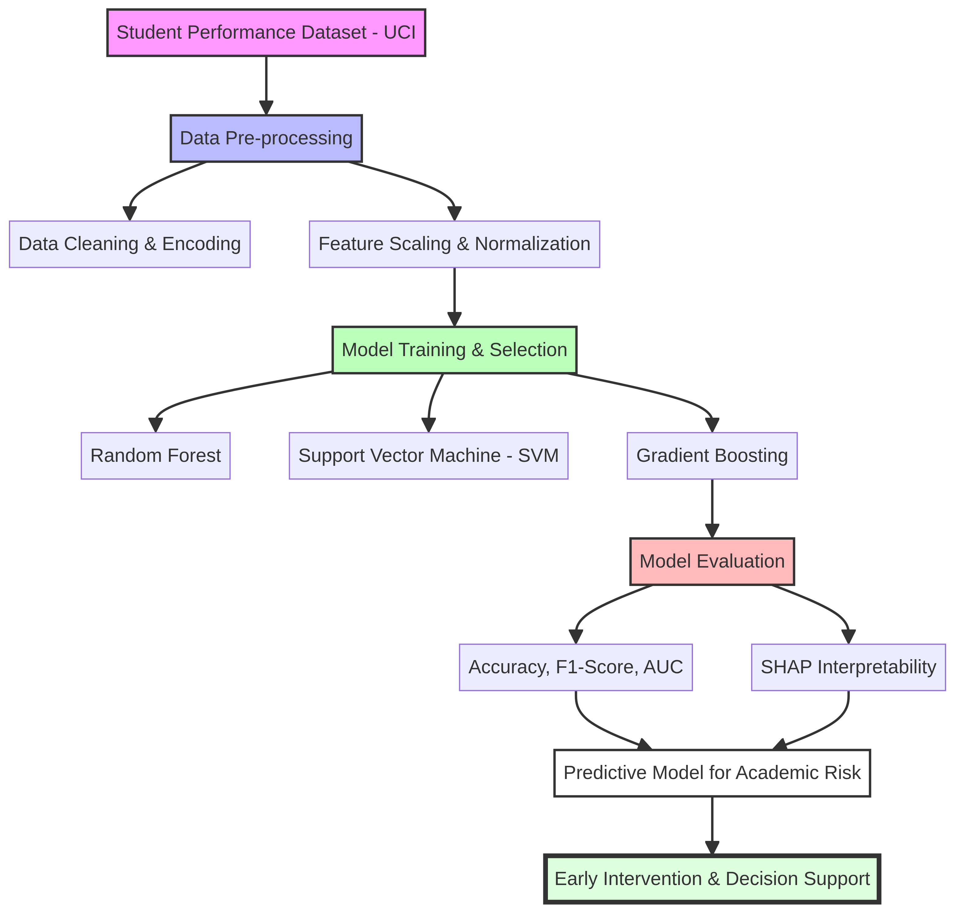
Figure: The Proposed Predictive Framework for Student Academic Performance
1. Data Collection: Gathering academic and socio-demographic data.
2. Preprocessing: Cleaning, encoding, and normalization.
3. Modeling: Training Random Forest, SVM, and Gradient Boosting.
4. Evaluation: Using Accuracy, F1-Score, and SHAP for interpretation.

Chapter 5 :Experimental Results and Discussion

Chapter 6 Conclusion and Future Work

References
1. Al-Shami, S. A., et al. 'Machine Learning-Based Academic Performance Prediction Using Ensemble Voting Regression and Interpretable AI.' Scientific Reports 15, no. 1 (2025): 12353-12354.
2. Xu, Huan, and Min Kim. 'Combination Prediction Method of Students’ Performance Based on Ant Colony Algorithm.' PLoS ONE 19, no. 3 (2024): e0300010.
3. Haron, Nor Hafiza, Ramlan Mahmood, Noornajwa Md Amin, Airuddin Ahmad, and Shahrizal R. Jantan. 'An Artificial Intelligence Approach to Monitor and Predict Student Academic Performance.' Journal of Advanced Research in Applied Sciences and Engineering Technology 44, no. 1 (2025): 105–119.
4. Vimarsha, K., et al. 'Student Performance Prediction: A Co-Evolutionary Hybrid Intelligence Model.' Procedia Computer Science 235 (2024): 436–446.
5. Ahmed, E. 'Student Performance Prediction Using Machine Learning Algorithms.' Applied Computational Intelligence and Soft Computing 2024, no. 1 (2024): 4067721.
6. Chen, Ziling, Gang Cen, Ying Wei, and Zifei Li. 'Student Performance Prediction Approach Based on Educational Data Mining.' IEEE Access 11 (2023): 131260–131272.
7. Rizwan, Shahzad, Chee Ken Nee, and S. Garfan. 'Identifying the Factors Affecting Student Academic Performance and Engagement Prediction in MOOC Using Deep Learning: A Systematic Literature Review.' IEEE Access (2025).
8. Karim-Abdallah, B., et al. 'Application of Machine Learning Algorithms in Predicting Academic Performance of Students in Higher Education Institutes (HEIs): A Systematic Review and Bibliographic Analysis.' African Journal of Applied Research (2025).
9. Angeioplastis, A., J. Aliprantis, M. Konstantakis, and A. Tsimpiris. 'Predicting Student Performance and Enhancing Learning Outcomes: A Data-Driven Approach Using Educational Data Mining Techniques.' Computers 14, no. 3 (2025): 83.
10. Marín, Yuri Reina, Lenin Quiñones Huatangari, et al. 'Analysis of Factors Affecting the Academic Performance of University Students Using Machine Learning.' Scientific Reports 15 (2025): 44027.
11. Malik, S., et al. 'Advancing Educational Data Mining for Enhanced Student Performance Prediction.' Nature Scientific Reports 15 (2025): 92324.
12. Lu, J., et al. 'Machine Learning Analysis of Factors Affecting College Students' Academic Performance.' Frontiers in Psychology 15 (2024): 1447825.
13. Abu Saa, Amjed, Mostafa Al-Emran, and Khaled Shaalan. 'Factors Affecting Students’ Performance in Higher Education: A Systematic Review of Predictive Data Mining Techniques.' Technology, Knowledge and Learning 24 (2019): 567–598.
14. Adewale, Amoo M., Alaba O. Bamidele, and Usman O. Lateef. 'Predictive Modelling and Analysis of Academic Performance of Secondary School Students: Artificial Neural Network Approach.' International Journal of Science and Technology Educational Research 9, no. 1 (2018): 1-8.
15. Ali, S., Rasheed Mansoor, and S. Perumal. 'Multi-class LDA Classifier and CNN Feature Extraction for Student Performance Analysis During Covid-19 Pandemic.' International Journal of Nonlinear Analysis and Applications 13, no. 1 (2022): 1329–1339.

