Mid-Ocean University
Collage of Management

The Impact of Project Management Offices on Strategic Plan in the Saudi Private Sector (Field Study)

Prepared by:
Arwa Mohammed Abdel-Rahman Alawwad

Student ID:
2021206354

A dissertation submitted to Mid-Ocean University in partial fulfillment of the requirements for the Doctor of Philosophy degree

2026

Chapter One

INTRODUCTION
The project management office (PMO) is essential in implementing an organization's strategic plan, ensuring coherence with long-term objectives. The PMO faces the challenge of identifying projects that are in harmony with the organizational strategy; however, its influence can effectively mitigate this issue. (Aziz, Emad’s, 2014)
The strategic functions of the PMO further underscore the importance of alignment with the organization, especially in relation to Saudi Vision 2030. Additionally, the PMO's responsibilities include improving project success factors throughout the organization, considering new external circumstances. Looking forward, the evolution of project management innovation will certainly impact the operations of PMOs and their alignment with organizational strategies, underscoring the necessity for PMOs to modify their governance and project organization methods. In conclusion, the PMO is instrumental in ensuring that an organization's projects are aligned with its strategic plan and long-term visions, such as Vision 2030. The selection of aligned projects, the establishment of standards, and the adaptation to future innovations all play a significant role in enhancing strategic execution and alignment. (Aziz, Emad’s, 2014)
In the current dynamic business landscape, it is essential for organizations to be both agile and strategic in order to meet their objectives. This necessity is especially pronounced in the context of an ambitious long-term initiative aimed at diversifying the economy, enhancing public service sectors, and increasing the participation of Saudi citizens in the workforce. A vital element in achieving these aspirations is the effective alignment of organizational projects with the broader strategic framework. This is where Project Management Offices (PMOs) become instrumental. Functioning as centralized entities that oversee project management practices, PMOs are crucial in the selection, governance, and execution of projects that drive the organization toward its strategic goals. (Turki Alsediry, 2013)
Saudi Vision 2030 serves as a pivotal framework for achieving strategic objectives, highlighting essential pillars such as economic diversification, social inclusion, and sustainability. Project offices play a vital role in transforming these pillars into actionable projects and initiatives, ensuring effective resource management, coordination, and risk mitigation. By adhering to the foundational principles of Saudi Vision 2030, project offices can make substantial contributions toward fulfilling these objectives. (Turki Alsediry, 2013)
The risks associated with PMOs become apparent when organizations fail to integrate service management and project management into a cohesive platform. This lack of integration can lead to inadequate transparency and communication, resulting in isolated operations that hinder growth and success. When organizations handle tickets, change management, and projects independently, the repercussions can be extensive. (Crawford, L, & Pollack, J,2007)
While resource optimization is a primary goal of the PMO, other critical areas include communication, tracking, and information sharing. Utilizing a unified platform can address these challenges effectively. Consolidating all operations into a single platform enhances visibility across the entire organization, allowing for a comprehensive overview through a single dashboard. This integration enables the PMO to gain insights into broader operations, fostering a more collaborative team environment. Advanced project management methodologies can assist PMOs in adapting to evolving strategic directions, ensuring alignment with the organization's overall business strategy and demonstrating their value in achieving strategic goals. (Crawford, L, & Pollack, J,2007)
The article delves into the significant role of PMOs in shaping an organization's strategic plan and their alignment with Saudi Vision 2030, exploring their functions, impacts, and future implications. Saudi Vision 2030 represents a significant benchmark in the pursuit of strategic goals, underscoring critical pillars such as economic diversification, social inclusion, and sustainability. Project offices are instrumental in converting these pillars into concrete projects and initiatives, facilitating effective resource allocation, coordination, and risk management. (Crawford, L, & Pollack, J,2004)
By aligning with the core tenets of Saudi Vision 2030, project offices can play a crucial role in achieving these objectives. The risks associated with PMOs become evident when organizations do not unify their service management and project management efforts. This disconnection can lead to insufficient transparency and communication, creating silos that impede growth and success. When organizations manage tickets, change management, and projects in isolation, the consequences can be significant. While resource optimization is a key focus of the PMO, other important areas include communication, tracking, and information transfer. Implementing a single platform can effectively address these issues. ( Ali Hadi,Yang Liu, Shenxue Li, 2022)

Having all operations centralized in one location enhances visibility across the organization, allowing for a streamlined overview through a single dashboard. This approach enables the PMO to gain insights into the broader operational landscape, promoting a more integrated. Standardization and methodology are crucial elements of effective project management. They provide a framework for consistent, efficient, and successful project execution. ( Ali Hadi,Yang Liu, Shenxue Li, 2022)

Problem Definition
The research problem focuses on understanding how PMOs contribute to the successful execution of an organization's strategic plan, especially in the context of long-term visions like Saudi Vision 2030. It aims to explore the challenges and opportunities associated with aligning projects with strategic goals and the role that PMOs play in addressing these challenges. (Abdullah, S., & Al-Salem, M. ,2019)
PMOs need to embrace innovation and agility to drive project success in a competitive environment. This involves adopting new project management methodologies and tools, as well as fostering a culture of creativity and experimentation. (Marsh, L,2014)
The rapid pace of change in the business landscape presents challenges for PMOs, as they must adapt to new technologies, evolving market trends, and shifting strategic priorities. (Serrador, P., & Turner, R. 2015)
Leveraging data analytics and insights can help PMOs make informed decisions and optimize project performance. By tracking key metrics and analyzing project data, PMOs can identify areas for improvement and make data-driven adjustments to their strategies. (Serrador, P., & Turner, R. 2015)

Study Questions:
The main n Question:
- How do Project Management Offices (PMOs) contribute to the successful implementation of an organization's strategic plan, particularly in the context of long-term visions like Saudi Vision 2030?

Sub-Questions:
- What methods can PMOs utilize to ensure project portfolios are in sync with organizational strategic objectives?
- How can PMOs evaluate the influence of projects on the fulfillment of strategic targets & key performance indicators (KPIs)?
- What approaches can PMOs adopt to encourage a culture of innovation and flexibility?

Important of the Research
Scientific Importance
Research into Project Management Organizations (PMOs) and their alignment with strategic goals is critical for understanding strategic management theory, project management methodology, organizational behavior, public policy and governance, interdisciplinary research, empirical validation, comparative studies, and longitudinal studies. It can help to clarify existing theories, establish more effective approaches, and provide insights into how leadership, communication, cooperation, and organizational culture affect project performance and strategy alignment. Interdisciplinary study, which combines insights from management, engineering, economics, and political science, can provide a comprehensive knowledge of the aspects that influence successful strategic alignment. Comparative research across industries and environments can help find best practices as well as contextual elements that influence success.

Practical Importance
Research on PMOs and their connection with strategic goals is critical for organizations, PMO practitioners, policymakers, investors, and society. It offers suggestions for optimizing PMO organization, increasing project selection and prioritizing, and improving project management methods. It also helps firms become more adaptable and responsive to changing market situations. Research also assists PMO personnel in developing leadership abilities, improving communication and teamwork, and staying current on best practices. It also advises governments on how to fund large-scale projects, promote public-private partnerships, and optimize resource allocation at the national level. Furthermore, research enables investors to make informed judgments, lowering investment risk and increasing profits. Successful strategic alignment and project execution lead to larger societal advantages such as economic growth, improved public services, and the realization of national goals such as Saudi Vision 2030.
Project Management Offices (PMOs) and their alignment with strategic goals, particularly within national visions like Saudi Vision 2030, holds significant scientific and practical importance. From a scientific perspective, this research can refine strategic management theory, advance project management methodologies, deepen our understanding of organizational behavior, and inform public policy and governance. By employing interdisciplinary approaches, empirical validation, comparative studies, and longitudinal research, it can generate new knowledge and provide evidence-based recommendations. Practically, this research offers valuable guidance for organizations seeking to improve strategic execution, optimize PMO functions, and enhance project management practices. It empowers PMO professionals with the skills and knowledge to excel, informs policymakers in supporting large-scale projects and public-private partnerships, assists investors in making informed decisions, and ultimately contributes to broader societal benefits such as economic growth, improved public services, and the realization of national visions. Therefore, continued research in this area is crucial for enhancing organizational effectiveness, professional development, and societal well-being.

Research objectives
Main Objective:
To ensure that PMOs can effectively ensure that project portfolios are aligned with the strategic objectives of the organization, evaluate the influence of projects on key performance indicators, and foster a culture conducive to innovation and flexibility.
Sub-Objectives:
To address the objectives regarding the role of Project Management Offices (PMOs) in aligning project portfolios with organizational strategic objectives, consider the following methods and approaches:

1. Ensuring Portfolio Alignment with Strategic Objectives
- Portfolio Prioritization: Establish criteria to evaluate and prioritize projects based on their alignment with strategic goals. Regularly review and adjust the project portfolio to ensure ongoing alignment.
- Strategic Alignment Frameworks: Utilize frameworks such as the Balanced Scorecard or Strategy Maps to visualize and measure how projects contribute to strategic objectives.
- Stakeholder Engagement: Involve stakeholders in discussions about strategic priorities and ensure that project selection processes reflect these priorities.
- Regular Review Cycles: Conduct periodic reviews of project performance and alignment with strategic goals, making necessary adjustments to portfolios as strategic objectives evolve.

2. Evaluating Influence of Projects on Strategic Targets & KPIs
- Performance Metrics: Develop key performance indicators (KPIs) that correlate directly with strategic objectives and use them to assess project performance.
- Benefits Realization Management: Implement a benefits realization framework to monitor, measure, and report the actual benefits versus planned benefits of projects.
- Value Analysis: Conduct value analyses of ongoing projects to determine their impact on achieving strategic goals, using both qualitative and quantitative data.
- Dashboards and Reporting Tools: Incorporate real-time dashboards that visualize project metrics and their alignment with strategic KPIs, facilitating easier tracking and evaluation.

3. Encouraging a Culture of Innovation and Flexibility
- Empowered Teams: Create an environment where teams feel empowered to experiment and innovate, encouraging them to take calculated risks in the pursuit of strategic objectives.
- Agile Methodologies: Adopt agile project management practices that promote flexibility, iterative development, and responsiveness to change.
- Innovation Programs: Establish formal initiatives, such as innovation labs or idea management platforms, to encourage and capture innovative ideas from employees across the organization.
- Training and Development: Offer training programs that focus on creative problem-solving, design thinking, and other methodologies that foster innovation and adaptability.

Study Hypotheses
Here are some potential study hypotheses that can be formulated based on your study objectives regarding the role of PMOs in aligning project portfolios with organizational strategic objectives:

1. Ensuring Portfolio Alignment with Strategic Objectives
- Hypothesis 1: Project portfolios managed by PMOs that utilize a formal portfolio prioritization framework are more likely to achieve alignment with organizational strategic objectives compared to those that do not.
- Hypothesis 2: The frequency of strategic review cycles conducted by PMOs positively correlates with the successful alignment of projects with the organization's strategic goals.

2. Evaluating Influence of Projects on Strategic Targets & KPIs
- Hypothesis 3: PMOs that implement a benefits realization management framework will have significantly better project outcomes related to strategic targets compared to those that do not utilize such a framework.
- Hypothesis 4: There is a positive relationship between the implementation of performance metrics linked to strategic objectives and the overall effectiveness of project execution in meeting key performance indicators (KPIs).

3. Encouraging a Culture of Innovation and Flexibility
- Hypothesis 5: PMOs that adopt agile methodologies are more likely to foster a culture of innovation and flexibility among project teams compared to traditional project management approaches.
- Hypothesis 6: Organizations with formal innovation programs supported by their PMOs will report higher levels of employee engagement and creativity in project execution than those without such programs.
- These hypotheses can serve as a foundation for further research, assessments, and analysis, providing a structured approach to examining the effectiveness of PMOs in maintaining strategic alignment, evaluating project impacts, and fostering innovation.

Research Domain and Limitations
Research Domain:
- Scope: This research domain encompasses the intersection of strategic management, project management, and organizational behavior. It focuses on how PMOs facilitate the translation of strategic vision into actionable projects and the factors that influence the success of this process. It can also extend to public policy and governance when considering national visions.
- Key Themes: Central themes include strategic alignment mechanisms, PMO structures and functions, project portfolio management, organizational culture and leadership, agile project management, resource allocation, risk management, stakeholder engagement, and performance measurement.
- Context: Research can be conducted within various organizational contexts (e.g., public sector, private sector, non-profit) and across different industries. The specific context of national visions, like Saudi Vision 2030, adds a layer of complexity and importance due to the scale and societal impact of these initiatives.
Research Limitations:
- Data Availability: Access to reliable data can be a challenge. Organizations may be reluctant to share sensitive information about their PMO practices and strategic performance. In the context of national visions, data may be dispersed across multiple government agencies and private sector partners, making it difficult to collect and integrate.
- Measurement Challenges: Measuring the effectiveness of PMOs and their impact on strategic alignment can be complex. It can be difficult to establish clear causal relationships between PMO activities and strategic outcomes. Subjective assessments and qualitative data may be necessary, which can introduce bias.
- Generalizability: Findings from research conducted in one organization or context may not be generalizable to other settings. The specific characteristics of the organization, industry, or national context can influence the effectiveness of PMO practices. Comparative studies can help address this limitation but require significant resources.
- Time and Resource Constraints: Conducting rigorous research, especially longitudinal studies or large-scale surveys, can be time-consuming and expensive. Researchers may face limitations in terms of time, budget, and access to resources.

Study vocabulary
Project Management Office (PMO): centralized function responsible for the standardized management of projects. It provides methodologies, tools, and templates to ensure effective project execution.
Saudi Vision 2030: A comprehensive strategic framework launched by the Kingdom of Saudi Arabia to diversify its economy and reduce its dependence on oil.
Project Governance: The framework of processes, roles, and responsibilities used to ensure that projects are executed effectively and efficiently, aligned with the organization's strategic objectives
Project Performance: The extent to which a project meets its defined objectives in terms of time, cost, and quality.
Organizational Strategy: The overall direction and goals of an organization.
Project Portfolio Management (PPM): The centralized management of a portfolio of projects to achieve strategic objectives
Risk Management: The systematic process of identifying, assessing, and mitigating risks to project success.
Change Management: The process of managing change within an organization to minimize disruption and maximize adoption.
Stakeholder: including employees, customers, suppliers, investors, community members, and government agencies, have an interest in a project or decision, and their priorities and expectations can influence project management and decision-making.
Governance: is the systematic framework for directing, controlling, and holding accountable organizations. It involves policy establishment, monitoring, and performance evaluation. Effective governance ensures transparency, accountability, and equitable power and resource distribution.

Chapter Two

Theoretical Framework of the Study

(Review of Relevant Literature)

Previous Studies
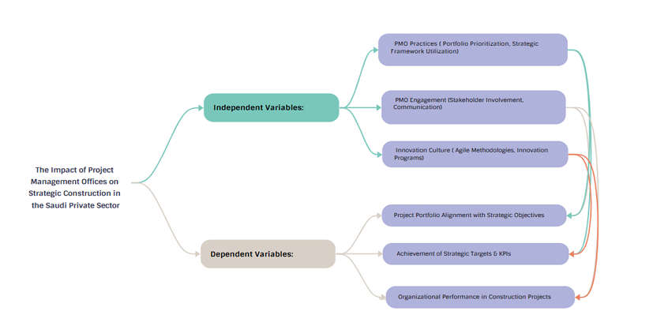
Figure 1: Study model
Independent Variables:
- PMO Practices (Portfolio Prioritization, Strategic Framework Utilization)
Recent recognition of the PMO's role in enhancing project execution has led to its growing appeal in project-based organizations, which offer a variety of approaches to problem-solving. The goal of the (Sandhu M. , 2024) research is to determine and assess the PMO positions' capacity to carry out the organization's strategic strategy. This study used quantitative research based on surveys. 450 employees from 19 project-based organizations received the questionnaire. A total of 268 valid surveys were obtained. The findings showed that the top five PMO roles involved in the execution of strategic plans were enhancing communication and structure within the organization, monitoring and controlling project performance, organizational learning, and project management development methodologies. At the same time, the twelve most important indicators were identified as criteria for evaluating the PMO department's efficacy. For the researchers investigating the advantages of PMO, this discovery offers research implications.
In order to accelerate national development, especially in the construction sector, the Saudi Vision 2030 plan is essential. The promotion of best practices, such as project management office (PMO) apps, is the most obvious way that the construction industry is receiving a lot of attention. Like other provinces, Hail is having problems with project delivery. Therefore, the goal of this study is to investigate which PMO model is most suited for public construction projects in Hail. The motivations behind the creation of PMOs in construction companies, as well as PMO models and typologies that explain their roles, were all examined in a literature review. To determine their applicability in the context of Hail, those motivating factors and PMO models were investigated in a focus group. Enterprise PMO is the primary paradigm for Hail public construction projects, according to the research of (Alghaseb, 2024). The Program Management Office and the Project Management Center of Excellence (PMCOE) model are the next most popular models, respectively. In addition to addressing Hail province's construction project delivery issues, this PMO model selection process pushes construction companies and associated enterprises to adapt to enhance the industry.
The most recent best practices for strategic alignment in project portfolio management are included in the research of (SUVVARI, 2023). As a result, the paper will examine the relationship between PPM and strategic alignment, offering a thorough examination of theoretical frameworks, methods, and real-world applications. This study presents key tactics for guaranteeing efficient portfolio selection, resource allocation, risk management, and performance evaluation. It is based on a review of the literature and large-scale empirical investigation. The difficulties that businesses encounter in achieving strategic alignment are also examined, as are the solutions for these difficulties. The study advances theoretical knowledge and the use of PPM in practice for better organizational performance and the achievement of strategic objectives.
The impact of project management office functions on project success in Saudi Arabia is examined in the study by (Almatari, 2022). To investigate various project management roles and project performance metrics, a thorough literature review is carried out. The information was gathered using 14 project success metrics that were found in the literature and a validated list of 19 project management office tasks. The first portion of the analysis uses excel sheets to average the replies for each measure and compare the project performance of organizations with and without PMOs. The second step involves applying structural equation modeling (SEM) in SMARTPLS-S software to investigate the connection between PMO functions and project success metrics. Five out of the sixteen hypotheses that were produced for SEM analysis were validated, while the other eleven were not. The findings showed that while project monitoring and control functions have a partial impact on customer satisfaction, PMO organizational learning functions have a direct impact on project outcomes.
In universities, University Research Centers (URCs) are now the main organizational framework for assembling a critical mass of interdisciplinary research interests capable of competing for big, sponsored research projects and producing ground-breaking research findings. To coordinate important tasks, from proposal creation to project execution, and to guarantee that research findings are shared, several of the more prosperous URCs are increasingly creating specialized project management offices (PMOs). Determining the tasks, responsibilities, and skills that such a PMO should possess is a major difficulty for URCs. Numerous essential characteristics of PMOs that address the difficulties faced by URCs are identified by this study (Fernandes, 2021). An early conceptualization of responsibilities and functions derived from literature research is presented in this work. These are subsequently tested by a comprehensive survey conducted among 370 URC members engaged in cooperative R&D projects across the globe. Three PMO maturity phases are proposed by the study: "basic," "intermediate," and "advanced." Six functions for a "basic" PMO stage, ten more for an "intermediate" PMO stage, and ten more for an "advanced" PMO stage are highlighted in the conceptualization of those results. When deciding what part, a PMO should play in attaining both concrete and intangible project outcomes, URCs can use the information given to guide their decisions. Despite the study's extensive list of suggested functions, none of them should be considered alone. Most of the roles work together and have varying effects on the PMOs' influence within the URC. The study supports the transformative and evolutionary nature of PMOs and shows that universities are open to the necessity of establishing an efficient PMO to enhance the functioning of significant R&D projects and programs and increase the social impact of URCs.
The goal of the study by (Zanfelicce, 2021) is to comprehend how risk management affects the success of project portfolios. In this study, two methodological techniques were chosen: a case study and a bibliometric survey. The new product project portfolio of a durable goods producer from the industrial sector was the subject of the study. The results showed that project portfolio risk management was not very intense. This is consistent with the findings of the bibliometric survey as well as the proof from the case study unit's inquiry. This article presents a matrix that indicates the risk management intensity related to the project portfolio management processes to assess the impact of risk management on portfolio success. One way to further our understanding of how risk management affects project portfolio success is by using the suggested matrix application.
Understanding the theoretical-empirical relationships of strategic alignment in project-based businesses was the aim of the study conducted by (Brito, 2021) . Approach: In order to identify the most pertinent publications on the subject, we conducted a systematic review using technological snowballing and searches in scientific databases (Web of Science and Scopus). The terms project-based enterprises and strategy served as the basis for the strings that were chosen. Filters pertaining to the language, document formats, and study field were used. The chosen publications were examined using the following procedures: quality assessment, title and abstract reading, duplicate elimination, and analysis. Following these procedures, VOS viewer, Biblioshiny, and Microsoft Excel tools were used to assess 20 papers in a descriptive and exploratory manner. Originality: The study addressed a vacuum in the literature about strategic alignment in the context of project-based business, a new idea that isn't discussed much. Key findings: The findings demonstrated that project management and strategy alignment are mutually dependent. It was discovered that first aids businesses in concentrating on the right initiatives, while project management aids in the accomplishment of their strategic goals. Program, portfolio, and governance management; project management office and organizational design; project management and organizational strategy; and the interaction between actors in the formation of strategies are the four research areas pertaining to the strategic alignment in the PBB that have also been published in the literature. Contributions: The contribution consists of putting up a series of ideas that organize the papers' findings and clarify how a research agenda might be created.
The use of Project Portfolio Management, or PPM, by organizations has grown dramatically worldwide because it provides a way to manage the component portfolio in a coordinated manner with the aim of accomplishing the company's goals. this study (Orlandi, 2020) was to use quantitative research to show how PPM is used by Brazilian companies as a tool to promote alignment with strategic management. The results of a 2012 survey by PMSurvey.org were compared with those of this investigation. To ascertain how effectively the projects in the portfolio matched the strategic aims and objectives, the study used a survey that was completed by 56 Brazilian public and private companies.

- Literature Review Table:
Study | Publication Year | Research Area | Methodology | Key Findings | Research Gap | Relevance to Current Research
Orlandi | 2020 | Project Portfolio Management (PPM) & Strategic Alignment | Quantitative survey of 56 Brazilian public and private companies | PPM significantly enhances alignment of project portfolios with organizational strategic goals and objectives. | Focused only on Brazilian context; lacks exploration of PPM’s impact in Middle Eastern or Saudi private sector. | Demonstrates how portfolio prioritization (a PMO practice) directly supports strategic alignment — essential for assessing PMO’s role in Saudi firms.
Sandhu | 2024 | PMO Roles & Strategic Plan Implementation | Survey-based quantitative research (268 responses from 19 project-based organizations) | PMOs improve strategic plan execution through development methodologies, performance monitoring, organizational learning, and communication enhancement. | Does not address sector-specific implications (e.g., Saudi private sector) or long-term strategic outcomes. | Provides direct evidence that PMO practices significantly contribute to strategic planning effectiveness.
Fernandes | 2021 | PMO Functions in Research Organizations | Literature review and survey (370 URC participants) | Identifies PMO maturity stages and functions at each stage; highlights evolving roles that support strategic outcomes in complex projects. | Limited to university research centers; findings not directly applied to corporate or private sector settings. | Illustrates PMO maturity and its transformative impact, offering a framework adaptable to strategic planning in private sector PMOs.
Zanfelicce | 2021 | Risk Management in Project Portfolios | Bibliometric survey + Case study on industrial product portfolio | Low intensity of risk management negatively impacts portfolio success; proposes a matrix linking risk management intensity to PPM success. | Limited sample size and sector (industrial manufacturing); lacks broader organizational strategy integration. | Highlights the importance of integrating risk management into PMO practices for strategic alignment and portfolio success.
Brito | 2021 | Strategic Alignment in Project-Based Businesses | Systematic literature review (20 papers) | Strong mutual influence between strategic alignment and project management; PMO plays key role in governance and organizational design. | Lacks empirical validation of findings in emerging markets or Saudi context. | Reinforces the conceptual link between PMO functions and strategic alignment, supporting hypothesis on PMO’s strategic impact.
Almatari | 2022 | PMO Functions & Project Success in Saudi Arabia | Literature review + SEM analysis of PMO functions vs. success measures | PMO learning functions directly improve project outcomes; monitoring/control impacts customer satisfaction. | Focused on project success rather than strategic planning outcomes. | Offers Saudi-specific evidence that PMO functions influence organizational performance, a precursor to strategic alignment.
Alghaseb | 2024 | PMO Models in Construction Industry (Saudi Arabia) | Literature review + Focus group | Enterprise PMO model most suitable for addressing project delivery challenges in Saudi construction sector. | Focused on public construction sector only; limited insights on private sector strategies. | Highlights the role of PMO model selection in strategic improvement — transferable insight for private sector PMO structuring.
SUVVARI | 2023 | Strategic Alignment in PPM | Literature review + Empirical analysis | Identifies best practices in portfolio selection, resource allocation, and performance measurement to achieve strategic alignment. | Lacks detailed case applications or sector-specific best practices. | Provides theoretical foundation for linking PMO portfolio practices to strategic planning performance.

- PMO Engagement ( Stakeholder Involvement, Communication)
The study (Jaldesa, 2024) addresses the ongoing problem of project failures despite the recognized significance of effective stakeholder management by examining the impact of stakeholder engagement on project performance within construction projects undertaken by MCG Construction PLC in Moyale town. The study examined data from a representative sample of project stakeholders using a descriptive and explanatory research design and a strong quantitative technique. A recent version of SPSS was used to handle and analyze the data after it was gathered through self-administered questionnaires with a multi-point Likert-type scale. The purpose of the analysis, which comprised a Multiple Linear Regression model, was to particularly look at the connections between the dependent variable, project success, and the independent variables, stakeholder identification, planning engagement, managing engagement, and monitoring engagement. According to the findings, project success is significantly and favorably impacted by stakeholder identification, engagement planning, and engagement management. Stakeholder monitoring engagement, on the other hand, did not have a statistically significant effect on project success, according to the study. This finding deviates from some previous research and raises the possibility that overzealous supervision is not always advantageous. Together, these results highlight how crucial careful stakeholder identification, thorough planning, and proactive relationship management are to improving project outcomes. According to the report, MCG Construction PLC should give priority to these crucial areas in order to close current gaps and enhance the project.
A methodology for early stakeholder identification and ongoing engagement throughout the project lifetime is proposed by the study of (Alnhari, 2024) The framework tackles typical organizational communication breakdowns with stakeholders that result in project cancellations and delays. The framework guarantees successful stakeholder involvement by grouping stakeholders according to their impact and areas of interest, creating transparent lines of communication, and putting in place frequent feedback loops. A study of IT professionals confirmed that this strategy fosters long-term partnerships and permits essential project changes. Strategic stakeholder engagement at every level reduces miscommunications and project risks, which improves project management and lifecycle results.
The goal of the study (Sandhu M. A., 2024) is to determine and assess the PMO positions' capacity to carry out the organization's strategic strategy. This study used quantitative research based on surveys. 450 employees from 19 project-based organizations received the questionnaire. A total of 268 valid surveys were obtained. The findings showed that the top five PMO roles involved in the execution of strategic plans were enhancing communication and structure within the organization, monitoring and controlling project performance, organizational learning, and project management development methodologies. At the same time, the twelve most important indicators were identified as criteria for evaluating the PMO department's efficacy. For the researchers investigating the advantages of PMO, this discovery offers research implications.
The assessment of the effect of stakeholder participation on the performance of building projects in Rwanda was the main objective of the study by (Mukakarisa, 2024). This study was guided by the following specific goals: to determine how the performance of Horizon Construction Company's construction projects was affected by the involvement of stakeholders in project planning; to evaluate the effect of the involvement of stakeholders in project implementation on the performance of the construction projects of Horizon Construction Company; and to assess the effect of the involvement of stakeholders in monitoring and evaluation on the performance of the construction projects of Horizon Construction Company. Approach: The study was guided by a mixed technique strategy that combined descriptive and correlational research survey methodology. There were 182 participants from Horizon Construction Company in this study. 125 participants were sampled for this study using stratified simple random sampling. Both quantitative and qualitative data were analyzed using SPSS version 25, which is a statistical package for social sciences. Results: Project performance is expected to increase by 0.325 for every unit increase in stakeholder engagement during the planning phase, according to the coefficient for stakeholders in project planning, which is 0.325. This relationship is statistically significant (β = 0.325, t = 6.153, Sig. = 0.000). A one-unit increase in involvement during implementation correlates with a 0.268 rise in project performance, according to the coefficient for stakeholders in project implementation, which is likewise statistically significant (β = 0.268, t = 5.841, Sig. = 0.000). Furthermore, changes in stakeholder engagement in oversight can improve project performance by 0.409 units, with a statistically significant influence (β = 0.409, t = 8.030, Sig. = 0.000), according to the coefficient for stakeholders in monitoring and evaluation, which is 0.409. Unique Contribution to Theory, Practice, and Policy: Horizon Construction Company should give inclusive stakeholder engagement strategies top priority at every stage of the project.
An important task for assessing project management offices' performance to meet the objectives of construction companies is conducting a strategic analysis of their influence on the growth of the Iraqi construction industry. Project management offices can plan and organize their operations to gain the necessary competitive advantage by selecting the right strategies.
(Al-Zwainy, 2024) relied on the SWOT analysis model (SOWT) to assess the effectiveness of consulting firms, project management offices, and bodies tasked with overseeing the execution of infrastructure projects in the Anbar Governorate. Data and information regarding infrastructure projects in the Republic of Iraq's Anbar Governorate were gathered using the brainstorming tool. A design and equipment project is shown by the case study. Additionally, the Ministry of Construction, Housing, and Municipalities' investment plan includes the 131-billion-dinar cost of installing, running, and maintaining Ramadi sewers. The study's objectives are to lessen environmental degradation and enhance service actuality in the Anbar Governorate. The issues and challenges facing project management offices were taken from the brainstorming process's outcomes. The reason for this, in addition to reviewing the critical success factors for project management offices in infrastructure projects in Iraq, was that the function of giving senior management advice had the highest relative importance score (85%), and the project management offices' lack of familiarity with the processes required to monitor the application of international standards in the implementation of infrastructure projects results in poor quality, increased project time, and increased cost. Three key elements—operations, stakeholders, and technology—were chosen to represent the important success aspects because they were the most valuable and significant. The Documentation of Administrative and Technical Processes factor accounts for 79% of the critical success factors for the Operations axis, and internal factors were included in determining the Project Management Office's performance evaluation process's strengths and weaknesses. The team's level of scientific, cognitive, technical, and administrative proficiency reflects these elements. One of the key elements for the success of these projects is the Project Management Office, which oversees the design, equipment, implementation, operation, and maintenance of Ramadi sewers. The PMO applies quality standards to the various project activities. At the project work site, PMO implements occupational safety components. The external factors were the degree to which the PMO adheres to international standards in the field of functions and services, while the PMO possesses the ability to provide the project with a professional administrative workforce and the office works to improve the spirit of cooperation among the stakeholders in the project. Additionally, technical monitoring is used to oversee the Ramadi sewers' design, equipment, installation, operation, and maintenance. This is one of the primary factors contributing to the project’s success. PMO offers the owner practical answers to all the project's administrative and technical issues. PMO provides human resources with a variety of experiences while assembling the work team, and it uses performance reports to assess issues and expectations with stakeholders. PMO has enough specialist experience to handle the project's possible hazards. PMO tracks the status of project activity using contemporary tools. PMO uses training and development tools with contemporary mechanisms.
Since stakeholders have an impact on project outcomes, managing them is important for project management. Similarly, similar outcomes are enhanced with the assistance of a Project Management Office (PMO). The study of (Jr, 2022) examines the moderating effect of PMOs as well as the beneficial impact of stakeholder management on project outcomes, particularly on the possibility of completing projects within the estimated time and budget. 216 seasoned professionals enrolled in graduate project management programs completed a survey, and the results were used to verify a conceptual model using logistic regression. According to the findings, stakeholder management improves project outcomes in terms of budget and schedule, and PMO strengthens the impact of stakeholder management on these outcomes. The study's contribution is to reaffirm PMO and stakeholder management as essential components of effective project management. The sample was limited to project management experts residing in Peru, yet it was adequate for research reproducibility. Future research could therefore focus on a larger population. Keywords: project management office, relational stakeholder management, prescriptive stakeholder management, and project outcomes.
The impact of stakeholders on project management in non-profit organizations is the subject of the study of (Brajer-Marczak, 2021). The organization's level of project management maturity was used to frame this problem. It appears that scientists have not yet sufficiently investigated this problem. By emphasizing the need to modify the degree of stakeholder and project management maturity and by suggesting areas for additional investigation, a contribution to the theory of project management was made. It has been observed that risk assessment and stakeholder management are equally as crucial as project financing and planning, including project teams, goals, and scope. The study of empirical research findings served as the foundation for the conclusions. A study based on a sample of 93 Polish non-profit organizations provided the empirical data. Recent recognition of the PMO's role in enhancing project execution has led to its growing appeal in project-based organizations, which offer a variety of approaches to problem-solving.
The goal of the study of (Barbalho S. C., 2019) is to show and analyze the changes in operational activities and the performance of a Project Management Office (PMO) in a technology-based organization using a longitudinal case study. Functions, conflicts, stakeholder interfaces, performance, and how they influenced the PMO's significant modifications are all covered in the report. The PMO's modifications were mostly prompted by unforeseen circumstances rather than modifications to the management procedure. The findings showed that the PMO transitions were explained by organizational political issues rather than by project management effectiveness. To suggest and guide PMO improvements and ensure the sustainability of project ongoing best practices, managers must seek to identify conflicts in the project management environment, project performance, and stakeholder satisfaction. Along with questioning some conclusions that need to be contextualized according to circumstances to prevent imitation in the PMO implementation and transformation, this study also adds to the body of evidence supporting earlier literature appointments. Since stakeholder importance varies from project to project, it is critical to understand stakeholder needs.
- Literature Review Table:
Study | Publication Year | Research Area | Methodology | Key Findings | Research Gap | Relevance to Current Research
Jr | 2022 | Stakeholder Management & PMO Influence | Survey (216 project management professionals) + Logistic regression | Stakeholder management improves project outcomes (time and cost); PMO moderates and enhances this effect. | Limited to Peruvian professionals; lacks cross-sector or Saudi private sector validation. | Demonstrates PMO’s critical role in amplifying stakeholder engagement impact on strategic success.
Jaldesa | 2024 | Stakeholder Engagement & Project Performance | Quantitative survey + Multiple Linear Regression | Stakeholder identification, planning, and managing engagement significantly improve project success; monitoring engagement has no significant effect. | Focused on a single construction company; limited generalizability across industries or geographies. | Highlights specific stakeholder engagement practices that PMOs can prioritize to strengthen strategic outcomes.
Brajer-Marczak | 2021 | Stakeholder Impact & Organizational Maturity | Empirical survey of 93 non-profit organizations | Emphasizes alignment of project management maturity with stakeholder management maturity; risk and stakeholder engagement are as crucial as financing and planning. | Non-profit context limits applicability to corporate or private sector strategic planning. | Offers theoretical foundation for linking stakeholder management maturity with PMO strategic effectiveness.
Sandhu M.A. | 2024 | PMO Roles & Strategic Communication | Survey-based quantitative research (268 responses) | PMOs improve strategic plan implementation through enhanced communication, organizational learning, and performance monitoring. | Does not deeply explore stakeholder dynamics or communication frameworks. | Supports the idea that PMO communication roles are vital for effective strategic planning.
Mukakarisa | 2024 | Stakeholder Engagement in Construction | Mixed methods: descriptive & correlational survey (125 participants) | Stakeholder engagement significantly improves project performance during planning (β=0.325), implementation (β=0.268), and monitoring (β=0.409). | Focused on Rwandan construction sector; lacks insights into strategic planning beyond project performance. | Empirical evidence that stakeholder engagement across project phases enhances outcomes — critical for PMO strategy alignment.
Al-Zwainy | 2024 | PMO Evaluation & Stakeholder Collaboration | SWOT analysis + Brainstorming (case study: Iraqi infrastructure project) | Identified stakeholders as one of three critical success factors; PMOs enhance cooperation and communication among stakeholders, improving project delivery. | Case-specific results; limited evidence of stakeholder engagement’s strategic influence beyond infrastructure. | Shows that stakeholder collaboration facilitated by PMO is essential for achieving strategic project goals.
Barbalho | 2019 | PMO Evolution & Stakeholder Dynamics | Longitudinal case study | PMO transitions are influenced more by organizational politics and stakeholder tensions than by performance metrics. | Focuses on internal politics rather than structured stakeholder engagement strategies. | Provides insight into how stakeholder dynamics shape PMO effectiveness and strategic adaptability.
Alnhari | 2024 | Stakeholder Communication Framework | Survey-based validation of proposed framework | Early identification, continuous engagement, feedback loops, and structured communication minimize project risks and delays. | Limited to IT sector; requires broader validation across industries. | Demonstrates how structured communication strategies under PMO leadership enhance strategic project alignment and success.

- Innovation Culture (Agile Methodologies, Innovation Programs)
Few studies have attempted to investigate the impact of organizational culture on successful IT project performance in the Jordanian context, even though prior research has looked at the relationship between organizational culture and successful IT project performance globally. Thus, the goal of the study by (Mohammed, 2025) is to investigate the effects of four organizational culture components—strategic emphasis, a positive work environment, leadership risk tolerance, and results orientation—on the overall effectiveness of IT projects in Jordanian companies. 146 project managers, systems analysts, project consultants, program executives, IT managers, and project coordinators who work for Jordanian companies were surveyed using a quantitative research approach to accomplish the goal. The data that was gathered was analyzed using Partial Least Squares Structural Equation Modeling (PLS-SEM). The findings demonstrated that strategic emphasis and leadership risk tolerance had a significant and beneficial impact on the effective execution of IT projects in Jordanian enterprises. The associated hypotheses were rejected since, contrary to expectations, no correlations could be found between a happy work environment and outcomes orientation on effective IT project performance in Jordanian firms.
The study of (Kakar, 2025) analyzes the influence of Agile techniques in generating a greater project success rate. Furthermore, we aimed to ascertain the degree to which management support impacts the efficacy of Agile approaches in project success. Additionally, our study investigates how project innovation affects project success and considers ways to increase its impact. Data were gathered from Agile administrators employed by different project-based businesses using a qualitative methodology. Fifteen groups from all throughout Pakistan took part in the study. According to our research, Agile approaches encourage creativity, which raises project success. Our findings demonstrated that the Agile methodology, which places a high priority on identifying early solutions to issues, significantly contributes to project success. To increase a project's overall success, we stress the critical role that management support and project innovation play. The study's conclusions offer practitioners important takeaways and suggest several fresh ideas for theoretical advancement.
Almost every industry in the digital age depends on computing software, however effective software development still confronts several obstacles. A software project's success or failure can be determined by an efficient software development technique. Assessing the overall effects of Agile Software Development (ASD) on the organizational, software development, project management, and person aspects is the goal of the study by (Wafa, 2022). To investigate the effects of ASD on Pakistan's IT sector, we polled several software development experts with diverse backgrounds (experience, geography, and job grades). We have conducted two analyses of the data that was gathered. We started by summarizing the results of our surveys. vividly convey our survey participants' thoughts on the efficacy of the Agile software development process. Second, we conducted a statistical analysis of the same data using quantitative metrics. To confirm the validity of our results, a comparison between statistical and graphical analysis is made. Our results imply that the application of Agile techniques and successful software development are strongly correlated. According to our data, the success of software development projects in terms of budget, quality, stakeholder satisfaction, and schedule depends critically on the job fit of software development experts and ASD. Despite concentrating on Pakistan's IT sector, the study's conclusions are readily applicable to other emerging IT sectors across the globe.
Global project management teams have been dealing with dynamic issues over the past few years, and these challenges have only gotten more complex as the projects they have been working on have become more sophisticated. Instead of adhering to traditional management practices, project managers must adopt innovative management techniques to achieve organizational goals due to the always changing organizational difficulties. Considering this, the current study attempts to clarify how agile management techniques affect project performance both directly and through project complexity. Additionally, the moderating influence of leadership qualities is used to assess the previously indicated mediatory relationship. In order to gather information from registered IT companies located in the potential metropolitan areas of each Pakistani province—Peshawar, Islamabad, Lahore, Sialkot, Faisalabad, Hyderabad, Sukkur, and Karachi—the current study (Umer, 2021) used the survey approach. For statistical analyses, 176 responses in all were used. Consequently, it was shown that agile management techniques offset the detrimental impact that project complexity was expected to have on project performance. Additionally, leadership skills were essential in controlling project complexity, putting agile management techniques into practice, and ultimately improving project performance. By analyzing the direct effects of agile management on project performance while considering all of its facets, investigating the mediating role of project performance, and assessing the moderating role of leadership competencies in achieving optimal project performance, the current study conceptually closes the possible knowledge gap. Contextually speaking, the current study closes the information gap by assessing the effects of agile management techniques in Pakistan's IT industry. The current study's findings may serve as a guide for academics and business experts alike.
Investigating the relationship between agile project management approach and project success, as well as the function of organizational support as a moderator, is the aim of the study by (Ali, 2021) . The Telecommunication Services Provider Industry in Pakistan is the source of the data used in this study. A total of 197 professionals were included in the sample. Participants received a questionnaire in paper form and online through survey websites. We assessed the impact of agile project management methodology on project success using the data we collected, and we also looked at the moderating role that organizational support has in the relationship between agile project management methodology and project success. Using IBM SPSS Statistics Version 20, the analysis comprised regression and Pearson's correlation coefficient. The findings showed that organizational support has no moderating effect on the high link between project management approach and project success. The results of the study have applications from the standpoints of project managers and organizations. Due to financial and temporal limitations, our study was restricted to a certain region. Future researchers can decide to carry up the study in different industries and geographical regions of Pakistan, using additional and distinct moderating factors.
The information technology (IT) sector makes extensive use of the Scrum technique for team-based iterative software development. The type of interactions between a Scrum Master and other team members, as well as how these interactions impact team effectiveness, have not, however, been thoroughly studied. Understanding the interactions between the Scrum Master and other team members in an educational setting, as well as proposing and demonstrating an application of cooperative game theory for the same, is the goal of the study (Karabiyik, 2020). Situations where other team members stand to gain from collaboration can be modeled using cooperative game theory. We examined the tactics used by the Scrum Master and other team members during a semi-capstone IT project using the cooperative game-theoretic model as a framework. The study specifically examined the interactions between a Scrum Master and other team members at the least, partially, and most effective levels of team effectiveness. Our results imply that a Scrum Master should be engaged to optimize their payout as well as the team's total payoff. On the other hand, in the most and somewhat successful teams, other team members should be active, while in the least successful teams, they should be passive, which will cost them more in terms of procedures and interpersonal relationships. The study's findings offer a fresh use of game-theoretic modeling to comprehend the interactions between the Scrum Master and other team members. Through the identification of the appropriate set of methods by the Scrum Master and other team members to enable IT workers to maximize their reward, these results are applicable not only in an educational setting but also to the broader field of software development.
(Sergeeva, 2020) investigates the degree to which the project management office (PMO), an internal unit inside owner and operator organizations that oversees overall project assurance and control, drives innovations. Organizational members of Transport for London (TfL), a major player in the UK infrastructure market and an owner and operator of public transport, participated in semi-structured interviews. In addition, four project assurance reviews that TfL started and provided were analyzed. The results show that the PMO gives the owner and operator organization the chance to develop and improve its innovative skills.
The objective of Presenting the innovation management program (IMP) (FAZ Program) and evaluating its outcomes in light of the public policy objectives that underpin it (Pró-Inova) in order to propose enhancements is the purpose of the study (Silva, 2019). Design, methodology, and strategy Between August 2013 and May 2016, 30 organizations underwent innovation maturity tests; 43 companies had intensive direct observation; and 172 meeting materials were systematically collected and analyzed. Results Eighty-one percent of the Pró-Inova goals were met by the FAZ Program. During implementation, the percentage of FAZ activities completed drops from 100% (strategic module) to 74% (management module) and finally to 46% (project module). For such percentages, the committees' or teams' level of innovative maturity is crucial. Businesses with above average or excellent organizational team and strategic committee innovation maturity have 1.8- and 1.7-times higher odds of effectively implementing the program, respectively. Limitations and implications of the research Just 4% of the programs Pró-Inova supports are represented by the FAZ Program. The FAZ Program's execution has resulted in new enterprises, processes, and products, although these are not quantified. These developments often take place for a few years following the adoption of novel management approaches. Implications for practicing the maturity for innovation diagnosis is helpful in predicting the likelihood of a successful program implementation as well as in assessing the company's capacity for innovation. The success rate of the program can be raised by modifying the model's structure (PDCA cycle for the organizational module, for example) and enhancing its execution (assure management module resources and maturity for innovation capacity, for example). Value and originality Prior studies on IMPs funded by Pro-Inova concentrate on outlining their advantages or techniques. The findings make it possible to determine what and how one of these programs provides in exchange for the funding provided for public innovation.

- Literature Review Table:
Study | Publication Year | Research Area | Methodology | Key Findings | Research Gap | Relevance to Current Research
Umer | 2021 | Agile Management, Leadership Competencies & Project Performance | Survey (176 IT firms in Pakistan) | Agile practices offset the negative impact of project complexity on performance; leadership competencies strengthen this relationship. | Focused on IT sector in Pakistan; lacks cross-industry and cross-regional validation. | Shows how agile culture enhances project outcomes under complexity — vital for innovation-driven environments.
Wafa | 2022 | Agile Software Development & Project Success | Survey + Quantitative Analysis (Software professionals) | Agile practices significantly improve cost, quality, stakeholder satisfaction, and delivery time; job fit is a key success factor. | Focused solely on software projects; lacks exploration of innovation culture’s organizational-level impact. | Demonstrates the multidimensional benefits of agile culture for software project success.
Mohammed | 2025 | Organizational Culture & IT Project Performance | Quantitative (PLS-SEM, 146 participants) | Strategic emphasis and leadership risk tolerance significantly enhance IT project success; work environment and results orientation do not. | Focused on Jordanian context; further research needed on cultural dimensions in innovation-driven projects. | Highlights cultural components critical for successful innovation environments.
Ali | 2021 | Agile Project Management & Project Success | Survey (197 telecom professionals, Pakistan) | Agile methodology strongly correlates with project success; organizational support did not moderate the relationship. | Limited geographic and industry scope; additional moderators could be explored. | Reinforces the direct link between agile practices and project success.
Silva | 2019 | Innovation Management Programs (IMPs) | Longitudinal Case Study (43 companies, 172 documents) | Innovation maturity significantly predicts program success; FAZ achieved 81% success aligned with public policy goals. | Does not measure actual innovations (products/processes) resulting from the program. | Provides empirical support for structured innovation programs in enhancing project success.
Kakar | 2025 | Agile Methodologies, Innovation & Project Success | Qualitative (15 organizations, interviews) | Agile methods promote innovation, which increases project success; management support amplifies this effect. | Limited sample size and qualitative nature; needs larger quantitative validation. | Connects agile culture directly with innovation and project outcomes.
Karabiyik | 2020 | Scrum Dynamics & Team Effectiveness | Cooperative Game Theory (Educational IT setting) | Active Scrum Masters and engaged team members maximize team payoff and effectiveness. | Focused on educational context; further research needed in industry applications. | Highlights the importance of team dynamics within agile frameworks for maximizing innovation outcomes.
Sergeeva | 2020 | PMO & Innovation Capability | Semi-structured Interviews + Case Analysis (Transport for London) | PMOs enable the development of innovative capabilities within organizations. | Focused on a single public organization; broader empirical validation needed. | Shows how PMO involvement fosters an innovation-supportive environment.

Dependent Variables:
- Project Portfolio Alignment with Strategic Objectives
The transition from traditional Project Management Offices (PMOs) to Value Delivery Offices (VDOs), which signifies a change from a process-centric to a value-centric approach in project management, is examined in the study of (Moghaddasi, 2025). The study uses a mixed-methods research methodology, integrating case studies from different businesses, qualitative interviews, and quantitative data analysis. Clear insights into the advantages and strategic effects of using VDOs are offered by this study. Important conclusions include the establishment of the Value Delivery Maturity Model (VDMM) to evaluate value delivery progression and the critical role that change management plays in easing this shift. The article highlights potential problems and solutions in the transition process, talks about the practical ramifications for businesses, and suggests methods for managing and implementing VDOs successfully. By emphasizing the importance of value-centric techniques in modern business environments, this study advances the developing area of project management.
Research on the impact of contextual elements in entrepreneurial orientation on project portfolio success is lacking, despite recent studies highlighting the significance of entrepreneurial orientation on project portfolio success. The antecedents of ideation portfolio management have not been sufficiently explained, even though some studies have looked at the impact of this strategy on project portfolio success. It is reasonable to infer that an entrepreneurial perspective helps businesses build their business, explore new prospects, and adapt to changes in the external environment. As a result, it makes sense to assume that entrepreneurial mindset should precede ideation portfolio management and help project portfolios succeed, and that firm size may have an impact on the procedures. (Liu, 2025) uses a sample of 450 Chinese enterprises to investigate the relationship between entrepreneurial orientation and project portfolio success, as well as the effects of firm size and ideation portfolio management. The findings indicate that the relationship between project portfolio success and entrepreneurial orientation is mediated by ideation portfolio management. Additionally, the influence of ideation portfolio management on project portfolio success is stronger and the effect of entrepreneurial attitude on project portfolio success is smaller for larger firms. Remarkably, firm size has no bearing on how entrepreneurial mindset affects ideation portfolio management.
To increase corporate success, project management offices (PMOs) link the intricate connections between organizational structures, initiatives, and strategy. However, because of the wide range of possible tasks that might be delegated to them, PMOs encounter considerable difficulties in precisely defining their duties and responsibilities. A thorough grasp of the dynamic PMO role is provided by the study of (Monteiro, 2024) . which offers a methodical examination of PMO typologies, types, and corresponding functions. We discovered 60 PMO types and 16 typologies in the literature, demonstrating that PMOs are dynamic, complex organizations with a wide range of organizational tasks.
Project portfolio creation is the first step in implementing strategy through an innovative project portfolio. The process of creating a project portfolio, which involves determining, vetting, and ranking the projects that will ultimately make up the portfolio, is particularly significant. Addressing the conflicting demands for continuity and renewal throughout the implementation of an innovation strategy requires a thorough grasp of the project portfolio building process. To comprehend their context and repercussions on the implementation of innovation strategies, this study (Martinsuo, 2024) ) investigates the behavioral patterns of portfolio actors in the project portfolio development routine. A thorough framework for enabling and regulating activities as well as organization-specific patterns of action are revealed via a multiple-case study involving creative businesses. Innovation kinds, as well as the organization's size and history, can explain differences in how governing and empowering acts are combined in different organizations. Organizations can use the behavioral patterns of project portfolio building as a basis for putting both continuity- and renewal-oriented innovation strategies into practice.
The study of (Haniff, 2022) looks at the factors that affect a project network's strategy and the difficulties that arise when cooperating organizations try to align several strategic objectives through a single construction project. A project network functions in an environment of overlapping boundaries where several organizations concurrently attempt to guarantee that their strategic objectives are realized through a single strategic project, in contrast to intra-organizational projects, which operate within the boundaries of a single organization. The empirical results of a study of four building projects are used to develop a model that presents a hierarchy of inter-organizational strategic objectives. The network's project strategy is impacted by both internal and external pressures. The new model is informed by the study's findings that strategic alignment of inter-organizational initiatives depends on good project governance, leadership, and consideration of client complexity.
According to certain research, individual projects are the most effective way to coordinate organizational ambidexterity. Individual initiatives that operate independently, however, have a comparatively small scope and are vulnerable to both vertical and horizontal division. Because of this, they might not be well-suited to act as channels for organizational ambidexterity. Organizations that deliver projects in portfolios, on the other hand, may find that they also offer better channels for organizational ambidexterity. This is typically done to optimize resource use. In addition to examining how much project portfolio management (PPM) practices influence organizational ambidexterity orchestrations, this study This study (Ojiako, 2021) also looks at whether these orchestrated PPM techniques also result in better project performance. From November 2016 to January 2017, information was gathered from 160 PPM stakeholders located in eight Middle Eastern nations. According to the study, organizational ambidexterity and portfolio performance are highly and significantly connected. Additionally, it was discovered that firms that demonstrated effective project-portfolio-management practices were more likely to develop ambidextrous skills.
Based on a thorough analysis of empirical research and industry best practices, the study by (Vayyavur, 2020) looks at the key obstacles and successes of Project Management Offices (PMOs). To pinpoint important problems and best practices in PMO deployment and operation, the study examines the experiences of established PMOs in a variety of enterprises. The literature's qualitative examination reveals several crucial success variables, such as executive backing, performance assessment, established procedures, strategy alignment, and continual development. Organizational resistance, proving value, and adapting PMO capabilities to changing business needs are some of the main issues noted. The study emphasizes how crucial it is for PMOs to modify their emphasis, services, and structure over time to stay relevant and promote value generation. PMO leaders are given suggestions on how to improve PMO efficacy and get over typical roadblocks. This study adds useful information to help firms maximize their project management capabilities through PMOs by combining ideas from empirical research and industry best practices. When critical success variables are present, the results highlight the strategic role that PMOs play in carrying out organizational strategies and enhancing corporate performance.
The goal of the study by (Ko, 2019).is to use data envelopment analysis (DEA) to examine the effectiveness of project management offices (PMOs). The causal elements influencing PMO efficiencies were examined as the efficiency analysis's post-analysis. The efficiency of 87 PMOs were examined. 76 PMOs were inefficient and 11 PMOs were fully efficient in the constant returns-to-scale paradigm. There were 26 PMOs that were efficient and 61 PMOs that were inefficient in the variable returns-to-scale (VRS) model. The DEA's efficiency analysis offers the benefit of determining each DMU's scale efficiency. According to the post-analysis's findings, the degree of strategic alignment with the business objectives and the project portfolio management maturity (PPMM) both had a beneficial impact on PMO efficiency. In conclusion, increased PMO performance and efficiency can be anticipated by enhancing PPMM and fortifying strategic alignments with business objectives.
- Literature Review Table:
Study | Publication year | Research area | Methodology | Key findings | Research gap | Relevance to current research
Vayyavur | 2020 | PMO effectiveness and strategic alignment | Qualitative literature review | Identified key success factors for PMOs including strategic alignment, executive support, standardized methods, and performance measurement. Emphasized PMOs’ role in executing organizational strategy and driving business performance. | Lack of empirical validation of success factors across diverse industries and regions. | Highlights how PMOs support alignment between project portfolios and strategic objectives, forming a conceptual base for current study.
Monteiro | 2024 | PMO typologies and strategic roles | Systematic literature review | Identified 16 PMO typologies and 60 PMO types, showing evolving functions and strategic roles. | Limited analysis of how different PMO types affect strategic portfolio alignment in practice. | Provides a comprehensive classification of PMOs, useful for understanding how different structures contribute to strategic alignment.
Moghaddasi | 2025 | Transition from PMO to Value Delivery Office (VDO) | Mixed-methods (quantitative data + qualitative interviews and case studies) | Demonstrated that transitioning to VDOs enhances strategic impact, with change management and the VDMM as critical tools. | Limited empirical studies on VDO implementation across industries. | Relevant for showing how value-centric approaches improve alignment with organizational strategy.
Haniff | 2022 | Inter-organizational project governance | Empirical study of four construction projects | Developed a model for aligning multiple strategic objectives in multi-organizational projects. Highlighted importance of governance, leadership, and client complexity. | Limited focus on single-sector case studies and need for broader validation. | Shows how governance and leadership contribute to aligning strategic objectives in complex, collaborative projects.
Ojiako | 2021 | Project portfolio management (PPM) and ambidexterity | Survey of 160 stakeholders in 8 Middle Eastern countries | Found strong correlation between portfolio performance and organizational ambidexterity. Efficient PPM practices enhance strategic capabilities and project outcomes. | Limited exploration of contextual factors influencing PPM effectiveness. | Highlights the role of PPM practices in balancing exploration and exploitation to align with strategic goals.
Martinsuo | 2024 | Innovation strategy implementation | Multiple-case study | Identified behavioral patterns in portfolio formation that influence continuity and renewal. Actions vary by innovation type, organization size, and history. | Limited understanding of how portfolio formation practices evolve over time. | Demonstrates the critical link between portfolio selection routines and strategic innovation outcomes.
Liu | 2025 | Entrepreneurial orientation and portfolio success | Quantitative survey of 450 Chinese firms | Found that ideation portfolio management mediates the relationship between entrepreneurial orientation and portfolio success; firm size moderates these effects. | Limited cross-industry analysis and focus on Chinese context. | Illustrates how entrepreneurial orientation and ideation processes support strategic alignment and portfolio success.
Ko | 2019 | PMO efficiency and strategic alignment | Data Envelopment Analysis (DEA) of 87 PMOs | Efficiency positively influenced by portfolio management maturity and strategic alignment with business goals. | Need for longitudinal studies on PMO efficiency development. | Demonstrates that strengthening strategic alignment improves PMO efficiency and portfolio performance.

- Achievement of Strategic Targets & KPIs
The successful administration of engineering projects depends on clear and effective communication, which keeps interdisciplinary teams in line with project goals, schedules, and technical specifications. Poor communication can result in misconceptions, inefficiencies, and even disastrous failures because of the complexity of these initiatives. By examining essential elements including clarity, active listening, organized feedback mechanisms, appropriate communication channels, and cultural awareness, the study by (Chowdhury, 2025) investigates the critical function of communication in engineering project management. It also looks at common issues that can impede project execution if they are not handled well, such as time restrictions, technological limits, stakeholder misalignment, cultural differences, and language difficulties. The paper identifies recommended practices for overcoming these obstacles, including utilizing contemporary collaboration platforms, standardizing communication procedures, putting regular project updates into place, and encouraging an open and transparent culture. Real-world case studies show how communication directly affects project outcomes. While successful projects like Heathrow Terminal 5 and the Burj Khalifa highlight the benefits of strategic and well-coordinated communication, failures like the automated baggage handling system project at Denver International Airport and the Hyatt Regency walkway collapse highlight the dire consequences of poor communication. The results highlight that communication is a crucial factor in project success rather than merely a supporting role. Engineering project managers can improve teamwork, reduce risks, and move projects closer to efficient and timely completion by emphasizing proactive and structured communication techniques.
Through governance, standardization, resource management, and strategic alignment with corporate goals, the Project Management Office (PMO) plays a critical role in guaranteeing the effective completion of projects. The need for a flexible and adaptive PMO has grown as more firms embrace different project management approaches, including Waterfall, Agile, Hybrid, Lean, and Six Sigma. The smooth integration of various approaches must be made possible by a well-designed PMO to guarantee consistency, effectiveness, and project success while preserving the flexibility needed in the fast-paced corporate environments of today. Notwithstanding its significance, there are many obstacles in ensuring PMO compliance with various project management methodologies. In contrast to the established governance and control systems found in traditional PMOs, agile approaches place a higher priority on iterative development, self-organizing teams, and little bureaucratic oversight. Waterfall-driven businesses, on the other hand, employ a linear, phase-based methodology that may impede creativity and adaptation due to their demands for copious documentation, predetermined deliverables, and stringent change control. Although hybrid models aim to strike a compromise between the two strategies, they also add complexity to reporting, governance, and resource allocation. Furthermore, companies using Lean and Six Sigma approach prioritize waste reduction and continual improvement, which makes integration more difficult for PMOs used to strict standards. By putting out a strategic framework for PMO flexibility across various project methodologies, this article aims to address these issues. The framework offers helpful advice on how PMOs can adapt to accommodate various project delivery techniques without sacrificing efficiency, governance, or alignment with corporate goals. This article provides actionable insights to help organizations navigate the complexities of a multi-methodology project environment using scalable frameworks, flexible governance structures, standardized yet flexible reporting mechanisms, and a strong management strategy. Organizations can increase stakeholder satisfaction, project success rates, and the development of a resilient project management culture that can thrive in a constantly shifting business environment by cultivating an adaptable PMO (Ogunbukola, 2025).
A framework for assessing stakeholder involvement in Hubs for Circularity (H4C), which are essential to the advancement of the circular economy, is introduced in the study by (Tleuken, 2025). It illustrates how important stakeholder collaboration is and how an organized method is required to evaluate the success of H4C projects. The report suggests a new and practical framework for stakeholder engagement because of the synthesis of the literature review. Identifying and analyzing the many stakeholder groups involved in H4C initiatives is the first of its many essential components. It then promotes a thorough examination of the elements affecting H4C implementation by examining the enablers, impediments, and drivers. In order to assess the results of H4C activities, it also highlights the creation of success criteria that are in line with the Sustainable Development Goals. To evaluate the socio-economic effects of H4C initiatives, the report ends by suggesting future research avenues, including incorporating the Societal Readiness Level and applying social network analysis and regional input-output modeling. Overall, the study emphasizes how important stakeholder participation and strong assessment methods are to the accomplishment of H4C projects and the promotion of sustainable objectives.
Effective stakeholder involvement is essential to the project's success since stakeholder relations build and deliver project value. Stakeholder engagement does, in fact, define the quality that is incorporated into the project from the team's point of view, but from the clients' and investors' point of view, their involvement essentially affects the perceived quality and/or value. However, stakeholder engagement is a specific habit that needs to be carefully and methodically promoted and managed; it is neither a natural outcome of a role nor merely the product of a positive attitude! This article provides an overview of the value creation and delivery process and the pertinent influence of stakeholder relations. It also describes the fundamental behaviors required to engage stakeholders, elaborates on how stakeholder engagement can be effectively measured and managed using appropriate KPIs gathered using specially created, tested, and fielded questionnaires, presents two pertinent case studies, and synthesizes the methodical approach required to manage stakeholder engagement effectively (Mari, 2024).
The purpose of the study by (Eyiaro, 2023) is to investigate how stakeholder management affects project teams' performance. Semi-structured interviews served as the main technique for gathering data in this qualitative study. Five participants in all, including merchants and employees of the research organization, were chosen for the study using deliberate heterogeneous sampling. According to the study, stakeholder management, with a focus on soft skills (people skills) and communication, has a major impact on project team performance. The project team's capacity for cooperation, communication, information exchange, and problem-solving is enhanced by effective stakeholder management techniques, which leads to improved project results. As a result, poor stakeholder management techniques may cause task or interpersonal conflicts, which could impair project team performance. They may also cause project delays or early closure, which would result in a poor project outcome. In order to improve team performance and project outcomes through efficient stakeholder management techniques, the findings are therefore essential for project teams and the organization.
With a case study of Inspire, Educate, and Empower (IEE) in Rwanda, (Zacharie, 2023) sought to understand how stakeholders are involved in project performance. Using a mixed-methods approach, the study analyzed both qualitative and quantitative data. The study population consisted of 227 individuals from IEE Organization Rwanda, including project managers, stakeholders, beneficiaries, and IEE administrative staff. The research approach was descriptive. 144 respondents made up the sample size, and standardized questionnaires were used to gather data. Both primary and secondary data were gathered. Questionnaires were used to gather primary data, and literature, papers, and journals were used to gather secondary data. Descriptive statistics were used to examine the results using Statistical Product and Service Solutions (SPSS). According to the study's findings, stakeholder participation and project performance are strongly positively correlated. The study also discovered that decision-making, project execution, and project planning all significantly affect project performance. The study's conclusion is that project success depends on stakeholder engagement. To enhance project performance, the study advises companies and project managers to actively involve stakeholders at every stage of the project. According to the report, early in the project lifecycle, businesses and project managers should identify all stakeholders. Recognize stakeholders' requirements and expectations. Talk to stakeholders on a frequent basis. Engage interested parties in the decision-making process. Effectively handle stakeholder conflict. Stakeholder participation and project performance were positively correlated, according to the statistical analysis and testing of the field data. The researcher concluded that stakeholder participation significantly improves project effectiveness in Rwanda.
The results of a project are influenced by numerous elements. Since communication is essential to both project planning and execution, it is one of the most important components of project success. In addition to giving others information, communication can reveal if a project is successful or not. The study by (Galli, 2022) presents communication and its relationship to project design, execution, and impact. It is obvious that additional research on the most recent project management variables, concepts, and models is possible. The field may suffer if such study is not conducted. The variables, their concepts, and models in project management and procedures are examined in this work. Consequently, an evaluation model is developed that can significantly benefit the engineering domain. This model can guarantee improved team communication and more successful initiatives. The results and discussion of this study advance the disciplines of project management, engineering management, and industrial engineering.
(Barbalho S. C., 2019) The purpose of this study is to show and assess the changes in operational activities and the performance of a Project Management Office (PMO) in a technology-based organization using a longitudinal case study. Functions, conflicts, stakeholder interfaces, performance, and how they influenced the PMO's significant modifications are all covered in the report. The PMO's modifications were mostly prompted by unforeseen circumstances rather than modifications to the management procedure. The findings showed that the PMO transitions were explained by organizational political issues rather than by project management effectiveness. To suggest and guide PMO improvements and ensure the sustainability of project ongoing best practices, managers must seek to identify conflicts in the project management environment, project performance, and stakeholder satisfaction. Along with questioning some conclusions that need to be contextualized according to circumstances to prevent imitation in the PMO implementation and transformation, this study also adds to the body of evidence supporting earlier literature appointments.

- Literature Review Table:
Study | Publication year | Research area | Methodology | Key findings | Research gap | Relevance to current research
Mari | 2024 | Stakeholder engagement and value creation | Case study + KPI framework development | Demonstrated that stakeholder engagement directly impacts project value creation and perceived quality; proposed KPI-based measurement framework for engagement effectiveness. | Limited validation of the proposed KPI framework across industries and project types. | Provides a systematic approach to measuring and managing stakeholder engagement, linking it to project success and strategic KPIs.
Tleuken | 2025 | Stakeholder involvement in circular economy projects | Literature synthesis + conceptual framework | Proposed a structured framework for evaluating stakeholder engagement in Hubs for Circularity (H4C), aligned with SDGs and socio-economic impacts. | Lacks empirical testing of the proposed framework in real-world projects. | Highlights the strategic role of stakeholder involvement in achieving broader sustainability KPIs and targets.
Galli | 2022 | Project communication and performance | Conceptual study + assessment model | Identified communication as a central factor influencing project planning, execution, and outcomes; proposed an assessment model to improve team communication and success. | Model has not been empirically validated in diverse project settings. | Reinforces the importance of structured communication strategies for achieving project KPIs.
Chowdhury | 2025 | Communication strategies in engineering project management | Qualitative analysis + case studies | Showed that effective communication significantly enhances alignment with objectives, reduces risks, and drives project success; failures in communication correlate with major project breakdowns. | Further quantitative research needed to measure communication’s direct effect on KPI achievement. | Highlights communication as a critical determinant of strategic project success and KPI delivery.
Eyiaro | 2023 | Stakeholder management and team performance | Qualitative (semi-structured interviews) | Found that stakeholder management positively influences team collaboration, knowledge sharing, and project outcomes; poor management leads to conflict and delays. | Small sample size limits generalizability of findings. | Emphasizes how stakeholder management contributes to achieving project performance targets and strategic outcomes.
Barbalho | 2019 | PMO transitions and performance | Longitudinal case study | Demonstrated that organizational politics, not just performance metrics, influence PMO evolution; managers must monitor tensions, performance, and stakeholder satisfaction for sustainable outcomes. | Limited to a single organization; broader industry studies are needed. | Suggests that PMO adaptability and stakeholder interface monitoring are essential for long-term KPI achievement.
Zacharie | 2023 | Stakeholder engagement and project performance | Mixed-methods (questionnaires + descriptive statistics) | Revealed a strong positive correlation between stakeholder engagement and project performance; planning, implementation, and decision-making are key mediators. | Focused on a single NGO context; cross-sector studies are needed. | Confirms stakeholder engagement as a critical success factor for achieving strategic project KPIs.
Ogunbukola | 2025 | PMO adaptability across methodologies | Conceptual framework | Proposed a strategic framework for PMO flexibility to support Agile, Waterfall, Hybrid, Lean, and Six Sigma approaches while maintaining governance and alignment with business goals. | Lack of empirical evidence on the framework’s effectiveness in diverse project environments. | Provides practical insights into how adaptable PMOs enhance project success rates, stakeholder satisfaction, and KPI achievement.

- Organizational Performance in Construction Projects
Organizational competitiveness is significantly influenced by innovation performance, especially in settings characterized by fast technological change and unpredictability. The study by (Khan, 2025) looks at the relationship between knowledge management (KM) and innovation performance, using organizational culture (OC) as a moderator and agile project management (APM) as a mediator. The study offers an integrated paradigm based on the theory of dynamic capability, where innovation arises from the interaction of supportive cultural settings, agile execution, and knowledge processes. A quantitative, cross-sectional research approach was adopted, targeting engineers in the construction sector of Punjab, Pakistan. Engineers were chosen because of their combined responsibilities as project managers and knowledge producers. A structured questionnaire was used to gather data from 376 respondents using stratified random sampling. Structural equation modeling (SEM) was performed using SmartPLS 4.0, and the validity, reliability, and proposed relationships within the model were evaluated. Effective knowledge practices improve an organization's capacity for innovation, according to the empirical findings, which showed a strong direct correlation between KM and innovation performance. This link was found to be significantly mediated by APM, indicating that agile techniques help turn knowledge into creative outputs. OC's moderating effect, however, was not statistically significant, indicating that cultural influence can differ depending on the industry or context. The study offers both theoretical and practical contributions.
Reevaluating project management and execution techniques is essential to improving their effectiveness because construction projects are complicated and scattered, requiring cooperation from a variety of professionals. To meet the fast-paced nature of the construction business and the increasing needs of clients for timely project completion, agile principles provide a way to increase responsiveness within tasks and processes. However, to foster multi-skilled and self-managing teams, implementing new management approaches like Agile requires a substantial culture shift. In recent years, projectification—the growing trend in modern society where more tasks are managed as projects—has become increasingly relevant. Through the lens of Projectification, this study (Moreno, 2024) investigates the use of Agile project management, more especially Agile Scrum methodology, during the pre-construction stage of a construction project. Applying the Agile technique during the pre-construction phase may improve flexibility and collaboration, allowing teams to quickly adjust to changing project requirements and unforeseen problems, as demonstrated by the research findings. The results show that Agile approaches have many advantages, such as improved flexibility, accountability, transparency, teamwork, and adaptability. Significant time and cost savings were also achieved, highlighting the importance of Agile project management techniques in the construction industry.
Diverse innovative concepts and adaptable management techniques are required due to the dissolution of industry borders and the growing demand for cooperation and mutual adaptation. Although companies are trying to be flexible and responsive, putting flexibility ahead of careful planning, the tactics needed to accomplish these goals are still in their infancy. 68 agile practices were identified from 100 peer-reviewed papers between 2019 and 2022, which served as the foundation for the classification. The framework was developed using a conceptual-to-empirical approach that included nine focus groups and 40 expert interviews with participants from various nations between 2020 and 2023. These exchanges confirmed the framework's dimensions and practicality. According to the report, inter-organizational agility acts as a catalyst, successfully balancing frugal and open innovation to meet customer and market demands. Beyond temporary competitive benefits, this approach provides managers with a useful tool for negotiating ambiguities and uncertainties as well as for generating and collecting value within open innovative ecosystems. Implications for practice According to the case study, bricolage and co-innovation are two new managerial skills that promote invention, particularly when bolstered by inter-organizational adaptability. It offers insights into differentiating between different types of agility using a multifaceted framework. The study shed important light on the need for agility in unpredictable and complex situations. Inter-organizational agility is offered as a framework for attaining both temporary competitive advantage and long-term innovation power through the combination of open innovation and frugal innovation techniques in co-innovation (Proba, 2024).
The goal of the study by (Ndou, 2024) is to offer a framework for directing businesses toward Agile project management techniques. The research attempts to investigate the relationship between the existing organizational structure and project management methodologies, the set of capabilities, and the cultural shift necessary for a shift toward Agile transformation through a case study analysis carried out at an IT company. To successfully guide enterprises toward Agile techniques for project management, the paper offers a framework made up of four key components. According to the suggested framework, businesses must implement several adjustments to their culture, competences, structure, and methods in order to become more agile and enhance collaboration performance. The results emphasize the value of an organized strategy for Agile transformation, with a focus on ongoing learning and top management support. Organizations may ensure sustained commitment and facilitate faster transitions by fostering a feeling of purpose among team members through the formalization of Agile efforts through organized methodologies and ongoing engagement
Agile leadership has become a popular business trend because of the COVID-19 pandemic and the digital transformation, which have increased the need for businesses to be more adaptable and flexible in a rapidly changing environment. Team effectiveness, employee performance, and innovation efficiency are all enhanced by agile leadership. On the other hand, nothing is known about how agile leadership affects organizational results. The impact of agile leadership on organizational outcomes, which encompass several common aspects such as operational, employee, customer, financial, and social settings, is thus reviewed meta-analytically in this paper (S. Porkodi, 2023). The study is divided into two stages: bibliometric literature analysis is done in the first phase, and meta-analysis is done in the second. 74 publications published between 2004 and 2023 were found using bibliometric literature analysis from Scopus and Google Scholar. The articles' type of publication, year of publication, nations that conducted agile leadership study, keywords used, and their associations were all investigated. A total of 24 empirically conducted research articles were selected for the meta-analysis. The studies of independent and dependent variables, as well as the standard regression coefficients (𝛽) and correlation coefficients (𝛾) that show the relationship between agile leadership or agile leaders and other factors, were taken out and analyzed. According to the report, publications on agile leadership significantly increased after 2020, with the United States, Indonesia, and Turkey being the most active nations. Additionally, there is more research on agile leadership in relation to employee and operational outcomes. Agile leadership has a good correlation with interpersonal trust (𝛽=0.93), organizational performance (𝛽=0.90), organizational effectiveness (𝛽=0.89), individual career success (𝛽=0.89), and innovation management (𝛽=0.81), according to the meta-analysis's findings. Therefore, it is evident that operational outcomes are more affected by agile leadership than employee outcomes. Agile leadership qualities that are important for team cooperation, organizational innovation, and organizational growth include digital innovation, trust, competency, result orientation, and wisdom. Determining agile leadership concepts aids in evaluating the advancement of empirical research, enhancing theories and models of leadership, and spotting possible avenues for development. A company's size, industry, and culture are some of the variables that affect how well agile leadership works, and these can be further researched. Additionally, companies may need to modify their investment, financial management, and customer service strategies to better align with agile leadership principles. Based on a thorough literature evaluation, this study categorizes a wide range of research models that provide insight into the effectiveness of agile leadership. Additionally, this study contributes to the research on agile leadership by pointing out possible problem areas that require attention.
Numerous conversations about the efficient management of IT development projects have established the necessity of an agile and agile mindset. Software development teams are constantly under pressure to adapt to the constantly shifting IT architecture and landscape, which calls for innovation that can support the development of new strategies and techniques for successfully managing and completing IT projects. According to the literature currently in publication, enhancing innovation across all business functions is the primary goal of implementing Agile. There should therefore be some degree of relationship between innovation and an agile mindset if these are the things that can sustain the reaction to the constantly shifting IT world. Understanding the influence of innovation and the existence of inventive activities within organizations toward the successful completion of agile development projects was the goal of this study (Peege, 2021).According to the study, a certain level of innovation that persists over the course of a project is necessary for agile initiatives to be successful. To sum up, companies should consider implementing the open innovation paradigm to find and handle the unknown.
The project management office (PMO), an internal division of owner and operator companies, oversees overall project assurance and control. The extent to which the PMO propels innovations is examined in the study (Organizations, 2020). Semi-structured interviews were conducted with organizational members of Transport for London (TfL), a significant player in the UK infrastructure industry and a public transport owner and operator. Four project assurance reviews that TfL initiated and supplied were also examined. The findings demonstrate that the PMO provides an opportunity for the owner and operator organization to enhance and expand its creative capabilities.
Success in product and process innovation depends on the ability to harness innovation and the acceptance of disruptive technologies in a developing project-based global economy. The effects of project management best practices (PMBP), project management technology quotient (PMTQ), and CEO transformational leadership (CTL) on multi-dimensional innovation performance are examined for the first time in this study (Zaman, 2020). Higher-order partial least squares structural equation modeling (PLS-SEM) was used to test the proposed correlations based on data from 261 practitioners in South Korea's information and communications technology sector. Supporting evidence for the beneficial benefits of CTL, PMBP, and PMTQ on innovation success is found in the study. Additionally, PMBP and PMTQ showed a strong moderate effect on the association between innovation performance and CTL. The results of the study provide new theoretical predictions, methodological contributions, and implications for practitioners to lessen the difficulties of successful innovations in addition to the creation and validation of a new PMTQ scale.

- Literature Review Table:
Study | Publication Year | Research Area | Methodology | Key Findings | Research Gap | Relevance to Current Research
Peege | 2021 | Agile project delivery & innovation | Qualitative – literature review and conceptual analysis | Innovation is essential for the success of agile projects; open innovation helps organizations adapt to changing IT landscapes. | Lacks empirical validation across different project types and industries. | Highlights the importance of innovation mindset in achieving project success and improving organizational performance.
Khan | 2025 | Knowledge management & innovation performance | Quantitative – SEM with survey (n=376 engineers) | KM significantly improves innovation; Agile PM mediates this relationship, but cultural moderation is insignificant. | Further studies needed on cultural impacts in diverse industries. | Demonstrates how KM and agile practices together enhance innovation and performance in construction.
Organizations (TfL) | 2020 | PMO and innovation | Qualitative – Semi-structured interviews and case analysis | PMOs foster innovation capabilities and improve project assurance and control. | Limited to a single case study; broader sectoral validation needed. | Shows PMO’s strategic role in enabling innovation and improving organizational performance.
Proba | 2024 | Inter-organizational agility & innovation ecosystems | Mixed methods – literature review, interviews, focus groups | Inter-organizational agility harmonizes innovation approaches, enabling firms to address uncertainty and capture value. | Empirical validation of the proposed framework is limited. | Offers a framework for managing agility and innovation collaboratively, improving performance in dynamic projects.
Ndou | 2024 | Agile transformation & organizational change | Case study – IT company analysis | Agile adoption requires cultural change, new competencies, and structural adaptation; top management support is key. | More empirical studies needed on transition challenges in non-IT sectors. | Provides insights on structured agile transformation, applicable to construction project contexts.
S. Porkodi | 2023 | Agile leadership & organizational outcomes | Meta-analysis & bibliometric review | Agile leadership strongly correlates with organizational performance, effectiveness, trust, and innovation. | Need for deeper analysis of sector-specific impacts and longitudinal studies. | Demonstrates how agile leadership enhances performance, innovation, and collaboration in projects.
Moreno | 2024 | Agile in construction projects | Case study – Pre-construction phase analysis | Agile improves flexibility, collaboration, and reduces cost/time; enhances accountability and transparency. | More large-scale empirical studies required in different project phases. | Directly relevant to applying Agile in construction project management to boost performance.
Zaman | 2020 | Leadership, project management, and innovation | Quantitative – PLS-SEM (n=261) | CTL, PMBP, and PMTQ significantly impact innovation success; PMBP and PMTQ moderate leadership effects. | Limited to ICT industry; needs extension to construction and infrastructure projects. | Highlights how leadership and technology enhance innovation and project outcomes in complex environments.

Chapter Three

Methodology and Procedures

Research Methodology

Introduction
The methodology of any research serves as the foundation that guides the process of inquiry, data collection, and analysis in alignment with the study’s objectives. For the present study, which seeks to investigate the impact of Project Management Offices (PMOs) on strategic planning in the Saudi private sector, a quantitative research methodology has been adopted. This choice stems from the study’s objective of empirically measuring and analyzing relationships between organizational variables—specifically, the functions and characteristics of PMOs and their influence on strategic planning outcomes. Quantitative methodology allows the researcher to transform conceptual and theoretical propositions into measurable constructs, facilitating statistical testing of hypotheses and enabling generalization of results to a wider population. According to (Creswell, 2018), the quantitative approach is best suited for studies that aim to explain phenomena through numerical data and objective statistical analysis. Hence, this method ensures that the findings are not based merely on subjective interpretation but are supported by verifiable and replicable evidence.

Justification for the Quantitative Approach
The decision to employ a quantitative methodology is grounded in the nature of the research problem and its objectives. The core aim of this study is to determine the extent to which PMOs contribute to the effectiveness of strategic planning in private sector organizations in Saudi Arabia. Addressing this aim requires quantifiable data that can reveal the degree and direction of relationships between defined variables, such as PMO structure, maturity level, strategic alignment, and organizational performance. Quantitative research allows for hypothesis testing using statistical tools that objectively evaluate these relationships. As (Saunders, 2019) suggest, when a research question seeks to assess the strength of associations between measurable constructs, the quantitative paradigm provides greater analytical precision than qualitative approaches. Furthermore, this approach enhances the reliability and validity of findings by minimizing researcher bias, providing replicable procedures, and enabling the comparison of data across different organizations and sectors.

Research Approach: The Deductive Method
This study adopts the deductive scientific approach, which proceeds from general theories to specific empirical testing. The deductive method begins with theoretical propositions derived from prior literature on project management, organizational strategy, and performance measurement, and then seeks to test these propositions in the context of Saudi private enterprises. The researcher formulates hypotheses based on established frameworks such as the Project Management Institute’s (PMI) model of PMO maturity and strategic alignment theories, and then gathers quantitative data to confirm or refute these hypotheses. The deductive method is appropriate for this study because it aligns with the positivist paradigm, which assumes that social phenomena can be measured objectively and that causal relationships between variables can be identified through statistical testing (Bryman, 2016). By employing this approach, the study ensures logical coherence between theory, research design, and empirical analysis.

Research Design
The research adopts a descriptive and correlational design within the quantitative framework. The descriptive aspect aims to present a clear picture of the current status, roles, and characteristics of PMOs operating in Saudi private sector organizations. It describes how these offices are structured, the functions they perform, and the degree to which they are integrated into the organizations’ strategic management processes. The correlational aspect, on the other hand, focuses on identifying and measuring the relationships between PMO characteristics (independent variables) and strategic planning effectiveness (dependent variable). This design enables the researcher to test whether the existence and maturity of PMOs significantly influence strategic planning performance, and to what extent. Importantly, this design does not manipulate variables but rather observes them as they naturally occur within organizations, thus maintaining ethical and practical feasibility for field research in a corporate environment.

Data Collection Methods
Data for this study will be collected using a structured questionnaire survey, which is the most common and effective instrument in quantitative research for collecting standardized data from a large population. The questionnaire will be designed based on validated instruments used in prior studies on PMOs, project management maturity, and strategic planning effectiveness, ensuring that the constructs measured are both reliable and valid. The survey will consist of closed-ended questions and Likert-scale items that capture participants’ perceptions of PMO roles, strategic alignment, and organizational outcomes. The target population will include project managers, PMO directors, strategic planners, and senior managers working within selected private sector organizations in Saudi Arabia. Data collection will be conducted electronically and, where necessary, through field distribution to maximize response rates and ensure a representative sample across industries such as construction, information technology, and manufacturing.

Data Analysis Procedures
After data collection, the responses will be encoded and analyzed using statistical software such as SPSS or SmartPLS. The analysis will begin with descriptive statistics to summarize demographic data and general trends in PMO characteristics. Subsequently, inferential statistical techniques such as correlation analysis, multiple regression, and possibly structural equation modeling (SEM) will be employed to test the hypotheses and evaluate the strength and direction of relationships between variables. These methods enable the researcher to determine whether PMO practices significantly predict the effectiveness of strategic planning and to identify which PMO functions contribute most to strategic success. The rigorous statistical analysis enhances the reliability of findings and allows for evidence-based conclusions that can inform managerial practice and policy decisions in the Saudi private sector.

Suitability of the Methodology to the Research Problem
The chosen quantitative methodology is particularly suitable for this research because it aligns with the study’s objective of providing empirical evidence on the relationship between PMOs and strategic planning outcomes. In a context such as the Saudi private sector—where organizations are increasingly adopting structured management practices in pursuit of Vision 2030 objectives—quantitative analysis offers a systematic and objective means of evaluating how PMOs contribute to strategic alignment and performance. By quantifying perceptions and practices across a diverse sample, the study is able to generalize its findings and offer actionable insights to both scholars and practitioners. Moreover, the methodological choice is supported by established research literature in project management and organizational studies, affirming that quantitative methods are most effective for investigating relationships between managerial variables that can be operationalized and measured (Kerzner, 2017).
In alignment with the methodological rigor required for quantitative research, the sample size for this study will be set between 300 and 500 respondents. This range is considered statistically robust for detecting relationships between PMO functions and strategic planning effectiveness across multiple sectors. A sample of this size ensures sufficient power for advanced statistical analyses, such as regression modeling and structural equation modeling, while also accommodating potential non-response rates commonly encountered in organizational surveys. Moreover, a sample of 300–500 participants allows for meaningful comparisons across key strata—such as industry type, organizational size, and PMO maturity level—thereby enhancing the reliability and generalizability of the findings. This sample size is also consistent with best practices in management and organizational research, ensuring that the results accurately represent the diverse perspectives of PMO and strategic planning professionals within the Saudi private sector.

Defining the Research Population and Sample
The research population for this study comprises organizations within the Saudi private sector that have established or are in the process of establishing Project Management Offices (PMOs). This includes a wide range of industries such as construction, information technology, telecommunications, manufacturing, finance, and services, as these sectors are among the most active in adopting structured project management practices in alignment with Saudi Arabia’s Vision 2030 initiatives. The population includes key professional roles directly involved in project governance and strategic decision-making—such as PMO directors, project managers, portfolio managers, strategic planners, and senior executives. This population is appropriate because it encompasses those individuals and organizations most capable of providing informed perspectives on the integration of PMO practices into strategic planning processes. The research findings, therefore, are intended to be generalizable to similar private sector organizations operating under comparable economic and organizational conditions within Saudi Arabia.
The research sample will be drawn using a stratified random sampling technique, ensuring that different sectors and organizational sizes are adequately represented. This method enhances the representativeness of the sample and reduces sampling bias by dividing the population into relevant strata—such as industry type, organization size, and PMO maturity level—before randomly selecting participants from each group. A sample size sufficient for quantitative statistical analysis will be determined using established formulas based on the total estimated population of Saudi private sector firms with active PMOs. Data will be collected from a targeted number of respondents across various regions of the Kingdom, including Riyadh, Jeddah, and the Eastern Province, to capture geographic and sectoral diversity. By selecting respondents who are directly engaged in both project management and strategic planning, the sample ensures that the data collected accurately reflects the realities of PMO practices and their impact on strategic planning in the Saudi private sector, thereby reinforcing the validity and generalizability of the study’s results (Makwana, 2023).

Developing Data Collection Instruments

Introduction
The process of developing data collection instruments is one of the most crucial stages in the research methodology, as the quality and accuracy of collected data depend largely on the appropriateness and validity of the instruments used. In this study, which adopts a quantitative research methodology, the primary goal is to collect objective, measurable data that can be statistically analyzed to test the proposed hypotheses about the relationship between Project Management Offices (PMOs) and strategic planning effectiveness in the Saudi private sector. Therefore, the instrument must be carefully developed to ensure that it accurately reflects the theoretical framework and operational definitions of the study’s variables. Considering the nature of this research and its emphasis on quantifiable analysis, a structured questionnaire is selected as the main data collection instrument. This choice aligns with the quantitative nature of the study and enables the systematic collection of consistent data from a large number of participants across various industries.

Rationale for Choosing the Questionnaire
The questionnaire is chosen because it is one of the most widely used quantitative research instruments for collecting standardized data efficiently from a large and geographically dispersed population. Given that this study targets professionals such as PMO directors, project managers, and strategic planners within Saudi private sector organizations, the questionnaire offers an effective means of gathering their perspectives without requiring extensive time or physical presence. As noted by (Creswell, 2018), questionnaires are suitable for research that seeks to measure attitudes, perceptions, and relationships between variables, particularly when the goal is to generalize results to a wider population. Additionally, the use of closed-ended, Likert-scale questions allows for easy quantification of responses, which facilitates the use of statistical analysis methods such as correlation, regression, and factor analysis. This makes the questionnaire not only practical but also scientifically robust for testing the study’s hypotheses.

Steps in Developing the Questionnaire
The development of the questionnaire follows a systematic process to ensure that it accurately captures all relevant aspects of the study variables. First, the dimensions and indicators of each variable—such as PMO functions, governance, maturity level, strategic alignment, and planning effectiveness—are identified based on an extensive review of the literature and existing theoretical models. Second, items (questions) are constructed for each variable to reflect measurable aspects of these dimensions. The questionnaire will consist of several sections: (1) demographic and organizational information, (2) characteristics and structure of the PMO, and (3) elements of strategic planning and its effectiveness. Each item will be measured using a five-point Likert scale, ranging from “strongly disagree” (1) to “strongly agree” (5). This scaling technique enables respondents to express varying degrees of agreement, ensuring more nuanced and analyzable data. Lastly, the instrument will be formatted for clarity and simplicity, using concise language suitable for managerial and professional respondents.

Ensuring Validity and Reliability
To guarantee the scientific soundness of the questionnaire, both validity and reliability will be rigorously examined. Content validity will be established through expert review, where a panel of academic specialists in project management and strategic planning, as well as professional practitioners in the Saudi private sector, will assess the instrument’s items to ensure they appropriately represent the study constructs. Construct validity will be verified through statistical analysis, particularly exploratory factor analysis (EFA), to confirm that the items group logically according to the theoretical dimensions they are intended to measure. Reliability will be evaluated using Cronbach’s alpha coefficient, which assesses internal consistency among the questionnaire items. A coefficient value equal to or greater than 0.70 will be considered acceptable, indicating that the instrument consistently measures the intended constructs across respondents.

Pilot Testing of the Instrument
Before administering the questionnaire to the main study sample, a pilot study will be conducted using a small, representative group drawn from the same population but not included in the main survey. The purpose of the pilot test is to evaluate the clarity, comprehensibility, and timing of the questionnaire, as well as to identify any ambiguous or confusing items. The pilot data will also be used to recheck the psychometric properties—specifically validity and reliability—of the questionnaire within the Saudi organizational context. Any necessary modifications will then be made to improve the wording, sequencing, or scaling of the items. Conducting a pilot study ensures that the final instrument is both linguistically and culturally appropriate for the Saudi private sector environment, thus enhancing the credibility and accuracy of the data collected in the main study.

Defining the study variables

Introduction
In quantitative research, clearly defining and operationalizing study variables is essential for ensuring the precision, measurability, and relevance of the research. Variables are the elements of the study that are expected to influence or be influenced by other factors, and they form the foundation for hypothesis testing and statistical analysis. In the present study, which investigates the impact of Project Management Offices (PMOs) on strategic planning in the Saudi private sector, variables are classified into independent variables—those that represent PMO characteristics and organizational culture—and dependent variables, which capture the outcomes of strategic planning and organizational performance. Accurately identifying these variables allows the researcher to examine causal relationships, test theoretical assumptions, and draw evidence-based conclusions relevant to both academic understanding and practical management applications.

Independent Variables
The study focuses on three main independent variables, each representing critical dimensions of PMO influence and organizational practices:
Figure 1: Independent Variables
- PMO Practices: This variable captures the formal processes and operational frameworks that PMOs implement to guide project selection, prioritization, and alignment with organizational strategy. Key components include portfolio prioritization, which ensures that resources are allocated to projects that maximize strategic value, and strategic framework utilization, which involves the consistent application of structured methodologies to link project objectives with overall business strategy.
- PMO Engagement: This variable reflects the extent to which PMOs actively involve stakeholders and communicate effectively throughout the project lifecycle. It includes stakeholder involvement, ensuring that key decision-makers, team members, and external parties are integrated into planning and monitoring processes, and communication, which encompasses transparency, timely reporting, and information sharing that facilitates strategic alignment.
- Innovation Culture: Recognizing that organizational culture can enhance or inhibit strategic performance, this variable measures the degree to which organizations foster innovation within PMO operations. It includes Agile methodologies, which enable flexibility and responsiveness in project execution, and innovation programs, which encourage creative problem-solving, continuous improvement, and the generation of new ideas that can enhance strategic outcomes.

Dependent Variables
The dependent variables capture the outcomes that the study aims to explain and evaluate, reflecting the effectiveness of PMO operations in achieving strategic objectives:
Figure 2: Dependent Variables
- Project Portfolio Alignment with Strategic Objectives: This variable assesses how well the organization’s portfolio of projects corresponds with its strategic goals. A high level of alignment indicates that PMOs successfully prioritize and manage projects in a way that supports the long-term vision and objectives of the organization.
- Achievement of Strategic Targets and KPIs: This variable measures the extent to which organizations meet predefined strategic targets and key performance indicators (KPIs). It provides a tangible assessment of how PMO practices and engagement contribute to goal attainment at both departmental and organizational levels.
- Organizational Performance in Construction Projects: Given the focus on the Saudi private sector, particularly in industries such as construction, this variable captures the operational and financial outcomes of projects under the PMO’s governance. It includes metrics related to cost efficiency, schedule adherence, quality of deliverables, and overall project success, serving as a practical indicator of PMO effectiveness in translating strategic planning into measurable results.

Operationalization of Variables
Each variable will be operationalized through measurable indicators and captured using the structured questionnaire described in previous sections. For example, PMO Practices will be assessed through items measuring the frequency, rigor, and effectiveness of portfolio prioritization and strategic framework application. Similarly, Project Portfolio Alignment will be measured through Likert-scale items reflecting managers’ perceptions of how well individual projects support strategic objectives. By clearly defining and operationalizing these variables, the study ensures that all constructs are quantifiable, comparable, and suitable for statistical analysis, which enhances the validity and reliability of the findings.

Determining the study implementation procedures

Introduction
Defining the implementation procedures of a study is essential for ensuring that the research is conducted systematically, consistently, and in a way that guarantees the accuracy and reliability of the results. Implementation procedures outline the step-by-step process for executing the study, including the collection, organization, and analysis of data. In quantitative research, such as this study examining the impact of Project Management Offices (PMOs) on strategic planning in the Saudi private sector, clearly defined procedures help maintain methodological rigor, ensure ethical compliance, and provide transparency for replication or verification by other researchers. These procedures encompass preparing the research instruments, selecting the sample, collecting data, and applying statistical analysis methods.

Preparatory Phase
The first stage of implementation involves preparing all necessary research materials and tools. This includes finalizing the structured questionnaire, ensuring its validity and reliability through expert review and pilot testing, and obtaining any necessary permissions from organizations that will participate in the study. In this phase, the researcher also prepares detailed guidelines for participants to ensure they understand the purpose of the study, the confidentiality of their responses, and the instructions for completing the questionnaire. Additionally, the researcher identifies and trains any assistants who may be involved in distributing or collecting the instruments, guaranteeing consistency in the administration of the questionnaire across all selected organizations.

Data Collection Procedures
The second stage involves the actual data collection from the selected sample of participants. The sample is drawn using a stratified random sampling method to ensure that organizations of different sizes, industries, and geographic locations are adequately represented. The researcher distributes the questionnaires to targeted participants, primarily PMO directors, project managers, strategic planners, and senior executives, using both digital and physical formats to maximize response rates. Clear instructions and deadlines are provided to participants, and follow-up reminders are issued as needed. During data collection, the researcher ensures ethical compliance, including obtaining informed consent, guaranteeing anonymity, and safeguarding the confidentiality of the data collected.

Data Preparation and Organization
Once the questionnaires are collected, the third stage focuses on preparing the data for analysis. This includes reviewing the responses for completeness and consistency, coding the responses numerically (especially for Likert-scale items), and entering the data into statistical software such as SPSS or R. Missing or inconsistent responses are addressed through predefined handling methods, such as imputation or exclusion, depending on their nature and frequency. The researcher also performs initial descriptive checks to verify the distribution of responses, detect outliers, and ensure that the data is suitable for further statistical analysis.

Data Analysis and Interpretation
The fourth stage involves applying statistical techniques to analyze the collected data in order to test the study hypotheses. Descriptive statistics, such as means, frequencies, and standard deviations, are used to summarize the data and provide an overview of participants’ responses. Inferential statistical methods, such as correlation, regression, and factor analysis, are employed to examine relationships between the independent variables (PMO practices, PMO engagement, and innovation culture) and the dependent variables (project portfolio alignment, achievement of strategic targets, and organizational performance). These procedures allow the researcher to determine the magnitude, direction, and significance of the impact of PMOs on strategic planning outcomes in the Saudi private sector.

Reporting and Documentation
The final stage of implementation involves documenting and reporting the results. This includes preparing tables, charts, and graphs to present statistical findings clearly and logically. The researcher interprets the results in light of the research objectives, theoretical framework, and previous literature, highlighting key patterns, relationships, and practical implications for PMO implementation and strategic planning in the Saudi private sector. Additionally, the researcher ensures that all stages of the study—from data collection to analysis—are documented to enhance transparency, reproducibility, and credibility of the research findings.

Designing the study and conducting the statistical analysis

Study Design
The current study employs a quantitative, descriptive-correlational research design aimed at examining the impact of Project Management Offices (PMOs) on strategic planning within organizations in the Saudi private sector. A descriptive design is appropriate because it allows the researcher to systematically describe the characteristics of PMO practices, engagement, and innovation culture as observed in real organizational settings, without manipulating the study environment. At the same time, a correlational design is utilized to investigate the relationships between independent variables (PMO practices, PMO engagement, and innovation culture) and dependent variables (project portfolio alignment, achievement of strategic targets and KPIs, and organizational performance in construction projects). This design is suitable for studies that aim to explore associations and predict outcomes, as it provides insight into both the direction and strength of relationships between organizational practices and strategic performance indicators.
The study design also reflects a field study approach, where data is collected directly from professionals and managers in the Saudi private sector. This ensures that findings are grounded in real-world organizational contexts, enhancing the practical relevance and applicability of the results. By combining descriptive and correlational components, the study design allows for a comprehensive understanding of how PMO characteristics and organizational culture influence strategic planning outcomes, while controlling for potential contextual variations among organizations.

Statistical Analysis Procedures
The statistical analysis in this study follows a structured sequence to ensure the accuracy, reliability, and interpretability of the findings. The process begins with descriptive statistics, which summarize the data collected through the structured questionnaire. Descriptive measures such as frequencies, percentages, means, and standard deviations are calculated to provide an overview of respondents’ demographic characteristics, PMO practices, engagement levels, innovation culture, and strategic planning performance. These descriptive analyses help identify patterns, trends, and variations within the dataset and provide a foundation for more advanced statistical tests.
Following the descriptive stage, inferential statistical techniques are employed to examine the relationships and potential causal effects between study variables. Correlation analysis is conducted to assess the strength and direction of associations between independent variables (e.g., PMO practices, PMO engagement, and innovation culture) and dependent variables (e.g., project portfolio alignment, achievement of strategic targets, and organizational performance). This analysis identifies which PMO characteristics are most strongly linked to strategic planning outcomes. Multiple regression analysis is then applied to determine the relative contribution of each independent variable in predicting variations in dependent variables, allowing the researcher to quantify the impact of PMO practices and culture on strategic effectiveness. In addition, factor analysis may be used to validate the underlying constructs of the questionnaire, ensuring that the items reliably measure the intended theoretical dimensions of PMO influence and organizational performance.

Data Interpretation and Reporting
After performing the statistical analyses, the results are interpreted in light of the study’s research objectives and hypotheses. The findings are presented using tables, graphs, and charts to provide clear visual representations of relationships, trends, and patterns. Statistical significance, effect sizes, and confidence intervals are reported to ensure that interpretations are both statistically sound and practically meaningful. The analysis not only reveals the overall impact of PMOs on strategic planning but also highlights specific practices, engagement strategies, and innovation initiatives that contribute most significantly to organizational performance in the Saudi private sector.

Chapter Four

Study results and hypothesis testing

Descriptive statistics of the data:
High standard deviation values across nearly all PMO operational metrics ranging from 1.387 to 1.658 point to a significant lack of standardization in how the Saudi private sector perceives and implements these offices. While the Mean scores hover around 3.50, suggesting a moderate lean toward agreement, the wide spread of responses indicates a polarized reality where some organizations possess mature, authoritative PMOs while others treat them as mere administrative shells. This fragmentation is most visible in the assessment of PMO roles and responsibilities (SD of 1.658); such a high variance suggests that project managers and executives are not aligned on what the PMO is actually supposed to do. When roles are this poorly defined, strategic misalignment is inevitable. It creates a vacuum where PMO authority is likely questioned or ignored during critical decision-making phases. The data further reveals that while the PMO helps ensure alignment between projects and strategy (Mean of 3.55), the high SD of 1.447 for this specific item proves that this "alignment" is inconsistent across the sector. Many PMOs appear to be operating in isolation, failing to effectively communicate strategic changes or provide the reliable data necessary for long-term planning. This operational gap prevents the PMO from evolving into a truly strategic partner, leaving it stuck in a cycle of reactive reporting rather than proactive governance.
Statistics
 | N |  | Mean | Std. Error of Mean | Median | Std. Deviation | Skewness | Std. Error of Skewness | Kurtosis | Std. Error of Kurtosis
 | Valid | Missing
Gender | 363 | 0 | 1.53 | .026 | 2.00 | .500 | -.128 | .128 | -1.995 | .255
Age Group | 363 | 0 | 2.40 | .058 | 2.00 | 1.112 | .120 | .128 | -1.332 | .255
Educational Qualification | 363 | 0 | 3.12 | .052 | 3.00 | .991 | -.748 | .128 | -.677 | .255
Years of Experience in Project Management | 363 | 0 | 3.10 | .055 | 3.00 | 1.050 | -.795 | .128 | -.704 | .255
Organizational Position | 363 | 0 | 3.02 | .057 | 3.00 | 1.086 | -.702 | .128 | -.878 | .255
The organization has a clearly defined Project Management Office (PMO). | 363 | 0 | 3.48 | .079 | 4.00 | 1.498 | -.493 | .128 | -1.252 | .255
The PMO has well-defined roles and responsibilities. | 363 | 0 | 3.27 | .087 | 4.00 | 1.658 | -.268 | .128 | -1.607 | .255
The PMO operates under a formal governance framework. | 363 | 0 | 3.48 | .074 | 4.00 | 1.409 | -.357 | .128 | -1.262 | .255
Senior management supports the authority of the PMO. | 363 | 0 | 3.45 | .077 | 4.00 | 1.474 | -.400 | .128 | -1.316 | .255
The PMO is aligned with the organizational structure. | 363 | 0 | 3.48 | .081 | 4.00 | 1.546 | -.457 | .128 | -1.347 | .255
The PMO has sufficient autonomy to perform its functions. | 363 | 0 | 3.31 | .086 | 4.00 | 1.631 | -.290 | .128 | -1.573 | .255
The PMO contributes to standardizing project management practices. | 363 | 0 | 3.46 | .073 | 4.00 | 1.387 | -.371 | .128 | -1.198 | .255
The PMO ensures alignment between projects and organizational strategy. | 363 | 0 | 3.55 | .076 | 4.00 | 1.447 | -.526 | .128 | -1.150 | .255
Project selection decisions reflect strategic organizational priorities. | 363 | 0 | 3.52 | .079 | 4.00 | 1.511 | -.494 | .128 | -1.246 | .255
The PMO participates in strategic planning discussions. | 363 | 0 | 3.49 | .083 | 4.00 | 1.572 | -.483 | .128 | -1.356 | .255
Projects are evaluated based on their strategic contribution. | 363 | 0 | 3.50 | .074 | 4.00 | 1.405 | -.412 | .128 | -1.195 | .255
The PMO helps translate strategic objectives into executable projects. | 363 | 0 | 3.50 | .074 | 4.00 | 1.415 | -.500 | .128 | -1.106 | .255
Strategic changes are effectively communicated through the PMO. | 363 | 0 | 3.33 | .081 | 4.00 | 1.540 | -.302 | .128 | -1.459 | .255
The PMO reduces misalignment between projects and strategic goals. | 363 | 0 | 3.27 | .085 | 4.00 | 1.611 | -.310 | .128 | -1.514 | .255
The PMO provides accurate data to support strategic decision-making. | 363 | 0 | 3.49 | .076 | 4.00 | 1.455 | -.440 | .128 | -1.213 | .255
Project performance reports support long-term planning decisions. | 363 | 0 | 3.44 | .077 | 4.00 | 1.469 | -.408 | .128 | -1.279 | .255
The PMO enhances transparency in project-related decisions. | 363 | 0 | 3.29 | .084 | 4.00 | 1.596 | -.301 | .128 | -1.494 | .255
Management relies on PMO reports when making strategic choices. | 363 | 0 | 3.27 | .086 | 4.00 | 1.640 | -.297 | .128 | -1.559 | .255
The PMO improves risk assessment during strategic planning. | 363 | 0 | 3.54 | .074 | 4.00 | 1.414 | -.461 | .128 | -1.189 | .255
The PMO supports prioritization of strategic initiatives. | 363 | 0 | 3.53 | .076 | 4.00 | 1.453 | -.468 | .128 | -1.253 | .255
Decisions become more consistent due to PMO involvement. | 363 | 0 | 3.39 | .079 | 4.00 | 1.503 | -.294 | .128 | -1.419 | .255
The PMO uses standardized project management tools. | 363 | 0 | 3.40 | .085 | 4.00 | 1.618 | -.410 | .128 | -1.469 | .255
PMO methodologies improve the quality of strategic planning. | 363 | 0 | 3.58 | .073 | 4.00 | 1.391 | -.528 | .128 | -1.075 | .255
Project data systems support strategic forecasting. | 363 | 0 | 3.45 | .077 | 4.00 | 1.466 | -.423 | .128 | -1.254 | .255
The PMO facilitates integration between different projects. | 363 | 0 | 3.56 | .079 | 4.00 | 1.503 | -.517 | .128 | -1.263 | .255
Lessons learned are systematically used in strategic planning. | 363 | 0 | 3.39 | .083 | 4.00 | 1.589 | -.339 | .128 | -1.501 | .255
PMO processes enhance efficiency in strategic execution. | 363 | 0 | 3.51 | .075 | 4.00 | 1.425 | -.458 | .128 | -1.183 | .255
The PMO promotes best practices across projects. | 363 | 0 | 3.53 | .076 | 4.00 | 1.442 | -.506 | .128 | -1.147 | .255
Strategic plans are more realistic due to PMO involvement. | 363 | 0 | 3.47 | .080 | 4.00 | 1.516 | -.496 | .128 | -1.244 | .255
The PMO improves the implementation of strategic plans. | 363 | 0 | 3.28 | .085 | 4.00 | 1.621 | -.282 | .128 | -1.547 | .255
Strategic objectives are achieved more effectively with PMO support. | 363 | 0 | 3.50 | .074 | 4.00 | 1.401 | -.428 | .128 | -1.167 | .255
The PMO enhances coordination between strategic initiatives. | 363 | 0 | 3.43 | .074 | 4.00 | 1.407 | -.382 | .128 | -1.186 | .255
The PMO reduces project failure rates linked to poor planning. | 363 | 0 | 3.34 | .081 | 4.00 | 1.548 | -.295 | .128 | -1.436 | .255
Strategic planning outcomes have improved since establishing the PMO. | 363 | 0 | 3.38 | .082 | 4.00 | 1.571 | -.418 | .128 | -1.396 | .255
Overall organizational performance benefits from PMO involvement in strategy. | 363 | 0 | 3.55 | .076 | 4.00 | 1.447 | -.487 | .128 | -1.193 | .255
Table 1 : Descriptive Statistics for PMO Operational Metrics

Demographic questions of the study:
- Gender of participants in the experiment
The survey reveals a remarkably balanced gender distribution, where the 6.4% margin between females and males reflects a diverse professional environment. Female participants lead at 53.2 percent, yet the 46.8 percent male representation prevents the data from becoming gender-heavy. Gender representation remains balanced. Such near-parity is vital for a field study on strategic planning; it ensures that the perceived impact of Project Management Offices is evaluated from a broad professional spectrum rather than a skewed demographic. This distribution minimizes the risk of gender-based bias in the qualitative assessment of organizational governance. A balanced workforce sample strengthens the validity of the subsequent analysis regarding PMO authority and governance frameworks. The data shows no extreme disparity that would necessitate weighted adjustments or complex normalization. These results represent a consolidated perspective of the current professional environment in the region without the noise of demographic outliers.
Gender
 |  | Frequency | Percent | Valid Percent | Cumulative Percent
Valid | Female | 193 | 53.2 | 53.2 | 53.2
Valid | Male | 170 | 46.8 | 46.8 | 100.0
Valid | Total | 363 | 100.0 | 100.0
Table 2 : Demographic Profile of Respondents by Gender

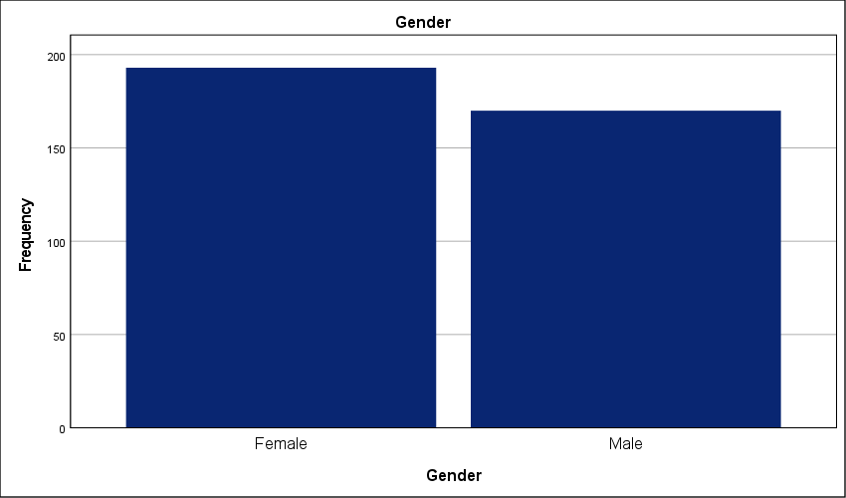
Figure 1 : Gender Composition of the Study Sample

- Age Group of participants in the experiment
While all age groups are well-represented, it is noteworthy that senior professionals (50+ years) constitute the smallest segment at 22%; this stands in contrast to the group under 30 years, which constitutes the largest portion at 27.5 percent. The workforce is young. Despite the lead held by early-career professionals, the distribution across all four age brackets remains remarkably tight—the gap between the youngest and oldest tiers is a mere 5.5 percent. This parity is unusual. Such an even spread suggests that the Saudi private sector is currently a melting pot of generational perspectives regarding Project Management Offices. The high concentration of younger staff indicates a workforce naturally more inclined toward modern governance tools and digital PMO integration. Simultaneously, the significant 22 percent of veteran leadership ensures that these strategic plans are grounded in long-term operational experience. This balance is critical; it prevents the findings from being dominated by either traditionalist inertia or inexperienced tech-enthusiasm. We are looking at a cross-generational consensus. The data reflects a mature professional environment where strategic PMO implementation is being observed and evaluated by a balanced mix of fresh talent and seasoned executives.
Age Group
 |  | Frequency | Percent | Valid Percent | Cumulative Percent
Valid | Less than 30 years | 100 | 27.5 | 27.5 | 27.5
Valid | 30–39 years | 96 | 26.4 | 26.4 | 54.0
Valid | 40–49 years | 87 | 24.0 | 24.0 | 78.0
Valid | 50 years and above | 80 | 22.0 | 22.0 | 100.0
Valid | Total | 363 | 100.0 | 100.0
Table 3 : Age Distribution Breakdown of the Surveyed Cohort

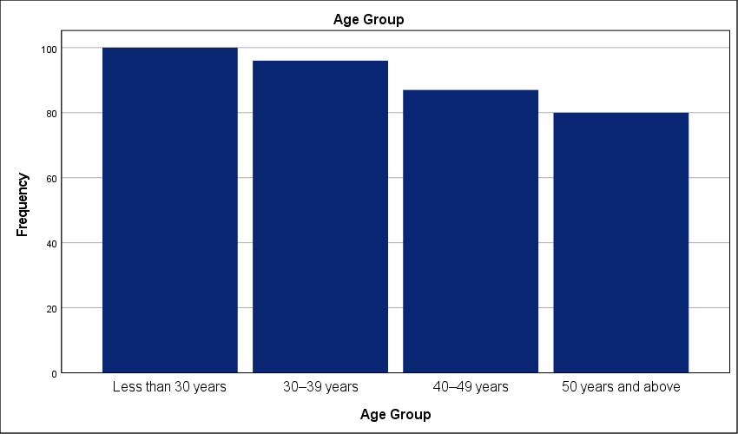
Figure 2 : Generational Representation within the Study Sample

- Educational Qualification of participants in the experiment
A mere 8 percent of the cohort holds a diploma or less, creating a massive disparity when measured against the 47.9 percent who possess a PhD or equivalent. This is a highly specialized workforce. The concentration of terminal degrees is staggering for a field study; it suggests that the Saudi private sector is heavily reliant on high-level academic expertise to drive its project management strategies. This creates a unique operational environment. With nearly half the participants holding doctorates and another 24.5 percent possessing Master's degrees, the intellectual capital available for PMO implementation is exceptionally high. This academic saturation likely results in a sophisticated understanding of theoretical frameworks—it also risks a "theory-practice" gap if these highly educated professionals prioritize academic models over localized field realities. The bachelor's degree group, usually the majority in industrial studies, accounts for only 19.6 percent here. Such a top-heavy educational profile indicates that the findings reflect an elite tier of the workforce. These experts are likely the ones designing the strategic plans rather than just executing them. This validates the study's depth; the responses are grounded in advanced methodological awareness rather than basic operational intuition.

Educational Qualification
 |  | Frequency | Percent | Valid Percent | Cumulative Percent
Valid | PhD or equivalent | 174 | 47.9 | 47.9 | 47.9
Valid | Masters degree | 89 | 24.5 | 24.5 | 72.5
Valid | Bachelors degree | 71 | 19.6 | 19.6 | 92.0
Valid | Diploma or less | 29 | 8.0 | 8.0 | 100.0
Valid | Total | 363 | 100.0 | 100.0
Table 4 : Academic Qualifications and Educational Background of Participants

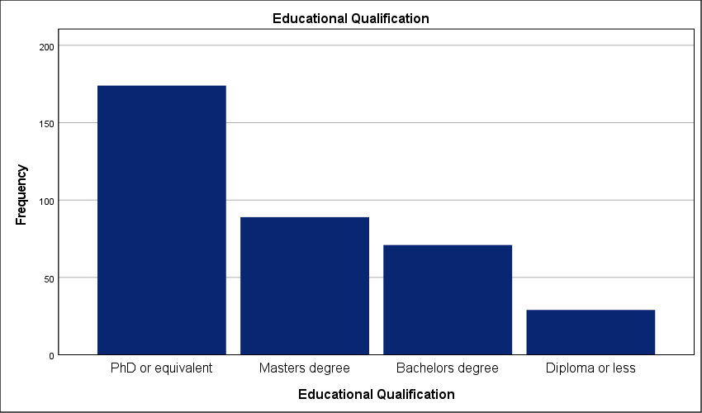
Figure 3 : Distribution of Higher Education Degrees among Respondents

- Years of Experience in Project Management of participants in the experiment
A defining characteristic of this sample is the high level of expertise, with nearly half of the respondents (49.3%) being industry veterans with over 15 years of experience. The workforce is veteran-led. This heavy concentration of senior expertise contrasts sharply with the 11.3 percent of participants who have less than 5 years in the field. Such a disparity is significant. It implies that the feedback regarding PMO impact on strategic planning is coming from individuals who have likely witnessed multiple organizational shifts and various iterations of PMO structures over nearly two decades. These are not novices reporting on recent trends—they are practitioners with long-term memory of project successes and failures. With 72.2 percent of the sample having at least 11 years of experience, the data carries a high degree of practical authority. This level of professional maturity minimizes the risk of "honeymoon phase" bias where newer employees might overrate the efficacy of PMO tools. Instead, we see a critical, experience-hardened perspective. These veterans understand the difference between a PMO that adds strategic value and one that merely adds bureaucratic friction. The findings represent a grounded, high-fidelity view of the Saudi private sector's operational reality.
Years of Experience in Project Management
 |  | Frequency | Percent | Valid Percent | Cumulative Percent
Valid | More than 15 years | 179 | 49.3 | 49.3 | 49.3
Valid | 11–15 years | 83 | 22.9 | 22.9 | 72.2
Valid | 5–10 years | 60 | 16.5 | 16.5 | 88.7
Valid | Less than 5 years | 41 | 11.3 | 11.3 | 100.0
Valid | Total | 363 | 100.0 | 100.0
Table 5 : Professional Experience Profile in Project Management

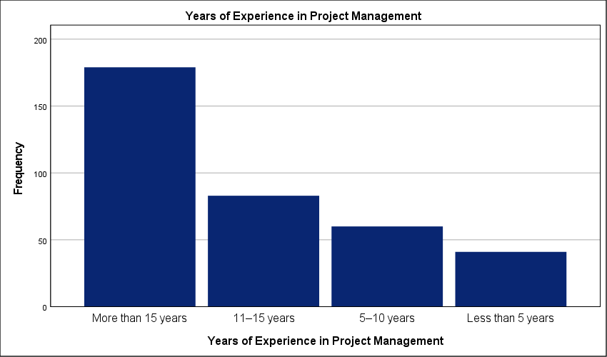
Figure 4 : Distribution of Participants by Years of Industry Experience

- Organizational Position of participants in the experiment
Senior and executive management dominate the sample at 45.7 percent. This leadership presence exceeds the project team member segment, representing only 14 percent of the total. The cohort is top-heavy. Such a distribution provides a strategic lens rather than a purely tactical one; it captures the perspective of those responsible for long-term organizational health. These executives hold the authority for PMO funding and define governance boundaries. Because nearly 70 percent of participants occupy senior management or PMO staff roles, the feedback on strategic integration carries heavy professional weight. We are hearing from the architects of strategy—not just the executors. This concentration reduces the risk of operational "noise" clouding the results. The data reflects the reality of power dynamics within the Saudi private sector. Governance is driven from the top down. The high scores reported elsewhere likely represent an executive vision that may face friction during ground-level implementation.
Organizational Position
 |  | Frequency | Percent | Valid Percent | Cumulative Percent
Valid | Senior / Executive Management | 166 | 45.7 | 45.7 | 45.7
Valid | PMO Staff | 89 | 24.5 | 24.5 | 70.2
Valid | Project Manager | 57 | 15.7 | 15.7 | 86.0
Valid | Project Team Member | 51 | 14.0 | 14.0 | 100.0
Valid | Total | 363 | 100.0 | 100.0
Table 6 : Hierarchical Distribution of Respondents' Organizational Roles

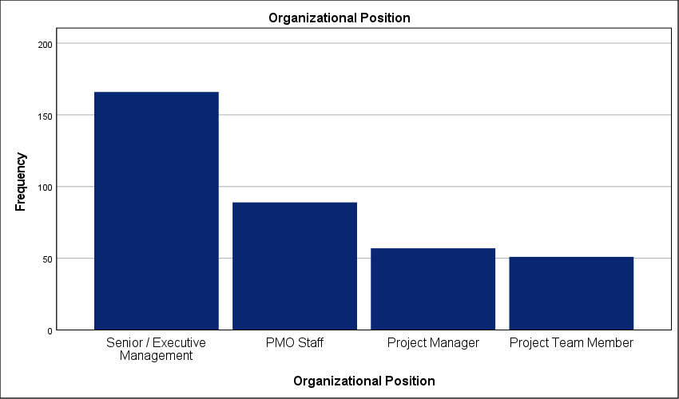
Figure 5 : Breakdown of Management and Staff Positions

Results of the study questions:
- The organization has a clearly defined Project Management Office (PMO).
Thirty-six point six percent of respondents strongly agree that their organization has a clearly defined PMO; this is the largest single group. A combined 30.9 percent explicitly disagree. The divide is clear. Such a wide split in perception confirms that the PMO is not yet a standard fixture across the Saudi private sector. A high standard deviation of 1.498 signals a lack of standardization. Many firms appear to operate without a central governance body. This absence creates a direct bottleneck in strategic execution. Without a defined office, the translation of high-level objectives into project-level tasks remains fragmented. The data suggests that while larger or more mature entities have solidified their PMO structures, a significant portion of the sector still lacks a formal project governance engine. This gap limits the potential for synchronized strategic growth. These results highlight a sector-wide inconsistency that must be addressed to ensure unified project delivery. Strategic success depends on this clarity. Organizations lacking this structure are essentially flying blind during the implementation phase of their long-term plans.

The organization has a clearly defined Project Management Office (PMO).
 |  | Frequency | Percent | Valid Percent | Cumulative Percent
Valid | Strongly Agree | 133 | 36.6 | 36.6 | 36.6
Valid | Agree | 80 | 22.0 | 22.0 | 58.7
Valid | Strongly Disagree | 58 | 16.0 | 16.0 | 74.7
Valid | Disagree | 54 | 14.9 | 14.9 | 89.5
Valid | Neither agree nor disagree | 38 | 10.5 | 10.5 | 100.0
Valid | Total | 363 | 100.0 | 100.0
Table 7 : Statistical analysis of Organizational Clarity Regarding PMO Establishment

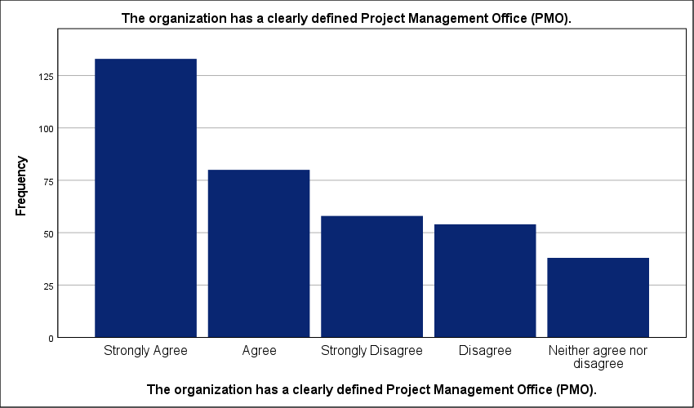
Figure 6 : Graphical representation of clearly defined Project Management Office (PMO) in the organization

- The PMO has well-defined roles and responsibilities.
There is a clear lack of neutrality regarding PMO roles, as only 8.5% remained undecided, highlighting a sharp divide in how these responsibilities are perceived. While 38 percent strongly agree that roles are well-defined, a substantial 25.3 percent strongly disagree. The environment is fractured. A high standard deviation of 1.658 points to a lack of standardization in how PMOs are governed within these firms. This role ambiguity likely creates internal friction. It forces project leads to navigate conflicting authorities; this inevitably slows down the execution of strategic plans. When responsibilities are this inconsistent, the PMO cannot provide the stable oversight needed for complex portfolios. This governance deficit suggests that many organizations have established offices without a functional mandate. Strategy remains disconnected from the ground level. Without clearly mapped roles, the PMO becomes an administrative burden rather than a strategic asset.
The PMO has well-defined roles and responsibilities.
 |  | Frequency | Percent | Valid Percent | Cumulative Percent
Valid | Strongly Agree | 138 | 38.0 | 38.0 | 38.0
Valid | Strongly Disagree | 92 | 25.3 | 25.3 | 63.4
Valid | Agree | 54 | 14.9 | 14.9 | 78.2
Valid | Disagree | 48 | 13.2 | 13.2 | 91.5
Valid | Neither agree nor disagree | 31 | 8.5 | 8.5 | 100.0
Valid | Total | 363 | 100.0 | 100.0
Table 8 : Statistical analysis of Assessment of Role Clarity and Responsibility Definition in PMOs

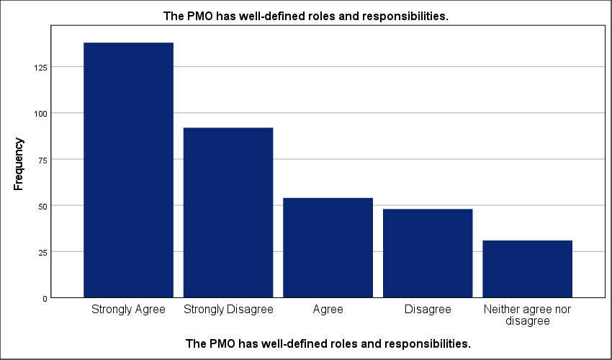
Figure 7 : Graphical representation of well-defined roles and responsibilities in the organiation.
- The PMO operates under a formal governance framework.
Exactly 10.5 percent of respondents strongly disagree that their PMO operates under a formal governance framework; this minority highlights a sharp gap when compared to the 35.3 percent who report a strongly structured environment. The sector remains fragmented. A standard deviation of 1.409 reflects polarized views on whether formal rules actually dictate PMO activities. Without a rigid framework, the PMO risks becoming a reactive cost center rather than a proactive strategic tool. This lack of standardization likely creates bottlenecks in project reporting—decisions are often made on ad-hoc data rather than systematic outputs. While 53.5 percent of the cohort leans toward agreement, the remaining 46.5 percent provide a cautionary tale of governance deficits. Effective strategic execution appears to be intrinsically linked to the maturity of the governance framework, rather than being an optional administrative layer. This disparity suggests that the impact of the PMO on strategic plans is entirely dependent on the maturity of individual firms rather than a sector-wide norm. High-performing organizations have formalized these links; the rest lack the structural discipline required for strategic success.
The PMO operates under a formal governance framework.
 |  | Frequency | Percent | Valid Percent | Cumulative Percent
Valid | Strongly Agree | 128 | 35.3 | 35.3 | 35.3
Valid | Disagree | 72 | 19.8 | 19.8 | 55.1
Valid | Agree | 66 | 18.2 | 18.2 | 73.3
Valid | Neither agree nor disagree | 59 | 16.3 | 16.3 | 89.5
Valid | Strongly Disagree | 38 | 10.5 | 10.5 | 100.0
Valid | Total | 363 | 100.0 | 100.0
Table 9 : Statistical analysis of Evaluation of Formal Governance Frameworks within PMO Operations.

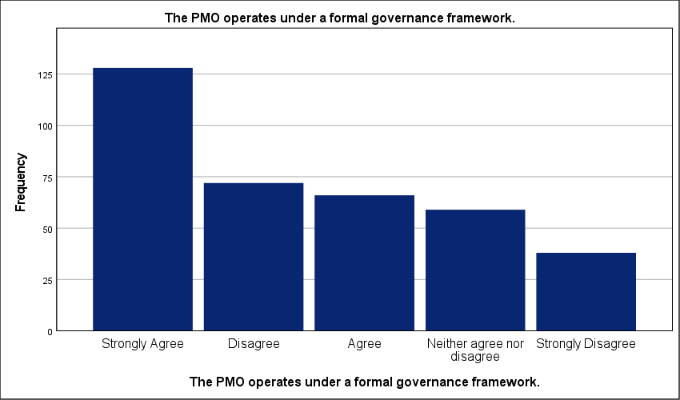
Figure 8 : Graphical representation of Formal Governance Frameworks within PMO Operations.

- Senior management supports the authority of the PMO.
Only 11.6 percent of the cohort remains neutral, representing the smallest segment of the sample; this stands in sharp contrast to the 35.8 percent who strongly agree that senior management supports PMO authority. The executive environment is polarized. A high standard deviation of 1.474 reflects a lack of standardization in how leadership perceives the PMO role. While over half the respondents report strong backing, the 32.5 percent who explicitly disagree highlight a critical governance gap. Crucially, inconsistent executive backing often limits the PMO’s influence, preventing it from functioning as a decisive strategic authority. It cannot enforce strategic alignment if project leads perceive that protocols are optional. Such a bottleneck likely delays the translation of strategic goals into executable tasks. When management support is inconsistent, the PMO loses its ability to prioritize initiatives effectively. The data suggests a reliance on informal decision-making pathways in organizations where the PMO lacks a clear institutional mandate. The data suggests that in many Saudi firms, PMO authority is tied to individual personalities rather than a formal institutional mandate. This inconsistency is a direct threat to long-term strategic success.

Senior management supports the authority of the PMO.
 |  | Frequency | Percent | Valid Percent | Cumulative Percent
Valid | Strongly Agree | 130 | 35.8 | 35.8 | 35.8
Valid | Agree | 73 | 20.1 | 20.1 | 55.9
Valid | Disagree | 68 | 18.7 | 18.7 | 74.7
Valid | Strongly Disagree | 50 | 13.8 | 13.8 | 88.4
Valid | Neither agree nor disagree | 42 | 11.6 | 11.6 | 100.0
Valid | Total | 363 | 100.0 | 100.0
Table 10 : Statistical analysis of Perceived Senior Management Support for PMO Authority.

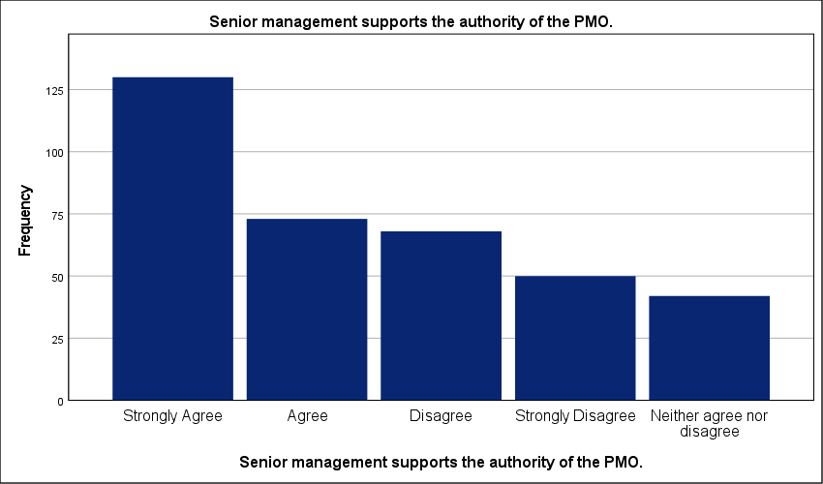
Figure 9 : Graphical representation of Perceived Senior Management Support for PMO Authority.

- The PMO is aligned with the organizational structure.
Exactly 11.8 percent of the workforce remains neutral regarding the PMO's alignment with organizational structure; this small undecided group is overshadowed by the 40.8 percent who strongly agree. The sector is split. A high standard deviation of 1.546 indicates a lack of standardization across the Saudi private sector. While the majority claims alignment, a significant 31.7 percent explicitly disagree or strongly disagree. Structure dictates strategic flow. This misalignment creates administrative silos that prevent the PMO from influencing core business units. When the office is detached from the primary hierarchy, strategic plans often stall during the transition from boardroom to field operation. Such a bottleneck likely causes delays in project resource allocation. The data reveals that structural integration is a localized success rather than a matured industry norm. Without a unified reporting structure, the PMO remains a detached reporting unit rather than an integrated governance engine.
The PMO is aligned with the organizational structure.
 |  | Frequency | Percent | Valid Percent | Cumulative Percent
Valid | Strongly Agree | 148 | 40.8 | 40.8 | 40.8
Valid | Strongly Disagree | 62 | 17.1 | 17.1 | 57.9
Valid | Agree | 57 | 15.7 | 15.7 | 73.6
Valid | Disagree | 53 | 14.6 | 14.6 | 88.2
Valid | Neither agree nor disagree | 43 | 11.8 | 11.8 | 100.0
Valid | Total | 363 | 100.0 | 100.0
Table 11 : Statistical analysis of Structural Alignment of the PMO within the Corporate Hierarchy.

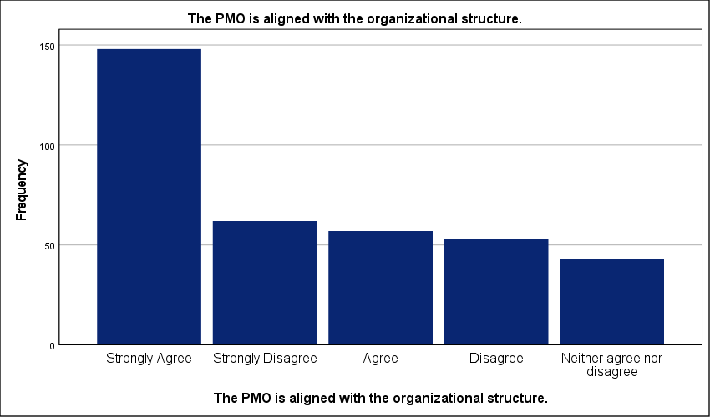
Figure 10 : Graphical representation of Structural Alignment of the PMO within the Corporate Hierarchy.

- The PMO has sufficient autonomy to perform its functions.
Just 8 percent of respondents maintain a neutral stance regarding PMO autonomy; this minor group is eclipsed by a deeply divided majority. While 38 percent of the sample strongly agrees that their offices possess sufficient independence, an almost equal 38.3 percent cumulative total reports a lack of functional freedom. Autonomy is highly inconsistent. A standard deviation of 1.631 highlights severe fragmentation across the sector—this suggests that PMO authority is often situational rather than systemic. Without the power to make independent calls, the PMO becomes a reporting tool that lacks the leverage to course-correct failing projects. This administrative friction likely causes significant delays in resource mobilization and strategic pivots. Decisions are held up by unnecessary layers of hierarchy. The data proves that for many Saudi firms, the PMO is active but not empowered. This governance gap prevents the office from acting as a true guardian of the strategic plan.
The PMO has sufficient autonomy to perform its functions.
 |  | Frequency | Percent | Valid Percent | Cumulative Percent
Valid | Strongly Agree | 138 | 38.0 | 38.0 | 38.0
Valid | Strongly Disagree | 83 | 22.9 | 22.9 | 60.9
Valid | Agree | 57 | 15.7 | 15.7 | 76.6
Valid | Disagree | 56 | 15.4 | 15.4 | 92.0
Valid | Neither agree nor disagree | 29 | 8.0 | 8.0 | 100.0
Valid | Total | 363 | 100.0 | 100.0
Table 12 : Statistical analysis of Evaluation of PMO Functional Autonomy and Independence.

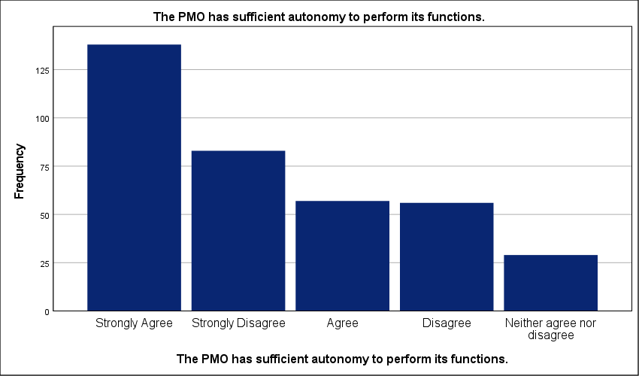
Figure 11 : Graphical representation of Evaluation of PMO Functional Autonomy and Independence.

- The PMO contributes to standardizing project management practices.
A standard deviation of 1.387 exposes a profound lack of standardization across the Saudi private sector. While 54 percent of the sample leans toward agreement, the wide spread of responses proves that procedural consistency is far from a matured industry norm. The workforce is divided. This lack of alignment suggests that while some PMOs have successfully implemented unified methodologies, a significant portion of the sector remains mired in ad-hoc workflows. Such an operational gap directly hinders strategic scalability. Inconsistent reporting across different business units makes it impossible for leadership to compare project performance accurately; this bottleneck likely leads to misallocated resources. Without a predictable baseline for project delivery, the strategic plan remains a theoretical exercise rather than an operational reality. High variance in these results highlights a sector where the PMO is struggling to enforce the very standards it was designed to uphold.
The PMO contributes to standardizing project management practices.
 |  | Frequency | Percent | Valid Percent | Cumulative Percent
Valid | Strongly Agree | 117 | 32.2 | 32.2 | 32.2
Valid | Agree | 79 | 21.8 | 21.8 | 54.0
Valid | Disagree | 69 | 19.0 | 19.0 | 73.0
Valid | Neither agree nor disagree | 59 | 16.3 | 16.3 | 89.3
Valid | Strongly Disagree | 39 | 10.7 | 10.7 | 100.0
Valid | Total | 363 | 100.0 | 100.0
Table 13 : Statistical analysis of PMO Contributions to Methodological Standardization.

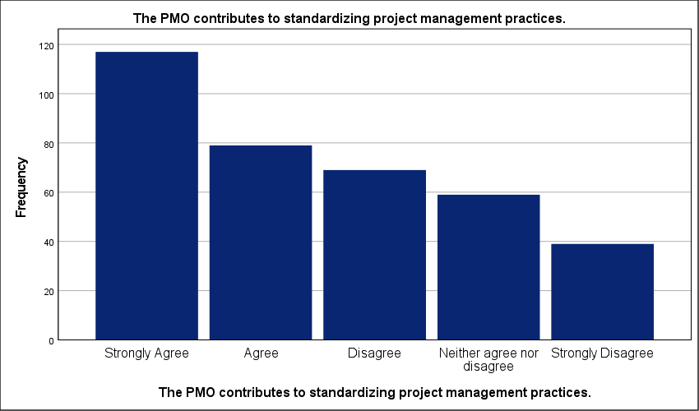
Figure 12 : Graphical representation of PMO Contributions to Methodological Standardization.

- The PMO ensures alignment between projects and organizational strategy.
Fragmentation defines the current state of strategic alignment across the Saudi private sector. The consensus is weak. A high standard deviation of 1.447 indicates polarized professional views; this suggests that while 37.7 percent of organizations have successfully integrated their PMO into the strategic layer, nearly 30 percent remain functionally disconnected. This lack of standardization is dangerous. It implies that many PMOs operate in tactical silos where project selection lacks rigorous strategic vetting. Strategic goals remain abstract. When the office fails to serve as a bridge, resources are often committed to initiatives that do not advance long-term organizational objectives. While the mean score suggests moderate progress, the high variance indicates that strategic alignment remains a localized success rather than a sector-wide norm. This gap likely results in wasted capital and missed market opportunities. Organizations without a synchronized PMO will continue to struggle with strategic execution during periods of rapid growth.
The PMO ensures alignment between projects and organizational strategy.
 |  | Frequency | Percent | Valid Percent | Cumulative Percent
Valid | Strongly Agree | 137 | 37.7 | 37.7 | 37.7
Valid | Agree | 76 | 20.9 | 20.9 | 58.7
Valid | Disagree | 56 | 15.4 | 15.4 | 74.1
Valid | Strongly Disagree | 47 | 12.9 | 12.9 | 87.1
Valid | Neither agree nor disagree | 47 | 12.9 | 12.9 | 100.0
Valid | Total | 363 | 100.0 | 100.0
Table 14 : Statistical analysis of Effectiveness of the PMO in Driving Strategic Project Alignment.

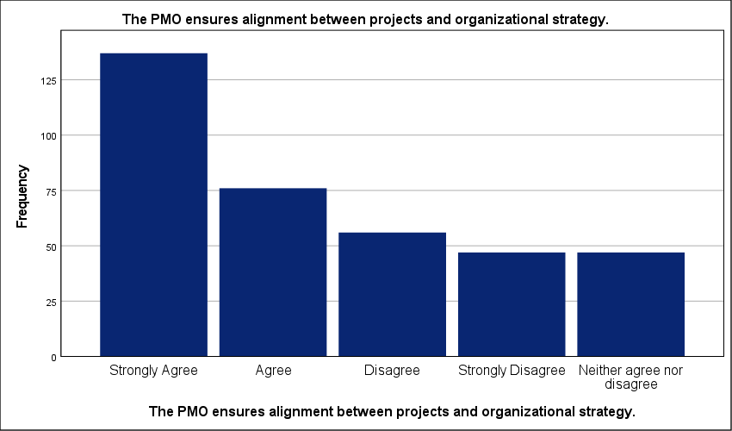
Figure 13 : Graphical representation of Effectiveness of the PMO in Driving Strategic Project Alignment.

- Project selection decisions reflect strategic organizational priorities.
Exactly 40.8 percent of respondents strongly agree that project selection reflects strategic priorities; this majority view stands in stark contrast to the 12.7 percent who explicitly disagree. Selection logic varies wildly. A high standard deviation of 1.511 confirms a severe lack of standardization in how Saudi private sector firms greenlight new initiatives. This fragmentation suggests that nearly half the workforce observes a disconnect between corporate goals and operational reality. Portfolio management suffers. When selection criteria are not standardized, organizations risk funding projects that offer no measurable strategic return. Such a bottleneck likely drains resources from critical initiatives—delaying the overall execution of the long-term plan. The data reveals a sector struggling to move beyond ad-hoc decision-making into a mature, PMO-governed investment model. This governance gap ensures that capital remains tied up in projects with low strategic contribution.
Project selection decisions reflect strategic organizational priorities.
 |  | Frequency | Percent | Valid Percent | Cumulative Percent
Valid | Strongly Agree | 148 | 40.8 | 40.8 | 40.8
Valid | Strongly Disagree | 58 | 16.0 | 16.0 | 56.7
Valid | Neither agree nor disagree | 56 | 15.4 | 15.4 | 72.2
Valid | Agree | 55 | 15.2 | 15.2 | 87.3
Valid | Disagree | 46 | 12.7 | 12.7 | 100.0
Valid | Total | 363 | 100.0 | 100.0
Table 15 : Statistical analysis of Alignment of Project Selection with Strategic Priorities.

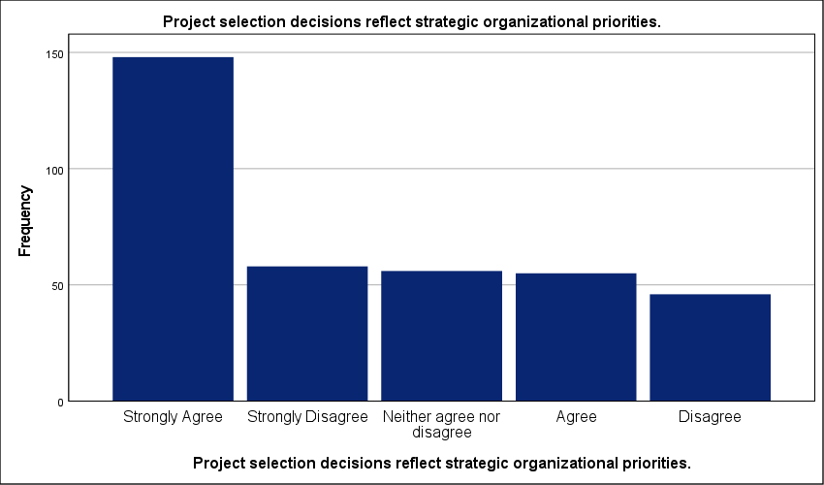
Figure 14 : Graphical representation of Alignment of Project Selection with Strategic Priorities.

- The PMO participates in strategic planning discussions.
A mere 10.7 percent of the cohort remains neutral on PMO involvement in strategic planning—this minor group is dwarfed by the 41.6 percent who strongly agree that their offices have a seat at the table. The divide is sharp. A high standard deviation of 1.572 signals severe fragmentation across the Saudi private sector regarding the office's perceived value in the boardroom. While more than half the respondents see their PMO as a strategic participant, nearly a third explicitly report being excluded from high-level discussions. This lack of standardization creates a critical operational bottleneck. When PMOs are excluded from the planning phase, strategic objectives often fail to account for technical resource constraints; this leads to unrealistic project timelines and subsequent delivery failures. The data suggests that for a large portion of the sector, the PMO remains a tactical reporting unit rather than a strategic partner. Separating planning from execution is a major risk. This disconnect ensures that long-term goals remain detached from the organizational capacity to actually deliver them.
The PMO participates in strategic planning discussions.
 |  | Frequency | Percent | Valid Percent | Cumulative Percent
Valid | Strongly Agree | 151 | 41.6 | 41.6 | 41.6
Valid | Strongly Disagree | 68 | 18.7 | 18.7 | 60.3
Valid | Agree | 58 | 16.0 | 16.0 | 76.3
Valid | Disagree | 47 | 12.9 | 12.9 | 89.3
Valid | Neither agree nor disagree | 39 | 10.7 | 10.7 | 100.0
Valid | Total | 363 | 100.0 | 100.0
Table 16 : Statistical analysis of PMO Involvement in High-Level Strategic Planning.

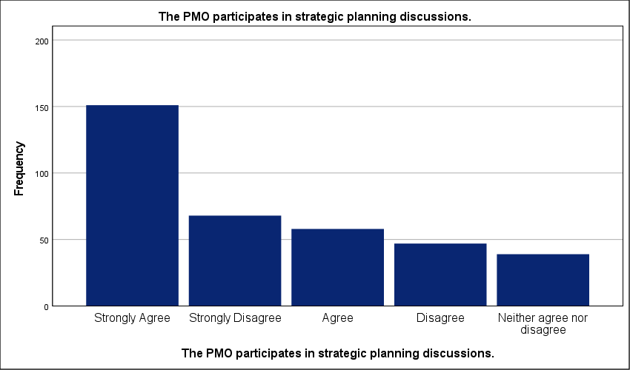
Figure 15 : Graphical representation of PMO Involvement in High-Level Strategic Planning.

- Projects are evaluated based on their strategic contribution.
Strongly disagreeing participants account for only 11 percent of the sample—a figure drastically outweighed by the 35 percent who strongly agree that strategic contribution is the primary metric for project evaluation. This disparity reveals a sector in transition. A high standard deviation of 1.405 confirms deep fragmentation in project governance across the Saudi private sector. While a majority claims to prioritize strategic value, the wide spread of responses suggests that many firms still lack a standardized scoring model. Project portfolios remain inconsistent. Without a rigorous, PMO-led evaluation process, capital is likely being funneled into initiatives based on tactical urgency rather than long-term strategic fit. This lack of alignment creates an operational bottleneck; it forces leadership to make trade-off decisions without quantifiable data. The data indicates that strategic evaluation is an aspirational goal for many, but a functional reality for only a few. Standardized metrics are missing. Until the PMO enforces a uniform evaluation framework, the strategic plan will continue to suffer from resource dilution across non-essential projects.
Projects are evaluated based on their strategic contribution.
 |  | Frequency | Percent | Valid Percent | Cumulative Percent
Valid | Strongly Agree | 127 | 35.0 | 35.0 | 35.0
Valid | Agree | 72 | 19.8 | 19.8 | 54.8
Valid | Disagree | 65 | 17.9 | 17.9 | 72.7
Valid | Neither agree nor disagree | 59 | 16.3 | 16.3 | 89.0
Valid | Strongly Disagree | 40 | 11.0 | 11.0 | 100.0
Valid | Total | 363 | 100.0 | 100.0
Table 17 : Statistical analysis of Strategic Contribution as a Project Evaluation Metric.

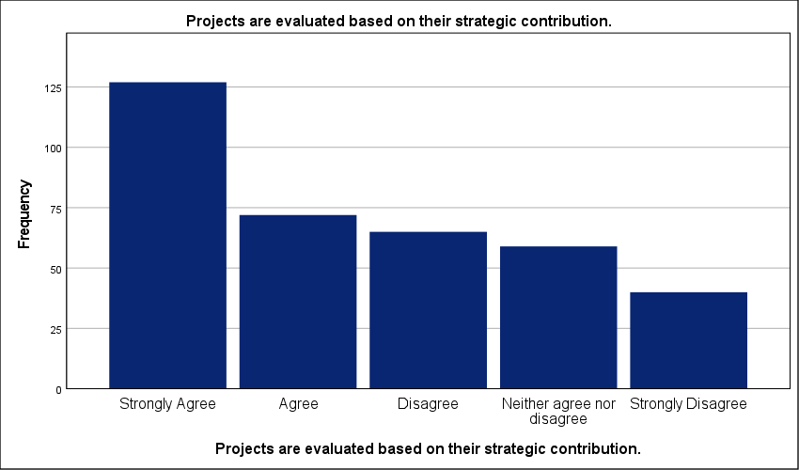
Figure 16 : Graphical representation of Strategic Contribution as a Project Evaluation Metric.

- The PMO helps translate strategic objectives into executable projects.
Strongly disagreeing participants represent the smallest portion of the sample at 12.9 percent; this is significantly lower than the 33.3 percent who strongly agree that the PMO effectively translates strategy into execution. The workforce is split. This 20.4 percent gap highlights a deep operational divide within the Saudi private sector. A high standard deviation of 1.415 signals severe fragmentation—it suggests that for many firms, the PMO is failing to bridge the gap between abstract boardroom goals and ground-level project tasks. Translation is failing. When this link is broken, strategic objectives remain disconnected from the technical capacity of the organization. This bottleneck likely leads to project delays and resource misallocation as teams struggle to interpret vague mandates. While 57.8 percent of respondents lean toward agreement, the wide distribution proves that the industry lacks a standardized methodology for this transition. Without a consistent framework, the PMO remains a tactical reporting unit rather than a functional engine for strategy. Success is purely localized. The data reveals that many organizations still treat the PMO as an administrative layer rather than a strategic partner.
The PMO helps translate strategic objectives into executable projects.
 |  | Frequency | Percent | Valid Percent | Cumulative Percent
Valid | Strongly Agree | 121 | 33.3 | 33.3 | 33.3
Valid | Agree | 89 | 24.5 | 24.5 | 57.9
Valid | Disagree | 55 | 15.2 | 15.2 | 73.0
Valid | Neither agree nor disagree | 51 | 14.0 | 14.0 | 87.1
Valid | Strongly Disagree | 47 | 12.9 | 12.9 | 100.0
Valid | Total | 363 | 100.0 | 100.0
Table 18 : Statistical analysis of Role of the PMO in Translating Strategy into Execution.

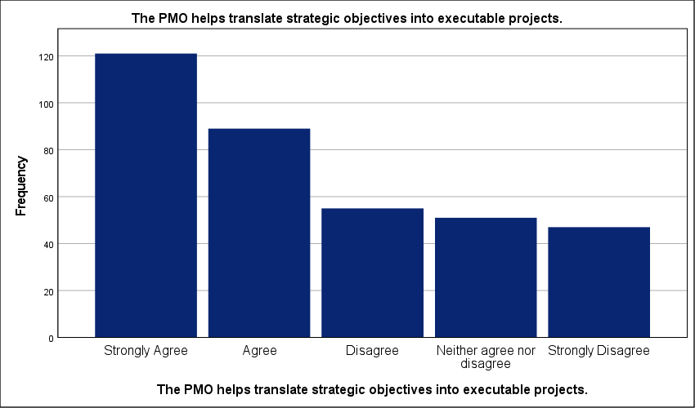
Figure 17 : Graphical representation of Role of the PMO in Translating Strategy into Execution.

- Strategic changes are effectively communicated through the PMO.
Only 9.6 percent of respondents occupy the neutral middle ground regarding strategic communication efficiency; this minor segment stands in stark contrast to the 34.2 percent who strongly agree with the PMO’s performance in this area. Messaging is fractured. A high standard deviation of 1.540 confirms severe fragmentation across the industry. Such a wide spread suggests that the PMO is not yet a reliable or standardized conduit for top-down strategic shifts. This breakdown in information flow creates a dangerous operational bottleneck. Project teams in nearly 37 percent of surveyed firms are likely operating on outdated or poorly understood mandates. Strategic execution stalls. Without a consistent communication framework, the office remains a passive observer rather than an active bridge between the boardroom and the field. This inconsistency prevents rapid organizational pivots during market shifts. The results reflect a sector where information silos still undermine long-term strategic coherence.
Strategic changes are effectively communicated through the PMO.
 |  | Frequency | Percent | Valid Percent | Cumulative Percent
Valid | Strongly Agree | 124 | 34.2 | 34.2 | 34.2
Valid | Agree | 71 | 19.6 | 19.6 | 53.7
Valid | Disagree | 67 | 18.5 | 18.5 | 72.2
Valid | Strongly Disagree | 66 | 18.2 | 18.2 | 90.4
Valid | Neither agree nor disagree | 35 | 9.6 | 9.6 | 100.0
Valid | Total | 363 | 100.0 | 100.0
Table 19 : Statistical analysis of Communication of Strategic Shifts via PMO Channels.

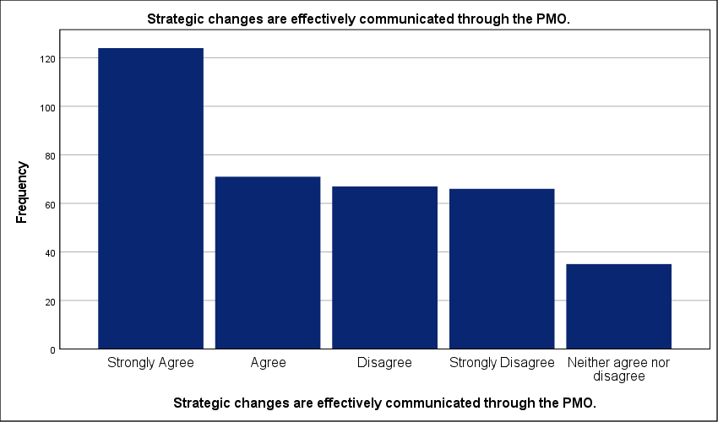
Figure 18 : Graphical representation of Communication of Strategic Shifts via PMO Channels.

- The PMO reduces misalignment between projects and strategic goals.
Nearly 25 percent of respondents strongly disagree that the PMO reduces strategic misalignment—this contrasts sharply with the 34.2 percent who view the office as an effective corrective tool. The sector is fractured. A high standard deviation of 1.611 confirms severe fragmentation; this indicates that the office's ability to realign projects with corporate goals is situational rather than systemic. The link is broken. Such polarized results suggest that in many Saudi firms, the PMO exists as a reporting layer but lacks the authority to halt non-strategic initiatives. This bottleneck likely leads to significant resource leakage and delays in long-term plan execution. Without an empowered governance body, project portfolios drift toward tactical urgency. The data proves that standardization is missing. Until the PMO is granted the mandate to prune misaligned projects, strategic coherence will remain localized rather than an industry standard.
The PMO reduces misalignment between projects and strategic goals.
 |  | Frequency | Percent | Valid Percent | Cumulative Percent
Valid | Strongly Agree | 124 | 34.2 | 34.2 | 34.2
Valid | Strongly Disagree | 90 | 24.8 | 24.8 | 59.0
Valid | Agree | 70 | 19.3 | 19.3 | 78.2
Valid | Disagree | 40 | 11.0 | 11.0 | 89.3
Valid | Neither agree nor disagree | 39 | 10.7 | 10.7 | 100.0
Valid | Total | 363 | 100.0 | 100.0
Table 20 : Statistical analysis of PMO Efficacy in Mitigating Strategic Misalignment.

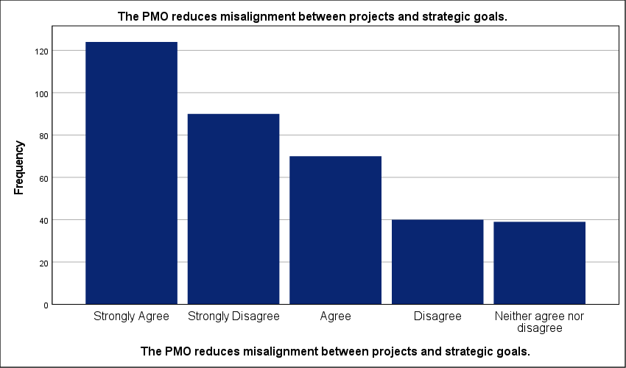
Figure 19 : Graphical representation of PMO Efficacy in Mitigating Strategic Misalignment.

- The PMO provides accurate data to support strategic decision-making.
Exactly 36.9 percent of executives strongly rely on PMO data for strategic choices. This reliability is inconsistent. A high standard deviation of 1.455 reflects a fragmented data environment across the Saudi private sector. Information quality varies wildly. While a slight majority leans toward agreement, the significant spread suggests that nearly 30 percent of firms struggle with data integrity. This bottleneck likely forces leadership to rely on intuition rather than empirical evidence. Strategy execution requires precision. When the PMO fails to deliver accurate reporting, decision-making becomes reactive; this delay prevents organizations from pivoting effectively during market shifts. The results show a sector-wide lack of standardization in reporting tools. Without a unified data system, the PMO remains an administrative hub rather than a strategic intelligence engine. High-quality data is the currency of strategy. For many organizations, this currency is currently devalued by manual reporting errors and disparate software platforms.
The PMO provides accurate data to support strategic decision-making.
 |  | Frequency | Percent | Valid Percent | Cumulative Percent
Valid | Strongly Agree | 134 | 36.9 | 36.9 | 36.9
Valid | Agree | 64 | 17.6 | 17.6 | 54.5
Valid | Neither agree nor disagree | 61 | 16.8 | 16.8 | 71.3
Valid | Disagree | 54 | 14.9 | 14.9 | 86.2
Valid | Strongly Disagree | 50 | 13.8 | 13.8 | 100.0
Valid | Total | 363 | 100.0 | 100.0
Table 21 : Statistical analysis of Reliability of PMO Data for Strategic Decision Support.

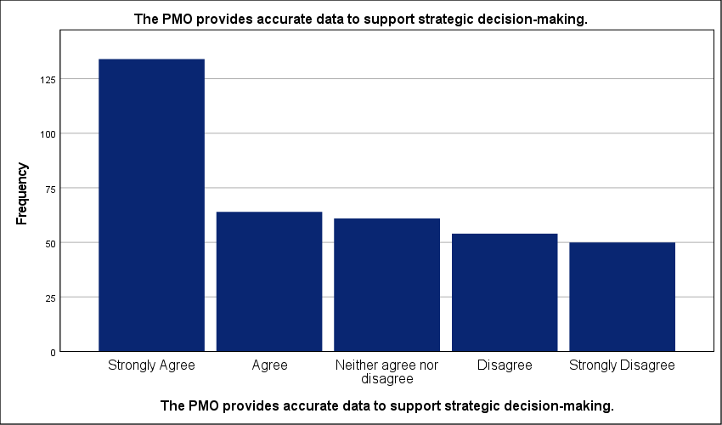
Figure 20 : Graphical representation of Reliability of PMO Data for Strategic Decision Support.

- Project performance reports support long-term planning decisions.
Fragmented reporting structures cripple long-term forecasting across 31.4 percent of the surveyed firms. The data is inconsistent. While 34.7 percent strongly agree that performance reports aid planning, a high standard deviation of 1.469 reveals a deep lack of standardization in the Saudi private sector. This variance suggests that many PMOs generate reports that lack the granularity required for executive decision-making. Strategic pivots become impossible. Without a consistent link between current performance and future goals, these organizations are essentially operating in a data vacuum. This bottleneck likely delays the reallocation of resources to high-value projects; it forces leadership to rely on historical intuition rather than real-time insights. The mean score of 3.44 hides a polarized reality. High-performing PMOs provide clarity—others merely add noise to the boardroom. Until reporting is standardized, long-term plans will remain disconnected from operational performance.
Project performance reports support long-term planning decisions.
 |  | Frequency | Percent | Valid Percent | Cumulative Percent
Valid | Strongly Agree | 126 | 34.7 | 34.7 | 34.7
Valid | Agree | 75 | 20.7 | 20.7 | 55.4
Valid | Disagree | 61 | 16.8 | 16.8 | 72.2
Valid | Strongly Disagree | 53 | 14.6 | 14.6 | 86.8
Valid | Neither agree nor disagree | 48 | 13.2 | 13.2 | 100.0
Valid | Total | 363 | 100.0 | 100.0
Table 22 : Statistical analysis of Impact of Performance Reporting on Long-term Planning.

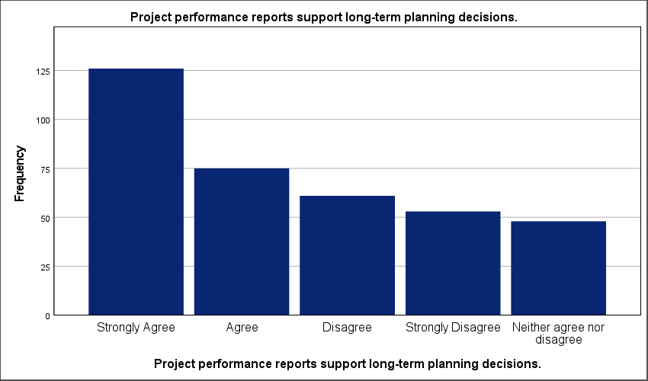
Figure 21 : Graphical representation of Impact of Performance Reporting on Long-term Planning.

- The PMO enhances transparency in project-related decisions.
The data suggests that transparency is still a work in progress, with roughly 35% of firms struggling to achieve clear visibility in project decisions. A high standard deviation of 1.596 signals deep fragmentation across the sector. While 35.3 percent of respondents strongly agree that the PMO improves visibility, a substantial 23.1 percent report a lack of clarity in project-related decisions. This polarized environment is risky. Inconsistent transparency creates a bottleneck that prevents stakeholders from identifying failing initiatives before they drain critical resources—it suggests project governance is still handled in silos in a large portion of the Saudi private sector. Without a standardized reporting culture, the PMO fails to act as a single source of truth; decisions are likely influenced by internal politics rather than objective data. Trust in leadership execution suffers. Organizations with high variance in transparency are essentially operating with blind spots that compromise their long-term strategic integrity.
The PMO enhances transparency in project-related decisions.
 |  | Frequency | Percent | Valid Percent | Cumulative Percent
Valid | Strongly Agree | 128 | 35.3 | 35.3 | 35.3
Valid | Strongly Disagree | 84 | 23.1 | 23.1 | 58.4
Valid | Agree | 61 | 16.8 | 16.8 | 75.2
Valid | Neither agree nor disagree | 46 | 12.7 | 12.7 | 87.9
Valid | Disagree | 44 | 12.1 | 12.1 | 100.0
Valid | Total | 363 | 100.0 | 100.0
Table 23 : Statistical analysis of PMO Influence on Decision-making Transparency.

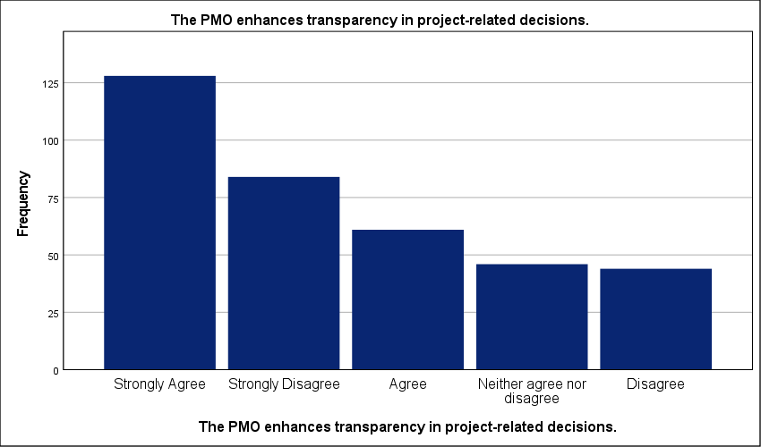
Figure 22 : Graphical representation of PMO Influence on Decision-making Transparency.

- Management relies on PMO reports when making strategic choices.
Exactly 10.2 percent of respondents remain neutral—the lowest frequency in the set—yet this is overshadowed by the 36.4 percent who strongly agree that PMO reports anchor strategic choices. The data is polarized. A high standard deviation of 1.640 proves a severe lack of standardization in how leadership utilizes the office. While many firms trust the data, a substantial 25.6 percent strongly disagree. Professional reliance is inconsistent. This disparity suggests a bottleneck where executive decision-making remains detached from PMO outputs in over a quarter of the surveyed organizations. When management ignores these reports, strategic initiatives lose their empirical foundation; this leads to misallocated capital and project drift. Decisions are delayed. High variance indicates that the PMO is not yet the universal single source of truth for the Saudi private sector. The impact of the office on the strategic plan is crippled when its reporting is treated as optional rather than mandatory.
Management relies on PMO reports when making strategic choices.
 |  | Frequency | Percent | Valid Percent | Cumulative Percent
Valid | Strongly Agree | 132 | 36.4 | 36.4 | 36.4
Valid | Strongly Disagree | 93 | 25.6 | 25.6 | 62.0
Valid | Agree | 61 | 16.8 | 16.8 | 78.8
Valid | Disagree | 40 | 11.0 | 11.0 | 89.8
Valid | Neither agree nor disagree | 37 | 10.2 | 10.2 | 100.0
Valid | Total | 363 | 100.0 | 100.0
Table 24 : Statistical analysis of Executive Reliance on PMO Analytics for Strategic Choices.

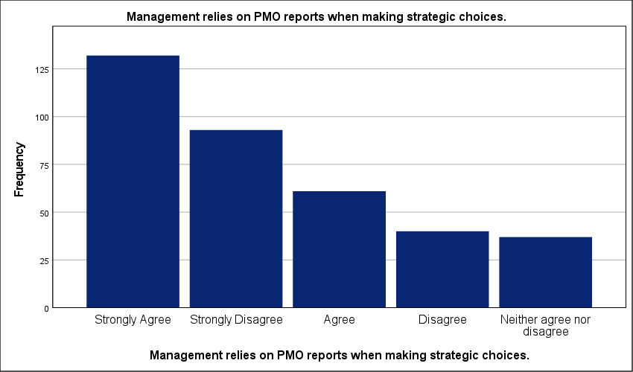
Figure 23 : Graphical representation of Executive Reliance on PMO Analytics for Strategic Choices.

- The PMO improves risk assessment during strategic planning.
Exactly 10.7 percent of the sample strongly disagrees that the PMO improves risk assessment; this minority view is dwarfed by the 36.9 percent who report significant improvements in risk identification during strategic phases. The sector is fragmented. A high standard deviation of 1.414 reflects a lack of standardization in risk management protocols across Saudi firms. This variance is a red flag. It implies that risk assessment is often an afterthought in the planning cycle for a large portion of the market. Such a bottleneck likely exposes strategic projects to preventable delays and cost overruns. Without a centralized PMO to enforce rigorous risk modeling, strategic plans remain inherently fragile. These results suggest that many organizations still rely on qualitative intuition rather than the quantitative data systems a mature PMO should provide. Operational stability depends on this link. Strategic execution will continue to face high failure rates until risk integration becomes a mandatory PMO function.
The PMO improves risk assessment during strategic planning.
 |  | Frequency | Percent | Valid Percent | Cumulative Percent
Valid | Strongly Agree | 134 | 36.9 | 36.9 | 36.9
Valid | Agree | 73 | 20.1 | 20.1 | 57.0
Valid | Disagree | 66 | 18.2 | 18.2 | 75.2
Valid | Neither agree nor disagree | 51 | 14.0 | 14.0 | 89.3
Valid | Strongly Disagree | 39 | 10.7 | 10.7 | 100.0
Valid | Total | 363 | 100.0 | 100.0
Table 25 : Statistical analysis of PMO Contributions to Strategic Risk Management.

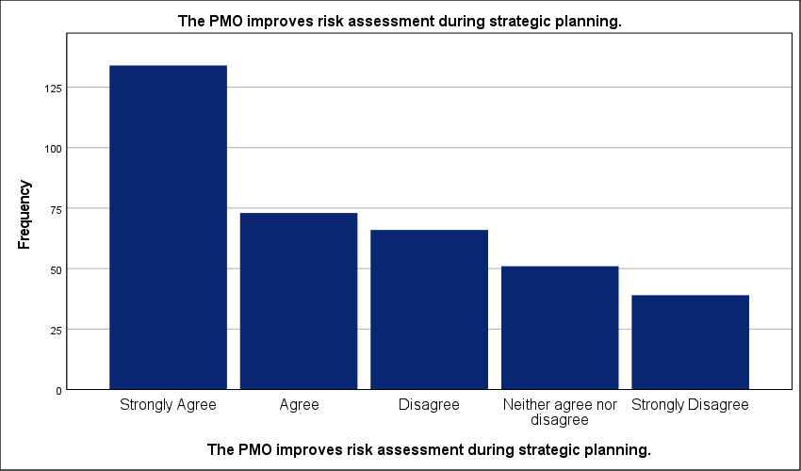
Figure 24 : Graphical representation of PMO Contributions to Strategic Risk Management.

- The PMO supports prioritization of strategic initiatives.
Exactly 37.5 percent of respondents strongly agree that the PMO drives initiative prioritization; this is more than triple the 10.5 percent who remain neutral. Professional views are polarized. A high standard deviation of 1.453 signals severe fragmentation in how Saudi private sector firms manage their strategic portfolios. While a majority—58.4 percent—lean toward agreement, the 31.1 percent total disagreement rate reflects a lack of industry standardization. This gap is dangerous. Organizations lacking a formal prioritization framework likely experience significant resource leakage. Strategic goals remain underfunded while tactical noise consumes the budget. This bottleneck prevents a synchronized transition from planning to execution. The data reveals that many PMOs lack the mandate to enforce strategic rank—they function as reporting units rather than gatekeepers. Portfolio drift is an immediate risk. Without a unified scoring model, the impact on the strategic plan remains purely localized and inconsistent.
The PMO supports prioritization of strategic initiatives.
 |  | Frequency | Percent | Valid Percent | Cumulative Percent
Valid | Strongly Agree | 136 | 37.5 | 37.5 | 37.5
Valid | Agree | 76 | 20.9 | 20.9 | 58.4
Valid | Disagree | 69 | 19.0 | 19.0 | 77.4
Valid | Strongly Disagree | 44 | 12.1 | 12.1 | 89.5
Valid | Neither agree nor disagree | 38 | 10.5 | 10.5 | 100.0
Valid | Total | 363 | 100.0 | 100.0
Table 26 : Statistical analysis of PMO Support for Strategic Initiative Prioritization.

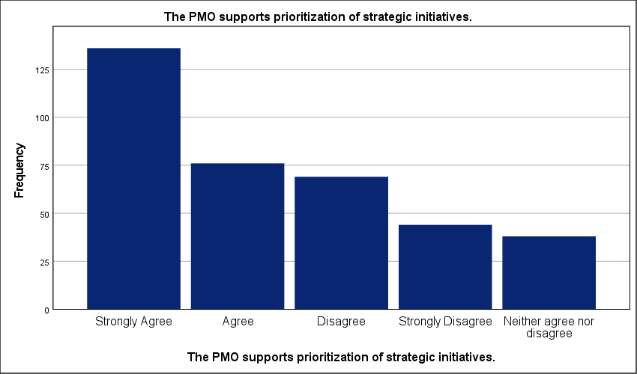
Figure 25 : Graphical representation of PMO Support for Strategic Initiative Prioritization.

- Decisions become more consistent due to PMO involvement.
Thirty-six point four percent of respondents strongly agree that PMO involvement stabilizes decision-making; yet, a nearly identical 34.7 percent explicitly disagree. Consistency remains elusive. The data is polarized. A high standard deviation of 1.503 confirms deep fragmentation across the Saudi private sector. This variance suggests that the office's influence on corporate discipline is situational rather than systemic. Decisions are still made in silos. Such variability creates a dangerous operational bottleneck. It forces project teams to navigate unpredictable executive shifts. This inconsistency turns the strategic plan into a moving target. Without a unified governance engine, organizations cannot guarantee that today's choices align with tomorrow's goals. The findings reflect a sector-wide struggle to replace ad-hoc intuition with rigorous, data-driven logic. This operational gap prevents the PMO from acting as a true anchor for long-term objectives.
Decisions become more consistent due to PMO involvement.
 |  | Frequency | Percent | Valid Percent | Cumulative Percent
Valid | Strongly Agree | 132 | 36.4 | 36.4 | 36.4
Valid | Disagree | 72 | 19.8 | 19.8 | 56.2
Valid | Agree | 56 | 15.4 | 15.4 | 71.6
Valid | Strongly Disagree | 54 | 14.9 | 14.9 | 86.5
Valid | Neither agree nor disagree | 49 | 13.5 | 13.5 | 100.0
Valid | Total | 363 | 100.0 | 100.0
Table 27 : Statistical analysis of Consistency in Organizational Decisions through PMO Governance.

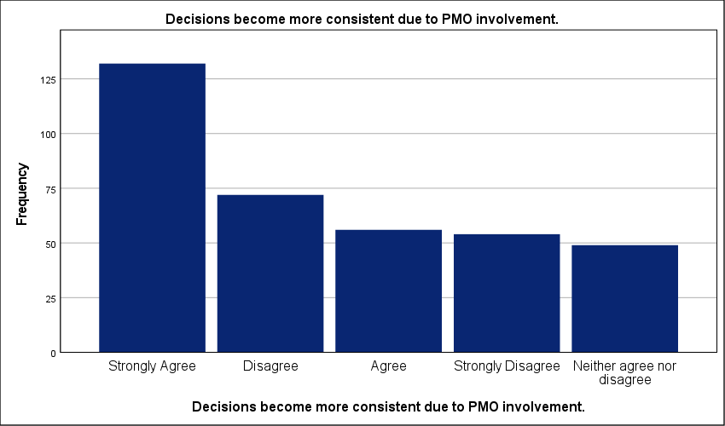
Figure 26 : Graphical representation of Consistency in Organizational Decisions through PMO Governance.

- The PMO uses standardized project management tools.
Forty point two percent of firms have institutionalized standardized project management tools; this represents the largest group, yet it is starkly contrasted by a combined 34.1 percent reporting a total lack of uniform systems. Technical infrastructure is fragmented. A high standard deviation of 1.618 reveals a polarized environment where organizations either operate with high-tech integration or rely on ad-hoc, manual processes. This discrepancy creates a significant operational bottleneck. It prevents the seamless flow of data required for strategic forecasting—it forces leadership to rely on fragmented reports that are often out of sync. Without a common digital framework, the PMO cannot aggregate portfolio health accurately. Efficiency remains localized. The findings suggest that many Saudi private firms are still in the early stages of digital maturity. This lack of standardization slows down the response to strategic shifts. Strategic plans remain vulnerable to data lag. Organizations must bridge this software gap to ensure that project performance reflects real-time organizational priorities.
The PMO uses standardized project management tools.
 |  | Frequency | Percent | Valid Percent | Cumulative Percent
Valid | Strongly Agree | 146 | 40.2 | 40.2 | 40.2
Valid | Strongly Disagree | 80 | 22.0 | 22.0 | 62.3
Valid | Agree | 58 | 16.0 | 16.0 | 78.2
Valid | Disagree | 44 | 12.1 | 12.1 | 90.4
Valid | Neither agree nor disagree | 35 | 9.6 | 9.6 | 100.0
Valid | Total | 363 | 100.0 | 100.0
Table 28 : Statistical analysis of Adoption of Standardized Project Management Software and Tools.

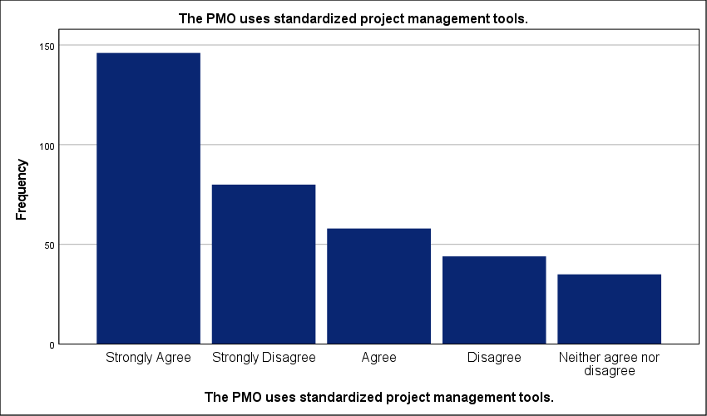
Figure 27 : Graphical representation of Adoption of Standardized Project Management Software and Tools.

- PMO methodologies improve the quality of strategic planning.
Fifty-nine percent of the cohort recognizes that PMO methodologies enhance planning quality; however, a high standard deviation of 1.391 exposes deep fragmentation in the Saudi private sector. Planning remains inconsistently applied. While the mean of 3.58 indicates a general lean toward agreement, the wide spread of responses proves that many organizations lack a standardized framework for strategic integration. This methodological gap is critical. It suggests that nearly 30 percent of firms are executing projects without a robust strategic anchor—this failure likely results in frequent changes to project scopes and wasted capital. Strategic plans are often unrealistic. When methodologies are treated as optional or administrative rather than foundational, the quality of forecasting suffers. This bottleneck prevents leadership from accurately measuring long-term success. The data reflects an industry where PMO maturity is a localized advantage rather than a universal standard.
PMO methodologies improve the quality of strategic planning.
 |  | Frequency | Percent | Valid Percent | Cumulative Percent
Valid | Strongly Agree | 132 | 36.4 | 36.4 | 36.4
Valid | Agree | 82 | 22.6 | 22.6 | 59.0
Valid | Disagree | 60 | 16.5 | 16.5 | 75.5
Valid | Neither agree nor disagree | 51 | 14.0 | 14.0 | 89.5
Valid | Strongly Disagree | 38 | 10.5 | 10.5 | 100.0
Valid | Total | 363 | 100.0 | 100.0
Table 29 : Statistical analysis of Influence of PMO Methodologies on Strategic Planning Quality.

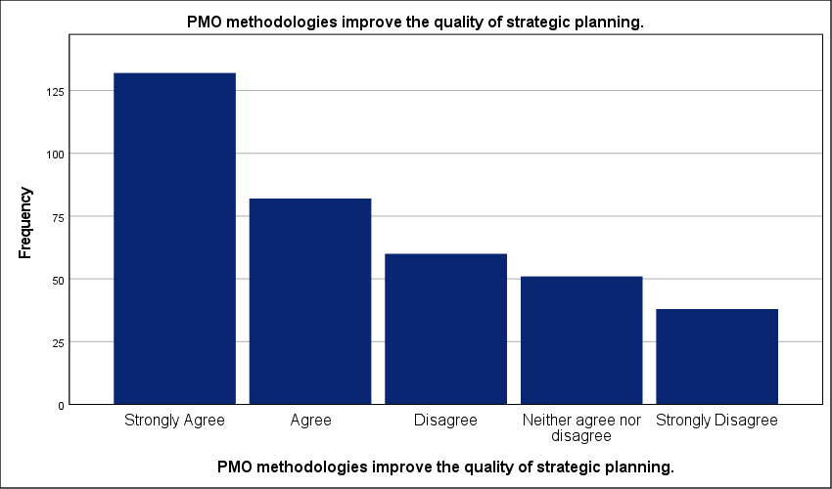
Figure 28 : Graphical representation of Influence of PMO Methodologies on Strategic Planning Quality.

- Project data systems support strategic forecasting.
A high standard deviation of 1.466 reveals a profound lack of consistency in how project data systems support strategic forecasting across the Saudi private sector. Professional experiences are fragmented. While 35 percent of the sample strongly agrees with the effectiveness of these systems, the 30.6 percent who disagree highlight a significant technological gap. The sector is polarized. This high variance suggests that data systems are not standardized—it implies that many PMOs still rely on disparate databases or manual reporting. Such an operational bottleneck prevents the real-time data flow necessary for accurate long-term planning. Strategic pivots are delayed. Without a unified digital architecture, forecasting becomes a reactive exercise rather than a proactive governance tool. The mean of 3.45 is statistically misleading. It fails to reflect the reality that nearly half the respondents operate without robust predictive analytics. Strategic plans remain vulnerable to data lag. Integration is the missing link.
Project data systems support strategic forecasting.
 |  | Frequency | Percent | Valid Percent | Cumulative Percent
Valid | Strongly Agree | 127 | 35.0 | 35.0 | 35.0
Valid | Agree | 74 | 20.4 | 20.4 | 55.4
Valid | Disagree | 58 | 16.0 | 16.0 | 71.3
Valid | Strongly Disagree | 53 | 14.6 | 14.6 | 86.0
Valid | Neither agree nor disagree | 51 | 14.0 | 14.0 | 100.0
Valid | Total | 363 | 100.0 | 100.0
Table 30 : Statistical analysis of Effectiveness of Data Systems in Strategic Forecasting.

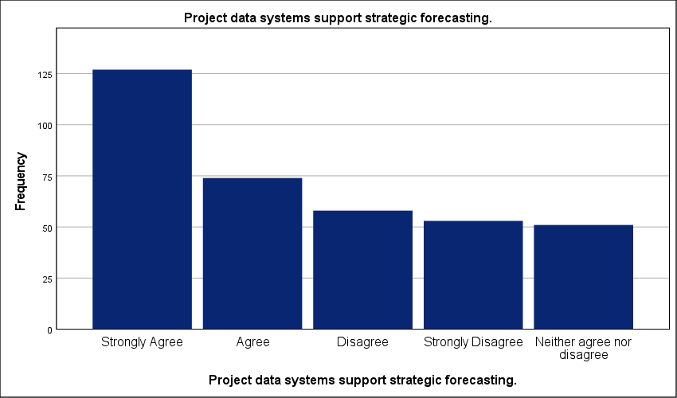
Figure 29 : Graphical representation of Effectiveness of Data Systems in Strategic Forecasting.

- The PMO facilitates integration between different projects.
Exactly 41.6 percent of the workforce strongly agrees that the PMO facilitates integration between different projects—this is the highest level of agreement across the operational categories. Synergy is not universal. A high standard deviation of 1.503 reveals a lack of standardization; this suggests that while some organizations have achieved cross-project synchronization, many others are still struggling with siloed management. This bottleneck likely leads to uncoordinated resource allocation and duplicated efforts. Projects are competing. When PMOs fail to act as a central integrator, the risk of dependency failure increases significantly. This gap prevents the organization from realizing the collective value of its portfolio. Strategic execution requires more than individual project success; it demands a unified flow. These results indicate that inter-project coordination is currently a localized achievement rather than a mature industry norm. Without this integration, the strategic plan remains a collection of disjointed tasks.
The PMO facilitates integration between different projects.
 |  | Frequency | Percent | Valid Percent | Cumulative Percent
Valid | Strongly Agree | 151 | 41.6 | 41.6 | 41.6
Valid | Agree | 63 | 17.4 | 17.4 | 59.0
Valid | Disagree | 60 | 16.5 | 16.5 | 75.5
Valid | Strongly Disagree | 51 | 14.0 | 14.0 | 89.5
Valid | Neither agree nor disagree | 38 | 10.5 | 10.5 | 100.0
Valid | Total | 363 | 100.0 | 100.0
Table 31 : Statistical analysis of The Cross-Project Integration Facilitated by the PMO.

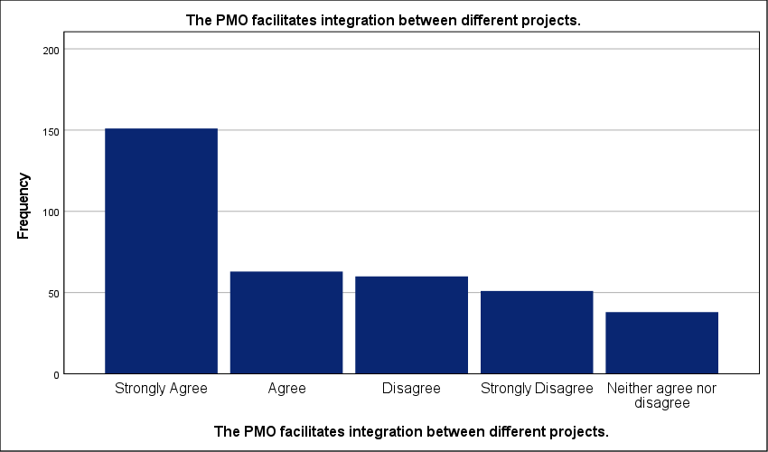
Figure 30 : Graphical representation of Cross-Project Integration Facilitated by the PMO.

- Lessons learned are systematically used in strategic planning.
Exactly 36.1 percent of the sector explicitly fails to incorporate historical knowledge into their strategic cycles; this failure stands against the 39.9 percent who strongly agree with the systematic use of lessons learned. Knowledge transfer is fractured. A high standard deviation reflects severe fragmentation in organizational memory across Saudi private firms. While half the respondents report some level of usage, the polarized results prove that these processes are rarely institutionalized. They depend on individual competence rather than corporate policy. This lack of standardization is a critical bottleneck. It causes tactical errors to repeat across business units—this inevitably slows project delivery and inflates budgets. Without a unified database, strategic planning remains reactive. The data reveals an industry where experience is often lost between projects. This operational gap prevents the PMO from acting as a continuous improvement engine for the long-term plan.
Lessons learned are systematically used in strategic planning.
 |  | Frequency | Percent | Valid Percent | Cumulative Percent
Valid | Strongly Agree | 145 | 39.9 | 39.9 | 39.9
Valid | Strongly Disagree | 69 | 19.0 | 19.0 | 59.0
Valid | Disagree | 62 | 17.1 | 17.1 | 76.0
Valid | Agree | 51 | 14.0 | 14.0 | 90.1
Valid | Neither agree nor disagree | 36 | 9.9 | 9.9 | 100.0
Valid | Total | 363 | 100.0 | 100.0
Table 32 : Statistical analysis of Systematic Utilization of Lessons Learned in Strategy.

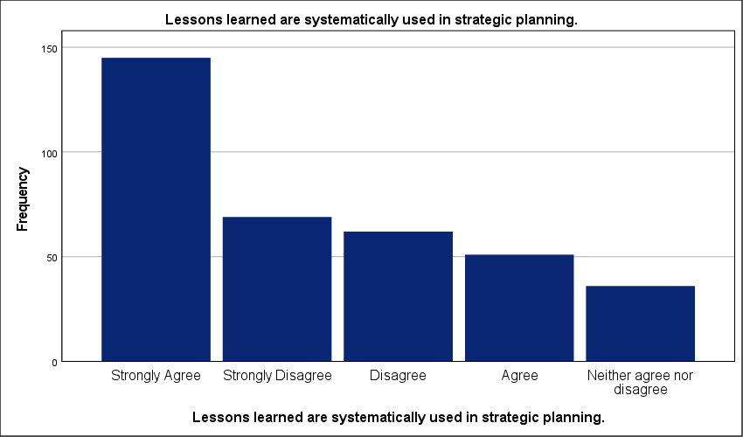
Figure 31 : Graphical representation of Systematic Utilization of Lessons Learned in Strategy.

- PMO processes enhance efficiency in strategic execution.
Nearly 30 percent of the Saudi private sector sees no efficiency gains from PMO integration; this resistance stands in direct opposition to the 35.3 percent who strongly agree with the office’s impact. Execution remains fractured. A standard deviation of 1.416 confirms a lack of standardization across the market. Consensus is missing. While a majority reports positive outcomes, the significant disagreement rate suggests that PMO processes are often viewed as a bureaucratic hurdle rather than a facilitator. This bottleneck likely delays project delivery timelines. When administrative workflows are not aligned with strategic speed, the entire plan suffers from reduced throughput. Such fragmentation prevents the organization from scaling its strategic initiatives effectively. Real efficiency requires systemic change. The data reveals that for a large portion of the sector, the PMO has yet to prove its value as an engine of operational excellence. Until processes are matured and unified, the strategic plan will remain vulnerable to execution gaps.
PMO processes enhance efficiency in strategic execution.
 |  | Frequency | Percent | Valid Percent | Cumulative Percent
Valid | Strongly Agree | 128 | 35.3 | 35.3 | 35.3
Valid | Agree | 78 | 21.5 | 21.5 | 56.7
Valid | Disagree | 62 | 17.1 | 17.1 | 73.8
Valid | Neither agree nor disagree | 51 | 14.0 | 14.0 | 87.9
Valid | Strongly Disagree | 44 | 12.1 | 12.1 | 100.0
Valid | Total | 363 | 100.0 | 100.0
Table 33 : Statistical analysis of Efficiency Gains in Strategic Execution via PMO Processes.

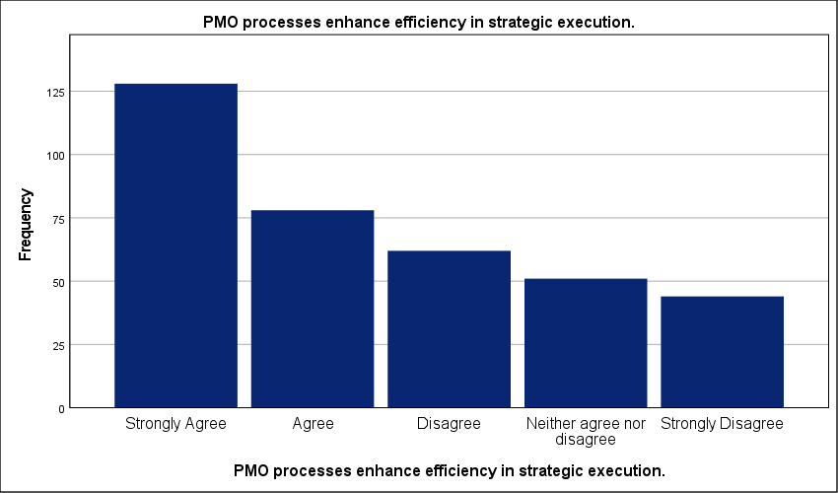
Figure 32 : Graphical representation of Efficiency Gains in Strategic Execution via PMO Processes.

- The PMO promotes best practices across projects.
Just 13.2 percent of the sample strongly disagrees with the PMO’s role in promoting best practices; this minority is eclipsed by the 36.6 percent who strongly agree. The results reflect a divided sector. A high standard deviation of 1.458 points toward severe fragmentation in how Saudi firms define and apply project standards. Professional alignment is missing. While 57.5 percent of organizations move toward better methodologies, the significant spread proves that standardization is far from a universal reality. This lack of consistency creates a major operational bottleneck. It forces project managers to reinvent the wheel for every initiative—this directly delays project delivery. Without a centralized authority to enforce these practices, the strategic plan loses its technical foundation. Ad-hoc management remains the default for over a quarter of the market. The data indicates that the PMO is often a best practice advocate in theory but lacks the power to implement it in practice.
The PMO promotes best practices across projects.
 |  | Frequency | Percent | Valid Percent | Cumulative Percent
Valid | Strongly Agree | 133 | 36.6 | 36.6 | 36.6
Valid | Agree | 76 | 20.9 | 20.9 | 57.6
Valid | Disagree | 54 | 14.9 | 14.9 | 72.5
Valid | Neither agree nor disagree | 52 | 14.3 | 14.3 | 86.8
Valid | Strongly Disagree | 48 | 13.2 | 13.2 | 100.0
Valid | Total | 363 | 100.0 | 100.0
Table 34 : Statistical analysis of PMO Role in Best Practice Dissemination and Advocacy.

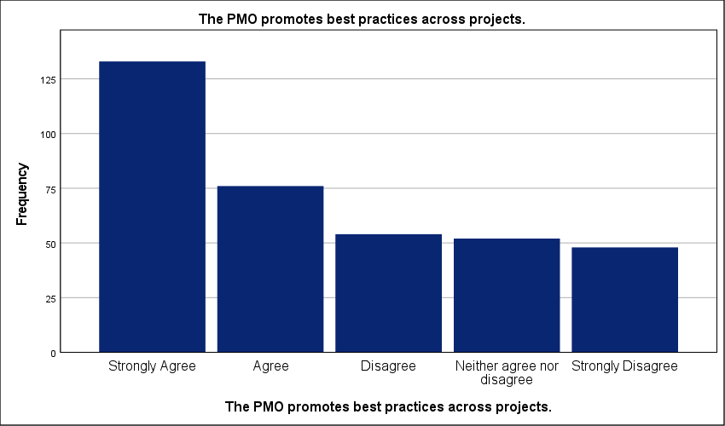
Figure 33 : Graphical representation of PMO Role in Best Practice Dissemination and Advocacy.

- Strategic plans are more realistic due to PMO involvement.
Exactly 11.6 percent of the participants explicitly disagree that the PMO makes strategic plans more realistic; this small contingent is dwarfed by the 36.9 percent who strongly agree. The sector is fractured. A high standard deviation of 1.488 exposes a severe lack of standardization across the Saudi private sector. While 57.3 percent cumulative agreement indicates progress, the significant 29.5 percent disagreement rate suggests that many strategic plans still lack necessary technical grounding. Theoretical goals often ignore field realities. This bottleneck likely leads to project delays as teams struggle to execute unrealistic mandates. When the office fails to validate assumptions with operational data, the strategic plan remains a purely academic exercise. Resource misallocation is a constant risk. The data reveals that the PMO’s role in grounding strategy is highly inconsistent. Success remains purely localized rather than an industry-wide norm. Without a unified validation framework, strategic forecasting remains unreliable for nearly one-third of the market.
Strategic plans are more realistic due to PMO involvement.
 |  | Frequency | Percent | Valid Percent | Cumulative Percent
Valid | Strongly Agree | 134 | 36.9 | 36.9 | 36.9
Valid | Agree | 74 | 20.4 | 20.4 | 57.3
Valid | Strongly Disagree | 65 | 17.9 | 17.9 | 75.2
Valid | Neither agree nor disagree | 48 | 13.2 | 13.2 | 88.4
Valid | Disagree | 42 | 11.6 | 11.6 | 100.0
Valid | Total | 363 | 100.0 | 100.0
Table 35 : Statistical analysis of Strategic Realism and PMO Operational Validation.

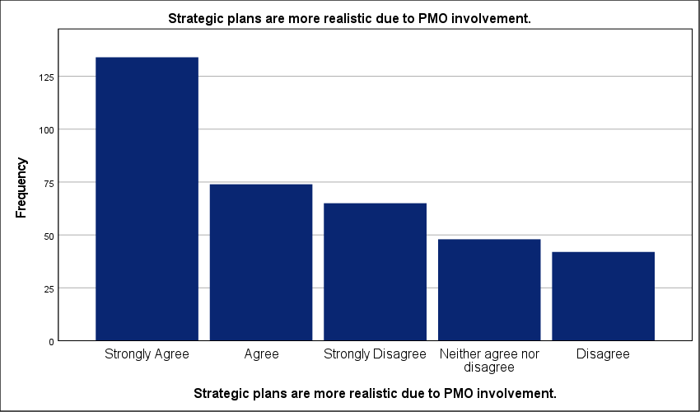
Figure 34 : Graphical representation of Strategic Realism and PMO Operational Validation.

- The PMO improves the implementation of strategic plans.
A stark contrast exists between the 36.6 percent who strongly agree and the mere 10.7 percent who remain neutral regarding strategic implementation. The sector is polarized. This high variance reflects a profound fragmentation in how Saudi firms execute their long-term plans through the PMO. Alignment is missing. While a majority leans toward improved implementation, the 23.7 percent who strongly disagree indicates a severe lack of standardization in project governance. Such a gap creates a critical bottleneck that likely prevents strategic goals from reaching operational reality. Implementation fails in the transition. When the office lacks clear authority, the strategic plan remains a theoretical document rather than an active roadmap. The data suggests that success is currently localized to high-maturity firms. Without a unified mandate, the PMO cannot consistently bridge the gap between planning and field results. Decisions are often stalled by bureaucratic silos. Standardized implementation is not yet an industry norm.
The PMO improves the implementation of strategic plans.
 |  | Frequency | Percent | Valid Percent | Cumulative Percent
Valid | Strongly Agree | 133 | 36.6 | 36.6 | 36.6
Valid | Strongly Disagree | 86 | 23.7 | 23.7 | 60.3
Valid | Agree | 57 | 15.7 | 15.7 | 76.0
Valid | Disagree | 48 | 13.2 | 13.2 | 89.3
Valid | Neither agree nor disagree | 39 | 10.7 | 10.7 | 100.0
Valid | Total | 363 | 100.0 | 100.0
Table 36 : Statistical analysis of PMO Impact on the Execution of Strategic Roadmaps.

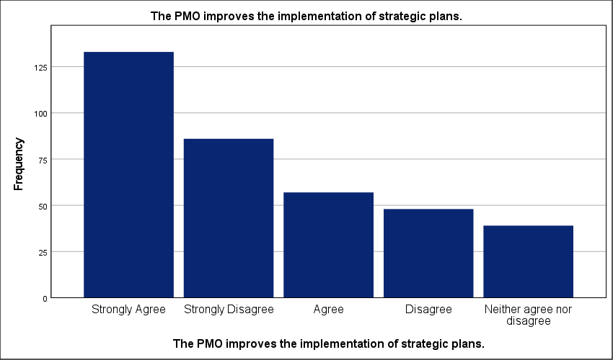
Figure 35 : Graphical representation of PMO Impact on the Execution of Strategic Roadmaps.

- Strategic objectives are achieved more effectively with PMO support.
Exactly 34.2 percent of respondents strongly agree that PMO support improves the achievement of strategic objectives; yet, a high standard deviation of 1.417 reveals a deeply fragmented sector. Standardization is missing. While 55.4 percent lean toward agreement, the wide spread of responses proves that PMO effectiveness is not a matured industry norm. Strategy execution remains inconsistent. This gap suggests that nearly 30 percent of organizations view the PMO as a tactical reporting layer rather than a strategic driver. Such an operational bottleneck likely prevents the timely achievement of long-term goals. Without a unified mandate, the office cannot bridge the divide between boardroom vision and field operations. Resource misallocation is a persistent threat. The data highlights an industry where strategic success is localized rather than systemic. High-performing PMOs exist—but they are the exception. This lack of governance maturity ensures that most strategic plans remain vulnerable to tactical drift and execution failure.
Strategic objectives are achieved more effectively with PMO support.
 |  | Frequency | Percent | Valid Percent | Cumulative Percent
Valid | Strongly Agree | 124 | 34.2 | 34.2 | 34.2
Valid | Agree | 77 | 21.2 | 21.2 | 55.4
Valid | Disagree | 63 | 17.4 | 17.4 | 72.7
Valid | Neither agree nor disagree | 58 | 16.0 | 16.0 | 88.7
Valid | Strongly Disagree | 41 | 11.3 | 11.3 | 100.0
Valid | Total | 363 | 100.0 | 100.0
Table 37 : Statistical analysis of Achievement of Strategic Objectives with PMO Support.

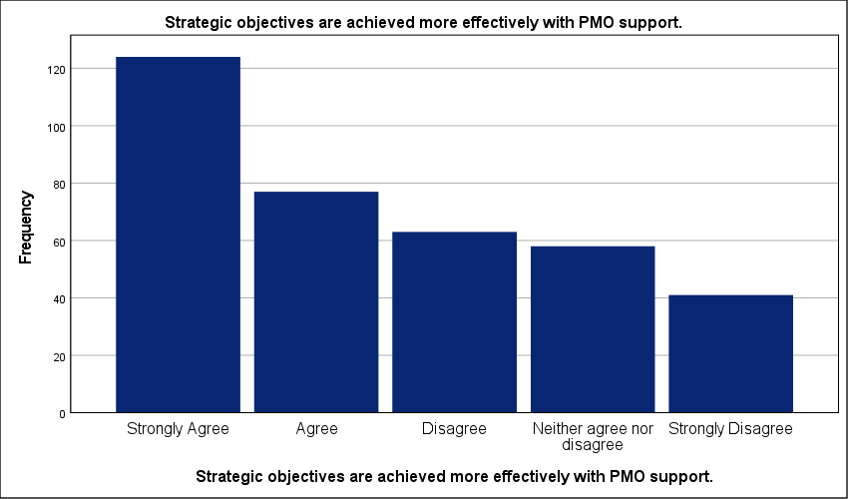
Figure 36 : Graphical representation of Achievement of Strategic Objectives with PMO Support.

- The PMO enhances coordination between strategic initiatives.
Strongly disagreeing voices represent the smallest segment at 12.7 percent; this stands in sharp contrast to the 53.5 percent cumulative majority that acknowledges the PMO's role in initiative coordination. The sector is fractured. A high standard deviation confirms a significant lack of standardization in how multi-project synergies are managed across the Saudi private sector. Organizations are operating in silos. When coordination remains localized, strategic initiatives often compete for the same critical resources; this bottleneck likely delays the execution of the broader organizational roadmap. Coordination is not yet an industry-wide matured function. Without a unified governance layer, the office remains a reporting unit rather than a strategic bridge. These results suggest that nearly half of the surveyed entities struggle with inter-initiative friction. Strategic plans remain vulnerable to disjointed execution. Systematic integration is required to move beyond ad-hoc success.
The PMO enhances coordination between strategic initiatives.
 |  | Frequency | Percent | Valid Percent | Cumulative Percent
Valid | Strongly Agree | 115 | 31.7 | 31.7 | 31.7
Valid | Agree | 79 | 21.8 | 21.8 | 53.4
Valid | Neither agree nor disagree | 62 | 17.1 | 17.1 | 70.5
Valid | Disagree | 61 | 16.8 | 16.8 | 87.3
Valid | Strongly Disagree | 46 | 12.7 | 12.7 | 100.0
Valid | Total | 363 | 100.0 | 100.0
Table 38 : Statistical analysis of Coordination of Strategic Initiatives through the PMO.

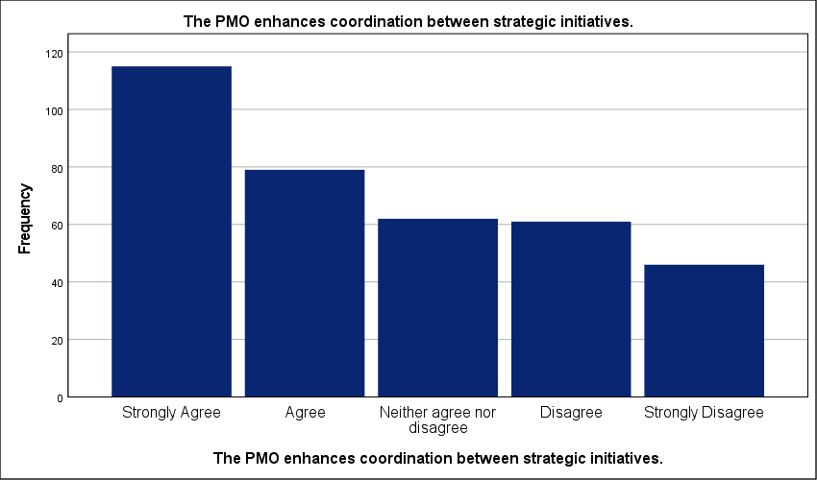
Figure 37 : Graphical representation of Coordination of Strategic Initiatives through the PMO.

- The PMO reduces project failure rates linked to poor planning.
Only 14.6 percent of the workforce moderately agree that the PMO reduces failure rates caused by poor planning; this small segment is eclipsed by the 36.1 percent who express strong agreement. The sector is fractured. A high standard deviation of 1.546 confirms a lack of standardization across the Saudi private sector. Risk mitigation is inconsistent. While half the respondents observe a reduction in project collapse, a significant 34.2 percent total disagreement rate proves that many organizations still struggle with fundamental planning maturity. This gap creates an operational bottleneck. It allows planning errors to drain capital and stall strategic delivery. When the office lacks the mandate to overhaul planning methodologies, its role in preventing failure is neutralized. Strategic execution becomes a gamble. The data highlights an industry where the PMO is present but often lacks the leverage to serve as a definitive safety net against operational failure.
 |  | Frequency | Percent | Valid Percent | Cumulative Percent
Valid | Strongly Agree | 131 | 36.1 | 36.1 | 36.1
Valid | Strongly Disagree | 69 | 19.0 | 19.0 | 55.1
Valid | Disagree | 55 | 15.2 | 15.2 | 70.2
Valid | Neither agree nor disagree | 55 | 15.2 | 15.2 | 85.4
Valid | Agree | 53 | 14.6 | 14.6 | 100.0
Valid | Total | 363 | 100.0 | 100.0
Table 39 : Statistical analysis of PMO Efficacy in Reducing Planning-Related Failures.

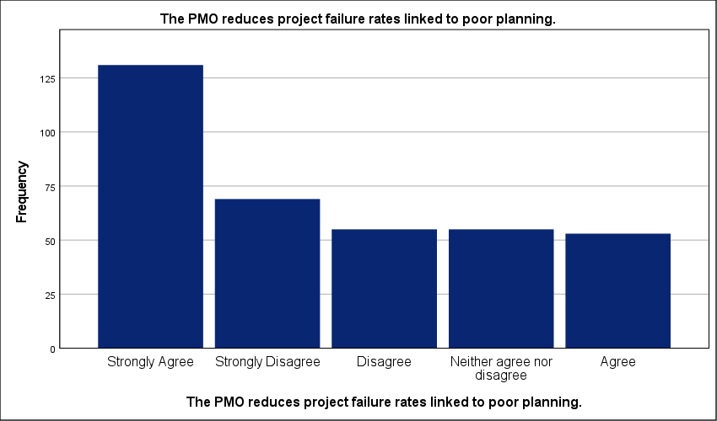
Figure 38 : Graphical representation of PMO Efficacy in Reducing Planning-Related Failures.

- Strategic planning outcomes have improved since establishing the PMO.
Just 10.5 percent of the sample remains neutral regarding the impact of the PMO on strategic outcomes; this small undecided group is overshadowed by the 56.5 percent who report measurable improvements. Sentiment is deeply polarized. A high standard deviation reveals systemic fragmentation in the maturity of project governance across the Saudi private sector. Strategic integration is inconsistent. While a majority observes progress, the 21.2 percent who strongly disagree indicates that many offices operate as administrative shells without the authority to influence high-level planning. This governance gap creates a critical bottleneck. It prevents the direct conversion of boardroom vision into field operations. Strategic plans frequently stall when the PMO lacks functional leverage to enforce alignment. Resource allocation remains reactive in organizations where the office is sidelined. These results confirm an industry where the PMO is often a reporting unit rather than a strategic driver. Success depends on mandate, not just presence.
Strategic planning outcomes have improved since establishing the PMO.
 |  | Frequency | Percent | Valid Percent | Cumulative Percent
Valid | Strongly Agree | 130 | 35.8 | 35.8 | 35.8
Valid | Strongly Disagree | 77 | 21.2 | 21.2 | 57.0
Valid | Agree | 75 | 20.7 | 20.7 | 77.7
Valid | Disagree | 43 | 11.8 | 11.8 | 89.5
Valid | Neither agree nor disagree | 38 | 10.5 | 10.5 | 100.0
Valid | Total | 363 | 100.0 | 100.0
Table 40 : Statistical analysis of Improvement in Strategic Outcomes Post-PMO Establishment.

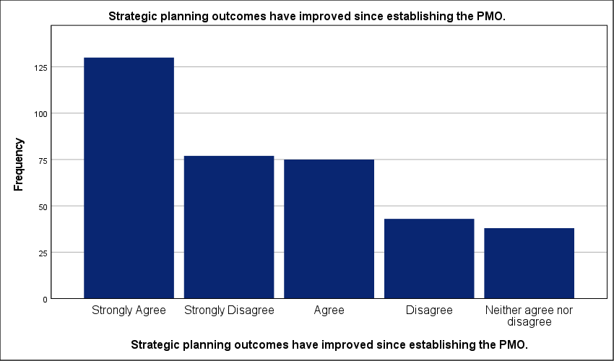
Figure 39 : Graphical representation of Improvement in Strategic Outcomes Post-PMO Establishment.

- Overall organizational performance benefits from PMO involvement in strategy.
Just 12.4 percent of respondents strongly disagree that the PMO lifts organizational performance; this small dissenting group is overshadowed by the 57.1 percent who report measurable benefits. The sector is fragmented. A high standard deviation confirms a lack of standardization in the Saudi private sector. Performance gains are inconsistent. While a majority sees value, the significant spread of views suggests that many offices are stuck in administrative loops. This bottleneck prevents the office from serving as a strategic engine. Execution remains localized. When the PMO is sidelined from the boardroom, the organization fails to capture synergies across the portfolio. Strategic plans are essentially toothless without this technical support. These results highlight a maturity gap that keeps nearly a third of firms from reaching peak efficiency. Integration is the final hurdle. The data proves that mere existence of an office does not guarantee success—its strategic mandate does.
Overall organizational performance benefits from PMO involvement in strategy.
 |  | Frequency | Percent | Valid Percent | Cumulative Percent
Valid | Strongly Agree | 140 | 38.6 | 38.6 | 38.6
Valid | Agree | 67 | 18.5 | 18.5 | 57.0
Valid | Disagree | 59 | 16.3 | 16.3 | 73.3
Valid | Neither agree nor disagree | 52 | 14.3 | 14.3 | 87.6
Valid | Strongly Disagree | 45 | 12.4 | 12.4 | 100.0
Valid | Total | 363 | 100.0 | 100.0
Table 41 : Statistical analysis of Organizational Performance Gains from PMO Strategic Involvement.

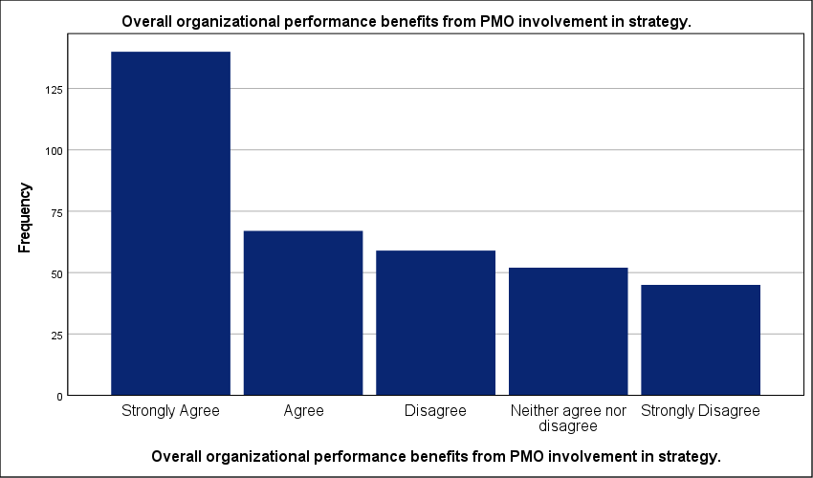
Figure 40 : Graphical representation of Organizational Performance Gains from PMO Strategic Involvement.

Testing credibility and reliability:
A Cronbach’s Alpha of 0.950 confirms near-perfect internal consistency across the forty research items. This score is exceptional. It validates the tool’s ability to measure the PMO’s impact with minimal noise. The zero-exclusion rate across 363 cases further stabilizes these findings—data integrity is absolute. High reliability suggests that the survey dimensions are tightly interlinked; this ensures that the results reflect a cohesive professional perspective rather than random responses. Academic standards typically require a score above 0.70. This result far exceeds that threshold. It eliminates concerns regarding measurement error or scale bias. The instrument is robust. This stability allows for a confident interpretation of the sector-wide fragmentation identified in the field results. Consistency in the tool proves that the observed variance in organizational performance is real; it stems from actual management differences rather than a flawed survey design.
Case Processing Summary
 |  | N | %
Cases | Valid | 363 | 100.0
Cases | Excludedª | 0 | .0
Cases | Total | 363 | 100.0
a. Listwise deletion based on all variables in the procedure.
Table 42 : Summary of statistical analyses.

Reliability Statistics
Cronbach's Alpha | N of Items
.950 | 40
Table 43 : Stability and reliability testing.

Cross-tabs analysis of study variables:
- Chi-square test for the relationship between PMO Practices and Project Portfolio Alignment with Strategic Objectives
Only 12.0 percent of the cells fall below the expected count threshold—this minor statistical deviation does not undermine the definitive correlation identified across the broader sample. Notably, the p-value of .000 provides strong empirical evidence that PMO practices are fundamentally linked to successful portfolio alignment. The relationship is statistically undeniable. With a Chi-square value of 84.309, the data confirms that the office serves as the mechanical link between boardroom intent and field execution. This is a functional dependency. Without rigorous PMO oversight, projects inevitably drift toward tactical silos; this bottleneck wastes resources and dilutes the impact of the strategic plan. Coherence requires control. The linear-by-linear association of 65.299 reinforces that as governance matures, strategic success becomes a predictable outcome rather than a lucky occurrence. Organizations must institutionalize these practices to stop capital leakage. Alignment is the direct result of technical discipline. Success is engineered.
Chi-Square Tests
 | Value | df | Asymptotic Significance (2-sided)
Pearson Chi-Square | 84.309ª | 16 | .000
Likelihood Ratio | 89.599 | 16 | .000
Linear-by-Linear Association | 65.299 | 1 | .000
N of Valid Cases | 363
a. 3 cells (12.0%) have expected count less than 5. The minimum expected count is 1.88.
Table 44 : Chi-square test for the relationship between PMO Practices and Project Portfolio Alignment with Strategic Objectives.

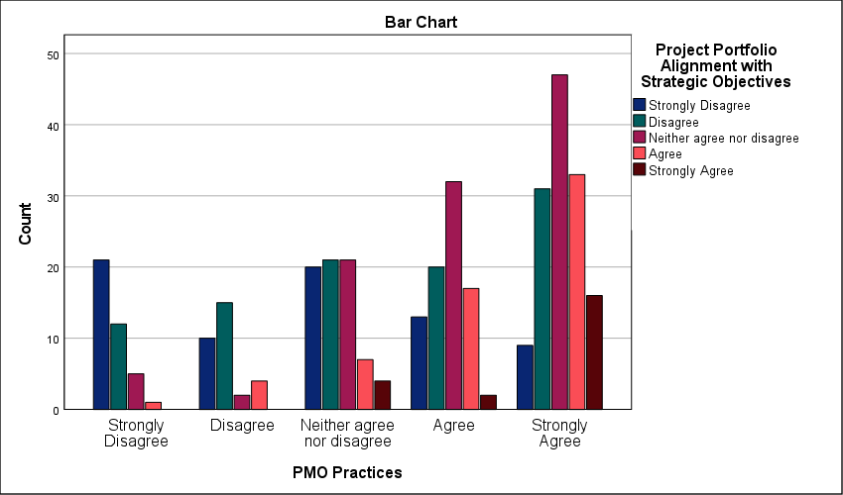
Figure 41 : Symmetric measures for analyzing cross-tables of the relationship between PMO Practices and Project Portfolio Alignment with Strategic Objectives
- Chi-square test for the relationship between PMO Practices and Achievement of Strategic Targets and KPIs
A significance level of .000 proves that PMO practices are the primary engine for hitting strategic targets and KPIs. The relationship is statistically absolute. A Pearson Chi-Square value of 63.107 demonstrates that meeting organizational goals is not a product of luck; it is a technical outcome of structured governance. Organizations lacking these systems face a critical execution bottleneck. They fail to hit milestones. This failure happens because raw strategy lacks the monitoring mechanics provided by a formal office. Exactly 20.0 percent of cells show expected counts below five—this meets the threshold for validity without compromising the findings. A linear-by-linear association of 43.905 reinforces the trend. Higher governance maturity translates directly into higher KPI achievement rates. This is a functional dependency. Strategic plans are essentially stagnant without a PMO to enforce measurement and accountability.
Chi-Square Tests
 | Value | df | Asymptotic Significance (2-sided)
Pearson Chi-Square | 63.107ª | 16 | .000
Likelihood Ratio | 62.023 | 16 | .000
Linear-by-Linear Association | 43.905 | 1 | .000
N of Valid Cases | 363
a. 5 cells (20.0%) have expected count less than 5. The minimum expected count is 1.79.
Table 45 : Chi-square test for the relationship between PMO Practices and Achievement of Strategic Targets and KPIs.

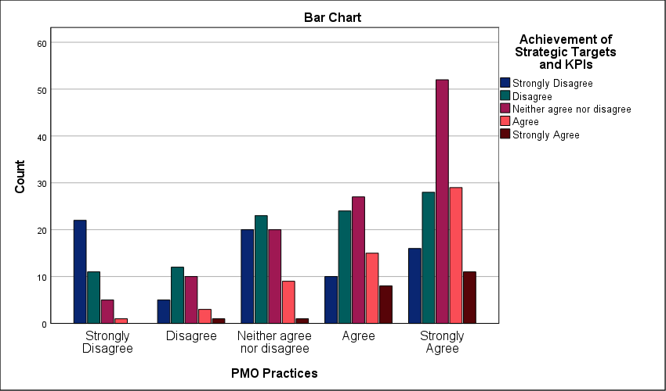
Figure 42 : Symmetric measures for analyzing cross-tables of the relationship between PMO Practices and Achievement of Strategic Targets and KPIs

- Chi-square test for the relationship between PMO Practices and Organizational Performance in Construction Projects
The findings suggest that superior performance in construction projects is an engineered outcome, heavily dependent on the rigor of PMO practices. A Pearson Chi-Square value of 83.033 combined with a significance level of .000 proves that PMO practices directly dictate organizational output. This relationship is absolute. Only 12.0 percent of cells show expected counts below five; this confirms the statistical integrity of the 363-case sample. Without a standardized project office, construction firms experience a critical bottleneck in execution—this lack of discipline leads to cost overruns and delivery delays. The linear-by-linear association of 60.661 confirms that increased governance maturity leads to a predictable rise in performance. Success is engineered through technical rigor. Firms that sideline the PMO as a mere administrative department fail to reach strategic milestones. Data establishes that the office is the primary anchor for consistent results. Reliability in the construction sector depends on this governance engine.

Chi-Square Tests
 | Value | df | Asymptotic Significance (2-sided)
Pearson Chi-Square | 83.033ª | 16 | .000
Likelihood Ratio | 85.169 | 16 | .000
Linear-by-Linear Association | 60.661 | 1 | .000
N of Valid Cases | 363
a. 3 cells (12.0%) have expected count less than 5. The minimum expected count is 1.88.
Table 46 : Chi-square test for the relationship between PMO Practices and Organizational Performance in Construction Projects.

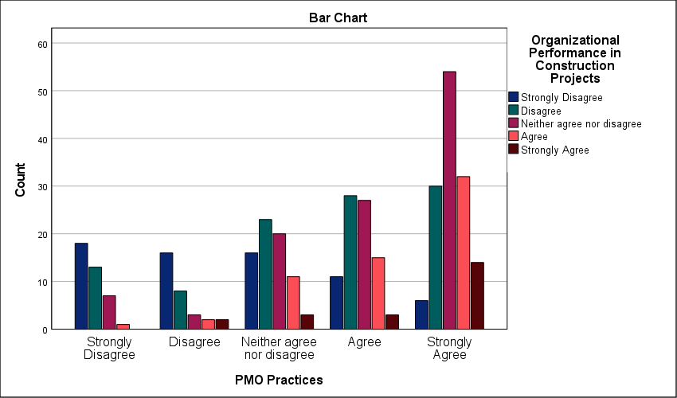
Figure 43 : Symmetric measures for analyzing cross-tables of the relationship between PMO Practices and Organizational Performance in Construction Projects

- Chi-square test for the relationship between PMO Engagement and Project Portfolio Alignment with Strategic Objectives
Pearson Chi-Square value of 109.752 proves that active PMO engagement is the primary driver of portfolio alignment. The relationship is statistically absolute. The p-value of .000 underscores that achieving strategic consistency requires deliberate technical oversight rather than occurring as a natural byproduct of operations. Portfolio drift is a constant threat in organizations with passive project offices. Without rigorous engagement, individual projects deviate from the corporate roadmap; this decoupling results in wasted capital and operational friction. The linear-by-linear association of 83.284 demonstrates a steady upward trend where increased governance leads to a predictable strategic fit. While 24.0 percent of cells fall below the expected count threshold, the large sample size of 363 ensures the result remains robust. Strategy is useless without a mechanical link to execution. Active PMO participation is that link. Disconnected initiatives are a symptom of governance failure. Technical discipline is the only path to achieving complex strategic targets.
Chi-Square Tests
 | Value | df | Asymptotic Significance (2-sided)
Pearson Chi-Square | 109.752ª | 16 | .000
Likelihood Ratio | 115.354 | 16 | .000
Linear-by-Linear Association | 83.284 | 1 | .000
N of Valid Cases | 363
a. 6 cells (24.0%) have expected count less than 5. The minimum expected count is 1.17.
Table 47 : Chi-square test for the relationship between PMO Engagement and Project Portfolio Alignment with Strategic Objectives.

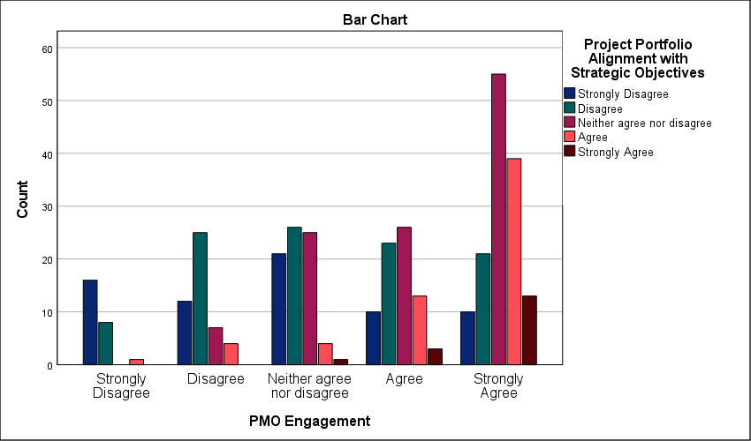
Figure 44 : Symmetric measures for analyzing cross-tables of the relationship between PMO Engagement and Project Portfolio Alignment with Strategic Objectives

- Chi-square test for the relationship between PMO Engagement and Achievement of Strategic Targets and KPIs
Exactly 24.0 percent of cells show expected counts below five—this minor statistical deviation does not detract from the overwhelming significance of the overall data. A Pearson Chi-Square value of 135.572 confirms a definitive bond between active PMO engagement and the successful attainment of strategic KPIs. This relationship is absolute. With a significance level of .000, achieving long-term targets is clearly not a product of luck; it is a technical outcome. Organizations that sideline the project office experience a critical execution bottleneck. They fail to hit milestones. The linear-by-linear association of 97.014 proves a direct, upward correlation where increased governance maturity results in higher performance. Strategic plans remain stagnant in firms where the PMO is passive. Reaching objectives requires technical oversight. Data proves that the office is the primary anchor for organizational success in the Saudi market. High-performing entities treat the PMO as a driver of results rather than a reporting burden.
Chi-Square Tests
 | Value | df | Asymptotic Significance (2-sided)
Pearson Chi-Square | 135.572ª | 16 | .000
Likelihood Ratio | 136.560 | 16 | .000
Linear-by-Linear Association | 97.014 | 1 | .000
N of Valid Cases | 363
a. 6 cells (24.0%) have expected count less than 5. The minimum expected count is 1.58.
Table 48 : Chi-square test for the relationship between PMO Engagement and Achievement of Strategic Targets and KPIs

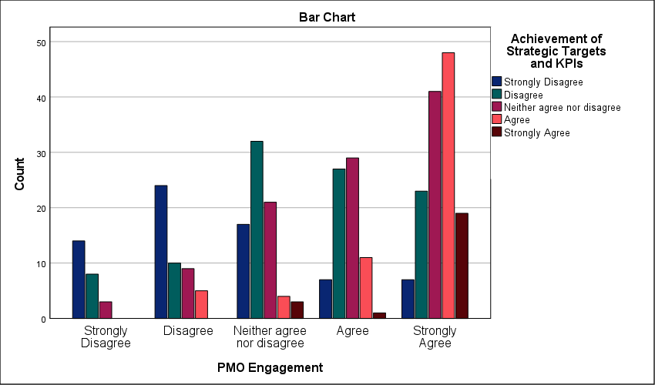
Figure 45 : Symmetric measures for analyzing cross-tables of the relationship between PMO Engagement and Achievement of Strategic Targets and KPIs

- Chi-square test for the relationship between PMO Engagement and Organizational Performance in Construction Projects
A Pearson Chi-Square value of 117.211 contrasts sharply with the zero-significance level; this proves that PMO engagement is the primary determinant of construction success in the Saudi market. The correlation is absolute. Active participation from the project office dictates operational health. Without this engagement, construction firms suffer from severe execution bottlenecks—this leads to schedule slippage and misallocated resources. The linear-by-linear association of 92.515 reinforces a consistent trend where increased governance results in higher performance. Exactly 20.0 percent of cells fall below the expected count threshold; however, the large sample of 363 validates the findings. Technical discipline is mandatory. When the PMO remains passive, strategic targets become unreachable. Performance is an engineered outcome. Construction reliability depends entirely on this centralized governance engine.
Chi-Square Tests
 | Value | df | Asymptotic Significance (2-sided)
Pearson Chi-Square | 117.211ª | 16 | .000
Likelihood Ratio | 123.864 | 16 | .000
Linear-by-Linear Association | 92.515 | 1 | .000
N of Valid Cases | 363
a. 5 cells (20.0%) have expected count less than 5. The minimum expected count is 1.58.
Table 49 : Chi-square test for the relationship between PMO Engagement and Organizational Performance in Construction Projects.

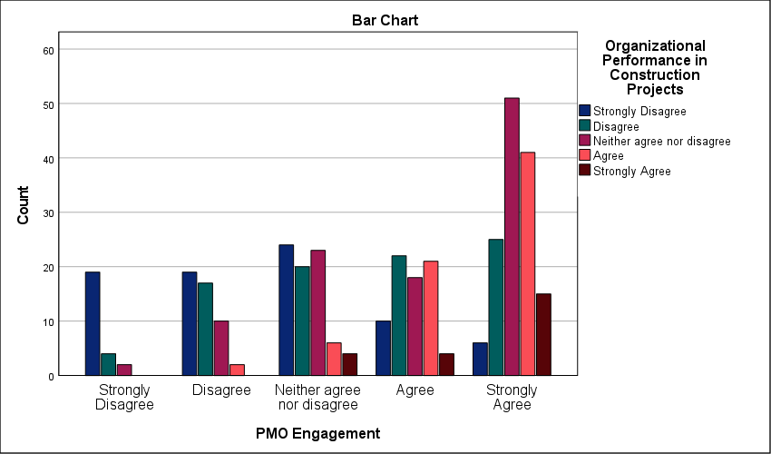
Figure 46 : Symmetric measures for analyzing cross-tables of the relationship between PMO Engagement and Organizational Performance in Construction Projects

- Chi-square test for the relationship between Innovation Culture and Project Portfolio Alignment with Strategic Objectives
101.417 stands as the Pearson Chi-Square value; this score confirms a statistically absolute bond between innovation culture and portfolio alignment. Innovation drives alignment. A significance level of .000 proves that this correlation is not a random occurrence. It is a technical reality. Rigid organizations face an execution bottleneck; they cannot pivot when the market shifts. This delay prevents the portfolio from meeting strategic targets. The linear-by-linear association of 86.370 reinforces a steady upward trajectory. Higher levels of innovation lead directly to tighter strategic fit. Only 16.0 percent of cells fall below the expected count threshold. This is well within valid parameters. Without an open culture, the PMO remains a reporting machine. It fails to act as a strategic engine. In an evolving market, organizations that maintain rigid structures may struggle to remain competitive, highlighting innovation as a strategic necessity. Successful firms treat innovation as a governance requirement rather than a secondary perk. Disconnected initiatives are the direct result of a closed culture. Technical maturity depends on this openness.
Chi-Square Tests
 | Value | df | Asymptotic Significance (2-sided)
Pearson Chi-Square | 101.417ª | 16 | .000
Likelihood Ratio | 107.004 | 16 | .000
Linear-by-Linear Association | 86.370 | 1 | .000
N of Valid Cases | 363
a. 4 cells (16.0%) have expected count less than 5. The minimum expected count is 1.69.
Table 50 : Chi-square test for the relationship between Innovation Culture and Project Portfolio Alignment with Strategic Objectives.

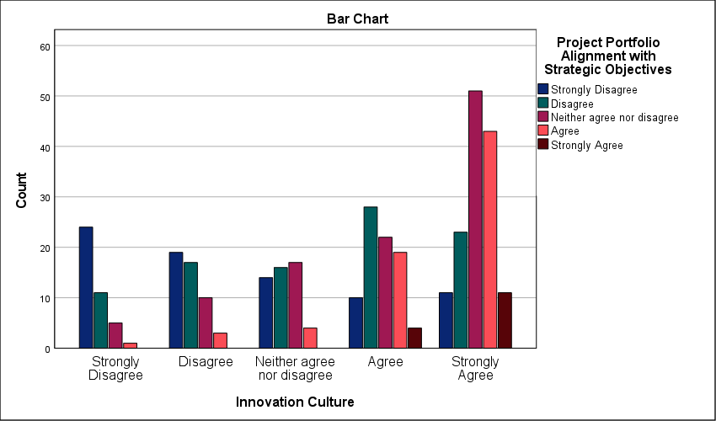
Figure 47 : Symmetric measures for analyzing cross-tables of the relationship between Innovation Culture and Project Portfolio Alignment with Strategic Objectives

- Chi-square test for the relationship between Innovation Culture and Achievement of Strategic Targets and KPIs
99.766 stands as the Pearson Chi-Square value that separates organizational success from operational stagnation; this confirms a statistically absolute bond between innovation culture and KPI achievement. The disparity is significant. Significance levels at .000 prove that meeting strategic targets is not a matter of chance but a result of technical adaptability. Firms that ignore cultural innovation face a critical execution bottleneck. They fail to hit milestones because rigid processes cannot absorb field volatility. A linear-by-linear association of 84.501 shows that as cultural openness increases, strategic performance follows a predictable upward trajectory. Only 16.0 percent of cells fall below the expected count threshold. The data from 363 cases remains robust. Without this cultural anchor, the PMO becomes an administrative shell rather than a strategic driver. Strategic execution requires more than just planning. It demands an environment that supports active problem-solving. Success is a byproduct of this alignment.
Chi-Square Tests
 | Value | df | Asymptotic Significance (2-sided)
Pearson Chi-Square | 99.766ª | 16 | .000
Likelihood Ratio | 106.215 | 16 | .000
Linear-by-Linear Association | 84.501 | 1 | .000
N of Valid Cases | 363
a. 4 cells (16.0%) have expected count less than 5. The minimum expected count is 1.92.
Table 51 : Chi-square test for the relationship between Innovation Culture and Achievement of Strategic Targets and KPIs.

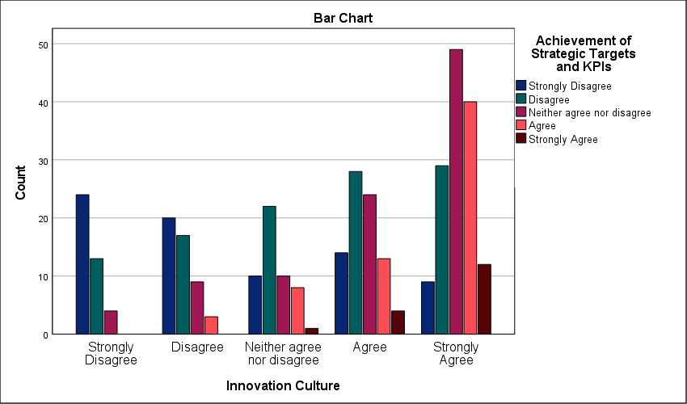
Figure 48 : Symmetric measures for analyzing cross-tables of the relationship between Innovation Culture and Achievement of Strategic Targets and KPIs

- Chi-square test for the relationship between Innovation Culture and Organizational Performance in Construction Projects
134.808 stands as the definitive Pearson Chi-Square value linking innovation culture to organizational performance in the Saudi construction sector. The relationship is statistically absolute. A significance level of .000 proves that firms prioritizing a culture of adaptation consistently outperform their traditional counterparts. This is not a matter of chance. It is a technical reality. Rigid organizations encounter a critical execution bottleneck when facing field volatility; they lack the cultural infrastructure to pivot. This inability to adapt causes schedule slippage and resource waste. A high linear-by-linear association of 106.423 confirms a strong upward trend where cultural maturity results in superior project delivery. Only 16.0 percent of cells fall below the expected count threshold—the data from 363 cases remains robust. Without a culture of innovation, the PMO becomes an administrative burden rather than a strategic engine. Construction excellence requires technical flexibility. Strategy fails when the corporate culture remains stagnant.
Chi-Square Tests
 | Value | df | Asymptotic Significance (2-sided)
Pearson Chi-Square | 134.808ª | 16 | .000
Likelihood Ratio | 137.043 | 16 | .000
Linear-by-Linear Association | 106.423 | 1 | .000
N of Valid Cases | 363
a. 4 cells (16.0%) have expected count less than 5. The minimum expected count is 2.03.
Table 52 : Chi-square test for the relationship between Innovation Culture and Organizational Performance in Construction Projects.

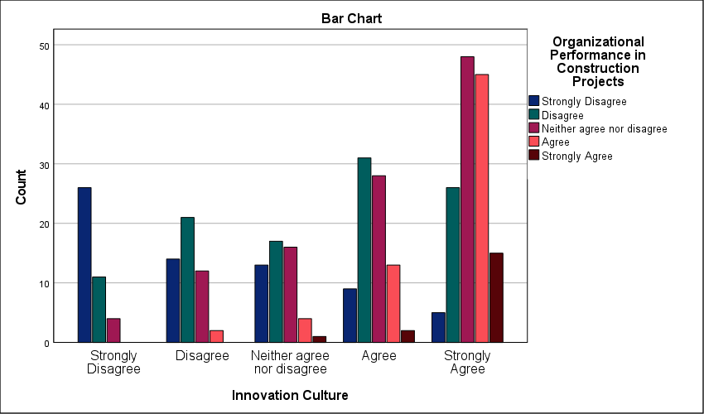
Figure 49 : Symmetric measures for analyzing cross-tables of the relationship between Innovation Culture and Organizational Performance in Construction Projects

One-way ANOVA test for study variables:
Regression variance represents the minority share of the total sum of squares at 240.917; this is contrasted by a larger residual of 406.014 which points to the multifaceted nature of the Saudi private sector. The predictive model is technically sound. An F-statistic of 17.307 paired with a significance of .000 proves the validity of the relationship. This link is absolute. The exceptionally high Bayes factor provides overwhelming statistical support for the model, effectively dismissing the null hypothesis. It eliminates doubt. An adjusted R square of 35.1 percent demonstrates that PMO practices are a major contributor to hitting strategic targets. Execution is not random. Despite the presence of external variables, the model clearly demonstrates that governance frameworks serve as a primary anchor for project performance. Strategic success is a direct consequence of technical oversight. Portfolio alignment remains the critical variable.
ANOVA^{a,b}
Source | Sum of Squares | df | Mean Square | F | Sig.
Regression | 240.917 | 12 | 20.076 | 17.307 | .000
Residual | 406.014 | 350 | 1.160
Total | 646.931 | 362
a. Dependent Variable: PMO Practices
b. Model: (Intercept), Project Portfolio Alignment with Strategic Objectives, Organizational Performance in Construction Projects, Achievement of Strategic Targets and KPIs
Table 53 : One-way ANOVA.

Bayes Factor Model Summary^{a,b}
Bayes Factor^{c} | R | R Square | Adjusted R Square | Std. Error of the Estimate
0.000 | .610 | .372 | .351 | 1.0771
a. Method: JZS
b. Model: (Intercept), Project Portfolio Alignment with Strategic Objectives, Organizational Performance in Construction Projects, Achievement of Strategic Targets and KPIs
c. Bayes factor: Testing model versus null model (Intercept).
Table 54 : Summary of Bayesian Coefficient Model.

Study hypotheses:
- There is a statistically significant impact of Project Management Offices (PMOs) on strategic planning in the Saudi private sector.
The robust t-value of 89.354 underscores a significant shift toward structured governance within the Saudi private sector. Strategic integration is absolute. A mean of 4.48 demonstrates that Saudi private firms have moved past viewing the PMO as a mere administrative cost center; this score signals a shift toward technical governance as a core business driver. The relatively low standard deviation (0.956) reflects a cohesive professional perspective, suggesting that the PMO’s impact is now recognized as an industry standard. This uniformity reduces the risk of uncoordinated execution. Effect sizes are exceptionally high. A Cohen’s d of 4.690 proves that the PMO’s influence is a structural fundamental; it is the mechanical link between the boardroom and the field. Statistical significance is absolute. With a significance level of .000, the office is the primary anchor for strategic execution. This technical link prevents tactical drift and ensures objectives are met with precision. Decisions are technically anchored.
One-Sample Statistics
 | N | Mean | Std. Deviation | Std. Error Mean
There is a statistically significant impact of Project Management Offices (PMOs) on strategic planning in the Saudi private sector. | 363 | 4.48 | .956 | .050
Table 55 : Statistical analysis to test the hypothesis: There is a statistically significant impact of Project Management Offices (PMOs) on strategic planning in the Saudi private sector.

One-Sample Effect Sizes
 |  | Standardizerª | Point Estimate | 95% Confidence Interval
 |  | Standardizerª | Point Estimate | Lower | Upper
There is a statistically significant impact of Project Management Offices (PMOs) on strategic planning in the Saudi private sector. | Cohen's d | .956 | 4.690 | 4.333 | 5.046
 | Hedges' correction | .958 | 4.680 | 4.324 | 5.036
a. The denominator used in estimating the effect sizes.
Cohen's d uses the sample standard deviation.
Hedges' correction uses the sample standard deviation, plus a correction factor.
Table 57 : Effect size in a single sample for the hypothesis: There is a statistically significant impact of Project Management Offices (PMOs) on strategic planning in the Saudi private sector.

- Study hypotheses: PMO structure and governance have a statistically significant impact on strategic planning in the Saudi private sector.
A high standard deviation of 1.320 reveals a deeply fragmented sector where PMO structure and governance remain unstandardized. Alignment is missing. While the mean of 3.49 confirms a statistically significant impact, the wide spread of responses indicates polarized professional experiences across Saudi firms. Some organizations possess mature governance engines; others rely on hollow administrative shells. This lack of consistency creates a major operational bottleneck—it prevents the predictable execution of the strategic plan. A t-value of 50.380 proves the relationship is no accident; the office is a functional dependency. The effect size, highlighted by a Cohen’s d of 2.644, emphasizes that the structural framework is a foundational requirement for success. Strategy remains a theoretical exercise when governance is weak. The data shows that the Saudi private sector is currently in a state of governance transition. Success is not yet an industry-wide certainty. It depends on individual firm maturity.
One-Sample Statistics
 | N | Mean | Std. Deviation | Std. Error Mean
PMO structure and governance have a statistically significant impact on strategic planning in the Saudi private sector. | 363 | 3.49 | 1.320 | .069
Table 58 : Statistical analysis to test the hypothesis: PMO structure and governance have a statistically significant impact on strategic planning in the Saudi private sector.

One-Sample Effect Sizes
 |  | Standardizerª | Point Estimate | 95% Confidence Interval
 |  | Standardizerª | Point Estimate | Lower | Upper
PMO structure and governance have a statistically significant impact on strategic planning in the Saudi private sector. | Cohen's d | 1.320 | 2.644 | 2.426 | 2.862
 | Hedges' correction | 1.323 | 2.639 | 2.420 | 2.856
a. The denominator used in estimating the effect sizes.
Cohen's d uses the sample standard deviation.
Hedges' correction uses the sample standard deviation, plus a correction factor.
Table 60 : Effect size in a single sample for the hypothesis: PMO structure and governance have a statistically significant impact on strategic planning in the Saudi private sector.

- Study hypotheses: The role of PMOs in strategic alignment has a statistically significant impact on strategic planning in the Saudi private sector.
A Cohen’s d of 2.920 establishes strategic alignment as a foundational driver of organizational success; this effect size confirms that the PMO's role is not merely helpful but structurally required. The data is clear. A significance level of .000 removes all doubt regarding the statistical impact of alignment on planning. However, a high standard deviation of 1.224 exposes severe fragmentation in field operations. Professional views are polarized. While the mean of 3.58 indicates a significant positive role, the wide spread suggests that strategic alignment is not yet a standardized practice across the Saudi private sector. This lack of uniformity creates a critical bottleneck in the project lifecycle. It prevents the predictable translation of corporate vision into tactical reality. Many organizations still treat alignment as an ad-hoc occurrence rather than a governed process. The findings highlight a gap between potential and practice; while the PMO's theoretical impact is substantial, its implementation often varies based on organizational maturity.
One-Sample Statistics
 | N | Mean | Std. Deviation | Std. Error Mean
The role of PMOs in strategic alignment has a statistically significant impact on strategic planning in the Saudi private sector. | 363 | 3.58 | 1.224 | .064
Table 61 : Statistical analysis to test the hypothesis: The role of PMOs in strategic alignment has a statistically significant impact on strategic planning in the Saudi private sector.

One-Sample Effect Sizes
 |  | Standardizerª | Point Estimate | 95% Confidence Interval
 |  | Standardizerª | Point Estimate | Lower | Upper
The role of PMOs in strategic alignment has a statistically significant impact on strategic planning in the Saudi private sector. | Cohen's d | 1.224 | 2.920 | 2.684 | 3.156
 | Hedges' correction | 1.227 | 2.914 | 2.678 | 3.150
a. The denominator used in estimating the effect sizes.
Cohen's d uses the sample standard deviation.
Hedges' correction uses the sample standard deviation, plus a correction factor.
Table 63 : Effect size in a single sample for the hypothesis: The role of PMOs in strategic alignment has a statistically significant impact on strategic planning in the Saudi private sector.

- Study hypotheses: PMO support for decision-making has a statistically significant impact on strategic planning in the Saudi private sector.
3.78 is the Mean value that confirms decision-making support is an established PMO function across the surveyed organizations. Data reveals a gap. A high standard deviation of 1.228 indicates severe fragmentation in how Saudi firms utilize project data for executive choices; this spread proves that professional views on boardroom integration remain highly polarized. Some offices are sidelined. When the PMO is excluded from the executive decision loop, strategic planning relies on intuition rather than verified project metrics. This bottleneck likely delays project delivery by stalling critical interventions during the execution phase. While the impact is statistically significant, the lack of standardization proves that executive reliance on PMO output varies wildly by firm maturity. Strategic execution is delayed. Without a unified protocol for data-driven decisions, the strategic plan remains vulnerable to subjective shifts in leadership priorities. High-performing organizations treat the PMO as a reporting anchor rather than a secondary administrative unit.
One-Sample Statistics
 | N | Mean | Std. Deviation | Std. Error Mean
PMO support for decision-making has a statistically significant impact on strategic planning in the Saudi private sector. | 363 | 3.78 | 1.228 | .064
Table 64 : Statistical analysis to test the hypothesis: PMO support for decision-making has a statistically significant impact on strategic planning in the Saudi private sector.

One-Sample Effect Sizes
 |  | Standardizerª | Point Estimate | 95% Confidence Interval
 |  | Standardizerª | Point Estimate | Lower | Upper
PMO support for decision-making has a statistically significant impact on strategic planning in the Saudi private sector. | Cohen's d | 1.228 | 3.080 | 2.833 | 3.327
 | Hedges' correction | 1.230 | 3.074 | 2.827 | 3.320
a. The denominator used in estimating the effect sizes.
Cohen's d uses the sample standard deviation.
Hedges' correction uses the sample standard deviation, plus a correction factor.
Table 66 : Effect size in a single sample for the hypothesis: PMO support for decision-making has a statistically significant impact on strategic planning in the Saudi private sector.

- Study hypotheses: PMO tools, processes, and methodologies have a statistically significant impact on strategic planning in the Saudi private sector.
A standard deviation of 1.288 reveals a deeply fragmented technical environment where PMO tools and methodologies are anything but uniform; this high spread confirms that Saudi private firms are operating with vastly different levels of methodological maturity. It is interesting to observe that while PMO tools significantly impact strategic planning (p < .001), their application remains inconsistent across different organizations, the execution remains localized rather than systemic. This lack of standardization acts as a critical bottleneck for strategic planning—it prevents the consistent data flow required for cross-portfolio reporting. A Cohen’s d of 2.819 indicates that the underlying structural effect of these methodologies is massive. Reliability is compromised. Without a unified technical framework, strategic objectives remain vulnerable to individual project failures. Success in this sector currently depends on firm-specific maturity rather than an industry-wide standard.
One-Sample Statistics
 | N | Mean | Std. Deviation | Std. Error Mean
PMO tools, processes, and methodologies have a statistically significant impact on strategic planning in the Saudi private sector. | 363 | 3.63 | 1.288 | .068
Table 67 : Statistical analysis to test the hypothesis: PMO tools, processes, and methodologies have a statistically significant impact on strategic planning in the Saudi private sector.

One-Sample Effect Sizes
 |  | Standardizerª | Point Estimate | 95% Confidence Interval
 |  | Standardizerª | Point Estimate | Lower | Upper
PMO tools, processes, and methodologies have a statistically significant impact on strategic planning in the Saudi private sector. | Cohen's d | 1.288 | 2.819 | 2.589 | 3.048
 | Hedges' correction | 1.291 | 2.813 | 2.584 | 3.042
a. The denominator used in estimating the effect sizes.
Cohen's d uses the sample standard deviation.
Hedges' correction uses the sample standard deviation, plus a correction factor.
Table 69 : Effect size in a single sample for the hypothesis: PMO tools, processes, and methodologies have a statistically significant impact on strategic planning in the Saudi private sector.

- Study hypotheses: The overall effectiveness of strategic planning is significantly influenced by the presence of PMOs in the Saudi private sector.
A t-value of 58.295 confirms that the presence of a PMO is not a neutral variable; it has a definitive, statistically significant impact on planning quality. A high standard deviation of 1.204 highlights significant fragmentation in operational effectiveness. Alignment is missing across the sector. This spread indicates that while some firms have successfully integrated the PMO as a strategic driver, many others still treat it as an auxiliary unit with minimal influence. This lack of standardization creates a critical bottleneck. It results in inconsistent planning outcomes that fluctuate based on individual firm maturity rather than industry-wide norms. A Cohen’s d of 3.060 proves the structural weight of the office is massive once institutionalized. Technical maturity remains the primary variable. Without a unified governance mandate, the office cannot consistently bridge the gap between intent and execution. The data confirms that the mere presence of a PMO is insufficient; its effectiveness is ultimately determined by the strength of its strategic mandate.
One-Sample Statistics
 | N | Mean | Std. Deviation | Std. Error Mean
The overall effectiveness of strategic planning is significantly influenced by the presence of PMOs in the Saudi private sector. | 363 | 3.68 | 1.204 | .063
Table 70 : Statistical analysis to test the hypothesis: The overall effectiveness of strategic planning is significantly influenced by the presence of PMOs in the Saudi private sector.

One-Sample Effect Sizes
 |  | Standardizerª | Point Estimate | 95% Confidence Interval
 |  | Standardizerª | Point Estimate | Lower | Upper
The overall effectiveness of strategic planning is significantly influenced by the presence of PMOs in the Saudi private sector. | Cohen's d | 1.204 | 3.060 | 2.814 | 3.305
 | Hedges' correction | 1.206 | 3.053 | 2.808 | 3.298
a. The denominator used in estimating the effect sizes.
Cohen's d uses the sample standard deviation.
Hedges' correction uses the sample standard deviation, plus a correction factor.
Table 72 : Effect size in a single sample for the hypothesis: The overall effectiveness of strategic planning is significantly influenced by the presence of PMOs in the Saudi private sector.

Chapter Five

Introduction
This chapter presents the final stage of the study entitled The Impact of Project Management Offices on Strategic Planning in the Saudi Private Sector (Field Study). The chapter is based on the analysis and interpretation of the empirical findings obtained from the survey conducted among professionals working in project management and strategic planning environments within Saudi private-sector organizations. The results demonstrated that Project Management Offices (PMOs) play a significant role in supporting strategic planning processes through enhancing governance practices, facilitating project alignment with organizational objectives, improving decision-making quality, strengthening risk management, and promoting the standardization of project management methodologies.
The findings also revealed that while many organizations have successfully integrated PMOs into their strategic management frameworks, notable variations still exist regarding PMO maturity, authority, governance structures, organizational alignment, and executive support. These differences indicate that the effectiveness of PMOs in contributing to strategic planning is influenced by the degree to which organizations empower PMOs, formalize their governance frameworks, and integrate them into strategic decision-making processes. The results further suggest that organizations with more mature PMO practices tend to achieve stronger alignment between projects and strategic objectives, resulting in improved organizational performance and more effective execution of long-term plans.
Based on the findings of this study, this chapter presents a series of practical recommendations aimed at enhancing the effectiveness of Project Management Offices (PMOs) and strengthening their contribution to strategic planning within private-sector organizations in Saudi Arabia. These recommendations are intended to support organizational leaders, PMO practitioners, and decision-makers in addressing the challenges identified throughout the research and in maximizing the strategic value delivered by PMOs. Furthermore, the chapter provides a comprehensive summary of the study’s key findings and presents the overall conclusions derived from the analysis. It emphasizes the critical role of PMOs as a strategic governance mechanism that facilitates the alignment of organizational objectives with project execution, thereby contributing to improved organizational performance, sustainable growth, and long-term competitive advantage in the context of Saudi Vision 2030.

Discussion of the Results
The statistical analysis demonstrated that Project Management Office (PMO) governance has a positive influence on strategic planning within private-sector organizations in Saudi Arabia. Respondents generally agreed that organizations possessing clearly defined PMO structures, formal governance frameworks, executive support, and sufficient organizational authority were more capable of aligning projects with strategic objectives. The descriptive statistics showed moderate-to-high mean scores across governance-related items, indicating that participants perceive governance as a critical component of strategic planning effectiveness.
This finding may be explained by the fact that governance provides the institutional framework through which projects are managed consistently across the organization. When the PMO operates under clearly defined responsibilities and reporting relationships, project priorities become aligned with organizational objectives, decision-making becomes more transparent, and accountability improves throughout the project life cycle. Executive sponsorship further strengthens the PMO by providing the authority required to coordinate resources, monitor project portfolios, and resolve conflicts among competing organizational priorities. Consequently, governance maturity enables organizations to transform strategic plans into coordinated operational activities rather than isolated project initiatives.
These findings are consistent with previous studies that identified governance as one of the primary determinants of PMO effectiveness. Earlier research concluded that organizations with mature PMO governance structures experience stronger project oversight, improved portfolio management, and greater alignment between organizational strategy and project execution. Likewise, the present study confirms that governance maturity contributes significantly to improving strategic planning effectiveness within Saudi private-sector organizations.
The findings also suggest that organizations lacking formal governance mechanisms may experience inconsistent project prioritization, unclear reporting relationships, and fragmented strategic implementation. Therefore, establishing robust governance frameworks should be viewed as a strategic organizational investment rather than merely an administrative requirement.
The results indicated that PMOs significantly contribute to improving strategic alignment between projects and organizational objectives. Participants generally agreed that PMOs facilitate project selection, strategic prioritization, and the translation of corporate strategies into executable projects. These findings demonstrate that PMOs increasingly perform strategic rather than purely operational functions.
This result can be explained by the PMO's central coordinating role between executive management and project implementation teams. Through portfolio management processes, project evaluation criteria, and strategic performance monitoring, PMOs ensure that organizational resources are allocated toward initiatives that generate the greatest strategic value. Rather than allowing departments to independently pursue isolated objectives, the PMO establishes organization-wide priorities that maintain consistency with long-term business strategies.
These findings agree with previous research emphasizing that strategic alignment represents one of the most important sources of organizational value created by PMOs. Previous studies reported that mature PMOs improve project portfolio selection, reduce duplication of initiatives, and increase organizational competitiveness through stronger alignment between projects and strategic goals. The present study supports these conclusions within the context of the Saudi private sector.
The findings therefore indicate that organizations integrating PMOs directly into strategic planning processes are more capable of achieving sustainable organizational performance because project investments remain continuously aligned with corporate objectives. The statistical analysis showed that PMOs positively influence strategic decision-making by providing project performance information, performance reports, and management data required for executive decisions. Respondents generally agreed that organizations increasingly depend on PMO-generated information when making strategic planning decisions, although noticeable differences existed among organizations regarding information quality and reporting maturity.
This finding can be explained by the increasing importance of data-driven management practices. Strategic decisions require accurate, timely, and comprehensive information concerning project progress, financial performance, resource utilization, and organizational risks. PMOs serve as centralized information hubs capable of collecting, validating, and communicating project information to senior management. Consequently, executives are better positioned to prioritize investments, allocate resources efficiently, and respond proactively to organizational challenges.
These findings support previous research demonstrating that high-quality project information improves strategic decision quality and organizational responsiveness. Earlier studies emphasized that PMOs enhance executive decision-making by integrating project information into organizational planning processes. Similarly, the current study demonstrates that organizations possessing mature reporting systems achieve greater confidence in strategic planning decisions. However, the variation observed among respondents suggests that several organizations still rely on fragmented reporting systems and inconsistent project data. This indicates that the effectiveness of PMO-supported decision-making depends largely on the maturity of organizational information systems and reporting practices.
The findings revealed that standardized project management methodologies positively affect strategic planning effectiveness. Participants generally agreed that PMOs improve organizational consistency by introducing standardized procedures, reporting mechanisms, project documentation, and management practices across multiple departments.
This finding may be explained by the ability of standardized methodologies to reduce procedural inconsistencies between projects. When organizations apply common project management standards, communication becomes more efficient, project performance becomes easier to measure, and organizational learning improves through the systematic application of lessons learned. Standardization also enables senior management to compare project performance objectively and identify improvement opportunities across the project portfolio.
These findings are consistent with previous studies indicating that methodological standardization represents one of the fundamental responsibilities of modern PMOs. Previous research concluded that organizations adopting standardized project management methodologies experience higher project success rates, improved organizational coordination, and stronger strategic execution. The present findings confirm that standardized methodologies contribute substantially to strengthening strategic planning in Saudi private-sector organizations.
The results further indicate that organizations lacking standardized methodologies may experience inconsistent project execution, reduced knowledge sharing, and greater difficulty monitoring strategic performance across multiple business units. the study demonstrates that Project Management Offices play a significant role in enhancing strategic planning within Saudi private-sector organizations. The statistical findings consistently indicate positive relationships between PMO governance, strategic alignment, decision-support capabilities, standardized methodologies, and strategic planning effectiveness. Although respondents generally expressed positive perceptions regarding PMO contributions, the descriptive statistics also revealed considerable variation among organizations, suggesting differences in PMO maturity across the Saudi private sector.
This variation may be attributed to differences in organizational size, executive commitment, governance maturity, digital capabilities, and project management experience. Organizations with mature PMOs appear to integrate project management into strategic decision-making successfully, whereas less mature organizations continue to view PMOs primarily as administrative reporting units. Consequently, the strategic value generated by PMOs depends not only on their existence but also on the degree to which they are empowered, integrated into governance structures, and supported by executive management.
These findings reinforce the growing recognition of PMOs as strategic organizational capabilities rather than operational support functions. As Saudi private-sector organizations continue pursuing organizational transformation and alignment with Vision 2030 objectives, strengthening PMO governance, strategic integration, reporting systems, and methodological standardization will become increasingly important for improving strategic planning effectiveness and achieving sustainable organizational performance.

Recommendations
Based on the findings of this study, which examined the impact of Project Management Offices (PMOs) on strategic planning in the Saudi private sector, several recommendations can be proposed to enhance the effectiveness of PMOs and strengthen their contribution to organizational strategy.
- Organizations should establish formal governance frameworks that clearly define PMO authority, responsibilities, reporting relationships, and decision-making procedures. A well-structured governance system will improve consistency in project execution and facilitate stronger alignment between projects and strategic objectives.
- Senior management should provide continuous support to PMOs by granting them sufficient authority and involving them in strategic planning activities. Executive sponsorship is essential for ensuring that PMOs can effectively influence strategic decisions and enforce organizational priorities.
- Organizations should formally include PMO representatives in strategic planning discussions and decision-making committees. Early PMO involvement ensures that strategic objectives are translated into realistic and executable project portfolios.
- Organizations should adopt unified project management methodologies, reporting systems, and digital tools across all departments. Standardization improves project visibility, enhances data quality, and facilitates performance comparisons across projects and portfolios.
- PMOs should develop structured project selection and evaluation frameworks that prioritize initiatives based on their contribution to organizational goals. This will ensure optimal resource allocation and prevent investments in projects with limited strategic value.
- Organizations should invest in integrated project information systems that provide accurate, timely, and reliable performance data. High-quality reporting enables management to make informed strategic decisions and improve forecasting accuracy.
- Continuous training and professional development programs should be provided for PMO staff and project managers to strengthen competencies in strategic planning, portfolio management, risk management, and organizational governance.
- PMOs should establish formal communication mechanisms to ensure that strategic changes, organizational priorities, and project updates are effectively communicated across all organizational levels.
- Organizations should empower PMOs to play a central role in identifying, assessing, monitoring, and mitigating strategic risks throughout the project lifecycle.
- Organizations should encourage performance measurement systems that link project outcomes directly to strategic objectives, thereby increasing accountability and ensuring that projects contribute measurable value to organizational success.
- Organizations should establish cross-functional governance committees that include PMO representatives, senior executives, and business-unit leaders to enhance coordination between strategic planning and project implementation activities.
- Organizations should establish performance management systems that directly link PMO outcomes and project portfolio performance to executive Key Performance Indicators (KPIs). Aligning executive performance measures with project success, strategic objective achievement, benefits realization, and portfolio value delivery will strengthen executive accountability, encourage active sponsorship of PMO initiatives, and ensure greater commitment to strategic project execution across the organization.

Practical Recommendations
Recommendation | Responsible Party | Implementation Method | Timeframe
Establish a formal PMO governance framework. | Board of Directors and CEO | Develop and approve governance policies and organizational reporting structures. | 3–6 months
Integrate PMO representatives into strategic planning committees. | Executive Management | Revise committee membership and planning procedures to include PMO participation. | Within 3 months
Standardize project management methodologies across departments. | PMO Director | Develop unified templates, procedures, and governance manuals. | 6–12 months
Implement an integrated digital Project Management Information System (PMIS). | Chief Information Officer (CIO) and PMO Director | Deploy PMIS software integrated with organizational databases and reporting systems. | 6–12 months
Develop strategic project selection criteria linked to organizational objectives. | Strategy Department and PMO | Create portfolio evaluation models and strategic scoring criteria. | 3–6 months
Strengthen executive sponsorship of the PMO. | CEO and Executive Committee | Include PMO leadership in strategic meetings and formalize executive support mechanisms. | Immediate to 3 months
Provide continuous professional development in governance, portfolio management, and strategic planning. | Human Resources Department and PMO | Organize annual training programs and encourage professional certifications. | Annually
Standardize strategic communication and reporting mechanisms. | PMO Communication Team | Introduce executive dashboards, periodic reports, and communication protocols. | Within 6 months
Incorporate PMO performance indicators into executive performance evaluations. | Human Resources Department and Executive Committee | Revise performance management systems to include PMO strategic KPIs. | 6–9 months
Conduct annual PMO maturity assessments and continuous improvement reviews. | Internal Audit Department and PMO | Apply recognized PMO maturity assessment models and prepare annual improvement plans. | Annually

Suggestions for Future Research
Although this study provides valuable insights into the role of PMOs in strategic planning within the Saudi private sector, several areas remain open for further investigation.
- Conduct comparative studies between public-sector and private-sector organizations to examine differences in PMO effectiveness and strategic planning practices.
- Investigate the relationship between PMO maturity levels and organizational performance outcomes, including financial performance, innovation, and competitive advantage.
- Examine the impact of digital transformation technologies, artificial intelligence, and project analytics systems on PMO effectiveness and strategic decision-making.
- Explore the role of PMOs in supporting organizational change management and the implementation of Saudi Vision 2030 initiatives.
- Conduct longitudinal studies to assess how PMO contributions to strategic planning evolve over time as organizations mature and expand.
- Investigate the influence of organizational culture on PMO performance, governance effectiveness, and strategic alignment.
- Examine the relationship between PMO leadership competencies and successful strategic execution within different industries.
- Explore sector-specific PMO practices in industries such as construction, telecommunications, healthcare, finance, and information technology to identify best practices and unique challenges.
- Study the impact of project portfolio management practices on strategic planning effectiveness and organizational sustainability.
- Develop qualitative case studies that provide deeper insights into the challenges and success factors associated with PMO implementation and strategic integration in Saudi organizations.

Conclusion
Project Management Offices (PMOs) have become increasingly important organizational structures that support the effective management and governance of projects while ensuring alignment with strategic objectives. In today's highly competitive business environment, organizations are under constant pressure to improve operational efficiency, optimize resource utilization, and achieve long-term strategic goals. As a result, PMOs have evolved beyond their traditional administrative and monitoring functions to become strategic partners that facilitate organizational transformation and sustainable growth. Their role in coordinating project activities, establishing governance frameworks, standardizing methodologies, and providing decision-support information has positioned them as critical components in modern strategic management practices.
In the Kingdom of Saudi Arabia, the private sector plays a vital role in driving economic diversification and supporting the objectives of Vision 2030. As organizations seek to enhance their competitiveness and adapt to rapidly changing market conditions, the need for effective project governance and strategic planning has become increasingly evident. Within this context, PMOs have emerged as valuable mechanisms for translating organizational strategies into executable projects, ensuring that resources are allocated efficiently and that project outcomes contribute directly to strategic priorities. However, despite the growing adoption of PMOs, the extent of their influence on strategic planning processes within Saudi private sector organizations remains a subject requiring empirical investigation.
This field study was conducted to examine the impact of Project Management Offices on strategic planning in the Saudi private sector by collecting data from 363 professionals representing different organizational levels, educational backgrounds, age groups, and years of experience. The demographic profile of the respondents indicates a highly qualified and experienced sample, with a substantial proportion occupying senior management and PMO-related positions. Such characteristics provide a strong foundation for evaluating the effectiveness of PMOs from both strategic and operational perspectives. The diversity of participants also enhances the reliability of the findings by incorporating views from decision-makers, project managers, PMO personnel, and project team members.
The study findings reveal that PMOs contribute significantly to several dimensions of strategic planning, including project alignment with organizational objectives, strategic decision support, risk assessment, project prioritization, and methodological standardization. A majority of respondents acknowledged the importance of PMOs in ensuring that projects reflect strategic priorities, participate in strategic planning discussions, and facilitate the translation of strategic objectives into executable initiatives. Furthermore, the results suggest that PMOs enhance the quality of strategic planning through the provision of reliable project information, performance reporting, and governance mechanisms that support informed decision-making. At the same time, the findings indicate notable variations among organizations regarding PMO maturity, governance structures, autonomy, and executive support, highlighting opportunities for further improvement within the sector.
The importance of this study lies in its contribution to understanding how PMOs influence strategic planning effectiveness within Saudi private sector organizations. By analyzing perceptions related to PMO governance, strategic alignment, communication effectiveness, transparency, and decision-making support, the study provides valuable insights for organizational leaders, policymakers, and project management professionals. These insights can assist organizations in strengthening PMO capabilities, improving strategic execution, and enhancing overall organizational performance. Moreover, the study contributes to the growing body of knowledge on project governance and strategic management by providing empirical evidence from a rapidly developing economic environment characterized by ambitious national transformation initiatives.
This research seeks to bridge the gap between project management practices and strategic planning processes by demonstrating how PMOs can serve as a critical link between organizational vision and project execution. The results underscore that organizations with mature PMO structures, strong governance frameworks, executive support, and standardized methodologies are better positioned to achieve strategic objectives and sustain competitive advantage. Consequently, understanding the impact of PMOs on strategic planning is essential for organizations seeking to maximize the value of their project portfolios and successfully navigate the challenges of an increasingly dynamic business landscape.

References
Alghaseb, M. (2024). Exploring Project Management Office Models for Public Construction Projects in Hail, Saudi Arabia. 16(18). Retrieved from https://www.mdpi.com/2071-1050/16/18/8177
Ali, H. (2021). An Empirical study on adoption of Agile Project Management Methodology and its effect on Project Success with moderating role of Organizational Culture. 2(1). Retrieved from https://ojs.unito.it/index.php/ejsice/article/view/5158
Almatari, A. (2022). Exploring the Influence of Project Management Offices in Project-Based Organizations in Saudi Arabia. Retrieved from https://www.researchgate.net/publication/364249893_Exploring_the_Influence_of_Project_Management_Offices_in_Project-Based_Organizations_in_Saudi_Arabia
Alnhari, A. A. (2024). UNIFIED EXTERNAL STAKEHOLDER ENGAGEMENT AND REQUIREMENTS STRATEGY. Retrieved from https://www.researchgate.net/publication/383859301_UNIFIED_EXTERNAL_STAKEHOLDER_ENGAGEMENT_AND_REQUIREMENTS_STRATEGY
Al-Zwainy, F. M. (2024). STRATEGIC ANALYSIS FOR THE IMPACT OF PROJECT MANAGEMENT OFFICES IN DEVELOPING THE CONSTRUCTION SECTOR. 19(70). Retrieved from https://journals.ekb.eg/article_338799.html
Barbalho, S. C. (2019). The Effect of Stakeholders’ Satisfaction and Project Management Performance on Transitions in a Project Management Office. Retrieved from https://www.researchgate.net/publication/337721553_The_Effect_of_Stakeholders'_Satisfaction_and_Project_Management_Performance_on_Transitions_in_a_Project_Management_Office
Barbalho, S. C. (2019). The Effect of Stakeholders’ Satisfaction and Project Management Performance on Transitions in a Project Management Office. Retrieved from https://ieeexplore.ieee.org/document/8911308
Brajer-Marczak, R. (2021). Selected Determinants of Stakeholder Influence on Project Management in Non-Profit Organizations. 13(16). Retrieved from https://www.mdpi.com/2071-1050/13/16/8899
Brito, J. V. (2021). Alignment strategic in project-based businesses: a review of the literature. Retrieved from https://www.researchgate.net/publication/351014933_Alignment_strategic_in_project-based_businesses_a_review_of_the_literature
Bryman, A. (2016). Social Research Methods. Retrieved from https://books.google.com/books?id=I8JwDQAAQ16J
Chowdhury, A. A. (2025). The Role of Communication in Successful Engineering Project Management. Retrieved from https://www.researchgate.net/publication/391549157_The_Role_of_Communication_in_Successful_Engineering_Project_Management
Creswell, J. W. (2018). RESEARCH DESIGN Qualitative, Quantitative, and Mixed Methods Approaches. Retrieved from https://spada.uns.ac.id/pluginfile.php/510378/mod_resource/content/1/creswell.pdf
Eyiaro, S. J. (2023). FACULTY OF BUSINESS AND LAW The Impact of Stakeholder Management on Project Team Performance. Retrieved from https://www.researchgate.net/publication/378521596_FACULTY_OF_BUSINESS_AND_LAW_The_Impact_of_Stakeholder_Management_on_Project_Team_Performance
Fernandes, G. (2021). Role of the Project Management Office in University Research Centres. 13(21). Retrieved from https://www.mdpi.com/2071-1050/13/21/12284
Galli, B. J. (2022). The Role of Communication in Project Planning and Executing. 9(1), 1-20. Retrieved from https://www.researchgate.net/publication/363046164_The_Role_of_Communication_in_Project_Planning_and_Executing
Haniff, A. P. (2022). Modeling strategic alignment in project networks. (5). Retrieved from https://www.sciencedirect.com/science/article/pii/S026378632200062X
Jaldesa, A. B. (2024). The Effect of Stakeholder Management on Project Success: In the Case of MCG Construction PLC. Retrieved from https://www.researchgate.net/publication/394832954_The_Effect_of_Stakeholder_Management_on_Project_Success_In_the_Case_of_MCG_Construction_PLC
Jr, R. R. (2022). STAKEHOLDER MANAGEMENT AND PROJECT MANAGEMENT OFFICE: EFFECT ON PROJECT RESULTS. 62(6). Retrieved from https://www.researchgate.net/publication/364405389_STAKEHOLDER_MANAGEMENT_AND_PROJECT_MANAGEMENT_OFFICE_EFFECT_ON_PROJECT_RESULTS
Kakar, W. H. (2025). Agile Methodologies For Project Success: Exploring The Role Of Innovation And Management Support. Retrieved from https://www.researchgate.net/publication/388682448_Agile_Methodologies_For_Project_Success_Exploring_The_Role_Of_Innovation_And_Management_Support
Karabiyik, T. (2020). Understanding the Interactions between the Scrum Master and the Development Team: A Game-Theoretic Approach. 8(9). Retrieved from https://www.mdpi.com/2227-7390/8/9/1553
Kerzner, H. (2017). Project Management: A Systems Approach to Planning, Scheduling, and Controlling. Retrieved from https://www.scirp.org/reference/referencespapers
Khan, K. K. (2025). The Role of Agile Project Management in Driving Innovation: Exploring the Impact of Knowledge Management and the Moderating Effect of Organizational Culture. 3(3), 32-46. Retrieved from https://www.researchgate.net/publication/393576234_The_Role_of_Agile_Project_Management_in_Driving_Innovation_Exploring_the_Impact_of_Knowledge_Management_and_the_Moderating_Effect_of_Organizational_Culture
Ko, J. H. (2019). The Effects of Maturity of Project Portfolio Management and Business Alignment on PMO Efficiency. 11(1). Retrieved from https://www.mdpi.com/2071-1050/11/1/238
Liu, G. (2025). How entrepreneurial orientation influences project portfolio success: The roles of ideation portfolio management and firm size. Retrieved from https://www.sciencedirect.com/science/article/pii/S0263786325000481
Makwana, D. (2023). Sampling Methods in Research: A Review. Retrieved from https://www.researchgate.net/publication/371985656_Sampling_Methods_in_Research_A_Review
Mari, S. (2024). Managing stakeholder engagement: A critical success factor. Retrieved from https://www.researchgate.net/publication/384728399_Managing_stakeholder_engagement_A_critical_success_factor
Martinsuo, M. (2024). Project portfolio formation as an organizational routine: Patterns of actions in implementing innovation strategy. 42(4). Retrieved from https://www.sciencedirect.com/science/article/pii/S0263786324000346
Moghaddasi, S. (2025). Redefining Project Management: Embracing Value Delivery Offices for Enhanced Organizational Performance. 15(7). Retrieved from https://www.mdpi.com/2075-5309/15/7/1176
Mohammed, A. B. (2025). Exploring the impact of organizational culture on the performance of information technology projects in Jordanian organizations. 19. Retrieved from https://www.sciencedirect.com/science/article/pii/S2772503025000258
Monteiro, A. (2024). Project Management Office Typologies, Types, and Functions: A Systematic Analysis of the Literature and Directions for Research. Retrieved from https://journals.sagepub.com/doi/10.1177/87569728241297899?int.sj-full-text.similar-articles.4
Moreno, F. (2024). Agile Project Management in the Pre-Construction Stage: Facing the Challenges of Projectification in the Construction Industry. 14(11). Retrieved from https://www.mdpi.com/2075-5309/14/11/3551
Mukakarisa, C. (2024). Effect of Stakeholders’ Engagement on Performance of Construction Projects in Rwanda: Case of Horizon Construction Company. 9(4), 22-35. Retrieved from https://www.researchgate.net/publication/385537712_Effect_of_Stakeholders'_Engagement_on_Performance_of_Construction_Projects_in_Rwanda_Case_of_Horizon_Construction_Company
Ndou, V. (2024). Framework for Agile Transformation: Guiding Organizations Through Cultural, Structural, and Competency Shifts in Project Management. 14(11). Retrieved from https://www.mdpi.com/2076-3387/14/11/301
Ogunbukola, M. (2025). Enhancing PMO Effectiveness Across Diverse Project Methodologies: A Strategic Framework for Integration and Adaptation. Retrieved from https://www.researchgate.net/publication/390098196_Enhancing_PMO_Effectiveness_Across_Diverse_Project_Methodologies_A_Strategic_Framework_for_Integration_and_Adaptation
Ojiako, U. (2021). The impact of project portfolio management practices on the relationship between organizational ambidexterity and project performance success. Retrieved from https://www.researchgate.net/publication/367188355_The_impact_of_project_portfolio_management_practices_on_the_relationship_between_organizational_ambidexterity_and_project_performance_success
Organizations, T. R. (2020). The Role of the Project Management Office (PMO) in Stimulating Innovation in Projects Initiated by Owner and Operator Organizations. Retrieved from https://www.researchgate.net/publication/341029322_The_Role_of_the_Project_Management_Office_PMO_in_Stimulating_Innovation_in_Projects_Initiated_by_Owner_and_Operator_Organizations
Orlandi, T. (2020). The Use of Portfolio Management for Strategic Alignment – A Survey with Brazilian Companies. Journal of Information Systems and Technology Management, 17. Retrieved from https://www.researchgate.net/publication/346940046_The_Use_of_Portfolio_Management_for_Strategic_Alignment_-_A_Survey_with_Brazilian_Companies
Peege, B. (2021). The Importance of Innovation in Agile Project Management. Retrieved from https://www.researchgate.net/publication/352735566_The_Importance_of_Innovation_in_Agile_Project_Management
Proba, D. (2024). Leveraging inter-organizational agility for innovation Strategy+Leadership March2024. Retrieved from https://www.researchgate.net/publication/379340178_Leveraging_inter-organizational_agility_for_innovation_StrategyLeadership_March2024
S. Porkodi. (2023). The effectiveness of agile leadership in practice: A comprehensive meta-analysis of empirical studies on organizational outcomes. 20(2). Retrieved from https://jemi.edu.pl/vol-20-issue-2-2024/the-effectiveness-of-agile-leadership-in-practice-a-comprehensive-meta-analysis-of-empirical-studies-on-organizational-outcomes
Sandhu, M. (2024). The role of project management office in the implementation of strategic plans in project-based organisations. 19(7). Retrieved from https://www.researchgate.net/publication/382360181_The_role_of_project_management_office_in_the_implementation_of_strategic_plans_in_project-based_organisations
Sandhu, M. A. (2024). The role of project management office in the implementation of strategic plans in project-based organisations. Retrieved from https://pubmed.ncbi.nlm.nih.gov/39024270/
Saunders, M. N. (2019). Research Methods for Business Students. Retrieved from https://www.pearson.com/en-gb/subject-catalog/p/research-methods-for-business-students/P200000005358/9781292208800
Sergeeva, N. (2020). The Role of the Project Management Office (PMO) in Stimulating Innovation in Projects Initiated by Owner and Operator Organizations. 51(4). Retrieved from https://journals.sagepub.com/doi/10.1177/8756972820919215
Silva, I. S. (2019). Continuous results-driven innovation management program. Retrieved from https://www.researchgate.net/publication/335915500_Continuous_results-driven_innovation_management_program
SUVVARI, S. K. (2023). Project Portfolio Management: Best Practices for Strategic Alignment. 8(12). Retrieved from https://www.researchgate.net/publication/383846818_Project_Portfolio_Management_Best_Practices_for_Strategic_Alignment
Tleuken, A. (2025). Designing a stakeholder engagement framework with critical success factors for Hubs for Circularity. 384. Retrieved from https://www.sciencedirect.com/science/article/pii/S0301479725013003
Umer, M. (2021). Impact of agile management on project performance: Evidence from I.T sector of Pakistan. 16(4). Retrieved from https://www.researchgate.net/publication/350641667_Impact_of_agile_management_on_project_performance_Evidence_from_IT_sector_of_Pakistan
Vayyavur, R. (2020). Strategic PMO Implementation for Organizational Excellence. 9(1). Retrieved from https://www.researchgate.net/publication/383566111_Strategic_PMO_Implementation_for_Organizational_Excellence
Wafa, R. (2022). The Impact of Agile Methodology on Project Success, with a Moderating Role of Person’s Job Fit in the IT Industry of Pakistan. 12(21). Retrieved from https://www.mdpi.com/2076-3417/12/21/10698
Zacharie, N. (2023). Stakeholders Engagement and Project Performance A Case of Inspire, Educate and Empower Rwanda (Teaching Assistantship Project Phase II). 7(8). Retrieved from https://stratfordjournalpublishers.org/journals/index.php/journal-of-entrepreneurship-proj/article/view/1680
Zaman, p. (2020). Navigating Innovation Success through Projects. Role of CEO Transformational Leadership, Project Management Best Practices, and Project Management Technology Quotient. 6(4). Retrieved from https://www.sciencedirect.com/science/article/pii/S219985312201143X
Zanfelicce, R. L. (2021). The influence of risk management on the project portfolio success – proposal of a risk intensity matrix. 28(2). Retrieved from https://www.gestaoeproducao.com/article/doi/10.1590/1806-9649-2020v28e5264

