
جامعة ميدأوشن
كلية الإعلام الرقمي
ماجستير التسويق الرقمي

AI-Powered Digital Marketing Strategies for Promoting Hospitality and Restaurant Services) Field Study)

A thesis submitted in partial fulfillment of the requirements for the Master’s degree in Digital Marketing

استراتيجيات التسويق الرقمي المدعومة بالذكاء الاصطناعي في الترويج لخدمات قطاع الضيافة والمطاعم (دراسة ميدانية)

رسالة مقدمة لنيل درجة الماجستير في التسويق الرقمي

إعداد الباحثة: أسماء حماد
إشراف: الدكتور /محمد عويس
السنة الجامعية :2025

الإهداء

إلى أمي الحبيبة، وإلى روح والدي الغالي رحمه الله، اللذين كانا دائمًا مصدر الحب والدعاء والدعم في حياتي
إلى زوجي العزيز، وأبنائي الغالين، على تشجيعهم وصبرهم الذي كان عونًا لي طوال هذه المسيرة
وإلى أختي العزيزة، التي كان دعمها وإيمانها بي دافعًا دائمًا لبذل أقصى جهدي،
إلى إخوتي وأخواتي جميعا ضياء الحياة وسند الحاضر والمستقبل
وإلى كل من دعـا لي دعوة بظهر الغيب
أهديكم هذا البحث تقديرًا وعرفانًا

Contents | Page
Dedication | 2
Introduction | 4
Research Background | 4
Critical Review of Previous Studies | 7
Problem Statement | 8
Research Significance | 8
Research Aim and Objectives | 8
Research Questions | 9
Key Concepts of the Study | 9
Research Hypotheses | 10
Theoretical Framework | 11
Conceptual Framework of the Study | 11
Relationship Between the Variables | 12
Methodological Framework | 12
The methodological framework of the study | 13
Fields of the Study | 13
Results and Discussions | 14
Hypotheses Testing | 22
Recommendations | 24
Study Abstract | 24
References | 25
Appendices | 28
Customer Survey | 28

Chapter 1: Introduction

The world is witnessing a rapid wave of digital transformation, which has become one of the most influential forces shaping modern business practices. This transformation plays a pivotal role in advancing digital marketing operations and enhancing the overall customer experience. In particular, marketers are increasingly relying on artificial intelligence tools especially for data analysis to better understand consumer behavior and preferences (Abdelwahab & Samir, 2025).
Despite the clear benefits that AI offers in digital marketing, its adoption remains limited in the hospitality and restaurant sector in Saudi Arabia. While AI provides advantages such as efficiency, personalization, and predictive analytics, it also presents challenges, notably the absence of human interaction and emotional intelligence (Al-Asdoudi, 2023) .

Research Background:

The research is organized into two primary dimensions

First: AI-powered digital marketing strategies

- Abdelwahab and Samir (2025) conducted a study to explore the role of artificial intelligence in data analysis and its ability to deliver personalized marketing experiences that enhance customer loyalty and support the development of digital marketing strategies. The study also examined the main obstacles that hinder AI adoption in the marketing field. Using a descriptive-analytical approach, the researchers focused on a sample of well-known global companies such as Amazon and Netflix. The findings highlighted the effectiveness of AI in understanding consumer behavior, improving targeting, enhancing customer experiences, and building long-term loyalty.

- Qasim and Khalifeh (2025) focused on how AI tools such as chatbots, automated content creation, and predictive analytics are being used in digital marketing. They found that these technologies help marketers personalize content, improve communication with customers, and increase overall campaign performance. Their study mainly relied on reviewing existing literature and practical case examples to highlight how AI is shaping modern marketing strategies.

- Al-Asdoudi (2023) conducted a field study to assess the effectiveness of artificial intelligence (AI) applications in digital marketing in achieving competitive advantage and supporting digital marketers. The study involved a sample of 60 participants, including marketing experts and academics. The findings showed that AI applications support the growth of Egyptian companies by enhancing content management, pricing strategies, marketing analytics, and data analysis, which collectively contribute to gaining a competitive edge.

- Wasfi et al. (2023) conducted a study to evaluate the effectiveness of artificial intelligence applications in developing and advancing digital tourism in the city of NEOM. The research included a sample of 134 Saudi citizens and used a descriptive-analytical survey method. The study found that AI plays a key role in shaping an innovative future image of NEOM, improving user experience, strengthening the digital economy's innovation capacity, and contributing to Saudi Arabia’s Vision 2030 and economic diversification goals.

- Basri (2020) examined the impact of AI on marketing through social media in Saudi Arabia, particularly on small and medium enterprises (SMEs). The study adopted an analytical approach based on 78 questionnaires distributed randomly to start-up business operators. The findings revealed that AI-assisted marketing is increasingly being adopted by companies, leading to a rise in customer numbers and contributing to improved profitability.

Second: The impact of artificial intelligence on digital marketing for hospitality services

- Khoso and Hussain (2025) sought to enhance customer satisfaction and increase their engagement in Jeddah restaurants through personalized recommendations powered by artificial intelligence (AI). The study adopted a descriptive methodology using an online questionnaire administered to a sample of 300 customers from 10 restaurants in Jeddah. The findings indicated that while AI enhances service quality, the direct effect of AI personalization on customer loyalty is relatively weak.

- Alotaibi (2024) conducted a study that aimed to explore the benefits of AI in digital marketing and identified the opportunities and challenges of implementing AI solutions. The study used a qualitative research method involving interviews with 15 experts in digital marketing. The results show a variety of perspectives regarding interaction with AI, privacy, technological characteristics, and the adoption of this technology. However, there is recognition of the potential of artificial intelligence to enhance efficiency.

- Wagobera et al. (2023) conducted a study to examine the role of AI software in automating personalized marketing through the creation of targeted marketing campaigns. The study investigated how such technologies could improve customer experience and drive sales growth. Using an analytical review approach, the research focused on global small and medium-sized enterprises, including companies like Amazon and Netflix. The findings showed that AI significantly enhances customer experience, increases sales performance, and provides predictive analytics that support better decision-making and generate substantial business value.

- Seo and Lee (2021) explored how customer trust, perceived risk, and satisfaction affect the intention to revisit restaurants that use service robots. Based on a survey of 338 participants, the study showed that when customers trust the robots, they feel more satisfied and less worried, which increases their willingness to return. It also found that if robots are seen as useful and easy to interact with, customers have a better overall experience. The authors recommend that restaurants focus on building customer trust when implementing robotic services.

- Blöcher & Alt (2021) investigated the opportunities for AI and robotics to enhance operations in European restaurants. The sample included 99 technological solutions. The findings were that replacing humans in mechanical tasks such as ordering and payment is possible. However, tasks that require emotional intelligence or social interaction remain dependent on humans.

Critical Review of Previous Studies:
Previous studies agree on the significant role of artificial intelligence (AI) in improving digital marketing strategies through several key aspects, including:
- Improving audience targeting, content creation, data analytics, supporting customer experience, and achieving competitive advantages.
- Emerging challenges in the use of this technology are primarily related to privacy concerns. Additionally, some tasks that require social interaction and emotional intelligence still depend on human involvement.
- The study by Abdelwahab and Samir differed from that of Khoso and Hussain regarding whether artificial intelligence applications effectively increase customer loyalty or whether their impact remains limited.

Research Problem:
According to Grand View Research (2024), the AI marketing market in Saudi Arabia was worth around $477.7 million in 2023 and is expected to grow by 27.5% annually until 2030. Despite this significant growth, SeoSandwitch (2024) reports that only 34% of hospitality and restaurant businesses worldwide currently utilize AI in their marketing strategies.
Although artificial intelligence is increasingly adopted in marketing, there is still a notable absence of local research that explores its impact on customer satisfaction, engagement, and loyalty within Saudi Arabia’s hospitality and restaurant sectors.

Significance of the Study:
This study is important as it aims to measure the role of artificial intelligence in enhancing digital marketing strategies within the hospitality and restaurant sectors in Saudi Arabia. It focuses on its impact on purchasing decisions, customer engagement, satisfaction, and brand loyalty.
Additionally, this study seeks to bridge the knowledge gap resulting from the limited number of local studies that have addressed this topic.

Research Objectives:
- Analyze the role of artificial intelligence applications in improving digital marketing strategies in hospitality and restaurant services in Saudi Arabia.
- Assess the impact of artificial intelligence applications on customer purchasing decisions, engagement, satisfaction, and brand loyalty in this sector.
- Identify the key challenges and barriers that may hinder the use of AI in marketing within the hospitality and restaurant industries.
- Provide recommendations for this sector regarding the optimal utilization of artificial intelligence to improve marketing performance.

Research Questions:
This research aims to answer the main research question:
What is the role of artificial intelligence in enhancing digital strategies for promoting hospitality and restaurant services?
- How does artificial intelligence contribute to increasing customer engagement, influencing purchasing decisions, improving satisfaction, and strengthening brand loyalty?
- Which artificial intelligence tools are most commonly used to enhance digital marketing strategies in the hospitality and restaurant sectors?
- What are the primary barriers that hinder the integration of artificial intelligence into digital marketing strategies?

Key Concepts of the Study
Artificial Intelligence:
The definitions of AI vary, but most revolve around the machine’s ability to act intelligently or in a human-like manner. AI can be defined as systems capable of collecting data and using it to make predictions, provide recommendations, make decisions, or select the best actions to achieve specific goals )SDAIA (

Digital marketing:
Improve marketing operations by using the internet, social media, and interactive channels to attract new customers, retain existing ones, enhance the brand, and increase sales. Belour et al.(2022)

Hospitality and Restaurant sector :
This refers to all service-based establishments offering accommodation or food services, including hotels and restaurants. Blöcher & Alt (2021)

Research Hypotheses:
- There is a positive impact of using AI tools in marketing on enhancing customer purchasing decisions and engagement.
- There is a positive correlation between the use of AI tools and both customer satisfaction and brand loyalty.
- However, there are several challenges and barriers that hinder the effective adoption of AI in this sector.
It is considered a crucial step because it clarifies the scientific foundation on which the research is based and reveals the relationships between the variables.

Chapter Two

Theoretical Framework:
It is considered a crucial step because it clarifies the scientific foundation on which the research is based and reveals the relationships between the variables.
This research explores the role of artificial intelligence (AI) and its impact on digital marketing, particularly on purchase decisions, customer engagement, satisfaction, and brand loyalty in the hospitality and restaurant sector. It also aims to identify the challenges and barriers that hinder the use of AI, such as privacy issues, which may lead to a loss of customer trust .

Conceptual Framework of the Study
Independent Variable:
The Use of Artificial Intelligence in Digital Marketing
Aspects of this variable include:
- Smart Recommendation Tools
- AI Content Creation
- Chatbots
- Content Personalization
- Marketing Automation
- Big Data Analytics
- Predictive Analytics

Dependent Variable:
Customer-Related Outcomes:
- Increased Customer Engagement
- Enhanced Customer Experience
- Improved Customer Satisfaction
- Strengthened Brand Loyalty

Relationship Between the Variables:
This study assumes that the use of artificial intelligence in digital marketing within the hospitality and restaurant sector enhances the overall customer experience and increases customer satisfaction and brand loyalty. However, this relationship may be influenced by certain challenges that hinder the effective implementation of AI, such as the lack of human interaction and concerns related to data privacy. These factors may reduce the efficiency and perceived value of using AI tools in digital marketing strategies.

Positives of Using AI Tools in Digital Marketing in the Hospitality and Restaurant Sector:
- Enhance user experience through personalized content.
- Raise the efficiency of digital marketing campaigns using big data analytics.
- Speed up customer interaction and response through chatbots.
- Minimize operational costs in the long term due to automation.
- Increase customer satisfaction and strengthen brand loyalty.

Chapter Three
The methodological framework of the study:
This study adopted a descriptive, analytical, and field-based methodology. It combined the analysis of previous research and theoretical concepts related to artificial intelligence in digital marketing with a practical field study using a questionnaire. The survey targeted 112 customers in the hospitality and restaurant sectors in Saudi Arabia to assess the impact of AI applications on purchasing decisions, engagement, satisfaction, and brand loyalty. The collected data were analyzed using SPSS to draw conclusions and support the research objectives. The research methodology is considered one of the fundamental pillars upon which scientific research is based, as it ensures accuracy and objectivity and provides a comprehensive analysis.

Fields of the Study
Geographical Scope:
This study is conducted in the Kingdom of Saudi Arabia, specifically in the hospitality and restaurant sector.
Time Scope:
This study is conducted within the time frame from July to August 2025.
Study Population :
This study targeted customers engaged in or interested in the hospitality and restaurant sector within the Kingdom of Saudi Arabia. The collected data were analyzed using appropriate statistical tools and methods through the Statistical Package for the Social Sciences (SPSS).
Results of the Field Study
Results and Discussions
- Introduction:
This chapter explains the procedures used to analyze the data collected through the questionnaire. It also presents basic descriptive statistics, such as means and standard deviations, to explore the status of the study variables. The study aims to examine the impact of AI-powered digital marketing strategies on promoting hospitality and restaurant services.
- Content Validity (Face Validity):
The questionnaire was reviewed by experts in digital marketing and hospitality management to ensure the items were clear, relevant, and aligned with the study objectives. Based on their feedback, some items were revised to improve clarity and accuracy, making the questionnaire valid for measuring the effectiveness of AI-powered marketing strategies in the hospitality sector.
Additionally, significance values (Sig.) were analyzed to determine whether the relationships were statistically meaningful or due to random chance. A significance level below 0.05 was taken to indicate a valid and statistically significant relationship between the item and its respective domain.
Axis 1: The Impact of Artificial Intelligence on Customer Experience
Questions | Correlation | Significant
- I see advertisements for restaurants or meals based on my previous orders or location. | 0.784** | 0.000
- Targeted ads based on my preferences or location make me more likely to order from the restaurant. | 0.789** | 0.000
- AI-powered chatbots make my orders faster and more accurate. | 0.795** | 0.000
- Using AI has helped reduce errors in my orders or delivery. | 0.804** | 0.000
*Statistically significant at the 0.05 level
**Statistically significant at the 0.01 level

The correlation results indicate that all questions under this axis have a strong positive relationship with the overall axis score, with correlation values ranging from (0.784) to (0.804) at a significance level of (0.01). Question (4) ranked first with the highest correlation value of (0.804), followed by Question (3) with a value of (0.795), then Question (2) with (0.789), and finally Question (1) with (0.784), which, despite being the lowest, still falls within the strong correlation range. These findings suggest that items addressing order accuracy and error reduction demonstrate the greatest impact on enhancing the customer experience.
Axis 2: Customer Satisfaction, Loyalty, and Challenges
Questions | Correlation | Significant
- I feel satisfied with restaurants that use smart technologies. | 0.501** | 0.000
- I prefer to reorder from restaurants that use AI. | 0.559** | 0.000
- Using smart technologies makes me more loyal to the restaurant. | 0.636** | 0.000
- I trust that restaurants use my data to improve service without compromising my privacy. | 0.617** | 0.000
- Sometimes I feel that the lack of human interaction makes the experience less personal. | 0.730** | 0.000
*Statistically significant at the 0.05 level
**Statistically significant at the 0.01 level

The results show that all questions in this axis recorded positive correlations ranging from moderate to strong with the overall axis score, all statistically significant at the (0.01) level. Question (5) ranked first with the highest correlation value of (0.730), followed by Question (3) with (0.636), then Question (4) with (0.617), Question (2) with (0.559), and lastly Question (1) with (0.501), which, although the lowest, still indicates a moderate positive correlation. These findings highlight that emotional factors and the sense of personal interaction remain important drivers of customer satisfaction and loyalty, alongside technological factors.
- Reliability of the Questionnaire
- Questionnaire Reliability Procedures
Reliability is a critical factor in evaluating a questionnaire. It is assessed by measuring the stability of calculating internal consistency (e.g., Cronbach's Alpha).
Variable | N. | Cronbach's Alpha
The Impact of Artificial Intelligence on Customer Experience | 4 | 0.803
Customer Satisfaction, Loyalty, and Challenges | 5 | 0.865
All Questions | 9 | 0.900

The Cronbach’s Alpha results demonstrate a high level of internal consistency for the questionnaire. The “Impact of Artificial Intelligence on Customer Experience” axis achieved a reliability coefficient of (0.803), indicating strong homogeneity among its four questions. The “Customer Satisfaction, Loyalty, and Challenges” axis recorded a higher value of (0.865), reflecting strong internal consistency across its five questions. The overall reliability for all nine questions reached (0.900), representing an excellent level of reliability that ensures the instrument’s ability to measure the targeted constructs accurately, thus reinforcing the validity of the study results.
- Descriptive Statistics for the Research Variables
- Descriptive Statistics for Demographic Data
The researcher presents, through the following tables, the characteristics of the research sample according to the demographic data (such as Gender, Age, Region, income, and how often do you order from or visit restaurants per month).
The distribution of the research sample based on the gender variable:
Variable | Levels of the Variable | Frequency | Percentage (%)
Gender | Female | 45 | 40.2
Gender | Male | 67 | 59.8
Total |  | 112 | 100
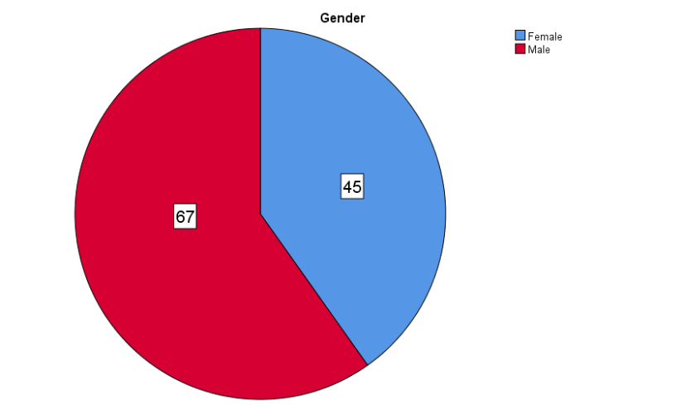

The table shows that out of 112 respondents, males represented the majority at (59.8%), while females accounted for (40.2%), indicating higher male participation in the sample.
The distribution of the research sample based on the age variable:
Variable | Levels of the Variable | Frequency | Percentage (%)
The age | Under 25 | 24 | 21.4
The age | 21–30 years | 22 | 19.6
The age | 31–40 years | 38 | 33.9
The age | 41–50 years | 18 | 16.1
The age | Over 50 years | 10 | 8.9
Total |  | 112 | 100
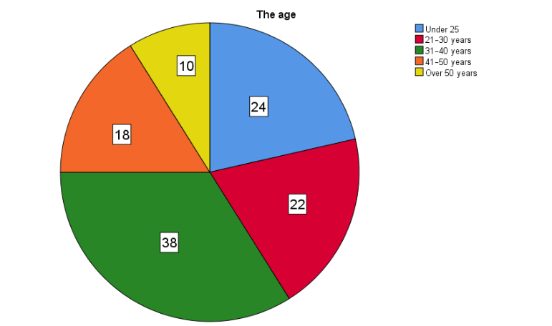

The table shows that the largest age group was 31–40 years (33.9%), followed by under 25 years (21.4%) and 21–30 years (19.6%). Smaller proportions were aged 41–50 years (16.1%) and over 50 years (8.9%).
The distribution of the research sample based on the Region variable:
Variable | Levels of the Variable | Frequency | Percentage (%)
Region | Eastern | 42 | 37.5
Region | Central | 28 | 25.0
Region | Western | 15 | 13.4
Region | Southern | 15 | 13.4
Region | Northern | 12 | 10.7
Total |  | 112 | 100
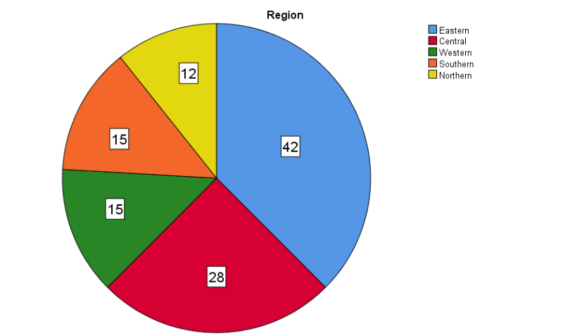

The table shows that most respondents were from the Eastern region (37.5%), followed by the Central region (25.0%). The Western and Southern regions each represented (13.4%), while the Northern region accounted for (10.7%).
The distribution of the research sample based on the How often do you order from or visit restaurants per month variable:
Variable | Levels of the Variable | Frequency | Percentage (%)
How often do you order from or visit restaurants per month | Once or less | 13 | 11.6
How often do you order from or visit restaurants per month | 2–3 times | 31 | 27.7
How often do you order from or visit restaurants per month | 4–6 times | 51 | 45.5
How often do you order from or visit restaurants per month | More than 6 times | 17 | 15.2
Total |  | 112 | 100

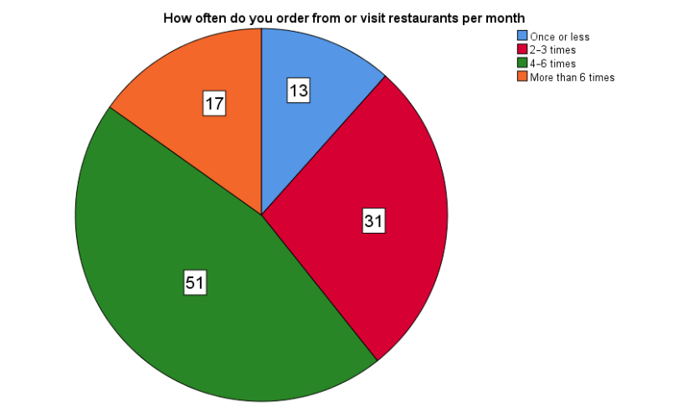

The table shows that nearly half of respondents (45.5%) visited or ordered from restaurants 4–6 times per month, 27.7% did so 2–3 times, 15.2% more than 6 times, and 11.6% once or less.
- Descriptive Statistics for Independent Variables
- The Impact of Artificial Intelligence on Customer Experience
Variable | Mean | Standard Deviation | Sig. | Rank
- I see advertisements for restaurants or meals based on my previous orders or location. | 3.97 | 1.127 | 0.000 | 1
- Targeted ads based on my preferences or location make me more likely to order from the restaurant. | 3.95 | 1.122 | 0.000 | 2
- AI-powered chatbots make my orders faster and more accurate. | 3.83 | 1.162 | 0.000 | 4
- Using AI has helped reduce errors in my orders or delivery. | 3.86 | 1.089 | 0.000 | 3
Overall Mean | 3.90

The table shows that the overall mean score for this axis is (3.90) with a standard deviation of (1.13), indicating a high level of agreement among respondents regarding the positive impact of AI on customer experience. Question (5) ranked first with the highest mean (3.97), reflecting the significant influence of AI-driven advertisements based on previous orders or location. This was followed by Question (6) (mean = 3.95), Question (8) (mean = 3.86), and finally Question (7) with the lowest mean (3.83), though still within a high agreement range. The relatively close mean values suggest that respondents perceive all listed AI applications as important contributors to enhancing their restaurant experience.
- Customer Satisfaction, Loyalty, and Challenges
Variable | Mean | Standard Deviation | Sig. | Rank
- I feel satisfied with restaurants that use smart technologies. | 3.73 | 1.273 | 0.000 | 2
- I prefer to reorder from restaurants that use AI. | 3.68 | 1.317 | 0.000 | 3
- Using smart technologies makes me more loyal to the restaurant. | 3.56 | 1.169 | 0.000 | 5
- I trust that restaurants use my data to improve service without compromising my privacy. | 3.68 | 1.164 | 0.000 | 4
- Sometimes I feel that the lack of human interaction makes the experience less personal. | 3.79 | 1.156 | 0.000 | 1
Overall Mean | 3.69

The table shows that the overall mean score for this axis is (3.69) with a standard deviation of (1.22), reflecting a moderate-to-high level of agreement among respondents. Question (5) ranked first with the highest mean (3.79), indicating that the reduction in personal interaction is perceived as the most noticeable factor in this category. It was followed by Question (1) (mean = 3.73), Question (2) and Question (4) (mean = 3.68 each), while Question (3) came last with the lowest mean (3.56). The variation in mean scores suggests that while customers appreciate technology-driven services, they remain sensitive to the emotional and interpersonal aspects of their dining experience.
- Hypotheses Testing
- There is a positive impact of using AI tools in marketing on enhancing customer purchasing decisions and engagement.
- There is a positive correlation between the use of AI tools and both customer satisfaction and brand loyalty.
Results of Testing the First Main Hypothesis:
There is a positive impact of using AI tools in marketing on enhancing customer purchasing decisions and engagement.
Sig. | t-value | Standardized Coefficients (Beta) |  | Standard Error | Unstandardized Coefficients (B) | Variable
0.000 | 11.193 | 0.730 |  | 0.072 | 0.803 | AI tools in marketing
Model Summary |  |  |  |  | ANOVA
0.730 |  |  | R |  | 125.279 | F
0.532 |  |  | R Square |  | 0.000 | Sig.
0.528 |  |  | Adjusted R Square

The results indicate a positive and statistically significant impact of AI tools in marketing on enhancing customer purchasing decisions and engagement. The standardized coefficient (Beta) is 0.730, with a t-value of 11.193 and a significance level of 0.000, confirming the strength and significance of the effect. The regression model shows R = 0.730, R² = 0.532, and Adjusted R² = 0.528, indicating that over 50% of the variance in purchasing decisions and engagement can be explained by the use of AI tools in marketing. These findings support the acceptance of the first hypothesis and highlight the critical role of AI tools in improving marketing effectiveness.
Results of Testing the Second Main Hypothesis:
There is a positive correlation between the use of AI tools and both customer satisfaction and brand loyalty.
 | Correlation | Significant
AI tools | 0.730** | 0.000
customer satisfaction and brand loyalty | 0.730** | 0.000

The results reveal a strong positive and statistically significant correlation between the use of AI tools and both customer satisfaction and brand loyalty. The correlation coefficient is 0.730 with a significance level of 0.000, indicating a direct and robust relationship. These findings confirm that implementing AI tools in marketing significantly enhances customer satisfaction and strengthens loyalty to the brand, supporting the acceptance of the second hypothesis.
Discussion of Findings
The findings of this study are consistent with previous research that highlighted the role of artificial intelligence in improving customer experience and building loyalty. For instance, Abdelwahab and Samir (2025) confirmed the ability of AI to understand consumer behavior and enhance marketing strategies. Similarly, Qasim and Khalifeh (2025) emphasized the importance of AI tools in delivering personalized content and improving customer engagement. In the same vein, Wagobera et al. (2023) demonstrated that AI significantly enhances customer experience, while Blöcher and Alt (2021) found that although AI can replace humans in mechanical tasks, activities requiring emotional intelligence or social interaction still rely on human involvement.
In contrast, the results of this study differ from Khoso and Hussain (2025), who argued that the effect of AI on brand loyalty remains weak. The present findings, however, demonstrated a clear relationship between the use of AI technologies and higher levels of customer satisfaction and engagement with the brand, which in turn positively influences purchasing decisions and customer loyalty.
This study contributes new insights by focusing on the hospitality and restaurant sector in Saudi Arabia, a vital sector linked to Saudi Vision 2030. Moreover, it addresses multiple dimensions (purchasing, engagement, satisfaction, and loyalty), making it complementary to previous literature, which often concentrated on partial aspects or different geographical contexts.

Recommendations
- Invest in artificial intelligence tools to provide personalized offers and recommendations for customers based on their purchasing preferences.
- Improve the use of automated chatbots by equipping them with the ability to understand customer needs and respond in an effective and friendly manner.
- Utilize big data analytics and predictive analysis to identify and understand customer trends and behavioral patterns.
- Enhance customer trust by protecting their data and adhering to the highest standards of privacy and cybersecurity.
- Conduct regular evaluations of customer satisfaction, including follow-up surveys after implementing AI-driven marketing strategies to measure improvements in satisfaction and brand loyalty.

Study Abstract:
This study aimed to measure the role of artificial intelligence (AI) in digital marketing for promoting the hospitality and restaurant sector in Saudi Arabia, and to assess its impact through a survey designed to test the research hypotheses. The findings confirm a positive relationship between the independent variable, which is the use of AI tools in digital marketing and the dependent variables, namely customer experience, satisfaction, and brand loyalty. A questionnaire consisting of 13 questions was distributed to 112 clients in this sector across different regions of Saudi Arabia, and the data were analyzed using the SPSS statistical software. The results indicate a direct positive relationship between the use of AI tools in promoting the hospitality and restaurant sector and the enhancement of customer experience, satisfaction, and loyalty to the brand.
Keywords: Artificial Intelligence, Digital Marketing, Hospitality sector, Restaurant, Customer Satisfaction, Loyalty to the brand.

Chapter Four
References
Arabic References :
Al-Kasasbeh, W., Abu Shalfeh, I., Al-Hussein, & Khalaf. (2023). The role of using smart applications in developing the future of digital tourism in NEOM smart city from the perspective of the Saudi citizen. Assiut University Journal of the Faculty of Education, 39(6.2), https://mfes.journals.ekb.eg/article_317121.html156–168.

Mansouri, A., Qadeeri, & Samir. (2025). The role of artificial intelligence in developing digital marketing strategies and anticipating consumer needs. Journal of Media and Society, 9(1), 233–250.
https://asjp.cerist.dz/en/article/269591

ALasdoudi, & Naha. (2023). Application of artificial intelligence mechanisms in digital marketing and their effects on achieving competitive advantages: A field study on experts. Journal of Media Research, 67(2), 837–902.
https://journals.ekb.eg/article_320638.html

Belour, F. R. (2022). The impact of digital marketing on consumer behavior [Master’s thesis, Abdelhafid Boussouf University Center, Mila].
https://2u.pw/ePNN7

Saudi Data and Artificial Intelligence Authority (SDAIA)
https://sdaia.gov.sa/ar/SDAIA/about/Pages/AboutAI.aspx

English References :
Alotaibi, I. S. (2024). A theoretical exploration study of artificial intelligence applications in marketing within Saudi Arabia. Univ. Tabuk, 4, 20-38.‏ https://2u.pw/iY48I
Basri, W. (2020). Examining the impact of artificial intelligence (AI)-assisted social media marketing on the performance of small and medium enterprises: Toward effective business management in the Saudi Arabian context. International Journal of Computational Intelligence Systems, 13, 142–152.https://link.springer.com/article/10.2991/ijcis.d.200127.002

Blöcher, K., & Alt, R. (2021). AI and robotics in the European restaurant sector: Assessing potentials for process innovation in a high-contact service industry. Electronic Markets, 31(3), 529-551.‏https://link.springer.com/article/10.1007/s12525-020-00443-2
Hussein, S. (2025). Evaluating the effectiveness of AI-driven personalized recommendations in enhancing guest experiences in Jeddah's restaurants. International Research Journal of Management and Social Sciences, 6(2), 55–65.https://irjmss.com/index.php/irjmss/article/view/451/425
Qasim, D., & Khalifeh, A. (2025). Implementing digital marketing using artificial intelligence. International Journal of Innovative Research and Scientific Studies, 8(3), 2377–2384.https://www.ijirss.com/index.php/ijirss/article/view/6993

Grand View Research. (2024). Saudi Arabia AI in marketing market size & forecast report 2023–2030. https://www.grandviewresearch.com/horizon/outlook/artificial-intelligence-ai-in-marketing-market/saudi-arabia?utm_source=chatgpt.com

Seo, K. H., & Lee, J. H. (2021). The emergence of service robots at restaurants: Integrating trust, perceived risk, and satisfaction. Sustainability, 13(8), 4431.
https://www.mdpi.com/2071-1050/13/8/4431

Appendices:
Customer Survey
https://docs.google.com/forms/d/1cHJxLWvFgLNcuqNUfDpQFzguWZJ2WArYG__p913AZ6Q/edit

Customer Questionnaire :
AI-Powered Digital Marketing Strategies for Promoting Hospitality and Restaurant Services

Section 1: Demographic Information
- Gender
  - ☐ Male
  - ☐ Female
- Age
  - ☐ Less than 20 years
  - ☐ 21–30 years
  - ☐ 31–40 years
  - ☐ 41–50 years
  - ☐ More than 50 years
- Region
  - ☐ Eastern Region
  - ☐ Central Region
  - ☐ Western Region
  - ☐ Southern Region
  - ☐ Northern Region
- How often do you purchase from restaurants per month?
  - ☐ Once or less
  - ☐ 2–3 times
  - ☐ 4–6 times
  - ☐ More than 6 times

Section 2: The Impact of AI Tools on Customer Experience
(Using a 5-point Likert scale: 1 = Strongly Disagree, 2 = Disagree, 3 = Neutral, 4 = Agree, 5 = Strongly Agree)
No. | Statement | 1 | 2 | 3 | 4 | 5
1 | I receive advertisements for restaurants or meals based on my previous orders or location. | ☐ | ☐ | ☐ | ☐ | ☐
2 | Personalized advertisements based on my taste or location make me more willing to order from the restaurant. | ☐ | ☐ | ☐ | ☐ | ☐
3 | AI-powered chatbots make my ordering process faster and more accurate. | ☐ | ☐ | ☐ | ☐ | ☐
4 | The use of AI has helped reduce errors in my orders or delivery. | ☐ | ☐ | ☐ | ☐ | ☐
5 | I am satisfied with restaurants that use smart technologies. | ☐ | ☐ | ☐ | ☐ | ☐
6 | I prefer to reorder from restaurants that use artificial intelligence. | ☐ | ☐ | ☐ | ☐ | ☐
7 | The use of smart technologies makes me more loyal to the restaurant. | ☐ | ☐ | ☐ | ☐ | ☐
8 | I trust that restaurants use my data to improve service without compromising my privacy. | ☐ | ☐ | ☐ | ☐ | ☐
9 | Sometimes, the lack of human interaction makes the experience feel less personal. | ☐ | ☐ | ☐ | ☐ | ☐

