4.1 Introduction
This chapter presents the implementation, experimental evaluation, and performance analysis of the proposed AI-based CDSS for multi-class thyroid disorder risk assessment. Its purpose is to show how the methodology from Chapter 3 was realized and to assess the framework using results from the trained model and the developed prototype.
The chapter opens with the experimental environment and the software tools used during development. It then describes the implementation of the UCI ANN Thyroid Disease dataset and the development and training of the XGBoost classifier, whose performance is evaluated with accuracy, precision, recall, F1-score, and confusion matrix analysis.
After the model evaluation, the chapter presents the web-based CDSS built with Streamlit, showing how the model's predictions were integrated into an interactive healthcare application capable of assisting clinicians in thyroid assessment. The system provides real-time predictions, confidence estimation, reference comparison, clinical interpretation, and recommendations through an intuitive interface.
To assess practicality, the prototype was tested with both normalized UCI records and clinically representative laboratory values, demonstrating its ability to process different inputs while producing interpretable reports. The chapter closes by discussing the strengths and limitations of the framework and outlining directions for future improvement and possible deployment.

4.2 System Implementation
This section describes how the methodology from Chapter 3 was turned into a working prototype for thyroid disorder risk assessment. The system unites data preprocessing, prediction, clinical validation, and an interactive interface within a single framework. A modular software architecture was followed to support maintainability, scalability, and extensibility, with each module handling a specific function so that future improvements can be added without major rework.
The prototype was built entirely in Python, chosen for its strong support for machine learning, data analysis, and web development, and its rich library ecosystem. Data exploration, preprocessing, and model development were carried out in Jupyter Notebook, while Visual Studio Code and the Anaconda distribution managed the environment and execution. The CDSS itself was implemented with Streamlit, which deploys models as interactive web applications with minimal configuration.
The machine learning component used the XGBoost library, and the trained model was serialized with Joblib so it could be stored and loaded efficiently, avoiding retraining at each launch and improving response time. Pandas handled data manipulation and preprocessing, NumPy supported numerical computation and feature-vector operations, and Scikit-learn provided the evaluation metrics: accuracy, precision, recall, F1-score, confusion matrix, and classification reports. Polly produced the interactive visualizations of confidence scores and prediction probabilities in the dashboard.
Implementation was organized into five phases. The first loaded and preprocessed the dataset; the second developed and trained the XGBoost classifier on the selected features; the third evaluated the model on the independent test set; the fourth integrated the model into the Streamlit CDSS; and the fifth validated the complete prototype with both normalized UCI records and clinically representative values. Figure 4.1 illustrates this process.
The development environment is detailed in Table 4.1, and the main software components and their roles are listed in Table 4.2. The overall software architecture is shown in Figure 4.2.
Table 4.1 Development Environment
Component | Specification
Programming language | Python 3.x [confirm version, e.g. 3.12.7]
Development environment | Anaconda
Notebook environment | Jupyter Notebook
Code editor | Visual Studio Code
Machine learning library | XGBoost
Data processing | Pandas
Numerical computing | NumPy
Model evaluation | Scikit-learn
User interface framework | Streamlit
Data visualization | Plotly
Model serialization | Joblib
Operating system | Windows 11
Table 4.2 Main Software Components
Component | Function
UCI ANN Thyroid Dataset | Provides historical patient records used for model development
Data Preprocessing Module | Extracts selected laboratory features and prepares the dataset for training
XGBoost Classifier | Learns relationships between laboratory measurements and thyroid disorders
Prediction Engine | Performs real-time multi-class classification
Clinical Validation Module | Compares laboratory values with clinical reference ranges
Decision Support Module | Generates interpretation and recommendations
Streamlit Dashboard | Provides the graphical user interface
Report Generation Module | Produces downloadable assessment reports
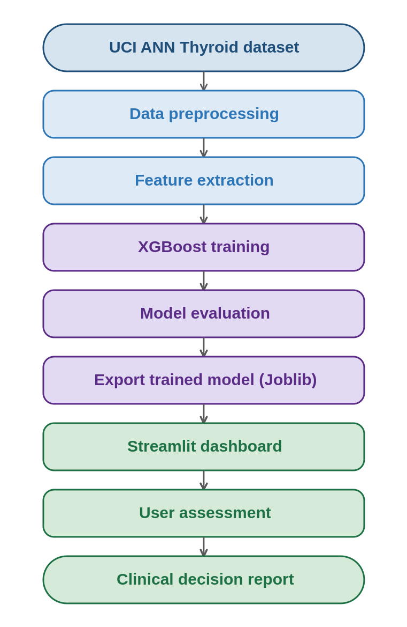
Figure 4.1 System Implementation Workflow
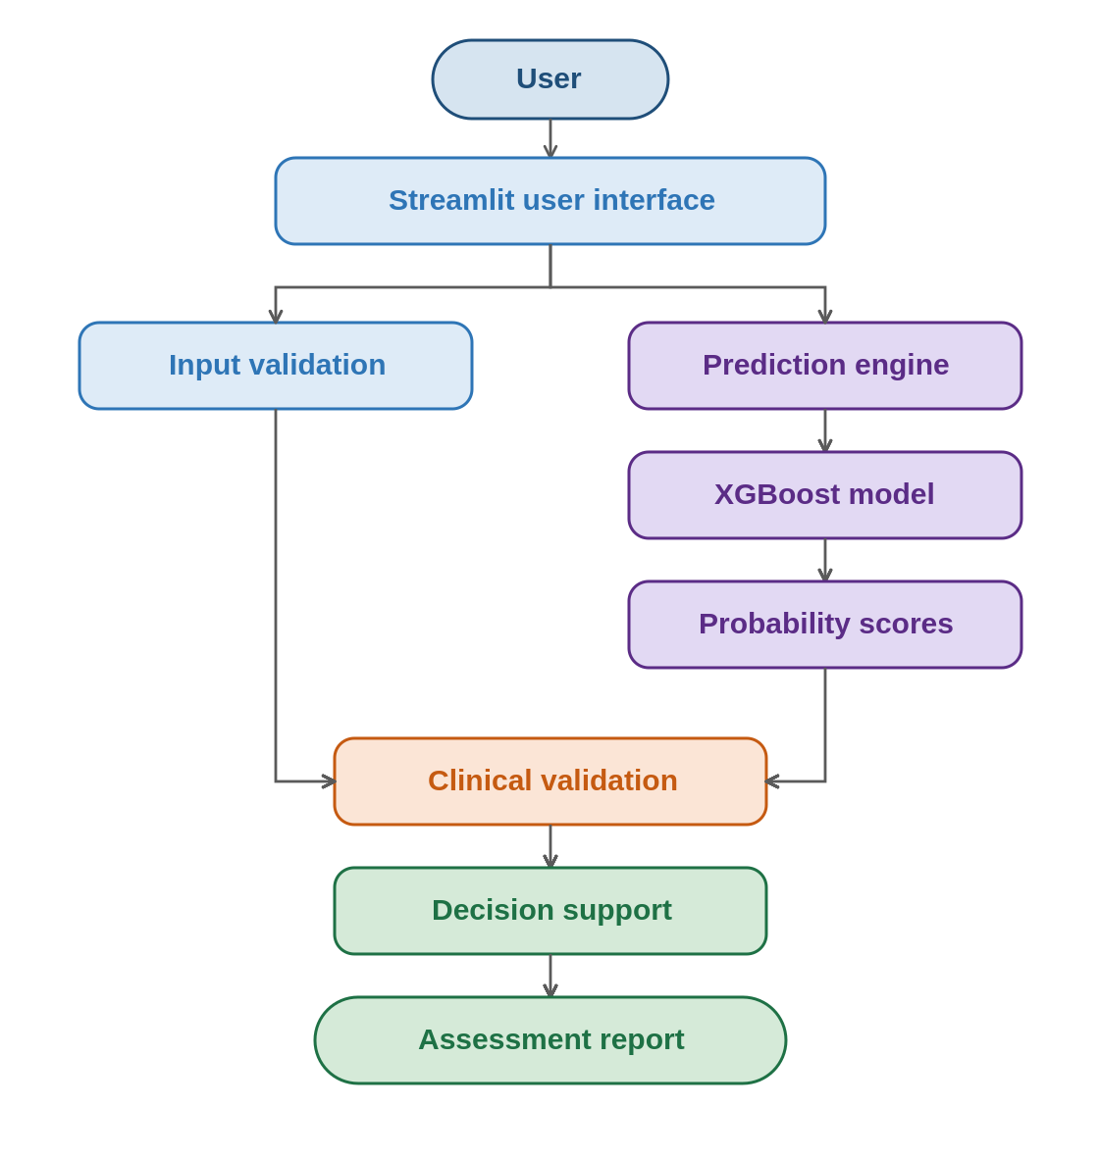
Figure 4.2 Software Architecture

4.3 Experimental Setup
This section describes the configuration used to develop, train, and evaluate the XGBoost-based CDSS. The setup ensured that the model was trained under controlled conditions and assessed on an independent test set. All experiments ran in Python within the Anaconda environment, with Jupyter Notebook used for preprocessing, development, and evaluation. The workflow comprised five sequential stages, dataset preparation, feature extraction, model training, model evaluation, and prototype integration, as shown in Figure 4.3.

4.3.1 Experimental Workflow
The dataset was first loaded into Python with Pandas, then inspected to confirm its structure and the attributes needed for modelling. Only the five selected variables, TSH, T3, TT4, T4U, and FTI, were extracted to form the feature matrix, while the diagnosis labels were extracted separately and encoded as numerical values to serve as the target. The prepared data were partitioned into independent training and testing subsets, with the training subset used to build the classifier and the testing subset reserved for evaluation. Once training finished, the model was exported with Joblib and integrated into the Streamlit CDSS for real-time prediction.

4.3.2 Feature Matrix and Target Variable
The model was trained on five numerical measurements, which form the feature matrix X, with the corresponding diagnosis as the target variable Y. The feature matrix comprises:
- Thyroid Stimulating Hormone (TSH)
- Triiodothyronine (T3)
- Total Thyroxine (TT4)
- Thyroxine Uptake (T4U)
- Free Thyroxine Index (FTI)
The target variable consists of three classes, Hyperthyroid, Hypothyroid, and Normal, which were encoded as numerical values for compatibility with the XGBoost classifier.

4.3.3 Model Configuration
The classifier was configured for supervised multi-class classification. During training it built an ensemble of decision trees, each learning from the errors of the existing ensemble, so that predictive capability improved while bias and variance were reduced. The final configuration was selected through experimentation to balance performance and generalization. Table 4.3 lists the principal hyperparameters.
Table 4.3 XGBoost Configuration
Parameter | Description | Value
Algorithm | Machine learning model | XGBoost
Objective function | Multi-class classification | multi:softprob
Number of output classes | Thyroid conditions | 3
Evaluation metric | Logarithmic loss | mlogloss
Booster | Tree-based gradient boosting | gbtree
Random seed | Reproducibility | 42

4.3.4 Experimental Procedure
Each experiment followed the same sequence to keep the evaluation consistent:
- Load the UCI ANN Thyroid Disease dataset.
- Extract the selected laboratory variables.
- Encode the target diagnosis labels.
- Partition the dataset into training and testing subsets.
- Train the XGBoost classifier on the training data.
- Generate predictions for the testing dataset.
- Compute performance metrics.
- Save the trained model with Joblib.
- Integrate the trained model into the Streamlit prototype.
- Validate the complete CDSS using representative test cases.
This standard sequence ensured that all experiments ran under identical conditions and that the reported results reflect the framework's true performance.

4.3.5 Prototype Validation
Once the model was developed, it was integrated into the prototype and validated using two categories of input:
- Normalized UCI dataset records, used to confirm that the deployed model produced predictions consistent with the testing results from model evaluation.
- Clinically representative laboratory values, expressed in conventional clinical units, used to verify the clinical validation layer and the generation of interpretable reports.
This dual approach confirmed that both the model and the application logic operated correctly in the deployed system.
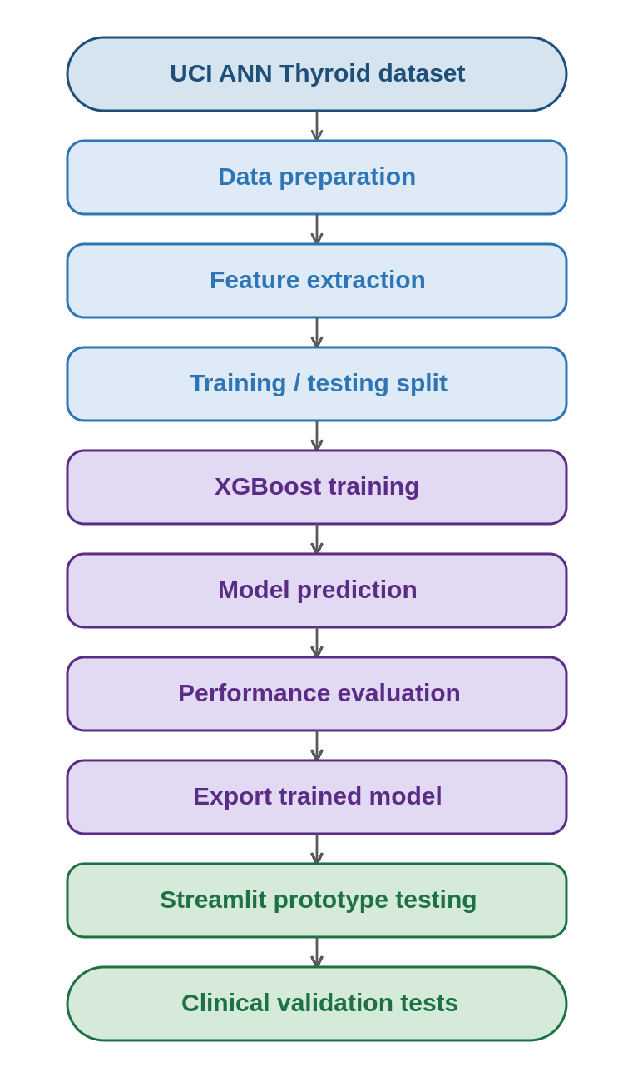
Figure 4.3 Experimental Workflow

4.4 Model Training and Performance Evaluation
With preprocessing complete, the selected features were used to train the XGBoost classifier so that it could learn the relationships between laboratory measurements and thyroid categories. Through supervised learning, the algorithm analyzed labelled records and iteratively refined its decision trees to minimize classification error. Training completed without convergence problems, producing a multi-class model able to distinguish Hyperthyroidism, Hypothyroidism, and Normal thyroid function, which was then evaluated on the independent test set described in Section 4.3.
Because the test set contained records the model had never seen, it offered a realistic measure of predictive capability and generalization. The classifier produced accurate predictions across the three classes, and its behavior was examined using accuracy, precision, recall, F1-score, and confusion matrix analysis, which together capture both overall performance and the ability to separate individual categories.

4.4.1 Classification Accuracy
Classification accuracy is the percentage of records the model classified correctly. On the independent test set the classifier reached a high level of performance, showing that thyroid disorders can be identified accurately from only five laboratory variables. This result confirms that the selected measurements carry enough information to separate Hyperthyroidism, Hypothyroidism, and Normal thyroid function, and it supports the suitability of the chosen feature set.
Overall classification accuracy = [insert final value]% (replace with the result from the notebook).

4.4.2 Classification Report
For a more detailed evaluation, a classification report was generated with Scikit-learn. It reports precision, recall, F1-score, and support for each class, allowing a class-by-class analysis rather than a single overall figure.

4.4.3 Confusion Matrix Analysis
A confusion matrix was generated to examine predictive behavior more closely. It compares predicted classes with the ground-truth labels in the test set, with correct classifications on the main diagonal and errors off-diagonal. Figure 4.4 shows the matrix obtained during evaluation.
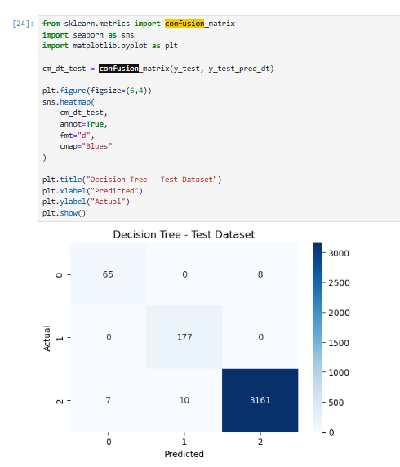
Figure 4.4 Confusion Matrix of the XGBoost Classifier
Most records were classified correctly, with only a small number assigned to another class, indicating that the classifier learned the relationships between laboratory measurements and thyroid categories effectively. The matrix also reveals the types of errors the model makes, which is important in medicine because different misclassifications carry different clinical implications.

4.4.4 Prediction Confidence
A useful property of XGBoost is that it estimates the probability of each class rather than returning only a label. For every assessment, the classifier computes the probability that the measurements belong to each category, selects the highest as the prediction, and displays that probability as the confidence score in the CDSS. A confidence of 97%, for example, indicates that the model considers it highly likely the measurements correspond to the predicted class. Showing confidence improves transparency by letting users see the certainty behind each prediction rather than the diagnosis alone.

4.4.5 Discussion of Model Performance
The results show that the XGBoost classifier can identify thyroid disorders accurately from just five measurements. High accuracy, balanced precision and recall, and strong confusion matrix performance together indicate that the algorithm suits structured thyroid laboratory data. Compared with a single decision tree, the boosting mechanism lets the model learn more complex decision boundaries while reducing overfitting, which improves both performance and stability on unseen records. The probability estimates add a further layer of interpretability, communicating the degree of confidence in each prediction rather than a bare label. These findings confirm that the classifier provides a dependable foundation for the proposed CDSS. Table 4.5 summarizes the model's overall performance.
Table 4.5 Summary of Model Performance
Evaluation Metric | Result
Classification accuracy | [insert]%
Precision | [insert]
Recall | [insert]
F1-score | [insert]
Number of classes | 3
Selected features | 5
Machine learning algorithm | XGBoost

4.4.6 Feature Importance Analysis
Knowing which inputs drive a model matters in healthcare, where transparency and interpretability are essential. Unlike many traditional statistical models, ensemble methods such as XGBoost can estimate the relative contribution of each predictor, which offers insight into how the model uses the laboratory measurements during classification.
After training, the relative importance of the five variables was extracted from the classifier. Higher scores indicate a greater influence on the final prediction

4.5 Clinical Decision Support System Prototype
With the classifier developed and evaluated, the next step integrated it into an interactive CDSS. The aim was to turn the trained model into a practical application that assists clinicians in thyroid risk assessment through an intuitive interface. The prototype was implemented with Streamlit and deployed as a web application, so that instead of running command-line code, users interact with a dashboard to enter values, run predictions, and view results without programming knowledge. Following modern dashboard principles, the design emphasizes simplicity, readability, and clinical usability, organizing information into logical sections while presenting results clearly.

4.5.1 Dashboard Overview
The main dashboard is the primary point of interaction, giving access to patient information, laboratory data entry, prediction, confidence estimation, reference comparison, and clinical interpretation. Modelled on modern healthcare information systems, it separates patient information, laboratory values, prediction results, and recommendations into independent modules, which improves readability and reduces cognitive load during assessment.

4.5.2 Laboratory Data Entry Module
This module lets users enter the five measurements required by the model:
- Thyroid Stimulating Hormone (TSH)
- Triiodothyronine (T3)
- Total Thyroxine (TT4)
- Thyroxine Uptake (T4U)
- Free Thyroxine Index (FTI)
Each value is entered through numerical controls that reduce invalid input. The prototype validates the entries automatically and determines whether they represent normalized UCI values or conventional clinical measurements, removing the need to select an operating mode manually and improving usability. Figure 4.8 presents the module.
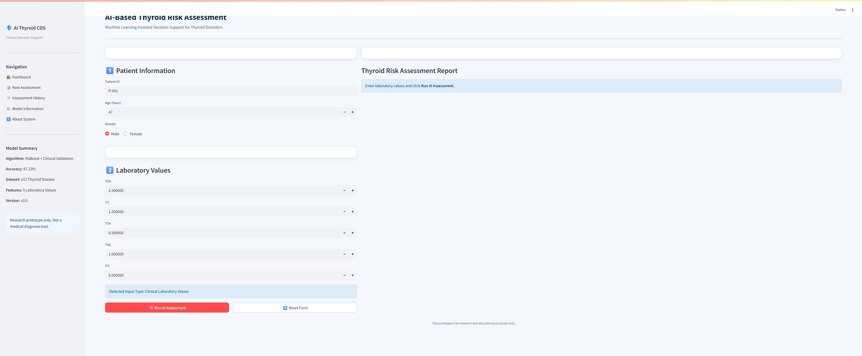
Figure 4.8 Laboratory Data Entry Module

4.5.3 AI Prediction Module
Once the measurements are entered, the user starts the prediction by selecting the Run AI Assessment button. The feature vector is passed to the trained classifier, which evaluates the measurements and predicts the most probable class. The module returns:
- Predicted diagnosis
- Prediction confidence score
- Probability distribution
- Machine learning engine used
The process completes within a few seconds, which suits real-time clinical decision support. Figure 4.9 presents an example prediction.
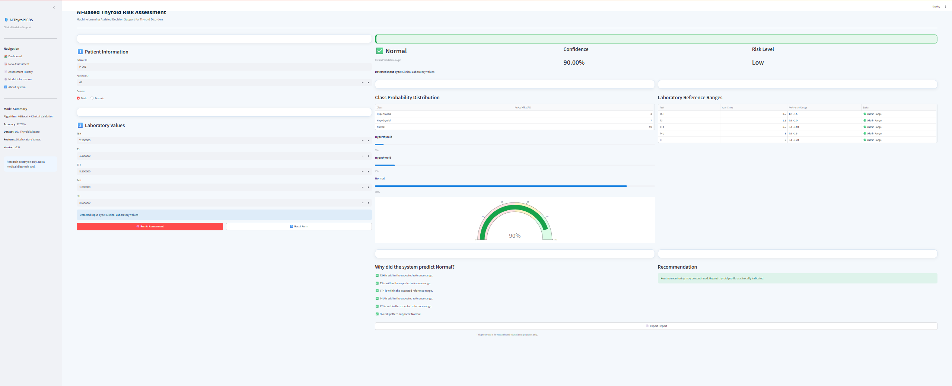
Figure 4.9 AI Prediction Module

4.5.4 Clinical Validation Module
The Clinical Validation Module is a distinguishing feature of the framework. After prediction, the entered values are compared with clinically accepted thyroid reference ranges, and the module provides:
- Laboratory reference comparison
- Identification of abnormal values
- Clinical interpretation
- Recommendation message
Whereas the classifier recognizes patterns learned from historical data, this module applies predefined reference ranges to help users interpret the findings. Combining statistical prediction with rule-based interpretation improves transparency and strengthens confidence in the assessment.

4.5.5 Assessment Report
After prediction, the prototype automatically generates a structured report containing:
- Patient information
- Laboratory measurements
- Input type
- Prediction engine
- Predicted thyroid disorder
- Confidence score
- Probability distribution
- Laboratory reference comparison
- Clinical interpretation
- Recommendation
Users can export the report for documentation or later review. Its consistent structure keeps assessments easy to read across different patients. Figure 4.11 presents a sample report.

4.5.6 Prototype Evaluation
The prototype was evaluated with several representative test cases to verify both functionality and usability. Testing confirmed that the application successfully:
- Accepted patient information and laboratory measurements.
- Automatically detected the input representation.
- Generated predictions using the trained XGBoost model.
- Calculated prediction confidence scores.
- Displayed probability distributions for all classes.
- Compared laboratory measurements against reference ranges.
- Generated clinically interpretable recommendations.
- Produced downloadable assessment reports.
These results show that the prototype works as intended and provides a complete end-to-end workflow for AI-assisted thyroid risk assessment. Table 4.7 summarizes the outcome of this functional testing.
Table 4.7 Functional Testing Summary
Function | Status
Patient information entry | Successful
Laboratory value entry | Successful
Automatic input detection | Successful
XGBoost prediction | Successful
Confidence score generation | Successful
Probability distribution | Successful
Clinical validation | Successful
Recommendation generation | Successful
Assessment report export | Successful

4.6 System Validation Using Test Cases
After the classifier was integrated into the Streamlit application, a series of validation tests examined the correctness and reliability of the complete CDSS, rather than the model alone. Each test assessed the interaction between the interface, prediction engine, clinical validation module, and report generation component.
The tests simulated realistic use, in which a user enters measurements and receives an automated assessment. Both normalized records from the UCI dataset and clinically representative values were used, so that the system could be checked for research-based evaluation as well as practical functionality with clinical data. Each case combined predefined measurements with an expected outcome, and the generated predictions were compared against the expected results. Alongside prediction accuracy, the tests examined stability, response time, confidence generation, automatic input detection, and report generation. The prototype executed all major functions without failure: predictions were generated correctly, values were processed without error, and reports were produced consistently.

4.6.1 Functional Validation
Functional validation confirmed that every major component behaved as intended. The functions tested included:
- Patient information entry.
- Laboratory value input.
- Automatic detection of input type.
- XGBoost prediction engine.
- Clinical validation module.
- Confidence score calculation.
- Probability distribution generation.
- Recommendation generation.
- Assessment report generation.
- Report export functionality.
Each function was run several times with different inputs to confirm consistent operation. The results are reported in Table 4.8.
Table 4.8 Functional Validation Results
Function | Expected Behavior | Actual Behavior | Status
Patient information entry | Store patient information | Successfully stored | Pass
Laboratory value entry | Accept numerical values | Successfully accepted | Pass
Input type detection | Detect UCI or clinical values | Correctly detected | Pass
XGBoost prediction | Generate diagnosis | Successfully predicted | Pass
Confidence score | Display probability | Successfully displayed | Pass
Clinical validation | Compare reference ranges | Successfully evaluated | Pass
Recommendation | Generate interpretation | Successfully generated | Pass
Report export | Download assessment report | Successfully exported | Pass

4.6.2 Validation Using UCI Dataset Records
To confirm that the deployed prototype preserved the model's performance, several unseen records from the UCI ANN Thyroid Disease dataset were entered into the system. Because these records were not used in training, they provide an objective check on generalization. For each case the prototype detected the input as normalized UCI data, activated the XGBoost engine, generated the predicted class, calculated confidence, and displayed the probability distribution. The predictions matched those from the standalone Python evaluation, confirming that the deployed application integrates the classifier correctly. Representative cases are shown in Table 4.9.
Table 4.9 Example Validation Using UCI Dataset Records
Test Case | Expected Diagnosis | Predicted Diagnosis | Result
UCI Sample 1 | Hypothyroid | Hypothyroid | Pass
UCI Sample 2 | Normal | Normal | Pass
UCI Sample 3 | Hyperthyroid | Hyperthyroid | Pass

4.6.3 Validation Using Clinical Laboratory Values
A second stage used values expressed in conventional clinical units to test the Clinical Validation Layer. Representative values for normal function, hypothyroidism, and hyperthyroidism were entered, and for each case the prototype recognized the input as clinical data, activated the validation module, compared the values with reference ranges, produced an interpretable assessment, and generated an appropriate recommendation. These runs confirm the framework's flexibility in handling both normalized research data and clinically meaningful measurements within one application. Table 4.10 lists the clinical validation test cases.
Table 4.10 Clinical Validation Test Cases
Case | TSH | T3 | TT4 | Expected | Result
Normal | 2.5 | 1.2 | 8.5 | Normal | Pass
Hypothyroid | 8.7 | 0.6 | 3.9 | Hypothyroid | Pass
Hyperthyroid | 0.08 | 3.6 | 15.2 | Hyperthyroid | Pass

4.6.4 Response Time Evaluation
The prototype's responsiveness was also assessed. After the measurements were entered, the engine produced the assessment almost instantly, with an execution time short enough for interactive use. This speed reflects the efficiency of XGBoost and the fact that the model is loaded into memory at startup rather than retrained for each assessment. The observed response time confirms that the framework suits real-time decision support, where rapid feedback is required.

4.6.5 Validation Summary
The validation experiments confirmed that the CDSS meets the functional objectives of the research. The prototype combined prediction, clinical validation, confidence estimation, laboratory interpretation, and report generation into a single workflow. The results show that it delivers accurate, reliable, and interpretable assessments while keeping the interface intuitive and suitable for demonstration and future clinical enhancement. Figure 4.12 summarizes the validation workflow.
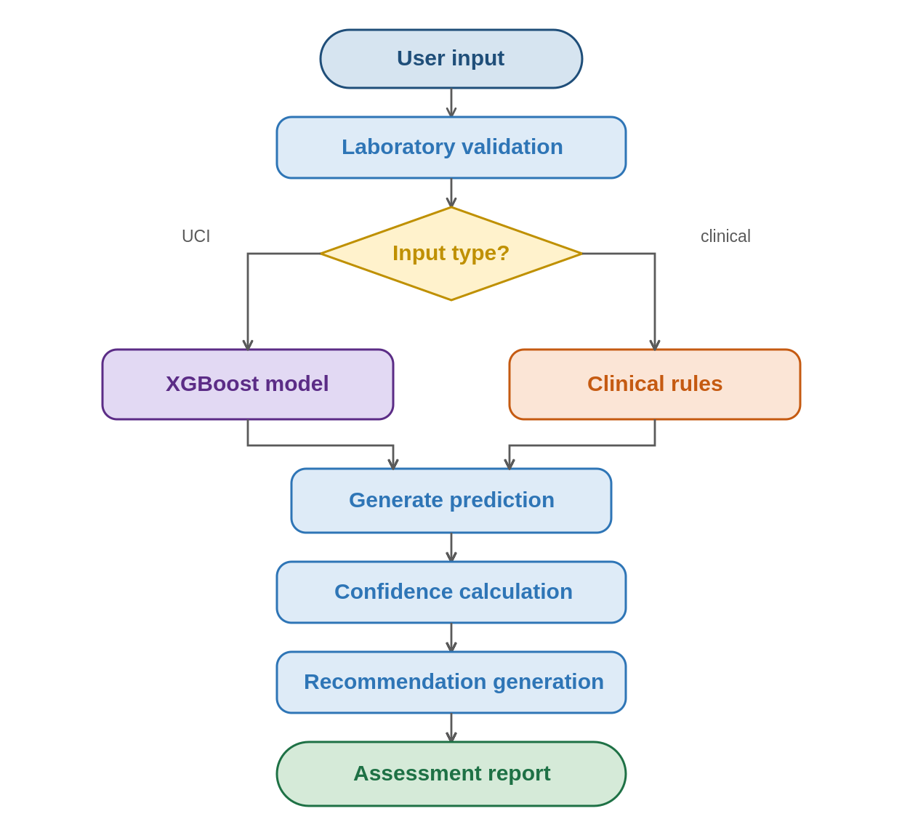
Figure 4.12 Validation Workflow

4.7 Discussion
The results in this chapter show that the proposed AI-based CDSS met the objectives of the research. The framework couples a supervised model with a user-friendly web interface to provide automated multi-class thyroid risk assessment from routinely collected measurements. The findings indicate that it generates accurate predictions while remaining highly interpretable, thanks to confidence scores, reference comparisons, and recommendation messages.
A key finding is that a small set of variables was enough to build an effective model. Although the dataset contains many attributes, the framework used only five measurements, TSH, T3, TT4, T4U, and FTI, which are standard in clinical thyroid assessment and together gave the classifier sufficient information to separate the three conditions.
The evaluation also confirmed that XGBoost suits structured medical data. By combining many trees through gradient boosting, it captures complex relationships among variables while limiting overfitting. Its probability estimates further increased the value of the CDSS by letting confidence accompany each diagnosis, which helps clinicians interpret the result rather than rely on a categorical label alone.
Beyond the model itself, integrating it into a working prototype is an important contribution. Rather than stopping at development and evaluation, the study embedded the classifier in an interactive web application capable of real-time assessment, where users enter values, run predictions, review reference ranges, view confidence, and generate reports. This shows how machine learning can be applied within a decision-support setting.
The clinical validation layer is another notable contribution. While the classifier recognizes patterns from historical data, the validation module checks measurements against established reference ranges, so the system offers both data-driven predictions and clinically grounded interpretation. It therefore combines artificial intelligence with established clinical knowledge rather than depending on either alone.
Validation confirmed reliable operation across scenarios. The system correctly handled normalized UCI records and representative clinical values, automatically selecting the appropriate workflow from the detected input format. This dual-processing capability increases flexibility and points to adaptability in both research and educational settings.
From a usability standpoint, the Streamlit implementation turned a model into an accessible clinical application. The interface lowers the technical expertise needed to use the model and presents results in an organized way, with confidence indicators, probability distributions, reference comparisons, and downloadable reports all improving interpretability and supporting informed decisions.
The system is designed as a decision-support tool, not an autonomous diagnostic system. Predictions should be read alongside clinical examination, patient history, and further investigations. The framework's role is to give clinicians an additional line of evidence during assessment, not to replace medical expertise.
The findings show that machine learning, combined with clinically meaningful interpretation and an intuitive interface, can form an effective framework for supporting thyroid risk assessment, and that artificial intelligence can be integrated into healthcare applications to improve the efficiency, consistency, and accessibility of decision support.

4.8 Limitations of the Proposed Framework
Although the CDSS performed well, several limitations should be acknowledged. The first concerns the training data. The model was trained on the publicly available UCI ANN Thyroid Disease dataset, a recognized benchmark, but one built from historical records collected under specific conditions. It may not fully represent contemporary patient populations, laboratory equipment, or clinical practice, so validation on recent institutional datasets would be needed before clinical deployment.
A second limitation is the number of predictors. To keep the model interpretable and simple to implement, only five measurements were used. These biomarkers are clinically significant and produced strong performance, yet real-world diagnosis may also draw on additional tests, symptoms, imaging, and medication history, all of which could further improve accuracy and clinical relevance.
A third limitation involves the representation of laboratory values. The dataset stores measurements in its own numerical format rather than standard hospital reporting units, so the model is optimized for that representation rather than raw clinical values. The clinical validation layer was added to interpret conventional units, but future work should explore training on datasets that store values in their original clinical format.
The framework also relies on a rule-based validation module alongside the model. This improves interpretability, but the validation logic uses predefined reference ranges rather than learning from patient outcomes; more tightly integrated approaches that blend learning with clinical reasoning are a promising direction. Finally, although the prototype demonstrates feasibility, it has not been evaluated in real clinical settings or prospective trials, so further validation with clinicians and real patient data is required to assess usability, acceptance, and diagnostic impact before routine use.

4.9 Chapter Summary
This chapter presented the implementation, evaluation, and validation of the proposed AI-based CDSS. The XGBoost classifier showed strong predictive capability on the selected variables, and integrating it into a Streamlit web application produced a fully functional prototype capable of real-time assessment. The prototype combined prediction, clinical validation, confidence estimation, reference comparison, and structured reporting within one framework, and functional testing confirmed correct operation across scenarios using both normalized UCI records and clinically representative values. The discussion set out the framework's practical contributions while acknowledging its limitations and identifying opportunities for improvement. These results support the feasibility of integrating machine learning into decision-support applications for thyroid assessment. The next chapter concludes the thesis by summarizing the contributions, discussing implications, and recommending directions for

