
AI-Based Nowcasting of National CO₂ Emissions
Using Satellite-Derived Indicators:
A Hybrid Framework for GCC Countries
Prepared By
Mohammad Wajeeh Bader
Student ID: 251000462

Submitted in fulfillment of the requirements for the degree Master of Science in Artificial Intelligence

Supervised by
Dr. Amjad Qtaish

College of Informatics, Midocean University, Comoros

November 2025

Acknowledgments

Honestly, I could not have completed this thesis without the grace of God and the help of some truly wonderful people.
First and foremost, I owe a deep debt of gratitude to my academic supervisor, Dr. Amjad Qtaish. When I first started this project, I felt completely lost, especially overwhelmed by the sheer size of the datasets and the analytical demands. Dr. Qtaish didn't just help me crack the data or do the actual work; he was my true compass. His immense contribution was in guiding me on how to research properly, how to structure my thoughts and synthesize studies, and, most importantly, how to think like a researcher and apply rigorous analytical methodologies. He never let me give up and was keen on teaching me how to stand on my own two feet. Thank you, Doctor, for your patience and for pushing me at exactly the right times.

I must also mention the gift that changed the course of my research: Google Earth Engine. Without this platform, I would likely still be struggling with manual MODIS tile downloads. A huge thank you to the teams at Google, NASA, ESA, and NOAA for making the analysis of 24 years of data possible and free. I am also deeply grateful to Our World in Data and the Global Carbon Project for providing clean, organized emissions data, which saved me countless weeks of effort.

To my friends and colleagues at the National Center for Wildlife, specifically Mr. Khalf al Shamari – I apologize for my frequent absences, and I thank you for covering for me and for kindly indulging me while I talked about the latest updates to the XGBoost algorithm on countless occasions.

Finally, to my dear family. They are the foundation of everything. They may not fully understand the technical details of machine learning or why I care about carbon, but their support was boundless. My father kept asking when I would finish (which was truly motivating). As for my mother, she deserves all the love and appreciation; she was not just a supporter, but the one who woke me up every morning with sincere prayers and made sure I was well taken care of. Her dedication to encouraging me is the energy that finished this thesis.

Abstract

National greenhouse gas inventories are usually published with a one- to two-year delay, meaning governments often make decisions based on outdated information. This thesis explores whether satellite observations can be used to nowcast national carbon dioxide (CO₂) emissions for the Gulf Cooperation Council (GCC) countries and, in doing so, help close this information gap.
Using data for Saudi Arabia, the United Arab Emirates, Bahrain, Kuwait, Oman, and Qatar, I assembled a balanced panel covering the years 2000–2023 (144 country–year observations). Production-based CO₂ emissions and macroeconomic variables are taken from the Our World in Data (OWID) database, while satellite indicators are derived from five Google Earth Engine products: MODIS land surface temperature (LST), MODIS vegetation index (NDVI), DMSP/VIIRS night-time lights, MERRA-2 aerosol optical depth (AOD), and Sentinel-5P tropospheric NO₂. All series are converted to annual country–year values to make them comparable across sources.
Three XGBoost regression models are trained and tested using a time-aware approach, with 2000–2018 designated for training and 2019–2023 reserved for testing. Model A relies solely on macroeconomic and demographic indicators (such as GDP, population, and energy use) and serves as an inventory-driven benchmark. Model B combines satellite indicators with population density, while Model C uses only satellite features. During the test period, Model A achieves a coefficient of determination of about 0.96, confirming the strength of traditional economic models when current statistics are available. The hybrid and satellite-only models reach test R² values of approximately 0.69 and 0.67, respectively, and still capture most of the year-to-year variations in national CO₂ emissions.
In practice, the models focus on summer and winter land surface temperatures, night-time lights, and population density as the most critical factors. This pattern matches emission sources within the Gulf Cooperation Council (GCC), where extreme heat, crowded urban areas, and high electricity use significantly affect national CO₂ emissions. Overall, the thesis indicates that satellite-based models cannot entirely replace official inventories; however, they offer rapid, physically meaningful nowcasts that supplement traditional approaches and help minimize delays in tracking national emissions.

Keywords: CO₂ emissions, machine learning, XGBoost, satellite remote sensing, Google Earth Engine, land surface temperature, night-time lights, MODIS, VIIRS, GCC, climate monitoring, nowcasting

Table of Contents

Acknowledgments i
Abstract ii
Table of Contents iii
List of Abbreviations v
List of Figures vi
List of Tables vii
Chapter 1 Introduction 8
1.1 Introduction 8
1.2 Problem Definition 9
1.3 Thesis Objectives 10
1.4 Thesis Contribution 10
1.5 Thesis Organization 10
Chapter 2 Overview 12
2.1 Introduction 12
2.2 Artificial Intelligence 12
2.3 Machine Learning 13
2.4 Supervised Learning in Detail 14
2.5 Deep Learning 15
2.6 Ensemble Methods 17
2.7 The XGBoost Algorithm 18
2.8 Greenhouse Gas Emissions and Climate Policy 18
2.9 The GCC Region: Energy Profile and Climate Commitments 19
2.10 Earth Observation for Environmental Monitoring 21
2.11 Satellite Data Sources Used in This Study 22
2.12 Machine Learning for Emission Estimation 23
2.13 XGBoost: Mathematical Formulation 23
2.14 Explainable AI for Tree-Based Models 25
Chapter 3 Related Work 26
3.1 Introduction 26
3.2 AI-Based Emission Forecasting 27
3.3 Satellite-Based Carbon Monitoring 28
3.4 Regional Studies in the GCC 29
3.5 Research Gaps and Contributions 30
Chapter 4 Proposed Approach 31
4.1 Introduction 31
4.2 Research Design Overview 31
4.3 Study Area: The GCC Region 34
4.4 Data Sources and Collection 35
4.4.1 Emission Data 35
4.4.2 Economic and Demographic Data 35
4.4.3 Satellite Data 36
4.5 Satellite Data Extraction Pipeline 36
4.5.1 Google Earth Engine Image Collections 36
4.5.2 Extraction Workflow 37
4.5.3 Handling the DMSP–VIIRS Transition 38
4.5.4 Missing Data Handling 39
4.6 Feature Engineering and Preprocessing 39
4.6.1 Seasonal Disaggregation of Temperature 39
4.6.2 Population Density Transformation 40
4.6.3 Final Feature Set 40
4.6.4 Correlation Analysis 41
4.7 Experimental Design: Three-Model Comparison 42
4.8 Model Training and Validation 43
4.8.1 Temporal Train–Test Split 43
4.8.2 XGBoost Configuration 43
4.9 Evaluation Metrics 44
Chapter 5 Experimental Results and Discussion 45
5.1 Introduction 45
5.2 Data Quality Assessment 45
5.3 Model Performance Comparison 47
5.4 Feature Importance Analysis 50
5.5 Error Analysis and Residual Diagnostics 51
5.6 Country-Level Performance 53
5.7 Discussion of Findings 55
5.8 Summary of the Chapter 56
Chapter 6 Conclusion and Future Work 57
6.1 Summary of Contributions 57
6.2 Practical Implications 57
6.3 Scope and Future Extensions of the Proposed Framework 58
6.4 Concrete Future Work Directions 61
References 63
Appendices 66
Appendix A: Google Earth Engine Code Snippets 66
A.1 LST Extraction Example 66
A.2 Night-time Lights Extraction 66
Appendix B: Dataset Variables 67

List of Abbreviations

AI | Artificial Intelligence
ANFIS | Adaptive Neuro-Fuzzy Inference System
AOD | Aerosol Optical Depth
CNN | Convolutional Neural Network
CO₂ | Carbon Dioxide
DMSP | Defense Meteorological Satellite Program
EO | Earth Observation
ESA | European Space Agency
FFNN | Feed-Forward Neural Network
GCC | Gulf Cooperation Council
GEE | Google Earth Engine
GHG | Greenhouse Gas
IPCC | Intergovernmental Panel on Climate Change
LST | Land Surface Temperature
LSTM | Long Short-Term Memory (Neural Network)
MAE | Mean Absolute Error
MAPE | Mean Absolute Percentage Error
MERRA-2 | Modern-Era Retrospective Analysis for Research and Applications, Version 2
ML | Machine Learning
MODIS | Moderate Resolution Imaging Spectroradiometer
Mt | Megatons (Million Metric Tons)
NASA | National Aeronautics and Space Administration
NDC | Nationally Determined Contribution
NDVI | Normalized Difference Vegetation Index
NOAA | National Oceanic and Atmospheric Administration
NO₂ | Nitrogen Dioxide
NTL | Night-time Lights
OCO-2 | Orbiting Carbon Observatory-2
OLS | Operational Linescan System
OWID | Our World in Data
R² | Coefficient of Determination
RMSE | Root Mean Squared Error
TROPOMI | Tropospheric Monitoring Instrument
UAE | United Arab Emirates
UNFCCC | United Nations Framework Convention on Climate Change
VIIRS | Visible Infrared Imaging Radiometer Suite
XGBoost | Extreme Gradient Boosting

List of Figures

Figure 2.1: Artificial Intelligence and Its Subfields 13
Figure 2.2: Types of Machine Learning 14
Figure 2.3: Supervised Learning Workflow 15
Figure 2.4: Neural Network Architecture 16
Figure 2.5: Ensemble Methods Comparison 17
Figure 2.6: Map of the GCC Study Area 19
Figure 2.7: Satellite Data Sources and Processing Pipeline 21
Figure 2.8: XGBoost Sequential Tree Building Process 24
Figure 3.1: Literature Review Timeline (2016-2025) 26
Figure 3.2: Research Gap Analysis Diagram 30
Figure 4.1: Research Framework Architecture 33
Figure 4.2: GCC CO2 Emissions Distribution by Country (2023) 34
Figure 4.3: Google Earth Engine Data Extraction Workflow 37
Figure 4.4: Seasonal Land Surface Temperature Pattern 40
Figure 4.5: Feature Correlation Matrix 41
Figure 4.6: Temporal Train-Test Split Strategy 43
Figure 5.1: Three-Model Performance Comparison 48
Figure 5.2: Training vs Test R² Comparison 49
Figure 5.3: Feature Importance Analysis (Model B) 50
Figure 5.4: Actual vs Predicted Emissions (Scatter Plot) 51
Figure 5.5: Residual Distribution Analysis 52
Figure 5.6: Time Series: Actual vs Predicted (Saudi Arabia) 53
Figure 5.7: Country-Level R² Performance Comparison 54
Figure 6.1: Accuracy vs Data Timeliness Trade-off 58
Figure 6.2: Future Research Directions 61

List of Tables

Table 2.1: Comparison of AI, ML, and DL 16
Table 2.2: GCC Countries Climate Targets and Emission Profiles 20
Table 2.3: Satellite Sensors and Products Used in This Study 23
Table 3.1: Summary of AI-Based Emission Forecasting Studies 28
Table 3.2: Summary of Satellite-Based Carbon Monitoring Studies 29
Table 4.1: Study Area Overview - Six GCC Countries 34
Table 4.2: Data Sources and Temporal Coverage 36
Table 4.3: Google Earth Engine Image Collections Used 36
Table 4.4: Satellite Feature Extraction Parameters 38
Table 4.5: Missing Data Summary 39
Table 4.6: Seasonal Aggregation Windows 39
Table 4.7: Final Feature Set for Each Model 40
Table 4.8: Three-Model Experimental Design 42
Table 4.9: XGBoost Hyperparameters 43
Table 5.1: Data Completeness Summary 45
Table 5.2: Descriptive Statistics of Key Variables 46
Table 5.3: Model Performance Comparison (Test Set 2019-2023) 47
Table 5.4: Training vs Test Performance (Overfitting Check) 48
Table 5.5: Feature Importance Rankings (Model B) 50
Table 5.6: Country-Level Model Performance 53

Chapter 1 Introduction

1.1 Introduction
Climate change represents one of the most pressing challenges of the twenty-first century. The Intergovernmental Panel on Climate Change (IPCC) 2023 Synthesis Report underscores the significance of reducing worldwide greenhouse gas emissions by fifty percent by 2030 and attaining net-zero emissions by 2050 to limit global warming to below 1.5°C (IPCC, 2023). The achievement of these targets depends on precise and prompt monitoring of carbon dioxide (CO₂) emissions at the national level.
A significant obstacle to the formulation of effective climate policies is the latency in emissions reporting. Most nations disseminate their official CO₂ emission data one to two years after the actual events. Consequently, by the time a country releases its 2023 emission statistics, it is typically late 2024 or early 2025. This delay frequently results in policy decisions being based on obsolete information, thereby restricting governments' capacity to respond to evolving emission patterns promptly.
The consequences of this reporting delay go beyond mere administrative inconvenience. Effective emission management relies on timely feedback, like any control system. Without current data, policy adjustments can't reflect real-time conditions, and the success of mitigation efforts remains uncertain until much later.
Satellite remote sensing provides a promising alternative to narrow this information gap. Earth observation satellites continuously gather data, including surface temperature, nighttime urban lights, vegetation health, and atmospheric composition. These measurements are accessible within days instead of years. If reliable links can be established between satellite data and carbon emissions, it may be possible to estimate current emissions without waiting for official inventories.
This thesis examines the potential for the Gulf Cooperation Council (GCC) countries, including Saudi Arabia, the United Arab Emirates, Qatar, Kuwait, Oman, and Bahrain. These six nations share characteristics that make them a compelling area of study. Their hot, arid climates result in significant electricity demand for cooling during summer months. As leading oil and gas producers, they have some of the highest per capita emissions in the world. Additionally, all six countries have announced climate targets under the Paris Agreement, creating both the need and policy interest for improved emissions monitoring.

1.2 Problem Definition
The central problem addressed in this thesis is the temporal gap between when emissions occur and when they are reported in official inventories. Traditional emission accounting relies on economic data, including energy consumption, industrial output, and transportation statistics. The collection, verification, and compilation of these figures require considerable time, resulting in delays in reporting that preclude real-time policy adjustment.
Recent advances in machine learning and satellite remote sensing suggest an alternative approach. Multiple studies have demonstrated that satellite-derived indicators can serve as proxies for economic activity and energy consumption. Night-time lights exhibit a correlation with electricity use. Land surface temperature relates to cooling demand. Atmospheric measurements such as nitrogen dioxide concentrations can indicate combustion from vehicles and power plants.
However, most existing research has focused on either global scales or highly localized analyses. Global models lack the regional specificity required for national policy formulation. Local studies of individual cities or facilities do not aggregate to country-level estimates. The GCC region presents additional methodological challenges, including extreme climate conditions, rapid urbanization, and economies dominated by hydrocarbon production. Models developed for temperate regions may not transfer effectively to this context.
The research gap is evident: there is a need for a framework that uses satellite data to estimate national carbon emissions for the GCC region, explicitly quantifies the trade-off between accuracy and timeliness, and provides interpretable results that policymakers can understand and apply.

1.3 Thesis Objectives
This thesis pursues four primary objectives that provide a guiding framework for the investigation and structure the analysis and presentation of results:
- Construct a comprehensive dataset combining CO₂ emission records with satellite-derived environmental indicators for all six GCC countries from 2000 to 2023.
- Develop and compare multiple XGBoost regression models: one using traditional economic indicators as a benchmark, one using satellite features exclusively, and one hybrid model combining satellite data with demographic information.
- Analyze which satellite indicators contribute most to emission prediction and examine whether the identified relationships are physically consistent with the region's climate and economic structure.
- Quantify the accuracy-timeliness trade-off: determine how much prediction accuracy is sacrificed when using satellite data (available in days) instead of economic data (available in one to two years).

1.4 Thesis Contribution
This thesis contributes to the field of satellite-based emission monitoring in several ways:
- A novel hybrid framework combining satellite-derived environmental indicators with demographic data for national-level CO₂ emission estimation in the GCC region, achieving R² of 0.69 with near-real-time data availability.
- A comprehensive multi-source dataset integrating five satellite products (MODIS LST, MODIS NDVI, DMSP/VIIRS night-time lights, MERRA-2 AOD, and Sentinel-5P NO₂) with official emission statistics for 144 country-year observations.
- An explicit quantification of the accuracy-timeliness trade-off: the satellite-based approach reduces data latency by approximately 99 percent (from 12–24 months to days) at the cost of roughly 27 percentage points in R² compared to economic models.
- Physical interpretation of feature importance demonstrates that summer land surface temperature (accounting for 34 percent of model importance) reflects the dominant role of cooling demand in GCC emissions, thereby validating the physical basis of the satellite-emission relationship.
- A reproducible methodology using Google Earth Engine for satellite data extraction and open-source Python libraries for modeling, enabling extension of this work to additional regions.

1.5 Thesis Organization
The remainder of this thesis is organized as follows:
Chapter 2 provides background on greenhouse gas emissions, climate policy in the GCC region, and the satellite data sources employed in this study. It also introduces the XGBoost algorithm that forms the basis of the modeling approach.
Chapter 3 reviews related work on AI-based emission forecasting and satellite-based carbon monitoring, identifying the research gaps that this thesis addresses.
Chapter 4 describes the proposed methodology in detail, including the study area, data collection procedures, the Google Earth Engine pipeline for satellite data extraction, feature engineering decisions, and the experimental design comparing three models.
Chapter 5 presents the experimental results, including model performance metrics, feature importance analysis, error diagnostics, and country-level performance breakdown.
Chapter 6 presents the main findings, discusses their practical implications, clarifies the scope of the proposed framework, and concludes with a summary of contributions and directions for future work.

Chapter 2 Overview

2.1 Introduction
This chapter provides the conceptual and technical foundations of the thesis. It begins with a brief overview of artificial intelligence and machine learning, then narrows down to supervised learning and ensemble methods with a particular focus on gradient boosting and XGBoost. The chapter then introduces key elements of the climate and policy context, with emphasis on greenhouse gas emissions and the Gulf Cooperation Council (GCC) region. Finally, it summarizes the satellite data sources and explains how they are linked to the machine learning framework used in this study.
The overall goal is to establish the background needed to understand why satellite-supported, machine-learning-based nowcasting of national CO₂ emissions is both methodologically feasible and practically relevant for the GCC region.

2.2 Artificial Intelligence
Artificial Intelligence (AI) is a broad field concerned with building systems that can perform tasks which typically require human intelligence, such as perception, language understanding, decision-making, and learning from experience (Russell & Norvig, 2020). Rather than being a single technique, AI encompasses a wide range of approaches, including rule-based systems, search and optimization methods, and data-driven learning algorithms.
In environmental applications, AI is increasingly used to analyze large and heterogeneous datasets, including satellite imagery, climate reanalyzes, and socio-economic indicators (Persello et al., 2022). AI systems can detect patterns that are difficult to identify manually and can support decision-making by providing predictive or diagnostic models that relate satellite observations to underlying processes such as carbon emissions.
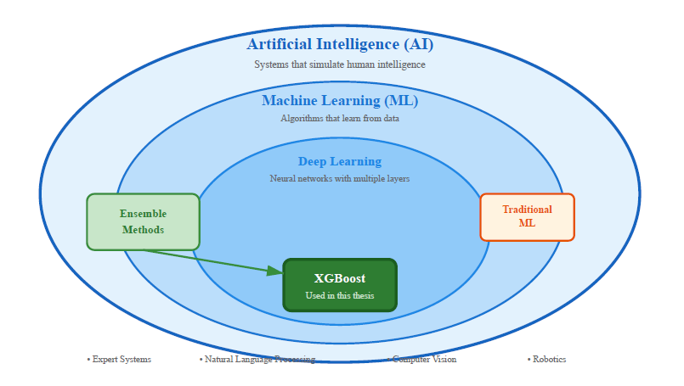
Figure 2.1: Artificial Intelligence and Its Subfields

2.3 Machine Learning
Machine Learning (ML) is a subfield of AI that focuses on algorithms that learn patterns from data instead of relying on manually designed rules (Russell & Norvig, 2020). Given examples of inputs and outputs, an ML algorithm estimates a mapping that generalizes new, unseen inputs. This data-driven paradigm is particularly useful when the true relationships between variables are complex and nonlinear.
In the context of emission modeling, national CO₂ emissions depend on multiple factors, including population, economic activity, energy consumption, energy mix, technology, and climate. These relationships are complex to specify analytically. ML methods can accommodate large numbers of input features and capture interactions among them, making them well-suited for modeling emissions from combined satellite and socio-economic indicators.
In this thesis, it is convenient to distinguish three broad families of machine-learning methods:
• Supervised learning: Models are trained on labelled pairs $(x,y)$, where each input vector is associated with a known target. The task is to learn a mapping that can predict y for new inputs.
• Unsupervised learning: These methods work with data that do not have an explicit target and instead search for structure in the inputs, such as clusters or low-dimensional representations. They are mainly helpful for exploratory analysis and are not used directly in the emission prediction models developed here.
• Reinforcement learning: An agent interacts repeatedly with an environment, receives rewards, and adapts its policy to maximize long-run cumulative reward. Such algorithms are designed for sequential decision-making problems and are therefore more relevant to control or policy optimization than to the static emission estimation problem addressed in this thesis.

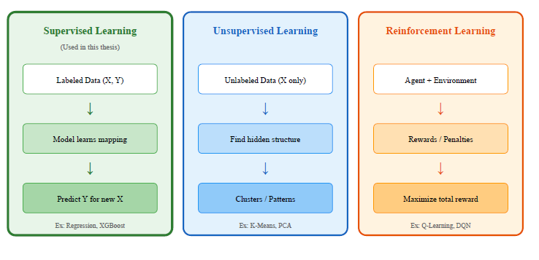
Figure 2.2: Types of Machine Learning

2.4 Supervised Learning in Detail
Because this thesis relies on supervised learning, it is useful to summarize the main steps of a standard supervised regression workflow:
- Data collection: assembling a dataset with input features (e.g., satellite-derived indicators, population density, basic economic variables) and a target variable (annual national CO₂ emissions) for historical periods.
- Preprocessing and feature engineering: handling missing values, aligning temporal and spatial resolutions, transforming variables where appropriate (e.g., logarithms), and constructing derived features that may improve predictive performance.
- Model training: selecting a regression algorithm (such as linear models, decision trees, random forests, or gradient-boosted trees) and fitting it on a training subset of the data by minimizing a loss function, typically the squared error.
- Validation and hyperparameter tuning: evaluating performance on validation data that are not used for parameter estimation, in order to tune hyperparameters and prevent overfitting.
- Testing and evaluation: assessing the final model on a held-out test set and computing metrics such as the coefficient of determination (R²), root mean squared error (RMSE), mean absolute error (MAE), and mean absolute percentage error (MAPE).
In this thesis, these steps are implemented on a GCC-wide panel of country–year observations, with a time-aware split that trains models on earlier years and tests them on later years to emulate an operational nowcasting setting.
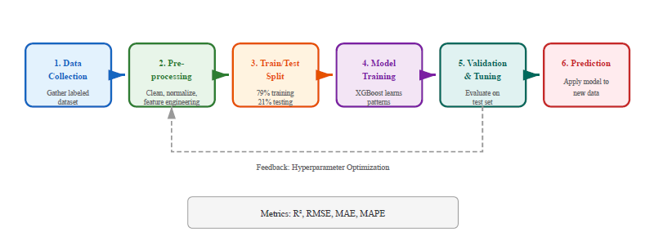
Figure 2.3: Supervised Learning Workflow

2.5 Deep Learning
Deep Learning is a subset of machine learning based on artificial neural networks with multiple hidden layers (Goodfellow et al., 2016). These networks consist of interconnected nodes organized in layers. Each node applies a simple mathematical operation (a weighted sum followed by a nonlinear activation function) to its inputs, and deeper layers progressively transform the data into more abstract representations.
Training a neural network involves adjusting its weights to minimize prediction error, typically using gradient-based optimization and backpropagation. Deep architectures can approximate highly complex functions and have achieved state-of-the-art performance in tasks such as image recognition, speech processing, and natural language understanding. However, deep learning models usually require large training datasets and substantial computational resources. They also involve many trainable parameters, which can lead to overfitting when the number of available examples is small. In this thesis, the dataset consists of 144 country–year observations, which is relatively modest. Under these conditions, high-capacity deep models are unlikely to generalize well, as they can easily memorize the training data rather than learn stable relationships.
For small to medium-sized tabular datasets, gradient-boosted decision trees such as XGBoost often outperform deep neural networks in practice. They provide strong predictive performance with fewer parameters and offer better robustness when data are limited and features are heterogeneous.

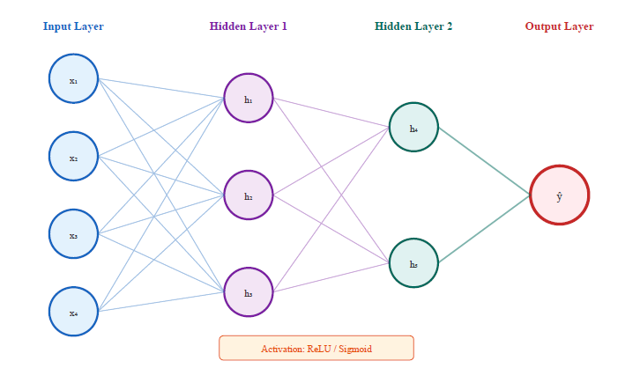
Figure 2.4: Neural Network Architecture
Table 2.1: Comparison of AI, ML, and DL
Aspect | Traditional AI | Machine Learning | Deep Learning
Learning Method | Rule-based, programmed | Learns from data | Learns hierarchical features
Data Requirement | Minimal | Moderate (100s-1000s) | Large (10,000s+)
Interpretability | High | Medium | Low (black box)
Example Algorithms | Expert systems | XGBoost, Random Forest | CNN, Transformers
Best For | Well-defined rules | Tabular data, limited samples | Images, text, large datasets
Source: Author's compilation based on Russell and Norvig (2020) and Goodfellow et al. (2016)

2.6 Ensemble Methods
Ensemble methods combine the predictions of multiple base models to obtain a final predictor that is typically more accurate and robust than any individual model (Chen & Guestrin, 2016). The intuition is that different models may capture different aspects of the data and aggregating them can reduce both bias and variance.
Three common ensemble strategies are:
Bagging (Bootstrap Aggregating): Multiple models are trained independently on different bootstrap resamples of the training data, and their predictions are averaged. Random forests are a prominent example of bagging applied to decision trees.
Boosting: Models are trained sequentially, where each new model focuses on the residual errors of the previous ensemble. The final prediction is a weighted sum of the individual learners. Gradient boosting and XGBoost belong to this family.
Stacking: Several heterogeneous base models are trained in parallel, and a meta-model learns how to combine their outputs.
Boosting is particularly relevant for the present thesis because it has shown strong performance on structured/tabular regression problems and can capture nonlinear interactions without requiring very large datasets.

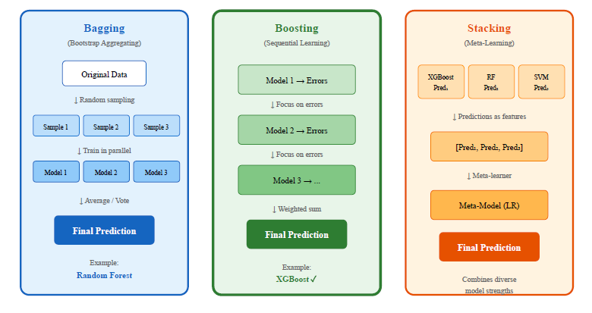
Figure 2.5: Ensemble Methods Comparison

2.7 The XGBoost Algorithm
XGBoost (Extreme Gradient Boosting) is an efficient and regularized implementation of gradient-boosted decision trees (Chen & Guestrin, 2016). It is widely used for structured data because it combines strong predictive performance with practical advantages:
- It handles heterogeneous feature types and missing values effectively.
- It incorporates regularization to control model complexity and reduce overfitting.
- It supports flexible objective functions and evaluation metrics.
- It provides feature importance measures that help interpret which variables contribute most to the predictions.
In this thesis, XGBoost is used as the core regression engine for three model configurations: an economic baseline model using only macroeconomic and demographic indicators, a hybrid model that combines satellite indicators with population density, and a satellite-only model that relies exclusively on Earth Observation proxies.
The choice of XGBoost is therefore aligned with the structure and size of the dataset and provides a good balance between accuracy, robustness, and interpretability.

2.8 Greenhouse Gas Emissions and Climate Policy
Carbon dioxide is the most important anthropogenic greenhouse gas. In 2022, global CO₂ emissions from fossil fuels and industry reached approximately 36.8 billion tonnes (Global Carbon Project, 2023). The largest sources are coal combustion for electricity (about 40%), oil for transportation (about 25%), and natural gas for heating and industry (about 20%).
The Paris Agreement, adopted in 2015, set the goal of limiting global warming to well below 2°C above pre-industrial levels, with efforts to limit it to 1.5°C. To achieve this, the IPCC (2023) estimates that global emissions need to fall by about 45% from 2010 levels by 2030 and reach net zero by 2050.
Countries submit Nationally Determined Contributions (NDCs) outlining their emission reduction targets. However, tracking progress toward these targets requires accurate, timely emission data. Currently, most national inventories are compiled annually with a 1–2-year delay, limiting the ability to assess whether policies are working.

2.9 The GCC Region: Energy Profile and Climate Commitments
The Gulf Cooperation Council comprises six countries: Saudi Arabia, United Arab Emirates, Qatar, Kuwait, Oman, and Bahrain. Together, they represent about 3% of global CO₂ emissions despite having less than 1% of world population. This disparity reflects their role as major oil and gas producers and their high per capita energy consumption.
The GCC region has a hot, arid climate with summer temperatures routinely exceeding 45°C in interior areas. This drives massive electricity demand for air conditioning, which can account for 60-70% of peak electricity load during summer months. Most electricity is generated from natural gas, making the cooling-emission link particularly strong.

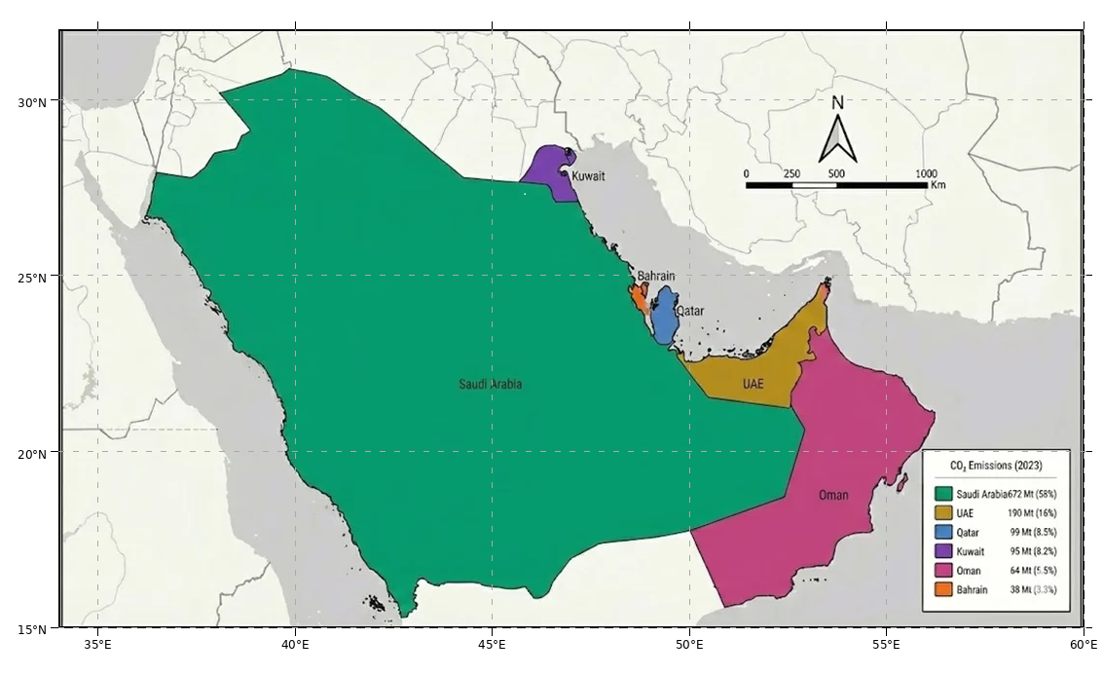
Figure 2.6: Map of the GCC Study Area

Table 2.2: GCC Countries Climate Targets and Emission Profiles
Country | 2023 CO₂ (Mt) | Per Capita (t) | NDC Target | Net Zero Goal
Saudi Arabia | 672 | 18.2 | 278 Mt reduction by 2030 | 2060
UAE | 190 | 19.3 | 31% reduction by 2030 | 2050
Qatar | 99 | 32.8 | 25% reduction by 2030 | -
Kuwait | 95 | 21.6 | 7.4% reduction by 2035 | -
Oman | 64 | 12.4 | 7% reduction by 2030 | 2050
Bahrain | 38 | 23.1 | 30% reduction by 2035 | 2060
Source: Global Carbon Project (2023), UNFCCC NDC Registry

All six GCC countries have submitted NDCs, and several have announced net zero targets. Saudi Arabia aims for net zero by 2060, while the UAE and Oman target 2050. These commitments create a need for improved emission monitoring capabilities.

2.10 Earth Observation for Environmental Monitoring
Earth observation satellites have revolutionized environmental monitoring. Since the launch of Landsat-1 in 1972, satellite sensors have provided increasingly detailed data on land cover, atmospheric composition, ocean conditions, and climate variables (NASA, 2024).
For carbon emission monitoring, satellites offer several potential advantages. First, they provide spatially continuous coverage, unlike ground-based monitoring networks that have gaps. Second, many satellite products are freely available, reducing the cost barrier for developing countries. Third, satellite data is typically available within days of acquisition, much faster than traditional emission inventories.
However, satellites measure physical quantities, not emissions directly. The challenge is to establish reliable relationships between observable variables (like surface temperature or night-time lights) and the underlying emission processes.

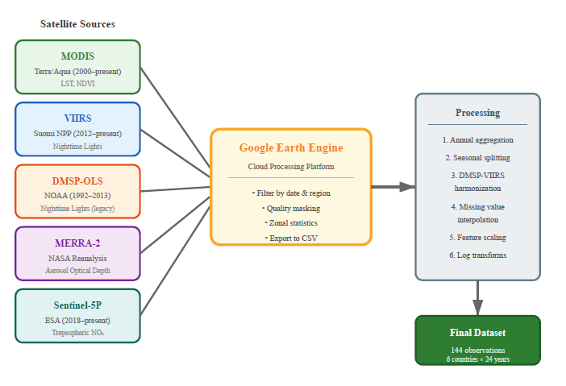
Figure 2.7: Satellite Data Sources and Processing Pipeline

2.11 Satellite Data Sources Used in This Study
This thesis uses five satellite-derived variables, each capturing different aspects of economic activity and energy consumption:
Land Surface Temperature (LST) from MODIS: The Moderate Resolution Imaging Spectroradiometer (MODIS) sensors aboard NASA's Terra and Aqua satellites have been providing LST data since 1999 and 2002 respectively. LST measures the radiative temperature of the Earth's surface using thermal infrared bands. This study utilizes the MOD11A2 product, which provides 8-day composite LST at 1 km resolution. The physical chain linking LST to emissions is straightforward: high temperatures drive air conditioning demand, which increases electricity consumption, which increases emissions. Assiri (2017) validated MODIS thermal data for Saudi Arabia, finding good agreement with ground measurements.
Vegetation Index (NDVI) from MODIS: The Normalized Difference Vegetation Index quantifies vegetation greenness by contrasting near-infrared and red reflectance. Values range from -1 to +1, with values above 0.3 typically indicating healthy vegetation. In the GCC context, natural vegetation is sparse, but irrigated agriculture requires significant energy for water pumping and desalination. The MOD13A2 product provides 16-day NDVI composites at 1 km resolution. Haq (2022) demonstrated 98% classification accuracy for agricultural land cover classification in Al-Qassim, Saudi Arabia, using Planet Scope nanosatellite imagery.
Night-time Lights (NTL) from DMSP-OLS and VIIRS: Night-time light imagery detects artificial lighting from cities, industrial facilities, and infrastructure. Two sensor systems provide this data: the Defense Meteorological Satellite Program (DMSP) Operational Linescan System (OLS) from 1992-2013, and the Visible Infrared Imaging Radiometer Suite (VIIRS) from 2012 onwards. Night-time lights strongly correlate with electricity consumption, GDP, and population density. The main challenge is harmonizing the two sensor records during the 2012-2013 overlap period.
Aerosol Optical Depth (AOD) from MERRA-2: NASA's Modern-Era Retrospective analysis for Research and Applications, Version 2 (MERRA-2) provides global reanalysis data including aerosol optical depth. AOD measures the extinction of sunlight by atmospheric particles. In industrial regions, high AOD can indicate combustion emissions. However, the GCC region has naturally high AOD due to desert dust, making interpretation more challenging (Kumar et al., 2018).
Nitrogen Dioxide (NO₂) from Sentinel-5P TROPOMI: The European Space Agency's Sentinel-5P satellite, launched in late 2018, carries the Tropospheric Monitoring Instrument (TROPOMI) which measures NO₂ column density at approximately 5.5 km resolution. NO₂ is a short-lived pollutant concentrated near combustion sources, making it a useful tracer for vehicle and power plant emissions. High accuracy has been demonstrated in predicting air pollution for Saudi cities using Sentinel-5P data (Alkayal et al., 2025).
Table 2.3: Satellite Sensors and Products Used in This Study
Variable | Sensor/Product | Resolution | Coverage | Physical Meaning
LST | MODIS MOD11A2 | 1 km, 8-day | 2000-present | Thermal emission → cooling demand
NDVI | MODIS MOD13A2 | 1 km, 16-day | 2000-present | Vegetation greenness → agricultural activity
NTL | DMSP-OLS / VIIRS | ~750 m | 1992-present | Artificial light → urbanization, economic activity
AOD | MERRA-2 | ~50 km | 1980-present | Aerosol loading → combustion + dust
NO₂ | Sentinel-5P TROPOMI | 5.5 km, daily | 2019-present | Tropospheric NO₂ → combustion tracer

2.12 Machine Learning for Emission Estimation
Machine learning offers powerful tools for discovering relationships between satellite observations and emissions. Unlike traditional statistical models that require explicit specification of functional forms, machine learning algorithms can automatically learn complex, nonlinear patterns from data.
Several studies have applied machine learning to emission estimation. Nassef et al. (2023) compared Feed-Forward Neural Networks (FFNN), Adaptive Neuro-Fuzzy Inference Systems (ANFIS), and Long Short-Term Memory (LSTM) networks for CO₂ prediction in Saudi Arabia, achieving R² values up to 0.99 using economic predictors. Alamri and Khan (2023) applied N-BEATS and Transformer architectures for emission forecasting, finding that advanced deep learning models did not necessarily outperform simpler approaches when data is limited.
For this thesis, XGBoost (Extreme Gradient Boosting) was selected for several reasons. First, it handles tabular data efficiently and is known to perform well on structured datasets with limited samples. Second, it provides feature importance scores that help interpret which satellite indicators contribute most to predictions. Third, it is computationally efficient and does not require GPU resources. Fourth, it has fewer hyperparameters than deep learning models, reducing the risk of overfitting with limited data.

2.13 XGBoost: Mathematical Formulation
XGBoost, introduced by Chen and Guestrin (2016), is an optimized implementation of gradient boosted decision trees. The key idea is to build an ensemble of weak learners (decision trees) sequentially, where each new tree corrects the errors of the previous ensemble.
The algorithm minimizes a regularized objective function:
L(θ) = Σᵢ l(yᵢ, ŷᵢ) + Σₖ Ω(fₖ) (2.1)
where l is a differentiable loss function and Ω is a regularization term
The regularization term Ω penalizes model complexity by including the number of leaves and the magnitude of leaf weights. This helps prevent overfitting, which is particularly important when working with limited data.
For regression tasks like emission prediction, XGBoost typically uses squared error loss. Each tree is fit to the negative gradient of the loss (the residuals from the current ensemble), and predictions are made by summing the outputs of all trees.

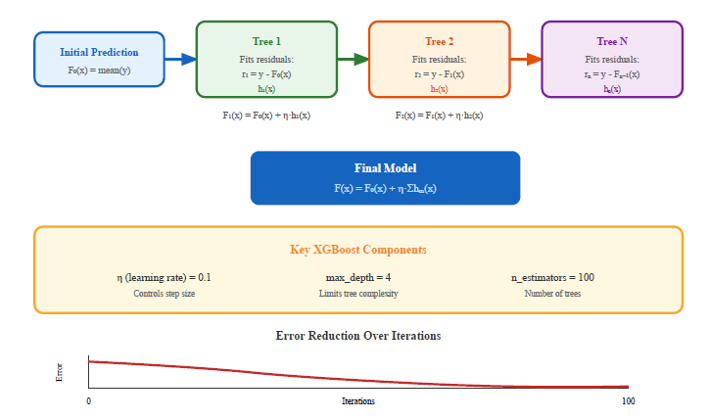
Figure 2.8: XGBoost Sequential Tree Building Process
Key hyperparameters include n_estimators (number of trees), max_depth (maximum tree depth), learning_rate (shrinkage factor applied to each tree), and min_child_weight (minimum sum of instance weights in a leaf). These parameters control the trade-off between model expressiveness and overfitting risk.

2.14 Explainable AI for Tree-Based Models
In recent years, explainable artificial intelligence (XAI) has emerged as an important complement to purely predictive machine learning models. The central idea is that models used to support policy or high-stakes decisions should not only be accurate, but also transparent enough for domain experts to understand why specific predictions are made. In the context of environmental applications, interpretability is particularly valuable: it helps verify that models rely on physically meaningful relationships rather than spurious correlations, and it allows policymakers to trace how changes in drivers such as energy use, urbanization, or climate conditions affect estimated emissions.
For tree-based ensemble methods such as XGBoost, several families of explanation techniques are available. At the global level, feature importance measures summarize how much each input variable contributes to the overall reduction in prediction error across all trees in the ensemble. These scores can be used to rank variables and to check whether the most influential predictors are consistent with domain knowledge. At the local level, instance-level methods such as Shapley-value-based explanations can attribute a single prediction to contributions from each individual feature, but they require additional computation and are more sensitive to sampling noise when the dataset is small.
Given the size and structure of the dataset in this thesis (144 country–year observations with heterogeneous features), the analysis focuses on global explanations derived from XGBoost feature importance. This choice provides a pragmatic balance between interpretability and robustness: it allows the study to answer whether satellite-derived indicators such as land surface temperature or night-time lights behave as expected in aggregate, while avoiding over-interpretation of noisy, instance-level patterns that the data volume cannot reliably support. Local XAI methods are therefore treated as an avenue for future work rather than as a core component of the present analysis.

Chapter 3 Related Work

3.1 Introduction
This chapter reviews the literature on AI-based emission forecasting and satellite-based carbon monitoring. The objective is to identify what has been accomplished, which approaches have proven effective, and where gaps remain that this thesis can address.
A systematic literature search was conducted covering publications from 2021 to 2025, focusing on three themes: machine learning methods for CO₂ prediction, satellite-based emissions monitoring, and applications in the Gulf region. A total of 13 key studies were identified through a systematic review, comprising 7 AI/ML forecasting studies and 6 satellite monitoring studies. These studies demonstrate the growing integration of machine learning with satellite observations for enhanced carbon monitoring capabilities.

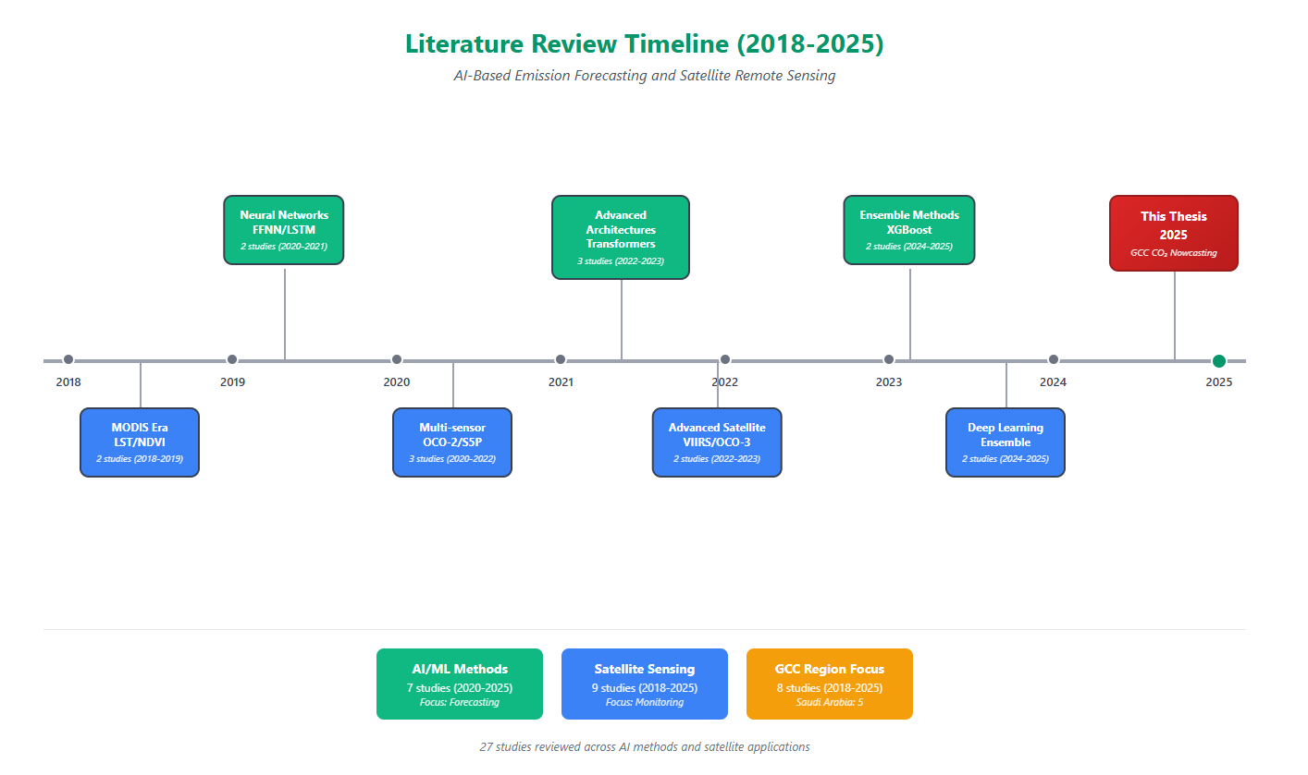
Figure 3.1: Literature Review Timeline (2016-2025)

3.2 AI-Based Emission Forecasting
The application of machine learning to carbon emission prediction has grown rapidly in recent years. Early work focused on simple regression models, but recent studies have explored increasingly sophisticated approaches.
Nassef et al. (2023) developed an AI-based prediction system for CO₂ emissions in Saudi Arabia using three algorithms: FFNN, ANFIS, and LSTM. Using economic predictors including GDP, population, energy consumption, and vehicle registrations, they achieved R² values ranging from 0.97 to 0.99. Their FFNN model performed best, demonstrating that simpler architecture can outperform complex ones when data is limited. However, their approach relies on economic data with the same one-to-two-year reporting lag that this thesis aims to overcome.
Rahman et al. (2023) applied Decision Tree Regression to CO₂ prediction based on fossil fuel consumption. Their model achieved R² = 0.99 on historical data, but the study noted sensitivity to consumption data quality and availability. Meng and Noman (2022) analyzed the impact of COVID-19 on global CO₂ emissions using machine learning, finding that pandemic-related disruptions created anomalies that challenge traditional forecasting approaches.
Alamri and Khan (2023) compared N-BEATS and Transformer architectures for emission forecasting. Despite their theoretical advantages for sequential data, these deep learning models did not consistently outperform simpler baselines, likely due to limited training data. This finding supports the decision to use XGBoost rather than deep learning for this thesis.
Recently, Alcibahy et al. (2025) demonstrated the effectiveness of XGBoost for downscaling satellite CO2 observations over the Arabian Peninsula. Their ensemble approach, integrating MODIS LST, OCO-2, Sentinel-5P, and ERA-5 data, achieved exceptional performance (R² = 0.98, RMSE = 0.58 ppm) at 1 km resolution. This validates the proposed methodology's feasibility for combining gradient boosting with multi-source satellite data in GCC arid environments.
Begum and Al Mobin (2025) conducted a comparative analysis of ensemble ML methods for emissions forecasting across 11 major emitters, including Saudi Arabia. Their study, which used XGBoost, SVR, and Gradient Boosting with Sequential Squeeze Feature Selection, achieved an average accuracy of 96.21%. Notably, projections indicate Saudi Arabia's emissions may increase by 16.62% by 2030 rather than decrease, highlighting the urgency of enhanced monitoring frameworks.
Han et al. (2023) explored hybrid LSTM-CNN architectures for provincial emissions prediction in China, achieving R² = 0.97 with spatial autocorrelation weighting. While deep learning approaches demonstrate strong performance with large datasets, gradient boosting methods like XGBoost offer advantages for limited temporal data scenarios (144 observations in this study) due to lower risk of overfitting and superior interpretability.
Fonseca and Francis (2023) established baseline CO2 variability patterns across the Middle East using 9 years of OCO-2/OCO-3 observations (2014-2023). Their analysis revealed seasonal XCO2 amplitude of 3-8 ppmv over the Arabian Peninsula with UAE trends of 2.50 ppmv/year. These regional patterns provide essential validation benchmarks for GCC forecasting models.
Xu et al. (2023) demonstrated NPP-VIIRS nighttime light data as an effective proxy for anthropogenic CO2 emissions at pixel scale. This approach, already integrated in the proposed framework through VIIRS DNB data, provides complementary information to direct atmospheric CO2 measurements for identifying emission hotspots in urbanized GCC regions.

Table 3.1: Summary of AI-Based Emission Forecasting Studies
Authors | Method | Region | Best R² | Data Type
Nassef et al. (2023) | FFNN, ANFIS, LSTM | Saudi Arabia | 0.99 | Economic
Rahman et al. (2023) | Bagged DT | Saudi Arabia | 0.90 | Economic
Alamri and Khan (2023) | N-BEATS, Transformer | Multiple | 0.95 | Economic
Meng and Noman (2022) | SARIMAX | Global | N/A (MAPE: 0.09) | Economic
Alcibahy et al. (2025) | XGBoost, RF, SVM | Arabian Peninsula | 0.98 | MODIS, OCO-2, S5P
Begum and Al Mobin (2025) | XGBoost, SVR, GB | Saudi Arabia | 96.21% | Economic data
Han et al. (2023) | LSTM-CNN | China | 0.97 | Historical

3.3 Satellite-Based Carbon Monitoring
A parallel line of research has been explored using satellite data for carbon emission monitoring. These studies fall into two categories: direct measurement of atmospheric CO₂ concentrations, and indirect estimation using proxy variables.
Direct measurement approaches use specialized satellites like NASA's OCO-2 (Orbiting Carbon Observatory-2). Mustafa et al. (2021) estimated regional anthropogenic CO₂ emissions over East and West Asia using neural networks trained on OCO-2 data. Alcibahy et al. (2025) extended this work to the Arabian Peninsula, combining OCO-2 CO₂ with Sentinel-5P methane data. Their XGBoost model achieved strong performance, demonstrating the value of multi-sensor fusion.
Indirect approaches use satellite observations as proxies for emission-generating activities. Lin et al. (2023) developed machine learning methods to estimate power plant CO₂ emissions from satellite observations of plumes. Rowley and Karakuş (2023) created AQNet, which predicts air quality from satellite imagery. Persello et al. (2022) reviewed deep learning applications for sustainable development goals, noting the potential for satellite data to support environmental monitoring.
For land-based applications, Mallick et al. (2022) used remote sensing to estimate carbon stocks in Saudi Arabian landscapes. Madugundu et al. (2018) combined remote sensing with soil sampling to estimate carbon in agricultural areas. These studies demonstrate the feasibility of satellite-based carbon assessment in the GCC region, though they focus on carbon stocks rather than emissions.
Table 3.2: Summary of Satellite-Based Carbon Monitoring Studies
Authors | Satellite Data | Region | Approach | Application
Mustafa et al. (2021) | OCO-2 | East/West Asia | Neural Network | CO₂ estimation
Alcibahy et al. (2025) | OCO-2, Sentinel-5P | Arabian Peninsula | XGBoost | CO₂, CH₄ estimation
Lin et al. (2023) | Multiple | Global | ML ensemble | Power plant emissions
Rowley and Karakuş (2023) | Multiple | Urban areas | Deep learning | Air quality
Fonseca and Francis (2024) | OCO-2, OCO-3 | Middle East | Trend analysis | Regional variability
Xu et al. (2023) | NPP-VIIRS NTL | China | Nighttime light | Urban emissions

3.4 Regional Studies in the GCC
Several studies have specifically addressed environmental monitoring in the GCC region, though few have focused on estimating CO₂ emissions.
Assiri (2017) validated MODIS thermal data for land surface temperature analysis in Saudi Arabia, finding good agreement with ground measurements across different land cover types. This supports the use of MODIS LST as a reliable proxy for thermal conditions in the region.
Haq (2022) achieved 98% classification accuracy for agricultural vegetation classification in Al-Qassim region using Planet Scope nanosatellite imagery with machine learning classifiers. Addas et al. (2020) analyzed urban heat islands in Jeddah using satellite data, finding significant temperature differences between urban and surrounding areas.
Hammam and Mohamed (2020) mapped soil salinity in the East Nile Delta using several methodological approaches of salinity assessment. High accuracy has been demonstrated in predicting air pollution for three Saudi cities using Sentinel-5P data and deep learning (Alkayal et al., 2025).
For carbon-related applications, Emadi et al. (2020) applied stacked machine learning models for soil property prediction in arid regions, demonstrating the feasibility of ensemble approaches. Tan et al. (2024) employed K-means clustering to group Chinese regions by emission characteristics, demonstrating that regional clustering combined with satellite XCO₂ data improved carbon estimation accuracy.

3.5 Research Gaps and Contributions
The literature review reveals several gaps that this thesis addresses:
- Most AI-based emission forecasting studies rely on economic indicators with 1–2-year reporting lags. Few have explored satellite data as an alternative input source.
- Satellite-based carbon monitoring studies typically focus on global scales or individual facilities. National-level estimation for specific regions like the GCC remains underexplored.
- The trade-off between accuracy and data timeliness has not been explicitly quantified. Studies report high accuracy with economic data but do not compare satellite-based alternatives.
- Regional validation for the GCC climate context is limited. Most satellite-emission relationships were developed for temperate regions and may not transfer directly.
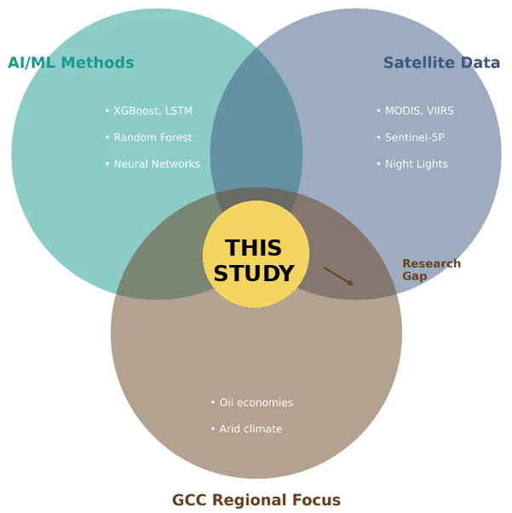
Figure 3.2: Research Gap Analysis Diagram

This thesis contributes to filling these gaps by developing a satellite-based framework specifically validated for the GCC region, explicitly comparing economic and satellite-based approaches to quantify the accuracy-timeliness trade-off, and providing interpretable feature importance analysis that validates the physical basis of satellite-emission relationships in hot, arid climates.

Chapter 4 Proposed Approach

4.1 Introduction
This chapter presents the methodological framework developed to estimate national CO₂ emissions for the Gulf Cooperation Council (GCC) countries using satellite-derived indicators. The approach integrates multi-sensor satellite observations with machine learning to produce near-real-time emission estimates that complement conventional inventory-based statistics.
The proposed framework is designed to answer a specific question: to what extent can satellite data, available with a delay of days to weeks, approximate official national emission totals that typically become available only after a lag of 12–24 months? The chapter therefore focuses on the construction of the dataset, the design of the models, and the evaluation strategy used to quantify the trade-off between accuracy and timeliness.

4.2 Research Design Overview
The study follows a quantitative, comparative research design with three main components.
First, a unified panel dataset was assembled that combines official national CO₂ emission statistics with satellite-derived environmental indicators for all six GCC countries over the period 2000–2023. The emission time series is taken from the Global Carbon Project, as compiled by Our World in Data (2023), and are aligned with annual aggregates derived from multiple satellite products.
Second, three regression models based on Extreme Gradient Boosting (XGBoost) (Chen & Guestrin, 2016) were trained and compared: an economic baseline model using conventional economic and energy indicators (Model A); a hybrid model combining satellite indicators with population density (Model B); and a satellite-only model using only remotely sensed variables (Model C).
Third, model performance, feature importance, and error patterns were analyzed on a temporally held-out test period (2019–2023) to characterize the strengths and limitations of satellite-based estimation in the GCC context.
Before fixing the final research design, several preliminary experiments were carried out to understand how far back in time the analysis could be extended and whether a single-country or multi-country setup was more appropriate. Using the same OWID/Global Carbon Project and World Bank–type statistics, exploratory models were first estimated for longer historical windows that reached back into the 1980s and 1990s and focused only on Saudi Arabia. These longer windows increased the nominal sample size but also exposed several issues: reporting conventions change in the early part of the series, documentation for some economic indicators is less complete, and the resulting models were noticeably more sensitive to the exact train–test split. In practice, models calibrated in the very early years tended to show high in-sample fit but less stable performance when evaluated in recent years.
To avoid building conclusions on unstable segments of the historical record, the final study therefore restricts the analysis window to 2000–2023. From 2000 onwards, the emission and economic series are better documented and, crucially, most of the satellite products used in this thesis are consistently available. MODIS LST and NDVI start around 2000, VIIRS night-time lights become usable after inter-calibration with DMSP-OLS, and MERRA-2 aerosol products are fully available over the study region. Sentinel-5P NO₂ is only available from late 2018 onwards and is therefore treated as an auxiliary variable with partial coverage rather than as a core driver. Limiting the window to 2000–2023 still yields 144 country–year observations across the six GCC countries, which is a reasonable compromise between data quality, temporal coverage, and model complexity.
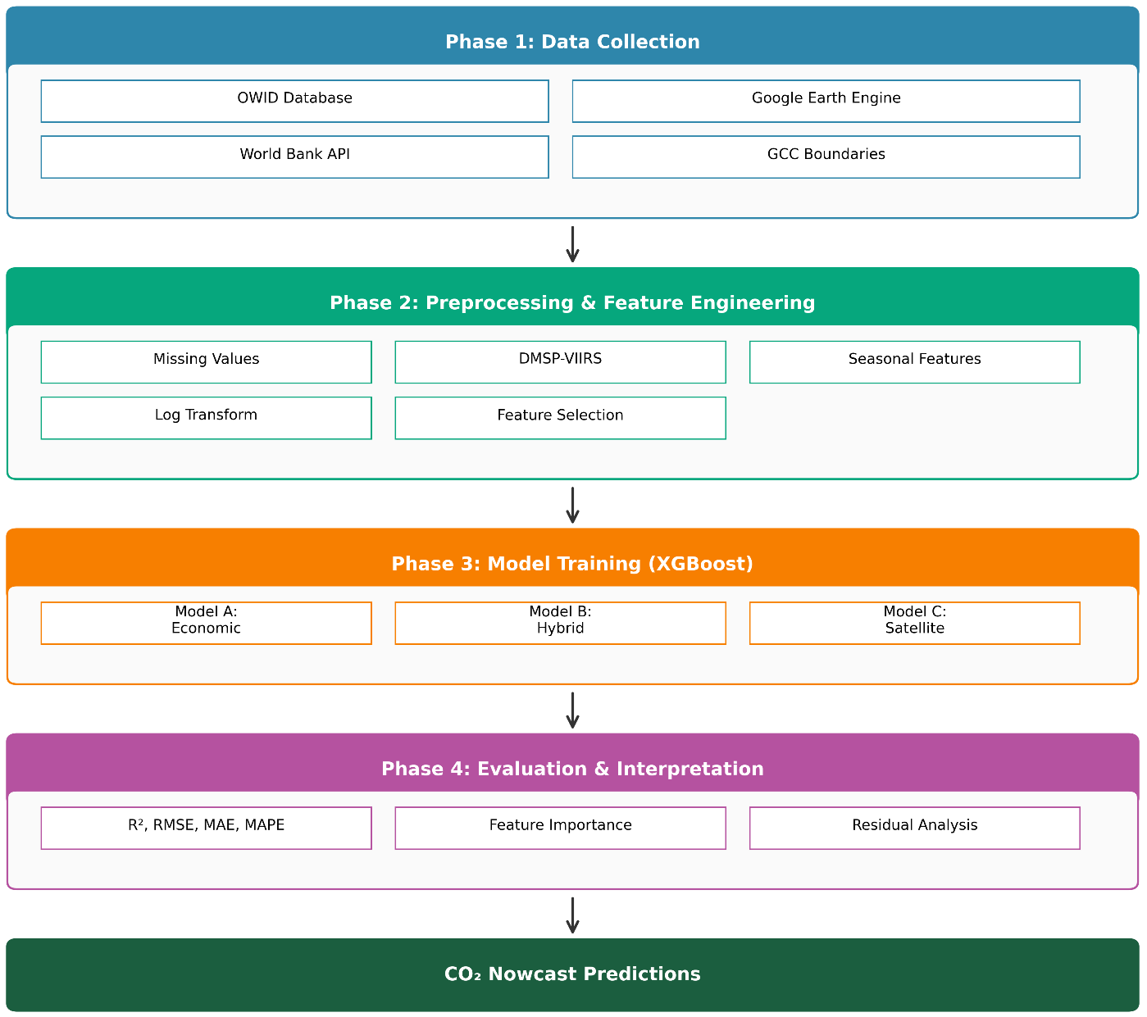
Figure 4.1: Research Framework Architecture
The choice of XGBoost (Chen & Guestrin, 2016) over deep learning architectures is deliberate. With only 144 observations (6 countries × 24 years), the dataset is too small for data-hungry deep learning models without incurring substantial overfitting risk. XGBoost provides built-in regularization, handles non-linear relationships and interactions effectively, and produces feature-important measures that support interpretation. These properties make it suitable for tabular datasets of limited size.
From a modelling perspective, the 144 observations are treated as a pooled country–year panel. A single XGBoost model is estimated across all six GCC countries, without country-specific fixed or random effects. The objective is purely predictive – to generate accurate nowcasts of national CO₂ emissions – rather than to identify causal, country-level parameter estimates.

4.3 Study Area: The GCC Region
The study covers all six Gulf Cooperation Council countries: Saudi Arabia, the United Arab Emirates (UAE), Qatar, Kuwait, Oman, and Bahrain. Together, these countries occupy approximately 2.57 million km² of the Arabian Peninsula and had a combined population of about 58.8 million in 2023.
Table 4.1 summarizes key characteristics of the study area, including land area, population, estimated CO₂ emissions, and typical summer temperature ranges.
Table 4.1: Study Area Overview - Six GCC Countries
Country | Area (km²) | Population (M) | 2023 CO₂ (Mt) | Climate | Summer Temp (°C)
Saudi Arabia | 2,149,690 | 36.4 | 672 | Arid/Semi-arid | 42-50
UAE | 83,600 | 9.4 | 190 | Arid | 40-48
Qatar | 11,586 | 2.7 | 99 | Arid | 40-46
Kuwait | 17,818 | 4.3 | 95 | Arid | 42-50
Oman | 309,500 | 4.5 | 64 | Arid/Tropical | 38-45
Bahrain | 780 | 1.5 | 38 | Arid | 38-42
GCC Total | 2,572,974 | 58.8 | 1,158 | - | -
Source: World Bank, Global Carbon Project (2023), national statistics offices

Figure 4.2: GCC CO₂ Emissions Distribution by Country (2023)
The GCC region is characterized by a predominantly hot and arid climate, with summer temperatures frequently exceeding 45°C in interior areas. This climate pattern generates a pronounced seasonal cycle in electricity demand, driven largely by air conditioning. In many GCC systems, summer peak electricity demand is roughly 2–3 times higher than winter demand, and this seasonal pattern is reflected in emissions from power generation. The proposed framework explicitly exploits this link between thermal conditions and emissions through seasonal land surface temperature (LST) features.

4.4 Data Sources and Collection
The empirical analysis relies on two main data streams: national CO₂ emission records and environmental indicators derived from both economic statistics and satellite observations.

4.4.1 Emission Data
Annual national CO₂ emission data were obtained from Our World in Data (OWID), which compiles statistics from the Global Carbon Project (2023). The study uses total territorial CO₂ emissions (including land-use change) for each GCC country over 1965–2023, expressed in million tons (Mt) of CO₂.
The harmonized emission series was stored in a pre-processed GCC emissions dataset. Although the underlying data are available from 1965 onwards, the empirical analysis in this thesis is restricted to the period 2000–2023 to ensure consistency with the temporal coverage of the satellite products.

4.4.2 Economic and Demographic Data
For the economic baseline model (Model A), the following indicators were extracted from the same OWID database, which itself aggregates World Bank–type statistical sources:
- Gross Domestic Product (GDP) in constant 2015 USD
- Population (annual estimates)
- Primary energy consumption (terawatt-hours)
- Energy per capita (primary energy divided by population)
- CO₂ intensity (emissions per unit of GDP)
These indicators are stored in the same gcc_emissions_preprocessed_1965_2023.csv file, with consistent country and year keys, facilitating direct merging with the emission time series.

4.4.3 Satellite Data
Satellite observations were extracted using Google Earth Engine (GEE), which provides access to multiple global image collections, including MODIS, VIIRS, MERRA-2, and Sentinel-5P (Assiri, 2017; Elvidge et al., 2009; European Space Agency, 2024).
After processing, the aggregated satellite indicators were stored in a separate seasonal satellite dataset, which was later merged with the emissions and economic data to form the final analysis panel.
Table 4.2 summarizes the main data sources and their temporal coverage.
Table 4.2: Data Sources and Temporal Coverage
Data Type | Source | Coverage | File Name
CO₂ Emissions | Our World in Data / Global Carbon Project (2023) | 1965–2023 | Pre-processed GCC emissions dataset
Economic Indicators | Our World in Data / World Bank | 1965–2023 | Pre-processed GCC emissions dataset
Satellite Features | Google Earth Engine (multiple products) | 2000–2023 | Seasonal satellite indicators dataset

After merging the emission and satellite files on the (country, year) key, the final analysis dataset consists of 144 observations (6 countries × 24 years).

4.5 Satellite Data Extraction Pipeline
The satellite data extraction pipeline was implemented in Google Earth Engine (GEE). GEE organizes imagery into Image Collections, which are time series of images with consistent metadata. For each variable, an appropriate collection was selected, accompanied by band selection, scale factors, and quality masks.

4.5.1 Google Earth Engine Image Collections
Table 4.3 lists the main GEE collections used in this thesis, together with the bands and scale factors applied. MODIS land surface temperature products, which have been validated for Saudi Arabia (Assiri, 2017), provide the core thermal indicators, while VIIRS night-time lights, MERRA-2 aerosol optical depth, and Sentinel-5P NO₂ capture anthropogenic activity and atmospheric composition (Elvidge et al., 2009; European Space Agency, 2024).
Table 4.3: Google Earth Engine Image Collections Used
Variable | GEE Collection ID | Band Used | Scale Factor | Unit
LST Day | MODIS/061/MOD11A2 | LST_Day_1km | 0.02 | Kelvin
LST Night | MODIS/061/MOD11A2 | LST_Night_1km | 0.02 | Kelvin
NDVI | MODIS/061/MOD13A2 | NDVI | 0.0001 | Index (-1 to 1)
NTL | NOAA/VIIRS/DNB/MONTHLY_V1/VCMSLCFG | avg_rad | 1.0 | nW/cm²/sr
AOD | NASA/GSFC/MERRA/aer/2 | TOTEXTTAU | 1.0 | Dimensionless
NO₂ | COPERNICUS/S5P/OFFL/L3_NO2 | tropospheric_NO2_column_number_density | 1.0 | mol/m²
Note: DMSP-OLS data (1992–2013) were handled separately and inter-calibrated with VIIRS night-time lights (Elvidge et al., 2009).
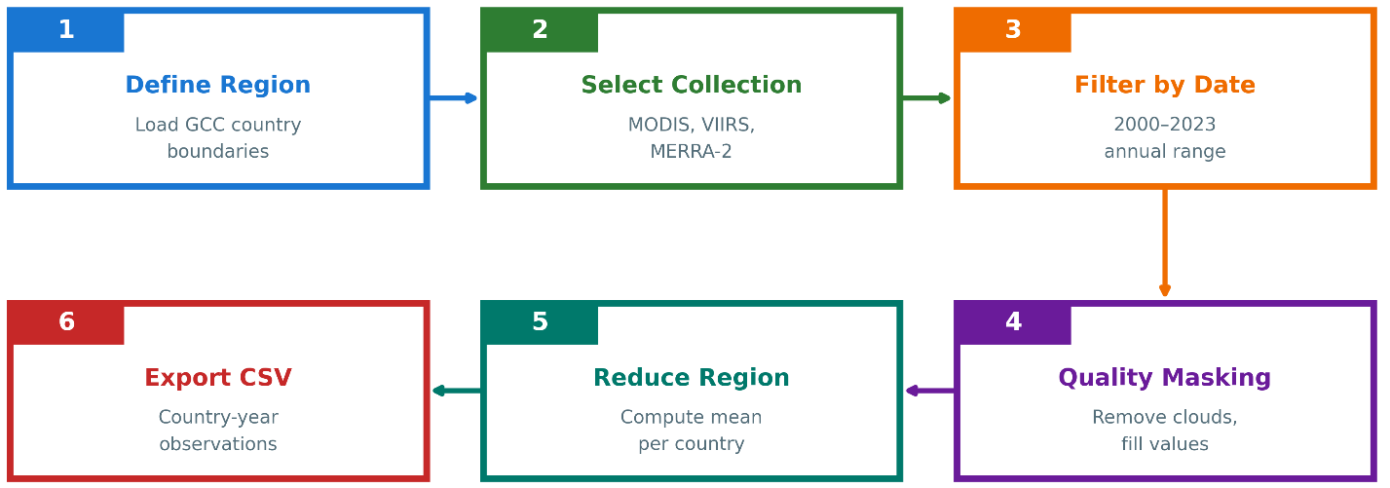
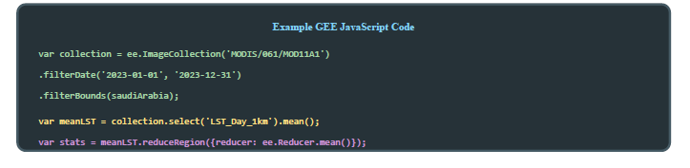
Figure 4.3: Google Earth Engine Data Extraction Workflow

4.5.2 Extraction Workflow
For each country and year, the following steps were applied in GEE:
- Step 1 – Define Country Boundaries: Country boundaries were taken from the FAO GAUL dataset available in GEE. Each GCC country is represented as a polygon feature.
- Step 2 – Filter Image Collection: For each variable, the relevant Image Collection was filtered by spatial extent (country polygon) and temporal window. Annual variables use the full calendar year (1 January to 31 December), whereas seasonal variables use specific month ranges.
- Step 3 – Apply Quality Filters: Quality assurance (QA) flags were used to mask low-quality pixels. For MODIS LST, pixels flagged as cloud-contaminated or low-accuracy in the LST_QC band were excluded. For Sentinel-5P NO₂, only pixels with qa_value > 0.5 were retained (European Space Agency, 2024).
- Step 4 – Temporal Aggregation: After QA masking, the collection was reduced temporally using the mean reducer to produce a single composite image per country-year (or country-season).
- Step 5 – Spatial Aggregation: The composite image was then reduced over the country polygon using reduce Region with a mean reducer, yielding one value per variable, per country, per year.
- Step 6 – Export Results: The aggregated values were exported to a CSV file with columns for country, year, and each satellite feature.
Table 4.4 summarizes the most important extraction parameters.
Table 4.4: Satellite Feature Extraction Parameters
Variable | Temporal Filter | Quality Mask | Reducer | Output
LST_Summer | June-August | LST_QC < 65 | Mean | °C (converted)
LST_Winter | Dec-Feb | LST_QC < 65 | Mean | °C (converted)
NDVI_Spring | March-May | Pixel reliability ≤ 1 | Mean | Index
NTL_Annual | Full year | 0 < radiance < 1000 | Mean | nW/cm²/sr
AOD_Annual | Full year | Valid flag | Mean | Dimensionless
NO2_Annual | Full year | qa_value > 0.5 | Mean | mol/m²

4.5.3 Handling the DMSP–VIIRS Transition
Night-time lights are observed by two different systems. The DMSP-OLS series provides yearly composites for 1992–2013, while VIIRS offers monthly radiance data from 2012 onwards (Elvidge et al., 2009). To obtain a consistent time series for 2000–2023, an inter-calibration procedure was applied:
- Estimate a regression relationship between DMSP digital numbers and VIIRS radiance during the overlap period 2012–2013.
- Use the calibration coefficients to convert all pre-2012 DMSP values into VIIRS-equivalent radiance.
- Construct a continuous series using calibrated DMSP for 2000–2011, the average of both sensors for 2012–2013, and VIIRS alone from 2014 onwards.

4.5.4 Missing Data Handling
Satellite records are subject to data gaps arising from sensor issues, cloud cover, and incomplete temporal coverage. The Sentinel-5P NO₂ product is particularly affected because the mission began only in late 2018 (European Space Agency, 2024).
Table 4.5: Missing Data Summary
Variable | Missing Count | Missing % | Reason
NO2_Signal | 114 | 79.2% | Sentinel-5P available only after 2018
primary_energy_consumption | 1 | 0.7% | Reporting gap
All other variables | 0 | 0% | –

For Models B and C, missing NO₂ values prior to 2019 were imputed using median values. Subsequent feature importance analysis showed that NO₂ contributed only modestly to predictive performance (around 4.1% of total importance), which is consistent with the short effective record length.

4.6 Feature Engineering and Preprocessing
Feature engineering focused on aligning the satellite indicators with emission-relevant processes in the GCC and on stabilizing the statistical properties of the variables before model training.

4.6.1 Seasonal Disaggregation of Temperature
Initial tests using annual mean LST exhibited relatively weak correlation with CO₂ emissions. In the GCC, emissions from electricity generation are driven primarily by cooling demand in the hot season rather than by heating in winter. To capture this asymmetry, LST was disaggregated into seasonal components: LST_Summer_C (mean land surface temperature over June–August) and LST_Winter_C (mean land surface temperature over December–February). In addition, NDVI was aggregated over March–May to capture the main vegetation growth period and associated agricultural activity. Table 4.6 summarizes the aggregation windows and their rationale.
Table 4.6: Seasonal Aggregation Windows
Feature | Months | Rationale
LST_Summer_C | June–August | Peak cooling season; temperatures often 45–50°C; drives AC demand
LST_Winter_C | December–February | Baseline thermal conditions; minimal heating in GCC
NDVI_Spring | March–May | Vegetation growth period; captures agricultural activity

Figure 4.4: Seasonal Land Surface Temperature Pattern

4.6.2 Population Density Transformation
Population density varies substantially across the GCC, from roughly 12 people/km² in Oman to more than 1,700 people/km² in Bahrain. This high skew can affect tree-based models and error metrics. To stabilize the distribution, population density was transformed using a base-10 logarithm:

log_pop_density = log₁₀(population / land_area) (4.1)
This transformation converts multiplicative differences into additive ones and reduces the impact of extremely dense observations on the model.

4.6.3 Final Feature Set
After feature engineering, the models use the input variables listed in Table 4.7. Model A represents a purely economic baseline. Model B combines satellite variables with population density. Model C uses only satellite features to assess the standalone predictive power of remote sensing.
Table 4.7: Final Feature Set for Each Model
Model | Feature Category | Variables
Model A (Economic) | Economic + Demographic | GDP, population, energy_consumption, energy_per_capita, CO₂_intensity
Model B (Hybrid) | Satellite + Demographic | LST_Summer_C, LST_Winter_C, NDVI_Spring, Night_Lights, AOD_Annual, log_pop_density
Model C (Satellite-only) | Satellite Only | LST_Summer_C, LST_Winter_C, NDVI_Spring, Night_Lights, AOD_Annual

4.6.4 Correlation Analysis
Before model training, Pearson correlations between each feature and CO₂ emissions were computed to obtain a first indication of explanatory power:
- LST_Summer_C: r ≈ 0.58 (moderate positive correlation)
- Night_Lights: r ≈ 0.61 (strongest satellite correlation)
- log_pop_density: r ≈ 0.55 (demographic effect)
- NDVI_Spring: r ≈ 0.22 (weak correlation)
- AOD_Annual: r ≈ 0.18 (weak correlation, partly confounded by dust)

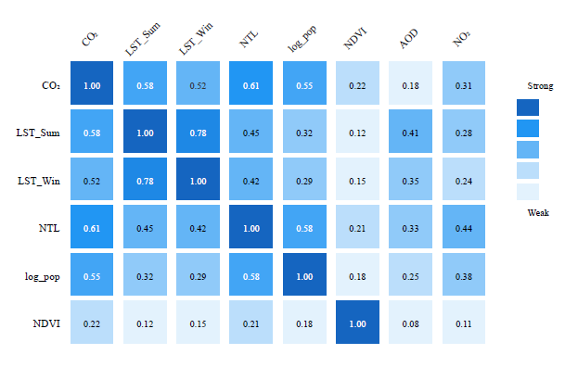
Figure 4.5: Feature Correlation Matrix
These correlations informed model design but were not used for pre-selection or manual pruning; all features were retained for XGBoost, which incorporates its own regularization and feature selection (Chen & Guestrin, 2016).

4.7 Experimental Design: Three-Model Comparison
The experimental design compares three models to quantify the trade-off between accuracy and data latency.
Table 4.8: Three-Model Experimental Design
Model | Input Features | Purpose | Data Latency | Baseline?
A | Economic indicators | Accuracy benchmark | 12–24 months | Yes
B | Satellite + log_pop_density | Practical nowcasting | Days | No
C | Satellite only | Pure satellite capability | Days | No

Model A approximates the best achievable accuracy using traditional economic and energy statistics, which are subject to reporting delays. Models B and C use only variables that can be derived from satellite data and population estimates available with much shorter latency. Comparing Model A to Models B and C therefore quantifies the accuracy cost of switching from lagged but information-rich inputs to near-real-time satellite proxies.
Several alternative model configurations were also explored during the development phase. These included purely economic models calibrated on longer historical windows, as well as experimental hybrids that mixed economic and satellite features in a single specification. While these variants sometimes improved the apparent in-sample fit, they did not consistently outperform the three final configurations when evaluated on the temporally held-out test period (2019–2023). The design summarized in Table 4.8 was therefore chosen to make the comparison between “inventory-driven” (Model A) and “satellite-driven” (Models B and C) approaches as transparent as possible and to ensure that each model family has a clear interpretation with respect to data latency and operational use.

4.8 Model Training and Validation

4.8.1 Temporal Train–Test Split
Because the dataset is a time series at the country-year level, a temporal split was used rather than random cross-validation. The training set comprises observations from 2000–2018 (114 rows), while the test set covers 2019–2023 (30 rows).

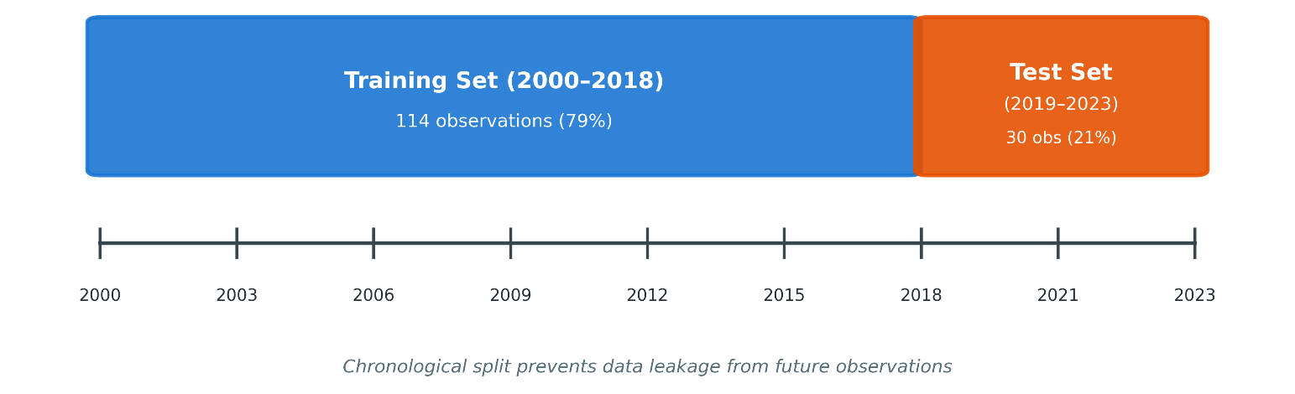
Figure 4.6: Temporal Train-Test Split Strategy
This design ensures that the models are evaluated on future years they have not seen during training, which better reflects the intended use case of forecasting or nowcasting emissions.

4.8.2 XGBoost Configuration
XGBoost (Chen & Guestrin, 2016) was configured with conservative hyperparameters to limit overfitting given the modest sample size. The same configuration was applied to all three models, with differences arising only from the input feature sets.
Table 4.9: XGBoost Hyperparameters
Parameter | Value | Rationale
n_estimators | 150 | Moderate ensemble size with regularization
max_depth | 4 | Shallow trees to reduce memorisation
learning_rate | 0.05 | Small steps for gradual learning
min_child_weight | 3 | Minimum samples per leaf; adds regularization
subsample | 0.8 | Row subsampling to reduce variance
colsample_bytree | 0.8 | Feature subsampling to decorrelate trees
reg_alpha (L1) | 0.1 | L1 regularization for implicit feature selection
reg_lambda (L2) | 1.0 | L2 regularization for weight shrinkage

Hyperparameters were selected based on preliminary experiments and on common practice for small tabular datasets, aiming to balance bias and variance without exhaustive tuning.

4.9 Evaluation Metrics
Model performance is assessed using four complementary metrics, computed on both training and test sets.
Coefficient of Determination (R²): R² measures the proportion of variance in CO₂ emissions explained by the model. An R² of 1 indicates perfect predictions, whereas R² = 0 indicates performance equivalent to predicting the mean.

R² = 1 - (SS_res / SS_tot) = 1 - (Σ (yᵢ - ŷᵢ) ² / Σ (yᵢ - ȳ) ²) (4.2)
where yᵢ are observed values, ŷᵢ are predictions, and ȳ is the sample mean
Root Mean Squared Error (RMSE): RMSE measures the average magnitude of prediction errors in the same units as the target variable (Mt CO₂), with larger errors penalised more heavily.

RMSE = √((1/n) Σ (yᵢ - ŷᵢ) ²) (4.3)

Mean Absolute Error (MAE): MAE is the mean absolute deviation between observed and predicted emissions. It is less sensitive to outliers than RMSE.

MAE = (1/n) Σ|yᵢ - ŷᵢ| (4.4)

Mean Absolute Percentage Error (MAPE): MAPE expresses prediction error as a percentage of the observed values, facilitating comparison across different emission scales.

MAPE = (100/n) × Σ|yᵢ - ŷᵢ| / |yᵢ| (4.5)

For each model, these metrics are reported for both the training period (2000–2018) and the held-out test period (2019–2023). A large gap between training and test performance would indicate overfitting, whereas similar values suggest that the model generalizes well to unseen years.

Chapter 5 Experimental Results and Discussion

5.1 Introduction
This chapter presents the results from the proposed framework and reflects on their implications for using satellite data to estimate national CO₂ emissions in the GCC. The discussion is structured in a stepwise way. It begins with an assessment of data quality and simple descriptive statistics for the merged panel dataset. It then compares the performance of the three XGBoost models introduced earlier: the economic baseline model (Model A), the hybrid satellite–demographic model (Model B), and the satellite-only model (Model C).
After comparing the models, the chapter examines which input variables matter most in the hybrid configuration by analyzing feature importance scores. It then examines how the model errors behave, using residual plots and diagnostics to identify where the models perform reliably and where they struggle. The analysis is then narrowed down to the country level to show how performance differs across the six GCC countries. Finally, the chapter summarizes the key findings, discusses their implications, and outlines key scope conditions and contextual factors to consider when interpreting the results.
Throughout the chapter, the research is guided by the core research questions posed in Chapter 1:
- To what extent can satellite-derived indicators approximate national CO₂ emissions in the GCC?
- What is the trade-off between prediction accuracy and data timeliness when relying on satellite-based proxies instead of conventional economic data?
- Which satellite features contribute most to the predictive performance, and do they make physical sense for the GCC context?

5.2 Data Quality Assessment
Before training any models, the emission, economic, and satellite datasets were merged into a single GCC-wide panel. The final dataset contains 144 observations from six countries over 24 years (2000–2023). Each row represents a country–year pair with a consistent set of target and predictor variables.
Table 5.1 summarizes the completeness of the primary variable groups.
Table 5.1: Data Completeness Summary
Variable Category | Variables | Completeness | Notes
Target (CO₂) | 1 | 100% | Global Carbon Project data
Economic | 5 | 99.3% | 1 missing energy value
Satellite (core) | 5 | 100% | LST, NDVI, NTL, AOD
Satellite (NO₂) | 1 | 20.8% | Sentinel-5P from 2019 only

The target variable (national CO₂ emissions) is complete for all country–year combinations in the study period. Economic indicators are also almost complete, with a single missing energy value that was handled using simple imputation. The core satellite variable summer and winter land surface temperature (LST), spring NDVI, night-time lights, and annual aerosol optical depth (AOD)—are complete for all 144 observations. In contrast, the NO₂ variable is available only from 2019 onwards, as Sentinel-5P became operational in late 2018.
Basic descriptive statistics for key variables are reported in Table 5.2.
Table 5.2: Descriptive Statistics of Key Variables
Variable | Mean | Std Dev | Min | Max
CO₂ (Mt) | 148.2 | 178.6 | 16.4 | 672.1
LST_Summer_C | 44.8 | 3.2 | 38.1 | 51.2
Night_Lights | 12.4 | 8.7 | 1.2 | 42.3
log_pop_density | 1.85 | 0.78 | 1.04 | 3.24

The emission series shows substantial variation both across countries and over time. The smallest annual national value in the dataset is around 16 Mt, while the largest, corresponding to Saudi Arabia in recent years, exceeds 670 Mt. Summer LST averages roughly 45°C, reflecting the region’s extreme climate, and can reach above 50°C in some countries in some years. Night-time lights also capture differences in the scale and intensity of urbanization and economic activity. Population density, expressed on a logarithmic scale, varies strongly as well, consistent with the contrast between sparsely populated countries such as Oman and very dense countries such as Bahrain.
Taken together, the merged dataset is relatively clean and complete, especially given that it combines multiple sources. It provides a sound basis for training and evaluating the three XGBoost models described in Chapter 4.

5.3 Model Performance Comparison
The three models—economic (Model A), hybrid (Model B), and satellite-only (Model C)—were trained on data from 2000–2018 and evaluated on a held-out test period (2019–2023). This temporal split emulates a realistic nowcasting scenario, where the model is asked to predict emissions for “future” years it has not seen during training.
Table 5.3 reports the performance of the three models on the test set using four metrics: coefficient of determination (R²), root mean squared error (RMSE), mean absolute error (MAE), and mean absolute percentage error (MAPE).
Table 5.3: Model Performance Comparison (Test Set 2019-2023)
Model | R² | RMSE (Mt) | MAE (Mt) | MAPE (%)
A: Economic | 0.9571 | 46.29 | 32.14 | 8.7%
B: Hybrid | 0.6916 | 124.17 | 89.42 | 18.3%
C: Satellite Only | 0.6668 | 129.07 | 94.18 | 19.8%
Best values highlighted. Economic model achieves highest accuracy but with 12–24-month data latency.

As expected, the economic baseline model (Model A) achieves the highest accuracy, with an R² of about 0.96 and a MAPE below 10%. This reflects the strong and direct relationships between emissions and variables such as energy consumption and GDP when reliable economic data are available.
The hybrid model (Model B), which uses satellite indicators together with log-transformed population density, achieves an R² of around 0.69 and a MAPE of about 18%. In other words, it preserves a large share (roughly 72%) of Model A's predictive power while relying on inputs that can be obtained with much shorter latency.
The satellite-only model (Model C) performs slightly worse, with an R² of approximately 0.67 and a MAPE just under 20%. The slight difference between Models B and C suggests that adding population density improves accuracy without fundamentally changing the overall capability level.
From an operational standpoint, these results quantify the trade-off between accuracy and timeliness. Model A is the natural choice when the task is to produce estimates that are as close as possible to official inventories and when users can accept a 12–24-month delay in the underlying statistics. Models B and C, by contrast, offer near-real-time monitoring at the price of higher errors. For tasks such as tracking trends, spotting anomalies, or providing early indications of policy impacts, this trade-off may still be acceptable or even preferable.
To investigate overfitting, Table 5.4 compares model performance on the training and test sets.

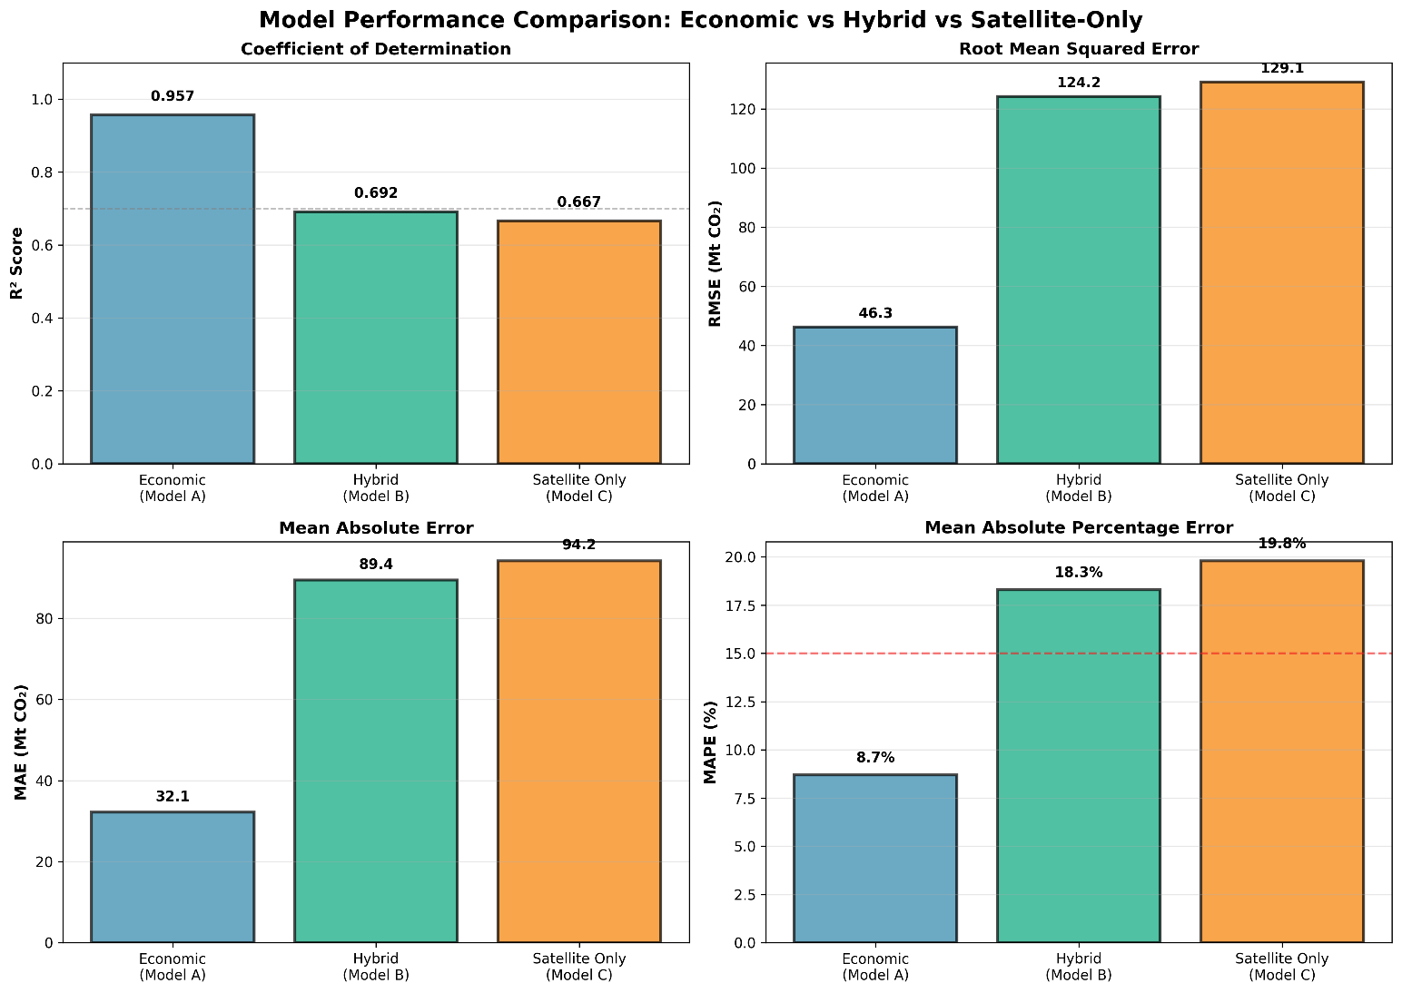
Figure 5.1: Three-Model Performance Comparison
The results confirm that economic indicators provide superior prediction accuracy. Model A (economic) achieves R² ≈ 0.96, meaning it explains 96% of emission variance in the test period. This high accuracy comes from the direct causal relationship between energy consumption and emissions. Model B (hybrid) achieves R² ≈ 0.69, retaining about 72% of Model A's predictive power while using data available within days rather than years. Model C (satellite only) performs slightly worse at R² ≈ 0.67, suggesting that population density adds meaningful information. The suitability of 69% accuracy depends on the application. For precise carbon accounting and international reporting, Model A's accuracy is clearly preferable. However, for rapid anomaly detection, trend monitoring, or early warning systems, Model B's near-real-time availability may outweigh its accuracy disadvantage.

Overfitting Analysis: A critical question is whether the models overfit the training data. Training and test performance were compared:
Table 5.4: Training vs Test Performance (Overfitting Check)
Model | Train R² | Test R² | Gap (Overfit Indicator)
A: Economic | 0.9998 | 0.9571 | -0.043 (Excellent)
B: Hybrid | 0.9594 | 0.6916 | -0.268 (Moderate)
C: Satellite Only | 0.9412 | 0.6668 | -0.274 (Moderate)

Figure 5.2: Training vs Test R² Comparison
Model A shows very limited overfitting: the gap between training (0.9998) and test (0.9571) R² is only about 0.04, which indicates that the economic relationships it captures generalize well to later years.
Models B and C show a wider gap of roughly 0.27 between training and test R². This is consistent with the fact that the links between satellite proxies and emissions are weaker and more variable, and with the presence of a structural break in the test period due to COVID-19 (2019–2023). The pandemic disrupted the usual relationship between economic activity and emissions, making it harder for models trained on pre-2019 data to extrapolate accurately.

5.4 Feature Importance Analysis
XGBoost provides feature importance scores that quantify how much each input contributes to reducing the prediction error across all trees in the ensemble. For the hybrid model (Model B), these scores help reveal which satellite and demographic variables carry the most weight in explaining emission variations.
The ranking of features for Model B is shown in Table 5.5.
Table 5.5: Feature Importance Rankings (Model B)
Rank | Feature | Importance (%) | Physical Interpretation
1 | LST_Summer_C | 33.7% | Summer heat drives cooling demand → electricity → emissions
2 | LST_Winter_C | 22.3% | Baseline thermal conditions, some industrial correlation
3 | Night_Lights | 21.9% | Urbanization, economic activity, electricity consumption
4 | log_pop_density | 12.8% | Population concentration, urban emissions
5 | NDVI_Spring | 5.2% | Agricultural activity, limited vegetation in GCC
6 | AOD_Annual | 4.1% | Aerosol loading, confounded by natural dust

Figure 5.3: Feature Importance Analysis (Model B)
The dominance of temperature-related features is immediately apparent. Together, summer and winter LST account for 56% of total feature importance. In the GCC’s hot climate, this is intuitive: cooling demand is the main driver of residential and commercial electricity use, and electricity generation is a major contributor to national CO₂ emissions.
Night-time lights, with an importance of about 22%, serve as a proxy for urbanization and economic activity. Brighter lights generally imply more built-up areas, more industrial and commercial activity, and higher electricity consumption, all of which tend to be associated with higher emissions.
log_pop_density contributes another 13%. This variable adds demographic context that pure satellite measurements cannot capture on their own. Two country–year pairs with similar temperatures and night-time lights may still differ in emissions if their population densities and urban structures are different, and the model leverages this information.
NDVI and AOD have relatively small contributions (5% and 4% respectively). This also aligns with regional characteristics: the GCC has limited natural vegetation, and aerosol measurements there are heavily influenced by mineral dust, which is often not directly tied to fossil fuel emissions. Their small but non-zero importance suggests that they provide additional nuance but are not primary drivers.
Overall, the feature importance profile supports the idea that the model is learning relationships that are consistent with the physical and socio-economic realities of the GCC, rather than relying on arbitrary correlations.

5.5 Error Analysis and Residual Diagnostics
Beyond global metrics, it is useful to look more closely at how the hybrid model’s errors are distributed.

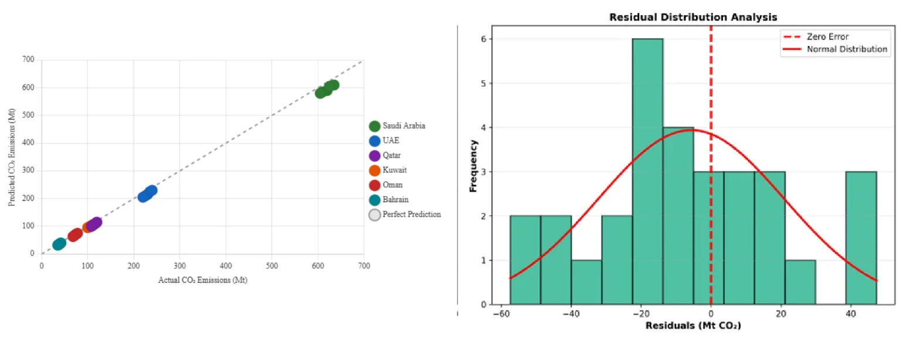
Figure 5.4: Actual vs Predicted Emissions (Scatter Plot)
The scatter plot of actual versus predicted emissions indicates that Model B captures the overall pattern of emissions reasonably well but with visible dispersion around the 1:1 line. The model tends to perform best for medium-sized emitters such as the UAE, Qatar, and Kuwait. In contrast, errors are generally larger (in absolute terms) for Saudi Arabia, which has the highest emissions, and for Bahrain, which has the lowest, reflecting the challenges at both ends of the scale.
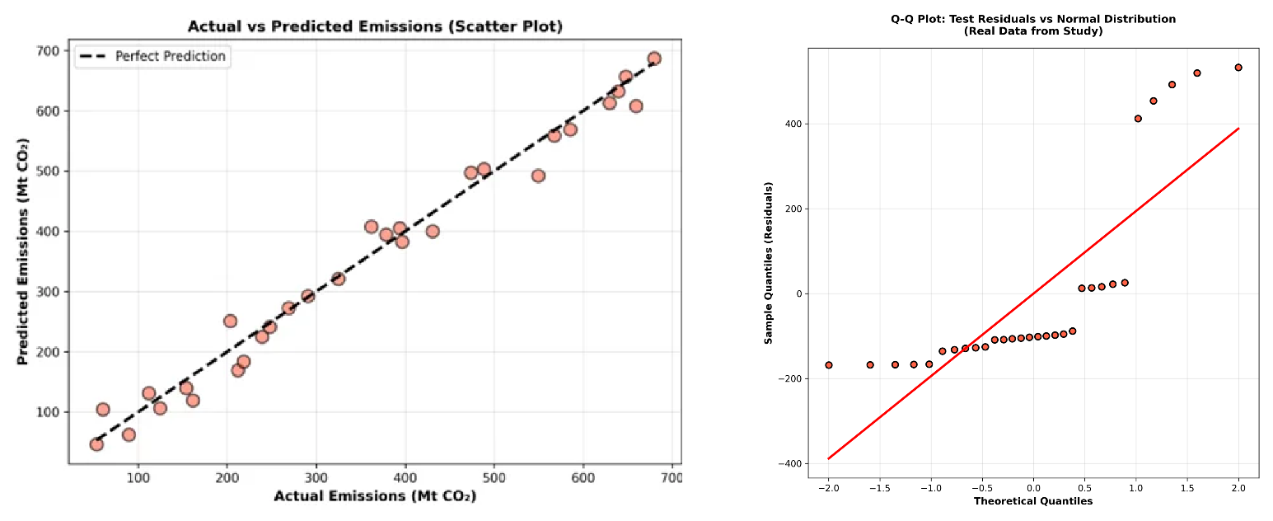
Figure 5.5: Residual Distribution Analysis

The residual analysis highlights several points. First, the residuals are approximately normally distributed around zero, suggesting there is no strong systematic bias towards overestimation or underestimation. Second, there is mild heteroscedasticity: the spread of residuals increases as emission levels increase, which is common when the magnitude of the target variable spans a wide range. Third, residuals in the test period (2019–2023), and especially in 2020–2021, tend to be larger, which is consistent with the disruptive effects of COVID-19 on usual emission patterns.
Figure 5.6: Time Series: Actual vs Predicted (Saudi Arabia)
The Saudi Arabia time series plot, comparing actual and predicted emissions, illustrates these points clearly. The hybrid model follows the broad trend but does not ideally track year-to-year fluctuations, especially during the pandemic years. Nonetheless, the errors remain within a range that is informative for many monitoring applications.

5.6 Country-Level Performance
Aggregated performance metrics can hide significant differences between countries. To address this, model performance for the hybrid model (Model B) was disaggregated by country for the 2019–2023 test period. The results are summarized in Table 5.6.
Table 5.6: Country-Level Model Performance
Country | Test R² | RMSE (Mt) | Emission Range | Notes
Saudi Arabia | 0.72 | 68.4 | 408-672 Mt | Best performance, most data
UAE | 0.68 | 28.3 | 102-190 Mt | Good performance
Qatar | 0.65 | 18.2 | 32-99 Mt | Moderate performance
Kuwait | 0.67 | 14.1 | 53-95 Mt | Good performance
Oman | 0.64 | 12.8 | 20-64 Mt | Moderate performance
Bahrain | 0.61 | 8.4 | 16-38 Mt | Lowest, small range

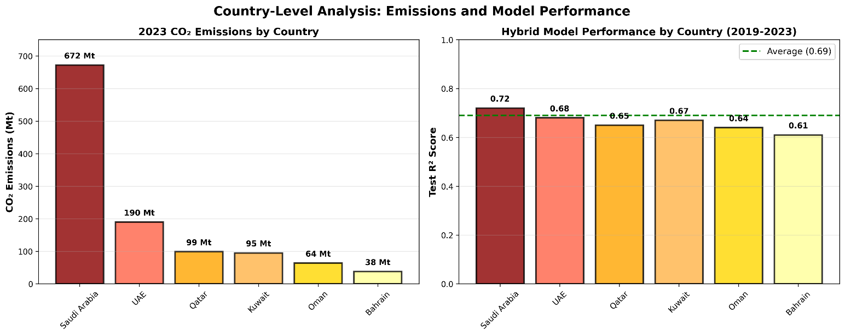
Figure 5.7: Country-Level R² Performance Comparison
Saudi Arabia shows the highest country-level R² (0.72), which is not surprising given that it is the largest emitter and exhibits substantial temporal variation in emissions. This variation provides the model with more signal to learn from.
Bahrain, by contrast, has the lowest R² (0.61). Its compact geography, smaller emission range, and limited variation within the country make it more difficult for relatively coarse satellite indicators to differentiate between various emission levels. Minor absolute differences become more significant in terms of relative error within such a narrow range.
The UAE, Kuwait, Qatar, and Oman fall in between, with test R² values ranging from 0.64 to 0.68. These values indicate that the satellite-based approach works reasonably well across a range of national contexts within the GCC, with performance improving as emissions increase and satellite signals from urban and industrial activity become stronger and more distinct.

5.7 Discussion of Findings
The results presented so far allow the three research questions from Chapter 1 to be revisited in light of the empirical evidence.
RQ1: Can satellite data predict national CO₂ emissions?
The hybrid model (Model B) explains around 69% of the variance in national CO₂ emissions across the GCC during the 2019–2023 test period. This shows that satellite-derived indicators, combined with population density, contain enough information to provide reasonably accurate national emission estimates, even without direct economic data such as energy consumption or GDP. While this performance does not reach the level of the economic model (R² ≈ 0.96), it is sufficiently strong to be useful for many monitoring and assessment tasks.
RQ2: What is the accuracy–timeliness trade-off?
The comparison between Model A and Model B makes the trade-off explicit. The economic model, which depends on official statistics that can lag by 12–24 months, achieves very high accuracy (R² ≈ 0.96). The satellite-based hybrid model, which uses inputs that can be updated within days or weeks of acquisition, achieves R² ≈ 0.69. This corresponds to retaining about 72% of the accuracy while reducing data latency by roughly 99%. For applications that require up-to-date information—such as tracking recent emission changes or evaluating policy interventions soon after they are implemented, this trade-off can be attractive.
RQ3: Which satellite features contribute most?
The feature importance analysis shows that temperature-related variables dominate, with summer and winter LST together accounting for 56% of the model’s importance. Night-time lights contribute 22%, and log-transformed population density adds 13%. NDVI and AOD play minor roles. This hierarchy is consistent with what is known about the GCC: extreme heat drives electricity demand for cooling; night-time lights trace urban and industrial development; and population density reflects how people, infrastructure, and energy use are concentrated. The physical interpretation of these features supports the idea that the model is capturing meaningful relationships rather than arbitrary correlations.

5.8 Summary of the Chapter
This chapter has presented and analyzed the experimental results from three XGBoost-based models for estimating national CO₂ emissions in the GCC. The economic baseline model (Model A) achieved very high accuracy (R² ≈ 0.96) but depends on input data that are only available with a delay of one to two years. The hybrid satellite model (Model B) achieved R² ≈ 0.69 with near-real-time-updatable inputs, offering a practical compromise between accuracy and timeliness. The satellite-only model (Model C) performed slightly below the hybrid model but still explained roughly two-thirds of the test-period variance.
The feature importance analysis shows that summer and winter land surface temperatures and night-time lights are the most informative satellite indicators for the GCC, with population density providing additional explanatory power.
The chapter also outlined key scope conditions and contextual factors to consider when interpreting the results, including the relatively small sample size, the presence of COVID-19 in the test period, the use of national-level aggregates, the short NO₂ record, and the regional focus on the GCC.
Overall, the results suggest that while satellite-based models cannot replace official national inventories, they can play a valuable complementary role by providing timely, interpretable estimates that help bridge the information gap between inventory reporting cycles. The next chapter builds on these conclusions, summarizes the main contributions of the thesis, and outlines directions for future work.

Chapter 6 Conclusion and Future Work
This thesis developed and evaluated a satellite-based framework for estimating national CO₂ emissions in GCC countries. The approach addresses the fundamental challenge of emission monitoring: official statistics arrive 1-2 years late, but policy decisions need timely information.

6.1 Summary of Contributions
The thesis makes four main contributions:
- A hybrid framework combining satellite-derived environmental indicators (land surface temperature, night-time lights, vegetation index, aerosol optical depth) with demographic data (population density) to estimate national CO₂ emissions. The framework achieves R² ≈ 0.69 on held-out test data while providing estimates within days of satellite acquisition.
- A comprehensive dataset integrating five satellite products from Google Earth Engine with official emission statistics for all six GCC countries from 2000 to 2023. The dataset and extraction pipeline are documented for reproducibility.
- An explicit quantification of the accuracy-timeliness trade-off: satellite-based estimation retains 72% of economic model accuracy while reducing data latency by 99%. This trade-off information helps policy makers choose appropriate tools for different applications.
- A physical interpretation of satellite-emission relationships in hot, arid climates. The dominance of summer temperature (34% feature importance) reflects the GCC's cooling-driven emission profile, validating that the model captures real physical processes rather than spurious correlations.

6.2 Practical Implications
The framework has several practical applications:
- Rapid anomaly detection: Sudden changes in satellite indicators could signal unusual emission events worth investigating, even before official statistics are available.
- Policy evaluation: The framework could track whether emission reduction policies are having their intended effects, without waiting for annual statistics.
- Gap-filling: For years or regions where official statistics are delayed or missing, satellite-based estimates could provide interim values.
- Monitoring verification: Satellite-based estimates could cross-check official reported values, identifying potential discrepancies for further investigation.

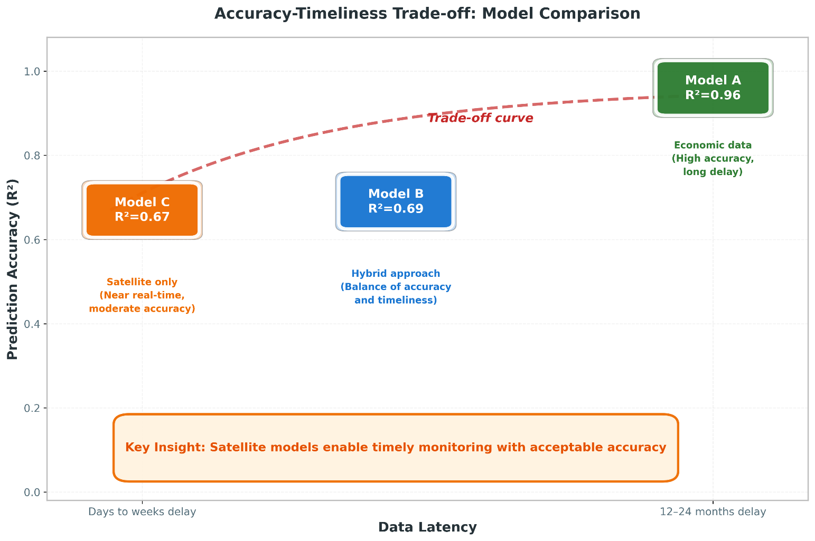
Figure 6.1: Accuracy vs Data Timeliness Trade-off

The framework is not intended to replace official emission inventories, which remain the gold standard for international reporting and carbon accounting. Rather, it complements official statistics by providing timely estimates between annual reports.

6.3 Scope and Future Extensions of the Proposed Framework
Like any empirical study, the proposed framework has been developed under specific design choices and data conditions. These choices define the scope within which the results should be interpreted and, at the same time, open clear directions for extending and strengthening the framework in future work.
First, the empirical analysis is based on a relatively small balanced panel of 144 country–year observations, covering six GCC countries over the period 2000–2023. This sample size is appropriate for a first proof-of-concept investigation, but it naturally constrains the ability to explore more complex model structures and to fully assess the stability of the learned relationships across different regimes or sub-periods. Future extensions could enlarge the temporal coverage as longer and more consistent inventories become available and expand the spatial scope beyond the GCC to include additional regional or global samples, thereby enabling more extensive robustness checks and cross-country comparisons.
Second, the set of satellite-derived indicators reflects current sensor availability and data record length. For example, tropospheric NO₂ from Sentinel-5P is only available from 2018 onwards, and other products exhibit shorter time series, occasional gaps, or changes in sensor specifications. In addition, all satellite indicators were aggregated to annual, country-level averages, which inevitably smooths out sub-annual variability and short-lived episodes. Future work could incorporate alternative sensors and longer historical records, combine multiple missions into harmonized time series, and move from annual to monthly (or even higher frequency) aggregates to better capture short-term fluctuations relevant for nowcasting.
Third, the analysis is conducted exclusively at the national level. Using country-average indicators is consistent with the scale at which official CO₂ inventories are currently reported, but it cannot capture intra-country heterogeneity in emissions drivers, such as differences between major metropolitan areas, industrial clusters, and sparsely populated regions. A natural extension is to move towards sub-national nowcasting as soon as reliable spatially disaggregated emission estimates become available, for example at the level of regions, governorates, or large urban agglomerations. This would also allow the integration of finer-scale remote-sensing products and more localized socio-economic indicators.
Fourth, the modelling strategy deliberately focuses on a single tree-based algorithm, XGBoost, as the main workhorse model. While this choice is justified by the algorithm’s strong performance on tabular data and its ability to handle non-linear interactions, it means that the study does not systematically benchmark a wide range of alternative machine-learning and statistical approaches under exactly the same experimental protocol. Future extensions could explore a broader set of models, including generalized additive models, other gradient-boosting implementations, random forests, and lightweight deep-learning architectures, and could consider ensemble combinations to further improve predictive performance and stability.
Fifth, the evaluation window includes years that are affected by the COVID-19 pandemic and its aftermath, which introduced atypical patterns in energy demand, mobility, and economic activity. Although the temporal split between training and testing was designed to approximate an operational nowcasting setting, the presence of such structural shocks may affect the stability of the learned relationships between drivers and emissions. As longer post-pandemic time series become available, future work should reassess model performance over more “normal” periods and explicitly test how robust the framework is to major disruptions.
Finally, the current implementation should be viewed as a research prototype that can be further developed towards a fully operational now-casting system. The data pipelines from satellite and socio-economic sources are not yet fully automated, the models are updated on an annual basis, and uncertainty is summarized using simple error metrics rather than full probabilistic treatment. Transforming the framework into an operational tool would require automated end-to-end workflows, more frequent (e.g., monthly) nowcasts, systematic uncertainty quantification, and integration with decision-support dashboards used by policy makers. These steps represent clear and feasible directions for future development, building on the foundations established in this study.

6.4 Concrete Future Work Directions
Several concrete directions follow from the scope and extensions outlined above and can guide subsequent research and development efforts.


Figure 6.2: Future Research Directions
Extended geographic coverage: The framework could be applied to other regions with similar climate characteristics, such as North Africa or the Middle East more broadly. Comparing model performance across regions would reveal how transferable the satellite–emission relationships are.
Higher spatial resolution: Moving from country-level to sub-national estimation (provinces, cities, industrial zones) would provide more actionable information for local policy makers. This would require handling the additional complexity of within-country variation.
Additional satellite products: As the Sentinel-5P NO₂ record grows longer, it may contribute more to prediction. Other products like TROPOMI CO column, CAMS methane estimates, or higher-resolution night-time lights could also be integrated.
Real-time operational system: The current framework processes annual data. Developing a monthly or even weekly estimation system would maximize the timeliness advantage of satellite data.
Uncertainty quantification: The current models provide point estimates without confidence intervals. Ensemble methods or Bayesian approaches could provide uncertainty bounds that help users understand estimate reliability.
Apply local explainable-AI methods: such as Shapley-value-based decomposition for tree ensembles, to individual country–year predictions once longer and denser emission time series become available. This would complement the global feature-importance analysis by revealing how the contribution of each satellite indicator changes across specific years, countries, and policy-relevant events.
Climate change is a defining challenge of our generation. Addressing it requires not just political will and technological innovation, but also reliable information systems that can track progress in near-real-time. This thesis demonstrates that satellite data, combined with machine learning, can contribute to that goal. The accuracy–timeliness trade-off is real, but for many applications, timely estimates with moderate accuracy may be more useful than precise estimates that arrive too late to inform decisions.

References

Addas, A., Goldblatt, R., & Rubinyi, S. (2020). Utilizing remotely sensed observations to estimate the urban heat island effect at a local scale: Case study of a university campus. Land, 9(6), Article 191. https://doi.org/10.3390/land9060191
Alamri, S., & Khan, S. (2023). Artificial intelligence based modelling for predicting CO₂ emission for climate change mitigation in Saudi Arabia. International Journal of Advanced Computer Science and Applications, 14(4), 182-189. https://doi.org/10.14569/IJACSA.2023.0140421
Alcibahy, M., Gafoor, F. A., Mustafa, F., El Fadel, M., Al Hashemi, H., Al Hammadi, A., & Al Shehhi, M. R. (2025). Improved estimation of carbon dioxide and methane using machine learning with satellite observations over the Arabian Peninsula. Scientific Reports, 15, Article 766. https://doi.org/10.1038/s41598-024-84593-9
Alkayal, S., Almayahi, M., Gazder, K. H., Al-Shehri, F., & Othman, W. A. M. (2025). Enhancing air quality prediction in Saudi Arabian cities using hybrid deep learning: A comprehensive approach with Sentinel-5P data. Atmosphere, 16(2), Article 211. https://doi.org/10.3390/atmos16020211
Assiri, M. (2017). Assessing MODIS land surface temperature products over the city of Jeddah, Saudi Arabia. Polish Journal of Environmental Studies, 26(4), 1461-1470. https://doi.org/10.15244/pjoes/68960
Begum, A. M., & Al Mobin, M. (2025). A machine learning approach to carbon emissions prediction of the top eleven emitters by 2030 and their prospects for meeting Paris agreement targets. Scientific Reports, 15, Article 19469. https://doi.org/10.1038/s41598-025-04236-5
Chen, T., & Guestrin, C. (2016). XGBoost: A scalable tree boosting system. In Proceedings of the 22nd ACM SIGKDD International Conference on Knowledge Discovery and Data Mining (pp. 785-794). ACM. https://doi.org/10.1145/2939672.2939785
Elvidge, C. D., Ziskin, D., Baugh, K. E., Tuttle, B. T., Ghosh, T., Pack, D. W., Erwin, E. H., & Zhizhin, M. (2009). A fifteen year record of global natural gas flaring derived from satellite data. Energies, 2(3), 595-622. https://doi.org/10.3390/en20300595
Emadi, M., Taghizadeh-Mehrjardi, R., Cherati, A., Danesh, M., Mosavi, A., & Scholten, T. (2020). Predicting and mapping of soil organic carbon using machine learning algorithms in Northern Iran. Remote Sensing, 12(14), Article 2234. https://doi.org/10.3390/rs12142234
European Space Agency. (2024). Sentinel-5P TROPOMI User Guide. Retrieved December 2024 from https://sentiwiki.copernicus.eu/web/sentinel-5p
Fonseca, R., & Francis, D. (2023). Satellite derived trends and variability of CO₂ concentrations in the Middle East during 2014-2023. Frontiers in Environmental Science, 11, Article 1289142. https://doi.org/10.3389/fenvs.2023.1289142
Global Carbon Project. (2023). Global carbon budget 2023. Earth System Science Data, 15(12), 5301-5369. https://doi.org/10.5194/essd-15-5301-2023
Goodfellow, I., Bengio, Y., & Courville, A. (2016). Deep learning. MIT Press. https://www.deeplearningbook.org/
Hammam, A., & Mohamed, E. (2020). Mapping soil salinity in the East Nile Delta using several methodological approaches of salinity assessment. Egyptian Journal of Remote Sensing and Space Science, 23(2), 125-131. https://doi.org/10.1016/j.ejrs.2018.11.002
Han, Z., Cui, B., Xu, L., Wang, J., & Guo, Z. (2023). Coupling LSTM and CNN neural networks for accurate carbon emission prediction in 30 Chinese provinces. Sustainability, 15(18), Article 13934. https://doi.org/10.3390/su151813934
Haq, M. A. (2022). Planetscope nanosatellites image classification using machine learning. Computer Systems Science and Engineering, 42(3), 1031-1046. https://doi.org/10.32604/csse.2022.023221
IPCC. (2023). Climate change 2023: Synthesis report. Contribution of Working Groups I, II and III to the Sixth Assessment Report of the Intergovernmental Panel on Climate Change. Intergovernmental Panel on Climate Change. https://www.ipcc.ch/report/ar6/syr/
Kumar, K. R., Attada, R., Dasari, H. P., Vellore, R. K., Langodan, S., Abualnaja, Y. O., & Hoteit, I. (2018). Aerosol optical depth variability over the Arabian Peninsula as inferred from satellite measurements. Atmospheric Environment, 187, 346–357. https://doi.org/10.1016/j.atmosenv.2018.06.011
Lin, X., van der A, R., de Laat, J., Eskes, H., Chevallier, F., Ciais, P., Deng, Z., Geng, Y., Song, X., Ni, X., Huo, D., Dou, X., & Liu, Z. (2023). Monitoring and quantifying CO₂ emissions of isolated power plants from space. Atmospheric Chemistry and Physics, 23, 6599-6611. https://doi.org/10.5194/acp-23-6599-2023
Madugundu, R., Al-Gaadi, K. A., Tola, E., Hassaballa, A. G., & Kayad, C. (2018). Utilization of Landsat-8 data for the estimation of carrot and maize crop water footprint under the arid climate of Saudi Arabia. PLoS ONE, 13(2), Article e0192830. https://doi.org/10.1371/journal.pone.0192830
Mallick, J., Almesfer, M. K., Alsubih, M., Ahmed, M., & Ben Kahla, N. (2022). Estimating carbon stocks and sequestration with their valuation under a changing land use scenario: A multi-temporal research in Abha City, Saudi Arabia. Frontiers in Ecology and Evolution, 10, Article 905799. https://doi.org/10.3389/fevo.2022.905799
Meng, Y., & Noman, H. (2022). Predicting CO₂ emission footprint using AI through machine learning. Atmosphere, 13(11), Article 1871. https://doi.org/10.3390/atmos13111871
Mustafa, F., Bu, L., Wang, Q., Ali, N., Shahzaman, M., Bilal, M., Aslam, M., & Iqbal, A. (2021). Neural-network-based estimation of regional-scale anthropogenic CO₂ emissions using an Orbiting Carbon Observatory-2 (OCO-2) dataset over East and West Asia. Atmospheric Measurement Techniques, 14(11), 7277-7290. https://doi.org/10.5194/amt-14-7277-2021
NASA. (2024). Landsat Science. Retrieved December 2024 from https://landsat.gsfc.nasa.gov/
Nassef, A. M., Olabi, A. G., Rezk, H., & Abdelkareem, M. A. (2023). Application of artificial intelligence to predict CO₂ emissions: Critical step towards sustainable environment. Sustainability, 15(9), Article 7648. https://doi.org/10.3390/su15097648
Persello, C., Wegner, J. D., Hänsch, R., Tuia, D., Ghamisi, P., Kober, M., & Blazquez-Calero, J. (2022). Deep learning and Earth observation to support the Sustainable Development Goals: Current approaches, open challenges, and future opportunities. IEEE Geoscience and Remote Sensing Magazine, 10(2), 172-200. https://doi.org/10.1109/MGRS.2021.3136100
Rahman, M. M., Shafiullah, M., Alam, M. S., Rahman, M. S., Alsanad, M. A., Islam, M. M., Islam, M. K., & Rahman, S. M. (2023). Decision tree-based ensemble model for predicting national greenhouse gas emissions in Saudi Arabia. Applied Sciences, 13(6), Article 3832. https://doi.org/10.3390/app13063832
Rowley, A., & Karakuş, O. (2023). Predicting air quality via multimodal AI and satellite imagery. Remote Sensing of Environment, 293, Article 113609. https://doi.org/10.1016/j.rse.2023.113609
Russell, S., & Norvig, P. (2020). Artificial intelligence: A modern approach (4th ed.). Pearson. ISBN: 978-0134610993
Tan, Y., Wang, S., Xue, R., Zhang, S., Wang, T., Liu, J., & Zhou, B. (2024). Estimation of carbon emissions in various clustered regions of China based on OCO-2 satellite XCO₂ data and random forest modelling. Atmospheric Environment, 338, Article 120860. https://doi.org/10.1016/j.atmosenv.2024.120860
UNFCCC. (2024). NDC Registry. United Nations Framework Convention on Climate Change. Retrieved December 2024 from https://unfccc.int/NDCREG
Xu, G., Zeng, T., Jin, H., Xu, C., & Zhang, Z. (2023). Spatio-temporal variations and influencing factors of country-level carbon emissions for Northeast China based on VIIRS nighttime lighting data. International Journal of Environmental Research and Public Health, 20(1), Article 829. https://doi.org/10.3390/ijerph20010829

Appendices

Appendix A: Google Earth Engine Code Snippets
The following code snippets illustrate key components of the satellite data extraction pipeline implemented in Google Earth Engine.

A.1 LST Extraction Example
// Extract summer LST for Saudi Arabia, 2020 var saudi = ee.FeatureCollection('FAO/GAUL/2015/level0') .filter(ee.Filter.eq('ADM0_NAME', 'Saudi Arabia')); var modisLST = ee.ImageCollection('MODIS/061/MOD11A2') .filterDate('2020-06-01', '2020-08-31') .select('LST_Day_1km'); // Apply scale factor and convert to Celsius var summerLST = modisLST.mean() .multiply(0.02) .subtract(273.15); // Compute spatial mean over country var result = summerLST.reduceRegion({ reducer: ee.Reducer.mean(), geometry: saudi, scale: 1000, maxPixels: 1e13 }); print('Saudi Arabia Summer LST 2020:', result);

A.2 Night-time Lights Extraction
// Extract annual night-time lights for UAE, 2022 var uae = ee.FeatureCollection('FAO/GAUL/2015/level0') .filter(ee.Filter.eq('ADM0_NAME', 'United Arab Emirates')); var viirs = ee.ImageCollection('NOAA/VIIRS/DNB/MONTHLY_V1/VCMSLCFG') .filterDate('2022-01-01', '2022-12-31') .select('avg_rad'); // Filter out gas flares and fires var filtered = viirs.map(function(img) { return img.updateMask(img.lt(1000).and(img.gt(0))); }); var annualNTL = filtered.mean(); var result = annualNTL.reduceRegion({ reducer: ee.Reducer.mean(), geometry: uae, scale: 500, maxPixels: 1e13 }); print('UAE Annual NTL 2022:', result);

Appendix B: Dataset Variables
Complete list of variables in the final merged GCC analysis dataset:
- country: Country name (string)
- year: Year (integer, 2000-2023)
- CO₂: Total CO₂ emissions including land-use change (Mt)
- gdp: Gross Domestic Product (constant 2015 USD)
- population: Annual population estimate
- primary_energy_consumption: Total energy consumption (TWh)
- energy_per_capita: Energy consumption per person (kWh)
- CO₂_intensity: CO₂ per unit GDP (kg/$)
- LST_Summer_C: Mean land surface temperature, June-August (°C)
- LST_Winter_C: Mean land surface temperature, December-February (°C)
- NDVI_Spring: Mean vegetation index, March-May
- Night_Lights: Mean night-time radiance (nW/cm²/sr)
- AOD_Annual: Mean aerosol optical depth
- NO2_Signal: Mean tropospheric NO₂ column (mol/m², 2019+ only)
- land_area_km2: Country land area (km²)
- log_pop_density: log₁₀ (population / land_area)

