

AI-Based Early Warning System for Academic Risk Detection in Education
Prepared By
Student 1: Marya Mohammed Bawazir ID: 253000692
Student 2: Hala Haytham Hajjar ID: 253001456
Submitted in fulfillment of the requirements for the degree Master of Science in Artificial Intelligence
At
Collage of Informatics
Midocean University
UAE
Supervisor Name: Hager Saleh.
College of Informatics, Midocean University, Comoros

Abstract:
Early identification of academically at-risk students is a major challenge for educational institutions, as timely intervention can significantly improve students' academic success and reduce failure rates. Traditional prediction methods often struggle to capture the complex relationships among students' academic performance, engagement, and behavioral indicators available in Learning Management Systems (LMS). This study proposes an AI-Based Early Warning System for predicting students' academic performance using supervised machine learning techniques. The proposed framework integrates comprehensive data preprocessing, including data transformation, feature selection based on Random Forest feature importance, class balancing using the (SMOTE), and hyperparameter optimization using Grid Search.
To investigate the effects of preprocessing strategies on prediction performance, four experimental configurations were designed: (1) Full Feature Set, (2) Selected Feature Set, (3) Full Feature Set with SMOTE, and (4) Selected Feature Set with SMOTE. Eight supervised machine learning algorithms were evaluated, including (DT), (RF), (LR), (SVM), (KNN), (NB), (AB), and (XGB). Model performance was assessed using Accuracy, Precision, Recall, F1-score, and Confusion Matrix analysis.
The experimental results demonstrated that XGB consistently achieved the best overall predictive performance across the different experimental configurations. The highest performance was obtained using the full feature set, where XGB achieved an accuracy of 82.80%, precision of 82.63%, recall of 82.80%, and an F1-score of 82.42%. Although DT achieved the same accuracy after Grid Search optimization in one experimental configuration, XGB exhibited superior stability and generalization capability across all experiments. Furthermore, feature selection successfully reduced the number of input variables without noticeably affecting prediction performance, while SMOTE improved the recognition of minority classes and produced more balanced classification results.
The proposed AI-Based Early Warning System provides an effective and reliable framework for predicting students' academic performance using LMS data. The developed model enables educational institutions to identify academically at-risk students at an early stage, supporting timely interventions, improving student success, and facilitating data-driven educational decision-making.

Table of Contents
List of Abbreviations...................................................................................... xiv
List of Figures................................................................................................. xvi
List of Tables.................................................................................................. xviii

Table of Contents
Chapter 1 Introduction 7
1.1 Problem Definition 7
1.2 Thesis Objectives 8
1.3 Thesis Contributions 8
1.4 Thesis Organization 9
Chapter 2 Background and Related Work 10
2.1 Background 10
2.1.1 AI 10
2.1.2 ML 11
2.1.3 Types of ML 11
Figure 2. Types of ML [4] 11
1. Supervised Learning 11
2. Unsupervised Learning 12
3. Semi-Supervised Learning 12
2.1.4 Classification 12
2.1.5 ML Algorithms 12
1. DT 12
2. RF 13
3. (KNN) 13
4. SVM 14
5. NV 14
2.1.6 Model Evaluation Metrics 15
1. Accuracy 15
2. Precision 15
3. Recall 15
4. F1-Score 15
2.1.7 Impact of Artificial Intelligence in Education 16
2.2 Related Work: 16
Chapter 3 31
Methodology and Proposed Approach 31
Introduction 31
3.1 Dataset Description 33
3.2 Data Preprocessing 34
• Data Inspection 34
• Data Transformation 34
• Encoding Categorical Variables 35
• Stratified Train-Test Split 35
• Class Balancing Using SMOTE 35
• Final Dataset Preparation 35
3.3 Feature Selection 35
• Feature Importance Analysis 35
• Feature Ranking 36
• Feature Elimination 36
• Selected Feature Set 36
3.4 Experimental Configurations 36
3.5 Machine Learning Models 36
3.5.1 Traditional Machine Learning Models 37
3.5.2 Ensemble Learning Models 37
3.6 Model Optimization 37
3.7 Summary 38
Chapter 5 Results. 40
5.1 Experimental Setup 40
5.2 Class Distribution 40
5.3 Feature Importance Analysis 42
5.4 Results of Models Before Applying SMOTE. 43
5.4.1 Results of Applying Models with Full Features without SMOTE. 43
5.4.2 Results of Applying Models with Selected Features without applying SMOTE. 47
5.5 Results of Models After Applying SMOTE. 52
5.5.1 Results of Applying Machine Learning Models with Full Features after Applying SMOTE 52
5.5.2 Results of Applying Machine Learning Models with Selected Features after Applying SMOTE 57
5.6 Final Model Selection 62
5.7 Comparative Analysis of the Experimental Configurations 63
5.7.1 Summary of the Experimental Findings 64
Chapter 5 Conclusion and Future Work 65
5.1 Conclusion 65
5.2 Future Work 66
References: 67

List of Abbreviations :
Acc.: Accuracy.
ANN: Artificial Neural Network.
ML: Machine Learning.
XAI: Explainable Artificial Intelligence.
SVM: Support Vector Machine.
RF: Random Forest.
DT: Decision Tree.
KNN: K-Nearest Neighbors.
DL: Deep Learning.
NV: Naïve Bayes.
CNN: Convolutional Neural Network.
LMS: Learning Management System.
LR: Logistic regression.

List of Figures :
Figure 1. AI [2] 10
Figure 2. Types of ML [4] 11
Figure 3. DT structure[8] 12
Figure 4. RF algorithm structure[9]. 13
Figure 5. KNN classification [6] 13
Figure 6.SVM [3]. 14
Figure 7Proposed AI-Based Early Warning System Framework (Student Risk Classification) 30
Figure 8. Data Preprocessing Pipeline 33
Figure 9 . Distribution of Student Performance Classes Before SMOTE. 40
Figure 10.Feature Importance Analysis 41
Figure 11. Random Forest Feature Importance Ranking. 42
Figure 12. Accuracy Comparison of ML Models with Full Features. 44
Figure 13. Confusion Matrices All Models 45
Figure 14. Performance Before and After Grid Search Optimization 46
Figure 15 Accuracy Comparison of Machine Learning Models with Selected Features 48
Figure 16 . Confusion Matrices of All Models 49
Figure 17. Performance Before and After Grid Search Optimization. 51
Figure 18. Accuracy Comparison of Machine Learning Models with Full Features after Applying SMOTE 53
Figure 19. Confusion Matrices of Traditional ML Models with Full Features after Applying SMOTE. 54
Figure 20. Performance Before and After Grid Search Optimization. 55
Figure 21. Accuracy Comparison of Machine Learning Models with Selected Features after Applying SMOTE 57
Figure 22. Confusion Matrices of Traditional Machine Learning Models 58
Figure 23.Performance Before and After Grid Search Optimization. 59

List of Tables:
Table 1 Of The Reviewed Papers 22
Table 2. Distribution of Student Performance Classes 39
Table 3.. Results of Applying Machine Learning Models with Full Features 43
Table 4. Performance Before and After Grid Search Optimization 45
Table 5.Results of Applying ML Models with Selected Features 47
Table 6. Performance Before and After Grid Search Optimization 50
Table 7. Results of Applying Machine Learning Models with Full Features after Applying SMOTE 52
Table 8. Performance Before and After Grid Search Optimization 55
Table 9. Results of Applying Machine Learning Models with Selected Features after Applying SMOTE. 56
Table 10. Performance Before and After Grid Search Optimization. 58
Table 11. Final Performance of the Best Models Across the Four Experimental Configurations 60

Chapter 1 Introduction

1.1 Problem Definition
Despite the increasing availability of student data in educational sectors, many systems still face challenges in identifying students at academic risk at an early stage to allow them to intervene effectively. Traditional evaluation methods often rely on certain and usual results. This reduces the opportunity of providing timely support or implementing appropriate personalized intervention plans. The lack of this diagnostic plan is an additional risk, as each student's skills, goals, and needs vary, necessitating early diagnosis to provide individualized support.
Also, educational data is very complex and diverse. It includes demographic information, behavioral data, attendance records, and interactions within learning management systems (LMS). Such complexity makes it difficult to figure out which factors have the biggest effect on predicting academic performance. This data is also often enormous and challenging to understand, which makes it even harder to analyze and make decisions.
Besides, the presence of extraneous or less important features may lead to various difficulties in constructing prediction models, including overfitting, higher computation costs, and non-explainability of the models. Consequently, the use of feature selection techniques to extract only the most relevant features will have great potential for constructing accurate and explainable models.
In contrast, artificial intelligence (AI), such as machine learning (ML) and deep learning (DL), is able to analyze the information from the education field, recognize patterns, detect students' behaviors, and predict student performance. With the help of the proper dataset, it will be possible to determine whether a student will probably perform well or not and what factors may cause their failure. However, the effectiveness of AI algorithms depends on data quality, feature selection, and model interpretability.
Therefore, the application of a data-driven early warning system based on AI is necessary for predicting and identifying at-risk students at an early stage. In particular, a data-driven model can help classify at-risk students by their risk level (low, medium, and high).
This study attempts to tackle the issue of inefficient and ineffective detection systems of students that could benefit from additional assistance, through the application of Artificial Intelligence techniques on the information provided by the LMS. The ultimate goal is to boost student performance and avoid academic failure.

1.2 Thesis Objectives
The major goal of the research is the development of an early warning system that can be applied to classify students' risk levels in terms of their academic performance by using AI and ML methods. The project will rely on LMS data, including students' academic performance indicators, engagement, and demographics, to identify those who have risks of poor performance as early as possible. For this purpose, the target (Final Mark) is transformed into a classification problem (low, medium, high). The research uses the technique of data pre-processing and feature engineering to increase the quality of the data used for predictions. Several ML classifiers are implemented in a stacking ensemble model to make more accurate predictions. Accuracy, precision, and recall measures are used to evaluate the algorithm, where special attention will be paid to recall in order to increase the chances of detecting at-risk students.

1.3 Thesis Contributions
This thesis makes the following contributions:
- Developed an AI-Based Early Warning System for predicting students' academic performance using educational engagement and assessment data extracted from a Learning Management System (LMS). The proposed system enables the early identification of academically at-risk students, allowing timely educational intervention before final assessments.
- Conducted a comprehensive comparative analysis of eight supervised machine learning algorithms, including six traditional machine learning algorithms (Decision Tree, Random Forest, Logistic Regression, Support Vector Machine, K-Nearest Neighbors, and Naïve Bayes) and two ensemble learning algorithms (AdaBoost and XGBoost) to identify the most effective predictive model for student academic performance classification.
- Designed and evaluated four experimental configurations to investigate the individual and combined effects of Feature Selection and the Synthetic Minority Oversampling Technique (SMOTE) on prediction performance, providing a comprehensive evaluation of different data preprocessing strategies.
- Improved data quality and prediction performance through an effective preprocessing pipeline that included data transformation, stratified train-test splitting, Feature Selection using Random Forest feature importance, and class balancing using SMOTE. These preprocessing techniques reduced data dimensionality, addressed class imbalance, and enhanced the overall prediction performance.
- Enhanced model performance through hyperparameter optimization using Grid Search with cross-validation. The optimization process improved the predictive performance of several classifiers, particularly Decision Tree and Random Forest, while demonstrating that XGBoost consistently maintained high predictive performance across different experimental configurations.
- Identified XGBoost as the most reliable prediction model by achieving consistently high classification performance across all experimental configurations. Although Decision Tree achieved the highest accuracy after hyperparameter optimization in one experimental setting, XGBoost demonstrated superior stability, robustness, and generalization capability, making it the final model adopted in the proposed framework.
- Proposed a practical AI-based decision-support framework that assists educational institutions in identifying academically at-risk students and supports timely data-driven interventions to improve student success, reduce academic failure, and enhance educational decision-making.

1.4 Thesis Organization
The remainder of this thesis is organized as follows:
- Chapter 2 presents the literature review and discusses previous studies related to student performance prediction, educational data mining, machine learning algorithms, feature selection techniques, class balancing methods, and AI-based early warning systems.
- Chapter 3 describes the proposed methodology, including the educational dataset, data preprocessing procedures, feature selection process, experimental configurations, machine learning models, hyperparameter optimization, and the proposed AI-Based Early Warning System framework.
- Chapter 4 presents the experimental results and provides a comprehensive performance evaluation of the developed machine learning models under the four experimental configurations. It also compares the effectiveness of the evaluated models using standard classification metrics and identifies the most reliable prediction model.
- Chapter 5 summarizes the major findings and contributions of this research, presents the study conclusions, discusses its limitations, and provides recommendations for future research directions.

Chapter 2 Background and Related Work

2.1 Background

2.1.1 AI
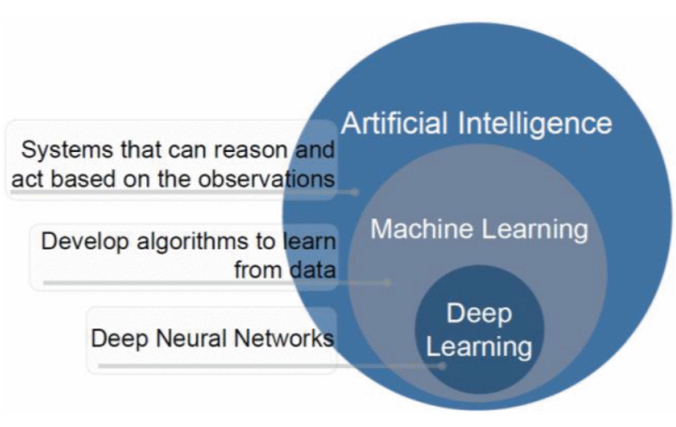
The ability of computer systems to do tasks like learning, reasoning, decision-making, and problem-solving that require human intelligence is known as AI. Systems analyze massive data using computational methods to produce predictions. AI is used more and more in the field of education to evaluate student data and assist with decision-making processes like identifying students who are at risk and enhancing learning outcomes[1].

Figure 1. AI [2]

2.1.2 ML
It is a branch of AI that focuses on creating algorithms that, without explicit programming, enable computers to recognize patterns in data and perform better. It can be used to predict or classify new data after being trained on historical data. Because it allows for examining massive amounts of data of students and finding their performance, ML is crucial to educational data mining and learning analytics. (Pattern Recognition and ML)[3].

2.1.3 Types of ML

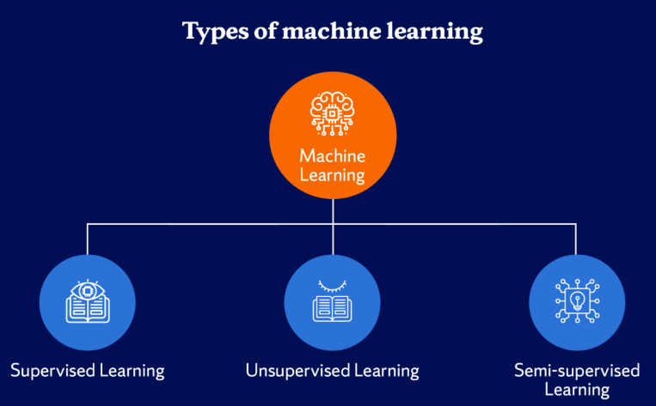

Figure 2. Types of ML [4]

1. Supervised Learning
The model is trained using labeled data in this ML method. There is an input and an output label for every training example. Learning a mapping between inputs and outputs is the aim of supervised learning, which enables the model to correctly predict the output for fresh, unseen data[5].

2. Unsupervised Learning
It uses unlabeled data to train models. In this kind of learning, the algorithm looks for unidentified patterns or structures in the data. In unsupervised learning, clustering and association rule learning are popular methods [3].

3. Semi-Supervised Learning
It includes both labeled and unlabeled data. This method works well when there is a lot of unlabeled data but little labeled data. By utilizing both kinds of data, it can enhance model performance[5].

2.1.4 Classification
Predicting a categorical label for a given input is the goal of this kind of supervised learning task. For instance, classification algorithms can be used in educational systems to assess a student's risk level based on behavioral and academic data[6].

2.1.5 ML Algorithms

1. DT
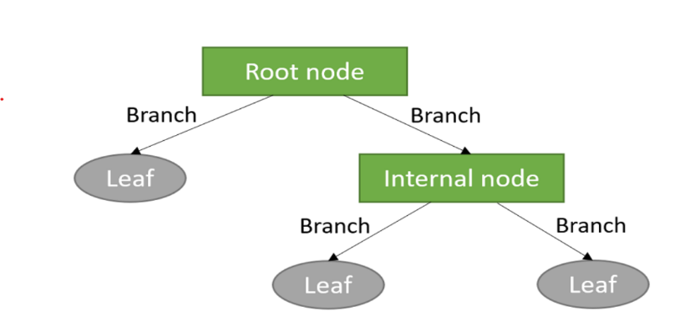
It is a supervised learning algorithm that uses a tree structure to represent decisions. A feature is represented by each internal node, a decision rule by each branch, and a class label by each leaf node. DT are frequently used in classification problems because they are simple to understand [7].

Figure 3. DT structure[8]

2. RF
Many DT are combined in the RF groups learning technique to increase prediction accuracy and decrease overfitting.it is subset of the dataset is used to train each tree in the forest, and the final prediction is produced by adding up all of the trees' predictions [7].
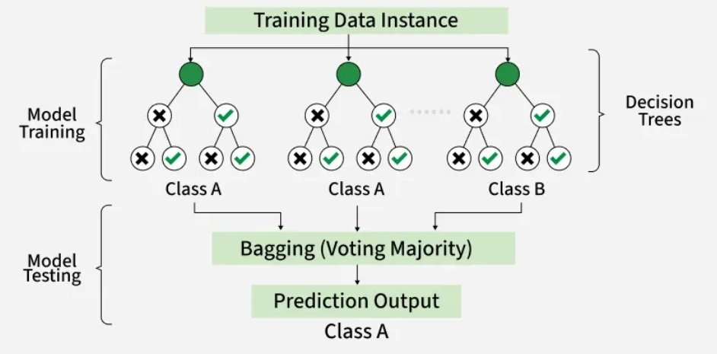
Figure 4. RF algorithm structure[9].

3. (KNN)
KNN uses the classes of a data point's closest neighbors in the feature space to predict the data point's class. It uses Euclidean distance, and other distance metrics are used by the algorithm to determine similarity [3].

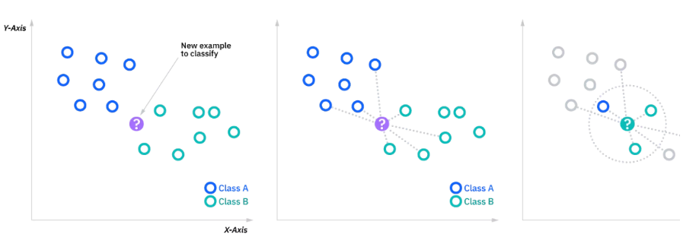
Figure 5. KNN classification [6]

4. SVM
It is a supervised learning algorithm for tasks involving regression and classification. To find the best hyperplane that divides data points from various classes, with the greatest margin, is how it operates [3].

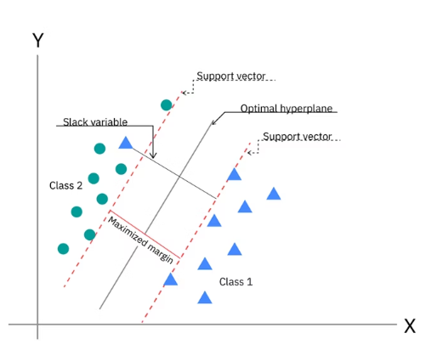
Figure 6.SVM [3].

5. NV
It is an algorithm of classification. It makes the assumption that features are conditionally independent, it makes computation easier, and enables the model to work great even with massive datasets[5].

2.1.6 Ensemble Learning
Ensemble learning is a machine learning paradigm that combines multiple base learners to improve predictive performance compared with using a single model. Rather than relying on one classifier, ensemble methods integrate the outputs of several models to produce a more accurate and robust prediction. The underlying assumption is that a group of diverse learners can compensate for each other's weaknesses, resulting in better generalization and reduced prediction errors.
Ensemble learning techniques are generally classified into two major categories: Bagging (Bootstrap Aggregating) and Boosting. Although both approaches combine multiple learners, they differ in the way individual models are constructed and aggregated.

Boosting
Boosting is another ensemble learning technique that improves predictive performance by sequentially training multiple weak learners. Unlike bagging, boosting assigns greater importance to observations that were incorrectly classified in previous iterations, allowing subsequent learners to focus on difficult samples.
The final prediction is computed as a weighted combination of all weak learners:
$$F\left(x\right)=\sum_{m=1}^{M}{α_{m}}h_{m}\left(x\right)$$where
- $h_{m}\left(x\right)$denotes the prediction of the $m^{th}$weak learner,
- $α_{m}$represents its corresponding weight,
- $M$is the number of boosting iterations.
Compared with bagging, boosting generally achieves higher predictive accuracy because each learner attempts to correct the errors made by previous learners. However, boosting algorithms are typically more computationally expensive and may become sensitive to noisy observations.
Among the most popular boosting algorithms are AdaBoost and Extreme Gradient Boosting (XGBoost), both of which were evaluated in this study.
- AdaBoost
Adaptive Boosting (AdaBoost), introduced by Freund and Schapire (1997), is one of the earliest and most influential boosting algorithms. AdaBoost combines multiple weak classifiers into a strong classifier by iteratively adjusting the weights assigned to training samples.
H(x)=sign(m=1∑M​αm​hm​(x))
- Extreme Gradient Boosting (XGBoost)
Extreme Gradient Boosting (XGBoost) is an advanced implementation of the Gradient Boosting algorithm developed to improve both prediction accuracy and computational efficiency. It constructs an ensemble of decision trees sequentially, where each new tree is trained to minimize the errors produced by the previous trees. Unlike traditional boosting algorithms, XGBoost incorporates regularization techniques to reduce overfitting while maintaining high predictive performance.
The prediction of XGBoost is obtained by summing the outputs of all decision trees:
$${\hat{y}}_{i}=\sum_{k=1}^{K}{f_{k}}\left(x_{i}\right)$$
where
${\hat{y}}_{i}$is the predicted value,
$K$is the total number of decision trees,
$f_{k}\left(x_{i}\right)$represents the prediction of the $k^{th}$decision tree.
The objective function of XGBoost consists of two components: the training loss and a regularization term that controls model complexity.

2.1.7 Model Evaluation Metrics

We used it to check how well classification models work and make sure they make accurate predictions, which is especially important in serious situations like finding students who are at risk[6].

1. Accuracy
It is the percentage of correctly predicted cases among all of the model's predictions.
Accuracy = TP+TN / FP+FNTP+TN​
Where: TP = True Positives, TN = True Negatives, FP = False Positives, FN = False Negatives. It is simple and intuitive; however, not deal with imbalanced datasets[7].

2. Precision
It is the percentage of correctly predicted positive cases among all predicted positive cases.
Precision = TP/ FP + TP​ , where it is important when the cost of false positives is high[7].

3. Recall
It is sometimes referred to as sensitivity, which gauges how well the model can identify real positive examples.
Recall=TP/ FN+TP​
When there is a positive case (like a student who is at risk), recall is very important[7].

4. F1-Score
When working with imbalanced datasets, the F1-score—which is the harmonic mean of precision and recall—offers a fair assessment of model performance.
F1-Score=2×Precision×Recall​ / Precision + Recall
This is especially helpful when you have datasets that aren't balanced, and you need both precision and recall [7].

2.1.8 Feature Selection
Feature selection is a preprocessing technique used to identify the most relevant variables for model training while removing redundant or irrelevant features. Reducing the number of input features simplifies the learning process, decreases computational cost, and may improve model generalization by eliminating noisy information.

2.1.9 Synthetic Minority Oversampling Technique (SMOTE)
The Synthetic Minority Oversampling Technique (SMOTE) is a data balancing method proposed to address the class imbalance problem in classification tasks. Instead of duplicating existing minority samples, SMOTE generates new synthetic samples by interpolating between neighboring observations belonging to the same minority class.
A synthetic sample is generated using the following equation:
$$x_{new}=x_{i}+λ\left(x_{nn}-x_{i}\right)$$
where
- $x_{i}$is a minority class sample,
- $x_{nn}$is one of its nearest neighbors,
- $λ$is a random value between 0 and 1.

2.1.10Grid Search with Cross-Validation
Grid Search is a hyperparameter optimization technique used to identify the combination of parameter values that produces the best model performance. It systematically evaluates all predefined combinations of hyperparameters and selects the configuration that achieves the highest evaluation score.
To obtain reliable performance estimates, Grid Search is commonly combined with k-fold cross-validation. In this approach, the training dataset is divided into $k$equal subsets. During each iteration, one subset is used for validation while the remaining subsets are used for training. The process is repeated until every subset has been used once as the validation set.
The average cross-validation score is calculated as
$$CV_{score}=\frac{1}{k}\sum_{i=1}^{k}{S}core_{i}$$
where
- $k$is the number of folds,
- $Score_{i}$is the evaluation score obtained from the $i^{th}$fold.

2.1.11 Impact of Artificial Intelligence in Education
The utilization of AI in the education sector makes it possible for teachers to recognize potential issues that students may have in their studies in a timely manner and, therefore, make necessary adjustments. Academic risks can be predicted through analysis of the information collected from the performance of students using various Machine Learning techniques. By employing predictive models powered by artificial intelligence, educational institutions can keep students[9, 10].

2.2 Related Work:

CR-NODE was proposed by Bettahi et al.[11], where continuous time was combined with completion-specific features to predict early dropout behavior. The dataset consists of longitudinal interactions recorded in the Canvas Learning Management System at a large public university spanning several terms. In the dataset, there are 100,878 students’ enrollments that have final grades, out of which we filtered 89,734 temporal interactions meeting the minimum observations requirement. To ensure temporal consistency and data quality, data preprocessing involved several steps. There were several steps in data preprocessing to make sure that the data was consistent over time and of good quality. They used six different baseline methods (Logistic Regression, RF, XGBoost, Gradient Boosting, LSTM, and Basic Neural ODE) to compare CR-NODE and set comprehensive performance benchmarks. The results showed that CR-NODE had the best balance between the rates of true positives and true negatives. XAI was used to understand model predictions.

Ujkani et al. [10]proposed a model based on CNN, LSTM, and XGBOOST. They used a dataset that was collected from the Open University Learning Analytics Dataset. It includes 32,593 students over a 9-month course period from 2014 to 2015. Different pre-processing steps were applied for predicting students’ success: Merge and Consolidate, Missing Value Handling, Feature Engineering, and Data Splitting. Different DL and ML models for forecasting students' success. To comprehend the prediction of models, the RF Classifier, Gradient Boosting Classifier, KNN, Multi-Layer Perceptron (Neural Network), First Custom Neural Network Architecture, Second Custom Neural Network Architecture, and XAI were employed. LSTMs were employed for training and assessment. Their findings show that, when compared to models for predicting students' success, their proposed models performed with the best accuracy, up to 94%. The models' predictions were analyzed using XAI, RF Classifier, and Gradient Boosting Classifier.

The proposed RADAR system by Embarak et al.[12] used statistical analysis and ML algorithms to identify patterns and trends in the data that indicate a student was at risk of falling behind or dropping out. A dataset of the students from a particular school district was taken to build the system; the information was gathered and processed properly through feature integration, data cleansing, and feature selection.This approach allows for the identification of the following elements of each particular individual student goals, strengths, weaknesses, identification of patterns that imply the student is in danger of dropping out of the educational institution, identification of the signs indicating the student is having difficulties, as well as providing necessary support. In this case, PAP can help in evaluating the ability of the student to continue studying in the future, as well as predicting the level of his/her success. With the help of such a comparison, Embarak et al. can emphasize the limitations of these methods. The machine learning system incorporating XAI can process multiple kinds of data and take into account other factors associated with the risks posed to students. Machine learning algorithms such as DT are applied to analyze the information and find patterns. Prediction of the students was done with the help of the specified criteria, thresholds, and patterns.
Subsequently, personalized interventions and evaluation became possible with the help of the findings of this stage.

Macfadyen [13]described how LMS data might be used to forecast the academic performance of students and determine which ones need extra help. The data sample for this research was obtained from the Blackboard Vista Learning Management System (LMS) at the University of British Columbia in Canada. The data sample contained logs of student activities such as participation in discussions, completion of assessments, sending emails, interactions, and frequency of logging into the LMS. These variables were then utilized to analyze student behavior on the internet and, thus, to forecast their performance. In the first place, the collected data were subject to further processing. Major predictors of student performance were established; they included participation in discussions, messaging, performance in tests/ quizzes, and frequency of logging into the LMS. Data cleaning was conducted, which entailed the elimination of observations that had missing values and structuring for predictive modeling (PM). The regression model (RM) technique was adopted for developing the predictive model (PM) for academic success using activity data from the LMS. LR was utilized to discover students at risk of poor performance and to predict their academic failure. Network analysis was also carried out to analyze patterns of interaction and determine which students are disengaged in discussion forums. According to the findings, activity data of students from the Learning Management System can be used to make accurate predictions regarding their performance. The regression model was able to explain more than 30% of the variance in the final grade. Additionally, the logistic regression model accurately predicted 81% of the failures.
Queiroga et al.[14] Presented a research paper that attempted to predict the at-risk students in high schools (secondary education level) by applying ML and learning analytics. The research presented the preprocessing techniques for the dataset, the modeling approaches, and the bias analysis conducted when constructing the predictive models. Additionally, the need for employing past student performance as predictors of future student performance was emphasized. The database for this study was sourced from the National Administration of Public Education (ANEP) of Uruguay. The database contained information on nine different education systems that covered the educational life journey of students from primary school to secondary school spanning 2015-2020. This included information on 258,440 students, encompassing their grades, attendance, demographics, and other features. Data preprocessing was also undertaken prior to modeling. Data preprocessing entailed the cleansing of data, integration of databases for multiple education systems, conversion of the database into a time series database, and derivation of additional attributes. Methodology: The methodological process undertaken was based on the CRISP-DM data mining methodology. Machine learning algorithms such as RF, DT, AdaBoost, LR, NB, and MLP were investigated. RF and MLP gave almost similar results; however, the latter model was preferred since it had a better performance and was more interpretable. From the analysis, it is clear that the ML models have done remarkably well through achieving a very high accuracy rate when predicting at-risk students. The AUROC and F1 scores produced a result above 0.90 and 0.88, respectively. Out of the eight models, seven were considered acceptable based on the bias score.
Bagunaid [15]introduced E-FedCloud, an AI-based e-learning system. The method was intended to predict student performance and identify potential difficulties that students may face. Recommendations were created and continually tracked in order to enhance the performance of the students. Engagement of the students was analyzed through federated learning, as well as Shannon entropy, which allowed secured data access. The application of deep reinforcement learning was achieved by using a method called ID2QN, which was used to predict the performance of students and categorize them according to their level of risk, such as students that might drop out of school, poor performers, and students that may fail the class. Also, ontology graphs, along with attention capsules, were used to create personal recommendations for each student. The
OULAD dataset comprising 32,593 students taking 22 courses was used as a training dataset. The dataset comprised demographic information, performance information, and learning behaviors data, including login behavior, assessment behavior, and interaction behavior. Preprocessing techniques were performed before using the modeling procedure.
These include data cleansing, feature selection, multiple sources' data integration, and preparing behavioral, academic and demographic variables. To improve data quality, additional preprocessing techniques such as contrast enhancement, denoising and image stabilization were carried out. In addition, various machine learning algorithms and deep learning algorithms were used. As a result, ID2QN Deep Reinforcement Learning algorithm was chosen for predicting academic performance. The majority voting multi-objective clustering algorithm was used to classify students based on the level of their involvement, and the Attention-based Capsule network was used for customization recommendation system. In terms of securing the collected data, federated learning and Cycle-GAN were applied. It is worth mentioning that the E-FedCloud framework exhibited a high prediction capability of identifying students who might experience difficulties. The accuracy of the model equaled almost 97%, and the F1-score equaled 95%.
Johora [16]developed an XML approach to predict the academic performance of undergraduate students in Bangladesh. In this research, a dataset consisting of 872 samples was created. It included demographic, academic, and behavioral data of the students. Preprocessing steps were followed, including handling of the missing data, elimination of the unimportant columns, and conversion of the categorical variables to numeric values using one-hot encoding. To overcome the class imbalance problem, SMOTE was used, and feature scaling was done. After that, several ML approaches were implemented. They included RF, GB, XGBoost, SVM, KNN, DT, and LR. As it can be seen, it was proved that stacking ensemble model is better in terms of its performance. In order to interpret the model and see what features play a key role in achieving success among students, SHAP and LIME methods were implemented in this research project. It should be noted that the highest accuracy reached 86.38% in terms of stacking ensemble model.
Christou et al. [17]have proposed a Machine Learning technique to forecast students’ future grades and study time based on past educational data. In this paper, the authors propose a feature selection and construction method called FSC4RBF which is implemented by Radial Basis Function Neural Networks using grammatical evolution. The data used in this study was collected from different departments of the University of Ioannina, Greece such as Physics, Philosophy, Primary Education, History, Mathematics, and Chemistry, which included students' educational data such as grades, course details, and study time. Preprocessing includes organizing and transforming student’s academic record data into suitable input features for machine learning models. Feature engineering helps in predicting accurate results. Comparison among different ML methods like DT, Bayesian Network, SVM, and various Neural Networks indicates that proposed (FSC4RBF) gives the best results. It obtained the lowest mean square error in most regression tasks and the highest accuracy in all classification tasks.
Realinho et al.[18] introduced a study in which a public higher education dataset containing 4424 student records with demographic, socioeconomic, macroeconomic, and academic features was developed to predict student dropout and academic success. The data were collected from multiple institutional sources, merged, cleaned, and preprocessed to support machine learning classification tasks. Several ML techniques were applied to analyse student performance and identify at-risk students. The study used a public dataset from the Polytechnic Institute of Portalegre, Portugal, containing 4424 student records with 35 attributes. The dataset included demographic, macroeconomic, socioeconomic, and academic performance data from enrollment until the end of the first and second semesters. Data collected from multiple sources, such as academic systems, national databases, The data were then combined into one single dataset. Data cleaning was done by eliminating duplicates, managing missing data, managing outliers, renaming the variable names, and selecting suitable features. The students were classified into groups according to their year of graduation.The analysis included the following ML models: RF, XGBoost, light gradient boosting machine (LightGBM), and CatBoost. Data integration and data preprocessing were performed, together with feature importance analysis conducted based on permutation feature importance. The project did not include the results about specific accuracy since the main goal was presentation and analysis of the dataset, but not the development of a single ML model. Nonetheless, the presented dataset allows predicting student drop-out and student achievement and can be used for benchmarking ML models and building learning analytics systems.
The employment of AI techniques to predict student academic performance within the BL environment of SEU was first done by Hamadneh [19]. The study sought to identify the major determinants of student academic achievement and develop a PD for student academic performance. Data for this study were extracted from the Blackboard LMS. The data contained the following predictors: type of study, participation in live lectures, exam results, and completion of assignments. Final exam marks were the target variable. Various data preprocessing techniques were employed. These techniques included descriptive statistics, correlation, multicollinearity test, and regression analysis, which used ordinary least squares, fixed-effects, and random-effects models. To determine the quality of the data and the key factors that determine students' academic success, the following procedures were followed. The researchers subsequently built a PD using the artificial neural network technique. The ANN in this case is a multilayer perceptron, whose input nodes are four, hidden nodes are ten, and the output node is one, which represents the final grade. The results indicated that the proposed hybrid neural network model achieved strong predictive performance with low prediction error.
The project of Skittou et al [20]developed an early warning system that took into account a number of socio-cultural, structural, and educational factors that have a direct impact on a student’s decision to drop out of school. They worked on an original database by aggregating data from several operational systems. The number of pupils in the study population is 125354, including 59384 girls. A considerable number of properties are deemed highly important for defining a student who is likely to drop out or not. dedicated to this issue, which reflected their approach of seeking exhaustiveness and precision in the choice of dropout indicators. The model they built performed very well, particularly with the KNN, with an accuracy rate of over 99.5% for the training set and over 99.3% for the test set. The database used is built specifically for this project's preprocessing; they used mainly ML analysis methods specialized in classification. Hence, the use of the best-known and most efficient methods for this aspect of analysis: SVM, RF, SGD, and KNN. The results are visualized using a Django application they developed for this purpose, and we show how this can be useful for educational planning.
David Bañeres et al. [9] created a new system with multiple contributions. The Gradual At-Risk (GAR) model was the first contribution, a predictive model. Such a model predicted students' chances of failing a course based solely on their grades. Using the dataset in a data mart, a thorough analysis of the model was carried out on the entire collection of university courses. They can see that, starting with the fall semester of 2016, the number of training registries rises every semester (20161). For every course and semester, they suggested a way to find the optimal classifier and training set. KNN, DT, NB, SVM, LR, Hierarchical Mixed models, and Neural Network models. The second is a technique to establish a cutoff point for classifying a course's trained GAR model as high- or low-quality. In an actual classroom, the GAR model gave students feedback according to their risk level. As a result, a teacher cannot afford to give a student incorrect advice or a message. The EWS uses GAR to modify the kind of message that is sent to the student. The third contribution involved using the EWS in two courses in an actual classroom. In terms of dashboards and feedback, the GAR model was utilized to give teachers and students useful information. They examine how well at-risk students are identified in such a real-world learning environment and how this affects the courses' final performance. Two undergraduate courses were used to test the system, and the results demonstrated a high level of accuracy in identifying students who were at risk.
Albreiki, Balqis, et al. [[9] stress the use of a customized rule-based system with the Risk Flag to identify and visualize at-risk students early in the course delivery. The dataset was gathered from an undergraduate programming course at the United Arab Emirates University's College of Information Technology. The information shows how well students performed in the introductory programming course during the academic years 2016–2017 (fall and spring), 2017–2018 (fall and spring), and 2018–2019 (fall and spring). The data was pre-processed to make it readable for the ML methods. To resolve any discrepancies, all files are first combined into a single structure. A Python script was used to combine the files into a single CSV file, and min-max normalization was used to normalize the marks. The averaged value of the same coursework components was used to replace the missing values, which were handled using imputation techniques. Time-wise, the results are still inefficient, and there are a lot of false predictions. They suggest a tailored rule-based model that provides at-risk students with prompt identification. It reacts in real time to the student's performance in the assessment component. It also helps the teacher identify the at-risk students and provide prompt intervention by visualizing them.
With various ML algorithms, Khan, Ijaz, et al. [21] created a set of prediction models. Because DT outperforms other models, they were further developed into a format that is simple to understand. The student academic records for a course taught at Buraimi University College, Sultanate of Oman, are used in the dataset. The college's registration department provides the data, and all ethical standards are strictly adhered to. Three semesters are covered by the training dataset. The training dataset contains 151 instances with one prediction class and ten prediction features. Students are categorized as "Low" or "High" based on the prediction. Data cleaning: The noise is either eliminated or minimized using a variety of methods. The training dataset contains 151 instances after the noisy instances are eliminated. WEKA, an open-source program with a variety of algorithms for data pre-processing, classification, clustering, regression, and association rules, was created at the University of Waikato in New Zealand. Four popular machine learning algorithms were chosen. They selected KNN, which is implemented as IBk in WEKA, from lazy algorithms. In WEKA, RepTree is a DT implementation. In a similar vein, they selected NV as the fourth algorithm and Multilayer Perceptron, a class of Artificial Neural Networks. They divided the training dataset into ten intervals of the same length using tenfold cross-validation. The tenth interval in each cycle is used to evaluate the algorithm's performance, while the first nine are used for learning. It was an iterative process; in each iteration, a new interval was chosen for testing. Both the teacher and the students seemed to find the prediction model beneficial. The prediction model appeared constructive and helpful for both the instructor and the students. By the sixth week of the semester, the students who were most likely to produce subpar results had been identified and warned. The model was praised by students who were on the verge of having a low CGPA, and an early warning inspired them to work hard and overcome their situation. Similarly, the students who achieved satisfactory results also followed the attendance advice, and by the end of the semester, very few students showed up for class. The improvement of the struggling students served as a gauge for the overall effects. Four out of five students were able to produce an end result that was acceptable. From the beginning of the course, students' performance is closely monitored as part of the supportive measures. Additionally, a series of preventive measures is implemented to provide extra support to students who are having difficulty.
Akçapınar et al.[22] studied 76 students enrolled in the Computer Hardware course in the Department of Computer Education and Instructional Technology at a state university in Turkey. The students' ages ranged from 21 to 23 years, with 41 women and 35 men. Data collected about the students' learning processes at the end of the term included 3803 sessions, 119,921 page visits, 4566 written texts, 62 discussion forum questions, 297 responses, 8601 evaluations, and 3937 tags used to label written messages. Both final term academic achievement scores and interaction among students data from the virtual classroom were taken into account in the analysis. They used two different preprocessing methods. These included techniques for data transformation and feature selection. The CN2 (86%) and kNN (86%) algorithms achieved the highest classification accuracy, and the Gini index was used to select the best features. According to the results of the study, at the end of the term, the kNN algorithm had an 89% accuracy rate in predicting students who would not succeed.

Table 1 Of The Reviewed Papers
Paper | Year | Models | Limitation | Dataset | Type | The best model | Result
Bettahi et al.[11] | 2025 | CR-NODE  LR, RF, XGBoost, Gradient Boosting, LSTM, and Basic Neural ODE | It focuses exclusively on predictive accuracy without evaluating whether deployment actually improves student outcomes. | large public university Dataset. | Private -Need request-. | CR-NODE | CR-NODE achieves the best balance
Ujkani et al[10] | 2024 | RF Classifier, Gradient Boosting Classifier, KNN, Multi-Layer Perceptron (Neural Network), First Custom Neural Network Architecture, Second Custom Neural Network Architecture, XAI, and LSTM. | The dataset used in this study is from a pre-pandemic period; it is important to acknowledge the broader context of how the COVID-19 pandemic may have altered students’ habits, motivations, and learning behaviors. | Open University Learning Analytics Dataset | Public https://analyse.kmi.open.ac.uk/open_dataset | Custom Neural Network Architecture | The proposed models performed with the best accuracy of up to 94% compared to models for predicting students’ success
Embarak & Hawarna [12] | 2024 | Data analysis, ML, feature selection, XAI, RADAR | The study relied on a specific dataset from a specific computing major, which may limit the generalizability of the findings to other situations. | Students from a school district Dataset. | Private | RADAR system | The RADAR system can help at-risk students receive better support and direction
Macfadyen & Dawson[13] | 2010 | Correlation analysis, Regression model, LR, Network analysis | Applied to one course only, a small dataset, not a full AI model, limited generalization | LMS dataset from Blackboard (student activity, messages, logins, assessments) | Private | LR model | Predicted at-risk students with 81% accuracy and explained 30% of the variation in final grades
Queiroga et al [14] | 2022 | RF, DT, AdaBoost, MLP, NB, LR | Needs annual data preprocessing and retraining; results based on Uruguay data only; one model showed bias and weak performance. | Nationwide K-12 dataset (Uruguay), 258,440 students; demographic data, grades, absences, social welfare, school data (2015–2020) | Private | RF | Achieved high performance (AUROC > 0.90, F1 > 0.88) and successfully predicted at-risk and dropout students early
Bagunaid et al[15] | 2024 | ID2QN (Deep Reinforcement Learning), MV-MOC Clustering, Att-CapsNet (DL), Federated Learning (CGAN), TSE (Entropy), LWEA + Blockchain | High computational complexity; requires multi-modal biometric data; privacy concerns; tested mainly on the OULAD dataset | OULAD dataset (32,593 students, 22 courses); demographic, academic, and behavioural LMS data | Public No Access | ID2QN (Improved Duelling Deep Q Network) | Achieved ~97% accuracy and ~95% F1-score; outperformed PCT, MST-FaDe, Fuzzy SVM, and AISAR; effectively predicted at-risk students early
Johora, Fatema Tuz, et [16] | 2025 | RF, Gradient Boosting, XGBoost, SVC, KNN, DT, LR, Stacking Ensemble, SHAP, LIME | Small dataset (872 students) from Bangladesh only; limited generalizability; based on survey data | 872 undergraduate students from multiple universities; demographic, academic, and behavioural features (31 features) | Private | Stacking Ensemble (RF + GB + SVC) | Achieved 86.38% accuracy; SHAP and LIME identified key factors such as attendance affecting student performance
Christou, Vasileios, et[17] | 2023 | RBF Neural Network, SVM, DT, Bayesian Network, Neural Networks | Data from one university only; limited generalization | Student academic records from several departments, University of Ioannina | Private | Feature selection and construction method for RBF network | Achieved the highest accuracy and the lowest error compared with other models in predicting grades and dropout
Realinho, Valentim, et al.[18] | 2022 | Random Forest, XGBoost, LightGBM, CatBoost | An imbalanced dataset, limited to one institution, and mainly focused on dataset description rather than proposing a strong predictive model. | Student Dropout and Academic Success Dataset – Polytechnic Institute of Portalegre | Public No Access | Not specified | Identified the most important factors for dropout prediction, such as grades, approved courses, tuition status, and course type
Hamadneh, Nawaf N., et al. [19] | 2022 | ANN, Multilayer Perceptron Neural Network, Multilayer Perceptron Neural Network with Firefly Algorithm | Limited to one university, a small dataset, and a few features | Dataset from the Blackboard Learning Management System at the Saudi Electronic University | Private | Neural Network trained by Firefly Algorithm | Achieved strong prediction performance with a root mean square error of 0.39 and identified midterm exams, assignments, attendance, and study mode as key factors
Skittou, et al [20] | 2023 | SVM, Random Forest, SGD, and KNN. | Lack interfaces for administration and data manipulation in dynamic and interactive ways, because aggregating data from several operational systems | The database used is built specifically for this project by aggregating data from several operational systems | Private- Need to request access from the author | (KNN) algorithm | Visualized using a Django application we developed for this purpose, and we show how this can be useful for educational planning.
Bañeres, David, et al.[9] | 2020 | DT, NB, SVM, LR, Hierarchical Mixed models, KNN, Neural Network models | When the assessment process is changed regarding the number of assessment activities or the contents of the activities, the model is invalid for the course. | This model has been tested using data available in an institutional data mart, where curated data from six semesters are available. | Private | Gradual At-Risk (GAR) model | The model showed a high accuracy in correctly detecting at-risk students.
Albreiki, Balqis, et al. [23] | 2021 | Statistical and ML techniques | The results still lack efficiency in terms of time and have high false predictions. In this study, we propose a customized rule-based model that offers timely identification for at-risk students. | The data was collected from a programming course taught for undergraduate students at the College of Information Technology (CIT), United Arab Emirates University (UAEU). | Private -Need request-. | Customized rule-based system (RBS) | It visualizes the at-risk students to support the educator in recognizing these students and offering timely intervention.
Khan, Ijaz, et al.[21] | 2021 | ML algorithms  KNN  RepTree  DT  (MLP)  (ANN) | The training dataset of a course may comprise a low number of total instances due to limitations on classroom size. | The student's academic records for a course taught at Buraimi University College (BUC), | Private -Need request-. | Developed a set of prediction models | The prediction model appeared constructive and helpful for both the instructor and the students.
Akçapınar, et al.[22] | 2019 | Prediction model  Classification model | Transferability and generalizability of prediction models into the different courses are still limited. | The study was conducted at a state university in Turkey with 76 students in online learning activities for a period of 14 weeks | Private -Need request- | (KNN) | The kNN algorithm accurately predicted unsuccessful students at the end of the term with a rate of 89%.

Chapter 3

Methodology and Proposed Approach

Introduction
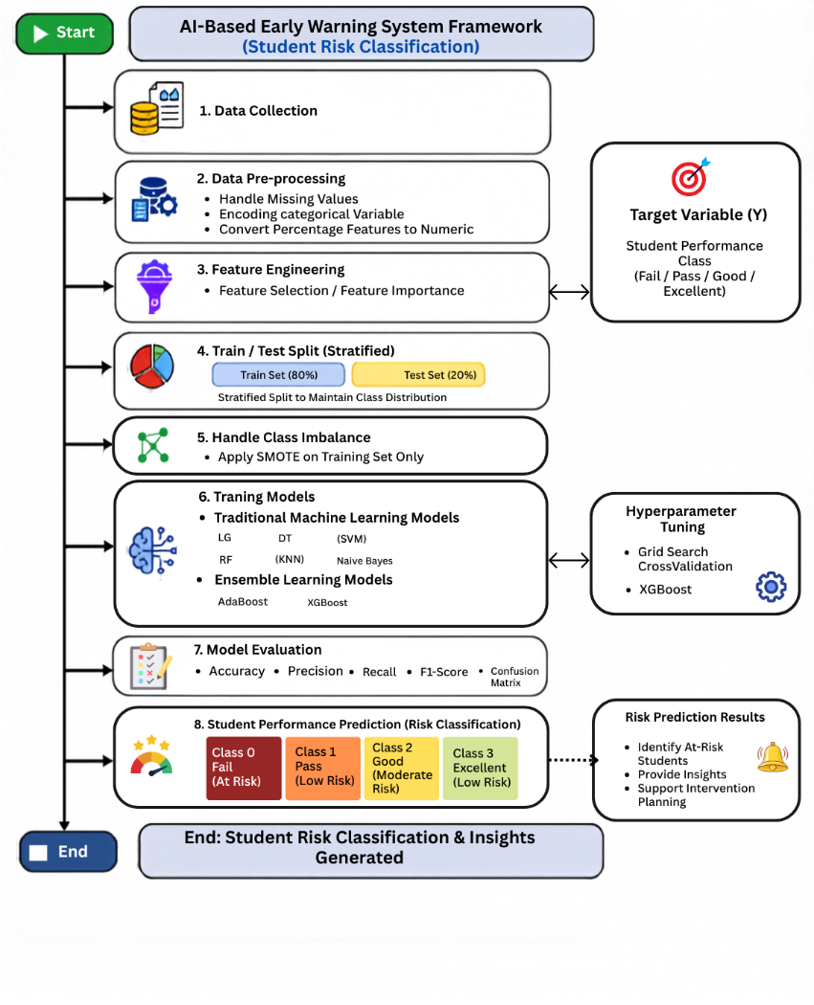
This chapter presents the methodology adopted to design, implement, and evaluate the proposed AI-Based Early Warning System for Academic Risk Detection in Education. Figure 7 describes the basic framework of the proposed system and identifies students who are at risk of poor academic achievement using educational data collected from the Learning Management System (LMS).
Figure 7Proposed AI-Based Early Warning System Framework (Student Risk Classification)

As shown in Figure 7, the proposed framework follows a systematic workflow consisting of the following sequential stages:
- Data Collection
- Data Preprocessing
- Stratified Train-Test Split
- Feature Selection
- Class Balancing using the Synthetic Minority Oversampling Technique (SMOTE)
- Machine Learning Model Training
- Hyperparameter Tuning using Grid Search
- Model Evaluation
- Student Performance Prediction (Risk Classification)
The data preprocessing stage is one of the most important phases of the proposed framework, as it prepares the dataset for machine learning analysis and improves the quality of the educational data before model development. The preprocessing stage includes the following steps:
- Handling missing values to improve data quality and ensure data consistency.
- Encoding categorical variables into numerical representations suitable for machine learning algorithms.
- Converting percentage-based features into numerical values for model processing.
- Splitting the dataset into 80% training and 20% testing subsets using the Stratified Train-Test Split technique to preserve the original class distribution.
- Applying the Synthetic Minority Oversampling Technique (SMOTE) only to the training dataset in the experimental configurations designed to address class imbalance.
After completing the preprocessing stage, feature selection is performed using the Random Forest feature importance method to identify the most informative educational variables affecting students' academic performance. Features with minimal contribution to prediction are eliminated to reduce model complexity while maintaining predictive performance.
To investigate the influence of preprocessing techniques on prediction performance, four experimental configurations were designed by evaluating the complete feature set and the selected feature set, both with and without applying SMOTE. These experimental settings enable a comprehensive comparison of the individual and combined effects of feature selection and class balancing on model performance.
The processed datasets are subsequently used to train and evaluate both traditional and ensemble machine learning algorithms under identical experimental conditions. The traditional machine learning models include DT, LR, SVM, KNN, and NB, while the ensemble learning models include RF, AB, and XGB.
To further improve predictive performance, Grid Search hyperparameter optimization is applied to the best-performing models identified in each experimental configuration. The optimized models are then re-evaluated and compared with their baseline performance.
Finally, the developed models are evaluated using standard classification metrics, including Accuracy, Precision, Recall, F1-score, and Confusion Matrix analysis. Based on the comparative analysis of all experimental configurations, the most reliable prediction model is selected to classify students into the four academic performance categories (Excellent, Good, Pass, and Fail) and generate early warning results that support timely educational intervention and data-driven decision-making.

3.1 Dataset Description
In this work, the experiments were conducted using a real educational dataset extracted from (LMS). The dataset consists of 1,395 student records represented by 18 educational attributes describing students' academic performance, participation, assessments, virtual classroom activities, homework completion, discussion participation, attendance, and other engagement indicators. The target variable represents students' academic performance and classifies each student into one of the following four categories:
- Excellent
- Good
- Pass
- Fail
These categories represent different levels of academic achievement and form the basis of the proposed early warning system for identifying students who require academic intervention.To ensure a fair evaluation of the developed models, the dataset was divided into training and testing subsets using the Stratified Train-Test Split technique. Approximately 80% of the dataset was allocated for model training, while the remaining 20% was reserved for testing. Stratified sampling was adopted to preserve the original class distribution in both subsets.

3.2 Data Preprocessing
Data preprocessing is a fundamental step in developing accurate machine learning models. The primary objective of this stage is to improve data quality, transform the raw educational data into a suitable format for machine learning algorithms, and reduce potential sources of prediction bias. Proper preprocessing also improves model generalization and contributes to obtaining more reliable prediction results. Figure 8 illustrates the preprocessing pipeline adopted in this study.

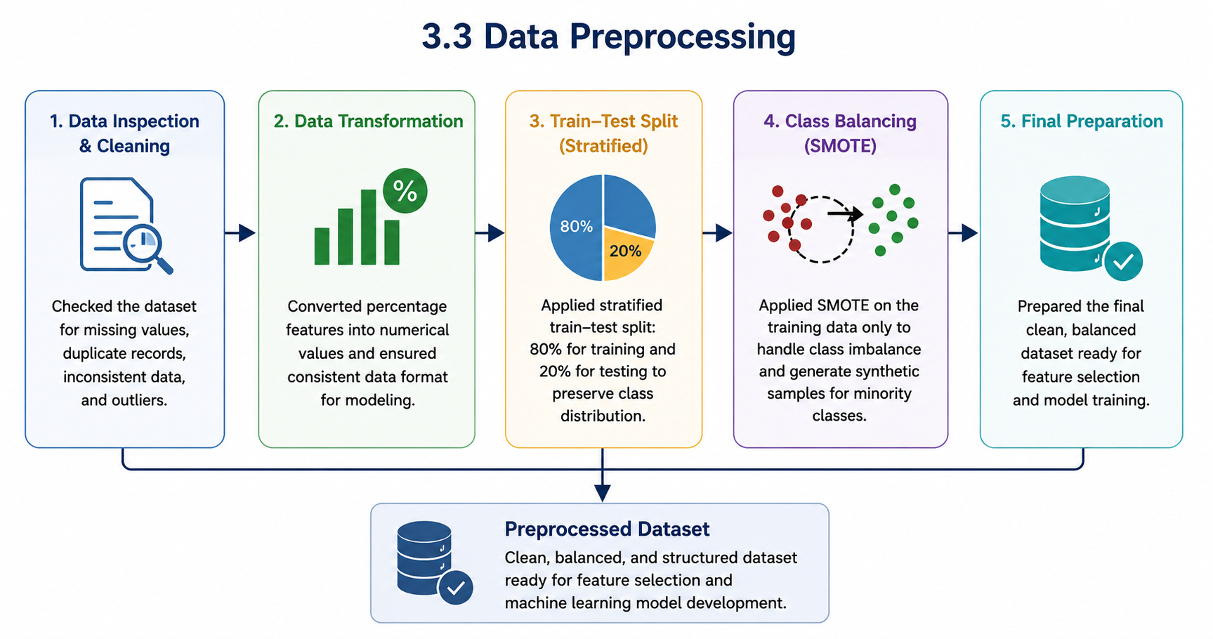
Figure 8. Data Preprocessing Pipeline
The preprocessing stage consists of the following sequential steps:

• Data Inspection
The educational dataset was initially inspected to verify its consistency and identify missing values, duplicated records, and potential data quality issues. This step ensured that the collected data were suitable for subsequent machine learning analysis.

• Data Transformation
Several educational attributes representing students' participation and engagement were stored as percentage values. These variables were converted into numerical values to ensure compatibility with the machine learning algorithms used in this research.

• Encoding Categorical Variables
Categorical variables were transformed into numerical representations whenever required to enable efficient model training and prediction.

• Stratified Train-Test Split
The dataset was divided into 80% training data and 20% testing data using the Stratified Train-Test Split technique. Stratified sampling was adopted to preserve the original distribution of the four academic performance categories in both subsets, ensuring a fair evaluation of the developed models.

• Class Balancing Using SMOTE
Since the dataset exhibited class imbalance, the Synthetic Minority Oversampling Technique (SMOTE) was applied only to the training dataset in the experimental configurations requiring class balancing. SMOTE generates synthetic samples for minority classes, allowing the machine learning models to learn balanced decision boundaries while preventing information leakage into the testing dataset.

• Final Dataset Preparation
After completing all preprocessing operations, the prepared datasets were used as input for feature selection and machine learning model development.

3.3 Feature Selection
Feature selection was performed to identify the educational variables that contributed most significantly to predicting students' academic performance. Reducing the number of irrelevant or low-impact variables helps simplify the prediction model, reduce computational complexity, and improve model interpretability while maintaining predictive performance.
The feature selection procedure consisted of the following steps:

• Feature Importance Analysis
A Random Forest classifier was employed to calculate the importance score of each educational attribute based on its contribution to prediction accuracy. The feature importance of each variable was computed based on the average reduction in impurity across all trees in the Random Forest model. The importance score of feature xj​ is calculated as:

• Feature Ranking
All input variables were ranked from the highest to the lowest importance score according to the Random Forest feature importance analysis.

• Feature Elimination
Features with negligible importance scores, including Teachers Messages and Student Login Percentage, were removed from the dataset because they contributed minimally to prediction performance.

• Selected Feature Set
The remaining high-importance features were retained and used in the feature-selection experiments to evaluate whether similar prediction performance could be achieved using fewer variables.

3.4 Experimental Configurations
To investigate the influence of feature selection and class balancing on prediction performance, four experimental configurations were designed and evaluated independently. These configurations enabled a comprehensive comparison of the individual and combined effects of the two preprocessing techniques.
The four experimental configurations are summarized as follows:
- Experiment 1: Full Feature Set without applying SMOTE.
- Experiment 2: Selected Feature Set without applying SMOTE.
- Experiment 3: Full Feature Set after applying SMOTE.
- Experiment 4: Selected Feature Set after applying SMOTE.
Each experimental configuration was evaluated under identical conditions using the same machine learning algorithms and evaluation metrics to ensure a fair comparison. The best-performing models obtained from each configuration were subsequently optimized using Grid Search before the final model selection.

3.5 Machine Learning Models
To determine the most suitable predictive model for the proposed AI-Based Early Warning System, several supervised machine learning algorithms were implemented and evaluated under identical experimental conditions. The evaluated algorithms represent different learning strategies commonly used in educational data mining and classification problems.
The evaluated models were divided into two categories.

3.5.1 Traditional Machine Learning Models
Six traditional classification algorithms were investigated in this study:
- DT
- RF
- LR
- SVM
- KNN
- NB
These models represent different statistical, probabilistic, distance-based, and tree-based learning approaches, providing a comprehensive comparison of classical machine learning techniques for predicting students' academic performance.

3.5.2 Ensemble Learning Models
In addition to the traditional classifiers, two ensemble learning algorithms were evaluated:
- AB
- XGB
These ensemble learning algorithms combine multiple learners to improve prediction accuracy, enhance model robustness, and reduce overfitting. Due to their strong predictive capabilities, they were included in the comparative analysis to evaluate their effectiveness in predicting students' academic performance.

3.6 Model Optimization
After evaluating the baseline machine learning models, a model optimization stage was conducted to further improve predictive performance. Hyperparameter optimization is an essential step in machine learning because the default parameter settings may not always provide the best classification performance or generalization capability.
In this study, Grid Search with cross-validation was employed as the optimization technique. Grid Search systematically evaluates different combinations of predefined hyperparameter values to determine the configuration that achieves the highest predictive performance. Cross-validation was incorporated into the optimization process to improve the robustness of the selected models and reduce the possibility of overfitting.
Since the best-performing algorithms differed across the four experimental configurations, hyperparameter optimization was applied to the highest-performing models identified in each experiment. Accordingly, DT, RF, and XGB were optimized whenever they achieved the best performance within a particular experimental configuration.
The optimization process consisted of the following steps:
- Selecting the best-performing baseline models from each experimental configuration.
- Defining a range of candidate hyperparameter values for each selected model.
- Applying Grid Search with cross-validation to evaluate all possible hyperparameter combinations.
- Selecting the optimal hyperparameter configuration based on the highest validation performance.
- Retraining the selected model using the optimal hyperparameter values.
- Evaluating the optimized model using the testing dataset and comparing its performance with the corresponding baseline model.
The optimized models were subsequently assessed using the same evaluation metrics employed throughout this study, namely Accuracy, Precision, Recall, F1-score, and Confusion Matrix analysis. The results of the optimization process were then compared with the baseline models to determine the effect of hyperparameter tuning on prediction performance. The detailed experimental results and performance comparisons are presented in the following chapter.

3.7 Summary
This chapter presented the methodology adopted for developing the proposed AI-Based Early Warning System for predicting students' academic performance and identifying academically at-risk students. It described the educational dataset, data preprocessing procedures, feature selection process, experimental configurations, machine learning models, and hyperparameter optimization approach used throughout this research.
A comprehensive preprocessing pipeline was implemented, including data inspection, data transformation, categorical variable encoding, stratified train-test splitting, and class balancing using the Synthetic Minority Oversampling Technique (SMOTE). Feature selection was performed using the Random Forest feature importance method to identify the most informative educational variables while reducing model complexity.
To evaluate the effectiveness of the proposed framework, four experimental configurations were designed to investigate the individual and combined effects of feature selection and SMOTE on prediction performance. Eight supervised machine learning algorithms, including both traditional and ensemble learning models, were trained and evaluated under identical experimental conditions. Hyperparameter optimization using Grid Search with cross-validation was subsequently applied to the best-performing models to further improve predictive performance.
The following chapter presents the experimental results, compares the performance of the evaluated models across all experimental configurations using standard classification metrics, and identifies the most suitable model for predicting students' academic performance and supporting early educational intervention.

Chapter 5 Results.

5.1 Experimental Setup
The experiments were conducted using Google Colab as the development environment and Python 3 as the programming language. The dataset consisted of 1,395 student records and 18 features related to student participation, engagement, assessments, and academic performance. Data preprocessing was performed using Pandas and NumPy libraries. Traditional machine learning algorithms were implemented, and ensemble learning was used.
The dataset was divided into training and testing subsets using stratified sampling, with 80% of the data allocated for training and 20% for testing. For imbalance class SMOTE was applied to the training dataset. Hyperparameter optimization was performed using Grid Search on the best-performing models.

5.2 Class Distribution
Before applying SMOTE, the dataset exhibited an imbalanced distribution among the four academic performance classes.

Table 2. Distribution of Student Performance Classes
Class | Number of Students | Percentage
Good | 725 | 51.97
Excellent | 322 | 23.08
Fail | 241 | 17.28
Pass | 107 | 7.67

As shown in Table 2, the Good class represented the majority of the dataset, accounting for approximately 52% of all records, whereas the Pass class represented only 7.67%. Therefore, SMOTE was employed to balance the training dataset and reduce classification bias toward the majority class.
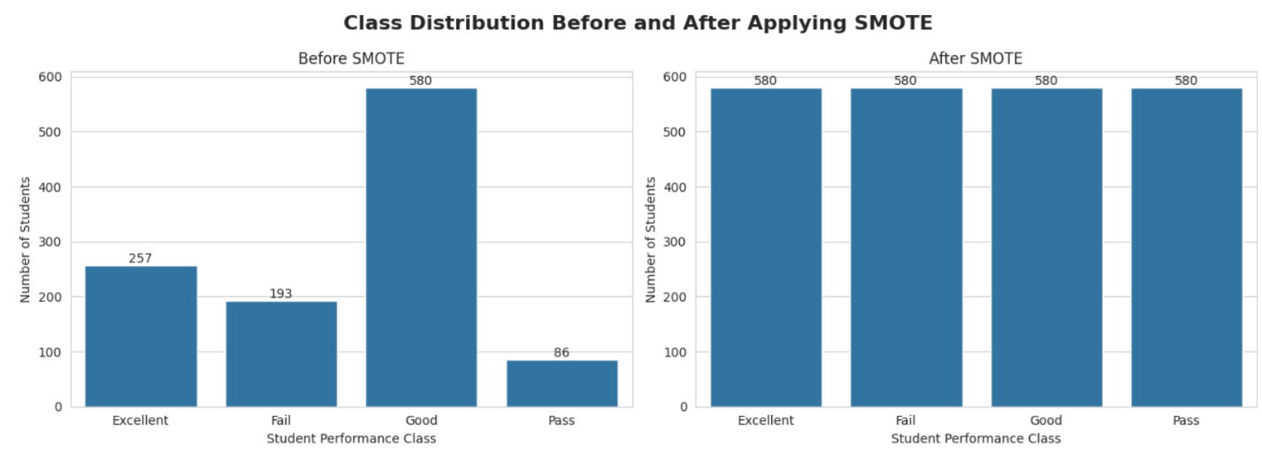
Figure 9 . Distribution of Student Performance Classes Before SMOTE.

The figure shows the class distribution before and after applying SMOTE to the training dataset. Before oversampling, the dataset exhibited a noticeable class imbalance, with the Good class containing the largest number of samples (580), while the Pass class had only 86 samples. The Excellent and Fail classes contained 257 and 193 samples, respectively. To address this imbalance, SMOTE was applied to generate synthetic samples for the underrepresented classes. As shown in the figure, all four classes contained 580 samples after applying SMOTE, resulting in a balanced class distribution. This balanced training dataset was subsequently used in the SMOTE-based experimental configurations to improve the models' ability to learn all student performance categories more effectively.

5.3 Feature Importance Analysis
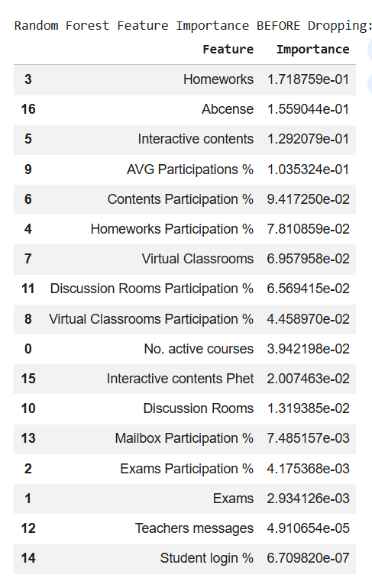
A Random Forest classifier was employed to evaluate the importance of the input features. The analysis identified the most influential variables affecting student performance prediction.
Figure 10.Feature Importance Analysis
The Table presents the feature importance scores obtained using the Random Forest algorithm before feature selection. The results indicate that Homework was the most influential feature, with an importance score of 0.1719, followed by Absence (0.1559) and Interactive Contents (0.1292). Other important predictors included Average Participation Percentage, Contents Participation Percentage, and Homework Participation Percentage, highlighting the significant role of student engagement and coursework in predicting academic performance.
In contrast, features such as Teachers' Messages and Student Login Percentage received extremely low importance scores (0.000049 and 0.000001, respectively), indicating that they contributed minimally to the prediction process. Consequently, these low-importance features were excluded from the final dataset to simplify the model and improve its efficiency without sacrificing predictive performance.

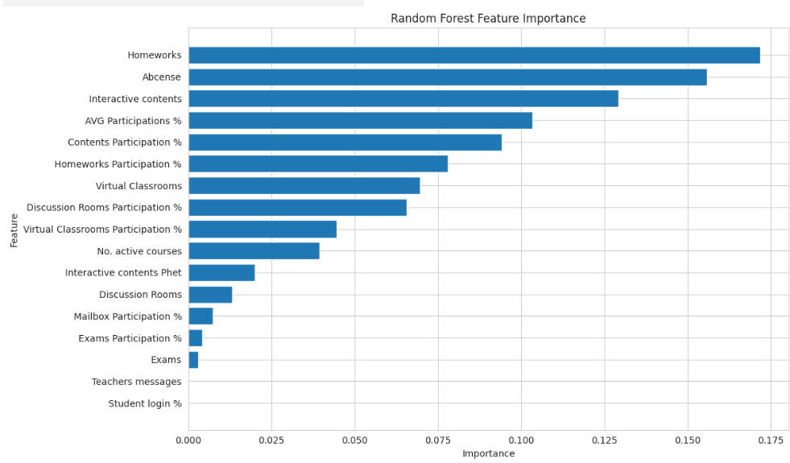
Figure 11. Random Forest Feature Importance Ranking.

The feature importance analysis revealed that participation-related variables and assessment indicators were among the most influential predictors. Conversely, Teacher Messages and Student Login Percentage contributed minimally to the prediction process and were therefore removed from the final feature set.

5.4 Results of Models Before Applying SMOTE.

5.4.1 Results of Applying Models with Full Features without SMOTE.
This experiment evaluated the predictive performance of machine learning models using the full feature set without applying SMOTE. The objective was to establish a baseline performance before evaluating the impact of class balancing. Both traditional ML and EL were trained and evaluated using identical experimental settings. Model performance was assessed using Accuracy, Precision, Recall, and F1-score, while confusion matrices were used to provide a detailed analysis of the classification results for each student performance category.

1) Performance Evaluation of Machine Learning Models

Table 3.. Results of Applying Machine Learning Models with Full Features
Approach | Model | Accuracy | Precision | Recall | F1-Score
Traditional ML | RF | 79.57 | 79.64 | 79.57 | 78.77
Traditional ML | DT | 79.21 | 79.42 | 79.21 | 79.21
Traditional ML | LR | 70.97 | 70.99 | 70.97 | 69.36
Traditional ML | SVM | 68.46 | 71.63 | 68.46 | 65.12
Traditional ML | KNN | 63.08 | 62.77 | 63.08 | 62.89
Traditional ML | NB | 20.43 | 53.03 | 20.43 | 21.41
Ensemble Learning | XGB | 82.80 | 82.63 | 82.80 | 82.42
Ensemble Learning | AdaBoost | 74.19 | 73.91 | 74.19 | 72.70

The results presented in Table 3 indicate clear variations in the predictive performance of the evaluated models. Among the traditional machine learning models, RF achieved the highest performance, recording an accuracy of 79.57%, a precision of 79.64%, a recall of 79.57%, and an F1-score of 78.77%. DT ranked second among the traditional ML models, with very close performance to that of RF. LR achieved acceptable classification performance, while SVM and KNN achieved lower performance and accuracy. Naïve Bayes produced the lowest performance. Naïve Bayes achieved the lowest classification performance, with an accuracy of 20.43%, showing that it was less effective than the other evaluated models.
For the EL models, XGB delivered the best overall performance, achieving the highest accuracy (82.80%), precision (82.63%), recall (82.80%), and F1-score (82.42%). AdaBoost ranked second among the ensemble methods with an accuracy of 74.19%, although its performance remained below that of both XGB and the Random Forest classifier. Overall, the results showed that the ensemble learning approach, particularly XGB, provided the highest predictive performance compared with most traditional ML models.

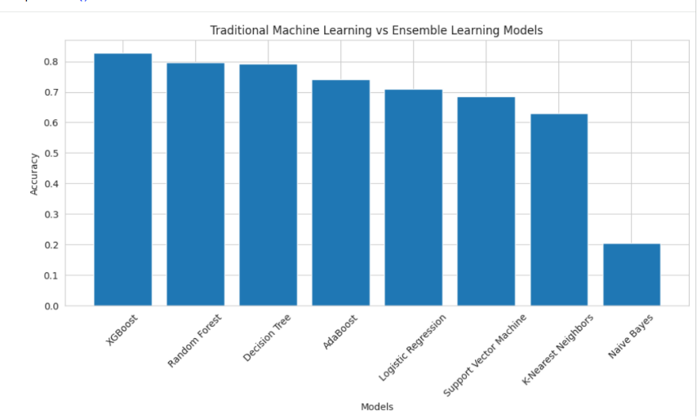
2) Accuracy Comparison
Figure 12. Accuracy Comparison of ML Models with Full Features.

Figure 12 provides a visual comparison of the performance metrics for all evaluated models. The figure clearly shows that XGBoost achieved the highest accuracy, while RF was the strongest performer among the traditional ML algorithms. DT achieved competitive performance, with evaluation metrics closely comparable to those of RF. Whereas LR, SVM, and KNN produced acceptable results. Naïve Bayes achieved the lowest scores across all evaluation metrics.

3) Confusion Matrix Analysis

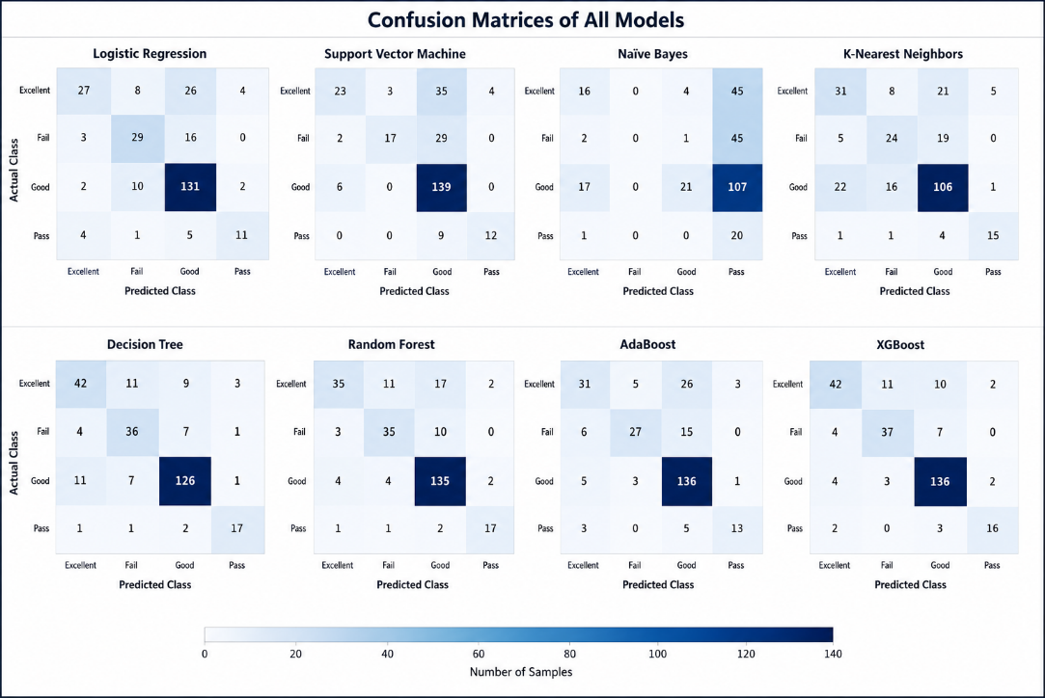
Figure 13. Confusion Matrices All Models

Eight confusion matrices are shown in Figure 13, each representing the classification performance of a different ML model across the four student performance categories (Excellent, Good, Pass, and Fail). The color intensity in each confusion matrix represents the number of observations assigned to each class, with darker colors indicating larger counts. XGB achieved the highest number of correctly classified observations, followed by RF and DT, as reflected by the strong concentration of values along the main diagonal. However, NB recorded the largest number of misclassified observations, while LR, SVM, and KNN showed moderate classification performance with greater confusion between neighboring classes.

4) Hyperparameter Optimization Using Grid Search

Table 4. Performance Before and After Grid Search Optimization
Grid Search | Model | Accuracy | Precision | Recall | F1-Score
Before | XGB | 82.80 | 82.63 | 82.80 | 82.42
Before | RF | 79.57 | 79.64 | 79.57 | 78.77
After | XGB | 81.72 | 81.66 | 81.72 | 81.10
After | RF | 80.29 | 80.21 | 80.29 | 79.35

To examine the effect of hyperparameter optimization on model performance, Grid Search with cross-validation was applied to the two best-performing models identified in the previous experiment, RF and XGB.
As presented in Table 4 the optimization process had different effects on the two models. RF showed a slight improvement after hyperparameter tuning, with its accuracy increasing from 79.57% to 80.29%. Small improvements were also observed in precision, recall, and F1-score, indicating that the optimized hyperparameters slightly enhanced the model's predictive performance. However, XGB experienced a minimal decrease in performance after optimization, with its accuracy decreasing from 82.80% to 81.72%, accompanied by small reductions in the remaining evaluation metrics. Even with this small reduction in performance, XGB remained the best-performing model overall. These findings suggest that hyperparameter tuning provided a modest improvement for RF, whereas the default hyperparameter configuration of XGB was already well suited to the characteristics of the current dataset.

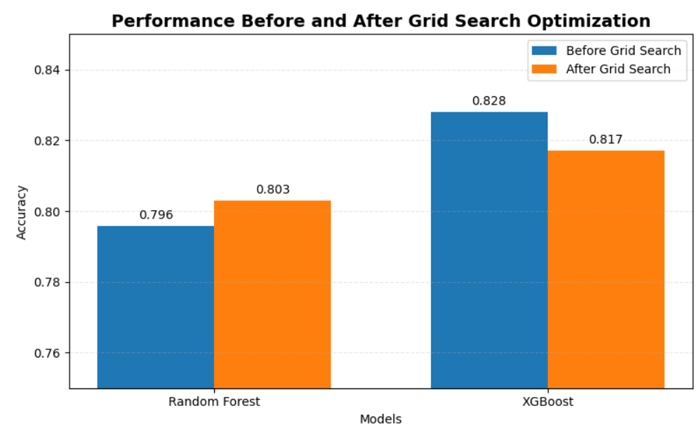
Figure 14. Performance Before and After Grid Search Optimization
Figure 14 compares the predictive performance of the selected models before and after Grid Search optimization. As shown in the figure, the performance of the two models was affected differently by hyperparameter tuning. RF exhibited a modest improvement, with its accuracy increasing from 79.57% before optimization to 80.29% after optimization. In contrast, XGB showed a marginal decrease in accuracy, from 82.80% to 81.72% following Grid Search. Even with this small reduction in performance, XGB remained the best-performing model.

5.4.2 Results of Applying Models with Selected Features without applying SMOTE.
In this experiment, feature selection was applied before model training to represent the effect of removing less informative features on classification performance. The selected feature set was used to train and evaluate both traditional and ensemble ML models without applying SMOTE. The same evaluation metrics used in the previous experiment, Accuracy, Precision, Recall, and F1-score, were employed to ensure a fair comparison between the two feature representations.

1) Performance Evaluation of All ML Models
Table 5.Results of Applying ML Models with Selected Features
Approach | Model | Accuracy | Precision | Recall | F1-Score
Traditional ML | (RF) | 79.57 | 79.69 | 79.57 | 78.77
Traditional ML | (DT) | 78.14 | 78.27 | 78.14 | 78.14
Traditional ML | (LR) | 70.97 | 70.99 | 70.97 | 69.36
Traditional ML | (SVM) | 68.46 | 71.63 | 68.46 | 65.12
Traditional ML | (KNN) | 63.08 | 62.77 | 63.08 | 62.89
Traditional ML | (NB) | 16.49 | 43.97 | 16.49 | 16.07
Ensemble Learning | (XGB) | 82.80 | 82.63 | 82.80 | 82.42
Ensemble Learning | AdaBoost | 74.19 | 73.91 | 74.19 | 72.70

Table 5 represents the performance of the evaluated ML models using the selected feature set. Among the traditional ML models, RF achieved the highest performance, with an accuracy of 79.57%, followed closely by DT, which achieved an accuracy of 78.14%. LR, SVM, and KNN obtained accuracies of 70.97%, 68.46%, and 63.08%, showing acceptable classification performance. In contrast, NB recorded the lowest performance, achieving an accuracy of 16.49%.
Among the ensemble learning models, XGB achieved the highest overall performance, recording an accuracy of 82.80%, a precision of 82.63%, a recall of 82.80%, and an F1-score of 82.42%. AdaBoost ranked second among the ensemble models, with an accuracy of 74.19%. Overall, XGB outperformed all evaluated models, while RF remained the strongest performer among the traditional ML algorithms.

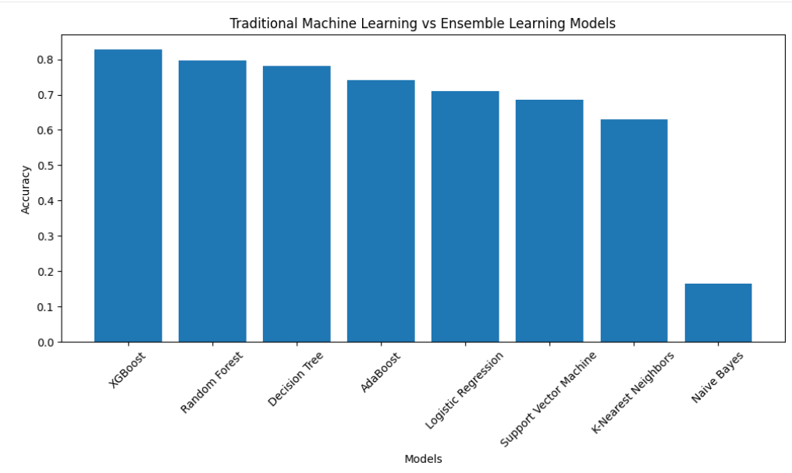
2) Accuracy Comparison
Figure 15 Accuracy Comparison of Machine Learning Models with Selected Features
Figure 15 compares the evaluation metrics of all machine learning models using the selected feature set. XGB achieved the highest overall accuracy, followed by Random Forest and Decision Tree. The remaining traditional models produced moderate performance, while Naïve Bayes continued to record the lowest evaluation scores. The figure shows the highest-performing models after feature selection.

3) Confusion Matrix Analysis
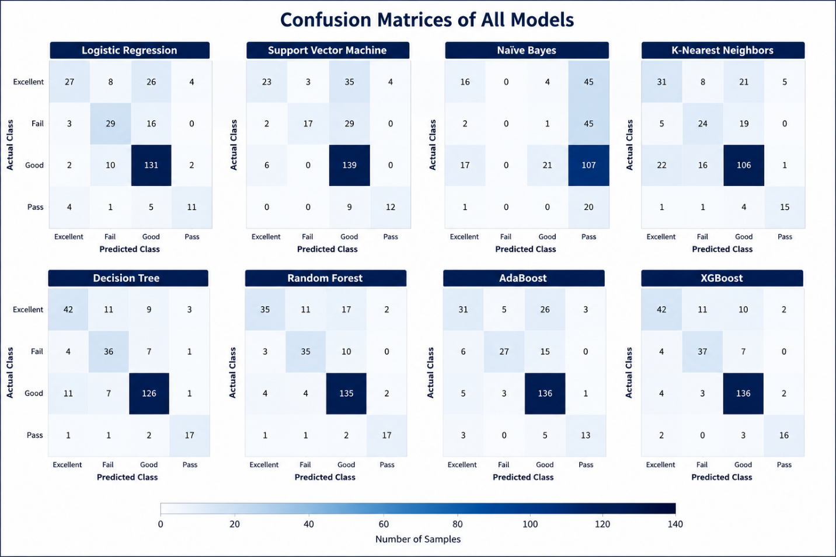
Figure 16 . Confusion Matrices of All Models

Eight confusion matrices are presented in Figure 16, each representing the classification performance of a different ML model across the four student performance categories (Excellent, Good, Pass, and Fail). The color intensity in each confusion matrix indicates the number of observations assigned to each class, with darker cells representing higher frequencies. Among the evaluated models, XGB achieved the highest classification performance, with the majority of observations correctly classified along the main diagonal. RF and DT also represent strong classification capability, producing a large number of correctly classified instances with relatively few misclassifications. In comparison, LR, SVM, and KNN showed greater confusion between the Excellent and Good categories, leading to a higher number of misclassifications. NB produced the weakest classification performance, misclassifying a considerable number of observations by assigning many instances from different classes to the Pass category. Overall, the confusion matrices visually confirm the performance of XGB, followed by RF and DT, compared with the remaining evaluated models.

4) Hyperparameter Optimization Using Grid Search

Table 6. Performance Before and After Grid Search Optimization
Grid Search | Category | Model | Accuracy | Precision | Recall | F1-Score
Before | Traditional ML | RF | 79.57 | 79.69 | 79.57 | 78.77
Before | Ensemble Learning | XGB | 82.80 | 82.63 | 82.80 | 82.42
After | Traditional ML | RF | 80.29 | 80.62 | 80.29 | 79.18
After | Ensemble Learning | XGB | 81.72 | 81.66 | 81.72 | 81.10
To examine the effect of hyperparameter optimization on model performance, Grid Search with cross-validation was applied to the best-performing traditional and ensemble learning models, RF and XGB. Table 6 presents the performance of both models before and after Grid Search optimization.
As shown in the table, the optimization process affected the two models differently. Before Grid Search, XGB achieved the highest accuracy (82.80%), while RF achieved an accuracy of 79.57%. After hyperparameter optimization, RF showed a modest improvement, with its accuracy increasing to 80.29%. Similar improvements were observed in precision, recall, and F1-score, indicating that hyperparameter tuning had a positive effect on the model's overall performance. In contrast, XGB experienced a minimal decrease after optimization, with its accuracy decreasing to 81.72. Even with this small reduction in performance, XGB remained the best-performing model overall. These findings suggest that hyperparameter tuning provided a modest improvement for RF, whereas the default hyperparameter configuration of XGB was already well suited to the characteristics of the current dataset.

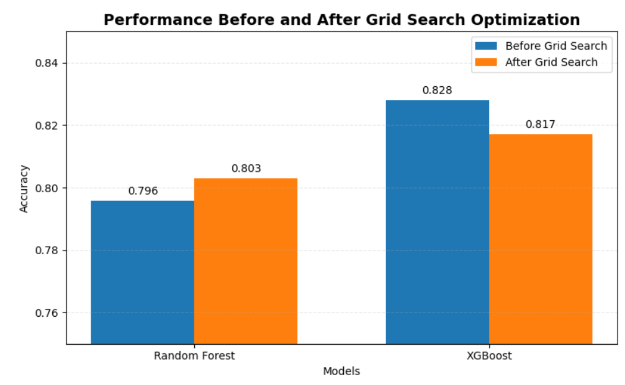
Figure 17. Performance Before and After Grid Search Optimization.

Figure 17 presents the classification accuracy of RF and XGB before and after Grid Search optimization. The figure shows that the optimization process had different effects on the two models. RF benefited from hyperparameter tuning, with its accuracy improving from 79.57% to 80.29%. In comparison, XGB recorded a slight decrease in accuracy, from 82.80% to 81.72%. Although its performance decreased marginally, XGB continued to achieve the highest classification accuracy.

5.5 Results of Models After Applying SMOTE.

5.5.1 Results of Applying Machine Learning Models with Full Features after Applying SMOTE
In this experiment, SMOTE was applied to the training dataset before model development to address the class imbalance problem. The full feature set was retained, and both traditional and ensemble ML models were trained and evaluated using the balanced dataset. The objective was to investigate the impact of class balancing on predictive performance while preserving all available features. Model evaluation was conducted using Accuracy, Precision, Recall, and F1-score, together with confusion matrices to assess the classification performance across the four academic performance categories.

1) Performance Evaluation of Machine Learning Models

Table 7. Results of Applying Machine Learning Models with Full Features after Applying SMOTE
Approach | Model | Accuracy | Precision | Recall | F1-Score
Traditional ML | DT | 79.57 | 79.82 | 79.57 | 79.51
Traditional ML | RF | 79.21 | 79.28 | 79.21 | 78.25
Traditional ML | LR | 66.67 | 70.98 | 66.67 | 66.74
Traditional ML | SVM | 60.93 | 66.83 | 60.93 | 61.01
Traditional ML | KNN | 60.93 | 65.40 | 60.93 | 61.90
Traditional ML | NB | 20.07 | 60.14 | 20.07 | 22.25
Ensemble Learning | XGB | 82.08 | 82.24 | 82.08 | 81.89
Ensemble Learning | AdaBoost | 71.33 | 73.89 | 71.33 | 70.92

Table 7 shows that the evaluated models achieved different levels of performance after training on the SMOTE-balanced dataset. Among the traditional ML algorithms, DT achieved the highest performance, recording an accuracy of 79.57%, followed closely by RF with an accuracy of 79.21%. LR, SVM, and KNN achieved moderate classification performance, whereas NB remained the weakest-performing model, with an accuracy of 20.07%.
Among the ensemble learning models, XGB achieved the highest overall performance, recording an accuracy of 82.08%, while AdaBoost achieved an accuracy of 71.33%. Overall, XGB achieved the highest overall performance, while DT was the best-performing traditional machine learning model.

2) Accuracy Comparison
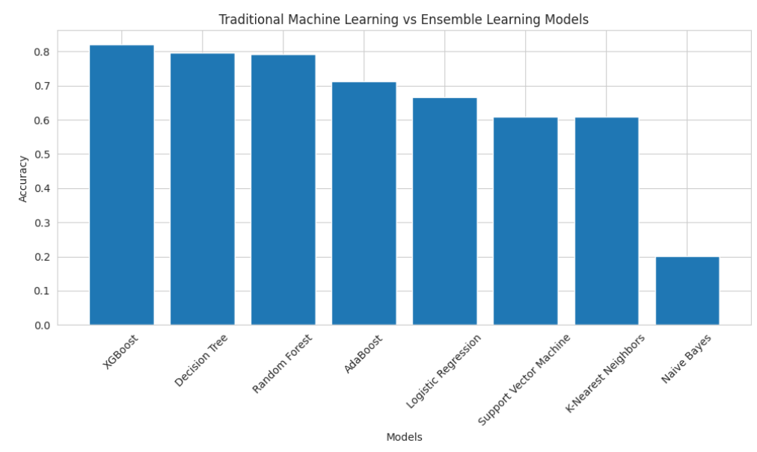
Figure 18. Accuracy Comparison of Machine Learning Models with Full Features after Applying SMOTE

Figure 18 compares the performance of all evaluated ML models using the full feature set after applying SMOTE. As shown in the figure, XGB achieved the highest classification accuracy (82.08%), followed by DT (79.57%) and RF (79.21%). AdaBoost also performed effectively. LR, SVM, and KNN achieved comparatively lower accuracies. In contrast, NB recorded the lowest performance among all the evaluated models. Overall, the figure shows that XGB remained the best-performing model, while DT was the strongest performer among the traditional ML models after balancing the training data using SMOTE.

3) Confusion Matrix Analysis
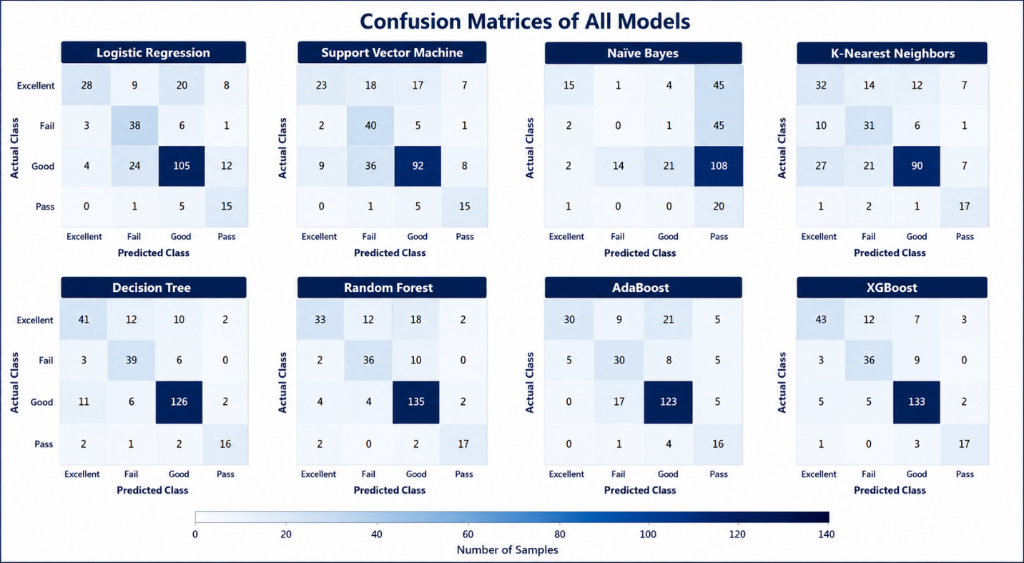
Figure 19. Confusion Matrices of Traditional ML Models with Full Features after Applying SMOTE.

Eight confusion matrices are presented in Figure 19, each representing the classification performance of a different ML model after applying SMOTE to the full feature set across the four student performance categories (Excellent, Good, Pass, and Fail). The color intensity in each confusion matrix represents the number of observations assigned to each class, with darker colors indicating larger counts. XGB achieved the highest number of correctly classified observations, followed by DT and RF, as reflected by the strong concentration of values along the main diagonal. However, NB recorded the largest number of misclassified observations, particularly for the Excellent and Good categories. While LR, SVM, and KNN showed moderate classification performance, with greater confusion between the Excellent and Good categories, resulting in a higher number of misclassifications.

4) Hyperparameter Optimization Using Grid Search with Full Features after Applying SMOTE.

Table 8. Performance Before and After Grid Search Optimization
Grid Search | Category | Model | Accuracy | Precision | Recall | F1-Score
Before | Traditional ML | DT | 79.57 | 79.82 | 79.57 | 79.51
Before | Ensemble Learning | XGB | 82.08 | 82.24 | 82.08 | 81.89
After | Traditional ML | DT | 77.78 | 78.49 | 77.78 | 78.05
After | Ensemble Learning | XGB | 82.08 | 82.33 | 82.08 | 81.48

To examine the effect of hyperparameter optimization on model performance, Grid Search with cross-validation was applied to the two best-performing models identified after applying SMOTE to the full feature set, DT and XGB. As presented in Table 8.11, the optimization process affected the two models differently. Before Grid Search, DT achieved an accuracy of 79.57%, while XGB achieved the highest accuracy of 82.08%. After hyperparameter tuning, DT showed a minimal decrease in performance, with its accuracy decreasing to 77.78%. Small reductions were also observed in its precision, recall, and F1-score. In contrast, XGB maintained its accuracy at 82.08%, with only minor changes in precision and F1-score, while recall remained unchanged. Overall, XGB remained the best-performing model.
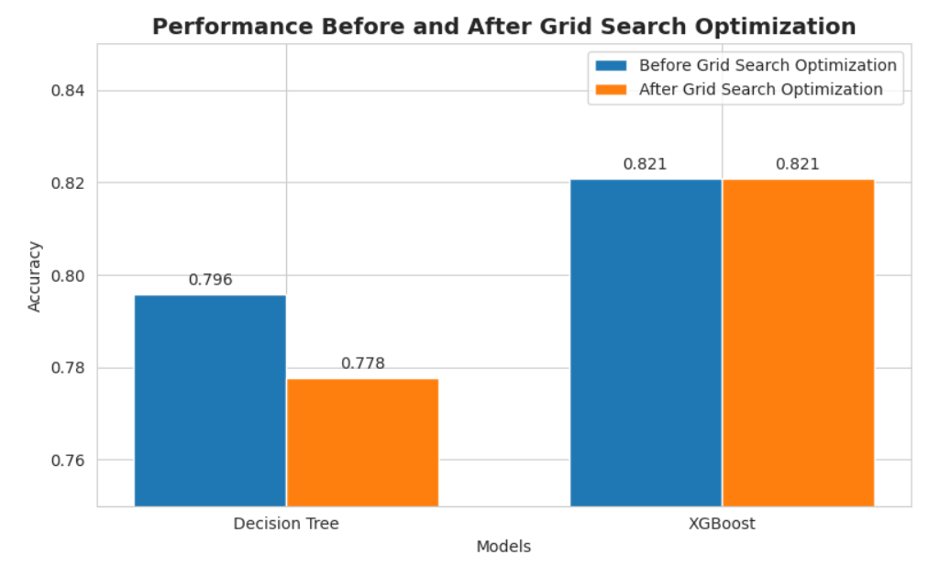
Figure 20. Performance Before and After Grid Search Optimization.

Figure 20 compares the classification accuracy of DT and XGB before and after Grid Search optimization using the full feature set after applying SMOTE. The figure shows that Grid Search affected the two models differently. DT recorded a minimal decrease in accuracy, dropping from 79.57% to 77.78% after optimization. On the other hand, XGB maintained a stable accuracy of 82.08% before and after hyperparameter tuning. These results suggest that Grid Search had a limited effect on the overall performance of the two models, with XGB continuing to achieve the highest classification accuracy.

5.5.2 Results of Applying Machine Learning Models with Selected Features after Applying SMOTE
This experiment combined feature selection with applying SMOTE to investigate their combined effect on student performance prediction. Feature selection was first applied to remove less informative variables, after which SMOTE was used to balance the training dataset. The resulting balanced and reduced dataset was then used to train and evaluate both traditional and ensemble ML models. The same evaluation metrics, Accuracy, Precision, Recall, and F1-score, were employed to ensure consistency across all experiments.

1) Performance Evaluation of All ML Models

Table 9. Results of Applying Machine Learning Models with Selected Features after Applying SMOTE.
Approach | Model | Accuracy | Precision | Recall | F1-Score
Traditional ML | DT | 79.93 | 80.56 | 79.93 | 79.84
Traditional ML | RF | 79.21 | 79.52 | 79.21 | 78.27
Traditional ML | LG | 66.67 | 70.98 | 66.67 | 66.74
Traditional ML | SVM | 64.52 | 68.16 | 64.52 | 64.03
Traditional ML | KNN | 60.57 | 65.11 | 60.57 | 61.55
Traditional ML | NB | 16.13 | 43.96 | 16.13 | 16.05
Ensemble Learning | XGB | 82.08 | 82.31 | 82.08 | 81.82
Ensemble Learning | AdaBoost | 70.97 | 73.94 | 70.97 | 70.71

Table 9 presents the performance of the evaluated machine learning models using the selected feature set after applying SMOTE. Among the traditional ML algorithms, DT achieved the highest performance, recording an accuracy of 79.93%, followed closely by RF with an accuracy of 79.21%. LR, SVM, and KNN achieved moderate classification performance, whereas NB remained the weakest-performing model, recording an accuracy of 16.13%.
Among the ensemble learning models, XGB achieved the highest overall performance, with an accuracy of 82.08%, while AB achieved an accuracy of 70.97%. Overall, XGB delivered the best classification performance among all the evaluated models, while DT emerged as the strongest performer among the traditional machine learning algorithms. These results indicate that the selected feature set, combined with SMOTE, enabled the best-performing models to maintain strong predictive performance while reducing the number of input features.

2)Accuracy Comparison
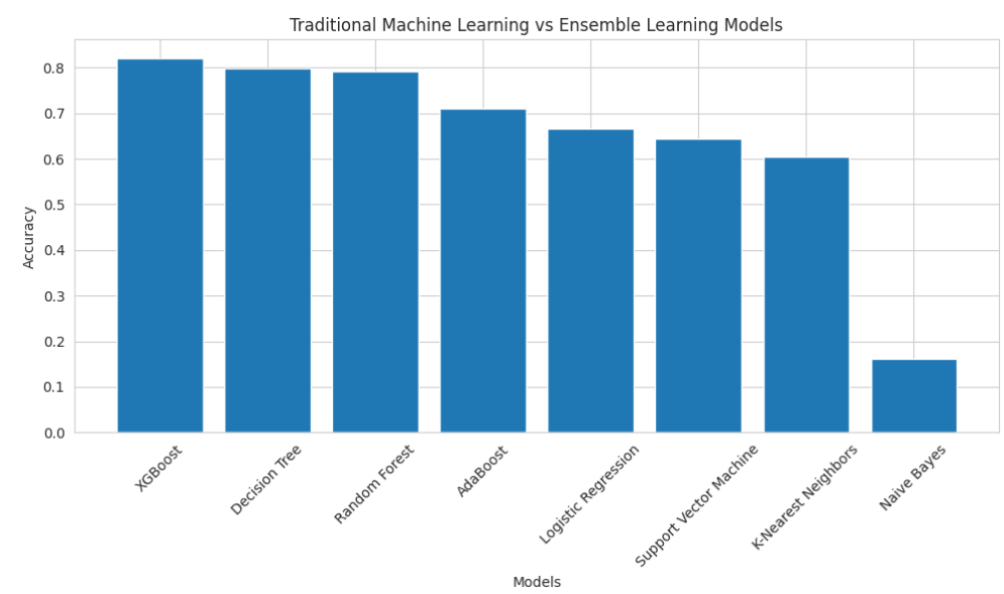
Figure 21. Accuracy Comparison of Machine Learning Models with Selected Features after Applying SMOTE

Figure 21 compares the classification accuracy of all evaluated ML models using the selected feature set after applying SMOTE. As shown in the figure, XGB achieved the highest classification accuracy (82.08%), followed by DT (79.93%) and RF (79.21%). AB also produced satisfactory results, while LR, SVM, and KNN achieved comparatively lower accuracies of 66.67%, 64.52%, and 60.57%, respectively. However, NB recorded the lowest performance, with an accuracy of 16.13%. Overall, the figure shows that XGB remained the best-performing model, while DT was the strongest performer among the traditional machine learning algorithms after applying SMOTE to the selected feature set.

3) Confusion Matrix Analysis

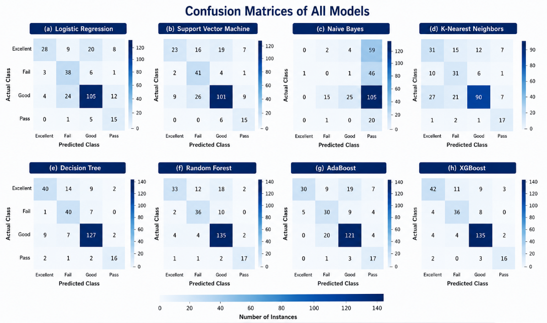
Figure 22. Confusion Matrices of Traditional Machine Learning Models

Eight confusion matrices are presented in Figure 8.13, each representing the classification performance of a different ML model using the selected feature set after applying SMOTE across the four student performance categories (Excellent, Good, Pass, and Fail). The color intensity in each confusion matrix represents the number of observations assigned to each class, with darker colors indicating larger counts. XGB achieved the highest number of correctly classified observations, followed by DT and RF. In contrast, NB recorded the largest number of misclassified observations, particularly by predicting many samples from the Excellent, Fail, and Good categories as Pass. While LR, SVM, and KNN achieved moderate classification performance, showing greater confusion between the Excellent and Good categories, as well as between the Good and Fail categories, resulting in a higher number of misclassifications.

4) Hyperparameter Optimization Using Grid Search

Table 10. Performance Before and After Grid Search Optimization.
Grid Search | Category | Model | Accuracy | Precision | Recall | F1-Score
Before | Traditional ML | DT | 79.93 | 80.56 | 79.93 | 79.84
Before | Ensemble Learning | XGB | 82.08 | 82.31 | 82.08 | 81.82
After | Traditional ML | DT | 82.80 | 82.56 | 82.80 | 82.37
After | Ensemble Learning | XGB | 81.72 | 81.66 | 81.72 | 81.10

To examine the effect of hyperparameter optimization on model performance, Grid Search with cross-validation was applied to the two best-performing models identified after applying SMOTE to the selected feature set, DT and XGB. As presented in Table 8.8, the optimization process affected the two models differently. DT showed a noticeable improvement after hyperparameter tuning, with its accuracy increasing from 79.93% to 82.80%, accompanied by improvements in precision, recall, and F1-score. In contrast, XGB experienced only a minimal decrease in performance, with its accuracy changing from 82.08% to 81.72%, while the remaining evaluation metrics changed only marginally. Overall, the XGB high-performance model performed well throughout the study, demonstrating stable predictive performance across the different experimental settings.

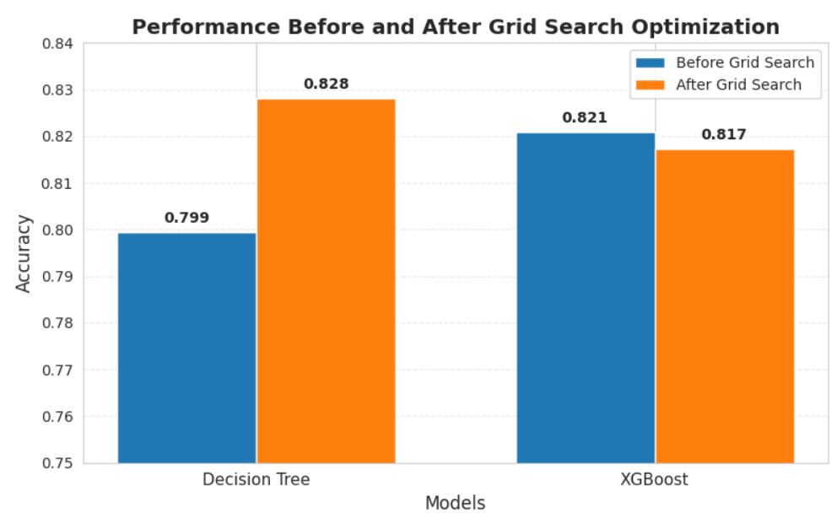
Figure 23.Performance Before and After Grid Search Optimization.

Figure 23 compares the classification accuracy of DT and XGB before and after Grid Search optimization using the selected feature set after applying SMOTE. As shown in the figure, the two models responded differently to hyperparameter tuning. DT benefited from the optimization process, with its accuracy improving from 79.93% to 82.80%, indicating that the selected hyperparameters enhanced its classification performance. In contrast, XGB showed only a slight decrease in accuracy, from 82.08% to 81.72%, suggesting that its default hyperparameter settings were already well suited to the dataset. Overall, the figure shows that Grid Search was effective in improving the performance of DT, whereas it had only a limited effect on XGB.

5.6 Final Model Selection

Table 11. Final Performance of the Best Models Across the Four Experimental Configurations
Experimental Configuration | Best Model | Accuracy | Precision | Recall | F1-Score
Full Feature Set | XGB | 82.80 | 82.63 | 82.80 | 82.42
Selected Feature Set | XGB | 82.80 | 82.63 | 82.80 | 82.42
Full Feature Set + SMOTE | XGB | 82.08 | 82.31 | 82.08 | 81.82
Selected Feature Set + SMOTE | DT | 82.80 | 82.56 | 82.80 | 82.37
Selected Feature Set + SMOTE | XGB | 81.72 | 81.66 | 81.72 | 81.10

The four experimental configurations were evaluated to determine the most effective combination of preprocessing techniques and machine learning algorithms for predicting students' academic performance. The experiments included:
(1) The full feature set without SMOTE
(2) The selected feature set without SMOTE,
(3) The full feature set after applying SMOTE
(4) The selected feature set after applying SMOTE.
The experimental results showed that different preprocessing strategies affected the performance of the evaluated models in different ways. While Decision Tree achieved the highest accuracy after Grid Search optimization in one experimental configuration, XGBoost consistently ranked among the top-performing models across all four experiments. Other than classifiers, XGBoost maintained stable predictive performance regardless of whether feature selection or SMOTE was applied.
Considering both predictive accuracy and model stability across all experimental configurations, XGBoost was selected as the final model. The model consistently achieved high Accuracy, Precision, Recall, and F1-score values while demonstrating balanced classification performance under different preprocessing conditions. These findings indicate that XGBoost provides a reliable and effective model for predicting students' academic performance.

5.7 Comparative Analysis of the Experimental Configurations
This section compares the four experimental configurations to evaluate the individual and combined effects of feature selection and SMOTE on predicting students' academic performance. The comparison is based on the best-performing model obtained from each experimental configuration, providing a comprehensive evaluation of the proposed prediction framework.
The comparison presented in Table 8.9 demonstrates that both feature selection and SMOTE influenced the predictive performance of the evaluated machine learning models. Although all four experimental configurations produced satisfactory classification results, the effect of each preprocessing technique varied depending on the learning algorithm.
The experiments conducted without applying SMOTE achieved competitive overall classification accuracy using the original class distribution. However, the confusion matrices revealed that several models struggled to correctly classify the minority classes, resulting in a larger number of misclassifications for these categories.
After applying SMOTE, the models produced more balanced classification results across the four academic performance categories. The balanced training data improved recognition of less represented classes, leading to better Recall and F1-score values while maintaining competitive classification accuracy. This improvement was particularly noticeable for the ensemble learning models, which benefited more from the balanced dataset.
Applying feature selection reduced the dimensionality of the dataset by removing variables with limited predictive importance. Despite using fewer input variables, the selected-feature experiments maintained performance levels comparable to those obtained using the complete feature set. This suggests that the retained features preserved most of the relevant information required for accurate student performance prediction while reducing model complexity.
Overall, the results indicate that combining feature selection with SMOTE provided the most balanced preprocessing strategy, producing competitive classification performance while simplifying the learning process. Among the evaluated algorithms, XGB consistently ranked among the strongest performers across all experimental settings, where DT and RF also achieved highly competitive results, particularly after hyperparameter optimization. LR, SVM, and KNN generally produced moderate performance, while NB consistently recorded the lowest evaluation scores.

5.7.1 Summary of the Experimental Findings
The findings from the four experimental configurations demonstrate that data preprocessing plays an important role in improving machine learning-based student performance prediction. Applying SMOTE enhanced the models' ability to recognize less represented classes by creating a more balanced training dataset, where feature selection reduced the number of input variables without noticeably affecting predictive performance.
Across all experiments, the ensemble learning models consistently achieved stronger classification performance than the traditional ML models. Although Decision Tree achieved the highest accuracy in one optimized experiment, XGBoost maintained consistently high performance under all preprocessing strategies, demonstrating both effective and generalization capability. These findings suggest that XGBoost is a reliable model for educational prediction tasks involving heterogeneous academic and behavioral data.
Overall, the experimental results show that integrating feature selection with SMOTE provides an effective preprocessing strategy for student academic performance prediction. The proposed framework successfully improved classification performance while maintaining balanced predictions across the four academic performance categories, thereby addressing the research objectives of this study.

Chapter 5 Conclusion and Future Work

5.1 Conclusion
This thesis presented an AI-Based Early Warning System for predicting students' academic performance using educational engagement and assessment data collected from a Learning Management System (LMS). The proposed framework integrates data preprocessing, feature selection, machine learning classification, and hyperparameter optimization to accurately identify students who are academically at risk and support early educational intervention.
A comprehensive preprocessing pipeline was implemented, including data transformation, stratified train-test splitting, feature selection based on Random Forest feature importance, and class balancing using the Synthetic Minority Oversampling Technique (SMOTE). Four experimental configurations were investigated to evaluate the individual and combined effects of feature selection and SMOTE on prediction performance.
Eight supervised machine learning algorithms were evaluated, including Decision Tree (DT), Random Forest (RF), Logistic Regression (LR), Support Vector Machine (SVM), K-Nearest Neighbors (KNN), Naïve Bayes (NB), AdaBoost, and XGBoost (XGB). The experimental results demonstrated that ensemble learning methods generally outperformed traditional machine learning algorithms. Among all evaluated models, XGBoost consistently achieved the strongest predictive performance across different experimental settings, reaching an accuracy of 82.80%, with a precision of 82.63%, recall of 82.80%, and F1-score of 82.42%. Although Decision Tree achieved the same accuracy (82.80%) after Grid Search optimization in one experimental configuration, XGBoost demonstrated greater stability and consistently ranked among the top-performing models across all experiments.
The experimental findings also showed that feature selection successfully reduced the number of input variables without noticeably affecting predictive performance, while SMOTE improved the recognition of minority classes and produced more balanced classification results. Hyperparameter optimization produced modest improvements for some models, particularly Decision Tree and Random Forest, whereas XGBoost maintained high performance even with its default parameter settings.
Overall, the proposed AI-based early warning framework provides an effective and reliable approach for predicting students' academic performance. The developed system enables educational institutions to identify academically at-risk students at an early stage, allowing timely interventions, improving student success, reducing academic failure, and supporting data-driven educational decision-making.

5.2 Future Work
Although the proposed framework achieved promising predictive performance, several opportunities remain for future research and further enhancement.
- Integrate additional educational data sources, such as attendance records, behavioral logs, discussion forum activities, assignment submission patterns, and temporal learning analytics, to provide a richer representation of students' learning behaviors.
- Investigate advanced deep learning approaches, including Long Short-Term Memory (LSTM), Transformer-based architectures, and hybrid machine learning–deep learning models, to capture sequential learning behaviors and potentially improve prediction performance.
- Develop a real-time AI-based early warning system that continuously monitors student engagement throughout the semester and generates automatic alerts for instructors, academic advisors, and students.
- Validate the proposed framework using larger and more diverse datasets collected from multiple educational institutions and different learning environments to improve the robustness and generalizability of the developed models.
- Incorporate Explainable Artificial Intelligence (XAI) techniques, such as SHAP and LIME, to provide transparent explanations of model predictions and increase educators' trust in AI-assisted decision-making.
- Explore personalized intervention recommendation systems that not only identify at-risk students but also recommend suitable academic support strategies based on each student's predicted risk profile.
- Investigate automated model updating and online learning techniques that enable the prediction model to adapt continuously as new educational data become available, ensuring sustained predictive performance over time.

References:
[1] Y. Li, "Artificial Intelligence Technologies for Education," ed: MDPI-Multidisciplinary Digital Publishing Institute, 2025.
[2] A. Taghvaie, T. Warnakulasuriya, D. Kumar, F. Zare, R. Sharma, and D. M. Vilathgamuwa, "A comprehensive review of harmonic issues and estimation techniques in power system networks based on traditional and artificial intelligence/machine learning," Ieee Access, vol. 11, pp. 31417–31442, 2023.
[3] C. M. Bishop and N. M. Nasrabadi, Pattern recognition and machine learning (no. 4). Springer, 2006.
[4] S. U. S. o. I. Studies. "Data Science vs. Machine Learning." Syracuse University. https://ischool.syracuse.edu/data-science-vs-machine-learning/ (accessed july 4, 2026).
[5] K. P. Murphy, Machine learning: a probabilistic perspective. MIT press, 2012.
[6] T. Hastie, "The elements of statistical learning: data mining, inference, and prediction," ed: springer, 2009.
[7] T. Hastie, R. Tibshirani, and J. Friedman, "The elements of statistical learning," ed: Springer series in statistics New-York, 2009.
[8] J. R. Quinlan, C4. 5: programs for machine learning. Elsevier, 2014.
[9] D. Bañeres, M. E. Rodríguez, A. E. Guerrero-Roldán, and A. Karadeniz, "An early warning system to detect at-risk students in online higher education," Applied Sciences, vol. 10, no. 13, p. 4427, 2020.
[10] B. Ujkani, D. Minkovska, and N. Hinov, "Course success prediction and early identification of at-risk students using explainable artificial intelligence," Electronics, vol. 13, no. 21, p. 4157, 2024.
[11] A. Bettahi, H. Harroud, and F.-Z. Belouadha, "Early Student Risk Detection Using CR-NODE: A Completion-Focused Temporal Approach with Explainable AI," Algorithms, vol. 18, no. 12, p. 781, 2025.
[12] O. H. Embarak and S. Hawarna, "Automated AI-driven system for early detection of at-risk students," Procedia Computer Science, vol. 231, pp. 151–160, 2024.
[13] L. P. Macfadyen and S. Dawson, "Mining LMS data to develop an “early warning system” for educators: A proof of concept," Computers & education, vol. 54, no. 2, pp. 588–599, 2010.
[14] E. M. Queiroga, M. F. Batista Machado, V. R. Paragarino, T. T. Primo, and C. Cechinel, "Early prediction of at-risk students in secondary education: A countrywide k-12 learning analytics initiative in uruguay," Information, vol. 13, no. 9, p. 401, 2022.
[15] W. Bagunaid, N. Chilamkurti, A. S. Shahraki, and S. Bamashmos, "Visual data and pattern analysis for smart education: a robust DRL-based early warning system for student performance prediction," Future Internet, vol. 16, no. 6, p. 206, 2024.
[16] F. T. Johora, M. N. Hasan, A. Rajbongshi, M. Ashrafuzzaman, and F. Akter, "An explainable AI-based approach for predicting undergraduate students academic performance," Array, vol. 26, p. 100384, 2025.
[17] V. Christou et al., "Performance and early drop prediction for higher education students using machine learning," Expert Systems with Applications, vol. 225, p. 120079, 2023.
[18] V. Realinho, J. Machado, L. Baptista, and M. V. Martins, "Predicting student dropout and academic success," Data, vol. 7, no. 11, p. 146, 2022.
[19] N. N. Hamadneh, S. Atawneh, W. A. Khan, K. A. Almejalli, and A. Alhomoud, "Using artificial intelligence to predict students’ academic performance in blended learning," Sustainability, vol. 14, no. 18, p. 11642, 2022.
[20] M. Skittou, M. Merrouchi, and T. Gadi, "Development of an early warning system to support educational planning process by identifying at-risk students," IEEE access, vol. 12, pp. 2260–2271, 2023.
[21] I. Khan, A. R. Ahmad, N. Jabeur, and M. N. Mahdi, "An artificial intelligence approach to monitor student performance and devise preventive measures," Smart Learning Environments, vol. 8, no. 1, p. 17, 2021.
[22] G. Akçapınar, A. Altun, and P. Aşkar, "Using learning analytics to develop early-warning system for at-risk students," International Journal of Educational Technology in Higher Education, vol. 16, no. 1, p. 40, 2019.
[23] B. Albreiki, T. Habuza, Z. Shuqfa, M. A. Serhani, N. Zaki, and S. Harous, "Customized rule-based model to identify at-risk students and propose rational remedial actions," Big Data and Cognitive Computing, vol. 5, no. 4, p. 71, 2021.

