

Title
Prepared By
Name: Hizam Ahmed ID No.: 251002066

Project Title: Development of a multimodal AI framework for ICU outcome mortality prediction using clinical notes and laboratory data
At
Collage of Informatics
Midocean University
UAE
Supervisor Name: Dr. Hager Salah
Collage of Informatics, Midocean University, Comoros
Email: hizam.alsaeedi@gmail.com

Acknowledgements
First and foremost, I would like to express my deepest gratitude to Dr. Hager Salah for her continuous support, valuable guidance, and encouragement throughout the course of this thesis. Her expertise, insightful feedback, and patience have been instrumental in shaping this work and ensuring its successful completion.

I would also like to thank all the faculty members and colleagues who provided assistance and shared their knowledge during the development of this thesis. Their constructive suggestions and motivation have greatly contributed to the improvement of this study.

Finally, I am sincerely thankful to my family and friends for their constant love, understanding, and support, which have been a source of strength throughout this journey.

Abstract
This these presents a multimodal artificial intelligence framework designed to improve ICU mortality prediction by integrating structured clinical data with unstructured clinical notes. The proposed approach combines multiple machine-learning methods with transformer-based language models to capture both numerical patterns and nuanced textual information recorded during patient care. In the structured data component, models such as Random Forest, Support Vector Machines, Logistic Regression, Decision Trees, and Naïve Bayes are evaluated using laboratory measurements, vital signs, and demographic attributes. To handle the unstructured part of the dataset, the study makes use of BioBERT and ClinicalBERT, which are well suited for interpreting medical language found in clinical notes. These models convert the narrative text into meaningful representations that capture clinical context and subtle linguistic cues. In parallel, the structured variables—laboratory findings, physiological measurements, and demographic attributes—are processed separately to form their own feature representation.
Once both streams are encoded, their outputs are brought together through a multimodal fusion layer that simply joins the two embeddings into one combined feature vector. This unified representation is then used to predict ICU mortality. The full framework is trained and tested on a dataset that includes both numeric patient information and written clinical documentation. Its performance is examined through several evaluation measures, including accuracy, precision, recall, F1-score, and AUC.
The results consistently show that merging text-based embeddings with structured clinical features leads to stronger predictive performance than relying on either source alone. By pairing transformer-based language models with established machine-learning methods, the approach offers a realistic path toward more dependable mortality prediction. The framework provides a practical foundation for clinical decision-support applications and has the potential to enhance risk assessment and patient management within intensive-care settings.

Table of Contents
Title 1
Acknowledgements 2
Abstract 3
List of Abbreviations 5
List of Figures 6
List of Tables 6
Chapter 1 Introduction 7
1.1 Problem Definition 7
1.2 Thesis Objectives 7
1.3 Thesis Contribution 8
1.4 Thesis Organization 9
Chapter 2 Overview 10
2.1 Introduction 10
2.2 Healthcare Data Analytics and Mining 10
2.3 Multimodal AI in Clinical Outcome Prediction 12
2.3.1 Structured Data Analysis 12
2.3.2 Unstructured Data Analysis 12
2.3.3 Multimodal Fusion Approaches 12
2.3.4 Optimization and Model Tuning 13
Chapter 3 Related Work 14
3.1 Introduction 14
3.2 History and Literature Review 14
3.3 Multimodal and Fusion-Based Frameworks 15
3.4 Optimization Methods in Model Development 16
Chapter 4 Proposed Approach 18
4.1 Overview 18
4.2 Overview of the Multimodal Framework 19
4.3 Structured Data Processing (Demographics and Lab Values) 20
4.3.1 Data Preprocessing 20
4.3.2 training models 20
4.4 Unstructured Data Processing (Clinical Notes) 21
4.4.1 Text Preprocessing 21
4.4.2 Feature Extraction with Transformer Models 21
4.5 Multimodal Fusion Layer 22
Chapter 5 24
5.1 Experimental Results and Discussion 24
5.2 Experimental Setup 24
5.3 Results on Structured and Unstructured Data Models 24
5.3.1 Word Count Representation 27
5.3.2 TF-IDF Representation 27
5.3.3 Contextual BERT Embeddings 27
5.4 Results on Multimodal 28
5.4.1 Multimodal Transformer Fusion Performance 29
5.4.2 Explanation of the ROC Curve 30
5.4.3 Confusion Matrix Interpretation 31
Chapter 6 Conclusion and Future Work 33
6.1 Conclusion 33
6.2 Future Work 33
References 34

List of Abbreviations
- Acc.: Accuracy
- NLP: Natural Language Processing
- ML: Machine Learning
- DL: Deep Learning
- XAI: Explainable Artificial Intelligence
- SVM: Support Vector Machine
- RF: Random Forest
- DT: Decision Tree
- RNN: Recurrent Neural Network
- LR: Logistic Regression
- AI: Artificial Intelligence
- NB: Naïve Bayes
- PRE: Precision
- REC: Recall
- F1: F1-Score

List of Figures
Fig 5. 1 Accuracy comparison of all models 26
Fig 5. 2 Comparison of Multimodal 28
Fig 5. 3 Accuracy comparison of all models, highlighting the best-performing model 29
Fig 5. 4 Receiver Operating Characteristic (ROC) curve of the model 30
Fig 5. 5 Confusion Matrix 31

List of Tables
Table 1 Comparison of All Models 26
Table 2 Comparison of Multimodal 28

Chapter 1 Introduction

1.1 Problem Definition
Predicting patient outcomes in the Intensive Care Unit (ICU) is one of the most critical challenges in clinical decision support. ICU patients often have complex medical conditions that evolve rapidly, requiring physicians to make time-sensitive and data-driven decisions [16]. Traditionally, outcome prediction models rely primarily on structured data such as demographics, laboratory test results, and vital signs. Although these structured data elements provide valuable quantitative insights, they fail to capture the qualitative and contextual information found in unstructured clinical notes, such as physicians’ observations, progress reports, and discharge summaries [2].
The integration of unstructured clinical text with structured data remains a significant challenge due to differences in data formats, semantics, and dimensionality. As a result, existing predictive models often exhibit limited generalization and lower performance in real-world ICU settings [16].
Therefore, the central thesis problem of this study is: How can structured (laboratory and demographic) data and unstructured (clinical notes) data be effectively integrated into a unified multimodal AI framework to improve ICU mortality outcome prediction accuracy and reliability?
This thesis seeks to bridge the gap between numeric and textual information, taking advantage of recent developments in natural language processing (NLP) and deep learning to enhance predictive performance and clinical interpretability.

1.2 Thesis Objectives
The main objective of this thesis is to design and develop a multimodal AI framework that integrates structured and unstructured clinical data for improved ICU mortality prediction.
The specific objectives include:
- Data preprocessing and representation: To preprocess and clean both structured (lab values, demographic data) and unstructured (clinical notes) datasets to ensure consistency, accuracy, and readiness for modeling.
- Model development for individual modalities: To develop separate models for structured and unstructured data such as Random Forests (RF), Logistic Regression (LR), Naïve Bayes (NB), Decision Tree (DT), Support Vector Machines (SVM), and Recurrent Neural Networks (RNN) for structured data, and Word Count, TF-IDF and transformer-based models such as BioBERT and ClinicalBERT for textual data.
- Multimodal fusion: To integrate outputs from both modalities through a concatenation (fusion) layer to form a comprehensive patient representation for outcome prediction.
- Performance evaluation: To evaluate the proposed model using standard metrics such as accuracy, precision, recall, F1-score, and area under the ROC curve (AUC).
- Comparative analysis: To compare the multimodal model against unimodal (single-type data) baselines to demonstrate its superiority in ICU mortality prediction tasks.

1.3 Thesis Contribution
This thesis contributes to the growing field of AI-driven healthcare analytics by introducing an innovative multimodal approach that leverages both structured and unstructured ICU data. The key contributions include:
- A unified multimodal AI architecture combining RNN for structured data processing and BioBERT/Transformer for textual feature extraction from clinical notes.
- An optimized data preprocessing pipeline capable of handling heterogeneous ICU data, including missing values, irregular sampling, and unstructured text.
- A fusion-based integration strategy using a concatenation layer that effectively combines deep representations from both modalities for enhanced predictive performance.
- Comprehensive performance evaluation, showing that the proposed model achieves higher accuracy, precision, recall, and F1-score compared to traditional unimodal models.
- Clinical interpretability, highlighting how multimodal fusion helps capture both quantitative and narrative aspects of patient health, supporting more informed ICU decision-making.

1.4 Thesis Organization
The remainder of this thesis is organized as follows:
- Chapter 2 provides an overview of machine learning and data mining in healthcare, focusing on predictive modeling and the role of multimodal data.
- Chapter 3 reviews related work on ICU outcome prediction, including existing models that use structured data, text-based clinical notes, and multimodal fusion techniques.
- Chapter 4 presents the proposed multimodal AI framework, detailing the data preprocessing, feature extraction, model architectures, and the fusion mechanism used to integrate structured and unstructured information.
- Chapter 5 discusses the experimental setup, implementation details, and comparative evaluation of model performance across multiple baselines.
- Chapter 6 concludes the thesis by summarizing key findings, highlighting limitations, and outlining future directions for improving multimodal healthcare prediction systems.

Chapter 2 Overview

2.1 Introduction
In recent years, hospitals have been relying more heavily on digital systems, especially electronic health records (EHRs), and this shift has significantly changed daily clinical practice [3]. This is particularly clear in Intensive Care Units (ICUs), where patient information is collected almost continuously [6]. As a result, a single ICU stay can generate an enormous amount of data [13]. Some of these data points are highly structured lab tests, vital signs, medication dosage while others come in the form of free-text notes written by clinicians [13]. Although these sources look very different, each of them captures something meaningful about a patient’s condition.
Working with this type of data is not straightforward. ICU datasets are usually large, messy, and often inconsistent from one patient to the next [5]. Traditional statistical approaches tend to struggle with such complexity, which is one reason why theses have increasingly turned to artificial intelligence (AI) and machine learning (ML)[8]. These methods are better suited for analyzing high-dimensional, multimodal information [16]. In addition, recent progress in DL and NLP has made it possible to extract clinical meaning from unstructured text using models that were trained specifically for biomedical language, such as BioBERT and ClinicalBERT [7].
The purpose of this chapter is to give a general overview of the concepts that guide the development of multimodal AI models for ICU mortality prediction. I start by describing how different types of healthcare data are organized and used in practice. After that, the chapter discusses the key characteristics of structured and unstructured ICU data. Finally, I explain why combining these two forms of information can improve prediction performance and provide more useful insights for clinicians.

2.2 Healthcare Data Analytics and Mining
Healthcare data analytics is essentially the practice of examining different types of clinical information to understand what is happening with patients and why. In hospitals, especially in intensive care units, a large amount of information is generated every day [5]. Some of it is numerical and well-organized such as laboratory readings, vital signs, or demographic records while other information appears in free-text form, including notes written by doctors, radiology comments, and discharge summaries [16]. Bringing these different elements together is an important part of understanding a patient’s overall condition.
When hospitals perform data mining, the work usually moves through several steps.
1. Collecting and combining data:
Information is gathered from electronic health records, lab systems, and bedside monitoring equipment. Often these sources store data differently, so they must be merged before analysis [16].
2. Preparing the data:
At this stage, missing values are handled, abnormal entries are checked, and numerical readings are standardized. Text is also cleaned and converted into a form that can be processed by computational models [13].
3. Extracting meaningful features:
Important variables are selected from structured data, while text is turned into numerical representations using language models such as BERT, BioBERT, or ClinicalBERT [16].
4. Building predictive models:
Different learning methods ranging from Random Forests and Gradient Boosting to deep learning approaches like CNNs, RNNs, or Transformer-based models are applied to estimate clinical outcomes [16].
5. Evaluating model performance:
Accuracy, Precision, Recall, F1-Score, and AUC are commonly used to judge how well a model works and how reliable it is when applied to new patient cases.
In ICU mortality prediction, these steps form the basis of decision-support tools that track patient status and provide early warnings when the risk of deterioration begins to rise [14].

2.3 Multimodal AI in Clinical Outcome Prediction
Early attempts to predict outcomes in the ICU mainly depended on structured, numeric information things like the APACHE II or SOFA scores. These systems were useful, but they only described what could be measured. In recent years, theses have found that models perform noticeably better when they combine those measurable features with the information found in free-text notes written by clinicians [16]. Structured data reflects the patient’s physiological state in numbers, while unstructured notes often include reasoning, context, and observations that never appear in a chart of measurements [16]. Bringing these two sources together has become one of the main directions in improving ICU prediction [16].

2.3.1 Structured Data Analysis
Structured ICU data includes lab results such as creatinine or hemoglobin, vital signs like heart rate or blood pressure, and demographic factors. Traditional machine-learning algorithms DT, RF, SVM, and others have all been widely tested on these features [18]. These models are especially good at picking up patterns and relationships that are not obvious from looking at the raw numbers alone, which helps in estimating a patient’s survival risk [18].

2.3.2 Unstructured Data Analysis
Unstructured data mostly refers to clinical notes. These notes require NLP methods because the information is written in natural language rather than arranged in tables [16]. Models like BioBERT and ClinicalBERT, trained on medical literature and real clinical documents, are able to understand context, terminology, and even the style in which physicians describe their thought process [16]. As a result, they can extract hints about diagnoses, treatments, and day-to-day changes that are difficult to quantify but still crucial for prediction [11].

2.3.3 Multimodal Fusion Approaches
Multimodal learning brings structured and unstructured data together in a single predictive system. This can be done in different ways: Early fusion mixes all features before training, Intermediate fusion connects representations from separate models for text and numeric data, Late fusion combines outputs from standalone models [16].
Regardless of the strategy, the idea is to form a completer and more realistic picture of the patient. Newer multimodal approaches such as Transformer-Fusion, multimodal transformer models, and hybrids that blend LSTMs with CNNs have shown strong results on commonly used datasets like MIMIC-III and MIMIC-IV [18].

2.3.4 Optimization and Model Tuning
To improve performance, theses usually fine-tune hyperparameters through methods like grid search, Bayesian optimization, or SHAC. These techniques help identify model settings that maximize metrics such as AUC or F1-Score, ensuring that the model performs well not only on the training data but also on new ICU cases [16].

Chapter 3 Related Work

3.1 Introduction
These days, hospitals have a lot of electronic health records. They include numbers, like lab tests and vital signs, but also doctors’ and nurses’ notes. Having both makes it possible to build AI systems that try to predict what might happen to patients in the ICU. Before, people mostly used simple statistical models. The basic methods worked to some extent, but they struggled with the more complicated patterns in the dataset. Machine learning and deep learning models do a better job, since they consider both the numbers and the text and can uncover hidden connections.
In this chapter, we go over recent studies on ICU predictions, like mortality or sepsis. Some models only use structured data, some only use clinical notes, and some try to combine both. Theses also spend a lot of time tweaking the models, merging different sources of information, and using newer architectures like transformers. All of this helps make predictions more reliable and closer to what doctors actually see.

3.2 History and Literature Review

In the beginning, ICU prediction mostly looked at structured data, like lab results or vital signs. People used traditional machine learning methods LR, DT, SVM. They worked okay, but as computers got faster and more data became available, deep learning and multimodal models started showing up. These could handle structured data and clinical notes at the same time [16].

Some studies stand out. Gao et al. (2024) [2] tested a bunch of machine learning models—Decision Trees, Gradient Boosting, XGBoost, LightGBM, Multilayer Perceptrons, SVM, and Random Forests—to predict sepsis using MIMIC-IV. They cleaned the data, handled missing values, regrouped categories, and even used SMOTE to balance the dataset. Random Forest came out on top with an AUROC of 0.94.

Iwase et al. (2022) [6] also compared Random Forest, XGBoost, Neural Networks, and Logistic Regression, looking at ICU mortality and length of stay. Again, Random Forest did best—AUROC of 0.961 for short stays, 0.830 for long ones. Huddar et al. (2016) [4] did something similar for acute renal failure using MIMIC-II. Despite messy data, Random Forest still outperformed others, with an AUC of 0.844.

When EHR data became more complex, deep learning gained ground. Al-Dailami et al. (2025) [5] compared CNNs, RNNs, autoencoders, and attention-based networks for ICU outcomes using MIMIC-III. They used a Transformer-based skip-gram for codes and BERT for clinical notes. CNN ended up with the highest AUROC, 0.9149.

Yang et al. (2021) [7] used CNNs to look at time-series data and clinical text together for disease progression. Their model got an AUCROC of 0.861. Shi and Zuo introduced IDDSAM, combining preprocessing strategies for MIMIC-III. Their accuracies ranged from 55% to 93%, doing well in diagnosis and mortality prediction.

Kumar et al [9]. reviewed lots of methods on MIMIC-III—from regression and SVMs to Bayesian and neural networks. Decision trees did well in some tasks, but deep learning scaled better with bigger datasets. Huang and Altosaar fine-tuned ClinicalBERT on hospital text. Unlike regular BERT, it caught medical nuances, with AUROC 0.714, and gave interpretable results through attention weights.

3.3 Multimodal and Fusion-Based Frameworks
Lately, ICU prediction has been moving toward combining numbers and notes to get a fuller picture of patients.

Ruan et al. (2025) [3] built a system that merged structured data with clinical notes. They used ResNet and Transformers for the numbers, and pre-trained language models for the text. The model got balanced accuracy of 0.7672, AUROC 0.8534, and AUPRC 0.4977.

Xu et al. [11] made an ensemble model. Text-CNN handled the notes, deep learning took care of semi-structured data, and decision trees worked on the tables. On MIMIC-III, it reached a micro-AUC of 0.9541, beating most of the baseline models.

Caicedo-Torres et al. (2022) [12] created ISeeU. It used multi-scale CNNs on nursing notes to predict ICU mortality. They added Shapley values to explain the predictions. ROC-AUC was 0.8735. Clinicians could actually understand what the model was doing.

Lyu W et al. (2022) [13] used a Multimodal Transformer. It combined structured EHR data and notes, capturing both time patterns and context. On MIMIC-III and eICU-CRD, AUROC was 0.877, AUPRC 0.538. Better than other fusion methods.

Shukla et al. (2019) [14] combined LSTM for time-series data with CNN for notes. AUROC reached 0.90. Shows mixing sequential and text data works well.

King et al. (2023) [15] went further with self-supervised pretraining. They used contrastive learning and masked modeling to encode both physiological and text data. Needed very little labeled data and improved AUC-ROC by 0.17 over models trained from scratch.

Finally, Saleh et al. (2023) [16] made a real-time system for ICU heart disease prediction. Transformer-Fusion combined BioBERT for notes and RNNs for numbers. They used MIMIC-III. Accuracy reached 91.72%. Shows Transformer-based models are really powerful in clinical AI.

3.4 Optimization Methods in Model Development
Designing the model is only part of the process choosing the right hyperparameters is equally important. Methods such as grid search, Bayesian optimization, and SHAC are commonly used to find the best settings. Adjusting the parameters this way usually improves model performance and helps it generalize more reliably [16]. This step is especially critical for healthcare data, where there are many features, complex interactions, and occasional inconsistencies or noise.

Chapter 4 Proposed Approach
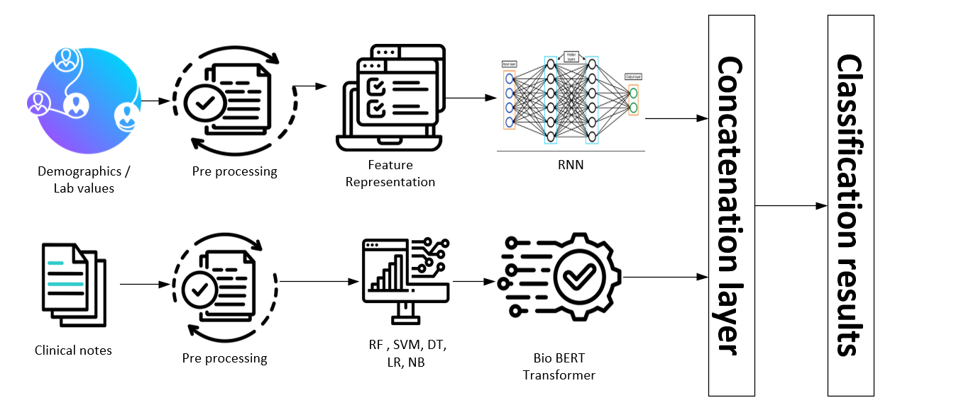
Fig. 4. 1 Proposed system architecture

4.1 Overview
This chapter introduces a multimodal AI framework developed to estimate ICU mortality by combining two main sources of patient information: structured data such as demographic details and laboratory results and unstructured clinical notes.
The key idea behind this framework is that patient outcomes in the ICU depend on both measurable physiological signals and descriptive observations made by medical staff. By bringing these numerical and textual elements together in one model, the system can offer more accurate predictions than approaches that rely on only a single type of data [16].
The overall architecture of the proposed system is illustrated in Figure 4.1.
It consists of six key stages:
- Data collection
- Preprocessing of structured and unstructured data
- Feature representation and model design
- Individual model training for each modality
- Multimodal fusion via concatenation
- Final classification and evaluation
Data Collection
The dataset used in this study was obtained from the MIMIC-III [23] clinical database, which provides de-identified information for patients admitted to the intensive care unit. For this work, both structured records and narrative clinical notes were collected to build a multimodal view of each patient’s condition.
The structured part of the dataset includes demographic details such as age, and gender, along with a wide range of physiological and laboratory measurements. These measurements cover heart rate, systolic and diastolic blood pressure, respiratory rate, SpO₂, body temperature, sodium, potassium, creatinine, BUN, hemoglobin, and white blood cell count. Clinical notes written by physicians and nurses were also retrieved to represent the unstructured portion of the data. Together, these elements provide a detailed snapshot of each hospital stay [16].
To define the prediction target, patients were assigned to one of two categories based on the clinical records: 429 cases were labeled as ELECTIVE, while 363 cases were labeled as EMERGENCY [16]. Before analysis, several preprocessing steps were carried out. Missing numerical values were replaced using the mean of each feature, while missing categorical fields were filled using the most frequent value. Categorical attributes were then encoded to make them suitable for machine-learning models. For the clinical notes, preprocessing involved tokenization, removal of stop words, case normalization, and elimination of irrelevant symbols and noise and the clinical notes were converted into numerical representations using BioBER [24].

4.2 Overview of the Multimodal Framework
The proposed framework integrates two distinct information modalities:
- Structured Data (Tabular Data): Includes patient demographics, vital signs, and laboratory test results.
- Unstructured Data (Clinical Notes): Consists of textual narratives from doctors and nurses describing patient conditions, progress, and diagnoses.
The two data streams are processed independently, transformed into latent feature representations, and later fused in a shared concatenation layer for joint learning and classification.

4.3 Structured Data Processing (Demographics and Lab Values)

4.3.1 Data Preprocessing
Structured data are often noisy, incomplete, and heterogeneous in ICU settings. To ensure data quality and consistency, the following preprocessing steps were applied:
- Handling Missing Values: Missing lab values and demographic attributes were imputed using median or mean imputation, depending on variable type.
- Normalization: Continuous features such as blood pressure, glucose, and creatinine levels were normalized using Min-Max scaling to ensure uniform feature distribution.
- Encoding Categorical Features: Non-numeric fields such as gender or admission type were encoded using one-hot or label encoding.
- Feature Selection: Redundant or low-variance features were removed to reduce dimensionality and prevent overfitting.

4.3.2 training models
Once preprocessed, the structured data were transformed into numerical tensors suitable for input into deep learning models. Several machine learning and deep models were used to model structured data:
- RF: To capture non-linear feature interactions.
- DT: As a baseline interpretable model.
- SVM: For high-dimensional boundary-based classification.
- LR: As a linear baseline for comparison.
- NB: To model probabilistic dependencies.
- RNN: Used to learn temporal dependencies and complex patterns in lab time-series data.
Each model produced predictive features or class probabilities representing the structured data’s contribution to the overall mortality risk.

4.4 Unstructured Data Processing (Clinical Notes)

4.4.1 Text Preprocessing
Clinical notes contain rich contextual information but require careful preprocessing to handle linguistic noise.
The following steps were performed:
- Tokenization: Text was split into tokens using a domain-specific tokenizer.
- Stopword Removal: Non-informative words (e.g., “the,” “and,” “was”) were removed using NLTK’s English stopword list.
- Lemmatization: Words were reduced to their base form using the WordNetLemmatizer to reduce lexical variability.
- Lowercasing and Cleaning: All text was converted to lowercase and punctuation, digits, and special characters were removed.

4.4.2 Feature Extraction with Transformer Models
For advanced text representation, two pre-trained transformer-based biomedical models were used:
• Word Count [25]: This method represents clinical notes as a vector of token frequencies. Each feature corresponds to the number of times a specific word appears in the document. Word Count captures basic lexical information and provides a simple, interpretable representation of the text.
• TF-IDF (Term Frequency–Inverse Document Frequency): TF-IDF improves upon Word Count by weighing words according to their importance across the corpus. Terms that appear frequently in a particular note but rarely across all notes receive higher weights. This allows the model to emphasize clinically meaningful terms while reducing the impact of common but uninformative words (e.g., “patient,” “the”) [16].
- BioBERT [24]: A BERT-based model pre-trained on biomedical literature (PubMed and PMC).
- ClinicalBERT [24]: Fine-tuned on hospital discharge summaries and MIMIC-III [23] clinical notes.
Each sentence was tokenized using the corresponding model tokenizer (AutoTokenizer.from_pretrained), and the encoded tokens were passed through the transformer layers to obtain contextual embeddings.
The final hidden states from the [CLS] token was extracted as the textual feature vectors representing the patient’s unstructured information.

4.5 Multimodal Fusion Layer
After obtaining separate embeddings from the structured data (using machine learning models such as RF or LR) and the unstructured textual data (using transformer-based models such as BioBERT and ClinicalBERT), both representations were concatenated to form a unified multimodal feature vector. This fusion allows the model to jointly learn complementary patterns from both modalities structured laboratory or vital-sign data and unstructured clinical notes. The concatenation-based fusion can be mathematically represented as:
Z_{fusion}​=[Z_{structured}​∣∣Z_{text}​] [18]
where Z_{structured} ​ denotes the embedding derived from tabular or numerical features, and Z_{text} represents the semantic embedding extracted from clinical notes [18]. This feature-level fusion approach is widely used in multimodal deep learning because it effectively integrates heterogeneous information sources into a single representation space for improved prediction performance. In this study, the fused representation Z_{fusion} was subsequently fed into fully connected layers for mortality outcome prediction [18].
The performance of each model was evaluated using the following metrics:
- Accuracy:
Accuracy measures the overall correctness of the model and is defined as:
Accuracy = (TP + TN) / (TP + TN + FP + FN) [19]
- Precision:
Precision represents the proportion of correctly predicted positive cases among all predicted positives:
Precision = TP / (TP + FP) [20]
- Recall (Sensitivity):
Recall measures the ability of the model to correctly identify all actual positive cases:
Recall = TP / (TP + FN) [21]
- F1-Score:
The F1-Score is the harmonic mean of Precision and Recall and provides a balanced measure when both metrics are important:
F1 = (2 × Precision × Recall) / (Precision + Recall) [22]

These metrics collectively measure the model’s ability to correctly identify mortality outcomes and minimize false alarms.
The final layer used a Softmax or Sigmoid activation (for binary classification) to output the predicted mortality probability.
Model performance was evaluated using several standard metrics:
- ACC: Overall correctness of predictions
- PRE: Correctly predicted positive cases
- REC: Sensitivity to true positive cases
- F1: Balance between precision and recall
- AUC: Area under the ROC curve for robustness
Cross-validation and hyperparameter optimization (via GridSearch for traditional models and fine-tuning for deep models) were used to ensure reliability and generalization.

Chapter 5

5.1 Experimental Results and Discussion
In this chapter, I talk about what came out of the experiments I ran with the multimodal system for predicting ICU mortality. The analysis is based on a clinical dataset that mixes two types of information: structured variables such as lab tests, demographics, and basic physiological readings, and also a large amount of unstructured text taken from clinical notes [16].
To see how each data source behaves, several machine-learning and deep-learning models were trained on the structured features and on the text separately. Once the two parts were tested individually, I brought the features together into a single multimodal setup. I checked how well the models worked using the standard metrics: Accuracy, Precision, Recall, F1-Score, and AUC.

5.2 Experimental Setup
Before I ran the experiments, I had to tidy up the dataset. That meant filling in missing values, normalizing the numerical columns, and encoding the categorical data. The text notes went through their own preparation steps, like tokenizing the sentences, lemmatizing the words, and removing common stopwords, and then they were passed through BioBERT [24] and ClinicalBERT [24] to get the embeddings.

The experiments were done on Google Colab using a GPU, mainly with PyTorch and scikit-learn. I used an 80/20 train–test split. For the classical models, I tuned the parameters with GridSearchCV, and for the deep models I used the AdamW optimizer with early stopping.

5.3 Results on Structured and Unstructured Data Models

I first tested several standard machine learning models on the structured ICU data: Logistic Regression, Decision Tree, Random Forest, Naïve Bayes, and SVM. Random Forest came out on top, probably because it handles complex feature interactions and non-linear relationships better than the others.

Feature representation |  | Accuracy | Precision | Recall | F1-score
Word count | RF | 84.28 | 84.27 | 84.28 | 84.27
Word count | SVM | 89.31 | 89.33 | 89.31 | 89.29
Word count | DT | 84.91 | 84.96 | 84.91 | 84.92
Word count | LR | 90.57 | 90.56 | 90.57 | 90.56
Word count | NB | 85.53 | 85.53 | 85.53 | 85.53
TF-IDF | RF | 85.53 | 85.53 | 85.53 | 85.53
TF-IDF | SVM | 89.94 | 89.94 | 89.94 | 89.94
TF-IDF | DT | 79.25 | 79.23 | 79.25 | 79.23
TF-IDF | LR | 89.94 | 89.94 | 89.94 | 89.94
TF-IDF | NB | 84.28 | 84.3 | 84.28 | 84.28
BERT | Bio BERT | 84.08 | 91.23 | 72.22 | 80.62
BERT | Clinical BERT | 85.35 | 98.04 | 69.44 | 81.30
Table 1 Comparison of All Models

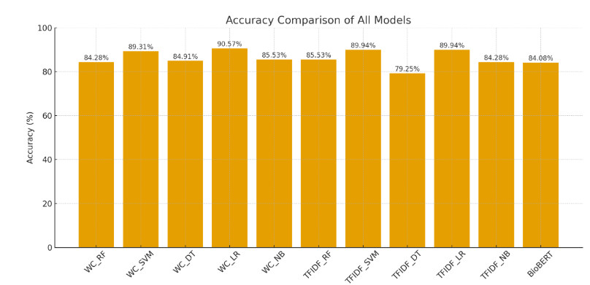
Fig 5. 1 Accuracy comparison of all models

Table 5.1 compared different ways of representing the features, like Word Count, TF-IDF, and BERT embeddings, with various machine learning models such as RF, SVM, DT, LR, and NB. The models were evaluated using Accuracy, Precision, Recall, and F1-score, which together give an idea of how well the models predict and how balanced they are between detecting positives and avoiding false alarms.

5.3.1 Word Count Representation
Using simple word count features, Logistic Regression came out on top with 90.57% accuracy, with SVM close behind at 89.31%. Both models had balanced Precision, Recall, and F1-scores, showing that even basic text features can be useful when combined with solid linear models. On the other hand, Decision Tree, Random Forest, and Naïve Bayes scored lower (around 84–85%), which suggests that word counts might not fully capture the context needed for more complicated clinical notes.

5.3.2 TF-IDF Representation
Applying TF-IDF improved the way the model emphasized important clinical terms. Logistic Regression and SVM both did well again, each scoring 89.94% accuracy, while tree-based models lagged behind. This shows that linear models handle high-dimensional, sparse data better. Decision Tree had the lowest accuracy at 79.25%, probably because it overfitted and couldn’t generalize across the sparse feature space.

5.3.3 Contextual BERT Embeddings
Using contextual embeddings had a notable impact on model performance. BioBERT achieved an accuracy of 84.08% with an F1-score of 80.62%, while ClinicalBERT performed slightly better, reaching 85.35% accuracy and an F1-score of 81.30%. ClinicalBERT also showed the highest precision at 98.04%, highlighting its ability to correctly identify positive mortality cases. However, its recall was 69.44%, suggesting that some positive cases were missed despite the high reliability of its predictions.

This balance between precision and recall reflects a conservative classification strategy, which can be advantageous in clinical risk prediction, where minimizing false positives is important. The better performance of ClinicalBERT [25] compared to BioBERT [25] is likely due to its domain-specific pretraining on clinical notes, giving it a deeper understanding of medical terminology and context.

Among the classical models, Logistic Regression performed best, particularly with Word Count and TF-IDF features. For deep contextual models, ClinicalBERT achieved the highest precision and a competitive F1-score, showing its strength in capturing subtle linguistic patterns in clinical text. Overall, these results indicate that while traditional text representations with simple models remain solid baselines, domain-specific transformer models like ClinicalBERT offer improved precision and interpretability for healthcare prediction tasks.

5.4 Results on Multimodal
Feature representation |  | Accuracy | Precision | Recall | F1-score
Multimodal | Transformer fusion | 91.08 | 91.13 | 91.08 | 91.09
Table 2 Comparison of Multimodal

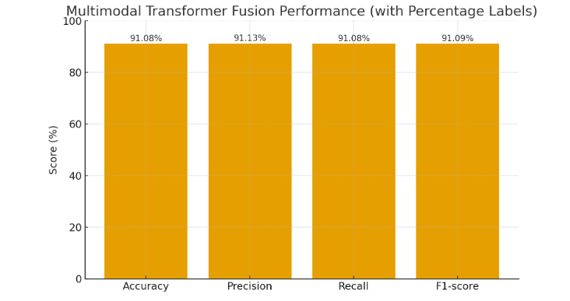
Fig 5. 2 Comparison of Multimodal

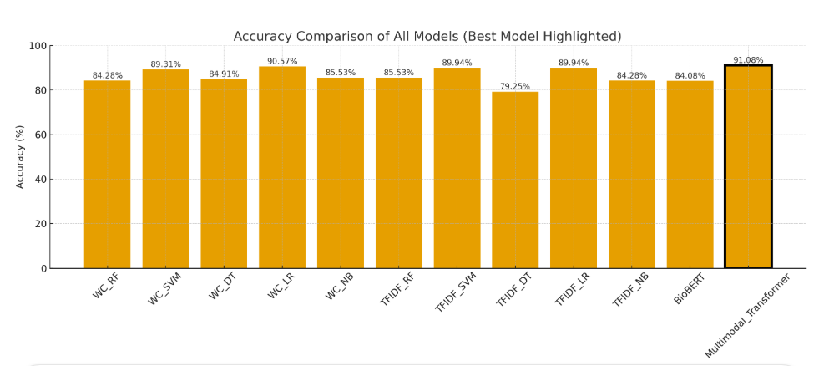
Fig 5. 3 Accuracy comparison of all models, highlighting the best-performing model

5.4.1 Multimodal Transformer Fusion Performance
The Multimodal Transformer Fusion model achieved the best overall results among all the approaches tested, reaching 91.08% accuracy, 91.13% precision, 91.08% recall, and an F1-score of 91.09%. These results highlight the benefit of combining structured data, such as laboratory tests and vital signs, with unstructured clinical notes in a single deep learning framework.
Unlike models that rely only on text or numerical data, the multimodal fusion approach takes advantage of complementary information from both sources. Its Transformer-based design allows the model to capture complex relationships between physiological measurements and the language used in clinical documentation. This produces richer patient representations and helps the model better distinguish between high-risk and low-risk ICU cases.
The similar values across precision, recall, and F1-score indicate that the model is both sensitive correctly identifying mortality cases and specific avoiding false alarms. This balance demonstrates that the Multimodal Transformer generalizes well and can robustly detect clinically relevant patterns.
Overall, these findings show that combining multiple data modalities improves prediction beyond what individual data sources can achieve. While ClinicalBERT provides strong contextual understanding of clinical text, integrating its embeddings with structured clinical features through the Transformer fusion network captures both semantic and physiological aspects of patient health. As a result, the Multimodal Transformer Fusion model offers a more complete view of ICU patient status, delivering the most accurate and balanced mortality predictions.
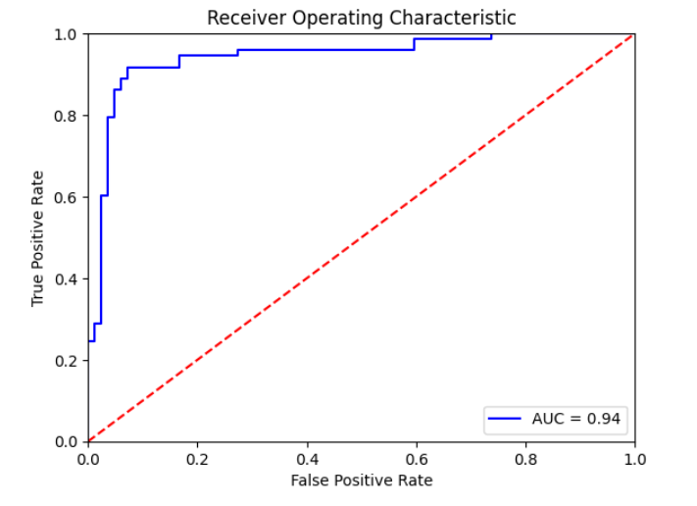
Fig 5. 4 Receiver Operating Characteristic (ROC) curve of the model

5.4.2 Explanation of the ROC Curve
Figure 5.4 presents the Receiver Operating Characteristic (ROC) curve for our ICU prediction model. The ROC curve shows how well the model can separate positive and negative cases at different classification thresholds.
- The x-axis represents the False Positive Rate (FPR).
- The y-axis represents the True Positive Rate (TPR).
In the figure 5.4, the blue curve illustrates the model’s actual performance, while the red dashed diagonal line represents a classifier with no discriminative ability (essentially random guessing), where the AUC would equal 0.50.
For our model, the ROC curve remains consistently above the diagonal, indicating strong separability between classes. The Area Under the Curve (AUC) is 0.94, which demonstrates:
- Excellent overall classification performance
- High sensitivity and specificity
- Reliable distinction between ICU and non-ICU cases
These results confirm that the model is highly effective at correctly identifying ICU outcomes while minimizing misclassifications.

An AUC score of 0.94 suggests that the model correctly ranks a randomly chosen positive instance higher than a negative one 94% of the time, which is considered very good performance in clinical prediction tasks.

5.4.3 Confusion Matrix Interpretation
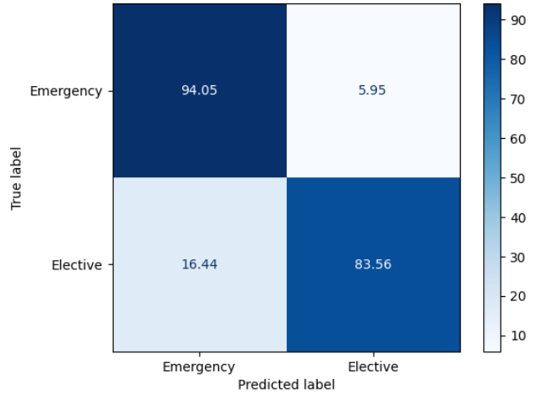
Fig 5. 5 Confusion Matrix

The confusion matrix shows the performance of a classification model in predicting two classes: Emergency and Elective.
True \ Predicted | Emergency | Elective
Emergency | 94.05 | 5.95
Elective | 16.44 | 83.56
Explanation:
- True Positives (TP):
  - Emergency predicted as Emergency: 94.05%
This means that out of all actual Emergency cases, 94.05% were correctly predicted as Emergency.
- False Negatives (FN):
  - Emergency predicted as Elective: 5.95%
This represents Emergency cases that the model misclassified as Elective.
- False Positives (FP):
  - Elective predicted as Emergency: 16.44%
This represents Elective cases that were incorrectly predicted as Emergency.
- True Negatives (TN):
  - Elective predicted as Elective: 83.56%
This means that out of all actual Elective cases, 83.56% were correctly predicted as Elective.

Key Observations:
- The model is more accurate at predicting Emergency cases (94.05%) than Elective cases (83.56%).
- There is a higher misclassification rate for Elective cases (16.44%) compared to Emergency cases (5.95%).
- This could suggest that the model is slightly biased towards predicting Emergency cases, which is common if the dataset is imbalanced.
For each class:
Emergency:
- Precision = TP / (TP + FP) = 94.05 / (94.05 + 16.44) ≈ 85.1%
- Recall = TP / (TP + FN) = 94.05 / (94.05 + 5.95) ≈ 94.0%
Elective:
- Precision = TP / (TP + FP) = 83.56 / (83.56 + 5.95) ≈ 93.4%
- Recall = TP / (TP + FN) = 83.56 / (83.56 + 16.44) ≈ 83.6%

Chapter 6 Conclusion and Future Work

6.1 Conclusion
This research set out to improve ICU mortality prediction by combining structured clinical data with unstructured text from patient notes. Instead of relying on a single type of information, the proposed multimodal framework brings together two complementary sources: numerical measurements such as laboratory results and vitals, and contextual information extracted from clinical narratives. BioBERT and ClinicalBERT were used to capture the meaning and subtle patterns within the text, while traditional machine-learning and deep models handled the structured variables. The fusion of these two streams created a more complete view of each patient’s condition. Across all evaluation metrics precision 91.13, accuracy 91.08, recall 91.08, F1-score 91.09, and AUC 95 the multimodal model consistently performed better than models trained on structured data alone or text alone. These results highlight the value of using domain-specific transformer models to understand clinical language and pairing them with established algorithms for numerical features. Overall, the study demonstrates that multimodal learning is not only feasible in critical-care settings but also adds meaningful improvements in predictive accuracy. This integrated approach can support clinicians by offering earlier and more reliable insights into patient risk, which may contribute to faster interventions and better outcomes in the ICU.

6.2 Future Work
Future work can focus on expanding the dataset, incorporating additional clinical modalities such as medical imaging, and exploring more advanced fusion strategies that go beyond simple concatenation. Improving model interpretability is another important direction, allowing clinicians to better understand the factors influencing predictions. Finally, testing the framework across multiple hospitals and real-time ICU settings would help validate its robustness and support its translation into practical clinical decision-support tools.

References
[1] Terwiesch, C., KC, D., Kahn, J.M.:Working with capacity limitations: operations management in critical care. Critical Care 15, 1–6 (2011)

[2] Gao, J., Lu, Y., Ashrafi, N., Domingo, I., Alaei, K., Pishgar, M.: Prediction of sepsis mortality in icu patients using machine learning methods. BMC Medical
Informatics and Decision Making 24(1), 228 (2024)

[3] Ruan, Y., Tan, D. J., Ng, S. K., Huang, L., & Feng, M. (2025). Towards accurate and reliable ICU outcome prediction: a multimodal learning framework based on belief function theory using structured EHRs and free-text notes. http://arxiv.org/abs/2501.04389

[4] V. Huddar, B. K. Desiraju, V. Rajan, S. Bhattacharya, S. Roy and C. K. Reddy, "Predicting Complications in Critical Care Using Heterogeneous Clinical Data," in IEEE Access, vol. 4, pp. 7988-8001, 2016, doi: 10.1109/ACCESS.2016.2618775.

[5] A. Al-Dailami, H. Kuang and J. Wang, "Multimodal Representation Learning Based on Personalized Graph-Based Fusion for Mortality Prediction Using Electronic Medical Records," in Big Data Mining and Analytics, vol. 8, no. 4, pp. 933-950, August 2025, doi: 10.26599/BDMA.2024.9020099.
[6] Iwase, S., Nakada, T. aki, Shimada, T., Oami, T., Shimazui, T., Takahashi, N., Yamabe, J., Yamao, Y., & Kawakami, E. (2022). Prediction algorithm for ICU mortality and length of stay using machine learning. Scientific Reports, 12(1). https://doi.org/10.1038/s41598-022-17091-5

[7] Yang, H., Kuang, L., & Xia, F. Q. (2021). Multimodal temporal-clinical note network for mortality prediction. Journal of Biomedical Semantics, 12(1). https://doi.org/10.1186/s13326-021-00235-3

[8] Shi, Z., Zuo, W., Liang, S., Zuo, X., Yue, L., & Li, X. (2020). IDDSaM: an Integrated Disease Diagnosis and Severity assessment Model for Intensive Care Units. IEEE Access, 8, 15423–15435. https://doi.org/10.1109/aCCESS.2020.2967417

[9] Kumar, S., Oh, I., Schindler, S., Lai, A. M., Payne, P. R. O., & Gupta, A. (2021). Machine learning for modeling the progression of Alzheimer disease dementia using clinical data: A systematic literature review. In JAMIA Open (Vol. 4, Issue 3). Oxford University Press. https://doi.org/10.1093/jamiaopen/ooab052

[10] Huang, K., Altosaar, J., & Ranganath, R. (2020). ClinicalBERT: Modeling Clinical Notes and Predicting Hospital Readmission. http://arxiv.org/abs/1904.05342

[11] Xu, K., Lam, M., Pang, J., Gao, X., Band, C., Mathur, P., Papay, F., Khanna, A. K., Cywinski, J. B., Maheshwari, K., Xie, P., & Xing, E. P. (2019). Multimodal Machine Learning for Automated ICD Coding. In Proceedings of Machine Learning Thesis (Vol. 106). https://www.cdc.gov/nchs/icd/icd10cm.htm

[12] Caicedo-Torres, W., & Gutierrez, J. (2022). ISeeU2: Visually interpretable mortality prediction inside the ICU using deep learning and free-text medical notes. Expert Systems with Applications, 202, 117190.

[13] Lyu W, Dong X, Wong R, Zheng S, Abell-Hart K, Wang F, Chen C. A Multimodal Transformer: Fusing Clinical Notes with Structured EHR Data for Interpretable In-Hospital Mortality Prediction. AMIA Annu Symp Proc. 2023 Apr 29;2022:719-728. PMID: 37128451; PMCID: PMC10148371.

[14] Shukla, S. N., & Marlin, B. M. (2020). Integrating physiological time series and clinical notes with deep learning for improved ICU mortality prediction. arXiv preprint arXiv:2003.11059.

[15] King, R., Yang, T., & Mortazavi, B. J. (2023, December). Multimodal pretraining of medical time series and notes. In Machine Learning for Health (ML4H) (pp. 244-255). PMLR.

[16] Saleh, H., Mccann, M., El-Sappagh, S., & Breslin, J. G. (n.d.). TransformerFusionNet: A Real-Time Multimodal Framework for ICU Heart Failure Mortality Prediction Using Big Data Streaming.

[17] A. E. Johnson, T. J. Pollard, L. Shen, L.-w. H. Lehman, M. Feng,M. Ghassemi, B. Moody, P. Szolovits, L. Anthony Celi, and R. G. Mark,“Mimic-iii, a freely accessible critical care database,” Scientific data,vol. 3, no. 1, pp. 1–9, 2016.
[18] T. Baltrušaitis, C. Ahuja and L. -P. Morency, "Multimodal Machine Learning: A Survey and Taxonomy," in IEEE Transactions on Pattern Analysis and Machine Intelligence, vol. 41, no. 2, pp. 423-443, 1 Feb. 2019, doi: 10.1109/TPAMI.2018.2798607.
[19] S. Liu, X. Wang, Y. Hou, G. Li, H. Wang, H. Xu, Y. Xiang, and B. Tang,“Multimodal data matters: language model pre-training over structured and unstructured electronic health records,” IEEE Journal of Biomedical and Health Informatics, vol. 27, no. 1, pp. 504–514, 2022.
[20] A. M. Merchant, N. Shenoy, S. Lanka, and S. Kamath, “Ensemble neural models for icd code prediction using unstructured and structured healthcare data,” Heliyon, vol. 10, no. 17, 2024.
[21] A. Spark, “Apache spark,” https://spark.apache.org/, online; accessed 2024.
[22] A. Kafka, “Apache kafka,” https://kafka.apache.org/, online; accessed 2024.
[23] A. E. Johnson, T. J. Pollard, L. Shen, L.-w. H. Lehman, M. Feng,M. Ghassemi, B. Moody, P. Szolovits, L. Anthony Celi, and R. G. Mark, “Mimic-iii, a freely accessible critical care database,” Scientific data, vol. 3, no. 1, pp. 1–9, 2016.
[24] J. Lee, W. Yoon, S. Kim, D. Kim, S. Kim, C. H. So, and J. Kang,“Biobert: a pre-trained biomedical language representation model for biomedical text mining,” Bioinformatics, vol. 36, no. 4, pp. 1234–1240,2020.
[25] K. P. Chodey and G. Hu, "Clinical text analysis using machine learning methods," 2016 IEEE/ACIS 15th International Conference on Computer and Information Science (ICIS), Okayama, Japan, 2016, pp. 1-6, doi: 10.1109/ICIS.2016.7550908.

