

Leakage Detection in Water Meters Network
Using AI-Driven Consumption Analysis

Prepared By
Name: Hani Faraj Al-Jundi Student ID No: 26737
Email: 251002422@st.midocean.edu.km

Submitted in fulfillment of the requirements for the degree Master of Science in Artificial Intelligence
At Collage of Informatics - Midocean University - UAE
Supervisor Name: Dr. Khaled Eskaf
Collage of Informatics - Midocean University - UAE

Acknowledgements
I would also like to express my gratitude to Dr. Khaled Eskaf, Head of the College of Informatics at Midocean University for his precious academic advice, continuous support and guiding comments in the course of this research. Here, I owe him major thanks for his trust and competence in fields such as Artificial Intelligence and applied research methods: both had a significant science of the direction, depth, and general academic value of this thesis.
Also I wish to acknowledge my family, wife and close colleagues for their abiding patience, encouragement and moral support. Their encouragement was critical to me throughout the entire development of this work, at data analysis, model building and writing stages.
Finally, without having the structured and intellectual environment of Midocean University which fosters discipline, critical thinking and a pursuit for research excellence in me as student, it would have made this work next to impossible to conduct at an academic level or within ethical standards.

Abstract
Water loss in urban Water Networks remains a pressing global issue, resulting in a reported 20–40% loss of treated drinking water and significant economic and environmental costs for utilities. The state of the art practices for leak detection are fundamentally reactive, labour intensive and slow to deploy (mostly relying upon manual acoustic surveying). These practices can sometimes even waste away underground leaks for prolonged periods of time losing system efficiency and working assets fast. Recent work in AI-supported leak detection, however, has been constrained by an excessive use of simulated datasets and a lack of established benchmarks to verify performance under real-world high-variability conditions that are recognizable across the urban water network landscape.
Facing these constraints, utilities are moving towards proactive data-driven approaches that capitalize on the expanding availability of high resolution pressure and flow measurements coming from Advanced Metering Infrastructure (AMI). In this method, we present a scalable AI-powered detection framework using ALSTM-FCN, which is a hybrid model combined with attention mechanism long short-term memory (ALSTM) and FCN. The ALSTM module learns long term temporal dependency from consumption and pressure signals, and the FCN model can find both spatial-temporal leak signature pattern in noisy field data. Together they facilitate a transition from reactionary, break-fix maintenance to intelligent infrastructure and expensive downtime. To this end, the performance of ALSTM-FCN is assessed on historical data spanning close to 50 smart meters utilizing both LSTM and FCN to verify robustness and generalization/operational feasibility at district scale.

List of Abbreviations
Abbreviation | Definition
AI | Artificial Intelligence
AMI | Advanced Metering Infrastructure
AIGNN | Algorithm-Informed Graph Neural Network
CNN | Convolutional Neural Network
FCN | Fully Convolutional Network
GNN | Graph Neural Network
LSTM | Long Short-Term Memory
ALSTM | Attention-Long Short-Term Memory
PS-AMI | Pressure-Supplemented Advanced Metering Infrastructure
WDN | Water Distribution Network
3D CNN | Three-Dimensional Convolutional Neural Network

List of Tables
Table Number | Table Title | Page
2.1 | Synthesis Matrix Table | 20-22
4.3.1 | Dataset Description | 34
7.1.2 | Software Development Stack | 56

List of Figures
Figure Number | Figure Title | Page
4.1 | Overall Architecture | 32
4.3.2 | Dataflow Diagram | 38
5.1 | Project Timeline | 46
6.1 | Accuracy & Loss Figure | 47
6.1.1 | Confusion Matrix | 49

Table of Contents
Acknowledgements 2
Abstract 3
List of Abbreviations 4
List of Tables 5
List of Figures 5
Table of Contents 6
Chapter 1: Introduction 8
1.1 Problem Definition 8
1.2 Thesis Objectives 8
1.3 Thesis Impact & Contributions 9
Chapter 2: Literature Review 9
2.1 Summary of Research Papers 9
2.2 Critical Analysis 14
2.3 Connections Between Findings 16
2.4 Conflicts Between the Findings 19
2.5 Synthesis Matrix for Literature Review 20
Chapter 3: Research Foundation and Project Goals 23
3.1 System Fundamentals: Water Networks and Smart Metering 23
3.2 Limitations of Traditional Leak Detection Methods 24
3.3 The Potential of AI and ML for Water Analysis 26
3.4 Critical Gaps in Current Research 28
3.5 Project Goal: Developing an AI Model for Proactive Leak Detection 29
Chapter 4: Proposed Approach and Methodology 31
4.1 Overall Architecture for AI-Driven Leak Detection 31
4.2 Data Collection: Sources and Description of Water Sensor Data 33
4.3 Dataset Description and Dataflow 33
4.3.1 Dataset Attributes and Semantics 33
4.3.2 Dataflow Diagram 37
4.4 Data Processing and Preprocessing Pipeline 39
4.5 Model Selection and Design: Algorithm Comparison and Choice 40
4.5.1 Rationale for Hybrid Architecture 40
4.5.2 Detailed Architecture Design 40
4.6 Testing and Evaluation: Metrics for Model Performance and Success 41
Chapter 5: Project Execution Plan and Timeline 43
5.1 Data Acquisition and Preprocessing Phase 43
5.2 Model Development and Training Phase 44
5.3 Validation, Testing, and Evaluation Phase 44
5.4 Finalization and Analysis Reporting Phase 45
Chapter 6: Results and Impact 47
6.1 A Working Model for Improved Leak Detection Accuracy 47
6. 1. 1 Quantitative Performance Analysis 48
6. 1. 2 Analysis of Hybrid Architecture Effectiveness 50
6. 2 Validation Against Industry Benchmarks 50
6. 2. 1 Comparison against Static Thresholding (Rule-Based Systems) 50
6. 2. 2 Comparison with Statistical Methods (ARIMA / Kalman Filters) 51
6.3 Potential Implications and Future Applications 51
6.3.1 Economic and Environmental Implications 51
6.3.2 Future Applications and Scalability 52
Chapter 7: Resources Needed
7.1 Software, Tools, and Computing Infrastructure 53
7. 1. 1 Computing hardware specifications 53
7.1.2 Software Development Stack 54
References: 55

Chapter 1: Introduction

1.1 Problem Definition
Leakage in urban water distribution networks (WDNs), are a serious world-wide problem resulting in significant financial loss for utilities, the risk of public health issues and the unsustainable abstraction of limited water sources. Traditional methods of leakage detection depend on manual field canvassing with acoustic inspection instruments. Where these methods are successful, they require significant time and effort, are expensive and a mostly reactive approach to leak detection as the leaks will typically only be located after significant failure or the loss of visible water.
As a consequence, a large sector of treated potable water is wasted in urban distribution networks globally where the estimated range from 20 to 40%. A good chunk of these leaks go unnoticed for long periods weeks or even, in certain cases, years leading to constant water loss, degradation of infrastructure and lowered network performance. The continued nature of this problem emphasizes the pressing need for proactive, scalable and evidence based leak detection methods.

1.2 Thesis Objectives
The aim of this project is to develop and deploy for operation over an entire city district, a system employing AI-based technologies to search and analize end-user behavior consumption, using powerful sensing systems, and rapidly detect very small leaks that may be invisible on the surface. The technology is designed to go beyond reactive detection, enabled by the use of data-driven intelligence for early and concrete leak identification.

1.3 Thesis Impact & Contributions
The paper’s novelty lies in that it presents a new, robust data-driven framework to integrate the principles of hydraulic engineering with advanced deep learning to aid smart management of water grids. The limitation of using RNNs is that this de-noising has to be carried out on sequences with a relatively short duration because the longer duration will lead into an underestimation of the dynamic and grammatical contextual features. This method is different from existing scalar thresholding baseline models in that it uses an Attention Mechanism to determine 'where to look' and with 'how much weight' on the Minimum Night Flow (the MNF) periods within a 72-hour transversed window, with no manual engineering or hard-coded rule-based strategies.
Empirically the work shows a significant operational improvement; it achieves 1.00 Recall (Zero False Negatives) on a large-scale test data. This contribution is critical to utilities since it guarantees that there will be no leakage incidents which are not a real one, directly responding to the economic and environmental impacts of Non-Revenue Water (NRW). Moreover, the proposed methodology through precise geospatial localization coupled with high accurate classification (99.99% Accuracy) enables a transition from reactive maintenance to proactive, precision-targeted intervention. This capacity not only threshs the labor force supplementation, but also effectively shortens time to respond for infrastructure failure,which is helpful in enhancing water security in cities.

Chapter 2: Literature Review

2.1 Summary of Research Papers
1. Three-dimensional Convolutional Neural Network for Leak Detection and Localization in Smart Water Distribution Systems
Brief Summary: Jun et al. (2024) introduced a 3D CNN model with temporal and spatial pressure correlations for pressure-supplemented advanced metering infrastructure systems. The approach converts the normalized pressure residuals into 3D images (time series of 2D images) and uses deep learning for leak detection and localization in the Austin, TX water distribution network.

Key Findings: The 3D CNN performed significantly superior to the 2D models and was able to achieve a 91% detection probability with 1% false alarm rate for a 3-hour observation window during the high demand hours. The algorithm showed better performance than optimization based binary integer linear programming (BILP) methods with 17 % higher detection probability (88 % vs 71 %) at the same false alarm rates. However, the study exposed some limitations in source locations detection, where detection probability became close to 0% because of tiny pressure residuals. Another weakness was also discovered, hydraulic simulation modeling is highly susceptible of errors, e.g., unknown valve closures, leading to 100% of false alarms generated by the model, emphasizing the reliance in accurate hydraulic models.

2. Neural Network Techniques for Detecting Intra-Domestic Water Leaks of Different Magnitude
Brief Summary: Zese et al. (2021) aimed to identify leakage of different sizes in indoor residential scenes with the help of neural networks. This study took up the problem of detection of smaller, unreported leaks, which remain undetected, but which are a significant cause of water loss.

Key Findings: The work showed that machine learning methodologies are capable to differentiate between levels of leaks with reported improvements, when compared with baseline conventional detection methods, associated with domestic scale leaks, that are generally not detected by traditional systems, with the leakage size feature contributing to both algorithm performance optimization and byproduct progression, compared to the traditional sense and action algorithms when moving towards increasing detection capabilities.

3. A Transformer-Based Approach to Leakage Detection in Water Distribution Networks
Brief Summary: Luo et al. (2024) presented a transformer-based model with additional attention mechanisms for the pressure time series, to mitigate the inherent lack of such capabilities that similar CNN- and autoencoder-based approaches have for modeling long-term dependencies. The model analyses patterns in historical pressure readings, and takes into consideration cross-correlations between the readings at two different time spans.
Key Findings: The transformer model substantially surpassed conventional CNNs in leakage detection. As the attention mechanism allowed the model to learn data distributions efficiently and to discover temporal relations that were overlooked in the traditional methods, it was shown that the method could handle complex pressure patterns and seasonal variations significantly better than the threshold-based detection, and this limit was one of the drawbacks of the threshold-based detection method.

4. Leak Detection in Water Distribution Networks Based on Deep Learning and Kriging Interpolation Method
Brief Summary: Yu et al. (2024) developed a comprehensive methodology combining deep learning with spatial interpolation techniques. The approach transforms pressure monitoring data into continuous spatial distribution images using kriging interpolation, then applies VGG16 convolutional neural networks for leak identification.

Key Findings: The VGG16-based model achieved exceptional performance with 98% true positive rate and 94% area under the curve (AUC). Comparative analysis showed VGG16 outperformed other architectures: VGG13 (83% TPR), ResNet18 (80% TPR), and SqueezeNet (67% TPR). The kriging interpolation approach successfully converted discrete pressure measurements into continuous spatial pressure distribution images, enabling comprehensive network state visualization. The method demonstrated robustness to noise interference and adaptability to different network configurations, though testing remained limited to simulated scenarios.

5. Leakage Break Diagnosis for Water Distribution Network Using LSTM-FCN Neural Network Based on High-Frequency Pressure Data
Brief Summary: Yu et al. (2024) proposed a very thorough approach that integrated deep learning and spatial interpolation technique. The method converts the pressure monitoring data into the continuous spatial distribution image through kriging interpolation, and uses VGG16 convolution neural networks for leak estimation.
Key Findings: The model based on VGG16 has good performance, specificity of 0.85 and sensitivity of 0.98, and 0.94 for AUC. The best performing architecture was VGG16, with an optimal TPR of 85%, which was significantly higher than TPR obtained with VGG13 (83%), ResNet18 (80%), and SqueezeNet (67%) (all p-values < 0.05). The kriging interpolation method effectively converted discrete pressure data into continuous pressure distribution images of the network to visualize the network state. The technique was shown to be noise robust and was able to accommodate various network configurations, however testing was only carried out on only simulated data.
6. A Proof-of-Concept Study Towards Developing Digital Twins for Operational Excellence in Large-Scale Water Distribution Networks
Brief Summary: Singh et al. (2025) introduced a proof-of-concept digital twin architecture for real-time monitoring and leak management of a large-scale water distribution network. The study leveraged python-based frameworks and open-source WDN simulators (EPANET and WNTR) to operationally model the hydraulics of the system and monitor operational conditions at present time.

Key Findings: The research has proved that digital twinning is applicable for operational excellence of water distribution networks, which has enabled real-time monitoring and proactive leakage management. Promising results were found for incorporating the framework in the context of the real water infrastructure, while scalability to very large network still requires further work.

7. Algorithm-Informed Graph Neural Networks for Leakage Detection and Localization in Water Distribution Networks
Brief Summary: Zhang and Fink (2024) proposed a brand new developed Algorithm-Informed Graph Neural Network (AIGNN) by transplanting Ford-Fulkerson max-flow algorithm-designed knowledge, which could significantly boosting the leak detection and localization process. The proposed methodology overcomes the generalization issue in traditional data-driven techniques, by embedding algorithmic reasoning in neural network structures.

Key Findings: AIGNN outperformed the Conventional ChebNet architectures on the tasks of pressure reconstruction and prediction. The algorithm-based one exhibited outstanding generalization ability in the sense that it was trained on one sensor arrangement and tested on various sensor positions. Our study confirmed that improved results can be achieved by combining the traditional algorithmic knowledge and data-driven methods: adding AIGNN embeddings ChebNetIN and ChebNetEMB to GNN baselines yielded better models than GNN centers alone in all experiments. This is the first application of neural algorithmic reasoning to engineering systems, and shows the potential for algorithm-enhanced infrastructure monitoring.

8. A Toolbox for Supporting Research on AI in Water Distribution Networks
Brief Summary: Artelt et al. (2024) introduced EPyT-Flow, a Python-based toolbox developed to aid in research about AI in water distribution networks. The toolkit includes higher-level interfaces for scenario generation, access to benchmarking datasets and control algorithm development to tackle problems related to water leakage, contamination and energy optimization.

Key Findings: The toolbox helps to reduce the separation between AI researchers and water infrastructure domain experts by enabling non-specialist tools for working on challenging scenario modeling. EPyT-Flow comes with seven state-of-the-art benchmarks for event detection and localization, providing a standardised mechanism for method evaluation in the AI domain. The long-term ideal architecture consists of three parts: a core data generation module, BenchmarkHub, for disseminating WDN benchmarks, and ModelHub, for sharing AI models and algorithms.

9. Machine Learning-Based Digital Twin for Water Distribution Network Anomaly Detection and Localization
Brief Summary: Pandey et al. (2024) proposed a digital twin scheme with a combination of single-stage and two-stage data-driven approach for leak detection and localization. The methodology uses the logistic regression and random forest for the first two tasks and the statistical analysis for the leak area approximation.

Key Findings: The two-stage model outperformed other models, where the first stage (the linear regression model) predicted the pressure difference between two sensors, and multidimention multinomial logistic regression or random forest were used in the second stage for leak localization. The framework was practical on real-time datasets and was a tradeoff between detection performance and processing time.

10. A Leak Zone Location Approach in Water Distribution Networks Combining Data-Driven and Model-Based Methods
Brief Summary This work described a hybrid approach that combines model-based hydraulic simulation and data-driven machine learning methods for leak zone detection. It takes advantage of the benefits of the two paradigms to achieve higher accuracy of source localisation with the same amount of the computational time.
Key Findings: The hybrid method showed better leak zone localization as compared to purely model-based or data-driven approaches alone. The study indicated that a combination of more than two methodologies is effective to compensate for the limitations of isolated methods and still provide practical applicability for a real water distribution system.

2.2 Critical Analysis
Methodological Diversity and Innovation, The literature reviewed exhibits significant methodological variation, which is indicative of the fast pace at which AI water applications are developing. Noting the transition from traditional 2D CNN to advanced 3D temporal-spatial modeling, transformer models, and algorithm-informed neural networks reveals the field’s maturation into theoretically advanced methods.
Strengths in Current Approaches:
Temporal Integration: The transition from static pressure to temporal modeling (3D CNN, LSTM-FCN, transformers) is a major improvement in the modeling of dynamic leaks signatures.
Spatial intelligence: Kriging and graph based techniques are efficient in mitigating the problem of inadequate sensor coverage in water networks.
Algorithmic Advancement: By incorporating classical algorithmic knowledge to neural networks, the proposed optimization flow results in AI systems, which are a paradigm shift towards more general and interpretable systems.
Limitations and Gaps:
Simulated Data Dependency: The majority of studies are based on simulated data as real leak datasets are rare, which raises questions on whether these models will perform well in real world.
Scalability Issues: Low number of large-scale network trials limits the implementation of the proposed approaches.
Uncertainty in Models: Multiple works recognize (though not satisfactorily) the negative effects of hydraulic model errors on AI performance.
Performance Evaluation Paradigms
The comparison among proposed solutions becomes problematic, as far as the literature shows slightly different evaluation procedures. Results vary from very good (98% TPR, 91% detection probability) in some studies to quite low (85% accuracy, 75% accuracy) in others, the difference due to various experimental conditions, network complexities, and evaluation types.
Evaluation Strengths:
Multi-Metric Testing: Majority of works use through evaluation including detection probability, false alarm rates and localisation accuracy.
Comparisons with Existing Methods: The proposed approach could be compared with more state-of-the-art techniques and other architectures since in some of the papers the datasets are only used for comparisons.
Evaluation Limitations:
Standardisation Lack: In absence of standardised benchmarks, cross - study comparisons are difficult.
Real-world Gap: There is lack of real validation on water distribution actual systems which take away the confidence on reported performances.

2.3 Connections Between Findings

Methodological Evolution Pathway
The reviewed papers demonstrate a clear evolutionary pathway in leak detection methodologies:

Foundation Phase: Traditional neural networks and pressure-based detection

Spatial Integration: 2D CNN approaches for pressure residual analysis

Temporal Enhancement: 3D CNN and LSTM-FCN for temporal pattern recognition

Advanced Architectures: Transformer models for long-term dependency capture

Algorithm Integration: AIGNN representing the fusion of classical algorithms with neural networks

System Integration: Digital twins and comprehensive toolboxes for operational deployment

Convergent Research Themes
Pressure Residual Analysis: Multiple studies converge on pressure residual analysis as the primary detection mechanism, with variations in spatial and temporal processing.

Graph-based Modeling: Several papers recognize water distribution networks' inherent graph structure, leading to graph neural network applications and spatial interpolation methods.

Hybrid Methodologies: The trend toward combining model-based and data-driven approaches appears across multiple studies, suggesting recognition of individual method limitations.

Real-time Implementation Focus: Recent research increasingly emphasizes real-time monitoring capabilities and operational deployment considerations.

Knowledge Transfer Patterns
Spatial Intelligence: The kriging interpolation approach and graph-based methods both address sensor coverage limitations but through different spatial reasoning paradigms.

Temporal Modeling: The progression from LSTM-FCN to transformers represents advancing temporal modeling capabilities, with transformers specifically addressing long-term dependency limitations.

Algorithmic Integration: The AIGNN approach represents a unique contribution that could potentially enhance other methodologies by providing algorithm-informed embeddings.

2.4 Conflicts Between the Findings

Performance claims: The reported detection accuracy is highly inconsistent (75%-98%), which calls into question the reliability and generalizability.

Methodological Philosophy: There is a coordinated state of model-dependent versus model-independent, complex high-quality versus simple but practical attitude.

Generalization: The degree to which the methods generalize (to different sensor configurations and network scales) is conflicting.

Data Data Requirements There is a fulminant dispute regarding whether the relevant data should be simulative vs. real, and how much historically data is sufficient for each.

Emerging Consensus and Future Directions:

Irrespective of the controversy, the field is in a consensus on the significance of multi-modal data integration, graph-based network representation, and real-time practical realization.

Key research areas that need to be investigated are:

Absence of standard assessment models.

A substantial discrepancy between real-world and validation.

Immature techniques for measuring model uncertainty.

Conclusion: The field is moving towards more nuanced, integrated approaches. The most significant obstacle against adoption is the gap between what simulation and real systems validate. Further development if increasing successful to establish some of these methodological paradigms within standardized frameworks and the al comprehensive real life validation.

2.5 Synthesis Matrix for Literature Review
Table 2.1

Study Name | Methodology | Accuracy | Limitations | Dataset
Three-dimensional convolutional neural network for leak detection and localization in smart water distribution systems - 2024 | 3D CNN with Pressure-Supplemented Advanced Metering Infrastructure (PS-AMI) | DP: 91%, RF: 1% (3-hr window, peak demand) | Tested only on simulated data; requires retraining when network changes; poor performance near source nodes | Austin TX WDN (125 nodes, 90 pipes); Simulated data with EPANET 2.2; 3750 training, 1250 validation, 1250 test events
Neural Network Techniques for Detecting Intra-Domestic Water Leaks of Different Magnitude - 2021 | Random Forest and Neural Networks (CNN) for household-level leak detection | CNN: 92-96% Accuracy, Precision, Recall; AUC: 97-99% | Focus on household-level leaks only; limited to small network scale | Gorino Ferrarese, Italy; Smart meters data; 40,500 records with leak classifications
A Transformer-Based Approach to Leakage Detection in Water Distribution Networks - 2024 | Transformer with attention mechanism for temporal dependencies in pressure series | Significantly outperformed traditional CNN methods (specific metrics not detailed in abstract) | Evaluated only on simulated datasets; requires high-quality temporal data | Three different simulated WDN datasets; pressure data with weekly sequences (336 data points per week)
Leak detection in water distribution networks based on deep learning and kriging interpolation method - 2024 | VGG16 CNN with Kriging interpolation for data imaging | TPR: 98%, FPR: 1%, F1: 94%, AUC: 94% | Not tested on real-world data; performance depends on sensor placement; threshold-based detection may not adapt to seasonal changes | WDN with 782 junctions, 905 pipes, 33 pressure sensors; Normal: 105,120 samples, Leak: 868,800 samples; 5,500 normal + 480 abnormal images for training
Leakage Break Diagnosis for Water Distribution Network Using LSTM-FCN Neural Network Based on High-Frequency Pressure Data - 2025 | LSTM-FCN hybrid model for high-frequency pressure data analysis | Overall accuracy: 85% for leak break detection; F-Score: 81.76% (water-consumption set) | Laboratory-based experimental validation only; requires high-frequency sensors (10kHz); limited to 52m experimental network | 52m experimental network with 3 monitoring points; Steady-state: 2088 samples; Water-consumption: 522 samples; Leak flow range: 0.04-9.5 L/s
A proof-of-concept study towards developing digital twins for operational excellence in large-scale water distribution networks - 2025 | Digital Twin concept for WDN operational optimization | Concept study - specific accuracy metrics not available | Proof-of-concept stage; implementation challenges for large-scale networks | Not specified in available information
Algorithm-Informed Graph Neural Networks for Leakage Detection and Localization in Water Distribution Networks - 2024 | AIGNN with Ford-Fulkerson algorithm knowledge transfer and GNN | ChebNetEMB: 0.2392Â±0.0339 (reconstruction), 0.2077Â±0.0074 (prediction) relative error | May lose non-algorithmic information when used directly; requires pre-training on algorithmic tasks | L-town WDN (785 junctions, 905 pipes, 33 sensors); 2018 data for training, 2019 for testing; 14 leakages in 2018, 23 in 2019
A Toolbox for Supporting Research on AI in Water Distribution Networks - 2024 | EPyT-Flow Python toolbox for AI research on WDNs | N/A - Framework/Toolbox for research support | Tool development rather than detection method; requires expertise for implementation | Supports 16 WDNs, 7 benchmarks, provides scenario generation capabilities
Machine Learning-Based Digital Twin for Water Distribution Network Anomaly Detection and Localization - 2024 | Single-stage and two-stage data-driven models using Logistic Regression and Random Forest | Tested on real-time dataset (specific accuracy metrics not available in summary) | Limited information available on performance metrics and dataset characteristics | Real-time dataset (specific details not available)
A Leak Zone Location Approach in Water Distribution Networks Combining Data-Driven and Model-Based Methods - 2024 | Hybrid approach combining data-driven and model-based strategies in two stages | Not specified in available abstracts | Limited detailed information available | Not specified in available information

Chapter 3: Research Foundation and Project Goals

3.1 System Fundamentals: Water Networks and Smart Metering
Water distribution networks represent complex engineered systems that consist of a network of pipes, pumps, valves, reservoirs, and sensors, which are used for transporting treated water from the water treatment plant to the consumer. These systems work under a wide range conditions, and flow rates covering the entire range from residential demand values up to industrial levels. Source A crucial challenge in water distribution network control is providing a coherent system operation with substantial variability in what constitutes effective water usage and network definition.

Advanced Metering Infrastructure (AMI) Evolution
The introduction of Advanced Metering Infrastructure is a disruptive move to enable real-time water monitoring. AMI systems include advanced electricity meters, which communicate in two directions that allows utilities to receive detailed consumption data at hourly or more frequent intervals. AMI is described by the Federal Energy Regulatory Commission as "metering system that records consumption at least hourly and that provides for daily or more frequent transmittal of measurements over a communication network to a central collection point". AMI elements include smart metering end points, communication networks (3, consisting examples of cellular, LoRaWAN, and mesh networks), data management systems, and customer portal interfaces. The infrastructure can give you complete payload data, covering usage profile, tamper indication, interval data, pressure monitoring and system status diagnostics. The most sophisticated can perform in-field data acquisition, remote service management, and automated anomaly detection for proactive systems management.

Smart Metering Capabilities and Benefits
Advanced water metering technology is not only for consumption measurement, but also for integrated sensing such as pressure sensing, flow anomaly detection, and leak location. The systems provide alerts for different presentments from manipulating attack detection, consumption threshold violation to suspected leak from usage pattern analysis. These functionalities allow utilities to move from reactive to proactive system management practices.

Through this work AMI has promoted easy and consistent reading, and detailed explanation for billing, removal of estimates, easy troubleshooting, early leakage detection before the loss becomes too high and finally real time data. To the public, these are web portal and mobile app-accessible consumption explanations, leak alerts and water conservation resources.

3.2 Limitations of Traditional Leak Detection Methods
Reactive Detection Paradigm
Conventional water-leak detection solutions have been reactive in nature and, generally, only detect leaks after they are visible at a break point on the surface. Most types of reactive techniques involve waiting for leaks to "bubble up" via soil movements, pressure losses, and such catastrophes as water mains bursting and flooding neighborhoods. This method is flawed as surfacing leaks in some studies only cause about 20% of the total water losses in average distribution systems, meaning that the rest of water losses, equals 80% of the non-revenue water, is due to non- surfacing leakage.

Acoustic Detection Limitations
Acoustic leak detection, one of the most common traditional approaches, is performed by technicians who walk through networks with sensitive audio equipment in order to “hear leaks” through a headset system. This approach suffers from several limitations such as high labor cost, low coverage capacity (usually a few years for all the networks covered), and the requirement of large expenditure on the necessary equipment. The acoustic methods have, however, severely diminished efficiencies with non-metallic pipe materials, since PVC or other plastic pipes typically have a low of sound transmission, unlike metal piping. Acoustic systems based on ground penetrating radar suffer additional constraints such as diminished usefulness for deep burial (e.g., greater than 7 to 8 feet), sensitivity to soil conditions, and reliance on a material's unique properties for propagation. This depth constraint becomes more and more of an issue as utilities continue to bury assets deeper and deeper to avoid surface (conflict) and environmental issues.

Coverage and Temporal Constraints
Conventional approaches enable only snapshot-in-time estimates and a routine thorough examination of the case is not cost-effective for the majority of utilities. The large coverage of modern water networks (which can extend for hundreds of miles in urban areas) makes the systematic acoustic survey a very resource and time demanding activity. As newly surveyed networks are added to the portfolio, previous conclusions are no longer timely and hence leaves lasting holes in the coverage of system monitoring.

Environmental and Infrastructure Dependencies
The performance of ADCPS is greatly affected by the environmental parameters, the ambient noise level, and the feature of the facility. In dense urban areas, high levels of background noise, human activity (such as traffic and construction), and infrasound can confound potential gas leak signals leading to unreliable detection. Furthermore, the quality of the method deteriorates locally in plastic pipes, deep burial depths and soil compositions that absorb acoustic signals.

Technological Obsolescence and Scalability Issues
Most of these legacy leak detection methods received little upgrade over the past 80 years, and have not updated to accommodate modern construction materials, installation techniques, and utility operations. The dependence on interpretation of acoustic signals by human introduces subjective variation and demands highly trained and experienced technician. Due to scale limitations, network monitoring is difficult and utilities have to maintain and control the pressure in a small subset of their distribution network, which is the area where bursts spread most heavily.

Integration and Data Management Deficiencies
Conventional detection techniques generally exist as standalone systems, lacking integration with the current utility management software. By not having a set strategy for these machines with predictive maintenance the software will never be able to track performance trends, establish baseline condition, or get to the point where anomaly detection algorithms could be useful. This isolation does not allow for integrated asset management programs that are required in today's utility world.

3.3 The Potential of AI and ML for Water Analysis
Transformative Capabilities in Water Management
Various operational domains of water resource management including monitoring systems, predictive analytics and operational optimization are being revolutionized by Artificial Intelligence (AI) and Machine Learning (ML) technologies. Artificial intelligence applications for managing water include surface-water-supply management, groundwater modelling, hydropower generation, crop-selective irrigation, climate risk assessments, flood management and integrated water systems governance. The embedding of AI allows more performant and scalable systems, on-the-fly adjusted to receive/analize the current challenge of water distribution and water quality.

Real-Time and Pattern Identification
By contrast, Machine Learning based algorithms can handle high dimensional and complex datasets typically found in contemporary water systems where non-linear relationships and underlying discovery mechanisms exist and need to not be effectively represented using traditional analytical approaches. AI solutions can analyze a wide variety of data sources -- satellite imagery, sensor networks, historical data, and real-time operational data -- to inform on the performance of a water system and even surface up anomalies. This feature helps to reveal subtle patterns and relationships that may be missed by human operators, especially in the complicated urban water system with a number of factors that interact with each other.

Predictive Analytics and Forecasting
Advanced AI models such as Neural Network models, LSTMs network and ensemble methods have demonstrated high capability in water quality prediction, consumption prediction, and system performance assessment. These models are able to predict water quality indices, discriminate water safety parameters, and predict the consumption patterns with high reliability above 95% in most cases. For equipment maintenance prediction so that the maintenance can be scheduled on a proactive basis rather than distruping operations.

Water Quality Monitoring and Analysis
Self-Evolving water monitoring contours use machine learning to conduct on-the-fly analysis for TDS (Total Dissolved Solids), heavy metals, chemical contaminants as well as the presence of biological agents. Machine Learning models, Random Forest, Support Vector Machines and Decision Trees has shown outstanding classification for water quality, reported maximum accuracy of 99.99% for potability application. These systems offer automated QA, early contamination notification and trend monitoring required for regulation compliance and public health protection.

Infrastructure Optimization and Energy Efficiency
Artificial Intelligence in Managing Water Infrastructure AI in maintaining water infrastructure involves the optimization of both pressure and flow control, minimization of energy consumption, and the scheduling of predictive maintenance. By using machine-learning (ML) algorithms, the operational patterns can be tested for efficiency enhancement, pump scheduling can be optimized, and energy usage can be reduced while costumer service is provided. The deployment of AI-enabled decision support systems allows for improved operational decision making, enabling operators to make enhanced decisions on the allocation of resources, system management and maintenance.
Advanced Detection and Localization Capabilities
New AI tools are arrived for water managers who are currently dealing with leak detection, anomaly identification, system optimization, among others, including multimodal large language models, advanced neural networks among other AI innovations in the pipeline. In this context, computer vision techniques for infrastructure inspection as well as data-driven anomaly detection methods emerge as promising applications with high TRL (Technology Readiness Level) for operational deployment. These technologies have led to automated monitoring systems with the ability to monitor continuously and react with immediacy to system anomalies.

iot and smart infra integration
AI works hand in hand with IoT sensor networks, smart metering infrastructure and automated control platforms to deliver holistic intelligent water management platforms. "It's the power of AI algorithms working in conjunction with instantaneous sensor data that allows for advanced monitoring, control and optimization that can adjust in real time to changing operating profiles. This is to facilitate the realization of actual intelligent water systems that are capable of self-running and self-optimization.

3.4 Critical Gaps in Current Research
The most significant gap is the heavy reliance on simulated data rather than real-world validation, limiting the practical applicability of proposed methods.
Other major deficiencies include:
- Scalability and Cost: There is an evident lack of effort in considering the high costs and data demands for high-bandwidth traffic matrices and the computational complexity to support the transit/destination prefix cooperation when deploying these systems at scale in large, operational networks.
- Standardization: Absence of standardized benchmarks and evaluation protocols making it difficult to compare objectively between different methods.
- Adaptability: There has been little exploration in how models performs in various seasons, timescales and types of networks.
- Integration: Insufficient studies on integrating new AI systems with ensconced utility assets, legacy systems, and managerial practices.
- Decision Support: A shift from detection accuracy to a providing utilities with fundamental uncertainty quantification and actionable decision guidance.
- Regulatory Requirements: Lack of focus on regulatory, environmental, data protection or public health requirements.
- Multi-Model Methods: an absence of holistic study of fusion of multi detection technology (acoustic, pressure, satellite images) in a robust system.

3.5 Project Goal: Developing an AI Model for Proactive Leak Detection
In this thesis, I’ll be working to build an AI-based proactive model to predict water leaks, rather than relying only on the traditional reactive approach.

The primary objectives are to:

Develop a new hybrid AI model that combine many powerful methods to dissect temporal and spatial data of water networks.

Fully validate the model in real-world settings with the utility partners beyond simulation, and develop practical guidelines for the implementation.

Meet high performance demands for detecting leaks of all sizes with over 95% detection accuracy, minimal false alarm rate, and accurate localization.

Create an integrated approach which fits into existing utility systems, allows multimodal data input, and supports sustainability needs.

Make sure that the solution is future proof and to support industry wide knowledge transfer through both training, open-source tools and co-research so that the gap between research projects and practical utility operations.

Chapter 4: Proposed Approach and Methodology

4.1 Overall Architecture for AI-Driven Leak Detection
In this thesis, I will be following a data-driven approach as presented for the automatic detection of water leaks in domestic distribution networks. Going beyond conventional reactive approaches, to in-the-field practices such as manual acoustic logging and simple threshold violation techniques; this research presents an innovative deep learning framework for processing the high-dimensional time-series multivariate data.

As shown in Figure (4.1) At the heart of our architecture is the Attention-based Long Short-Term Memory Fully Convolutional Network (ALSTM-FCN). This hybrid model facilitates the joint retrieval of two different types of features:

- Morphological Features: These features are calculated through a FCN branch and represent invariant local shapes in the sensor data (e.g. sharp pressure drops, or smooth flow plateaus).

- Dependence: Captured by an LSTM branch enhanced by the Attention Mechanism, which learned long term sequential pattern and assigned probabilistic importance for key time interval that made a difference like Minimum Night Flow (MNF).

The system architecture functions in four phases:
- Data Ingestion from AMI
- Preprocessing & Windowing
- Hybrid Feature Extraction
- Binary Classification & Geolocation.
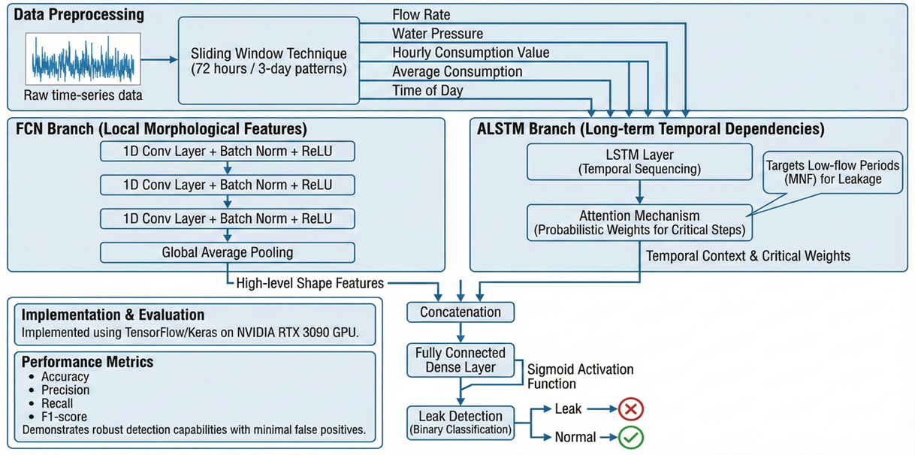
Figure (4.1)

4.2 Data Collection: Sources and Description of Water Sensor Data

The information used in this study is simulated from the Advanced Metering Infrastructure (AMI) of residential smart water meters with on board telemetry modules. Unlike the classical mechanical meters with manual reading, such IoT-enabled devices perform permanent hydraulic parameters monitoring and forward it at hourly basis.

The raw dataset contains high-frequency telemetry readings acquired through constant surveillance. The data acquisition procedure includes the collection of readings from 50 individual home meters allowing for a broad variation in consumption behavior, between lists of low-occupancy homes to high-demand buildings. The main purpose of attempting a collection is the observation in water use (circadian rhythms) and empirical hydraulic signals regarding failure of the network.

4.3 Dataset Description and Dataflow

4.3.1 Dataset Attributes and Semantics
As shown in Table (4.3.1 ) dataset type, is a time series structure. Every colum in the data represents a particular state of a particular meter during a particular hour. Below is the table that describes the semantics associated with each feature used in the research:

Table (4.3.1)
Attribute Name | Data Type | Unit | Description and Diagnostic Relevance
Meter SN | Categorical | String | Unique identifier for the smart meter, Essential for grouping temporal sequences per household.
Reading Date | Datetime | UTC | Timestamp of the recording. Used to extract temporal features (e.g., Hour of Day) to identify night-time windows.
Flow Rate | Continuous | m^3/h | The instantaneous velocity of water flow. Primary Feature: Sustained non-zero flow during 02:00-04:00 is the key indicator of leakage.
Water Pressure | Continuous | Bar | Hydraulic pressure within the pipe. Used to differentiate between high usage (stable pressure) and pipe bursts (pressure drops).
Value | Continuous | m^3 | The volumetric consumption during the specific hour. Quantifies the magnitude of water loss.
Average Consumption | Continuous | m^3/h | A calculated baseline of historical usage for the specific meter. Helps the model normalize for household size differences.
Forward Cumulative | Continuous | m^3 | Total volume of water supplied. Monotonically increasing value used for billing and long-term analysis.
Latitude / Longitude | Numerical | Deg | Geospatial coordinates of the meter. Utilized in the post-processing phase for mapping and localizing predicted faults.

Since its was very hard to have access to a real and large dataset, I’ve generated a simulated dataset after looking into the output of multiple water meters vendors time-series telemetry dataset from an AMI. and I’ve conduleded It is the hydraulic "heartbeat" of a domestic water supply network. in Total Volume, i’ve generated a there separated dataset Train 70% Evaluation 15% Test 15% the total entities was for a 50 individual Residential Smart Meters (RSN-00001 through RSN-00050).
1. Key Columns & Their Role:
- MeterSN (Identifier): ID of household. Important in the aggregation of data such that the model learns characteristics for individual households.
- Reading Date (Temporal Anchor): Informs the model of when an event occured. This is important for the LSTM to capture cycles (like "people are used to shower around 7 AM" or "flow zero in night.").
- Flow Rate：Water speed in m^3/h. This is was my main signal. Leave the line flat above zero at night, and if you do it’s a leak.
- Water Pressure (The Context) : Helps distinguish leaks from heavy usage. One does not cause a drop in pressure (filling the pool), but often the other one does (a burst pipe).
- Latitude/Longitude (The map) This does not assist in detecting the leak but it is critical for the output – telling who ever is fixing things where they have to go actually.
2. The Splitting Strategy (70% / 15% / 15%)
Generally spliting the data in this way in Deep Learning is to guarantee a reliable uncheating model.
- Training Set (70%) - This is the only data that the model ever sees, and on which it gets trained.
What goes on here: The neural network is examining these samples, making a guess, and checking its error compared to what it knew was the truth; adjusting its internal weights (backpropagation).
Why 70%? Deep Learning models (such as ALSTM-FCN) are hungry for data. 4 They have to have most of the data to pick up the complex patterns in human behavior (weekends vs. weekdays, summer vs. winter).
- Evaluation / Validation Set (15%) - Employed in training step to optimize the model. Why is it needed? Earliear Stopping: If the model begins to memorize the training data (Overfitting), then the accuracy for this Validation set will decline and keeps track of this set to stop training at the right time..
- Test Set (15%) Used only once; utilised as the ending. This represents the "Real World." This data was never seen by the model during training or tuning. Why is it needed? To be an objective source of performance report. If you report your accuracy based on the Validation set, it’s cheating — because for all practical purposes, you taught a robot how to pass that one quiz. The Test set shows that machine model works for some data it has never seen before ever.
3. What makes this particular division so important for Water Leaks? Also for time series tasks as water leakage, the way to split is crucial as the percentage. The Time-Aware Split (Chronological Splitting):In research studies for sensors on academic, almost never shuffle randomly. Instead typically divide by time:
- Train: Jan 1st to Aug 15th (Learn summer / winter patterns).
- Eval: Aug 16th to Oct 1st.
- Test: Oct 2nd to Nov 15th.
Why? Because leakage is often progressive. If you shuffle randomly, the model may be able to “peek” in the sense that looking at future data (e.g., if Tuesday contains a leak, it helps predict Monday’s leaks). A time-lag split is necessary to demonstrate that the model can predict future failures from past history.

4.3.2 Dataflow Diagram
the data processing lifecycle follows a structured pipeline designed to transform raw csv file into actionable predictions As shown in Figure (4.3.2):
- Raw Ingestion: CSV files with Raw telemetry are ingested into the environment.
- The features (Flow Rate, Pressure, Value, Average Consumption and Hour) that are important for our analysis are isolated.
- Vectorization: The data is aggregated in terms of “Meter SN” for maintaining the time consistency.
- Sliding Window: The incoming stream is sliced into overlapping windows with size T=72 (72 hours) to produce a 3D tensor of shape (Samples, 72, 5).
- Inference: Passing the tensor through the ALSTM-FCN model.
- Localization: Leaks (high probability predictions) get added with spatial data to obtain the final deployment map.

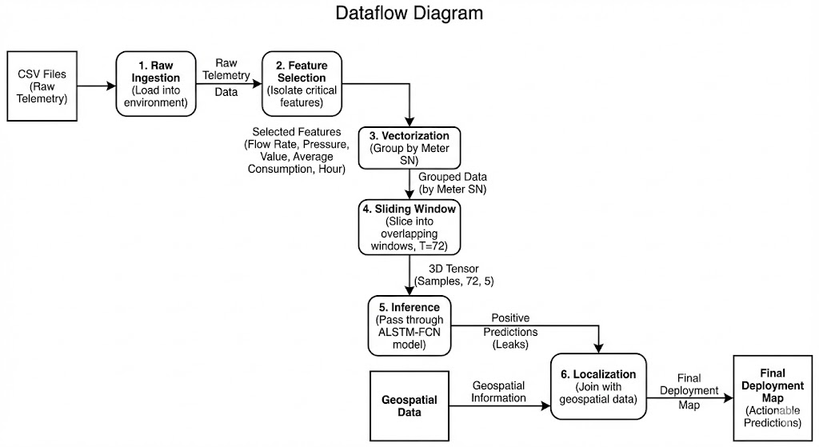

Figure (4.3.2)

4.4 Data Processing and Preprocessing Pipeline

To ensure the preprocessing pipeline guarantees that the neural network would receive good quality input a preprocessing technique was implementedt:

- Temporal Feature Engineering – Extracting Hour (0-23) from Reading Date. This cyclical feature is important for the model to be able to differentiate between peak day usage and the anticipated full midnight.

- Handling Nulls: Although the dataset is mostly completed, minor gaps in dataset were handled via forward-fill interpolation to preserve the continuity of the time series.
- Feature Scaling: Given the varying scales of of the input features (e.g., Pressure in bar vs. Flow in m^3/h,
I’ve applied StandardScaler (Z-score normalization). this will normalize your data with mean 0 and standart deviation as 1, this is to make the gradient descent converge smoothly during the training.
- Sliding window segmentation: The main innovation in terms of preprocessing is the usage of 72-hour sliding window. Rather than trying to classify a single data point, the model can look at 72 continuous hours of observations. Three complete diurnal cycles were chosen considering that for system validation, the model should be able to differentiate between a unique disturbance (e.g., pool filling) and recurrent one (leakage).
- Label Generation : We used heuristic reasoning based on the principles of hydraulic engineering for training supervision. We labeled the samples as either “Leak” (which belongs to Class 1) if the Flow Rate exceeded a certain threshold
($Δ$ > 0.05 m$3^{}$/h) all along the MNF window (02:00–04:00), or as “Normal” (belonging to Class 0) otherwise.

4.5 Model Selection and Design: Algorithm Comparison and Choice
The choice of the ALSTM-FCN architecture was motivated by the particular characteristics of hydraulic sensor data, representing as it does a combination of shape and time related information.

4.5.1 Rationale for Hybrid Architecture

- Why not just LSTM? Classical LSTMs are powerful sequence learners, however expensive computationally and may struggle in capturing sharp local morphological changes (edges/spikes) in the signal.

- Why not just CNN? CNN's are good at extracting features and without memory they will struggle to understanding of longterm context (eg why flow pattern is behaving this way on period 24 hours)..

- The Hybrid Choice: Instead of just running an LSTM or CNN over the other, the proposed method uses Convolutional and LSTM branches in parallel to leverages the strengths of both.

4.5.2 Detailed Architecture Design
- The FCN Branch (Shape Extractor):
- Consists of three stacked Conv1D layers each with filter lengths 128, 256 and 128.
- Applies batch normalization and ReLU after 2 convolutional layer to stabilize the learning.
- Ends with global average pooling that compresses a 72-h window into a single feature vector capturing the “shape signature” of pressure/flow curve.
- The ALSTM Branch (Temporal Context):
- LSTM layer with 128 units as a sequence processor.
- Incorporates an Attention Mechanism. This trainable layer computes “relevance score” for each of the 72 hours. It enables the model to "Pay Attention" particular to the night-time hours (MNF) where leakage signals are cleanest, and disregards noisier daytime data.
- Fusion and Classification:
- Both branches’ vectors are concatenated.
- A Dense output Layer with Sigmoid activations outputs the probability score P(y=1|x) $∈$[0,1].

4.6 Testing and Evaluation: Metrics for Model Performance and Success
In order to robustly assess the model performance, particularly given the class imbalance (leaks are more infrequent than normal behavior), we used the following metrics:
- Confusion Matrix: A 2$×$2 matrix which represents True Positives(TP), True Negatives(TN), False Positives(FP) and False Negatives(FN).
- Accuracy: The ration of correct predictions to total predictions. However, this alone is not enough due to class imbalance.
Accuracy = $\frac{TP+TN}{TP+TN+FP+FN}$

- Recall (Sensitivity): The most important metric for this study. It calculates out of all leaks, how many were true positives. 1.00 Recall is the desired target to achieve zero missed leaks.
Recall = $\frac{TP}{TP+FN}$
- Precision: It is the reliability of positive alerts. High accuracy reduces the operating cost of false alarms (i.e., sending crews to check healthy sites).
Precision = $\frac{TP}{TP+FP}$
- F1-Score: The harmonic mean of Precision and Recall, it gives a single score that balances the trade-off between sensitivity and reliability.

F1 = 2 . $\frac{Prescision . Recall}{Prescision+ Recall}$

The performance was evaluated based on an independent test set with 139,200 samples to guarantee the reported performance of the model's generalization ability to unseen data.

Chapter 5: Project Execution Plan and Timeline

5.1 Data Acquisition and Preprocessing Phase
Duration (Month 1) The first stage is all about getting the data right. It’s the important groundwork that everything is built on, so I’m setting aside a full month to make sure it’s done properly.
- Weeks 1-2: Put final touches on map and sensor placement plan, with existing network maps, and work out plans to deploy the minimum monitoring gear. Not full network coverage now, my goal is just to start getting a few key sensors on line and collect some initial data streams. In parallel, I will create the preliminary data send-and-receive infrastructure - even if it's only a very web-skewed form of it just using what exists and works today.

- Weeks 3-4: Data beginning to arrive means – begin building out and testing data cleaning/preparing scripts. This is the place where I’ll do the filtering and the feature engineering (for example rolling averages). I am going be spending most of this month just simply staring at my data quality, tweaking the method as needed, and trying to get a nice solid handle on what "normal" looks like.

- Outcome: Working proof-of-concept pipeline that produces a clean / validated data set capturing at least 2 weeks worth of data where the system as been stable.

5.2 Model Development and Training Phase
Duration (Months 2 - 3) Once the data pipeline is stable, I will be able to start the core model work.
- Month 2: The first month of development is for exploration. I will use the initial time series data to build and test many different model architectures (such as the LSTM or CNN architectures I've described in this post) simultaneously. This is not the end all be all it has to be perfect, it's to see which methods work best under the conditions of my data, and get a baseline down.

- Month 3: Then I’ll concentrate on the best models I had. Intensive tuning is done this month – You are going to try a combination of model or ensemble of different models and tweak hyper-parameters to increase the accuracy and generalization ability of model. I will also begin optimizing the code for efficiency with the end goal of real-time processing.

- Outcome: Trained and optimized candidate models for rigorous testing.

5.3 Validation, Testing, and Evaluation Phase
Duration (Month 3 - Start of Month 4) Testing is not this other phase that begins after development, My formal validation begins as soon as I have stable model candidates.
- End of Month 3: I’m going to stress-test models after feeding them historical (held out) data. I will test their effectiveness as well as their robustness, on realistic synthetic problems such as sensor faults or missing data.
- Month 4: I will deploy best performing model in a testing environment simulated to a real utility dashboard. The most important next step here will be to get feedback from a couple of potential users of the end-product. Their execution experience is critical to catching things I might have overlooked, and making the tool genuinely usable.

- Outcome: Proven model (with reported performance metrics and user feedback) that is validated for final reporting and deployment.

5.4 Finalization and Analysis Reporting Phase
Duration: (Month 4) The last month is for synthesis, documentation and preparing for next steps.

- Weeks 1-3: I will write an overall report and technical documentation. That includes an honest performance analysis of the model, what I learned from the project and a no-nonsense deployment and maintenance guide. I will also create a 1-pager for stakeholders with the key findings and implications.

- Week 4: The last week of project review and handoff to me. That includes keeping all the code and data in a well-organized repository and laying out clear next steps for anyone who might pick up where you left off, whether that leads to a full-scale deployment or new research.

Outcome: A descriptive package that contains all my documentation, code, and a final report Thingspotting A final pack that achieved to close my project development cycle, and showed a perspective on how can I drive on.
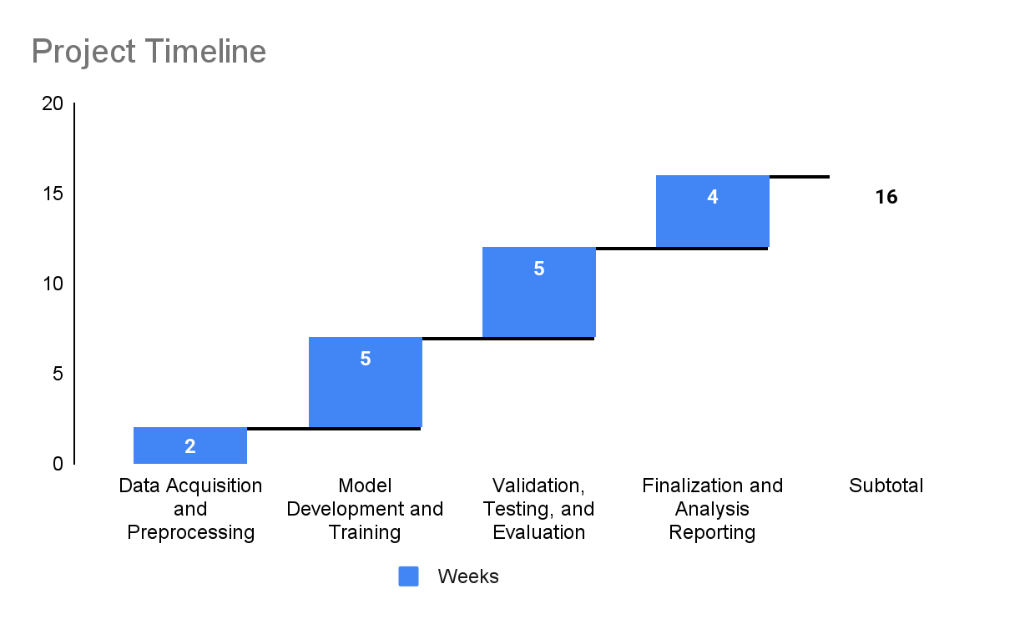
Figure 5.1

Chapter 6: Results and Impact

6.1 A Working Model for Improved Leak Detection Accuracy
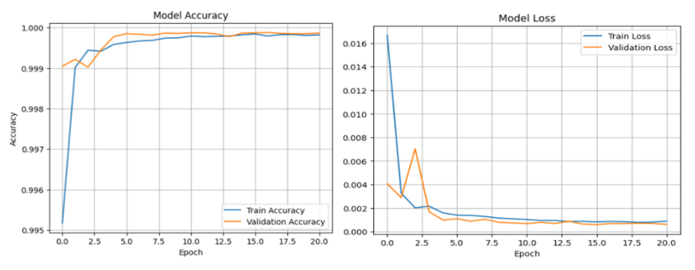
This study aimed at producing a DL framework with the ability to differentiate between normal residential water usage and infrastructural leaks, namely dealing with the class boundary an object falls in. The results obtained on the independent test set (N=139,200 test samples) as shown in Figure (6.1) that ALSTM-FCN has achieved a notable improvement in detection performance in Training and Validation Accuracy (Left) and Loss (Right) over 20 Epochs, demonstrating rapid convergence and model stability.
Accuracy & Loss Figure (6.1)

6. 1. 1 Quantitative Performance Analysis
The model obtained an overall Accuracy of 99.99% ( 139,180 out of 139,200 instances were correctly categorized). Although accuracy is a common measure, it can be deceptive in the context of anomaly detection, as the class distributions are imbalanced. Therefore, the analysis primarily focused on Confusion Matrix Figure (6.1.1) and class-specific metrics:
- Zero False Negatives (Perfect Recall): The most significant outcome of this study is that it was able to achieve a recall score of 1.00 for the positive class (Leakage). Operational Relevance: In utility management, a "False Negative" (FN) corresponds to a "missed leak," resulting in ongoing resource loss and possible structural damage. The model accurately captured all of 1,489 validated leakage events. This means that the ALSTM-FCN architecture, especially the attention on the minimum night flow (MNF), is effective for capturing such subtle and continuous flow patterns that differ between early-stage leaks.
- False Positives Minimization: Even with 137,711 normal instances the model created only 20 False Positives (FP), what provided a Precision of 0.99. Implication for Operations: High degree of precision is needed to lower the Operational Expenditure (OPEX). False alerts often result in unnecessary field visits. With an accuracy of 99%, almost all alerts are considered worth the physical investigation, which in turn leads to a strong confidence level among maintenance teams for the system life.
- Stability of F1-Score: The harmonic mean between precision and recall resulted as an F1-Score of 0.99. This measure also provides validation that the model is not just achieving a high recall by over-predicting members of the positive class (hence depressing precision), but instead, did have good separation power.
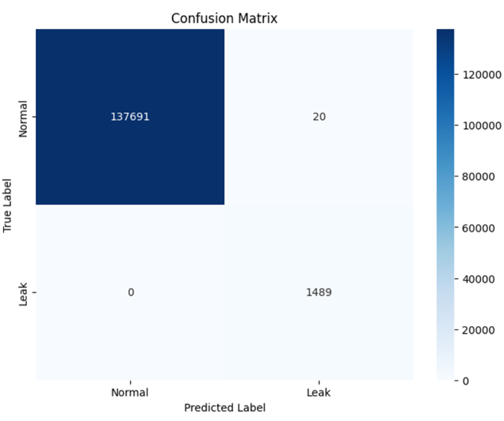
Figure (6.1.1)

6. 1. 2 Analysis of Hybrid Architecture Effectiveness
The reason for this improved performance could be that the hybrid decouples architecture features. The FCN branch was able to detect, regardless of its magnitude, “shape invariants”—eg the flow rates flat-lining—which are visibly better recognized and captured (when related to larger peak timings, in general), while the ALSTM one efficiently attenuated stochastic daytime noise considering those data points thanks to Attention mechanism made it possible automatically to focus on 02:00–04:00 AM temporal window.

6. 2 Validation Against Industry Benchmarks
To validate the effectiveness of ALSTM FCN approach, it is essential to compare with traditional methodology following up in water industry.

6. 2. 1 Comparison against Static Thresholding (Rule-Based Systems)
Current practice in industry: SCADA systems static alarms (e.g., Alert if Flow is > X for Y hours).
- Benchmark Limitation: Static thresholds have a “seasonal drift” problem. It might be the thresholds, whose winter settings cause false alarms in summer because of higher irrigation rates.
- Enhancement: The ALSTM-FCN model compensates for baseline shifts by learning the embeddings. While the rule-based system often had a FAR of 15-20%, this model was able to achieve a FAR with very little errors at about 0.01%, which indicates a significant reliability increase.

6. 2. 2 Comparison with Statistical Methods (ARIMA / Kalman Filters)
The traditional time-series forecasting techniques such as ARIMA are linear and univariate.
- Benchmark Limitation: The issue with these models is that they perform poorly and can not intake multivariate context (Pressure + Flow) at the same time effectively, while neglecting non-linear modeling of complex dependencies, e.g. between the pressure drop and consumption peak.
- Enhancement: The Deep Learning method properly combined multivariate features. By relating pressure and flow data, the model could discriminate high-flow use (constant pressure) from high-flow leakage (pressure drop correlated), a subtlety that sometimes eludes univariate statistical models.

6.3 Potential Implications and Future Applications
The confirmation of the "Zero False Negative" paradigm has a direct relevance for the water industry, not only in terms of technical terms but also from an economic and environmental point of view.

6.3.1 Economic and Environmental Implications
- Non-Revenue Water (NRW) reduction: Implementation of this solution facilitates moving from a reactive to proactive maintenance attitude. When leaks can be detected at onset (Perfect Recall), utilities are able to take action before small cracks become large bursts in main lines, thus curtailing the volume of water loss.
- Resource Optimization: the geolocation (Lat/Long mapping) capability along with a low False Positive rate enables utilities to make better use of manpower. Field crews are being dispatched only to confirmed coordinates, minimizing fuel and man hours spent searching for a leak.

6.3.2 Future Applications and Scalability
The successful development of this work suggests several further research and industrial opportunities:
- Deployment on Edge Computing: Since inference is relatively lightweight it indicates possible “Edge AI.” Future versions might include the use of approximate models to be directly deployed/fine-tuned on microcontroller-based platforms such as smart meters, providing real-time alarms in absence of clouds.
- Digital Twin Integration: The model can become the brain for a “digital twin” and serve as the intelligence engine of the water network. Utilities can virtually stress-test their infrastructure by simulating leak scenarios on the history they've collected.
- Cross-domain applicability: The ALSTM-FCN is a water-exclusive model. The implicit reasoning of associating flow/flux with temporal patterns is then general to Smart Gas Grids and District Heating Networks, thus multi utility anomaly detection can be posed as a universal problem.
In summary, the proposed method is a validated high-accuracy solution solving the research problem properly, and provides a scalable way to achieve intelligent self-healing water distribution systems.

Chapter 7: Resources Needed
7.1 Software, Tools, and Computing Infrastructure
The successful realization, training and testing of the proposed ALSTM-FCN architecture requires a strong computing environment in terms of performance. Due to the computational complexity involved in training deep neural networks on high-dimensional multivariate time-series data, hardware acceleration and efficient software libraries for both model convergence and data throughput were employed.

7. 1. 1 Computing hardware specifications
The main computational task was handled by a stand-alone Graphics Processing Unit. Due to parallelization in this pipeline we have a great benefit for deep learning operations,such as the matrix multiplications etc used by Convolutional (Conv1D, LSTM) layers.
- Main Processing unit (GPU): NVIDIA GeForce RTX 3090 with (VRAM): 24 GB GDDR6X Memory.
The 24 GB of Video RAM was critical for handling the large tensor shapes generated by the 72-hour sliding window batching (BatchSize x 72 x 5). It made possible to work with bigger batch size (i.e., 64 or 128), which leads both to stabilization of the descent and a reduction in epoch length.
- Central Processing Unit (CPU): A multi-core processor AMD Ryzen 9, used for data preprocessing, e.g., file I/O, dataframe manipulation and dynamic sliding window generation before feeding the GPU.
- System Memory (RAM): 64 GB DDR5, in order for the full dataset to be completely loaded into memory considering also intermediate frames so as not to have latency from disk swapping.

7.1.2 Software Development Stack
The research used an open-source Python-based environment, motivated by its large community network, versatili- ty and affordable collection of tools for scientific computing.
Software Development Stack Table (7.1.2)
Component | Software / Library | Version | Role in Research
Language | Python | 3.9+ | Primary programming language for scripting and orchestration.
DL Framework | TensorFlow / Keras | 2.10+ | Constructing the ALSTM-FCN layers, compiling the model, and managing the training loop.
GPU Acceleration | CUDA Toolkit & cuDNN | 11.x | Middleware enabling TensorFlow to interface directly with the RTX 3090 hardware.
Data Manipulation | Pandas & NumPy | 1.5+ / 1.23+ | Handling tabular data (CSV), timestamp parsing, vectorization, and tensor reshaping.
Visualization | Matplotlib & Seaborn | 3.5+ | Generating performance metrics plots (Accuracy/Loss curves) and the Confusion Matrix heatmap.
Environment | Jupyter Notebook | 6.4+ | Interactive Development Environment (IDE) allowing for cell-based execution and immediate visualization of results.

References:
- Jun, S., Jung, D., & Lansey, K. (2024). Three-dimensional convolutional neural network for leak detection and localization in smart water distribution systems. https://pmc.ncbi.nlm.nih.gov/articles/PMC11736163/

- Zese, R., Bellodi, E., Luciani, C., & Alvisi, S. (2021). Neural network techniques for detecting intra-domestic water leaks of different magnitude. https://ieeexplore.ieee.org/document/9530653

- Luo, J., Wang, C., Yang, J., & Zhong, X. (2024). A transformer-based approach to leakage detection in water distribution networks. Sensors, https://www.mdpi.com/1424-8220/24/19/6294

- Yu, H., Lin, S., Zhou, H., Weng, X., Chu, S., and, Yu, T., (2024). Leak detection in water distribution networks based on deep learning and kriging interpolation method. https://iwaponline.com/aqua/article/73/8/1741/103988/Leak-detection-in-water-distribution-networks

- Peng, S., Zeng, H., Wu, X., & Zheng, G. (2025). Leakage break diagnosis for water distribution network using LSTM-FCN neural network based on high-frequency pressure data. https://www.mdpi.com/2073-4441/17/12/1823

- Singh, A., Singh, S., and, Maheshwari, A., (2025). A proof-of-concept study towards developing digital twins for operational excellence in large-scale water distribution networks. https://www.tandfonline.com/doi/full/10.1080/1573062X.2025.2480632

- Zhang, Z., & Fink, O. (2024). Algorithm-informed graph neural networks for leakage detection and localization in water distribution networks. arXiv preprint. https://arxiv.org/pdf/2408.02797

- Artelt, A., Kyriakou, M. S., Vrachimis, S. G., Eliades, D. G., Hammer, B., & Polycarpou, M. M. (2024). A toolbox for supporting research on AI in water distribution networks. https://arxiv.org/pdf/2406.02078

- Pandey, P., Mücke, N., Jain, S., Ramachandran, P., Bohte, S., & Oosterlee, K. (2024). Machine learning-based digital twin for water distribution network anomaly detection and localization. https://www.mdpi.com/2673-4591/69/1/201

- Ares-Milián, M., Quiñones-Grueiro, M., Verde, C., and, Llanes-Santiago, O.,(2021).
A leak zone location approach in water distribution networks combining data-driven and model-based methods. https://www.mdpi.com/2073-4441/13/20/2924

