The code is :
import random
# Generate a random number between 1 and 5
number = random.randint(1, 5)
# Ask the user to guess the number
while True:
guess = input("Guess the number between 1 and 5: ")
# Check if the guess is correct
if int(guess) == number:
print("Congratulations! You guessed the number correctly.")
break
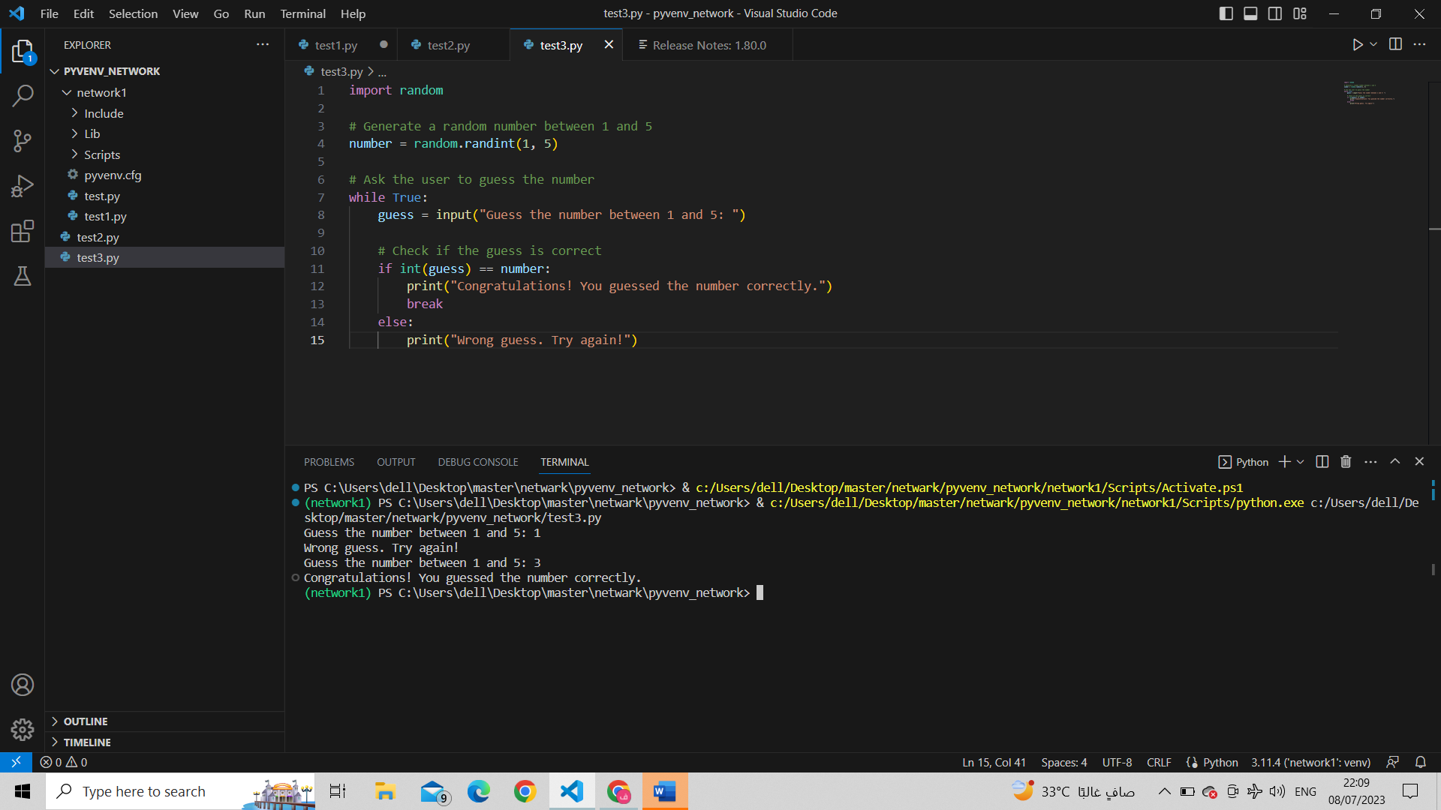
else: print("Wrong guess. Try again!")

