
MIDOCEAN UNIVERSITY
College of Administration
Department/Section/ Risk Management

Optimizing Claims Management in Health Insurance:
Exploring Opportunities and Challenges in the Saudi Market

Student name | Norah Abdullah Alassoum ID No. | 241000422 Degree | Master of Risk Management

Supervisor | Dr. Asmaa Abu Ansza

Year of 2024

ACKNOWLEDGMENTS
I would like to express my appreciation to all the people who assisted me in conducting this research on the optimization of claims management in health insurance Saudi market. First I would like to show my appreciation to the committee members and assessors. The officials and servants of the [Midocean University] and my colleagues in our company were supplying me with the means to implement this project and the conditions in general. I should also express my appreciation to the experts in risk function who gave me some advice in this paper. It has assisted in making the research more informative and efficient by incorporating their experience. The last ones are my Husband, family, relatives, and friends who treated and understood me in times of weakness – it is an extraordinary contribution to my social life and therefore the ready work. I wish that everyone would have their approach meet their needs. Thank you all.

ABSTRACT
This study focuses on the analysis of the efficiency of claims management within the health insurance industry of Saudi Arabia. This includes the prospects and challenges of outside (outsourced) and inside (in-house) management. The health insurance industry in KSA is evolving at a very fast pace due to the changes in legislation at the regulatory level and the growth within the industry and beyond. The decision of whether to handle claims internally or externally has significant consequences on the efficiency and viability of insurance companies. The research objectives of the study are as follows: to assess the current state of health claims management in Saudi market; to determine the prospects and drawbacks of inside and outside approaches and to evaluate the effectiveness and efficiency of the approaches. The data for this research was collected through literature review, case studies, and interviews of the experts and specialists. The findings of the study enable the identification of the strengths and weaknesses of each method. The best management practices were identified to ascertain the optimization of the process in order to support the highest efficiency claim. Research shows that inside methods of claims management offer better control and data protection; however, this option is more costly. When outsourcing claims management, businesses get cost benefits and the ability to retain scalability. However, outside claims management may experience some issues in data security and regulatory compliance. The last section of the research is a feasibility study on how to transfer from out sourcing the medical claims management to full internal control process.. Altogether, the present research adds to the existing literature on health insurance management and will offer insurance companies in the Saudi market data to enhance their claims management.

TABLE OF ABBREVIATIONS

Abbreviation | Definition
ACM | Association for Computing Machinery
SAMA | Saudi Arabia Monetary Authority/ Saudi Central Bank
CHI | Commission of Health Inspection
ERM | Enterprise Risk Management
AI | Artificial Intelligence
AMS | Advanced Metering Infrastructure
BMC | BioMed Central
C. | Chapter
EJMBE | European Journal of Management and Business Economics
IEEE | Institute of Electrical and Electronics Engineers
II | Information Infrastructure
IJSSCA | International Journal of Six Sigma and Competitive Advantage
INQUIRY | The Journal of Health Care Organization, Provision, and Financing
IT | Information Technology
JAOC | Journal of Accounting & Organizational Change
JBIM | Journal of Business & Industrial Marketing
KSA | Kingdom of Saudi Arabia
MD | Doctor of Medicine
MDPI | Multidisciplinary Digital Publishing Institute
NHI | National Health Insurance
Q1 | Quartile 1 (top 25% of journals)
Q2 | Quartile 2 (25-50% of journals)
QRS | Quality, Reliability, and Security
RBV | Resource-Based View
RPA | Robotic Process Automation
TPA | Third-Party Administrator
UHC | Universal Health Coverage
IBNR | Incurred but not reported Claims in Financial Statements

TABLE OF CONTENTS

Chapters | Title |  | Page
 | Acknowledgments |  | 3
 | Abstract |  | 4
 | Table of Abbreviations |  | 5
Chapter 1 | Introduction |  | 10
 | Problem Statement |  | 13
 | Study Purposes |  | 14
 | Study Question |  | 17
 | Theoretical Model |  | 19
Chapter 2 | Literature Review |  | 22
 | Introduction |  | 22
 | TPA’s Role |  | 22
 | Dependent Variable: Efficiency and Effectiveness of Claims Management |  | 23
 | Independent Variable: Internal (In-House) vs. External (Outsourced) Claims Management Approaches |  | 23
 | Summary of Past Studies |  | 24
 | Internal Claims Management |  | 24
 | External Claims Management |  | 26
 | Advantages and Disadvantages of Internal Claims Management |  | 28
 | Advantages and Disadvantages of External Claims Management |  | 30
 | Comparative Analysis of Past Studies |  | 32
 | Building Upon or Differing from Previous Studies |  | 32
 | Theoretical Framework of the Study |  | 33
 | Resource-Based View (RBV) |  | 33
 | Cost-Benefit Analysis |  | 34
 | Customer Satisfaction Theories |  | 35
 | Summary |  | 35
References |  | 54

Chapter

01

Chapter 1: Introduction
The Saudi Arabian health insurance industry is a field that can be described as characterized by the significant and continuous process of transformation. The specific history includes the field of health insurance from a critical reading perspective as it is an essential grindstone to the Kingdom’s Vision 2030, the goal of which is to provide all the citizens with a comprehensive and highly qualitative healthcare service (Commission of Health Inspection CHI in Saudi Arabia, n.d.). Therefore, as stated by the Commission of Health Inspection CHI in Saudi Arabia, the process of starting the legislation of health insurance in the Kingdom can be traced back to 1999 when the government set up the Health Insurance Council. However, an actual efficient regulation started in 2005 when the government provided SAMA (Saudi Arabian Monetary Agency) the complete authority in the insurance sector as now the name changed to (Saudi Central Bank) since 24th November 2020. It has also been subsequent by the employing of the particular capacity of SAMA to exert augmented control over the sector regulating the processes of licensing, overseeing, and regulating the incorporated bodies (Information Affairs Authority in Saudi Arabia, n.d.). SAMA has, over the last decade, sought to impose considerable change to the overall legislations and frameworks to enhance the best practice in aspects such as prudential standards, supervisory reviews and disclosure standards.
The shift towards the financial soundness and stability of the domestic and international banking sectors at the same time also helped the subsidiary insurance and reinsurance markets in their search for efficiency and growth. The final result can be obtained – with no need for additional analyses that require critical thinking – as the direct outcome of the change in the state policy regarding the mechanism of financing healthcare services (Information Affairs Authority in Saudi Arabia, n.d.). The SAMA market entry competitive framework and the policy of massive market reform by enlargement and privatizing conduce to the government’s objectives of using the particular forces of the market and the facility for universal enrollment. Such byproduct suggests improvements in population health and systematic consumer costs staggering enlacement, improvements in competition, stimulated efficiency, and the structure of individual choice and responsibility.
The Health Insurance Council is considered an independent government entity that has a legal personality, on the decision of the Council of Ministers No. 71 dated 27/4/1420H, it was decided to establish the council with the aim of monitoring the implementation of health insurance regulations. later, the Insurance Authority was established by the decision of the Council of Ministers No. 85 which was made on 28/1/1445H, which exercising all powers and responsibilities that have been decided in relation to the insurance sector in the Cooperative Health Insurance System, issued by Royal Decree No. M/10, date 1/5/1420H, and in the

Cooperative Insurance Companies Control System, issued by Royal Decree No M/32, date 2/6/1424H (Information and Communications Technology Authority, Saudi Arabia, n.d.). The increase in the regulation and legislative transformation has resulted in the overall market to significantly shooting upward alongside an increasing overall membership and the volumes of claims to be managed. However, with these numbers, the workload has been rising and has therefore begun to exert pressure on insurers, especially the conventional way of handling claims processing as part of the overall means to cater for the bills on the healthcare of the insured (AlJohani & Bugis, 2024). Whereas the companies have been directly dealing with them through their capability, the same is through manpower and concrete but now appears to be inadequate.
To address this increasing number of claims, insurers are now starting to consider the outsourcing of one processing function or the entire spectrum of works to (TPA) third-party administrators. TPAs are involved in the handling of claims on a very big scale. The decision to centralize or decentralize claims administration management, TPAs has strategic and operational consequences that are not fully appreciated in the Saudi context. These corporate concerns are cost containment, productivity, time to adjournment of bills, and members and provider satisfaction (Nabrawi & Alanazi, 2023). Outsourcing helps professional TPAs to use the latest technologies and specialized knowledge, but at the same time, it weakens the insurers’ control and decreases their direct communication with customers. Furthermore, this challenge is further supported since there is no available standard performance indicators in Saudi Arabia that can distinguish both approaches up to this date (Alharbi, 2022). Of course, the question does not turn into a competitive advantage but it has to be answered through highly instrumental analyses – that too with sound evaluation criteria.
Moreover, it is essential to note that the execution of these strategies through the use of ERM frameworks is necessary. ERM enables insurers to manage and prevent risks that are inherent in claims processing both internally and externally and all over the company’s various risks. It is crucial to determine and analyze the key financial effects of risk indicators in order to assess the financial solvency and productivity of insurance organizations. It is possible to use diagrams to explain the ERM framework and financial effects of risk indicators in order to get a better understanding of these aspects.
Illustrates the application of enterprise risk management (ERM) in an organization:


Human Resources
strategic marketing
Legal
MEDICAL CARE
Research
Financial
Information Technology

Figure 1: Enterprise Risk Management Structure in the Organization (Etges et al., 2019).
Corporate Management
Chief Exccutive Officer (CEO) / Chief Financial Officer (CFO)
Value driven management
Enterprise Risk Management Chief Risk Officer (CRO)

No such opportunities or challenges assessment compares internal processing with outsourced processing against their primary local data. The decision of whether to perform claims administration internally or externally is one of the most basic, and the available data at the moment does not offer any solutions and simply deprives insurers of the metrics they could use to make their choices (Al-Hanawi, Mwale, & Qattan, 2021). Hence, this research aims to fill the local inadequate understanding by undertaking a research evaluation of the claims administration strategies from several insurers through data collection and analysis. This will provide a clearer picture of how performance is affected by approach and insurer- and claim- specific context factors peculiar to the Kingdom (Nabrawi & Alanazi, 2023). Such adequately resilient data will help insurers regain control of their decision-making processes through an improved appreciation of their realities in managing an industry that is rapidly becoming modern.

Problem Statement
The Saudi health insurance industry has been growing at a fast pace over the past few years because the government pushed for the implementation of UHC. This has been among other sector wide effects that have compounded a myriad of operational challenges to health insurance providers. In particular, the most significant issue that is currently affecting insurers in Saudi Arabia is the identification of the most effective claims administration strategy (Alonazi, 2020). To date, market members have concentrated on internal claims processing in terms of claims administration, which is the employment of the company’s own personnel and equipment. However, a steady rise in healthcare costs and the frequency of utilization has put pressure on claims processing. Due to this, many companies are now finding it hard to operate under the new workload as this has affected the efficiency of the employees, availability of resources and turnaround time (Puteh, Aizuddin, & Al Salem, 2022). Due to these new trends, most of the Saudi health insurance firms are now contemplating on outsourcing their claims to third party administrators. On the one hand, these TPAs are able to process medical bills for providers at a faster rate than they could individually because of the scale of the organizations that employ them and the special technology and knowledge that they possess (Alonazi, 2020). In general, potential outsourcing advantages are faster and less costly processes for insurance suppliers. However, making a deal with a TPA also comes with certain risks such as loss of control and oversight, deterioration of the quality of service, and reliance on third parties.
There has been a growing interest in Third-Party Administrators (TPAs) in the recent past. Nevertheless, there is a lack of studies on the Saudi market that compares the efficiency of internal vs. outsourced management of claims. Currently, there is no clear local data and new trends, which makes it difficult to make decisions in the industry. Insurers in Saudi Arabia are sometimes forced to use experiences from other markets as a reference (Al-Hanawi, Mwale, & Qattan, 2021). However, other countries may have different regulatory requirements, another economic setting, and belong to a different culture, which are all likely to influence the relative price and effectiveness of both methods. There are pros and cons of internal and outsourced claims administration that are already in place (Al-Hanawi, Mwale, & Qattan, 2021). The claim of in-housing processing provides a better feel for control, more standardization, and better security of sensitive information. At the same time, this method is more costly and demanding in terms of human resources. On the other hand, the use of TPAs is sometimes looks cheaper and can be extended to a large number of clients, but it means the loss of control and deterioration of the level of satisfaction of clients (AlHadlaq, 2024). It is therefore necessary to undertake a thorough and structured comparison of both these options. As it has been mentioned, the performance indicators are to a significant extent universal and are determined by the characteristics of the studied system. In this piece of research, the aim is to fill the existing knowledge gap with findings that are specific to the Saudi phenomenon.

Study Purposes
The purpose of this mixed-methods study is to identify and describe the claims management in the health insurance sector in Saudi Arabia and to identify the internal and external claims management opportunities and threats. In this regard, the objective of the study is to examine the efficiency, effectiveness and overall performance of the two types of claims management using quantitative data analysis and qualitative findings. The research is to include a questionnaire to the professionals in the industry, case studies of insurance companies using internal and external management, and statistical analysis of such parameters as cost, productivity measures, turnaround time, and customer satisfaction. On the one hand, the quantitative data collection and analysis are to give a prima facie comparison of the cost, efficiency, and effectiveness of the two types of claims management. Also, the data is to be complemented with the information obtained from the qualitative part of the research, which involves conducting semi-structured interviews and questionnaires to the industry practitioners about their practice and perception of in-house and outsourced claims management. Therefore, the mixed-methods paradigm offers a comprehensive view of the existing situation in Saudi health insurance claims management, including the existing problems and the possibilities that can be opened. The recommendations arising from the research are to be used to formulate policies that will help internal and external claims managers to perform better, reduce costs, improve on service delivery and increase customer satisfaction (Hazazi, Wilson, & Larkin, 2022). The result of the study will be useful to the health insurance companies to make decision on the best practices to adopt in the management of claims and also useful data to the policymakers in the Saudi health industry.

In the case of every health insurance company, there should be no questions as to what the best claims management strategy is. It affects performance, costs, and satisfaction, so it is one of the most significant factors to use when addressing this competition in Saudi Arabia, a dynamic and gradually becoming complex market that has recently adopted the obligatory insurance state and faces a tremendous financial pressure that leads to growing expectations from the insured population (AlJohani & Bugis, 2024). This study attempts to prove that claims management is not just a back process, but it can contribute to the improvement of the operational efficiency of a health insurance company and reduction of its costs.
The management of claims can enhance the efficiency of health insurance firms by enhancing the claims process. It can benefit in several ways, the most apparent of which is the enhancement of the speed of the process, which will also be of advantage in meeting the company’s obligation to pay claims to providers on time. Additionally, if the process is efficient, the company involved will not be overwhelmed with a lot of administrative work during the busy times, which is a

major cause of inefficient work and unhappy employees (AlJohani & Bugis, 2024). This in turn will help efficiency, and thus reduce the operational cost of the company in question even more. Furthermore, with the right software solution that is fine-tuned to the requirements of a health insurance company, it is possible to sustain efficiency even during the peak periods. This scalability is also a major factor that enables cost leadership because it means that companies can handle more clients while incurring the same costs (AlJohani & Bugis, 2024). The non-life structure of their spending guarantees that even with the rise in benefits paid to providers and insured patients, the fixed costs of managing the rise in claims remain the same.
Optimization of claim management is significant for both carriers and clients. For the latter, outstanding performance of this function may guarantee that all services provided in the policy would be considered during the decision-making process (Hemrit, 2022). Besides, the promoted level of faster claim adjustment and overall service may also serve as a justified incentive to renew an insurance contract. In its turn, for carriers, it is vital to manage claims appropriately to avoid potential issues and achieve economies of scale through enhanced productivity. This way, the given research is aimed at deepening our understanding of which claim management approach is more beneficial from both an internal and external point of view and what is their specific impact on the Saudi Health Insurance industry (Hemrit, 2022). It is necessary to emphasize that the developed project may be particularly required for major market players that are curious about the best route for optimizing their claim management. In the case of an internal management approach, the given project may help to determine which of the developed tools and practices served as sufficient (Hemrit, 2022). By the companies that partly chose self-management aspects, the mentioned research may help to develop a profound understanding regarding the drawbacks and potentials of the already selected outsource teams with their subsequent upgrade.
Cumulative advantages of having both claim management types covered in the research project. Since the internal claim management approach is more time-tested and conventional, its advantages and disadvantages are mostly determined (Al-Faryan & Alokla, 2023). It is a comparatively minor challenge to gather data and make a conclusion about tools used in the standardized situation. In the case of the outsourced claim management approach, the situation is different. There is no time to test all possible routes of how to do it to identify which of the tools were, in fact, useful (Al-Faryan & Alokla, 2023). Treading paths made by others is associated with risks, and a product with real, showcased examples, aimed at assisting health insurance companies, guarantees its significant demand.
Also, the recommendations will provide some useful insight into the health insurance sector as a whole. Even though the present study addresses the needs of stakeholders from the Saudi health

insurance industry, evidence regarding the efficiency of certain types of claims management as opposed to the alternatives can influence the decision-making process of policymakers and regulatory authorities (Hemrit, 2020). Specifically, the tools provided based on the current research might inspire the above-mentioned authorities to consider enhancing the transparency and effectiveness of the Saudi health insurance industry further. Overall, the significance of the study in question is particularly high since determining the appropriate claims management approach is one of the key aspects that will allow firms working in the health insurance area to expand. The ability of health insurance companies to redesign their claims management processes and, therefore, improve the overall efficiency of their performance, reduce costs, and increase the quality of experience for their clients is crucial (Hemrit, 2020). The current study will allow for enhancing the toolbox for both identifying the target claims management and designing the most suitable strategy. The solutions for different types of claims management processes offered in the study will help firms working in the field of health insurance in Saudi Arabia to overcome their currently existing challenges and tap into their full potential.
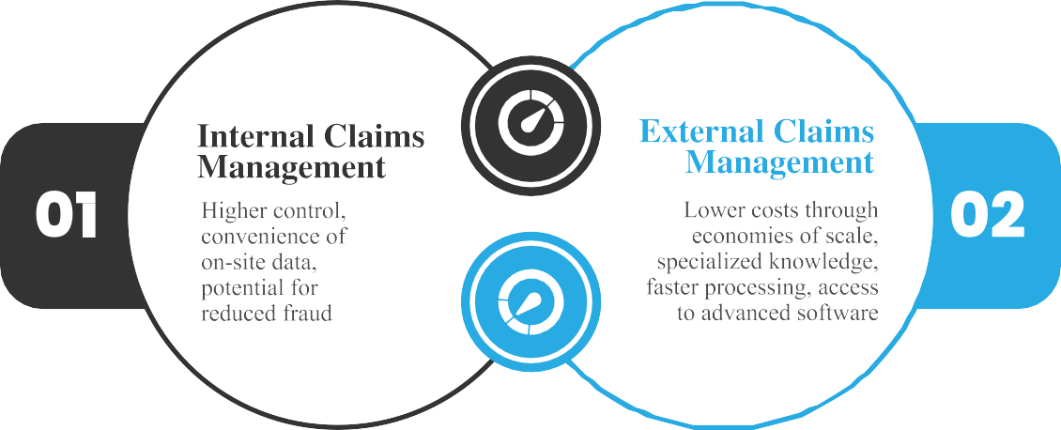
Figure 2: Should the Insurance Company manage claims internally or outsource to a third- party administrator (TPA)

Study Question

What are the prevalent methods of claims management in the Saudi health insurance sector?

The question asks about the prevalent methods of claims management to determine the baseline of current Saudi health insurance practices. Its purpose is to find out which strategies and technologies are the most common among insurers and whether they are efficient, effective, and compliant with the existing regulations. In this visual, this concept is generally illustrated by a chart including different lines indicating strategies based on their intensity. Specifically, if all of them are identified, it can be easier to gain insight into standard industry practices and compare them with both internal approaches and their alternatives (Nabrawi & Alanazi, 2023). Finally, this information will help in figuring out which technologies and practices should be adopted by insurers to address the need for greater competitiveness and regulatory compliance.

What opportunities and challenges are associated with internal claims management?

It is essential to understand the opportunities and challenges of internal claims management to realize whether this activity influences the efficiency and quality of service of insurers. Internal management is characterized by the possibility of control and a high level of data safety, allowing to provide customers with unique service products (Alonazi, 2020). Simultaneously, this approach has some disadvantages, such as staff expenses, deficiency of resources, and negative impact on the system’s operation during active seasons. Thus, a response to this question will help to discuss the identified factors in more detail, providing the insurers with an opportunity to evaluate the advantages of an internal strategy of claims management over the drawbacks and decide on the purchase of corresponding internal facilities or search for an alternative solution.

What opportunities and challenges are associated with external claims management?

Considering the opportunities and challenges that external claims management presents can help insurers better understand the potential advantages and risks of managing expenses through third-party administrators. While external management allows for cost reductions, scalability, and the potential to benefit from specialized knowledge, there is also a variety of risks such as reduced degree of conducted control, potential data leaks, and the necessity to rely on third parties or agents for some of the company’s critical operations (Puteh, Aizuddin, & Al Salem, 2022). To some extent, the following question provides a holistic view of both aspects of the issue, which may be useful for insurers seeking to make an outsourcing decision, and ensuring that the identified opportunities form the basis of a company’s advantage, with the challenges being effectively mitigated.

How do internal and external claims management approaches compare in terms of efficiency and cost?
In order to determine which approach is more cost-effective and efficient, conducting research and comparing the efficiency and cost of internal vs. external claims management is required (Al-Hanawi, Mwale, & Qattan, 2021). This research question focuses on the type of quantitative metric including processing time, administrative cost and error rate. By comparing these metrics, the research will give clear insights into efficiency and cost effectiveness of both approaches. The comparison will allow the insurers to optimize the claims management process and balance cost efficiency with the requirement for effectiveness and reliability of the services.

What best practices can be recommended for optimizing claims management in Saudi Arabia?
Best practices for claims management are known to play a crucial role in helping insurers optimize their operations and the quality of service they provide (AlHadlaq, 2024). As such, the primary purpose of this research project to investigate and synthesize the information about the successful strategies for claims management, both internal and external, in the Saudi context. By comparing and contrasting the identified best practices, technologies, and organizational aspects, the study will provide recommendations that insurance agencies can adopt to enhance their practices of managing claims in ways that would help them to meet the specific requirements of the Saudi market.

Theoretical Model:

Transaction cost theory provides a useful lens to examine and evaluate whether health insurers in Saudi Arabia should internally handle the transactions related to processing claims, and tractions that would be outsourced to third-party administrators. The theory maintains that, as transaction volume increases, the marginal cost of undertaking the transaction internally is also likely to rise because of the diminishing returns (AlJohani & Bugis, 2024). This is central to the problems that health insurance companies have because the transaction volumes of these organizations are probably going through the roof. They are experiencing rising claims demand partly because of previous market reforms and newly opened markets. According to the theory, at the beginning, when tractions were less involved and with low amounts or value, it was only efficient to internalize the transaction costs. This implies that the companies should bring under their roofs, claims function and the attendant facilitative functions such as reports and customer service (Nabrawi & Alanazi, 2023). The companies were able to control and coordinate the efforts of all the support departments ensuring that a considerable part of fixed and variable costs was incurred. Such efforts were efficient in the short run when the policyholders and claims were still few.
According to transaction cost theory, there is a volume at which it becomes cheaper for the insurers on the scale to outsource such specialized processes and gain scale economies for TPAs. Due to the high volume, the service may be contracted out to another firm that is not affiliated with the insurance company (Nabrawi & Alanazi, 2023). It may have lower processing fees, technological efficiencies, or specialized human resources to perform the product or specialized processes relatively cheaper than TPAs. Based on the extent of the overlap, larger transaction services may be acquired at a cheaper price to the company, thus a possible decrease in the growth of in-house operations, compared to the company, although some specific transactions may be in the organization. But it will also result in other costs. When services are performed outside, other risks are attached to the frequency of intervention that the final supplier of the services sold directly to the insured person has no control and is directly controlled by the third party (Alonazi, 2020). This increases the chance of following their interests at the expense of the company. It is like not providing the quality and quantity of services that is expected of you.
Also, the external party may be tempted to use the consumer and contractual information for other purposes. Transaction costs theory states that when asset specificity is high, which is a very regulated industry, with data security being of high importance, such opportunity costs rise (AlJohani & Bugis, 2024). This could be addressed by good contract, incorporation, and long-term contract governance mechanisms by providing the right hedging. Persistent gaming and cautious strategies can maintain the external transaction costs in proportionality even if

they are charged high fees (Al-Hanawi, Mwale, & Qattan, 2021). In general, the transaction cost theory demonstrates that, given the volume of claims that insurance companies have to process, outsourcing may obtain scale efficiencies proportional to internal costs as the cost of outsourcing goes into consideration to overcome insurers’ internal control rents if contingency and contracts are kept at a minimum (Alonazi, 2020). These roughly bound the hypothesis of the degree of outsourcing at which the flat scale ceases to compensate for the internal cost of component manufacture.




Chapter

02

Chapter 2: Literature Review Introduction

TPA’s Role:

TPA is a company that provides operational services such as claims processing management under contract to another company. Insurance companies and self-insured companies often outsource their claims processing to third parties. Thus, such companies are often called third- party claims administrators.

Key services offered by TPA Companies in Saudi Arabia include:
- Claims Processing & Management:
TPA companies in Saudi Arabia handle the processing and management of insurance claims on behalf of insurance companies or self-insured entities. This involves receiving, reviewing, and adjudicating claims submitted by healthcare providers on behalf of insured individuals. TPAs ensure that claims are processed efficiently, accurately, and in compliance with insurance policies and regulations.
- Provider Network facility:
TPA companies establish and maintain a network of healthcare providers, including hospitals, clinics, physicians, and other healthcare facilities. This network ensures that insured individuals have access to a wide range of healthcare services within a specified network.
- Client Services facility:
TPA companies offer client services to insurance companies, employers, and policyholders to facilitate smooth communication, address inquiries, and provide support related to insurance coverage and services. Client services may include assistance with policy enrollment, coverage queries, claims status updates, and general inquiries about insurance benefits. This function aims to enhance customer satisfaction and ensure a positive experience for clients.
- Digital & E-Services:
TPA companies leverage digital technologies and online platforms to provide electronic services to clients, policyholders, and healthcare providers. This includes offering online portals for claims submission, tracking, and management, as well as access to digital tools for policy management, provider searches, and real-time information updates. Digital and e-services enhance convenience, transparency, and efficiency in managing insurance processes and interactions.

Claims management is one of the operational activities that are central to the running of health insurance. Medical claims payments are the base of a relationship that insurers have with customers by paying Naushad et al., (2021). Automation of claims processing is beneficial to the process while poor management of the same is detrimental to the quality of service. Maintaining the efficiency of the Saudi insurance industry is important during this transition (Saber & Ali, 2021). This literature review examines what is currently known about claims management practices in general and sheds light on the internal versus outsourced process of effective claim management recommended within Saudi Arabia. Thus, by looking at the previous empirical studies, one can identify the impact of each one on cost, time for the process, and satisfaction. It revisits the theoretical underpinnings of the organization policies, cost benefit analysis and customer loyalty. Integration of perspectives at this level is aimed at placing the current research challenges and hypotheses within the framework of existing theories so that the gaps that can be filled by studying social media in higher education can be identified.

Dependent Variable: Efficiency and Effectiveness of Claims Management

Efficiency and effectiveness of claims management are the two dependent variables in this study. What Efficiency Means for Claims Management and Insurance Companies. This requires less administrative burden, shorter process times, and efficient resource use to manage claims faster without undue delays. A smooth running and more effective claims management system translates to fewer errors and delays when dealing with claims, enabling faster resolution of these same claims (Sabert & Ali, 2021). On the other hand, effectiveness has to do with the quality of claims processing as a whole and consistency in it (Konrad et al., 2020). It helps to establish that valid claims are recognized and paid on a timely basis, at the appropriate amount showing adherence of the insurer to its obligations towards policyholders. This is especially important as it illustrates the insurer’s ability to process claims professionally and with transparency, which also helps in retaining customer trust and satisfaction. As a result, customer satisfaction increases since policyholders have an easy claim process involving as little effort on their part. Broadly, the study examines how well a claims management system can reconcile proper trade- off between speed and accuracy (process efficiency) vs. quality and reliability of service being delivered to the respective clients for maximum outcomes on each side - both insurer as well as insurance.

Independent Variable: Internal (In-House) vs. External (Outsourced) Claims Management Approaches
In the analysis of the research objective, the independent variable is the internal (in-house) and the external (outsourced) approach in policyholder claims management by insurance companies. Working loss control is when an insurance company handles all of its claims with the tools that it has developed and deployed for this purpose. This method helps the insurer to have control over the whole process by ensuring that internal standards are complied with (Nabrawi & Alanazi, 2023). It also allows for direct supervision of everything and provides a chance to respond to issues immediately which can lead to higher accuracy and better customer service. On the other hand, external claims management is where you hire TPAs to work for your company and manage all your claims. This method leverages the experience, technology, and other specialized resources that TPAs possess which in most cases leads to reduced turnaround time and related costs through economies of scale (Konrad et al., 2020). TPAs can provide complex data analysis, fraud detection, and other high-end equipment that may be beyond the reach of individual insurers to develop on their own. However, some challenges are faced with outsourcing which include; loss of control over the claims process and security risks concerning data as well as reliance on the external provider’s service satisfaction (Saber & Ali, 2021).

This study will further elaborate on this issue by comparing these two other implementation methods of the chosen strategy, in the context of the Saudi health insurance market and its own regulatory economic and cultural environment to determine which of the two methods would yield higher efficiency effectiveness.

Summary of Past Studies

Internal Claims Management
Internal claims management on the other hand allows an insurer to have full control of the total life cycle of a claim for its team. It guarantees compliance and equal treatment by the provisions of data protection legislation. Like previous studies, internal processing may be linked to higher customer satisfaction because of insurers’ quick response and individual attention. However, this is at the expense of key resources operating sophisticated claims processes internally (Jovanovic et al., 2021). Performance is limited to the current headcount and system infrastructure and thus fails to improve performance as a response effort during high demand and scale-up with business growth. Particularly, when the volume number is rising across the KSA market, cost control and Productivity are the major issues.
Research has provided knowledge on how to manage claims. For instance, a study conducted by Chen et al A study conducted in a large Asian market (Ting & Bay, 2021) compared the impact of internal and outsourced models. They concluded that private commercial internal claims adjustment always provided superior protection of highly sensitive customer health and financial information. On the other hand, insurance firms were not more willing to open up their data repositories for delivery and storage elsewhere such as third-party platforms because they have better ways of accessing the data through internal systems than through outside vendors. The research also revealed that conflicts were solved faster with internal instruments since insurance workers could quantify the exact circumstances of a case and had broader jurisdiction to coordinate progress (Chen et al., 2021). However, Jovanovic et al. (2021) pointed out that self- administration had a significant amount of redundant overhead that required the maintenance of different claims processing departments for each group. Some of the insurance firms were small with limited resources to fund the cost of handling claims internally and it was becoming costly to manage the claims in-house – hence many required a solution that outsourcing service delivery would provide.
Further work by Eckert et al. (2022) found that internal claims management in effect granted insurers virtually free rein to sift through enormous heaps of highly sensitive and private

records of individuals’ health and financial lives. Working with enterprise-level APIs makes the application of national data privacy regulations seamless and is critical in industries that are highly regulated like Insurance. However, Eckert et al. (2022) also found that during the rush of claims, while being triggered by crises or market booms-is administered internally that more limits are put on productivity. The researchers noted that internal claims teams could not maintain the processing throughput when the volume was high and thus faced an increased backlog level as well as operation stress. Any decline in such figures has implications for customers’ satisfaction and growth since the competition can forward with better performance levels.
Bourova et al. (2020) focused their study on the manner in which internal claims handling affects the customer satisfaction level. Customers in general expressed a preference for directly dealing with the insurer’s own claims personnel, as per the customer feedback. The reasons given by insured consumers are mostly service-related, such as quicker replies to inquiries, a different method of problem-solving, and a friendly relationship with familiar adjusters. However, Bourova et al. (2020) also pointed out that direct service coordination of this kind can increase the level of well-being and credibility among clients at the claim level, while being costly for insurers who need to maintain a large number of highly qualified employees in the insurance claiming department. The cost exposure includes training of the personnel to ensure that their skills are in par with the technological & regulatory requirements of the industry besides the constant upgrade of the claims processing systems. This is the kind of expense that puts a lot of pressure on the resources if one is to source all the needs internally.

Resource Limitations
Cost Pressures
Limited Headcount
Inadequate System Infrastructure
Training Cost
System Upgrades
inefficiencies and High Costs in Internal Claims Management
Individual Attention Increased Backlog
Quick Response Times
Customer Satisfaction
Issues
High Claim Volumes
Productivity Challenges

Figure 3: Challenges in Internal Claims Management

External Claims Management
To the insurers, outsourcing of claims management implies that there are opportunities as well as risks. The most frequently cited expected benefit in numerous articles is the savings that can be achieved through the use of TPAs. From what we have studied, the more the number of claims volumes that a TPA has from their several insurer-clients, the operational efficiencies that they get in terms of infrastructure and workforce. This enables lower per-claim processing fees than if we were to grow in-house capabilities in a stepwise manner (Kunnath, 2020; Njegomir and Bojanić, 2021). Also, external administration has certain advantages in terms of scalability because most of the TPAs have large operational capacities to accommodate fluctuations in the workload. It gives exposure to core-competence in claims technologies and regulatory- compliance – the learning curve is boosted exponentially (Kunnath, 2020). However, there are some inherent risks in this course as well; lack of supervision, potential issues with data security, and heavy dependence on external vendors for the continuous functioning of the course. Otherwise, you require some form of performance measurement at least in the vicinity.
Sunder and Kunnath (2020) investigated the impact of outsourced claims administration in insurers in India. The researchers also found that the latter method increased the processing time by 30% less than the former through the statistical study of the invocation counts reported over several row by pattern intervals documented with operators Insurance companies that outsource their claims management to TPAs had an average of about 20% lower operational cost per claim. These productivity and efficiency gains offered some backing to the potential advantages of scale economies and specialized competence that might be obtained from outsourcing arrangements. In the same regard, Sunder and Kunnath (2020) noted that there are still concerns of loss of control and possible security vulnerabilities arising from outsourcing customer medical records and financial data to third parties. Also, there are issues concerning the fact that outsourcing models eliminate personal touch and reduce service satisfaction whenever policyholder interaction with insurers is taken out.
Some of the benefits of outsourcing in the Serbian insurance market that Njegomir and Bojanic (2021) pointed out include the following. TPAs have a tendency to gather claims processing systems which are technically much superior and even more advanced in digital tools than anything that the insurers could have been able to procure on their own with limited funds. For instance, this entailed using RPA processes to automate manual tasks and AI tools for real-time fraud detection; these were not possible in the previous years. Thus TPAs delivered claims processing like no other and that was possible only by leveraging these modern day techs to the optimum. In a later study, Njegomir and Bojanić (2021) also observed that the insurers who used TPA partnerships reported their performance in terms of per-claim costs and turn around/

error rates. However, researchers pointed out that while outsourced models for some security functions could indeed be advantageous in minimizing the risk of insufficient supervision and revealing weaknesses, this was only possible if there were stringent contractual service level agreements (SLAs) and periodic reviews.
In a similar manner, synthesizing data from various studies carried out in different countries, John and Parikh (2020) made the observation that insurance firms in general realized significant gains when they outsourced claims handling to professional TPAs. TPAs were said to have cut per-claim processing expenses for insurers by 15-25% on average, depending on the volume of claims in multiple client portfolios. The economies of scale and robust digital platforms have also reduced the turnaround times by 20-35 percent. However, they stress that insurers must be careful so that outsourcing benefits do not translate into a loss of control and oversight. John and Parikh (2020) recommended that there should be compliance with the contractual requirements on data protection, record keeping, customer service standards, and regulatory compliance. They will be subjected to all sorts of “privacy violations, disputes, and reputational loss arising from unsatisfactory TPA outcomes” if there is no constant third-party oversight supported by robust mechanisms of responsibility.

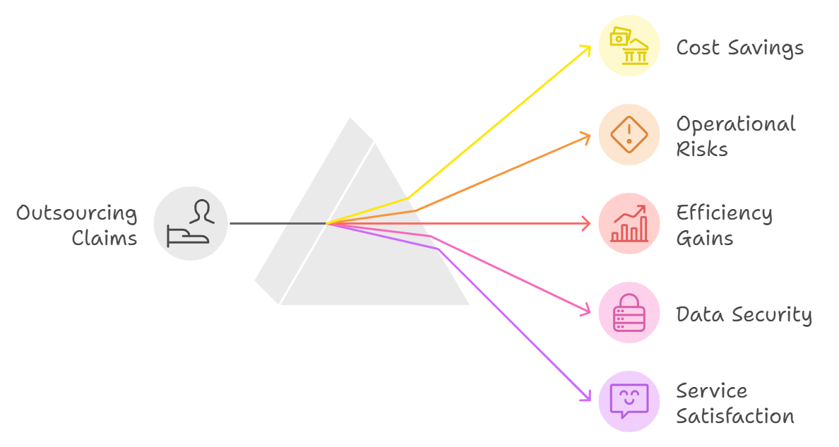

Figure 4: Opportunities & benefits of outsourcing claims management

Advantages and Disadvantages of Internal Claims Management
There are several advantages that can be attributed to internal-based claims management, these include: Insurance companies that oversee the management of claims processing internally have full control over how their administration lifecycle is going to turn out. This makes it possible for an insurer to enforce its highly specialized service standards and data privacy policies. Customer healthcare and financial information remain within the insurer’s IT perimeter through internal processing. Consequently, internal personnel take care of individual policyholders by focusing on each case and the history of claims (Orlando & Bace 2021; Andreeva. 2021). However, some studies also reveal some demerits of internal models as well. However, higher customer satisfaction that may be achieved through more personalized interaction is balanced by the fact that self-administration is costly to an insurer. Consequence: Having dedicated claims departments are major variable expense – people, systems, and equipment maintenance, for example. The fixed costs vary with the workload changes slightly and would be high when a given volume of claims in the market is low (Orlando & Bace, 2021; Andreeva. 2021). While such paid services may not be necessary for larger carriers, for smaller or even insurers with rather weak capitalization who are not willing to perform personnel expansions and thus directing most of the outward eye in controlling escalating per-claim costs would also contribute to operational solvency if they could outsource administrative tasks.
Andreeva (2021) studied how specific claim operating models impact insurers in various regions. Carriers adopting an inside approach offered better service due to accurate record keeping and faster dispute resolution than outsourced options, the research found. By the in- house staff adjudicating end-to-end, errors born out of communication gaps between the insurer and TPA were decimated. Direct participation also made it possible to take quicker action in response to customer complaints and denied liability. However, customer-centric merits notwithstanding, self-management placed heavy financial demands on insurers with sizeable salaries and technologies required to maintain claims staff were inundated by a frenetic wave of new claims (Andreeva, 2021). The thesis argued the increase in ongoing costs could eat into precious capital needed to margin up other core activities such as product development, marketing, or technology investments over time. Escalating internal costs would be allowed to go unchecked at the possible expense of profit potential and competitive positioning for carriers.
Orlando et al completed an additional contextual analysis (Orlando & Bace 2021). Their work specifically intended to quantitatively study the scalability of internal claim administration models common among insurers. Researchers assessed the performance of an organization during previous catastrophic events and found that although in routine workout conditions,

internally managed system worked fairly well yet when there were sharp spike volumes it exceeded its capacity. Namely: the processing power and levels of staffing required to deliver outstanding customer service in normal caseloads were not equipped to dynamically scale up when confronted with a surge brought about by large-scale disasters such as hurricanes or pandemics. The existing fixed infrastructure had a very hard time keeping up, leading to massive backlogs and increased speed of response times needed ever increasing overtime work hours as well as expensive temporary hires per claim. Orlando and Bace (2021) ultimately concluded that the failure to be scalable is a weakness of internal models, as major events will overburden what resources are available rather than relying upon retaining external partnerships.

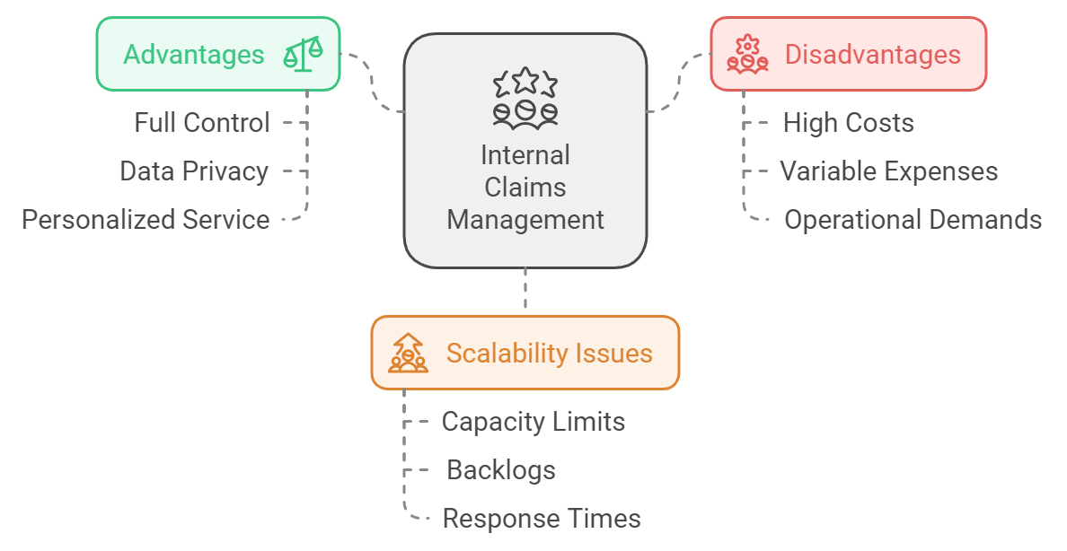

Figure 5: Advantages and Disadvantages of Internal Claims Management

Advantages and Disadvantages of External Claims Management
Direct handling of claims within the insurer’s company has the advantage of direct control while outsourcing to TPAs has the advantages of cost, flexibility, and expertise if well managed. Implementation of TPAs brings down the unit cost even lower as they are normally able to obtain economies of scale by utilizing infrastructure and resources across many insurer clients, thus providing 15-25% savings compared to the incremental buildup of in-house capacity(Zanke,2021). Also, they can scale features ages-wise for different workloads because features are highly massive in their nature. Advanced digital technologies coupled with the core competencies in managing different volumes enable TPAs to handle large volumes of claims in the most efficient way. However, outsourcing also poses other challenges to insurers like; loss of operational control, cybersecurity threats and over reliance on the vendors (Zanke, 2021). The reports also point out that in order to obtain the maximum benefits of outsourcing activities and minimize potential risks, insurers have to sign more specific contracts that would describe in detail what is expected from partners in terms of results accomplished, as well as testing provisions that would state how these deliverables would be checked and what sanctions would be applied should performance standards not be met or privacy regulations breached. It also has the responsibility of confirming whether contractual obligations have been well managed and spells an increase to the concept of continuous auditing.
Martinelli and Yautsiukhin (2016) analyzed the impact of the outsourcing process on a wide number of European insurers. The research mentioned that the carriers were able to achieve an average of 30%-40% less expense per claim when they interacted with focus-based TPAs because they derive an advantage from the size in terms of the unit cost of handling. Outsourcing arrangements also led to a reduction in average claim resolution time by 3 – 4 weeks as well. However, the researchers pointed out that these could be realized only if insurers have effective security measures in place to safeguard clients’ information. It suggested SLAs that require compliance with stringent information security standards and the periodic assessment of the TPA infrastructure environments and backup plans. Martinelli and Yautsiukhin (2016) stated that carriers required strict reporting procedures and agreement remedies to ensure that the level of service quality remained as it was when outsourcing carriers directly eliminated any influence. If risk management strategies are well implemented, then, insurers could get the best out of productivity through TPA.
Likewise, research by Prentice et al, 2023 focuses on the impact of outsourced claims management on the customer side. According to their findings, they noted that the scale efficiency gains could be achieved on the operational benefits if and only if proper measures were taken to guard against the negative impacts of outsourcing on the client loyalty perception. In particular, the

analysis of the policyholders who faced claims showed that most of the dissatisfaction stemmed from the changes in the frequency and the nature of the interactions with TPA rather than directly with an employee of the insurer. Another area of disconnect is brands and respondents stated that they do not always have a single point of contact where they can take their grievances to regarding solutions offered by TPAs. To mitigate these customer experience risks, the research by Prentice et al (2023) also advised that insurers put in place compliance verification procedures that are of a high standard, including the regular validation that is done with and involving the policyholders. Issue escalation routes and awareness of redressed mechanisms were also emphasized for enhancement of the relationships that get compromised with direct or indirect involvement of third parties in the value chain.

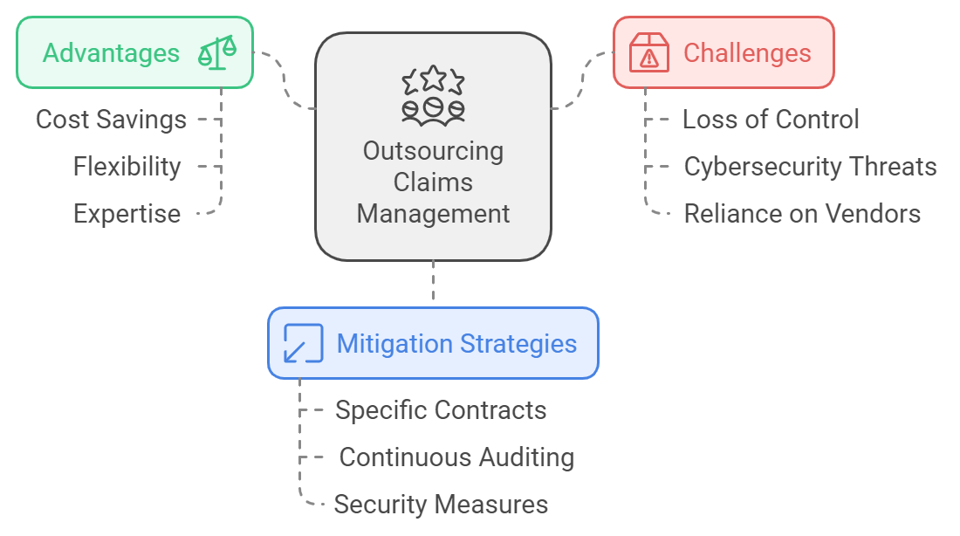

Figure 6: Advantages and Disadvantages of outsourcing Claims Management

Comparative Analysis of Past Studies
Previous research has only provided a partial answer to the question of the advantages and disadvantages of insurers’ decision to have internal or outsourced Aims. For example, Bourova et al., seminal research amongst multiple European carriers (2020) surveyed operational statistics and obtained customer feedback to compare self-administered administration with TPA-controlled operations The results showed that unit costs were cut by 15-25%, and cycle times were shortened by 20-30%, which was consistent with scale effects from outsourcing. However, Bourova et al At the same time it was identified that the customer satisfaction ratings are 5-10% higher where benefits are managed internally because of the relationship staff fosters with employees primarily due to their direct and personal interaction and not through TPA- only arrangements. But the study revealed that no single approach was found to be superior in all the performance indicators and insurers had to evaluate their specific portfolio needs in conjunction with their resource strengths and risk tolerance levels for the best fit. The last one was the continuous monitoring to act in case outsourcing partnerships did not deliver the expected productivity or service level in the long run as well.
Among the identified meta-analysis synthesizing comparisons, one was found to be published by Hanafy and Ming in 2021. Their assessment, based on collating research conducted across a variety of geographies and periods, identified clear signals as to the relative performance of internal vs outsourced claims administration functionality used by policyholders wherever they were located or when policies crossed international boundaries. At the top-end and on average, external management through TPAs delivered significantly lower per-claim costs with a faster throughput for large insurers handling thousands of claims annually -doubling down during periods of heightened volume. However, the meta-analysis also incorporated that smaller-volume carriers as well as those with specific market segments, usually benefited more by maintaining internal control to avoid direct customer interface and customized offers. As Hanafy and Ming (2021) pointed out, insurers required prudence when matching the business profile with the claims operating models they wanted. The advantage of outsourcing was greater than meaningful economics in the same breath as individualized care through self-directedness was preferred by insurers seeking high touch as opposed to low touch mass production.

Building Upon or Differing from Previous Studies
This study seeks to build on these prior studies by providing a comprehensive qualitative analysis of the Saudi health insurance market. As opposed to prior studies that have primarily focused on Western markets, this research will consider the Saudi health insurance market’s specific government structures, economic necessities, and cultural factors affecting and considering claims management. By employing both quantitative and qualitative data, the study aims

at offering a better understanding of how different management decisions influence the key performance indicators including cost, efficiency, and consumer satisfaction. Although previous research differentiates between internal and external claims management programs, none of them has been aimed at the Saudi environment. Therefore, there is at the present time a lack of literature that evaluates the best claims management approach in this specific market. The described lack is important because the two examined approaches seem to be equally efficient. While AlNemer (2021) has identified the local distinctiveness affecting internal and external claims processing in Saudi Arabia in a prior study, this work seeks to buttress that evidence with actual data and analysis.
The conclusion drawn from this study will be useful for insurance companies to learn how to improve on their claims management strategies and improve their operations in the health insurance sector of Saudi Arabia.

Theoretical Framework of the Study
In order for the theoretical framework to be applied in this paper, there are several models and theories that need to be taken into account. The models and theories that are used to establish the most suitable theoretical framework for this paper include the resource-based view, cost- benefit analysis, and customer satisfaction theories. As pointed out by Varpio et al. (2021), these theories and models can assist the researcher navigate through the core domains of the research and data collection. They are useful in enabling the learner to arrive at the best comparison between the two approaches with regard to the health insurance industry in Saudi Arabia. The models and theories can be divided into management models, cost benefit models and customer
satisfaction models.

Resource-Based View (RBV)
The resource-based view of the firm is grounded on a conceptual framework that focuses on internal resources. Thus, these resources and capabilities can be considered as the foundation of competitive advantage. For example, according to the theory, organizations have specific resources, for example, knowledge, personnel, or technologies that are exclusive to the organization. From this perspective, the specialty insurance companies with better internal capacity are more likely to handle claims internally (Kosiol et al., 2023). It is probable for these organizations to use sophisticated data analysis systems, their skilled claims adjusters, or a complicated and efficient claims procedure. Therefore, the practice contributes to the assurance that an organization is in charge of important operations; thus, high service quality

and appropriate data security are provided (Kosiol et al., 2023). It is also important to note that not all insurance companies are blessed with comparable internal capabilities. In this regard, it could be logical for organizations with relatively low internal capacities to delegate the management of claims to third-party administrators. These TPAs are probably to have specialized knowledge, sophisticated tools and scale advantages to offer high productivity of claims handling (Ahmed et al., 2020). The solution enables insurance companies to obtain resources that they could not afford to invest in order to build the required competencies. At the same time, since not all characteristics can be purchased, competence of organizations can be useful to them, while they concentrate on their strong points. In the long term, internal resources can be needed (Ahmed et al., 2020). Therefore, the practice to outsource claims management
might be conditionally accepted.

Cost-Benefit Analysis
Cost-benefit analysis is the major tool for evaluating the financial consequences of internal vs. external claims management. The basic principle is that cost consists of several components. First, there are operational expenses, such as the payment of salaries and fees. Second, each approach demands a different kind of technology investment, both in initial implementation and subsequent upgrades, and can be seen as a part of costs (Koopmans & Mouter, 2020). For example, internal claims need a variety of expenses, such as salaries, training, maintenance, and upgrades of the equipment. External claims management requires only the TPA fees, although there may be costs associated with maintaining and checking their performance. Third, it is essential to consider the savings that can be achieved through efficiencies (Koopmans & Mouter, 2020). Salaries and fees would not require consideration of additional safety measures as expensive as technology upgrades, but may call instead for the active management of the outsourcing firm. The main benefit of both approaches is the speed and cost of claims processing along several dimensions. Internal claims may decrease fraud because the process is more under the control of the company. Outsourcing substantially decreases costs through economies of scale and specialized knowledge of the service and might be faster in processing (Mishan & Quah, 2020). In addition, TPA services are likely to possess software, the implementation of which the company would find significantly expensive. The advantage of the first scenario would be the relatively tight control over the service by the company and the convenience of having the data on-site. However, the advantages of the second proposal are so significant that the best cost-benefit ratio is probably to be had with external claims management.

Customer Satisfaction Theories
There are many theories within the domain of customer satisfaction. It presupposes the importance of satisfying or even exceeding the customers’ needs and expectations in the process of service provision. There is also a concept of customer satisfaction within the domain of insurance (Méndez-Aparicio et al., 2020). Some theories suppose that the satisfaction of the customers is critical to client retention and loyalty. In the domain of claims management, the two key determinants of customer satisfaction are speed with which the claim is processed and the accuracy of the claim. Another important factor is providing the clients with information and quality of the customer support, in general. Speed is one of the key determinants since the client expects the claim to be processed quickly (Méndez-Aparicio et al., 2020). Any undue delay may result in client dissatisfaction, especially if money is required for essentials. A claim should be accurately processed – any inaccuracies will result in inconvenience, and the client’s trust may be damaged.
Clear and open communication are other aspects that can be regarded as vital. The researchers stress the fact that policyholders value the frequency, transparency, and accuracy of information concerning the status of their claims (Sreedharan & Saha, 2021). Therefore, such opportunity can be used to improve the understanding of the aims as well as to control the expectations of the customers. Thus, it can be very important in minimizing the uncertainties and enhancing the experience in general. Thus, it is important to stress that there can be many factors that can and should be taken into account when assessing the overall customer experience. Therefore, with the assistance of the theoretical framework, one might strive to compare two approaches, which are stated by the given research, concerning the nature of claims management. These may include the following differences: whether an insurer engages an external or internal firm for that purpose (Sreedharan & Saha, 2021). Last but not the least, depending on the assessment, one may try to find out whether a particular approach can be deemed to be more effective in meeting the expectations of the policyholders and whether it can be a factor that contributes to the enhancements in satisfaction levels and the subsequent loyalty.

Summary

The literature review has outlined the current state of research regarding claims management in health insurance in general and that in the Saudi market, in particular. Advantages and disadvantages of internal and external management were also presented, and theoretical frameworks were described. Past studies have shown that internal management allows for more control, better data security, and higher customer satisfaction due to personalized service. External management, in turn, is beneficial because it can deliver large cost savings, as well

as scale better and include provider expertise. The present study is expected to go beyond the existing findings and provide a detailed overview of the field. All peculiarities of the Saudi case, such as its regulatory environment, economic conditions, and specific cultural traits influencing claims management, would be taken into account. The results of the literature review section supported by these frameworks, such as the transaction cost theory and the resource-based view, would be relevant in the discussion chapter to provide recommendations. Customer satisfaction theories and cost-benefit analysis would also be integrated, allowing for the development of a clear and practical set of suggestions. It is possible to note that the theories’ information is necessary to gain a better understanding of the topic. It would also be useful for the health insurance professionals in the region, making their strategic choices effectively balancing cost- efficiency and the cost of providing a service of high quality. The next chapter would describe research methodology that helped to collect and analyze data allowing to achieve a relevant, context-bound approach to the research question and address the objectives.

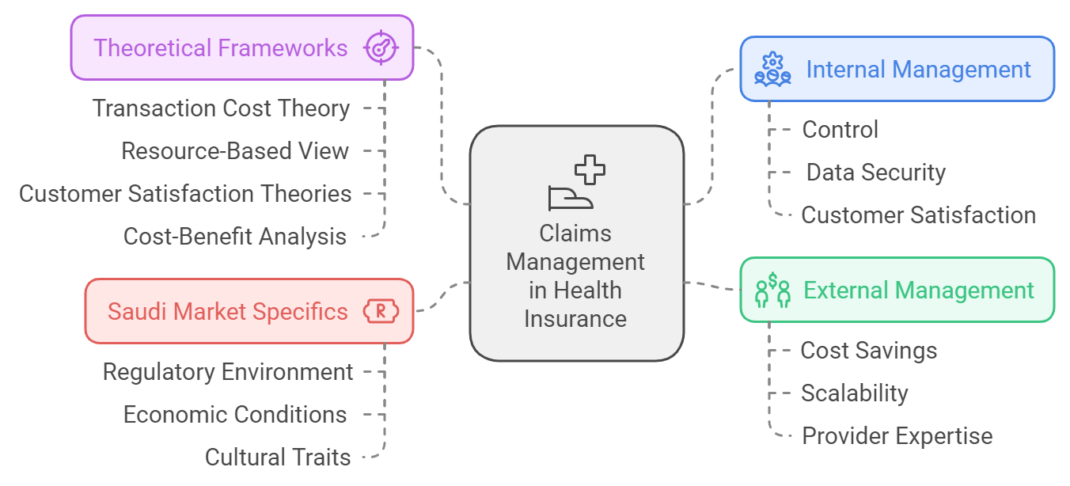

Figure 7: Advantages and disadvantages of internal and external management in Saudi Market with theoretical framework

9.1 Risk Evaluations

Uncertain events or conditions that, if they occur, have a positive or negative effect on a project’s objectives. Risk is often the measure of the inability to achieve overall project objectives within defined project requirements and constraints and has three components;
  - Probability of occurrence
  - The impact of the risk on the project
  - The time horizon during which the consequence will occur if the risk is not mitigated.

Risk Scoring Matrix

IMPACT
 |  | Low | Moderate | High | Major
 |  | 1 | 2 | 3 | 4
Rare | 1 | 1 | 2 | 3 | 4
Unlikely | 2 | 2 | 4 | 6 | 8
Moderate | 3 | 3 | 6 | 9 | 12
Likely | 4 | 4 | 8 | 12 | 16

LIKELIHOOD

Risk Exposure

The risk exposure is a value calculated that is the result of multiplying the probability of occurrence and impact.

Control Scoring Matrix

DESIGN
 |  | Very Strong | Strong | Limited | Weak
 |  | 1 | 2 | 3 | 4
Very Strong | 1 | 1 | 2 | 3 | 4
Strong | 2 | 2 | 4 | 6 | 8
Limited | 3 | 3 | 6 | 9 | 12
Weak | 4 | 4 | 8 | 12 | 16

PERFORMANCE

    - Residual Risk

The residual risk is the amount of risk or danger associated with an action or event remaining after natural or inherent risks have been reduced by risk controls.
The general formula to calculate residual risk is:
(Likelihood x Impact) – (Design x Performance) = Residual Risk

 |  | CONTROL SCORE
 |  | 1 | 2 | 3 | 4 | 6 | 8 | 9 | 12 | 16
RISK SCORE | 1 | 1 | 2 | 3 | 4 | 6 | 8 | 9 | 12 | 16
RISK SCORE | 2 | 2 | 4 | 6 | 8 | 12 | 16 | 18 | 24 | 32
RISK SCORE | 3 | 3 | 6 | 9 | 12 | 18 | 24 | 27 | 36 | 48
RISK SCORE | 4 | 4 | 8 | 12 | 16 | 24 | 32 | 36 | 48 | 64
RISK SCORE | 6 | 6 | 12 | 18 | 24 | 36 | 48 | 54 | 72 | 96
RISK SCORE | 8 | 8 | 16 | 24 | 32 | 48 | 64 | 72 | 96 | 128
RISK SCORE | 9 | 9 | 18 | 27 | 36 | 54 | 72 | 81 | 108 | 144
RISK SCORE | 12 | 12 | 24 | 36 | 48 | 72 | 96 | 108 | 144 | 192
RISK SCORE | 16 | 16 | 32 | 48 | 64 | 96 | 128 | 144 | 192 | 256

References
⬥ AlJohani, B. A., & Bugis, B. A. (2024). Advantages and challenges of implementation and strategies for health insurance in Saudi Arabia: a systemic review. INQUIRY: The Journal of Health Care Organization, Provision, and Financing, 61, 00469580241233447. https://doi. org/10.1177/00469580241233447
⬥ AlJohani, B. A., & Bugis, B. A. (2024). Advantages and challenges of implementation and
strategies for health insurance in Saudi Arabia: a systemic review. INQUIRY: The Journal of Health Care Organization, Provision, and Financing, 61, 00469580241233447. https://doi. org/10.1177/00469580241233447
⬥ AlHadlaq, A. S. (2024). Effect of Saudi’s updated health insurance policy: 4-Year
comparative study pre and post implementation. World Medical & Health Policy. https:// doi.org/10.1002/wmh3.603
⬥ Al-Faryan, M. A. S., & Alokla, J. (2023). Do publicly listed insurance firms in Saudi
Arabia have strong corporate governance?. Economies, 11(1), 21. https://doi.org/10.3390/ economies11010021
⬥ Prentice, C., Dominique-Ferreira, S., & Wang, X. (2023). Supply chain management in the
insurance industry–symmetrical and asymmetrical analysis. Journal of Business & Industrial Marketing, 38(11), 2505-2518. https://doi.org/10.1108/JBIM-07-2022-0305
⬥ Kosiol, J., Fraser, L., Fitzgerald, A., & Radford, K. (2023). Resource-based view: A new
strategic perspective for public health service managers. Asia Pacific Journal of Health Management, 18(1), 8-19. https://doi.org/10.3316/informit.007870393088402
⬥ Nabrawi, E., & Alanazi, A. (2023). Fraud detection in healthcare insurance claims using
machine learning. Risks, 11(9), 160. https://doi.org/10.3390/risks11090160
⬥ Puteh, S. E. W., Aizuddin, A. N., & Al Salem, A. A. (2022). Feasibility of National Health Insurance for Saudi healthcare services: qualitative study. Inf Sci Lett, 11(2), 427-437. http://dx.doi.org/10.18576/isl/110213
⬥ Hemrit, W. (2022). Does insurance demand react to economic policy uncertainty and
geopolitical risk? Evidence from Saudi Arabia. The Geneva Papers on Risk and Insurance. Issues and Practice, 47(2), 460. https://doi.org/10.1057%2Fs41288-021-00229-3
⬥ Ahmed, D., Yuantao, X., & Saeed Bhutta, U. (2022). Insurers’ risk management as a business
process: a prospective competitive advantage or not?. European Journal of Management and Business Economics, 31(3), 345-366. https://doi.org/10.1108/EJMBE-08-2021-0221
⬥ Eckert, C., Neunsinger, C., & Osterrieder, K. (2022). Managing customer satisfaction:
digital applications for insurance companies. The Geneva Papers on Risk and Insurance- Issues and Practice, 47(3), 569-602. https://doi.org/10.1057/s41288-021-00257-z
⬥ Alharbi, A. (2022). Willingness to pay for a National Health Insurance (NHI) in Saudi
Arabia: a cross-sectional study. BMC Public Health, 22(1), 951. https://doi.org/10.1186/ s12889-022-13353-z

⬥ Hazazi, A., Wilson, A., & Larkin, S. (2022, November). Reform of the health insurance funding model to improve the care of noncommunicable diseases patients in Saudi Arabia. In Healthcare (Vol. 10, No. 11, p. 2294). MDPI. https://doi.org/10.3390/healthcare10112294
⬥ Al-Hanawi, M. K., Mwale, M. L., & Qattan, A. M. (2021). Health insurance and out-of-
pocket expenditure on health and medicine: heterogeneities along income. Frontiers in Pharmacology, 12, 638035. https://doi.org/10.3389/fphar.2021.638035
⬥ Andreeva, T. (2021). Risk management in the insurance company. Ethics and Sustainability
in Accounting and Finance, Volume II, 131-138. https://doi.org/10.1007/978-981-15-1928- 4_7
⬥ Chen, C. L., Deng, Y. Y., Tsaur, W. J., Li, C. T., Lee, C. C., & Wu, C. M. (2021). A traceable
online insurance claims system based on blockchain and smart contract technology. Sustainability, 13(16), 9386. https://doi.org/10.3390/su13169386
⬥ Hanafy, M., & Ming, R. (2021). Machine learning approaches for auto insurance big data.
Risks, 9(2), 42. https://doi.org/10.3390/risks9020042
⬥ Njegomir, V., & Bojanić, T. (2021). Disruptive technologies in the operation of insurance industry. Tehnički vjesnik, 28(5), 1797-1805.
⬥ Orlando, G., & Bace, E. (2021). Challenging times for insurance, banking and financial supervision in Saudi Arabia (KSA). Administrative Sciences, 11(3), 62. https://doi. org/10.3390/admsci11030062
⬥ Saber, M. G., & Ali, M. A. M. (2021). An analytical study of Insurance Sector in the
Kingdom of Saudi Arabia and its compatibility with Vision 2030. The Academic Journal of Contemporary Commercial Research, 1(1), 75-85. https://dx.doi.org/10.21608/ ajccr.2021.211513
⬥ Sreedharan V, R., & Saha, R. (2021). An integrated framework for service quality, choice
overload, customer involvement and satisfaction: Evidence from India’s non-life insurance sector. Management decision, 59(4), 801-828. https://doi.org/10.1108/MD-12-2018-1354
⬥ Zanke, P. (2021). Enhancing Claims Processing Efficiency Through Data Analytics in
Property & Casualty Insurance. Journal of Science & Technology, 2(3), 69-92. https://www. thesciencebrigade.com/jst/article/view/183.
⬥ Alonazi, W. B. (2020). Fraud and Abuse in the Saudi healthcare system: a triangulation
analysis. INQUIRY: The Journal of Health Care Organization, Provision, and Financing, 57, 0046958020954624. https://doi.org/10.1177/0046958020954624
⬥ Bourova, E., Ramsay, I., & Ali, P. (2020). Cause to Complain? Consumer Experiences of
Internal and External Dispute Resolution in the Context of General Insurance. Consumer Experiences of Internal and External Dispute Resolution in the Context of General Insurance (September 21, 2020). Australasian Dispute Resolution Journal, 30(4), 302-316. https:// ssrn.com/abstract=3730471
⬥ Hemrit, W. (2020). Determinants driving Takaful and cooperative insurance financial

performance in Saudi Arabia. Journal of Accounting & Organizational Change, 16(1), 123- 143. https://doi.org/10.1108/JAOC-03-2019-0039
⬥ John, B., & Parikh, P. (2020). Improving the insurance claim processing process using Six
Sigma methodology. International journal of six sigma and competitive advantage, 12(4), 348-368. https://doi.org/10.1504/IJSSCA.2020.112368
⬥ Konrad, R., Zhang, W., Bjarndóttir, M., & Proaño, R. (2020). Key considerations when
using health insurance claims data in advanced data analyses: an experience report. Health Systems, 9(4), 317-325. https://doi.org/10.1080/20476965.2019.1581433
⬥ Koopmans, C., & Mouter, N. (2020). Cost-benefit analysis. In Advances in transport policy
and planning (Vol. 6, pp. 1-42). Academic Press. https://doi.org/10.1016/bs.atpp.2020.07.005
⬥ Méndez-Aparicio, M. D., Jiménez-Zarco, A., Izquierdo-Yusta, A., & Blazquez-Resino, J. J. (2020). Customer experience and satisfaction in private insurance web areas. Frontiers in Psychology, 11, 581659.
https://doi.org/10.3389/fpsyg.2020.581659
⬥ Mishan, E. J., & Quah, E. (2020). Cost-benefit analysis. Routledge.
⬥ Naushad, M., Faridi, M. R., & Faisal, S. (2020). Measuring the managerial efficiency of insurance companies in Saudi Arabia: A data envelopment analysis approach. The Journal of Asian Finance, Economics and Business, 7(6), 297-304. https://dx.doi.org/10.13106/ jafeb.2020.vol7.no6.297
⬥ Rindfleisch, A. (2020). Transaction cost theory: past, present and future. AMS Review,
10(1), 85-97. https://doi.org/10.1007/s13162-019-00151-x
⬥ Sunder M, V., & Kunnath, N. R. (2020). Six Sigma to reduce claims processing errors in a healthcare payer firm. Production Planning & Control, 31(6), 496-511. https://doi.org/10.1 080/09537287.2019.1652857
⬥ Varpio, L., Paradis, E., Uijtdehaage, S., & Young, M. (2020). The distinctions between
theory, theoretical framework, and conceptual framework. Academic medicine, 95(7), 989- 994. https://doi.org/10.1097/ACM.0000000000003075
⬥ Etges, A. P. B. D. S., de Souza, J. S., Kliemann Neto, F. J., & Felix, E. A. (2019). A proposed
enterprise risk management model for health organizations. Journal of Risk Research, 22(4), 513-531.https://doi.org/10.1080/13669877.2017.1422780
⬥ AlNemer, H. A. (2018). Perception of the benefits and features of health insurance policies
offered by the employers: empirical findings from Saudi Arabia. International Journal of Business and Management, 13(6), 214-214. https://doi.org/10.5539/ijbm.v13n6p214
⬥ Martinelli, F., & Yautsiukhin, A. (2016, August). Security by insurance for services. In 2016
IEEE International Conference on Software Quality, Reliability and Security Companion (QRS-C) (pp. 344-351). IEEE. https://doi.org/10.1109/QRS-C.2016.53

Copyright 2024

