A comparative Analysis of machine learning techniques for class imbalanced in datasets
Ahmed Abdulqadeer Ahmed Alzubaidi
First Trimester 2026

Table of Contents
Abstract 2
Introduction 3
Background: 3
Problem statement: comparing machine learning methods for imbalance dataset. 5
Research objective: 5
Research scope: 6
Literature review: 7
Research Methodology: 13
Phase 1: Literature Review: 13
Phase 2: Comparative Analysis 13
Phase 3: Guideline Recommendation 14
Expected outcomes 14
Gantt chart 15
References: 16

Abstract:
Imbalanced datasets one of the most common challenges in machine learning, this affects model learning and may lead to bias toward majority class. Many methods used and developed hybrid methods to handle this issue. However, it depends on tests, examinations, results, error and findings. There is still no clear guidance that explain the class condition or circumstances and which method will be the most suitable to apply first. The research focuses on comparing machine learning methods for imbalanced dataset, to understand the how the class characteristics may interact, especially data size and imbalanced ratio. The research adopts comparative analytical methodology based on reviewing previous literature and reported results. To understand the relationship and how the classes interact with different factors. Thus, to have a clearer problem understanding and recommended guideline for selecting suitable methods under particular conditions.

Introduction:
In recent years, the world has been changing rapidly, and the reliance on artificial intelligence has become a part of human daily life, in the era of digital transformation, a large amount of data is available that could support in learning, prediction and decision making in different fields and domain. However, the quality and distribution of data is a common challenge described as imbalanced dataset problem, where some classes contain a smaller number of samples or some classes have higher representation than other classes.
This challenge appears in many real-world cases, such as medical diagnosis, fraud detection, risk prediction. where the minority classes are often the most important cases to identifiy.
Although, Machine learning methods have evolved. However, this challenge still hinders better solutions, as it often requires needs trial and error and optimization adaptation which needs very complicated steps to test and evaluate, for this reason, studying machine learning methods for imbalanced datasets remains important. This research focuses on comparing different techniques and approaches to understand how imbalanced dataset characteristics impact the selection of method to be applied. The research aims to provide a structured recommendation guideline to support the decision of choosing the most suitable method based on particular conditions.

Background:
Machin learning algorithm tends to learn more effectively from majority classes than the minority classes, as a result the model become weak to identify the less represented class. This led to a serious problem as often the minority class carries higher importance in machine learning task. To address the challenge, previous studies provide different methods and approaches to solve the problem. Some methods focus on modifying data distribution (data-level). Other methods focus on the learning process (algorithm-level). However, these methods not perform at the same level in all cases, it is affected by different conditions and circumstances. So the effectiveness may change depending on dataset characteristics

Problem statement: comparing machine learning methods for imbalance dataset.
Imbalance data distribution is one of the most common challenges in machine learning. An imbalanced dataset refers to a situation where some classes are underrepresented compared to others, this discrepancy is often not considered as a mistake, However, it is a natural reflection for the reality, for example, minority classes are often related to rare diseases compared to normal situation. Sometimes it belongs to data collection bias that concentrate on particular category more than another that’s this occurs in various types and severely hinder machine learning process (Gao et al.,2025)Studies and researches pointed that is the situation is not limited to imbalance, it is a multi-factor problem (Krawczyk et al., 2023), class imbalanced: minority classes, complexity such as same symptoms for infected and not infected, data size: less data guides to weak learning, model behavior: bias to majority, concept drift: changes in data or changed outcomes with no adaptation of the model. If more than one problem occurred it leads to a complex problem.

Research objective:

This research aims to compare different machine learning approaches for imbalanced dataset to propose a guideline for method selection based on dataset characteristics and performance behavior:
- To analyze key dataset characteristics, how it interacts, affected by different applied methods, particularly, imbalance ratio, complexity, representation
- To compare machine learning methods across different imbalanced dataset, classical machine learning, deep learning and other techniques
- To evaluate different approaches in optimization and training strategies in improving performance and output, especially to reduce bias with decreasing of computational cost.
- To review and organize machine learning techniques including re-sampling, re-weighting, training strategies, ensemble learning and combining methods to develop hybrid approaches to effectively overcome imbalanced data challenges.

Research scope: this research investigates challenges in imbalanced datasets at two levels: data-level and algorithm-level. in data level will concentrate on dataset characteristics particularly data size challenge and imbalance ratio. At algorithm level the purpose is to compare different methods should be applied first based on dataset characteristics. In addition, how the subsequent method should be selected to apply based on evaluation results. Model evaluation will use a combination of accuracy and G-mean metrics for better measurement and assessment. However, comparing evaluation metrics is not the main focus of this research.

Literature review:
This paper recognizes that class imbalanced as a major challenge which has been widely investigated through multiple methodologies, re-sampling, training optimization and ensemble learning (Tanha et al., 2020). Approach that shown an unexpectedly refinement, nevertheless, it is one of the basic techniques was oversampling, particularly hence minority samples are scarce. Moreover, no method is applicable or dominant across all cases or datasets (Batista et al., 2004)

In deep learning, the challenge still remaining unresolved. Moreover, sometimes it becomes more complicated. Experiments indicates that imbalanced dataset affect performance negatively, especially if it has noise, overlap or imbalanced class. (Gosh et al., 2024), consequently, more studies have transitioned from data-level solutions, exploring on algorithm approaches such as label-distribution, deferred re-weighting, in order to overcome minority class obstacle.

The problem becomes more complex in multi-class, where imbalanced beyond majority and minority class, instead, Multiple classes my exist in different level of representation, the effect of each class may vary depending on some circumstances. Under these condition, model effectiveness not only rely on learning method applied, but it has factors that may take in consideration, class distribution, number if classes and evaluation metric used. Comparative results from boosting methods shows different algorithm has unstable performance as long as the conditions changed. No ensemble strategy has dominant performance throughout all multi-class imbalanced scenarios. (Tanha et al., 2020)

A further degree of complexity in data stream, where class imbalance affected with concept drift, class proportion and change of features value (Krawczyk et al., 2023) more scenarios, imbalance ratio may flipped over time, minority and majority classes may switch roles, as a result the learning should be remain continuously. This approve that class imbalance is not static problem. However, algorithm behavior adopted based on modified needs. As a result, method that gives outstanding performance on static dataset may not give same performance in different data environment which makes comparative evaluation in focus.

The reviewed literature demonstrate that class imbalance explored using multiple methods and approaches, yet there is no technique that performs in same level in all cases or context. (Batista et al., 2004). The suitable method should be tested and compared with different methods to make sure which method gives the best. Because it depends on multi-factors and interacts simultaneously. It became worst if the case is a result from combined problem.
Accordingly, the problem needs to solve based on multi-layer of solution which applied before, during and after. Moreover, studies should take place and needed to clarify how different approaches interact with imbalanced problems and scenarios, to learn deeply strength and limitation of each method, and guidance to minimize or determine which techniques are most candidate or appropriate for different dataset condition.

Previous studies indicate that imbalanced datasets represent a problem that starts from imbalanced classes or data samples, that gradually becomes more complex, until it has multi-factors that interact together. Despite this, there is a lack of clear guidance on which method should be applied first to improve method selection and reduce trial and error. moreover, there is no clear framework to determine which subsequent step or method should be applied based on the evaluation of the previous step result.

In their survey Wuxing chen (2024) examined imbalanced dataset across different machine learning settings such as classification, regression clustering, long-tail and data streams it shows that imbalanced dataset has been approached from multiple settings. The survey provides a recent and structured review of methods organized into levels, such as data-level, algorithm-level and hybrid methods. This categorization explains why imbalance cannot be addressed by one method only (chen et al., 2024). Moreover, the paper discusses strengths and limitations of some approaches.
This study was to review previous studies and developments in imbalanced learning, summarize current methods and approaches and identify future direction, in order to demonstrate that, the survey reviewed recent literature and grouped existing methods into several categories to examine how imbalance addressed in different learning context and discussed application of imbalanced learning across multiple domains. The key findings of survey show that imbalanced dataset needs several solutions rather than one dominant approach. Data-level methods are widely used because they are simple, but may introduce overfitting, noise or information loss as long as there is no guideline. Algorithm-level methods may be more efficient in some cases, while hybrid methods provide stronger performance at higher complexity (chen et al., 2024) However, the study does not provide a practical guideline to explain which method is more suitable to applied first based on dataset characteristic, and the subsequent method should be selected based on performance results.

Parekh, Nemlekar and P.Losey (2026) in their study addressed imbalanced datasets from a different perspective of model learning behavior rather than class alone. This study combines theoretical analysis with experiments results, it shows that imbalance does not affect the performance only, but it may also bias towards the frequent represented behaviors, with weak ability to learn from underrepresented class while it is more important to learn. However, the authors showed that when all samples in imbalanced dataset weighted equally, the learning becomes biased toward dominant behavior. Also examine different approaches such as equally learning each behavior (relatively) and meta-gradient approach. The results showed that imbalance has direct effects on what the model learns, also found simple methods may give better results in some cases based on dataset characteristics. Accordingly, the study finds that dataset balancing not always the optimal solution to apply. It depends on dataset characteristics and how it is interacted together, the difficulty of behaviors to learn by the model. As key finding, no balancing approach is suitable for all cases, it has multi-factors that should be taken in consideration before applying a method.

Dube and Verster (2023) in their study, focused on comparing machine learning under different imbalance conditions. The authors applied ten different machine learning models as a comparative analysis for performance and outcomes. It compares several classifiers with different imbalance cases and balancing techniques. The study highlights model performance is not stable and changed across different imbalance conditions, on the other hand, some models were robust more than other. However, the study was conducted on credit risk prediction, which may limit the generalization of its findings on other domains. The methodology followed in this study is a comparative experimental design which consisted of ten machine learning models were evaluated with different metrics using F1, MCC and ROC-AUC, the paper divided the imbalanced into nine different levels, then applied fixed two techniques which are under-sampling and ADASYN. The result shows that the performance affected based on the level of dataset imbalance. However, ADASYN generally provided better results than under-sampling in most of nine levels of imbalance. Hence, between ten machine learning methods, decision tree and random forest were robust even under different conditions of imbalance, both performed better than the other models. On the other hand, models such as Logistic regression model, NaÅNıve Bayesian approach showed weaker performance in general.

Aymaz (2025) addressed imbalanced datasets by focusing on balancing ratio optimization rather than applying fixed methods for balancing datasets. The study investigated whether there is a relationship between imbalance ratio and performance. Different ratio impact could improve the performance more effectively than rely on balance only. This study takes an interesting direction, which is how much balancing should be applied. To investigate that, the author used six imbalanced datasets and applied several balancing methods, including SMOTE , ADASYN, SVM-SMOTE, Borderline-SMOTE, Cubic interpolation and Quadratic interpolation. The study also applied optimization techniques of data balancing ratio including PSO, WOA, and Optuna to identify the most suitable balancing ratio. However, the classification process was not a primary focus on this study, given that the influence of data balancing ratio could be evaluated by a variety of classification models (Aymaz, 2025). The key finding showed that performance is affected by the amount of balancing applied. The optimized balance could produce better outcomes than full balance or original imbalance in some cases. The study also showed balancing decision should not depend on accuracy alone, because also other factors are important such as runtime and resource consumption in evaluating the overall results. In conclusion, the experiment suggests that the choice of balancing ratio should take into consideration the dataset characteristics with performance behavior and resource consumption.
Overall, the literature agrees on three main points: First, no single method is suitable for all imbalanced dataset cases. Second, dataset characteristics has a strong effect on the selected approach and results. Third, studies still have lack of clear guidance or framework for which method should be applied first, and how subsequent method should be selected based on the previous result. This show that the opportunity to research and investigate to develop a structured guideline that clarifies the link between dataset characteristic method selection and performance behavior.

Research Methodology:
This research adopts a comparatives analytical methodology to analyze the previous studies and research challenges, investigations, applied methods and results on imbalanced datasets. For exploration or understand the link between dataset characteristics and how these factors interact togethers.

Phase 1: Literature Review:
This phase is to have a comprehensive literature review of previous and recent studies and experiments on imbalanced datasets to clarify the relationship between class characteristics and how imbalance has been handled by using different approaches including data-level and algorithm-level.
Data Sources: academic databases (eg. Google Scholar, IEEE Xplore, Springer)
Selection Criteria: research focusing on imbalanced datasets chararchtstic, how imbalanced dataset interacted with different methodologies published within last five years.

Phase 2: Comparative Analysis
The second phase compares the methods based on dataset characteristics, focusing on data size and imbalance ratio. Moreover, review reported performance, behavior, and results using fixed evaluation metrics namely Accuracy and G-Mean.
This phase aims to understand how results changed under different conditions, establish relevant relationship between them across multiple experiments with similar outcomes

Phase 3: Guideline Recommendation
This phase is to report and gives a priority for methods based on identified characteristics, and to provide a structured recommendation guideline for imbalanced dataset. It will be depended on the findings of the previous phase outcomes, which clarify the relationship between imbalanced dataset characteristics and most suitable method to be applied under particular condition. Step-by-step what is the most suitable method and the subsequent method based on the previous result.

Expected outcomes:
This research is expected to give better insights and understanding of imbalanced datasets characteristic. Especially, from data size and imbalance ratio perspective, also to provide a clearer comparison between methods and a recommendation for choosing a suitable method to apply based on known conditions, particularly, in data-level and algorithm-level with high-level explanation of strengths and limitation of each approach.
Another expected outcome is to understand performance behavior and how it is affected by dataset factors, as well as how the results may change across different cases
The main expected outcome is to provide a structured recommendation guideline that suggest the most suitable method that may give the most expected result, moreover, identifies what is the subsequent step or method based on the previous result.
This study is also expected to support future research and experiments, especially to find out metrics for evaluation , developing a well-organized guideline, since imbalanced datasets are widespread case in most machine learning studies

Gantt chart:
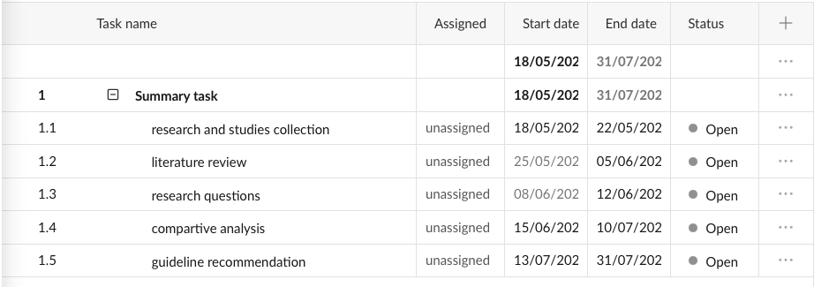
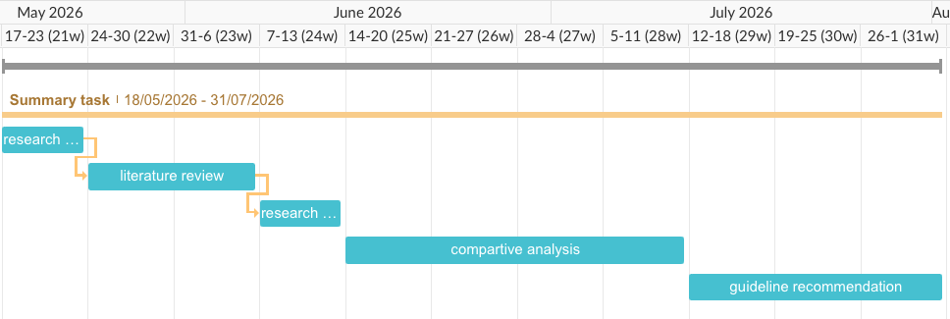

References:
Aguiar, G., Krawczyk, B., & Cano, A. (2024). A survey on learning from imbalanced data streams: taxonomy, challenges, empirical study, and reproducible experimental framework. Machine learning, 113(7), 4165-4243. https://link.springer.com/article/10.1007/s10994-023-06353-6
Aymaz, S. (2025). Unlocking the power of optimized data balancing ratios: a new frontier in tackling imbalanced datasets. The Journal of Supercomputing, 81(2), 443. Unlocking the power of optimized data balancing ratios: a new frontier in tackling imbalanced datasets | The Journal of Supercomputing | Springer Nature Link
Batista, G. E., Prati, R. C., & Monard, M. C. (2004). A study of the behavior of several methods for balancing machine learning training data. ACM SIGKDD explorations newsletter, 6(1), 20-29. https://dl.acm.org/doi/abs/10.1145/1007730.1007735
Cao, K., Wei, C., Gaidon, A., Arechiga, N., & Ma, T. (2019). Learning imbalanced datasets with label-distribution-aware margin loss. Advances in neural information processing systems, 32. https://proceedings.neurips.cc/paper/2019/hash/621461af90cadfdaf0e8d4cc25129f91-Abstract.html
Gao, X., Xie, D., Zhang, Y., Wang, Z., Chen, C., He, C., ... & Zhang, W. (2026). A comprehensive survey on imbalanced data learning. Frontiers of Computer Science, 20(11), 2011622. A comprehensive survey on imbalanced data learning | Frontiers of Computer Science | Springer Nature Link
Chen, W., Yang, K., Yu, Z., Shi, Y., & Chen, C. P. (2024). A survey on imbalanced learning: latest research, applications and future directions. Artificial Intelligence Review, 57(6), 137. A survey on imbalanced learning: latest research, applications and future directions | Artificial Intelligence Review | Springer Nature Link
Ghosh, K., Bellinger, C., Corizzo, R., Branco, P., Krawczyk, B., & Japkowicz, N. (2024). The class imbalance problem in deep learning. Machine Learning, 113(7), 4845-4901. . https://link.springer.com/article/10.1007/s10994-022-06268-8
Dube, L., & Verster, T. (2023). Enhancing classification performance in imbalanced datasets: A comparative analysis of machine learning models. Data Science in Finance and Economics, 3(4), 354. Enhancing classification performance in imbalanced datasets: A comparative analysis of machine learning models
Parekh, S., Nemlekar, H., & Losey, D. P. (2026). Towards balanced behavior cloning from imbalanced datasets. Autonomous Robots, 50(1), 9. Towards balanced behavior cloning from imbalanced datasets | Autonomous Robots | Springer Nature Link
Tanha, J., Abdi, Y., Samadi, N., Razzaghi, N., & Asadpour, M. (2020). Boosting methods for multi-class imbalanced data classification: an experimental review. Journal of Big data, 7(1), 70.https://link.springer.com/article/10.1186/s40537-020-00349-y

