Practical Work Record

Contents
Introduction 2
1) Initial dataset inspection and preparation 2
2) 64 × 64 stage 2
3) 128 × 128 stage 3
4) 160 × 160 stage 4
5) 224 × 224 stage 5
6) 256 × 256 stage 5
Final integrated framework executed on the adopted best model 7
7) Base evaluation 7
8) Confusion matrix analysis 7
9) Qualitative correct/incorrect analysis 8
10) Interpretability 9
11) Robustness 10
12) Uncertainty estimation 11
Final novelty of the project 12

Introduction
We would like to present the practical work as a real implementation record, not just as a general summary. The work was completed in stages, and the choice of models and techniques was not random. We selected the experimental directions based on what is commonly used in previous studies in galaxy morphology classification, starting from baseline CNN models, then moving to transfer learning, and later to stronger modern architectures such as ConvNeXt, CoAtNet, and MaxViT. The reason for this was to build the work gradually and to test more than one technical direction before deciding on the final model.

1) Initial dataset inspection and preparation
We started by checking the dataset itself before training any model. We confirmed that the Galaxy10 DECaLS dataset file was available and accessible, then inspected its internal structure and data organization. The confirmed dataset used in the project contained 17,736 images, with 10 classes, and the original image size was 256 × 256 × 3. This was the starting point before any resizing or experimentation.

2) 64 × 64 stage
We began the practical experiments at 64 × 64 as the first controlled baseline stage. This was done intentionally to start with a lighter and faster setup, confirm that the pipeline worked correctly, and compare several techniques before moving to larger image sizes.
At this stage, we implemented and compared three different model directions:
- Baseline CNN (64 × 64)
- ResNet50 transfer learning (64 × 64, frozen stage)
- EfficientNetB0 transfer learning (64 × 64, frozen stage)
The results of this stage were clear:
- Baseline CNN (64 × 64)
  - Test Accuracy = 0.6280
  - Precision = 0.6187
  - Recall = 0.6280
  - F1-score = 0.6127
- ResNet50 (64 × 64, frozen stage)
  - Test Accuracy = 0.4563
- EfficientNetB0 (64 × 64, frozen stage)
  - Test Accuracy = 0.5183
This comparison showed that, at this small image size, the Baseline CNN was the best model, while the transfer learning models did not outperform it. After selecting the best model at this stage, we also produced a more complete evaluation of the 64 × 64 baseline CNN, including:
- classification report,
- precision, recall, and F1-score,
- confusion matrix,
- and the beginning of robustness analysis using the saved best baseline model.
So, at the 64 × 64 stage, the work did not depend on one experiment only. We tested multiple model types, compared them directly, and selected the strongest one based on actual results.

3) 128 × 128 stage
After the 64 × 64 comparison stage, we moved to 128 × 128 as the next experimental step. The goal here was to test whether a larger image size could preserve more morphological detail and support stronger models than the early baseline stage.
At this stage, we first:
- recreated the dataset at 128 × 128,
- rebuilt the train, validation, and test generators,
- and confirmed that the data pipeline at this size was working correctly.
Then we explored more than one model direction at this resolution:
- Baseline CNN (128 × 128)
- ConvNeXtTiny (128 × 128)
- MaxViT-oriented speed-testing path (128 × 128)
- CoAtNet Nano was also introduced as one of the directions to be tested first at this stage
This means that the 128 × 128 stage was not just a resize step. It was a real exploratory stage where we moved beyond the first baseline and started testing stronger modern architectures. However, this stage did not become the final adopted path, because later stages at larger resolutions and stronger models became more promising. One confirmed value from the 128 × 128 baseline path was that validation accuracy reached about 0.6172 during training, which shows that this stage was still close to the earlier baseline level and had not yet produced the stronger final jump in performance.

4) 160 × 160 stage
After that, we moved to 160 × 160 as part of the fast-search phase. At this stage, we created a resized 160 × 160 version of the dataset and rebuilt the full data pipeline using:
- train_loader_160
- val_loader_160
- test_loader_160
We verified that the 160 × 160 pipeline was stable by checking:
- train, validation, and test sample counts,
- batch image shapes,
- batch label shapes,
- and image value ranges.
The confirmed values at this stage included:
- Train samples = 12,414
- Validation samples = 1,774
- Test samples = 3,548
- Batch image shape = [16, 3, 160, 160]
This stage also included a clearly defined fast baseline recipe on 160 × 160 using:
- MaxViT Nano RW 256
- on 160 × 160 images
- with:
  - no Mixup,
  - no cosine scheduler,
  - partial fine-tuning of stages.2 + stages.3 + head,
  - and 1 epoch only
This stage was important because it shows that by this point the work had already moved into structured higher-resolution testing with a strong modern architecture, not just simple baseline CNN work.

5) 224 × 224 stage
The 224 × 224 stage was a much stronger experimental stage. Here, the work was no longer limited to basic model comparison. Instead, we focused on a modern architecture and tested it using multiple fine-tuning strategies.
The confirmed main architecture at this stage was:
- MaxViT Tiny RW 224
We explored this model through several different training strategies:
- Head-only fine-tuning
- Last-stage fine-tuning
- Full refinement
These were not assumed or theoretical paths. They existed as real practical result folders, which means they were actually implemented as different experiment directions. In addition, there was also a ConvNeXt Tiny 224 setup prepared at this resolution, which confirms that the 224 × 224 stage also included another modern architecture direction.
So, the 224 × 224 stage clearly shows that we were not relying on a single model or a single training method. We were testing modern architectures with more than one fine-tuning strategy to identify the strongest direction before moving to full resolution.

6) 256 × 256 stage
After the earlier exploratory and intermediate stages, we moved to the original image size, 256 × 256, because this was the most suitable size for preserving full galaxy morphology detail. This became the strongest and most important experimental stage.
At this stage, we first built the true 256 × 256 data pipeline and confirmed that the full-resolution loaders were working correctly. The confirmed batch information included:
- Train generator batches = 776
- Validation generator batches = 111
- Test generator batches = 222
- Batch image shape = (16, 256, 256, 3)
Then we launched the first full-resolution run using:
- MaxViT Nano RW 256
The first 256 × 256 run used a conservative recipe:
- fine-tune only the last stage + head first
- and run for 1 epoch as an initial full-resolution test
This first run finished successfully and recorded a best validation result and a saved checkpoint path.
The 256 × 256 stage then continued through multiple staged checkpoints and refinements, including:
- maxvit_nano_rw_256_first_run_best
- maxvit_nano_rw_256_stage1_best
- maxvit_nano_rw_256_stage2_best
- maxvit_nano_rw_256_stage3_best_restart
- stage3_refine_push_best
- stage3_refine_push_last
This means that the final result at 256 × 256 did not come from one isolated run. It came from a staged refinement process at the original full image resolution.
At this stage, there was also a strong transfer-learning experiment using:
- EfficientNetB0 on the original 256 × 256 images
This confirms that even at the original resolution, the work did not completely ignore transfer learning directions before settling on the final best-performing model.
The final adopted best model for the thesis became:
- MaxViT Nano RW 256
- final best checkpoint:
  - stage3_refine_push_best.pth
The strongest final predictive result reached in the practical path was:
- Test Accuracy = 0.8459 with TTA
- Test F1-score = 0.8419 with TTA
The same final model, without TTA, gave:
- Test Accuracy = 0.8392
- F1-score = 0.8358
Later, when we rebuilt the structured base evaluation package, the confirmed base evaluation results were:
- Accuracy = 0.8392
- Macro Precision = 0.8192
- Macro Recall = 0.8267
- Macro F1-score = 0.8177
So, the 256 × 256 stage was the final stage where the strongest model and strongest results were established.

Final integrated framework executed on the adopted best model
After selecting the final best model, we did not stop at accuracy only. We completed a full integrated framework around the final adopted checkpoint.

7) Base evaluation
We ran the final model on the official test set and generated a complete base evaluation package, including:
- predictions,
- probabilities,
- confusion matrix,
- classification report,
- and saved summary files.
Confirmed base results:
- Accuracy = 0.8392
- Macro Precision = 0.8192
- Macro Recall = 0.8267
- Macro F1-score = 0.8177

8) Confusion matrix analysis
We performed class-level analysis using the confusion matrix. This showed that the strongest-performing classes were:
- 2, 3, 8, and 9
while the most difficult classes were:
- 0, 6, and 7
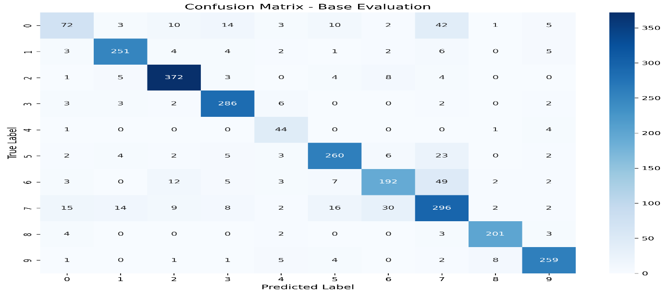

9) Qualitative correct/incorrect analysis
We extracted and saved:
- correct prediction examples,
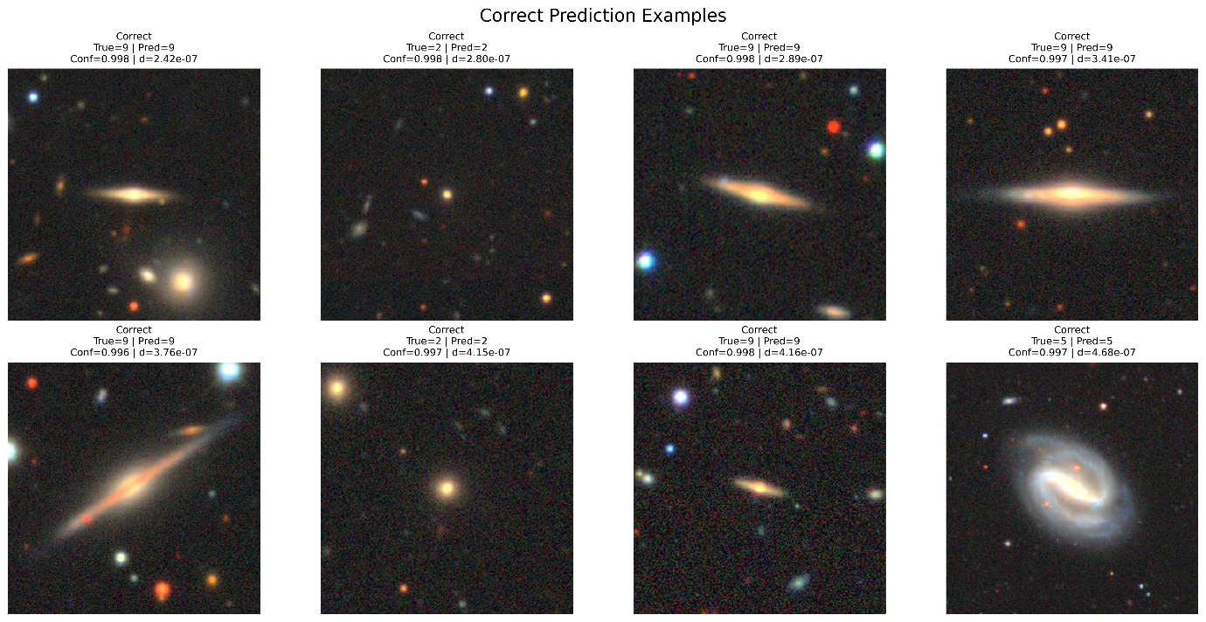
- incorrect prediction examples.
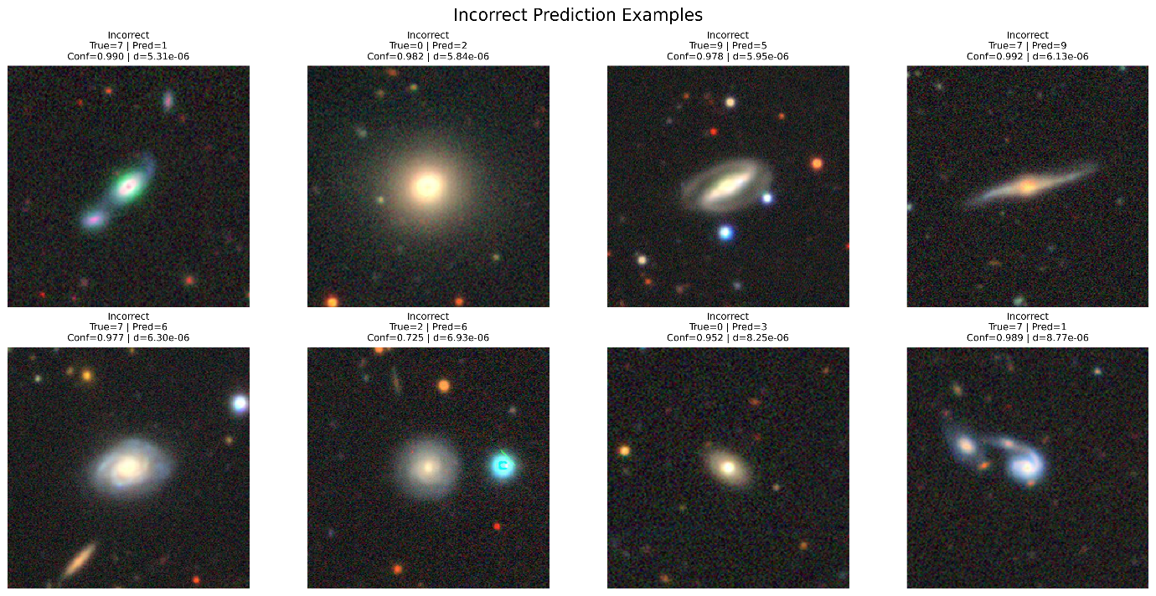
When the original test indices were lost after runtime changes, we did not ignore the issue. We tried several recovery approaches and finally succeeded using:
- probability fingerprint matching
This recovery was highly reliable, with:
- label agreement ratio = 99.62%

10) Interpretability
- Applied Grad-CAM to the final adopted MaxViT Nano RW 256 model.
- Generated Grad-CAM visualizations for selected correct and incorrect prediction examples.
- Used the layer:
  - stages.3.blocks.0.conv.conv3_1x1
- Saved the final interpretability outputs as:
  - if4_gradcam_correct.png
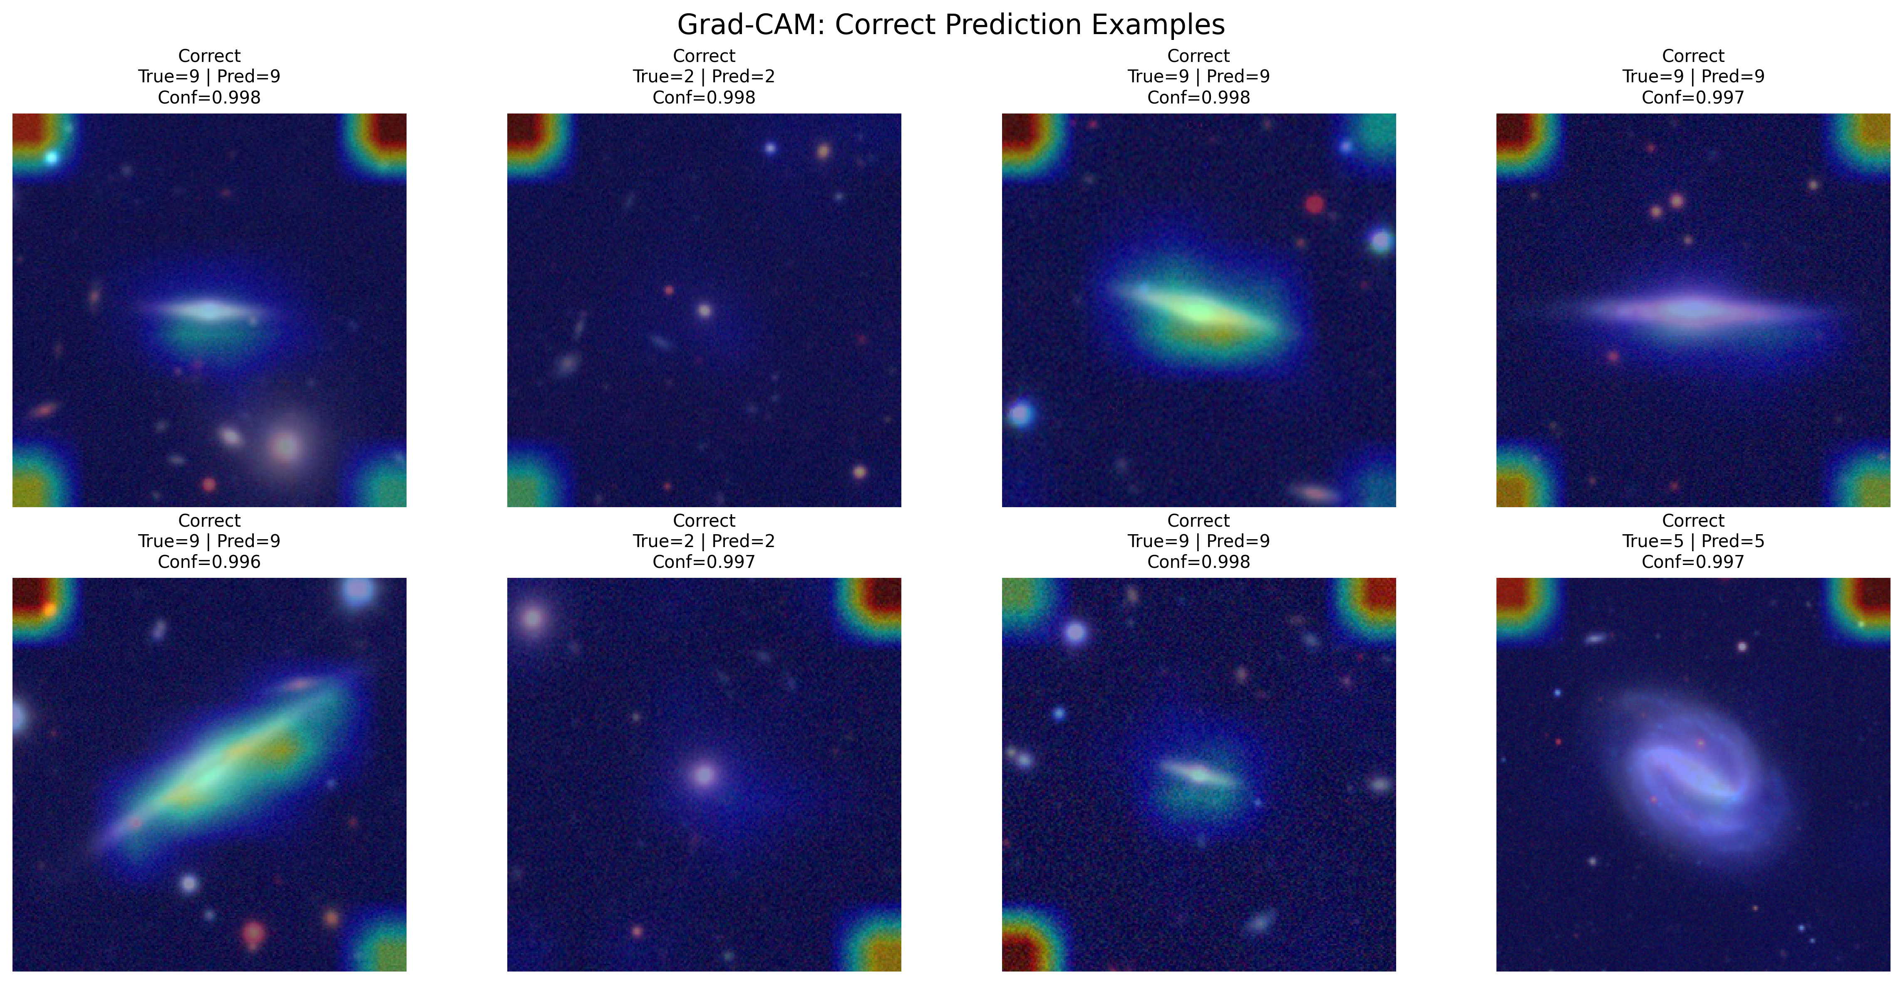
  - if4_gradcam_incorrect.png
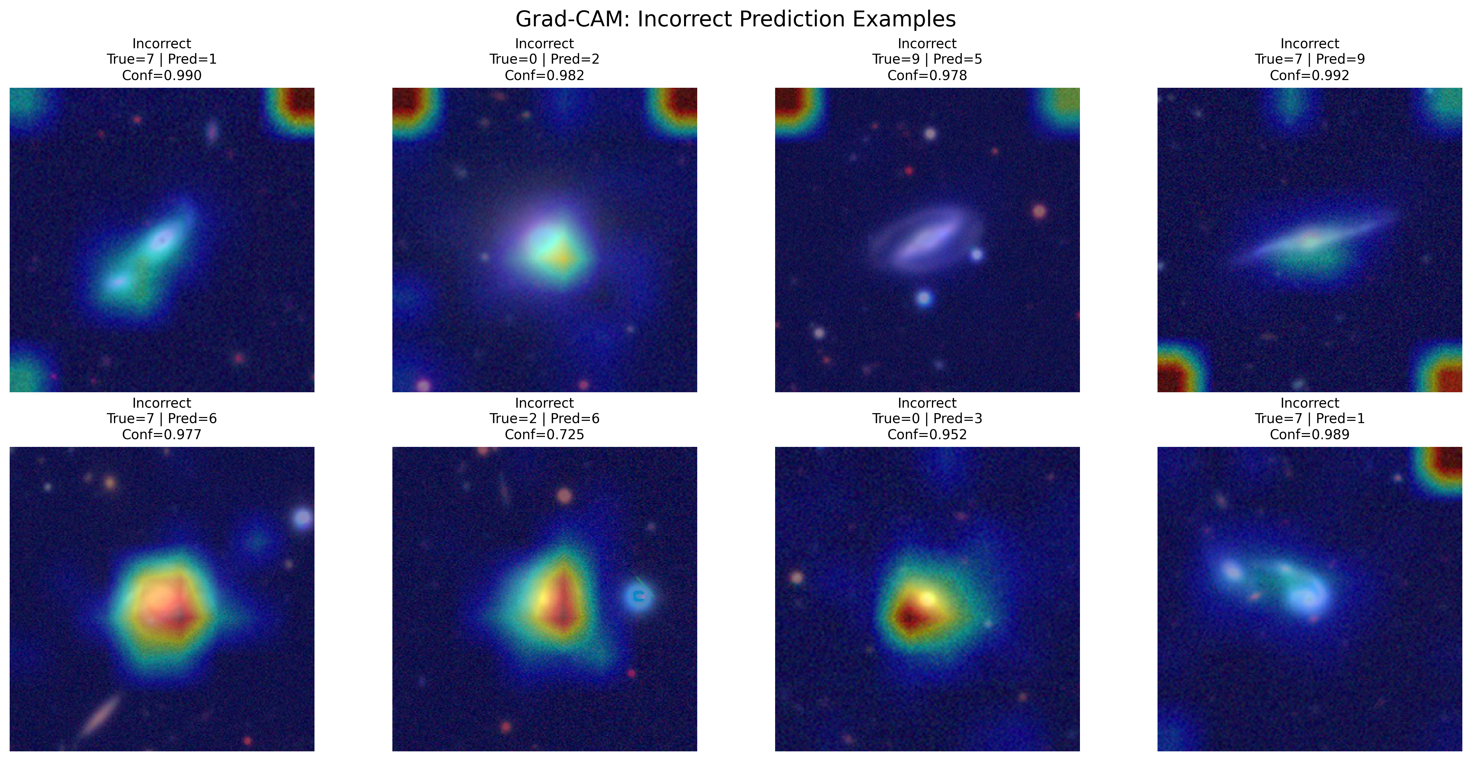
- This stage provided visual evidence of the image regions that contributed most strongly to the model’s decisions.

11) Robustness
- Performed robustness testing on the final adopted model using a subset of 800 test samples.
- Applied the following perturbations:
  - Gaussian noise
  - brightness down
  - brightness up
  - Gaussian blur
- Re-evaluated the model under each perturbation and compared the results with the clean baseline.
- Confirmed results:
  - Clean: Accuracy = 0.8488, Macro F1 = 0.8275
  - Gaussian noise: Accuracy = 0.6400, Macro F1 = 0.5931
  - Brightness down: Accuracy = 0.8137, Macro F1 = 0.7950
  - Brightness up: Accuracy = 0.8087, Macro F1 = 0.7795
  - Gaussian blur: Accuracy = 0.7887, Macro F1 = 0.7464
- The strongest performance degradation was observed under Gaussian noise.
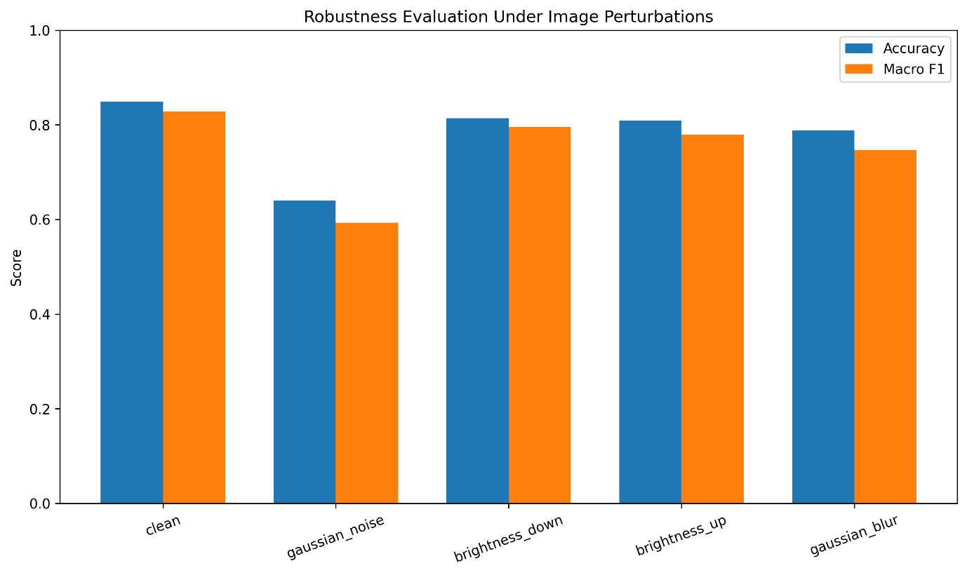

12) Uncertainty estimation
- Applied Monte Carlo Dropout to the final adopted model.
- Used a subset of 400 test samples.
- Performed 20 stochastic forward passes during inference.
- Computed uncertainty-related measures, including:
  - mean confidence
  - confidence standard deviation
  - predictive entropy
- Compared uncertainty behaviour between correct and incorrect predictions.
- Confirmed results:
  - Correct predictions:
    - Mean confidence = 0.9040
    - Predictive entropy = 0.3249
  - Incorrect predictions:
    - Mean confidence = 0.7368
    - Predictive entropy = 0.7618
- The results showed that the model was generally more uncertain when it made incorrect predictions.
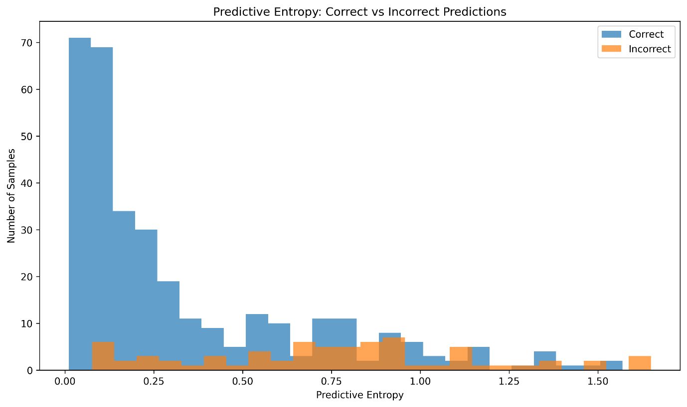

Final novelty of the project
The novelty of this project is not only that it achieved a strong final classification result.
The novelty is that the project developed a progressive and integrated deep learning framework for galaxy morphology classification.
This novelty comes from two connected aspects:
- First, the practical work followed a real staged progression:
  - starting from a baseline CNN,
  - then transfer learning,
  - then larger image sizes,
  - then modern architectures such as ConvNeXt, CoAtNet, and MaxViT,
  - and finally staged refinement at full resolution.
- Second, after selecting the final best model, the work did not stop at accuracy only. The final adopted model was evaluated through:
  - predictive performance,
  - class-level error analysis,
  - qualitative inspection,
  - interpretability,
  - robustness,
  - and uncertainty estimation
within one unified framework.
So, the novelty of the project lies in building a more reliable, interpretable, and scientifically useful galaxy morphology classification framework, rather than presenting only one best-accuracy model.

