Page memory

What Is Memory Paging?
Memory paging is a memory management technique used by the operating system (OS) to manage how a computer's memory resources are shared. Processes being executed are done so within memory.
Example for Memory Page Allocation:
Consider Tasks A, B, and C that need to be loaded into memory for execution. We have a total memory space sized at 32Mb. Memory frames have been partitioned into 4Mb compartments. An area is reserved exclusively for the operating system.

Task A requires 8Mb of memory for execution. This means that task A will have to be allocated two 4Mb frames. This is indicated by pages A0 and A1 in main memory.

Task B requires 11Mb of memory for execution. This means Task B will have to be allocated three 4Mb frames denoted by pages B0, B1, and B2, to accommodate its size.

Task C requires less than 4Mb, but will have to occupy one 4MB frame, shown as page C0.
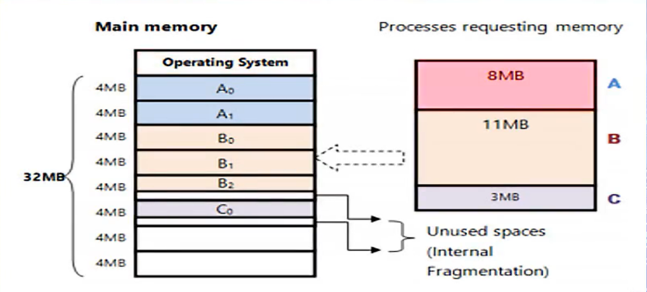

Name: Areej Gaisi
221001740

