

AI-Based Early Warning System for Academic Risk Detection in Education
Prepared By
Student 1: Marya Mohammed Bawazir ID: 253000692
Student 2: Hala Haytham Hajjar ID: 253001456
Submitted in fulfillment of the requirements for the degree Master of Science in Artificial Intelligence
At
Collage of Informatics
Midocean University
UAE
Supervisor Name: Hager Saleh.
College of Informatics, Midocean University, Comoros

Abstract:

Table of Contents
List of Abbreviations...................................................................................... xiv
List of Figures................................................................................................. xvi
List of Tables.................................................................................................. xviii

Chapter 1: Introduction…………………………………………………….…….……6
1.1 Problem Definition…………………………………………………………………...6
1.2 Thesis objectives……………………………………………………………..…...…7
1.3 Thesis Contribution……………………………………………………………..……
1.4 Thesis Organization …………………………………………………….…..………
Chapter 2: Background and Related Work………………………………………….9
2.1 Background………………………………………………………………….………...9
2.1.1 Artificial Intelligence (AI).......................................................................9
2.1.2 Machine Learning (ML)........................................................................9
2.1.3 Types of Machine Learning……………………………………………....10
2.1.4 Classification………………………………………………………………10
2.1.5 Machine Learning Algorithms…………………………………………...11
2.1.6 Model Evaluation Metrics…………………………………………….…..13
2.1.7 Impact of Artificial Intelligence in Education………………………….....14
2.2 Related Work………………………………………………………………….…..…..15
Chapter 3: Proposed Approach ..............................................................................
4.1 Introduction ...........................................................................................................

Chapter 4: Experimental Results and Discussion ................................................
Chapter 5: Conclusion and Future Work ................................................................
7.1 Important Features ................................................................................................
7.3 Future Work ..........................................................................................................
References ..................................................................................................................28

List of Abbreviations :
• Acc.: Accuracy
• ANN: Artificial Neural Network
• ML: Machine Learning
• XAI: Explainable Artificial Intelligence
• SVM: Support Vector Machine
• RF: Random Forest
• DT: Decision Tree
• KNN: K-Nearest Neighbors
• DL: Deep Learning
•NV: Naïve Bayes
• CNN: Convolutional Neural Network
- LMS: Learning Management System
- LR: Logistic regression

List of Figures :
Fig. 1 Artificial Intelligence (AI)….........................................................................9
Fig. 2 Machine Learning (ML)…..........................................................................10
Fig. 3 Decision Tree (DT)....................................................................................11
Fig. 4 Random Forest (RF).................................................................................12
Fig. 5 k-Nearest Neighbors (KNN)......................................................................12
Fig. 6 Support Vector Classifier (SVC) ..............................................................13
Fig. 10 Proposed Framework……………………………………………………..… 8
Fig. 11Results of Individual Models......................................................................

List of Tables:
2.2 Table of Reviewed Papers…………………………………………………………23

Chapter 1 Introduction

1.1 Problem Definition
Despite the increasing availability of student data in educational sectors, many systems still face challenges in identifying students at academic risk at an early stage to allow them to intervene effectively. Traditional evaluation methods often rely on certain and usual results. This reduces the opportunity of providing timely support or implementing appropriate personalized intervention plans. The lack of this diagnostic plan is an additional risk, as each student's skills, goals, and needs vary, necessitating early diagnosis to provide individualized support.
Also, educational data is very complex and diverse. It includes demographic information, behavioral data, attendance records, and interactions within learning management systems (LMS). Such complexity makes it difficult to figure out which factors have the biggest effect on predicting academic performance. This data is also often enormous and challenging to understand, which makes it even harder to analyze and make decisions.
Furthermore, irrelevant or less significant features might create many problems when developing predictive models, such as overfitting, increased computational cost, and lack of model interpretability. Therefore, applying feature selection methods to select only the most relevant features will be highly effective for building reliable models that can be interpreted by humans.
On the other hand, AI, such as ML and DL, is capable of analyzing the data from the educational sector, identifying patterns, detecting student behavior, and predicting student achievement. By using the appropriate dataset, it is possible to determine whether a student will be likely to achieve success and which factors might contribute to poor outcomes. However, the effectiveness of AI algorithms depends on data quality, feature selection, and model interpretability.
Therefore, the application of a data-driven early warning system based on AI is necessary for predicting and identifying at-risk students at an early stage. In particular, a data-driven model can help classify at-risk students by their risk level (low, medium, and high).
This study attempts to tackle the issue of inefficient and ineffective detection systems of students that could benefit from additional assistance, through the application of Artificial Intelligence techniques on the information provided by the LMS. The ultimate goal is to boost student performance and avoid academic failure.
1.2 Thesis Objectives
The major goal of the research is the development of an early warning system that can be applied to classify students' risk levels in terms of their academic performance by using AI and ML methods. The project will rely on LMS data, including students' academic performance indicators, engagement, and demographics, to identify those who have risks of poor performance as early as possible. For this purpose, the target (Final Mark) is transformed into a classification problem (low, medium, high). The research uses the technique of data pre-processing and feature engineering to increase the quality of the data used for predictions. Several ML classifiers are implemented in a stacking ensemble model to make more accurate predictions. Accuracy, precision, and recall measures are used to evaluate the algorithm, where special attention will be paid to recall in order to increase the chances of detecting at-risk students.

1.3 Thesis Contribution
1.4 Thesis Organization

Proposed Framework

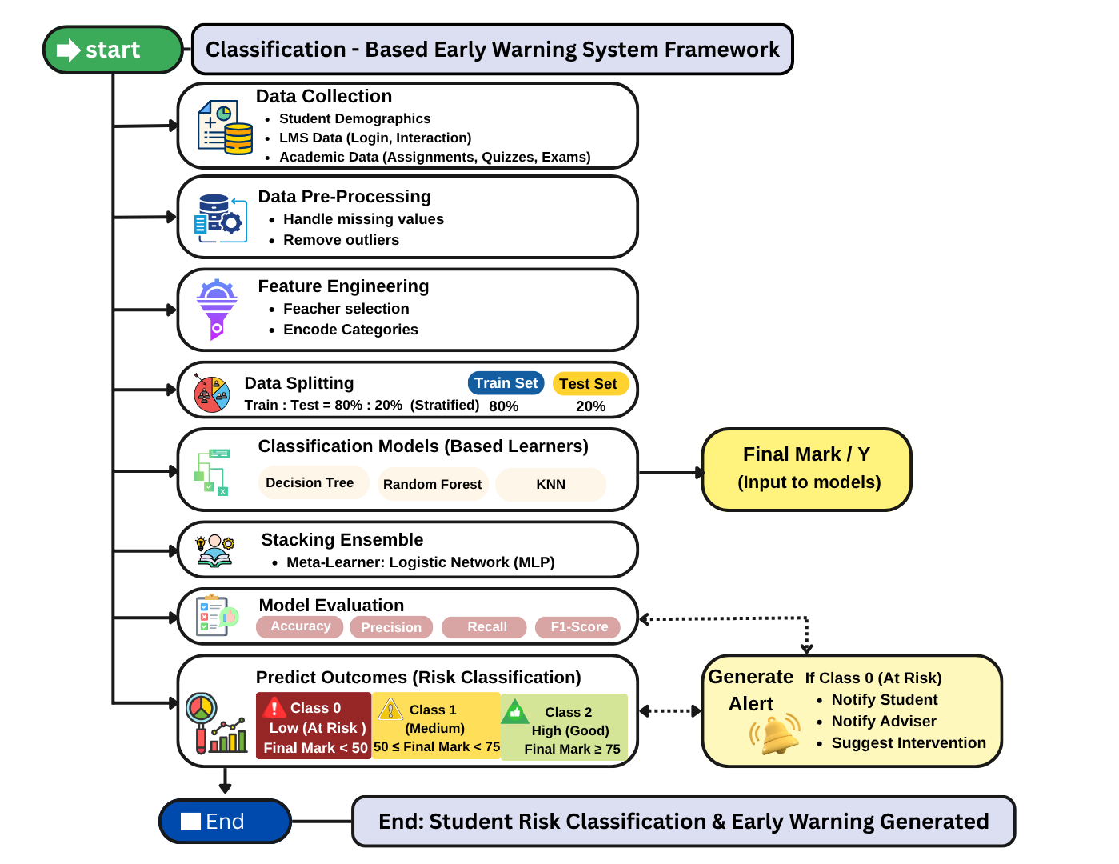
Fig.7. Proposed Framework

Chapter 2 Background and Related Work

2.1 Background

2.1.1 AI
The ability of computer systems to do tasks like learning, reasoning, decision-making, and problem-solving that require human intelligence is known as AI. Systems analyze massive data using computational methods to produce predictions. AI is used more and more in the field of education to evaluate student data and assist with decision-making processes like identifying students who are at risk and enhancing learning outcomes [16].
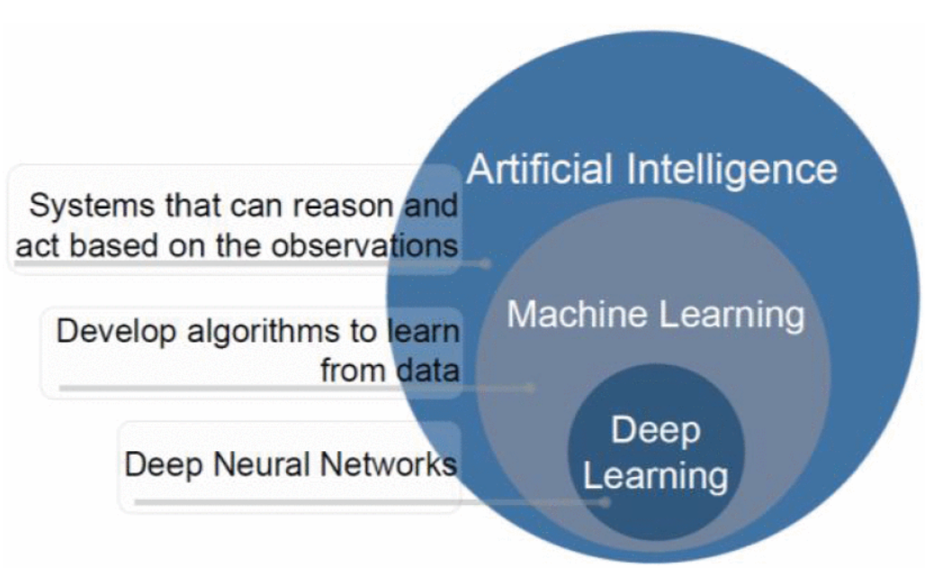
Fig. 1. AI [22]

2.1.2 ML
It is a branch of AI that focuses on creating algorithms that, without explicit programming, enable computers to recognize patterns in data and perform better. It can be used to predict or classify new data after being trained on historical data. Because it allows for examining massive amounts of data of students and finding their performance, ML is crucial to educational data mining and learning analytics. (Pattern Recognition and ML) [17] .

2.1.3 Types of ML

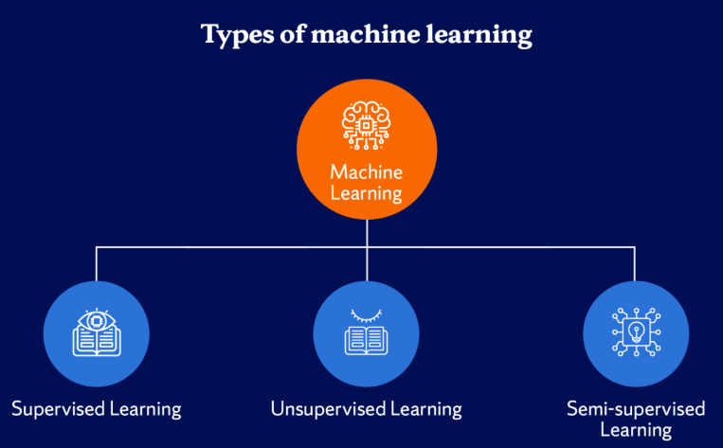

Fig. 2. Types of ML [23]

1. Supervised Learning
The model is trained using labeled data in this ML method. There is an input and an output label for every training example. Learning a mapping between inputs and outputs is the aim of supervised learning, which enables the model to correctly predict the output for fresh, unseen data [18].

2. Unsupervised Learning
It uses unlabeled data to train models. In this kind of learning, the algorithm looks for unidentified patterns or structures in the data. In unsupervised learning, clustering and association rule learning are popular methods[17].

3. Semi-Supervised Learning
It includes both labeled and unlabeled data. This method works well when there is a lot of unlabeled data but little labeled data. By utilizing both kinds of data, it can enhance model performance [18] .

2.1.4 Classification
Predicting a categorical label for a given input is the goal of this kind of supervised learning task. For instance, classification algorithms can be used in educational systems to assess a student's risk level based on behavioral and academic data [19].

2.1.5 ML Algorithms

1. DT
It is a supervised learning algorithm that uses a tree structure to represent decisions. A feature is represented by each internal node, a decision rule by each branch, and a class label by each leaf node. DT are frequently used in classification problems because they are simple to understand [19].
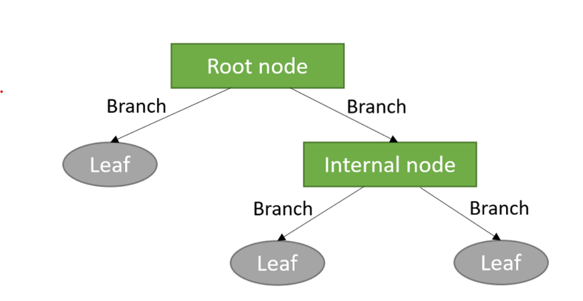

Fig. 3. DT structure [24].

2. RF
Many DT are combined in the RF groups learning technique to increase prediction accuracy and decrease overfitting.it is subset of the dataset is used to train each tree in the forest, and the final prediction is produced by adding up all of the trees' predictions [19].
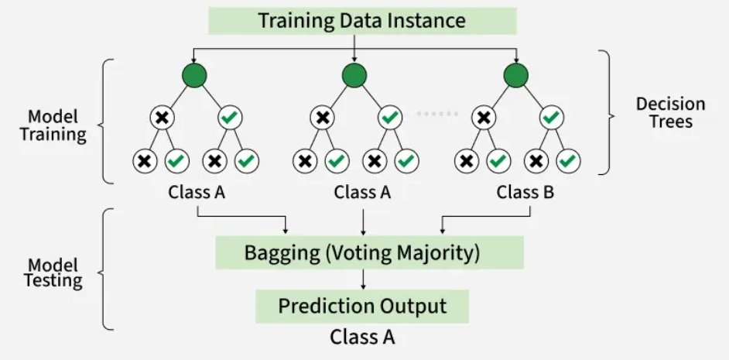
Fig. 4. RF algorithm structure [25].

3. (KNN)
KNN uses the classes of a data point's closest neighbors in the feature space to predict the data point's class. It uses Euclidean distance, and other distance metrics are used by the algorithm to determine similarity [17].

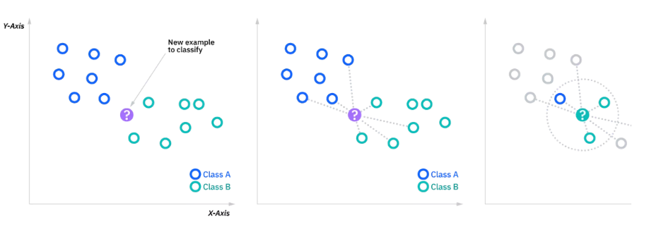

Fig. 5. KNN classification [26]

4. SVM
It is a supervised learning algorithm for tasks involving regression and classification. To find the best hyperplane that divides data points from various classes, with the greatest margin, is how it operates [17].

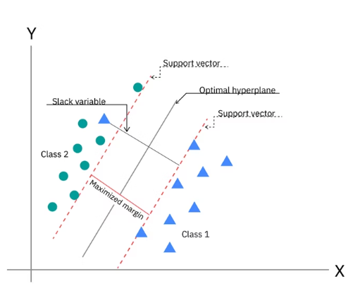

Fig.6. SVM [27].

5. NV
It is an algorithm of classification. It makes the assumption that features are conditionally independent, it makes computation easier, and enables the model to work great even with massive datasets [18].

2.1.6 Model Evaluation Metrics

We used it to check how well classification models work and make sure they make accurate predictions, which is especially important in serious situations like finding students who are at risk [19].

1. Accuracy
It is the percentage of correctly predicted cases among all of the model's predictions.
Accuracy = TP+TN / FP+FNTP+TN​
Where: TP = True Positives, TN = True Negatives, FP = False Positives, FN = False Negatives. It is simple and intuitive; however, not deal with imbalanced datasets [19].

2. Precision
It is the percentage of correctly predicted positive cases among all predicted positive cases.
Precision = TP/ FP + TP​ , where it is important when the cost of false positives is high[19].

3. Recall
It is sometimes referred to as sensitivity, which gauges how well the model can identify real positive examples.
Recall=TP/ FN+TP​
When there is a positive case (like a student who is at risk), recall is very important[19].

4. F1-Score
When working with imbalanced datasets, the F1-score—which is the harmonic mean of precision and recall—offers a fair assessment of model performance.
F1-Score=2×Precision×Recall​ / Precision + Recall
This is especially helpful when you have datasets that aren't balanced, and you need both precision and recall [19].

2.1.7 Impact of Artificial Intelligence in Education
The utilization of AI in the education sector makes it possible for teachers to recognize potential issues that students may have in their studies in a timely manner and, therefore, make necessary adjustments. Academic risks can be predicted through analysis of the information collected from the performance of students using various Machine Learning techniques. By employing predictive models powered by artificial intelligence, educational institutions can keep students. [20,21].
2.2 Related Work:

CR-NODE was proposed by Bettahi et al.[1], where continuous time was combined with completion-specific features to predict early dropout behavior. The dataset consists of longitudinal interactions recorded in the Canvas Learning Management System at a large public university spanning several terms. In the dataset, there are 100,878 students’ enrollments that have final grades, out of which we filtered 89,734 temporal interactions meeting the minimum observations requirement. To ensure temporal consistency and data quality, data preprocessing involved several steps. There were several steps in data preprocessing to make sure that the data was consistent over time and of good quality. They used six different baseline methods (Logistic Regression, RF, XGBoost, Gradient Boosting, LSTM, and Basic Neural ODE) to compare CR-NODE and set comprehensive performance benchmarks. The results showed that CR-NODE had the best balance between the rates of true positives and true negatives. XAI was used to understand model predictions.

Ujkani et al. [2]proposed a model based on CNN, LSTM, and XGBOOST. They used a dataset that was collected from the Open University Learning Analytics Dataset. It includes 32,593 students over a 9-month course period from 2014 to 2015. Different pre-processing steps were applied for predicting students’ success: Merge and Consolidate, Missing Value Handling, Feature Engineering, and Data Splitting. Different DL and ML models for forecasting students' success. To comprehend the prediction of models, the RF Classifier, Gradient Boosting Classifier, KNN, Multi-Layer Perceptron (Neural Network), First Custom Neural Network Architecture, Second Custom Neural Network Architecture, and XAI were employed. LSTMs were employed for training and assessment. Their findings show that, when compared to models for predicting students' success, their proposed models performed with the best accuracy, up to 94%. The models' predictions were analyzed using XAI, RF Classifier, and Gradient Boosting Classifier.

The proposed RADAR system by Embarak et al.[3] used statistical analysis and ML algorithms to identify patterns and trends in the data that indicate a student was at risk of falling behind or dropping out. A dataset of the students from a particular school district was taken to build the system; the information was gathered and processed properly through feature integration, data cleansing, and feature selection. The system may be used to determine the goals, strengths, and weaknesses of the individual student, recognize patterns which suggest the student is in danger of dropping out of school, recognize signs of difficulty that the student may be experiencing, and offer assistance. PAP could help evaluate the student's readiness for college and predict his/her success in higher education. By making this comparison, Embarak et al. can point out flaws in these systems. Machine learning systems, which incorporate XAI, are able to process many different types of information and consider other factors related to the risk of students. ML algorithms, like DT, are utilized to perform an analysis of information and detect patterns. Students were predicted by the system using predefined thresholds, chosen features, and recognized patterns. Individualized interventions and ongoing evaluation were subsequently made possible by the prediction results. The results of the study demonstrate how the RADAR system can improve the guidance and support given to at-risk students, ultimately leading to improved academic performance.

Macfadyen [4] introduced how LMS data could be used to predict academic performance and identify at-risk students. The dataset for this study was collected from the University of British Columbia's Blackboard Vista Learning Management System (LMS) in Canada. This dataset included student activity logs, which contained information on discussion participation, assessment completion, email exchanges, interaction patterns, and login frequency. These indicators were subsequently applied to the analysis of students' activities on the web platform and, consequently, to the prediction of their performance. At the preliminary stage, the data collected from the LMS were subjected to further analysis. Key predictors of academic success were defined; these included participation in discussions, messaging, performance in the test and quiz sections, and the number of logins into the system. The data were then cleaned, meaning that incomplete observations were discarded, and structured for predictive modeling (PM). Regression modeling (RM) was used in this study to create a predictive model (PM) of academic success, based on activity data collected from the LMS. LR was utilized to discover students at risk of poor performance and to predict their academic failure. Network analysis was also carried out to analyze patterns of interaction and determine which students are disengaged in discussion forums. According to the findings, activity data of students from the Learning Management System can be used to make accurate predictions regarding their performance. The regression model was able to explain more than 30% of the variance in the final grade. Additionally, the logistic regression model accurately predicted 81% of the failures.
Queiroga et al.[5] Presented a research paper that attempted to predict the at-risk students in high schools (secondary education level) by applying ML and learning analytics. The research presented the preprocessing techniques for the dataset, the modeling approaches, and the bias analysis conducted when constructing the predictive models. Moreover, the importance of utilizing the past performance of students in predicting their future performance was highlighted. The dataset used in this research was obtained from the National Administration of Public Education (ANEP) of Uruguay. The dataset included nine different education systems, capturing the academic journey of students from primary to secondary education levels, covering the period between 2015 and 2020. It involved data about 258,440 students, including their grades, attendance, demographics, and other attributes. Preprocessing of data was also conducted before model construction. This process included data cleansing, merging several education system datasets, converting the dataset to a time series format, and deriving additional features. Methodology: The process followed is known as the CRISP-DM approach to data mining. Various machine learning algorithms were examined, including RF, DT, AdaBoost, LR, NB, and MLP. RF and MLP yielded almost identical results; however, the former was chosen due to its superior performance and higher level of explainability. From the findings, it can be noted that the ML algorithms performed impressively well by attaining high levels of accuracy in the prediction of at-risk students. The AUROC and F1 measures yielded values of over 0.90 and 0.88, respectively. Seven out of eight models were considered acceptable after evaluating their bias level.

Bagunaid [6] introduced E-FedCloud, an AI-based e-learning system. This technique was aimed at predicting student performance and determining possible areas of difficulty for students. Personalized recommendations were generated and constantly monitored to improve students' performance. Student engagement analysis was performed using federated learning along with Shannon entropy for secured data access. Furthermore, a deep reinforcement learning model, named ID2QN, was applied to predict students' performance and divide them into categories based on their risk levels, including students at risk of dropping out, students with poor performance, and students who may potentially fail the course. Additionally, the ontology graph and the attention-based capsule network were employed to generate personalized recommendations for every single student. The OULAD database, consisting of 32,593 students taking 22 courses, was utilized as the training set. It comprised demographic data, academic performance data, and learning behavior data such as login frequency, assessments, and interactions with learning content. Data pre-processing techniques were applied prior to modeling. They included data cleaning, feature extraction, multiple source data integration, and behavioral, academic, and demographic variables preparation. For further optimization of data quality, pre-processing techniques such as contrast adjustment, denoising, and image stabilization were implemented. In turn, several different machine learning and deep learning algorithms were employed. Afterward, the ID2QN deep reinforcement learning algorithm was selected for predicting the academic results of students. Majority Voting Multi-Objective Clustering was applied to categorize students by their engagement degree, while the Attention-based Capsule Network was implemented to provide customized recommendations. In terms of securing the collected data, federated learning and Cycle-GAN were applied. It is worth mentioning that the E-FedCloud framework exhibited a high prediction capability of identifying students who might experience difficulties. The accuracy of the model equaled almost 97%, and the F1-score equaled 95%.
Johora [7] developed an XML approach to predict the academic performance of undergraduate students in Bangladesh. In this research, a dataset consisting of 872 samples was created. It included demographic, academic, and behavioral data of the students. Preprocessing steps were followed, including handling of the missing data, elimination of the unimportant columns, and conversion of the categorical variables to numeric values using one-hot encoding. To overcome the class imbalance problem, SMOTE was used, and feature scaling was done. After that, several ML approaches were implemented. They included RF, GB, XGBoost, SVM, KNN, DT, and LR. It was shown that the stacking ensemble model gave better performance. In order to explain the decisions made by the model and identify which features were the most important for student success, SHAP and LIME techniques were used in this research. According to the results obtained, the best accuracy achieved by the stacking ensemble model was 86.38%.
Christou et al. [8] introduced an ML approach to predict students’ future grades and study duration using historical academic data. The study introduced a feature selection and construction method based on grammatical evolution combined with Radial Basis Function neural networks (FSC4RBF). The dataset was collected from several departments at the University of Ioannina, Greece, including physics, philosophy, primary education, history, mathematics, and chemistry. It contained students’ academic records such as grades, course information, and study duration. During preprocessing, the dataset was prepared using feature selection and feature construction techniques. Student academic records were organized and transformed into suitable input features for machine learning models. Feature engineering was applied to improve prediction accuracy and model generalization. The proposed model was compared with several ML methods, including DT, Bayesian networks, SVM, and other neural network models. The results showed that the proposed (FSC4RBF) model achieved the best performance. It obtained the lowest mean square error in most regression tasks and the highest accuracy in all classification tasks.

Realinho et al.[9] introduced a study in which a public higher education dataset containing 4424 student records with demographic, socioeconomic, macroeconomic, and academic features was developed to predict student dropout and academic success. The data were collected from multiple institutional sources, merged, cleaned, and preprocessed to support machine learning classification tasks. Several ML techniques were applied to analyse student performance and identify at-risk students. The study used a public dataset from the Polytechnic Institute of Portalegre, Portugal, containing 4424 student records with 35 attributes. The dataset included demographic, macroeconomic, socioeconomic, and academic performance data from enrollment until the end of the first and second semesters. Data collected from multiple sources, such as academic systems, national databases, and macroeconomic data. All the data were combined into one dataset where data cleaning was performed through deleting duplicated observations, missing data handling, and outliers management, feature names’ modification and selection of appropriate features, as well as classification of students into graduation classes. The analysis included the following ML models: RF, XGBoost, light gradient boosting machine (LightGBM), and CatBoost. Data integration and data preprocessing were performed, together with feature importance analysis conducted based on permutation feature importance. The project did not include the results about specific accuracy since the main goal was presentation and analysis of the dataset, but not the development of a single ML model. Nonetheless, the presented dataset allows predicting student drop-out and student achievement and can be used for benchmarking ML models and building learning analytics systems.
The employment of AI techniques to predict student academic performance within the BL environment of SEU was first done by Hamadneh [10]. The study sought to identify the major determinants of student academic achievement and develop a PD for student academic performance. Data for this study were extracted from the Blackboard LMS. The data contained the following predictors: type of study, participation in live lectures, exam results, and completion of assignments. Final exam marks were the target variable. Various data preprocessing techniques were employed. These techniques included descriptive statistics, correlation, multicollinearity test, and regression analysis, which used ordinary least squares, fixed-effects, and random-effects models. To determine the quality of the data and the key factors that determine students' academic success, the following procedures were followed. The researchers subsequently built a PD using the artificial neural network technique. The ANN in this case is a multilayer perceptron, whose input nodes are four, hidden nodes are ten, and the output node is one, which represents the final grade. The results indicated that the proposed hybrid neural network model achieved strong predictive performance with low prediction error.
The project of Skittou et al [11] developed an early warning system that took into account a number of socio-cultural, structural, and educational factors that have a direct impact on a student’s decision to drop out of school. They worked on an original database by aggregating data from several operational systems. The number of pupils in the study population is 125354, including 59384 girls. A considerable number of properties are deemed highly important for defining a student who is likely to drop out or not. dedicated to this issue, which reflected their approach of seeking exhaustiveness and precision in the choice of dropout indicators. The model they built performed very well, particularly with the KNN, with an accuracy rate of over 99.5% for the training set and over 99.3% for the test set. The database used is built specifically for this project's preprocessing; they used mainly ML analysis methods specialized in classification. Hence, the use of the best-known and most efficient methods for this aspect of analysis: SVM, RF, SGD, and KNN. The results are visualized using a Django application they developed for this purpose, and we show how this can be useful for educational planning.
David Bañeres et al. [12] created a new system with multiple contributions. The Gradual At-Risk (GAR) model was the first contribution, a predictive model. Such a model predicted students' chances of failing a course based solely on their grades. Using the dataset in a data mart, a thorough analysis of the model was carried out on the entire collection of university courses. They can see that, starting with the fall semester of 2016, the number of training registries rises every semester (20161). For every course and semester, they suggested a way to find the optimal classifier and training set. KNN, DT, NB, SVM, LR, Hierarchical Mixed models, and Neural Network models. The second is a technique to establish a cutoff point for classifying a course's trained GAR model as high- or low-quality. In an actual classroom, the GAR model gave students feedback according to their risk level. As a result, a teacher cannot afford to give a student incorrect advice or a message. The EWS uses GAR to modify the kind of message that is sent to the student. The third contribution involved using the EWS in two courses in an actual classroom. In terms of dashboards and feedback, the GAR model was utilized to give teachers and students useful information. They examine how well at-risk students are identified in such a real-world learning environment and how this affects the courses' final performance. Two undergraduate courses were used to test the system, and the results demonstrated a high level of accuracy in identifying students who were at risk.

Albreiki, Balqis, et al. [13] stress the use of a customized rule-based system with the Risk Flag to identify and visualize at-risk students early in the course delivery. The dataset was gathered from an undergraduate programming course at the United Arab Emirates University's College of Information Technology. The information shows how well students performed in the introductory programming course during the academic years 2016–2017 (fall and spring), 2017–2018 (fall and spring), and 2018–2019 (fall and spring). The data was pre-processed to make it readable for the ML methods. To resolve any discrepancies, all files are first combined into a single structure. A Python script was used to combine the files into a single CSV file, and min-max normalization was used to normalize the marks. The averaged value of the same coursework components was used to replace the missing values, which were handled using imputation techniques. Time-wise, the results are still inefficient, and there are a lot of false predictions. They suggest a tailored rule-based model that provides at-risk students with prompt identification. It reacts in real time to the student's performance in the assessment component. It also helps the teacher identify the at-risk students and provide prompt intervention by visualizing them.

With various ML algorithms, Khan, Ijaz, et al. [14] created a set of prediction models. Because DT outperforms other models, they were further developed into a format that is simple to understand. The student academic records for a course taught at Buraimi University College, Sultanate of Oman, are used in the dataset. The college's registration department provides the data, and all ethical standards are strictly adhered to. Three semesters are covered by the training dataset. The training dataset contains 151 instances with one prediction class and ten prediction features. Students are categorized as "Low" or "High" based on the prediction. Data cleaning: The noise is either eliminated or minimized using a variety of methods. The training dataset contains 151 instances after the noisy instances are eliminated. WEKA, an open-source program with a variety of algorithms for data pre-processing, classification, clustering, regression, and association rules, was created at the University of Waikato in New Zealand. Four popular machine learning algorithms were chosen. They selected KNN, which is implemented as IBk in WEKA, from lazy algorithms. In WEKA, RepTree is a DT implementation. In a similar vein, they selected NV as the fourth algorithm and Multilayer Perceptron, a class of Artificial Neural Networks. They divided the training dataset into ten intervals of the same length using tenfold cross-validation. The tenth interval in each cycle is used to evaluate the algorithm's performance, while the first nine are used for learning. It was an iterative process; in each iteration, a new interval was chosen for testing. Both the teacher and the students seemed to find the prediction model beneficial. The prediction model appeared constructive and helpful for both the instructor and the students. By the sixth week of the semester, the students who were most likely to produce subpar results had been identified and warned. The model was praised by students who were on the verge of having a low CGPA, and an early warning inspired them to work hard and overcome their situation. Similarly, the students who achieved satisfactory results also followed the attendance advice, and by the end of the semester, very few students showed up for class. The improvement of the struggling students served as a gauge for the overall effects. Four out of five students were able to produce an end result that was acceptable. From the beginning of the course, students' performance is closely monitored as part of the supportive measures. Additionally, a series of preventive measures is implemented to provide extra support to students who are having difficulty.

Akçapınar et al.[15] studied 76 students enrolled in the Computer Hardware course in the Department of Computer Education and Instructional Technology at a state university in Turkey. The students' ages ranged from 21 to 23 years, with 41 women and 35 men. Data collected about the students' learning processes at the end of the term included 3803 sessions, 119,921 page visits, 4566 written texts, 62 discussion forum questions, 297 responses, 8601 evaluations, and 3937 tags used to label written messages. Both final term academic achievement scores and interaction among students data from the virtual classroom were taken into account in the analysis. They used two different preprocessing methods. These included techniques for data transformation and feature selection. The CN2 (86%) and kNN (86%) algorithms achieved the highest classification accuracy, and the Gini index was used to select the best features. According to the results of the study, at the end of the term, the kNN algorithm had an 89% accuracy rate in predicting students who would not succeed.

Table 1 Of The Reviewed Papers

Paper | Year | Models | Limitation | Dataset | Type | The best model | Result
Bettahi et al.[1] | 2025 | CR-NODE  LR, RF, XGBoost, Gradient Boosting, LSTM, and Basic Neural ODE | It focuses exclusively on predictive accuracy without evaluating whether deployment actually improves student outcomes. | large public university Dataset. | Private -Need request-. | CR-NODE | CR-NODE achieves the best balance
Ujkani et al[2] | 2024 | RF Classifier, Gradient Boosting Classifier, KNN, Multi-Layer Perceptron (Neural Network), First Custom Neural Network Architecture, Second Custom Neural Network Architecture, XAI, and LSTM. | The dataset used in this study is from a pre-pandemic period; it is important to acknowledge the broader context of how the COVID-19 pandemic may have altered students’ habits, motivations, and learning behaviors. | Open University Learning Analytics Dataset | Public https://analyse.kmi.open.ac.uk/open_dataset | Custom Neural Network Architecture | The proposed models performed with the best accuracy of up to 94% compared to models for predicting students’ success
Embarak & Hawarna [3] | 2024 | Data analysis, ML, feature selection, XAI, RADAR | The study relied on a specific dataset from a specific computing major, which may limit the generalizability of the findings to other situations. | Students from a school district Dataset. | Private | RADAR system | The RADAR system can help at-risk students receive better support and direction
Macfadyen & Dawson[4] | 2010 | Correlation analysis, Regression model, LR, Network analysis | Applied to one course only, a small dataset, not a full AI model, limited generalization | LMS dataset from Blackboard (student activity, messages, logins, assessments) | Private | LR model | Predicted at-risk students with 81% accuracy and explained 30% of the variation in final grades
Queiroga et al [5] | 2022 | RF, DT, AdaBoost, MLP, NB, LR | Needs annual data preprocessing and retraining; results based on Uruguay data only; one model showed bias and weak performance. | Nationwide K-12 dataset (Uruguay), 258,440 students; demographic data, grades, absences, social welfare, school data (2015–2020) | Private | RF | Achieved high performance (AUROC > 0.90, F1 > 0.88) and successfully predicted at-risk and dropout students early
Bagunaid et al[6] | 2024 | ID2QN (Deep Reinforcement Learning), MV-MOC Clustering, Att-CapsNet (DL), Federated Learning (CGAN), TSE (Entropy), LWEA + Blockchain | High computational complexity; requires multi-modal biometric data; privacy concerns; tested mainly on the OULAD dataset | OULAD dataset (32,593 students, 22 courses); demographic, academic, and behavioural LMS data | Public No Access | ID2QN (Improved Duelling Deep Q Network) | Achieved ~97% accuracy and ~95% F1-score; outperformed PCT, MST-FaDe, Fuzzy SVM, and AISAR; effectively predicted at-risk students early
Johora, Fatema Tuz, et [7] | 2025 | RF, Gradient Boosting, XGBoost, SVC, KNN, DT, LR, Stacking Ensemble, SHAP, LIME | Small dataset (872 students) from Bangladesh only; limited generalizability; based on survey data | 872 undergraduate students from multiple universities; demographic, academic, and behavioural features (31 features) | Private | Stacking Ensemble (RF + GB + SVC) | Achieved 86.38% accuracy; SHAP and LIME identified key factors such as attendance affecting student performance
Christou, Vasileios, et[8] | 2023 | RBF Neural Network, SVM, DT, Bayesian Network, Neural Networks | Data from one university only; limited generalization | Student academic records from several departments, University of Ioannina | Private | Feature selection and construction method for RBF network | Achieved the highest accuracy and the lowest error compared with other models in predicting grades and dropout
Realinho, Valentim, et al.[9] | 2022 | Random Forest, XGBoost, LightGBM, CatBoost | An imbalanced dataset, limited to one institution, and mainly focused on dataset description rather than proposing a strong predictive model. | Student Dropout and Academic Success Dataset – Polytechnic Institute of Portalegre | Public No Access | Not specified | Identified the most important factors for dropout prediction, such as grades, approved courses, tuition status, and course type
Hamadneh, Nawaf N., et al. [10] | 2022 | ANN, Multilayer Perceptron Neural Network, Multilayer Perceptron Neural Network with Firefly Algorithm | Limited to one university, a small dataset, and a few features | Dataset from the Blackboard Learning Management System at the Saudi Electronic University | Private | Neural Network trained by Firefly Algorithm | Achieved strong prediction performance with a root mean square error of 0.39 and identified midterm exams, assignments, attendance, and study mode as key factors
Skittou, et al [11] | 2023 | SVM, Random Forest, SGD, and KNN. | Lack interfaces for administration and data manipulation in dynamic and interactive ways, because aggregating data from several operational systems | The database used is built specifically for this project by aggregating data from several operational systems | Private- Need to request access from the author | (KNN) algorithm | Visualized using a Django application we developed for this purpose, and we show how this can be useful for educational planning.
Bañeres, David, et al.[12] | 2020 | DT, NB, SVM, LR, Hierarchical Mixed models, KNN, Neural Network models | When the assessment process is changed regarding the number of assessment activities or the contents of the activities, the model is invalid for the course. | This model has been tested using data available in an institutional data mart, where curated data from six semesters are available. | Private | Gradual At-Risk (GAR) model | The model showed a high accuracy in correctly detecting at-risk students.
Albreiki, Balqis, et al. [13] | 2021 | Statistical and ML techniques | The results still lack efficiency in terms of time and have high false predictions. In this study, we propose a customized rule-based model that offers timely identification for at-risk students. | The data was collected from a programming course taught for undergraduate students at the College of Information Technology (CIT), United Arab Emirates University (UAEU). | Private -Need request-. | Customized rule-based system (RBS) | It visualizes the at-risk students to support the educator in recognizing these students and offering timely intervention.
Khan, Ijaz, et al.[14] | 2021 | ML algorithms  KNN  RepTree  DT  (MLP)  (ANN) | The training dataset of a course may comprise a low number of total instances due to limitations on classroom size. | The student's academic records for a course taught at Buraimi University College (BUC), | Private -Need request-. | Developed a set of prediction models | The prediction model appeared constructive and helpful for both the instructor and the students.
Akçapınar, et al.[15] | 2019 | Prediction model  Classification model | Transferability and generalizability of prediction models into the different courses are still limited. | The study was conducted at a state university in Turkey with 76 students in online learning activities for a period of 14 weeks | Private -Need request- | (KNN) | The kNN algorithm accurately predicted unsuccessful students at the end of the term with a rate of 89%.

References:

- [1]Bettahi, Abdelkarim, Hamid Harroud, and Fatima-Zahra Belouadha. "Early Student Risk Detection Using CR-NODE: A Completion-Focused Temporal Approach with Explainable AI." Algorithms 18.12 (2025): 781.
- [2]Ujkani, Berat, Daniela Minkovska, and Nikolay Hinov. "Course success prediction and early identification of at-risk students using explainable artificial intelligence." Electronics 13.21 (2024): 4157.
- [3]Embarak, Ossama H., and Shatha Hawarna. "Automated AI-driven system for early detection of at-risk students." Procedia Computer Science 231 (2024): 151-160.
- [4]Macfadyen, Leah P., and Shane Dawson. "Mining LMS data to develop an “early warning system” for educators: A proof of concept." Computers & education 54.2 (2010): 588-599.
- [5] Queiroga, Emanuel Marques, et al. "Early prediction of at-risk students in secondary education: A countrywide k-12 learning analytics initiative in uruguay." Information 13.9 (2022): 401.‏
- [6]Bagunaid, Wala, et al. "Visual data and pattern analysis for smart education: a robust DRL-based early warning system for student performance prediction." Future Internet 16.6 (2024): 206.
- [7]Johora, Fatema Tuz, et al. "An explainable AI-based approach for predicting undergraduate students academic performance." Array 26 (2025): 100384.
- [8]Christou, Vasileios, et al. "Performance and early drop prediction for higher education students using machine learning." Expert Systems with Applications 225 (2023): 120079.
- [9]Realinho, Valentim, et al. "Predicting student dropout and academic success." Data 7.11 (2022): 146.
- [10]Hamadneh, Nawaf N., et al. "Using artificial intelligence to predict students’ academic performance in blended learning." Sustainability 14.18 (2022): 11642.
- [11]Skittou, Mustapha, Mohamed Merrouchi, and Taoufiq Gadi. "Development of an early warning system to support educational planning process by identifying at-risk students." IEEE access 12 (2023): 2260-2271.
- [12]Bañeres, David, et al. "An early warning system to detect at-risk students in online higher education." Applied Sciences 10.13 (2020): 4427.
- [13]Albreiki, Balqis, et al. "Customized rule-based model to identify at-risk students and propose rational remedial actions." Big Data and Cognitive Computing 5.4 (2021): 71.
- [14]Khan, Ijaz, et al. "An artificial intelligence approach to monitor student performance and devise preventive measures." Smart Learning Environments 8.1 (2021): 17.
- [15]Akçapınar, Gökhan, Arif Altun, and Petek Aşkar. "Using learning analytics to develop early-warning system for at-risk students." International Journal of Educational Technology in Higher Education 16.1 (2019): 40.
- [16] Y. Liang, W. Wu, and Y. Li, Artificial Intelligence Technologies for Education: Advancements, Challenges, and Impacts, MDPI, 2025.
- [17] C. M. Bishop, Pattern Recognition and Machine Learning. New York, NY, USA: Springer, 2006.
- [18] K. P. Murphy, Machine Learning: A Probabilistic Perspective. Cambridge, MA, USA: MIT Press, 2012.
- [19] T. Hastie, R. Tibshirani, and J. Friedman, The Elements of Statistical Learning: Data Mining, Inference, and Prediction, 2nd ed. New York, NY, USA: Springer, 2009.
- [20] D. Bañeres, M. E. Rodríguez, M. Serra, and S. Caballé, “An early warning system to detect at-risk students in online higher education,” Applied Sciences, vol. 10, no. 13, p. 4427, 2020.
- [21] B. Ujkani, D. Minkovska, and N. Hinov, “Course success prediction and early identification of at-risk students using explainable artificial intelligence,” Electronics, vol. 13, no. 21, p. 4157, 2024.
- [22] Taghvaie, Amir, et al. "A comprehensive review of harmonic issues and estimation techniques in power system networks based on traditional and artificial intelligence/machine learning." Ieee Access 11 (2023): 31417-31442.
- [23] Syracuse University School of Information Studies, “Data Science vs. Machine Learning,” [Online]. Available: https://ischool.syracuse.edu/data-science-vs-machine-learning/
- [24] StatLect, “Decision Tree,” [Online]. Available: https://www.statlect.com/machine-learning/decision-tree
- [25] GeeksforGeeks, “Random Forest Algorithm in Machine Learning,” [Online]. Available: https://www.geeksforgeeks.org/machine-learning/random-forest-algorithm-in-machine-learning/
- [26] IBM, “k-Nearest Neighbors (KNN),” [Online]. Available: https://www.ibm.com/think/topics/knn
- [27] IBM, “Support Vector Machine (SVM),” [Online]. Available: https://www.ibm.com/think/topics/support-vector-machine

